Supplementary Information

Evolvable Carbohydrate-Binding Modules Shape Function and Engineering of a Bacterial Galactose Oxidase

André Taborda^{1†}, Tomás Frazão^{1†}, Tiago Lopes^{1†}, Carolina Dias¹, Filipe Folgosa¹, Márcia Rénio¹, M. Rita Ventura¹, Ferran Sancho², Patrícia T. Borges¹, Lígia O. Martins^{1*}

¹Instituto de Tecnologia Química e Biológica, Universidade Nova de Lisboa, Av da República, 2780-157 Oeiras Portugal; ²Zymvol Biomodeling, C/Pau Claris, 94, 3B, 08010 Barcelona Spain

†A.T., T.F. and T.L. contributed equally to this work.
*Corresponding author

Table of contents

Supplementary Figures 4
Supplementary Fig. 1. Sequence similarity network among copper radical oxidases. 4
Supplementary Fig. 2. SDS-PAGE analysis of WT PsGalOx and truncated versions. 5
Supplementary Fig. 3. Assessment of the generated Alphafold model of PsGalOx. 6
Supplementary Fig. 4. Homology and solubility analysis of the CBM present in PsGalOx. 7
Supplementary Fig. 5. UV-Vis spectra of PsGalOx.. 8
Supplementary Fig. 6. EPR spectra of PsGalOx. 9
Supplementary Fig. 7. Biochemical and biophysical properties of WT PsGalOx. 10
Supplementary Fig. 8. Effect of CBMs on aggregation of PsGalOx. 11
Supplementary Fig. 9. Example of steady-state kinetics for wild-type and truncated variants. 12
Supplementary Fig. 10. Evaluation of PsGalOx dependence on peroxidase-mediated activation 13
Supplementary Fig. 11. NMR spectra of the reaction product obtained after enzymatic oxidation 14
Supplementary Fig. 12. HMQC NMR spectrum of the product mixture after oxidation 15
Supplementary Fig. 13. ITC Thermograms of PsGalOx CBMs Binding to Galactan and D-Gal 16
Supplementary Fig. 14. Overall structural comparison of WT-ΔCBMI and WT-ΔCBMI-Gal 17
Supplementary Fig. 15. Representation of normalized B-factor values of WT-ΔCBMI structure. 18
Supplementary Fig. 16. Structural model of the PsGalOx based on MD simulation 19
Supplementary Fig. 17. Structural alignment of PsGalOx CBMII and other CBM32. 20
Supplementary Fig. 18. D-Gal binding site in carbohydrate-binding modules 21
Supplementary Fig. 19. Conceptual models illustrating functional roles of CBMs 22
Supplementary Fig. 20. Calcium coordination in CBMs.. 23
Supplementary Fig. 21. Structural alignment of the catalytic domain present in AA5_2 members. 24
Supplementary Fig. 22. Distances obtained during Molecular docking of D-Gal on PsGalOx 25
Supplementary Fig. 23. Summary of the molecular dockings of D-Gal on PsGalOx. 26
Supplementary Fig. 24. AA5_2 family binding pocket hydrophobicity 27
Supplementary Fig. 25. E381-W423 interaction on PsGalOx WT 28
Supplementary Fig. 26. Sequence alignment of the four chimeric CBM types 29
Supplementary Fig. 27. ITC thermograms of the chimeric CBMs binding to galactan and D-Gal 30
Supplementary Fig. 28. RMSD of Cα positions along the 150 ns MD simulations. 31
Supplementary Fig. 29. Molecular dynamics flexibility analysis of CBM domains. 32
Supplementary Tables 34
Supplementary Table 1. BLAST output of bacterial entries with highest identity to FgrGalOx. 34
Supplementary Table 2. Summary of production yields and copper content 35
Supplementary Table 3. Activity profile of PsGalOx for a range of sugars, alcohols and furans. 36
Supplementary Table 4. Catalytic parameters of the fungal GalOxs characterized in the literature 37
Supplementary Table 5. Summary of the binding parameters obtained using ITC 38
Supplementary Table 6. Data collection, processing, and refinement statistics 39
Supplementary Table 7. RMSD values of the WT-ΔCBMI and the deposited structures 40
Supplementary Table 8. Directed evolution of PsGalOx for D-Gal. 41
Supplementary Table 9. Apparent steady-state kinetic parameters of DE variants. 42
Supplementary Table 10. Bacterial strains, plasmids, and primers used in this study 43
Supplementary Table 11. Conditions of the PCRs performed in this study. 45
Supplementary References 46

Supplementary Figures

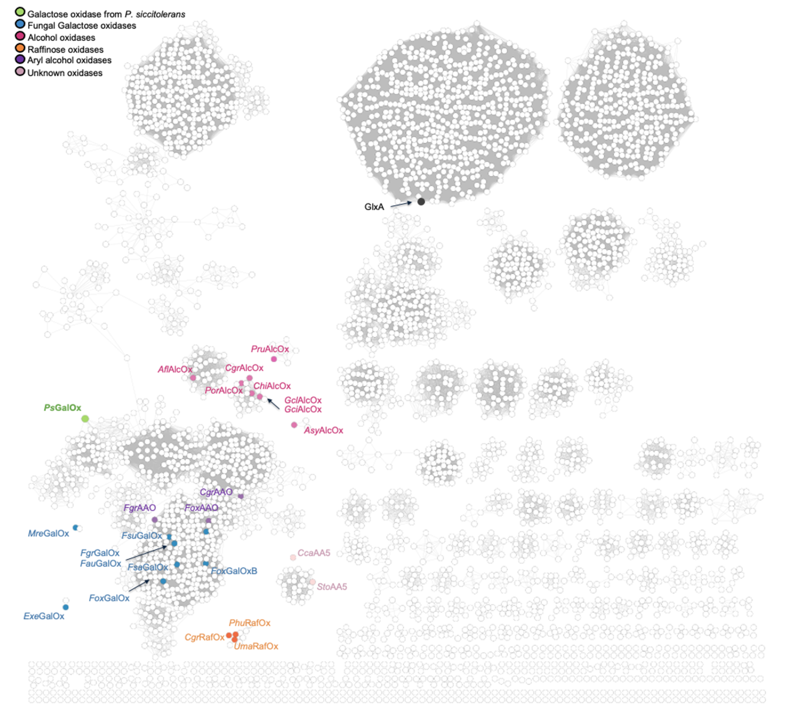Supplementary Fig. 1. Sequence similarity network among copper radical oxidases. Using the Enzyme Function Initiative^{1,2}A network was generated using the catalytic module of PsGalOx as the query, with an E-value cutoff of 5 for edge definition. Nodes representing sequences with 100% identity were consolidated into a single node. Clusters were then delineated in Cytoscape using a 65% sequence identity filter. Colored nodes highlight characterized members of AA5_2: PsGalOx is depicted in green, fungal D-Gal oxidases in blue, alcohol oxidases in magenta, aryl alcohol oxidases in purple, raffinose oxidases in orange, and AA5_2 enzymes with poorly explored substrate profiles in pale pink.
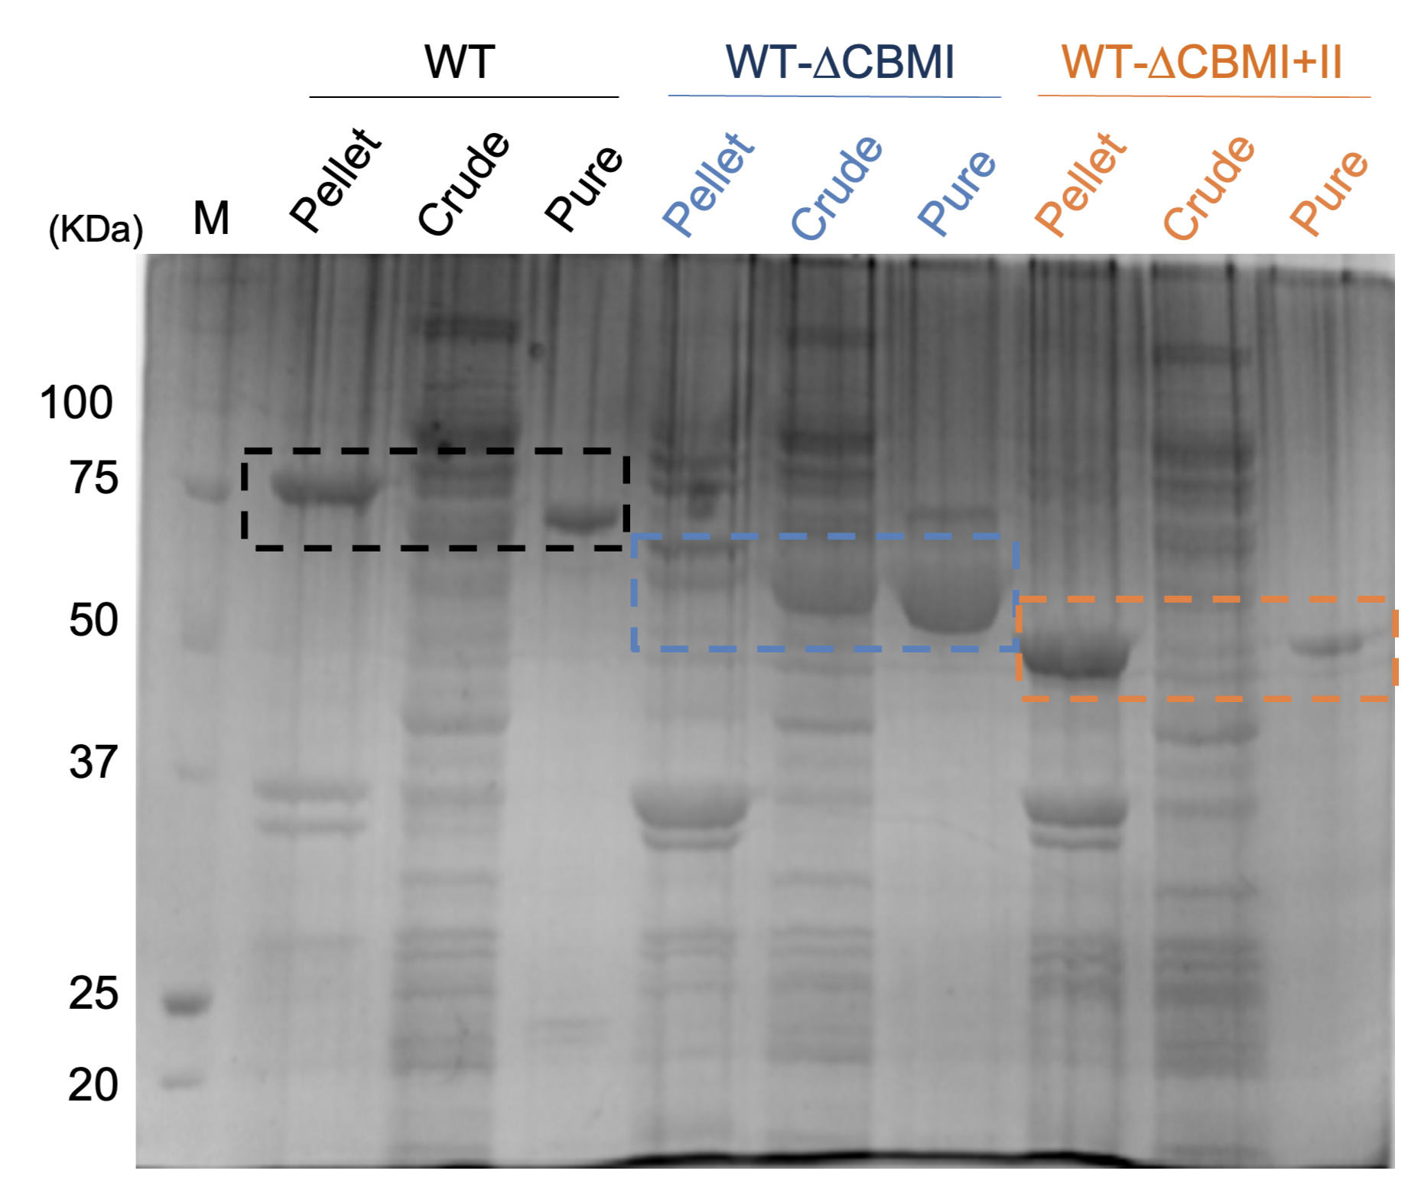
Supplementary Fig. 2. SDS-PAGE analysis of WT PsGalOx and truncated versions. The insoluble (pellet) and soluble fraction (crude) of cell lysate, as well as the pool of purified preparations, were loaded onto the gel. The WT is indicated in black (79 kDa), the truncated variant WT-ΔCBMI in blue (64 kDa), and the truncated variant WT-ΔCBMI+II in orange (49 kDa).
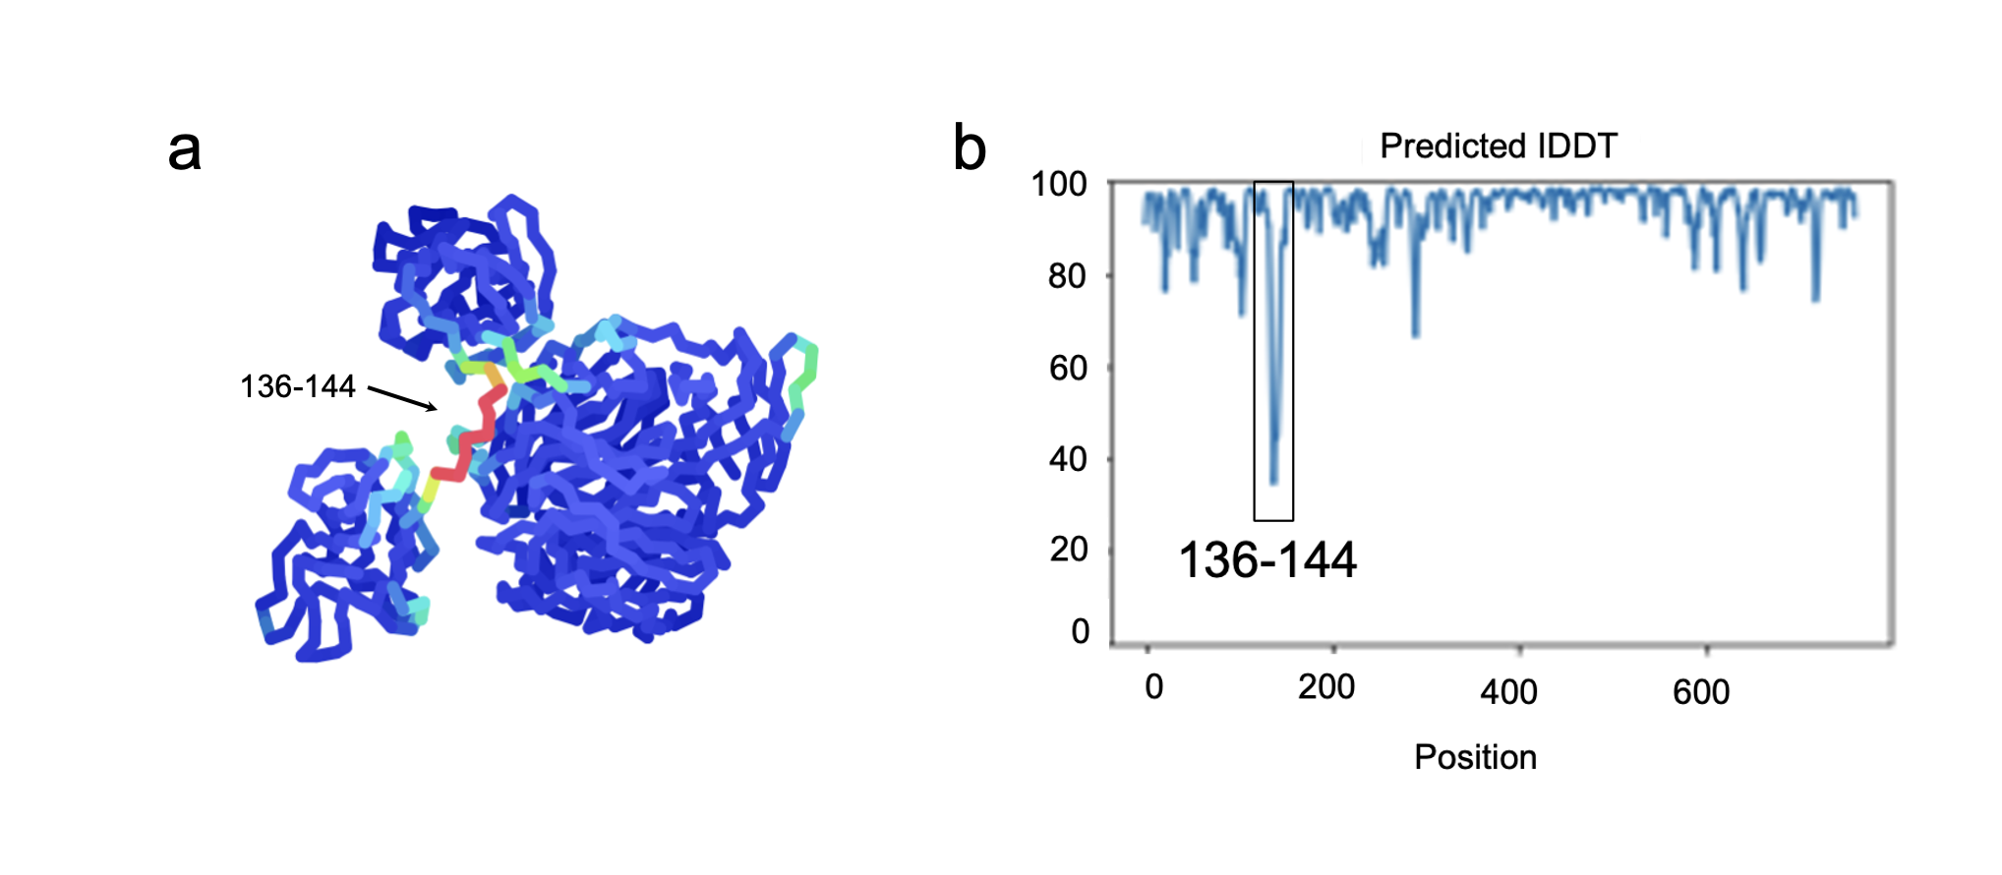

Supplementary Fig. 3. Assessment of the generated Alphafold model of PsGalOx. a. AlphaFold predicted structure of PsGalOx colored by prediction confidence (pLDDT): Very low (red), Low (yellow), acceptable (green), confident (cyan), very high (blue). b. Predicted IDDT as a function of the amino acid residue position.
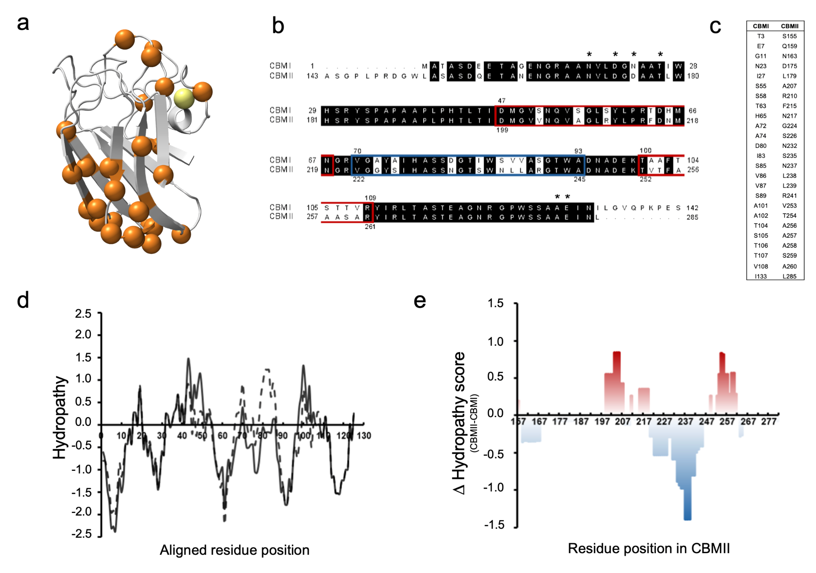

Supplementary Fig. 4. Homology and solubility analysis of the CBM present in PsGalOx. a. Structural model of CBMII, with amino acid residues that differ from CBMI highlighted as orange spheres at their C𝛼 positions. b. Sequence alignment between PsGalOx’s CBMI and CBMII. The calcium-coordinating residues in the WT-ΔCBMI (PDB 9G43) structure are highlighted with “*”. c. List of amino acid residues differing between CBMI and CBMII. d. Hydropathic character analysis of CBMI (solid line) and CBMII (dashed line) aligned residues. Positive or negative values represent hydrophobic and hydrophilic residues, respectively. e. Difference of hydropathicity between CBMII and CBMI. The regions where CBMII is more hydrophobic than CBMI are colored red, while the areas that are more hydrophilic are colored blue.
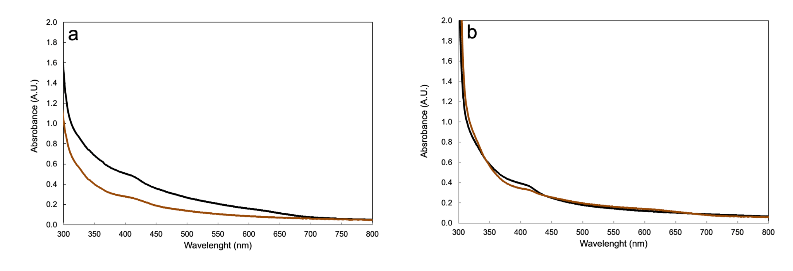

Supplementary Fig. 5. UV-Vis spectra of PsGalOx. Spectra of a. WT and b. WT-ΔCBMI were recorded from 300 to 800 nm using ~80 μM fully metalated purified enzyme samples. The black trace represents the enzyme without oxidant, while the brown trace corresponds to the enzyme after oxidation with 10 equivalents of ferricyanide. The source data is provided in a Source Data file.
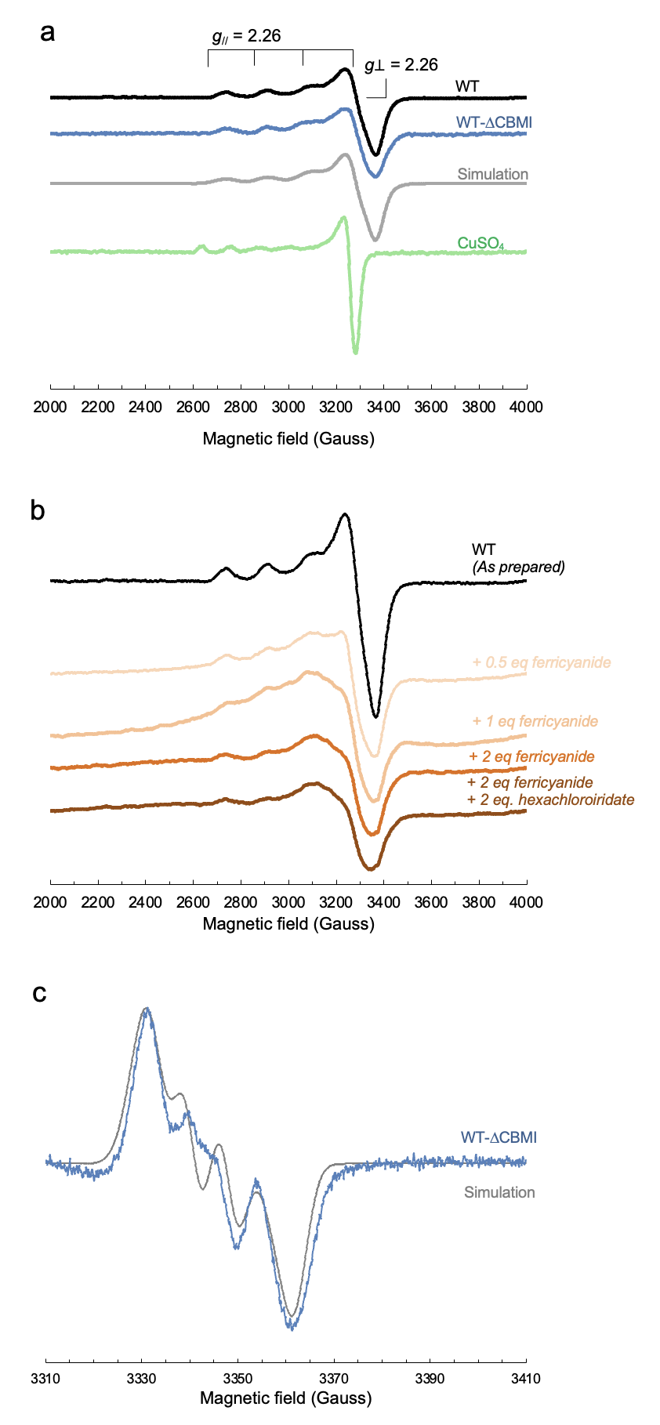

Supplementary Fig. 6. EPR spectra of PsGalOx. a. EPR spectra of the copper center in wild-type PsGalox (black) and WT-ΔCBMI variant (blue). Both spectra were simulated (grey dashed line) with g⊥ = 2.06, g// = 2.26, and A// = 176 × 10⁻⁴ cm⁻¹. The spectra of CuSO₄ (green) were performed as a control. b. Changes in EPR spectra of wild-type PsGalox metal center upon oxidation. The spectra were obtained upon the stepwise addition of increasing amounts of oxidant. The enzyme preparation (80 µM) was titrated with up to 2 equivalents of potassium ferricyanide and hexachloroiridate (the number of equivalents used is mentioned beside each trace and is color-coded accordingly). Spectra were recorded at 120 K, with a microwave frequency of 9.45 GHz, modulation amplitude of 1.0 mT, and a microwave power of 2 mW. c. EPR spectrum of the oxidized apo WT-ΔCBMI (blue) previously oxidized with two equivalents of potassium ferricyanide and potassium hexachloroiridate. The simulated spectrum (grey dashed line) was obtained using the following parameters, g_{x} = 2.016, g_{y} = 2.006 and g_{z} = 1.997 (g_{iso} = 2.006) and hyperfine constant of A_{xx1} = 3.33 x 10⁻⁴ cm⁻¹, A_{yy1} = 7.00 x 10⁻⁴ cm⁻¹ and A_{zz1} = 1.33 x 10⁻⁴ cm⁻¹ and A_{xx2} = 2.67 x 10⁻⁴ cm⁻¹ A_{yy2} = 6.00 x 10⁻⁴ cm⁻¹ and A_{zz2} = 6.67 x 10⁻⁵ cm⁻¹. The spectra were recorded at 120 K, with a microwave frequency of 9.40 GHz, modulation amplitude of 0.5 mT, and a microwave power of 1.3 mW. The source data is provided in a Source Data file.
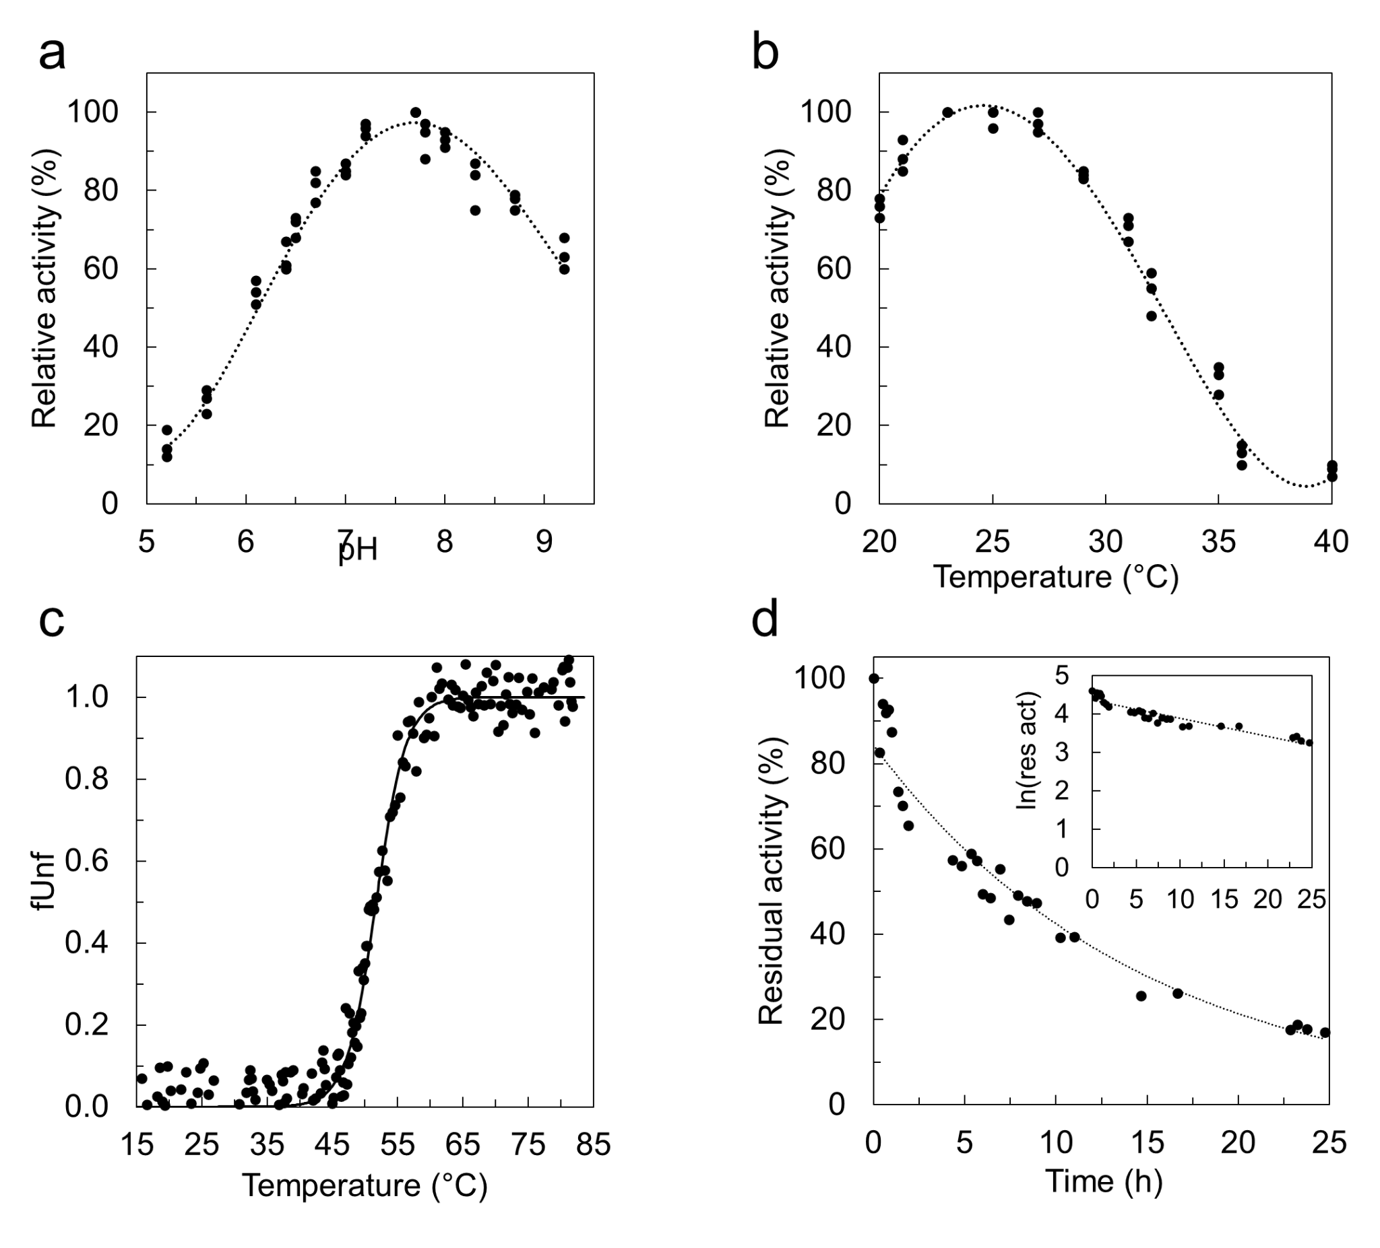Supplementary Fig. 7. Biochemical and biophysical properties of WT PsGalOx. a. Activity dependence on the pH. The reactions were monitored using an HRP/ABTS coupled assay at 25 °C. b. Activity dependence on temperature. The reactions were observed through an HRP/ABTS coupled assay at pH 7.5. c. Melting curve of PsGalOx. The calculated melting temperature was 50 ± 2 ºC. d. Thermal inactivation of PsGalOx at 30 ºC. The estimated half-life time was 7 ± 1 h. The residual activity was monitored using an HRP/ABTS-coupled assay at 25 °C and pH 7.5. The source data is provided in a Source Data file.
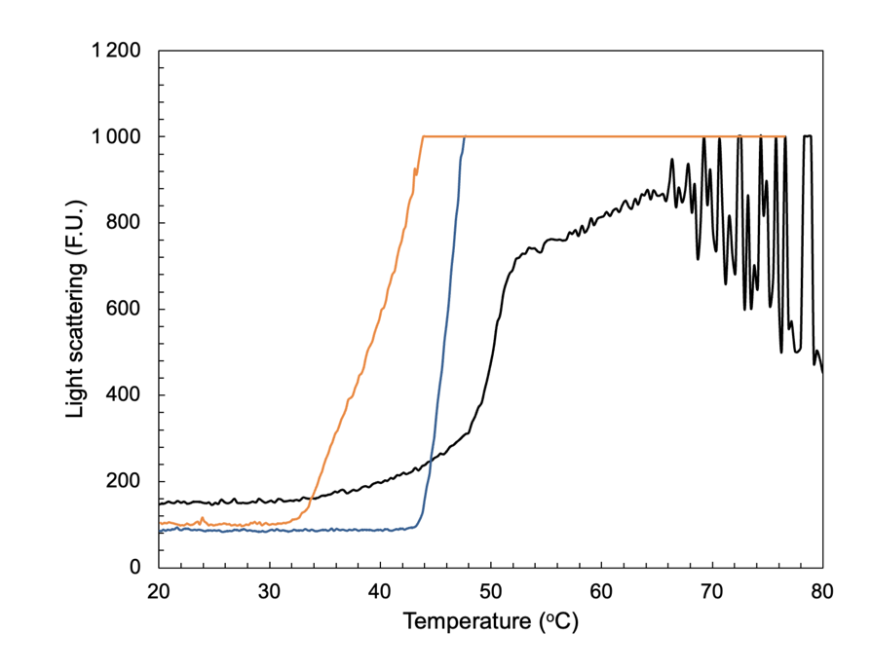

Supplementary Fig. 8. Effect of CBMs on aggregation of PsGalOx. Temperature-induced aggregation profiles showing the aggregation onset temperature (T_{agg}), estimated at 46 °C for WT (black), 43 °C for WT-ΔCBMI (blue), and 32 °C for WT-ΔCBMI+II (orange).

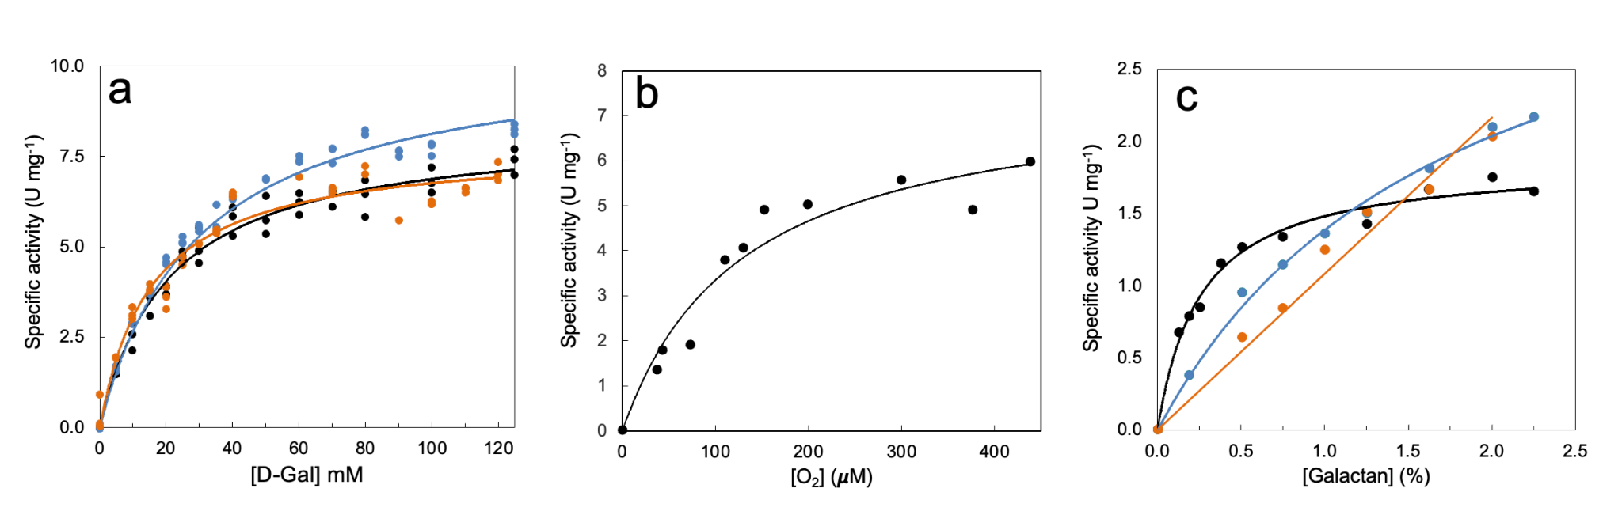

Supplementary Fig. 9. Example of apparent steady-state kinetics for wild-type and truncated variants. a. Activity measurements for D-Gal were performed using the HRP/ABTS coupled assay in the presence of 0-125 mM substrate, 1 mM ABTS, and 10 U mL⁻¹ HRP in 100 mM sodium phosphate buffer, pH 7.5, at 25 °C. The wild-type is represented in black while the truncated variants WT-ΔCBMI and WT-ΔCBMI+II are colored in blue and orange, respectively. b. Kinetics of oxygen were performed at different oxygen concentrations (0-400 µM) using 250 mM D-Gal as the electron donor. The assay was performed in a 1 mL chamber in 100 mM sodium phosphate buffer (pH 7.5) at 25 °C using an Oxygraph system. c. The kinetics of potato galactan were measured using an oxygraph by monitoring molecular oxygen consumption. Assays were performed in a 1 mL reaction volume containing 100 mM sodium phosphate buffer (pH 7.5) at 25 °C under continuous stirring. The circles represent the experimental data, and the line represents the fit to the Michaelis-Menten equation, adjusted using Origin. The source data is provided in a Source Data file.
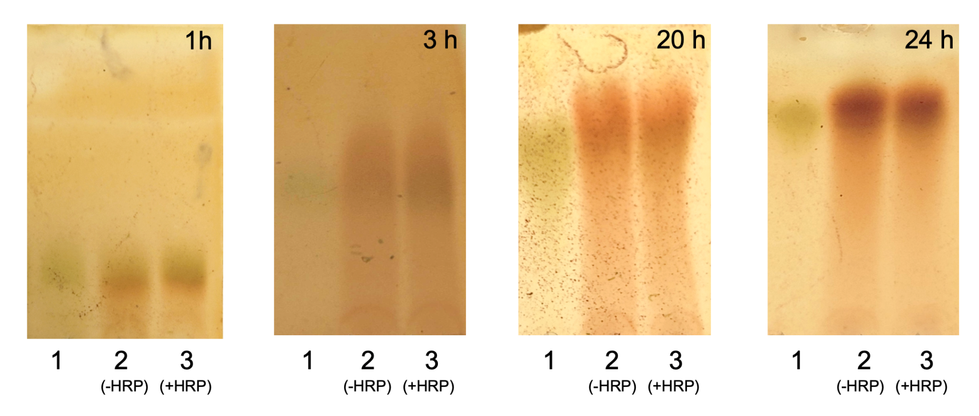

Supplementary Fig. 10. Time course evaluation of PsGalOx dependence on peroxidase-mediated activation. Aliquots of the reaction mixtures were collected at 1, 3, 20, and 24 hours and applied to a silica TLC plate. Lane 1 corresponds to the D-Gal substrate (100 mM); lane 2 contains the reaction mixture with 100 mM D-Gal, 100 μM CuSO₄, and 1000 U mL⁻¹ catalase (without HRP); and lane 3 includes 10 U mL⁻¹ horseradish peroxidase (HRP). All reactions were performed in a 1 mL volume using 100 mM sodium phosphate buffer (pH 7.5) at 25 °C. Elution was performed with a dichloromethane:methanol:water solvent system (65:30:5, v/v/v) and visualized using the 2,4-dinitrophenylhydrazine (DNPH) detection reagent (12 g DNPH dissolved in 60 mL concentrated H₂SO₄, 80 mL H₂O, and 200 mL 95% ethanol). The green coloration indicates the presence of the reducing sugar D-Gal, whereas orange/brown spots correspond to the formation of aldehyde products.
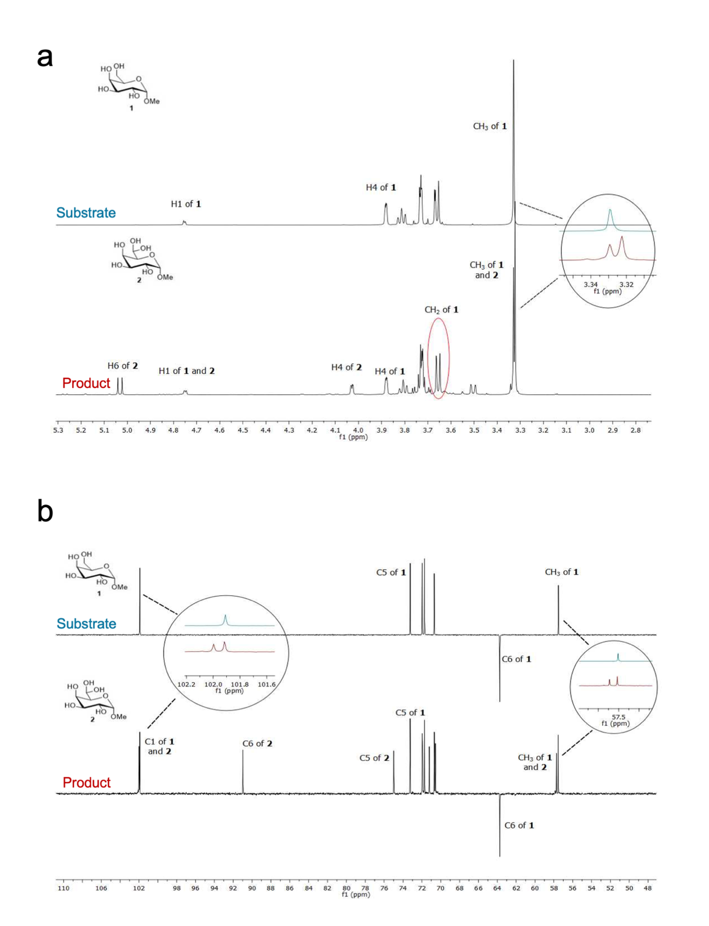Supplementary Fig. 11. NMR spectra of methyl-α-D-galactopyranoside and the reaction product obtained after enzymatic oxidation. a. ¹H spectra of the substrate methyl-α-D-galactopyranoside (top) and the reaction product (bottom). Comparison of the ¹H-NMR spectra of methyl-α-D-galactopyranoside and the product reveals a shift of the CH₂ (2 × H6) signal from 3.73 ppm to ~ 5.11 ppm, consistent with H6 deshielding due to aldehyde hydration (compound 2, Fig. 2b). A shift in the protecting methyl group's signal to 3.3 ppm was also observed. Integration of the methyl signals indicates a conversion yield of approximately 35%. b. ¹³C spectra of the substrate (top) and reaction product (bottom). The spectrum of the reaction mixture displays two distinct signals corresponding to the methyl groups. A comparable shift is observed for the anomeric carbon. Notably, the C6 signal appears as a positive peak at 90 ppm in the product, whereas it is not visible in the substrate because of its CH₂ character. The typical ketone peaks (around 200 ppm) were not observed in the spectrum, indicating that oxidation did not occur at C2, C3, or C4. The enzymatic reaction was performed in 2 mL containing 70 mM methyl-α-D-galactopyranoside, 0.3 U mL⁻¹ of WT PsGalOx, 10 U mL⁻¹ of HRP, and 2300 U mL⁻¹ of catalase. The spectra were recorded in D₂O at 25 ºC.
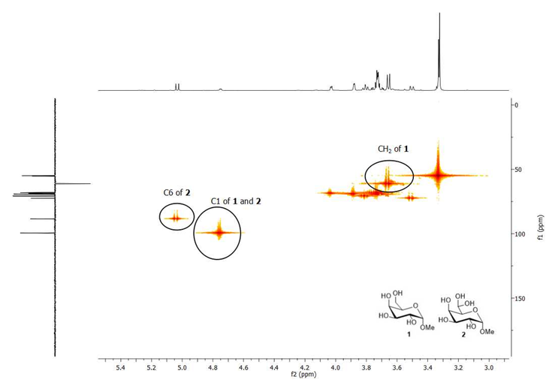

Supplementary Fig. 12. HMQC NMR spectrum of the product mixture after oxidation by PsGalOx. The compounds 1 and 2 refer to the substrate and the hydrated reaction product, respectively. The enzymatic reaction was performed in 2 mL containing 70 mM of methyl-α-D-galactopyranoside, 0.3 U mL⁻¹ of WT PsGalOx, 10 U mL⁻¹ of HRP and 2300 U mL⁻¹ of catalase.
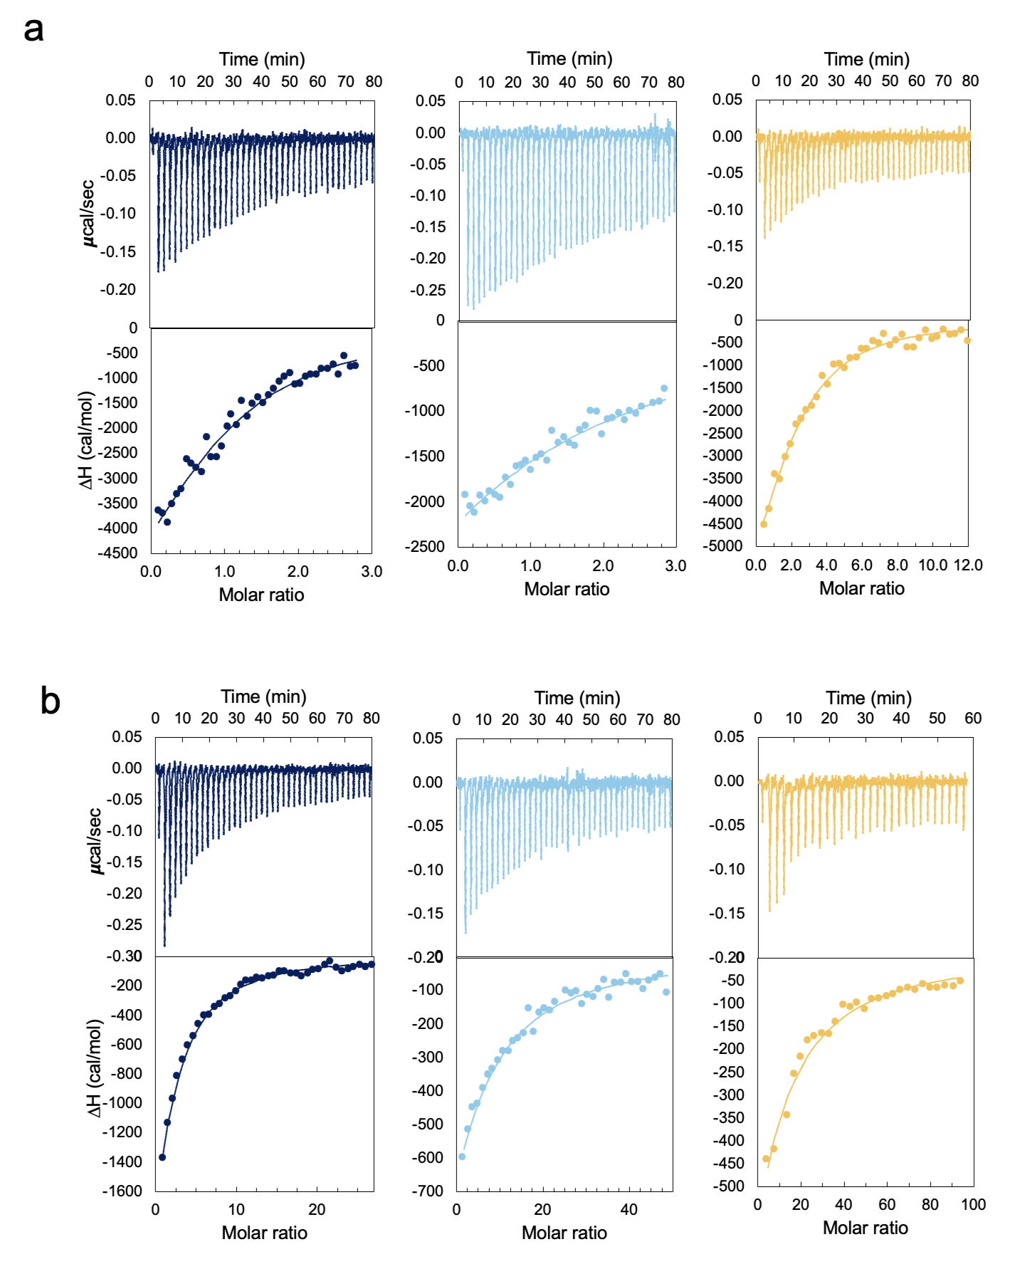

Supplementary Fig. 13. ITC Thermograms of PsGalOx CBMs Binding to Galactan and D-Gal. Thermograms obtained by titration of a. galactan or b. D-Gal into CBMI (dark blue), CBMII (cyan), and CBMI+II (yellow). The top graphics show the heat released by the binding during the titration. In contrast, the bottom graphics show the integration of the peaks according to the molar ratios CBM:galactan or CBM:D-Gal. The line in the bottom graphic represents the fit to the one-binding-site equation. All experiments were performed in 20 mM Tris-HCl, pH 7.5, supplemented with 200 mM NaCl at 25 ºC under 400 rpm. The calculated parameters are evidenced in Table S5. Source data is provided as a Source Data file.
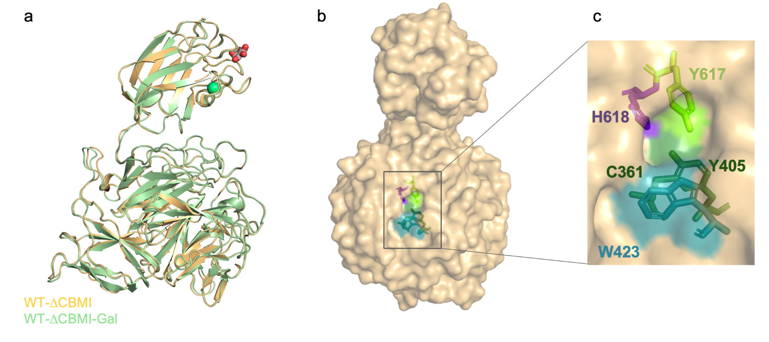

Supplementary Fig. 14. Overall structural comparison of WT-ΔCBMI and WT-ΔCBMI-Gal. a. Superimposition of X-ray crystal structures of WT-ΔCBMI (PDB 9G43, yellow) and WT-ΔCBMI-Gal complex (PDB 9G8H, light green). Calcium ions are represented as green spheres. D-Gal is represented as spheres with carbons and oxygens colored in gray and red, respectively. b. Top view of the WT-ΔCBMI structure, represented as the solvent-accessible area. c. Detailed view of copper cavity highlighting the solvent-exposed residues Y405 (and C361), Y617, H618 and W423, which were colored in dark green, light green, purple and blue, respectively.
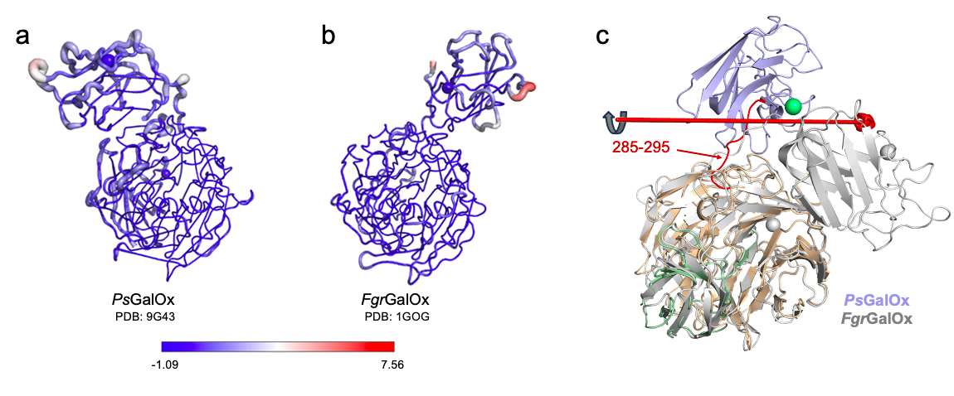

Supplementary Fig. 15. Representation of normalized B-factor values of WT-ΔCBMI structure. Normalized B-factor of a. WT-ΔCBMI (PDB 9G43) and b. FgrGalOx (PDB 1GOG). Red, thicker regions represent higher B-factor values (greater flexibility), while blue, thinner regions represent lower B-factor values. c. Comparison of the overall fold of WT-ΔCBMI (The CBM is colored in blue while the DIII and DIV of the catalytic core are colored in orange and green, respectively) and FgrGalOx (grey). The axis along which the CBM32 of both structures changes is illustrated as a red line. The loop region 285-295 (in the PsGalOx sequence) would allow for the domain rotation observed in both structures. The Calcium ion is represented as a green or grey sphere in PsGalOx and FgrGalOx structures, respectively.
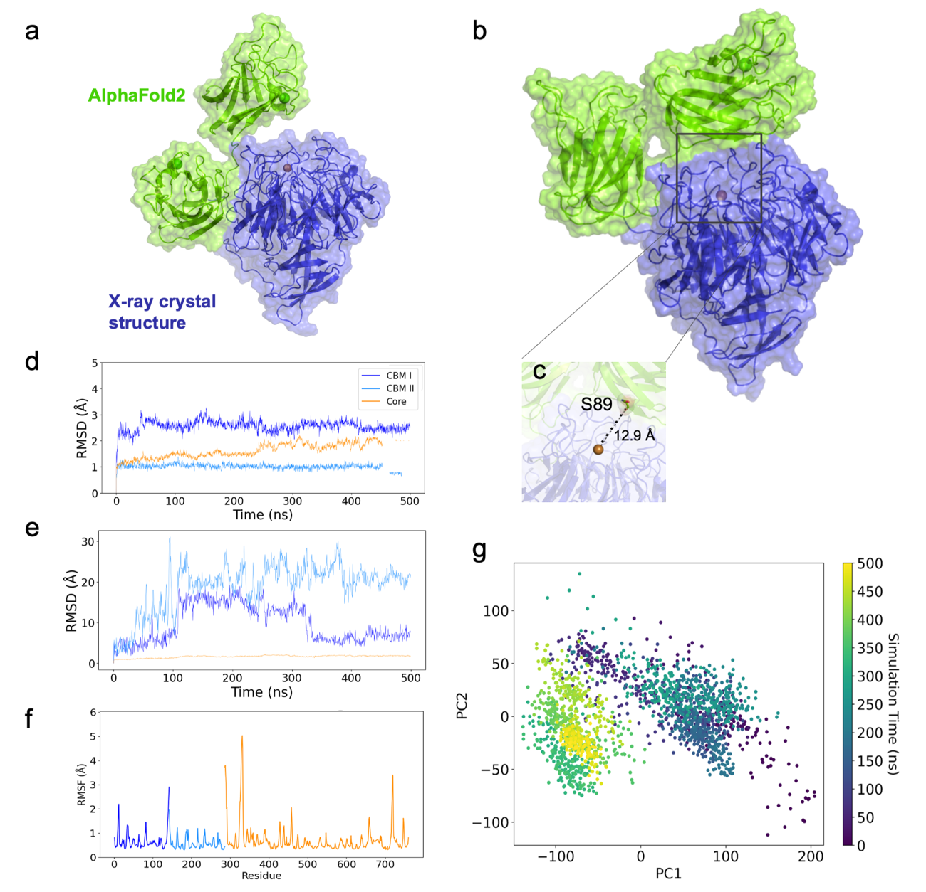

Supplementary Fig. 16. Structural modification of the PsGalOx model throughout molecular dynamics simulation. a. Full-length WT PsGalOx model. The core domain (blue) was obtained from the X-ray crystallographic structure (PDB 9G43). Both CBM domains, shown in green, were generated using the AlphaFold2 model, and the final model was built in Yasara. b. A structural model was obtained after 400 ns of simulation. c. Detailed view showing that CBM^{I} does not occlude the active site (the distance between the copper ion and S89 is approximately 12.9 Å). d. RMSD (root-mean-square deviation, in Å) of Cα positions along the 500 ns molecular dynamics simulation. The entire system was divided into CBMI (dark blue), CBMII (light blue), and the Core domain (orange) to minimize RMSD variations resulting from intra-domain movements. Each domain was aligned with itself. The plots show convergence of the simulation after ~250 ns. e. RMSD of Cα positions along the 500 ns molecular dynamics simulation. The entire system was divided into CBMI, CBMII, and the Core domain, but each domain was aligned with the Core domain to account for CBM movement relative to DIII. f. RMSF (root-mean-square fluctuation, in Å) of Cα positions along the last half (250 ns, after converging) of the molecular simulation. Each domain was aligned separately. g. The projection of the MD trajectory onto the first two principal components was obtained using PCA and colored by simulation time, ranging from purple to yellow. Here, we can observe the high intra-domain movements in the first half of the simulation.
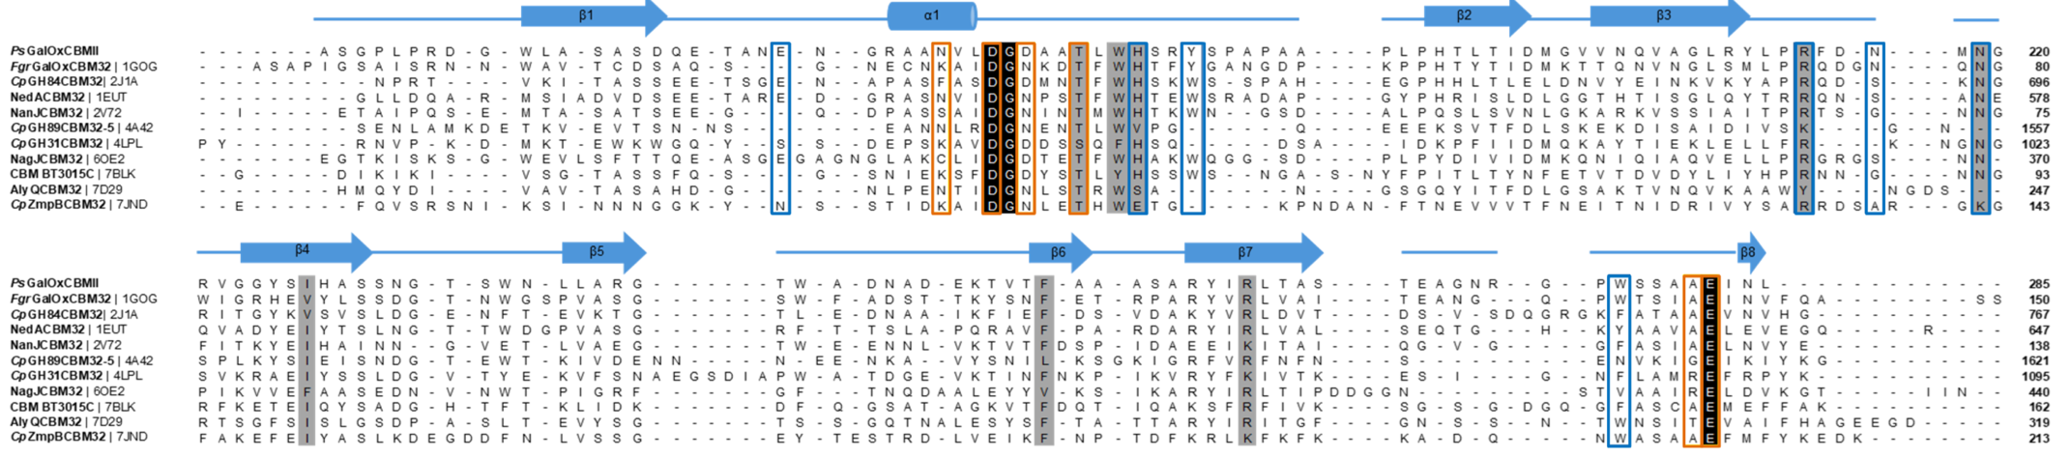

Supplementary Fig. 17. Structural alignment of the CBMII present in PsGalOx with deposited structures of CBM32. The solved crystal structures of CBM32 were collected from the CAZy database. Some were extracted from the enzyme structures as is the case of de carbohydrate oxidase PsGalOx (PDB 9G43), FgrGalOx(PDB 1GOG) or the hydrolase NedA (PDB 1EUT), but most were available as an independent structure (without being attached to the enzyme structure) which includes CBM32 of CpGH84 (PDB 2J1A), NanJ (PDB 6OE2), CpGH89 (PDB 4A41), CpGH31 (PDB 4LPL), NagJ (PDB 6OE2), BT3015C (PDB 7BLK), AlyQ (PDB 5XNR) and CpZmpB (PDB 7JND). The secondary structures are indicated as α-helices and β-chains above the alignment. The strictly conserved amino acids are represented on a black background, and the most conserved residues among the selected sequences are highlighted in a dark gray background. Residues interacting with D-Gal are marked with a blue box. Calcium-coordinating residues are marked with an orange box.
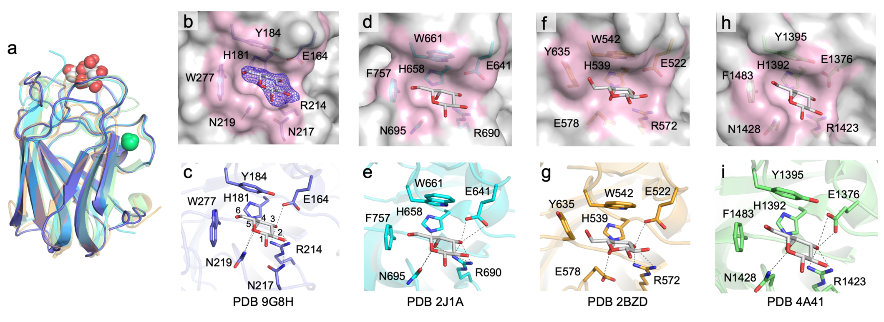

Supplementary Fig. 18. D-Gal binding site in carbohydrate-binding modules. a. Superposition of the available CBM structures complexed with D-Gal from WT-ΔCBMI (PDB 9G8H), CpGH84 (PDB 2J1A), NedA (PDB 2BZD), and CpGH89 (PDB 4A41). The D-Gal is represented as spheres with carbon and oxygen colored in grey and red, respectively. Ca(II) is defined as a green sphere. Detailed view of D-Gal binding site in CBM from (b-c) PsGalOx WT-ΔCBMI, (d-e) CpGH84, (f-g) Ned, A and (h-i) CpGH89. D-Gal is represented as sticks with carbon and oxygen colored in grey and red, respectively.

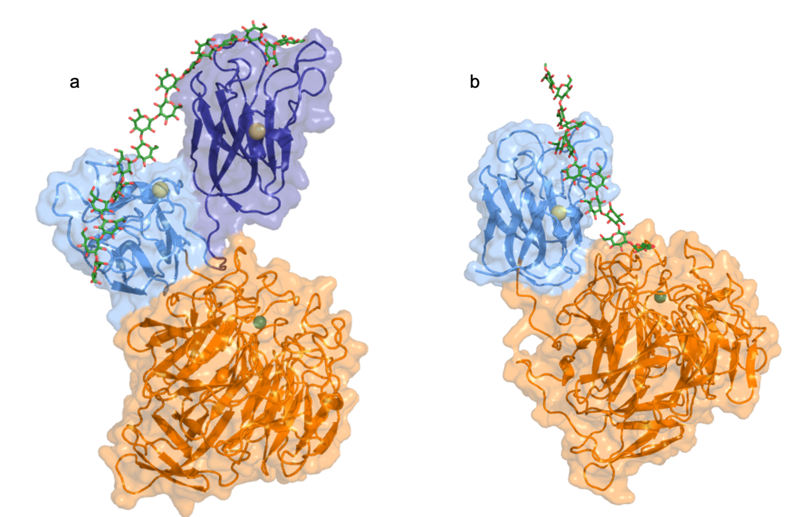

Supplementary Fig. 19. Conceptual models illustrating functional roles of carbohydrate-binding modules in PsGalOx generated with Boltz-2. a. Dual polysaccharide-binding mode in PsGalOx WT, in which CBMI and CBMII jointly anchor the enzyme to a galactan chain. b. Single-module anchoring in WT-ΔCBMI, highlighting CBMII-mediated association with the polysaccharide while the catalytic core remains solvent-exposed. Galactan is shown in dark green with 16 (a) and 12 (b) D-galactose units. CBMI, CBMII, and the catalytic domains (DIII and DIV) are colored dark blue, light blue, and orange, respectively. Ca²⁺ and Cu²⁺ ions are represented as yellow and green spheres. These models are intended to illustrate domain-level organization and relative positioning; specific enzyme–carbohydrate interactions were not analyzed because of the inherent uncertainty in predicted protein–polysaccharide complexes.
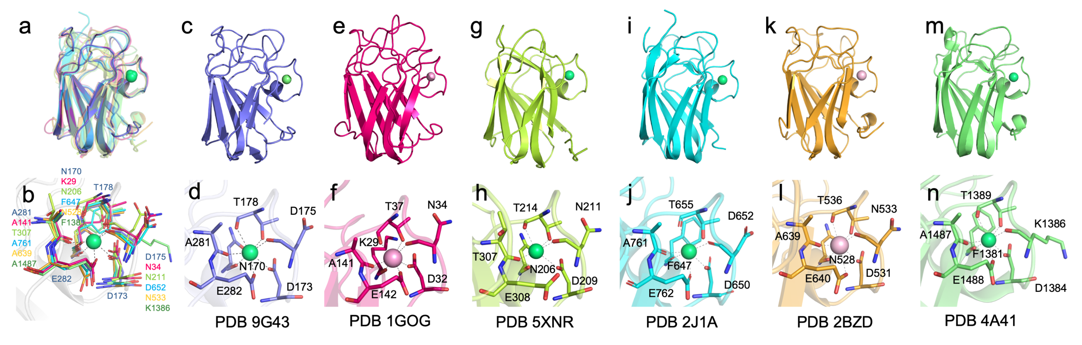

Supplementary Fig. 20. Calcium coordination in CBMs. a-b. Superposition of CBM32 members with the solved structure, with calcium represented as a green sphere. Individual calcium/sodium binding to CBM32 in c-d. WT-ΔCBMI (PDB 9G43, dark blue), e-f. FgrGalOx (PDB 1GOG, pink), g-h. AlyQ (PDB 5XNR, light green), i-j. CpGH84 (PDB 2J1A, cyan), k-l. NedA (PDB 2BZD, orange), and m-n. CpGH89 (PDB 4A41, green). Calcium and sodium are represented as green and pink spheres, respectively.

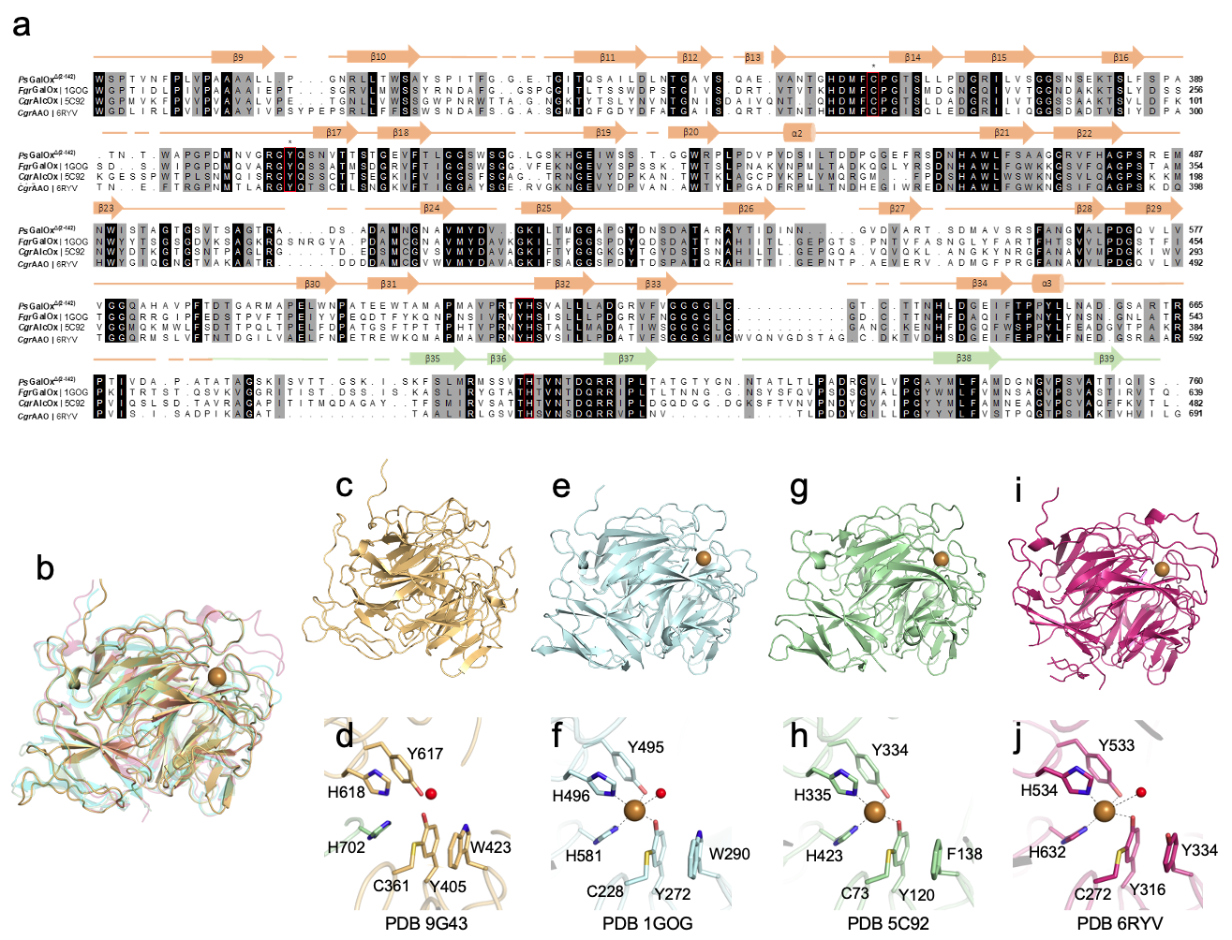
Supplementary Fig. 21. Structural alignment and architecture of the catalytic domain present in AA5_2 members. a. Structural alignment of AA5_2 catalytic domains of WT-ΔCBMI, FgrGalOx (PDB 1GOG), CgrAlcOx (PDB 5C92), and CgrAAO (PDB 6RYV). Cys-Tyr radical residues are highlighted with *. The copper-coordinating residues are marked with a red box. Strictly conserved amino acids are represented on a black background, and dark gray represents the most conserved residues among the selected sequences. The α-helices or β-β-chains are numbered and colored according to PsGalOx domain arrangement (DIII-orange, DIV-green). b. Superposition of the catalytic core structure of WT-ΔCBMI (PDB 9G43, golden), FgrGalOx (PDB 1GOG, blue), CgrAlcOx (PDB 5C92, green), and CgrAAO (PDB 6RYV, pink). Individual catalytic domains with the detailed copper coordination in c-d. WT-ΔCBMI, e-f. FgrGalOx, g-h. CgrAlcO,x and i-j. CgrAAO. The copper ion is represented as a brown sphere. The water molecules found in the active site are represented as red spheres.

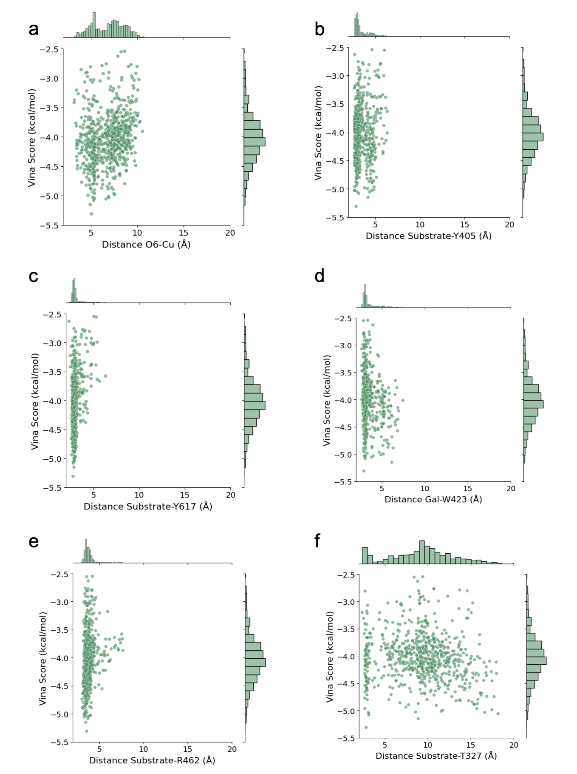

Supplementary Fig. 22. Molecular docking analysis of D-Gal distances to the copper cofactor and key interacting residues. Docking poses are represented based on their VINA score and a. the distance between the copper ion and the target group for oxidation (O6); b. the minimum distance between each substrate and Y405^{OH}; c. the minimum distance between each substrate and Y617^{OH}; d. the minimum distance between each substrate and W423^{NE1}; e. the minimum distance between each substrate and R462^{CZ}; f. the minimum distance between each substrate and T327^{OG1}. Approximately 1000 dockings were performed. To ensure substrate positioning within the active site, docking results were filtered using an accessible surface area (ASA) threshold of 80 Å². An unidimensional histogram displays the distribution of VINA scores and distances. Source data is provided as a Source Data file.
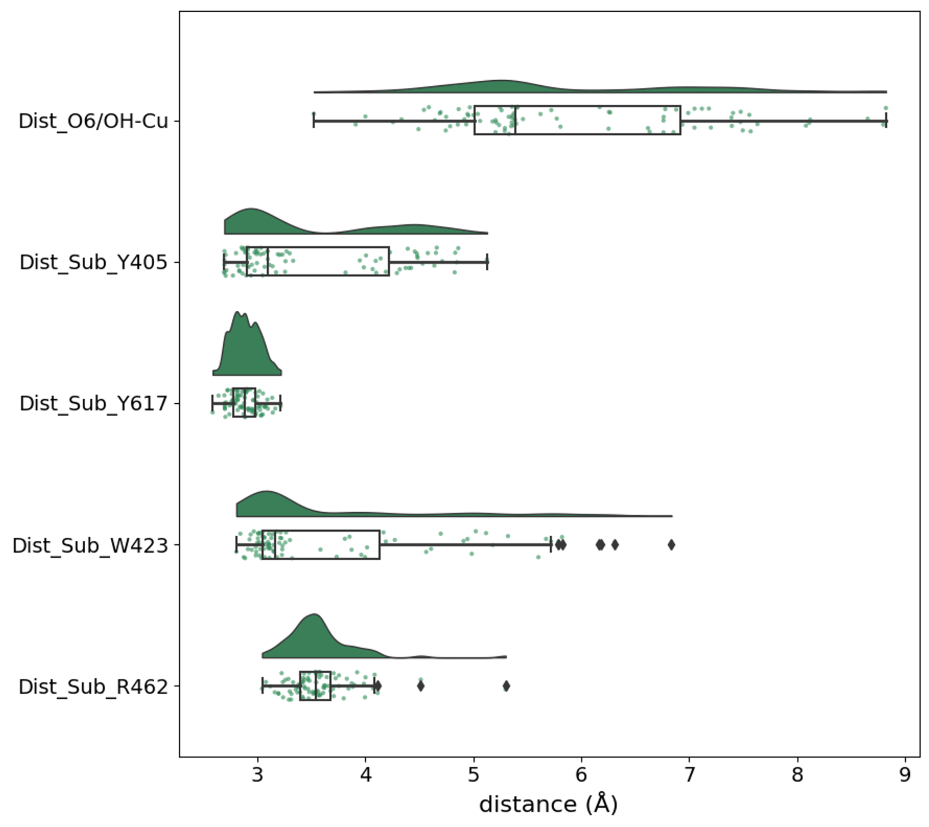Supplementary Fig. 23. Summary of the molecular dockings of D-Gal on PsGalOx. A raincloud plot represents the distribution of the D-Gal minimum distance for each substrate with Cu(II), Y405^{OH}, Y617^{OH}, W423^{NE1}, R462^{CZ}, and T327^{OG1}. Only poses with a score lower than -4.5 kcal/mol are shown. The boxplots and raw data points are included under each respective “cloud”. Values below Q1-1.5*IQR or above Q3+1.5*IQR (interquartile range) were considered as outliers (⧫). The source data is provided in a Source Data file.
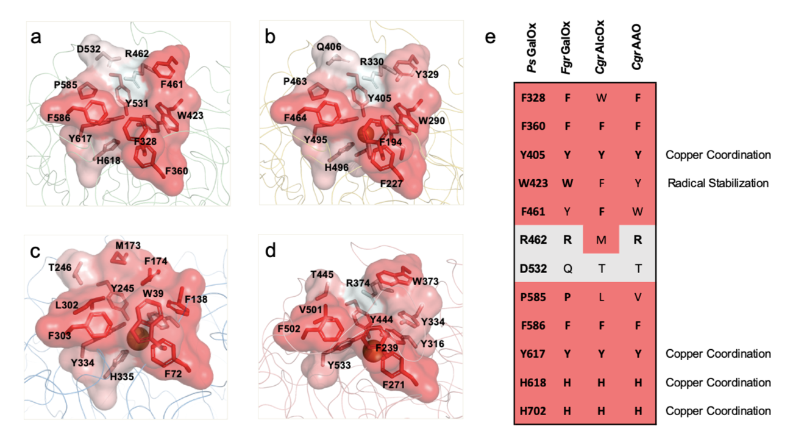

Supplementary Fig. 24. AA5_2 family binding pocket hydrophobicity. Active-site structure of a. WT-ΔCBMI, b. FgrGalOx (PDB 1GOG), c. CgrAlcOx (PDB 5C92), and d. CgrAAO (PDB 6RYV) shown as a cartoon loop. Active-site pocket residues are represented as sticks and surfaces, colored by hydrophobicity: highly hydrophobic residues are red, and polar residues are white. (e) Binding pocket residues alignment and conservation. Hydrophobic residues are red. Previous studies corroborate the importance of W423 in defining substrate specificity.³ CgrAAO-Y334W and CgrAlcOx-F138W were reported to have depleted activity for HMF and benzyl alcohol, respectively. Moreover, CgrAAO-Y344W has a shift in activity towards D-Gal.⁴ In the same direction, the FgrGalOx-W290F variant resulted in a significant reduction in GalOx activity. ⁵ W423Y and W423F could promote a shift in activity towards benzyl alcohol and HMF, respectively. In addition to W423, R462 may hinder proper binding of benzyl alcohol by promoting a more polar active-site environment than in CgrAlcOx. The corresponding residue in CgrAlcOx, M173, increases the hydrophobicity of the active-site entrance relative to other AA5_2 enzymes. This could help explain CgrAlcOx’s preference for primary alcohols. On the other hand, the reduced hydrophobicity of PsGalOx and FgrGalOx may act as a switch, increasing their carbohydrate activity.
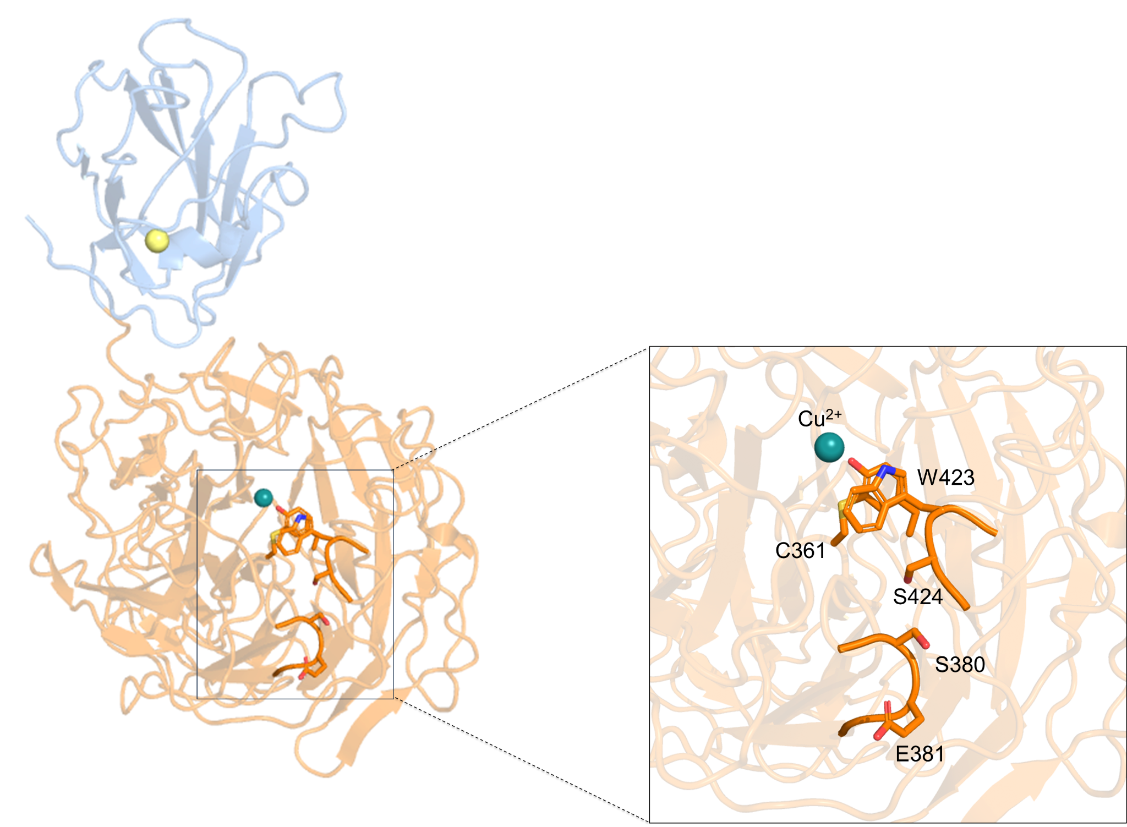

Supplementary Fig. 25. E381-W423 interaction on PsGalOx WT. The possible altered loop-loop interaction is highlighted. Intervening residues are represented as sticks. Cu(II) and Ca(II) are shown as deepteal and yellow spheres, respectively. The CBM II and core domains are colored in blue and orange, respectively. An altered residue network (E381-S380-S424-W423) could modulate the catalytic role of W423, thereby accounting for the 5-fold increase in k_{cat} reported for the 17B8 DE variant.
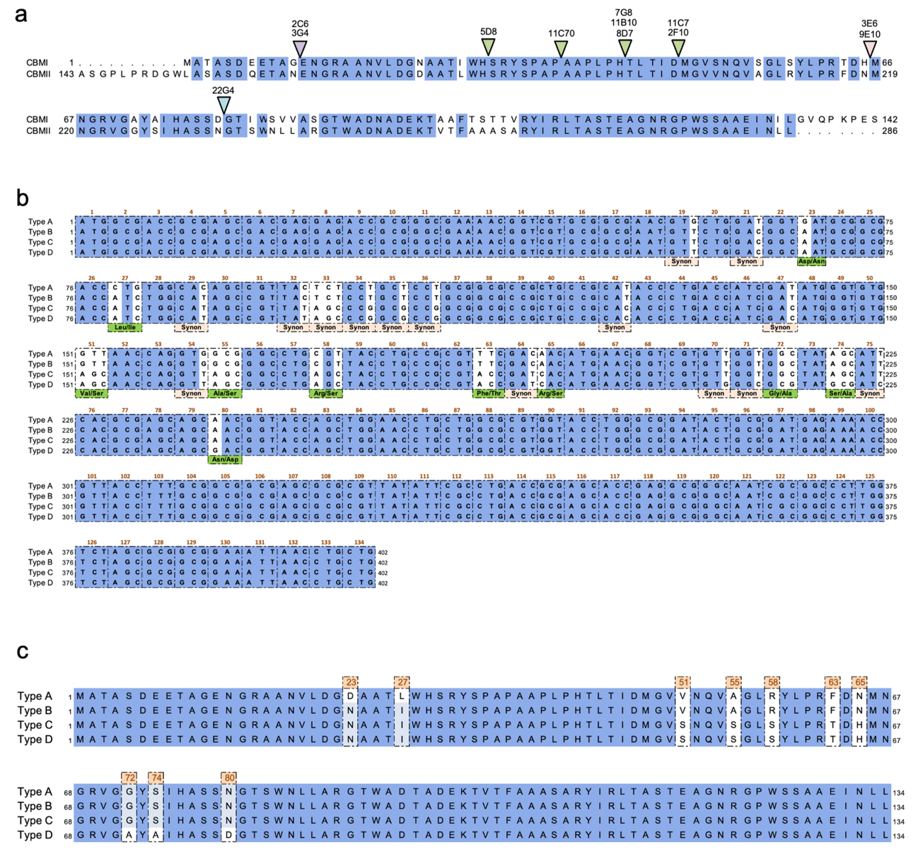

Supplementary Fig. 26. Sequence alignment of the four chimeric CBM types. a. Amino acid sequence alignment of CBMI and CBMII (blue background highlights the conserved amino acids between CBMI and CBMII. Colored triangles indicate the junction points where CBMI ends, and CBMII begins in distinct chimeric CBMs. Due to high sequence similarity in certain regions, some chimeras (green triangles) share identical sequences. b. DNA sequences of the four chimeric CBM types (Types A–D). Dashed boxes indicate the translational reading frames. Nucleotide differences among the chimeras are highlighted in white. Some of these variations correspond to synonymous codons (Synon), resulting in no change to the amino acid sequence. In contrast, others lead to amino acid substitutions consistent with residues from either CBM I or CBM II. c. Amino acid sequences of the chimeric CBMs, reflecting changes resulting from the nucleotide differences shown in b.
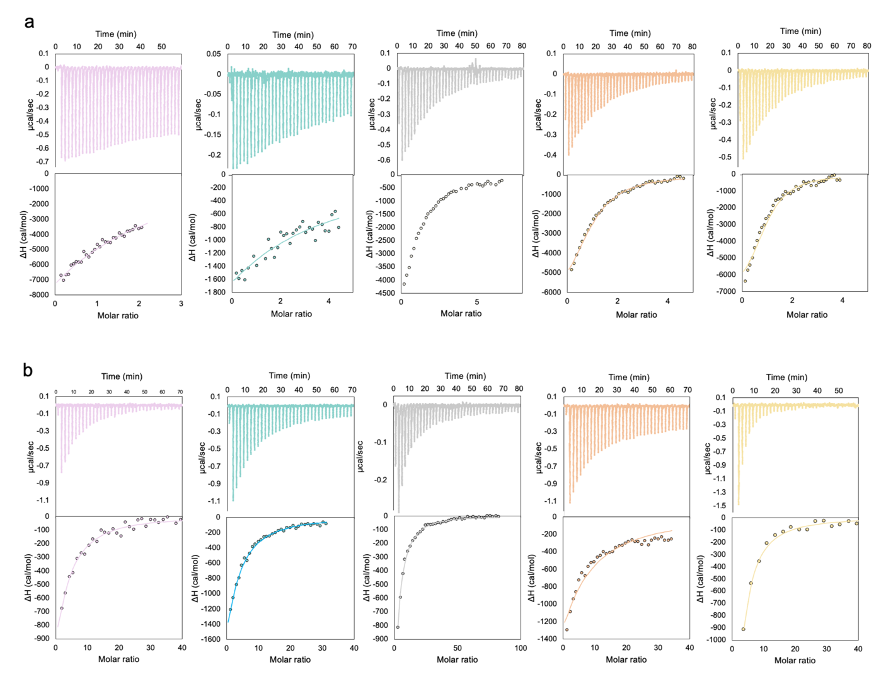

Supplementary Fig. 27. ITC thermograms of the chimeric CBMs binding to galactan and D-Gal. ITC thermograms obtained by titration of a. galactan or b. D-Gal into CBM Type A (pink), CBM Type B (green), CBM Type B N65H (grey), CBM Type C (orange), and CBM Type D (yellow). For each experiment, the top graphics correspond to the heat release of the binding during the titration, and the bottom graphics present the integration of the peaks according to the molar ratio of CBM:galactan or CBM:D-Gal. The line in the bottom graphic represents the fit to the one-binding-site equation. All experiments were performed in 20 mM Tris-HCl, pH 7.5, supplemented with 200 mM NaCl at 25 ºC under 400 rpm. The calculated parameters are evidenced in Table S5. The source data is provided in a Source Data file.
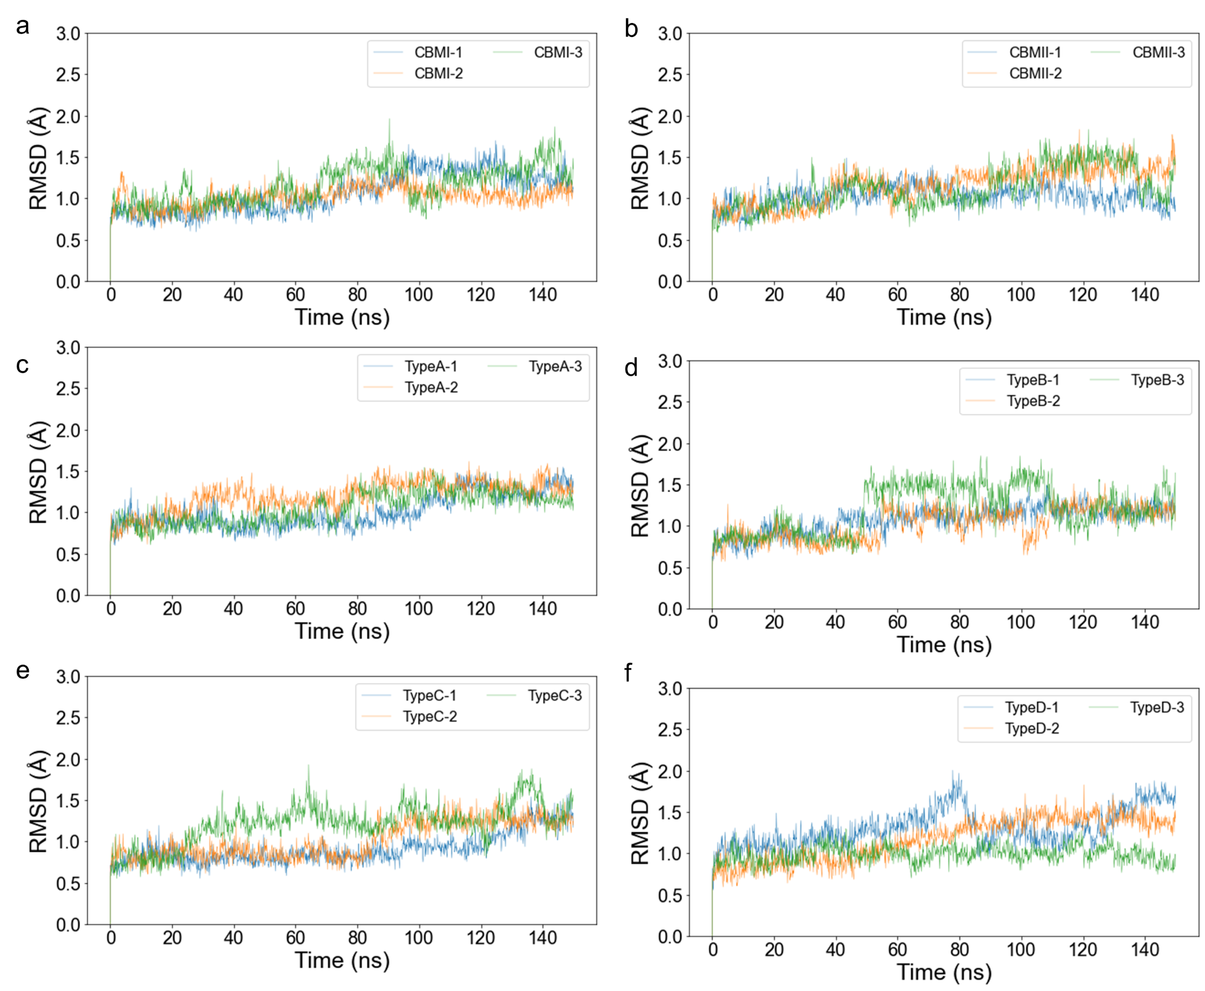Supplementary Fig. 28. RMSD (root-mean-square deviation, in Å) of Cα positions along the 150 ns molecular dynamics simulations. The data is represented for a. CBMI, b. CBMII, CBM chimera c. Type A, d. Type B, e. Type C and f. Type D. The plots show the simulation's convergence. The source data is provided in a Source Data file.
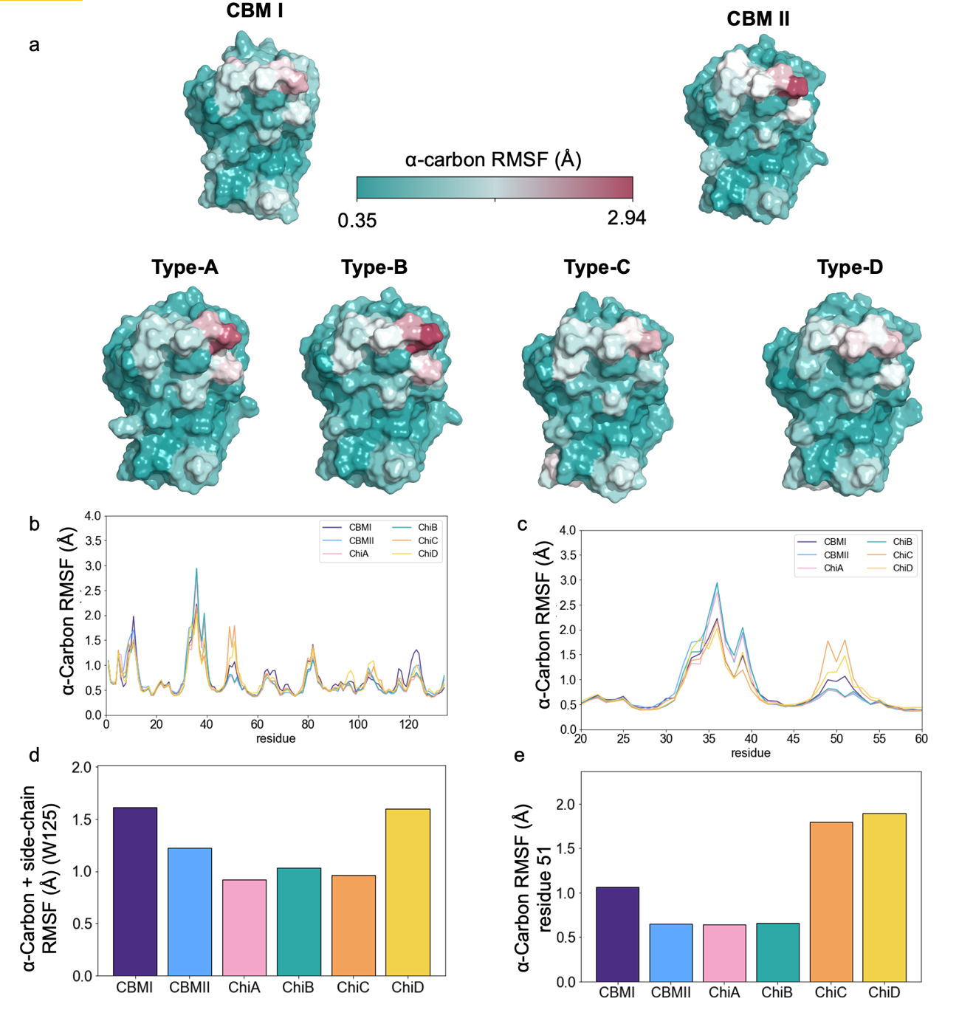Supplementary Fig. 29. Molecular dynamics flexibility analysis of CBM domains. a. Surface representation of CBM I, II, and chimeric CBMs Type A to D. Each residue is colored according to its α-carbon RMSF value, averaged from the three independent molecular simulations of 150 ns (450 ns total for each system). Blue regions represent lower RMSF values (low flexibility), while pink/red regions represent higher RMSF values (higher flexibility). b. Correspondent values are represented for the full length of each CBM type, as well as c. for residues 20-60. Singular RMSF values for d. W125 and e. V/S51 are represented as bar plots. The source data is provided in a Source Data file.

Supplementary Tables

Supplementary Table 1. BLAST output of the 60 bacterial entries showing the highest identity to FgrGalOx. The gene of Pseudarthrobacter siccitolerans GalOx (PsGalOx) is colored in blue. DDC- Discoidin domain-containing protein; Hyp- Hypothetical protein
Description | Organism/strain | Query cover | E-value | Identity | Acession
DDC protein | Actinoplanes sp. KI2 | 92 % | 0 | 49.6 % | WP_263026935.1
DDCprotein | Actinoplanes toevensis | 94 % | 2 E-172 | 49.5 % | WP_246606174.1
Hyp protein Ato02nite_011750 | Actinoplanes toevensis | 94 % | 4 E-172 | 49.5 % | GIM89382.1
DDC protein | Couchioplanes caeruleus | 92 % | 0 | 49.3 % | WP_229798315.1
Hyp protein Adu01nite_01140 | Actinoplanes durhamensis | 92 % | 0 | 49.2 % | GID98763.1
DDC protein | Actinoplanes durhamensis | 92 % | 0 | 49.2 % | WP_239132017.1
DDC protein | Virgisporangium aliadipatigenens | 99 % | 6 E-175 | 48.7 % | WP_239152458.1
DDC protein | Actinoplanes tereljensis | 94 % | 2 E-171 | 48.6 % | WP_203800032.1
DDC protein | Actinoplanes nipponensis | 92 % | 0 | 48.5 % | WP_203765923.1
DDC protein | Actinoplanes aureus | 98 % | 1 E-173 | 48.2 % | WP_196417253.1
DDC protein | Couchioplanes caeruleus | 92 % | 1 E-172 | 48.2 % | WP_071805097.1
Hyp protein Aiant_72240 | Actinoplanes ianthinogenes | 92 % | 3 E-180 | 48.1 % | BCJ46567.1
DDC protein | Actinoplanes ianthinogenes | 92 % | 3 E-179 | 48.1 % | WP_189334041.1
DDC protein | unclassified Actinoplanes | 98 % | 1 E-174 | 48.1 % | WP_014689965.1
Hyp protein Afe05nite_11080 | Actinoplanes ferrugineus | 98 % | 4 E-172 | 48.1 % | GIE09268.1
DDC protein | Actinoplanes ferrugineus | 92 % | 5 E-172 | 48.1 % | WP_239117578.1
DDC protein | Actinokineospora sp. PR83 | 92 % | 0 | 48.0 % | WP_240012537.1
DDC protein | Actinokineospora sp. PR83 | 92 % | 0 | 48.0 % | MCG8915816.1
Hyp protein Aoc01nite_70590 | Actinoplanes octamycinicus | 92 % | 1 E-175 | 47.9 % | GIE61657.1
DDC protein | Actinoplanes octamycinicus | 92 % | 3 E-175 | 47.9 % | WP_185041363.1
DDC protein | Actinoplanes globisporus | 92 % | 1 E-171 | 47.9 % | WP_063713519.1
DDC protein | Wangella sp. NEAU-J3 | 93 % | 0 | 47.8 % | WP_225256859.1
DDC protein | Actinoplanes subtropicus | 92 % | 2 E-176 | 47.7 % | WP_084599126.1
DDC protein | Actinokineospora pegani | 95 % | 2 E-159 | 47.6 % | WP_156754907.1
DDC protein | Arthrobacter sp. Leaf69 | 98 % | 8 E-174 | 47.6 % | WP_200912979.1
Endo-1,4-β-galactosidase | Arthrobacter sp. Leaf69 | 98 % | 9 E-174 | 47.6 % | KQN95501.1
D-Gal oxidase | Arthrobacter sp. ok909 | 94 % | 0 | 47.4 % | SDP52846.1
DDC protein | Arthrobacter sp. ok909 | 94 % | 0 | 47.4 % | WP_217639788.1
DDC protein | Arthrobacter sp. CJ23 | 92 % | 2 E-177 | 47.4 % | WP_258440318.1
DDC protein | Arthrobacter sp. EPSL27 | 93 % | 1 E-171 | 47.4 % | WP_231728431.1
Endo-1,4-β-galactosidase | Arthrobacter sp. EPSL27 | 93 % | 2 E-171 | 47.4 % | KUM41111.1
DDC protein | Arthrobacter pityocampae | 96 % | 2 E-178 | 47.3 % | WP_104119850.1
DUF1929 domain-containing protein | Cryobacterium sp. TMT1-19 | 92 % | 4 E-163 | 47.3 % | TFD31444.1
DDC protein | Cryobacterium sp. M25 | 92 % | 9 E-163 | 47.3 % | WP_199182901.1
DDC protein | Cryobacterium sp. TMT1-19 | 92 % | 1 E-162 | 47.3 % | WP_198412008.1
DDC protein | Cryobacterium sp. M23 | 92 % | 1 E-160 | 47.3 % | WP_233199361.1
DDC protein | Arthrobacter sp. U41 | 98 % | 2 E-169 | 47.2 % | WP_222124039.1
Hyp protein NKCBBBOE_03087 | Arthrobacter sp. | 93 % | 5 E-179 | 47.1 % | CAI3802413.1
DDC protein | Actinokineospora spheciospongiae | 92 % | 3 E-180 | 47.0 % | WP_219994221.1
D-Gal oxidase | Actinokineospora spheciospongiae | 92 % | 9 E-180 | 47.0 % | PWW66821.1
D-Gal oxidase precursor | Actinokineospora spheciospongiae | 92 % | 3 E-170 | 47.0 % | EWC62380.1
DDC protein | Actinokineospora spheciospongiae | 92 % | 3 E-170 | 47.0 % | WP_200873361.1
DDC protein | Arthrobacter sp. ov407 | 95 % | 6 E-178 | 47.0 % | WP_090576023.1
D-Gal oxidase | Arthrobacter sp. ov407 | 99 % | 4 E-177 | 47.0 % | SDK46884.1
DDC protein | Nocardioides flavescens | 93 % | 9 E-169 | 47.0 % | WP_160878216.1
DDC protein | Alloactinosynnema sp. L-07 | 93 % | 3 E-167 | 47.0 % | WP_082860106.1
DDC protein | Arthrobacter sp. L77 | 99 % | 3 E-173 | 46.9 % | WP_197060675.1
DDC protein | Arthrobacter sp. QL17 | 95 % | 2 E-171 | 46.9 % | WP_247826383.1
DDC protein | Lentzea aerocolonigenes | 92 % | 0 | 46.9 % | WP_201780122.1
D-Gal oxidase | Lentzea aerocolonigenes | 92 % | 0 | 46.9 % | MCP2246620.1
DDC protein | Actinokineospora auranticolor | 93 % | 6 E-179 | 46.8 % | WP_181043448.1
DDC protein/ D-Gal oxidase | Pseudarthrobacter siccitolerans | 92 % | 3 E-161 | 46.6 % | WP_200900755.1/ CCQ45078.1
DDC protein | Lentzea alba | 93 % | 0 | 46.5 % | WP_166046367.1
DDC protein | Actinoplanes subtropicus | 92 % | 1 E-177 | 46.4 % | WP_030440774.1
DDC protein | Actinoplanes globisporus | 96 % | 9 E-172 | 46.2 % | WP_020511087.1
DDC protein | Actinokineospora terrae | 93 % | 6 E-172 | 46.2 % | WP_218150556.1
D-Gal oxidase | Actinokineospora terrae | 93 % | 2 E-171 | 46.2 % | SEQ98940.1
Hyp protein nicsoilc12_28260 | Arthrobacter sp. NicSoilC12 | 94 % | 2 E-165 | 46.2 % | GIU57077.1
DDC protein | Arthrobacter sp. NicSoilC12 | 94 % | 2 E-165 | 46.2 % | WP_223916421.1
DDC protein | Lentzea terrae | 92 % | 4 E-179 | 46.1 % | WP_112261427.1

Supplementary Table 2. Summary of production yields and copper content in the variants considered in this study.
 |  | Enzyme production  (mg/L of culture) |  | Copper content as purified  (mol Cu²⁺/mol enzyme) |  | Copper content after incubation  (mol Cu²⁺/mol enzyme)
Enzymes
Wild-type | 0.1 |  | 0.88 |  | 0.91
WT-ΔCBMI | 2.9 |  | 0.15 |  | 0.86
WT-ΔCBMI+II | 0.1 |  | 0.85 |  | 0.87
4E7 | 1.9 |  | 0.05 |  | 0.98
17B8 | 1.0 |  | 0.09 |  | 0.93
4D7 | 1.3 |  | 0.11 |  | 0.97
11C7 | 4.6 |  | 0.07 |  | 0.95
Carbohydrate-binding modules
CBMsI+II | 0.2 |  | - |  | -
CBMI | 0.3 |  | - |  | -
CBMII | 1.3 |  | - |  | -
CBM Type-A | 0.5 |  | - |  | -
CBM Type-B | 0.8 |  | - |  | -
CBM Type-C | 1.4 |  | - |  | -
CBM Type-D | 0.7 |  | - |  | -

Supplementary Table 3. Activity profile of PsGalOx for a range of sugars, alcohols and furans. Activity screening of PsGalOx for a set of sugars (orange), polysaccharides (green), furans (light blue), and alcohols (dark blue). Activities were monitored using 250 mM for carbohydrates, 0.1% for polysaccharides, 50 mM for furans, or 25 mM for alcohols. Measurements were performed at 25°C in 100 mM sodium phosphate buffer, pH 7.5, containing 10 U ml⁻¹ HRP and 1 mM ABTS in 96-well plates. The values are represented as mean ± SD. Source data is provided as a Source Data file.

Substrates | Specific activity  (U mg⁻¹)
Mono-, Di- and Tri-saccharides
D-Gal | (8.4 ± 0.3) ⋅ 10⁰
N-acetyl-Galatosamine | (5.5 ± 0.1) ⋅ 10⁰
methyl-α-D-Gal | (3.3 ± 0.2) ⋅ 10⁰
D-raffinose | (2.9 ± 0.4) ⋅ 10⁰
D-lactose | (2.5 ± 0.2) ⋅ 10⁰
D-mellibiose | (2.0 ± 0.2) ⋅ 10⁰
L-arabinose | (0.8 ± 0.1) ⋅ 10⁻¹
D-xylose | (4.1 ± 0.1) ⋅ 10⁻²
D-mellezitose | (2.2 ± 0.9) ⋅ 10⁻³
D-glucose | (1.5 ± 0.3) ⋅ 10⁻³
N-acetyl-glucosamine | (0.9 ± 0.2) ⋅ 10⁻³
D-maltose | (0.7 ± 0.3) ⋅ 10⁻³
D-sorbitol | (1.5 ± 0.1) ⋅ 10⁻²
Polysaccharides
Galactan (Lupin) | (4.5 ± 0.3) ⋅ 10⁰
Guar Galactomannan | (2.7 ± 0.1) ⋅ 10⁰
Galactomannan | (2.9 ± 0.1) ⋅ 10⁰
Arabinogalactan | (1.7 ± 0.1) ⋅ 10⁰
Pectin Galactan | (3.5 ± 0.1) ⋅ 10⁻¹
Galactan (Potato) | (2.5 ± 0.1) ⋅ 10⁻¹
Debranched arabinan | (1.5 ± 0.1) ⋅ 10⁻¹
Glucomannan | (1.1 ± 0.1) ⋅ 10⁻¹
Beta Glucan | (0.6 ± 0.1) ⋅ 10⁻¹
Arabinan | (0.6 ± 0.1) ⋅ 10⁻¹
K-Carrageennan | (0.6 ± 0.1) ⋅ 10⁻²
Furans
HMF | (1.1 ± 0.1) ⋅ 10⁻¹
Alcohols
veratryl alcohol | (3.5 ± 0.2) ⋅ 10⁻¹
benzyl alcohol | (0.8 ± 0.1) ⋅ 10⁻¹
sinapyl alcohol | (1.7 ± 0.2) ⋅ 10⁻³
glycerol | (1.1 ± 0.1) ⋅ 10⁻¹

Supplementary Table 4. Apparent steady-state catalytic parameters for D-Gal of the fungal GalOxs characterized in the literature. nd – not reported

Name | Native Organism | Expression system | k_{cat} (s⁻¹) | K_{m} (mM) | k_{cat}/K_{m} (M⁻¹s⁻¹) | References
PsGalOx | Pseudarthrobacter siccitolerans | E. coli | 7.4 ± 0.7 | 26.2 ± 3.4 | (2.8 ± 0.5) × 10² | This work
FgrGalOx | Fusarium graminearium | P. pastoris | 1090 ± 40 | 68 ± 5 | (1.6 ± 0.1) × 10⁴ | ⁶
FgrGalOx | Fusarium graminearium | E. coli | 1070 ± 43 | 53 ± 3 | (1.9 ± 0.1) × 10⁴ | ⁷
FsuGalOx | Fusarium subglutinans | E. coli | 12243 ± nd | 133 ± 18 | (9.2 ± nd) × 10⁴ | ⁸
FveGalOx | Fusarium verticillioides | - | nr | - | - | ⁹
FauGalOx | Fusarium austroamericanum | - | nr | - | - | ⁹
FoxGalOx | Fusarium oxysporum G12 | E. coli | 95 ± nd | 47 ± nd | (2.0 ± nd) × 10³ | ¹⁰
FsaGalOx | Fusarium sambucinum | E. coli | 54 ± nd | 61 ± 4 | (8.9 ± nd) × 10² | ¹¹
FoxGalOxB | Fusarium oxysporum | P. pastoris | 81 ± 1 | 24 ± 1 | (3.4 ± 0.2) × 10³ | ¹²
ExeGalOx | Exophiala xenobiotica | P. pastoris | 130 ± 4 | 25 ± 4 | (5.2 ± 0.8) × 10³ | ¹²
MreGalOx | Mytilinidion resinicola | P. pastoris | 32 ± 1 | 64 ± 5 | (5.0 ± 0.4) × 10² | ¹²
PfeGalOx | Penicillium fellutanum | P. pastoris | 140 ± 5 | 28 ± 7 | (5.0 ± 1.2) × 10³ | ¹²
XpaGalOx | Xanthoria parietina | P. pastoris | 241 ± 2 | 10 ± 1 | (24.1± nd) × 10³ | ¹³
BspGalOx | Bisporella sp. | P. pastoris | 52 ± 1 | 36 ± 1 | (1.4 ± nd) × 10³ | ¹³
EfeGalOx | Epichloe festucae | P. pastoris | 0.7 ± 0.1 | 8 ± 2 | 85.0 ± nd | ¹³
NexGalOx | Niesslia exilis | P. pastoris | 8 ± 1 | 828 ± 78 | 9.0 ± nd | ¹³
NhaGalOx | Nectria haematococca | P. pastoris | 4 ± 1 | 930 ± 98 | 5.0 ± nd | ¹³

Supplementary Table 5. Summary of the binding parameters obtained using ITC. The estimated affinity constant (Ka), enthalpy (ΔH), and entropy (ΔS) associated with the binding of D-Gal or galactan (from potato) to CBMs are summarized. All experiments were performed in 20 mM Tris-HCl, pH 7.5, supplemented with 200 mM NaCl, at 25 °C and 400 rpm. The values are represented as mean ± SD. The source data is provided in a Source Data file.

 |  |  | nª | K_{a}  (⋅ 10³ M⁻¹) | ΔH  (kcal mol⁻¹) | ΔS  (cal mol⁻¹ ºC⁻¹)
Galactan |  | CBMI+II | 2 | 55.6 ± 3.0 | -7.0 ± 2.1 | -5.8 ± 2.8
 |  | CBMI | 1 | 38.2 ± 6.5 | -7.6 ± 2.6 | -7.9 ± 9.6
 |  | CBMII | 1 | 2.1 ± 0.4 | -13.7 ± 2.7 | -30.8 ± 9.6
 |  | CBM Type-A | 1 | 1.7 ± 0.7 | -49.4 ± 6.1 | -152 ± 22.6
 |  | CBM Type-B | 1 | 2.3 ± 0.7 | - 4.4 ± 2.8 | - 6.2 ± 1.3
 |  | CBM Type-B-N65H | 1 | 13.7 ± 1.0 | -9.1 ± 1.1 | -11.5 ± 4
 |  | CBM Type-C | 1 | 25.3 ± 3.8 | -8.0 ± 0.6 | - 6.9 ± 2.2
 |  | CBM Type-D | 1 | 35.9 ± 5.1 | - 8.2 ± 0.6 | - 6.7 ± 2.1
D-Gal |  | CBMI+II | 2 | 2.4 ± 0.9 | -15.5 ± 4.1 | -38.4 ± 3.1
 |  | CBMI | 1 | 4.8 ± 0.2 | -9.2 ± 0.5 | -13.8 ± 1.7
 |  | CBMII | 1 | 2.1 ± 0.1 | -12.8 ± 3.5 | -27.7 ± 11.8
 |  | CBM Type-A | 1 | 2.8 ± 0.5 | -5.8 ± 3.5 | -16.2 ± 5.9
 |  | CBM Type-B | 1 | 2.6 ± 0.7 | -11.8 ± 1.7 | -24.0 ± 6.2
 |  | CBM Type-B-N65H | 1 | 4.2 ± 0.9 | -11.0 ± 0.9 | -20.5 ± 3.4
 |  | CBM Type-C | 1 | 3.4 ± 0.1 | -11.7 ± 0.6 | -22.9 ± 2.1
 |  | CBM Type-D | 1 | 4.6 ± 0.5 | -11.1 ± 1.4 | -20.3 ± 4.8
ªITC data were analyzed using a single-site binding model. For polysaccharide ligand, where the molar concentration is not defined, the n value was adjusted to one for CBMI and CBMII and to two for CBMI+II

Supplementary Table 6. Data collection, processing, and refinement statistics for WT-ΔCBMI and WT-ΔCBMI-Gal structures. Values in parentheses correspond to the highest resolution shell.

Data collection | WT-ΔCBMI | WT-ΔCBMI-Gal
Beamline | ALBA BL13 - XALOC | ESRF ID30A-3
Wavelength (Å) | 0.97918 | 0.9677
Space group | P2₁2₁2₁ | P2₁2₁2₁
Unit cell (Å) | a = 48.27, b = 62.94, c = 183.28 | a = 48.00, b = 61.41, c = 186.40
Resolution (Å) | 91.64-1.20 (1.29-1.20) | 58.32-2.10 (2.32-2.10)
Number of observations | 579480 (28981) | 112242 (3140)
Unique reflections | 138716 (6936) | 22173 (1109)
Completeness spherical (%) | 80.0 (21.3) | 66.9 (13.0)
Completeness ellipsoidal (%) | 92.6 (57.0) | 89.2 (45.8)
Multiplicity | 4.2 (4.2) | 5.1 (2.8)
Mosaicity (°) | 0.052 | 0.227
CC_{1/2} (%)ª | 99.7 (61.3) | 98.8 (53.9)
Rmeas (%)^{b} | 9.4 (94.2) | 20.3 (84.4)
Rpim (%)^{c} | 4.4 (44.4) | 8.6 (48.6)
I/<σ(I)> | 8.2 (1.5) | 5.6 (1.7)
Wilson B-factor (Å²) | 14.8 | 14.4
V_{M} (Å³ Da⁻¹) | 2.17 | 2.14
Estimated solvent content (%) | 43.25 | 42.47
Refinement
Rwork (%)^{d} | 13.4 | 16.1
Rfree (%)^{d} | 16.6 | 23.7
RMSD for bond lengths (Å) | 0.011 | 0.006
RMSD for bond angles (°) | 1.656 | 1.420
Average chain B-factor (A²) | 12.6 | 16.4
Number of residues | 618 | 617
Ramachandran plot
Residues in favored regions (%) | 96.94 | 96.12
Residues in allowed regions (%) | 3.06 | 3.72
Residues in disallowed regions (%) | 0.00 | 0.16
PDB code | 9G43 | 9G8H
ª CC_{1/2} = Percentage of correlation between intensities from random half-datasets¹⁴
^{b} R_{meas} = Σ_{hkl} [N/(N(hkl) -1)]^{1/2} Σ_{i} |I_{i}(hkl) - <I(hkl) >|/Σ_{hkl} Σ_{i} I_{i} (hkl), where N(hkl) is the data multiplicity, I_{i}(hkl) is the observed intensity and <I(hkl)> is the average intensity of multiple observations from symmetry-related reflections. It is an indicator of the agreement between symmetry-related observations¹⁵
^{c} R_{pim} = Σ_{hkl} [1/(N(hkl) -1)]^{1/2} Σ_{i} |I_{i}(hkl) - <I(hkl) >|/Σ_{hkl} Σ_{i} I_{i} (hkl), where N(hkl) is the data multiplicity, I_{i}(hkl) is the observed intensity and <I(hkl)> is the average intensity of multiple observations from symmetry-related reflections. It indicates the precision of the final merged and averaged dataset¹⁶
^{d} R_{work} refers to the actual working data set used in reﬁnement, while R_{free} refers to a cross-validation set that is not directly used in reﬁnement and is therefore free from reﬁnement bias.

Supplementary Table 7. RMSD values from structural superposition of the WT-ΔCBMI and the deposited structures of AA5_2 members and CBM32. The domain organization of WT-ΔCBMI includes a catalytic core and a CBM32. Since the CBM module is not universally present in all members of the AA5_2 family, RMSD calculations were performed not only in comparison with the entire structure of FgrGalOx but also focused on the catalytic core of FgrGalOx, CgrAlcOx, and CgrAAO (members of AA5_2 with deposited structures). The CBM32 present in WT-ΔCBMI was also compared with other deposited CBM32 structures.

Domain | Protein/ PDB | FgrGalOx  PDB 1GOG | FgrGalOx  PDB 1GOG | CgrAlcOx  PDB 5C92 | CgrAAO  PDB 6RYV | FgrGalOx^{CBM32}  PDB 1GOG | MvGH^{CBM32}  PDB 2BZD | CpGH84^{CBM32}  PDB 2JIA | CpGH89^{CBM32}  PDB 4A41 | AlyQ^{CBM32}  PDB 5XNR
Comparison of the entire structure  (GalOxs) | WT-ΔCBMI  PDB 9G43 | 1.98
Comparison of the catalytic core  (AA5_2 subfamily) | WT-ΔCBMI  PDB 9G43 |  | 0.98 | 1.09 | 0.98
Comparison of the catalytic core  (AA5_2 subfamily) | FgrGalOx  PDB 1GOG |  |  | 0.95 | 0.87
Comparison of the catalytic core  (AA5_2 subfamily) | CgrAlcOx  PDB 5C92 |  |  |  | 1.02
Comparison of the available CBM32  structures | PsGalOx CBMII  PDB 9G43 |  |  |  |  | 0.92 | 1.04 | 1.06 | 1.02 | 1.34
Comparison of the available CBM32  structures | FgrGalOx CBM32  PDB 1GOG |  |  |  |  |  | 1.10 | 1.18 | 0.98 | 1.45
Comparison of the available CBM32  structures | MvGH CBM32  PDB 2BZD |  |  |  |  |  |  | 1.27 | 1.28 | 1.41
Comparison of the available CBM32  structures | CpGH84 CBM32  PDB 2J1A |  |  |  |  |  |  |  | 1.14 | 1.48
Comparison of the available CBM32  structures | CpGH89 CBM32  PDB 4A41 |  |  |  |  |  |  |  |  | 1.43

Supplementary Table 8. Directed evolution of PsGalOx for D-Gal. Four rounds of DE were performed, and approximately 17,000 variants were initially screened using a qualitative plate-based assay to identify active clones. Of these, 4,000 variants were subsequently quantitatively screened in microtiter plates. The reaction mixture contained 100 mM D-Gal, 1 mM ABTS, and 10 U mL⁻¹ HRP in 100 mM sodium phosphate buffer (pH 7.5) at 25 °C. Synonymous mutations are in parentheses. Amino acid deletions acquired during evolution are noted by the corresponding amino acid residues number. values are represented as mean ± SD.
Parent | Screened variants  (plate assay/96-well) | Variant | Genotype | Deletions | Relative activity to the parent
WT | 1st round  (7000/1152) | 4E7 | N247T | - | 9.8 ± 1.8
4E7 | 2nd round  (7000/2166) | 17B8 | N247T/E381K | - | 6.2 ± 0.9
4E7 | 2nd round  (7000/2166) | 22G4 | N247T | ∆ 81-232 | 4.7 ± 1.1
4E7 | 2nd round  (7000/2166) | 2F10 | N247T (L419L) | ∆ 48-199 | 1.9 ± 0.8
4E7 | 2nd round  (7000/2166) | 11C7 | N247T | ∆ 37-188 | 1.8 ± 0.4
17B8 | 3rd round  (3000/638) | 4D7 | N247T/E381K/E485K (R241R) | - | 7.0 ± 0.8
17B8 | 3rd round  (3000/638) | 5D8 | N247T/E381K | ∆ 30-181 | 11.2 ± 0.7
17B8 | 3rd round  (3000/638) | 2C6 | N247T/E381K | ∆ 12-163 | 8.7 ± 1.4
17B8 | 3rd round  (3000/638) | 3E6 | N247T/E381K/N657D | ∆ 66-217 | 6.2 ± 1.8
17B8 | 3rd round  (3000/638) | 7G8 | N247T/E381K (S412S) | ∆ 43-194 | 2.7 ± 0.6
17B8 | 3rd round  (3000/638) | 11B10 | N247T/E381K/G474S (D571D) | ∆ 43-194 | 2.2 ± 0.4
17B8 | 3rd round  (3000/638) | 8D7 | N247T/E381K/T364I/M525T | ∆ 43-194 | 2.2 ± 0.6
4D7 | 4th round  (2242/960) | 11C7 | N247T/E381K/E485K (R241R) | ∆ 48-199 | 5.4 ± 0.5

Supplementary Table 9. Apparent steady-state kinetic parameters of DE variants. Kinetic parameters were determined under steady-state conditions at pH 7.5 and 25 °C. Data were fitted to the Michaelis–Menten model. Experimental details are provided in the Methods section. Data is represented as mean ± SD (n = 3). Source data is provided as a Source Data file.

Variant | Genotype | k_{cat} (s⁻¹) | K_{m} (mM) | k_{cat} /K_{m} (M⁻¹ s⁻¹)
WT |  | 7.4 ± 0.7 | 26.2 ± 3.4 | (2.9 ± 0.5) × 10²
WT-ΔCBMI |  | 11.9 ± 1.9 | 23.4 ± 6.3 | (4.9 ± 0.1) × 10²
WT-ΔCBMI+II |  | 7.2 ± 0.8 | 21.9 ± 6.6 | (3.4 ± 0.5) × 10²
4E7 | N247T | 6.0 ± 0.9 | 24.7 ± 3.7 | (2.5 ± 0.5) × 10²
22G4-CBM-Type D ª | N247T-CBM-Type D | 6.5 ± 0.1 | 19.2 ± 2.9 | (3.5 ± 0.5) × 10²
11C70-CBM-Type B ^{b} | N247T-CBM-Type B | 7.1 ± 0.7 | 12.2 ± 2.5 | (6.1 ± 0.2) × 10²
17B8 | N247T-E381K | 28.8 ± 1 | 19.5 ± 2.5 | (1.5 ± 0.1) × 10³
2C6-CBM-Type A^{c} | N247T-E381K-CBM-Type A | 44.3 ± 4.3 | 8.6 ± 0.6 | (5.5 ± 1.0) × 10³
5D8-CBM-Type B ^{d} | N247T-E381K-CBM-Type B | 35.9 ± 1.7 | 11.5 ± 0.5 | (3.0 ± 0.2) × 10³
4D7 | N247T-E381K-E485K | 26.9 ± 1.2 | 26.1 ± 2.9 | (1.3 ± 0.3) × 10³
11C7-CBM-Type B^{e} | N247T-E381K-E485K-CBM-Type B | 31.5 ± 1.8 | 18.4 ± 0.7 | (1.7 ± 0.1) × 10³
ª∆81-232; ^{b}∆37-188; ^{c}∆12-163; ^{d}∆30-181; ^{e}∆48-199

Supplementary Table 10. Bacterial strains, plasmids, and primers used to construct PsGalOx variants. F indicates forward primers and R indicates reverse primers.

Strains, Plasmids, or Primers | Genotype, property, or sequence | Reference or source
Strains
E.coli DH5𝛂 | F– φ80lacZΔM15 Δ(lacZYA argF)U169 recA1 endA1 hsdR17(r_{K}–, m_{K}⁺) phoA supE44 λ– thi-1 gyrA96 relA1 | Novagen
E.cloni 10G elite | F– mcrA Δ(mrr⁻hsdRMS⁻ mcrBC) endA1 recA1 φ80dlacZΔM15 ΔlacX74 araD139 Δ(ara,leu)7697 galU galK rpsL (Str^{R}) nupG λ⁻ tonA | Lucigen
E.coli BL21 star | F– ompT hsdS_{B} (r_{B}⁻, m_{B}⁻) gal dcm rne131 (DE3) | ThermoFisher
ArticExpress(DE3) | E. coli B F– ompT hsdS(r_{B}⁻ m_{B}⁻) dcm⁺ Tet^{r} gal λ(DE3) endA Hte [cpn10 cpn60 Gent^{r}] | Agilent
Plasmids
pET15b | Cloning vector with a T7 promoter with a N-terminal T7tag and C-terminal 6xHis tag; amp^{r} | Novagen
pPsGalOx | pET15b with optimized psgalox gene (GenScript) cloned into NdeI and XhoI sites | This work
pAT48 | pET15b with optimized psgalox gene cloned into NdeI and XhoI sites containing the deletion of the residues 2 to142, PsGalOx^{ΔCBMI}, introduced by site-directed mutagenesis | This work
pAT49 | pET15b with optimized psgalox gene cloned into NdeI and XhoI sites containing the deletion of the residues 2 to 286, PsGalOx^{ΔCBMI+II}, introduced by site-directed mutagenesis | This work
pAT64 | pET15b containing the sequence that codifies for the first CBM between residues 1-142 (CBM^{I}) of PsGalOx, cloned into NdeI and XhoI sites | This work
pAT65 | pET15b containing the sequence that codifies for the two CBMs between residues 1-286 (CBM^{I+II}) of PsGalOx cloned into NdeI and XhoI sites | This work
pAT66 | pET15b containing the sequence that codifies for the second CBM, between residues 143-286 (CBM^{II}) of PsGalOx, cloned into NdeI and XhoI sites | This work
pCD4E7 | pET15b carrying the gene of the directed evolution variant of PsGalOx from the 1st generation, 4E7, carrying the mutation N247T | This work
pCD17B8 | pET15b carrying the gene of the directed evolution variant of PsGalOx from the 2nd generation, 17B8, carrying the mutations N247T and E381K | This work
pCD5 | pET15b carrying the gene of the directed evolution variant of PsGalOx from the 2nd generation, 22G4, carrying the mutation N247T and a deletion between amino acid residues 81 and 232 (Δ81-232) | This work
pCD6 | pET15b carrying the gene of the directed evolution variant of PsGalOx from the 2nd generation, 2F10, carrying the mutation N247T and a deletion between amino acid residues 48 and 199 (Δ48-199) | This work
pCD7 | pET15b carrying the gene of the directed evolution variant of PsGalOx from the 2nd generation, 11C70, carrying the mutation N247T and a deletion between amino acid residues 37 and 188 (Δ37-188) | This work
pCD4D7 | pET15b carrying the gene of the directed evolution variant of PsGalOx from the 3rd generation, 4D7, carrying the mutations N247T, E381K and E485K | This work
pCD10 | pET15b carrying the gene of the directed evolution variant of PsGalOx from the 3rd generation, 5D8, carrying the mutations N247T, E381K and a deletion between amino acid residues 30 and 181 (Δ30-181) | This work
pCD11 | pET15b carrying the gene of the directed evolution variant of PsGalOx from the 3rd generation, 2C6, carrying the mutations N247T, E381K and a deletion between amino acid residues 12 and 163 (Δ12-163) | This work
pCD13 | pET15b carrying the gene of the directed evolution variant of PsGalOx from the 3rd generation, 3E6, carrying the mutations N247T, E381K, N657D and a deletion between amino acid residues 66 and 217 (Δ66-217) | This work
pCD15 | pET15b carrying the gene of the directed evolution variant of PsGalOx from the 3rd generation, 7G8, carrying the mutations N247T, E381K and a deletion between amino acid residues 43 and 194 (Δ43-194) | This work
pCD16 | pET15b carrying the gene of the directed evolution variant of PsGalOx from the 3rd generation, 11B10, carrying the mutations N247T, E381K, G474S and a deletion between amino acid residues 43 and 194 (Δ43-194) | This work
pCD17 | pET15b carrying the gene of the directed evolution variant of PsGalOx from the 3rd generation,8D7, carrying the mutations N247T, E381K, T364I, M525T and a deletion between amino acid residues 43 and 194 (Δ43-194) | This work
pCD11C7 | pET15b carrying the gene of the directed evolution variant of PsGalOx from the 3rd generation, 4D7, carrying the mutations N247T, E381K and E485K and a deletion between amino acid residues 48 and 199 (Δ48-199) | This work
pTL2 | pET15b containing the sequence that codifies for the chimeric CBM Type-A, which carries a deletion between amino acid residues 12 and 163 | This work
pTL3 | pET15b containing the sequence that codifies for the chimeric CBM Type-B, which carries a deletion between amino acid residues 30 and 181 | This work
pTL4 | pET15b containing the sequence that codifies for the chimeric CBM Type-,C which carries a deletion between amino acid residues 66 and 217 | This work
pTL5 | pET15b containing the sequence that codifies for the chimeric CBM Type-,D which carries a deletion between amino acid residues 81 and 232 | This work
Primers
PsGalOx- Δ(2-142)-F | 5’-GCCGCGCGGCAGCCATATGGCGAGCGGTCCG-3’  (Forward primer for the amplification of PsGalOx^{ΔCBMI} gene) | This work
PsGalOx- Δ(2-286)-F | 5’-GCCGCGCGGCAGCCATATGGGTACCCCGCCGAAAG-3’  (Forward primer for the amplification of PsGalOx^{ΔCBMI+II} gene) | This work
PsGalOx-GA-R | 5’-AGCCGGATCCTCGAGTTAGCTGATCTGAATGGTGGTCGC-3’  (Reverse primer for the amplification of PsGalOx truncated genes and for epPCR amplification) | This work
PsGalOx-GA-F | 5’-GGCAGCCATATGGCGACCGCGAGCGACG-3’  (Forward primer for the amplification of the CBM^{I}, CBM^{II}, CBM^{I+II} and chimeric CBM genes and for epPCR amplification) | This work
CBM⁽¹⁻¹⁴²⁾-R | 5’-GCAGCCGGATCCTCGAGTTAGCTTTCCGGCTTCGGCTGA-3’  (Reverse primer for the amplification of the CBM^{I} gene) | This work
CBM⁽¹⁻²⁸⁶⁾-R | 5’-GCAGCCGGATCCTCGAGTTACAGCAGGTTAATTTCCG-3’  (Reverse primer for the amplification of the CBM^{II}, CBM^{I+II} and chimeric CBM genes) | This work
PsGalOx- pET15b-R^{CBMs} | 5’-CCATATGGCTGCCGCGCGGCACCAGG-3’  (Reverse primer for the amplification of vector allowing further ligation to CBMs or PsGalOx truncated genes) | This work
PsGalOx- pET15b-R | 5’-GCTAACTCGAGGATCCGGCTGCTAACAAAGCCC-3’  (Reverse primer for the amplification of vector allowing further ligation to PsGalOx truncated genes or epPCR product) | This work
PsGalOx-pET-15b-F | 5’-TAACTCGAGGATCCGGCTGCTAACAAAGCCC-3’  (Forward primer for the amplification of the vector, allowing further ligation to CBM genes or epPCR product) | This work
Type-B-N65H-F | 5’-GACCGTTCATGTGATCGAAACGCGGCAGG -3’  (Forward primer for the mutation of residue 65 from an asparagine to a histidine of chimeric CBM type-B) | This work
Type-B-N65H-R | 5’-CCT GCCGCGTTTCGATCACATGAACGGTCG -3’  (Reverse primer for the mutation of residue 65 from an asparagine to a histidine of chimeric CBM type-B) | This work

Supplementary Table 11. Conditions of the PCRs performed in this study. All PCRs were performed in a final volume of 50 μl. F and R mean forward and reverse primers.

 | Protocol 1  (Amplification of truncated variant genes) | Protocol 2  (Amplification of vector) | Protocol 3  (Error-prone PCR)
Reaction set-up | 100 ng DNA template  1 μM primers (F and R)  200 μM dNTPs  1 U NZYProof polymerase (NZYtech) | 100 ng vector pET-15b  1 μM primers (F and R)  200 μM dNTPs  1 U Q5 high fidelity DNA polymerase (NEB) | 50 ng DNA template  1 μM primers (F and R)  1.5 mM MgCl₂  2.5 U Taq (Thermoscientific)  10 μM MnCl₂
PCR program | 95 ºC – 4 min | 98 ºC – 30s | 95 ºC – 2 min
PCR program | 25 cycles  95 ºC – 1 min  72 ºC – 30 s  72 ºC – 2 min | 35 cycles  98 ºC – 10 s  72 ºC – 30 s  72 ºC – 4min | 20 cycles  95 ºC – 1 min  55 ºC – 1min  72 ºC – 2 min
PCR program | 72 ºC – 10 min | 72 ºC – 2 min | 72 ºC – 10 min

Supplementary References

1. Oberg, N., Zallot, R. & Gerlt, J.A. EFI-EST, EFI-GNT, and EFI-CGFP: Enzyme Function Initiative (EFI) Web Resource for Genomic Enzymology Tools. J Mol Biol 435, 168018 (2023).
2. Zallot, R., Oberg, N. & Gerlt, J.A. The EFI Web Resource for Genomic Enzymology Tools: Leveraging Protein, Genome, and Metagenome Databases to Discover Novel Enzymes and Metabolic Pathways. Biochemistry 58, 4169-4182 (2019).
3. Mathieu, Y. et al. Discovery of a Fungal Copper Radical Oxidase with High Catalytic Efficiency toward 5-Hydroxymethylfurfural and Benzyl Alcohols for Bioprocessing. ACS Catal 10, 3042-3058 (2020).
4. Yin, D. et al. Structure–function characterization reveals new catalytic diversity in the galactose oxidase and glyoxal oxidase family. Nat Comm 6, 10197 (2015).
5. Rogers, M.S. et al. The stacking tryptophan of galactose oxidase: a second-coordination sphere residue that has profound effects on tyrosyl radical behavior and enzyme catalysis. Biochem 46, 4606-18 (2007).
6. Wilkinson, D. et al. Structural and kinetic studies of a series of mutants of galactose oxidase identified by directed evolution. Protein Eng Des Sel 17, 141-148 (2004).
7. Sun, L., Petrounia, I.P., Yagasaki, M., Bandara, G. & Arnold, F.H. Expression and stabilization of galactose oxidase in Escherichia coli by directed evolution. Protein Eng 14, 699-704 (2001).
8. Faria, C.B. et al. Production of Galactose Oxidase Inside the Fusarium fujikuroi Species Complex and Recombinant Expression and Characterization of the Galactose Oxidase GaoA Protein from Fusarium subglutinans. Mol Biotechnol 61, 633-649 (2019).
9. Aparecido Cordeiro, F., Bertechini Faria, C. & Parra Barbosa-Tessmann, I. Identification of new galactose oxidase genes in Fusarium spp. J Basic Microbiol 50, 527-537 (2010).
10. Paukner, R. et al. Galactose Oxidase from Fusarium oxysporum - Expression in E. coli and P. pastoris and Biochemical Characterization. PLoS One 9, e100116 (2014).
11. Paukner, R., Staudigl, P., Choosri, W., Haltrich, D. and Leitner, C. Expression, purification, and characterization of galactose oxidase of Fusarium sambucinum in E. coli. Protein Expr Purif 108, 73-79 (2015).
12. Cleveland, M.E. et al. A survey of substrate specificity among Auxiliary Activity Family 5 copper radical oxidases Cell Mol Life Sci 78, 8187-8208 (2021).
13. Fong, J.K. et al. Expansion of Auxiliary Activity Family 5 sequence space via biochemical characterization of six new copper radical oxidases. Appl. Environ. Microbiol. 90, e0101424 (2024).
14. Karplus, P.A. & Diederichs, K. Linking Crystallographic Model and Data Quality. Science 336, 1030-1033 (2012).
15. Diederichs, K. & Karplus, P.A. Improved R-factors for diffraction data analysis in macromolecular crystallography. Nat Struct Biol 4, 269-275 (1997).
16. Weiss, M.S. Global indicators of X-ray data quality. J Appl Cryst 34, 130-135 (2001).

