Supporting Information

Efficient and Self-Powered MoSSe/GeP p-n Diode Enabled by Perovskite Lead-Free Quantum Dots
Muhammad Asim^{1‡}, Muhammad Hamza Pervez^{2‡}, Arslan Rehmat^{1‡}, Kyung Ho Kim¹, Ehsan Elahi³, Muhammad Suleman⁴, Farooq Ahmad⁵, Muhammad Ammar Yasir⁶, Muhammad Nasim², Muhammad Farooq Khan²* and Jonghwa Eom¹*
¹Department of Physics & Astronomy, Sejong University, Seoul 05006, Republic of Korea
²Department of Semiconductor Systems Engineering, Sejong University, Seoul 05006, Republic of Korea
³Department of Inorganic Chemistry, University of Chemistry and Technology Prague, Prague 616628, Czech Republic
⁴Department of Nanotechnology and Advanced Materials Engineering, and HMC, Sejong University, 05006, South Korea
⁵Centre of Excellence in Solid State Physics, University of the Punjab, Lahore, Pakistan
⁶Energy, Water, and Environment Lab, College of Humanities and Sciences, Prince Sultan University, Riyadh 11586, Saudi Arabia
‡These authors contributed equally
*Corresponding author: mfksejong@gmail.com and eom@sejong.ac.kr

Supporting notes

Section 1. Atomic, Electronic, and Optical Properties of GeP and Janus MoSSe

Section 2. Step-by-Step Fabrication of the MoSSe/GeP Heterostructure Device
Section 3. Optical and SEM Characterization Before and After Quantum Dot Coating
Section 4. Raman spectroscopy of individual GeP and MoSSe FETs

Section 5. Transfer and IV characteristics of individual GeP and MoSSe FETs

Section 6. Ideality Factor Extraction of Pristine and QD-Based GeP/MoSSe Heterojunction

Section 7. Transient Photoresponse Dynamics

Section 8. Optical Response Analysis

Section 9. Power-Dependent Photocurrent

Section 10. Device Stability Analysis

Supporting Information

Efficient and Self-Powered MoSSe/GeP p-n Diode Enabled by Perovskite Lead-Free Quantum Dots

Section 1. Atomic, Electronic, and Optical Properties of GeP and Janus MoSSe
The optimized atomic configurations of monolayer GeP and Janus MoSSe in top and side views are shown in Figure S1. GeP crystallizes in an orthorhombic puckered lattice with Cmca symmetry, while Janus MoSSe adopts a trigonal prismatic structure (P3m1 symmetry) in which sulfur and selenium occupy opposite chalcogen planes. This broken out-of-plane symmetry in MoSSe gives rise to an intrinsic dipole field, whereas GeP exhibits pronounced in-plane anisotropy. These structural features provide a favorable basis for interfacial coupling and charge separation in GeP/MoSSe heterostructures.
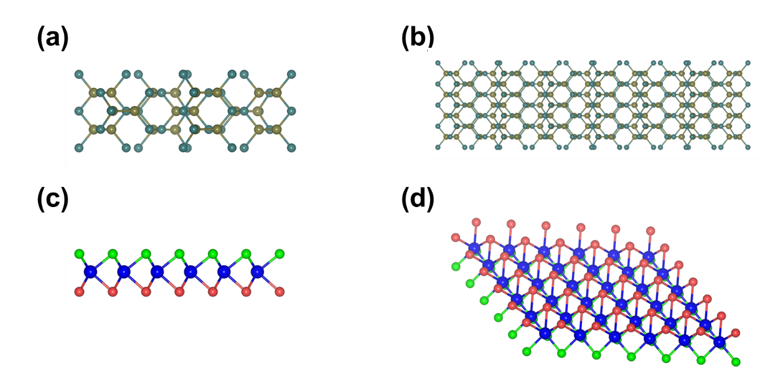
Figure S1. (a,b) Crystal structure of GeP, showing the top-view (a) and side-view (b). (c,d) Crystal structure of Janus MoSSe, presented in top-view (c) and side-view (d), highlighting the out-of-plane asymmetry arising from different chalcogen atoms (S and Se) on the upper and lower planes.
The frequency-dependent optical constants of MoSSe and GeP are summarized in Figure S2. The real part of the dielectric function, ε₁(ω), shown in Figure S2(a), reflects the polarization response of the materials to an applied electric field [1]. MoSSe exhibits a high dielectric constant, reaching values of ~10 near photon energies of ~2 eV, indicative of strong dielectric screening and enhanced light-matter interaction in the visible region [2]. GeP also shows elevated ε₁(ω) at low photon energies, although with a slightly reduced magnitude [3]. For both materials, ε₁(ω) decreases and becomes negative at higher energies (~4–6 eV), consistent with plasma-like behavior. The imaginary component of the dielectric function, ε₂(ω), presented in Figure S2(b), corresponds directly to interband optical absorption. MoSSe shows a pronounced absorption peak near ~3 eV, consistent with efficient visible-light absorption, while GeP exhibits broader absorption extending from ~2 to 6 eV, indicating suitability for broadband and near-infrared (NIR) photodetection [3]. These trends are consistent with the respective electronic band structures of the two materials. The refractive index n(ω) and extinction coefficient k(ω) are shown in Figures S2(c) and S2(d), respectively. Both materials exhibit refractive indices exceeding 3 in the visible region, with MoSSe reaching values of ~4–5 at lower photon energies due to its higher dielectric constant. The extinction coefficient reveals strong absorption in MoSSe near ~1.8 eV, whereas GeP exhibits enhanced absorption at higher energies, supporting broadband optical activity. These parameters are critical for determining optical confinement and absorption efficiency in ultrathin photodetector architectures.

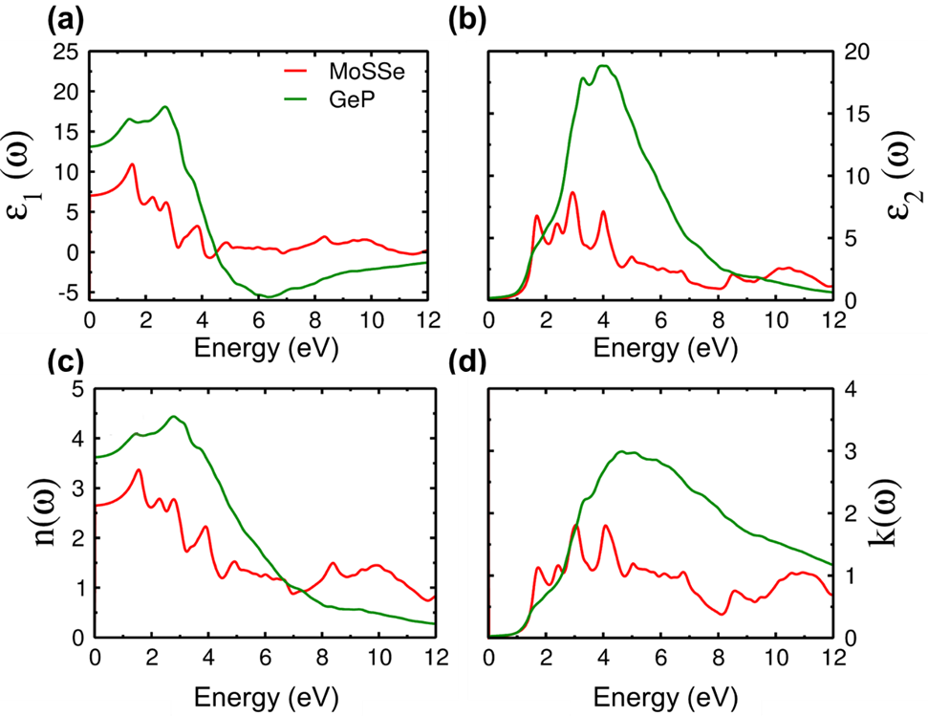
Figure S2. Optoelectronic characteristics of MoSSe and GeP (a) Real part of the dielectric function ε₁(ω) (b) Imaginary part of the dielectric function ε₂(ω) (c) Refractive index n(ω) (d) Extinction co-efficient k(ω)
Additional optical characteristics are presented in Figure S3. The energy-loss function L(ω), shown in Figure S3(a), reveals plasmon-related excitations at higher photon energies (>6 eV), with MoSSe exhibiting a stronger response than GeP, indicating more pronounced collective electronic oscillations. Reflectivity spectra in Figure S3(b) show that MoSSe maintains a lower average reflectivity across the visible range, facilitating stronger light absorption, while GeP exhibits higher reflectivity at elevated photon energies. The absorption coefficient I(ω), presented in Figure S3(c), confirms strong absorption in both materials beyond their respective band edges, with GeP displaying broader spectral coverage. Finally, the real part of the optical conductivity σ(ω), shown in Figure S3(d), follows trends similar to ε₂(ω) and I(ω), indicating efficient photoexcited carrier generation and transport over a wide energy range, which is beneficial for photodetector applications [4]. Overall, these atomic and optical analyses establish Janus MoSSe as an efficient visible-light absorber with intrinsic dipolar asymmetry, while GeP provides broadband and NIR sensitivity with favorable carrier transport characteristics. The complementary optical responses of the two materials support their integration into vertical van der Waals heterostructures for broadband photodetection.
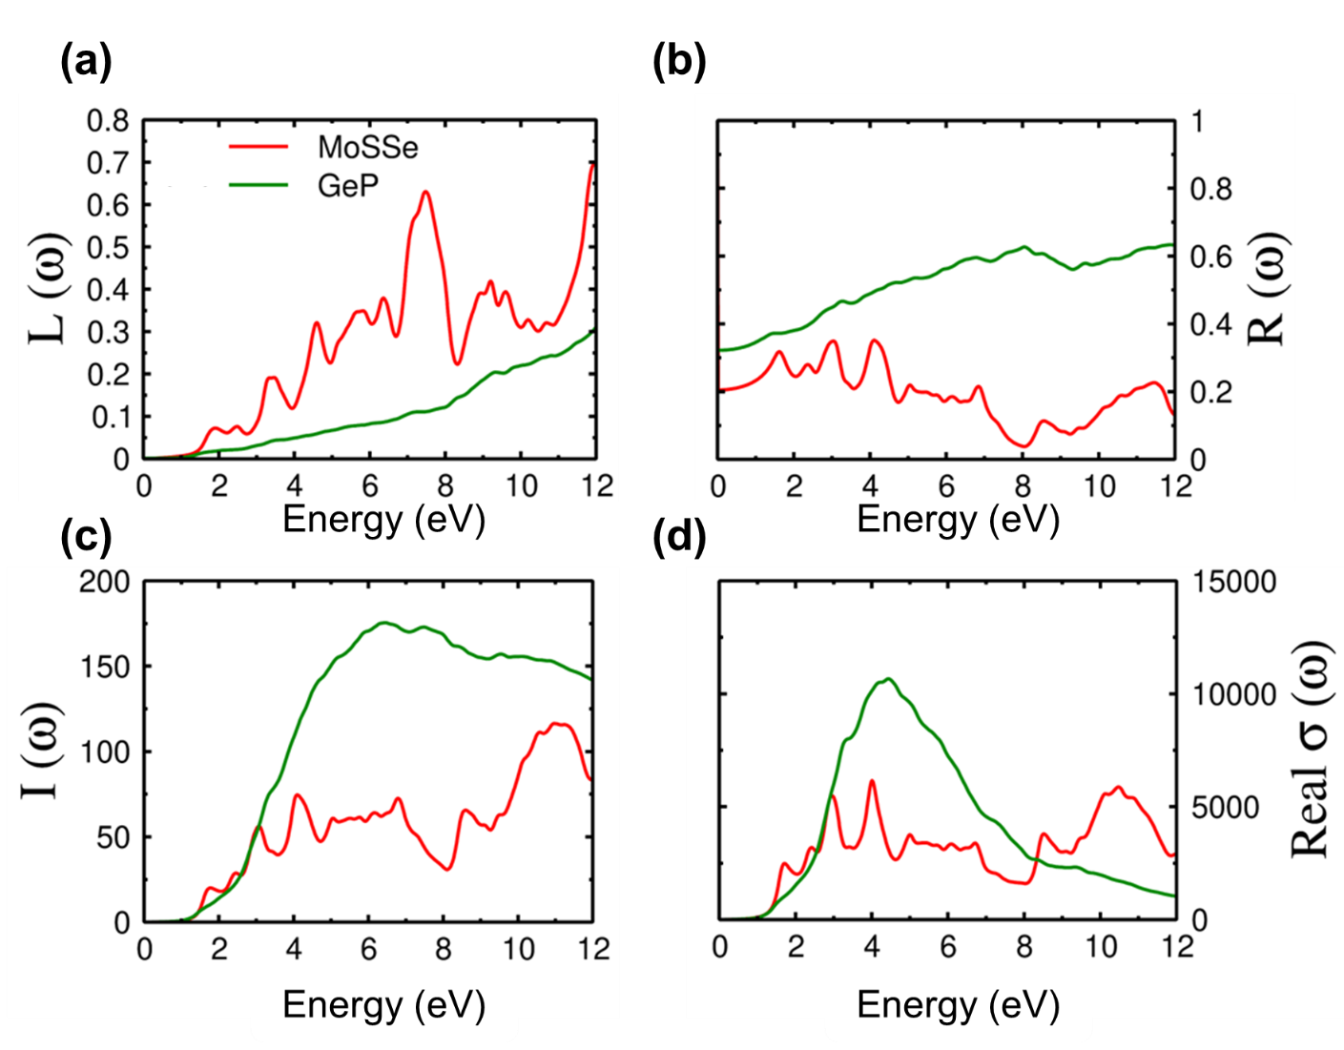
Figure S3. The calculated (a) energy loss function L(ω), (b) Reflectivity R(ω), (c) the light absorption co-efficient I(ω), also referred to as the imaginary part of optical conductivity, and (d) the real part of optical conductivity σ(ω).

Section 2. Step-by-Step Fabrication of the MoSSe/GeP Heterostructure Device
The sequential fabrication process of the MoSSe/GeP van der Waals heterostructure photodiode is illustrated schematically in Figure S4. The process begins with the preparation of an Elvacite polymer film on a clean glass slide, which serves as the transfer medium for deterministic dry pickup. Few-layer GeP flakes were mechanically exfoliated from bulk crystals onto an O₂-plasma-treated Si/SiO₂ substrate (5 min treatment) to slightly roughen the surface and facilitate reliable flake pickup. A suitable GeP flake was identified and subsequently picked up using the Elvacite stamp, ensuring that the pristine, tape-free surface of the flake remained oriented downward. The GeP flake was then deterministically transferred onto predefined Cr/Au bottom electrodes.
Following the GeP transfer, MoSSe flakes were exfoliated on a separately plasma-treated substrate, selected under optical microscopy, and picked up using the same Elvacite-assisted method. The MoSSe flake was then precisely aligned and transferred onto the underlying GeP region, forming a vertically stacked p-n heterostructure. This dry-transfer approach avoids solvent exposure and polymer contamination at the metal-semiconductor and semiconductor-semiconductor interfaces, enabling a clean van der Waals junction.
After stacking, the device was thermally annealed at 180 °C for 5 min to enhance interlayer adhesion, improve interfacial coupling, and minimize residual adsorbates [5]. Finally, a thin overlayer of lead-free perovskite quantum dots (oleic acid/oleylamine capped, 10 mg mL⁻¹ in toluene) was deposited by spin coating at 2000 rpm, followed by heating at 180 °C for 5 min to promote uniform coverage and strong interfacial interaction. The final optical image confirms precise alignment of the MoSSe and GeP layers, indicating successful heterojunction formation with a clean and well-defined interface.
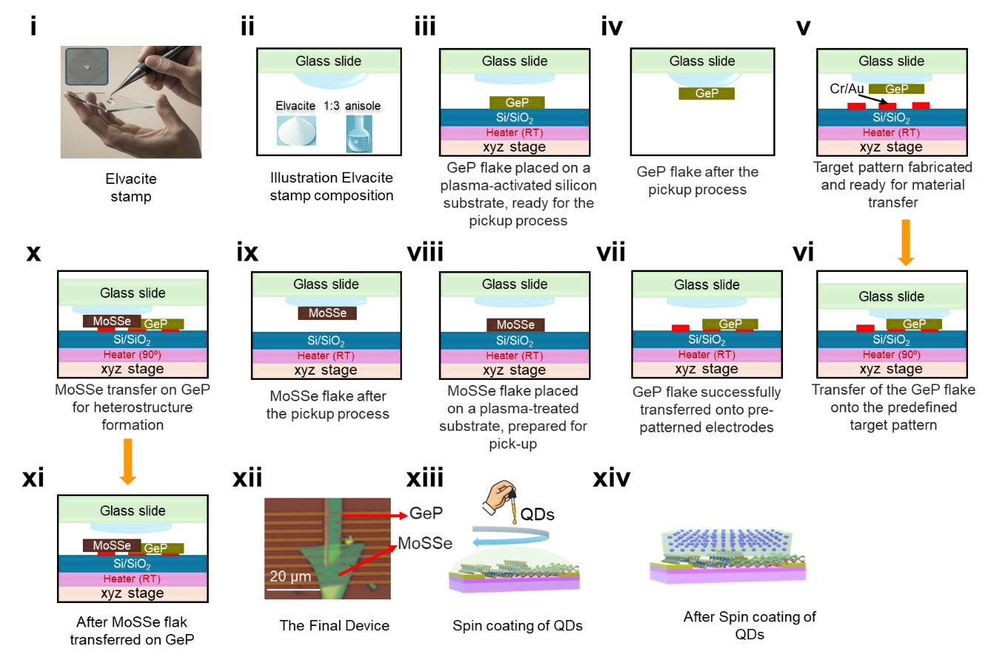
Figure S4. Step-by-step fabrication process of the MoSSe/GeP heterostructure device. (i) The Elvacite stamp is prepared on a glass slide for the pickup process. (ii) A clean glass slide is used as the supporting substrate. (iii) GeP flake is exfoliated onto a plasma-treated Si/SiO₂ substrate. (iv) GeP flake placed on the plasma-activated substrate, ready for pickup. (v) GeP flake after the pickup process. (vi) The target pattern is fabricated and prepared for material transfer. (vii) The GeP flake is transferred onto the predefined target pattern. (viii) GeP flake successfully aligned on pre-patterned electrodes. (ix) MoSSe flake is exfoliated on a plasma-treated substrate, prepared for pickup. (x) MoSSe flakes after the pickup process. (xi) Transfer process of MoSSe onto the GeP layer already transferred onto the electrodes. (xii) Formation of the stacked MoSSe/GeP heterostructure. (xiii) Optical image of the final heterostructure device showing clear interface alignment. (xiv) Schematic representation of the complete MoSSe/GeP heterostructure illustrating the vertical stacking configuration.

Section 3. Optical and SEM Characterization Before and After Quantum Dot Coating
Optical and SEM characterization of the MoSSe/GeP heterostructure before and after lead-free quantum dot (QD) deposition is presented in Figure S5. The optical images show a uniform and well-aligned junction before QD coating, with clear contrast between the MoSSe and GeP regions. After QD spin coating, a slight change in surface contrast is observed, indicating the formation of a continuous QD layer on the device surface. Corresponding SEM images further confirm homogeneous and conformal QD coverage across the active heterostructure region. Importantly, no structural deformation, interface delamination, or surface damage is observed after QD deposition, demonstrating the mechanical robustness of the MoSSe/GeP van der Waals stack and its compatibility with the QD overlayer.
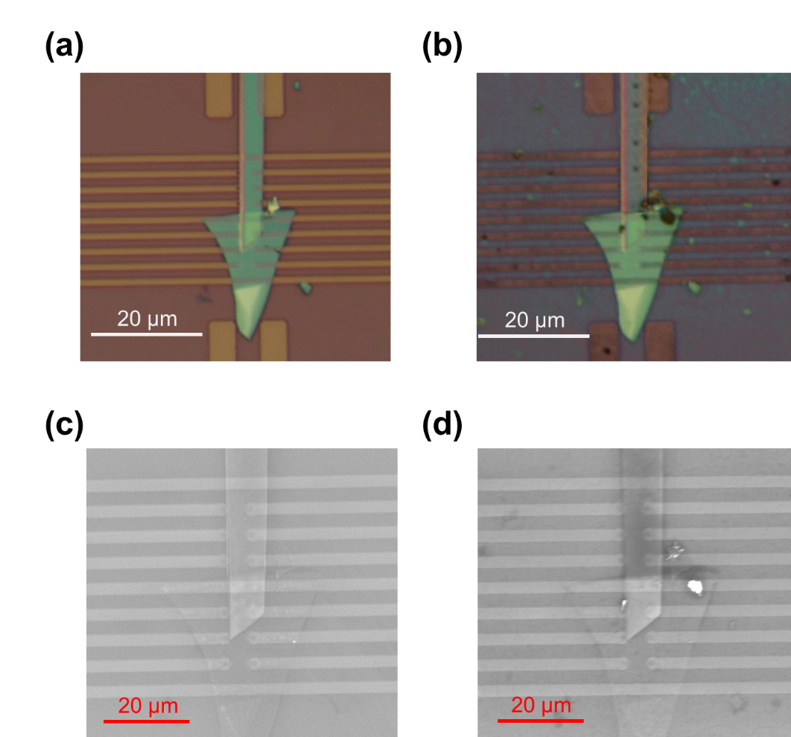
Figure S5. Optical and SEM images of the MoSSe/GeP heterostructure device before and after QD coating. (a) Optical image of the device before QD deposition. (b) Optical image after QD coating, showing a slight change in surface contrast. (c) SEM image of the device before QD coating. (d) SEM image after QD coating, confirming the uniform surface coverage of quantum dots over the heterostructure region.

Section 4. Raman spectroscopy of individual GeP and MoSSe FETs
The Raman spectrum of the GeP flake, shown in Figure S6(a), displays prominent vibrational modes at B_{3g} (203.6 cm⁻¹), $A_{g}^{1}$ (249 cm⁻¹), $A_{g}^{2}$ (296 cm⁻¹), B_{1g} (313 cm⁻¹), $A_{g}^{3}$ (352 cm⁻¹) and $B_{{2g}^{2}}$ (363.7 cm⁻¹), consistent with the orthorhombic lattice structure and confirming the high crystallinity of the p-type GeP channel [6]. In Figure S6(b), the MoSSe flake exhibits the signature Janus phonon modes, $E_{{2g}^{1}}$ (271.7 cm⁻¹), A_{1g} (355 cm⁻¹), $E_{{2g}^{2}}$ (373 cm⁻¹), and B_{2g} (382 cm⁻¹), originating from the broken out-of-plane symmetry of the S-Mo-Se configuration and strong spin-orbit coupling [7]. The sharpness and stability of all Raman peaks in both flakes indicate that the individual layers are structurally intact and free from polymer residues or transfer-induced damage, ensuring a clean and efficient interface upon forming the MoSSe/GeP heterostructure.
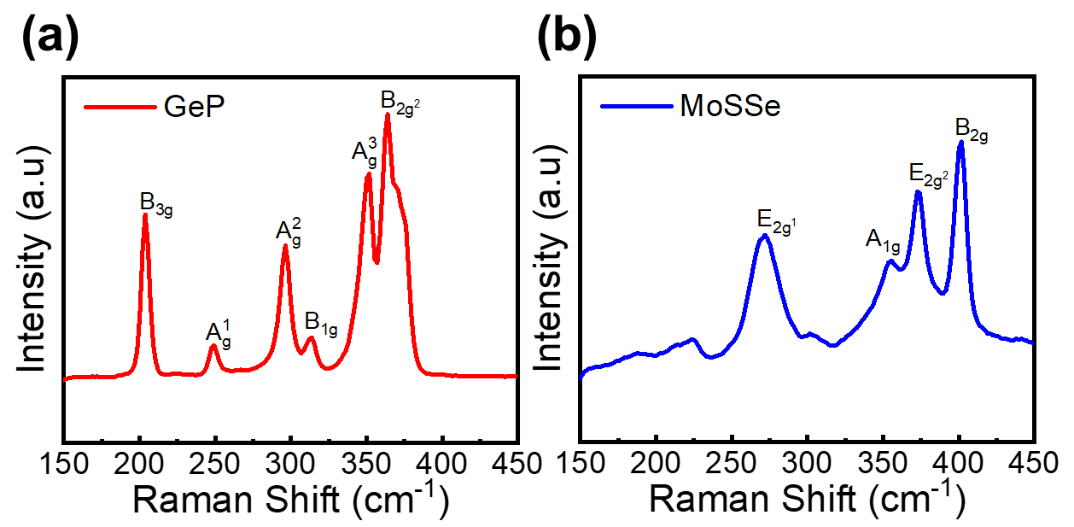
Figure S6. Raman spectra of individual GeP and MoSSe flakes, showing their characteristic vibrational modes and confirming high crystallinity and structural integrity before heterostructure assembly.
Section 5. Transfer and IV characteristics of individual GeP and MoSSe FETs
The transfer curve of the GeP channel in Figure S7(a) (V_{ds} = 0.5 V) exhibits clear p-type behavior, with the drain current decreasing gradually as V_{g} is swept from –60 V to +60 V; the inset shows the logarithmic representation, confirming gate-controlled hole transport with a well-defined minimum near the charge-neutrality point [8]. In contrast, Figure S7(b) shows that MoSSe behaves as an n-type semiconductor [9], with its drain current increasing significantly under positive gate bias, again supported by the log-scale inset. These complementary transfer characteristics validate GeP as a p-type absorber and MoSSe as an n-type electron-transport layer in the heterostructure. The corresponding output curves in Figure S7(c) and S7(d) further reinforce this behavior: GeP displays stronger conduction under negative gate bias (–60 V), while MoSSe shows enhanced conduction under positive bias (+60 V). The systematic shift of the output curves with gate voltage confirms efficient electrostatic modulation, clean channel formation, and low contact resistance in both devices. Together, these results establish that the individually characterized GeP and MoSSe flakes possess stable, gate-tunable p- and n-type transport, forming a reliable foundation for the vertical MoSSe/GeP p-n diode used in the main manuscript.
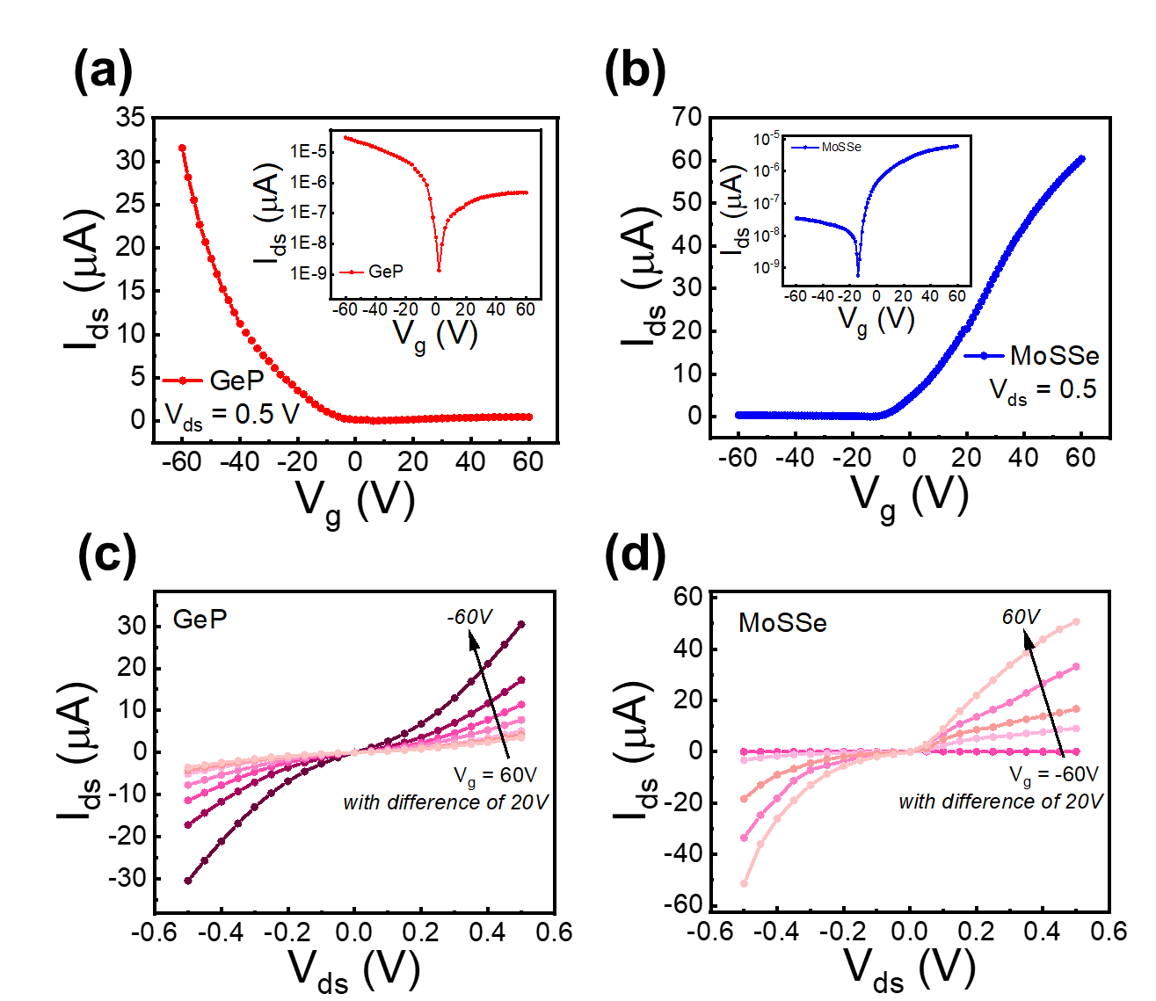
Figure S7. (a) I_{ds}–V_{ds} transfer curve of GeP at V_{ds} = 0.5 V (inset: log scale), confirming p-type conduction. (b) I_{ds}–V_{ds} transfer curve of MoSSe at V_{ds} = 0.5 V (inset: log scale), showing n-type behavior. (c) I_{ds}–V_{ds} output curves of GeP for V_{g} = –60 to +60 V (20 V steps). (d) I_{ds}–V_{ds} output curves of MoSSe across the same gate range, consistent with n-type transport.
Section 6. Ideality Factor Extraction of Pristine and QD-Based GeP/MoSSe Heterojunction
The forward-bias region of the MoSSe/GeP junction was analyzed to quantify its diode transport quality through the extraction of the ideality factor (η). The semi-logarithmic fitting applied to the pristine device, as shown in Figure S8(b), yields an ideality factor of η = 1.21 ± 0.13 at V_{g} = 40 V. Such a value slightly above unity indicates the presence of moderate recombination-assisted transport within the depletion region, which is typical for multilayer 2D p-n junctions where interfacial states and imperfect band alignment may influence carrier motion [10]. Gate-dependent measurements for the pristine junction presented in Figure S8(a) provide the forward-bias data used for this extraction, confirming that the exponential regime is sufficiently well-defined for reliable fitting. The resulting η values across the entire gate range fall between 1.53 and 1.20, demonstrating that although the junction is functional, recombination and interface scattering still play a role in limiting the diode’s ideal transport behavior.
After sensitization with lead-free QDs, the MoSSe/GeP heterojunction exhibits a markedly improved transport quality. The fitting shown in Figure S8(d) gives an ideality factor of η = 1.06 ± 0.10, very close to the ideal Shockley diode limit of unity. This improvement arises from reduced trap-assisted recombination and enhanced interfacial charge transfer introduced by the QD layer, which effectively passivates surface states and promotes cleaner band-to-band transport. Gate-dependent I_{ds}–V_{ds} curves for the QD-sensitized device provided in Figure S8(c) serve as the basis for this analysis and reveal a consistent reduction in η across the bias range, from 1.45 down to 1.06. This trend confirms that QD sensitization suppresses defect-mediated recombination pathways and produces a more efficient and energetically favorable junction interface.

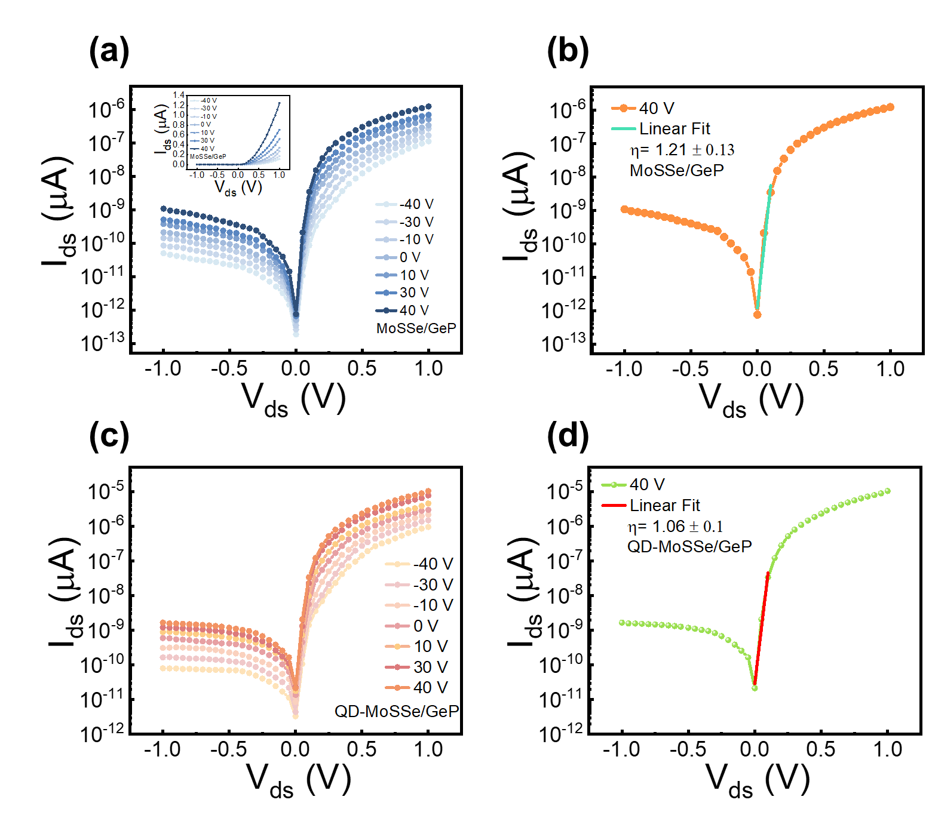
Figure S8. (a) I_{ds}–V_{ds} characteristics of the pristine MoSSe/GeP heterojunction measured from −40 to +40 V gate bias, showing gate-tunable rectification. (b) Extraction of the ideality factor (η = 1.21 ± 0.13) for the pristine heterojunction using the forward-bias linear fitting at V_{g} = 40 V. (c) I_{ds}–V_{ds} characteristics of the QD-MoSSe/GeP device under identical gate voltages, exhibiting enhanced forward current after QD sensitization. (d) Ideal diode fitting for the QD-sensitized device at V_{g} = 40 V, yielding η = 1.06 ± 0.1, indicating improved junction quality and reduced recombination.

Section 7. Transient Photoresponse Dynamics
The transient photoresponse behavior of the GeP/MoSSe heterostructure before and after QD sensitization is presented in Figure S7 under periodic illumination at λ = 455 nm. Figure S7 (a) and (d) show stable, repeatable, and intensity-dependent switching cycles across varying power densities (0.63–5.53 mW cm⁻²), confirming the device’s reliable photoactivity. The rise and decay dynamics, fitted using exponential growth and decay models,
$$\begin{matrix} & I_{\text{ph}}(t)=I_{0}+A\left[1-\exp\left(-\frac{t}{τ_{R}}\right)\right]\text{ (rise fitting)} & & \text{….(2)}\end{matrix} \\ \begin{matrix} & I_{\text{ph}}(t)=I_{0}+A\exp\left(-\frac{t}{τ_{D}}\right)\text{ (decay fitting)} & & \text{ ….(3)}\end{matrix}$$
yielded response and recovery times of τ_{R} = 48 ms and τ_{D} = 83 ms for the pristine device, and τ_{R} = 73 ms and τ_{D} = 107 ms after QD coating. The slightly slower dynamics in the QD-assisted device arise from enhanced carrier trapping and prolonged photocarrier lifetime due to strong interfacial coupling and trap-state modulation induced by QD sensitization. In addition, the zero-bias transient characteristics displayed in Figure S9(g–i) further confirm robust and stable device operation, yielding τ_{R} = 97.2 ms and τ_{D} = 129.9 ms, consistent with self-powered operation driven purely by the built-in electric field. These results demonstrate that QD incorporation effectively enhances photogain without compromising response stability [11].
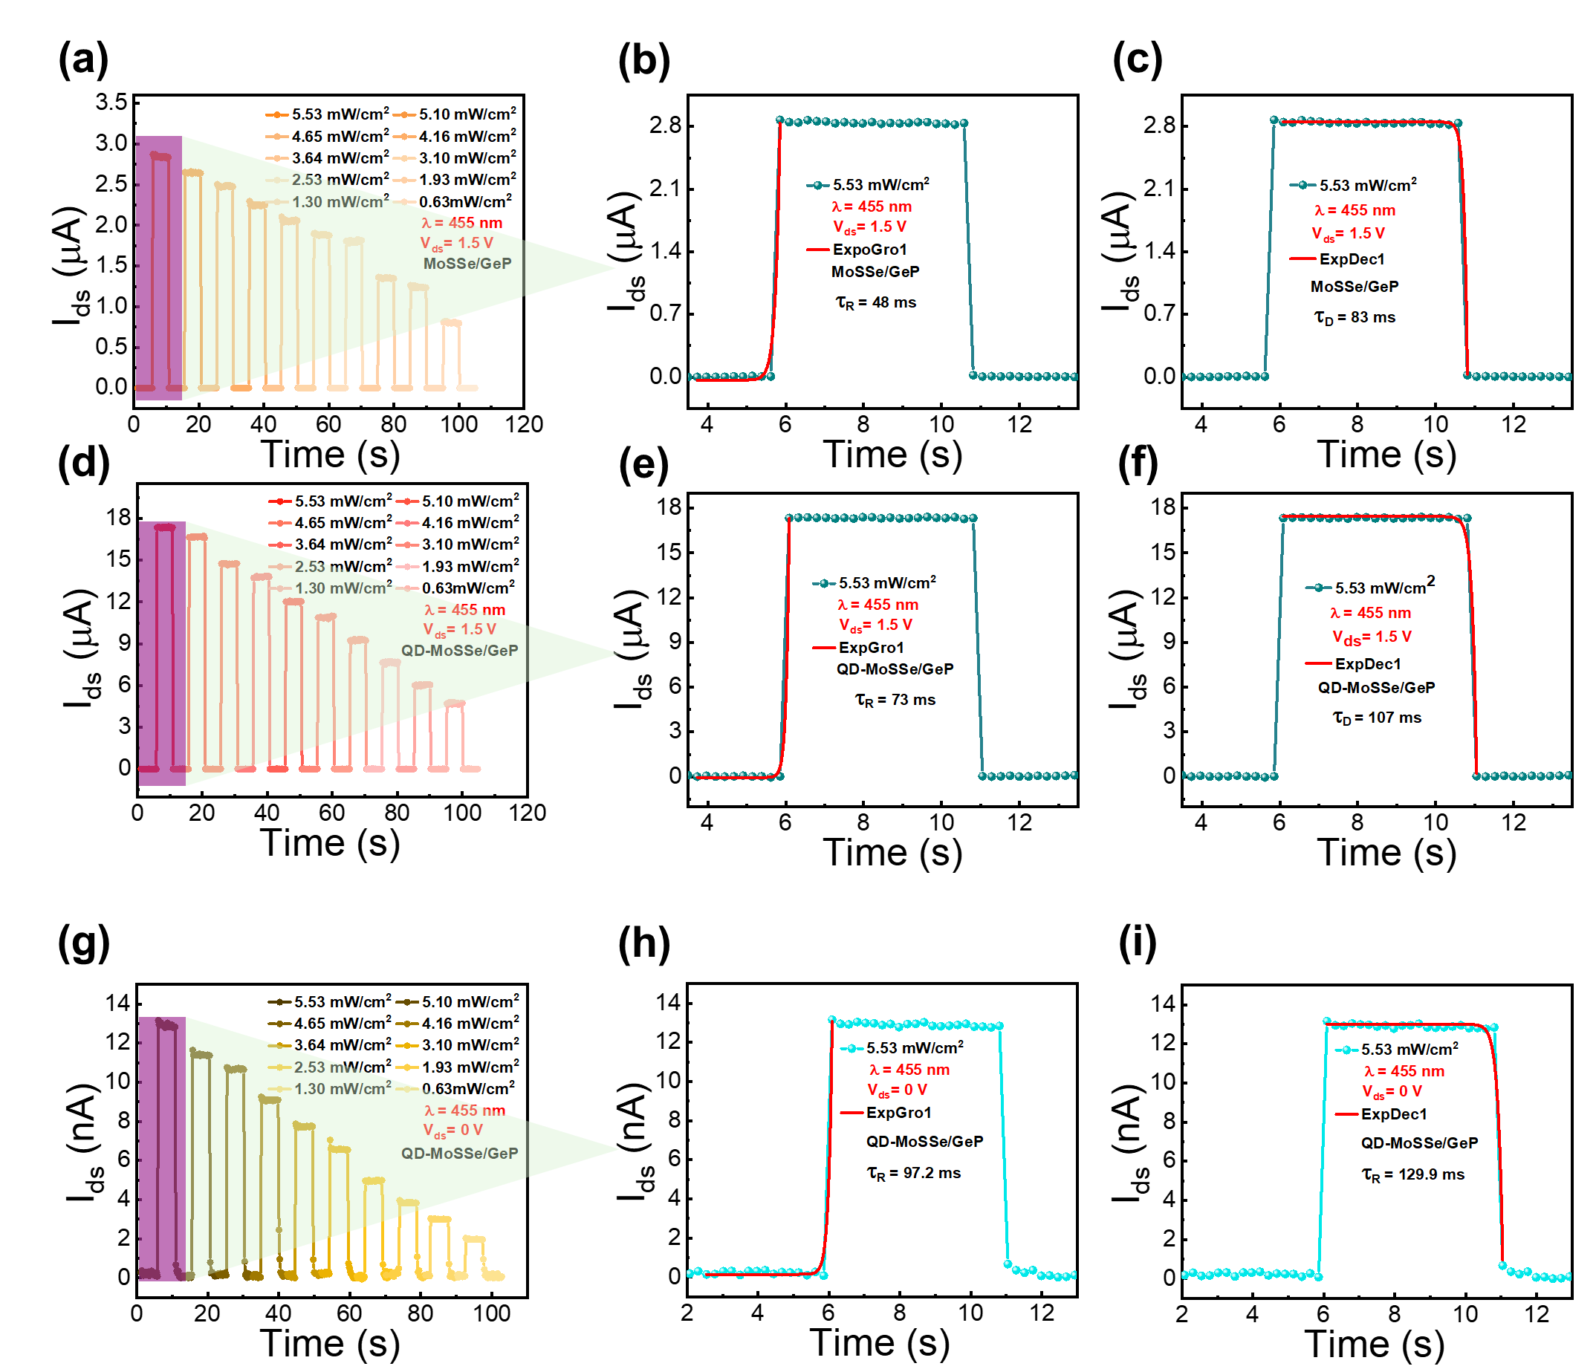
Figure S9. (a) Transient photoresponse of the GeP/MoSSe heterostructure without quantum dots under different illumination intensities (0.63–5.53 mW cm⁻², λ = 455 nm), showing stable and repeatable switching behavior. (b,c) Fitted rise and decay profiles at 5.53 mW cm⁻² and λ = 455 nm for the same device, yielding response and recovery times of τ_{R} = 48 ms and τ_{D} = 83 ms, respectively. (d) Photoresponse of the GeP/MoSSe heterostructure with quantum dots under identical conditions, demonstrating enhanced and consistent photodetection performance. (e,f) Fitted rise and decay curves at 5.53 mW cm⁻² and λ = 455 nm for the QD-assisted device, exhibiting τ_{R} = 73 ms and τ_{D} = 107 ms, respectively, indicating prolonged carrier lifetime and improved charge trapping dynamics due to quantum dot incorporation.(g–i) Zero-bias transient response and corresponding rise/decay fittings for the QD-MoSSe/GeP heterostructure, yielding τ_{R} = 97.2 ms and τ_{D} = 129.9 ms, confirming efficient self-powered operation governed by the built-in electric field.

Section 8. Optical Response Analysis
Figure S10 illustrates the dependence of external quantum efficiency (EQE) and photocurrent (I_{PH}) on light intensity and wavelength for the MoSSe/GeP heterostructure before and after QD sensitization. As shown in Figure S10 (a,b), both EQE and I_{PH} increase with illumination power (0.63–5.53 mW cm⁻² at λ = 455 nm), with significantly higher values in the QD-coated device, confirming improved photon absorption and interfacial charge transfer.
Figure S10 (c,d) displays wavelength-dependent responses under a fixed intensity of 5.53 mW cm⁻², demonstrating broadband sensitivity across 365–940 nm. Notably, a sharp enhancement around 455 nm and 530 nm corresponds to the QD emission band (λₑₘ ≈ 510 nm), validating strong optical coupling and efficient exciton transfer [12]. This synergistic interaction enhances carrier generation and suppresses recombination, resulting in superior photodetection performance for the QD-assisted MoSSe/GeP device.
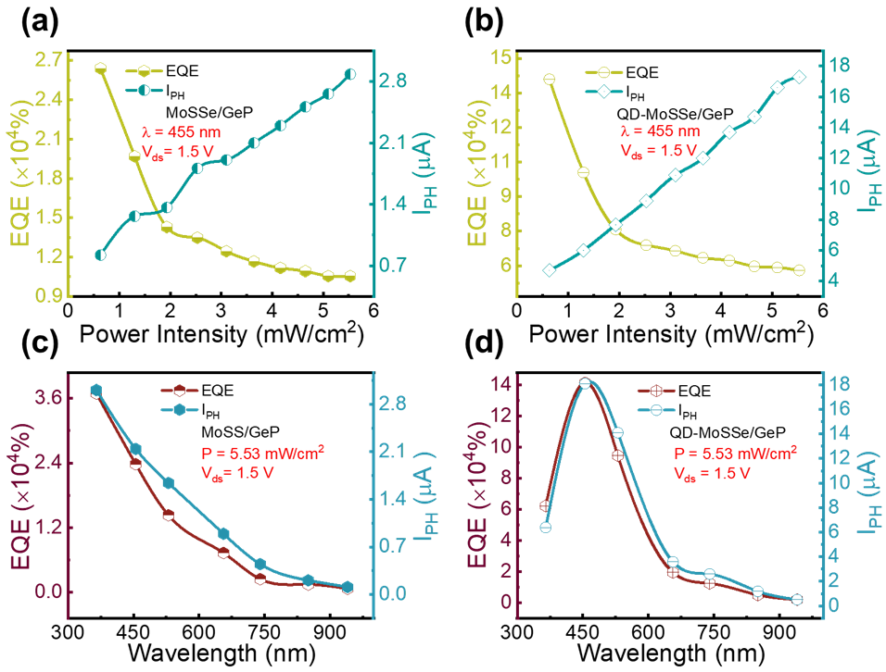
Figure S10. (a,b) Variation of EQE and photocurrent (I_{ph}) with light intensity for the GeP/MoSSe heterostructure without and with quantum dots, respectively. (c,d) Variation of EQE and photocurrent (I_{PH}) as functions of illumination wavelength at a fixed intensity of 5.53 mW cm⁻², demonstrating broadband sensitivity and superior optoelectronic performance of the QD-assisted device.

Section 9. Power-Dependent Photocurrent
The power-dependent photocurrent characteristics of the pristine and QD-sensitized MoSSe/GeP diodes follow the empirical relation I_{PH}= AP^{α}, where the exponent α provides direct insight into the dominant photocarrier generation and recombination mechanisms [13]. A value approaching unity corresponds to ideal, trap-free photocarrier transport, while smaller values reflect trap-assisted recombination, carrier scattering, or sublinear photogating effects. In Figure S11(a), the pristine MoSSe/GeP device exhibits α = 0.59 at V_{ds} = 1.5 V, indicating substantial trap-mediated recombination within the van der Waals junction and the MoSSe channel. The introduction of lead-free perovskite QDs significantly modifies this behavior. As seen in Figure S11(b), the QD-sensitized heterostructure yields an increased exponent of α = 0.75, demonstrating that QD absorption and interfacial charge injection enhance photocarrier density while simultaneously mitigating recombination through improved transfer kinetics and interlayer coupling. Under self-powered operation (V_{ds} = 0 V), Figure S11(c) shows an α value of 0.62 for the QD-MoSSe/GeP device. Despite the absence of an external electric field, the built-in field at the p–n junction effectively separates photogenerated carriers, maintaining sublinear yet stable behavior typical of self-driven photodiodes. The modest α reduction compared to the biased condition reflects the limited driving force but confirms that the heterostructure preserves efficient photocarrier extraction even in zero-bias mode.
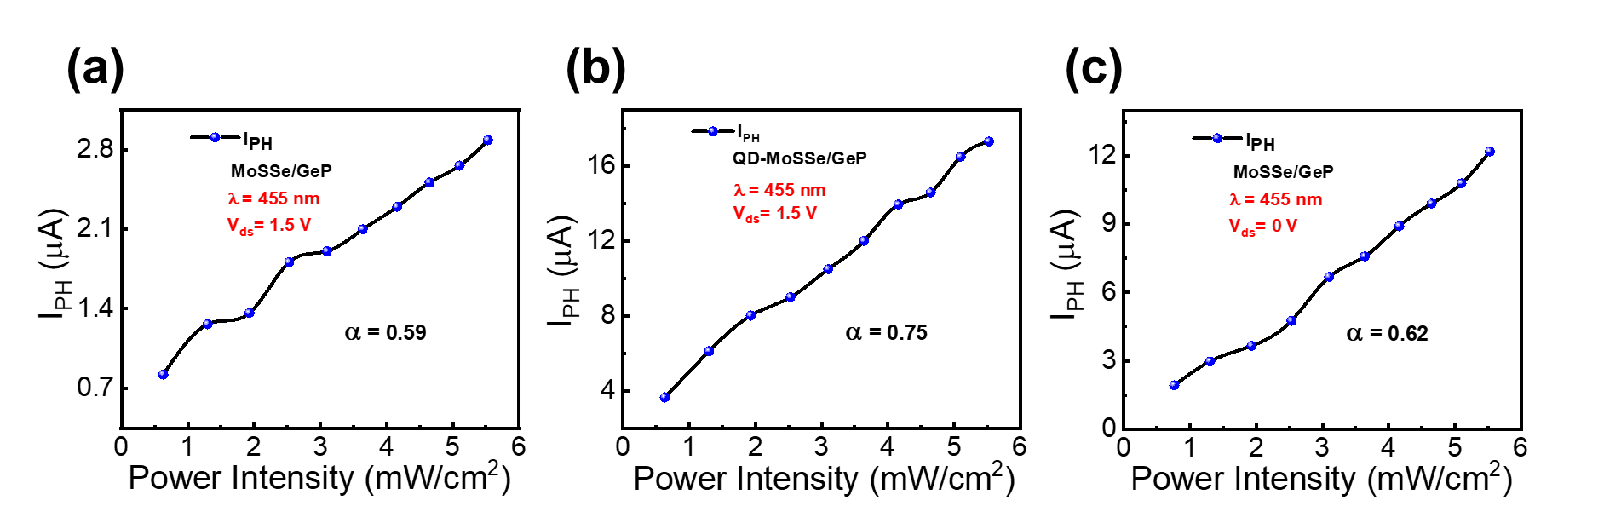
Figure S11. (a) Power-dependent photocurrent of the pristine MoSSe/GeP heterostructure at λ = 455 nm and V_{ds} = 1.5 V, showing a power-law exponent of α = 0.59. (b) Power-dependent photocurrent of the QD-MoSSe/GeP device at λ = 455 nm and V_{ds} = 1.5 V, exhibiting an enhanced exponent of α = 0.75, indicating improved carrier generation and reduced recombination. (c) Power-dependent photocurrent of the QD-MoSSe/GeP diode under self-powered operation (V_{ds} = 0 V), yielding α = 0.62, confirming efficient photocarrier separation driven solely by the built-in electric field.

Section 10. Device Stability Analysis
The long-term operational stability of the GeP/MoSSe heterostructure photodiodes before and after QD sensitization is presented in Figure S12 under continuous illumination (P = 5.53 mW cm⁻², λ = 455 nm). Both devices maintain highly reproducible photoresponse cycles during prolonged on/off switching, demonstrating outstanding temporal stability and endurance. The QD-sensitized device exhibits nearly identical photocurrent amplitude throughout extended operation, with minimal degradation in response intensity, confirming excellent interfacial integrity and charge-transport robustness. This sustained performance verifies that QD incorporation does not introduce instability but instead enhances carrier lifetime and signal uniformity. Such reliability underscores the potential of the lead-free QD-MoSSe/GeP heterostructure for durable, broadband optoelectronic applications.
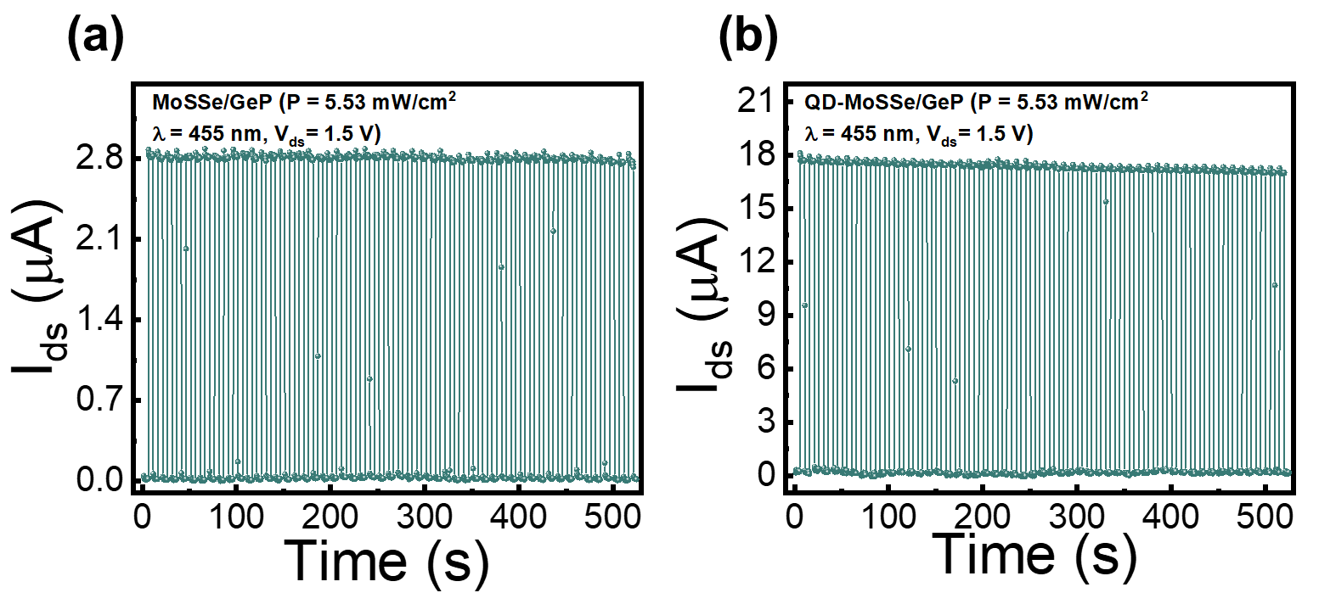
Figure S12. (a,b) Long-term stability measurements of the GeP/MoSSe heterostructure without and with quantum dots under continuous illumination (P = 5.53 mW cm⁻², λ = 455 nm, V_{ds} = 1.5 V), showing highly stable and repeatable photoresponse cycles over extended operation, confirming excellent device reliability and durability.

References
1. Yasir, M.A., Noor, N.A., Khan, M.A., Niaz, S., Mumtaz, S., Moussa, I.M., and Ullah, H. (2025) Spin-polarized analysis of ferromagnetism, optoelectronic and transport characteristics of HgGd2(S/Se)4 spinels: DFT-calculations. Mater. Today Commun., 43, 111636.
2. Ye, X., Zhuang, F., and Zhang, R. (2023) Electronic properties and applications of MoSSe/MoSTe heterostructure in photocatalytic water splitting. Mater. Today Commun., 37, 107351.
3. Chen, Q.-Y., Cao, C., and He, Y. (2019) Optical anisotropy and strain tunable optical, electronic and structural properties in monolayer GeP: A computational study. Phys. E Low-Dimens. Syst. Nanostructures, 113, 172–180.
4. Multiplier Effects of Photodetectors—Source of Gain.
5. Asim, M., Rehmat, A., Khan, M.F., Shin, S.-H., Kim, T.W., and Eom, J. (2025) High-Performance Spin Field-Effect Transistors with Multicycle Spin Precession in BLG/WSe2/hBN Heterostructures. ACS Omega, 10 (38), 44365–44373.
6. Yu, T., Nie, H., Wang, S., Zhang, B., Zhao, S., Wang, Z., Qiao, J., Han, B., He, J., and Tao, X. (2020) Two-Dimensional GeP-Based Broad-Band Optical Switches and Photodetectors. Adv. Opt. Mater., 8 (2), 1901490.
7. Petriıfmmode \acutec\else ć\fi, M.M., Kremser, M., Barbone, M., Qin, Y., Sayyad, Y., Shen, Y., Tongay, S., Finley, J.J., Botello-Méndez, A.R., and Müller, K. (2021) Raman spectrum of Janus transition metal dichalcogenide monolayers WSSe and MoSSe. Phys Rev B, 103 (3), 035414.
8. Dushaq, G., and Rasras, M. (2021) Multilayer 2D germanium phosphide (GeP) infrared phototransistor. Opt. Express, 29 (6), 9419–9428.
9. Ding, Y., Yang, G., Gu, Y., Yu, Y., Zhang, X., Tang, X., Lu, N., Wang, Y., Dai, Z., Zhao, H., and Li, Y. (2020) First-Principles Predictions of Janus MoSSe and WSSe for FET Applications. J. Phys. Chem. C, 124 (38), 21197–21206.
10. Myeong, G., Shin, W., Sung, K., Kim, S., Lim, H., Kim, B., Jin, T., Park, J., Lee, T., Fuhrer, M.S., Watanabe, K., Taniguchi, T., Liu, F., and Cho, S. (2022) Dirac-source diode with sub-unity ideality factor. Nat. Commun., 13 (1), 4328.
11. Tong, L., Yan, H., Xu, C., Bai, W., Su, C., Li, H., Wang, X., Fan, W., Chen, X., Zhang, Z., Wang, Q., and Yin, S. (2024) Perovskite quantum dots/WSe2 mixed-dimensional van der Waals heterostructure for photoelectric enhancement and polarization sensitivity. Chem. Eng. J., 499, 155861.
12. Wu, H., Si, H., Zhang, Z., Kang, Z., Wu, P., Zhou, L., Zhang, S., Zhang, Z., Liao, Q., and Zhang, Y. (2018) All‐inorganic perovskite quantum dot‐monolayer MoS2 mixed‐dimensional van der Waals heterostructure for ultrasensitive photodetector. Adv. Sci., 5 (12), 1801219.
13. Edgorova, D.M. (2009) Photocurrent amplification effect of the fet gate p–n junction. J. Eng. Phys. Thermophys., 82 (1), 190–197.

