Facile method for synthesis and polymerization of 1-allenyl-3-methyl- and 1-allenyl-5-methylpyrazoles
L. A. Bichakhchyan, M. L. Petrosyan, N. A. Mirakyan*, R. M. Hakobyan, H. S. Attaryan
Lilit Bichakhchyan^{a,b} (ORCID 0000-0002-8713-3724)
Maria Petrosyan (ORCID 0009-0009-8248-5489)
Nagharsh Mirakyan (ORCID 0000-0001-8917-3327)
Robert Hakobyan (ORCID 0000-0002-4318-3172)
Hovhannes Attaryan (ORCID 0000-0001-9790-2577)
ª Scientific and Technological Center of Organic and Pharmaceutical Chemistry, Azatutyan ave. 26, 0014, Yerevan. Republic of Armenia
^{b} Eurasia International University, Azatutyan Ave., 24/2 Building, 0014, Yerevan, Republic of Armenia,
E-mail: lilitbichakhchyan@gmail.com, mariapetrosyan-3@aspu.am, nmiraqyan1@gmail.com, robahakob@gmail.com, hovelenatt@mail.ru

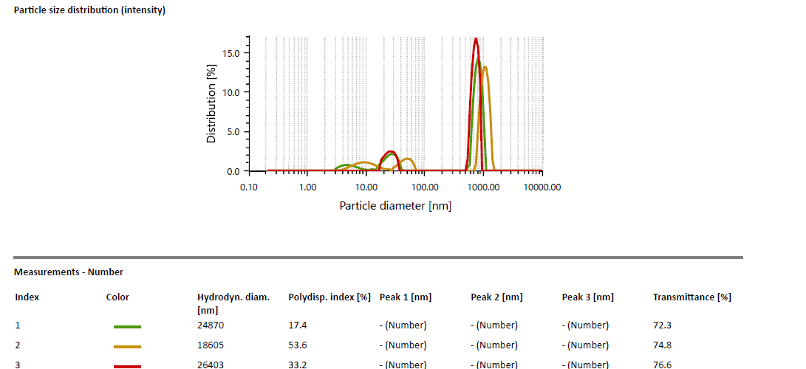
Fig. 2 PA-1 Ultrasonicated
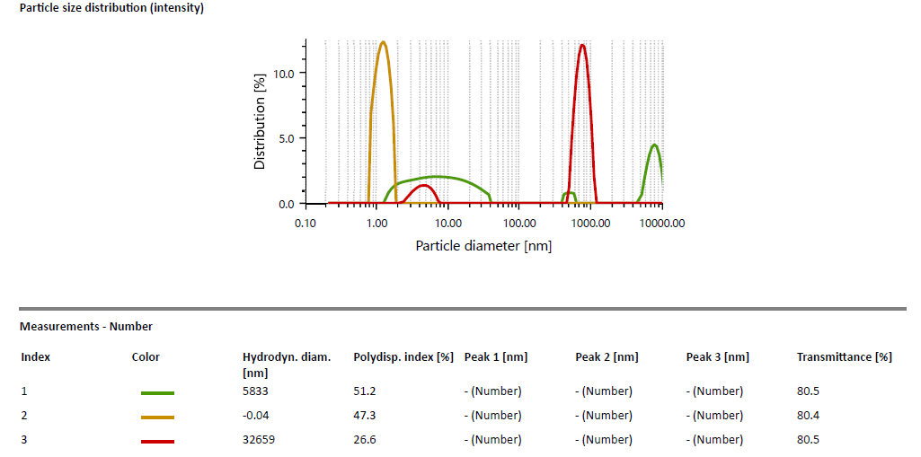
Fig. 3 PA-1 Ultrasonicated and filtered

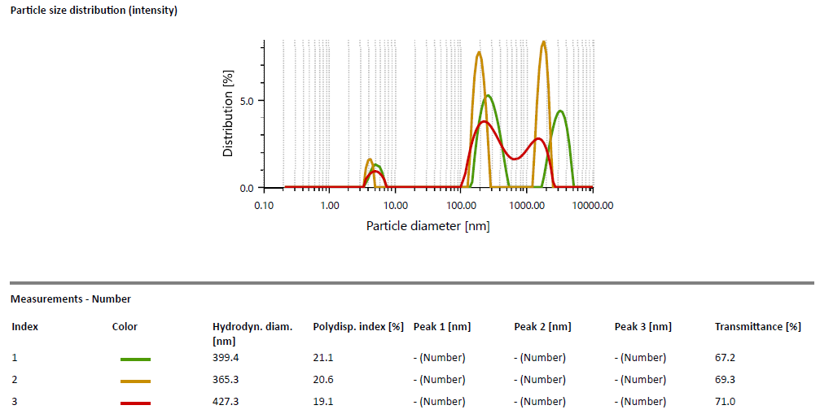
Fig.4 PA-2
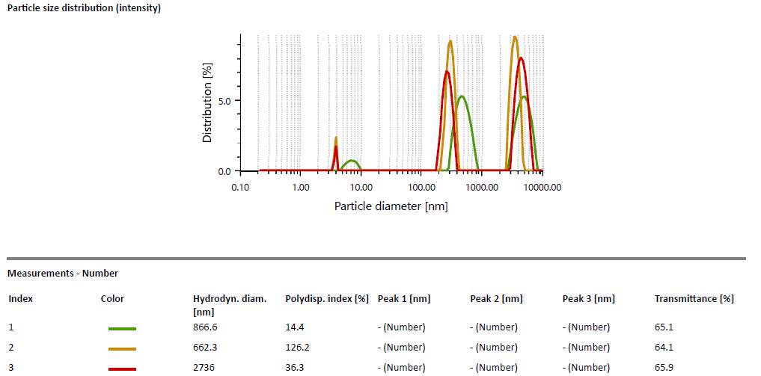
Fig.5 PA-2 Ultrasonicated

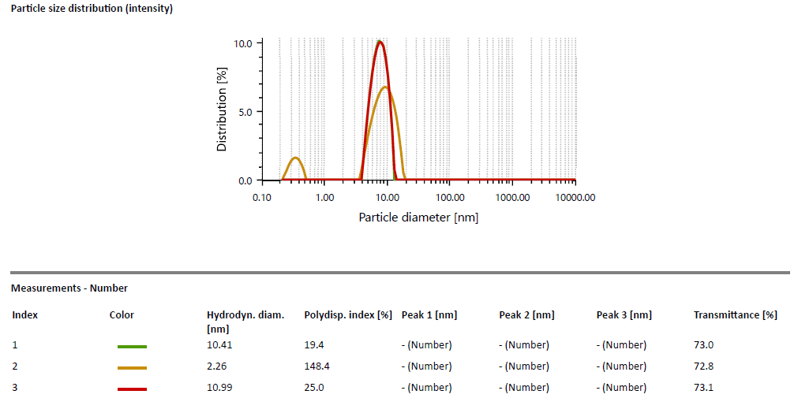
Fig.6 PA-2 Ultrasonicated and filtered
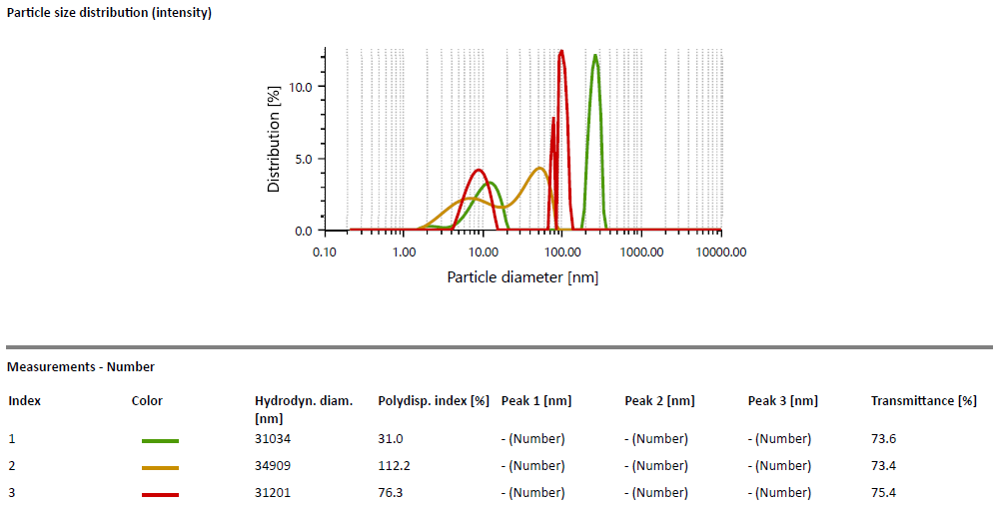
Fig.7 PA-3

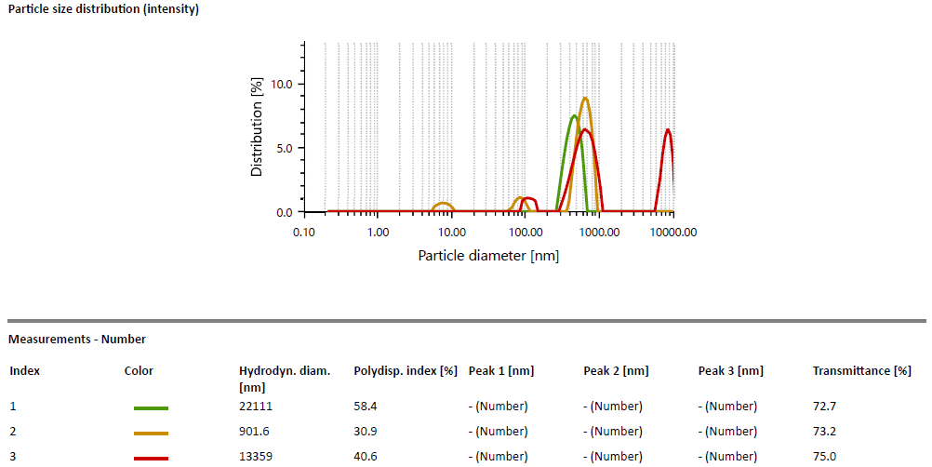
Fig.7 PA-3 Ultrasonicated
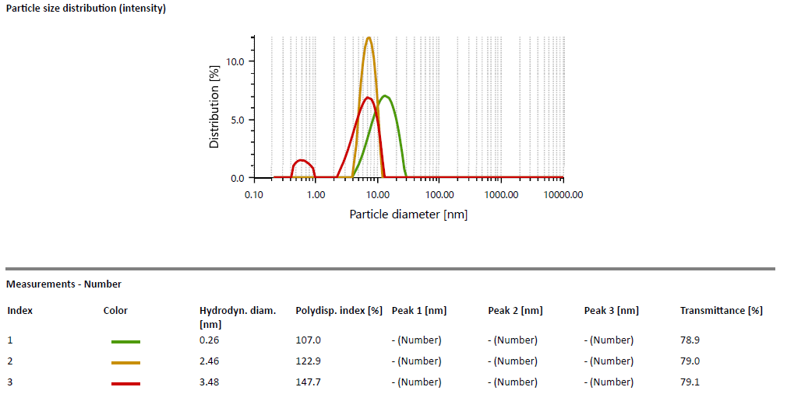
Fig.8 PA-3 Ultrasonicated and filtered

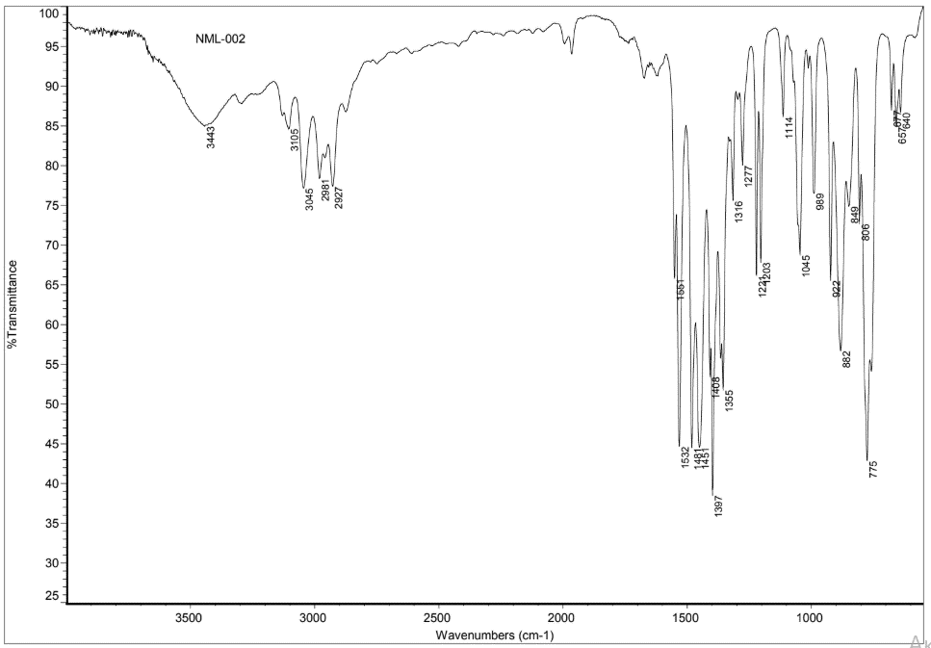
Fig.9 IR spectrum of 1-allenyl-5-methylpyrazole

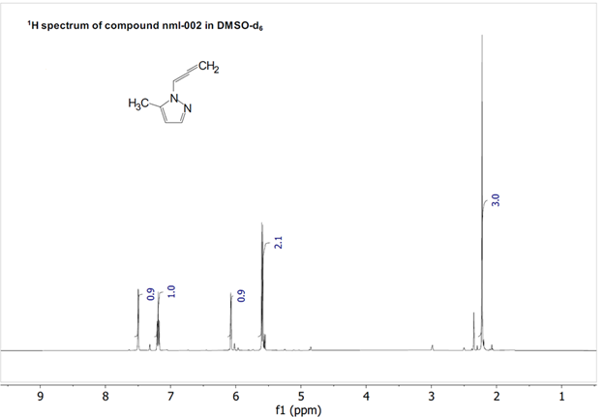
Fig.10 ¹Н NMR spectrum of 1-allenyl-5-methylpyrazole

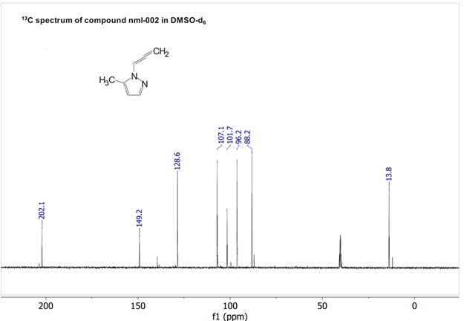
Fig.11 ^{1З}C NMR spectrum of 1-allenyl-5-methylpyrazole

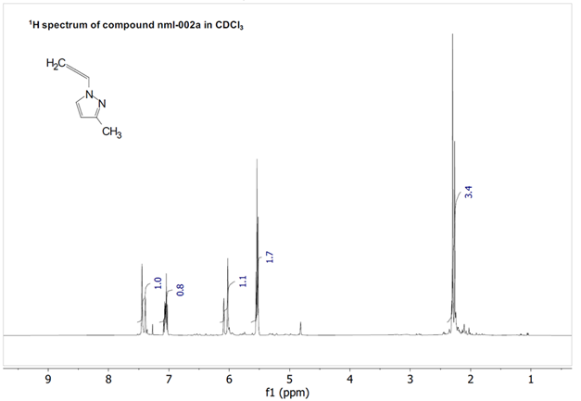
Fig.12 ¹Н NMR spectrum of 1-allenyl-3-methylpyrazole

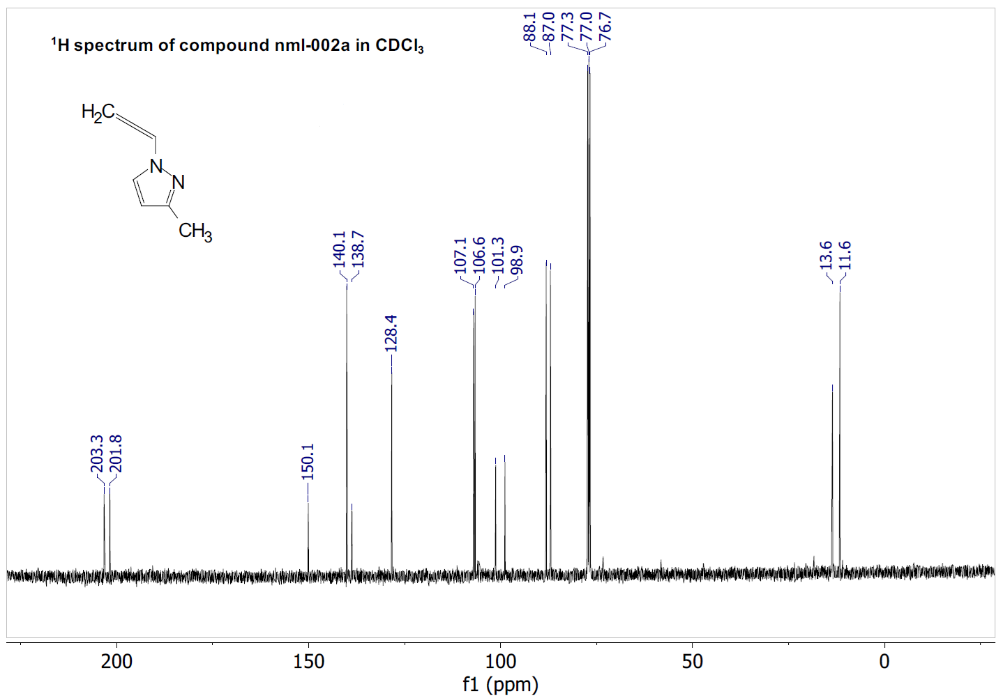
Fig.13 ^{1З}C NMR spectrum of 1-allenyl-3-methylpyrazole

