Supplementary Material

IGI Scale Description and Data Processing
The Inventario de Gestión de Intervención (IGI) consists of 43 items grouped into 8 domains assessing dynamic risk and need factors (see Table S1).
[Table S1]. IGI Domains and Items
Domain Code | Domain Name | Items
HD | Historia Delictual (Criminal History) | HD1–HD8
EDU | Educación/Empleo (Education/Employment) | EDU9–EDU17
FAM | Familia (Family) | FAM18–FAM21
UTL | Uso Tiempo Libre (Leisure Time Use) | UTL22–UTL23
PAR | Pares (Peers) | PAR24–PAR27
CAD | Actitud/Comportamiento (Attitude/Behavior) | CAD28–CAD35
PRO | Orientación Procriminal (Pro-criminal Orientation) | PRO36–PRO39
PAT | Patrones Delictivos (Offending Patterns) | PAT40–PAT43
The original IGI items are scored on a 4-point scale (0–3), where lower values typically indicate higher needs for intervention (0) and higher values indicate strength or stability (3). For the purpose of network estimation, which focuses on the presence or absence of specific risk factors, items were binarized as follows:
- 1 (Risk Present): Original score of 0 (Needs Intervention).
- 0 (Risk Absent): Original scores of 1, 2, or 3 (Adequate functioning or strength).
This transformation ensures that the network edges represent the conditional dependence of active risk factors. Using this convention, the distribution of total IGI scores (sum of binarized items) in the analytical sample covers the full range of severity, showing a slightly right-skewed distribution (Figure S1).
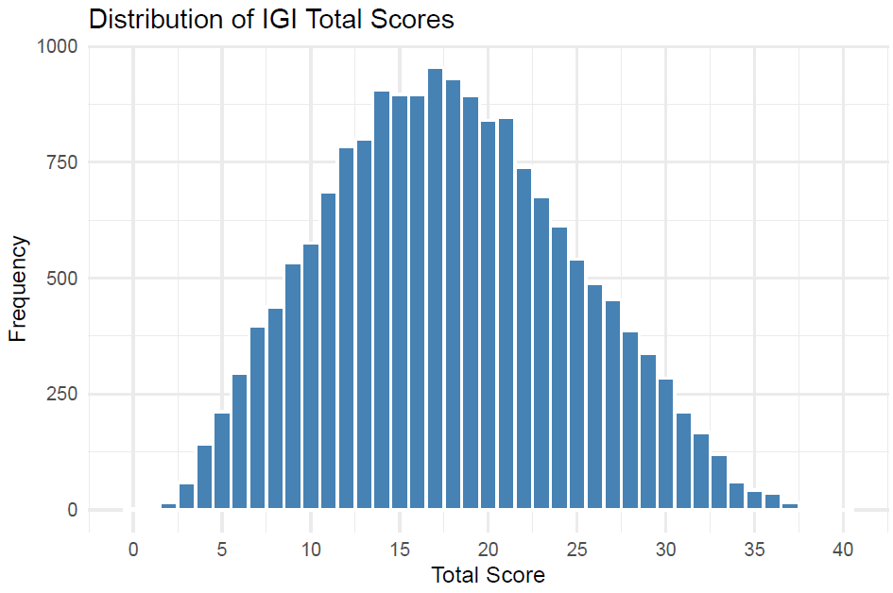
Figure S1: Distribution of total IGI scores (binarized items)

Sequential Clustering Mapping
To ensure that cluster labels remain comparable across overlapping windows as severity increases, we implemented a sequential mapping strategy rather than treating each window as an independent clustering task. Since adjacent windows $w_{t}$ and $w_{t+1}$ share a substantial proportion of individuals, we use the structure of window $t$ to inform the initialization of window $t+1$.
Formally, let $M_{t}=\{μ_{t,1},…,μ_{t,K}\}$ be the set of medoids (representative profiles) identified for the $K$ clusters in window $t$. For the subsequent window $t+1$, we initialize the cluster centers using these projected medoids. For any individual $v$ residing in the overlap region $I_{t}∩I_{t+1}$, let $c_{t}\left(v\right)$ denote their cluster assignment in the previous window. We apply a soft drift rule to determine their new assignment $c_{t+1}\left(v\right)$. The individual retains their previous label $c_{t}\left(v\right)$ unless a different cluster $c'$ offers a substantially better fit.
Specifically, the assignment changes to $c'$ if and only if:
$$J\left(x^{\left(v\right)},μ_{t+1,c'}\right)<J\left(x^{\left(v\right)},μ_{t+1,c_{t}\left(v\right)}\right)-δ$$
where $J\left(⋅,⋅\right)$ is the Jaccard distance and $δ$ is a stability threshold (set to $0.08$ in our analysis). This parameter $δ$ acts as an inertia term, preventing arbitrary label flipping due to minor fluctuations in distance and ensuring that the evolution of configurations across the severity gradient is smooth and substantively traceable. Individuals entering the analysis for the first time in window $t+1$ (non-overlapping observations) are assigned purely based on proximity to the updated medoids $M_{t+1}$.

Analysis 1 - Trajectory and Volatility Analysis
To ensure that the networks reported in the main text are stable and not driven by window-specific noise, we analyzed the trajectory of edge weights across all 7 rolling windows. We defined “volatility” as the standard deviation of an edge’s partial correlation coefficient across windows. Figure S2 plots the mean absolute strength of each edge (X-axis) against its volatility (Y-axis). The diagnostic confirms that the edges identified as significant in the M3 model (highlighted in Green) are consistently located in the “robust” quadrant (high strength, low volatility). Conversely, the most volatile edges (Red points) are weak and nonsignificant, effectively representing statistical noise. This indicates that the core network structure is stable across the severity continuum.
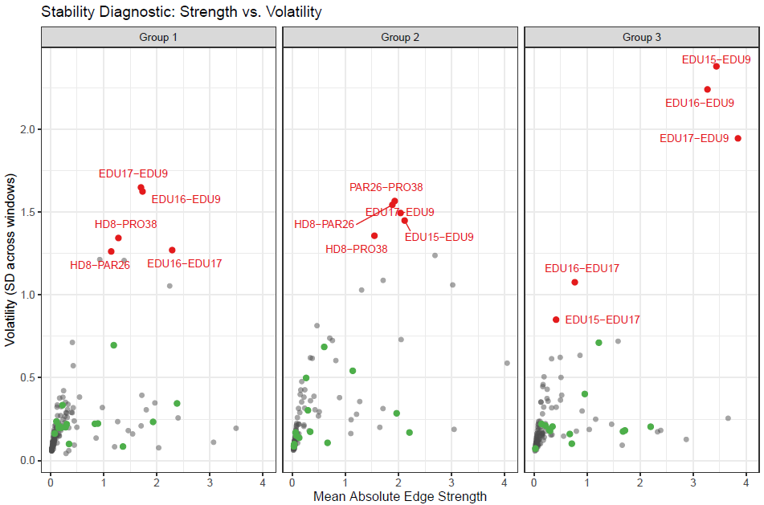
Figure S2: Edge stability diagnostic: mean strength vs volatility across score windows

Analysis 2 - Window Size Sensitivity
To test the sensitivity of our results to the specific window width used, we re-estimated all models using narrower ($W=3$) and wider ($W=7$) windows. To ensure semantic comparability with the original configurations, we did not run unsupervised clustering on the new window samples; instead, individuals in the $W=3$ and $W=7$ sets were assigned to clusters based on their proximity to the medoids identified in the original $W=5$ model. While narrower windows naturally reduce statistical power and filter out peripheral edges, Figure S3 demonstrates that the backbone of the risk network is highly robust: for every edge that remained significant in the alternative specifications, the direction of its effect on recidivism was 100% consistent with the main model (zero sign flips observed). This suggests that while window size affects sensitivity (which edges are detected), it does not alter the substantive interpretation of the risk configurations.
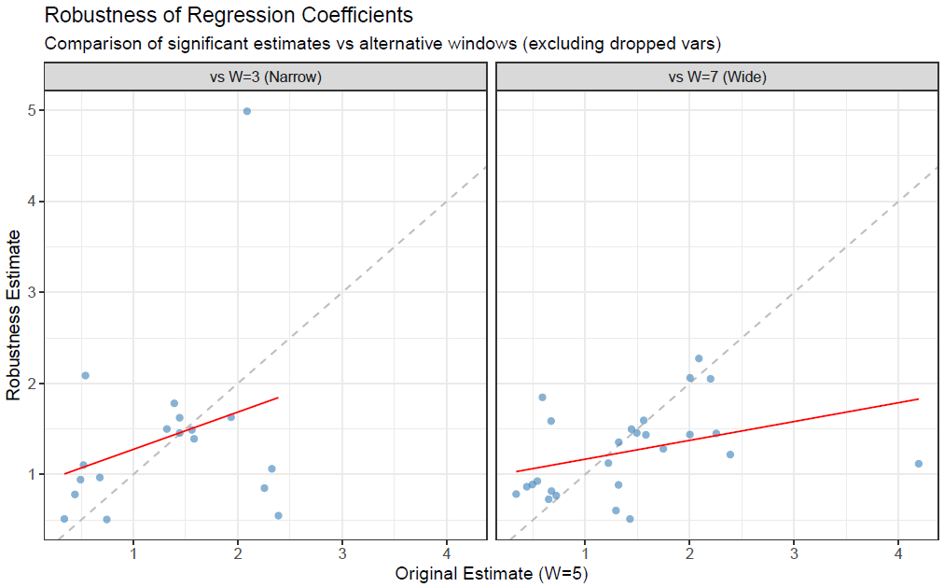
Figure S3: Comparison of coefficient estimates across window widths (W=5 vs W=3/W=7)

Analysis 3 - Robustness to Score Conditioning
A potential concern in score-conditioned analysis is “collider bias”—the possibility that fixing the sum score might induce artificial correlations between items. We addressed this via a rigorous “restricted score” test. For every significant relationship found in the primary model (e.g., between Item A and Item B), we re-ran the entire analysis pipeline using slightly different samples obtained from modified risk scores that specifically excluded Items A and B. Once the samples for each score window were obtained, we re-added the items A and B and constructed k different groups from which the regressions were conducted.
Figure S4 confirms that the definition of risk configurations is not an artifact of the score: cluster assignments under the restricted score models matched the original M3 assignments in 91.6% of cases (using medoid-anchored comparisons). Figure S5 displays the stability of statistical significance: 92.5% of the tested relationships maintained their significance status (Stable or Consistent Non-Sig) even when the score constraint was relaxed. Only a small fraction (Loss) dropped below the significance threshold, which is expected due to the slight loss of information, but no systematic bias was found.
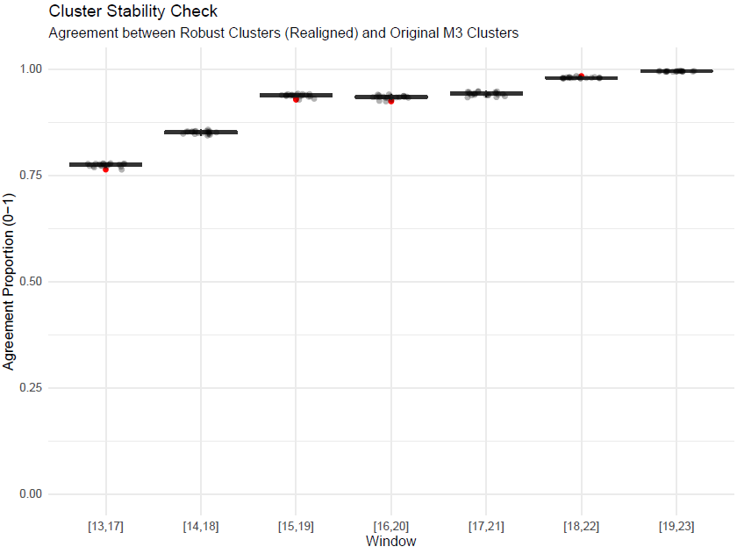
Figure S4: Agreement in cluster assignments under alternative specifications

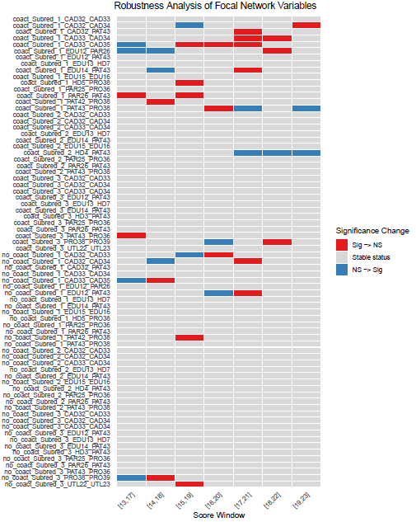
Figure S5: Changes in statistical significance across edge coefficients

