Supplementary Materials
High-Polarization-Extinction Raman Conversion in Gas-Filled Polarization-Maintaining Hollow-Core Fibers
Xianhao Qi,^{1,2} Pau Arcos,^{3,†} Yizhi Sun,^{1,2} Shoufei Gao,^{1,2,4} Wei Ding,^{1,2} David Novoa,^{3,5,6,*}and Yingying Wang^{1,2,4*}
¹ College of Physics & Optoelectronic Engineering, Jinan University, Guangzhou 510632, China
² Guangdong Provincial Key Laboratory of Optical Fiber Sensing and Communication, Institute of Photonics Technology, Jinan University, Guangzhou 510632, China
³ Department of Communications Engineering, University of the Basque Country (UPV/EHU), Bilbao, 48013, Spain.
⁴ Linfiber Technology (Nantong) Co., Ltd., Jiangsu 226010, China
⁵ EHU Quantum Center, University of the Basque Country(UPV/EHU), Bilbao, 48013,Spain.
⁶ IKERBASQUE, Basque foundation for Science, Bilbao, 48009, Spain.
Email: *david.novoa@ehu.eus; *wangyy@jnu.edu.cn

Contents
S1 Theoretical framework 3
S1.1 SRS polarization dependence 3
1.2 Linear approximation of PER around 0 dB 4
2. Experimental and Data Processing Details 4
S2.1 Measurement Procedure for Fiber PER Upper Limit 4
S2.2 Method for Measuring Vibrational Raman PER 5
S2.3 Operational Details for Gas Filling Experiments 5
S2.4 Wavelength-Dependent Fiber Principal Axis (Simulation) 6
S3 Supplementary Data for Vibrational Raman PER Scanning Experiments 7
3.1 Pressure and Pump Parameters for Fibers of Different Lengths 7
3.2 Comparison with Non-PM Fibers 7
S4 Optimization of SRS Experiments Using PM-ARF 8
4.1 Fiber Length 8
S4.2 Gas Pressure 8
S4.3 Pump Power 9
References 10

S1 Theoretical framework

S1.1 SRS polarization dependence
In this section we will introduce how the polarization of the light affects the Raman scattering. Here we analyze the nonlinear polarization element of third order (the one that gives rise the SRS) to understand the very nature of the vibrational scattering. We represent the electric field $\vec{E}(\vec{r},t)$ vector and the nonlinear polarization $\vec{P}(\vec{r},t)$ of the medium as discrete superpositions of a number of different frequency components, that is:
$$\begin{aligned}\vec{E}\left(\vec{r},t\right)=\sum_{m}{ }{\vec{A}}_{m}\left(\vec{r}\right)e^{i\left(\vec{k}\vec{r}+ω_{m}t\right)},\vec{P}\left(\vec{r},t\right)=\sum_{m}{ }{\vec{P}}_{m}\left(\vec{r}\right)e^{i\left(\vec{k}\vec{r}+ω_{m}t\right)},\#\left(1\right)\end{aligned}$$
$$\begin{aligned}E_{-m}=E_{m}^{*};w_{-m}=-w_{m},\#\left(2\right)\end{aligned}$$
where $m$ represent the different frequency components, $A$ is the spatially slowly varying electric field amplitude and $\vec{k}$ is the wave number vector. The $ω_{m}$ represent the different frequency components and
$$\begin{aligned}P_{i,m}=\sum_{pqr}{ }\sum_{jkl}{ }χ_{ijnl}\left(ω_{m};ω_{p},ω_{q},ω_{r}\right)E_{pj}E_{qk}E_{rl}\#\left(3\right)\end{aligned}$$
is the electric field dependent part, where $χ$ is the susceptibility tensor of fourth order.
Here, we are focused in a diatomic molecule (N₂) in a gaseous form. For such material, we assume that is isotropic respect to the electric field.
The $\{i,j,k,l\}$ indices represent the different directions of the fields $\{1,2,3\}$ and $\{p,q,r,m\}$ represent the different frequencies involved. For isotropic materials the only tensor components that are independent are those who have even indices (i.e. $\text{ijkl}$ = 1111, 1122, 1212, 1221). Moreover, $χ_{1111}=χ_{1212}+χ_{1221}+χ_{1122}$ due to symmetry. The formula stands as follows:
$$\begin{aligned}P_{1m}=\sum_{pqr}{ }\left[χ_{1122}E_{p1}E_{q2}E_{r2}+χ_{1212}E_{q2}E_{p1}E_{r2}+χ_{1221}E_{r2}E_{p2}E_{q1}\right]\#\left(4\right)\end{aligned}$$
The sum extends over all available frequency combinations that fulfills $ω_{m}=ω_{p}+ω_{q}+ω_{r}$. In our case we will only have Stokes emission so, the allowed frequencies are $±ω_{S}$ and $±ω_{P}$. The allowed combinations are $ω_{P}=ω_{P}+ω_{S}-ω_{S}$, $ω_{S}=ω_{S}+ω_{P}-ω_{P}$, $ω_{P}=ω_{P}+ω_{P}-ω_{P}$ and $ω_{S}=ω_{S}+ω_{S}-ω_{S}$. If we consider that the susceptibility is independent from any frequency permutation and regroup our terms into vectorial form we get the following expression:
$$\begin{aligned}\begin{aligned}{\vec{P}}_{s}=6\left[χ_{1122}{\vec{E}}_{S}\left({\vec{E}}_{P}⋅{\vec{E}}_{P}^{*}\right)+χ_{1212}{\vec{E}}_{P}\left({\vec{E}}_{S}⋅{\vec{E}}_{P}^{*}\right)+χ_{1221}{\vec{E}}_{P}^{*}\left({\vec{E}}_{S}⋅{\vec{E}}_{P}\right)\right] \\ +3\left[χ_{1122}{\vec{E}}_{S}\left({\vec{E}}_{S}⋅{\vec{E}}_{S}^{*}\right)+χ_{1212}{\vec{E}}_{S}\left({\vec{E}}_{S}⋅{\vec{E}}_{S}^{*}\right)+χ_{1221}{\vec{E}}_{S}^{*}\left({\vec{E}}_{S}⋅{\vec{E}}_{S}\right)\right],\end{aligned}\#\left(5\right)\end{aligned}$$
The terms in the second set of square brackets, which give rise to the nonlinear refractive index but do not contribute to stimulated Raman conversion, can be dropped. It is useful to relate the different susceptibility tensor components with the polarizability anisotropy $γ$ as [1,2]:
$$\begin{aligned}{\vec{P}}_{S}=6\left[\frac{1}{2}\left(a+c\right){\vec{E}}_{S}\left({\vec{E}}_{P}⋅{\vec{E}}_{P}^{*}\right)+\frac{1}{2}\left(a+c\right){\vec{E}}_{P}\left({\vec{E}}_{S}⋅{\vec{E}}_{P}^{*}\right)+b{\vec{E}}_{P}^{*}\left({\vec{E}}_{S}⋅{\vec{E}}_{P}\right)\right],\#\left(6\right)\end{aligned}$$
where $a=c=γ/9$ and $b=0$ since, in our system, the tensor is scalar due to the isotropic nature of the vibrational polarizability. Therefore, with this substitution, the nonlinear polarization yields ${\vec{P}}_{S}=2/3γ{\vec{E}}_{S}({\vec{E}}_{P}⋅{\vec{E}}_{P}^{*})$. We can apply a similar process to the pump component of the polarization and get $\begin{aligned}{\vec{P}}_{P}=2/3γ{\vec{E}}_{S}({\vec{E}}_{S}⋅{\vec{E}}_{P}^{*})\end{aligned}$. Now, if we plug it into the wave equation, the evolution of the Stokes field can be described by the following expression:
$$\begin{aligned}∂_{z}{\vec{E}}_{S}∝{\vec{E}}_{S}\left({\vec{E}}_{P}⋅{\vec{E}}_{P}^{*}\right)∝{\vec{E}}_{S}{\left|E_{P}\right|}^{2}.\#\left(7\right)\end{aligned}$$
Assuming no pump depletion and using the Jones formalism, Eq. (7) becomes polarization independent. Such approximation is backed up with experimental data which shows that the Stokes polarization is never emitted cross-polarized respect to the pump polarization [3], i.e. the Stokes is always co-polarized in vibrational transitions of the Q(1) branch [4].

1.2 Linear approximation of PER around 0 dB
In Section 2 of the main text, we obtained the polarization extinction ratio (PER) for Stokes emission as:
$$\begin{aligned}PER\left(Stokes\right)=\frac{10}{\ln{10}}g_{P}I_{P}L\cos\left(2θ\right),\#\left(8\right)\end{aligned}$$
Its cosinusoidal dependence implies near linear behavior around PER = 0 dB, so if we expand around $θ_{0}={45}^{∘}$ we get:
$$\begin{aligned}\cos\left(2θ\right)≈-2\left(θ-{45}^{∘}\right),\#\left(9\right)\end{aligned}$$
$$\begin{aligned}PER∝-2g_{P}I_{P}L\left(θ-{45}^{∘}\right).\#\left(10\right)\end{aligned}$$
Eq. (10) shows that, in the vicinity of $θ_{0}={45}^{∘}$, the PER slope scales linearly with $g_{P}$, $I_{P}$, and L. As an illustrative example, Fig. S1 confirms that the PER slope gets steeper when we increase the fiber length. This behavior is crucial since these parameters (fiber length, Raman gain, and pump intensity) can be experimentally controlled, enabling access to on-demand Stokes PER and, consequently, enhanced polarization purification.
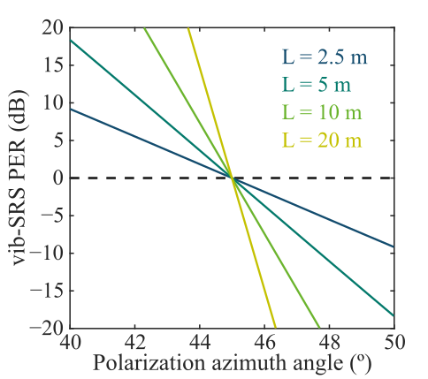
Fig. S1 shows an illustration of the PER variation with the azimuth angle for different fiber lengths.

2. Experimental and Data Processing Details

S2.1 Measurement Procedure for Fiber PER Upper Limit
The Polarization Extinction Ratio (PER) is conventionally used to characterize the purity of linear polarization. It is defined as:
$$\begin{aligned}PER=10\log_{10}\left(\frac{P_{1}}{P_{2}}\right).\#\left(11\right)\end{aligned}$$
Where P₁ and P₂ represent the optical power levels along two orthogonal directions. In this work, we measured the PER using an optical spectrum analyzer (Yokogawa, AQ6370D). The measurement setup is illustrated in Fig. S2. A wavelength-tunable swept laser was employed as the light source. To select the polarization of the free-space light, we utilized a polarizer and an analyzer (Thorlabs, GTH10M). By selecting orthogonal directions, the intensity levels along the different birefringence axes of the fiber were measured. Subtracting the spectrum obtained with the polarizer at ${90}^{∘}$ from that at $0^{∘}$ yields the PER level of the hollow-core fiber at the laser wavelength.
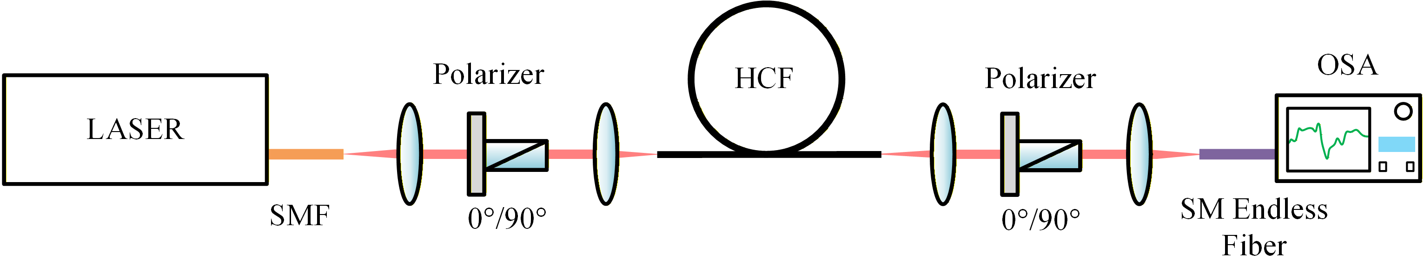
Figure S2: PER measurement process for the hollow-core fiber.
Due to the presence of distributed crosstalk, the measured PER of a Polarization-Maintaining Hollow-Core Fiber (PM-HCF) increases as the fiber length decreases. To determine the upper limit of the PER for the PM-HCF used in our experiments within the vibrational Raman band, we sequentially cut back the fiber to lengths of 5 m, 2 m, 1 m, and 0.5 m for measurement. It is important to note that after each cutback, the optical path required realignment to ensure consistent coupling efficiency.

S2.2 Method for Measuring Vibrational Raman PER
Unlike the setup in Fig. S2, the measurement of vibrational Raman light must be conducted during the Raman generation process. As shown in Fig. S3, an analyzer was inserted after the dichroic mirror (DM). When the half-wave plate was adjusted to the desired angle (during PER scanning experiments), the analyzer was rotated to locate the spectral lines with the strongest and weakest intensities on the spectrometer. By fine-tuning the analyzer, the angular settings corresponding to the maximum and minimum intensities were identified; these angles correspond to the fast and slow axes of the fiber output face. We collected the vibrational Raman signals output from the fiber's fast and slow axes using the spectrometer. The PER data for vibrational Raman scattering were obtained from the spectra collected at the outputs of the fast and slow axes of the fiber, centered at 1415.55 nm. The average values of these PER measurements correspond to the data points presented in Section 3.2, with error bars representing the standard deviation of the PER. All subsequent PER data related to vibrational Raman scattering were acquired using the same methodology.
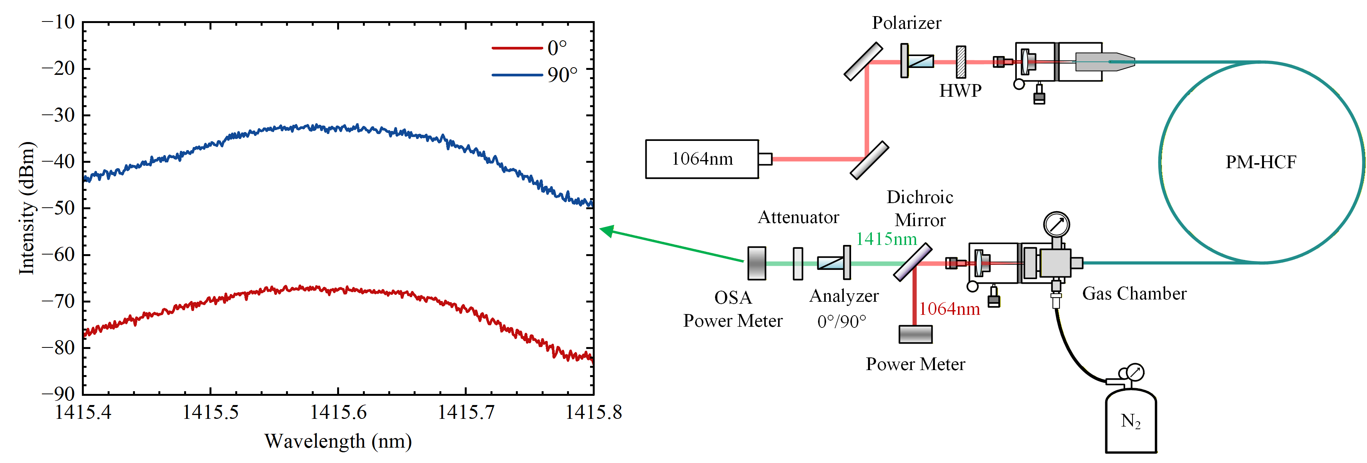
Fig. S3: Experimental setup for the PER scan measurements.
Following multiple sets of vibrational Raman PER measurement experiments, we observed that the angular difference between the fast and slow axes of the PM-HCF used in this work was not exactly ${90}^{∘}$. This deviation corresponds to the imperfections in the actual fiber structure, indicating that the fiber's birefringence axes are not perfectly collinear and orthogonal.

S2.3 Operational Details for Gas Filling Experiments
Due to the varying cross-sectional areas of the microstructured regions within the hollow-core fiber, gas flow rates differ across these regions during filling. This discrepancy leads to pressure differentials between regions, as illustrated by the varying shades of blue at different depths in Fig. S4a. Consequently, it is necessary to equilibrate the air pressure among the various regions to prevent structural collapse of the thin microstructured walls caused by pressure gradients.
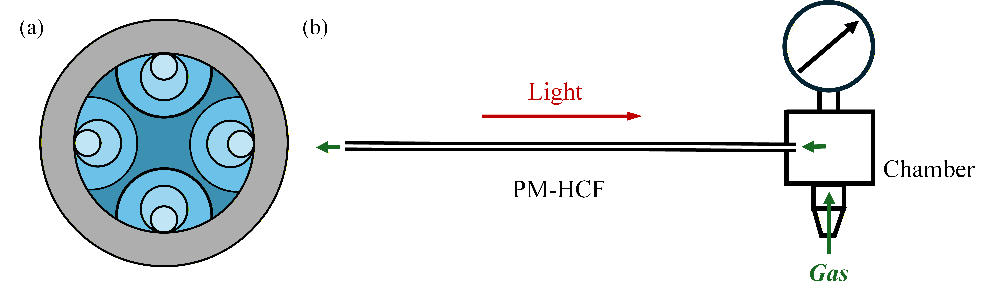
Fig. S4: Fiber End-Face and Gas Filling Process. a. Pressure gradient within the fiber. b. Process of filling the gas cell and fiber.
To reduce back-reflection, improve fiber coupling efficiency, and facilitate fiber cut-back for varied measurements, this work employed a single gas cell, creating a semi-sealed gas environment, as shown in Fig. S3b. A pressure gradient exists along the fiber, with higher pressure near the gas cell and lower pressure further away. We estimated the flow rate of gas molecules in different regions based on the approximation of the Poiseuille equation [5] within a continuous medium as:
$$\begin{aligned}Q=\frac{πr^{4}}{8ηL}ΔP.\#\left(12\right)\end{aligned}$$
The volume of a capillary section is given by:
$$\begin{aligned}V=πr^{2}L.\#\left(13\right)\end{aligned}$$
The time required for pressure equilibration in a region can be estimated from $t=V/Q$.
Based on calculations, to balance the pressure difference across different regions of this specific fiber, a waiting time of no less than 20 minutes was required after each pressure increase not exceeding 3 bar. In this work, during gas filling, the pressure was increased stepwise to 2 bar, 4 bar, 6 bar..., waiting for 30 minutes after each increment.

S2.4 Wavelength-Dependent Fiber Principal Axis (Simulation)
For PM-HCF, the actual fiber structure is not perfectly symmetric, causing the birefringence principal axes to exhibit an offset angle. This offset angle is wavelength-dependent. To investigate the orientation of the principal axes of the PM-HCF used in our experiments at the pump wavelength and the vibrational Raman wavelength, we performed finite element simulations of the actual fiber structure using COMSOL software. By calculating the modes at the precise pump wavelength (1065.45 nm) and the precise vibrational Raman wavelength (1415.55 nm), we obtained the principal axis orientation relationship shown in Fig. S5.
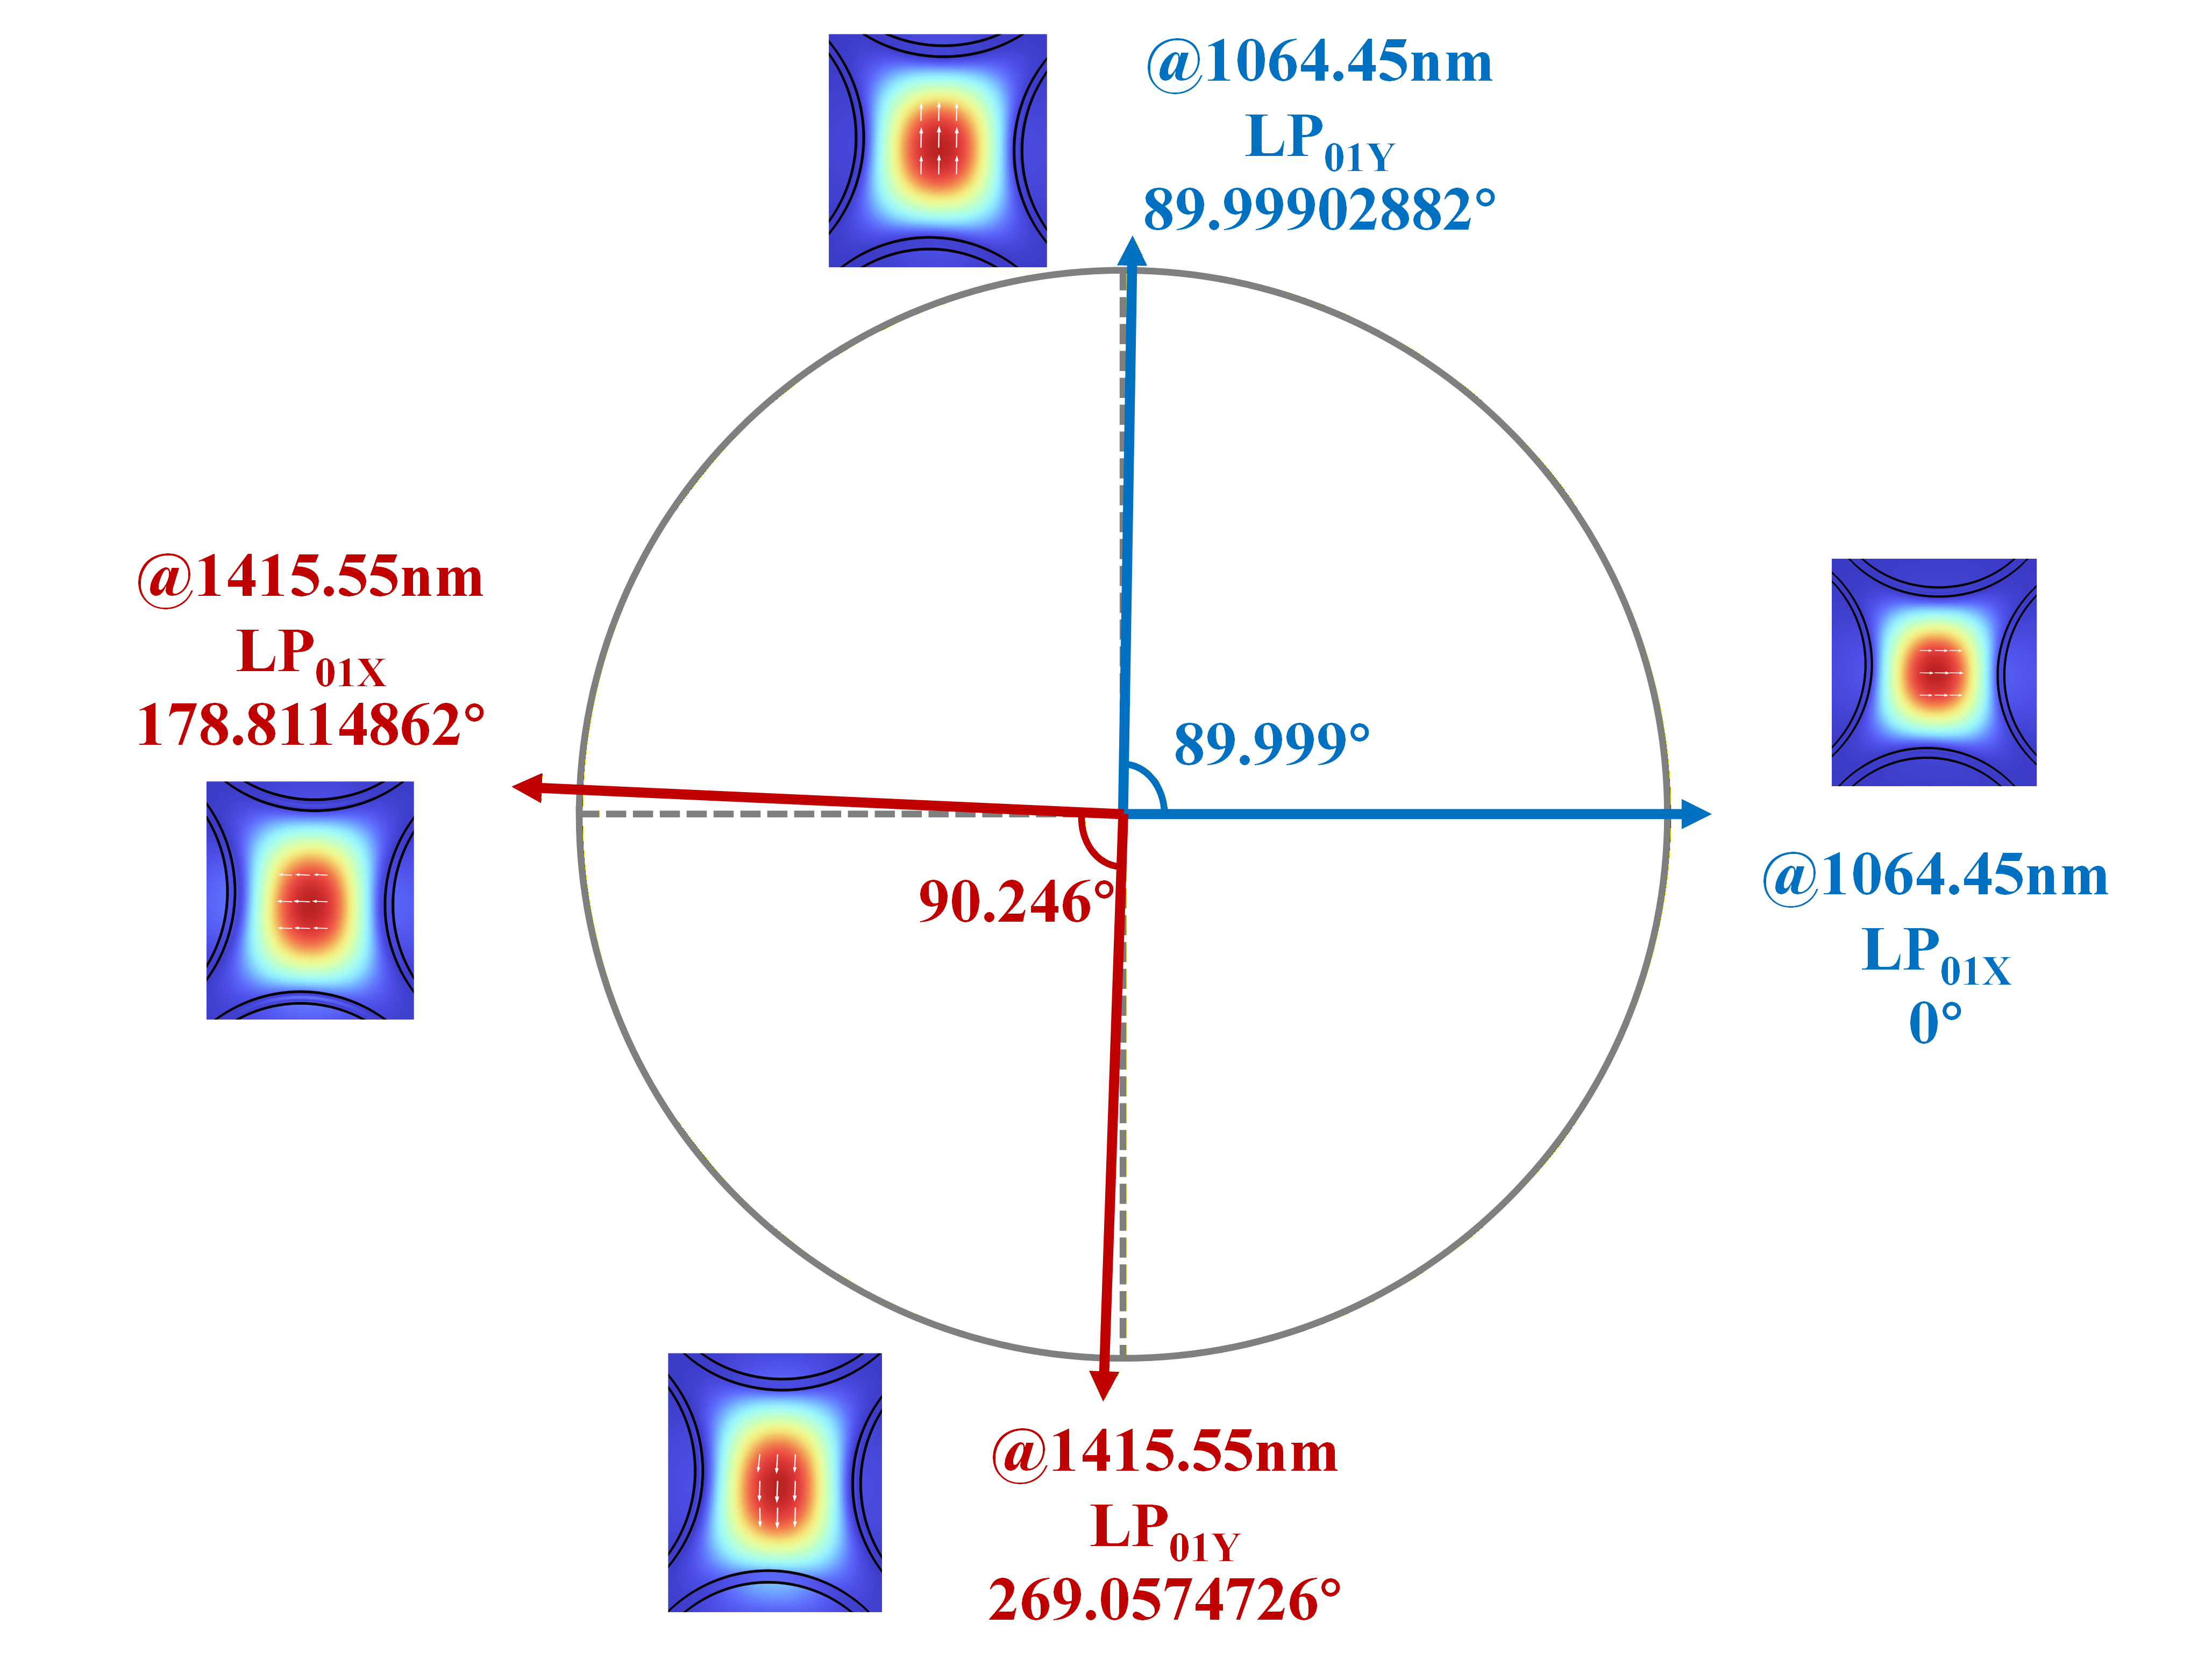
Fig. S5: Fiber principal axes calculated via finite element simulation.
We calibrated the principal axis angles for the pump and vibrational Raman waves using the polarization electric field direction of the LP_{01X} mode at the pump wavelength as the $0^{∘}$ reference. The calculations reveal that neither the polarization principal axis of the pump nor that of the vibrational Raman wave is perfectly at ${90}^{∘}$, which aligns with the phenomena observed in our experiments. According to the simulation results, the LP_{01X} polarization principal axis at 1064 nm and 1415 nm has a relative offset of ${1.189}^{∘}$. For the LP_{01Y} mode, the relative offset is ${0.942}^{∘}$.

S3 Supplementary Data for Vibrational Raman PER Scanning Experiments

3.1 Pressure and Pump Parameters for Fibers of Different Lengths
For the vibrational Raman PER experiments with different fiber lengths (Section 3.2 of the main text), we employed different gas pressures and pump intensities. This was necessary to excite sufficient vibrational Raman signals for characterization. The gas pressures and pump intensities used for different fiber lengths are listed in Supplementary Table 1.
Supplement Table 1. Experimental parameters and Vibrational Raman output.
Fiber length(m) | Gas pressure(bar) | Effective pump power (mW) | Vibrational Raman power at 0° (mW)
10 | 8 | 102 | 7.79
5 | 10 | 104 | 6.45
2.5 | 22 | 129 | 19.36
2 | 24 | 105 | 4.64

3.2 Comparison with Non-PM Fibers
When conducting comparative SRS excitation experiments using non-PM fibers (Section 4 of the main text), we characterized the vibrational Raman PER and power output, as shown in Fig. S6.
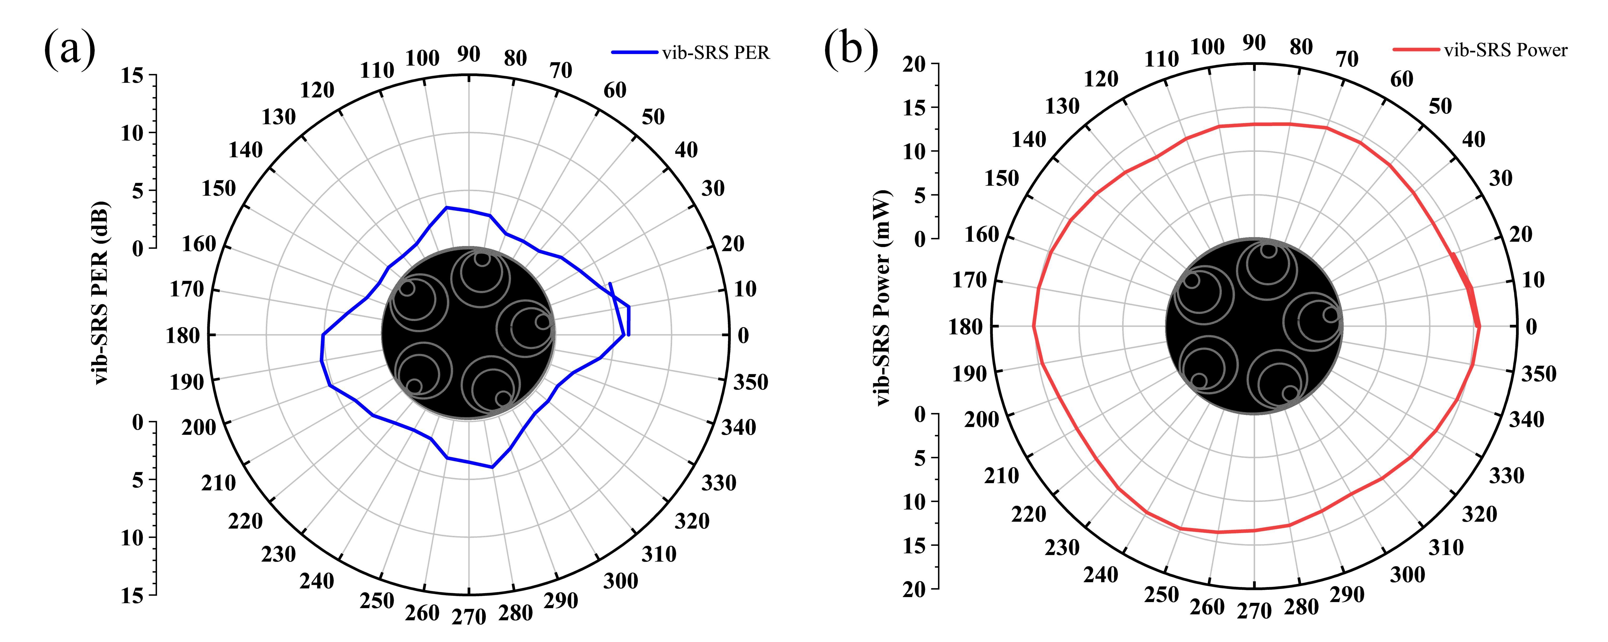
Fig S6: SRS experiments using non-PM fiber for linear polarization azimuth scanning. a. Relationship between vibrational Raman PER and incident polarization azimuth. b. Relationship between vibrational Raman power and incident polarization azimuth.
PER scanning was performed by varying the linear polarization azimuth. The variations of vibrational Raman PER and power with the polarization azimuth are presented in Fig. S6. In non-PM fibers, the vibrational Raman signal still exhibits some regular periodicity with the polarization azimuth; the Raman PER excited at the point of highest power is typically the strongest (5.9 dB), while the absolute value of the Raman PER at the lowest power point is closest to 0 dB. Furthermore, the fluctuation of vibrational Raman power with the pump azimuth is minimal, ranging between 12 and 15 mW.
The periodicity of the Raman light in non-PM fiber with respect to the pump azimuth arises because non-PM fibers still possess a weak degree of birefringence. Consequently, generalized birefringence axes exist. When the pump azimuth is parallel to these birefringence axes, stronger vibrational Raman gain is generated, resulting in higher power and PER levels for the excited vibrational Raman light. However, compared to the intense and significant PER periodicity observed in PM fibers, the excitation efficiency and PER purity in non-PM fibers are significantly inferior.

S4 Optimization of SRS Experiments Using PM-ARF
To explore the achievable Quantum Efficiency (QE) for SRS using the PM-ARF, we optimized the fiber length, gas pressure, and pump power.

4.1 Fiber Length
In the initial phase of this work, we conducted SRS experiments using a 10 m fiber. Due to the excessive fiber length, rotational Raman scattering was inevitably excited, accompanied by severe cascading phenomena. The spectrum is shown in Fig. S7a, where rotational Raman cascade lines pumped by the vibrational Raman signal appeared in the 1400 nm–1450 nm range.
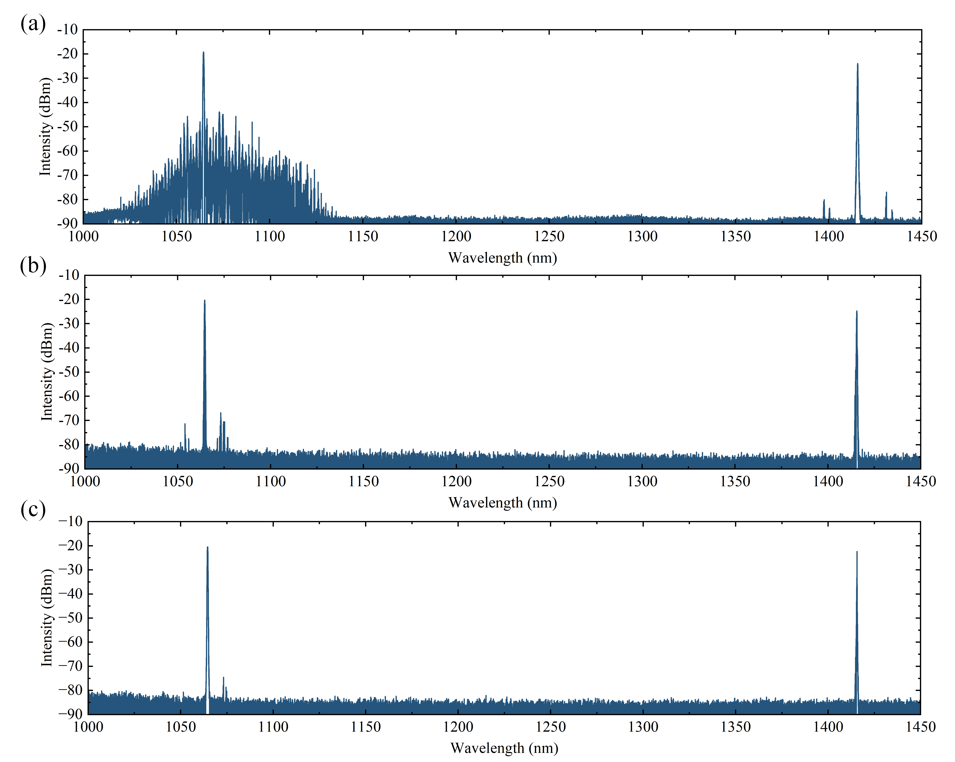
Fig. S7: Spectra from Gas SRS Experiments Using Fibers of Different Lengths. a. Excitation spectrum with 10-meter fiber. b. Excitation spectrum with 6-meter fiber. c. Excitation spectrum with 5-meter fiber.
Following multiple optimizations of the fiber length, we found that a 5 m length yielded relatively pure vibrational Raman light. Only minimal rotational lines appeared near the pump (~80 dB), which were negligible. To filter out the effects of interference between rotational and vibrational lines and to ensure efficient Raman conversion, the high-conversion-efficiency experiments were conducted at a length of 5 meters.

S4.2 Gas Pressure
Using the 5 m PM fiber with an effective average pump power of 141 mW, we increased the gas pressure and recorded the power and PER at different pressures. As shown in Fig. S8a, the vibrational Raman power increased with pressure, accompanied by a decrease in residual pump power. During the pressurization process, the vibrational Raman PER was maintained at 30-35 dB, while the pump PER decreased to approximately 15 dB as the pressure increased. At 34 bar, cascaded rotational Raman scattering pumped by the vibrational Raman signal began to appear (Fig. S8b). Consequently, the pressure was not increased further. At this point, the QE was 66.40%.
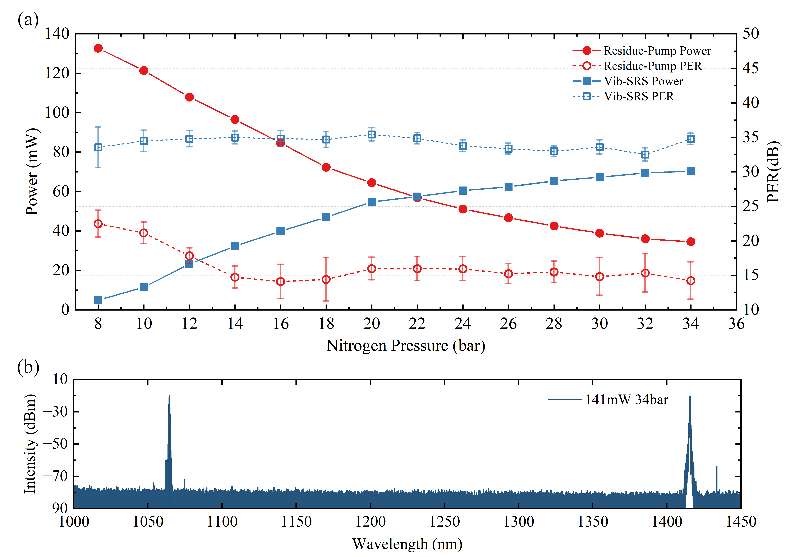
Fig. S8: Raman Conversion versus Gas Pressure. a. Vibrational Raman conversion versus increasing gas pressure. b. Output spectrum of the fiber at 34 bar.

S4.3 Pump Power
Maintaining the gas chamber pressure at 34 bar, we varied the laser power (the microchip laser used in this work requires adjusting the input current intensity to change the laser power). The effective pump power was increased from 100 mW to 170 mW, exciting vibrational Raman light of varying intensities. Fig. S9a displays the excitation under different pump intensities. Notably, an effective pump power of 141 mW corresponds to 7700 mA; when the pump power exceeded 141 mW, cascaded rotational Raman scattering emerged.
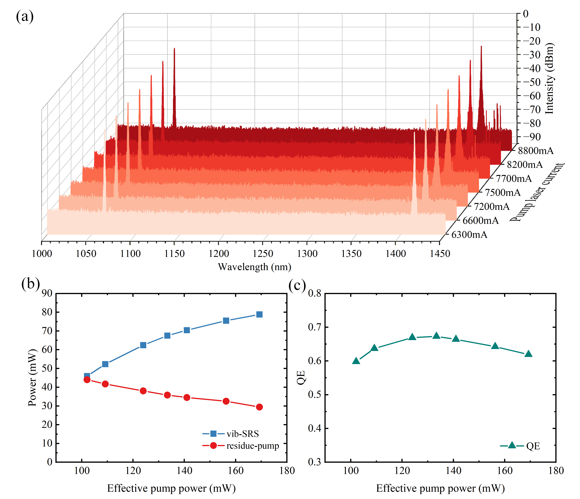
Fig. S9: Raman Conversion versus Pump Power. a. Spectra at different pump power levels. b. Vibrational Raman and residual pump power versus pump power. c. Vibrational Raman Quantum Efficiency versus pump power.
Supplementary Table S2 illustrates the relationship between pump current and effective pump power. Combined with Fig. S9b, the highest vibrational Raman power (average power of 78.8 mW) was achieved at a pump intensity of 169.3 mW. However, the highest vibrational Raman quantum efficiency (67.29%) was observed at 133.4 mW. As the pump intensity increased further, a portion of the energy was transferred to the cascaded rotational Raman modes. Thus, indiscriminately increasing the pump intensity eventually leads to a reduction in quantum efficiency.
Supplement Table 1. Pump current and vibrational Raman conversion performance.
Laser current(mA) | Effective pump power (mW) | Vib-SRS power (mW) | Residue-pump power (mW)
6300 | 102.1 | 45.9 | 44.0
6600 | 109.2 | 52.3 | 41.7
7200 | 124.0 | 62.4 | 38
7500 | 133.4 | 67.5 | 35.8
7700 | 141.0 | 70.4 | 34.5
8200 | 156.3 | 75.5 | 32.5
8800 | 169.3 | 78.8 | 29.4
Through this series of experiments, we demonstrated frequency conversion achieving both high quantum efficiency (max QE = 67.29%) and high linear polarization purity (PER ~35 dB).

References
- Minck, R. W., Hagenlocker, E. E. & Rado, W. G. Stimulated pure rotational Raman scattering in deuterium. Phys. Rev. Lett. 17, 229 (1966).
- Landau, L. D. et al. Electrodynamics of continuous media. (Elsevier, 2013).
- Yu, Y. et al. Precise measurement of the depolarization ratio from photoacoustic Raman spectroscopy. J. Raman Spectrosc. 38, 1206–1211 (2007).
- Clark, R. J. H. & Long, D. A. Raman spectroscopy. (McGraw-Hill, New York, 1977).
- Poiseuille, J. L. Recherches expérimentales sur le mouvement des liquides dans les tubes de très-petits diamètres. (Imprimerie Royale, 1844).

