Supplementary Information
Microfluidic-assisted 3D-printed eye (MAP-eye): a biomimetic ommatidium array with direct full-colour 3D to 2D panoramic imaging and position tracking
Bo Dai^{1,†}, Liang Zhang^{1,†}, Chenglong Zhao^{2,3†}, Hunter Bachman⁴, Ryan Becker⁵, John Mai⁶, Ziao Jiao¹, Wei Li¹, Lulu Zheng¹, Xinjun Wan¹, Tony Jun Huang⁴*, Songlin Zhuang¹, and Dawei Zhang^{1,7}*

¹ Engineering Research Center of Optical Instrument and System, the Ministry of Education, Shanghai Key Laboratory of Modern Optical System, University of Shanghai for Science and Technology, Shanghai, 200093, China
² Department of Physics, University of Dayton, Dayton, OH 45469, USA
³ Department of Electro-Optics and Photonics, University of Dayton, Dayton, OH 45469, USA
⁴ Department of Mechanical Engineering and Materials Science, Duke University, Durham, NC 27709, USA
⁵ Department of Biomedical Engineering, Duke University, Durham, NC 27709, USA
⁶ Alfred E. Mann Institute for Biomedical Engineering, University of Southern California, Los Angeles, CA 90089, USA
⁷ Shanghai Institute of Intelligent Science and Technology, Tongji University, China

† These authors contributed equally: Bo Dai, Liang Zhang, Chenglong Zhao
* Correspondence and requests for materials should be addressed to T.J.H. (email: tony.huang@duke.edu) or D.Z. (email: dwzhang@usst.edu.cn)

Supplementary Notes

Microfluidic-assisted moulding used in the MAP-eye fabrication
The MAP-eye consists of two main components: a single hemispherical substrate with silicone waveguides throughout it to guide the light to the image sensor, and a regular array of microlenses within posts which protrude from the surface of the hemisphere and collect the light. The structure of the microlenses and the cylindrical posts on the hemispherical surface of the MAP-eye are formed by microfluidic-assisted moulding via complementary replication of the mould structure shown in Fig. 1f of the main text. Since the lenses and posts are critical for properly collecting and transmitting light into the waveguides underneath, the formation of convex microlenses on the surface of the hemisphere is a critical step for a properly functioning MAP-eye.
The formation of the 3D microlens arrays is realized using a microfluidic-assisted moulding technique. First, a mould with an open hemispherical pit is 3D printed with microholes distributed across its surface. Then, the hemispherical pit is filled with acrylate resin. After that, the mould is spun at a spin rate of Ω rpm. The theoretical model of the mould formation is explained in the next section. When the rotational speed was larger than a critical value Ω_{c}=1,385 rpm, no acrylate resin remained within the main hemispherical pit of the mould, and all of the resin that remained was contained within the microholes. Therefore, spinning the mould above this threshold value ensured that resin only remained within the holes, where the curved fluid-air interface could then be cured to form the requisite lens surfaces.
The acrylate resin that remains in each cylindrical microhole is subject to gravity, a centrifugal force, and surface tension, and understanding how these forces contribute to the finalized geometry is critical to successful MAP-eye fabrication. The numerical simulations for the analysis of the acrylate resin in the microholes at different orientations (α) within a spinning mould and after the spinning are presented in Fig. 2b and Fig. S5. The surface of the liquid-state acrylate resin in an on-axis microhole (α=0º) deforms symmetrically around the spinning axis and forms a parabolic shape. The surface of the liquid-state acrylate resin in the off-axis microholes (α≠0º) shows a gradual tilt towards the outer part of the microhole as the angle α increases. When the spinning stops, the centrifugal force vanishes and the effect of gravity on the liquid surface can be neglected because the diameter of the microhole is much smaller than the capillary length,$l_{c}=\sqrt{γ/\left(ρg\right)}$, where γ is the acrylate resin-air surface tension (γ=31×10⁻³ N/m), ρ is the density of the acrylate resin (ρ=1.02×10³ kg/m³), and g is the acceleration due to gravity (g=9.8 m/s²). Thus, the surface tension plays a dominate role to deform the surface of the acrylate resin into a concave shape within the microholes. The curvature of the concave acrylate resin is the same regardless of the orientation of the microhole. In this regard, each microhole can be treated as an individual capillary tube, where the concave surface of the acrylate-resin fluid is determined by the interaction of the interfacial tension of the acrylate resin (liquid phase), the sidewall of the microhole (solid phase), and the air above the acrylate resin (gas phase). Therefore, the curvature radius of the concave surface can be expressed as $R=d/\left(2cos⁡\left(θ_{e}\right)\right)$, where θ_{e} is the contact angle between the three phases under thermodynamic equilibrium. Consequently, the convex lenses can be formed by placing the hemispherical eye into the mould, and curing a silicone elastomer into the shape of the lens and waveguides. The curvature of the convex lenses is identical to those of the concave surface of the acrylate resin within the microholes but have opposite sign (Fig. 2c-e).
We have demonstrated empirically and through numerical simulations that this microfluidic-assisted moulding process yields a desired convex microlens on top of cylindrical posts of various lengths. Each of these posts is connected to the bottom flat surface of the MAP-eye through a waveguide, using the same material and is hence perfectly optically matched. The diameter of each cylindrical post is slightly larger than that of the connecting waveguides to increase the contact area between the outer portion (the microlens/post system) and the internal structures (hemispherical substrate/optical pathways) for safely demoulding the substrate. This variation in diameter has a low influence on the efficiency of light coupling into the waveguide because the light is converged at the central area of the waveguide (Fig. 1b and Fig. 3i).

Theoretical model of the mould formation
We have developed a two-stage analytical model for the mould formation. The first stage is when the mould is spinning. The centrifugal force plays an important role, resulting in microholes that are partially filled with acrylate resin. In dynamic equilibrium, the surface of the acrylate resin remaining in a microhole with an orientation of α can be described as follows:
$$z_{Spin}_α\left(Ω\right)=\frac{Ω^{2}\left(x^{2}+y^{2}\right)}{2g}-\frac{Ω^{2}D^{2}\sin^{2}\left(\left|α\right|+φ\right)}{8g}+\frac{1}{2}\sqrt{D^{2}-d^{2}}+\frac{d}{2}cos\left(\left|α\right|\right)tan\left(δ\right)+\frac{D}{2}\left(cos\left(\left|α\right|\right)-cos\left(\left|α\right|+φ\right)-1\right)+Hcos\left(\left|α\right|\right)-\sqrt{\frac{{\left(dcos\left(\left|α\right|\right)tan\left(δ\right)+2Hcos\left(\left|α\right|\right)\right)}^{2}-d^{2}\tan^{2}\left(δ\right)}{4}+\frac{d^{2}}{4\cos^{2}\left(δ\right)}-x^{2}-{\left(y+\frac{D}{2}sin\left(\left|α\right|\right)\right)}^{2}-H^{2}+sin\left(\left|α\right|\right)\left(y+\frac{D}{2}sin\left(\left|α\right|\right)\right)\left(dtan\left(δ\right)+2H\right)-dH}tan\left(δ\right)$$
(1)
where Ω is the spin rate, D is the diameter of the hemispherical pit in the mould, d is the diameter of the microhole, g is gravitational acceleration, H is the depth of the microhole, φ=arcsin(d/D) and δ=α-arctan(Ω²d/2g)+90º.
To avoid leaving any residual acrylate resin in the hemispherical pit, the rotational rate should be higher than a critical value, Ω_{c}, which has the form:
$Ω_{c}=\sqrt{\frac{32g}{3D}}$ (2)
The rotational rate is inversely proportional to the amount of acrylate resin left in the microholes. At a very high spin speed, too little acrylate is left in the microholes, which makes it difficult to form a curved surface. Thus, the volume of the residual acrylate resin in any microhole, V_{Spin_α_Residual}, should be no less than the volume, V_{Static_min}, which is sufficient to form a continuous concave surface in the microhole after spinning, i.e. V_{Spin_α_Residual}≥V_{Static_min}.
$V_{Spin_α_Residual}\left(Ω\right)=\int_{-d/2}^{d/2}{\int_{-d/2}^{d/2}{Z_{Spin_α}\left(Ω\right)dXdY}}$ (3)
and
$V_{Static_min}=\frac{{πd}^{3}}{8}\left(\frac{90º-θ_{e}}{135{º×cos}^{3}\left(θ_{e}\right)}-\frac{tan\left(θ_{e}\right)}{3}\right)$ (4)
where
$\left[\begin{matrix}X \\ Y \\ Z_{Spin_α}\left(Ω\right)\end{matrix}\right]=\left[\begin{matrix}1 & 0 & 0 \\ 0 & cos\left(α\right) & sin\left(α\right) \\ 0 & -sin\left(α\right) & cos\left(α\right)\end{matrix}\right]\left[\begin{matrix}x \\ y \\ z_{Spin_α}\left(Ω\right)\end{matrix}\right]$ (5)
and θ_{e} is the contact angle between the acrylate resin, cured photosensitive polymer and air under a thermodynamic equilibrium. The volume of the residual acrylate resin in the microholes can be numerically calculated for any given spin rate. Thus, the maximum spin rate can be calculated.
The second stage of this model is after spinning. Each microhole acts as a capillary tube. The capillary effect acts to curve the surface of the residual acrylate resin in the microhole. The curvature of the acrylate resin surface is:
$R=\frac{d}{2cos⁡\left(θ_{e}\right)}$ (6)
Above this concave surface, there is a section of cylindrical vacancy due to the loss of the acrylate resin during spinning. The depth of this vacant cylinder, i.e. the height of the post under the microlens, is
$h_{Post}=H-\frac{4V_{Spin_α_residual}}{πd^{2}}-\frac{d}{2}\left(\frac{90º-θ_{e}}{135º×\cos^{3}\left(θ_{e}\right)}-\frac{tan\left(θ_{e}\right)}{3}\right)$ (7)
In static equilibrium, the location of the surface of the acrylate resin becomes
$$z_{Static_α}\left(Ω\right)=\sqrt{\frac{d^{2}}{4\cos^{2}\left(θ_{e}\right)}-x^{2}-{\left(y-sin\left(α\right)\left(\frac{D}{2}cos\left(φ\right)+h_{Post_α}+dtan\left(θ_{e}\right)-\frac{d}{cos\left(θ_{e}\right)}\right)\right)}^{2}}+\frac{D}{2}+H-\frac{d}{2}tan\left(φ\right)-cos\left(α\right)\left(\frac{D}{2}cos\left(φ\right)+h_{Post_α}+dtan\left(θ_{e}\right)-\frac{d}{cos\left(θ_{e}\right)}\right)$$
(8)
In the design of the MAP-eye, the diameter of the microholes in the mould should be less than the capillary length, i.e. $l_{c}=\sqrt{γ/\left(ρg\right)}$, where γ is the surface tension at the acrylate resin-air interface, and ρ is the density of the acrylate resin. Thus, the resulting structure of the microlens array and the posts can be predicted based on this model. In order to realize relatively uniform posts, a spin rate which is slightly higher than the critical spin rate is used in practice.

Design of the hemispherical substrate of the MAP-eye
Fig. S3 depicts the design procedure for the hemispherical substrate. The size of the MAP-eye, the diameter of the waveguide proximal ends, d_{B}, and the distribution pattern of the ommatidia are first determined. Then, the distribution of waveguide exits at the flat bottom of a hemisphere need to be arranged. After that, the routing of hollow pipelines within the hemisphere is performed using the following design rules.
An auxiliary axis, labelled as the w-axis, passes through the origin point of the hemisphere and the centre of a waveguide end (on the flat bottom) for a specific ommatidium. This yields a cross section of the hemisphere defined by the wz-plane. In this cross section, two edges of the waveguide end (as it exits the flat bottom of the substrate) are marked as A and A’. On the hemisphere, two edges of an opening hole, marked as B and B’, are located where OB and OB’ cut the hemisphere with angles of θ and θ’ with respect to the z-axis. The angles can be calculated as follows.
$$θ=\frac{2L_{OA}}{D}×90°$$
$$θ'=\frac{2L_{OA'}}{D}×90°$$
where L_{OA} and L_{OA’} are the distance from the origin point to point A and point A’, respectively. Afterwards, two perpendicular bisectors of the lines AB and A’B’ are plotted as auxiliary lines CD and C’D’. The points D and D’ are the points where CD and C’D’ intersect with the w-axis. The boundaries of the pipelines, i.e. the curves and , are determined with D and D’ as the centre points and AD and A’D’ as radii, respectively. Consequently, all the remaining pipelines can be designed by repeating the above steps. Hence, the direction of the opening of the pipeline on the hemisphere surface actually determines the angular orientation of the ommatidium. The polar angle, α, is (θ+θ’)/2 and the azimuthal angle, β, is the angle of intersection between the x-axis and w-axis.

Supplementary Figures

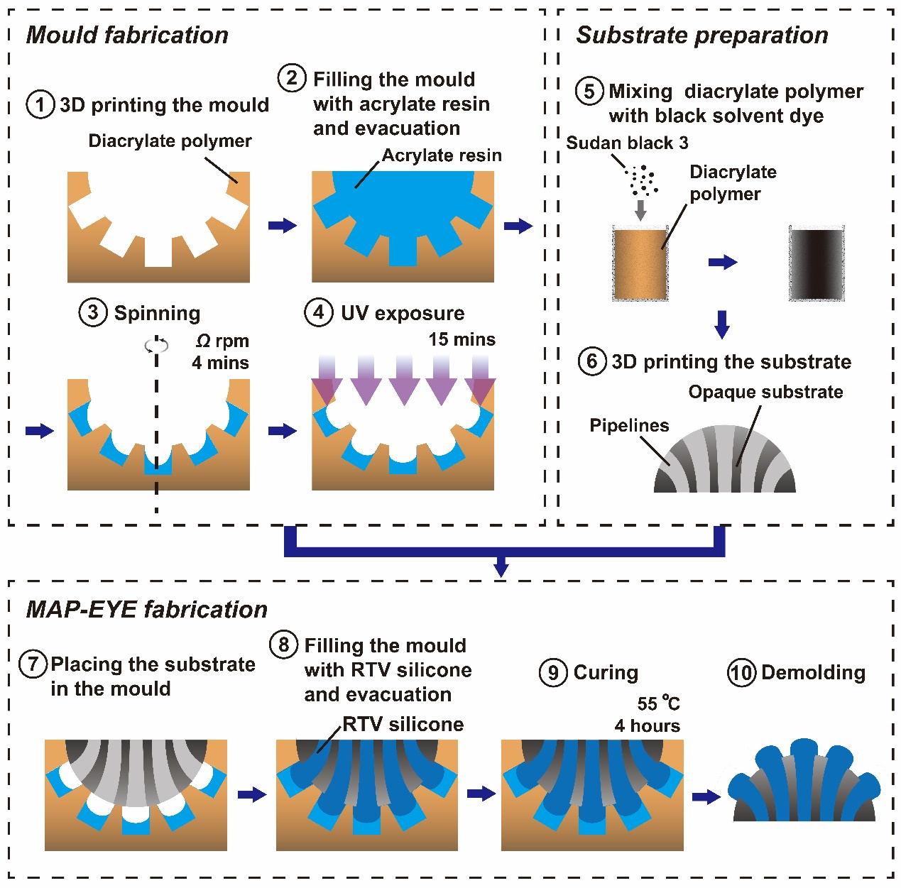
Figure S1: Fabrication procedure of the mould and the MAP-eye.

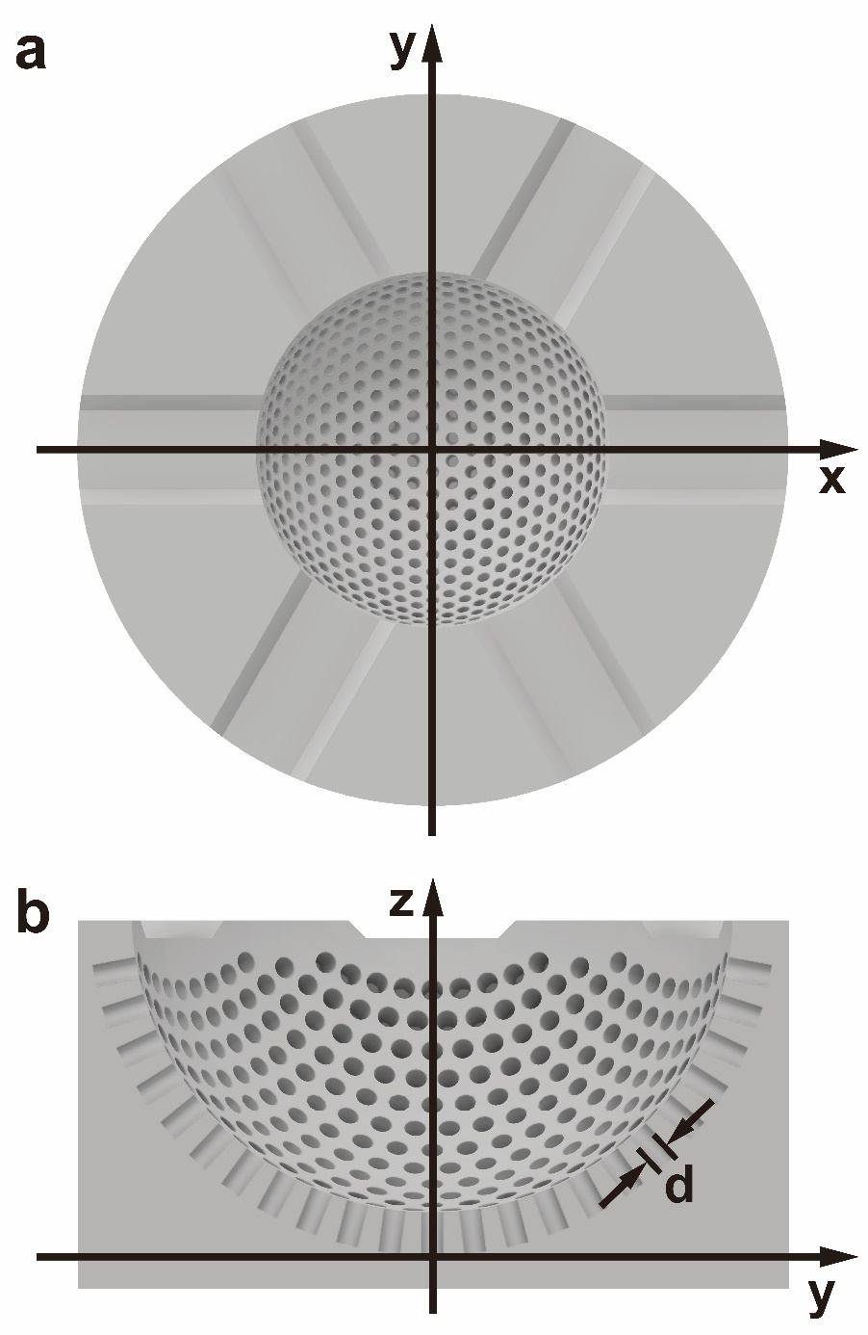
Figure S2: 3D model of the mould. a, Top view of the substrate. b, Cross section of the substrate.

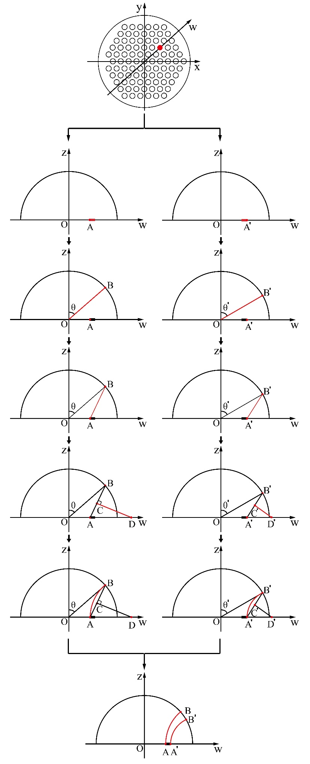
Figure S3: Design procedure of the substrate.
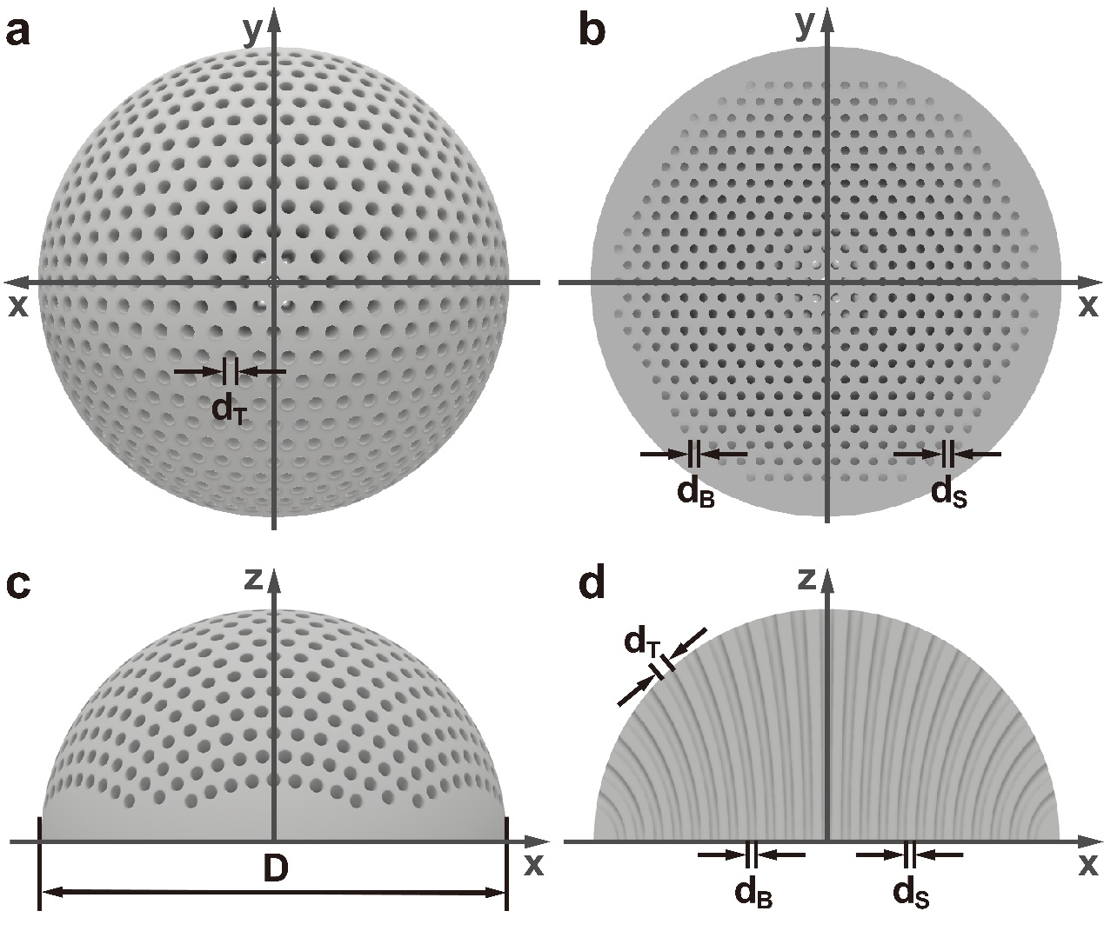
Figure S4: 3D model of the substrate. a, Top view of the substrate. b, Bottom view of the substrate. c, Side view of the substrate. d, Cross section of the substrate.

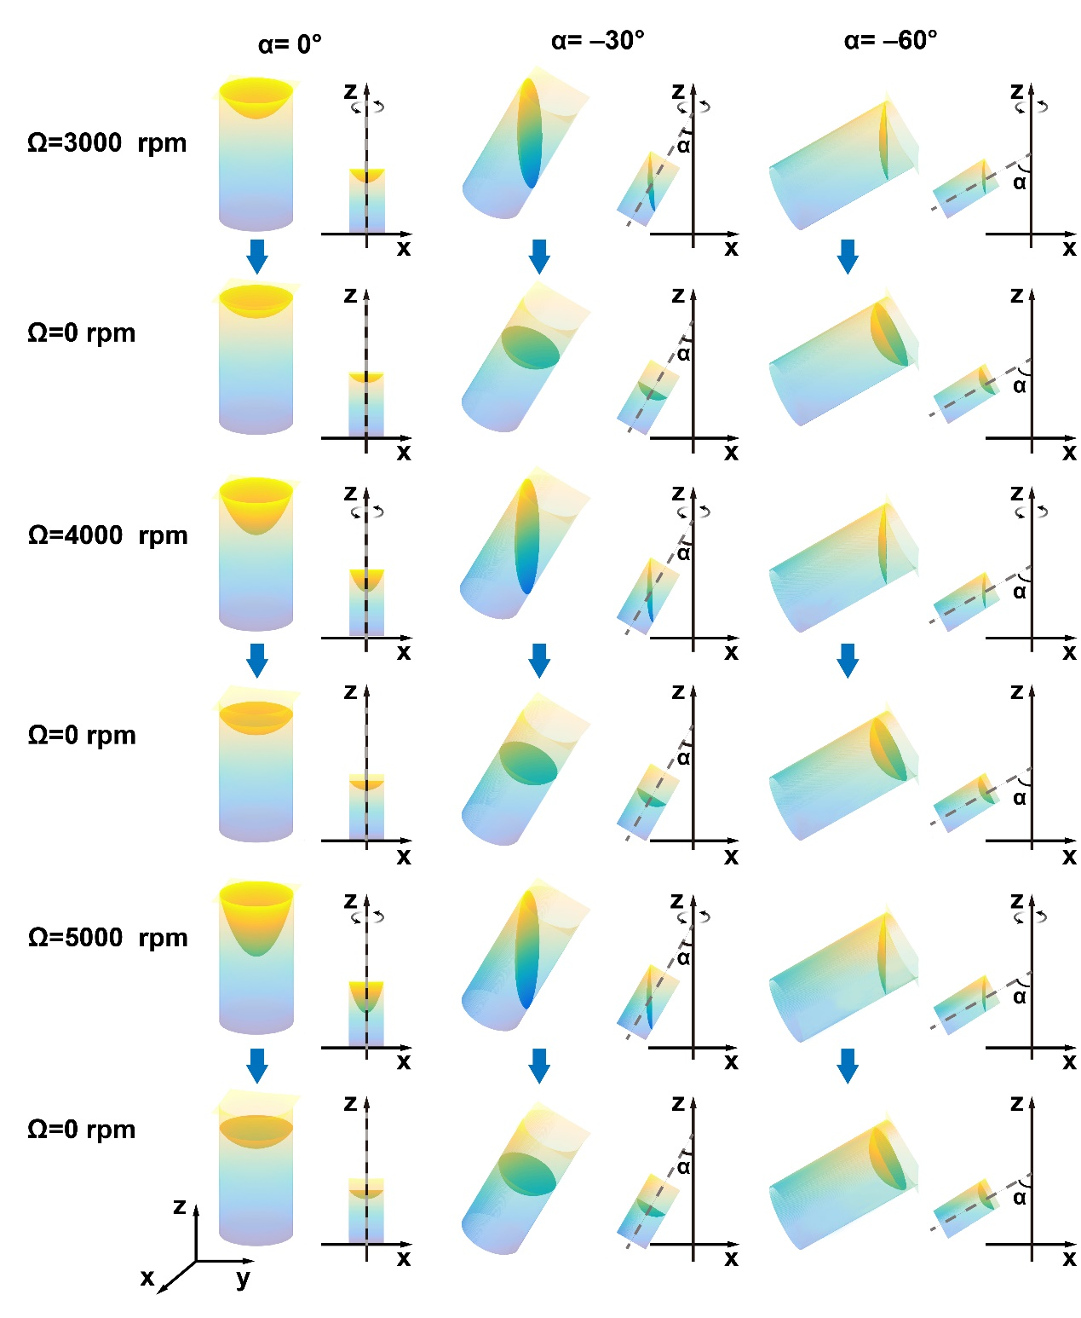
Figure S5: Surface profile of the acrylate resin in microholes with different orientations during the spinning process at different spin rates (in dynamic equilibrium) and after spinning (in static equilibrium).

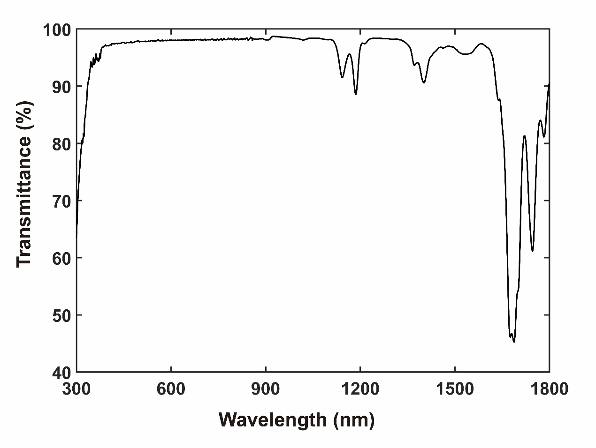
Figure S6: The optical transmission spectrum of the RTV silicone.

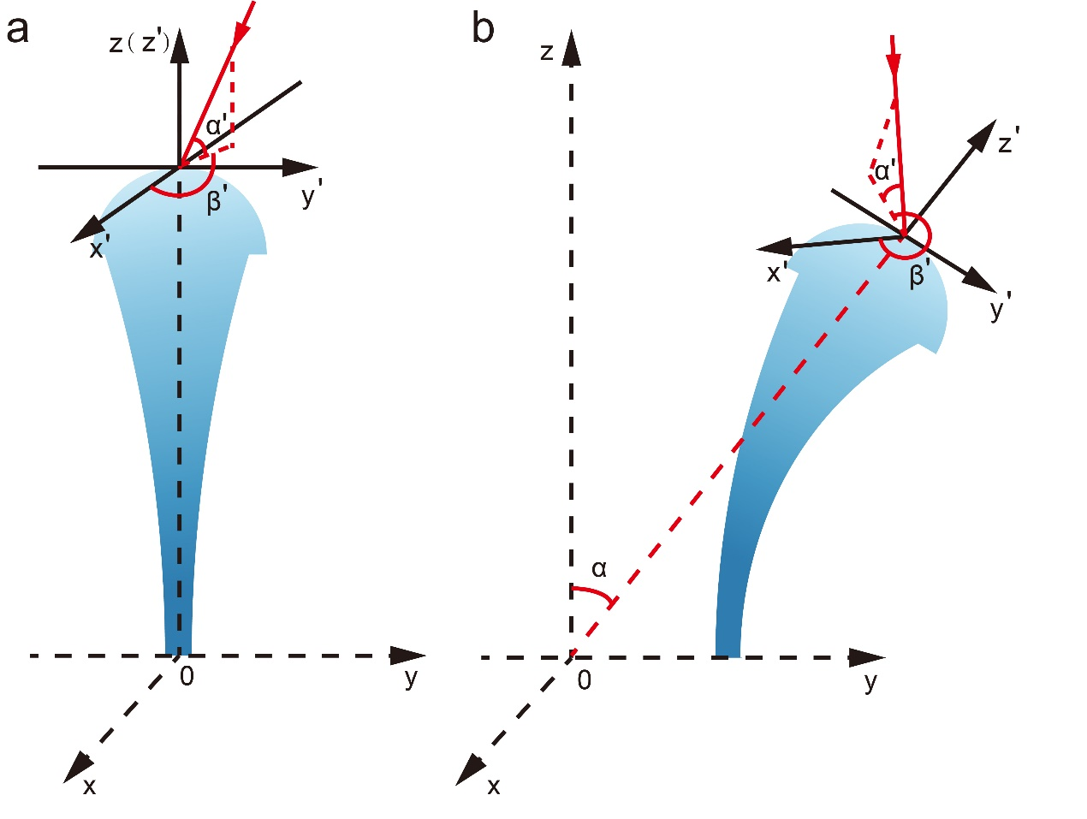
Figure S7: The coordinate system used for angular sensitivity measurements.

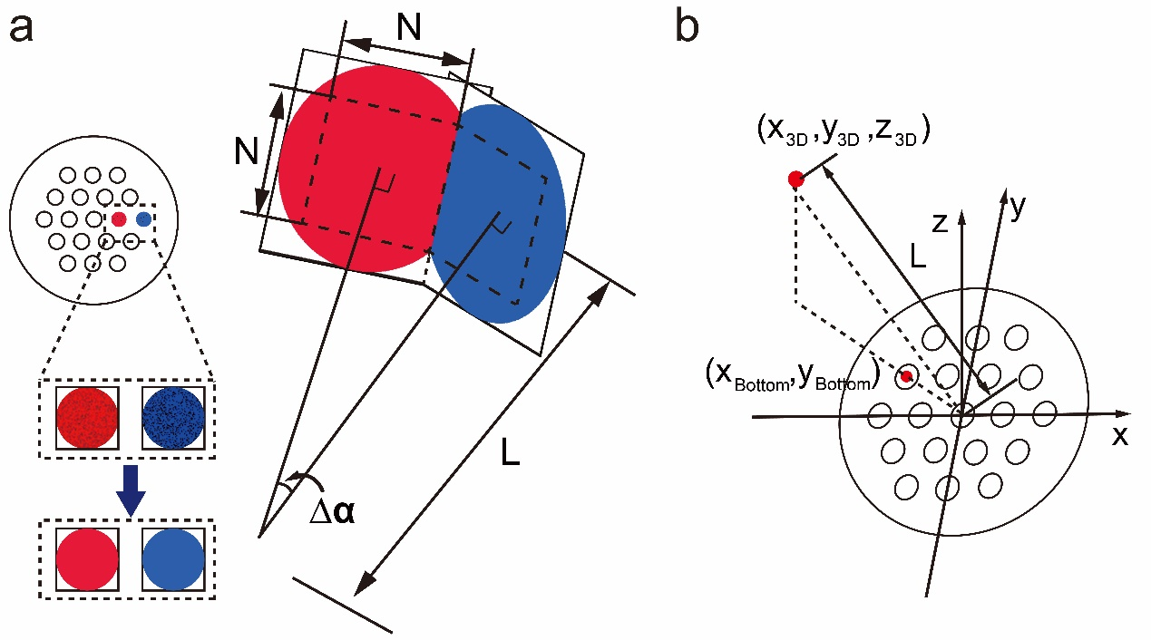
Figure S8: Reconstruction of a panoramic image. a, Schematic diagram of image stitching. b, The coordinate system used for the hemispherical imaging.

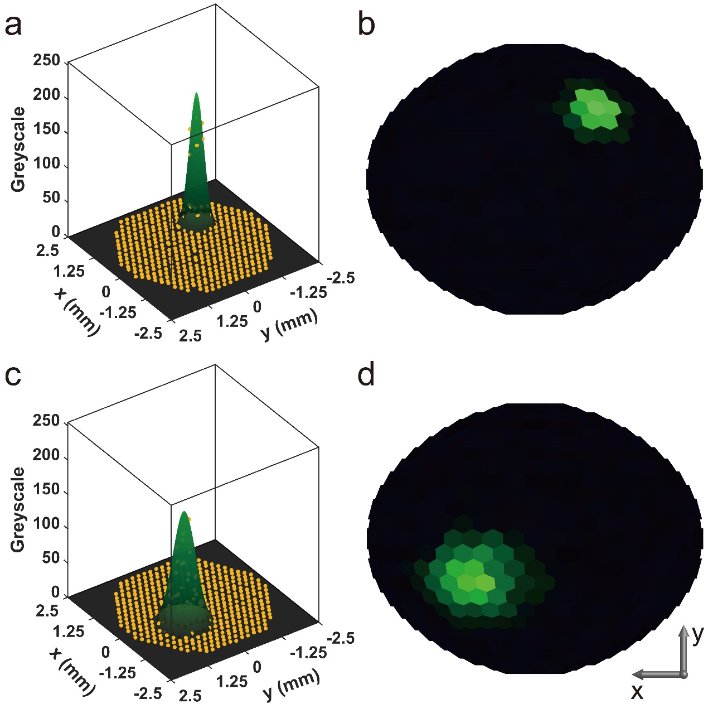
Figure S9: Positioning of the spotlight sources. a and c, The intensity distribution obtained by the MAP-eye and fitted with Gaussian functions. b and d, The reconstructed hemispherical images of the light spots. The target and measured positions of the spotlight source are marked in Fig. 5b.

