Graph-based pan-genome analysis uncovers genetic variation in wild, semi-domesticated, and commercial oil palm (Elaeis guineensis Jacq.)

Redi Aditama^{1,2}, Heri Adriwan Siregar^{1,3}, Zulfikar Achmad Tanjung², Diny Dinarti¹, Sintho Wahyuning Ardie¹, Willy Bayuardi Suwarno¹, Tony Liwang², Edy Suprianto³, Hernan Mauricio Romero², Condro Utomo², Sudarsono Sudarsono^{1,*}
¹Department of Agronomy and Horticulture, Faculty of Agriculture, IPB University, Bogor 16680, West Java, Indonesia
²Department of Biotechnology, Plant Production and Biotechnology Division, PT SMART Tbk, Bogor 16810, West Java, Indonesia
³Division of Oil Palm Breeding, Indonesian Oil Palm Research Institute (IOPRI), Medan 20158, North Sumatra, Indonesia
*Corresponding author: Plant Molecular Biology Laboratory, Department of Agronomy and Horticulture, Faculty of Agriculture, IPB University, Jl. Meranti – IPB Dramaga Campus, Bogor 16680, West Java, Indonesia (Email: sudarsono_agh@apps.ipb.ac.id).

Running title:
Graph-based oil palm pan-genome

Supplementary Notes

Supplementary Note S1. Glossary of Terms
To ensure clarity and terminology consistency, the following definitions are used throughout this study.

Copy number variation (CNV)
Refers specifically to structural-variant-derived copy number gains inferred from duplication-associated events identified in the pan-genome graph. This definition excludes read-depth-based estimates of absolute copy number and focuses exclusively on SV-supported duplication signals.

Pan-genome components
- Core genes – Genes present in nearly all accessions and typically associated with essential cellular functions and strong evolutionary constraints.
- Shell genes – Genes variably presents across subsets of accessions, reflecting partial functional turnover and lineage-dependent retention.
- Unique genes – Genes restricted to one or few accessions. Although sometimes termed “dispensable” or “private” in other studies, these genes are consistently referred to here as unique to avoid ambiguity.

Structural variation (SV) and duplication classes
SV50 refers to graph-derived variants with allele length ≥50 bp, where variant length was defined as max(len(REF), len(ALT)) after VCF normalization. Insertions were defined as records with len(ALT) > len(REF), whereas deletions were defined as records with len(REF) > len(ALT). Duplication-associated insertions were inferred when inserted sequences aligned to the EG11 reference genome with ≥0.90 identity and ≥0.80 coverage. Tandem duplications were defined as same-chromosome events occurring within or ≤10 kb from the inferred origin locus. Proximal duplications were same-chromosome events located >10 kb and ≤200 kb from the inferred origin. Dispersed duplications were same-chromosome events located >200 kb from the inferred origin. Interchromosomal duplications were events where insertion and inferred origin loci were located on different chromosomes or chromosome-level sequences. These classes represent operational spatial categories adapted from established duplication-distance concepts and were used to summarize duplication-derived structural variation.

Presence-absence variation (PAV)
Gene-level presence or absence across accession inferred from SV overlaps and validated by assembly-based alignments of gene-span sequences.

Resistance gene classes
- CNL – Coiled-coil nucleotide-binding leucine-rich repeat genes.
- RLK – Receptor-like kinase genes.
- NL – Nucleotide-binding leucine-rich repeat genes lacking coiled-coil or TIR domains.
- TNL – TIR-domain nucleotide-binding leucine-rich repeat genes.
- RLP – Receptor-like protein genes.
- MLO – Mildew resistance locus O genes.
These definitions are applied constantly across the manuscript for facilitate reproducibility and to minimize ambiguity in the interpretation of pan-genome, PAV, CNV, and resistance gene analysis.

Supplementary Note S2. Graph pan-genome construction and variant extraction commands
The graph-based pan-genome was constructed using the cactus-pangenome workflow from the Comparative Genomics Toolkit v2.9.5, with EG11 specified as the primary reference backbone. Input assemblies were provided in a sequence file containing one polished assembly per accession. Each accession was represented as a haploid assembly path in the graph construction workflow.
The general command structure used for graph construction was:
cactus-pangenome \
./jobStore_pg30x \
pg30x.seqfile.txt \
--outDir pg30x_cactus \
--outName pg30x \
--reference EG11_ref \
--vcf \
--gfa \
--gbz
The resulting graph files were generated in GBZ/GFA-compatible formats. Graph conversion and downstream graph handling were performed using the vg toolkit v1.58.0. When required, the GBZ graph was converted to GFA format using:
vg convert \
-g pg30x.gbz \
> pg30x.gfa
Graph-derived variants were extracted relative to the EG11 reference path using vg deconstruct. The general command structure was:
vg deconstruct \
-P 'EG11_ref|' \
-r pg30x.snarls \
-a \
-t 32 \
pg30x.gbz \
> pg30x.graph.raw.vcf
The resulting VCF was then compressed and indexed for downstream processing:
bgzip -c pg30x.graph.raw.vcf > pg30x.vcf.gz
tabix -p vcf pg30x.vcf.gz
Multi-allelic VCF records were decomposed into biallelic records using bcftools norm:
bcftools norm \
-m -any \
-Oz \
-o pg30x.split.vcf.gz \
pg30x.vcf.gz

tabix -p vcf pg30x.split.vcf.gz
Because graph-derived VCF records did not consistently contain standardized SVTYPE and SVLEN annotations, structural variants were operationally defined from normalized VCF records based on allele length. Variant length was calculated as:
SV_length = max(length(REF), length(ALT))
SV50 records were defined as variants with allele length >=50 bp. Insertions and deletions were classified according to the relative lengths of the REF and ALT alleles:
Insertion: length(ALT) > length(REF) and SV_length >= 50 bp
Deletion: length(REF) > length(ALT) and SV_length >= 50 bp
A unique variant key was assigned to each normalized record using the following structure:
VAR_KEY = CHROM:POS:REF:ALT
This key was used to connect genotype tables, BED intervals, SV classifications, gene-overlap analyses, PAV inference, and downstream CNV gain analyses.
For graph-level expansion analysis, node-growth rarefaction was evaluated using panacus v0.4.1 from the graph representation. The general command structure was:
panacus histgrowth \
pg30x.gfa \
> pg30x.node_growth.tsv
The graph-derived VCF, normalized VCF, and graph summary outputs were subsequently used for structural variant classification, per-accession SV burden estimation, chromosome-level SV density calculation, gene-overlap analysis, gene presence-absence variation inference, insertion-origin assignment, and duplication-derived copy-number gain analysis. All coordinate-based analyses were interpreted relative to the EG11 reference coordinate system.

Supplementary Figures

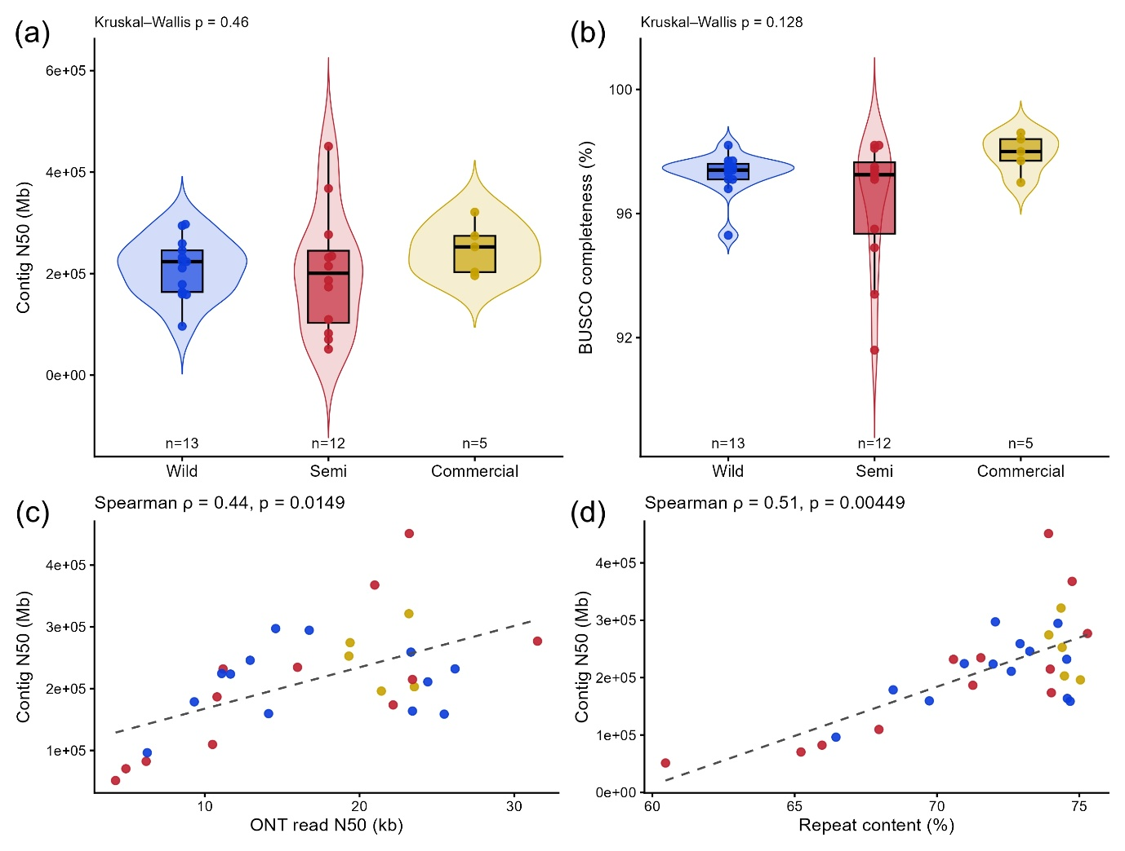
Supplementary Figure S1. (a) Distribution of contig N50 (Mb) by group (Wild, Semi, Commercial; n = 13, 12, 5), shown as violin plots with overlaid boxplots (median, IQR) and individual points (beeswarm); Kruskal–Wallis test: p = 0.46. (b) Distribution of BUSCO completeness (%) by group; Kruskal–Wallis test: p = 0.128. (c) Relationship between ONT read N50 (kb) and contig N50 (Mb); Spearman ρ = 0.44, p = 0.0149, with loess trend (dashed). (d) Relationship between assembly repeat content (%) and contig N50 (Mb); Spearman ρ = 0.51, p = 0.00449, with loess trend (dashed). Effect sizes for group comparisons (η²H) and full statistics are provided in Supplementary Tables S1-S3.

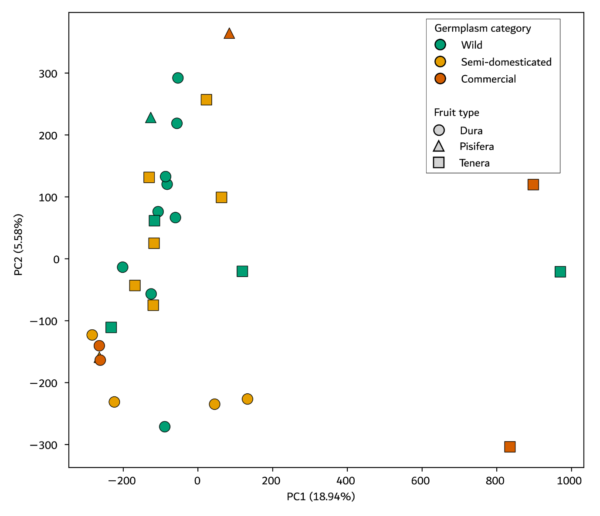
Supplementary Figure S2. Genome-wide SNP-based principal component analysis of 30 Elaeis guineensis accessions. PCA was performed using informative SNP sites retained from the cleaned genome-wide SNP alignment. Points are colored according to germplasm category and shaped according to fruit type or breeding role. PC1 and PC2 explained 18.94% and 5.58% of the total variation, respectively. The PCA was used to visualize genetic relationships among accessions rather than to define discrete population clusters. The partial overlap among wild, semi-domesticated, and commercial categories is consistent with the breeding and germplasm history of oil palm. The dispersion of commercial accessions further reflects the inclusion of elite Dura and Pisifera parental lines and commercial Tenera hybrids, which represent different components of the oil palm hybrid breeding system.

Supplementary Tables

Supplementary Table S1.
Accession metadata, domestication classification, sequencing information, and public database accessions.
This table summarizes the accession metadata for the 30 oil palm genomes analyzed in this study, including accession identifier, domestication category, fruit type, provenance, germplasm source, sequencing platforms, BioSample accession, GenBank assembly accession, and release status. Domestication categories were assigned based on documented provenance, breeding history, germplasm management records, and commercial release status.

Supplementary Table S2.
Per-accession genome assembly statistics and completeness assessment.
This table reports genome assembly statistics for each the 30 oil palm accessions, including assembly size, number of contigs, contig N50, sequencing depth, ONT read N50, repeat content, and BUSCO completeness metrics. These accession level statistics were used to evaluate whether assembly quality was sufficiently consistent across wild, semi-domesticated, and commercial groups for graph-based pan-genome construction.

Supplementary Table S3.
Correlation, covariate, and group wise comparisons of assembly quality metrics.
This table summarizes statistical analyses of assembly quality metrics, including group-wise comparisons of contig N50 and BUSCO completeness among wild, semi-domesticated, and commercial accessions, Spearman correlation analyses between contig N50 and sequencing or repeat-related metrics, and covariate-adjusted linear models evaluating the effects of read length, sequencing depth, and repeat content on assembly contiguity.

Supplementary Table S4.
Summary statistics of the oil palm graph-based pan-genome constructed from 30 genomes.
This table reports summary statistics of the graph-based oil palm pan-genome constructed from 30 genome assemblies, including total graph length, number of nodes, node length distribution, edge statistics, and reference/non-reference graph component where applicable. Node length statistics should be interpreted in the context of graph representation, as short graph nodes may reflect both single-nucleotide variants and small sequence differences. The statistics support the structural characterization of the pan-genome graph.

Supplementary Table S5.
Structural variant counts per accession and variant class.
This table summarizes per-accession counts of graph-derived structural variation across the 30 oil palm genomes. Insertion and deletion counts were obtained from split graph-derived VCF records by identifying non-reference genotypes with allele length differences ≥ 50 bp. Duplication-associated copy-number gains were summarized from insertion-derived duplication calls and classified as tandem, proximal, dispersed, or interchromosomal according to relationship between the inserted sequence and its inferred origin. Duplication counts represent binary copy-number gain events per accession and should not be interpreted as absolute copy-number dosage. Total SV50 represents the sum of insertion, deletion, and classified duplication-associated gain events for each accession.

Supplementary Table S6.
Chromosome-level structural variant density normalized by chromosome length.
This table reports chromosome-level abundance and density of graph-derived SV50 event across the 16 EG11 reference chromosomes. Raw counts are provided for insertions, deletions, tandem duplications, proximal duplications, dispersed duplications, interchromosomal duplications, and total SV50. SV density was calculated as the number of SV50 events per megabase using EG11 chromosome lengths. These normalized values were used to compare chromosome-level SV distribution while accounting for differences in chromosome size.

Supplementary Table S7.
Gene presence–absence category counts and assembly-based validation of SV-derived PAV inference.
This table summarizes the number and percentage of genes assigned to core, shell, and unique pan-genome categories and reports assembly-based validation of SV-derived gene presence–absence variation (PAV) inference. Genes were classified as core when present in at least 29 of 30 accessions, shell when present in 2–28 accessions, and unique when present in only one accession. Assembly-based validation was performed by comparing SV-derived PAV calls with gene-span alignments against individual assemblies. Confusion-matrix statistics are reported for all genes and separately for core, shell, and unique categories. Because biologically consequential error types differ among categories, interpretation emphasizes false absence rates for core genes and false presence rates for unique genes.

Supplementary Table S8.
Copy-number gain summary per accession, domestication group, and duplication class.
This table summarizes binary copy-number gain events inferred from insertion-derived duplications across the 30 oil palm accessions. Copy-number gains are reported per accession, domestication group, and duplication class, including tandem, proximal, dispersed, and interchromosomal duplications. The table includes both accession-level CNV burden and group-level gain proportions, allowing interpretation of duplication mechanisms without implying that proportional differences necessarily reflect differences in total CNV burden.

Supplementary Table S9.
Functional enrichment statistics for GO, eggNOG-derived COG categories, and KEGG pathways across pan-genome categories.
This table reports functional enrichment and depletion analyses for GO terms, eggNOG-derived COG functional categories, and KEGG pathways across core, shell, and unique gene categories. For each functional term or pathway, observed and expected counts, enrichment ratios, raw p-values, and Benjamini-Hochberg adjusted FDR values are provided. These statistics support the functional stratification summarized in the main text, in which core genes are enriched for conserved housekeeping and primary metabolic functions, whereas shell and unique genes show enrichment for regulatory, stress-responsive, transport-related, and specialized metabolic functions.

Supplementary Table S10.
Resistance gene repertoire, PAV, and CNV burden per accession.
This table summarizes resistance gene repertoires across 30 oil palm accessions by integrating R-gene class counts, pan-genome category assignment, and binary copy-number gain calls. For each accession, total R-gene count, R-gene CNV gain burden, and class-level counts are reported for major R-gene classes, including CNL, NL, TNL, RLK, RLP, RLP-other, and MLO. Gene-level summaries provide pan-genome category, domain composition, and CNV gain frequency across accessions. CNV values represent binary copy-number gain incidence and should not be interpreted as absolute copy-number dosage.

Supplementary Table S11.
Enrichment and depletion of resistance gene classes across pan-genome categories.
This table represents contingency-based enrichment analyses accessing associations between resistance gene classes and pan-genome categories. Observed counts, expected counts, standardized residuals, raw p-values, adjusted p-values, and enrichment labels are provided for each R-gene class and pan-genome category combination. Positive standardized residuals indicate enrichment, whereas negative standardized residuals indicate depletion. These results support the enrichment and depletion patterns of R-gene classes across core, shell, and dispensable genome compartments.

Supplementary Table S12.
Stability-variability profiles for each resistance gene class across pan-genome components.
This table summarizes stability-variability profiles for each resistance gene class based on the proportion of genes assigned to core, shell, and unique pan-genome components. For each R-gene class, the table reports total gene count, number and percentage of core, shell, and unique genes, and derived stability and variability indices. The stability index was calculated as the proportion of genes assigned to the core genome, whereas the variability index was calculated as the proportion of genes assigned to shell plus dispensable components. These descriptive profiles complement the enrichment and depletion statistics reported in Supplementary Table S11.

