Title: Atomic-scale mechanism for shock-induced ambient-stable hexagonal close-packed Iron
Authors: Jiamu Liu¹†, Jianxing Liu¹†, Pengfei Wang²†, Jian Wang³*, Hao Ding⁴, Tingting Huang², Mingyu Gong⁵, Mao Liu¹*
Affiliations
¹School of Metallurgy, Northeastern University, Shenyang 110819, China.
²CAS Key Laboratory of Mechanical Behavior and Design of Materials, University of Science and Technology of China, Hefei 230027, China.
³Department of Mechanical and Materials Engineering, University of Nebraska, Lincoln 68588, USA.
⁴Hunan Aviation Powerplant Research Institute, Aero Engine (Group) Corporation of China, Zhuzhou 412002, China.
⁵State Key Lab of Metal Matrix Composites, School of Materials Science and Engineering, Shanghai Jiao Tong University, Shanghai 200240, China.
†These authors contributed equally to this work.
*Corresponding authors: Email: jianwang@unl.edu (Jian Wang);
liumao@mail.neu.edu.cn (Mao Liu)

This file includes:
Supplementary Text
Supplementary Fig. 1 to Fig. 6
Supplementary References
Supplementary Text
APT analysis
In this study, beyond observing elemental Fe distribution in APT maps—confirming phase transformation stems purely from structural rearrangement—we performed pole reconstruction on deformed single-crystal Fe specimens. Using bcc (111) planes identified via STEM as reference axes, orientation imaging microscopy (OIM) analysis perpendicular to the STEM sampling direction revealed a 3D architecture of parallel (111) planes distributed radially along the needle apex. This spatial configuration aligns with prior EBSD and STEM results.​​
Pole reconstruction enables crystallographic characterization from reconstructed atomic data. Although complete crystal information may not be directly attainable, key features can be inferred: atomic planes emerge in reconstructed datasets, and statistical techniques account for minor deviations of atoms from ideal lattice sites. Despite inherent APT has limitations that the spatial offsets during field evaporation may distort absolute positions. Data correction compensates for distortions introduced during acquisition and analysis^{51,52}.
The principle is that sample's overall crystal structure is typically preserved by Fourier Transform (FT) based periodicity detection⁵³. FT identifies global periodic structures by converting real-space atomic positions into reciprocal space, where lattice plane signals intensify⁵⁴.
The equation that defines the FT of a three-dimensional real-space function $r(x,y,z)$ into reciprocal space $R(X,Y,Z)$ is:
$$F\left(R\right)=\iiint{f(r)e^{-2πi(r∙R)}}dxdydz \left(1\right)$$
Applying the Dirac delta function yields the atomic grid position formula:​​
$$f\left(r\right)=\sum_{i=1}^{N}{δ(r-r_{i})} (2)$$
Written as
$$F\left(R\right)=\sum_{i=1}^{N}{e^{-2πi(r_{i}∙R)}} (3)$$
Spatial distribution maps (SDM) characterize interplanar spacing $d^{\{hkl\}}$ along the depth direction and angles $θ^{\{hkl\}}$ and $φ^{\{hkl\}}$ between crystal planes and coordinate axes. Transverse SDM analysis resolves local atomic neighborhoods, retaining crystallographic data. Here, z-SDM reconstruction of Fe atoms confirmed (111) plane distribution.​​
AP Suite software is used for the visualization:​​
(1) ​​OIM-guided orientation locking​​: Manually defining the crystallographic orientation (111) to establish a reference frame, requiring expertise to ensure accuracy.
​​(2) Orientation-based filtering​​: Selecting atoms with proper the target on (111) plane.
​​(3) 3D reconstruction and rotation​​: Aligning the atomic cloud perpendicular to (111) planes to verify the correct interplanar spacing.
​​Critically, heterogeneous zones in the 3D pole reconstruction (Fig. 3b) cannot be definitively attributed to hcp Fe. Since reconstruction relies on (111) plane alignment, and hcp-bcc interfaces are coherent, position-correction algorithms may inadvertently realign hcp atoms. Thus, atomic clusters deviating from (111) aggregation patterns were not classified as hcp domains, pending correlated TEM validation.​
EBSD analysis
EBSD mapping for 77 K (Fig. 1f and Supplementary Fig. 2b) and room temperature (Fig. 1g and Supplementary Fig. 2a) reveals a reorientation from predominant (110) to (111) textures. The microstructure exhibits a divergent crystallographic colonies​ distribution: fine grains with randomized orientations dominate the central region, while radially distributed (001) oriented streaks propagate from the core toward the periphery, terminating within the (111) textured matrix. High-magnification analysis (Supplementary Fig. 2) demonstrates that the 77K sample contains over an order of magnitude more fine grains than the room-temperature counterpart, with average grain size reduced by approximately 50%.​
Temperature dependence of phase transition in TEM
To assess temperature dependence of hcp phase formation in bcc Fe, SHPB shock tests were conducted at room temperature (298 K) under identical projectile velocity (35.4 m/s). As revealed by TEM and HAADF-STEM imaging (Supplementary Fig. 6a and b), the crystallographic relationship—bcc (111) || hcp (0001)—remains consistent with the 77 K groups. Crucially, the cryogenic and room-temperature samples exhibit distinct hcp phase distribution characteristics. As highlighted in Supplementary Fig. 4, the 77K sample demonstrates densely clustered hcp domains. Conversely, room-temperature shocked specimens (Supplementary Fig. 6) display dispersed hcp features. This contrast underscores temperature-dependent nucleation kinetics—suppressed thermal activation at 77 K promotes localized hcp phase coalescence.
Phase diagram and spatial orientation
Figure 5a and b demonstrates the crystallographic correspondence between bcc and hcp phases and three-dimensional spatial structure model determined based on this correspondence. Using established OR—bcc(111) || hcp(0001) and bcc(110) || hcp($10\overline{1}0$)—we aligned both phases' stereographic projections to their matching orientations (Fig. 5a). Within these superimposed projections, spatially coincident pole pairs were identified to determine mutually coherent interface planes between the phases.​​
​​Three low-index coherent planes (highlighted by green dashed circles in Fig. 5a) exhibit 120° rotational symmetry in the stereographic projection. These symmetry axes indicate that such coherent planes can form space-filling polyhedral configurations at phase boundaries. While these low-index planes define a fundamental crystallographic existence, realistic interfaces may incorporate additional high-index planes.​​
​​Based solely on the three symmetric planes and the primary OR bcc(111) || hcp(0001), a polyhedral structural unit was constructed (Fig. 5b). This unit which termed the ​​transition layer​​, features an ​​hcp core enclosed by coherent normal facets​​ aligned to the identified pole pairs. Remarkably, this configuration agrees with our atomic-resolution ac-STEM observations, confirming that hcp phases exist as ​​coherent nuclei​​ within the transition layer, embedded epitaxially within the bcc matrix.​ The schematic representation depicts atomic arrangement patterns within the structure, independent of the ensemble's spatial shape or size.​
​​Nanoscale Stress Concentration analysis
Geometric phase analysis (GPA) of STEM images quantified stress concentration around transition layers. Fig. 5c shows an atomic-resolution STEM micrograph containing an hcp domain (red oval), with the inset SAED pattern confirming unstrained bcc matrix diffraction conditions. As indicated by the red and blue circles with identical radii and tangentially connected, this region denotes the matrix area with an unstrained lattice.​ By generating local SAED patterns across the region and comparing spot displacement vectors relative to the central reference, inverse FT yielded complex images whose phase components encoded local atomic displacements. These were converted to strain tensors using the stress-field equation^{55,56}:​
$\left.\begin{aligned}u_{x}=a_{x}e_{xx}+a_{y}e_{xy} \\ u_{y}=a_{y}e_{yy}+a_{x}e_{yx} \\ v_{x}=b_{x}e_{xx}+b_{y}e_{xy} \\ v_{y}=b_{y}e_{yy}+b_{x}e_{yx}\end{aligned}\right\}\begin{matrix}\left[\begin{aligned}e_{yx} \\ e_{yy}\end{aligned}\right]={\left[\begin{matrix}a_{x} & a_{y} \\ b_{x} & b_{y}\end{matrix}\right]}^{-1}\left[\begin{matrix}u_{y} \\ v_{y}\end{matrix}\right] \\ \left[\begin{aligned}e_{xx} \\ e_{xy}\end{aligned}\right]={\left[\begin{matrix}a_{x} & a_{y} \\ b_{x} & b_{y}\end{matrix}\right]}^{-1}\left[\begin{matrix}u_{x} \\ v_{x}\end{matrix}\right]\end{matrix}$ (S4)
Where $\left(u_{x},u_{y}\right)$ and $\left(v_{x},v_{y}\right)$ are the coordinates of the displacement with respect to reference vector $\overset{⃑}{a}\left(a_{x},a_{y}\right)$ and $\overset{⃑}{b}\left(b_{x},b_{y}\right)$ , respectively, and $e_{xx}$, $e_{xy}$, $e_{yy}$, and $e_{yx}$ are defined as follows:
$e_{xx}=\frac{∂_{u}}{∂_{x}}$ , $e_{xy}=\frac{∂_{u}}{∂_{y}}$ , $e_{yy}=\frac{∂_{v}}{∂_{y}}$ , $e_{yx}=\frac{∂_{v}}{∂_{x}}$ (S5)
​​ Figure 5d displays the $e_{xy}$ strain component, revealing intense stress confinement surrounding the hcp nucleus, showing a signature of thermodynamic stability. Atomic-scale tracking of the bcc to hcp transition pathway (Fig. 5e-h) identified two distinct atomic slip directions within the (111) plane: perpendicular and parallel to the phase transition direction. These displacements represent projections of shear-induced transformation mechanisms, consistent with shock-mediated kinetics.​​
​​Critically, the observed microstructures are not static transition snapshots but dynamically arrested states. Unlike quasi-static transformations, ultrahigh-strain-rate shock loading causes instantaneous phase progression, and the core exhibits complete hcp conversion, while peripheral regions retain increasing bcc character with distance from the nucleus.

Supplementary Figure
Supplementary Fig. 1 FIB preparation of samples for correlative STEM and APT analysis. (a) Schematic of STEM and APT sampling locations​. The orange frame highlights the STEM sampling site normal to sample cross-section. The blue frame highlights APT sampling site normal to (110) crystallographic plane. (b-e) Sample was processed by FIB, welded onto a copper TEM grid via Pt deposition, and prepared for TEM/STEM characterization. (f-i) APT sample was processed by FIB, and the final needle tip exhibits a smooth morphology with approximately 300 nm in height and 100 nm in diameter.
Supplementary Fig. 2 Magnified EBSD images of the areas within the white boxes in Fig. 1g and f, showcasing the statistical analysis of grain size. (a) EBSD at room temperature. (b) EBSD at 77K. (c) Grain pixel counting of samples at room temperature and liquid nitrogen.
Supplementary Fig. 3 Structural diagram of crystallographic orientation relationship. (a) 3D isometric view of bcc Fe and hcp Fe. (b) Crystallographic orientation relationships of bcc (111) || hcp (0001), bcc ($11\overline{2}$) || hcp ($11\overline{2}0$) and bcc (110) || hcp ($10\overline{1}0$).

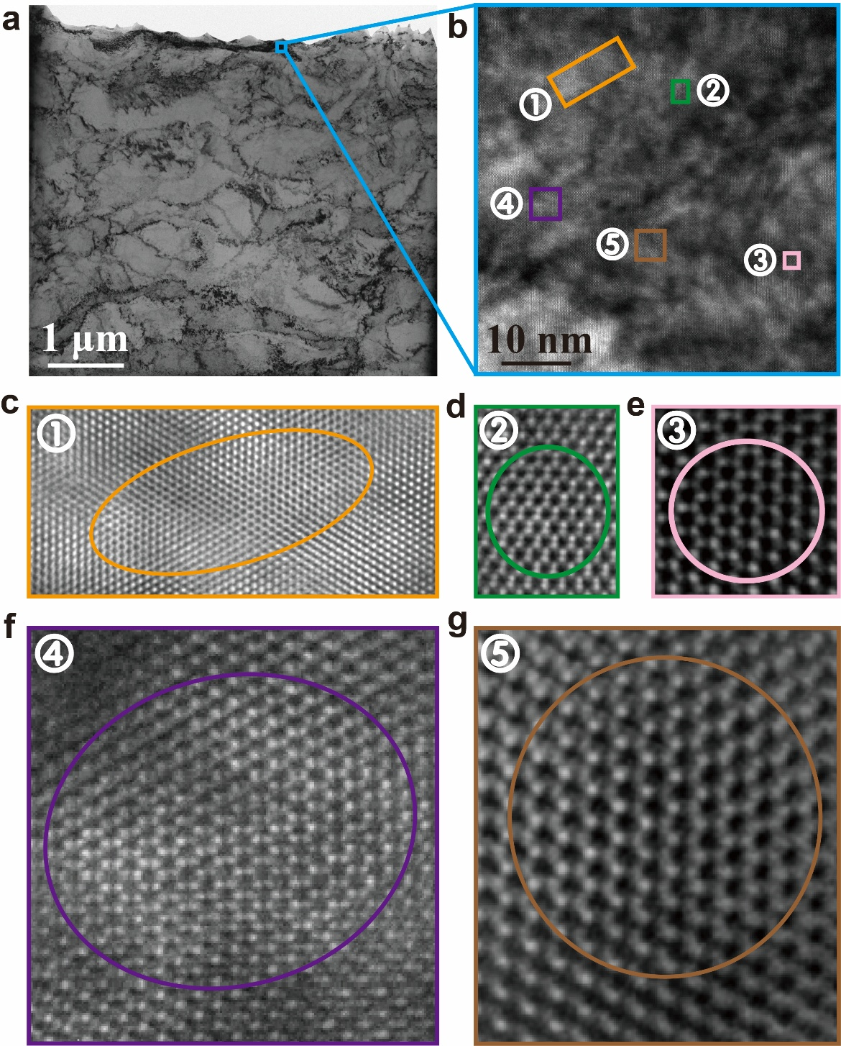
Supplementary Fig. 4 HAADF-STEM images showing the phase transition of bcc (111) || hcp (0001) at 77K. (a) TEM image of the FIB-milled sample at large-scale, the blue box denotes the magnified area. (b) Magnified HAADF-STEM image, and the color-coded rectangles denote regions with distinct hcp atomic arrangements, spaced approximately 10 nm apart. (c-g) Characteristic hcp (0001) ring-like features are highlighted with colored ovals or circles, corresponding to the positions highlighted in (b).

Supplementary Fig. 5 Split-Hopkinson pressure bar (SHPB) shock compression. (a) Three stress waves in SHPB test under 38m/s ($\dot{ε}=1.96×{10}^{4} s^{-1}$) shock loading. (b) Engineering stress-strain curve and strain rate-strain curve.

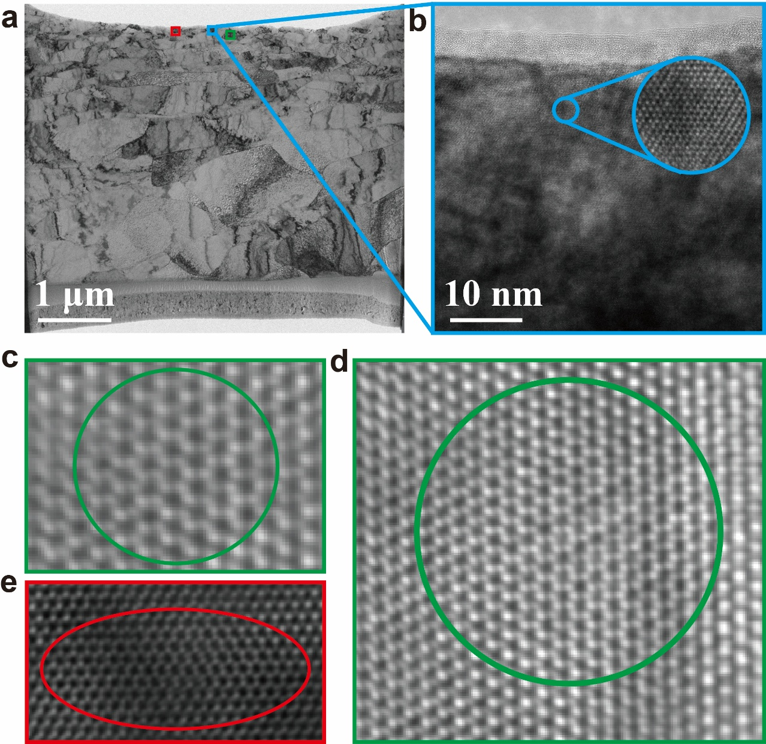
Supplementary Fig. 6 HAADF-STEM images showing the phase transition of bcc (111) || hcp (0001) at room temperature. (a) TEM image of the FIB-milled sample at large-scale, the colored boxes denote the magnified area. (b) HAADF image which is framed by blue rectangles, and the blue circle highlights an amplification of the hcp feature. (c-e) Characteristic hcp (0001) ring-like features, highlighted by green circles and red oval, are observed in the areas corresponding to green and red rectangles highlighted in (a). These features exhibit a more discrete distribution of hcp characteristics compared to the liquid nitrogen group.

Supplementary References
51. Gault, B. et al. Advances in the calibration of atom probe tomographic reconstruction. Journal of Applied Physics 105, (2009).
52. Gault, B., Moody, M. P., Cairney, J. M. & Ringer, S. P. Atom Probe Microscopy. vol. 160 (Springer New York, New York, NY, 2012).
53. W. A. Sethares & T. W. Staley. Periodicity transforms. IEEE Transactions on Signal Processing 47, 2953–2964 (1999).
54. Warren, P. J., Cerezo, A. & Smith, G. D. W. An atom probe study of the distribution of rhenium in a nickel-based superalloy. Materials Science and Engineering: A 250, 88–92 (1998).
55. Galindo, P. L. et al. The Peak Pairs algorithm for strain mapping from HRTEM images. Ultramicroscopy 107, 1186–1193 (2007).
56. Hÿtch, M. J., Snoeck, E. & Kilaas, R. Quantitative measurement of displacement and strain fields from HREM micrographs. Ultramicroscopy 74, 131–146 (1998).

