Valorization of Teak Wood Biomass into Nanobiochar for Environmental Remediation
By
Deshraj Singh Thakur¹, *Santosh Narayan Chadar²
¹⁻² Govt. Auto. Girls P.G. Excellence College Sagar (M.P.)
dr.santoshnarayan@gmail.com ; deshrajthakur117@gmail.com
*Corresponding author: E-mail: dr.santoshnarayan@gmail.com

Table S1. Adsorption_Performance_of_Nanobiochar
Metal Ion | Initial Concentration (mg/L) | Run 1 Final (mg/L) | Run 2 Final (mg/L) | Run 3 Final (mg/L) | Mean Final (mg/L) | Standard Deviation
Pb²⁺ | 50 | 5.8 | 5.1 | 5.6 | 5.5 | 0.35
Cd²⁺ | 50 | 7.8 | 7.1 | 7.6 | 7.5 | 0.36
Hg²⁺ | 20 | 3.9 | 3.3 | 3.6 | 3.6 | 0.3
As⁵⁺ | 10 | 2.3 | 2 | 2.4 | 2.2 | 0.21

Table S2. Removal_Efficiency_of_Metal_Ions
Metal Ion | Run 1 (%) | Run 2 (%) | Run 3 (%) | Mean (%) | Standard Deviation
Pb²⁺ | 88.4 | 89.8 | 88.8 | 89 | 1.2
Cd²⁺ | 84.4 | 85.8 | 84.8 | 85 | 1.5
Hg²⁺ | 80.5 | 83.5 | 82 | 82 | 1.3
As⁵⁺ | 77 | 80 | 76 | 78 | 1.4

Table S3. Effect_of_Experimental_Conditions_on_Heavy_Metal_Removal

Metal Ion | Initial Concentration (mg/L) | pH | Contact Time (min) | Adsorbent Dosage (g/L) | Run 1 (%) | Run 2 (%) | Run 3 (%) | Mean (%) | Standard Deviation
Pb²⁺ | 50 | 5.5 | 120 | 1 | 88.5 | 89.8 | 88.7 | 89 | 1.2
Cd²⁺ | 50 | 5 | 120 | 1 | 84.2 | 86.1 | 84.7 | 85 | 1.5
Hg²⁺ | 20 | 6 | 120 | 1 | 81.1 | 83.3 | 81.6 | 82 | 1.3
As⁵⁺ | 10 | 5.8 | 120 | 1 | 77 | 79.2 | 77.8 | 78 | 1.4

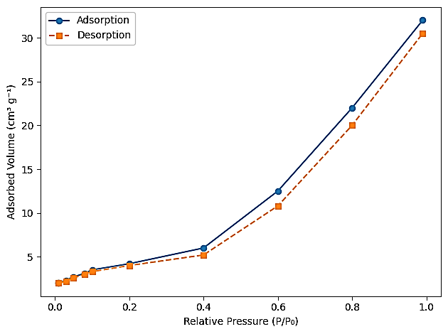

Figure 4. N₂ adsorption–desorption isotherm of teak wood–derived nano-biochar synthesized at 800-900 °C

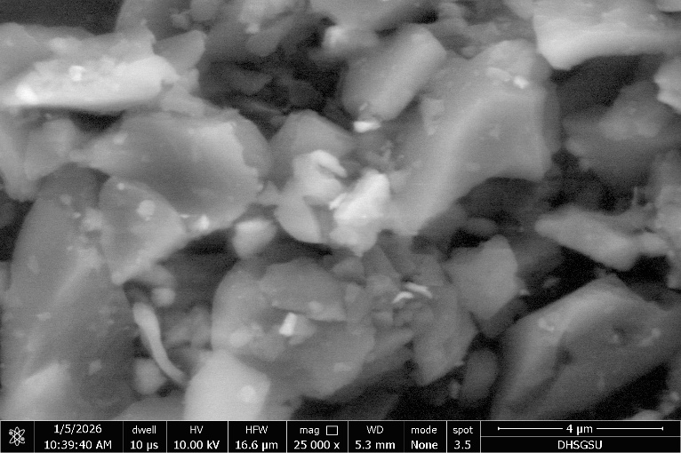
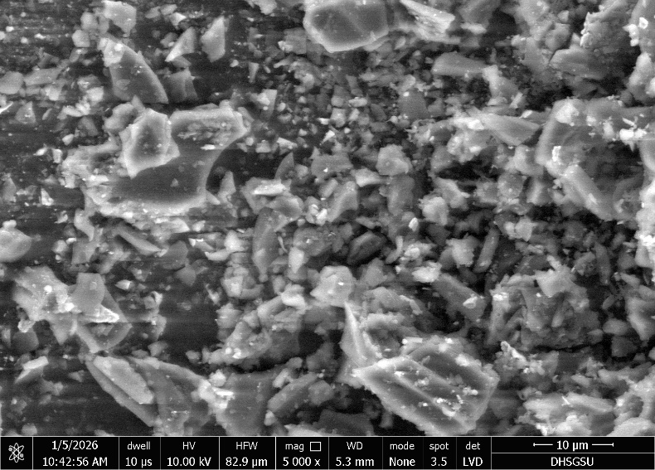
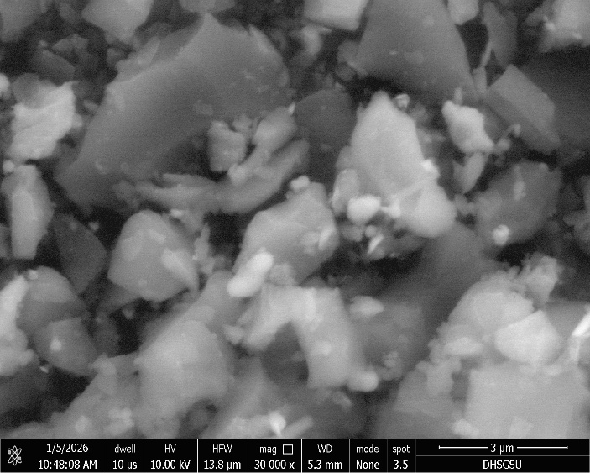
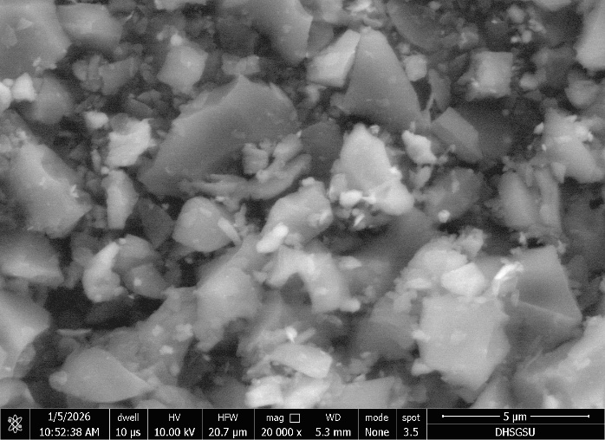
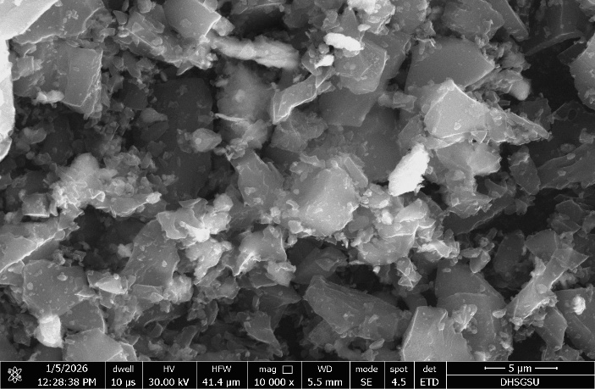
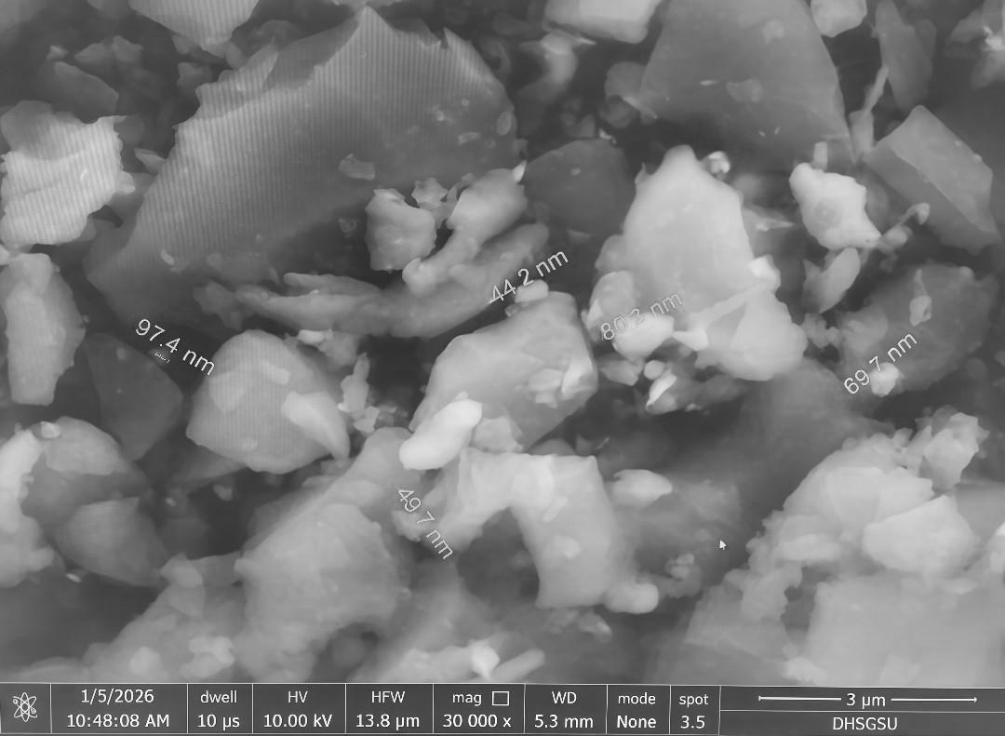

Figure 5. Synthesized nanobiochar micrographs taken using a scanning electron microscope (SEM) at various magnifications.


Application Note
Company / Department

Figure 6. The spatial distribution of the elements C, O, and Fe is displayed in EDS elemental mapping images.
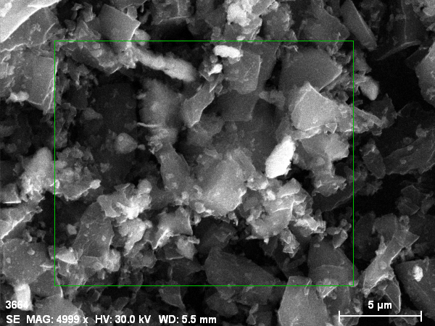
3664Date:1/5/2026 1:19:46 PMImage size:1024 x 768Mag:4999.4111969112xHV:30.0kV

Map data 1829Date:1/5/2026 1:20:03 PMImage size:704 x 578Mag:4999.4111969112xHV:30.0kV

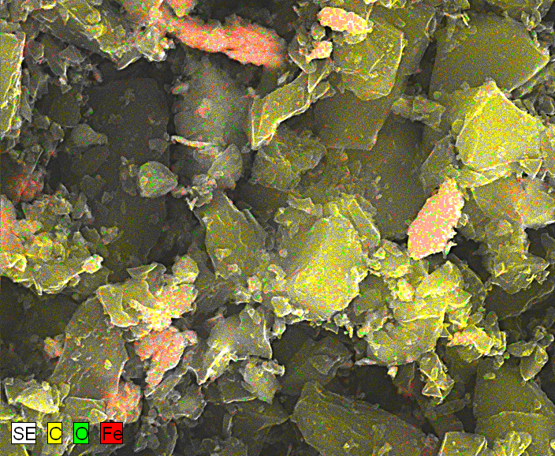

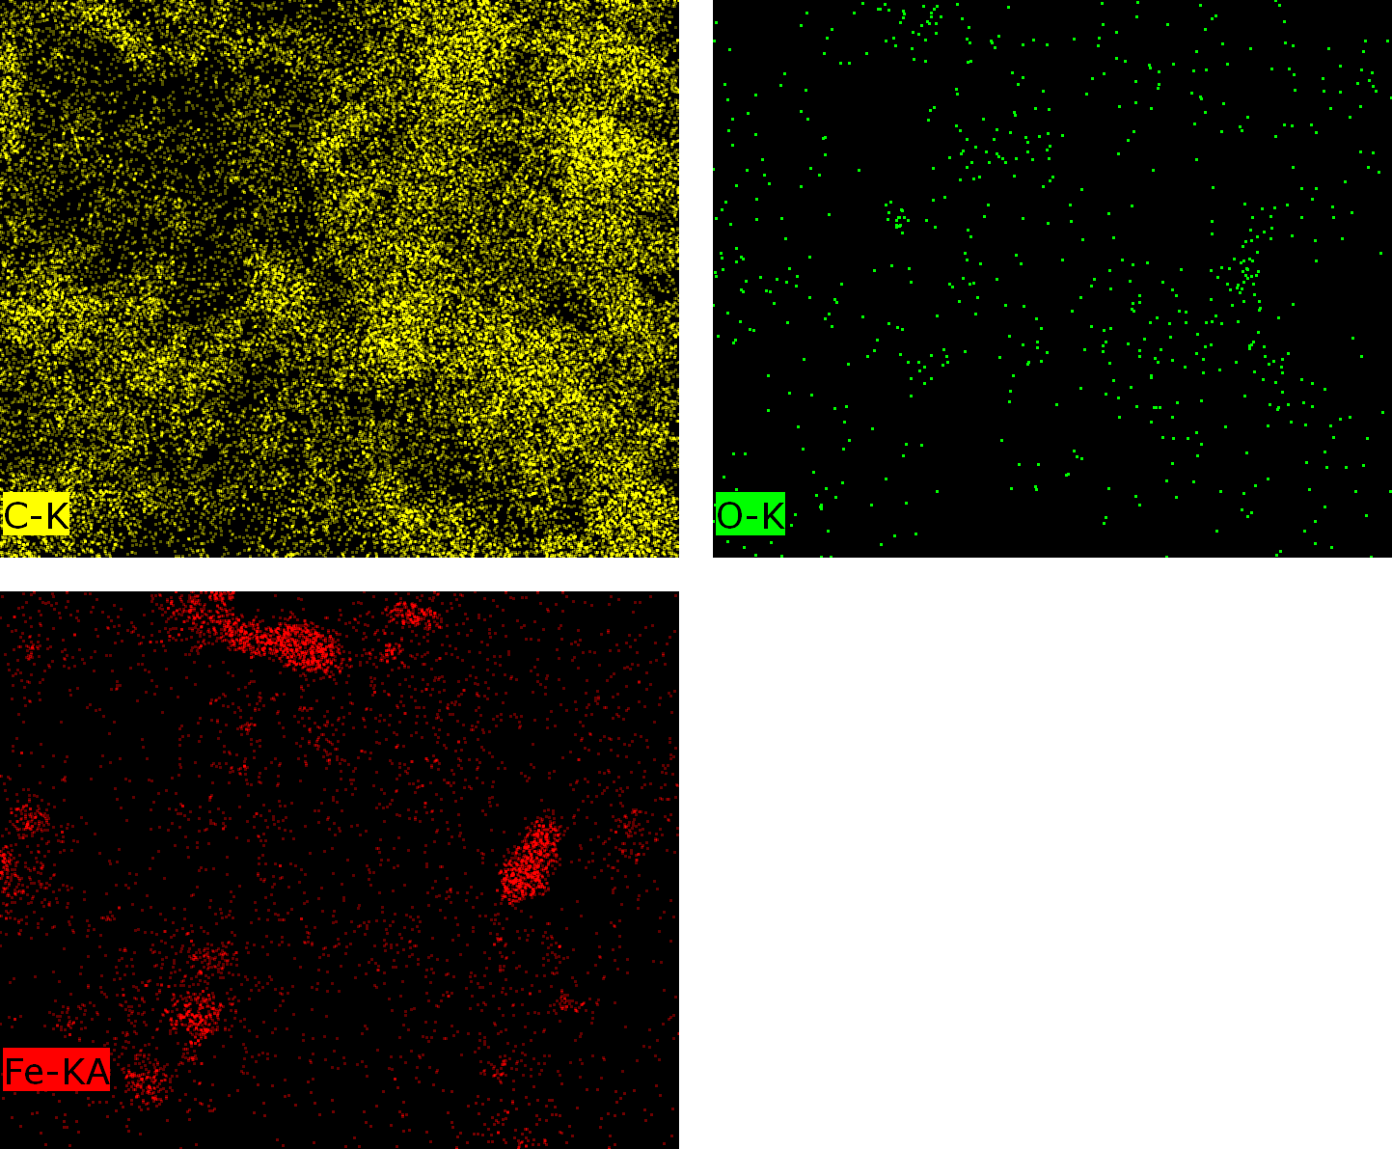
C-K, O-K, Fe-KADate:1/5/2026 1:24:13 PM
Image size:704 x 578
Mag:4999.4111969112x
HV:30.0kV

El AN Series unn. C norm. C Atom. C Error (1 Sigma)
[wt.%] [wt.%] [at.%] [wt.%]
-----------------------------------------------------
C 6 K-series 87.49 87.49 92.58 10.24
O 8 K-series 8.07 8.07 6.41 1.96
Fe 26 K-series 4.45 4.45 1.01 0.15
-----------------------------------------------------
Total: 100.00 100.00 100.00

Figure 7. EDS spectrum that shows the synthetic material's elemental composition.

El AN Series unn. C norm. C Atom. C Error (1 Sigma)
[wt.%] [wt.%] [at.%] [wt.%]
-----------------------------------------------------
C 6 K-series 86.31 86.31 92.41 10.12
O 8 K-series 6.69 6.69 5.38 1.63
Fe 26 K-series 4.35 4.35 1.00 0.15
Na 11 K-series 1.00 1.00 0.56 0.10
Si 14 K-series 0.74 0.74 0.34 0.06
Ca 20 K-series 0.49 0.49 0.16 0.04
Cl 17 K-series 0.42 0.42 0.15 0.04
-----------------------------------------------------
Total: 100.00 100.00 100.00

Figure 4. N₂ adsorption–desorption isotherm of teak wood–derived nano-biochar synthesized at 800-900 °C

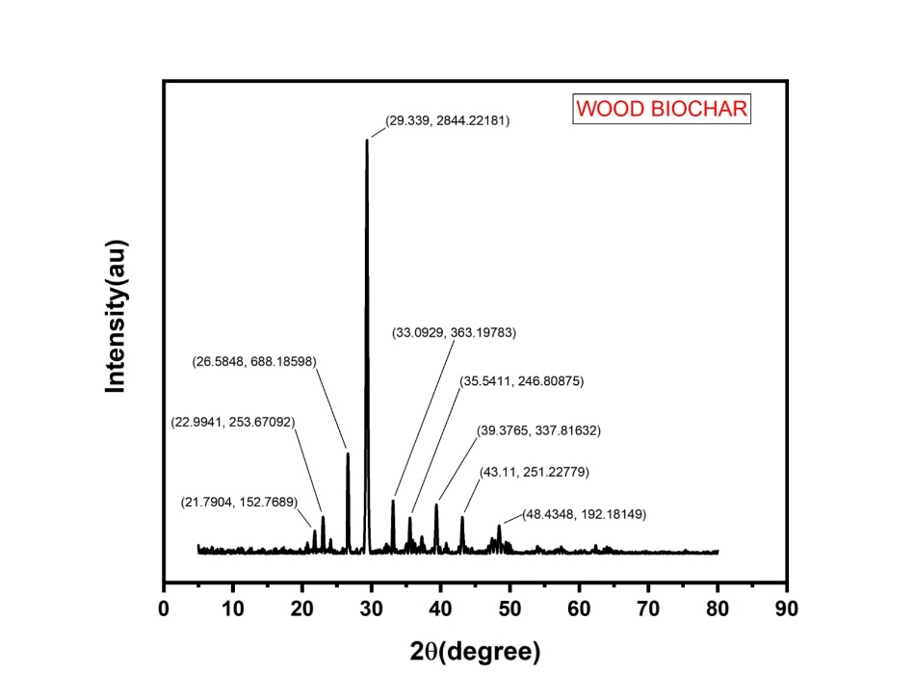

Figure 8. X-ray diffraction (XRD) pattern of Nanobiochar made from teak wood, displaying
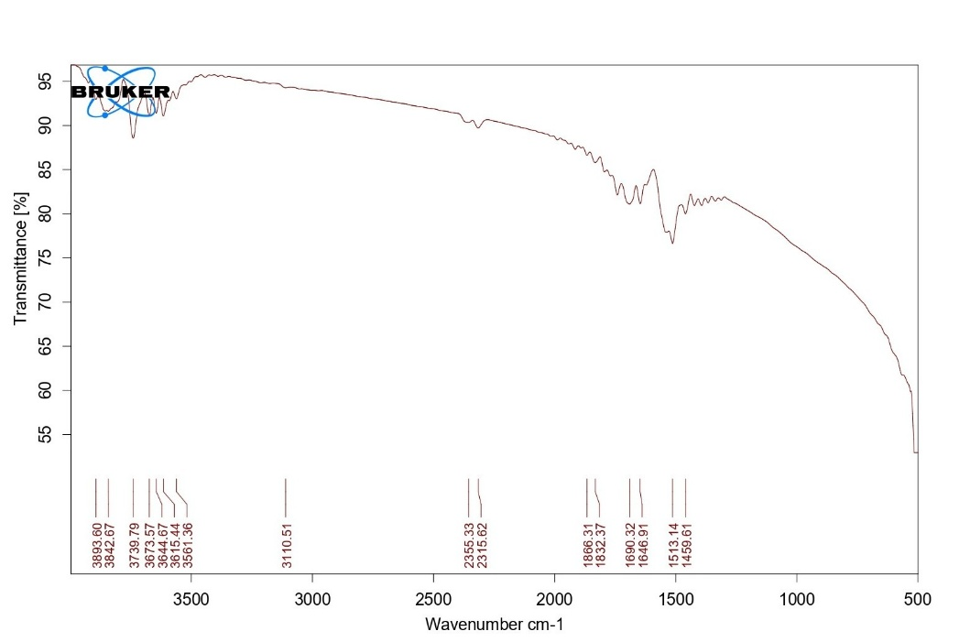

Figure 9. FTIR measurement of the produced biochar/nanobiochar sample

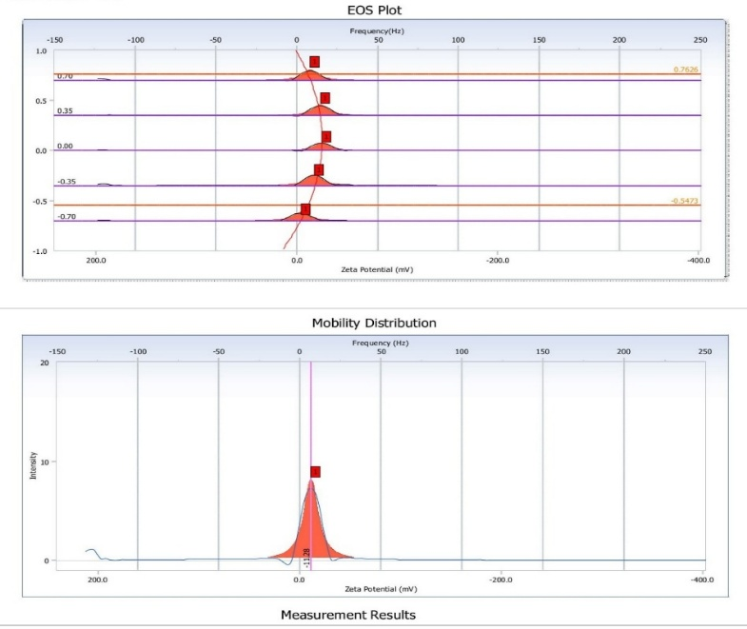

Figure 10. The measurement data, zeta potential distribution, and electrophoretic mobility map of the generated material.

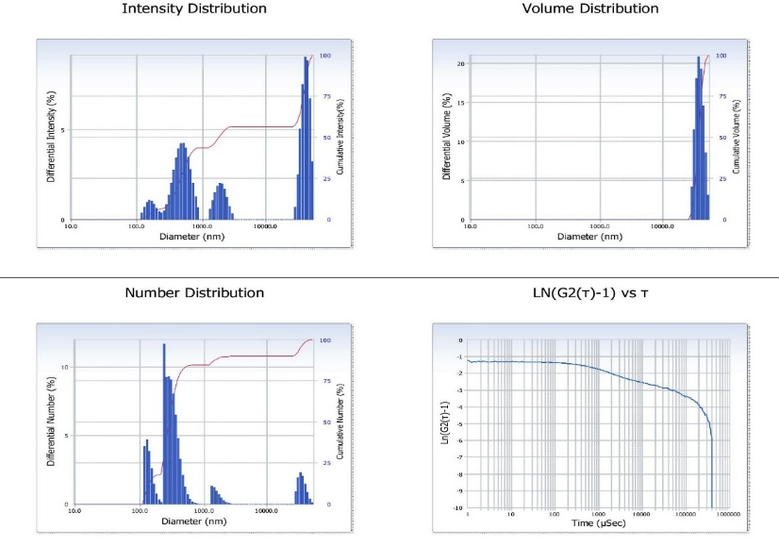

Figure 11. Particle size distribution analysis of the synthesized material.

