Supplementary Appendix

This appendix has been provided by the authors to give readers additional information about their work.

Supplement to:

Vaccine-induced immune thrombotic thrombocytopenia and spike protein
M. De Michele (M.D., PhD)*, P. Piscopo (BS), A. Crestini (BS), R. Rivabene (BS), G. d’Amati (M.D.), M. Leopizzi (PhD), L. Stefanini (PhD), D. Flego (PhD) , F. Pulcinelli (M.D., PhD), A. Chistolini (M.D., PhD), M. Iacobucci (M.D.), O.G. Schiavo (M.D.), I. Berto (M.D.), E. Nicolini (M.D.), L. Petraglia (M.D.), M.T. Di Mascio (M.D., PhD), D. Toni (M.D., phD)

* Corresponding author. Email: M.DeMichele@policlinicoumberto1.it

The PDF file includes:

- Expanded materials and methods……………………………….pages 3-6
- Supplementary Figure 1 (Figure S1)……………………………page 7
- Supplementary Figure 2 (Figure S2)……………………………page 8
- Supplementary Table 1 (Table S1)..…………………………….page 9
- Reference.……………………………………………………….page 10

EXPANDED MATERIALS AND METHODS

VITT patients’ adjunctive clinical information

All patients had negative COVID-19 real-time reverse transcriptase-polymerase chain reaction (rRT-PCR) test on nasopharyngeal swab, whereas serum antibodies to SP of Sars-CoV-2 (IgG) measured with the Liaison-CLIA – DiaSorin system on blood samples were positive in patient 1, negative in patient 2 and not available in patient 3.
Neither of the patients was ever exposed to heparin.
Protein content
The protein concentration was measured using the commercially available Coomassie brilliant blue dye-binding assay (Bio-Rad Laboratories, Hercules, CA, USA), according to the manufacturer’s instructions.
Evaluation of serum ACE2 and SP contents by Enzyme-linked immunosorbent assays (ELISA)
Total serum ACE2 content was determined by ACE2 ELISA Kit (BioVision, Milpitas, CA, USA, cat. #E4528-100), while SP content by Covid-19 SP ELISA Kit (My BioSource, San Diego, CA, USA, cat. # MBS7608267), according to the respective manufacturer’s protocols. Samples were analyzed in triplicate blinded experiments. The optical density (OD) of the samples was determined at 450 nm and the results were expressed as ng (ACE2) or pg (SP)/ml.

Western Blot
Platelets were obtained by multiple centrifugations, harvested in lysis buffer (50 mM Tris, 150 mM NaCl, 1% NP-40, 0.1% SDS, 5 mM EDTA and 0,5% Na-deoxycholate), containing a cocktail of protease inhibitors (Sigma-Aldrich St. Louis, MO, USA). Protein concentration was measured using the commercially available Coomassie brilliant blue dye-binding assay (Bio-Rad Laboratories, Hercules, CA, USA), according to the manufacturer’s instructions.
Proteins (20 μg) were resolved on 4-20% precast Tris-Glycine Gel (Invitrogen, Waltham, MA, USA) and electrically transferred onto polyvinylidene difluoride membranes for 1 h at room temperature, then incubated overnight at 4 °C with mouse monoclonal anti-ACE2 (Cell Signaling Technology, cat. #74512, dil. 1:1000), rabbit polyclonal anti-SARS-CoV-2 SP (Cell Signaling Technology, cat. #56996, dil. 1:1000), and mouse monoclonal anti-γ-actin (Sigma-Aldrich, cat. #5441, dil. 1:5000) Membranes were washed, incubated by Horse Radish Peroxidase conjugated species-specific secondary antibodies (Cell Signaling technology, cat. #7076 and cat. #7074, dil. 1:2000) followed by enhanced chemiluminescence reaction (EuroClone, Milan, Italy, cat. # EMP002005). Reactive bands were detected by the ChemiDoc MP system (Bio-Rad Laboratories), and signal quantification was performed using the IMAGE LAB 5.0 software (Bio-Rad Laboratories). Proteins were normalized as a function of γ-actin.
Functional platelet assay
Washed platelet suspension (73 μL) was dispensed in microplates and activated with heat-inactivated (56°C for 30 min) patient serum (27 μL) in the presence or absence of high heparin dose (100 U/mL). The suspension was left for 20 min at room temperature to allow activation. Hirudin (5 U/ml) was added to the patient sera in order to avoid any possible thrombin effect. ATPlite (PerkinElmer, Waltham, MA), and ATP monitoring system based on luciferin/luciferase method, (25 μL) was then added to the microplates. Emitted light was measured with a plate luminometer (Victor 3, PerkinElmer). All dosages were performed in duplicate. Effective ATP release was calculated according to company instructions. Platelet suitability was evaluated with U-46619 plus epinephrine (2 + 20 μM)-induced ATP release. Data are reported as a percentage of ATP release induced by serum/total intraplatelet ATP amount.
Functional platelet assay with incubation of the FcγIIa recepetor-blocking antibody and the anti-Sars-cov-2 SP antibody
Serum obtained from VITT patients or healthy donors was pretreated with an antibody directed against the Sars-cov-2 SP S1 subunit (Invitrogen, clone P06DHuRb) or with the FcγIIa receptor-blocking antibody (Boster Biological Technology, clone IV.3) for 15 minutes at 37°C.
Washed platelets were obtained from 3 healthy donors by serial centrifugation, combined to a final concentration of 5x10⁸ cells/ml and incubated for 10 minutes with untreated serum or with anti-spike protein or anti-FcγRIIa-treated serum. Following incubation, the activation of the platelet-specific αIIbβ3 integrin was assessed by measuring the binding of PAC1-FITC (BD Bioscience, San Jose, California) on a BD Accuri C6 flow cytometer.
Neutrophil extracellular traps (NETs)
NETs were quantified in sera by measuring DNA-myeloperoxidase (DNA-MPO) complexes, using the cell death detection ELISA kit (Roche, Cat. No: 11774425001) according to Kessenbrock et al.¹ Briefly 5μg/ml of anti-MPO monoclonal antibody (ABD Serotec, Cat-No. 0400-0002) was coated to 96-well microtiter plates (75 μL per well) overnight at 4°C. After blocking in 1% BSA (125μL per well), 40μL of patient sera was added per well in combination with the peroxidase-labeled anti-DNA monoclonal antibody (component No.2 of the commercial cell death detection ELISA kit; Roche, Cat. No: 11774425001) according to the manufacturer ́s instructions. After two hours of incubation at RT on a shaking device (320 rpm), the samples were washed three times with 200μL PBS per well and the peroxidase substrate (ABTS) of the kit (Roche, Cat. No: 11774425001) was added. The absorbance at 405nm wavelength was measured using Fluostar Optima (BMG Labtech) after 40 minutes incubation at 37°C in the dark.
Immunohistochemistry
Blood clot samples retrieved during the first mechanical thrombectomy from patient 1 and from a pre-pandemic age- and sex-matched ischemic stroke patient were analyzed.
Samples were fixed in 10% neutral buffered formalin, paraffin embedded and cut into serial sections (3 μm thick).
Clot samples were stained with routine hematoxylin and eosin for diagnosis (H&E) to identify three components of clots (red blood cells, white blood cells and platelets/fibrin) and classify the clots into sub-groups such as Red-Blood Cell-Rich, Fibrin-Rich and Mixed (ref).
Immunohistochemistry was performed using 2 different antibodies: ACE2 (Mouse monoclonal anti-ACE2 (Cell Signaling Technology, Boston, MA, USA, cat. #74512, dil. 1:200) and Sars-cov-2 SP (rabbit polyclonal anti-SARS-CoV-2 SP - Cell Signaling Technology, Boston, MA, USA, cat. #56996, dil. 1:100).
Sections were deparaffinized, pretreated in citrate buffer (pH 6 3*5’ MW) and were incubated overnight at 4°C with primary antibodies. Immunohistochemical staining was performed with the biotin- strepavidin complex technique (Universal DAKO Labeled Streptavidin Biotin 2 System Horseradish Peroxidase) and with diaminobenzidine as chromogen substrate (Dako).
The positive control consisted of a COVID-19 lung section; the negative controls were obtained omitting the primary antibodies.
A double immunofluorescence was performed to colocalize platelets with Sars-cov-2 SP, using the primary antibodies, anti-CD61 (Monoclonal Mouse Anti-Human CD61, Platelet Glycoprotein IIIa/APC, Clone Y2/51, dil. 1:100) and anti-Sars-cov-2 SP, visualized, respectively, with Goat anti-Mouse Alexa Fluor 594 (dil 1:300) and donkey anti-rabbit Alexa Fluor 488 (dil. 1:300) (Thermo Fisher). The nuclei were stained with DAPI.
Morphologic and immunohistochemical findings were assessed by 2 of the authors (GD & ML).
Statistics
Continuous variable are expressed as mean ± standard deviation (SD) of the mean or median. An unpaired Student’s t test or two-way Anova with Tukey's multiple comparisons test were used, as appropriate. A p value of less than 0.05 was considered statistically significant. Statistical analyses were performed using SPSS (version 21.0) and GraphPad Prism (7.0).

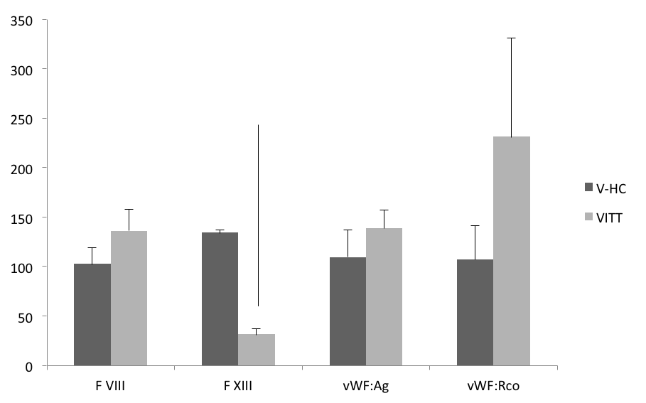
*
**
*

Figure S1. Coagulation is activated in VITT patients compared to vaccinated healthy controls. Factor VIII and XIII were respectively significantly increased and decreased in VITT patients compared to vaccinated healthy controls (V-HC). All VITT patients showed evidence of endothelial activation with significantly elevated VWF:RCo compared to V-HC. Statistical analyses were performed using unpaired Student’s test. .*P < 0.05; **P < 0.01.

Figure S2. Macroscopic aspect of the «white» thrombus retrieved during the first endovascular thrombectomy from middle cerebral artery in Patient 1.

Time from vaccination  (days) | 9 | 11 | 21 | 24 | 35 | 45
Time from admission/stroke  (days) | 0 | 2 | 12 | 15 | 26 | 36
PLT count  (per mm³)  (reference value  150,000-450,000) | 44,000 | 23,000 | 344,000 | 94,000 | 47,000 | 72,000
D-dimer*  µg/L  (0-550) | NA | >4318 | 13617 | 1939 | 2825 | 993
INR  (0.80-1.20) | 1.16 | 1.17 | 1.21 | 1.54 | 1.94 | 1.10
FBG mg/dL  (200-400) | 405 | 250 | NA | >555 | 312 | 280
SP  (pg/ml) | 0.868 | 0.7177 | NA | 0.853 | 0.798 | NA
sACE2  (ng/ml) | 2.843 | 0.565 | NA | 3.575 | 0.85 | NA
Anti-PF4  (OD₄₅₀ ) | NA | Neg  (0.5) | NA | Pos  (1.68) | NA | Neg  (0.35)
Platelet activation  (ATP release) | NA | -  (6%) | NA | ++  (22%) | NA | ++  (20%)
NETs  (OD₄₅₀ ) | 0.231 | 0,0 | NA | 0.91 | 0.104 | NA

Table S1. Patient 1 laboratory findings over time, during her hospital stay. Note that soluble Sars-cov-2 Spike protein (SP) was found up to 35 days after vaccination. Anti-PF4 antibodies were detected for the first time only at day 15 from admission. On day 45, despite negativity of anti-PF4 antibodies, serum patient continued to activate platelets from healthy donors and this activation was inhibited by both low and high dose of heparin (6% and 3% respectively). Platelet count reached normal values on day 12 after admission, 3 days after intravenous high dose immunoglobulin administration. Plasma exchange was performed on day 15th from admission. PLT: platelet; NETs: Neutrophil Extracellular Traps.
*D-dimer was dosed by Emergency Department laboratory with a cut-off of 4318 µg/L except on day 12th when D-dimer was dosed by Hematology Laboratory with no cut-off.

Reference
1. Kessenbrock K, Krumbholz M, Schönermarck U, et al. Netting neutrophils in autoimmune small-vessel vasculitis. Nature medicine 2009;15:623-5.

