Supplemental materials for
Three-dimensional magic angles enabled with an acoustic metacube
Chenglin Han^{1,2,3†}, Hong-Tao Zhou^{3,5†}, Shida Fan^{1†}, Liang Bai¹, Menghan Li¹, Jingjing He⁶, Jie Sun^{1,4} *, Tianzhi Yang^{1,2} * and Cheng-Wei Qiu^{3,} *

Supplementary section 1. The assembly of the metacube modules
A video showing the assembly of the metacube modules is available at the following link: https://drive.google.com/file/d/1eK3gupI6U0EORDMhd_4IIkqSEQYuLe-d/view?usp=sharing.

Supplementary section 2. Cell structure
The geometry of the cavity directly determines the acoustic impedance characteristics along different directions. Longer coupling tubes or those with smaller cross-sectional areas enhance momentum–inertial effects, resulting in inductive acoustic impedance. In contrast, shorter tubes or those with larger cross-sections are dominated by compressive effects, leading to capacitive impedance. By carefully tailoring the geometry of the coupling tubes, the acoustic impedance can be engineered to exhibit inductive or capacitive behavior along specific directions, thereby enabling extreme anisotropy within the sublattice. Conversely, if all coupling tubes share identical geometry, the system exhibits isotropic behavior.
As shown in Fig. S1, inspired by the concept of nonlocal connectivity¹, we equipped each custom-designed resonator with a set of coupling tubes along the x, y, and z directions. By systematically varying the length, size, and shape of the coupling tubes and the central resonator, we established distinct impedance characteristics along the three directions, enabling the coexistence of three types of dispersion. In addition, in the $5×5×5$ stacked metacube, the coupling tubes form a fully interconnected 3D network, allowing acoustic energy to transfer between non-adjacent resonators and thereby realizing a nonlocal propagation state. Finally, the array is arranged in a subwavelength-scale square lattice with a uniform lattice constant of a = 26 mm along all three orthogonal directions (see Fig. S1).
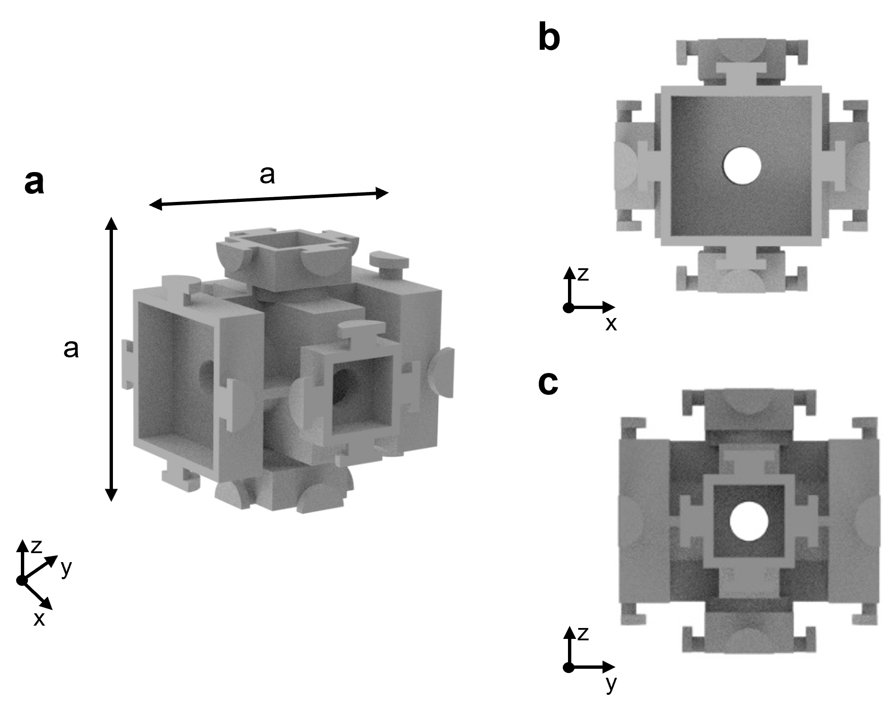
Fig. S1: Acoustic cell structure in the metacube. a, the overall structure. b and c, the side views

Supplementary section 3. Isofrequency curve analysis of the cell structures
As shown in Fig. S2, we computed the isofrequency contours of the unit-cell structure along three orthogonal directions using COMSOL Multiphysics. In Fig. S2a, the contour near 3500 Hz exhibits a smooth hyperbolic profile, indicative of extreme anisotropy along that direction. By contrast, Figs. S2b and S2c reveal circular and conventional hyperbolic contours, corresponding respectively to isotropic and standard anisotropic responses. The clear separation of these three dispersion types underscores the capability of the structure to support multidimensional wave manipulation.
Moreover, multiple contours of similar shape appear at different frequencies within the same unit cell, implying that wave phenomena such as localization, canalization, and asymmetric propagation can be sustained over a broad frequency interval. This bandwidth persistence highlights the robustness of the structure from a dispersion-engineering perspective.
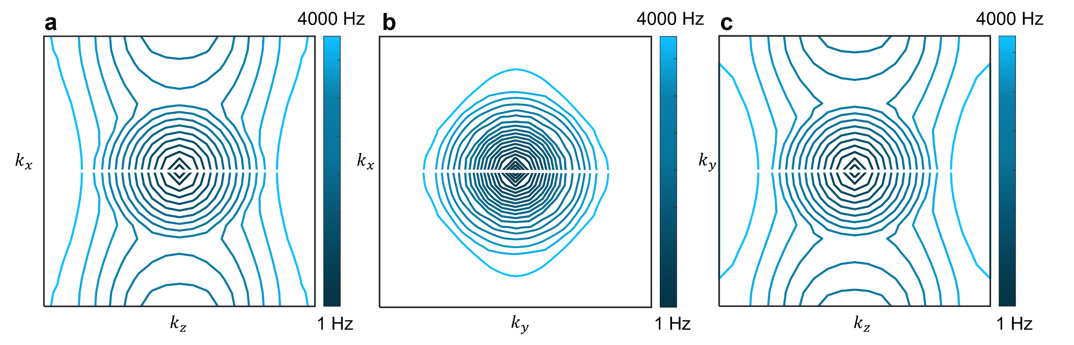
Fig. S2: Isofrequency curve diagrams for three directions. a, isofrequency curve of extreme anisotropic dispersion. b, isofrequency curve of isotropic dispersion. c, isofrequency curve of anisotropic hyperbolic dispersion.

Supplementary section 4. Derivation of metacube dispersion relations
First, let us consider the monolayer in the $xy$-plane of a metacube. Assume a unit cell is located on an infinite periodic monolayer metacube in the $xy$-direction. As shown in Fig. S3a, based on the continuity of normal mass velocity and sound pressure at Point 1, we derive:
$$P_{1}^{+}+P_{1}^{-}=P_{z1}^{+}+P_{z1}^{-}$$ | (S1)
$$-\frac{k_{z}}{k_{0}}P_{1}^{+}+\frac{k_{z}}{k_{0}}P_{1}^{-}=-P_{z1}^{+}+P_{z1}^{-}$$ | (S2)
Here, $ρ$ represents the air density, $c$ is the speed of sound in air, $k_{0}=\frac{ω}{c}$ and$\cos{(α)=\frac{k_{z}}{k_{0}}}$. Eqs. (S1) and (S2) are formulated at point 1, where the z-axis aligns with the red line in Fig. S3a, taking this point as the coordinate origin and neglecting the initial phase. For clarity, the coupling tubes in the unit cell illustrated in Fig. 3 are rendered in an elongated form, which does not represent their actual physical length. Similarly, by taking point 2 as the coordinate origin, the following expressions are derived based on the continuity of sound pressure and the conservation of mass:
$$P_{z1}^{+}+P_{z1}^{-}=P_{z2}^{+}+P_{z2}^{-}=P(x,y,z)$$ | (S3)
$$U_{z1}^{+}-U_{z1}^{-}=U_{z2}^{+}-U_{z2}^{-}+U_{x}^{-}-U_{x}^{+}+U_{y}^{-}-U_{y}^{+}$$ | (S4)
Here, $U_{z1}^{-}$ and $U_{z1}^{+}$ denote the volume velocities of inflow and outflow, respectively, from the upper section of the tube in the z-direction at point 2. Similarly, $U_{z2}^{-}$ and $U_{z2}^{+}$refer to the inflow and outflow volume velocities in the lower section of the tube. For the x-direction, $U_{x}^{-}$ and $U_{x}^{+}$ represent the outflow and inflow volume velocities, respectively. Likewise, $U_{y}^{+}$ and $U_{y}^{-}$ correspond to the volume velocities from the y-direction. The term $P\left(x,y,z\right)$ indicates the sound pressure at point 2. Eq. (S4) can thus be explicitly written as:
$$-\frac{S}{ρc}P_{Z1}^{+}e^{ik_{z}Δz}+\frac{S}{ρc}P_{Z1}^{-}e^{-ik_{z}Δz}=-U_{x}\left(x-Δx,y,z\right)+U_{x}\left(x,y,z\right)-U_{y}\left(x,y-Δy,z\right)+U_{y}\left(x,y,z\right)-\frac{S}{ρc}P_{Z2}^{+}+\frac{S}{ρc}P_{Z2}^{-}$$ | (S5)
Here, $S$ represents the cross-sectional area of the resonator along the z-direction. Equation (S5) is reformulated as a differential equation on the subwavelength scale¹.
$$-\frac{S}{ρc}P_{z1}^{+}e^{ik_{z}Δz}+\frac{S}{ρc}P_{z1}^{-}e^{-ik_{z}Δz}=\frac{∂U_{x}\left(x,y,z\right)}{∂x}Δx+\frac{∂U_{y}\left(x,y,z\right)}{∂y}Δy-\frac{S}{ρc}P_{z2}^{+}+\frac{S}{ρc}P_{z2}^{-}$$ | (S6)
The acoustic impedances ($Z$) of the coupling tubes in the x- and y-directions can be expressed as $Z_{x}$ and $Z_{y}$, respectively. According to its definition, the acoustic impedance is given by:
$$-\frac{∂P\left(x,y,z\right)}{Z_{x}\left(x,y,z\right)∂x}Δx=\frac{\left(P(x,y,z)-P(x+Δx,y,z)\right)}{Z_{x}\left(x,y,z\right)}=U_{x}\left(x,y,z\right)$$ | (S7)
$$-\frac{∂P\left(x,y,z\right)}{Z_{y}\left(x,y,z\right)∂y}Δy=\frac{\left(P(x,y,z)-P(x,y+Δy,z)\right)}{Z_{y}\left(x,y,z\right)}=U_{y}\left(x,y,z\right)$$ | (S8)
Here, $∆x$, $∆y$ and $∆z$ represent the distances in the x-, y- and z-directions, respectively, as shown in Fig. S3. By substituting the expressions for $U_{z1}$, $U_{z2}$, $U_{x}$ and $U_{y}$ from Eqs. (S7) and (S8) into Eq. (S6), we obtain:
$$-\frac{S}{ρc}P_{z1}^{+}e^{ik_{z}Δz}+\frac{S}{ρc}P_{z1}^{-}e^{-ik_{z}Δz}=\left(\frac{S}{ρc}+\frac{k_{x}^{2}Δx^{2}}{Z_{x}\left(x,y,z\right)}+\frac{k_{y}^{2}Δy^{2}}{Z_{y}\left(x,y,z\right)}\right)P_{z2}^{-}+(-\frac{S}{ρc}+\frac{k_{x}^{2}Δx^{2}}{Z_{x}\left(x,y,z\right)}+\frac{k_{y}^{2}Δy^{2}}{Z_{y}\left(x,y,z\right)})P_{Z2}^{+}$$ | (S9)
Similarly, enforcing the continuity of sound pressure and normal mass velocity at point 3 leads to the following conditions:
$$P_{z2}^{+}+P_{z2}^{-}=P_{2}^{+}+P_{2}^{-}$$ | (S10)
$$P_{z2}^{+}-P_{z2}^{-}=P_{2}^{+}-P_{2}^{-}$$ | (S11)
Since the metasurface is embedded in a semi-infinite space, no downward reflection occurs ($P_{2}^{-}=0$). By combining Eqs. (S1), (S2), (S3), (S9), (S10), and (S11), we obtain three 2$×$2 transfer matrices that relate the sound-pressure components inside the structure:
$$\left(\begin{aligned}&P_{1}^{+} \\ &P_{1}^{-}\end{aligned}\right)={\hat{T}}_{A}\left(\begin{aligned}&P_{z1}^{+} \\ &P_{z1}^{-}\end{aligned}\right)$$ | (S12)
$$\left(\begin{aligned}&P_{z1}^{+} \\ &P_{z1}^{-}\end{aligned}\right)={\hat{T}}_{B}\left(\begin{aligned}&P_{z2}^{+} \\ &P_{z2}^{-}\end{aligned}\right)$$ | (S13)
$$\left(\begin{aligned}&P_{z2}^{+} \\ &P_{z2}^{-}\end{aligned}\right)={\hat{T}}_{C}\left(\begin{aligned}&P_{2}^{+} \\ &P_{2}^{-}\end{aligned}\right)$$ | (S14)
with
$${\hat{T}}_{A}=\left(\begin{matrix}\frac{k_{0}+k_{Z}}{2k_{Z}} & -\frac{k_{0}+k_{Z}}{2k_{Z}} \\ -\frac{k_{0}+k_{Z}}{2k_{Z}} & \frac{k_{0}+k_{Z}}{2k_{Z}}\end{matrix}\right)$$ | (S15)
$${\hat{T}}_{B}=\left(\begin{matrix}-\frac{Δx^{2}ρc{k_{x}}^{2}e^{iΔzk_{z}}}{SZ_{x}(e^{(2Δzk_{z})}+1)}+\frac{SZ_{y}(e^{iΔzk_{z}}+1)-Δy^{2}ρc{k_{y}}^{2}e^{iΔzk_{z}}}{SZ_{y}(e^{2iΔzk_{z}}+1)} & -\frac{Δx^{2}ρc{k_{x}}^{2}e^{iΔzk_{z}}}{SZ_{x}(e^{2iΔzk_{z}}+1)}-\frac{SZ_{y}(e^{iΔzk_{z}}-1)+Δy^{2}ρc{k_{y}}^{2}e^{iΔzk_{z}}}{SZ_{y}(e^{2iΔzk_{z}}+1)} \\ \frac{Δx^{2}ρc{k_{x}}^{2}e^{iΔzk_{z}}}{SZ_{x}(e^{2iΔzk_{z}}+1)}+\frac{SZ_{y}(e^{(Δzk_{z})}-1)+Δy^{2}ρc{k_{y}}^{2}e^{(Δzk_{z})}}{SZ_{y}(e^{2iΔzk_{z}}+1)} & \frac{Δx^{2}ρc{k_{x}}^{2}e^{iΔzk_{z}}}{SZ_{x}(e^{2iΔzk_{z}}+1)}+\frac{SZ_{y}(e^{iΔzk_{z}}+1)+Δy^{2}ρc{k_{y}}^{2}e^{iΔzk_{z}}}{SZ_{y}(e^{2iΔzk_{z}}+1)}\end{matrix}\right)$$ | (S16)
$${\hat{T}}_{C}=\left(\begin{matrix}\frac{k_{0}+k_{z}}{2k_{0}} & 0 \\ \frac{k_{0}-k_{z}}{2k_{0}} & 0\end{matrix}\right)$$ | (S17)
Specifically, the three transfer matrices are derived using points 1, 2, and 3 as their respective coordinate origins. However, they are not yet expressed within a unified coordinate system, and the associated phase offsets are therefore not captured. To reconcile these differences, the matrices are connected through the propagation matrix ${\hat{T}}_{d}$, yielding a combined relation matrix that links the input and output sound-pressure fields:
$$\left(\begin{aligned}&P_{1}^{+} \\ &P_{1}^{-}\end{aligned}\right)={\hat{T}}_{1→2}\left(\begin{aligned}&P_{2}^{+} \\ &P_{2}^{-}\end{aligned}\right)$$ | (S18)
$${\hat{T}}_{1→2}={\hat{T}}_{A}{\hat{T}}_{d}{\hat{T}}_{B}{\hat{T}}_{d}{\hat{T}}_{C}$$ | (S19)
with
$${\hat{T}}_{d}=\left(\begin{matrix}e^{ik_{z}d} & 0 \\ 0 & e^{-ik_{z}d}\end{matrix}\right)$$ | (S20)
Here, $d$ represents the distance between two adjacent points. Using the phase relationship between the input and output sound pressures, we derive:
$$\left(\begin{aligned}&P_{1}^{+} \\ &P_{1}^{-}\end{aligned}\right)={\hat{T}}_{1→2}\left(\begin{aligned}&P_{2}^{+} \\ &P_{2}^{-}\end{aligned}\right)=\left(\begin{matrix}T_{11} & T_{12} \\ T_{21} & T_{22}\end{matrix}\right)\left(\begin{aligned}&e^{-ik_{z}d_{h}}P_{1}^{+} \\ &e^{-ik_{z}d_{h}}P_{1}^{-}\end{aligned}\right)$$ | (S21)
Here, $d_{h}$ denotes the height of the z-direction resonator, specifically the distance between points 1 and 3. By rearranging Eq. (S21), we arrive at:
$$\left[\left(\begin{matrix}T_{11} & T_{12} \\ T_{21} & T_{22}\end{matrix}\right)-\left(\begin{matrix}e^{ik_{z}d_{h}} & 0 \\ 0 & e^{ik_{z}d_{h}}\end{matrix}\right)\right]\left(\begin{aligned}&P_{2}^{+} \\ &P_{2}^{-}\end{aligned}\right)=0$$ | (S22)
Since the equation has only one solution, we arrive at:
$$\left|\begin{matrix}T_{11}-e^{ik_{z}d_{h}} & T_{12} \\ T_{21} & T_{22}-e^{ik_{z}d_{h}}\end{matrix}\right|=0$$ | (S23)
The dispersion relation for the monolayer metacube is determined by substituting the elements of ${\hat{T}}_{1→2}$, calculated from Eq. (S19), into Eq. (S23). The twist effect is characterized by associating the wave vector of each layer with its respective twist angle $(α)$. An illustrative example of a monolayer twist is as follows:
$$\left(\begin{matrix}k_{x1} \\ k_{y1}\end{matrix}\right)=\left(\begin{matrix}\cos{(}α) & -\sin{(}α) \\ \sin{(}α) & \cos{(}α)\end{matrix}\right)\left(\begin{matrix}k_{x} \\ k_{y}\end{matrix}\right)$$ | (S24)
The twisted dispersion relation is derived by substituting $k_{x}$ and $k_{y}$ in the dispersion relation equation with $k_{x}$ and $k_{y}$ from Eq. (S24). It should be noted that the angle $α$ is used when twisting the $xy$ plane; for other planes, the corresponding twist angle should be applied accordingly, while the structure of the rotation matrix remains unchanged. In addition, the method for introducing the tilt angle has already been derived in our previous work².
The above dispersion relation is derived for the $xy$ plane of a monolayer metacube. The same derivation applies to the other two orthogonal planes, as their geometrical configurations and boundary conditions follow the same form. Subsequently, we generalize the monolayer model to a multilayer metacube by employing the transfer matrix method to connect the metasurfaces between adjacent layers³:
$${\hat{T}}_{1→n+1}={\hat{T}}_{1→2}{\hat{T}}_{d_{1}}{\hat{T}}_{2→3}⋯{\hat{T}}_{d_{n-1}}{\hat{T}}_{n→n+1}$$ | (S25)
with:
$${\hat{T}}_{d_{n}}=\left(\begin{matrix}e^{ik_{z}d_{n}} & 0 \\ 0 & e^{-ik_{z}d_{n}}\end{matrix}\right)$$ | (S26)
Here, the method for deriving ${\hat{T}}_{n→n+1}$ is analogous to that used for obtaining ${\hat{T}}_{1→2}$. The matrix ${\hat{T}}_{d_{n}}$ represents the transfer matrix for wave propagation through the interlayer with a thickness $d_{n}$. With the input–output pressure relation matrix defined for any layer configuration, the dispersion characteristics of a metacube comprising an arbitrary number of layers can be obtained via Eqs. (S21)–(S23).
Taken together, the above formulation provides a general and scalable framework for metacubes composed of an arbitrary number of layers. Because the derivation hinges only on the impedance-based interface conditions—expressed here as acoustic impedance but directly corresponding to surface impedance, mechanical impedance, or other sign-changing effective parameters in different wave systems—the method is inherently independent of the specific physical domain. Consequently, this approach extends naturally beyond acoustics to a broad class of multilayer artificial materials in electromagnetics, elastodynamics, and other wave-based platforms that employ nonlocal coupling or twist- and tilt-induced geometric modulation.
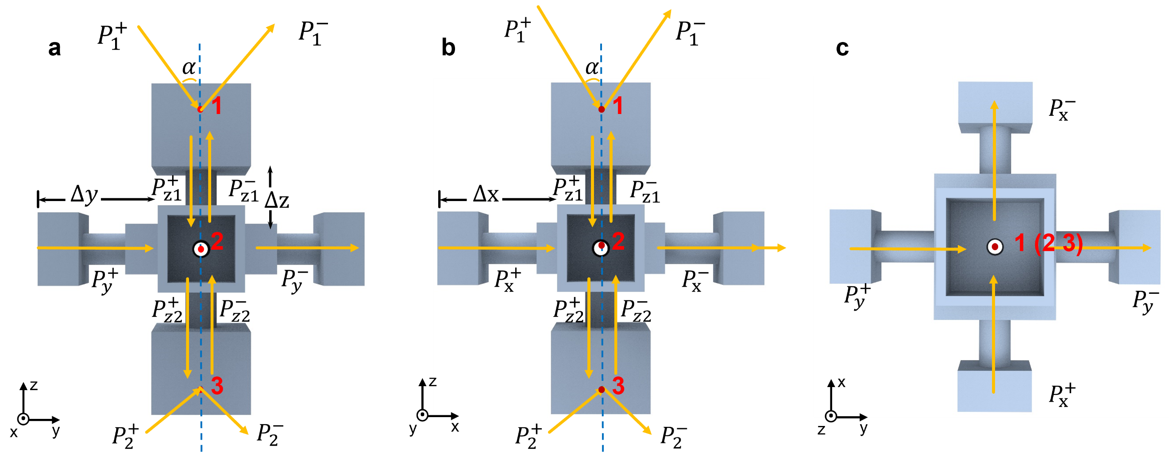
Fig. S3: Structural layout of the metacube unit cell. a-c, Side views along the x, y, and z directions, respectively.

Supplementary section 5. Additional acoustic field results of metacubes
Fig. S4–S7 present additional acoustic field patterns across a wide range of twisting and tilting configurations. The characteristic behaviors identified in Fig. 4—such as unidirectional canalization, hyperbolic and asymmetric propagation, and localization—consistently reappear throughout these extended parameter spaces, while their specific manifestations vary with the applied twist or tilt. These results demonstrate that the metacube’s unconventional wave responses are both robust and highly tunable, arising universally from its three-dimensional nonlocal coupling architecture.
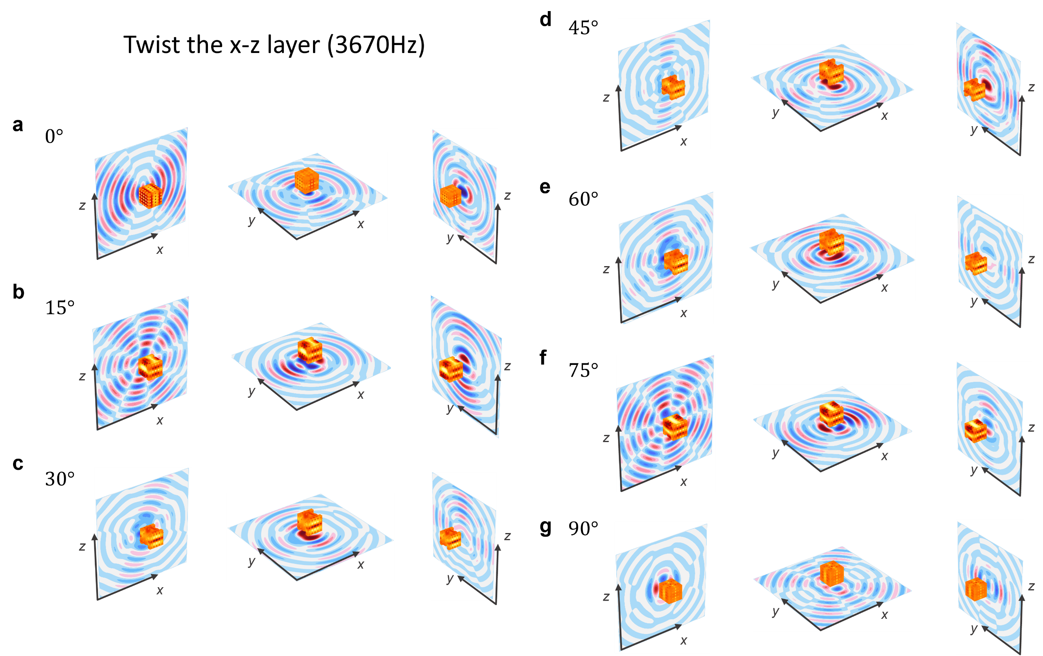
Fig. S4: Sound field diagrams. a-g, the acoustic fields on the three orthogonal faces when the x–z layer is twisted from 0° to 90° in steps of 15°.
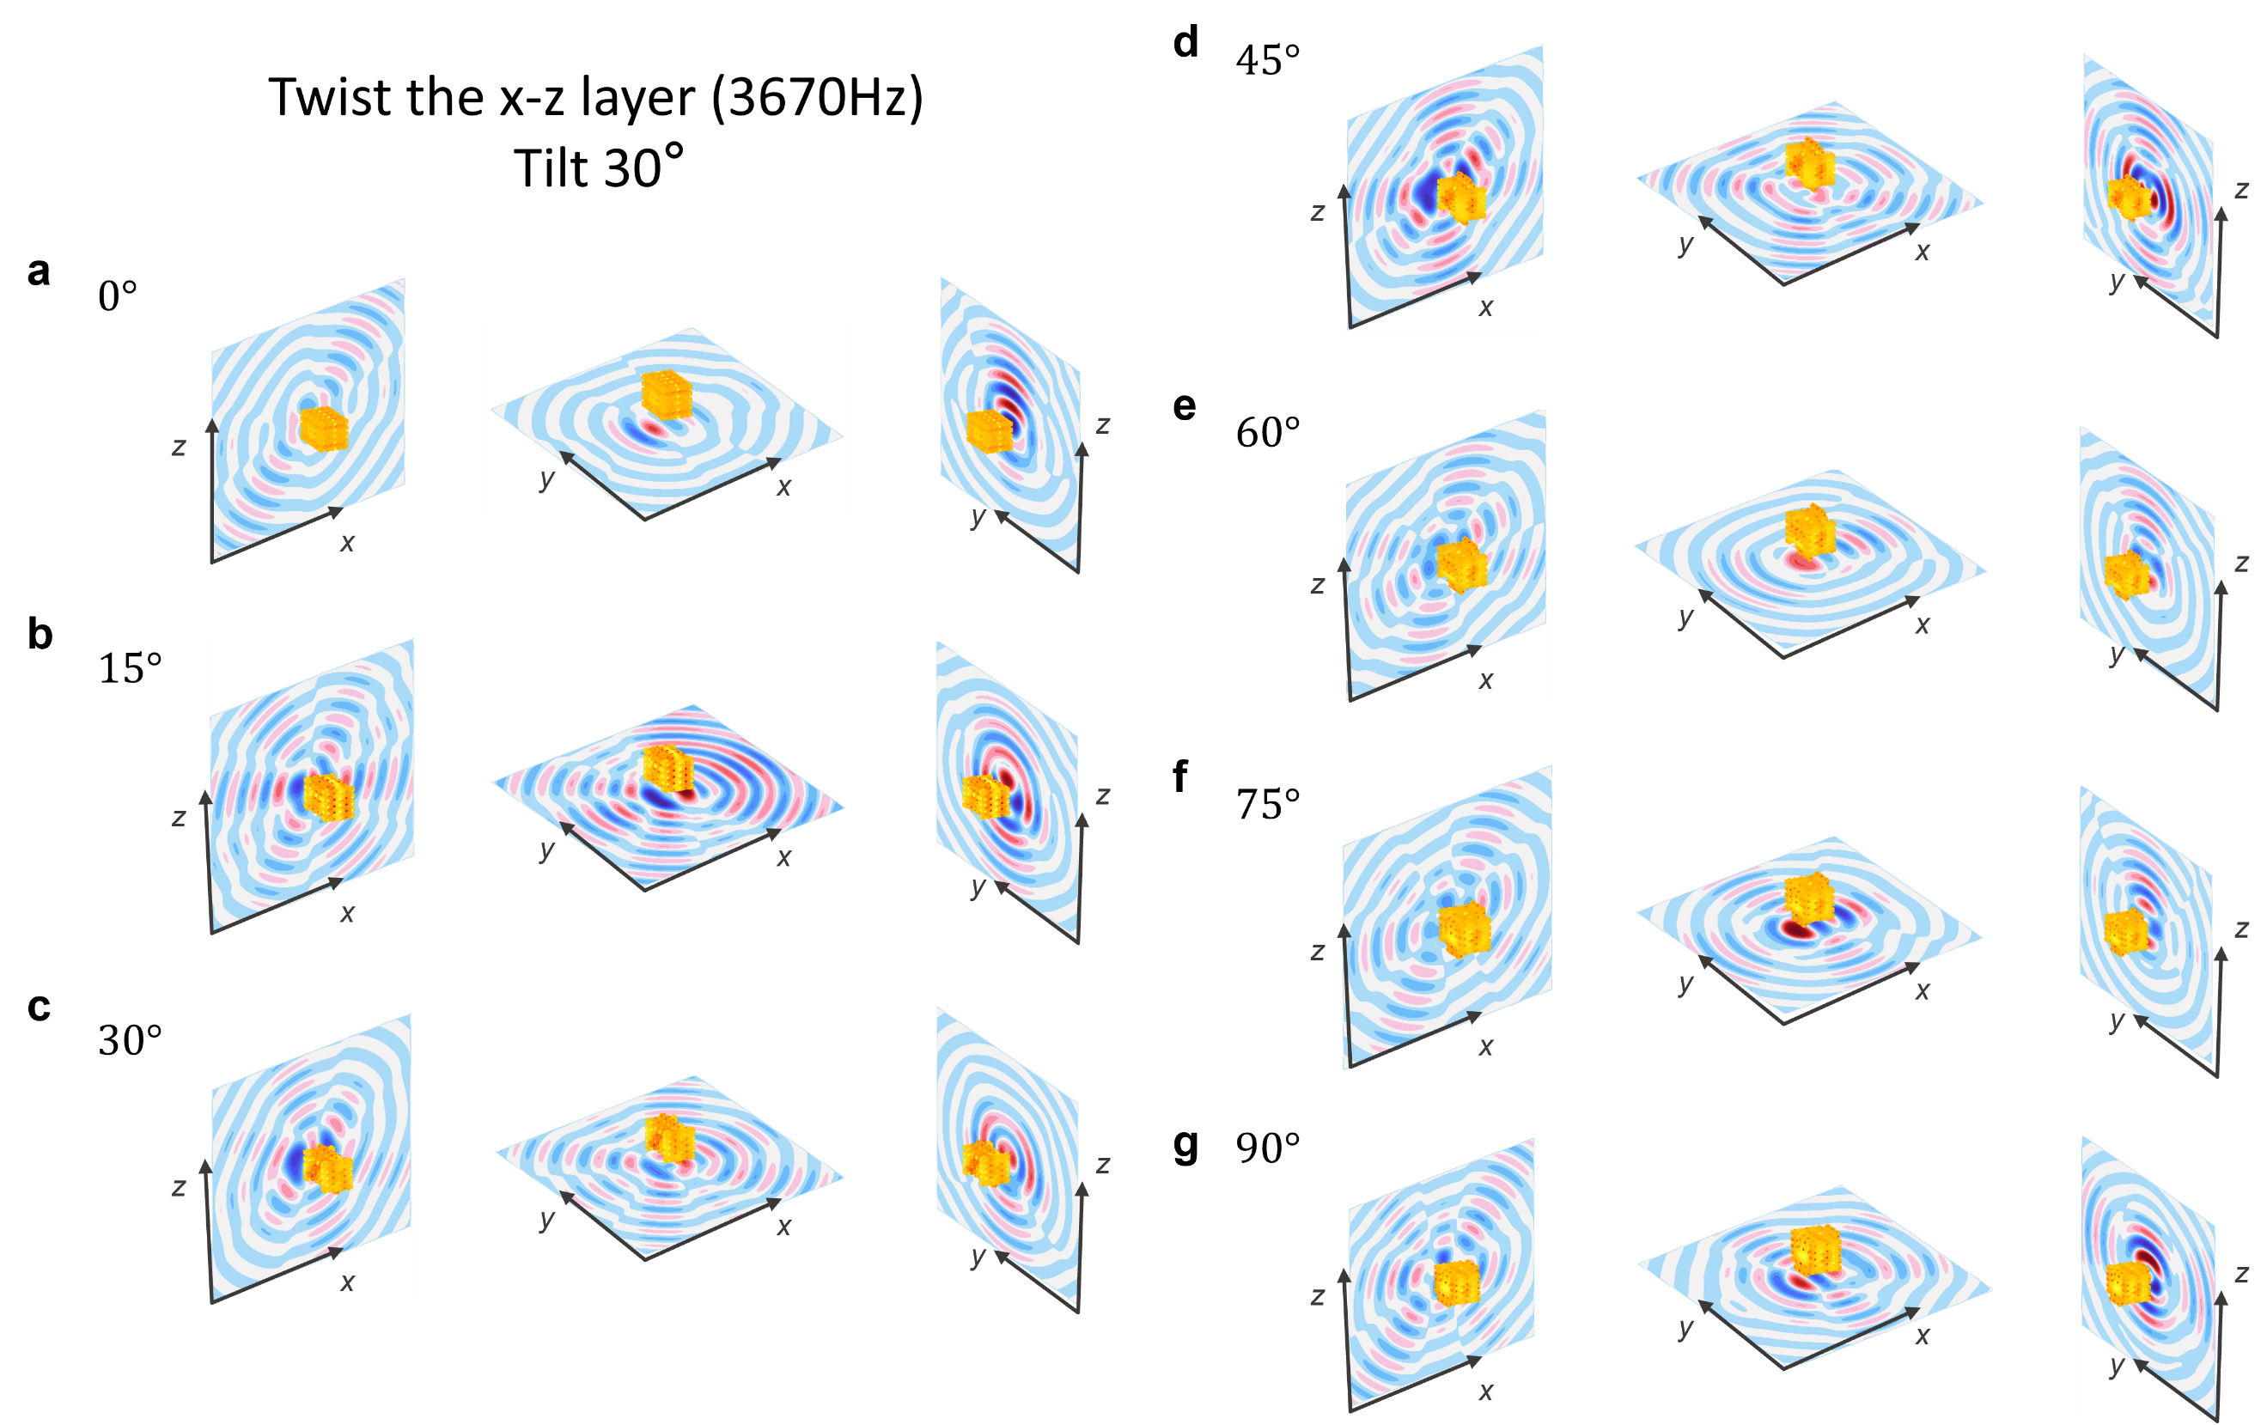
Fig. S5: Sound field diagrams. a-g, the acoustic fields on the three orthogonal faces when the x–z layer is twisted from 0° to 90° in 15° increments under a 30° tilt.
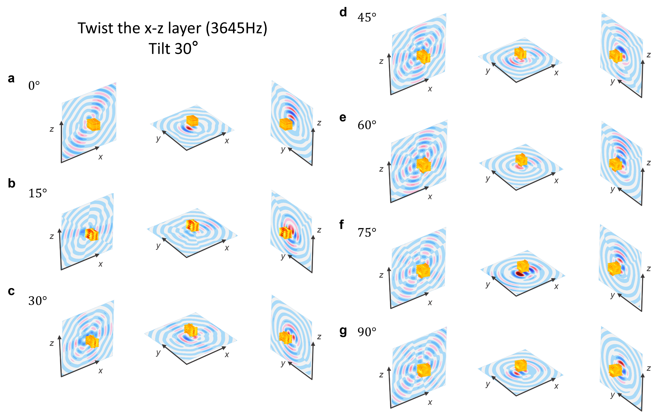
Fig. S6: Sound field diagrams. a-g, the acoustic fields on the three orthogonal faces when the x–z layer is twisted from 0° to 90° in 15° increments under a 30° tilt.
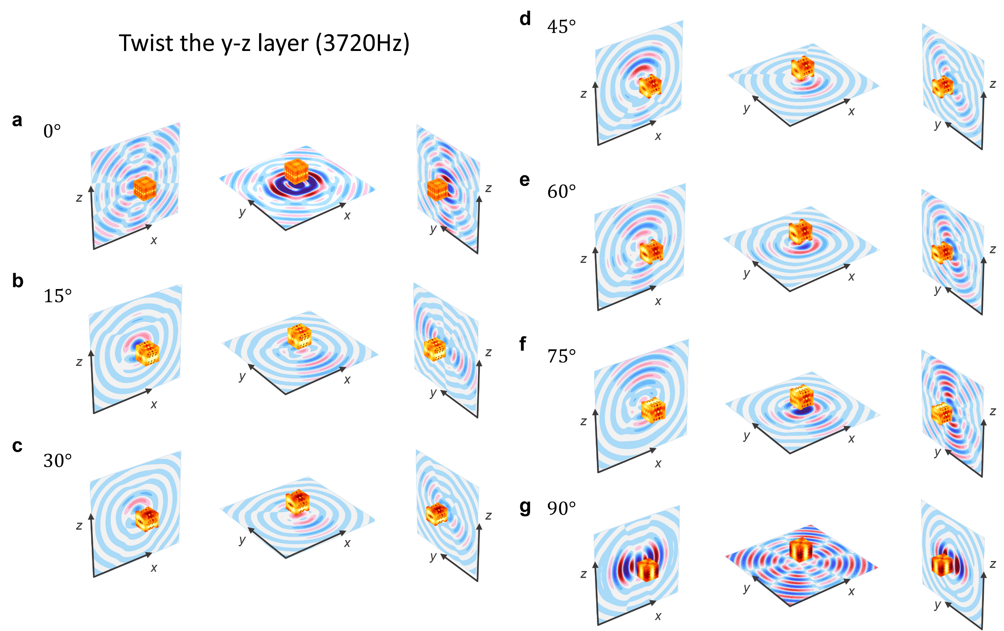
Fig. S7: Sound field diagrams. a-g, the acoustic fields on the three orthogonal faces when the y–z layer is twisted from 0° to 90° in steps of 15°.

Supplementary section 6. Results from arbitrary metacube configurations
As shown in Fig. S8, the two-dimensional symmetric arrangement of the metacube produces clear canalization on the $xy$-plane, while the $xz$-plane exhibits a stable fourfold symmetric interference pattern. In Fig. S9, the fully symmetric 3D configuration produces highly consistent and symmetry-protected interference patterns across all three orthogonal planes. Such globally coordinated field symmetry reflects the self-organized nature of the metacube’s internal coupling network and provides a robust mechanism for stabilizing wavefronts and maintaining uniform energy distribution throughout the structure. Fig. S10 highlights an extreme configuration in which a vertically aligned metacube chain produces ultra-long-distance canalization, forming a highly collimated, low-diffraction transport channel. Finally, Fig. S11 shows a systematic progression from 1D to 2D to 3D stacking, where each dimensional configuration exhibits a distinct acoustic response, illustrating that the metacube can be freely reconfigured while retaining deterministic control over multidimensional wave propagation.
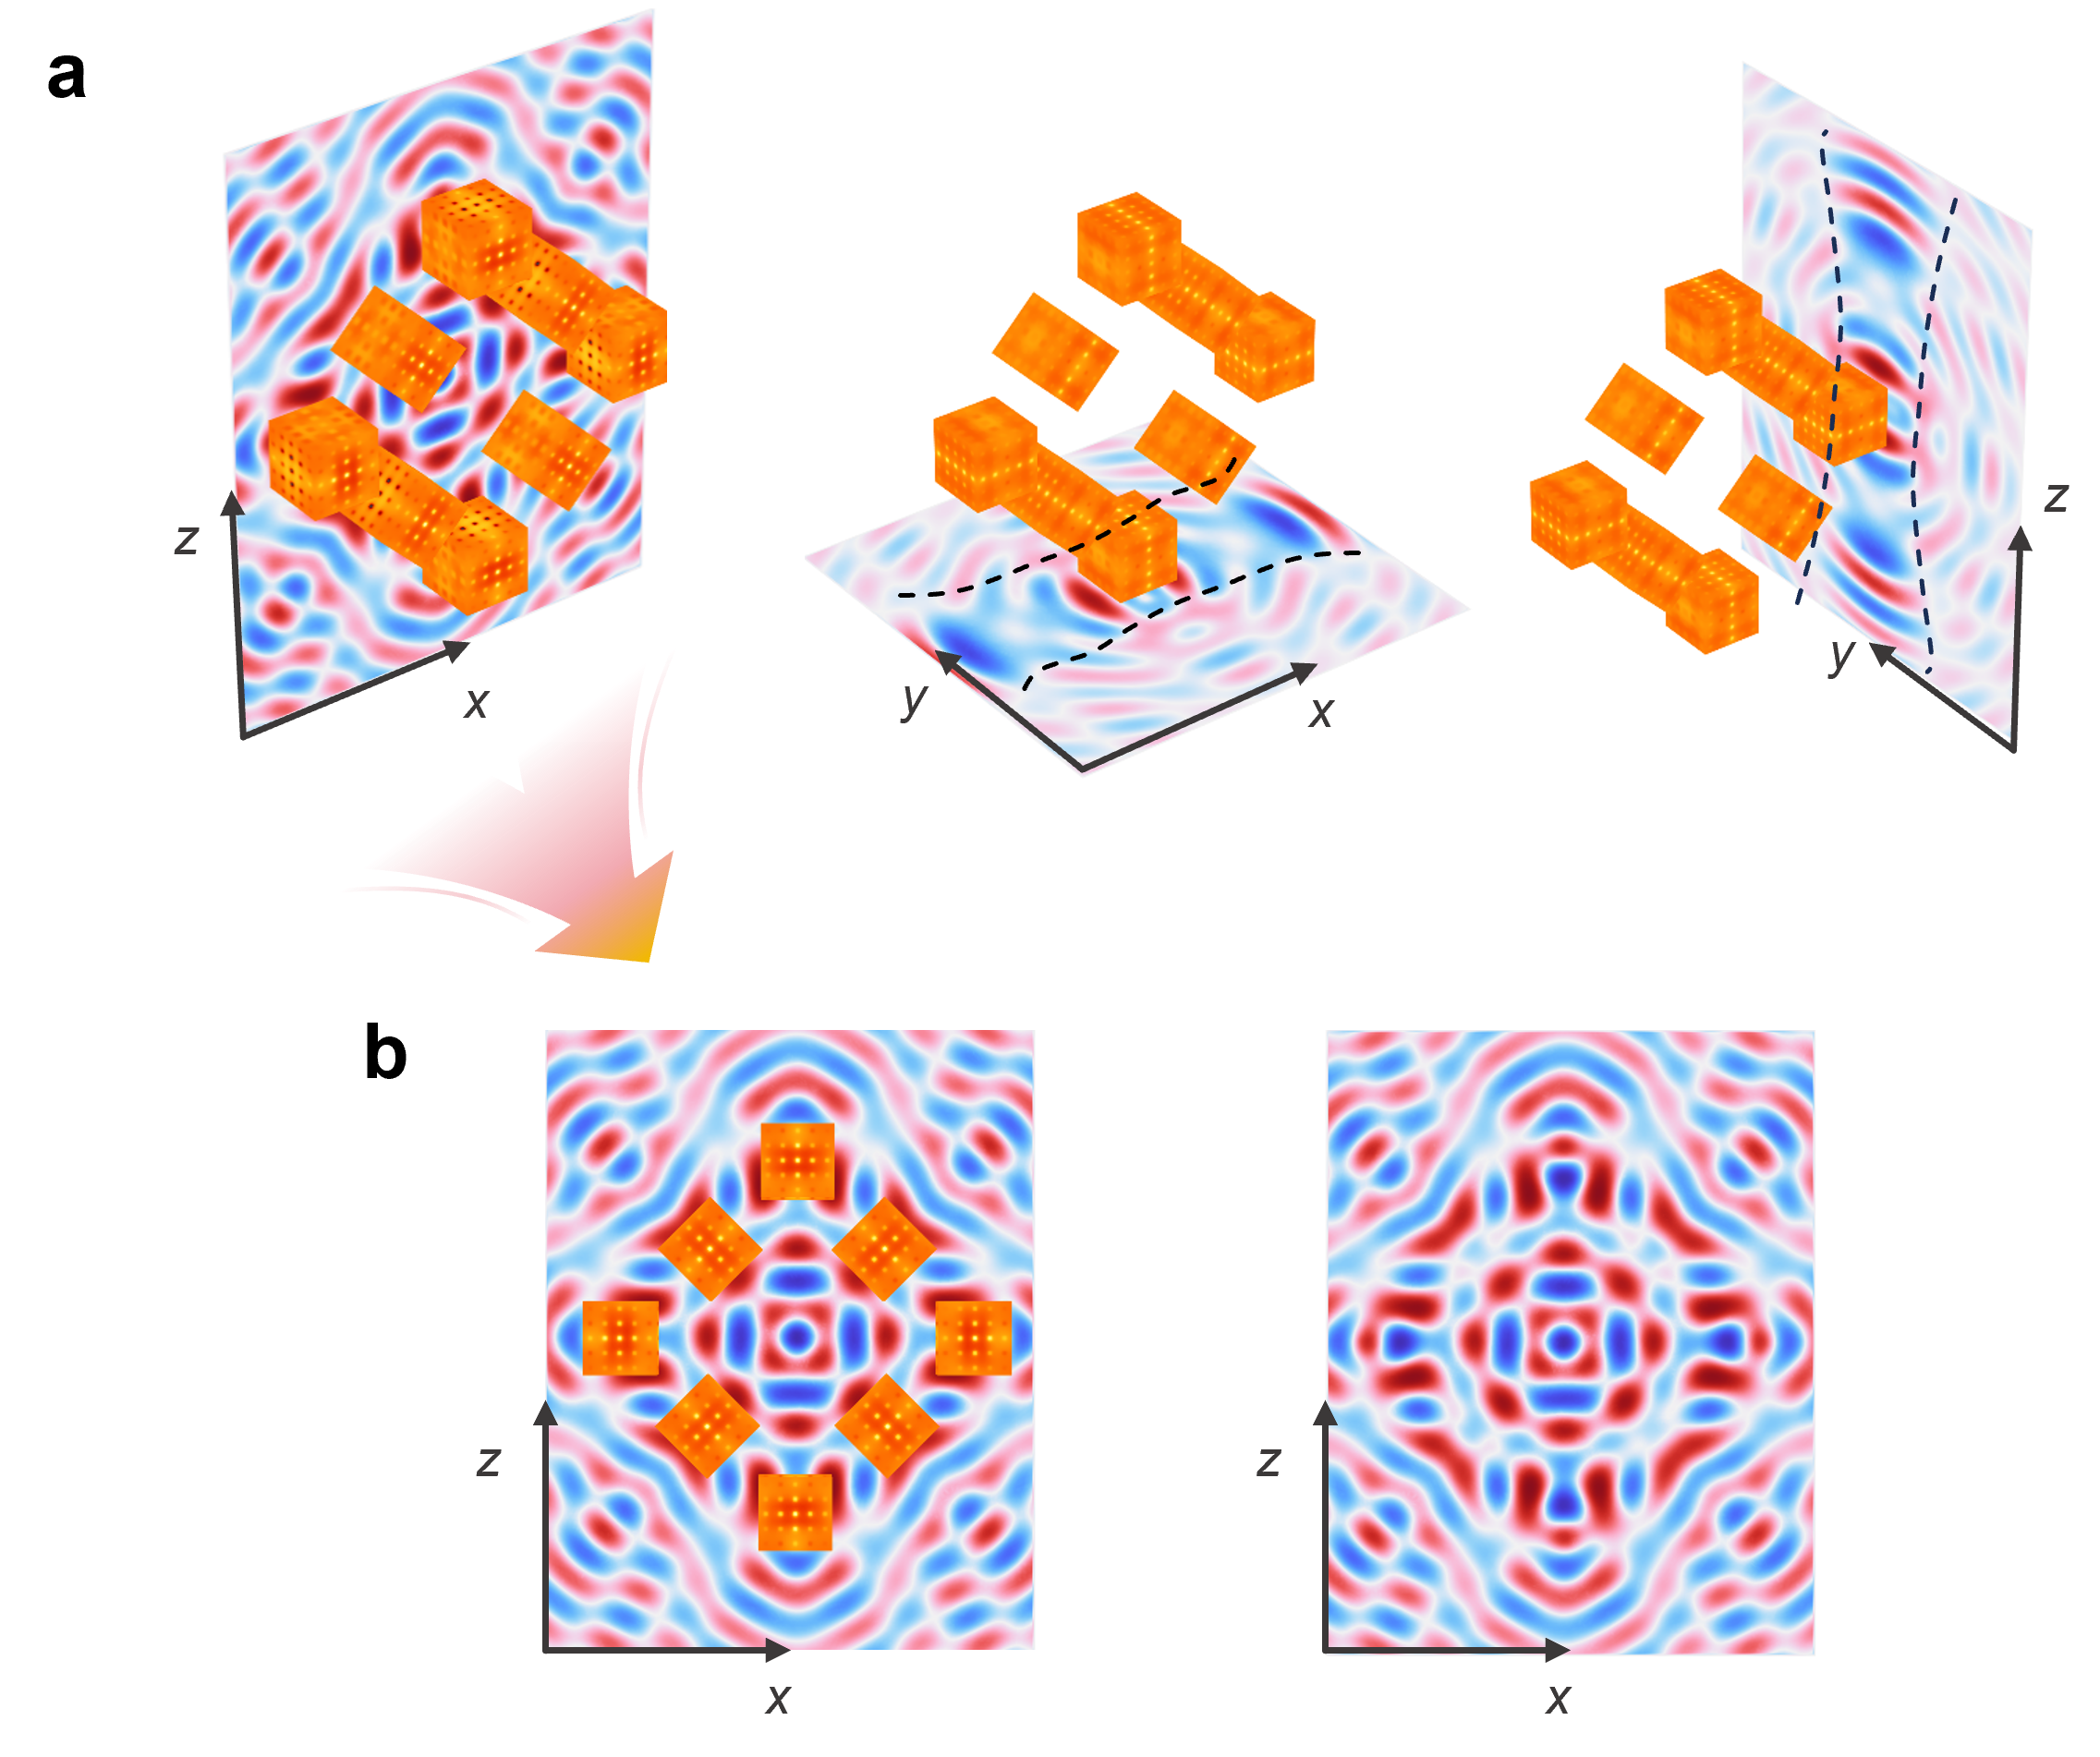
Fig. S8: Acoustic field of the 2D symmetric structure. a, Acoustic field distributions along the three orthogonal directions. b, Acoustic field on the $xz$-plane. The steady-state acoustic field exhibits a pronounced fourfold symmetric interference pattern.
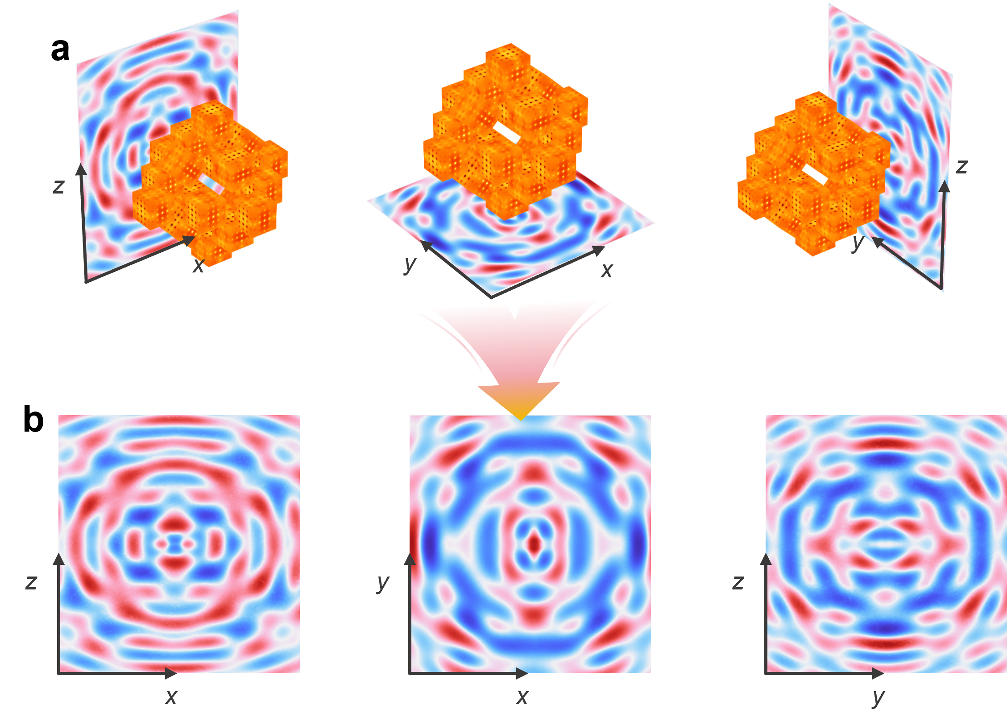
Fig. S9: Acoustic field of the 3D symmetric structure. a and b Acoustic field distributions along the three orthogonal directions. The field shows a well-defined symmetric interference structure.
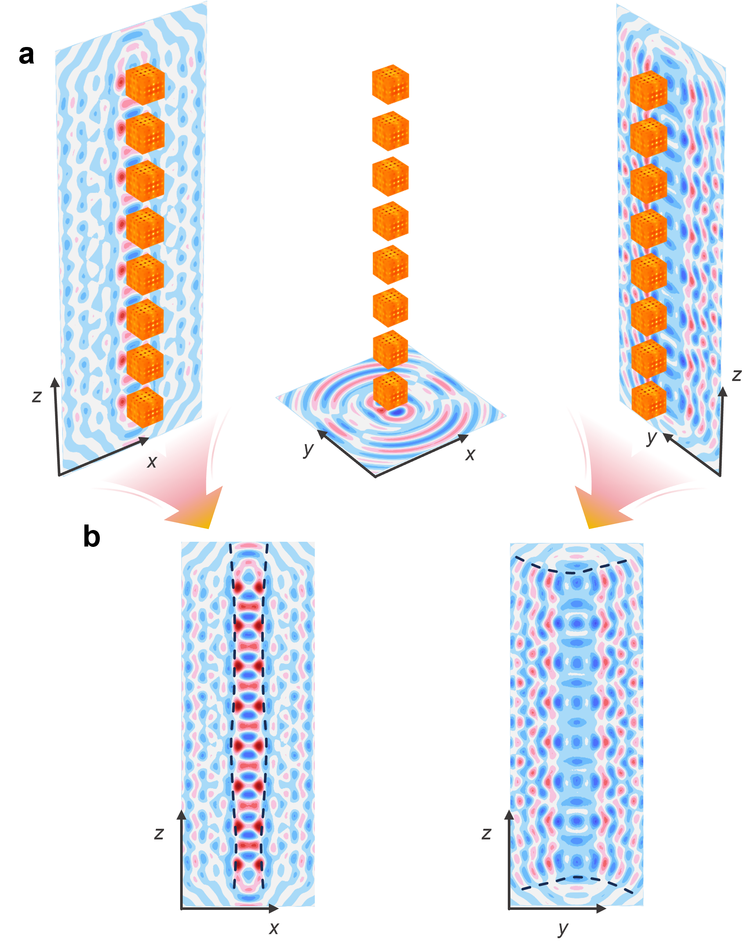
Fig. S10: Acoustic field of the ultra-long canalization. a and b Acoustic field distributions along the three orthogonal directions. The acoustic field on the $xz$-plane exhibits ultra-long-distance canalization.
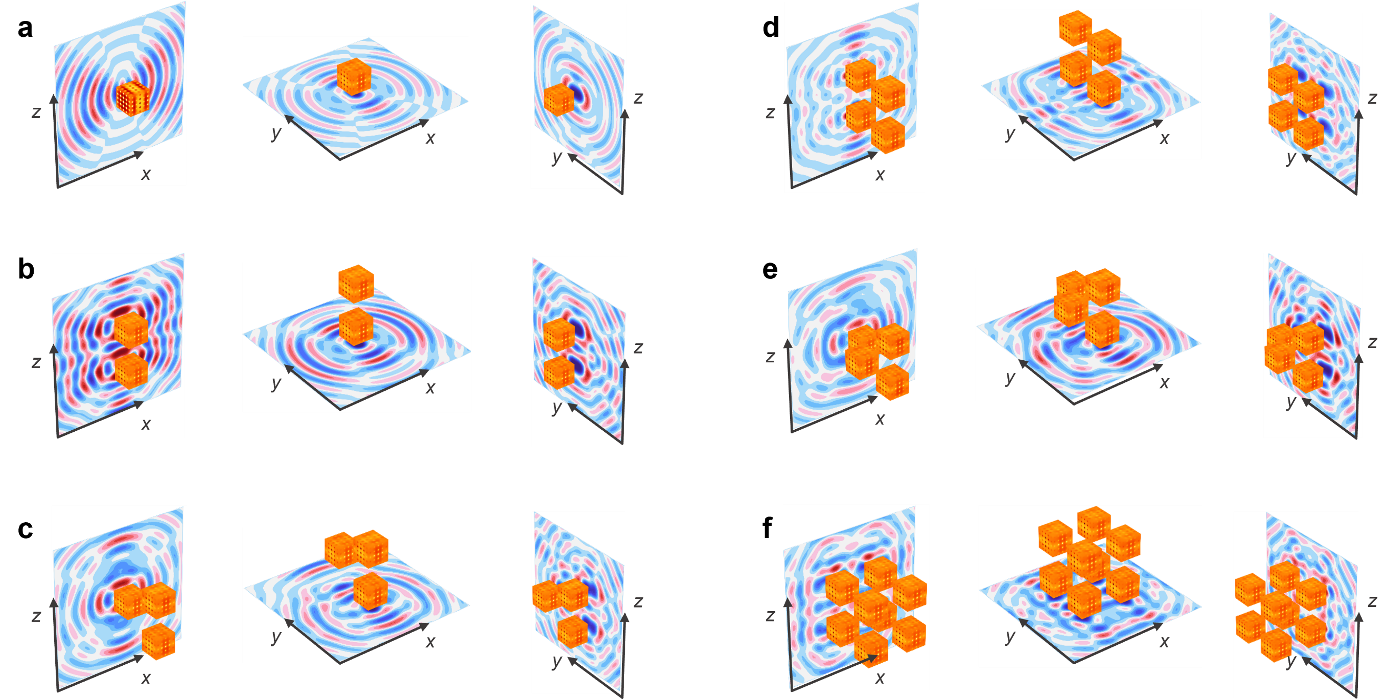
Fig. S11: Acoustic fields of metacubes transitioning from 1D to 2D to 3D stacking. a, A single metacube. b, Two metacubes. c, Three metacubes. d, Four metacubes. e, Four metacubes arranged in a staggered configuration. f, Eight metacubes assembled into a 3D cube.

Supplementary section 7. Experimental setup
As shown in Fig. S12a, we developed an automated three-axis precision measurement platform to experimentally validate the accuracy of the established moiré system. The platform integrates three-dimensional motion control with acoustic excitation and signal acquisition, enabling point-wise pressure scanning and dynamic response measurements throughout an arbitrary spatial region. A 3.0 mm radius speaker is placed at the center of the metacube and serves as an omnidirectional point source. For clarity, the speaker is enlarged in the illustration and the surrounding acoustic foam is omitted.
The three-axis system provides high-precision, programmable, multi-degree-of-freedom control, allowing the microphone to be repositioned freely within the measurement volume for high-resolution reconstruction of the acoustic field. As shown in Fig. S12b, the platform consists of X, Y, and Z linear modules, each driven by an independent stepper motor and equipped with limit switches and origin calibration for zero-position recovery and travel protection. Software control enables precise tuning of the velocity, displacement, and trajectory of each axis, providing a reliable mechanical and motion-control basis for the automated acquisition of acoustic-pressure distributions on the moiré metasurface.
Compared with traditional single-axis or planar measurement setups, this platform significantly enhances experimental flexibility and spatial coverage while ensuring excellent repeatability and consistency across measurement points, thereby reducing systematic errors. Its modular and extensible design further allows compatibility with various acoustic measurement tasks, offering a robust and versatile experimental foundation for the study of complex three-dimensional systems.
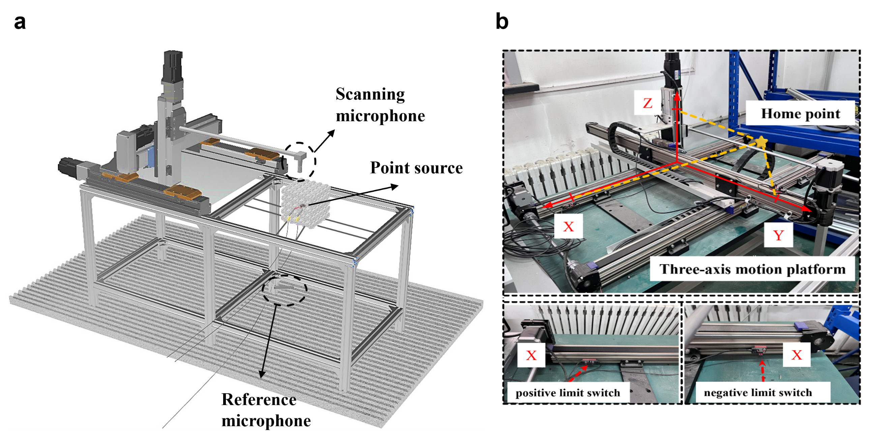
Fig. S12: Diagram showing the overall experimental device setup. To display the positions of the microphone and sound source, the acoustic foam that surrounds them has been omitted from the figure.

Supplementary section 8. Supplementary References
- Quan, L., Alù, A. Hyperbolic sound propagation over nonlocal acoustic metasurfaces. Phys. Rev. Lett. 123, 244303 (2019).
- Han, C., Fan, S., Zhou, HT, Yang, T. Z., Qiu, C-W. All-angle unidirectional flat-band acoustic metasurfaces. Nat. Commun. 16, 634 (2025).
- Kotov, O., Lozovik, Y. Hyperbolic hybrid waves and optical topological transitions in few-layer anisotropic metasurfaces. Phys. Rev. B. 100, 165424 (2019).

