Supplemental Materials
Supplemental Figures
Figure S1. ACE2, CTSL, and TMPRSS2 expression associated with current cigarette smoking in nasal and bronchial epithelium.
(a) Boxplots showing the significance of associations between VE gene expression and smoking status in nasal (N = 150) and bronchial (N = 305) epithelium from the AEGIS cohort, assessed by Student’s t-test on residual expression values after correction for sex, age, percentage of predicted FEV1, cancer status, batch, and mTIN. The upper and lower hinges correspond to the first and third quartile, the center line represents the median, and whiskers extend from the hinge to the largest or smallest value at most 1.5 times the interquartile range. (b) Associations between the expression of ACE2 (tan), CTSL (brown), and TMPRSS2 (olive) and clinical covariates in the nasal and bronchial epithelium. Nasal (pink) and bronchial (purple) brushings were collected from subjects at high-risk of developing lung cancer from 4 different studies (DECAMP bronchus: N = 341; AEGIS bronchus: N = 305; BCLHS bronchus: N = 238; PCA bronchus: N = 133; DECAMP nose: N = 253; AEGIS nose: N =150). The size and color of the bubbles represent the significance and magnitude, respectively, of the t-statistics, calculated using linear modeling of VE gene expression as a function of each clinical variable: smoking status, sex, age, and percentage of predicted FEV1 (and, for the AEGIS dataset, lung cancer diagnosis), correcting for batch and mean Transcript Integrity Number (mTIN). Significance levels: * < 0.05, ** < 0.01, *** < 0.001 (c) Expression of VE genes is not significantly correlated (p>0.05, Pearson correlation) between paired AEGIS nasal (x-axis) and bronchial epithelial samples (y-axis) (N = 113). Residual expression values adjusted for sex, age, percentage of predicted FEV1, cancer status, batch, and mTIN were used for the comparison. The blue line is the line of best fit and the grey shading represents the 95% confidence level interval for predictions from the linear model.

Figure S2. Modules of co-expressed genes within the nasal and bronchial epithelium.
Hierarchal clustering of Pearson correlation coefficients between consensus module eigengenes in the (a) nasal and (b) bronchial epithelium across the cohorts. The modules containing the VE genes are highlighted as follows: ACE2 (tan), CTSL (brown), and TMPRSS2 (olive). The ACE2 and TMPRSS2 modules cluster with one another in the bronchial dataset but not in the nasal dataset. The CTLS module did not cluster with the ACE2 or TMPRSS2 modules in either dataset.

Figure S3. Comparison between the expression of the VE gene modules and their corresponding genes.
(a) The expression of the VE genes is significantly correlated with that of their corresponding gene modules (p<0.05, Pearson correlation). Residual expression adjusted for sex, age, percentage of predicted FEV1, batch, and mTIN were used for the comparison. (b) Correlations between the expression of VE gene modules and smoking status, sex, age, and percentage of predicted FEV1 across four cohorts with samples collected from nasal (DECAMP N = 211, AEGIS N = 150) and bronchial (DECAMP N = 341, AEGIS N = 305, BCLHS N = 238, PCA N = 133) epithelium. The size and color of the bubbles represent the magnitude and direction, respectively, of the t-statistics calculated using linear modeling of VE gene expression as a function of the clinical variables, correcting for batch and mTIN. Significance level: * < 0.05, ** < 0.001, *** < 0.0001. (c) Scatterplots comparing the overrepresentation of MSigDB Hallmark pathway gene sets within the ACE2 and TMPRSS2 gene modules in the nose and bronchus. (d) Pearson correlation of the expression of gene modules between paired AEGIS nasal (x-axis) and bronchial (y-axis) epithelial samples (N = 113). Residual expression adjusted for sex, age, percentage of predicted FEV1, cancer status, batch, and mTIN were used for the comparison. The blue line is the line of best fit and the grey shading represents the 95% confidence level interval for predictions from the linear model.

Figure S4. Heatmaps of the expression of the top marker genes within each cell type of the nasal and bronchial epithelium.
The heatmap displays gene expression patterns for marker genes of each cell population cluster from the (a) nasal and (b) bronchial epithelium. Markers for each population were found using differential expression testing with the FindMarkers function of the Seurat package (Version 3.0). The expression of each marker gene was z-score normalized across all cells. Individual genes are represented in rows and cells are represented in columns. All bronchial cells and a random subsample of 3,000 nasal cells were used to generate each plot. Yellow indicates high relative gene expression and purple indicates low or no expression. The color bars at the top represent the cell clusters showing in the UMAP of Figure 3.

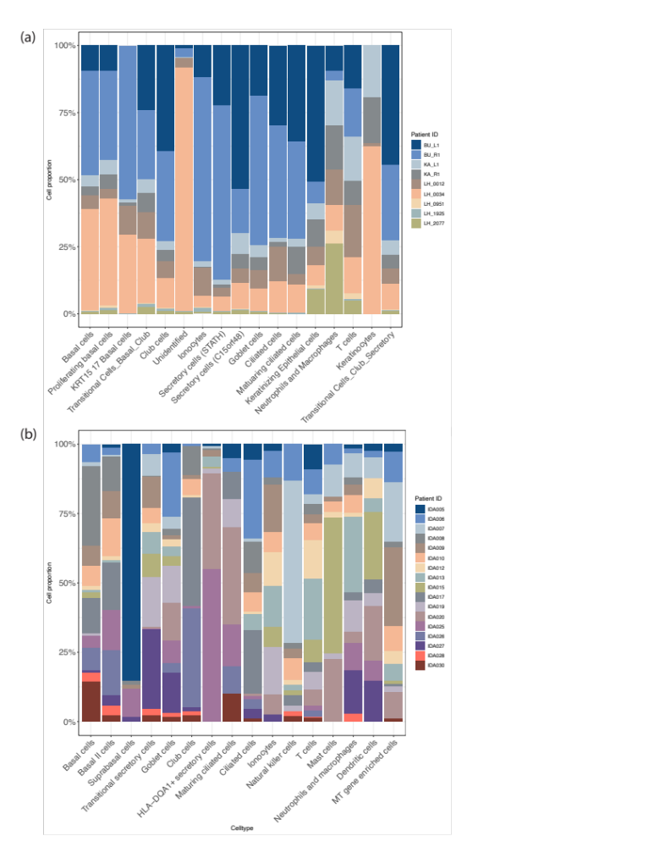
Figure S5. Cell populations contributed by multiple samples in both nasal and bronchial epithelium.
The stackplot displays the proportion of cells contributed from each patient for each cell type in the (a) nasal and (b) bronchial epithelium. Cell populations are displayed on the x-axis, and sample proportions are displayed on the y-axis in percentage. Different colors represent patient samples.

Figure S6. Sparse expression of individual VE genes in the nasal and bronchial epithelium.
Expression patterns of the individual VE genes, ACE2 (tan), CTSL (brown), and TMPRSS2 (olive), across different cell types in nasal and bronchial brushing single cell RNA-seq datasets. The same UMAP project shown in Figure 3 was used and the normalized counts of each gene were used for the plot.

Figure S7. Cigarette smoking was negatively correlated with the proportion of ciliated cells in both nasal and bronchial epithelium but positively correlated with nasal and bronchial goblet cells, as well as bronchial ionocytes and peri-goblet cells.
Boxplots of cell proportions estimated by AutoGeneS in the bulk RNA-seq AEGIS (a) nasal (N = 508) data, (b) AEGIS bronchial (N = 938) data, (c) BCLHS bronchial (N = 238) data, and (d) PCA bronchial (N = 137) data in current and former smokers. Significant cell proportion differences between current and former smokers were determined by Student’s t test (* indicates FDR<0.05). The proportion of ciliated cells was significantly lower in current smokers in both nasal and bronchial brushing datasets. The proportion of goblet cells was significantly higher in current smokers in both datasets. In the bronchial brushing dataset, the proportions of ionocytes and peri-goblet cells were also significantly higher in current smokers.

Supplemental Methods

Detailed Description of each Nasal and Bronchial Datasets.
Samples of the DECAMP cohort¹ were collected from ever smokers with indeterminate pulmonary nodules (7-30 mm) in the DECAMP1 study (NCT01785342) and from patients undergoing lung cancer screening in the DECAMP2 study (NCT02504697) (360 bronchial brushings, 288 nasal brushings, and 124 paired samples). This data are being submitted to Gene Expression Omnibus (GEO).

Samples from the AEGIS cohort² were collected from patients undergoing bronchoscopy for suspicion of lung cancer and profiled using Affymetrix Human Gene 1.0 ST microarrays (938 bronchial brushings, and 505 nasal brushings, 440 of which are paired samples). The data had previously been published^{2,3,4}.

Samples from the BCLHS cohort (GEO Series GSE37147, n = 238)⁵ were collected from bronchial airway brushings from high-risk subjects being followed longitudinally for the development of lung cancer and profiled using Affymetrix Human Gene 1.0 ST microarrays.

Samples from the PCA cohort (GEO Series GSE109743, n = 137)⁶ were collected from normal-appearing mainstem bronchus of participants undergoing lung cancer screening by CT scan and profiled using Illumina RNA sequencing. Residual count matrices adjusted for RNA quality (median TIN, mTIN) and batch (Illumina flow cell) were calculated using the original method in the publication and used as input for clinical covariate association and WGCNA analysis.

Library Preparation, Sequencing, and Data Preprocessing
DECAMP: Total RNA was isolated from nasal and bronchial brushings using the miRNeasy Mini Kit [Qiagen, Valencia, CA]. RNA integrity was assessed by Agilent BioAnalyzer, and RNA purity was confirmed using a NanoDrop spectrometer. Libraries were generated using the Illumina TruSeq Stranded Total RNA kit and sequenced on Illumina NextSeq 500 and Illumina HiSeq2500 instruments with 75 base-pair paired-end reads (Illumina, San Diego, CA). Demultiplexing and creation of FASTQ files were performed using BaseSpace. We developed an automatic pipeline (https://github.com/compbiomed/RNA_Seq) with standard setups based on the Nextflow framework to obtain the expression levels for each gene⁷. Reads were aligned to the Genome Reference Consortium human build 37 (GRCh37) using STAR⁸. Gene and transcript level counts were calculated using RSEM⁹ using Ensembl v75 annotation. Quality metrics were calculated by STAR and RSeQC¹⁰.

AEGIS: Human Gene 1.0 ST CEL files were normalized to generate gene-level expression values using the R environment for statistical computing (version 3.6.0) and the Robust Multiarray Average (RMA) algorithm¹¹ with an Ensembl Gene-specific probe set mapping (version 22.0.0) from the Molecular and Behavioral Neuroscience Institute (Brainarray) at the University of Michigan [http://brainarray.mbni.med.umich.edu/]. Standardized RMA quality metrics were assessed, including the normalized un-scaled standard (NUSE) error and relative log expression (RLE).
The gene expression profiles were processed before the analysis to adjust for technical effects. Specifically, for DECAMP-nasal and DECAMP-bronchial datasets, normalized counts were calculated by performing variance stabilizing transformation on log2 counts per million (CPM) using DESeq2¹² and batch correction using ComBat-Seq¹³. For the BCLHS dataset, ComBat¹⁴ was used for batch correction.

All samples included for the analysis had sex annotation correlated with the expression of the constitutively expressed Y-linked genes CYorf15A, DDX3Y, KDM5D, RPS4Y1, USP9Y, and UTY. No additional filtering of samples was carried out for calculating clinical correlations. RNA-seq samples with mTIN < 60 were not included for generating consensus gene modules.

Derivation of Consensus Gene Modules and Pathway Enrichment Analysis
Consensus gene modules were separately identified using the blockwiseConsensusModules function from the WGCNA (Weighted Gene Correlation Network Analysis) package¹⁵ across each dataset. The signed network type was used for both nasal and bronchial derivations. The parameters set for the nasal derivation were a soft power threshold of 12 and a merge cut height of 0.2, and minimum module size of 10. For the bronchial derivation, the parameters set were a soft power threshold of 13, a merge cut height of 0.1, and minimum module size of 30. The Hallmark pathway gene sets from the MSigDB database¹⁶ were leveraged for pathways enrichment analysis (Version v7.2). The implementation of Fisher’s exact test within the GeneOverlap package¹⁷ was used to generate p-values and odds ratios to quantify overlap between the MSigDB gene sets and genes in each of the VE modules.

Single-cell isolation, library preparation, and sequencing
In the nasal scRNA-seq data, cells were initially dissociated from two nasal swabs [CytoSoft, Camarillo, CA] obtained from the inferior turbinate. The cells were then washed with Phosphate-buffered saline (PBS, Sigma Aldrich, Burlington, MA) and dissociated to single-cell suspensions using 0.25% Trypsin/EDTA (Thermo Fisher, Waltham, MA). Red blood cells were removed after treatment with 1X RBC Lysis Buffer [Thermo Fisher, Waltham, MA] for 2 minutes. Trypan blue exclusion [STEMCELL, Vancouver, BC, Canada] was used for measuring cell viability. The final concentration of cells was measured using a hemocytometer under a light microscope before library preparation using the 10X Genomics Platform [Pleasanton, CA].

In the bronchial scRNA-seq data, the tissue obtained from bronchial brushings was treated with 0.25% Trypsin/EDTA for epithelial sheet dissociation and cells were sorted using a BD FACSAria II. FACS was used to isolate singlet events based on forward scatter height vs. forward scatter area (FSH-H vs. FSH-A). Dead cells (PI+) and red blood cells (GYPA/CD235a+) were stained and excluded. For each donor, single live cells (Hoechst 33342⁺ Propidium Iodide⁻ CD235a⁻) were sorted into two 96-well PCR plates per patient sample.

Both the nasal and bronchial samples were sequenced on an Illumina NextSeq 500 with 75 base-pair single-end reads. Reads were demultiplexed using Cell Ranger (v3.1.0) and aligned to human genome build hg38 (v1.2.0) and tabulated according to unique combination of a Universal Molecular Identifier (UMI) and alignment position¹⁸.

scRNA-seq quality control

Quality metrics and gene-level counts were generated for the single-cell RNA-sequencing samples using Scruff¹⁹. In the nasal scRNA-seq data, cells had a median of 3095 UMIs, a median of 1277 genes detected, median predicted contamination of 0.04%, and 7.5% predicted doublets. Cells were identified as poor quality if they satisfied any of the following criteria: 1) bottom quantile for a total number of genes detected, 2) bottom quantile for total library size and 3) greater than 30% the counts mapped to the mitochondrial genome. In total, 15787 cells were filtered and 34833 cells were kept for further analysis.
In the bronchial scRNA-seq data, cells had a median of 4580 UMIs, a median of 1870 genes detected, median predicted contamination of 0.168 %, and 7.51% predicted doublets. Cells were identified as poor quality if they met any of the following criteria: 1) bottom quantile for a total number of genes detected, 2) bottom quantile for total library size and 3) top quantile for the percentage of counts mapped to the mitochondrial genome. Overall, 1189 cells (including 34 empty wells) were filtered and 2075 cells were kept for further analysis.
Cell Type Identification
Cells were defined by examining the relative expression level of knowledge-based gene markers. Transitional cells were named based on their relative location on the UMAP plot and expression of a combination of marker genes.

In the nasal scRNA-seq data, markers included KRT5, KRT15 and KRT 17 (basal cells), SCGB1A1 (club cells), MUC5AC (goblet cells), FOXJ1 (ciliated cells), FOXI1 (ionocytes), CD3D (T cells), CD74 (neutrophils and macrophages), STATH and C15orf48 (secretory cells), CDC20B (maturing ciliated cells), and SPRR3 (keratinizing epithelial cells). In the bronchial scRNA-seq data, markers included KRT5 (basal cells), CEACAM5 (peri-goblet cells), SCGB1A1 (club cells), MUC5AC (goblet cells), FOXJ1 (ciliated cells), FOXI1 (ionocytes), CD3D (T cells), GNLY (NK cells), KIT (mast cells), and CXCR2 (neutrophil and macrophages).

Deconvolution of bulk RNA-seq gene expression using cell type markers derived from the scRNA-seq datasets.
To dissect cell population proportions from bulk RNA samples, reference gene expression profiles (GEPs) were derived using the nasal and bronchial scRNA-seq data following a similar procedure. Marker genes of each cell type were identified using the FindMarkers function within the Seurat package using the MAST method of modeling (FDR < 0.05, logFC > 0.25). The GEPs of each cell population were defined as the mean expressions of the corresponding cell cluster using Seurat scaled counts. After generating the GEPs of the cell populations, the AutoGenes function within the Autogenes package²⁰ was called to further identify the top 400 most informative genes for deconvolution using multi-objective optimization. The filtered informative genes GEPs were defined as the signature matrix. Nu Support Vector regression was employed to deconvolute or predict cell proportions from the bulk RNA-seq data based on the filtered informative genes. For the DECAMP and PCA datasets, normalized and batch corrected counts were used, and for the BCLHS dataset, batch corrected array measurements were used for the deconvolution.

References
1. Billatos E, Duan F, Moses E, et al. Detection of early lung cancer among military personnel (DECAMP) consortium: study protocols. BMC Pulm Med. 2019;19(1):59. doi:10.1186/s12890-019-0825-7
2. Silvestri GA, Vachani A, Whitney D, et al. A Bronchial Genomic Classifier for the Diagnostic Evaluation of Lung Cancer. N Engl J Med. 2015;373(3):243-251. doi:10.1056/NEJMoa1504601
3. AEGIS Study Team. Shared Gene Expression Alterations in Nasal and Bronchial Epithelium for Lung Cancer Detection. J Natl Cancer Inst. 2017 Jul 1;109(7):djw327. doi: 10.1093/jnci/djw327. PMID: 28376173; PMCID: PMC6059169.
4. Whitney DH, Elashoff MR, Porta-Smith K, et al. Derivation of a bronchial genomic classifier for lung cancer in a prospective study of patients undergoing diagnostic bronchoscopy. BMC Med Genomics. 2015;8:18. Published 2015 May 6. doi:10.1186/s12920-015-0091-3
5. Steiling K, van den Berge M, Hijazi K, et al. A dynamic bronchial airway gene expression signature of chronic obstructive pulmonary disease and lung function impairment. Am J Respir Crit Care Med. 2013;187(9):933-942. doi:10.1164/rccm.201208-1449OC
6. Beane JE, Mazzilli SA, Campbell JD, et al. Molecular subtyping reveals immune alterations associated with progression of bronchial premalignant lesions. Nat Commun. 2019;10(1):1856. doi:10.1038/s41467-019-09834-2
7. Di Tommaso P, Chatzou M, Floden EW, Barja PP, Palumbo E, Notredame C. Nextflow enables reproducible computational workflows. Nat Biotechnol. 2017;35(4):316-319. doi:10.1038/nbt.3820
8. Dobin A, Davis CA, Schlesinger F, et al. STAR: ultrafast universal RNA-seq aligner. Bioinforma Oxf Engl. 2013;29(1):15-21. doi:10.1093/bioinformatics/bts635
9. Li B, Dewey CN. RSEM: accurate transcript quantification from RNA-Seq data with or without a reference genome. BMC Bioinformatics. 2011;12(1):323. doi:10.1186/1471-2105-12-323
10. Wang L, Wang S, Li W. RSeQC: quality control of RNA-seq experiments. Bioinformatics. 2012 Aug 15;28(16):2184-5. doi: 10.1093/bioinformatics/bts356. Epub 2012 Jun 27. PMID: 22743226.
11. Rafael. A. Irizarry, Benjamin M. Bolstad, Francois Collin, Leslie M. Cope, Bridget Hobbs and Terence P. Speed (2003), Summaries of Affymetrix GeneChip probe level data Nucleic Acids Research 31(4):e15
12. Love MI, Huber W, Anders S (2014). “Moderated estimation of fold change and dispersion for RNA-seq data with DESeq2.” Genome Biology, 15, 550. doi: 10.1186/s13059-014-0550-8.
13. Zhang Y, Parmigiani G, Johnson WE. ComBat-seq: batch effect adjustment for RNA-seq count data. NAR Genomics Bioinforma. 2020;2(3). doi:10.1093/nargab/lqaa078
14. Johnson WE, Li C, Rabinovic A. Adjusting batch effects in microarray expression data using empirical Bayes methods. Biostatistics. 2007;8(1):118-127. doi:10.1093/biostatistics/kxj037
15. Langfelder P, Horvath S. WGCNA: an R package for weighted correlation network analysis. BMC Bioinformatics. 2008;9:559. doi:10.1186/1471-2105-9-559
16. Liberzon A, Subramanian A, Pinchback R, Thorvaldsdóttir H, Tamayo P, Mesirov JP. Molecular signatures database (MSigDB) 3.0. Bioinforma Oxf Engl. 2011;27(12):1739-1740. doi:10.1093/bioinformatics/btr260
17. Shen L, Sinai ISoMaM (2020). GeneOverlap: Test and visualize gene overlaps. R package version 1.26.0, http://shenlab-sinai.github.io/shenlab-sinai/.
18. Zheng GX, Terry JM, Belgrader P, et al. Massively parallel digital transcriptional profiling of single cells. Nat Commun. 2017;8:14049. Published 2017 Jan 16. doi:10.1038/ncomms14049
19. Wang Z, Hu J, Johnson WE, Campbell JD. scruff: an R/Bioconductor package for preprocessing single-cell RNA-sequencing data. BMC Bioinformatics. 2019 May 2;20(1):222. doi: 10.1186/s12859-019-2797-2.
20. Aliee H, Theis F. AutoGeneS: Automatic gene selection using multi-objective optimization for RNA-seq deconvolution. bioRxiv. Published online February 23, 2020:2020.02.21.940650. doi:10.1101/2020.02.21.940650

