Supplementary Materials

Supplementary Methods

S1. Validation of Reference Standard Reliability (Inter-reader Agreement)
To ensure the rigor of the composite reference standard used for model development and evaluation, a subset of examinations was independently reviewed by a sports medicine physician (J.X., 8 years of experience) and a musculoskeletal radiologist (H.L., 26 years of experience), both blinded to clinical history and model predictions. Discrepancies were adjudicated by a senior sports medicine physician (J.Z., 32 years of experience).
Method
Analyses were conducted in Python (v3.12.7) using scikit-learn and scipy. For binary rotator cuff tear identification, inter-reader reliability was quantified using Cohen’s kappa with 95% confidence intervals (CI) derived via bootstrap resampling (n = 1,000). For ordinal Goutallier grading, reliability was assessed using the intra-class correlation coefficient (ICC). Both readers were additionally benchmarked against the finalized composite reference standard to compute sensitivity, specificity, and accuracy.
Visual diagnostics of agreement
Beyond summary statistics, complementary visualization techniques were employed to characterize inter-reader agreement and potential systematic bias. For binary tear identification, agreement patterns were illustrated using Bland–Altman plots, confusion matrices, and label distribution comparisons (Supplementary Figure S7). For ordinal Goutallier grading, analogous visualizations were provided separately to assess grade-wise concordance and clinically plausible disagreement patterns (Supplementary Figure S8). These visual diagnostics confirmed that disagreement was centered around zero, indicating the absence of directional bias, and that discordance—when present—was predominantly limited to adjacent Goutallier grades.
Results
For tear identification, inter-reader agreement was substantial, with a bootstrapped Cohen’s kappa of 0.911 (95% CI: 0.885–0.936). Confusion-matrix visualization demonstrated minimal discordance between readers (Supplementary Figure S7). When benchmarked against the composite reference standard, Expert 1 achieved an accuracy of 98.5%, sensitivity of 98.6%, and specificity of 98.5%, while Expert 2 achieved an accuracy of 97.0%, sensitivity of 98.1%, and specificity of 95.9%.
For Goutallier grading, agreement between readers and the reference standard remained excellent. Expert 1 achieved an accuracy of 97.3% with a Cohen’s kappa of 0.962, while Expert 2 achieved an accuracy of 94.7% with a Cohen’s kappa of 0.928. Sensitivity and specificity exceeded 95% for both readers. Visual agreement analyses demonstrated a near-zero mean bias and narrow limits of agreement, with discrepancies largely confined to adjacent grades, supporting the robustness of the reference standard (Supplementary Figure S8).

S2. Validation of Automated Anatomical Segmentation and ROI Localization
Given that the proposed pipeline relies on automated delineation of anatomical anchors and subsequent ROI localization on non-contrast chest CT, we adopted a dual-validation paradigm integrating quantitative geometric accuracy and qualitative clinical plausibility.

S2.1. Quantitative evaluation of skeletal anchor segmentation
A validation sub-cohort was randomly sampled from the prospective development set. Skeletal landmarks, including the proximal humerus and scapula, were manually segmented using ITK-SNAP and compared against automated outputs generated by TotalSegmentator V2. Segmentation accuracy was quantified using the Dice Similarity Coefficient (DSC).
The automated pipeline demonstrated high spatial overlap with manual annotations, achieving a mean DSC of 0.927 ± 0.031 for the humerus and 0.910 ± 0.030 for the scapula. These results support the geometric reliability of the skeletal anchors used for downstream ROI localization.

S2.2. Qualitative expert assessment of the Functional Soft Tissue Belt
Because pixel-perfect separation of individual shoulder muscles is technically challenging in non-contrast chest CT, we validated a clinically functional extraction zone rather than strict muscle-boundary segmentation. Specifically, a Functional Soft Tissue Belt was defined as the 0–25 mm circumferential zone surrounding the segmented skeletal structures, serving as the primary ROI for downstream analysis of compensatory soft-tissue signatures.
For representative cases stratified by segmentation fidelity, three-dimensional visualizations were generated with the Belt Mask overlaid on the original CT images. Two blinded experts independently rated anatomical coverage using a 5-point Likert scale, where higher scores indicated better clinical plausibility and functional coverage of relevant muscle groups.
- 5 (Excellent): Perfectly encapsulates core muscle bellies (e.g., latissimus dorsi, trapezius) with no deviation.
- 4 (Good): Covers target muscles with minor peripheral drift not impacting HU extraction.
- 3 (Acceptable): Covers the majority of target structures with minor inclusion of non-muscular tissue.
- 2–1 (Inadequate): Significant misalignment or failure to capture compensatory muscle groups.
Inter-rater reliability was quantified using weighted Cohen’s kappa with 95% confidence intervals (CI). In addition, systematic bias between expert ratings was assessed using Bland–Altman analysis.
Results
The Clinical Acceptance Rate (Likert score ≥ 4) was 87.5%. Mean scores were 4.38 (95% CI: 4.13–4.62) and 4.45 (95% CI: 4.22–4.68) for the two experts, respectively, demonstrating excellent inter-rater reliability (weighted kappa = 0.885; 95% CI: 0.773–0.967). Bland–Altman analysis revealed a near-zero mean difference (−0.07) and narrow, symmetric limits of agreement, indicating the absence of systematic scoring bias(Supplementary Figure S9).

S3. Technical Details of the Image Analysis Pipeline and Hybrid Model Architecture
S3.1 Detailed Preprocessing Protocols
Resampling was performed via trilinear interpolation using the SimpleITK library. The intensity normalization process was governed by the following equation:
$$I_{norm}=\text{clip}\left(\frac{I_{raw}+200}{1000},0,1\right)$$
where $I_{raw}$ denotes the native radiodensity of the voxel in Hounsfield Units, and $I_{norm}$ represents the normalized intensity value. The function $\text{clip}(x,a,b)$ constrains values within the interval $[a,b]$. Specifically, signals below −200 HU (approximating air) and above 800 HU (approximating cortical bone or metallic artifacts) were truncated to maximize the dynamic range for soft tissue analysis.
S3.2 ROI Definition and Localization Algorithm
The 14 segmented regions of interest (ROIs) included 10 muscle groups (supraspinatus, infraspinatus, subscapularis, teres major, pectoralis major, pectoralis minor, triceps brachii, deltoid, trapezius, and latissimus dorsi) and 4 skeletal landmarks (humerus, scapula, T1 vertebra, and C7 vertebra). The coordinate system was constructed using a geometric approach to normalize variability. Specifically, the maximum Z-axis coordinate of the lung apex served as the superior-inferior reference anchor. On the X-Y plane, a local coordinate system was defined by integrating the spatial centroids of the clavicle and scapula. This registration process corrected for non-standard positioning, ensuring anatomical consistency across the cohort.
S3.3 Deep Learning Architecture and Attention Mechanism
Each bag consisted of a maximum of N=48 instances. Each instance was a 3D patch of size 48×48×48 voxels. The encoder (Simple3DEncoder) produced 256-dimensional instance-level embeddings ($h_{k}$). To capture complex non-linear relationships among instances, we employed the Gated Attention mechanism proposed by Ilse et al¹.
The attention weight $a_{k}$ for each patch is computed as follows:
Where:
$h_{k}$ is the 3D CNN-encoded feature vector of the $k$-th instance (patch).
$w$ and $V$ are learnable bilinear weight matrices that capture complex non-linear feature relationships.
$U$ is a learnable vector that maps the gated representation to a scalar attention score.
$⊙$ denotes the element-wise multiplication (Hadamard product).
$σ$ (sigmoid function) gates informative features.
$tanh$ (hyperbolic tangent) ensures numerical stability of the attention scores.
S3.4 Multi-center quantitative feature extraction, feature fusion, and comparative model analysis
This study constructed three model categories for comparative analysis: deep learning models, machine learning (radiomics-driven) models, and deep learning-machine learning hybrid models.
Feature extraction and preprocessing: For 14 key anatomical ROIs, quantitative analysis was automated via Pyradiomics. Five metrics per ROI—mean CT value, cross-sectional area, 3D volume, contrast, and entropy—were extracted, forming a 70-dimensional radiomic feature matrix (X_{Rad}), strictly following IBSI guidelines². To remove cross-center batch effects, the ComBat mothod (empirical Bayesian) was applied for parametric translation and scaling of feature distributions, using the primary center as the reference batch, with age, sex, and disease status preserved as biological covariates³. Missing values were handled by multiple imputation (≤15 iterations), followed by standardization to eliminate dimensional effects, yielding the final input matrix for machine learning. Prior to extraction, voxel intensities were discretized with a fixed 25 HU bin width to ensure texture feature reproducibility.
Model construction and optimization:

Attn-MIL. The Attn-MIL model employs a 3D convolutional neural network (Simple3DEncoder) as its feature encoder, which outputs 256-dimensional instance features through three convolutional layers, batch normalization, ReLU activation, and adaptive average pooling¹. The attention module computes instance weights via bilinear layers (V layer with Tanh activation; U layer with Sigmoid activation) and performs weighted summation to generate 256-dimensional bag-level deep feature vectors (denoted as X_{DL}).
The model was trained on a distributed cluster equipped with three NVIDIA RTX 4090D GPUs. We used the AdamW optimizer (initial learning rate: 3×10⁻⁴, weight decay: 1×10⁻⁴) to minimize binary cross-entropy loss. Training was conducted for 50 epochs with a batch size of 6 bags per GPU (global effective batch size: 18). Automatic mixed precision (AMP) was employed to optimize gradient computation. During inference, the model directly outputs prediction probabilities via its built-in classification head, which consists of fully connected layers (256 to 128 to 1) with a dropout rate of 0.2.

Radiomics Model. The 70-dimensional radiomic features (X_{Rad}) extracted from 14 anatomical ROIs were processed using ComBat for batch effect removal, multiple imputation (≤15 iterations), and standardization before being used as input to machine learning models. Feature extraction strictly followed the IBSI guidelines, with voxel intensities discretized using a fixed bin width of 25 HU.
Radiomic features were ranked using LASSO regression with 10-fold cross-validation (maximum 20,000 iterations). Feature subsets were constructed by selecting the top K=5,8,10,12,18 features. Seven classification algorithms were evaluated: logistic regression (LogReg, max 5,000 iterations), linear regression (LinReg), support vector machine (SVM, probability output), random forest (RF, 400 trees), XGBoost (700 trees, max depth 4), LightGBM (600 trees, 31 leaves), and CatBoost (600 iterations, depth 5). All models employed class balancing strategies. For each feature subset, 10-fold stratified cross-validation was performed to assess model performance using AUC as the evaluation metric. The best-performing model was selected and its cross-validation prediction probabilities were recorded.

Hybrid Model. To integrate radiomic and deep features, the corrected and standardized radiomic features X_{Rad} were horizontally concatenated with the deep features XDL​ generated by Attn-MIL, forming a 326-dimensional hybrid feature space.
The hybrid model adopted the optimal radiomic feature subset corresponding to ML_{best} (i.e., the top K features) and concatenated it with the full 256-dimensional deep features XDL to construct the final input X_{Hybrid}​. The same seven machine learning algorithms were retrained on X_{Hybrid} using 10-fold stratified cross-validation. AUC was again used to select the optimal hybrid model, and its cross-validation prediction probabilities were recorded.
Model evaluation and interpretability analysis: Following construction of three model categories, pairwise AUC difference comparisons were executed through DeLong tests, computing statistical significance P values for each comparison group while generating ROC curves, AUC comparison bar charts, and DeLong P-value matrices. For model interpretability analysis, TreeExplainer (primarily for tree-based models) or KernelExplainer (general-purpose) was applied to ML_{best} to generate SHAP summary plots for radiomic features, quantifying each feature’s contribution to model predictions⁴. GradientExplainer was applied to deep learning models to analyze the importance of deep features X_{DL}, ultimately outputting comprehensive reports encompassing model performance metrics, statistical test results, visualization charts, and interpretability analyses to substantiate model validity and clinical application value.
Gradient-weighted Spatial Attention Mapping (Grad-SAM): To accurately visualize the spatial decision logic of the Attn-MIL network, we implemented the Grad-SAM technique, adapted from Barkan et al. for multiple instance learning⁵. Unlike conventional methods that rely solely on raw attention weights ($a_{k}$), Grad-SAM synergizes these weights with the gradient sensitivity of the model's output to filter out non-contributory noise. Specifically, we computed the importance score $S_{k}$ for each 3D patch instance $k$ using the following formulation:
$$S_{k}=a_{k}⋅\text{ReLU}\left(\frac{∂y}{∂a_{k}}\right)$$
where $y$ denotes the predicted logit for the target class (e.g., Rotator Cuff Tear), and $a_{k}$ represents the learned attention weight for the $k$-th patch. The Rectified Linear Unit (ReLU) activation is critical here; it zeroes out negative gradients, thereby suppressing instances where increased attention would negatively impact the prediction confidence. This ensures that the generated heatmaps exclusively highlight anatomical regions that make a positive contribution to the diagnosis. The resulting patch-level scores $S_{k}$ were then spatially mapped back to their original coordinates in the 3D CT volume and smoothed via Gaussian interpolation to generate the final clinically interpretable heatmaps.

S4. Cohort Study Protocol
Study Title: Development and Multi-Center Validation of a Hybrid Deep Learning-Radiomics Model for Opportunistic Screening of Rotator Cuff Tears Using Routine Chest CT
Date: May 10, 2025 (Current Consolidated Version 2.0)
Original Protocol Date: June 15, 2019

1. Study Administrative Information

1.1 Study Registration
- Study registration: This study was not registered in a public trial registry.
- Study design: This is a multi-center, hybrid prospective–retrospective diagnostic accuracy study.

1.2 Protocol Version History
Version | Date | Description
1.0 | Jun 15, 2019 | Original Protocol: Initiated as a single-center prospective study. Defined inclusion and exclusion criteria and established a prospective consecutive enrollment workflow designed to ensure an adequate number of outcome events relative to model complexity, consistent with contemporary recommendations for prediction model development.
2.0 | May 10, 2025 | Major Amendment (Validation Phase):  1. External Validation: Protocol amended to include two independent retrospective cohorts to rigorously test model generalizability.  2. Statistical Analysis Plan Finalization: The Statistical Analysis Plan and model hyperparameters were frozen prior to inference on the external datasets.

2. Introduction and Rationale

2.1 Background
Rotator cuff tears (RCT) are prevalent but often undiagnosed. Routine chest CT provides an opportunity for screening, but lacks direct soft tissue visualization. We hypothesize that AI can detect systemic compensatory signatures (muscle atrophy, bone density changes) on CT that serve as reliable surrogates for RCT.

2.2 Objectives
● Primary Objective: Develop and validate a Hybrid AI model using prospectively collected data.
● Secondary Objective: Evaluate generalizability across different healthcare tiers using retrospective external data.

3. Study Design

3.1 Overall Design
● Phase 1 (Derivation): Prospective, consecutive enrollment at the Primary Center (Shanghai Sixth People's Hospital).
● Phase 2 (Validation): Retrospective data collection from two independent centers (Dongying & Pingyu) to serve as a geographically diverse test set.

3.2 Study Sites
● Site 1: Shanghai Sixth People's Hospital (National-level)
● Site 2: Shengli Oilfield Central Hospital (Municipal-level)
● Site 3: People's Hospital of Pingyu County (County-level)

4. Eligibility Criteria

4.1 Inclusion Criteria
- age between 50 and 85 years;
- underwent routine chest CT examinations for non-rotator cuff indications (e.g., lung screening);
- CT scan range fully encompassed the anatomy from the thoracic inlet to the superior border of the first lumbar vertebra (L1), ensuring complete visualization of the pectoralis major and upper body musculature for reliable segmentation;
- underwent shoulder MRI or arthroscopic exploration within 7 days of the CT acquisition to ensure temporal synchronization.

4.2 Exclusion Criteria

Confounding Shoulder Pathologies: History of significant trauma, prior surgery, fractures, malignancy, infectious lesions, or severe osteoarthritis on the ipsilateral shoulder；

Image Quality Limitations: Suboptimal chest CT or shoulder MRI quality due to severe motion artifacts, metallic implants, or other noise that precluded accurate muscle segmentation or tendon integrity assessment；

Neuromuscular Comorbidities: Diagnosed history of neuromuscular diseases capable of systemically affecting muscle quality (e.g., amyotrophic lateral sclerosis, myasthenia gravis)；

Systemic Wasting Conditions: Presence of active malignancy or cachexia.

5. Sample Size

5.1 Time-Based Enrollment Strategy
The study employed a prospective, active recruitment strategy targeting the opportunistic screening population.Research coordinators were stationed in the Radiology Department waiting area. Adult patients scheduled for routine non-contrast chest CT were approached prior to their scan. This setting ensures the enrollment of a general population representative of routine clinical practice, minimizing the referral bias typically seen in orthopedic outpatient clinics.

5.2 Sample Size Justification
No formal sample size calculation was performed. Given the high-dimensional nature of radiomics and deep learning features, sample size planning emphasized enrolling a sufficiently large number of outcome events relative to overall model complexity rather than targeting a fixed effect size or performance metric.
The final prospective enrollment provided a large number of outcome events, supporting robust model development, internal validation, and prespecified subgroup analyses while minimizing the risk of overfitting.

6. Methodology and AI Framework

6.1 Reference Standard
Ground truth established by MRI or Arthroscopy. Radiologists establishing the ground truth are blinded to AI predictions.

6.2 Image Analysis Pipeline
- Preprocessing: Isotropic resampling (1.0mm) and intensity normalization.
- Segmentation: Automated segmentation of 14 ROIs (muscles & bones) using TotalSegmentator V2.
- Feature Extraction:
  - Radiomics: Quantitative features per ROI, harmonized via ComBat (Reference batch: Primary Center).
  - Deep Learning: Attn-MIL framework for latent feature extraction.

7. Statistical Analysis Plan (SAP)

7.1 Analysis Populations
● Training/Internal Validation Set: Primary center data (propensity score matched 1:1).
● Independent Test Set: Complete external cohorts.
● Separation Protocol: External datasets were treated as a hold-out test set. The AI model parameters were finalized prior to external validation, and model performance was evaluated on the external cohorts without any retraining, fine-tuning, or model updating.

7.2 Primary Endpoint
● Metric: Area Under the ROC Curve (AUC).
● Comparison: DeLong test to compare Hybrid Model vs. Single-modality baselines.

7.3 Stratified Performance Analysis
To assess clinical robustness, model performance will be stratified by key clinical and technical variables. These stratifications were pre-planned to evaluate the model's sensitivity across the disease spectrum and imaging conditions:
- Demographics: Age groups and BMI categories.
- Disease severity: stratification based on MRI-derived fatty infiltration grades (e.g., Goutallier classification) was prespecified to evaluate model performance across early and advanced disease stages.
- Technical Factors: Slice thickness and CT Manufacturer.

7.4 Interpretability & Fairness
- SHAP Analysis: To identify top predictive features.
- Grad-SAM: To visualize anatomical attention focus.
- Fairness: Evaluation of performance consistency across Sex and Age groups.

8. Data Management and Ethics

8.1 Data Preparing
Data are managed using a secure Electronic Data Capture (EDC) system and Institutional PACS. All data are de-identified and assigned unique study IDs prior to processing.

8.2 Ethical Approvals
- Primary Center: Approved in 2019 (Prospective, Informed Consent obtained from all participants, IRB No. 2019-KY-033(K)).
- External Centers: Approved in 2025 (Retrospective, Waiver of Informed Consent granted due to observational design, IRB No. YXLL202517201,IRB No. PYCPH-2025-003).

Supplementary Figures
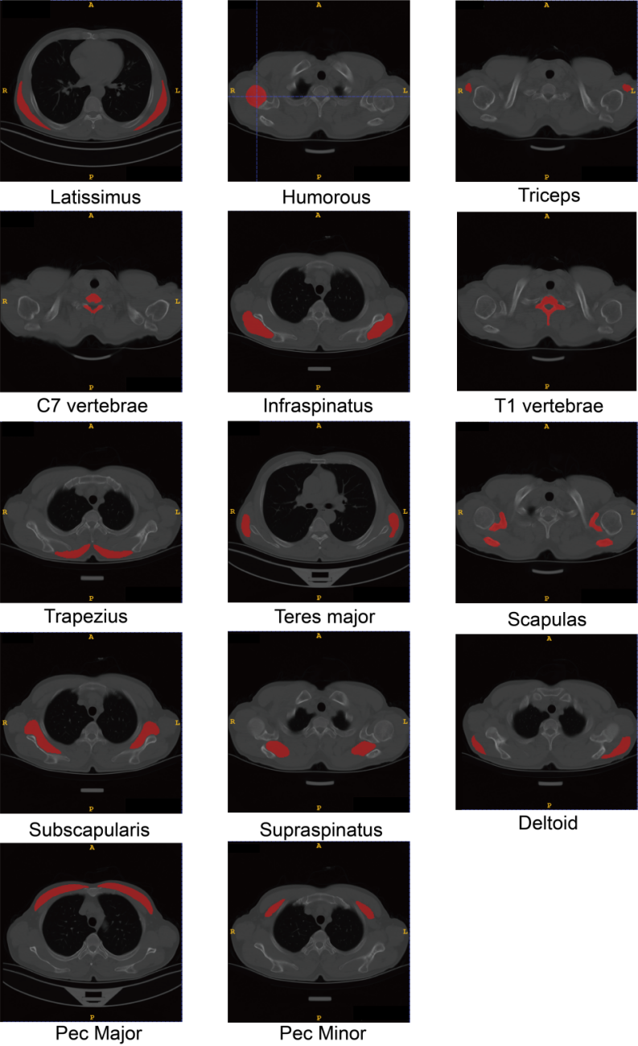
Supplementary Figure S1 | Automated segmentation of 14 predefined anatomical regions of interest (ROIs) using the TotalSegmentator-based pipeline. Representative axial chest CT images demonstrate the precise localization and automated segmentation of 14 core anatomical structures across various levels. Red-shaded areas represent the generated segmentation masks. The ROIs include the latissimus dorsi, humerus, triceps brachii, C7 vertebra, infraspinatus, T1 vertebra, trapezius, teres major, scapula, subscapularis, supraspinatus, deltoid, pectoralis major, and pectoralis minor. These examples, ranging from the cervicothoracic junction to the lower thorax, illustrate the pipeline's high segmentation consistency and robustness in handling heterogeneous routine clinical CT data with varying fields of view and anatomical variations.

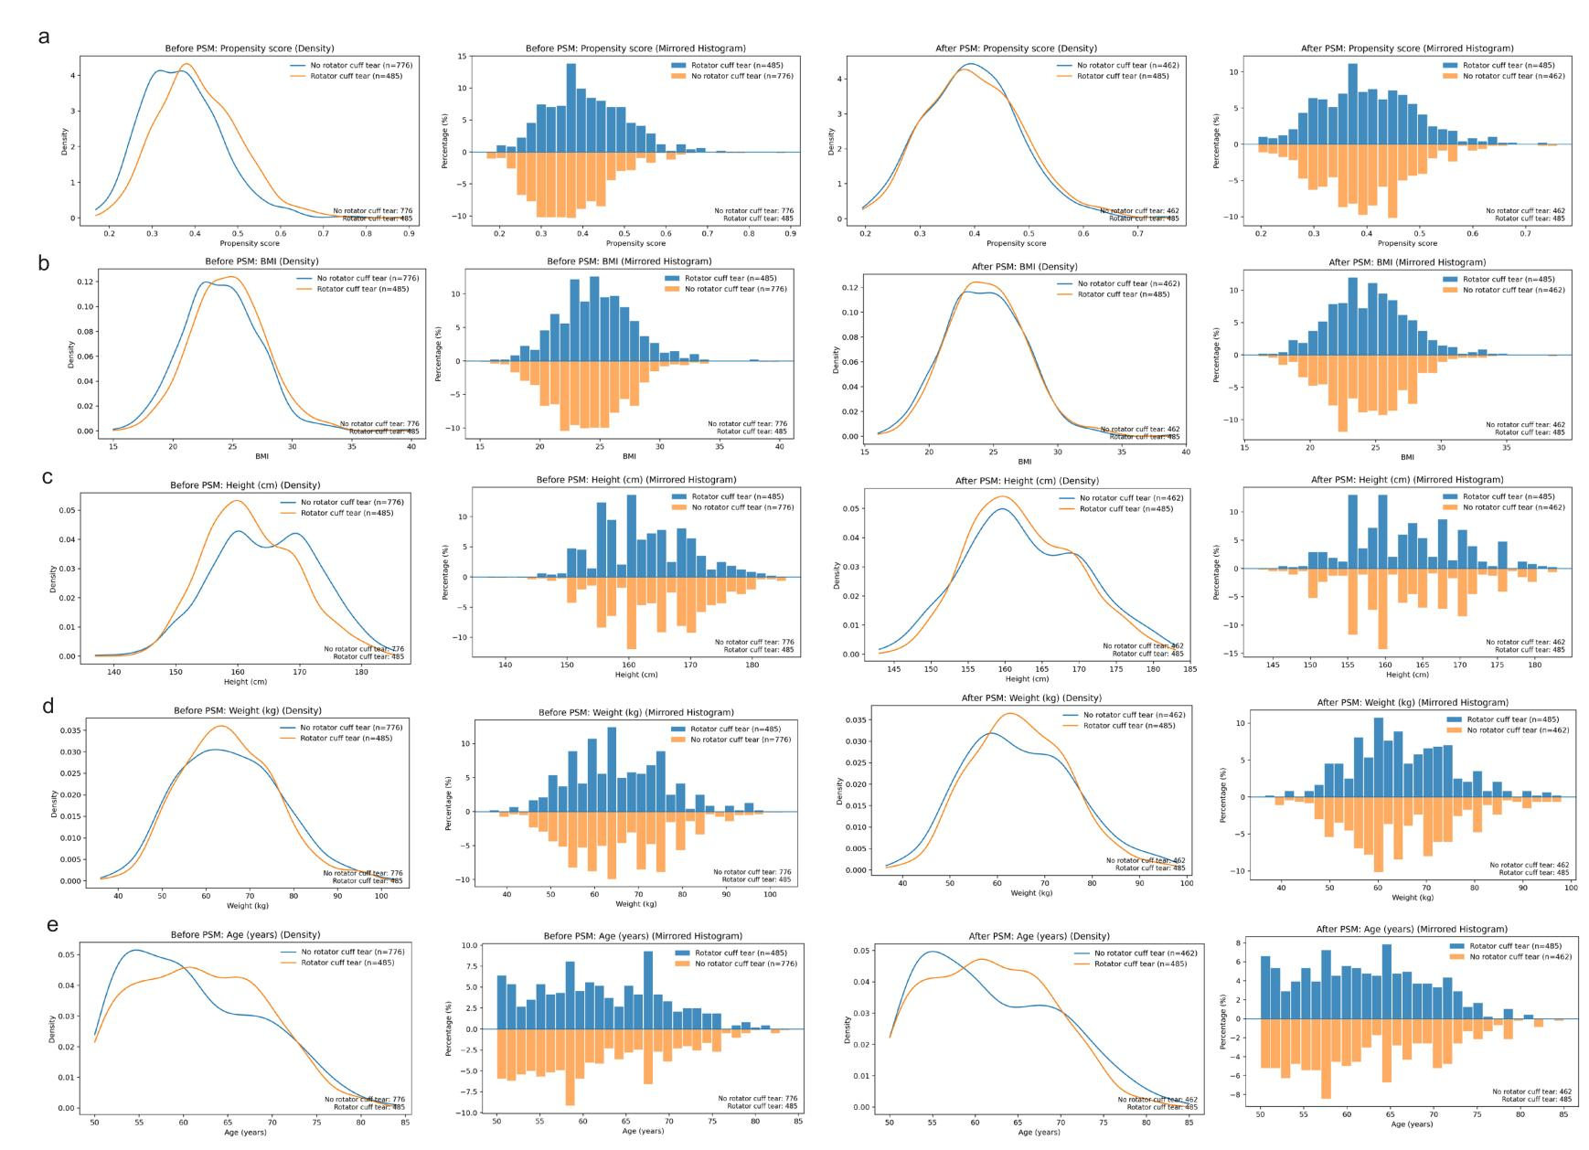
Supplementary Figure S2 | Assessment of covariate balance via Propensity Score Matching (PSM). a-eMirror histograms displaying the distribution of propensity scores and covariates before and after matching. Love plot illustrating the absolute Standardized Mean Differences (SMD) for all baseline covariates.
After matching, all SMDs were reduced to <0.10, indicating well-balanced cohorts. PSM propensity score matching, SMD standardized mean difference.
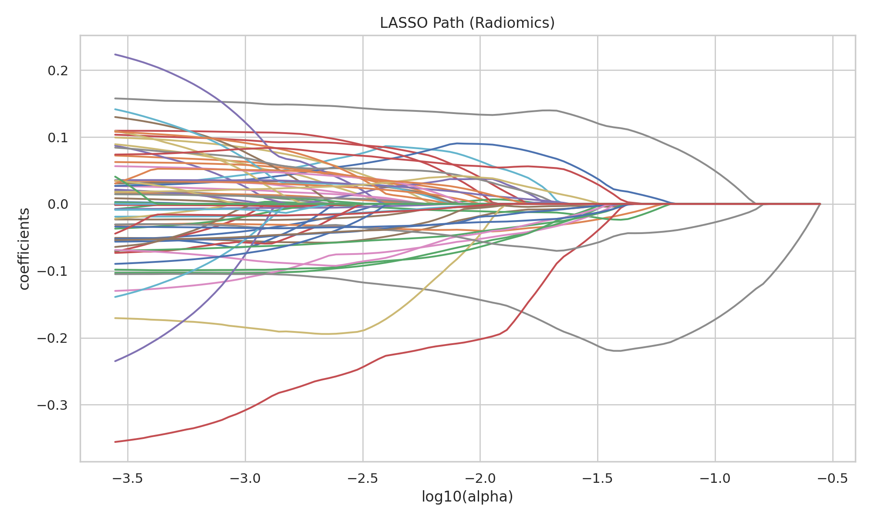
Supplementary Figure S3 | Convergence of feature coefficients via LASSO regression. To identify the most robust predictors for rotator cuff tear screening, LASSO regression was employed to reduce dimensionality. The diagram displays the solution path of the coefficients: as the penalty parameter $α$ (plotted as $\log_{10}(α)$) increases, the coefficients of less informative features shrink to zero. This shrinkage process allows for the identification of a sparse model representation. A final optimal subset of 18 key features (comprising morphological, textural, and density metrics) was selected from this path, balancing model parsimony with diagnostic accuracy.

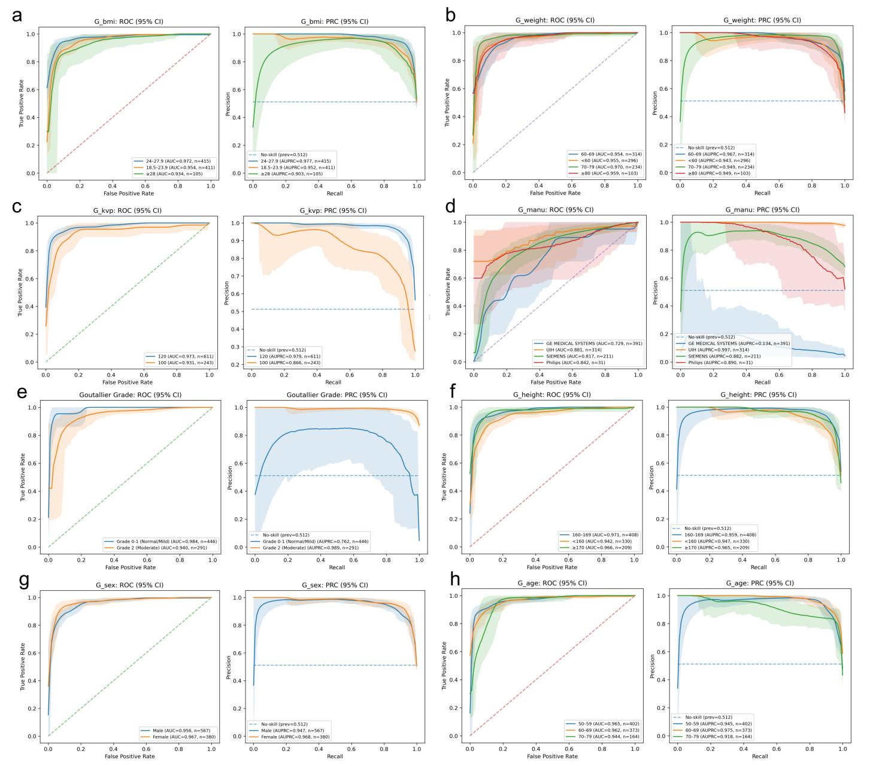
Supplementary Figure S4 | Comprehensive subgroup analysis of the Hybrid Model’s diagnostic performance. The ROC and PRC curves illustrate the model’s stability and generalizability across eight clinical and technical dimensions: (a) BMI, (b) Weight, (c) Tube voltage (kVp), (d) CT manufacturer, (e) Goutallier grade, (f) Height , (g) Sex, and (h) Age. The Hybrid Model maintains consistent diagnostic accuracy across different demographic profiles and hardware platforms, including major manufacturers (GE, Siemens, Philips, and UIH). While minor performance fluctuations exist across subgroups due to variations in sample prevalence and scanner-specific protocols, the high overall AUC and AUPRC values demonstrate the robustness of the automated screening tool for real-world clinical applications.

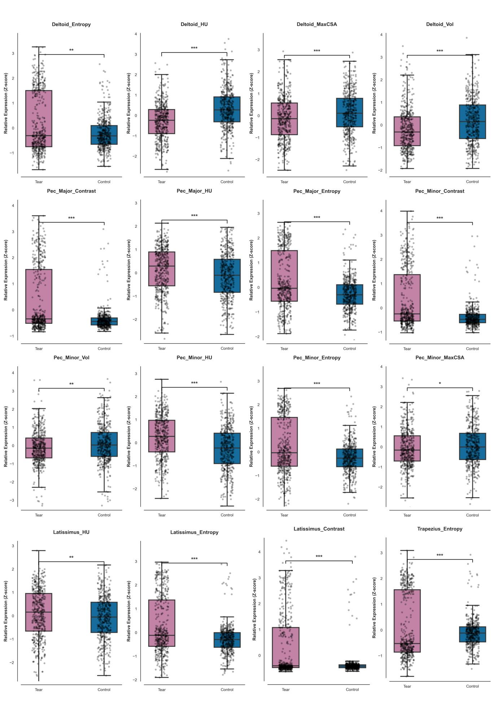
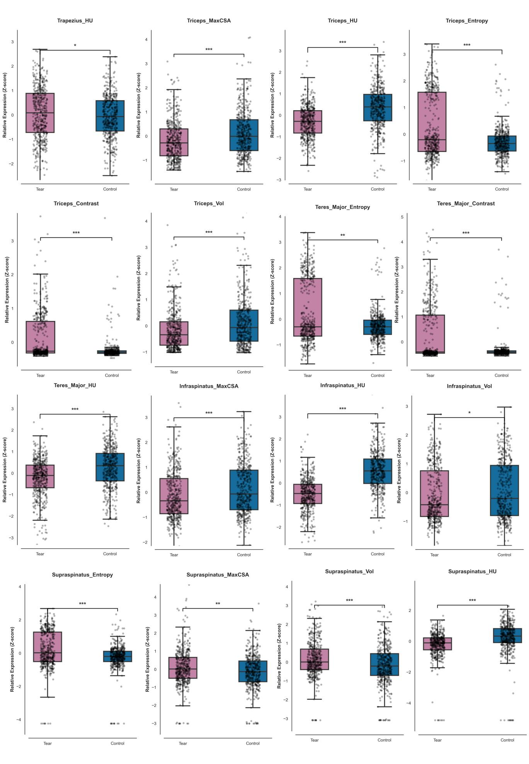
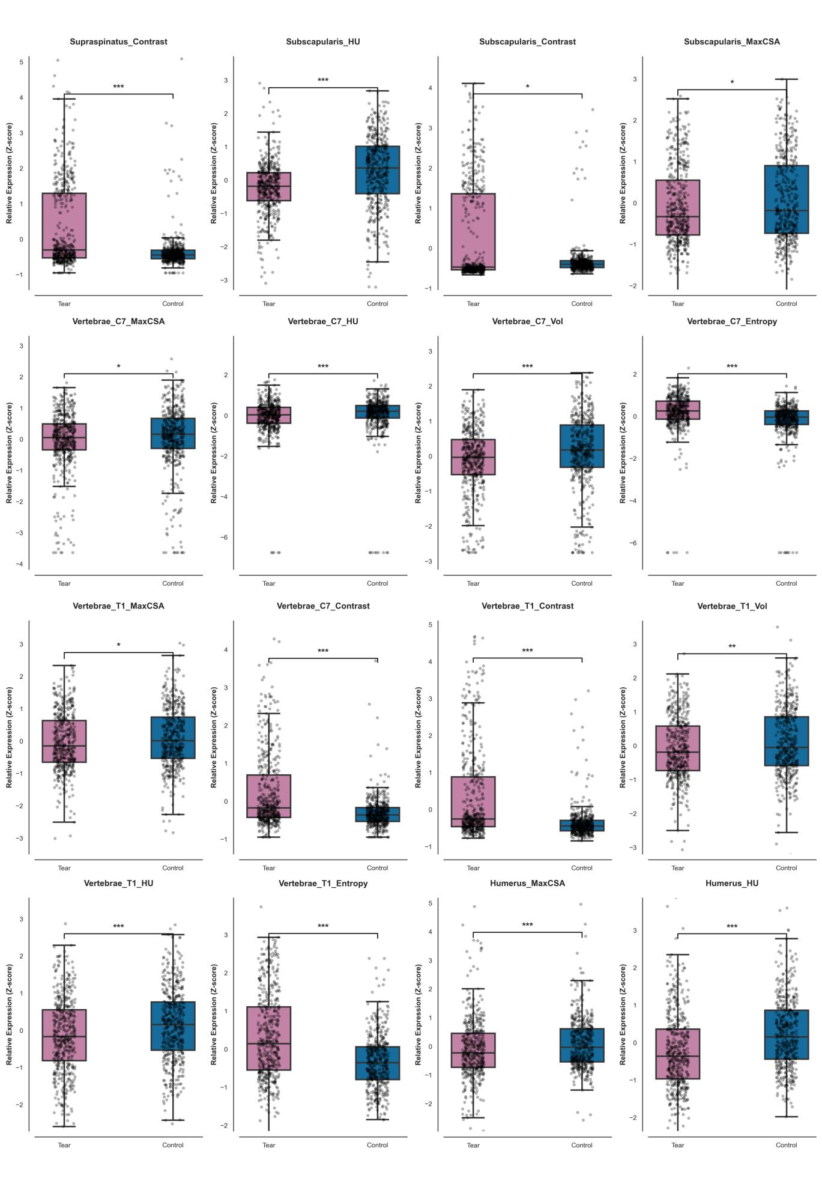
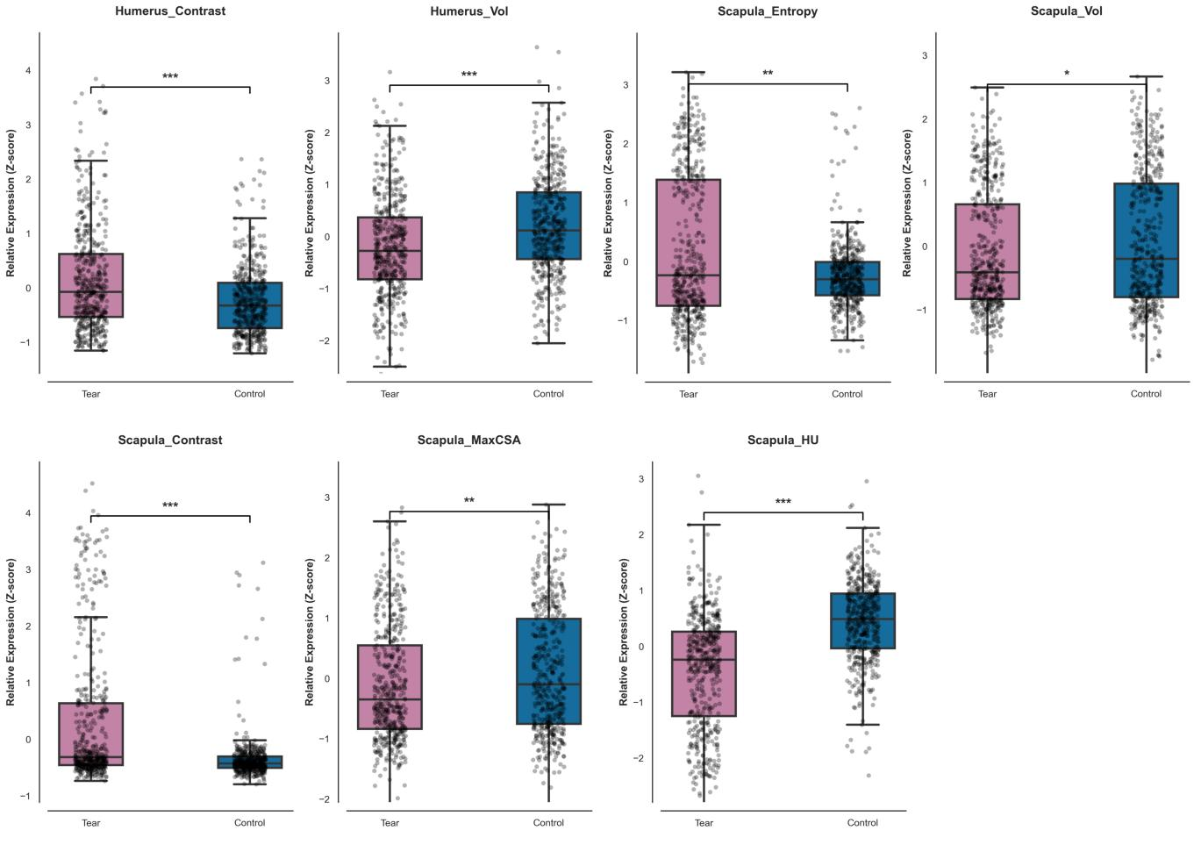
Supplementary Figure S5 | Statistical validation of discriminatory features via univariate analysis.
Box plots illustrate the distribution of 55 statistically significant features across the RCT (Tear) and control groups.Features are presented as Z-score normalized values to amplify intergroup differences and ensure comparability across metrics.The center line represents the median,while the box bounds indicate the interquartile range (IQR). Statistical significance was determined via independent-samples t-tests or Mann-Whitney U tests,as appropriate: *P<0.05; **P<0.01; ***P<0.001.This granular validation confirms that the high-weight features identified by the SHAP framework (Figure4) possess robust and consistent biological differences between cohorts.

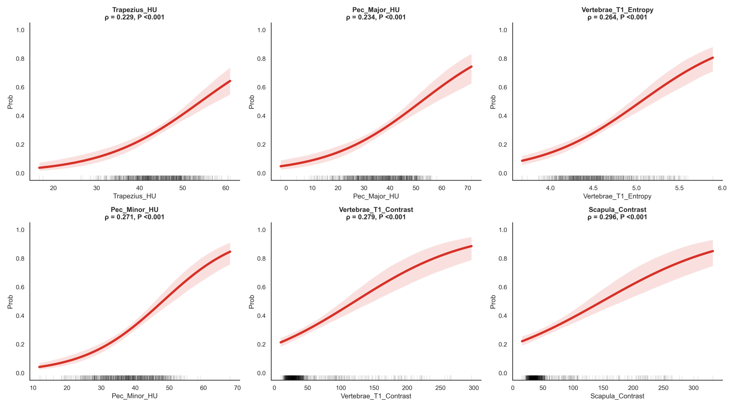
Supplementary Figure S6 | Regression plots illustrating associations between representative radiomic features and predicted probabilities.
The curves depict the relationship between the values of selected radiomic features (x-axis) and the model-predicted probability of rotator cuff tear (y-axis). The solid red lines represent the fitted regression trends, while the translucent red shaded regions indicate the 95% confidence intervals. Vertical rug marks along the x-axis visualize the distribution of individual data points. The strength of each association is quantified using Spearman’s rank correlation coefficient ($ρ$) and the corresponding P value.

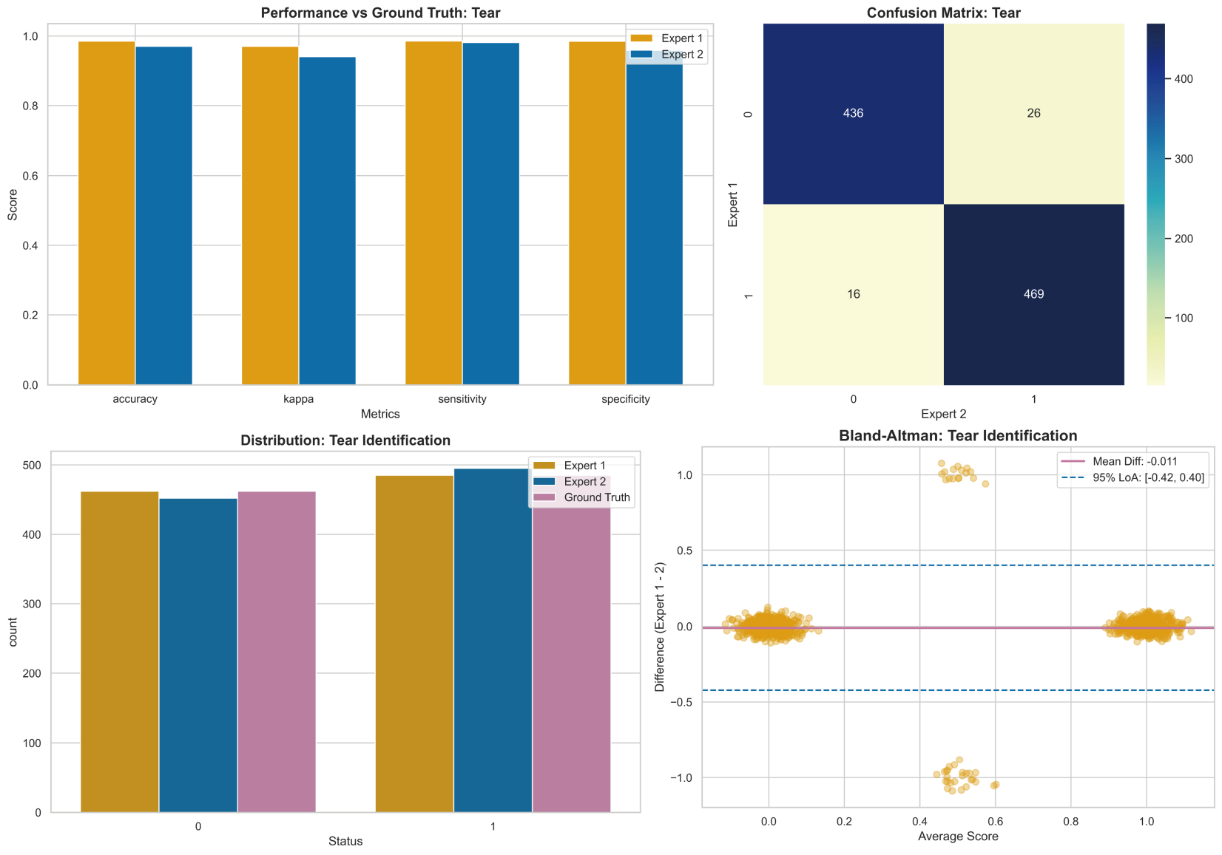

Supplementary Figure S7 | Tear identification: inter-reader agreement and benchmarking against the composite reference standard. Distribution plots illustrate consistent tear prevalence across Expert 1, Expert 2, and the composite reference standard. Performance metrics (accuracy, Cohen’s kappa, sensitivity, and specificity) quantify agreement between each expert and the reference standard. Bland-Altman analysis demonstrates minimal systematic bias between readers, with differences symmetrically distributed around zero. The confusion matrix highlights strong concordance, with misclassifications limited to a small number of binary disagreements.

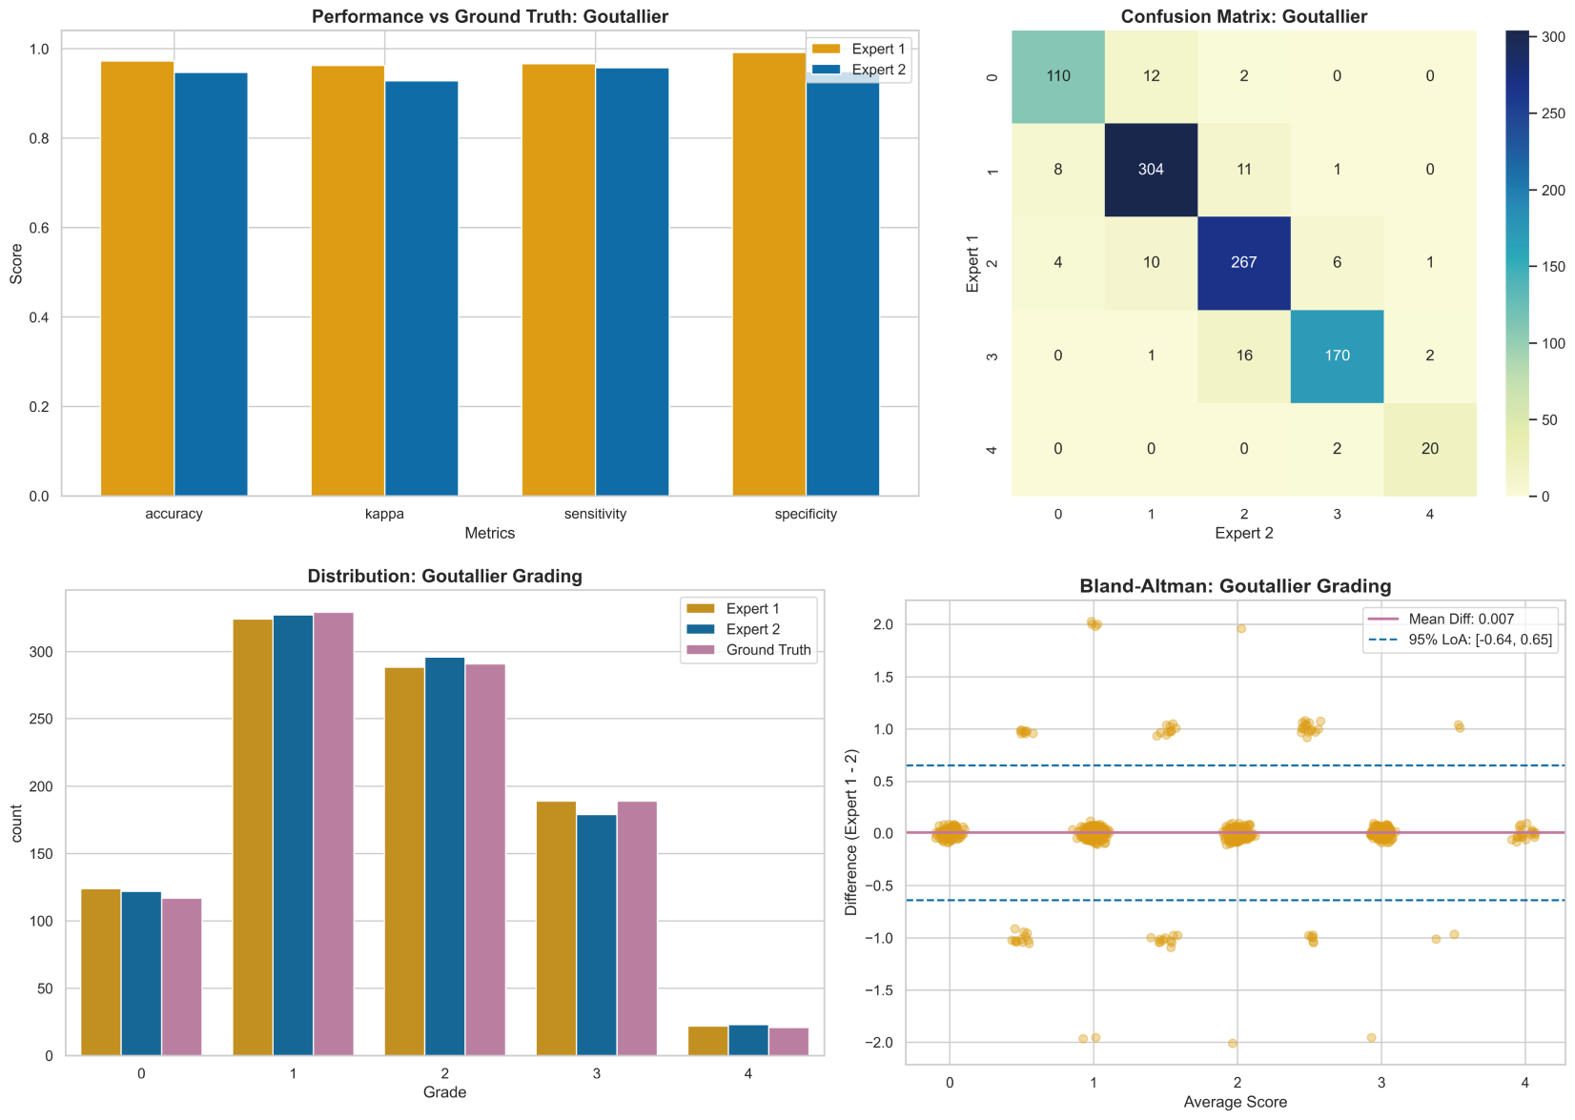

Supplementary Figure S8 | Goutallier grading: inter-reader agreement and grade-wise consistency analysis. Distribution comparisons show similar grading tendencies between Expert 1, Expert 2, and the composite reference standard. Performance metrics summarize agreement with the reference standard across accuracy, kappa, sensitivity, and specificity. Bland-Altman plots reveal a near-zero mean difference and narrow limits of agreement, indicating the absence of systematic bias. Confusion-matrix analysis demonstrates that most discrepancies occur between adjacent Goutallier grades, reflecting clinically plausible variation rather than severe misclassification.

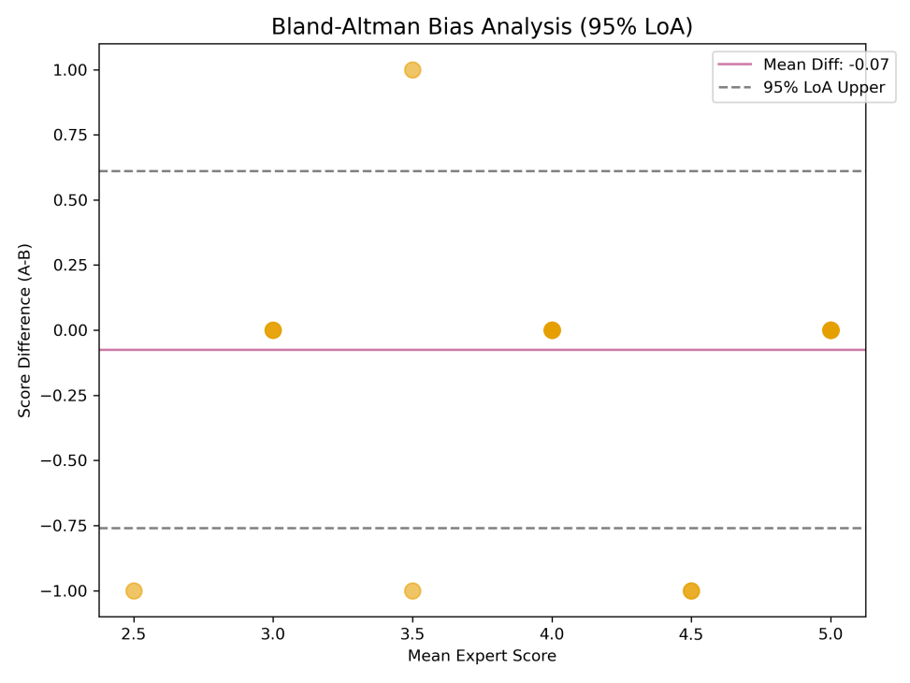  A | 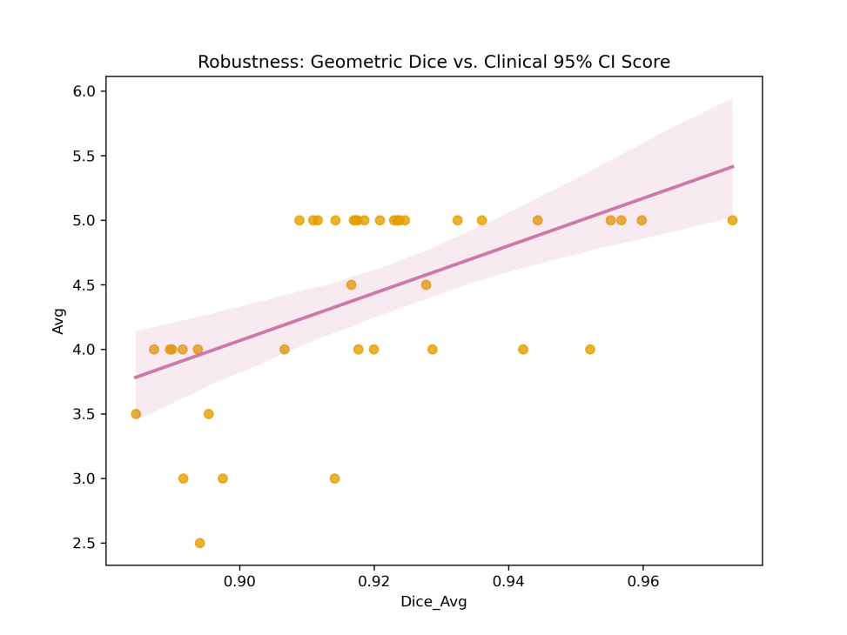  B
Supplementary Figure S9 | Clinical validation and robustness analysis of the Functional Soft Tissue Belt.
(A) Bland-Altman analysis evaluating systematic bias between expert ratings of clinical acceptability for the Functional Soft Tissue Belt. The near-zero mean difference and narrow 95% limits of agreement indicate the absence of directional bias.
(B) Robustness analysis illustrating the relationship between geometric segmentation fidelity (average Dice score) and clinical acceptability. Higher Dice scores were associated with higher Likert ratings and reduced variability, supporting that geometric accuracy translates into stable and clinically meaningful ROI localization.

Supplementary Tables
 | Before Matching (N=1261) |  |  |  | After Matching(N=947)
 | Control(N=796) | Rotator Cuff Injury(N=485) | P-value | SMD | Control(N=462) | Rotator Cuff Injury(N=485) | P-value | SMD
age | 60.00  [55.00, 67.00] | 62.00  [56.00, 67.00] | 0.06 | 0.09 | 60.00  [55.00, 68.00] | 61.00  [56.00, 67.00] | 0.92 | -0.03
height | 165.00  [159.00, 170.00] | 162.00  [157.00, 168.00] | <0.001 | -0.31 | 162.00  [157.00, 169.00] | 162.00  [157.00, 168.00] | 0.68 | -0.03
weight | 65.00  [56.50, 74.00] | 65.00  [57.00, 72.00] | 0.78 | -0.02 | 65.00  [56.00, 73.00] | 65.00  [57.50, 72.00] | 0.59 | 0.01
bmi | 23.88  [22.03, 26.05] | 24.65  [22.64, 26.57] | <0.001 | 0.21 | 24.24  [22.22, 26.43] | 24.46  [22.51, 26.56] | 0.44 | 0.06

Supplementary Table S1 | Baseline characteristics assessment before and after Propensity Score Matching (PSM). Demographic and clinical variables of the initial recruited population (n=1,261) and the final matched development cohort (n=947). The table presents the median (IQR) for continuous variables and number (%) for categorical variables. IQR interquartile range, SMD standardized mean difference.
Feature | P
Infraspinatus HU | 4.04040362009026e-72
Scapula HU | 3.1311138007587547e-43
Triceps HU | 9.031110095070697e-30
Vertebrae T1 Contrast | 2.0783764135644944e-27
Supraspinatus HU | 2.3031117457396434e-25
Deltoid HU | 1.6304270084909839e-21
Vertebrae C7 Entropy | 1.2649009447038521e-20
Vertebrae T1 Entropy | 2.0596723539333504e-20
Scapula Contrast | 2.0446600088557243e-19
Subscapularis HU | 5.706724244367005e-19
Vertebrae C7 Contrast | 2.433291306883523e-18
Pec Minor HU | 3.8611500828821923e-16
Pec Minor Contrast | 4.3071897786416355e-16
Humerus HU | 1.461198389479203e-14
Teres Major HU | 4.796238685145241e-14
Supraspinatus Contrast | 4.942842431302537e-14
Pec Major Contrast | 8.127643970186002e-13
Triceps Contrast | 1.3191172886550376e-12
Humerus Vol | 1.310516069121304e-10
Humerus Contrast | 6.693314731697675e-10
Deltoid Vol | 1.063277019961282e-09
Pec Major Entropy | 2.38726570529434e-09
Supraspinatus Entropy | 8.591883234442524e-09
Latissimus Entropy | 1.3034260388845876e-08
Pec Minor Entropy | 1.5958834436410676e-07
Triceps Vol | 2.0656243946360845e-07
Triceps MaxCSA | 3.449325828209767e-07
Supraspinatus Vol | 5.898070831278699e-07
Triceps Entropy | 1.0475842326726368e-06
Vertebrae C7 Vol | 4.5373736852973155e-06
Vertebrae C7 HU | 6.125513679351936e-06
Latissimus Contrast | 6.827819544223325e-06
Pec Major HU | 7.363375068625505e-06
Infraspinatus MaxCSA | 1.2363494672190063e-05
Vertebrae T1 HU | 3.3945776468570594e-05
Teres Major Contrast | 3.560243232964088e-05
Deltoid MaxCSA | 5.608727501565031e-05
Trapezius Entropy | 0.00024848624686541946
Humerus MaxCSA | 0.0008067337594800407
Scapula MaxCSA | 0.001285695972365763
Supraspinatus MaxCSA | 0.001502892059126713
Latissimus HU | 0.0034773306943278997
Vertebrae T1 Vol | 0.0045173510767630215
Deltoid Entropy | 0.005616403421146121
Teres Major Entropy | 0.005925144080565781
Pec Minor Vol | 0.006278742358458849
Scapula Entropy | 0.008184010809816986
Scapula Vol | 0.025618648005501087
Infraspinatus Vol | 0.027256844059356713
Subscapularis Contrast | 0.030324840940925184
Subscapularis MaxCSA | 0.030750607997469516
Vertebrae T1 MaxCSA | 0.03431816818772894
Pec Minor MaxCSA | 0.04318064534035727
Trapezius HU | 0.046500866372542755
Vertebrae C7 MaxCSA | 0.049272630508667994
Humerus Entropy | 0.05549212078566696
Trapezius Vol | 0.06964390473029353
Teres Major MaxCSA | 0.07290498931741617
Latissimus Vol | 0.1385140206702539
Subscapularis Vol | 0.19911672610391695
Teres Major Vol | 0.22823252837399544
Trapezius Contrast | 0.4228546294972968
Pec Major Vol | 0.43332433110762514
bmi | 0.4366021840461748
Latissimus MaxCSA | 0.5089988496641487
weight | 0.5923605591446253
Infraspinatus Contrast | 0.6368743355585202
height | 0.6793793683709011
Trapezius MaxCSA | 0.6979173454016372
Pec Major MaxCSA | 0.7010858020553086
Infraspinatus Entropy | 0.8015336957923089
Subscapularis Entropy | 0.8035577409820743
age | 0.9227767781972296
Deltoid Contrast | 0.9442892637823839

Supplementary Table S2 | Statistical significance of radiomic features differentiating RCT patients from controls.
Univariate analysis was performed to evaluate the discriminatory power of each feature. The P-value indicates the significance of the difference between the RCT and matched Control groups, derived from either Student's t-test or Mann-Whitney U test based on data distribution. The results confirm widespread differences in muscle density (HU), texture heterogeneity (Entropy, Contrast), and morphology, supporting the hypothesis of systemic musculoskeletal reorganization.


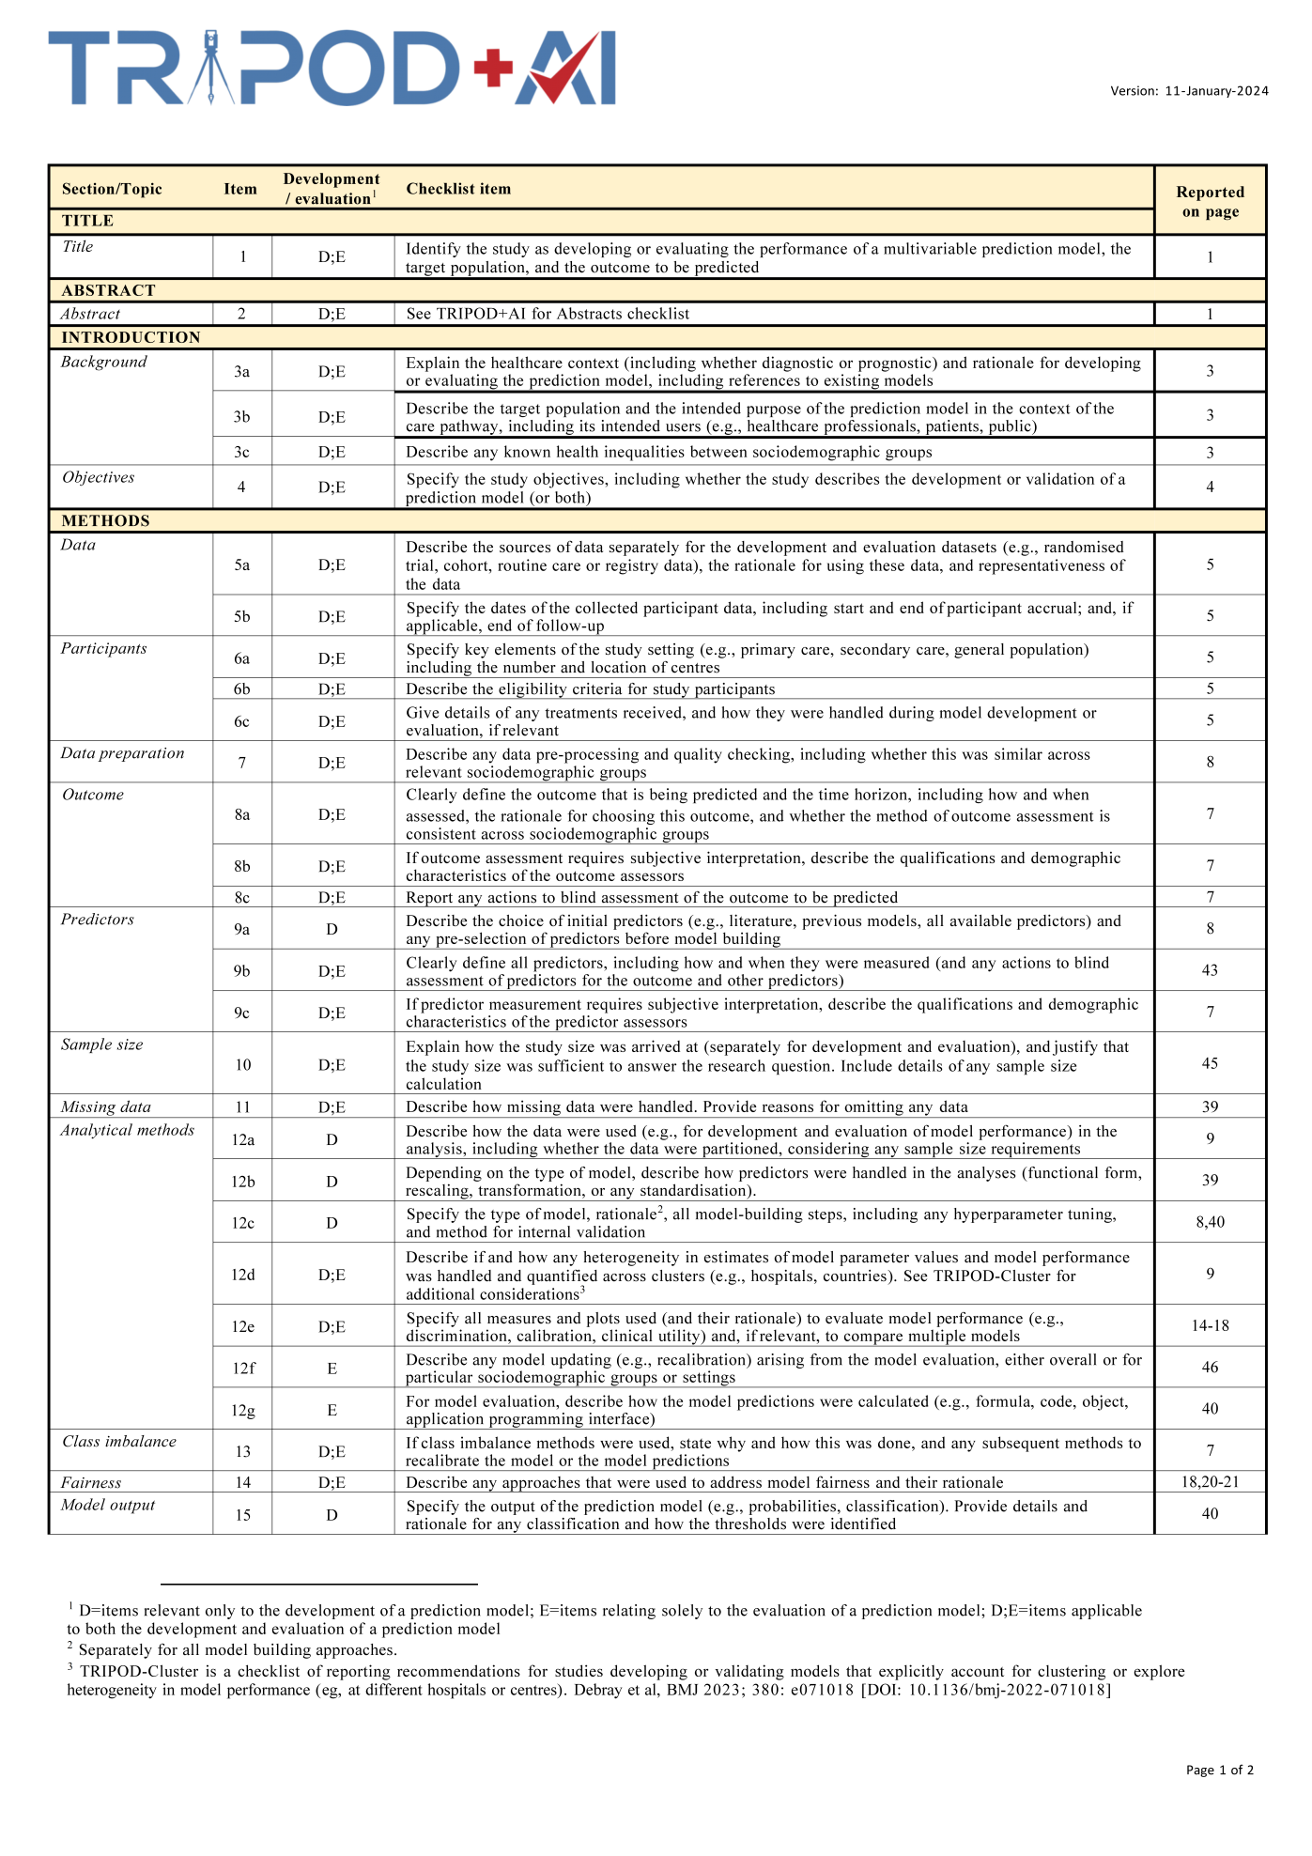
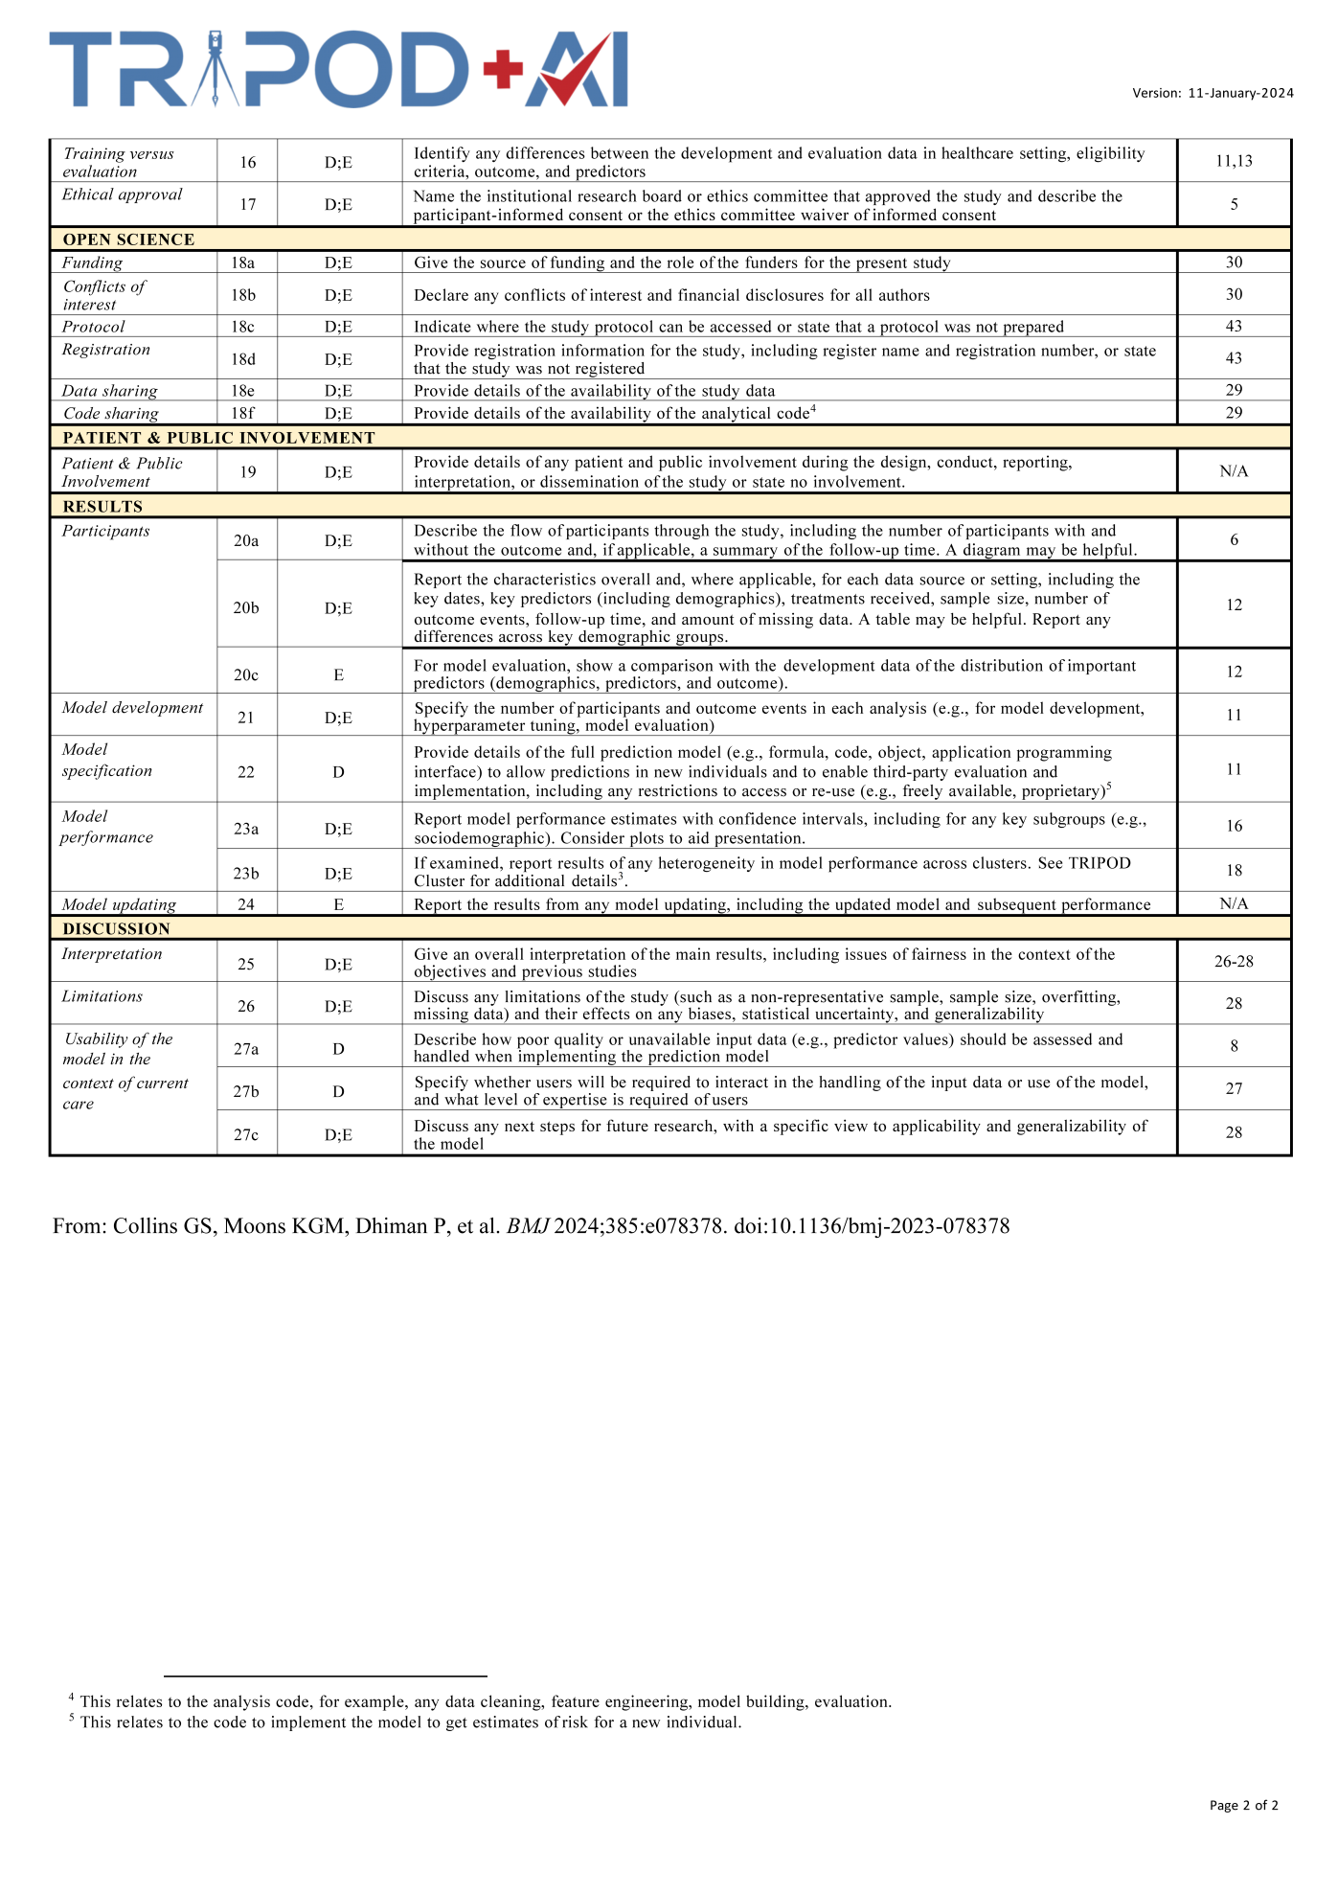
Reference
1. Ilse, M., Tomczak, J. & Welling, M. in International conference on machine learning 2127-2136 (PMLR, 2018).
2. van Griethuysen, J.J.M. et al. Computational radiomics system to decode the radiographic phenotype. Cancer Res 77, e104-e107 (2017).
3. Fortin, J.P. et al. Harmonization of cortical thickness measurements across scanners and sites. Neuroimage 167, 104-120 (2018).
4. Lundberg, S.M. & Lee, S.-I. in Proceedings of the 31st International Conference on Neural Information Processing Systems 4768–4777 (Curran Associates Inc., Long Beach, California, USA; 2017).
5. Barkan, O. et al. in Proceedings of the 30th ACM International Conference on Information & Knowledge Management 2882-2887 (2021).

