Table S1. Baseline clinicopathologic and CT imaging characteristics of patients in the TCGA-KIRC cohort
characteristics | MCRS-Low | MCRS-High | pvalue | statistic | method
n | 97 | 97
tumor size, median (IQR) | 4.6 (3.2, 6.3) | 6.1 (4.3, 9.3) | 0.000191042857319509 |  | Wilcoxon
tumor architecture (solid or Multicystic), n (%) |  |  | 0.181024115101775 | 1.78919631093544 | Chisq test
Solid | 77 (39.7%) | 84 (43.3%)
Multicystic | 20 (10.3%) | 13 (6.7%)
tumor margin (Ill-defined or Well-defined), n (%) |  |  | 1.13879109015167e-05 | 19.2632197414806 | Chisq test
Well-defined | 87 (44.8%) | 61 (31.4%)
Ill-defined | 10 (5.2%) | 36 (18.6%)
spiculated margin(the Present of at least one sharp protrusion on the tumor margin, and the distance between the tumor margin and the furthest point of the sharp protrusion was more than Absent.5mm), n (%) |  |  | 0.0222986160585804 | 5.22233300099701 | Chisq test
Absent | 93 (47.9%) | 84 (43.3%)
Present | 4 (2.1%) | 13 (6.7%)
enhancement pattern (Homogeneous or Nodular enhancement on nephrographic-phase images), n (%) |  |  | 0.0385184083706309 | 4.28198198198198 | Chisq test
Homogeneous | 67 (34.5%) | 53 (27.3%)
Nodular enhancement | 30 (15.5%) | 44 (22.7%)
intratumoral calcification, n (%) |  |  | 0.247399164232734 | 1.33793103448276 | Chisq test
Absent | 76 (39.2%) | 69 (35.6%)
Present | 21 (10.8%) | 28 (14.4%)
intratumoral angiogenesis, n (%) |  |  | 0.000124199003652398 | 14.7278361163711 | Chisq test
Absent | 89 (45.9%) | 68 (35.1%)
Present | 8 (4.1%) | 29 (14.9%)
necrosis(the Present of more than 5Absent% areas within the tumor that did not demonstrate contrast enhancement during the nephrographic and delayed phase), n (%) |  |  | 0.00811045635781581 | 7.00892060660125 | Chisq test
Present | 50 (25.8%) | 68 (35.1%)
Absent | 47 (24.2%) | 29 (14.9%)
renal vein invasion, n (%) |  |  | 7.51415034715817e-05 | 15.6767676767677 | Chisq test
Absent | 96 (49.5%) | 80 (41.2%)
Present | 1 (0.5%) | 17 (8.8%)
collecting system invasion, n (%) |  |  | 0.0297096430046607 | 4.72601503759399 | Chisq test
Absent | 92 (47.4%) | 83 (42.8%)
Present | 5 (2.6%) | 14 (7.2%)

Table S2 Single-cell annotation Maker
# Main class
cell_markers4$`Imm` <- c("PTPRC")
cell_markers4$`Fibro` <- c("COL1A1")
cell_markers4$`Endo` <- c("VWF")
cell_markers4$`Epi` <- c("EPCAM")
# Subclass
cell_markers4$`T cells` <- c("CD3D", "CD3E")
cell_markers4$`CD8 T` <- c("CD8A")
cell_markers4$`CD4 T` <- c("CD4")
cell_markers4$`MAIT` <- c("SLC4A10")
cell_markers4$`Treg` <- c("FOXP3","CTLA4","TNFRSF18","LAYN","TNFRSF9","IKZF2","IL2RA","BATF")
cell_markers4$`B cells+Plasma` <- c("CD79A")
cell_markers4$`B cells` <- c("MS4A1", "MZB1")
cell_markers4$`Hematopoietic stem cell` <- c("CD34")
# Proliferating cells
cell_markers4$`Prolife` <- c("SPP1I67", "TOP2A", "CENPF", "MCM6")
# NK cells
cell_markers4$`NK cells` <- c("KLRF1")
cell_markers4$`CD16+ NK` <- c("FCGR3A")
cell_markers4$`NK sub` <- c("CCL1")
cell_markers4$`Mast cells` <- c("TPSAB1")
# Myeloid cells
cell_markers4$`Myeloid` <- c("ITGAX", "ITGAM", "LYZ")
cell_markers4$`Macro` <- c("LYZ", "LYVE1")
cell_markers4$`Mono` <- c("FCN1", "VCAN", "FCGR3A", "FCGR3B")
cell_markers4$`Neu` <- c("LCN2", "CSF3R")
cell_markers4$`DC` <- c("ITGAX")
cell_markers4$`pDC` <- c("LILRA4")
cell_markers4$`cDC1` <- c("CLEC9A", "XCR1")
cell_markers4$`cDC2` <- c("CD1C")
cell_markers4$`LAMP3-DC` <- c("LAMP3")
# Fibroblast cells
cell_markers4$`Myofibro` <- c("MYH11", "ACTG2")
cell_markers4$`Pericyte` <- c("RGS5")
#cell_markers$`Other Fibro` <- c("iCAF", "mCAF", "APCAF", "CCL19+")
# Specific marker
cell_markers4$`doublets` <- c("LYZ", "CD3E")
cell_markers4$`CCNF` <- c("CCNF")

Table S3 CCNF overexpression plasmid
Target sequence 1:
GATCGTCAGGCCAGGAAGTCATGTTTCTCGAGAAACATGACTTCCTGGCCTGATTTTTT

Target sequence 2:
GATCGTCAGGCCAGGAAGTCATGTTTCTCGAGAAACATGACTTCCTGGCCTGATTTT

Table S4
source data for Figure 9F that describe RCC tumour growth
Days | OE-Ctrl1 | OE-Ctrl2 | OE-Ctrl3 | OE-Ctrl4 | OE-Ctrl5 | OE-CCNF1 | OE-CCNF2 | OE-CCNF3 | OE-CCNF4 | OE-CCNF5
0 | 0 | 0 | 0 | 0 | 0 | 0 | 0 | 0 | 0 | 0
7 | 5.64 | 4.3361 | 10.233 | 13.232 | 12.314 | 42.312 | 54.3566 | 15.7605 | 35.2323 | 36.103
10 | 14.112 | 13.95 | 17.1 | 23.12 | 18.45 | 73.75 | 80.19 | 28.88 | 61.2255 | 74.1285
13 | 24.624 | 22.05 | 17.92 | 25.1125 | 24.854 | 79.768 | 86.2125 | 29.4335 | 66.25 | 85.6745
16 | 30.42 | 23.275 | 20.48 | 26.568 | 27.5625 | 81.12 | 87.725 | 30.8025 | 71.656 | 92.2625
19 | 37.6 | 24.624 | 21.78 | 34.2225 | 28.175 | 85.176 | 93.775 | 40 | 75.843 | 92.697
21 | 40 | 25.272 | 22.542 | 34.983 | 36.8 | 90.75 | 120.9325 | 94.982 | 75.843 | 105.875
24 | 50.625 | 27.38 | 24.5 | 40.8 | 37.6 | 98.784 | 138.915 | 137.628 | 92.2625 | 169.805
27 | 63.132 | 46.1415 | 46.575 | 57.132 | 40 | 128.384 | 168.776 | 157.132 | 103.715 | 261.688
30 | 77.132 | 65 | 29.602 | 87.132 | 66.654 | 139.838 | 181.3 | 187.132 | 112.786 | 295.695
33 | 86.208 | 87.044 | 46.2275 | 117.4 | 81.944 | 156.368 | 246.5195 | 239.248 | 121.4 | 356.45

OE, Overexpression

Figure S1 Extended Data Figure
Samples were run on the same gel for OS-RC-2 and Caki-1

OS-RC-2

Repeat
180 kDa
140 kDa

100 kDa
75 kDa
60 kDa
45 kDa

35 kDa
anti-CCNF(88kDa)
anti-GAPDH(36kDa)

Caki-1

140 kDa

100 kDa

75 kDa

45 kDa

35 kDa

anti-CCNF(88kDa)

anti-GAPDH(36kDa)

Repeat

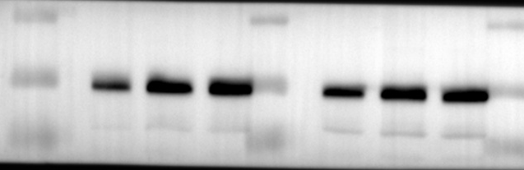

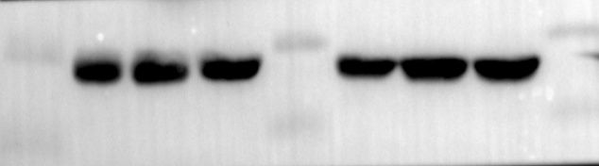

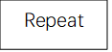
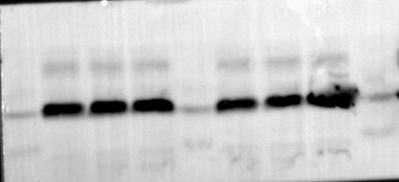
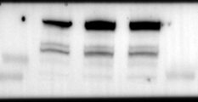
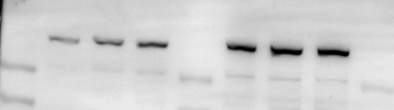
35 kDa
250 kDa
250 kDa
anti-GAPDH(36kDa)
anti-p-mTOR(288kDa)
anti-mTOR(288kDa)
OS-RC-2

