Supplementary Information
Supplementary Information A- Participant Demographics
Table 1. Participant written responses to the question 'What is your ethnic group?'.
Ethnic group | N | %
White English/Welsh/Scottish/Northern Irish/British | 25 | 41.7
White/Caucasian | 8 | 13.3
White Polish | 6 | 10.0
White Portuguese | 2 | 3.3
White Italian | 2 | 3.3
Mixed/Multiple Ethnic Groups- White and Asian | 2 | 3.3
European | 2 | 3.3
Polish | 2 | 3.3
Black African | 1 | 1.7
Mixed/Multiple Ethnic Groups- Other | 1 | 1.7
Asian Pakistani | 1 | 1.7
Asian Indian | 1 | 1.7
White Slavic | 1 | 1.7
White Albanian | 1 | 1.7
Black Caribbean | 1 | 1.7
White Hungarian/Greek | 1 | 1.7
British | 1 | 1.7
Latino/Hispanic | 1 | 1.7
White European | 1 | 1.7

Supplementary Information B- Quantity of autistic participants that met criteria for diagnosis

The level of autistic characteristics of 22 individuals in the ASD group was assessed using the Autism Diagnostic Observation Schedule (version 2 (ADOS-2; Lord et al., 2012). Of the 22 who completed the ADOS-2 assessments, 15 met ADOS criteria for ASD (5 autism, 10 autism spectrum). Although seven individuals in the ASD group did not meet criteria for ASD according to the ADOS, they had previously received diagnoses from independent clinicians, and thus still participated in the study. Unfortunately, it was not feasible to complete observational assessments on all ASD participants due to restrictions on face-to-face testing during the COVID-19 pandemic.

Supplementary Information C- Binary accuracy analysis

To facilitate completion of a binary accuracy analysis (i.e. correct; 1 or incorrect; 0), we transformed the data such that participants scored 1 when they gave the highest emotion rating to the correct emotion, and 0 when they rated either of the incorrect emotions higher than the correct emotion. We then multiplied these values by 100 such that the emotion recognition scores would reflect percentage accuracy (i.e. the percentage of trials where participants gave the highest rating to the correct emotion). We then submitted these binary accuracy scores to a 2 x 3 x 3 x 3 Analysis of Variance (ANOVA) with the between-subjects factor group (ASD, control) and the within-subjects factors emotion (happy, angry, sad), stimulus spatial level (S1, S2, S3), and stimulus kinematic level (K1, K2, K3).

Mirroring the results reported in the main manuscript, this analysis revealed a significant main effect of emotion [F(2, 116) = 27.05, p < .001, η_{P}² = .32, BF₁₀ = 5.66e²¹], with percentage accuracy highest for happy [mean(SEM) = 76.10(1.73)], and comparable for angry [mean(SEM) = 59.76(1.99)] and sad [mean(SEM) = 61.74(1.89)] expressions.

We also identified a main effect of spatial level [F(2,116) = 109.11, p < .001, η_{P}² = .65, BF₁₀ = 6.01e²⁹], with percentage accuracy lowest at the S1 level [mean(SEM) = 54.14(1.74)] and comparable at the S2 [mean(SEM) = 70.62(1.40)] and S3 [mean(SEM) = 72.84(1.26)] levels. In line with the findings reported in the main manuscript, the effect of spatial level was qualified by an emotion x spatial interaction [F(4,232) = 80.66, p < .001, η_{P}² = .58, BF₁₀ = 2.77e⁵⁴]. Post-hoc repeated measures ANOVAs revealed that whilst there was an effect of the spatial manipulation for all three emotions (all F > 18, all p < .001) , the direction of the effect varied between high and low arousal emotions (mirroring the results reported in the main manuscript): percentage accuracy for angry and happy expressions were highest for 150% spatial extent (S3) [angry mean(SEM) = 78.82(1.84); happy mean(SEM) = 85.67(1.78)], followed by 100% spatial extent (S2) [angry mean(SEM) = 66.13(2.30); happy mean(SEM) = 82.97(1.74)], followed by 50% spatial extent (S1) [angry mean(SEM) = 34.32(2.84); happy mean(SEM) = 59.67(3.11)]. In contrast, accuracy improved for sad expressions as the level of the spatial manipulation decreased [S3 mean(SEM) = 54.02(2.33); S2 mean(SEM) = 62.76(2.27); S1 mean(SEM) = 68.44(2.42)]; Fig. 1].

In addition, we identified a main effect of kinematic level [F(2,116) = 4.651, p < .05, η_{P}² = .07, BF₁₀ = 0.04], with percentage accuracy highest at the K2 level [mean(SEM) = 67.64(1.33)], and comparable at the K3 [mean(SEM) = 65.48(1.37)] and K1 levels [mean(SEM) = 64.48(1.45)]. In line with the results reported in the main manuscript, this main effect of kinematic level was qualified by an emotion x kinematic interaction [F(4,232) = 38. 59, p < .001, η_{P}² = .40, BF₁₀ = 4.80e¹⁸]. Post-hoc repeated measures ANOVAs indicated that whilst there was an effect of the kinematic manipulation across all three emotions (all F > 11, p < .001), the direction of the effect was different between high and low arousal emotions (in line with the results reported in the main manuscript): percentage accuracy for angry and happy expressions were highest for the 150% speed (K3) [angry mean(SEM) = 67.90(2.57); happy mean(SEM) = 78.90(1.84)], followed by 100% speed (K2) [angry mean(SEM) = 60.65(2.09); happy mean(SEM) = 78.30(2.01)], followed by 50% speed (K1) [angry mean(SEM) = 50.73(2.49); happy mean(SEM) = 71.11(2.17)]. In contrast, accuracy for sad expressions improved as speed decreased (K3 mean(SEM) = 49.63(2.17); K2 mean(SEM) = 63.98(2.35); K1 mean(SEM) = 71.59(2.52); Fig. 1].

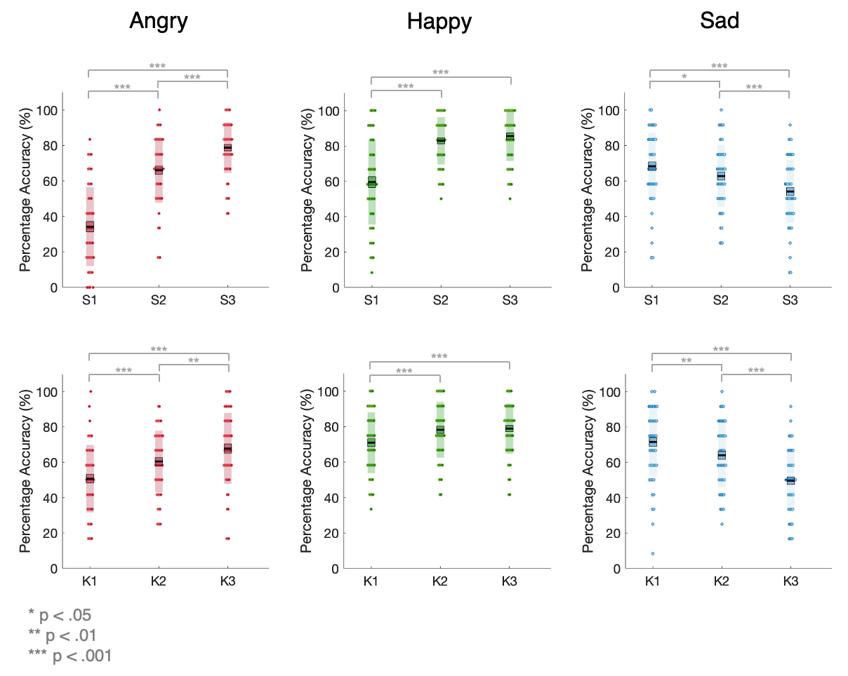
Fig. 1 Percentage accuracy scores, for all participants, for each emotion across the spatial and kinematic levels. The black line represents the mean, the shaded region represents the standard deviation, the coloured box represents 1 standard error around the mean and the dots are individual datapoints

Finally, this analysis also revealed an emotion x kinematic x group interaction [F(4,232) = 2.74, p < .05, η_{P}² = .05, BF₁₀ = 0.13]. In order to unpack this significant emotion x kinematic x group interaction, we conducted post-hoc 2 x 3 (group, emotion) ANOVAs for each kinematic level. This analysis revealed a significant emotion x group interaction at the K2 [F(2,116) = 3.93, p < .05, η_{P}² = .06, BF₁₀ = 2.89] but not K1 [p = .616, BF₁₀ = 1.64e⁻⁴] or K3 [p = .548, BF₁₀ = 0.18] levels. Bonferroni-correct post-hoc independent sample t-tests revealed that control, relative to autistic, participants had higher accuracy for angry videos at the 100% speed level (averaged across all spatial levels) [t(58) = 3.30, p_{bonf} < .01, mean difference = 13.77, BF₁₀ = 20.06]. There were no significant group differences in percentage accuracy for happy [p = .133, BF₁₀ = 0.30] or sad [p = .572, BF₁₀ = 0.68] expressions at this 100% speed level (Fig. 2).

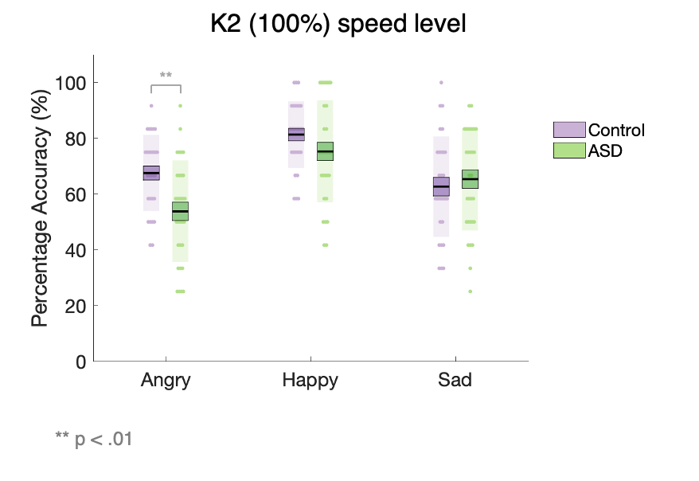

In order to establish whether any group differences at the S2K2 (100% spatial extent, 100% speed) level (that we found in the accuracy analyses in the main paper) were driving the group difference we identified for angry expressions at the K2 level (when averaged across spatial levels), we conducted a further three Bonferroni-corrected independent sample t-tests for angry expressions at the K2 level, at each of the spatial levels. This revealed that controls had significantly higher emotion recognition accuracy for angry expressions at the S2K2 level [t(58) = 3.61, p_{bonf} < .01, mean difference = 20.33, BF₁₀ = 40.59], but not at the S1K2 [p_{bonf} = .231, BF₁₀ = 1.00] or S3K2 [p_{bonf} = .072, BF₁₀ = 2.42] levels, thus mirroring the results reported in the main manuscript. Hence, our findings suggest that the group difference in accuracy for angry expressions discovered at the K2 level (across the spatial levels) may be mainly driven by a group difference at the S2K2 level.
Fig. 2 Percentage accuracy at the K2 (100%) speed level, as a function of emotion. Control in lilac, ASD in green. The black line represents the mean, the coloured box represents the standard error of the mean, the shaded region represents the standard deviation, and the dots are individual datapoints

Supplementary Information D- Unpacking the significant main effects of Emotion and Spatial level

In our main analysis, we conducted a mixed 2 x 3 x 3 x 3 ANOVA with the between-subjects factor group (ASD, control) and the within-subjects factors emotion (happy, angry, sad), stimulus spatial level (S1, S2, S3), and stimulus kinematic level (K1, K2, K3). This analysis revealed a significant main effect of emotion [F(2,116) = 17.79, p < .001, η_{P}² = .24, BF₁₀ = 4.83e¹³], with recognition scores highest for happy [mean(SEM) = 4.19(.19)], and comparable for sad [mean(SEM) = 3.14(.18)] and angry [mean(SEM) = 2.96(.18)] videos. The main analysis also revealed a main effect of spatial level [F(2,116) = 259.57, p < .001, η_{P}² = .82, BF₁₀ = 7.62e⁶¹], with recognition scores improving as the spatial level increased [S1 mean(SEM) = 2.04(.13); S2 mean(SEM) = 3.68(.16); S3 mean(SEM) = 4.56(.15)].

Supplementary Information E- Comparing our findings with Sowden et al., (in press.)
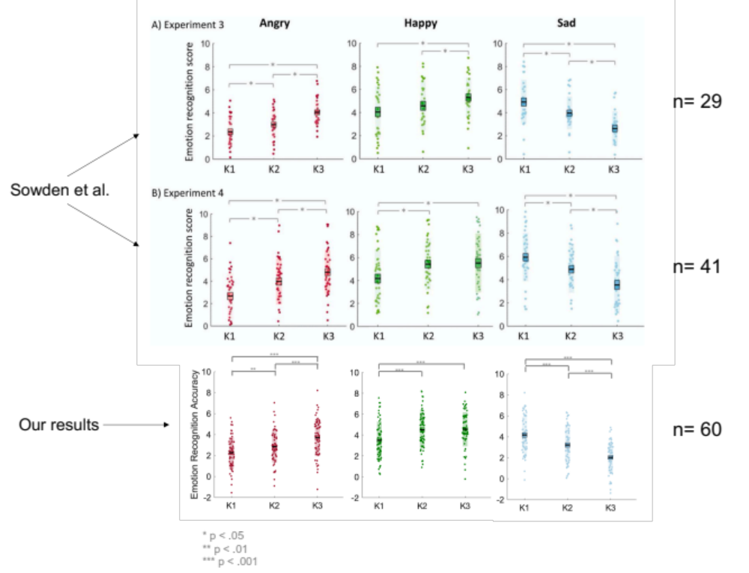
Fig. 3 A graph to compare the results from Experiment 3 and Experiment 4 in Sowden et al., (in press.) and from the present study. The graphs depict the mean accuracy scores for all participants, for each emotion across the kinematic levels. The black line represents the mean, the shaded region represents the standard deviation, the colored box represents 1 standard error around the mean and the dots are individual datapoints

In the present study, we identified that for angry videos, emotion recognition improved with increasing speed [Angry: K1 mean(SEM) = 2.28(.19); K2 mean(SEM) = 2.87(.19); K3 mean(SEM) = 3.73(.23)], thus supporting the results from both ‘Experiment 3’ and ‘Experiment 4’ in Sowden et al., (in press; Fig. 3). For happy videos, we identified that recognition accuracy improved from K1 to K2 but didn’t from K2 to K3 [Happy: K1 mean(SEM) = 3.50 (.23); K2 mean(SEM) = 4.50(.22); K3 mean(SEM) = 4.55(.21)]. Hence, these findings contradict the evidence from ‘Experiment 3’ and favor the results from ‘Experiment 4’ in Sowden et al., (in press.). For sad videos, emotion recognition improved as speed decreased [K3 mean(SEM) = 2.03(.19); K2 mean(SEM) = 3.21(.22); K1 mean(SEM) = 4.18(.23)], thus confirming the findings from ‘Experiment 3’ and ‘Experiment 4’ in Sowden et al., (in press.).

