Supplementary Materials
Supplementary Materials A- Participant Demographics
Table 1. Participant written responses to the question 'What is your ethnic group?'.
Ethnic group | N | %
White English/Welsh/Scottish/Northern Irish/British | 25 | 41.7
White/Caucasian | 8 | 13.3
White Polish | 6 | 10.0
White Portuguese | 2 | 3.3
White Italian | 2 | 3.3
Mixed/Multiple Ethnic Groups- White and Asian | 2 | 3.3
European | 2 | 3.3
Polish | 2 | 3.3
Black African | 1 | 1.7
Mixed/Multiple Ethnic Groups- Other | 1 | 1.7
Asian Pakistani | 1 | 1.7
Asian Indian | 1 | 1.7
White Slavic | 1 | 1.7
White Albanian | 1 | 1.7
Black Caribbean | 1 | 1.7
White Hungarian/Greek | 1 | 1.7
British | 1 | 1.7
Latino/Hispanic | 1 | 1.7
White European | 1 | 1.7

Supplementary Materials B- Unpacking the significant main effects of Emotion and Spatial level

In our main analysis, we conducted a mixed 2 x 3 x 3 x 3 ANOVA with the between-subjects factor group (ASD, control) and the within-subjects factors emotion (happy, angry, sad), stimulus spatial level (S1, S2, S3), and stimulus kinematic level (K1, K2, K3). This analysis revealed a significant main effect of emotion [F(2,116) = 17.79, p < .001, η_{P}² = .24, BF₁₀ = 4.83e¹³], with recognition scores highest for happy [mean(SEM) = 4.19(.19)], and comparable for sad [mean(SEM) = 3.14(.18)] and angry [mean(SEM) = 2.96(.18)] videos. The main analysis also revealed a main effect of spatial level [F(2,116) = 259.57, p < .001, η_{P}² = .82, BF₁₀ = 7.62e⁶¹], with recognition scores improving as the spatial level increased [S1 mean(SEM) = 2.04(.13); S2 mean(SEM) = 3.68(.16); S3 mean(SEM) = 4.56(.15)].

Supplementary Materials C- Comparing our findings with Sowden et al., (in press.)
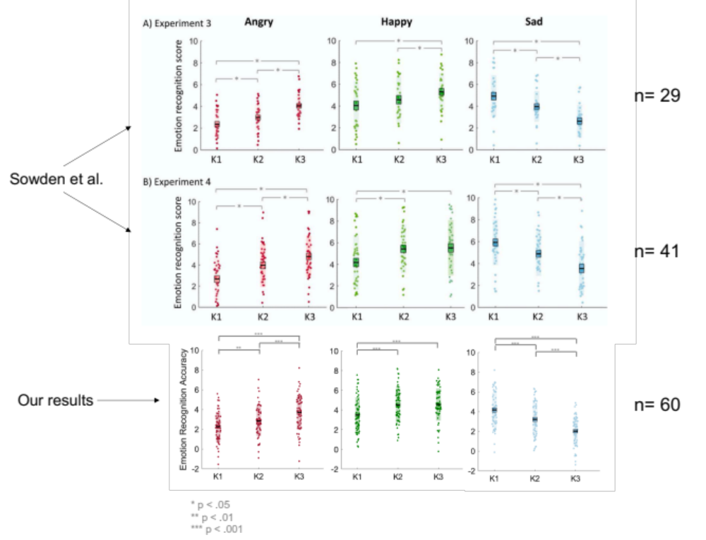
Figure 1. A graph to compare the results from Experiment 3 and Experiment 4 in Sowden et al., (in press.) and from the present study. The graphs depict the mean accuracy scores for all participants, for each emotion across the kinematic levels. The black line represents the mean, the shaded region represents the standard deviation, the colored box represents 1 standard error around the mean and the dots are individual datapoints.

In the present study, we identified that for angry videos, emotion recognition improved with increasing speed [Angry: K1 mean(SEM) = 2.28(.19); K2 mean(SEM) = 2.87(.19); K3 mean(SEM) = 3.73(.23)], thus supporting the results from both ‘Experiment 3’ and ‘Experiment 4’ in Sowden et al., (in press; Figure 1.). For happy videos, we identified that recognition accuracy improved from K1 to K2 but didn’t from K2 to K3 [Happy: K1 mean(SEM) = 3.50 (.23); K2 mean(SEM) = 4.50(.22); K3 mean(SEM) = 4.55(.21)]. Hence, these findings contradict the evidence from ‘Experiment 3’ and favor the results from ‘Experiment 4’ in Sowden et al., (in press.). For sad videos, emotion recognition improved as speed decreased [K3 mean(SEM) = 2.03(.19); K2 mean(SEM) = 3.21(.22); K1 mean(SEM) = 4.18(.23)], thus confirming the findings from ‘Experiment 3’ and ‘Experiment 4’ in Sowden et al., (in press.).

