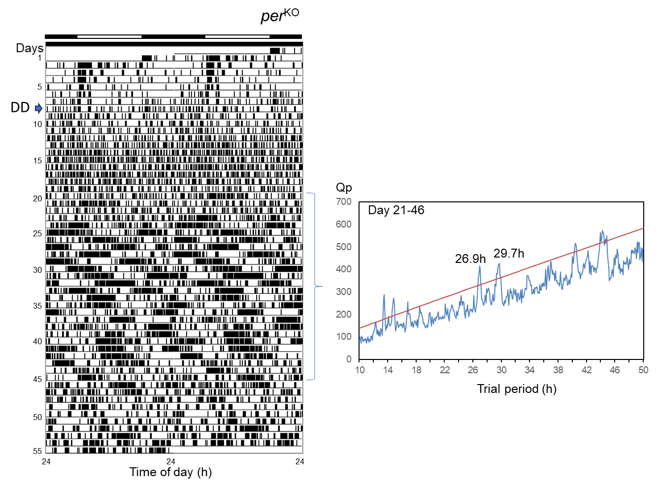

Supplementary Figure S3. An example of locomotor activity record (left panel) and chi-square periodogram of adult male per^{KO} Gryllus bimaculatus showing multiple free-running components. The transition to DD occurred at 18:00 on day 8, as indicated by an arrow. White and black bars denote the light and dark phases, respectively. The periodogram obtained from days 21 to 46 reveals rhythmic components free-running with a period of 26.9 h and 29.7 h under DD. The oblique line in the periodogram represents the 0.05% significance threshold.

