Diurnal OJIP chlorophyll a fluorescence changes reveal key Photosystem II parameters associated with yield of siliques in rapeseed-mustard under elevated temperatures

Krishna M. Nair¹ • S. Shanmughapriya¹ • Mahesh Rao² • Alexandrina Stirbet³ • G. Govindjee⁴ • Anirban Guha¹

¹School of Biology, Indian Institute of Science Education and Research, Thiruvananthapuram (IISER TVM), Thiruvananthapuram, Kerala 695551, India
²ICAR-National Institute for Plant Biotechnology (NIPB), LBS Building, Pusa Campus, New Delhi 110012, India
³Newport News, VA 23606, USA
⁴Department of Plant Biology, Department of Biochemistry, and Center of Biophysics & Quantitative Biology, University of Illinois at Urbana-Champaign, Urbana, IL 61801, USA

Anirban Guha
guhaanirban@iisertvm.ac.in
https://orcid.org/0000-0002-6202-0045

Supporting Material
Table of contents
Fig. S1: Views of the greenhouse study
Fig. S2: Photosynthetically active radiation and air temperature recorded inside the greenhouse
Fig. S3: Diurnal OJIP chlorophyll a fluorescence transients, normalized at Fo
Fig. S4: Diurnal response of the IP phase of chlorophyll a fluorescence transient
Fig. S5: Afternoon leaf temperature and corresponding greenhouse air temperature
Table S1: List of the rapeseed-mustard genotypes examined
Table S2: Characteristics of the IP phase of the OJIP chlorophyll a fluorescence rise kinetics
Table S3: Growth, biomass, and silique yield variables

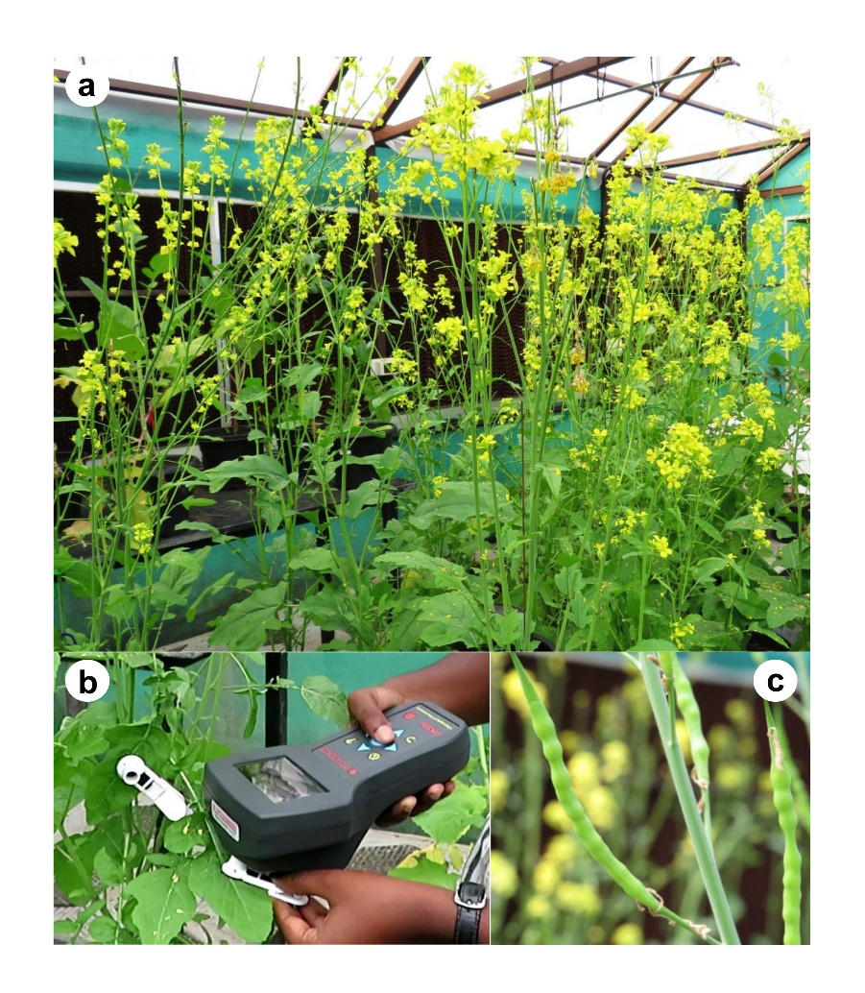
Fig. S1 Views of the greenhouse study on 17 rapeseed-mustard genotypes conducted at the Indian Institute of Science Education and Research Thiruvananthapuram: (a) the experimental plants inside the greenhouse at the flowering stage; (b) measurements of dark-adapted OJIP chlorophyll a fluorescence parameters in leaves using a modulated fluorometer (OS-30p+; Opti-Sciences, USA) and dark-adaptation leaf clips (Opti-Sciences, USA); and (c) green siliques of the rapeseed-mustard plants, which are specialized, elongated seed pods that contain multiple seeds

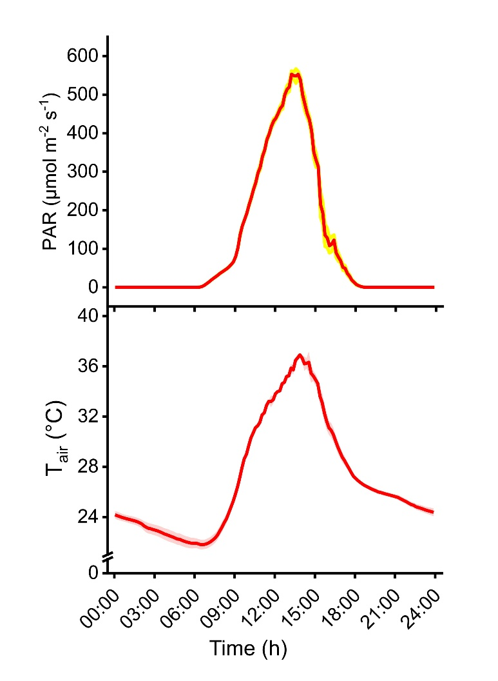
Fig. S2 Diurnal photosynthetically active radiation (PAR) and air temperature (T_{air}) recorded inside the greenhouse used for our experiments at the Indian Institute of Science Education and Research Thiruvananthapuram. Data were recorded using the HOBOMX1104 sensor and data logger (Onset Computer Corporation, MA, USA) over several consecutive days. Values are means ± SE represented by the shaded areas

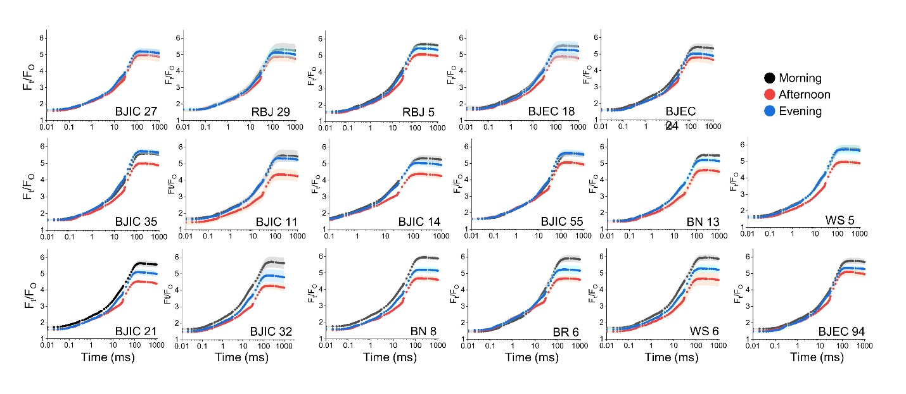
Fig. S3 Chlorophyll a fluorescence transients (OJIP), normalized at F_{O}, in 17 rapeseed-mustard genotypes recorded diurnally at morning (07:30-08:00 h), afternoon (14:00-14:30 h), and evening (16:30-17:00 h). Values are means ± SE (n = 3-5) represented by the shaded areas

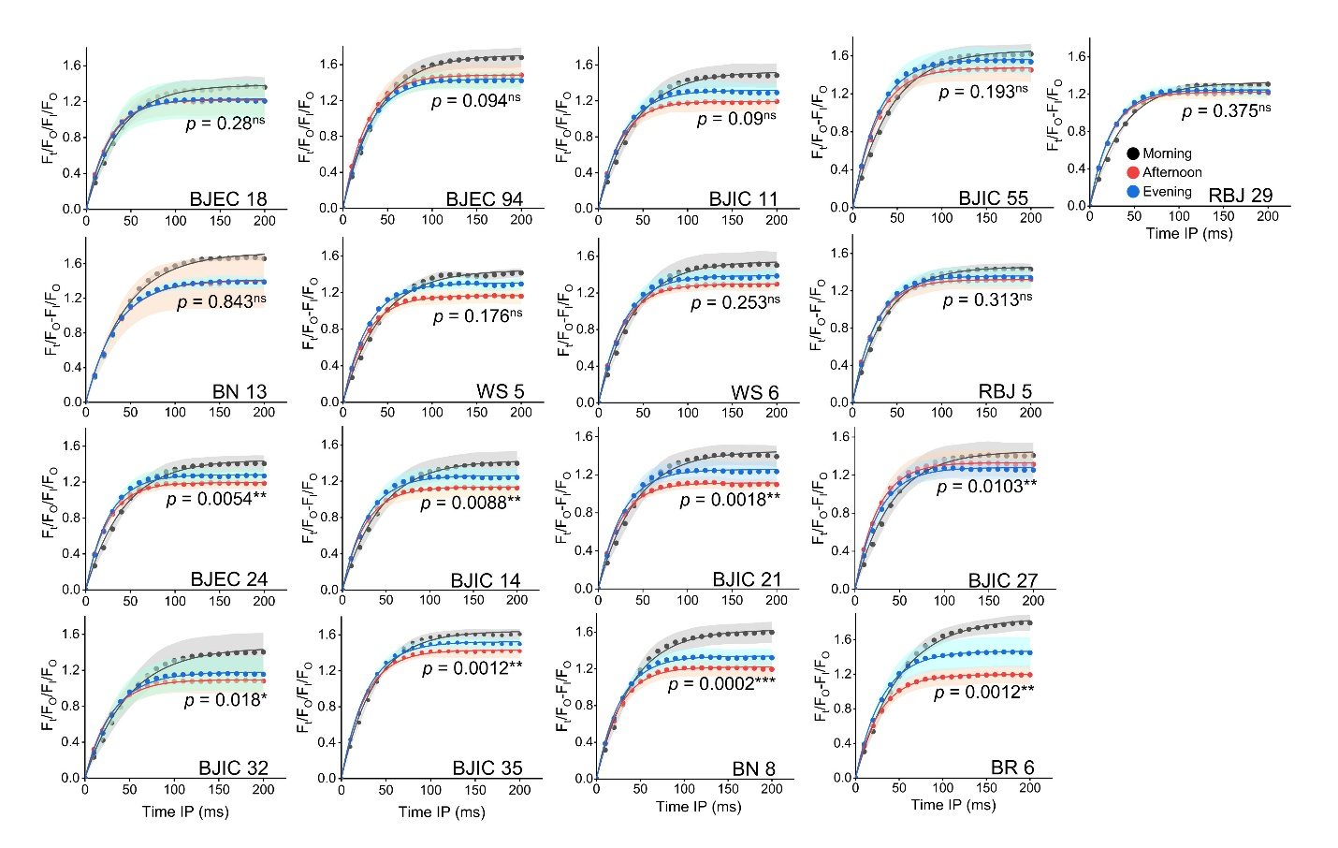
Fig. S4 Diurnal response of the IP phase of the OJIP chlorophyll a fluorescence transients plotted on a linear time scale. The normalized fluorescence between 30 and 230 ms (the IP phase) was fitted using the exponential function (see Materials and Methods). Based on the changes in amplitude of the I-P phase (A_{IP}), genotypes were categorized as (a-i) stress-insensitive (no significant change in A_{IP}), and (j-q) stress-sensitive (significant drop in afternoon and/or evening A_{IP}). Values are means ± SE (n = 3-5), represented by the shaded areas. One-way repeated measure ANOVA was used to test whether the estimated A_{IP} values significantly differed across the timepoints (morning, afternoon, and evening) in a genotype (***p ≤ 0.001; **p ≤ 0.01; *p ≤ 0.05; ns = nonsignificant)

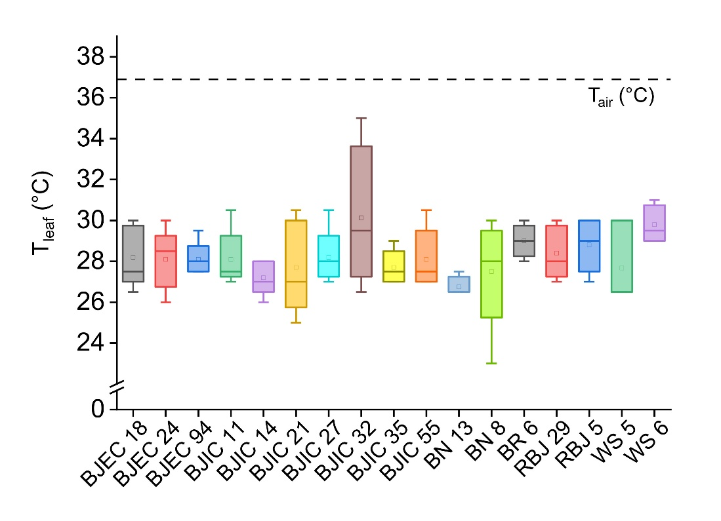
Fig. S5 Afternoon leaf temperature (T_{leaf}) and corresponding greenhouse air temperature (T_{air}) recorded in 17 rapeseed-mustard genotypes. Values are means ± SE (n = 3-5)

Table S1 List of the rapeseed-mustard genotypes examined in the present study with species name, common name, code, and accession number

 | Species name | Common name | Code | Accession number
1 | Brassica juncea | Indian mustard | BJEC 18 | EC182918
2 | Brassica juncea | Indian mustard | BJEC 24 | EC414324
3 | Brassica juncea | Indian mustard | BJEC 94 | EC399294
4 | Brassica juncea | Indian mustard | BJIC 11 | IC355411
5 | Brassica juncea | Indian mustard | BJIC 14 | IC312514
6 | Brassica juncea | Indian mustard | BJIC 21 | IC49921
7 | Brassica juncea | Indian mustard | BJIC 27 | IC571627
8 | Brassica juncea | Indian mustard | BJIC 32 | IC385632
9 | Brassica juncea | Indian mustard | BJIC 35 | IC246635
10 | Brassica juncea | Indian mustard | BJIC 55 | IC395555
11 | Brassica nigra | Black mustard | BN 8 | IC338498
12 | Brassica nigra | Black mustard | BN 13 | IC560726
13 | Brassica rapa | Brown sarson | BR 6 | IC338498
14 | Brassica tournifortii | African mustard | WS 5 | RBT-2002
15 | Brassica tournifortii | African mustard | WS 6 | RBT-2003
16 | RBJ 5 | Resynthetic Indian mustard | RBJ 5 | RBJ 5
17 | RBJ 29 | Resynthetic Indian mustard | RBJ 29 | RBJ 29

Table S2 The estimated best-fit parameter values characterizing the IP phase of the OJIP chlorophyll a fluorescence rise kinetics of 17 rapeseed-mustard genotypes

 | A_{IP}(M) | A_{IP}(AN) | A_{IP}(E) | k_{IP}(M) | k_{IP}(AN) | k_{IP}(E) | t_{½}(M) | t_{½}(AN) | t_{½}(E)
BJEC 18 | 1.39 ± 0.132 | 1.22 ± 0.182 | 1.23 ± 0.247 | 0.03 ± 0.001 | 0.04 ± 0.002 | 0.04 ± 0.002 | 37.22 ± 1.672 | 24.51 ± 1.442 | 25.87 ± 1.636
BJEC 24 | 1.45 ± 0.105 | 1.20 ± 0.070 | 1.28 ± 0.088 | 0.02 ± 0.000 | 0.04 ± 0.002 | 0.04 ± 0.001 | 42.52 ± 0.794 | 24.30 ± 0.944 | 25.62 ± 0.688
BJEC 94 | 1.71 ± 0.120 | 1.48 ± 0.149 | 1.44 ± 0.109 | 0.03 ± 0.001 | 0.04 ± 0.001 | 0.03 ± 0.001 | 38.93 ± 0.779 | 26.55 ± 0.423 | 28.77 ± 0.592
BJIC 11 | 1.53 ± 0.156 | 1.20 ± 0.115 | 1.32 ± 0.124 | 0.03 ± 0.001 | 0.04 ± 0.001 | 0.04 ± 0.001 | 40.56 ± 2.655 | 24.40 ± 0.733 | 27.54 ± 0.840
BJIC 14 | 1.43 ± 0.153 | 1.14 ± 0.124 | 1.26 ± 0.118 | 0.02 ± 0.001 | 0.04 ± 0.001 | 0.03 ± 0.001 | 43.96 ± 2.376 | 25.51 ± 1.195 | 28.05 ± 1.236
BJIC 21 | 1.45 ± 0.120 | 1.11 ± 0.068 | 1.26 ± 0.118 | 0.02 ± 0.001 | 0.04 ± 0.002 | 0.04 ± 0.001 | 42.26 ± 2.298 | 24.01 ± 0.920 | 26.80 ± 0.439
BJIC 27 | 1.45 ± 0.159 | 1.33 ± 0.159 | 1.28 ± 0.124 | 0.02 ± 0.001 | 0.04 ± 0.002 | 0.04 ± 0.001 | 42.12 ± 2.010 | 25.11 ± 1.100 | 26.71 ± 0.507
BJIC 32 | 1.63 ± 0.254 | 1.19 ± 0.150 | 1.32 ± 0.220 | 0.02 ± 0.002 | 0.04 ± 0.002 | 0.03 ± 0.002 | 47.65 ± 5.079 | 26.00 ± 1.386 | 30.64 ± 2.639
BJIC 35 | 1.64 ± 0.068 | 1.43 ± 0.083 | 1.52 ± 0.068 | 0.03 ± 0.001 | 0.04 ± 0.002 | 0.04 ± 0.001 | 36.23 ± 0.820 | 26.40 ± 1.137 | 28.09 ± 0.769
BJIC 55 | 1.67 ± 0.126 | 1.47 ± 0.143 | 1.56 ± 0.155 | 0.02 ± 0.002 | 0.04 ± 0.002 | 0.04 ± 0.002 | 42.44 ± 3.078 | 27.26 ± 1.150 | 27.85 ± 1.470
BN 13 | 1.63 ± 0.106 | 1.22 ± 0.128 | 1.34 ± 0.082 | 0.03 ± 0.001 | 0.04 ± 0.003 | 0.04 ± 0.002 | 39.87 ± 1.686 | 25.44 ± 4.372 | 26.88 ± 3.298
BN 8 | 1.73 ± 0.129 | 1.42 ± 0.108 | 1.42 ± 0.107 | 0.02 ± 0.000 | 0.03 ± 0.001 | 0.03 ± 0.001 | 45.27 ± 0.487 | 34.60 ± 0.349 | 34.81 ± 0.819
BR 6 | 1.86 ± 0.109 | 1.20 ± 0.117 | 1.47 ± 0.201 | 0.02 ± 0.001 | 0.04 ± 0.003 | 0.03 ± 0.003 | 50.57 ± 3.874 | 27.39 ± 1.632 | 29.72 ± 2.522
RBJ 29 | 1.45 ± 0.037 | 1.17 ± 0.078 | 1.31 ± 0.062 | 0.02 ± 0.001 | 0.04 ± 0.001 | 0.04 ± 0.001 | 42.12 ± 1.924 | 26.22 ± 0.689 | 27.29 ± 0.368
RBJ 5 | 1.55 ± 0.069 | 1.30 ± 0.110 | 1.39 ± 0.111 | 0.03 ± 0.001 | 0.04 ± 0.002 | 0.04 ± 0.003 | 38.36 ± 1.943 | 26.30 ± 1.489 | 28.38 ± 1.955
WS 5 | 1.46 ± 0.044 | 1.32 ± 0.074 | 1.36 ± 0.063 | 0.03 ± 0.001 | 0.04 ± 0.001 | 0.04 ± 0.003 | 36.45 ± 2.759 | 25.66 ± 0.981 | 26.45 ± 2.151
WS 6 | 1.33 ± 0.173 | 1.22 ± 0.072 | 1.25 ± 0.091 | 0.03 ± 0.001 | 0.04 ± 0.001 | 0.04 ± 0.001 | 36.10 ± 1.051 | 26.13 ± 0.635 | 28.42 ± 0.906
 | G^{ns}, T****, G × T* |  |  | G***, T****, G × T^{ns} |  |  | G***, T****, G × T**
A_{IP}, amplitude of the IP-phase; k_{IP}, rate constant of fluorescence rise; t_{½}, half rise time of the curves. Values are means ± SE (n = 3-5). The abbreviations M, AN, and E denote measurements taken in the morning (07:30-08:00 h), afternoon (14:00-14:30 h), and evening (16:30-17:00 h). Two-way repeated measure ANOVA results (****p ≤ 0.0001; ***p ≤ 0.001; **p ≤ 0.01; *p ≤ 0.05; ns = nonsignificant) for genotype (G), time (T), and genotype × time (G × T) interaction are given

Table S3 Growth, biomass, and silique yield variables in 17 rapeseed-mustard genotypes

Genotype | PH (cm plant⁻¹) | SD (mm plant⁻¹) | LA (mm² plant⁻¹) | BN (no. plant⁻¹) | DBM (g plant⁻¹) | DSM (g plant⁻¹)
BJEC 18 | 214.75 ± 18.39 | 12.06 ± 0.88 | 1419.58 ± 185.2 | 37.5 ± 10.6 | 26.39 ± 5.2 | 1.7 ± 0.5
BJEC 24 | 238.5 ± 4.42 | 11.65 ± 0.51 | 1668.63 ± 215.65 | 19.25 ± 2.63 | 24.4 ± 2.41 | 1.5 ± 0.31
BJEC 94 | 223.1 ± 6.40 | 10.97 ± 0.72 | 1542.05 ± 413.44 | 34.6 ± 1.89 | 25.61 ± 3.53 | 1.64 ± 0.15
BJIC 11 | 208.4 ± 7.32 | 8.94 ± 0.38 | 683.93 ± 59 | 23.4 ± 2.09 | 12.57 ± 0.93 | 0.94 ± 0.11
BJIC 14 | 213.4 ± 9.21 | 10 ± 0.68 | 1103.33 ± 219.79 | 29 ± 8.37 | 13.67 ± 0.9 | 1.44 ± 0.19
BJIC 21 | 231.5 ± 5.95 | 11.31 ± 0.3 | 1565.72 ± 14337 | 19 ± 7.54 | 25.14 ± 0.73 | 0.68 ± 0.15
BJIC 27 | 231.9 ± 2.35 | 11 ± 0.34 | 1365.18 ± 66.66 | 32 ± 7.08 | 23.58 ± 2.13 | 2.29 ± 0.45
BJIC 32 | 200.75 ± 1.64 | 10.27 ± 0.67 | 1771.09 ± 162.22 | 31 ± 6.28 | 23.31 ± 4.75 | 1.5 ± 0.25
BJIC 35 | 205.75 ± 5.12 | 9.79 ± 0.24 | 808.59 ± 274.89 | 47.75 ± 6.64 | 21.84 ± 1.77 | 1.65 ± 0.34
BJIC 55 | 173.2 ± 21.06 | 8.58 ± 0.82 | 1499.67 ± 777.59 | 30.2 ± 7.35 | 16.41 ± 3.81 | 2.01 ± 0.28
BN 8 | 194.5 ± 15.17 | 7.06 ± 0.36 | 705.73 ± 156.53 | 33 ± 3.81 | 13.75 ± 2.16 | 0.83 ± 0.13
BN 13 | 145.75 ± 6.09 | 7.63 ± 0.44 | 278.39 ± 134.12 | 111 ± 23.68 | 18.54 ± 2.54 | 1.24 ± 0.06
BR 6 | 150.6 ± 11.02 | 8.97 ± 0.77 | 737.77 ± 123.33 | 9.2 ± 1.36 | 12.67 ± 2.36 | 1.74 ± 0.27
WS 5 | 110 ± 2 | 7.64 ± 0.74 | 372.35 ± 20.41 | 47 ±12 | 11.675 ± 1.37 | 2.32 ± 1.55
WS 6 | 125.87 ± 3.22 | 7.12 ± 0.26 | 284.05 ± 143.28 | 44.75 ± 6.54 | 11.83 ± 1.78 | 2.19 ± 0.32
RBJ 5 | 276.8 ± 6.47 | 11.99 ± 1 | 2005.28 ± 423.84 | 20.8 ± 4.87 | 35.95 ± 6.12 | 0.45 ± 0.11
RBJ 29 | 268.3 ± 3.82 | 9.22 ± 0.37 | 1009.49 ± 105.06 | 9.8 ±1.2 | 21.514 ± 1.59 | 0.37 ± 0.06
 | **** | **** | ** | **** | **** | ***
PH, plant height; SD, stem diameter; LA, leaf area; BN, total number of branches; DBM, total plant dry biomass; DSM, dry silique biomass. Values are means ± SE (n = 3-5). One-way ANOVA results (****p ≤ 0.0001; ***p ≤ 0.001; **p ≤ 0.01) are given

