Supplementary Information
Table S1. Study site characteristics
Web | Coordinates | Location | Year | Altitude (m) | Glaciality Index | Glaciality Index (standardised) | Glacier cover (%) | Proglacial lake | Water temp (°C) | EC (µS cm⁻¹) | Turbidity (NTU) | 1/Pfankuch | Diatom richness | Invertebrate richness
A | 47.12213, 12.63853 | Eisboden | 2015 | 2154 | -2.18 | 1 | 36 | N | 2.35 | 107.0 | 157.00 | 0.018 | 8 | 6
B | 46.83104, 11.04022 | Rotmoosache | 2016 | 2351 | -1.63 | 0.85 | 64 | N | 3.30 | 81.9 | 34.14 | 0.018 | 7 | 4
C | 47.14075, 12.65157 | Unter Rifflkees | 2015 | 2275 | -1.59 | 0.84 | 46 | N | 1.30 | 61.1 | 70.00 | 0.019 | 9 | 3
D | 46.84623, 11.01827 | Rotmoosache | 2016 | 2253 | -0.91 | 0.66 | 30 | N | 7.10 | 78.0 | 42.60 | 0.019 | 9 | 6
E | 47.14214, 12.27648 | Obersulzbach | 2015 | 1746 | 0.52 | 0.29 | 42 | Y | 8.00 | 17.0 | 4.97 | 0.025 | 42 | 16
F | 47.13157, 12.63372 | Eisboden | 2015 | 2080 | 0.65 | 0.25 | 0 | N | 4.60 | 68.3 | 0.00 | 0.034 | 55 | 16
G | 47.12970, 12.28065 | Obersulzbach | 2015 | 1948 | 0.93 | 0.18 | 52 | Y | 8.50 | 12.0 | 1.29 | 0.027 | 34 | 13
H | 47.13979, 12.65328 | Unter Rifflkees | 2015 | 2286 | 1.23 | 0.10 | 1 | N | 4.50 | 17.2 | 1.66 | 0.050 | 45 | 16
I | 47.12436, 12.63836 | Eisboden | 2015 | 2129 | 1.38 | 0.06 | 3 | N | 11.35 | 60.0 | 0.41 | 0.033 | 59 | 17
J | 47.13407, 12.63720 | Eisboden lower | 2016 | 2057 | 1.61 | 0 | 0 | N | 7.55 | 4.4 | 0.00 | 0.023 | 46 | 11

Table S2. Data sources used for assessments of food web community level diatom and invertebrate richness and abundance/density representativeness. n denotes number of study rivers in each dataset. Upper case letters followed by numbers are location codes highlighted on Figure S1. Data sources were selected from the authors’ knowledge of previous alpine river studies that collected primary datasets for diatoms and/or invertebrates. Studies were retained for the meta-analysis only for regions where quantitatively sampled datasets were available for both diatoms and invertebrates. Asterisk denotes where diatoms and invertebrate datasets were available from concurrent collections.
Region | Location | Diatoms | Invertebrates
N. America | Coast Range & Rockies, SE Alaska/NW Canada | Brahney et al. (2021), n=15, D1  Gesierich & Rott (2006), n=10, D2 | Brown & Milner (2012) n=17, I1
S. America | Cordillera Blanca & Vilcanota, Peru | Kerr et al. (2025), n=23, D3+D4 | Palacios-Robles et al. (2024), n=10, I2
N. Europe | North Central Highlands, Iceland | Hansen et al. (2006a, b), n=9, D5 | Gíslason et al. (2001), n=69, I3
S. Europa | Central Alps., Austria | Gesierich & Rott (2004), n=13, D6 | Füreder (2007), n=46, I4

Table S3. Results for models fitted to meta-analysis data shown in main paper Figure 1.
Dependent variable | Model | Optimal Random effect structure | AIC | R²adj marginal | Dispersion | Model component | Est. (se) | t/z | p
Diatom richness (n=80) | GLMM, Poisson | River/Site | 622.53 | 0.150 | 0.178 | intercept  glacier cover | 3.17 (0.09)  -0.85 (0.23) | 35.89  -3.67 | <2e⁻¹⁶  0.000248
Diatom abundance (n=42) | LME, log-normal | River | 128.83 | 0.316 | - | intercept  glacier cover | 7.73 (0.24)  -2.58 (0.51) | 32.05  -5.02 | <0.0001  0.001
Invertebrate richness (n=152) | GLMM, Poisson | River | 740.63 | 0.439 | 0.399 | intercept  glacier cover | 2.69 (0.07)  -1.44 (0.18) | 39.07  -7.94 | <2e⁻¹⁶  1.88e-15
Invertebrate abundance (n=152) | GLMM, neg.bin | River | 2882.74 | 0.313 | 0.523 | intercept  glacier cover | 9.02 (0.21)  -3.10 (0.41) | 42.33  -7.55 | <2e⁻¹⁶  4.39e⁻¹⁴

Table S4. Multiple examples of predation and cannibalism were directly observed through gut contents analysis, among invertebrates that are usually considered to be primary consumers (herbivores/detritivores).
Consumer | Prey | Cannibalism | Food web
Acrophylax zerberus | Baetis, Diamesa, Orthocladiinae, Prosimulium |  | H, I, F
Baetis alpinus grp. | Chironomidae, Diamesa, Orthocladius | Y | B, C, D, E, F, G, H, I
Diamesa (various spp.) | Chironomidae, Orthocladiinae, Orthocladius, Prosimulium | Y | All
Heptagenia (various spp.) | Baetis alpinus grp |  | D, E
Leuctra | Baetis, Chironomidae, Nemouridae, Orthocladiinae, Orthocladius, Prosimulium, Tanypodinae | Y | F, G, H, I
Limnephilidae | Chironomidae, Orthocladius |  | I
Nemoura | Chironomidae, Diamesa |  | F
Nemouridae | Baetis alpinus grp., Chironomidae, Diamesa, Parorthocladius, Prosimulium, Tanypodinae | Y | F, H
Orthocladius (various spp.) | Chironomidae, Orthocladiinae |  | F, G, I, J
Parorthocladius | Chironomidae |  | H, J
Prosimulium | Baetis, Chironomidae, Diamesa, Orthocladius, Parorthocladius, Tanypodinae | Y | A, F, G, H, I, J,
Protonemura | Chironomidae, Diamesa, Nemouridae | Y | E, F
Rhithrogena semicolorata | Baetis alpinus grp. |  | B, D, E, H

Table S5. Sources for each of the parameter values used in the Allometric Diet Breadth Model. Body mass and abundance data were collected for 10 streams in the Hengill area of Iceland in August 2008. Values for all other parameters were sourced from the literature, with references provided in the table, except those marked † which maximise the fit of the model to the empirical data.
Parameter | Description | Value | Source
M | average species body mass (mg) | variable | river data
N | total species abundance (m⁻²) | variable | river data
ɑ₀ | normalisation constant for attack rate at T₀ | e^{-16.82} | meta-analysis  (Rall et al., 2012)
ɑ_{i} | resource mass to attack rate exponent | 0.15 | meta-analysis  (Rall et al., 2012)
ɑ_{j} | consumer mass to attack rate exponent | 0.47 | meta-analysis  (Rall et al., 2012)
ε | mass to energy scaling exponent | 1 | (Petchey et al., 2008; O’Gorman et al., 2019)  †
h₀ | normalisation constant for handling time at T₀ | e^{8.30} | †
b | mass to handling time critical ratio | 0.01 | †

Fig. S1. Sampling locations used for (i) the biodiversity meta-analysis, and (ii) detailed food web analysis in Austria (see Table S1 for further details). Blue circles/I codes show invertebrate sampling locations; green circles/D codes show diatom sampling locations (see Table S3 for further information). Panels iii – Rotmoosach, iv – Obersulzbach and v – Eisboden/Unter Rifflkees show locations where samples of both invertebrates and diatoms were collected for the detailed food web analysis.
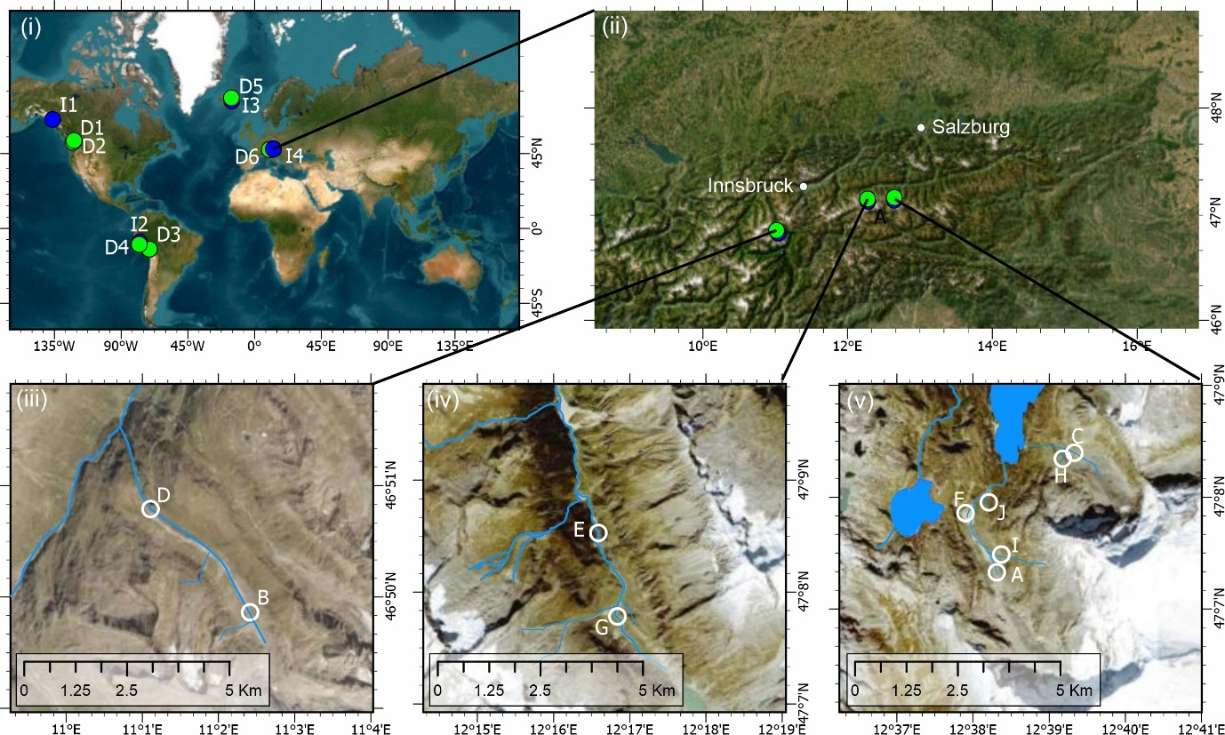

Fig. S2. Linear associations between glacier influence (glaciality index scores) and river physical properties: (a) turbidity (R²=0.43, p=0.0395; (b) water temperature (R²=0.53, p=0.00177); (c) electrical conductivity (R²=0.63, p=0.00642); (d) channel stability (Pfankuch bottom component, R²=0.46, p=0.0317). Upper case letters represent the ten food webs.

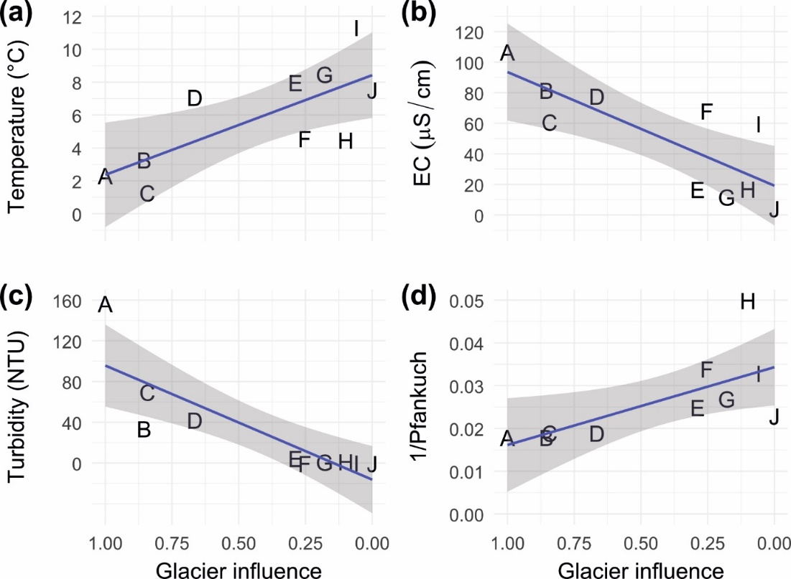

Fig. S3. Total diatom biomass (sum of each diatom taxon’s average cell mass x density/m²) increased as glacier influence declined. Linear fit R²=0.61, p=0.008. Upper case letters represent the ten food webs.

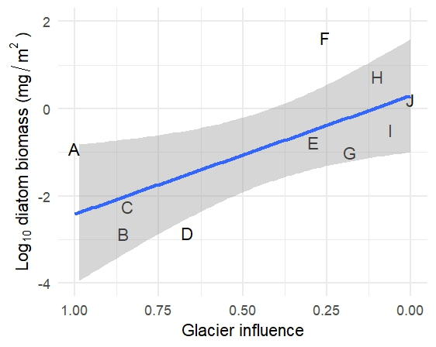

Fig. S4. Relationships between community beta-diversity components (total, turnover and nestedness) and between-site differences in glaciality index (Glaciality difference). (a-c) invertebrates only; (d-f) diatoms only. Summary statistics are results from Mantel tests using the Spearman method and 9,999 permutations.
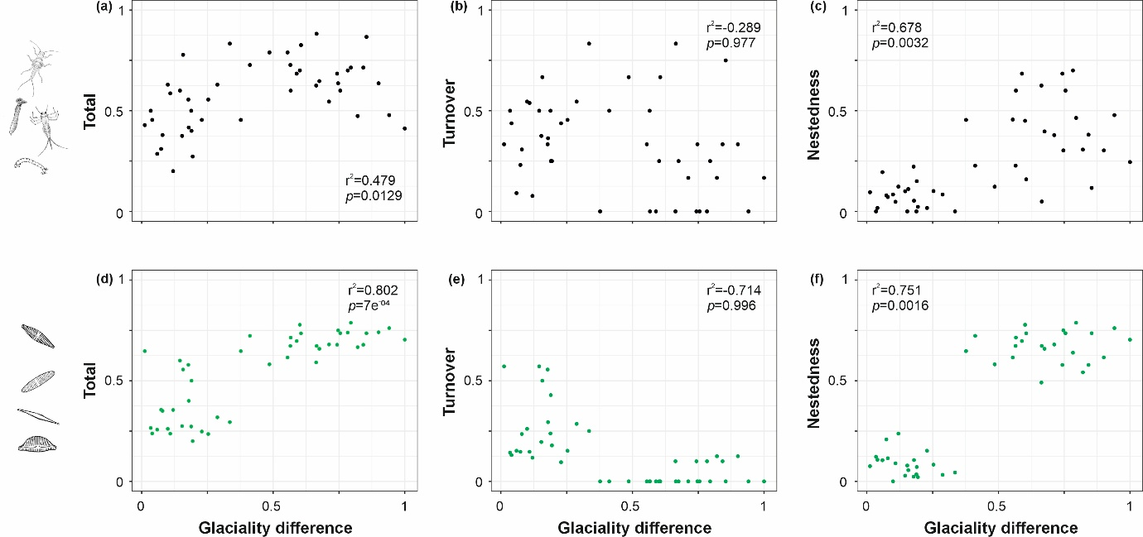
Fig. S5. ADBM predictions for the ten empirical food webs show close correspondence between observed and predicted food web links. Binary predation matrices are displayed for each river, where rows are resources and columns are consumers, with species arranged in order of increasing body mass. A green circle indicates an observed trophic interaction correctly predicted by the ADBM, a grey circle indicates a real trophic interaction that was not predicted by the ADBM, and an orange circle indicates a trophic interaction predicted by the ADBM that did not occur in the real system. River codes are indicated in each panel, along with the percentage of real trophic interactions that were correctly predicted by the ADBM ('correct'), and the percentage of trophic interactions predicted by the ADBM that did not occur in the real system ('extra'). Dashed line represents the 1:1 relationship.

Supplementary Methods
Body mass estimation
Published equations were used to estimate body length (mm) and body mass (mg) of both consumer and ingested macroinvertebrates.

For Chironomidae larvae, body length (L, mm) was estimated from head capsule width (HCW, mm) using:
L = - 3.62 + 29.73 HCW (Smock, 1980) (Eq. S1)

For all other macroinvertebrates, body length was measured to 0.01 mm using a calibrated optical micrometer eye piece at x25 magnification. Linear body length equated to the distance between the head anterior and final abdominal segment posterior (Smock, 1980). Body mass (dry M, mg) was then determined for all consumer and ingested macroinvertebrates from body length (L, mm), with family, genera or species-specific regression constants (a, b) (Eq. S2; Table S6).

ln M = ln a + b* ln L (Smock, 1980, p.376) (Eq. S2)

Table S6. Taxon specific regression constants for Equation (2).
Taxon | ln a | ln b | Reference
Diptera | -5.221 | 2.43 | Smock (1980)
Chironomidae/ Orthocladiinae | -5.279 | 2.32 | Smock (1980)
Diamesa | -6.231 | 2.602 | Nolte (1990)
Micropsectra atrofasciata | -7.321 | 2.588 | Nolte (1990)
Orthocladius spp. | -6.228 | 2.264 | Nolte (1990)
Tanypodinae | -5.573 | 2.41 | Smock (1980)
Simuliidae | -5.339 | 2.55 | Smock (1980)
Ephemeroptera | -5.021 | 2.88 | Smock (1980)
Baetis spp. | -5.714 | 3.20 | Smock (1980)
Plecoptera | -6.075 | 3.39 | Smock (1980)
Trichoptera | -6.266 | 3.12 | Smock (1980)

For some invertebrates where L:M relationships were not available in the literature, regressions were developed between macroinvertebrate body length and dimensions of their individual body parts using Surber sample collections (Figure S6). Regression equations were then used to estimate the body length of macroinvertebrate prey from the size of individual body parts found fragmented in the gut contents of consumers, and published regressions were then used to estimate body mass (after Woodward et al 2005). All measurements were made using a calibrated eye piece graticule at x25 to x1000 magnification.

Fig. S6. Relationships between aquatic macroinvertebrate body length and selected body part dimensions from the ten new food webs. Abdomen segment width refers to the widest abdominal segment available for measurement. (a) Baetis alpinus grp; (b) Trichoptera spp.; (c) Chironomidae spp.
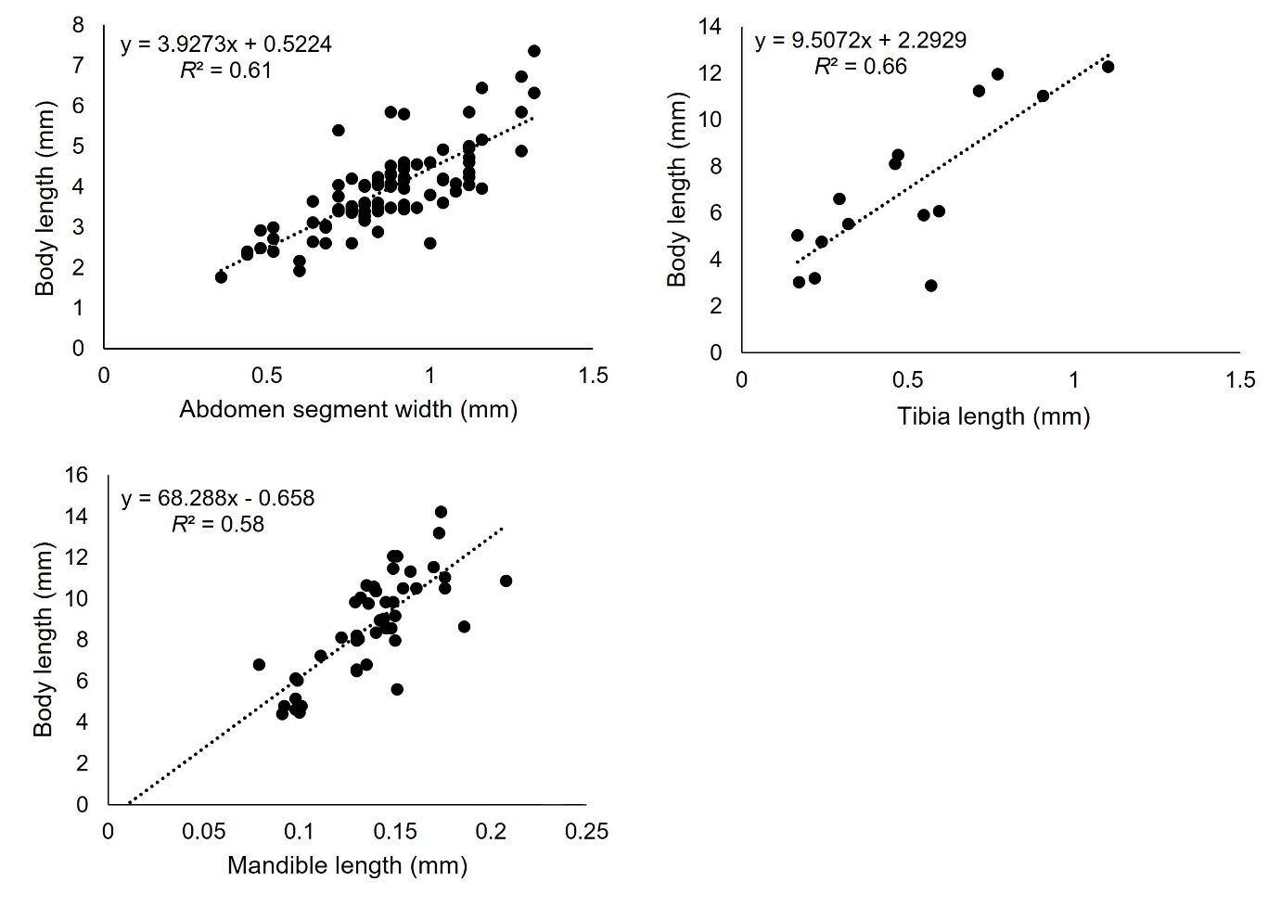
Following the European Standard protocol (CEN, 2015), ingested diatoms were assigned shape categories based upon their length, width and depth measurements, which informed standardised equations used to determine biovolume. Where depth was not visible microscopically, equations provided by the protocol were used to estimate this dimension, and in their absence, depth was assumed to equal width for small freshwater algae approximating them to spheres (Sun and Lui, 2003; CEN, 2015). Biovolume was converted to body mass using the regressions provided by Menden-Deuer and Lessard (2000).

Food web diatom and invertebrate taxa beta-diversity were analysed using the betapart package (Baselga & Orme, 2012) to quantify total dissimilarity, turnover and nestedness components. Beta-diversity components were assessed in relation to between-site differences in glaciality index values using Mantel tests based on the Spearman method in the vegan package in R (Oksanen et al., 2017) with 9999 permutations.

Food web basal species
In some invertebrate gut contents, observed algal groups included diatoms, green-algae (e.g. Chlorella, Spirogyra) and golden algae (e.g. Hydrurus). However, reliable M and N estimates could not be collated for the non-diatom algal taxa, preventing their inclusion in M-N webs. Our highly resolved food webs were therefore constructed using diatom producer and invertebrate consumer datasets. This approach enabled univariate, bivariate and trivariate food web analyses (e.g. connectance to M-N webs) to be compared consistently from the same underlying food web datasets, and also with other food web studies that used comparable methods (Thompson & Townsend, 2003; Layer et al., 2010; Ledger et al., 2013; Thompson et al., 2016; O’Gorman et al., 2019; ) However, we were able to build univariate connectance webs that incorporated a range of basal algae species. This showed that the inferences drawn from relationships between food web statistics and glacial influence were consistent with those from our approach used in the main paper for our full univariate, bivariate and trivariate analyses (Table S7).

Table S7. Significant linear regression relationships were observed between decreasing glacial influence and multiple connectance metrics for food web incorporating all basal algae observed in invertebrate gut contents. Relationships with glacier influence were analysed using linear regression in the same way as those presented in the main text for diatom-invertebrate webs. See main text methods for definitions of each variable.
Variables | Intercept | Slope | F | p | R²adj
Link richness | 564.8 | -562.2 | 19.91 | 0.002 | 0.68
Connectance | 0.059 | 0.100 | 35.30 | <0.001 | 0.79
Proportion of basal species | 0.851 | -0.074 | 6.24 | 0.037 | 0.37
Mean trophic position | 1.156 | 0.080 | 6.11 | 0.039 | 0.36

Supplementary References
Baselga, A. and Orme, C.D.L. 2012, betapart: an R package for the study of beta diversity. Methods in Ecology and Evolution 3: 808-812.
Brahney, J., M.L. Bothwell, L. Capito, C.A. Gray, S.E. Null, B. Menounos, P.J. Curtis. 2021. Glacier recession alters stream water quality characteristics facilitating bloom formation in the benthic diatom Didymosphenia geminate. Science of The Total Environment 764: 142856
Brown, L.E. and Milner, A.M. 2012. Rapid loss of glacial ice reveals stream community assembly processes. Global Change Biology 18: 2195-2204.
Comité European de Normalisation (CEN). 2015. Water Quality - Guidance on the Estimation of Phytoplankton Biovolume, EN 16695: 2015. Geneva: Comité European de Normalisation.
Füreder, L. 2007. Life at the Edge: Habitat Condition and Bottom Fauna of Alpine Running Waters. International Review of Hydrobiology 92: 491-513.
Gesierich, D. & Rott, E. 2004. Benthic Algae and Mosses from Aquatic Habitats in the Catchment of a Glacial Stream (Rotmoos, Ötztal, Austria). Berichte des naturwissenschaftlichen-medizinischen Verein Innsbruck 91: S. 7 – 42.
Gesierich, D. & Rott, E. 2006. Is diatom richness responding to catchment glaciation? A case study from Canadian headwater streams. Journal of Limnology 71: e7.
Gíslason, G.M., Adalsteinsson, H., Hansen, I., Ólafsson, J.S. and Svavarsdóttir, K. 2001. Longitudinal changes in macroinvertebrate assemblages along a glacial river system in central Iceland. Freshwater Biology 46: 1737-1751.
Hansen, I., Gíslason, G. M., & Ólafsson, J. S. 2006a. Diatoms in glacial and alpine rivers in Central Iceland. Verhandlungen der Internationale Vereinigung für Theoretische und Angewandte Limnologie 29: 1271–1274.
Hansen, I., Gíslason, G. M., & Ólafsson, J. S. 2006b. Correction: Diatoms in glacial and alpine rivers in Central Iceland. Verhandlungen der Internationale Vereinigung für Theoretische und Angewandte Limnologie 29: 2343.
Kerr, N.R., Quincey, D., Fell, S.C., Kelly, M., Medina, K., Loarte, E. & Brown, L.E. 2025. Diatom biodiversity response to shrinking glaciers in the Peruvian Andes. bioRxiv 2025.02.17.635084.
Layer, K., Hildrew, A.G., Monteith, D. & Woodward, G. 2010. Long‐term variation in the littoral food web of an acidified mountain lake. Global Change Biology 16: 3133-3143
Ledger, M.E., Brown, L.E., Edwards, F.K., Milner, A.M. & Woodward, G. 2013. Drought alters the structure and functioning of complex food webs. Nature Climate Change 3: 223-227
Menden-Deuer, S. and Lessard, E. J. 2000. Carbon to volume relationships for dinoflagellates, diatoms, and other protest plankton. Limnology and Oceanography 45: 569–579.
Nolte, U. 1990. Chironomid biomass determination from larval shape. Freshwater Biology 24: 443–451.
O’Gorman, E. J. et al. 2019. A simple model predicts how warming simplifies wild food webs. Nature Climate Change 9: 611-616
Oksanen, F.J. et al. 2017. Vegan: Community Ecology Package. R package. CRAN.R-project.org/package=vegan
Palacios-Robles, E., Medina, K., Loarte, E., Castañeda-Barreto, A., Gamboa-Mendoza, M., Polo-Salazar, R., Tapia, P., Pellicciotti, F., & Brown, L.E. 2024. Declining glacier cover drives changes in aquatic macroinvertebrate biodiversity in the Cordillera Blanca, Perú. Global Change Biology 30, e17355.
Petchey, O. L., Beckerman, A. P., Riede, J. O. & Warren, P. H. 2008. Size, foraging, and food web structure. Proceedings of the National Academy of Sciences of the United States of America 105: 4191-4196
Rall, B.C. et al. 2012. Universal temperature and body-mass scaling of feeding rates. Philosophical Transactions of the Royal Society B: Biological Sciences 367: 2923-2934
Riede, J.O. et al. 2011. Stepping in Elton’s footprints: a general scaling model for body masses and trophic levels across ecosystems. Ecology Letters 14: 169-178
Smock, L. A. 1980. Relationships between body size and biomass of aquatic insects. Freshwater Biology 10: 375–383.
Sun, J. and Lui, S. 2003. Geometric models for calculating cell biovolume and surface area for phytoplankton. Journal of Plankton Research 25: 1331–1346.
Thompson, M., Bankier, C., Bell, T., Dumbrell, A., Gray, C., Ledger, M., Lehmann, K., McKew, B., Sayer, C., Shelley, F., Trimmer, M. & Woodward, G. 2016. Gene‐to‐ecosystem impacts of a catastrophic pesticide spill: testing a multilevel bioassessment approach in a river ecosystem. Freshwater Biology 61: 2037-2050
Thompson, R.M. & Townsend, C.R. 2003. Impacts on stream food webs of native and exotic forest: an intercontinental comparison. Ecology 84: 145-161.
Woodward, G., Speirs, D.C., Hildrew, A.G. and Hal, C., 2005. Quantification and resolution of a complex, size-structured food web. Advances in Ecological Research 36: 85-135.

