Palladium Nanoparticles Supported on Activated Carbon (C)) for the Catalytic Hexavalent Chromium Reduction

İbrahim Gözetenª, Mehmet Tunçª
ªDepartment of Chemistry, Faculty of Science, Van Yüzüncü Yıl University, 65080, Tuşba, Van, Turkey

(SUPPORTING INFORMATION)

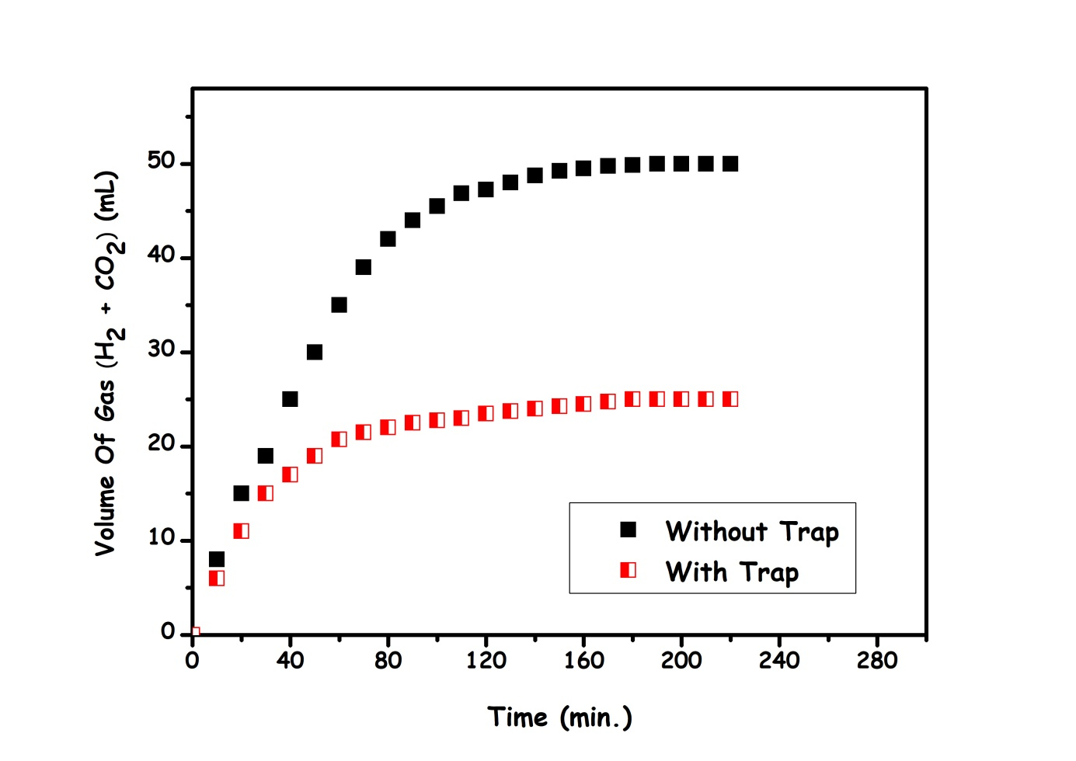Fig. S-1 The volume of gas versus time graph for the decomposition of FA aqueous solution (10.0 mL H₂O, 250 mM FA, 250 mM SF ) over Pd@C catalyst at 298 K.in the without trap and with trap.

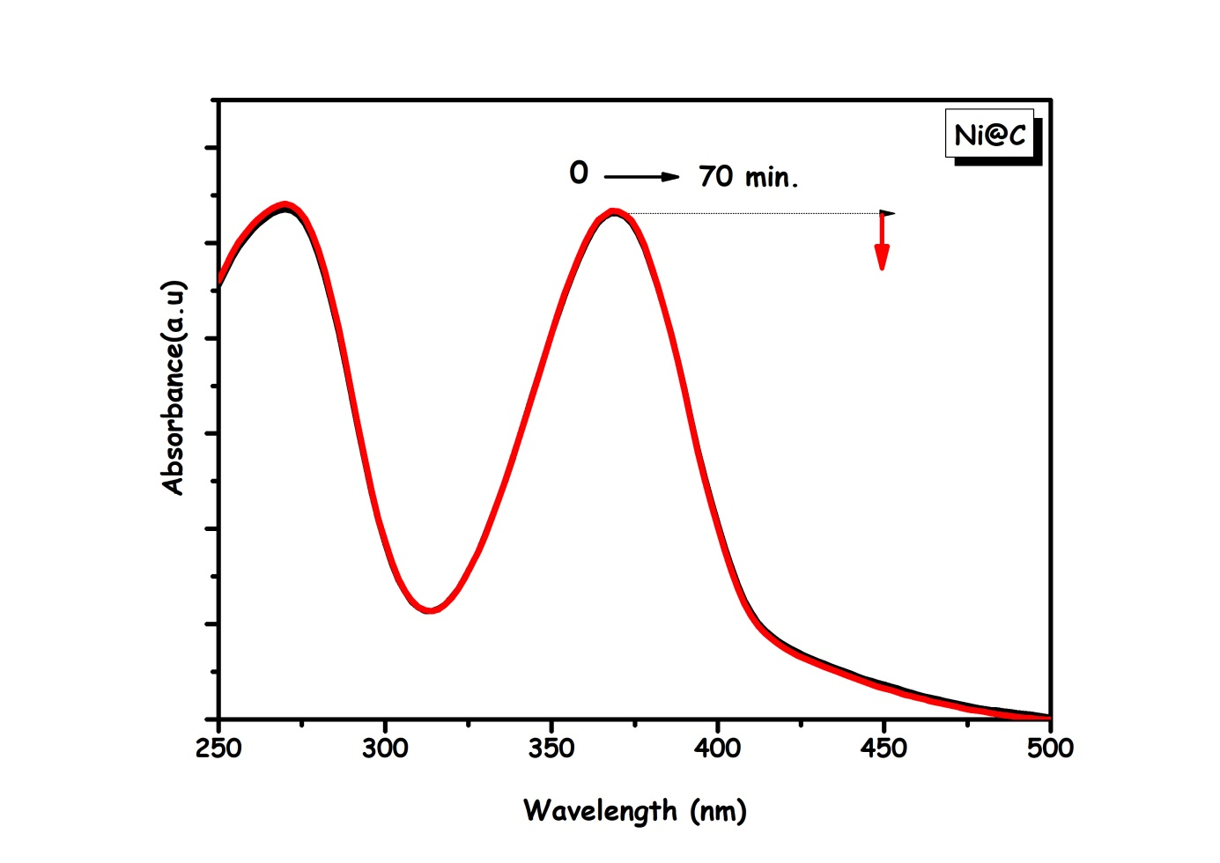
Fig. S-2 UV-Vis spectra for the reduction of chromium (VI) to chromium (III) using FA by (2.10³⁻ M K₂Cr₂O₇, 450 mM HCOOH, 450 mM HCOONa in 10 ml H₂O) on Ni@C nanocatalyst (10 mg; 1.40 wt %; 0.238 mM Pd) at 298 K.

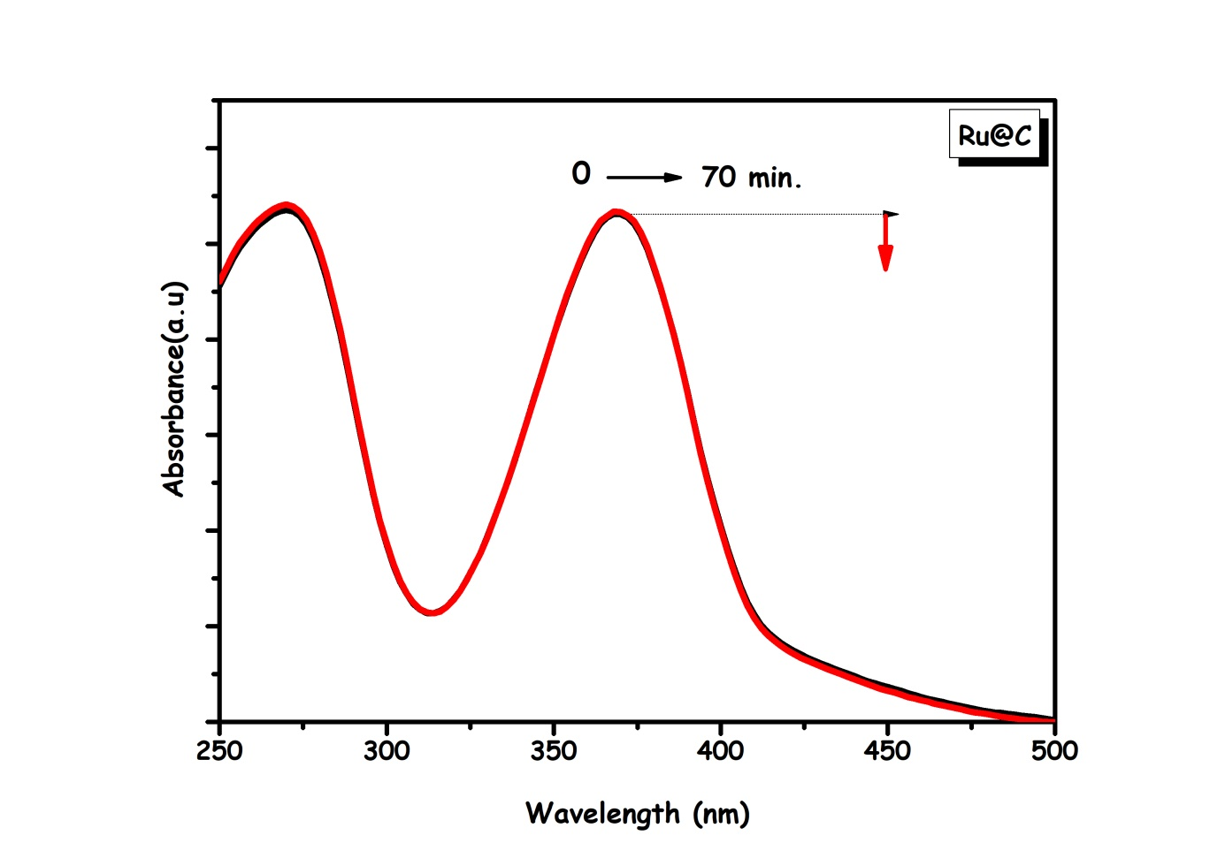
Fig. S-3 UV-Vis spectra for the reduction of chromium (VI) to chromium (III) using FA by (2.10³⁻ M K₂Cr₂O₇, 450 mM HCOOH, 450 mM HCOONa in 10 mL H₂O) on Ru@C nanocatalyst (10 mg; 1.37 wt %; 0.136 mM Pd) at 298 K.

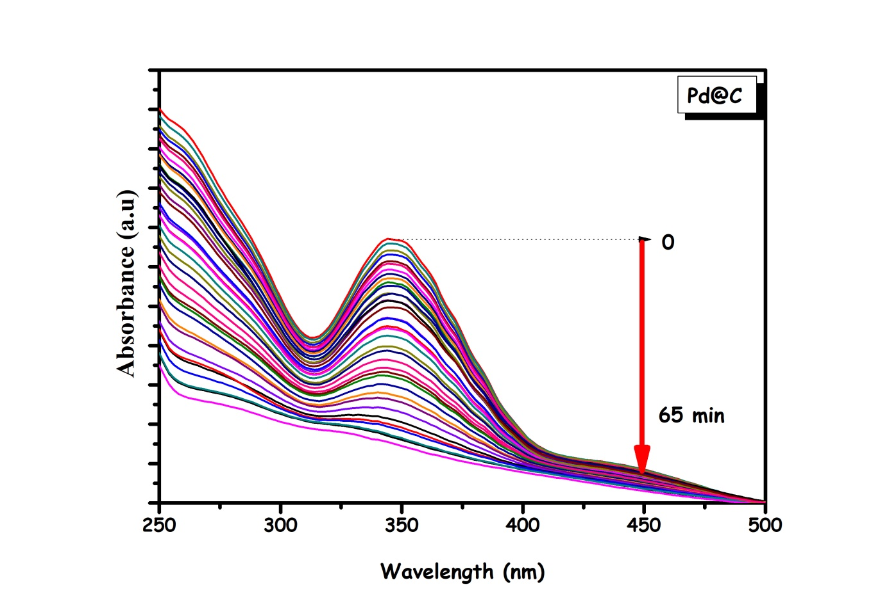
Fig. S-4 UV-Vis spectra for the reduction of chromium (VI) to chromium (III) by using FA by (2.10³⁻ M K₂Cr₂O₇, 450 mM HCOOH, 450 mM HCOONa in 10 mL H₂O) on Pd@C nanocatalyst (10 mg; 1.37 wt %; 0.129 mM Pd) at 298 K.
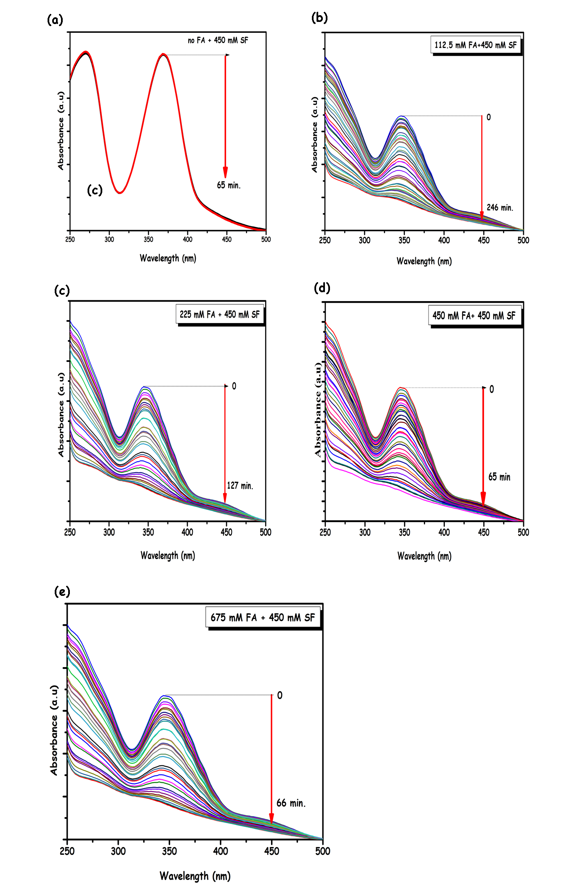
Fig. S-5 UV-Vis spectra for the reduction of chromium (VI) to chromium (III) using FA by (2.10³⁻ M K₂Cr₂O₇, 450 mM HCOOH, 450 mM HCOONa in 10 mL H₂O) on Pd@C nanocatalyst (10 mg; 1.37 wt %; 0.129 mM Pd) at 298K. by different FA concentrations.
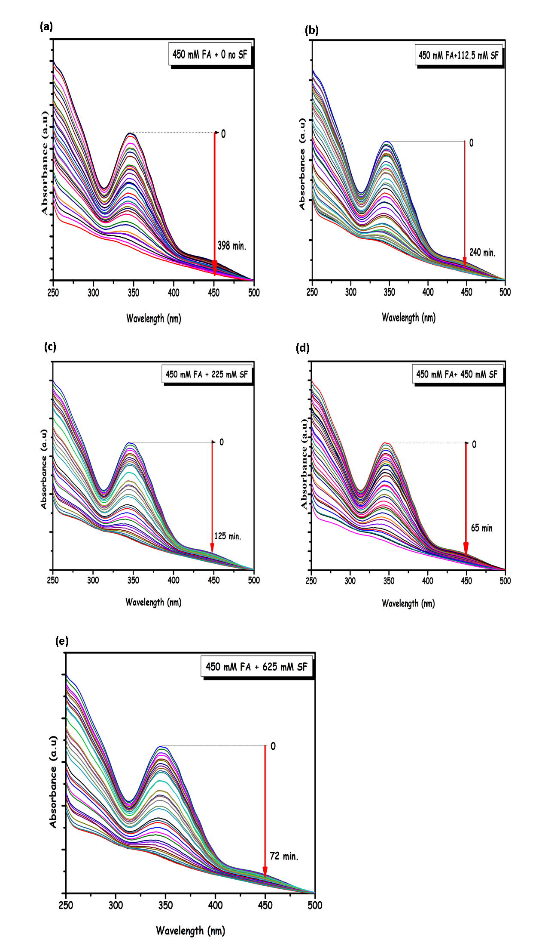
Fig. S-6 UV-Vis spectra for the reduction of chromium (VI) to chromium (III) using FA by (2.10³⁻ M K₂Cr₂O₇, 450 mM HCOOH, 450 mM HCOONa in 10 mL H₂O) on Pd@C nanocatalyst (10 mg; 1.37 wt %; 0.129 mM Pd) at 298 K. by different SF concentrations.
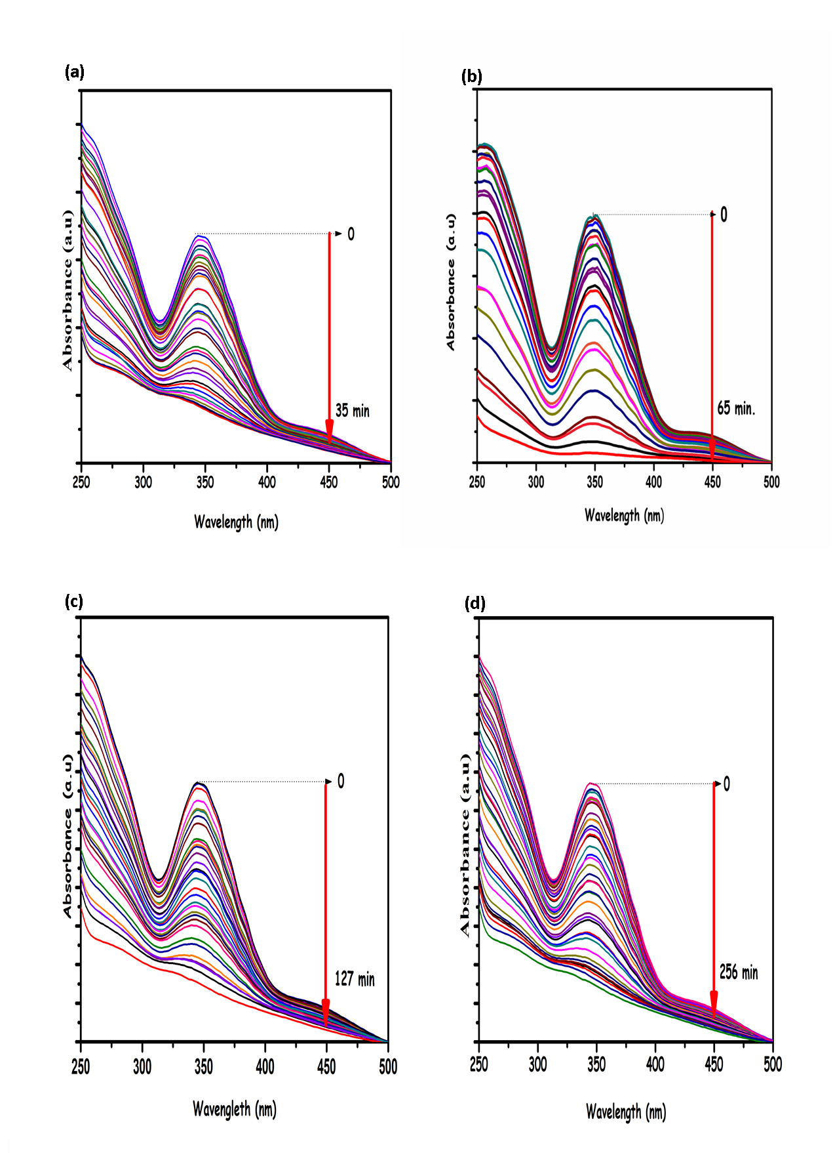
Fig. S-7 UV-Vis spectra for the reduction chromium (VI) to chromium (III) using FA by (2.10³⁻ M K₂Cr₂O₇, 450 mM HCOOH, 450 mM HCOONa in 10 mL H₂O) on Pd@C nanocatalyst (10 mg; 1.37 wt %; 0.129 mM Pd) at 298K by different Cr₂O₇²⁻ concentrations (a) 1.0 mM, (b) 2.0 mM, (c) 4.0 mM, (d) 8.0 mM.

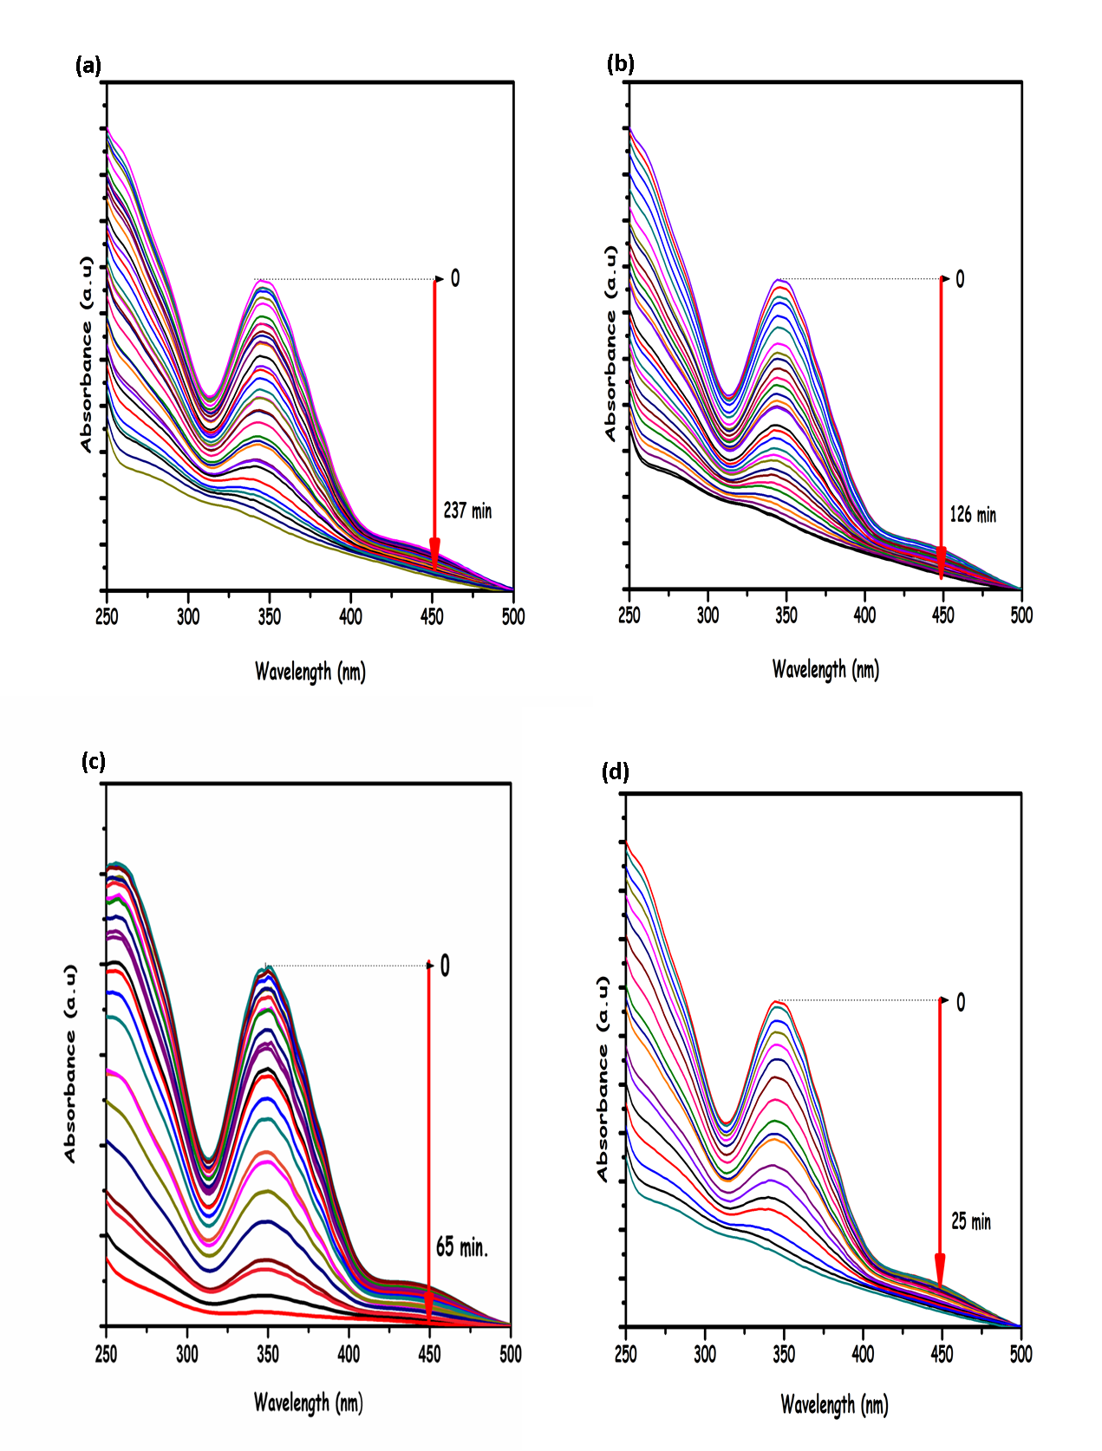
Fig. S-8 UV-Vis spectra for the reduction of chromium (VI) to chromium (III) using FA by (2.10³⁻ M K₂Cr₂O₇, 450 mM HCOOH, 450 mM HCOONa in 10 mL H₂O) on Pd@C nanocatalyst (10 mg; 1.37 wt %; 0.129 mM Pd) and different Pd concentrations (a) 6.4 µmol, (b) 97 µmol, (c) 129 µmol, (d) 193 µmol at 298K.
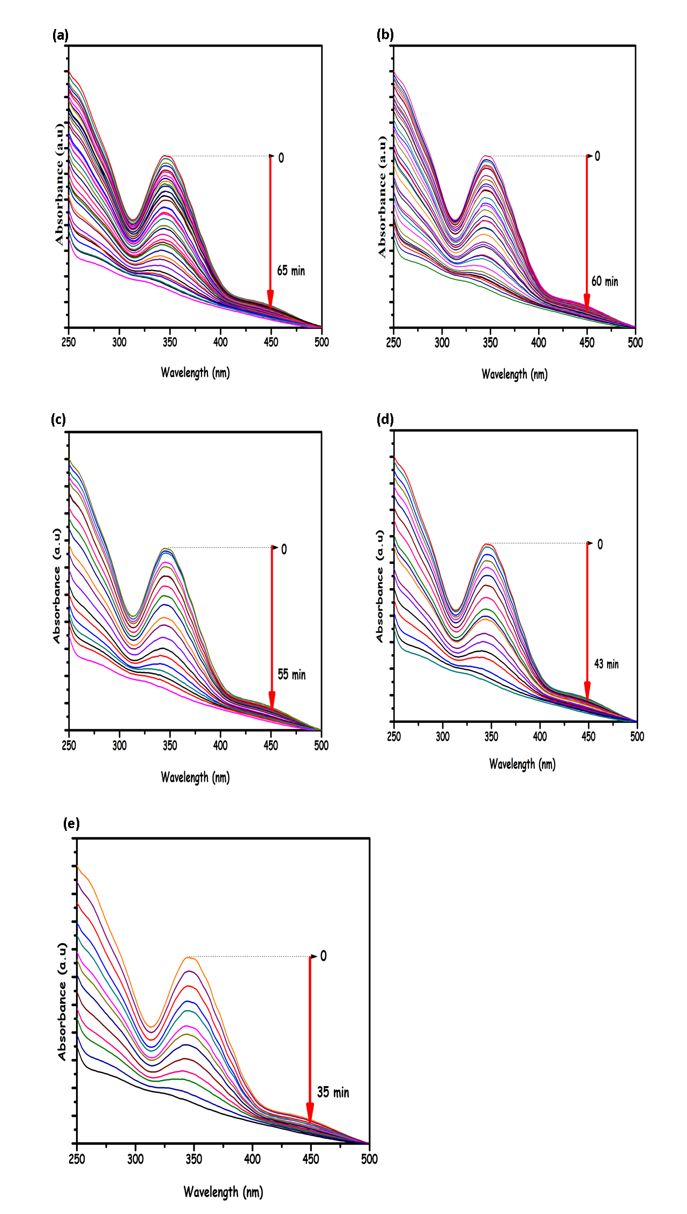
Fig. S-9 UV-Vis spectra for the reduction of chromium (VI) to chromium (III) using FA by (2.10³⁻ M K₂Cr₂O₇, 450 mM HCOOH, 450 mM HCOONa in 10 mL H₂O) on Pd@C nanocatalyst (10 mg; 1.37 wt%; 0.129 mM Pd) in the different (a) 298K, (b) 303K, (c) 308K, (d) 313K and (e) 318K temperatures.

Author to whom correspondence should be addressed: E-mail address: ibrahim6349@hotmail.com (İ. Gözeten)

