Supplementary Information for
Detection and Emergence of Climate change Signals in Extreme Sea Levels: a global-scale analysis
Khin Nawarat^{1,2}*, Claudia Tebaldi³, Johan Reyns^{1,4,5}, Sanne Muis^{4,6}, Roshanka Ranasinghe^{1,2,4}
¹IHE Delft Institute for Water Education, Delft, The Netherlands
²University of Twente, Enschede, The Netherlands
³University of Maryland, College Park, MD, USA
⁴Deltares, Delft, The Netherlands
⁵Delft University of Technology, Delft, the Netherlands
⁶Institute for Environmental Studies (IVM), Vrije Universiteit, Amsterdam, The Netherlands

Emergence with S/N>1
When considering the less stringent threshold of S/N > 1 (i.e., emergence occurs when the signal exceeds the 1 standard deviation), the global-median ToE across computational points is 1979 [1974–1988] with S/N >1 (see Supplementary Fig 6a), which is 9 [4–17] years earlier than the global-median ToE with S/N > 2.
At the scale of IPCC AR6 WGI regions, the earliest emergence has occurred in the Equatorial Atlantic Ocean, Central Africa, Equatorial Indian Ocean, Western Africa (all have regional-median ToE in 1975), Arabian Sea, Northeastern South America, and Northern South America (all in 1976; see Supplementary Fig. 6c). The latest emergence is found, in earliest-to-latest order, in Northern Europe, Western and Central Europe, East Asia, Central Australia, Northwestern North America, and Central North America, with regional-median ToEs between 1983 and 1990. Across all IPCC regions, emergence occurs on average 9 years earlier with S/N > 1 compared to S/N > 2 (see Supplementary Table 1). In regions where the ToE is most sensitive to the S/N threshold, the regional-median ToE is more than a decade earlier for S/N > 1—for example, 19 years earlier for central North America, 14 years earlier for Central Australia, and 13 years earlier for East Asia and Western and Central Europe.
When linking ToE based on S/N > 1 with socio-economic indicators, we observed a pattern similar to that for S/N > 2 (see Supplementary Fig. 8). Poorer countries—those least prepared for adaptation and least responsible for climate change—have been experiencing increases in ESL magnitude for the longest period. However, the difference in the ToE between country categories is smaller compared to the results based on S/N > 2. Emergence occurs 3 years earlier in low-income countries (median ToE within this category is 1978) compared to high-income countries (1981), 4 years earlier in countries with low ND-GAIN scores (1977) compared to those with high scores (1981), 2 years earlier in low-HDI countries (1978) relative to high-HDI countries (1980), and 3 years earlier in low-emission countries (1977) compared to high-emission countries (1980).

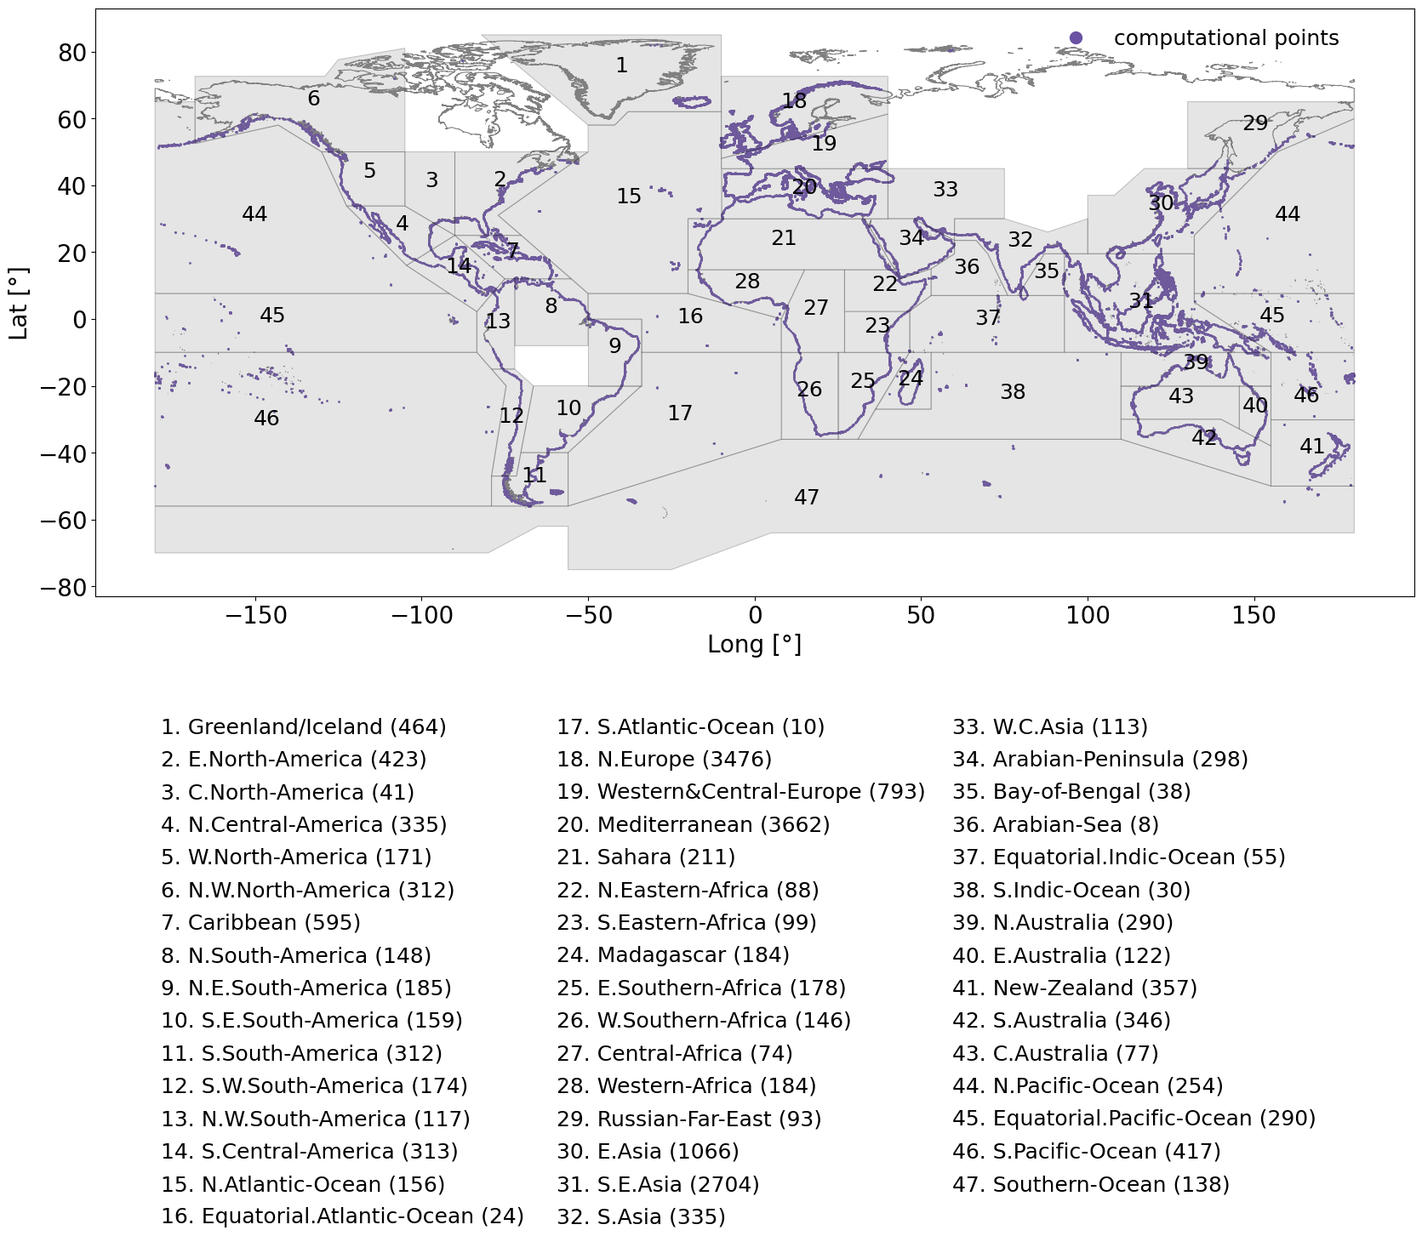
Fig. 1 The 47 IPCC AR6 WGI reference regions (with a coastline) considered in the present study, each containing output locations (comprising the computational points in this study) with sea level change time series from GTSM-ERA5 dataset along the global ice-free coastline. The number in parentheses indicates the number of computational points analysed in each IPCC AR6 WGI region.

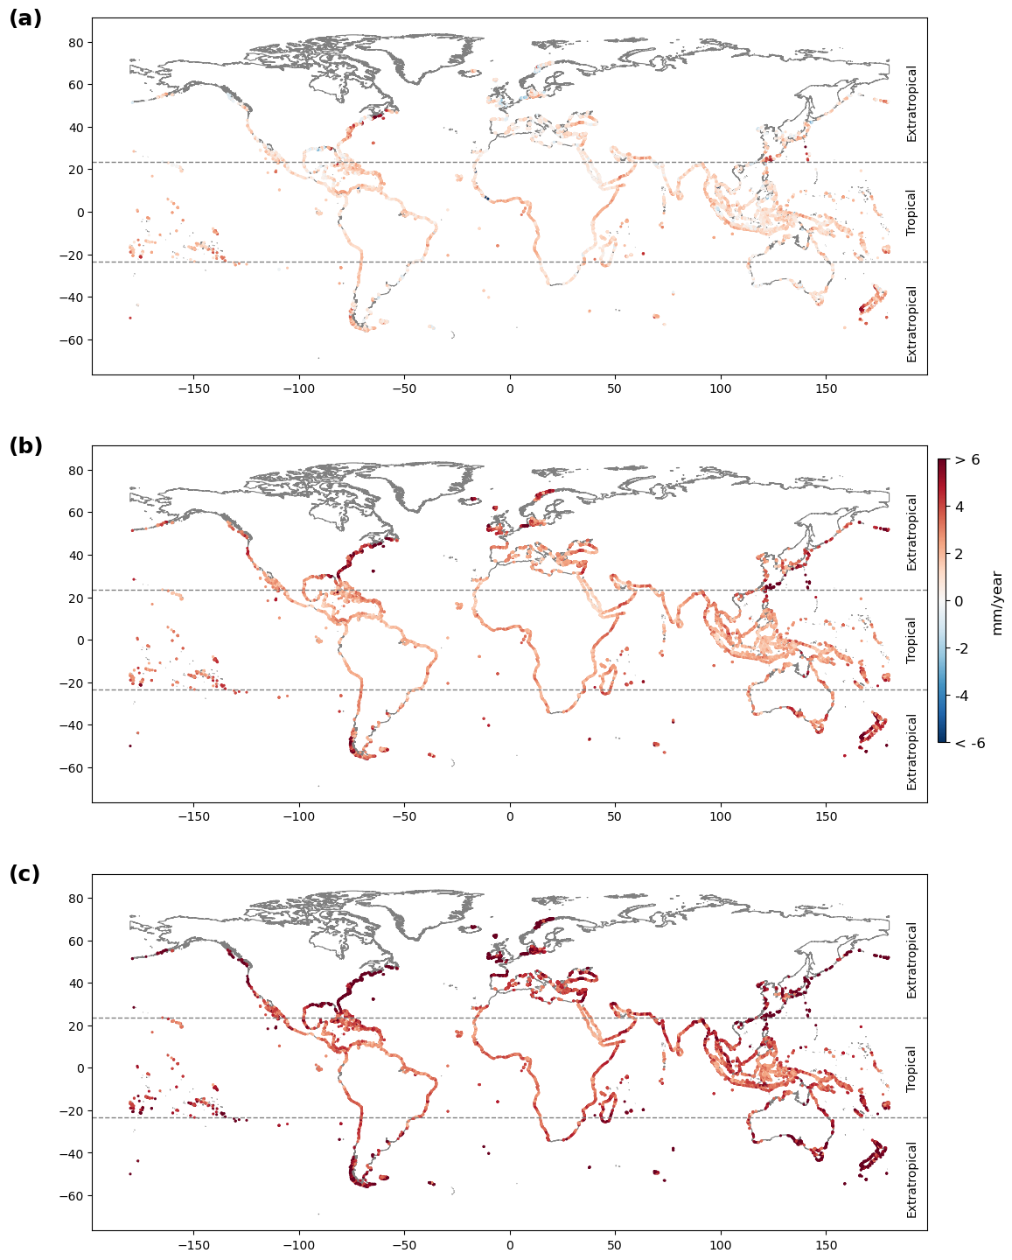
Fig. 2 Statistically significant trends in extreme sea level (ESL) magnitude over the 1970–2023 period; (a) 5th percentile, (b) 50th percentile (median), and (c) 95th percentile values at each computational point along the global ice-free coastline.

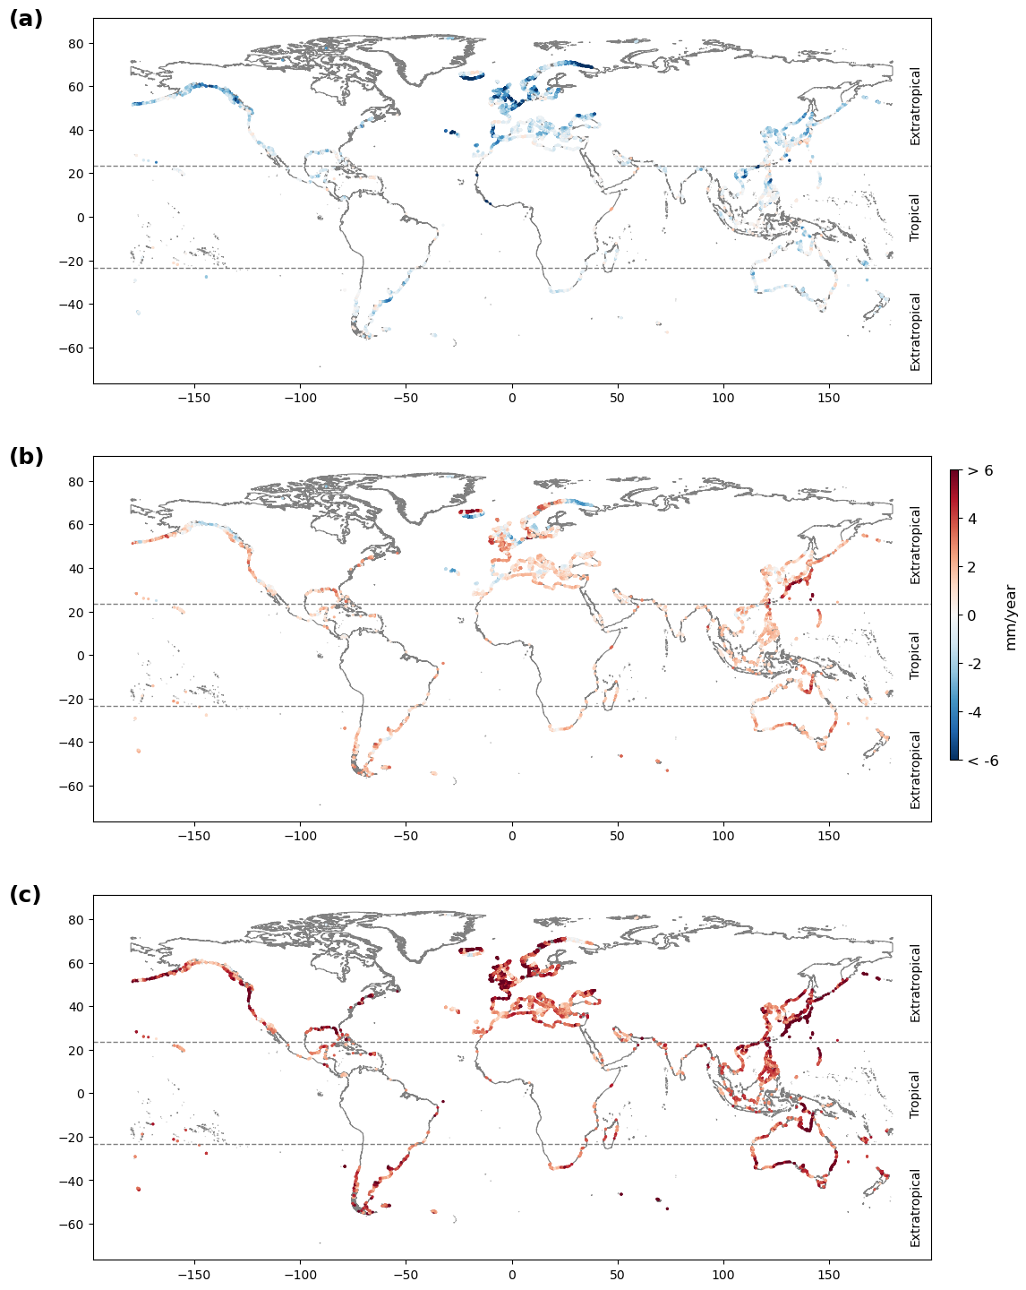
Fig. 3 Statistically insignificant trends in extreme sea level (ESL) magnitude over the 1970–2023 period; (a) 5th percentile, (b) 50th percentile (median), and (c) 95th percentile values at each computational point along the global ice-free coastline.

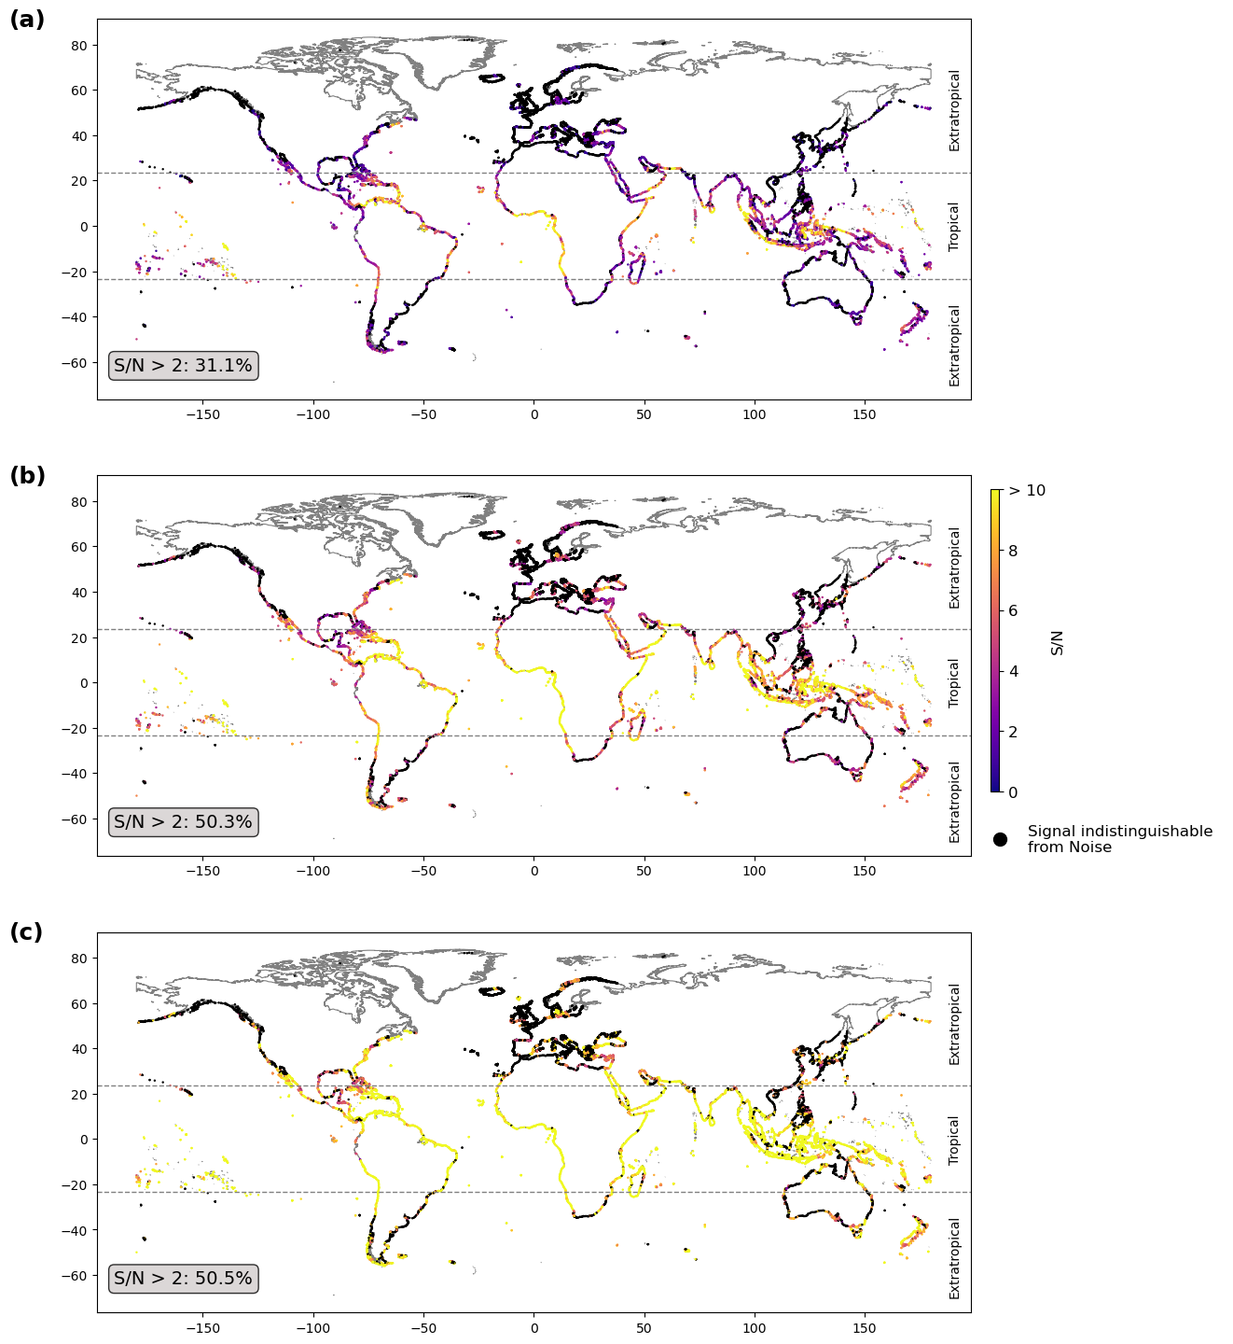
Fig. 4 Extreme sea level (ESL) signal-to-noise ratio (S/N) by 2023; (a) 5th percentile, (b) 50th percentile (median), and (c) 95th percentile values at computational points along the global ice-free coastline. The percentages of computational points where the S/N by 2023 exceeds thresholds of 2 for each percentile are shown in the text box. (Computational points where the ESL signal is statistically indistinguishable from noise, either due to increasing but insignificant trends or decreasing trends, are shown as black dots.)
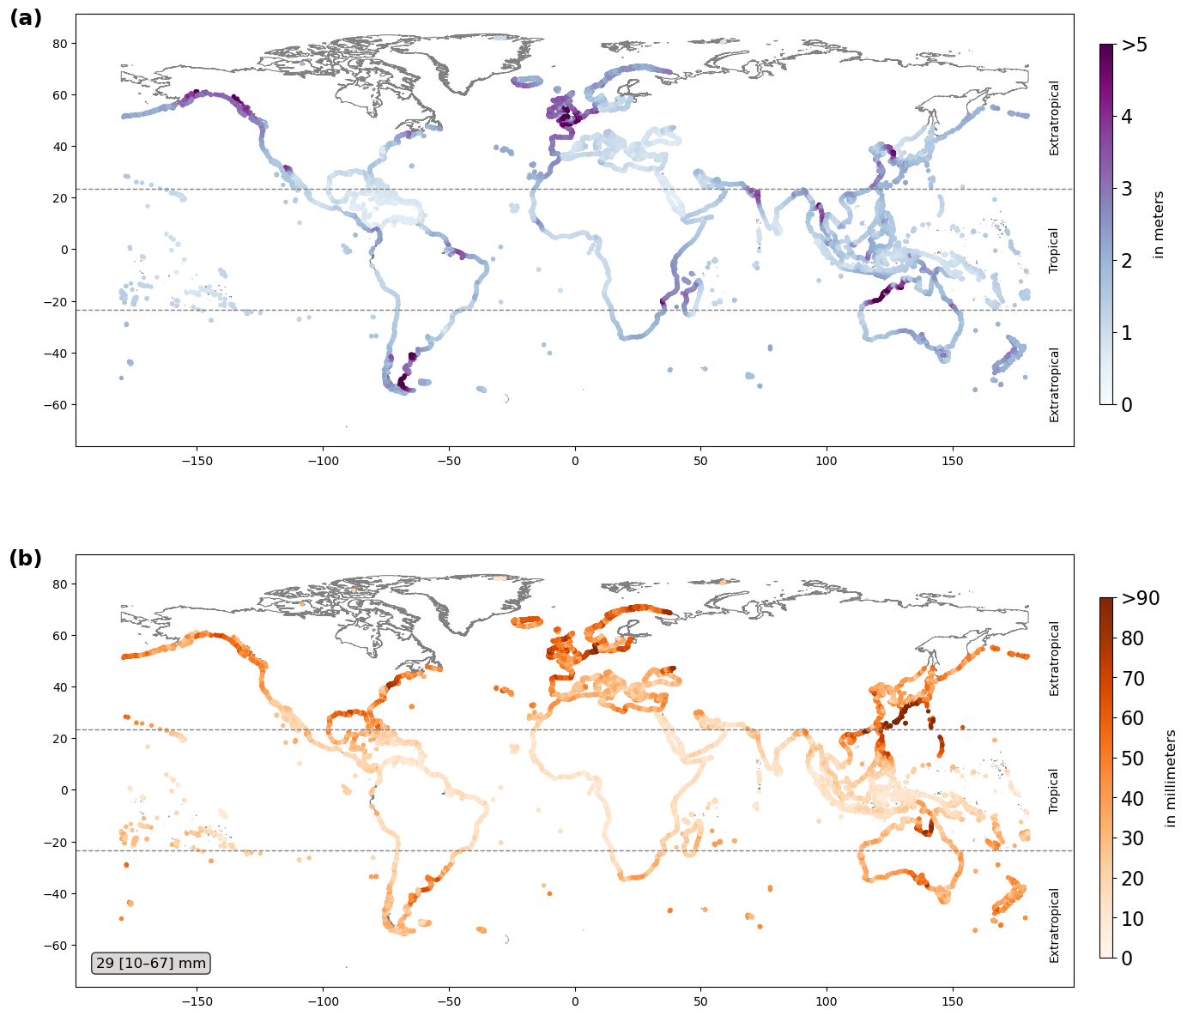
Fig. 5 Extreme sea level (ESL) characteristics over the reference period (1950–1969); (a) location parameter of the ESL GEV distribution during 1950–1969, and (b) the internal variability of the ESL signal (i.e. the noise = 1 standard deviation of 1,000 location parameters based on bootstrapped annual maxima from 1950–1969). The text box shows the global-median and its 90% confidence interval (50th [5th–95th percentiles]).

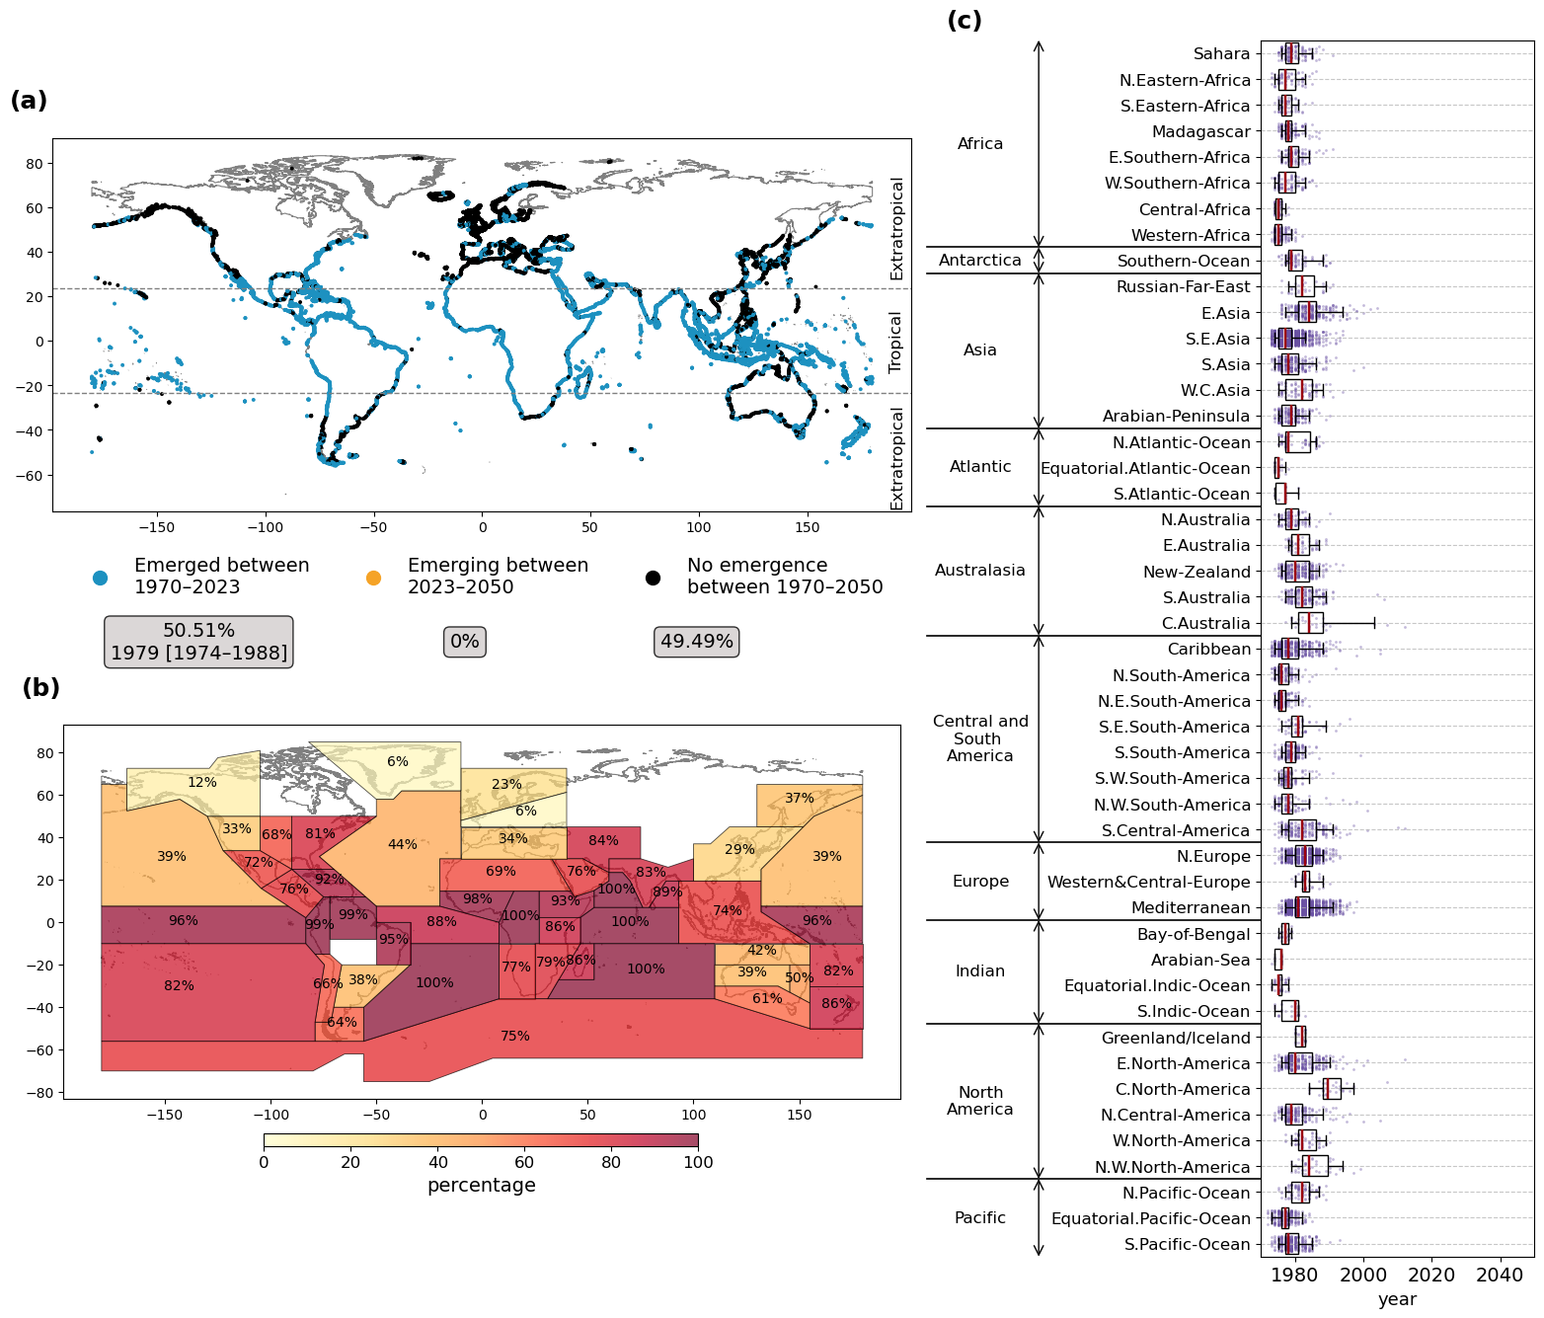
Fig. 6 Emergence of climate change signal in extreme sea level (ESL) magnitude, with a signal-to-noise ratio (S/N) greater than 1; (a) Time of emergence (ToE) median estimate (50th percentile) at computational points along the global ice-free coastline. The text box summarizes the percentage of computational points in each emergence category, together with the global-median ToE and its 90% confidence interval (50th [5th–95th percentiles]). Computational points with increasing but statistically insignificant trends or decreasing trends are counted as ‘No Emergence between 1970–2050’. (b) Percentage of the computational points within each IPCC AR6 WGI region where emergence has already occurred between 1970–2023 (i.e., S/N by 2023 > 1). (c) Distribution of ToE per IPCC AR6 WGI region. Box plots show the interquartile range, with whiskers extending to the 5th–95th percentile values across computational points within each region. The underlying jitter plot showing the total number of computational points within each region. The red vertical line indicates the regional-median (50th percentile) ToE.

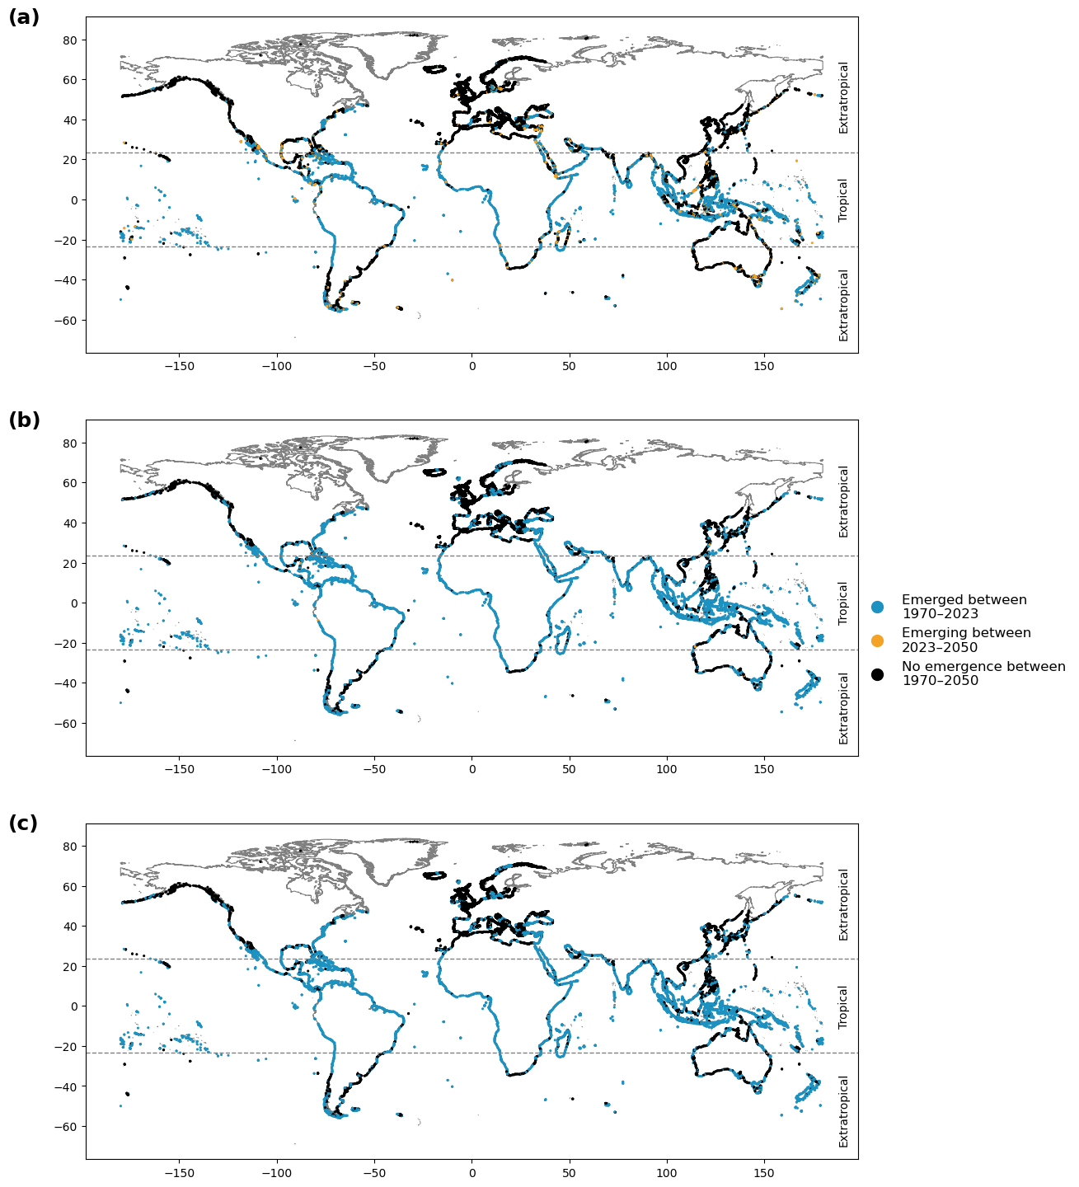
Fig. 7 Time of emergence (ToE) of the climate change signal in extreme sea level (ESL) magnitude, based on a signal-to-noise ratio (S/N) of 2; (a) 5th percentile, (b) 50th percentile (median), and (c) 95th percentile values at computational points along the global ice-free coastline. (Computational points where the trends are either increasing but statistically insignificant or decreasing are counted as ‘No emergence between 1970–2050’.)
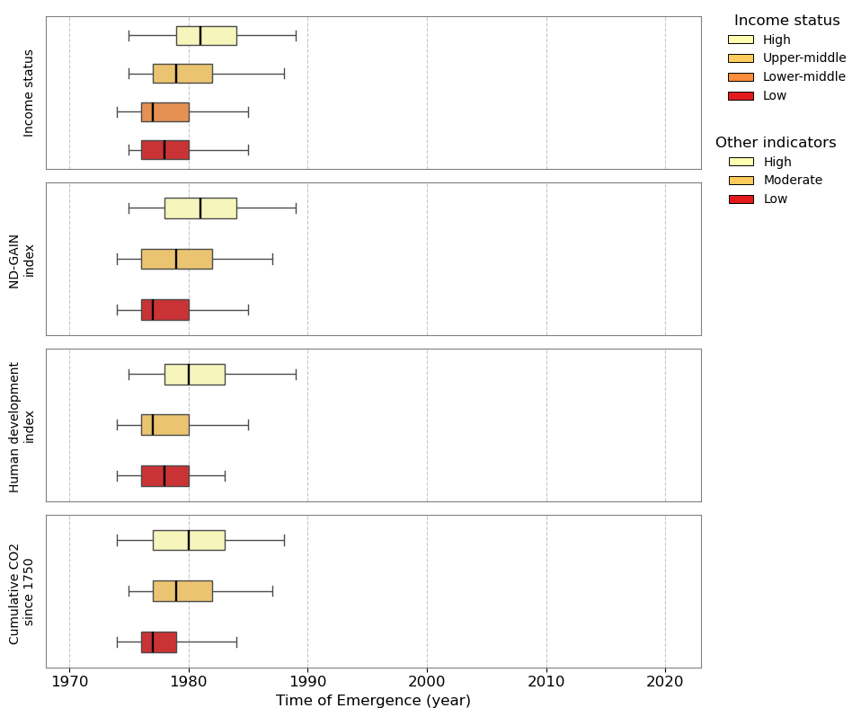
Fig. 8 Socio-economic status indicators, adaptation needs and opportunities, and country emissions vs time of emergence (ToE) of the climate change signal in extreme sea level (ESL) magnitude (based on signal-to-noise ratio (S/N) of 1); Distribution of ToE across computational points grouped by (a) income category, (b) Notre Dame Global Adaptation Initiative (ND-GAIN) Index category, (c) human development level, and (d) cumulative CO₂ emissions category. Box plots represent the interquartile range, with whiskers indicating the 5th to 95th percentiles. Classification thresholds are as follows: Income status (World Bank 2024 GNI per capita): High ≥ 13,936 USD; Upper-middle 4,496–13,935 USD; Lower-middle 1,136–4,495 USD; Low ≤ 1,135 USD. ND-GAIN Index: High > 60; Moderate 43–60; Low < 43. Human Development Index (HDI): High > 0.777; Moderate 0.515–0.777; Low < 0.515. Cumulative CO₂ emissions since 1750 (Gt): High > 2.432; Moderate 0.125–2.432; Low < 0.125.
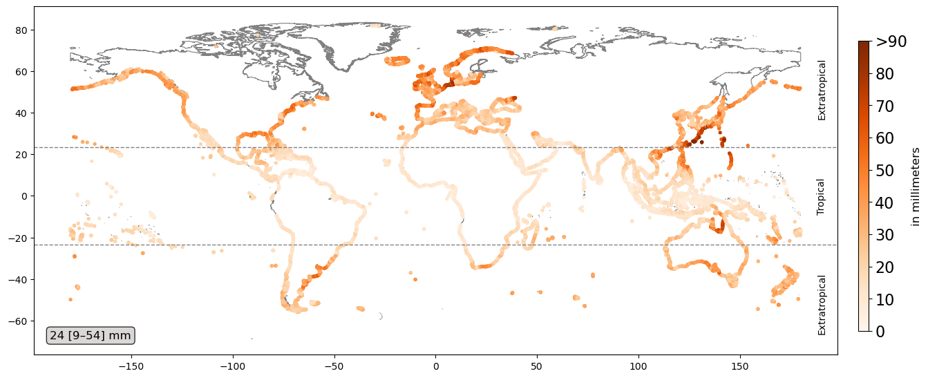
Fig. 9 The internal variability of the extreme sea level (ESL) signal using first 30-years (1950–1979) as a reference period (i.e. the noise = 1 standard deviation of 1,000 location parameters based on bootstrapped annual maxima from 1950–1979). The text box reports the global median and its 90% confidence interval (50th [5th–95th percentiles]).

Table 1 Regional-median time of emergence (ToE) for IPCC AR6 WGI regions with S/N > 2 and S/N > 1. The extreme right column indicates the ToE advancement (in years) for S/N > 1 relative to S/N > 2.
Continent/Ocean | Name | with S/N > 2 | with S/N > 1 | Earlier emergence  (in years)
Africa | Sahara | 1987 | 1979 | 8
Africa | N.Eastern-Africa | 1983 | 1977 | 6
Africa | S.Eastern-Africa | 1983 | 1977 | 6
Africa | Madagascar | 1985 | 1978 | 7
Africa | E.Southern-Africa | 1988 | 1979 | 9
Africa | W.Southern-Africa | 1983 | 1977 | 6
Africa | Central-Africa | 1979 | 1975 | 4
Africa | Western-Africa | 1980 | 1975 | 5
Antarctica | Southern-Ocean | 1988 | 1979 | 9
Asia | Russian-Far-East | 1993 | 1982 | 11
Asia | E.Asia | 1997 | 1984 | 13
Asia | S.E.Asia | 1984 | 1977 | 7
Asia | S.Asia | 1986 | 1978 | 8
Asia | W.C.Asia | 1993 | 1982 | 11
Asia | Arabian-Peninsula | 1987 | 1979 | 8
Atlantic | N.Atlantic-Ocean | 1985 | 1978 | 7
Atlantic | Equatorial.Atlantic-Ocean | 1979 | 1975 | 4
Atlantic | S.Atlantic-Ocean | 1983 | 1977 | 6
Australasia | N.Australia | 1987 | 1979 | 8
Australasia | E.Australia | 1991 | 1981 | 10
Australasia | New-Zealand | 1990 | 1980 | 10
Australasia | S.Australia | 1994 | 1982 | 12
Australasia | C.Australia | 1998 | 1984 | 14
Central  and  South America | Caribbean | 1985 | 1978 | 7
Central  and  South America | N.South-America | 1982 | 1976 | 6
Central  and  South America | N.E.South-America | 1981 | 1976 | 5
Central  and  South America | S.E.South-America | 1991 | 1981 | 10
Central  and  South America | S.South-America | 1987 | 1979 | 8
Central  and  South America | S.W.South-America | 1985 | 1978 | 7
Central  and  South America | N.W.South-America | 1985 | 1978 | 7
Central  and  South America | S.Central-America | 1993 | 1982 | 11
Europe | N.Europe | 1995 | 1983 | 12
Europe | Western&Central-Europe | 1996 | 1983 | 13
Europe | Mediterranean | 1992 | 1981 | 11
Indian | Bay-of-Bengal | 1983 | 1977 | 6
Indian | Arabian-Sea | 1981 | 1976 | 5
Indian | Equatorial.Indic-Ocean | 1980 | 1975 | 5
Indian | S.Indic-Ocean | 1990 | 1980 | 10
North America | Greenland/Iceland | 1993 | 1982 | 11
North America | E.North-America | 1990 | 1980 | 10
North America | C.North-America | 2008 | 1989 | 19
North America | N.Central-America | 1988 | 1979 | 9
North America | W.North-America | 1994 | 1982 | 12
North America | N.W.North-America | 1996 | 1984 | 12
Pacific | N.Pacific-Ocean | 1993 | 1982 | 11
Pacific | Equatorial.Pacific-Ocean | 1983 | 1977 | 6
Pacific | S.Pacific-Ocean | 1986 | 1978 | 8

