Supporting Information

Preparation of citric acid-modified β-cyclodextrin/poly (acrylic acid-co-acrylamide) composite hydrogel for enhanced methylene blue adsorption

Ayiguzaili Abudiwayiti ª, Amatjan Sawut ª*, Rena Simayi ^{b}*, Long Cheng ^{b}
ª State Key Laboratory of Chemistry and Utilization of Carbon Based Energy Resources; College of Chemistry, Xinjiang University, Urumqi, 830017, Xinjiang, China.
^{b} College of Chemical Engineering and Technology, Xinjiang University, Urumqi, 830046, China

*Corresponding Author email: amatjansawut@xju.edu.cn (A. Sawut);
ranaaysimayil@xju.edu.cn (R.Simayi)

1. Determination of active β-CD content in CA-β-CD
The content of β-CD in CA-β-CD was determined by the phenolphthalein titration method. β-CD standards containing 0, 4, 6, 8, 10, and 12 mg of β-CD were accurately weighed and dissolved in 10 mL of distilled water. Then, 2 mL of phenolphthalein standard solution and 5 mL of Na₂CO₃ solution were added to each solution, and the final volume was adjusted to 50 mL. The absorbance of each solution was measured at 553 nm using a UV–visible spectrophotometer and a standard curve was plotted (Fig. S1). The decrease in the absorbance of the alkaline phenolphthalein solution is due to the hydrophobic phenolphthalein groups being included in the β-CD cavity. Consequently, the absorbance is inversely proportional to the amount of active β-CD present. Subsequently, 20 mg of CA-β-CD was accurately weighed and treated under the same conditions as the phenolphthalein and Na₂CO₃ solutions. The measured absorbance of this sample was 0.368. Based on the standard curve, the corresponding mass of active β-CD was determined to be 8.317 mg.
The content of active β-CD cavities (TC) in the CA-β-CD sample was then calculated using Eq 1:
$\text{T}\text{C} \text{=} \frac{{\text{m}}_{\text{β}\text{-CD}}}{{\text{M}}_{\text{β}\text{-}\text{C}\text{D}}\text{×0.02}}\text{×1000}$ (1)
TC is defined as the active β-CD cavity content (mmol/g), m_{β-CD} is the mass of active β-CD (g) obtained from the standard curve, M_{β-CD} is the molar mass of β-CD, and 0.02 g is the sample mass.
2. Determination of carboxyl group content in CA-β-CD
The carboxyl group in CA-β-CD was determined by base hydrolysis-acid titration[1]. The procedure involved the accurate weighing of 0.1 g of CA-β-CD, which was then placed into 20 mL of 0.1 M NaOH solution. The solution was then subjected to stirring at 30 °C until dissolution occurred. Thereafter, the solution was titrated with 0.1 M HCl solution until the pH had reached 7. The content of total acidic groups (TA) in CA-β-CD was then calculated according to Eq 2:
$\text{TA=}\frac{\text{C×}\left({\text{V}}_{\text{0}}\text{-}{\text{V}}_{\text{1}}\right)}{\text{W}}$ (2)
In this equation, C denotes the concentration of HCl solution (mmol/L), V₀ is the volume of HCl consumed by the blank solution (L), V₁ is the volume of HCl consumed by the sample solution (L), and W is the mass of the CA-β-CD sample (g).
3. Calculation of degree of substitution DS
The degree of substitution, DS, is to be calculated according to eq 3:
$\text{DS=}\frac{\text{TA}}{\text{TC}\text{×7}}$ (3)
Fig. S1 Standard curve for β-CD

4. molecular weight distribution of CA-β-CD by GPC

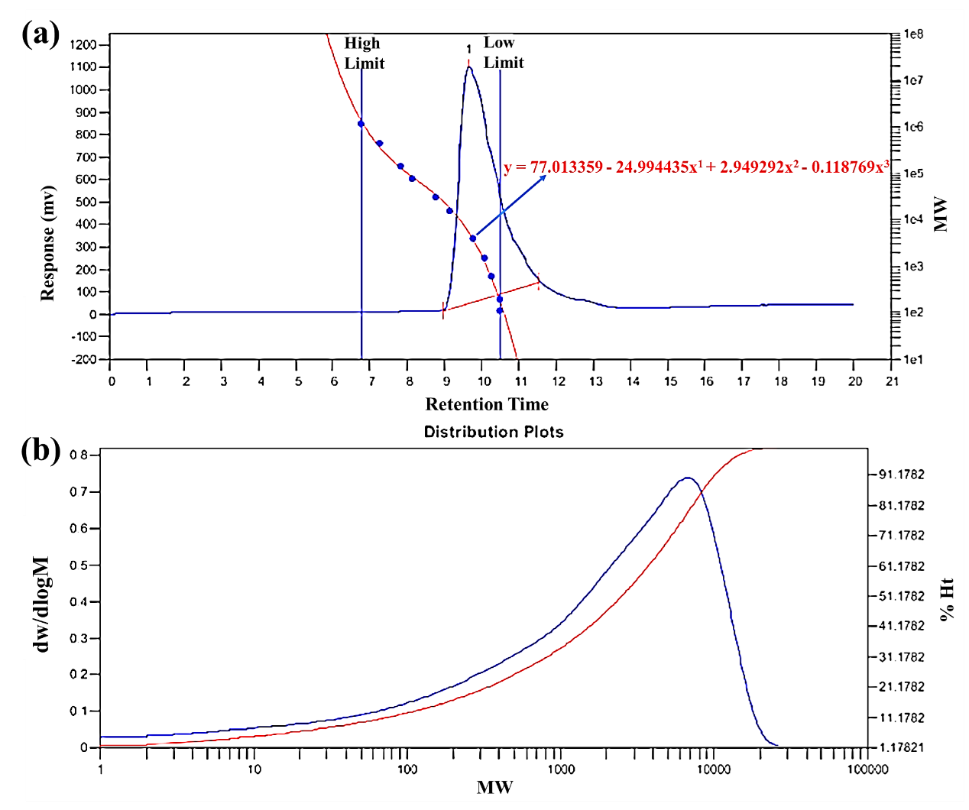
Fig. S2 (a) GPC calibration curve (polyethylene glycol); (b) molecular weight distribution of CA-β-CD

5. SEM analysis of primitive β-CD and CA-β-CD
To investigate the effect of chemical modification on the microstructure of the materials, the pristine β-CD and CA-β-CD microforms were comparatively analysed using SEM (Fig. S3 a-b). The results showed that the pristine β-CD exhibited a regular block structure with relatively smooth surfaces and clear edges, displaying lamellar crystalline orientation. This is consistent with the ellipsoidal and lamellar crystalline morphology of β-CD reported in the literature [2], reflecting a highly ordered molecular arrangement [3]. The morphology of CA-β-CD changed significantly after modification (Fig. S3 c-d), and the original structure was transformed into a rough and loose agglomerate with irregular morphology, showing a large number of voids and uneven features on the surface. This structural transformation originated from the change of intermolecular forces caused by the introduction of citric acid groups, indicating that the chemical modification has effectively regulated the microstructure of β-CD. The more developed pore structure is expected to enhance the affinity and capture ability for pollutants, which predicts that CA-β-CD has better performance in adsorption applications.
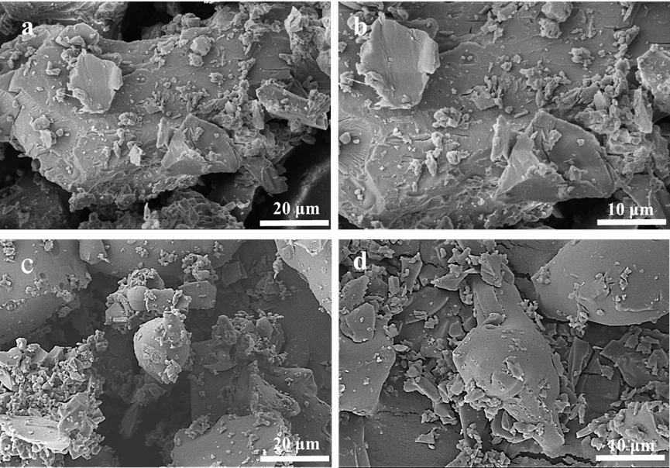
Fig. S3 SEM of (a-b) β-CD; (c-d) CA-β-CD
6. Single-factor experiment
In the present study, the effect of the CA to β-CD molar ratio (1:6, 1:8, 1:10, 1:12, and 1:14 for n_{CA}:n_{β-CD}, respectively) on the adsorption performance of CA-β-CD/P(AA-co-AM) was examined. It was found that the Q_{e} and R of the composite hydrogel showed a gradual increase with the increase of the CA ratio; however, both of them decreased when the molar ratio was increased to 1:14 (Fig. S4 b). Therefore, the optimal molar ratio was determined to be 1:12, at which CA was able to effectively cross-link β-CD and successfully introduce -COOH as a new adsorption site, thus enhancing the adsorption capacity [4]. As the proportion of CA increased, the active sites also increased and the adsorption capacity improved. However, when the proportion of CA was excessive, the excessive crosslinking density densified the composite hydrogel structure, leading to a decrease in adsorption performance [5].
The optimal molar ratio of 1:12 was subjected to further screening for reaction time (Fig. S4 c). With the increase in reaction time, Q_{e} and R demonstrated an increase and subsequent decrease, respectively. The maximum values of Q_{e} and R were attained at a reaction time of 6 h.
As demonstrated in Fig. S4 d, the Q_{e} and R of the composite hydrogels exhibited an increasing trend, followed by a subsequent decrease, with an increase in MBA content. The optimal amount of MBA facilitates the degree of cross-linking of the composite hydrogel, thereby forming a three-dimensional porous network with an appropriate structure to increase the specific surface area and enhance the adsorption performance of MB. However, an excess of MBA resulted in elevated cross-linking density, leading to a reduction in network flexibility and pore size contraction. This, in turn, restricted the diffusion and transport of MB within the gel and effective contact with the adsorption sites, consequently diminishing the adsorption performance. Therefore, the amount of MBA was adjusted to 0.12 g.
The alteration in the extent of monomer AA neutralisation is predominantly indicative of the shift in the proportion of -COOH to -COONa groups within the reaction system. As illustrated in Fig. S4 e, with an increase in AA neutralisation degree, Q_{e} and R exhibited an initial rise followed by a subsequent decline, concurrent with an enhancement in the proportion of -COONa groups and a reduction in -COOH. The electrostatic repulsion between the ionic groups can effectively over crosslink, thereby facilitating the formation of a three-dimensional network structure, thus enhancing the adsorption performance. However, when the neutralisation degree exceeded 85%, the presence of -COONa in the system increased, leading to a decrease in cross-linking density, and the formed network exhibited excessive looseness, while the presence of excessive water-soluble components resulted in a decline in Q_{e} and R [6]. The findings indicated that the cross-linking density of the AAs was excessive. Consequently, the optimal degree of neutralisation of AA was determined to be 85%.
As demonstrated in Fig. S4 f, the adsorption performance of CA-β-CD/P(AA-co-AM) on MB decreases gradually with increasing CA-β-CD addition. The maximum values of Q_{e} and R are reached when the addition amount is 0.2 g. The source of optimality can be attributed to a synergistic effect of two parties: the cavity of β-CD recognised the MB molecule through host-guest interactions [7]. The carboxyl and amino groups on the chain of P(AA-co-AM), on the other hand, enhanced the adsorption through electrostatic and hydrogen-bonding interactions. However, excessive CA-β-CD leads to a decrease in Q_{e} and R. This can be attributed to two main factors. Firstly, excessive introduction of CA-β-CD destroys the structural stability and pore homogeneity of the three-dimensional network of the hydrogel, increases the mass transfer resistance, and hinders the diffusion of MB to the adsorption sites. Secondly, CA-β-CD may change the pH and ionic strength of the local microenvironment, which affects the ionisation state of MB and the electrostatic and hydrogen-bonding interactions with the hydrogel, and thus inhibits the adsorption. Therefore, the addition of CA-β-CD was controlled at 0.2 g to balance the number of adsorption sites with the structural integrity to achieve optimal adsorption performance.
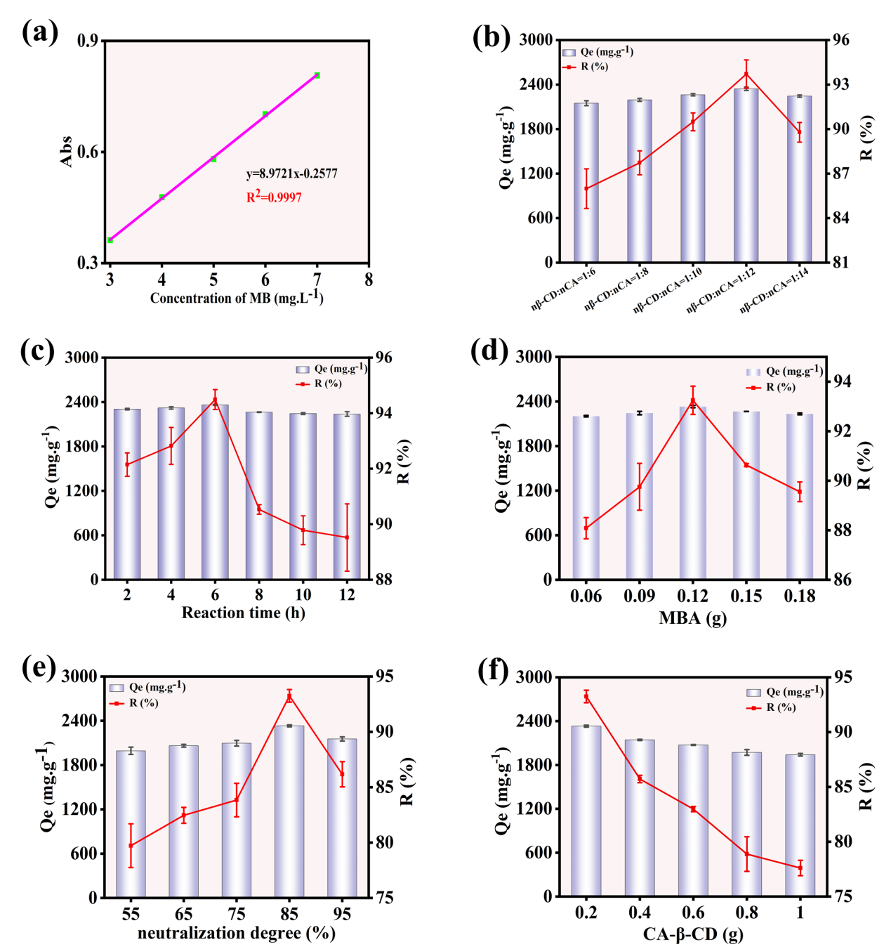
Fig. S4 Effect of CA-β-CD/P(AA-co-AM) composite hydrogel on the adsorption properties of MB: (a) standard curve of MB; (b) molar ratio of β-CD to CA; (c) reaction time; (d) MBA content; (e) degree of neutralisation of AA; and (f) amount of CA-β-CD added (experimental conditions were as follows: mass of composite hydrogel m = 10 mg, MB dye solution volume V = 25 mL, initial concentration c = 1000 mg/L, adsorption time t = 4 h, temperature T = 298.15 K, and vibration speed 130 rpm)

Table S1 Thermodynamic parameters of composite hydrogels at different temperatures
T (K) | ∆G (kJ/mol) | ∆H (kJ/mol) | ∆S (J/mol·K) | R²
298.15 | -8.8365 | -23.9866 | -51.7721 | 0.9644
308.15 | -7.9696 | -23.9866 | -51.7721 | 0.9644
318.15 | -7.2116 | -23.9866 | -51.7721 | 0.9644
328.15 | -6.6877 | -23.9866 | -51.7721 | 0.9644
338.15 | -6.6346 | -23.9866 | -51.7721 | 0.9644
348.15 | -6.2017 | -23.9866 | -51.7721 | 0.9644

Table S2 Parameters of the three isothermal adsorption models: Langmuir, Freundlich and Temkin
isotherm model | isotherm parameter
Langmuir | Q_{max} (mg/g) | KL (L/mg) | R2
 | 3743.23 | 0.02381 | 0.9989
Freundlich | 1/n | Kf (L/mg) | R2
 | 0.45799 | 217.78 | 0.9105
Temkin | bT (J/mol) | AT (L/g) | R2
 | 3.511 | 0.352 | 0.8864

Table S3 Pseudo-primary and pseudo-secondary kinetic model parameters
Concentrations  C₀ (mg·L⁻¹) | 100 | 500 | 1000 | 1500 | 2000 | 3000
Q_{exp}  (mg/g) | 242.704 | 1198.865 | 2334.795 | 2691.169 | 3543.933 | 5057.937
K₁  (min⁻¹) | 0.40513 | 0.45098 | 0.11288 | 0.09659 | 0.12084 | 0.04629
Q_{e}  (mg/g) | 54.373 | 6.949 | 17.789 | 50.646 | 75.646 | 92.467
R2 | 0.47283 | 0.73965 | 0.09599 | 0.05789 | 0.09651 | 0.01249
K₂*10³  (g/mg·min) | 36.77 | 9.610 | 21.77 | 6.080 | 3.850 | 2.760
Q_{e}  (mg/g) | 244.29 | 1227.29 | 2340.46 | 2754.24 | 3498.98 | 5105.34
R2 | 0.99995 | 0.99994 | 0.99998 | 0.9998 | 0.99988 | 0.99989

Table S4 Composite hydrogel intraparticle diffusion modelling parameters
C₀  (mg/L) | 100 | 500 | 1000 | 1500 | 2000 | 3000
K₁  (mg/g·min^{0.5}) | 31.02 | 150.05 | 104.06 | 282.53 | 201.69 | 349.81
C₁ | 202.96 | 988.34 | 2183.88 | 2287.65 | 3042.43 | 4447.08
R₁² | 0.5995 | 0.8733 | 0.9475 | 0.9734 | 0.8237 | 0.7766
K₂  (mg/g·min^{0.5}) | 0.4084 | 11.66 | 0.9719 | 19.54 | 45.64 | 52.47
C₂ | 241.84 | 1173.87 | 2332.84 | 2685.27 | 3321.60 | 4878.30
R₂² | 0.7533 | 0.9177 | 0.09868 | 0.5245 | 0.5511 | 0.5608
K₃  (mg/g·min^{0.5}) | 0.0269 | 0.5757 | -1.831 | -1.271 | -0.897 | 4.935
C₃ | 243.35 | 1274.29 | 2334.87 | 2740.70 | 3476.06 | 5048.05
R₃² | 0.2035 | 0.3981 | 0.1117 | 0.0029 | 0.0552 | 0.0258

Table S5 compares the maximum adsorption capacity (Q_{max}) of adsorbents for MB reported in the literature.
Adsorbents | Q_{max}  (mg/g) | Adsorbent dosage (g/L) | Ref
β-CD/AC | 166.67 | 0.5 | [8]
CMS-co-(PAm/PAA) | 1700.00 | 0.889 | [9]
Fe₃O₄/GON/CA-CDP | 173.00 | 0.4 | [10]
β-CD-CA-PEG | 563.18 | 2.0 | [11]
CA-β-CD | 295.19 | 2.0 | [12]
HPCD-CA | 497.72 | 0.5 | [13]
CM-β-CD-GO | 245.70 | 0.5 | [14]
CDP-Fes | 565.00 | 0.4 | [15]
CA-β-CD/AC | 862.07 | 0.5 | [16]
MA-β-CD-co-AA-co-AM | 2609.14 | 0.4 | [17]
CA-β-CD/P(AA-co-AM) | 3743.23 | 0.4 | This works

As illustrated in Table S5, the following substances are represented: β-cyclodextrin (β-CD); citric acid modified β-cyclodextrin/activated carbon hybrid composite (CA-β-CD/AC); carboxymethyl starch-co-(polyacrylamide/polyacrylic acid) hydrogel (CMS-co-(PAm/PAA)); novel Fe₃O₄/graphite oxide nanosheets/citric acid crosslinked β-cyclodextrin polymer (Fe₃O₄/GON/CA-CDP); citric acid modified β-cyclodextrin polymer (CA-β-CD); cyclodextrin-cyclodextrin-polyethylene glycol polymer (βCD-CA-PEG); citric acid crosslinked 2-hydroxypropyl-β-cyclodextrin adsorbent (HPCD-CA); carboxymethyl-functionalized β-cyclodextrin modified graphene oxide adsorbent (CM-β-CD-GO); nanoparticles/β-cyclodextrin-based polymers (CDP-Fes); citric acid-modified β-cyclodextrin/activated carbon hybrid materials (CA-β-CD/AC); maleic anhydride-modified β-cyclodextrin-co-acrylic acid-co-acrylamide hydrogels (MA-β-CD-co-AA-co-AM).

References
1. Zhao D, Zhao L, Zhu C, et al (2009) Synthesis and properties of water-insoluble β-cyclodextrin polymer crosslinked by citric acid with PEG-400 as modifier. Carbohydrate Polymers 78:125–130. https://doi.org/10.1016/j.carbpol.2009.04.022
2. Thurein SM, Lertsuphotvanit N, Phaechamud T (2018) Physicochemical properties of β-cyclodextrin solutions and precipitates prepared from injectable vehicles. Asian Journal of Pharmaceutical Sciences 13:438–449. https://doi.org/10.1016/j.ajps.2018.02.002
3. Wang H, Wang S, Zhu H, Wang S, Xing J (2019) Inclusion Complexes of Lycopene and β-Cyclodextrin: Preparation, Characterization, Stability and Antioxidant Activity. Antioxidants 8:8080314. https://doi.org/10.3390/antiox8080314
4. Zhang Y, Zhang L, Wang N, et al (2023) Citric acid modified β-cyclodextrin for the synthesis of water-stable and recoverable CD-MOF with enhanced adsorption sites: Efficient removal of Congo red and copper ions from wastewater. Journal of Environmental Chemical Engineering 11:111413. https://doi.org/10.1016/j.jece.2023.111413
5. Singh R, Sharanagat VS (2020) Physico-functional and structural characterization of ultrasonic-assisted chemically modified elephant foot yam starch. International Journal of Biological Macromolecules 164:1061–1069. https://doi.org/10.1016/j.ijbiomac.2020.07.185
6. Zhu Z, Sawat A, Simayi R, Jiao X (2024) Preparation of hypromellose-graft-polyacrylic acid superabsorbent resin by ultraviolet polymerization and its slow-release performance. ACS Applied Polymer Materials 6:3128–3138. https://doi.org/10.1021/acsapm.3c02872
7. Liu X, Ren Z, Liu F, Zhao L, Ling Q, and Gu H (2021) Multifunctional Self-Healing Dual Network Hydrogels Constructed via Host-Guest Interaction and Dynamic Covalent Bond as Wearable Strain Sensors for Monitoring Human and Organ Motions. ACS Applied Materials & Interfaces 13:14612–14622. https://doi.org/10.1021/acsami.1c03213
8. Zhou K, Li Y, Li Q, Du Q, Wang D, Sui K, Wang C, Li H, and Xia Y (2018) Kinetic, Isotherm and Thermodynamic Studies for Removal of Methylene Blue Using β-Cyclodextrin/Activated Carbon Aerogels. Journal of Polymers and the Environment 26:3362–3370. https://doi.org/ 10.1007/s10924-018-1219-2
9. Zamani-Babgohari F, Irannejad A, Kalantari Pour M, Khayati GR (2024) Synthesis of carboxymethyl starch co (polyacrylamide/ polyacrylic acid) hydrogel for removing methylene blue dye from aqueous solution. International Journal of Biological Macromolecules 269:132053. https://doi.org/10.1016/j.ijbiomac.2024.132053
10. Jiang L-W, Zeng F-T, Zhang Y, et al (2021) Preparation of a novel Fe₃O₄/graphite oxide nanosheet/citric acid-crosslinked β-cyclodextrin polymer composite to remove methylene blue from water. Advanced Powder Technology 32:492–503. https://doi.org/10.1016/j.apt.2020.12.026
11. Altayan MM, Tzoupanos N, Barjenbruch M (2023) Polymer based on beta-cyclodextrin for the removal of bisphenol A, methylene blue and lead (II): Preparation, characterization, and investigation of adsorption capacity. Journal of Molecular Liquids 390:122822. https://doi.org/10.1016/j.molliq.2023.122822
12. Sulaiman NS, Zaini MAA, Arsad A (2021) Evaluation of dyes removal by beta-cyclodextrin adsorbent. Materials Today: Proceedings 39:907–910. https://doi.org/10.1016/j.matpr.2020.03.696
13. Liu C, Song L, Cao S, et al (2023) Green synthesis of 2-hydroxypropyl-β-cyclodextrin polymers crosslinked by citric acid for highly efficient removal of methylene blue. Polymer 280:126043. https://doi.org/10.1016/j.polymer.2023.126043
14. Fabrication of carboxymethyl functionalized β-cyclodextrin-modified graphene oxide for efficient removal of methylene blue Arabian Journal of Chemistry. https://arabjchem.org/fabrication-of-carboxymethyl-functionalized-cyclodextrin-modified-graphene-oxide-for-efficient-removal-of-methylene-blue/. Accessed 16 Sept 2025
15. Xie ZW, Lin JC, Xu M-Y, Wang H-Y, Wu Y-X, He F-A, Jiang H-L (2020) Novel Fe₃O₄ Nanoparticle/β-Cyclodextrin-Based Polymer Composites for the Removal of Methylene Blue from Water Industrial & Engineering Chemistry Research 59:12270–12281. https://doi.org/10.1021/acs.iecr.0c01115
16. Tang K, Li Y, Zhang X, Li M, Du Q, Li H, Wang Y, Li H, and Xia Y 2020 Synthesis of Citric Acid Modified β-Cyclodextrin/Activated Carbon Hybrid Composite and their Adsorption Properties Toward Methylene Blue. Journal of Applied Polymer Science 137：48315. https://doi.org/10.1002/app.48315
17. Jiang M, Simayi R, Sawut A, et al (2023) Modified β-Cyclodextrin hydrogel for selective adsorption and desorption for cationic dyes. Colloids and Surfaces A: Physicochemical and Engineering Aspects 661:130912. https://doi.org/10.1016/j.colsurfa.2022.130912

