Supplementary Information

Content
Single-crystal X-ray crystallography of CLC 2
Antimicrobial activity of CLC 4
Cryo-EM of CLC-ribosome complexes 6
DNATCO-guided analysis of CLC-ribosome models 8
Molecular dynamics of CLC-ribosome complexes 18
Lists of strains, plasmids, oligonucleotides, and toeprinting templates 30
Synthesis of artificial chimeric antibiotics ODC and CLC 32
References 53

Single-crystal X-ray crystallography of CLC

Supplementary Table 1. Crystal, data collection, and refinement data of CLC.
Structure | CLC
Empirical formula | 2(C₂₆H₄₀ClN₂O₈S) · 2(Cl) · 5(H₂O)
Formula weight | 1313.24
T (K) | 180
λ (Å) | 1.54184
Crystal system | Orthorhombic
Space group | P2₁2₁2₁
a (Å) | 11.7535(2)
b (Å) | 14.6505(4)
c (Å) | 37.6933(6)
α (°) | 90
β (°) | 90
γ (°) | 90
V (Å³) | 6490.6(2)
Z | 4
Dcalc (g.cm⁻³) | 1.344
µ (mm⁻¹) | 2.88
F(000) | 2791.978
θ_{min}, θ_{max} (°) | 3.236, 72.761
Refl. Collected | 23646
Refl. Indep., R_{int} | 12495, 0.082
Refl. Observed | 11453
Ref. param., restr. | 837, 56
GOF | 1.013
R₁ [I > 2σ(I)] | 0.0501
wR₂ [I > 2σ(I)] | 0.1247
R₁ (all data) | 0.0547
wR₂ (all data) | 0.1283
Flack parameter | 0.004(13)
Δρ_{min}, Δρ_{max} (e⁻.Å⁻³) | -0.42, 0.44
CCDC number | 2529822

Supplementary Fig. 1. The numbering scheme of molecule 1 (A) and molecule 2 (B) of the crystal structure of CLC, the ADPs are drawn at a 50% probability level.

Antimicrobial activity of CLC
Supplementary Fig. 2. Antimicrobial activity of new and established lincosamides against Gram-positive pathogens. Minimum inhibitory concentrations (MICs) of lincomycin, clindamycin, ODC, and CLC against representative clinical isolates of Staphylococci, Clostridioides difficile, Enterococci, and Streptococci with defined clindamycin-resistance mechanisms.

Cryo-EM of CLC-ribosome complexes

Supplementary Table 2. Cryo-EM data collection, refinement, and validation statistics
 | Lincosamide-sensitive 70S – CLC  (EMDB-52711)  (PDB 9I88) | A2058-methylated 70S – CLC  (EMDB-52712)  (PDB 9I89)
Data collection and processing
Magnification | 45,000 | 45,000
Voltage (kV) | 200 | 200
Electron exposure (e–/Å²) | 50 | 50
Defocus range (μm) | −0.4 to −1.8 | −0.4 to −1.8
Pixel size (Å) | 0.895 | 0.895
Symmetry imposed | C1 | C1
Initial particle images (no.) | 389,149 | 659,304
Final particle images (no.) | 61,266 | 63,589
Map resolution (Å)  FSC threshold | 2.98  0.143 | 3.01  0.143
Map resolution range (Å) | 2.62-8.7 | 2.75-9.08
Refinement
Initial model used (PDB code) | 7NHM | 9I88
Model resolution (Å)  FSC threshold | 2.72 (3.03)  0.143 (0.5) | 2.86 (3.12)  0.143 (0.5)
CC (mask) | 0.88 | 0.87
CC (volume) | 0.88 | 0.87
Map sharpening B factor (Å²) | -10 | -10
Model composition  Non-hydrogen atoms  Protein residues  RNA bases  Ligands | 139,544  5,379  4,510  391 | 139,448  5,379  4,503  431
B factors (Å²)  Protein  RNA  Ligand | 105.87  104.68  69.02 | 121.07  120.15  82.73
R.m.s. deviations  Bond lengths (Å)  Bond angles (°) | 0.007  0.999 | 0.008  1.011
Validation  MolProbity score  Clash score  Poor rotamers (%) | 1.10  3.08  0.04 | 1.12  3.25  0.02
Ramachandran plot  Favored (%)  Allowed (%)  Disallowed (%) | 98.39  1.61  0.00 | 98.50  1.50  0.00

DNATCO-guided analysis of CLC-ribosome models

DNATCO-based comparison of two cryo-EM models sheds light on the conformational changes in the ribosome provoked by CLC
To inspect the 23S rRNA conformational changes in more detail, we analyzed both lincosamide-sensitive and A2058-dimethylated ribosome structures with DNATCO, a tool for in-depth analysis and validation of nucleic acid structures (Černý et al., 2020, 2026). DNATCO decomposes the RNA backbone into overlapping dinucleotide steps and assigns those to one of 96 canonical classes – diNucleotide Conformers (NtC). Each NtC class represents a unique dinucleotide conformation. NtC classes are further organized into 14 so-called CANA clusters (Conformational Alphabet of Nucleic Acids) to provide a convenient view of multiple levels of structural granularity. By comparing the assigned NtC classes between the two models, we can accurately assess the three-dimensional information they capture and address differences that cannot be revealed by visual inspection.
The lincosamide-sensitive ribosome contains 4501 dinucleotide steps, out of which 1019 are unassigned (atypical unique conformation), while the lincosamide-resistant ribosome contains 4494 dinucleotide steps, out of which 1017 are unassigned. The number of unassigned dinucleotide steps correlates with the distribution found in other ribosomes solved by X-ray crystallography and cryo-EM. In the main rRNA structure analysis, we focused on the region within a 15 Å radius from the antibiotic, which covers 77 dinucleotide steps (Supplementary Tables 3 and 4). The overall NtC assignment is nearly identical for lincosamide-sensitive and A2058-dimethylated ribosomes, and there are almost no improvable unassigned dinucleotide steps in the inspected region with RMSD below 0.5 Å (geometrical closeness to the closest standard NtC representative), which points to the complex architecture of the PTC stabilizing those unassigned dinucleotide steps in their atypical conformation. Only four out of 77 deeply analyzed dinucleotide steps were assigned to a different NtC class in both models, and out of these four, solely dinucleotide step A2058_A2059 (mA2058_A2059, respectively) is in immediate proximity to the antibiotic (Supplementary Tables 3 and 4). While this dinucleotide step is assigned as NtC class AA09 (CANA cluster AAA – A or A-like form of RNA) in the A2058-dimethylated ribosome, it remains unassigned with relatively high RMSD to the closest AA02 class (CANA cluster AAA) in the lincosamide-sensitive ribosome, despite an extensive effort to refine this dinucleotide to any NtC belonging to the canonical AAA CANA cluster. Notably, dinucleotide step A2058_A2059 is assigned to one of the canonical AAA CANA conformations (typically NtCs AA09 or AA08) in several other inspected drug-bound or vacant ribosome structures (PDB S. aureus: 4WCE, 4WFA, 5HKV, E. coli: 8CGD, 7K00, T. thermophilus: 7RQ8, 7RQ9, 6HXV, 8UD6, 8UD7) (Supplementary Table 5).
Altogether, the analysis indicates that the CLC in S^{R} conformation possibly provokes the suboptimal unassigned conformation of A2058_A2059 dinucleotide in the lincosamide-sensitive ribosome, where the salicylate moiety gets into the immediate vicinity of these bases. Specifically, the structural rearrangement of the A2058_A2059 dinucleotide step is manifested by a transition in the A2059 ribose conformation (Supplementary Fig. 4). Interestingly, CLC-induced shift of dimethylated A2058 does not alter the common AA09 NtC conformation of the dinucleotide step mA2058_A2059. Furthermore, step C2610_C2611 facilitates the most stable π-stacking interaction of the salicylate moiety in both S^{R} and R^{R} CLC conformations. Both C2610 and C2611 residues are stabilized by base-pairing with other 23S rRNA residues, and this dinucleotide step does not correspond to any canonical NtC class in both analyzed ribosome structures.

Supplementary Table 3. DNATCO analysis of lincosamide-sensitive ribosome in complex with CLC – region within 15 Å from the antibiotic (PDB 9I88). Abbreviations: diNucleotide Conformer (NtC), Conformational Alphabet of Nucleic Acids (CANA), Confal Score (CS), Root Mean Square Deviation (RMSD). Steps highlighted in bold differ between lincosamide-sensitive and lincosamide-resistant ribosome complexes. Analyzed nucleotides (grey) together with CLC (gold) are shown in the right panel.
Supplementary Table 4. DNATCO analysis of lincosamide-resistant ribosome in complex with CLC – region within 15 Å from the antibiotic (PDB 9I89). Abbreviations: diNucleotide Conformer (NtC), Conformational Alphabet of Nucleic Acids (CANA), Confal Score (CS), Root Mean Square Deviation (RMSD). Steps highlighted in bold differ between lincosamide-resistant and lincosamide-sensitive ribosome complexes. Analyzed nucleotides (powder blue) together with CLC (navy blue) are shown in the right panel.

Supplementary Fig. 3. An example of optimal dinucleotide conformations according to DNATCO. A detailed view of dinucleotide steps adjacent to the nucleotide A2058 in lincosamide-sensitive (A) and lincosamide-resistant (B) ribosomal complex. The closest NtC listed in the table is shown in the figure as a green stick model. The corresponding step is indicated in the upper-left corner of each figure.

Supplementary Table 5. DNATCO analysis of two consecutive steps 2057_2058 and 2058_2059 (E. coli numbering) of 23S rRNA in several ribosomal complexes. Complexes marked with the asterisk are visualized in Supplementary Fig. 4.
PDB ID  (eventually chain ID) |  | Assigned NtC of the step  (eventually closest NtC) |  | Organism | Antibiotic bound | Ribosome
 |  | G_2057_A_2058 | A_2058_A_2059
9I88* |  | AA00 | NANT (AA02) | S. aureus | CLC | WT
9I89* |  | AA00 | AA09 | S. aureus | CLC | A2058-dimethylated
4WCE* |  | AA00 | AA09 | S. aureus | No | WT
4WFA |  | AA00 | AA08 | S. aureus | Linezolid | WT
5HKV |  | AA00 | AA08 | S. aureus | Lincomycin | WT
8CGD* |  | AA00 | AA09 | E. coli | Clindamycin | WT
7K00 |  | AA00 | AA08 | E. coli | No | WT
7RQ8* | 1A | AA00 | AA09 | T. thermophilus | Iboxamycin | WT
7RQ8* | 2A | AA00 | AA09 | T. thermophilus | Iboxamycin | WT
7RQ9* | 1A | AA00 | AA09 | T. thermophilus | Iboxamycin | A2058-dimethylated
7RQ9* | 2A | AA00 | AA09 | T. thermophilus | Iboxamycin | A2058-dimethylated
6XHV | 1A | AA08 | AA08 | T. thermophilus | No | A2058-dimethylated
6XHV | 2A | AA00 | AA09 | T. thermophilus | No | A2058-dimethylated
8UD6 | 1A | AA00 | AA09 | T. thermophilus | Cresomycin | WT
8UD6 | 2A | AA00 | AA09 | T. thermophilus | Cresomycin | WT
8UD7 | 1A | AA00 | AA09 | T. thermophilus | Cresomycin | A2058-dimethylated
8UD7 | 2A | AA00 | AA09 | T. thermophilus | Cresomycin | A2058-dimethylated
*Models from this study in bold

Supplementary Fig. 4. Conformational changes of the 23S rRNA dinucleotide step A2058_A2059 analyzed by DNATCO. (A) Superposition of CLC-bound S. aureus ribosome (yellow; this study, PDB 9I88), CLC-bound A2058-dimethylated S. aureus ribosome (navy blue; this study, PDB 9I89), vacant S. aureus ribosome (grey; PDB 4WCE) (Eyal et al., 2015), clindamycin-bound E. coli ribosome (orange; PDB 8CGD) (Paternoga et al., 2023), iboxamycin-bound T. thermophilus ribosome (dark red; PDB 7RQ8) (Mitcheltree et al., 2021), and iboxamycin-bound A2058-dimethylated T. thermophilus ribosome (cyan; PDB 7RQ9) (Mitcheltree et al., 2021). NtC assignment of the A2058_A2059 dinucleotide according to DNATCO is indicated. NANT – non-assigned dinucleotide (the closest NtC class is indicated in brackets). ATB – antibiotic. (B) A detailed view of the nucleotide A2059, whose ribose adopts a markedly altered conformation (indicated) in the complex of CLC bound to lincosamide-sensitive ribosome (yellow) compared to other available structures listed in panel (A).

Molecular dynamics of CLC-ribosome complexes

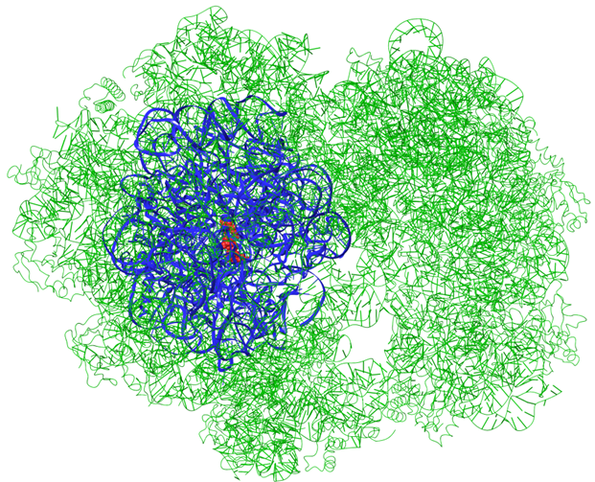Supplementary Fig. 5. The model of the ribosome of lincosamide-sensitive Staphylococcus aureus with CLC (red). The full cryo-EM structure is shown in green; the reduced model for MD simulations is shown in blue. The same approach was used for the lincosamide-resistant ribosome complex with CLC.

Supplementary Table 6: A list of restrained RNA residues in MD simulations (S. aureus numbering).
198 | 815 | 1317 | 1347 | 1676 | 1974 | 2266 | 2661 | 2745
495 | 816 | 1318 | 1348 | 1677 | 1975 | 2267 | 2662 | 2746
496 | 817 | 1319 | 1349 | 1678 | 1976 | 2268 | 2663 | 2747
497 | 818 | 1320 | 1350 | 1679 | 1977 | 2287 | 2664 | 2748
498 | 858 | 1321 | 1351 | 1680 | 1978 | 2288 | 2665 | 2749
499 | 859 | 1322 | 1352 | 1681 | 1979 | 2289 | 2666 | 2750
500 | 860 | 1323 | 1353 | 1682 | 1980 | 2290 | 2667 | 2751
501 | 861 | 1324 | 1354 | 1683 | 1981 | 2291 | 2668 | 2752
502 | 862 | 1325 | 1355 | 1684 | 1982 | 2292 | 2669 | 2753
503 | 863 | 1326 | 1356 | 1685 | 1985 | 2293 | 2670
504 | 879 | 1327 | 1357 | 1686 | 1986 | 2294 | 2671
505 | 880 | 1328 | 1358 | 1687 | 1987 | 2295 | 2704
506 | 881 | 1329 | 1359 | 1725 | 1988 | 2296 | 2705
517 | 1013 | 1330 | 1365 | 1788 | 1989 | 2297 | 2706
518 | 1018 | 1331 | 1366 | 1794 | 1990 | 2298 | 2707
563 | 1019 | 1332 | 1367 | 1795 | 1991 | 2299 | 2708
564 | 1031 | 1333 | 1368 | 1854 | 1992 | 2454 | 2709
565 | 1032 | 1334 | 1369 | 1855 | 1993 | 2455 | 2710
566 | 1033 | 1335 | 1650 | 1963 | 1994 | 2459 | 2711
567 | 1034 | 1336 | 1666 | 1964 | 1995 | 2460 | 2712
568 | 1070 | 1337 | 1667 | 1965 | 1996 | 2589 | 2713
569 | 1071 | 1338 | 1668 | 1966 | 1997 | 2591 | 2714
715 | 1072 | 1340 | 1669 | 1967 | 1998 | 2654 | 2715
716 | 1226 | 1341 | 1670 | 1968 | 1999 | 2655 | 2739
725 | 1229 | 1342 | 1671 | 1969 | 2000 | 2656 | 2740
726 | 1313 | 1343 | 1672 | 1970 | 2001 | 2657 | 2741
727 | 1314 | 1344 | 1673 | 1971 | 2002 | 2658 | 2742
807 | 1315 | 1345 | 1674 | 1972 | 2003 | 2659 | 2743
813 | 1316 | 1346 | 1675 | 1973 | 2004 | 2660 | 2744

Supplementary Fig. 6. Conformational dynamics of CLC bound to lincosamide-sensitive and lincosamide-resistant ribosome in molecular dynamics simulations. Root mean square deviation (RMSD) profiles of CLC during 100-ns molecular dynamics (MD) simulations bound to lincosamide-sensitive (WT; left) and lincosamide-resistant (A2058meth; right) ribosome. (A, B) RMSD of the entire CLC molecule relative to the starting coordinates. (C, D) RMSD of the salicylate moiety of CLC relative to the starting coordinates. (E, F) RMSD of the 4-propyl-N-methyl-L-proline moiety of CLC relative to the starting coordinates. Each trace (black, red, and green) represents an independent MD replicate. The A2058 methylation induces increased conformational fluctuations of CLC and its salicylate moiety compared with the lincosamide-sensitive ribosome complex, consistent with reduced binding stability in the methylated complex.

Supplementary Fig. 7. Distances between clindamycin and key nucleotides in 23S rRNA during molecular dynamics simulations. Average center-of-mass distances between CLC and selected nucleotides of 23S rRNA were monitored over 100-ns molecular dynamics (MD) simulations with lincosamide-sensitive (WT; left) and lincosamide-resistant A2058-methylated (A2058meth; right) ribosome. (A, B) Distances between CLC and A2058. (C, D) Distances between the salicylate moiety of CLC and C2610. (E, F) Distances between the salicylate moiety of CLC and C2611. Each trace (black, red, and green) represents an independent MD replicate. Methylation of A2058 increases the mobility and average separation of CLC from key rRNA nucleotides of the CLC binding pocket, consistent with weakened binding interactions in the modified complex.

Legends to Supplementary movies S1-S3
Movie S1 sensitive_ribo_rep1.mp4
Movie S2 sensitive_ribo_rep2.mp4
Movie S3 sensitive_ribo_rep3.mp4
Time-resolved conformations of CLC (gold) bound to lincosamide-sensitive S. aureus ribosome (grey) during a 100-ns molecular dynamics simulation. Snapshots from the simulation are shown in Supplementary Figs. 8-10.

Legends to Supplementary movies S4-S6
Movie S4 A2058meth_ribo_rep1.mp4
Movie S5 A2058meth_ribo_rep2.mp4
Movie S6 A2058meth_ribo_rep3.mp4
Time-resolved conformations of CLC (navy blue) bound to A2058-methylated S. aureus ribosome (powder blue) during a 100-ns molecular dynamics simulation. Snapshots from the simulation are shown in Supplementary Figs. 11-13.

Supplementary Fig. 8. Time-resolved conformations of CLC during molecular dynamics simulation – repeat 1. Representative coordinates of CLC (gold) bound to lincosamide-sensitive S. aureus ribosome (grey) are shown at selected timepoints (every 10 ns) from a 100-ns molecular dynamics trajectory.
Supplementary Fig. 9. Time-resolved conformations of CLC during molecular dynamics simulation – repeat 2. Representative coordinates of CLC (gold) bound to lincosamide-sensitive S. aureus ribosome (grey) are shown at selected timepoints (every 10 ns) from a 100-ns molecular dynamics trajectory.
Supplementary Fig. 10. Time-resolved conformations of CLC during molecular dynamics simulation – repeat 3. Representative coordinates of CLC (gold) bound to lincosamide-sensitive S. aureus ribosome (grey) are shown at selected timepoints (every 10 ns) from a 100-ns molecular dynamics trajectory.
Supplementary Fig. 11. Time-resolved conformations of CLC during molecular dynamics simulation – repeat 1. Representative coordinates of CLC (navy blue) bound to A2058-methylated S. aureus ribosome (powder blue) are shown at selected timepoints (every 10 ns) from a 100-ns molecular dynamics trajectory.
Supplementary Fig. 12. Time-resolved conformations of CLC during molecular dynamics simulation – repeat 2. Representative coordinates of CLC (navy blue) bound to A2058-methylated S. aureus ribosome (powder blue) are shown at selected timepoints (every 10 ns) from a 100-ns molecular dynamics trajectory.
Supplementary Fig. 13. Time-resolved conformations of CLC during molecular dynamics simulation – repeat 3. Representative coordinates of CLC (navy blue) bound to A2058-methylated S. aureus ribosome (powder blue) are shown at selected timepoints (every 10 ns) from a 100-ns molecular dynamics trajectory.

Lists of strains, plasmids, oligonucleotides, and toeprinting templates

Supplementary Table 7. List of strains used in this study.
Strain | Note | Reference
Staphylococcus aureus JE2 |  | (Fey et al., 2013)
Staphylococcus aureus NE1858 | Transposon Mutant SAUSA300_2453 | (Fey et al., 2013)
Staphylococcus aureus NE854 | Transposon Mutant SAUSA300_2453 | (Fey et al., 2013)
Staphylococcus aureus RN4220

Supplementary Table 8. List of plasmids used in this study.
Plasmid | Note | Reference
pRN12 (Addgene plasmid #84456) | Shuttle plasmid for sarA P1-mAmetrine expression | (De Jong et al., 2017)

Supplementary Table 9. List of oligonucleotides used in this study.
Strain | Sequence | Note | Use
FP_T7_TP  (fwd_short, T7_f) | CGATCGAATTCTAATACGACTCACTATAG |  | Toeprinting templates amplification
RP_NV1_TP  (rev_short, TP_NV1_r) | GGTTATAATGAATTTTGCTT |  | Toeprinting templates amplification
NV_YY | GGTTATAATGAATTTTGCTTATTAAC | 5'-Yakima Yellow labelled | Toeprinting
A2058met_Sa_YY | GTAAAGCTCCACGGGGTC | 5'-Yakima Yellow labelled | Primer Extension Inhibition assay
Supplementary Table 10. List of toeprinting templates used in this study. T7 promoter (yellow), RBS (orange), ORF (green), stop codon (pink), primer annealing site (blue)

ID | Name | uORF Sequence | Sequence | Type
TPMN020 | TP_ermBL_{v} | MLVFQMRNVDKTSTILKSE | CGATCGAATTCTAATACGACTCACTATAGGGCTTAAGTATAAGGAGGAAAAAATATGTTGGTATTCCAAATGCGTAATGTAGATAAAACATCTACTATTTTGAAAAGCGAATAATAACTCTGAACAACATCCGTACTCTTCGTGCGCAGGCAAGGTTAATAAGCAAAATTCATTATAACC | ss oligo
TPMN021 | TP_ermDL_{v}Ile | MTHSMRLRFPTLNQISE | CGATCGAATTCTAATACGACTCACTATAGGGCTTAAGTATAAGGAGGAAAAAATATGACACACTCAATGAGACTTCGTTTCCCAACTTTGAACCAGATTAGCGAATAATAACTCTGAACAACATCCGTACTCTTCGTGCGCAGGCAAGGTTAATAAGCAAAATTCATTATAACC | ss oligo

Synthesis of artificial chimeric antibiotics ODC and CLC

General experimental detail
HPLC-MS analyses were performed on a Shimadzu UFLC-MS-2020 system with ESI. Column: Acquity UPLC BEH C18 1.7 µm, 2.1x50 mm. Solvent A: H₂O + 0.1% HCOOH; Solvent B: MeCN + 0.1% COOH. Total flow 0.6 ml/min. The total time of the method is 10 min. The mass spectrum was recorded in the range 100-1500 m/z both in positive and negative mode with event time 0.2 s., or in the range 350-1300 m/z in positive mode with event time 0.2 s. NMR analyses were performed on Bruker Avance III™ HD 400 MHz or Bruker Avance III™ HD 400 MHz Prodigy. Thin-layer chromatography (TLC) was conducted with E. Merck silica gel 60 F254 pre-coated plates (0.25 mm) and visualized by exposure to UV light (254 nm) or stained with 5% H₂SO₄ in ethanol or potassium permanganate.

The synthesis was designed to provide multigram quantities of the final compounds (ODC and CLC).

Compound 2
Lincomycin A (60.0 g, 135.5 mmol) was dissolved in pyridine (550 mL) in a 2 L round-bottom flask, and TBDMSOTf (8.0 equiv., 1084 mmol, 249 mL) was added dropwise at 0 °C. The reaction mixture was stirred for 1 h at room temperature and then heated to 110 °C overnight. After cooling to room temperature, the solvent was removed under reduced pressure by co-evaporation with toluene. The resulting amorphous residue was dissolved in diethyl ether (500 mL), and the organic layer was washed sequentially with distilled water (1 × 200 mL), saturated aqueous NaHCO₃ (1 × 100 mL), and brine (3 × 100 mL). The combined aqueous layers were extracted with diethyl ether (1 × 200 mL), and the combined organic extracts were washed again with water and brine. The organic phase was dried over Na₂SO₄, filtered, and concentrated under reduced pressure to afford crude compound 2 (145.0 g) as an orange viscous oil. LC-MS analysis indicated nearly quantitative conversion to product 2, which was used without further purification.
¹H NMR (400 MHz, Chloroform-d) δ 7.26 (d, J = 10.2 Hz, 1H), 5.14 (d, J = 5.4 Hz, 1H), 4.38 (ddd, J = 10.3, 6.9, 4.4 Hz, 2H), 4.12 (qd, J = 6.3, 3.5 Hz, 1H), 3.96 – 3.84 (m, 2H), 3.63 (dd, J = 9.9, 1.9 Hz, 1H), 3.15 (ddd, J = 7.4, 5.3, 3.0 Hz, 1H), 2.89 (dd, J = 10.7, 4.7 Hz, 1H), 2.40 (s, 3H), 2.11 (s, 3H), 2.09 – 1.89 (m, 2H), 1.89 – 1.77 (m, 1H), 1.45 (s, 1H), 1.38 – 1.23 (m, 4H), 1.08 (d, J = 6.3 Hz, 4H), 1.02 – 0.88 (m, 31H), 0.91 (s, 1H), 0.85 (s, 8H), 0.92 – 0.82 (m, 1H), 0.23 – 0.03 (m, 23H). ¹³C NMR (101 MHz, CDCl₃) δ 174.27, 91.09, 77.48, 77.16, 76.84, 74.25, 72.76, 72.49, 69.59, 69.29, 67.16, 63.01, 51.94, 41.90, 38.15, 37.67, 36.07, 27.06, 26.66, 26.62, 26.25, 25.84, 25.80, 21.73, 18.99, 18.96, 18.41, 18.13, 17.99, 16.69, 14.53, 14.45, 0.14, -2.96, -3.43, -3.61, -4.08, -4.47, -4.57, -4.61, -4.90. MS (calcd. for C₄₂H₉₀N₂O₆SSi₄): 862.56; found [M+H]⁺ 863.55.

Compound 3
The crude reaction mixture of compound 2 (145.0 g, ca. 135.4 mmol) was dissolved in DCM (200 mL) and cooled to 0 °C. A solution of mCPBA (2.1 equiv., 75%, 284.4 mmol, 65.44 g) in DCM (300 mL) was then added dropwise over 4 h (precipitation of a white solid was observed during the addition). The reaction mixture was subsequently treated with Me₂S (1.8 equiv., 243.8 mmol, 18 mL), warmed to room temperature, and quenched with saturated aqueous NaHCO₃ (200 mL). The layers were separated, and the aqueous layer was extracted with DCM (2 × 100 mL). The combined organic extracts were dried over Na₂SO₄ and concentrated under reduced pressure to afford crude compound 3 as a red oil.
The crude material was dissolved in a MeCN/Et₂O (1:1, 300 mL) mixture and treated with (PinB)₂ (1.0 equiv., 34.4 g, 135.4 mmol) to enable N-oxide reduction. The reaction mixture was stirred at room temperature for 1 h and then concentrated under reduced pressure. The resulting residue was dissolved in diethyl ether (400 mL) and washed sequentially with saturated aqueous NaHCO₃ (2 × 100 mL), aqueous K₂CO₃ (2 × 100 mL), distilled water (1 × 100 mL), and brine (3 × 100 mL). The organic phase was dried over Na₂SO₄, filtered through a short plug of silica gel (eluent: diethyl ether), and concentrated under reduced pressure to yield compound 3 (139.0 g) as an orange oil. Compound 3 was used without further purification. An analytical sample was obtained by purification on a silica column (hexane → 10 % EtOAc) as white crystals. Product 3 was obtained as a mixture of diastereomers (S=O).
¹H NMR (401 MHz, Chloroform-d) δ 7.19 (d, J = 10.6 Hz, 1H), 4.75 – 4.59 (m, 2H), 4.51 (dd, J = 9.9, 1.6 Hz, 1H), 4.43 – 4.32 (m, 1H), 4.37 – 4.28 (m, 1H), 4.13 (d, J = 6.5 Hz, 1H), 3.98 (d, J = 1.6 Hz, 1H), 3.12 (q, J = 4.6 Hz, 1H), 2.87 (dd, J = 10.7, 4.6 Hz, 1H), 2.66 (s, 3H), 2.37 (s, 3H), 2.04 – 1.93 (m, 2H), 1.96 – 1.85 (m, 1H), 1.44 (s, 1H), 1.28 (q, J = 8.3, 7.4 Hz, 9H), 1.03 – 0.90 (m, 26H), 0.92 (s, 4H), 0.94 – 0.82 (m, 2H), 0.86 (s, 7H), 0.24 – 0.13 (m, 15H), 0.12 – 0.03 (m, 9H). ¹³C NMR (101 MHz, CDCl₃) δ 174.16, 92.14, 79.86, 77.34, 77.02, 76.70, 73.23, 72.37, 69.91, 69.04, 62.71, 52.03, 41.67, 37.98, 37.42, 35.92, 34.28, 26.92, 26.57, 26.51, 26.21, 25.71, 25.03, 21.57, 18.82, 18.77, 18.22, 17.87, 14.40, -0.00, -2.89, -3.82, -4.10, -4.37, -4.42, -4.71, -5.02, -5.21. MS (calcd. for C₄₂H₉₀N₂O₇SSi₄): 878.55; found [M+H]⁺ 879.75.

Compound 4
A portion of lincomycin sulfoxide 3 (73.18 g, ca. 83 mmol) was dissolved in dry diethyl ether (800 mL). DTBMP (2.0 equiv., 166.4 mmol, 32.0 g) and 4 Å molecular sieves were added, and the mixture was stirred at room temperature for 30 min. The reaction mixture was then cooled to –78 °C, and Tf₂O (1.2 equiv., 99.8 mmol, 16.8 mL) was added dropwise over 5 min. After stirring for 10 min at –78 °C, 2-((tert-butyldimethylsilyl)oxy)ethane-1-thiol (Yatvin et al., 2015) (4; 2.0 equiv., 166.4 mmol, 37.5 mL) was added. The mixture was slowly warmed to 0 °C, stirred for 3 h, quenched with saturated aqueous NaHCO₃ (200 mL), and filtered through a short pad of Celite. The organic phase was separated and washed sequentially with saturated aqueous NaHCO₃ (1 × 200 mL), water (1 × 100 mL), and brine (1 × 100 mL). The aqueous phase was extracted with diethyl ether (2 × 100 mL), and the combined organic layers were washed again with water and brine, dried over Na₂SO₄, and concentrated under reduced pressure.
The same procedure was applied to the remaining portion of lincomycin sulfoxide 3 (65.81 g). Both crude extracts of product 4 were purified separately by column chromatography (eluent: cyclohexane + 1% EtOAc, gradient to 1.5% EtOAc;), affording compound 4 (96.5 g, yellow oil) as a mixture with unreacted 2-((tert-butyldimethylsilyl)oxy)ethane-1-thiol and other by-products. Compound 4 was used without further purification.
An analytical sample was obtained by purification on a silica column (hexane → 10 % EtOAc) as white foam.
¹H NMR (401 MHz, Chloroform-d) δ 7.26 (d, J = 10.2 Hz, 1H), 5.27 (d, J = 5.4 Hz, 1H), 4.42 – 4.30 (m, 2H), 4.18 – 4.06 (m, 1H), 3.96 – 3.84 (m, 2H), 3.78 (ddd, J = 8.5, 6.6, 1.7 Hz, 2H), 3.64 (dd, J = 9.9, 1.8 Hz, 1H), 3.19 – 3.10 (m, 1H), 2.89 (dd, J = 10.7, 4.7 Hz, 1H), 2.77 – 2.57 (m, 2H), 2.40 (s, 3H), 2.10 – 1.90 (m, 3H), 1.88 – 1.76 (m, 1H), 1.38 – 1.23 (m, 6H), 1.07 (d, J = 6.2 Hz, 3H), 1.02 – 0.83 (m, 39H), 0.85 (s, 9H), 0.20 – 0.02 (m, 28H). ¹³C NMR (101 MHz, CDCl₃) δ 174.17, 88.85, 77.33, 77.01, 76.70, 73.93, 72.55, 72.36, 69.24, 69.16, 66.88, 63.18, 62.86, 51.93, 41.74, 38.00, 37.53, 35.91, 32.64, 31.44, 30.19, 29.70, 26.92, 26.53, 26.48, 26.20, 25.89, 25.68, 21.59, 18.84, 18.82, 18.31, 18.18, 17.83, 16.59, 14.38, -0.00, -3.08, -3.77, -4.21, -4.60, -4.63, -4.79, -5.04, -5.19, -5.24, -5.33. MS (calcd. for C₄₉H₁₀₆N₂O₇SSi₅): 1006.66; found [M+H]⁺ 1007.70

.

Compound 5
The purified compound 4 (96.5 g) was dissolved in THF (400 mL) and cooled to 0 °C. A solution of TFA/H₂O (1:3, 280 mL) was added dropwise over 10 min, and the reaction mixture was stirred at the same temperature for 2 h. An additional portion of TFA (10 mL) was then added, and stirring was continued until complete deprotection of the starting material was observed (≤1 h, monitored by LC-MS). The reaction mixture was neutralized with solid NaHCO₃ (caution: rapid gas evolution) and extracted with diethyl ether (2 × 250 mL). The combined organic layers were washed with brine (3 × 100 mL), dried over Na₂SO₄, and concentrated under reduced pressure to afford crude compound 5 (85.5 g) as an orange oil. Compound 5 was used without further purification.
An analytical sample was obtained by purification on a silica column (hexane → 20 % EtOAc) as white foam.
¹H NMR (401 MHz, Chloroform-d) δ 7.29 (d, J = 10.1 Hz, 1H), 5.26 (d, J = 5.4 Hz, 1H), 4.44 – 4.29 (m, 2H), 4.09 (qd, J = 6.3, 3.8 Hz, 1H), 4.00 – 3.91 (m, 2H), 3.88 – 3.71 (m, 2H), 3.67 (dd, J = 9.9, 1.8 Hz, 1H), 3.20 – 3.10 (m, 1H), 2.89 (dd, J = 10.7, 4.6 Hz, 1H), 2.85 – 2.66 (m, 2H), 2.39 (s, 3H), 2.23 – 2.13 (m, 1H), 2.09 – 1.90 (m, 2H), 1.88 – 1.76 (m, 1H), 1.69 (s, 1H), 1.38 – 1.21 (m, 5H), 1.07 (d, J = 6.3 Hz, 3H), 1.01 – 0.88 (m, 30H), 0.88 (dd, J = 20.0, 5.0 Hz, 2H), 0.85 (s, 8H), 0.24 – 0.04 (m, 20H), 0.06 (s, 3H). ¹³C NMR (101 MHz, CDCl₃) δ 174.33, 88.53, 77.34, 77.02, 76.70, 73.90, 72.73, 72.39, 69.16, 69.12, 62.87, 61.27, 52.12, 41.80, 38.01, 37.54, 35.89, 33.88, 26.52, 26.45, 26.15, 25.68, 25.66, 21.59, 18.83, 18.80, 18.12, 17.83, 14.38, -3.04, -3.57, -3.85, -4.19, -4.54, -4.55, -4.69, -5.02, -5.03. MS (calcd. for C₄₃H₉₂N₂O₇SSi₄): 892.57; found [M+H]⁺ 893.50.

Compound 6
Salicylic acid (33.05 g, 239.2 mmol, 2.5 equiv.), compound 5 (85.5 g), and DMAP (5.85 g, 47.9 mmol, 0.5 equiv.) were dissolved in DCM (500 mL). DCC (49.35 g, 239.2 mmol, 2.5 equiv.) was added slowly at 0 °C, and the reaction mixture was stirred at room temperature for 16 h. A second portion of salicylic acid (33.05 g, 239.2 mmol, 2.5 equiv.), DCC (49.35 g, 239.2 mmol, 2.5 equiv.), and DMAP (5.85 g, 47.9 mmol, 0.5 equiv.) was then added, and stirring was continued for an additional 16 h. The precipitated dicyclohexylurea was filtered off, and the solvent was removed under reduced pressure. The residue was triturated twice with diethyl ether, filtered, and the filtrates were combined. The organic phase was washed successively with saturated aqueous NaHCO₃, water, and brine, dried over Na₂SO₄, and concentrated under reduced pressure. Purification by column chromatography (cyclohexane/EtOAc 10:1) afforded crude compound 6 (68.0 g) as a yellow oil. Compound 6 was used without further purification.
The analytical sample was obtained by purification on a silica column (hexane → 20% EtOAc) as white powder. Although LC–MS analysis indicated a single component, the ¹H and ¹³C NMR spectra displayed two sets of signals in an approximately 1:10 ratio, suggesting the presence of atropisomers resulting from restricted rotation of the salicylic acid moiety at room temperature. This phenomenon was not investigated further, as the subsequent reaction step afforded a single compound.
¹H NMR (401 MHz, Chloroform-d) δ 10.71 (s, 1H), 7.87 (dd, J = 8.0, 1.7 Hz, 1H), 7.54 – 7.41 (m, 1H), 7.31 (d, J = 9.9 Hz, 1H), 7.06 – 6.96 (m, 1H), 6.90 (ddd, J = 8.1, 7.2, 1.1 Hz, 1H), 5.37 (d, J = 5.5 Hz, 1H), 4.52 (td, J = 6.8, 2.0 Hz, 2H), 4.46 – 4.27 (m, 2H), 4.13 (pd, J = 6.3, 4.5 Hz, 1H), 4.01 – 3.83 (m, 2H), 3.67 (dd, J = 9.9, 1.8 Hz, 1H), 3.20 – 3.11 (m, 1H), 2.99 (dt, J = 13.5, 6.7 Hz, 1H), 2.94 – 2.79 (m, 2H), 2.40 (d, J = 1.7 Hz, 3H), 2.12 – 1.91 (m, 2H), 1.82 (ddd, J = 13.0, 10.7, 9.4 Hz, 1H), 1.44 (s, 1H), 1.37 – 1.23 (m, 5H), 1.09 (d, J = 6.2 Hz, 3H), 1.00 (dd, J = 12.6, 6.1 Hz, 1H), 0.99 (s, 9H), 0.99 – 0.83 (m, 22H), 0.85 (s, 7H), 0.84 (d, J = 1.5 Hz, 2H), 0.24 – 0.03 (m, 22H). ¹³C NMR (101 MHz, Chloroform-d) δ 174.32, 174.26, 169.88, 163.86, 162.05, 161.75, 136.48, 135.87, 134.11, 132.14, 130.61, 129.99, 126.57, 123.86, 123.28, 119.60, 119.20, 117.85, 117.60, 112.22, 93.03, 88.43, 73.92, 72.66, 72.37, 69.22, 69.20, 64.45, 64.19, 62.90, 52.33, 52.15, 41.87, 38.03, 37.56, 35.88, 28.62, 26.92, 26.53, 26.45, 26.12, 25.68, 21.59, 18.82, 18.13, 18.09, 17.85, 17.83, 16.84, 14.38, -3.01, -3.79, -3.82, -4.20, -4.53, -4.56, -4.58, -4.60, -4.72, -5.04, -5.07, -5.10. MS (calcd. for C₅₀H₉₆N₂O₉SSi₄): 1012.59; found [M+H]⁺ 1013.50; [M-H]⁻ 1011.55

ODC
The crude reaction mixture containing compound 6 (68.0 g) and TBAF·3H₂O (6.0 equiv., 128 g, 404 mmol) was dissolved in THF (650 mL) and stirred at room temperature overnight (completion of deprotection was confirmed by LC-MS). The solvent was reduced to one-third of the original volume, and the resulting solution was worked up in two equal portions. Each portion was partitioned between EtOAc and aqueous acid, and the organic layers were washed with 1 M HCl, water, and brine. The combined aqueous phases were neutralized with solid NaHCO₃ and extracted with EtOAc. The combined organic layers were washed with water and brine, dried over Na₂SO₄, and concentrated under reduced pressure.
The residue was dissolved in EtOAc/Et₂O (1:1, 300 mL), and dry HCl (generated in situ from aq. HCl and CaCl₂) was bubbled through the stirred solution, resulting in rapid precipitation of a beige solid. Alternatively, 4M HCl in dioxane can be used. The precipitate was collected by filtration, washed with EtOAc/Et₂O (1:3, 50 mL) and Et₂O (200 mL), and dried under vacuum to afford ODC (12.79 g, 86% purity at 303 nm) as a beige solid. The purity of compound ODC can be further improved by C18 reverse-phase chromatography (H₂O + 0.1% HCl → 50% MeCN). Additional crystallization from a H₂O/MeCN mixture afforded material of up to 99% purity.
MS (calcd. for C₂₆H₄₀N₂O₉S): 556.25; found [M+H]⁺ 557.30.

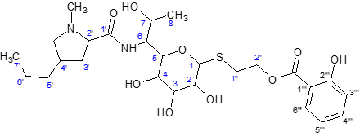
Atom # | δ_{C} | m. | δ_{H} | m. | J_{HH} [Hz]
1 | 89.01 | d | 5.496 | d | 5.6
2 | 69.31 | d | 4.109 | dd | 5.6, 10.2
3 | 71.97 | d | 3.551 | dd | 3.2, 10.2
4 | 70.39 | d | 3.943 | dd | 0.7, 3.2
5 | 70.83 | d | 4.237 | dd | 0.7, 8.6
6 | 56.05 | d | 4.403 | dd | 5.4, 8.6
7 | 67.63 | d | 4.063 | dq | 5.4, 6.4
8 | 18.29 | q | 1.171 | d | 6.4
1’’ | 30.08 | t | 3.044 | td | 6.7, 13.6
 |  |  | 2.966 | td | 6.7, 13.6
2’’ | 65.72 | t | 4.603 | td | 6.7, 11.2
 |  |  | 4.523 | td | 6.7, 11.2
1’’’ | 113.53 | s | -
2’’’ | 162.90 | s | -
3’’’ | 118.48 | d | 6.947 | dd | 1.2, 8.5
4’’’ | 137.05 | d | 7.495 | ddd | 1.7, 7.2, 8.5
5’’’ | 120.43 | d | 6.917 | ddd | 1.2, 7.2, 8.0
6’’’ | 131.19 | d | 7.877 | dd | 1.7, 8.0
1’’’-C=O | 171.16 | s | -
1’ | 169.41 | s | -
2’ | 69.79 | d | 4.193 | dd | 6.5, 9.7
3’ | 36.57 | t | 2.255 | m | -
4’ | 38.04 | d | 2.355 | m | -
5’ | 35.83 | t | 1.474 | m | -
6’ | 22.14 | t | 1.366 | m | -
7’ | 14.30 | q | 0.948 | t | 7.2
4’-CH₂ | 62.25 | t | 3.750 | dd | 6.7, 10.9
 |  |  | 2.887 | dd | 10.9, 11.3
N-CH₃ | 41.00 | q | 2.935 | s | -

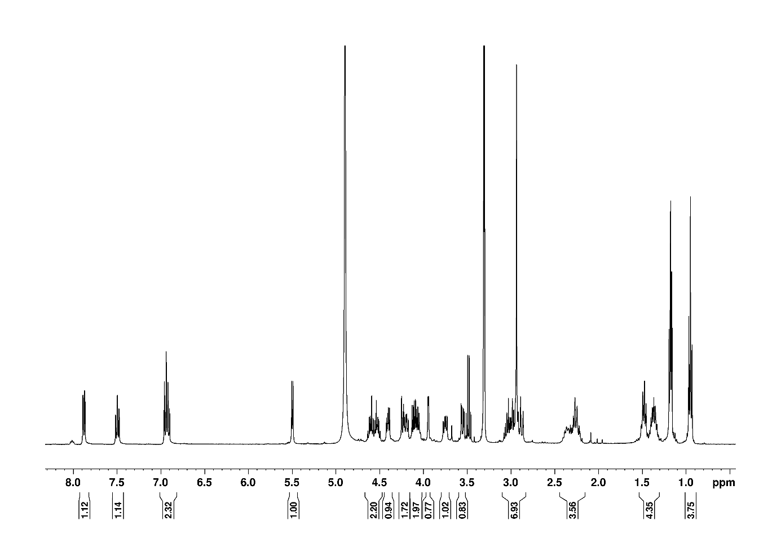
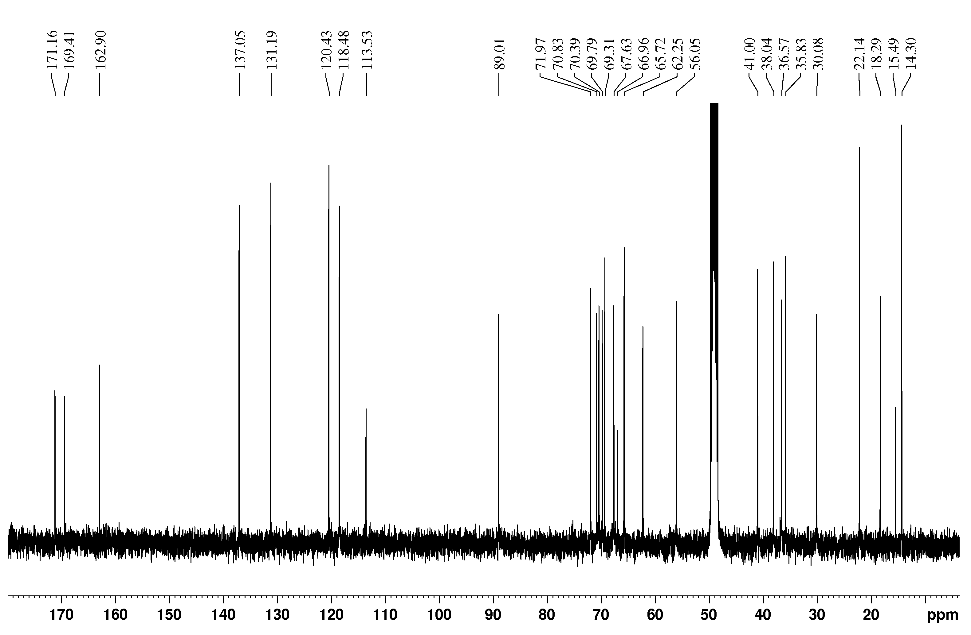

CLC
A solution of oxalyl chloride (6.86 mL, 81.1 mmol) in DCM (40 mL) was added dropwise to DMF (6.25 mL, 81.1 mmol) in DCM (20 mL) at 0 °C (caution: toxic gas evolution). The mixture was stirred at 0 °C for 30 min and evaporated to dryness. The resulting white residue was dissolved in dry DMF (45 mL), and ODC (6.0 g, 10.1 mmol) was added at 0 °C. The reaction mixture was stirred at 0 °C for 15 min, at room temperature for 10 min, at 63 °C for 4.5 h, and then overnight at room temperature. An aqueous solution of K₂CO₃ (15 g in 50 mL water) was added at 0 °C (exothermic; gas evolution observed), and the reaction was stirred at room temperature for 2 h (completion of deprotection was monitored by LC-MS). The mixture was diluted with saturated aqueous NaHCO₃ (100 mL) and water (200 mL) and extracted with EtOAc/Et₂O (1:1, 3 × 200 mL). The combined organic phases were washed with brine (2 × 100 mL), water (2 × 100 mL), and brine (2 × 50 mL), dried over Na₂SO₄, and concentrated under reduced pressure. The residue was dissolved in EtOAc/Et₂O (1:2, 150 mL), and dry HCl (generated from aq. HCl and CaCl₂; alternatively 4M HCl in dioxane can be used) was bubbled through the stirred solution, resulting in rapid precipitation of a beige solid. The precipitate was collected by filtration, washed with Et₂O (100 mL), and dried under vacuum to afford CLC (5.41 g, 76% purity at 303 nm) as a beige solid. The purity of compound CLC can be further improved by C18 reverse-phase chromatography (H₂O + 0.1% HCl → 50% MeCN). Additional crystallization from a H₂O/MeCN mixture afforded material of up to 99% purity.
MS (calcd. for C₂₆H₃₉N₂ClO₈S): 574.21; found [M+H]⁺ 575.30.
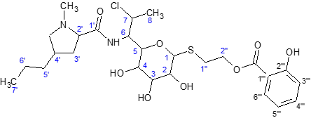
Atom # | δ_{C} | m. | δ_{H} | m. | J_{HH} [Hz]
1 | 88.01 | d | 5.560 | d | 5.7
2 | 69.28 | d | 4.120 | dd | 5.7, 10.2
3 | 72.01 | d | 3.604 | dd | 3.3, 10.2
4 | 69.70 | d | 3.838 | dd | 1.3, 3.3
5 | 70.82 | d | 4.324 | dd | 1.3, 9.9
6 | 54.59 | d | 4.58^{H} | m | -
7 | 59.327 | d | 4.58^{H} | m | -
7 | 59.318
8 | 23.15 | q | 1.420 | d | 6.8
1’’ | 29.48 | t | 3.129 | td | 6.5, 13.8
 |  |  | 3.003 | td | 6.5, 13.8
2’’ | 65.83 | t | 4.620 | td | 6.5, 11.2
 |  |  | 4.566 | td | 6.5, 11.2
1’’’ | 113.54 | s | -
2’’’ | 162.91 | s | -
3’’’ | 118.46 | d | 6.947 | dd | 1.1, 8.4
4’’’ | 137.03 | d | 7.492 | ddd | 1.8, 7.3, 8.4
5’’’ | 120.41 | d | 6.913 | ddd | 1.1, 7.3, 7.9
6’’’ | 131.19 | d | 7.873 | dd | 1.8, 7.9
1’’’-C=O | 171.19 | s | -
1’ | 169.41 | s | -
2’ | 69.56 | d | 4.245 | dd | 6.4, 9.7
3’ | 36.92 | t | 2.314 | m | -
 |  |  | 2.236 | m | -
4’ | 38.02 | d | 2.364 | m | -
5’ | 35.79 | t | 1.504 | m | -
6’ | 22.12 | t | 1.379 | m | -
7’ | 14.28 | q | 0.954 | t | 7.3
4’-CH₂ | 62.21 | t | 3.778 | dd | 6.8, 11.2
 |  |  | 2.919 | dd | 10.7, 11.2
N-CH₃ | 41.11 | q | 2.957 | s | -
^{H} – HSQC readouts

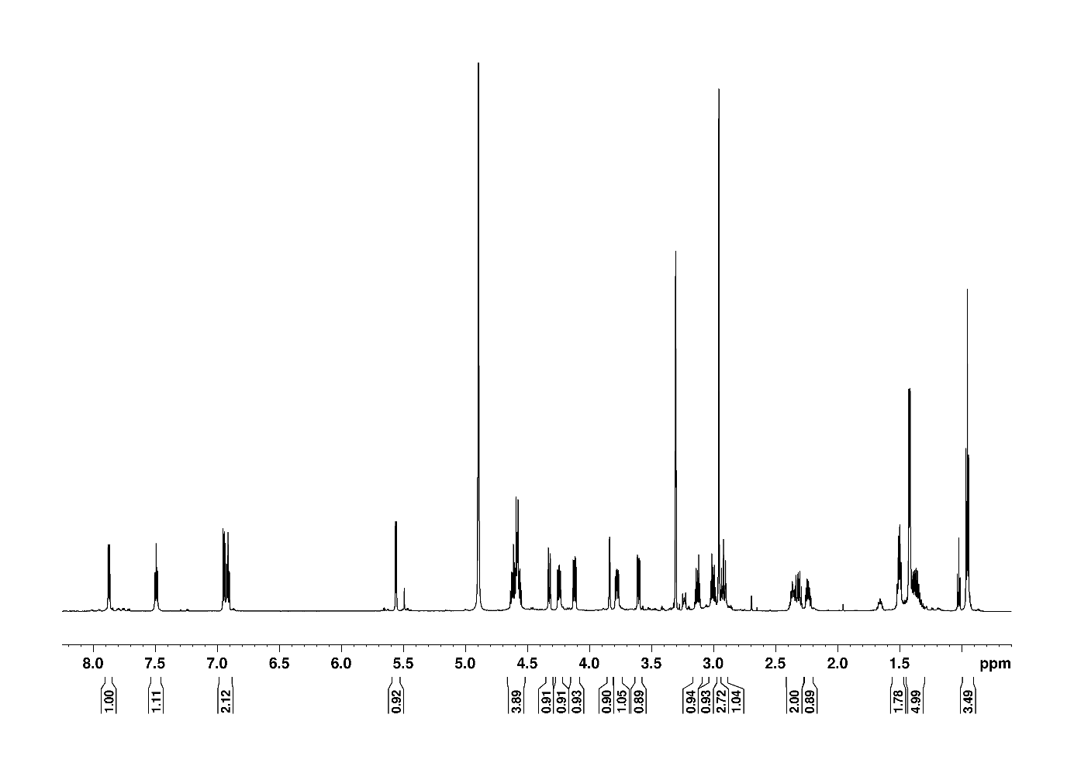
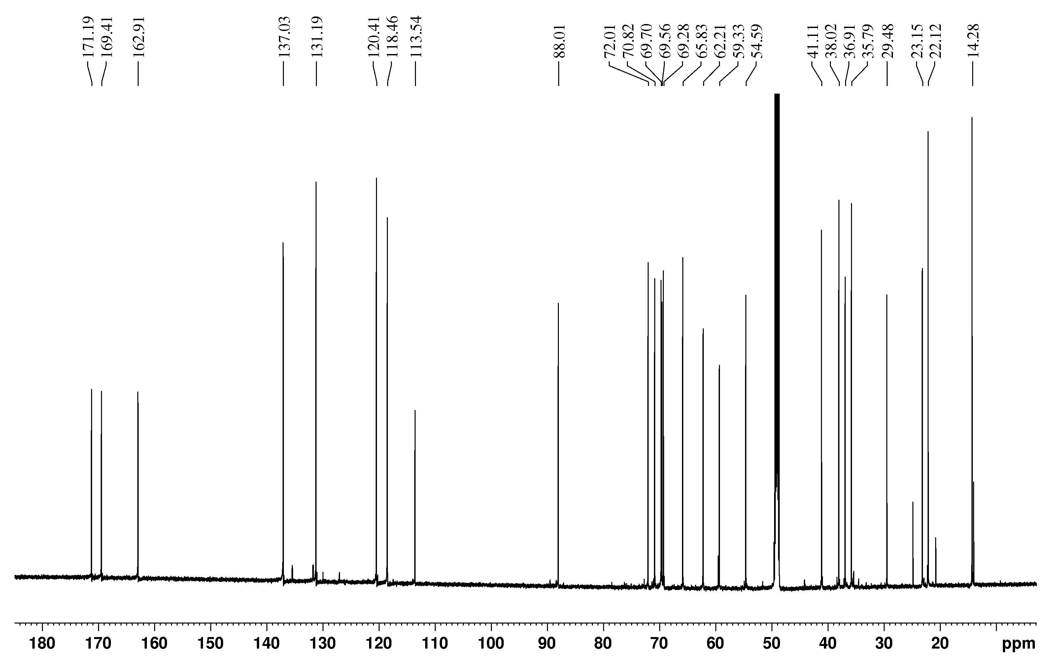

References

Černý, J. et al. (2020). A unified dinucleotide alphabet describing both RNA and DNA structures. Nucleic Acids Res. 48, 6367–6381.
Černý, J. et al. (2026). DNATCO v5.0: integrated web platform for 3D nucleic acid structure analysis. Nucleic Acids Res. 54, gkaf1491.
Eyal, Z. et al. (2015). Structural insights into species-specific features of the ribosome from the pathogen Staphylococcus aureus. Proc. Natl. Acad. Sci. U. S. A. 112, E5805–E5814.
Fey, P.D. et al. (2013). A genetic resource for rapid and comprehensive phenotype screening of nonessential Staphylococcus aureus genes. MBio 4, e00537-12.
De Jong, N.W.M. et al. (2017). Fluorescent reporters for markerless genomic integration in Staphylococcus aureus. Sci. Rep. 7.
Mitcheltree, M.J. et al. (2021). A synthetic antibiotic class overcoming bacterial multidrug resistance. Nature 599, 507–512.
Paternoga, H. et al. (2023). Structural conservation of antibiotic interaction with ribosomes. Nat. Struct. Mol. Biol. 1–13.
Yatvin, J. et al. (2015). SuFEx on the surface: A flexible platform for postpolymerization modification of polymer brushes. Angewandte Chemie International Edition 54, 13370–13373.

