Custom Surgical Phantom Workflow with Radiographic Compatibility and Haptic Fidelity
Giacomo Riberi^{1,2,*}, Roberto Spagnulo², Francesco Riberi³, Vittorio Monasterolo², Enrico Vezzetti⁴ Luca Ulrich⁴, Marco Agus⁵, Paolo Titolo¹, and Corrado Calì ^{2,6,7,*}
¹Department of Orthopedic and Traumatology - Hand Surgery Unit, CTO Hospital, Citta` della Salute e della Scienza, Via Gianfranco Zuretti 29, 10126 Torino, Italy ²Department of Neuroscience ”Rita Levi Montalcini”, Universita` degli Studi di Torino, Corso Massimo D’Azeglio 52, 10126 Torino, Italy
³Independent Researcher
⁴DIGEP, Politecnico di Torino, Corso Duca degli Abruzzi 24, Torino, Italy ⁵College of Science and Engineering, Hamad Bin Khalifa University, LAS Building, Doha, Qatar
⁶Neuroscience Institute Cavalieri Ottolenghi, Regione Gonzole 10, 10043 Orbassano (TO), Italy
⁷Universit´e Grenoble-Alpes, Fonds Clinatec, Grenoble, France
*Corresponding authors: giacomo.riberi@unito.it (G.R.); corrado.cali@unito.it

S1

S2 S3
S4 S5 S6 S7 S8 S9 S10 S11 S12

S1 Materials

S1.1 Raw Materials
S1.1.1 PLA+Copper Filament
The copper-filled filament used in this study was MetalFilM Classic Copper (Formfutura BV, Ni-jmegen, The Netherlands), a PLA composite containing approximately 80% encapsulated copper powder by weight. According to the manufacturer’s technical data sheet[30], this filament exhibits a specific gravity of 3.4 g/cm³, approximately three times greater than standard PLA. The mate-rial demonstrates a tensile strength of 18.3 MPa, tensile modulus of 4210 MPa, and elongation at break of 4.5% (ISO 527). The recommended printing temperature ranges from 190–220 °C, with a melting temperature of 210 ± 10 °C and a Vicat softening temperature of approximately 66 °C (ISO 306). The high copper content imparts metallic thermal conductivity characteristics and enables post-processing techniques such as polishing and patina treatments.

S13

S14 S15 S16 S17 S18 S19 S20 S21 S22 S23 S24 S25

S1.1.2 Silicone
The silicone rubber used was R 5 with C15/20 catalyst (Reschimica, Italy), a two-component RTV silicone elastomer curing through polycondensation[31]. The uncured silicone exhibits a viscosity of approximately 17,000 mPa·s at 23 °C and a pot life of 90–120 minutes when catalyzed at 5 parts per hundred. After 24 hours of polymerization at room temperature, the cured material demon-strates Shore A hardness of approximately 5 points, increasing to approximately 6 points after 96 hours. Mechanical testing on 2 mm thick ASTM specimens after 24 hours revealed tear strength of approximately 20 kN/m, tensile strength of approximately 3.2 MPa, and elongation at break of approximately 633%. This RTV silicone system offers low linear shrinkage, good thermal stability, excellent mold release properties, and high fidelity in reproducing fine details. For optimal crosslink-ing, the manufacturer recommends operating in an isothermal environment at approximately 25 °C, with temperatures not exceeding 30 °C to prevent under-curing. Cured molds should rest for 4 days at room temperature before use to achieve maximum dimensional stability.

S26 S27
S28 S29 S30 S31 S32 S33 S34 S35 S36 S37 S38 S39

S1.2 Phantom Fabrication

S1.2.1 Digital Modeling and Design
Anatomical data acquisition began with extraction of segmented bone structures (humerus, radius, ulna) and joint capsule geometry from the Z-Anatomy Atlas in STL format. These high-resolution digital models provided the foundation for phantom design, ensuring anatomical accuracy based on validated human anatomy datasets.
The digital models were imported into Autodesk Fusion 360 CAD software for modification and mold design. Key design considerations included: (1) split-mold geometry for efficient casting, (2) alignment features for precise mold registration, (3) integrated mounting points for surface markers, and (4) internal cavity design for realistic bone density simulation.
Expert orthopedic surgeons identified three critical anatomical targets for K-wire insertion simu-lation, representing high-risk areas due to proximity to major vascular bundles and limited soft-tissue coverage. These targets were incorporated into the digital model as reference points for subsequent validation studies.

S40

S1.2.2 Bone Structure Fabrication

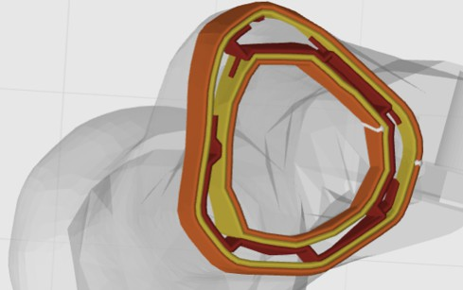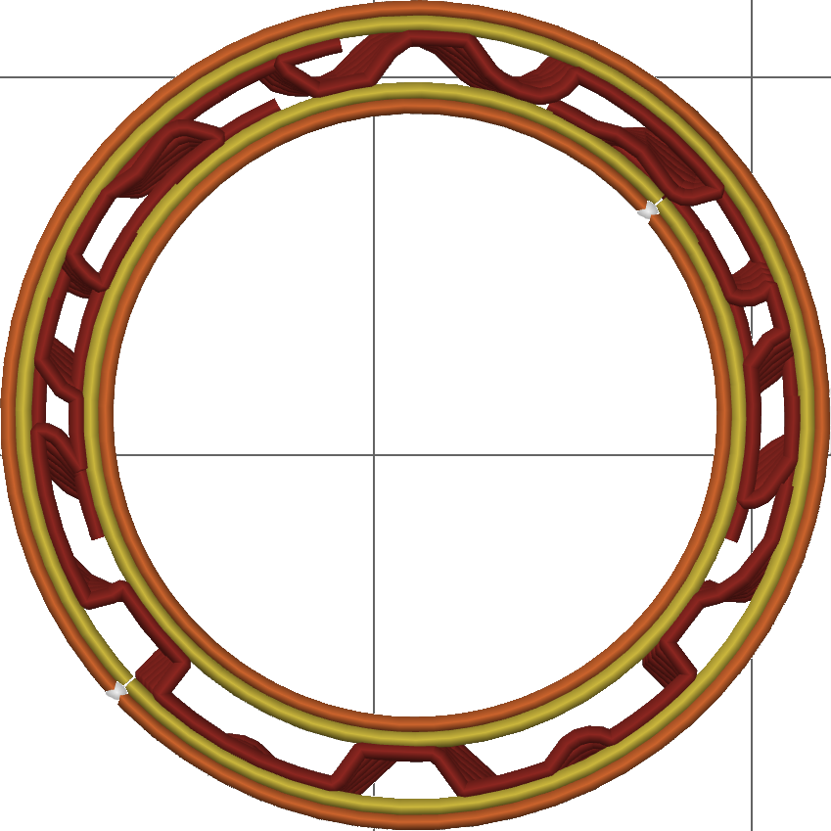
A
B
Figure S1: (A) Section of the 3D-printed radius phantom, showing cortical and medullary regions. The cortical region was printed using a gyroid infill pattern with 20% density. (B) Orthogonal projection of the 3D-printed specimen used for drilling tests. Six printed layers (each 0.16 mm thick) are visible. Colors indicate different structural components: yellow—inner wall, orange—outer wall, and red—infill. Each grid square corresponds to 10 mm; the external diameter of the test cylinder is 22 mm.

S41 S42 S43 S44 S45 S46 S47 S48 S49 S50 S51 S52 S53 S54 S55
Bone components were produced by FDM 3D printing to reproduce the geometry and mechanical response required for surgical simulation. Printing used 1.75 mm PLA filament with a nominal layer height of 0.20 mm (variable layer height applied in regions requiring improved surface finish or detail). Perimeter and infill parameters were selected to balance anatomical fidelity, printability, and realistic drill/anchor behavior: two wall loops with 0.40 mm extrusion width (effective wall thickness 0.80 mm), gyroid infill at 20% density[32, 33], and simulated cortical shell thickness in the range
1.5–3.5 mm[34]. Internally, the medullary region was printed as a hollow cavity that can optionally be filled (e.g., with foam or resin) to better reproduce radiographic and mechanical properties of native cancellous bone.
The gyroid infill pattern was chosen because its continuous, isotropic lattice approximates tra-becular architecture while remaining highly printable and providing meaningful resistance during drilling and screw insertion. Post-processing consisted of support structure removal followed by light surface finishing (200-grit sandpaper) to remove print artifacts and improve fit between bone and surrounding soft-tissue components. All dimensions and print parameters were recorded in the manufacturing log.

S56

S57 S58 S59 S60 S61 S62

S1.2.3 Soft Tissue Simulation and Assembly
The soft-tissue component was manufactured to reproduce both geometric detail and tactile com-pliance of human tissue for orthopedic simulation and AR-guided procedures. Anatomical geometry (bones, vasculature, and nerves) was extracted from the Z-anatomy digital model and processed in Blender and CAD environments to produce a split-mold design; surgical planning (K-wire trajec-tories) and mold geometry are illustrated in Fig. S2.1–4, and the assembled 3D-printed mold with positioned bones is shown in Fig. S2.5.

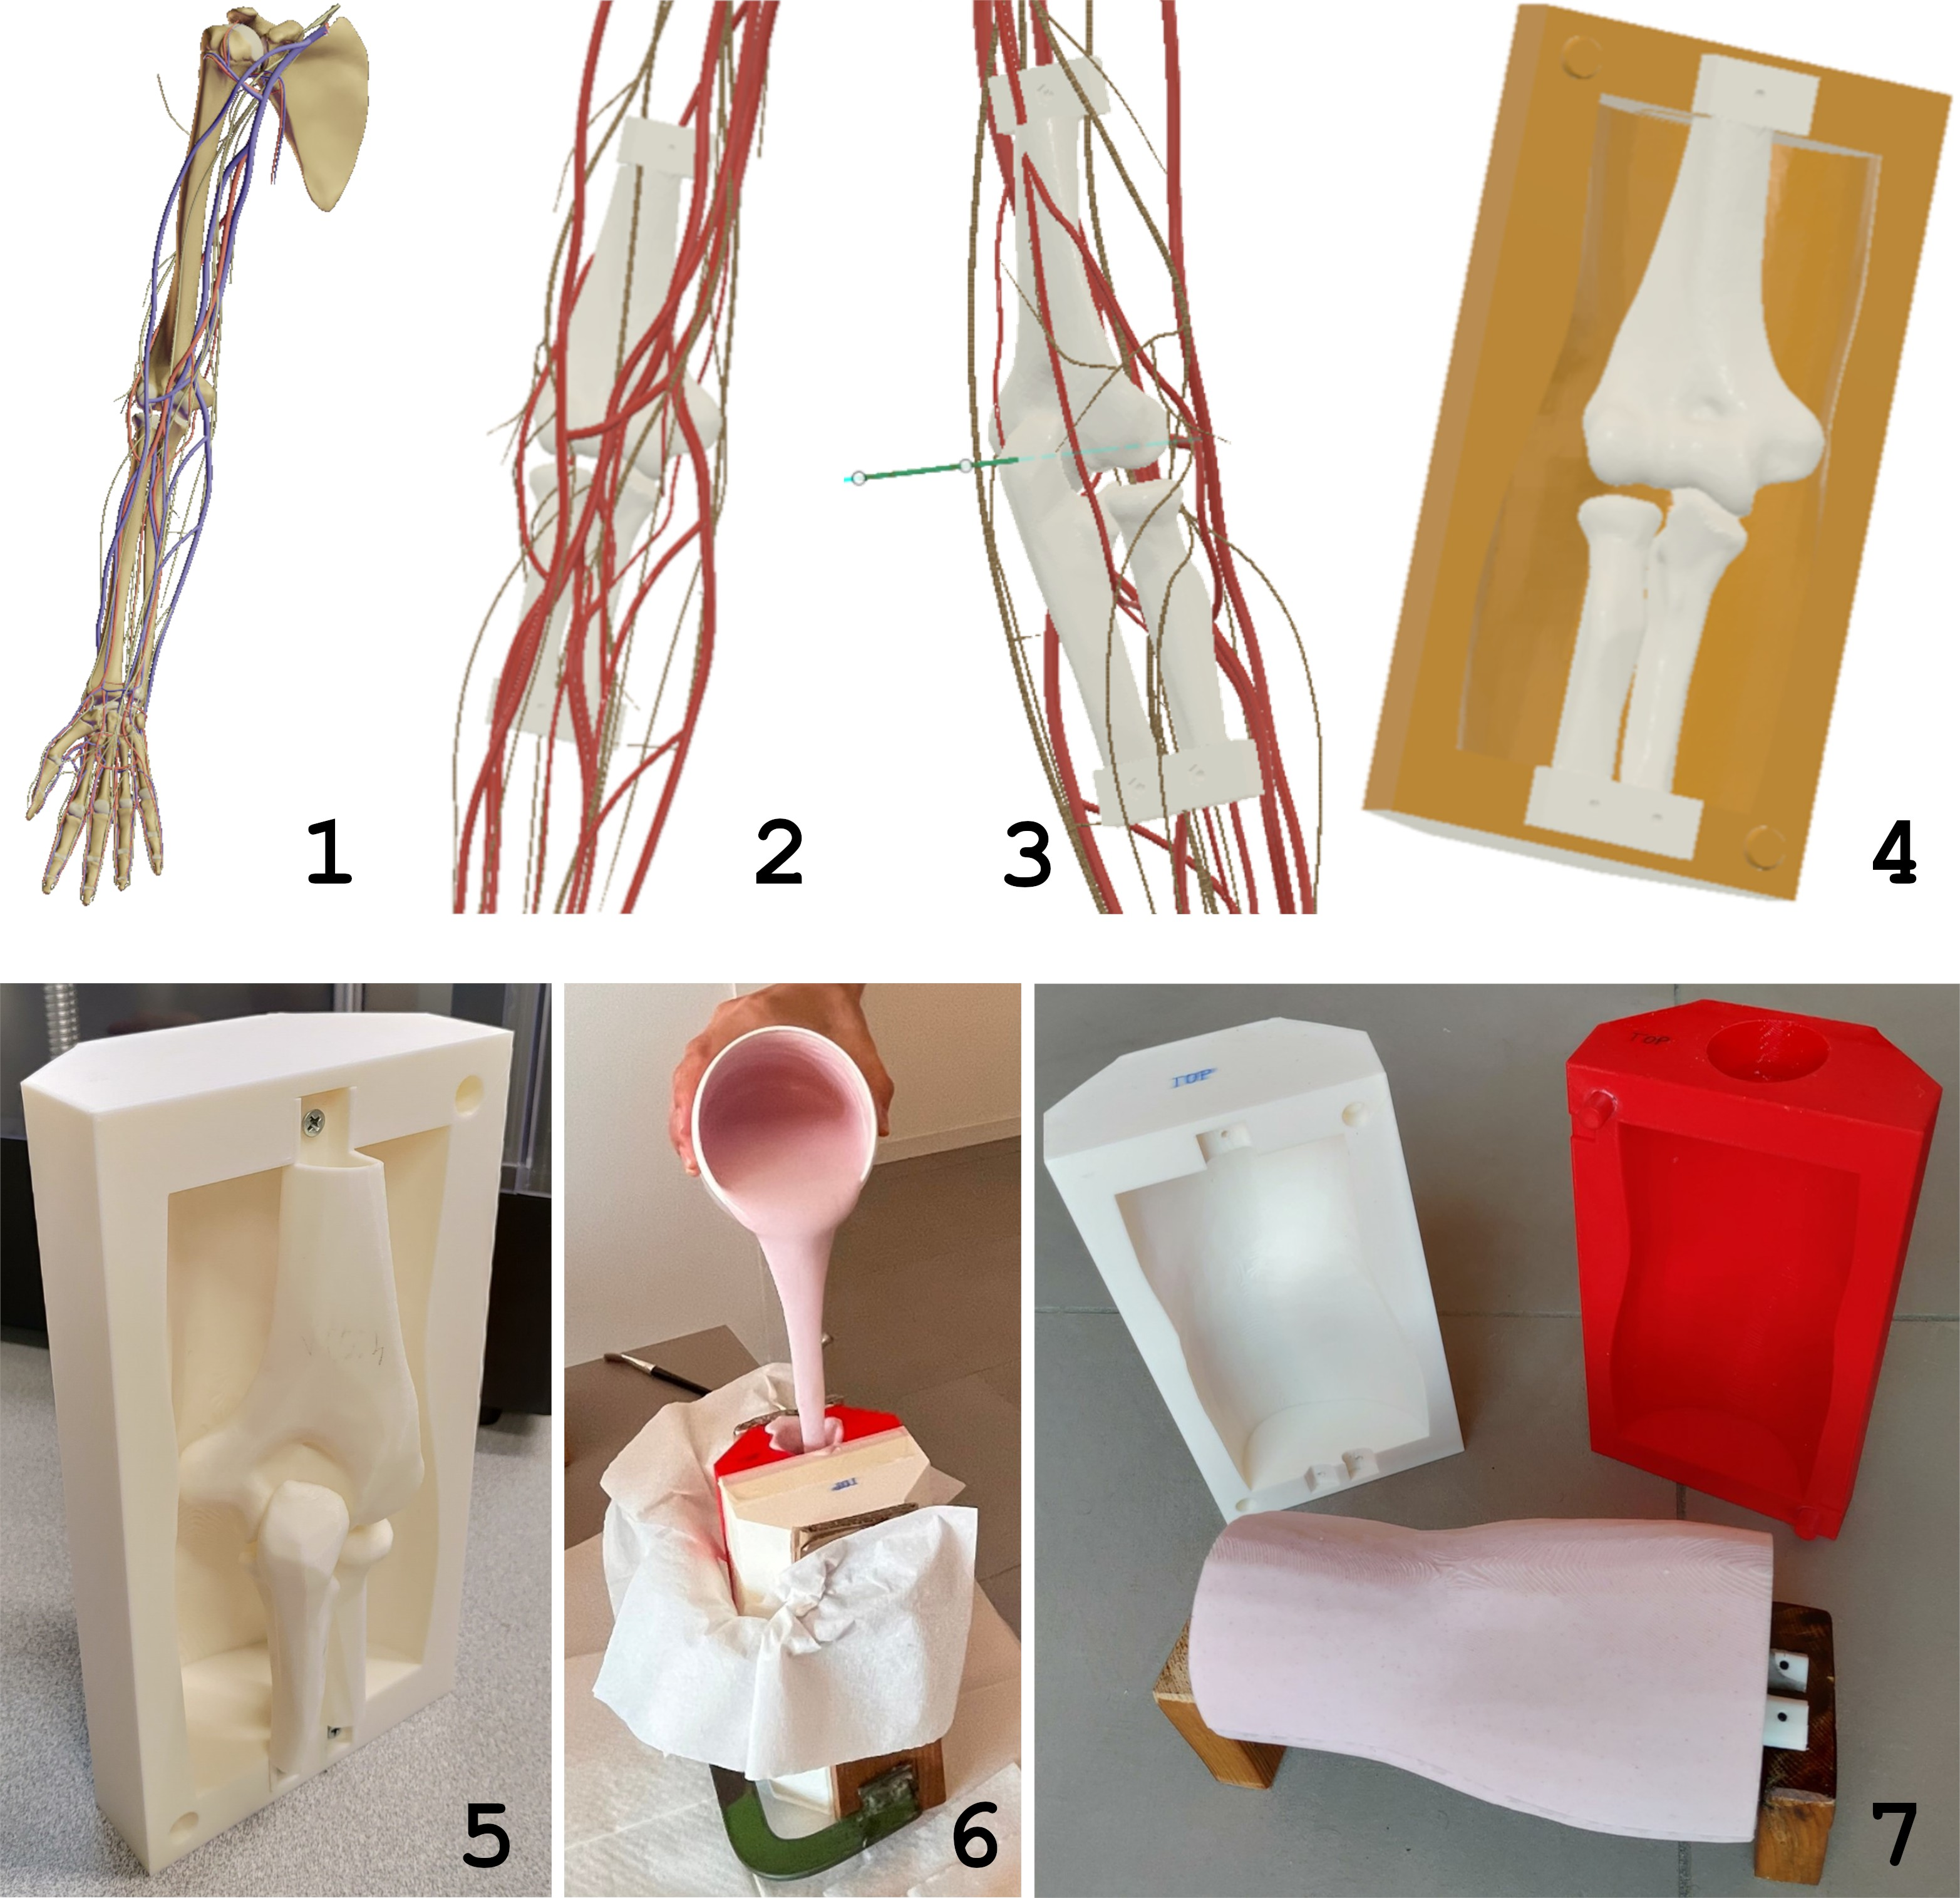
Figure S2: Phantom manufacturing workflow. (1) Z-anatomy digital model extraction of right upper limb including bones, vasculature, and nerves. (2) Blender-processed anatomical segment focusing on elbow region. (3) Fusion 360 surgical planning interface showing K-wire placement trajectory in green. (4) CAD model of split-mold design for soft tissue casting. (5) 3D-printed mold assembly with bones positioned for casting. (6) RTV silicone casting process in closed mold configuration. (7) Final phantom after mold removal and surface finishing.[24]

S63 S64 S65 S66 S67 S68 S69 S70 S71 S72 S73 S74 S75 S76 S77 S78 S79 S80 S81 S82 S83 S84 S85 S86 S87 S88
Materials and appearance. Soft tissue was cast from RTV silicone (see Section S1.1) selected to approximate soft-tissue compliance (Shore A∼5). The silicone base was combined with the manufacturer-recommended catalyst and 1% by weight red food coloring (E124) to achieve a skin-like appearance prior to pouring. Bone, vascular, and neural components were positioned inside the split mold using dedicated alignment guides to ensure anatomical fidelity and repeatable placement during casting (Fig. S2.5).
Registration markers. To permit accurate spatial co-registration between the physical phan-tom and its virtual counterpart (e.g., during AR guidance), ten surface reference markers were embedded in the molds: five on the dorsal surface and five on the volar surface. The markers were integrated at known locations in the CAD model so that their coordinates in the physical phantom correspond directly to the virtual model used for planning and validation.
Molding and curing workflow. The molding procedure was performed as a single controlled sequence: (1) the lower mold half was placed on a vibrating table to promote degassing and reduce entrapped air at the bone–silicone interface; (2) prefabricated bone components were seated in the lower mold using alignment guides and checked for correct orientation and depth; (3) the mixed silicone (base + catalyst + colorant) was poured in a controlled manner to minimize turbulence and air entrapment (see Fig. S2.7); (4) the upper mold half was closed and secured using compression clamps to maintain registration of internal components during cure; and (5) the assembly underwent a complete cure cycle under controlled environmental conditions (temperature and humidity per the silicone manufacturer’s recommendations).
Demolding and finishing. After full cure, the mold was disassembled, the phantom was demolded, and excess material was removed. Final surface finishing and visual inspection were performed to verify anatomical detail and marker integrity (Fig. S2.7). Dimensional and visual con-cordance between the physical phantom and virtual model were confirmed by registering embedded surface markers to the digital dataset; these checks ensured the manufactured phantom was suitable for subsequent AR-guided validation and orthopedic simulation studies.[24]

S89 S90
S91 S92 S93 S94 S95 S96 S97 S98 S99

S1.3 Sample Descriptions

S1.3.1 Biological Bone Specimens
Real animal bone specimens and commercial synthetic bone surrogates served as anatomical refer-ences and ground-truth comparisons for drill resistance and X-ray imaging behavior.
The biological specimens consisted of bovine ribs, bovine vertebrae, and ovine vertebrae, each selected for distinct cortical thickness, curvature, and internal architecture. Bovine ribs were exam-ined both intact and in cross-sections exposing the medullary cavity, enabling evaluation of corti-cal–trabecular contrast. Vertebrae from bovine and ovine sources provided complex 3D geometry and thick cortical regions characteristic of axial skeletal structures.
A commercial synthetic tibia (Sawbones@) was included to provide a standardized, reproducible benchmark with known material properties, commonly used in biomechanical and imaging research.

Code (file name) Sample
b cowrib1 Cow rib 1
b cowrib1 medullary Cow rib 1 (drilled axially) b cowrib2 Cow rib 2
b cowrib3 Cow rib 3
b cowrib4 Cow rib 4
b cow vertebra Bovine vertebra b sheep vertebra Sheep vertebra
s sawbone tibia Synthetic tibia (Sawbones)

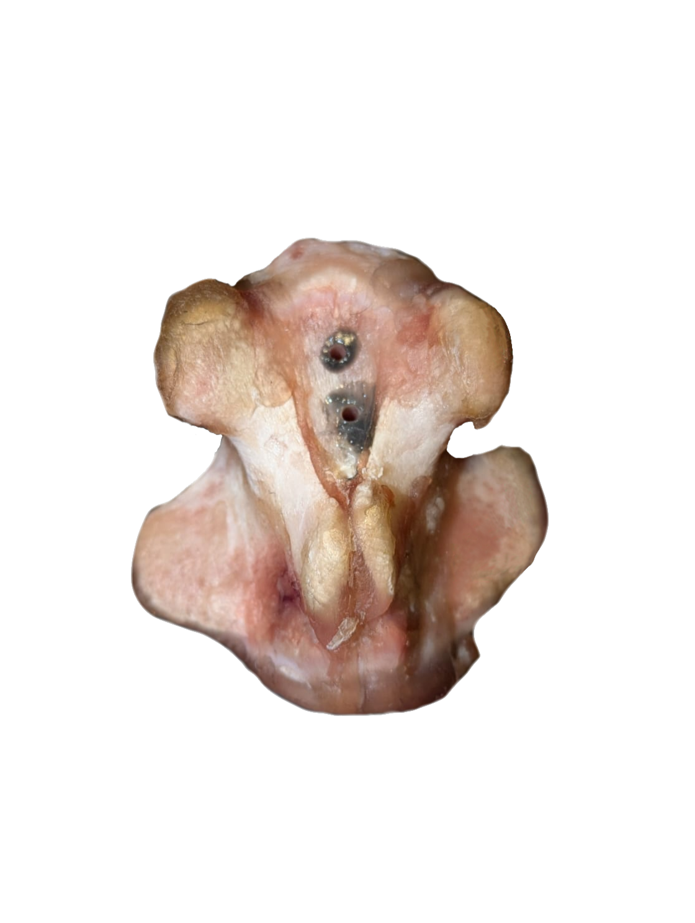
Table S1: Real bone and synthetic bone samples used for drill resistance analysis. These specimens are referenced throughout the main text (see Section 2.3 in the main article).
A

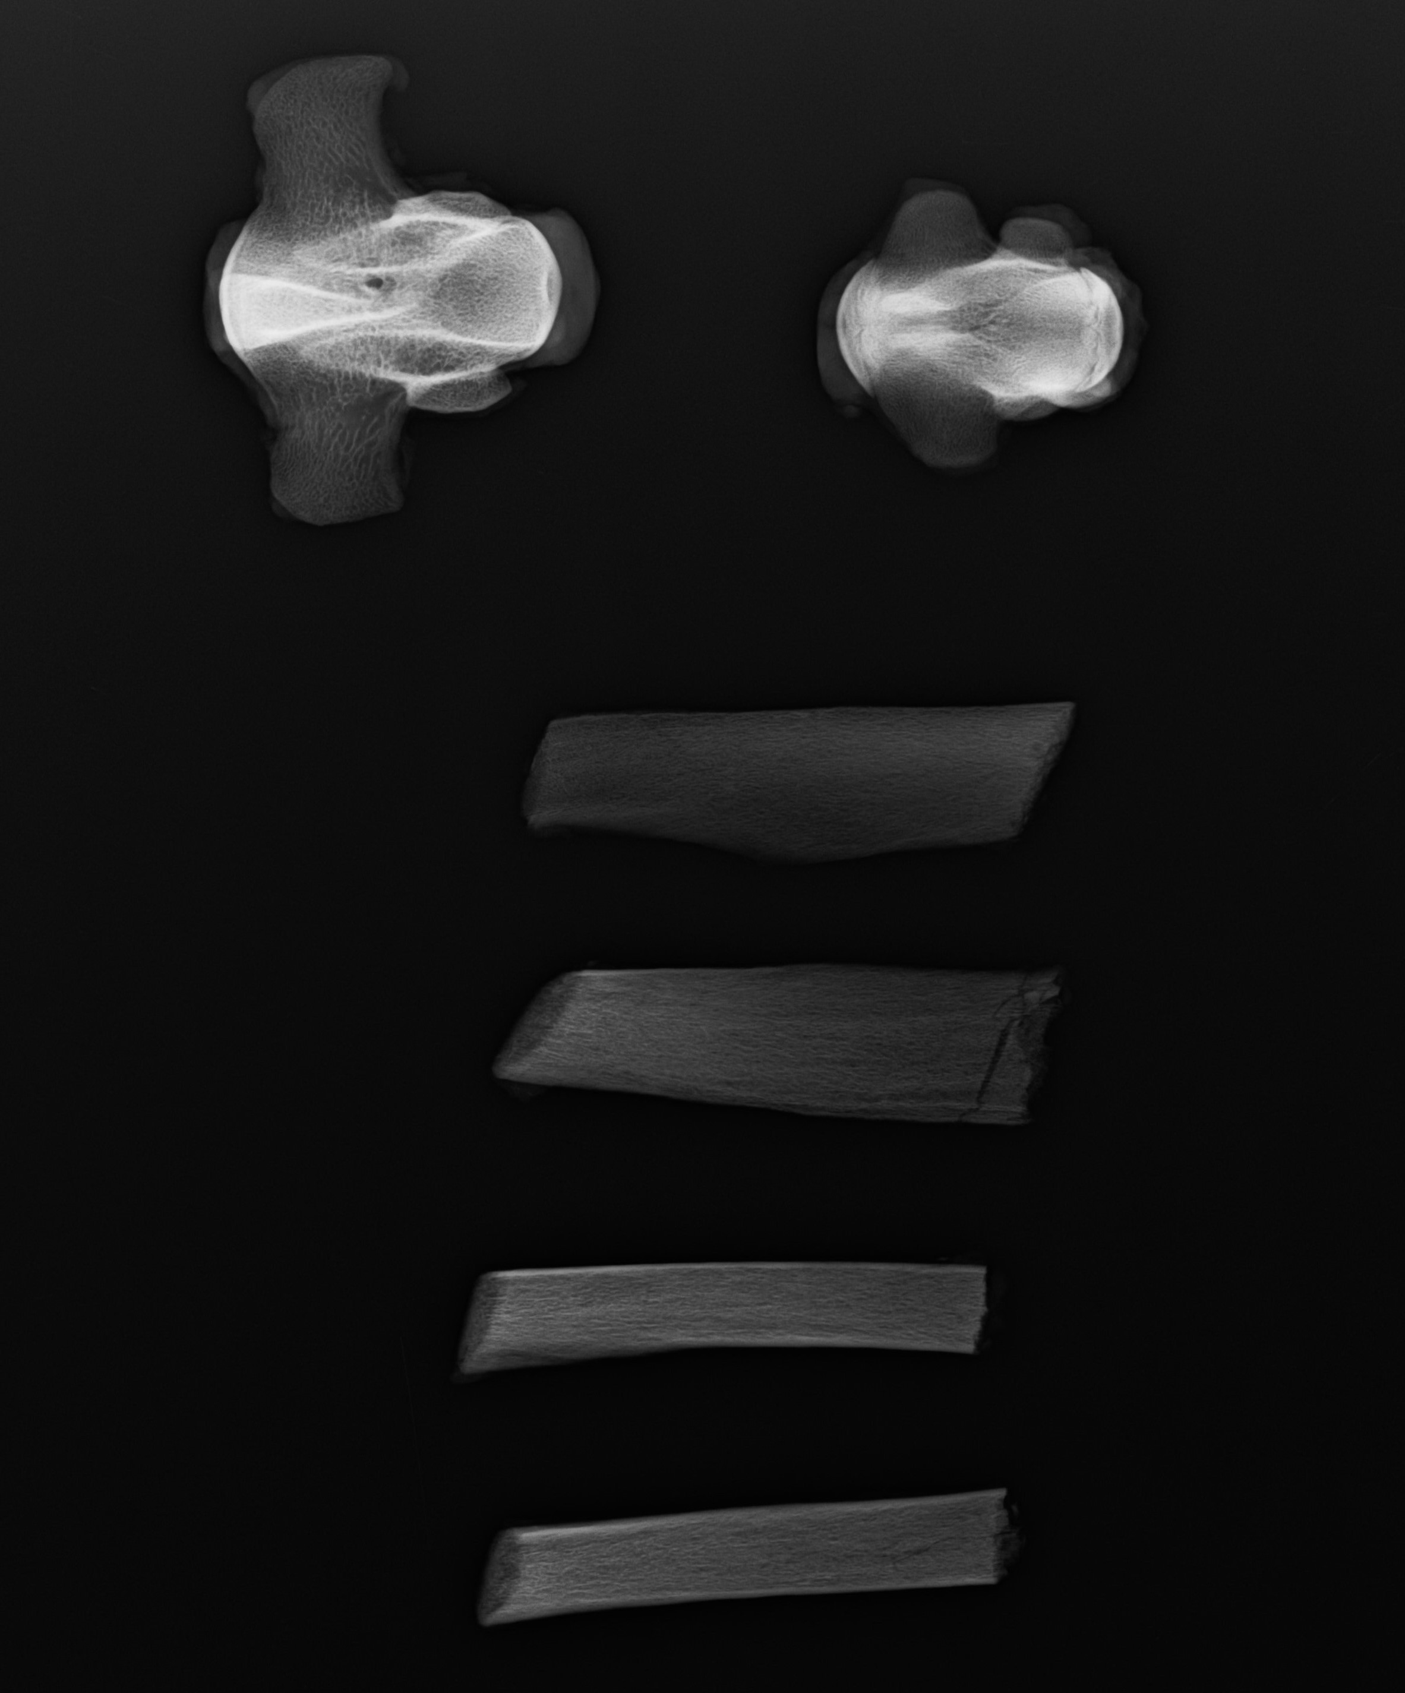
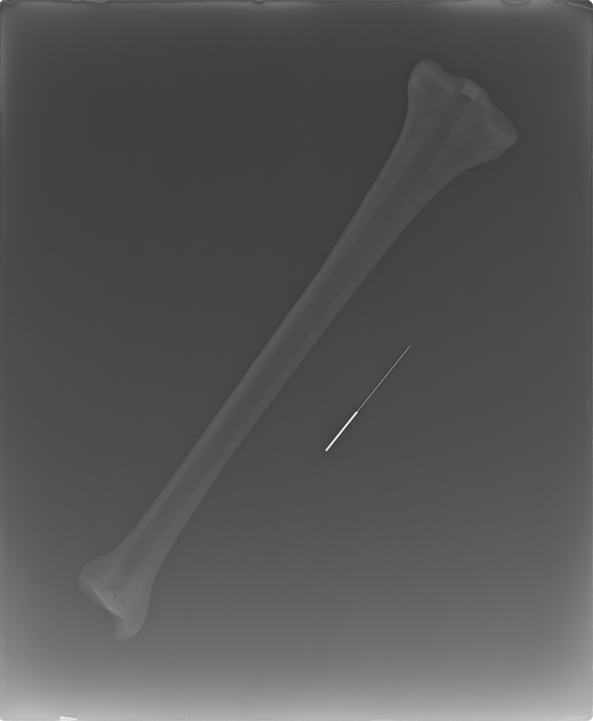
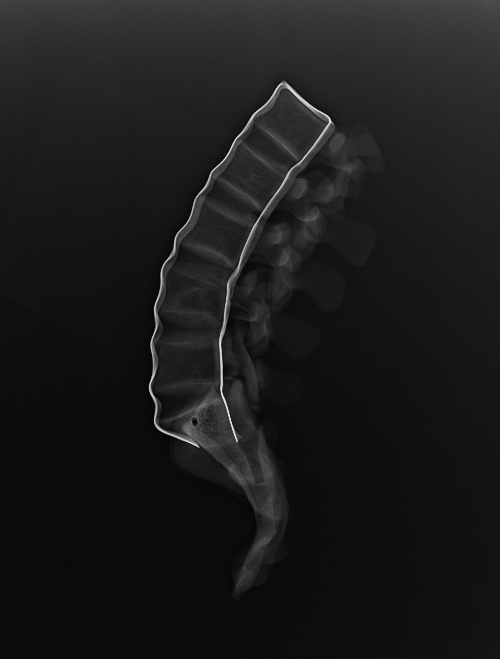
B
C
D
Figure S3: Representative real bone specimens: (A) bovine vertebra; (B) bovine and sheep vertebrae and bovine ribs (samples b cowrib1–4 as listed in Table S1); (C) synthetic tibia (Sawbones); (D) lumbar spine segment.

S100

S101 S102 S103 S104 S105 S106

S1.3.2 Phantom bones
Standard AP and LAT radiographs were acquired for each phantom bone configuration (p A–p D) and a PLA-only plastic control using the clinical setup described in Section 2.2.1 of the main article. These images qualitatively assessed cortical–trabecular contrast, overall attenuation, and the effect of different medullary fillings on intramedullary structure visibility. The full set of radiographs is reported in Section S2.1 (Fig. S6), providing a side-by-side comparison of how chalk–silicone mixtures and steel wool alter the radiographic appearance relative to unfilled and PLA-only bones.

S107 S108 S109 S110 S111 S112 S113 S114 S115 S116 S117 S118 S119 S120
Four phantom bone configurations were fabricated to evaluate medullary fill composition effects on mass distribution and radiographic appearance. Table S2 summarizes fill materials, bone masses, and relevant observations. All phantom bones were printed using PLA+Copper filament as described in Section S1.1.
Phantom p A served as the baseline configuration with unfilled medullary cavities. Phantoms p B and p C incorporated powdered chalk–silicone mixtures (2:3 and 1:3 w/w ratios, respectively) infiltrated into the medullary cavity by centrifugation to approximate trabecular bone density and radiographic attenuation. During fabrication of p B, a fracture occurred on the humerus component. Phantom p D utilized hollow bone structures with steel wool distributed within the medullary cavity to evaluate discrete radiopaque inclusion effects on imaging characteristics.
Drilling analysis was not performed directly on these anatomical bone phantoms but rather on standardized cylindrical specimens described in Section S1.3.3.
The most relevant printing parameters were: layer height 0.16 mm, line width 0.42 mm, three top shell layers, three bottom shell layers, sparse infill density 20%, and gyroid sparse infill pattern.

Table S2: Phantom bone configurations with medullary fill compositions and measured masses.

Phantom Fill Humerus Radius Ulna Notes
p A no medullary fill 40.11 g 16.26 g 22.84 g —

p B powder chalk + sili-cone (w/w — 2 g / 3 g)
p C powder chalk + sili-cone (w/w — 1 g / 3 g)
66.17 g 19.33 g 28.66 g silicone infiltrated by
centrifugation; frac-ture on humerus
66.30 g 17.80 g 25.75 g silicone infiltrated by
centrifugation

p D steel wool 45.10 g 18.29 g 25.56 g —

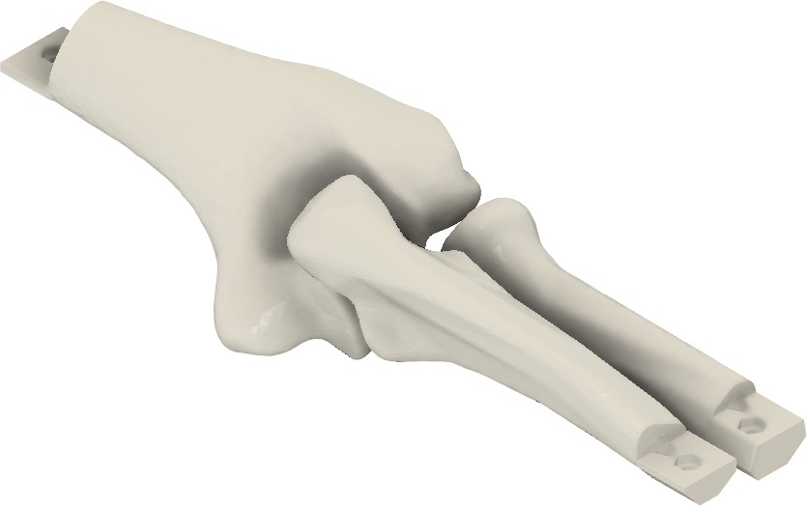
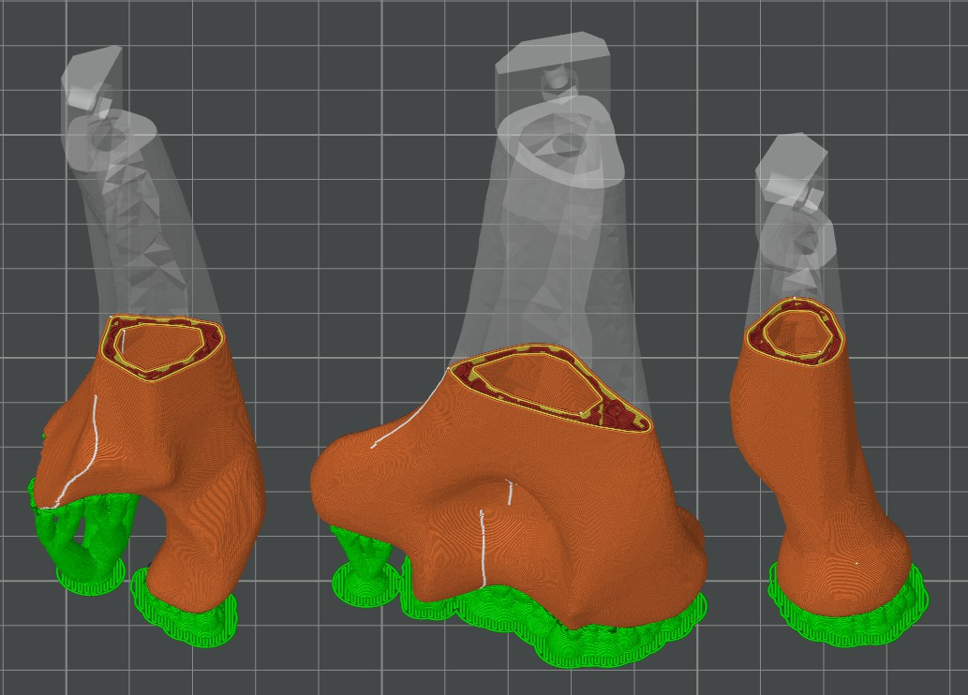
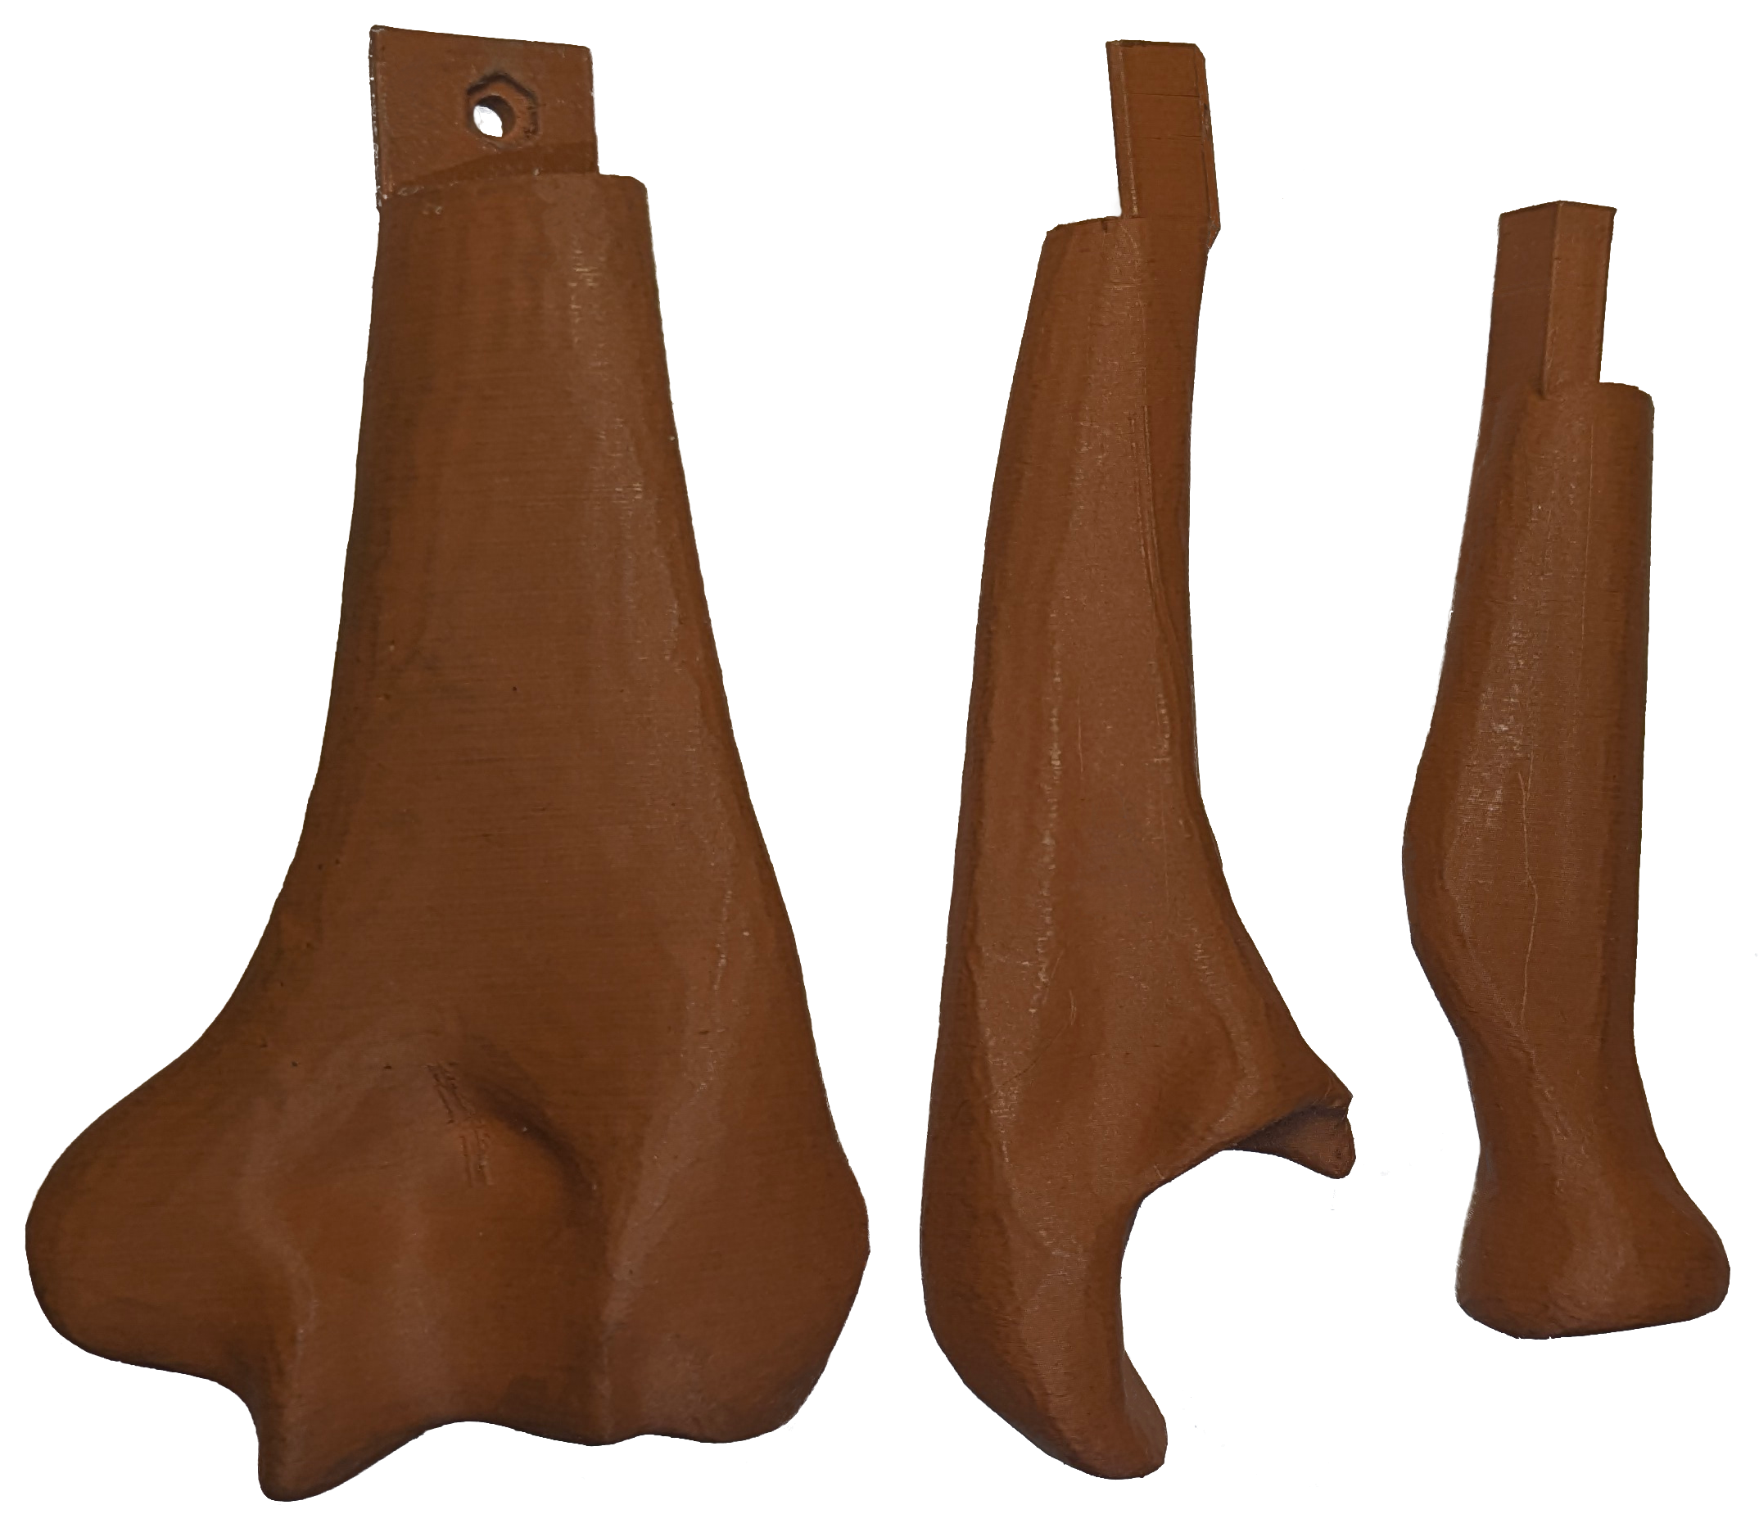
A
B
C
Figure S4: Phantom bone fabrication workflow. (A) CAD model of the elbow bone set (humerus, radius, and ulna) designed for 3D printing. (B) 3D-printed bone components in standard PLA filament. (C) Final PLA+Copper printed bone set used for radiographic evaluation.

S121

S122 S123 S124 S125 S126 S127 S128 S129 S130

S1.3.3 Cylindrical Bone Surrogates
Cylindrical bone surrogate samples were additively manufactured using either standard PLA or PLA reinforced with copper particles (see Section S1.1). Each sample consisted of a hollow cylindrical structure designed to approximate a simplified long bone diaphysis: outer diameter 22 mm, inner diameter 16 mm, resulting in a cortical wall thickness of 3 mm. Printing parameters were standard-ized: three top and three bottom shell layers, top shell thickness 0.6 mm, and 20% gyroid sparse infill to mimic low-density trabecular bone.
To investigate the influence of both printing material and intramedullary filling on imaging ap-pearance and attenuation properties, samples were produced according to the matrix in Table S3. For each sample category (A–D), two versions were printed: one in PLA and one in PLA+Copper.

S131 S132 S133 S134 S135 S136 S137 S138 S139
The internal cavity was left unfilled (A), or filled with one of three materials intended to approxi-mate different intramedullary compositions: powdered chalk–silicone mixture (2:3 w/w), powdered chalk–silicone mixture (1:3 w/w), or steel wool (B–D, respectively).
Representative images are shown in Fig. S5: (A) original 3D model; (B) fabricated 3D-printed structure; (C) X-ray image demonstrating expected radiopacity of the cortical shell; (D) assembled physical sample with fill material where applicable.
This set of cylindrical phantoms enabled systematic evaluation of how filament composition and intramedullary fillings affect structural integrity, ultrasound visibility, and radiographic attenuation characteristics.

Sample PLA PLA+Copper Fill material
- c A1 c A2 Unfilled (hollow)
- c B1 c B2 Powdered chalk:silicone (2:3 w/w)
- c C1 c C2 Powdered chalk:silicone (1:3 w/w)
- c D1 c D2 Steel wool

Table S3: Cylindrical test sample matrix for PLA and PLA+Copper filaments (see Section S1.1).

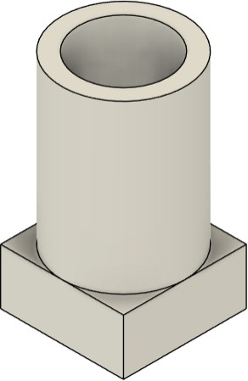
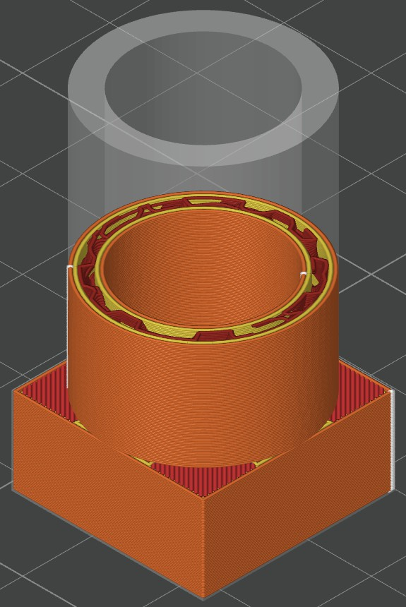
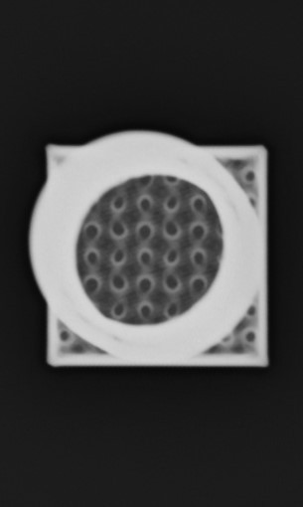
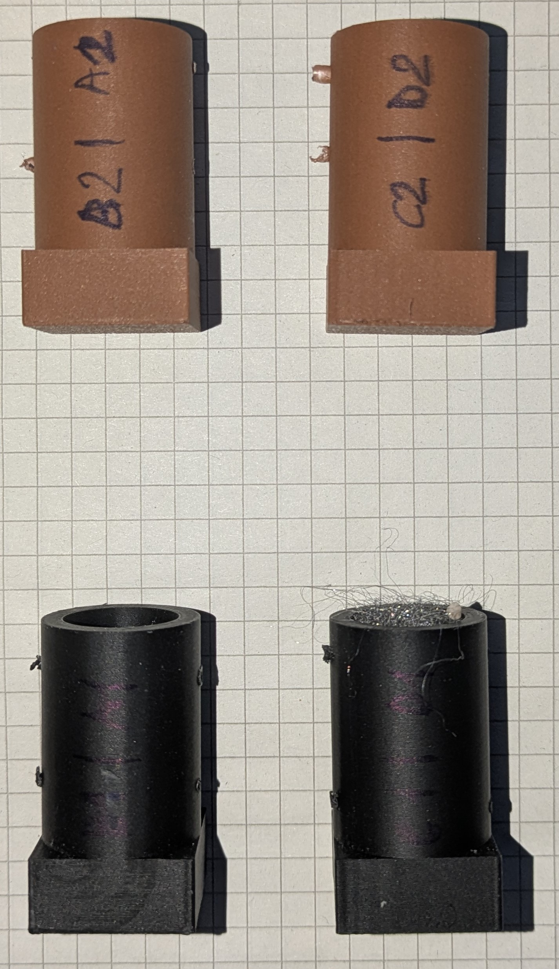
A
B
C
D
Figure S5: Representative cylindrical bone samples. (A) 3D design; (B) 3D-printed model; (C) X-ray image of the sample; (D) physical sample.

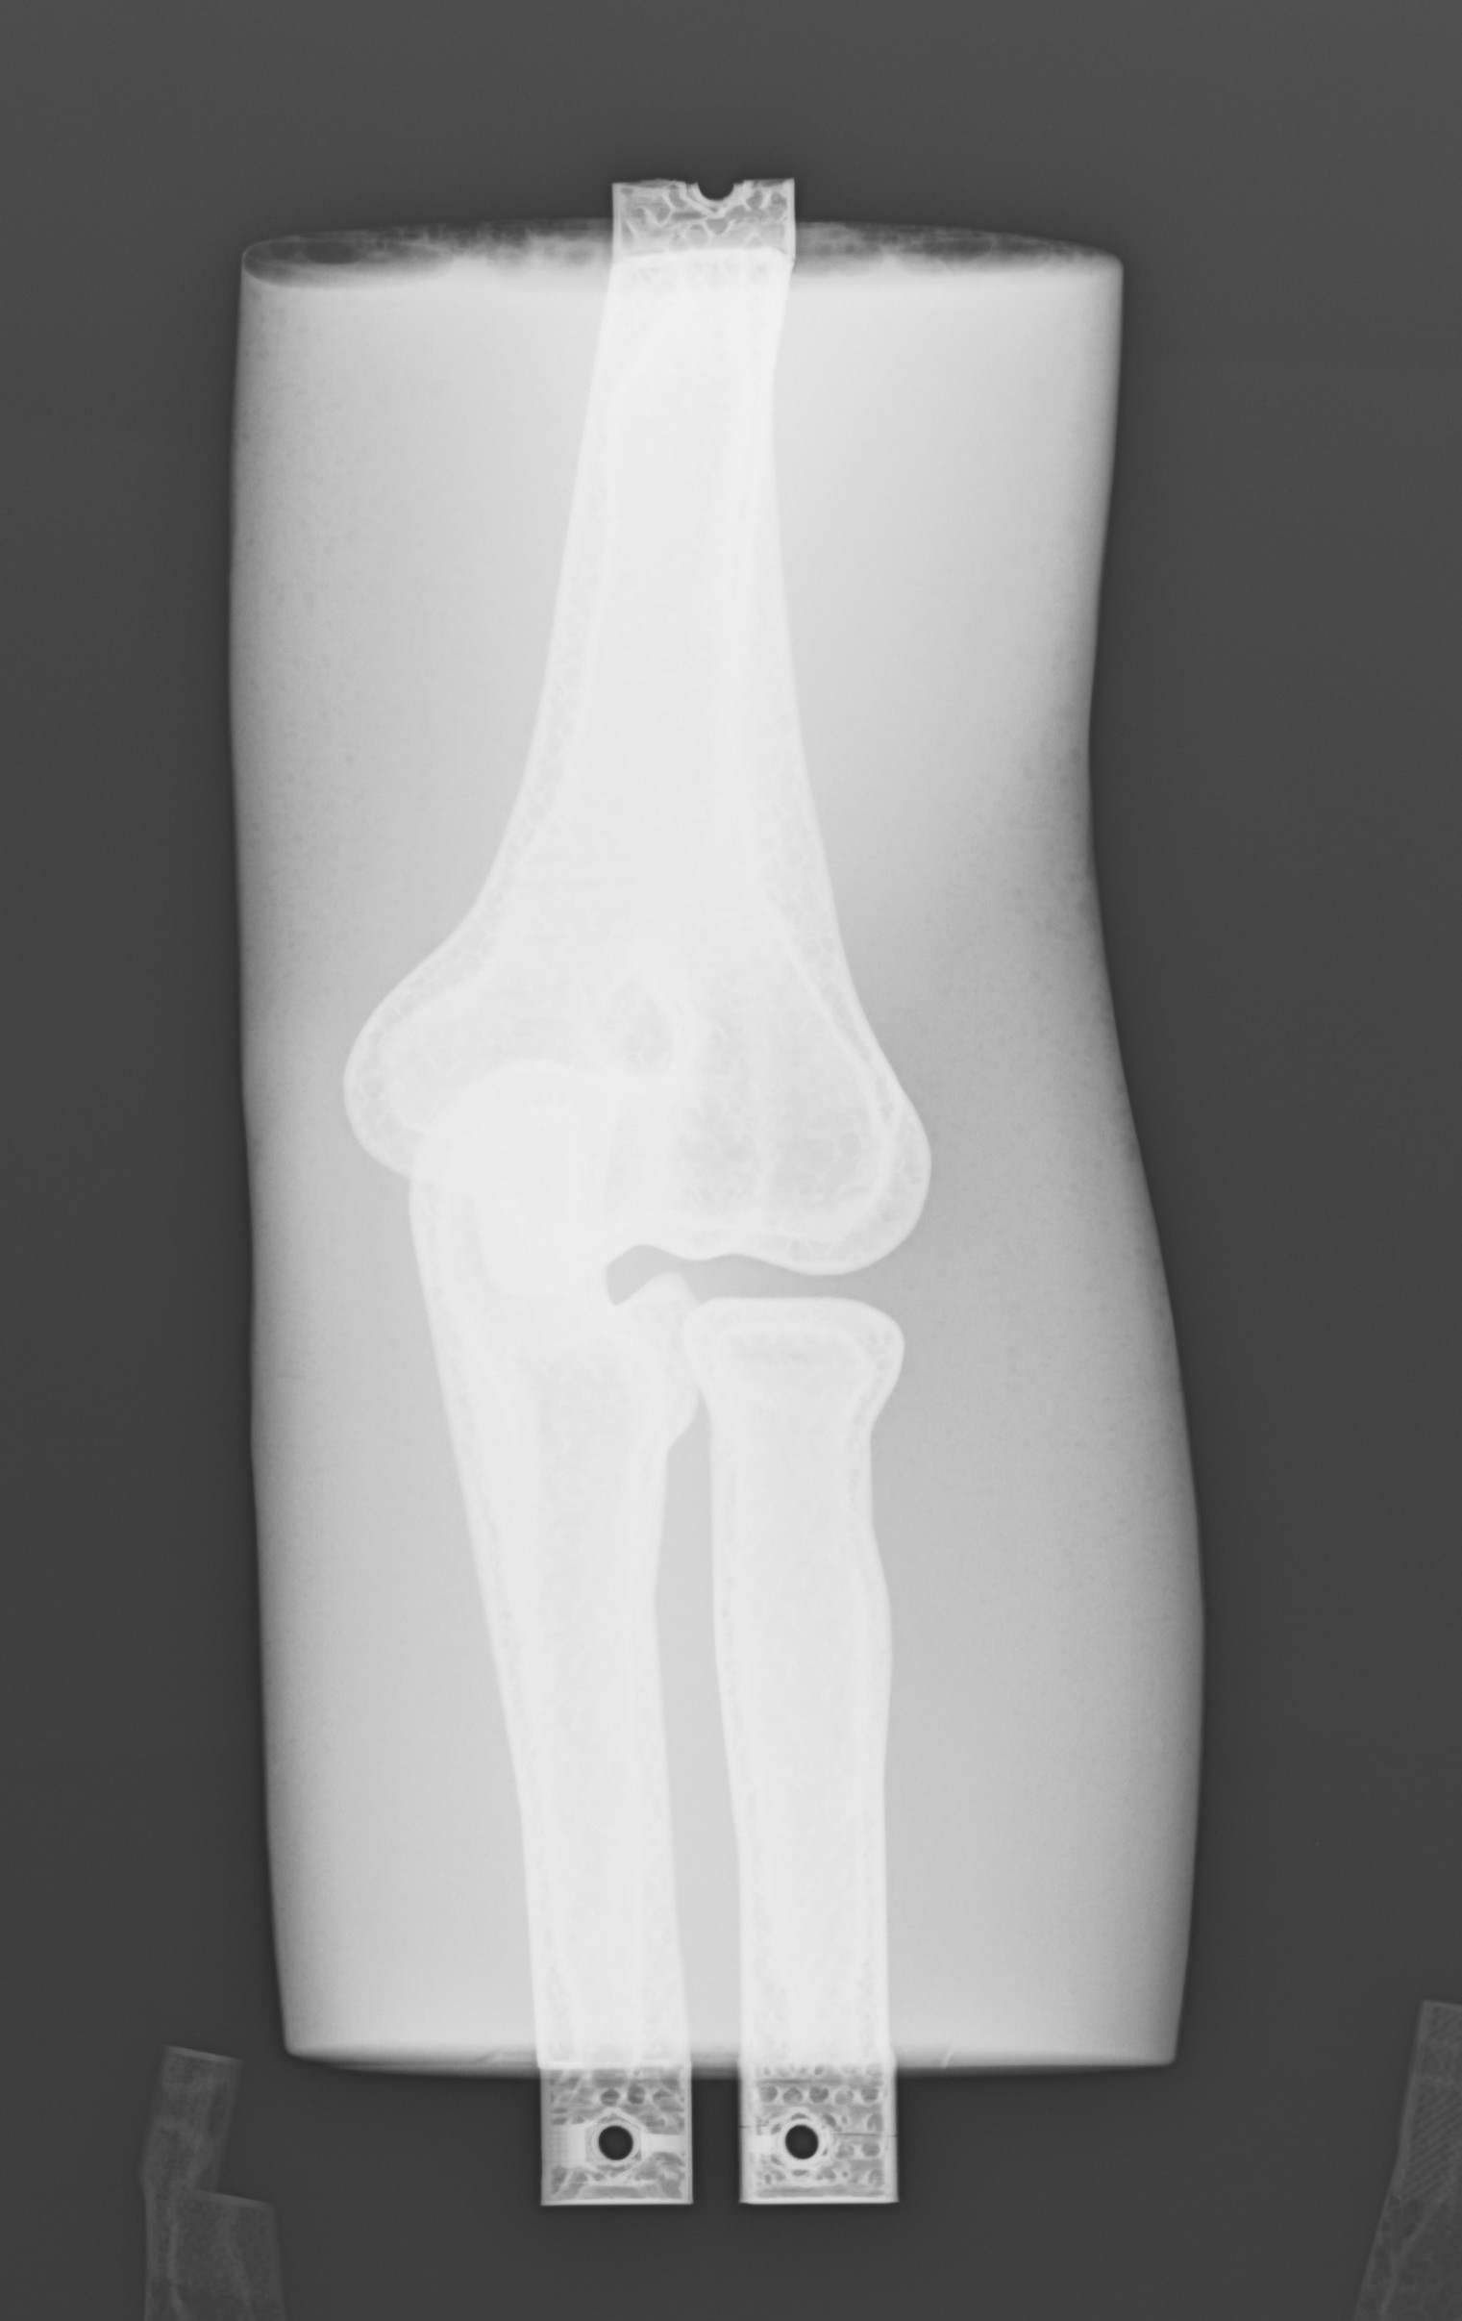
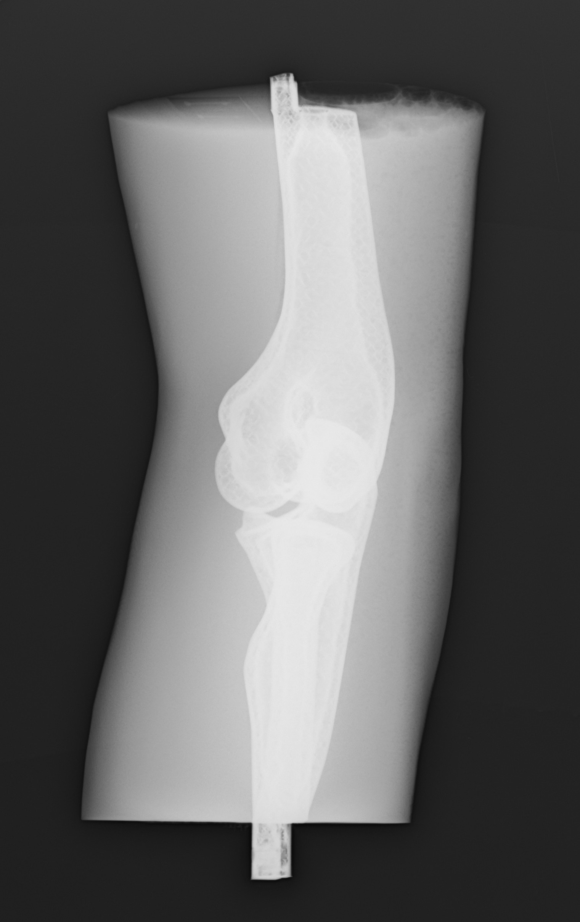
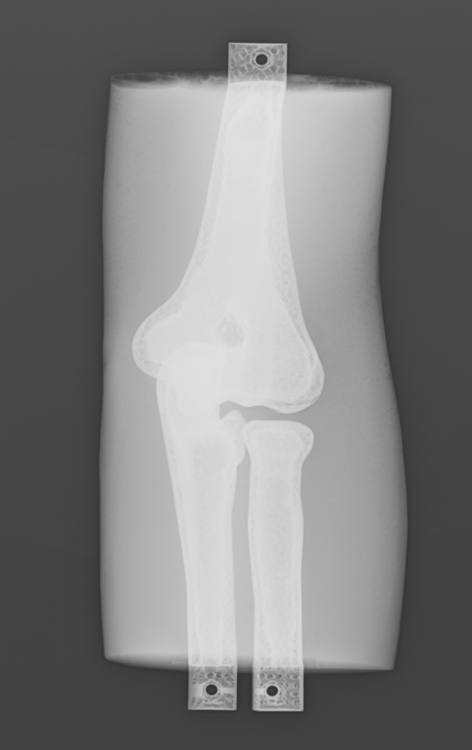
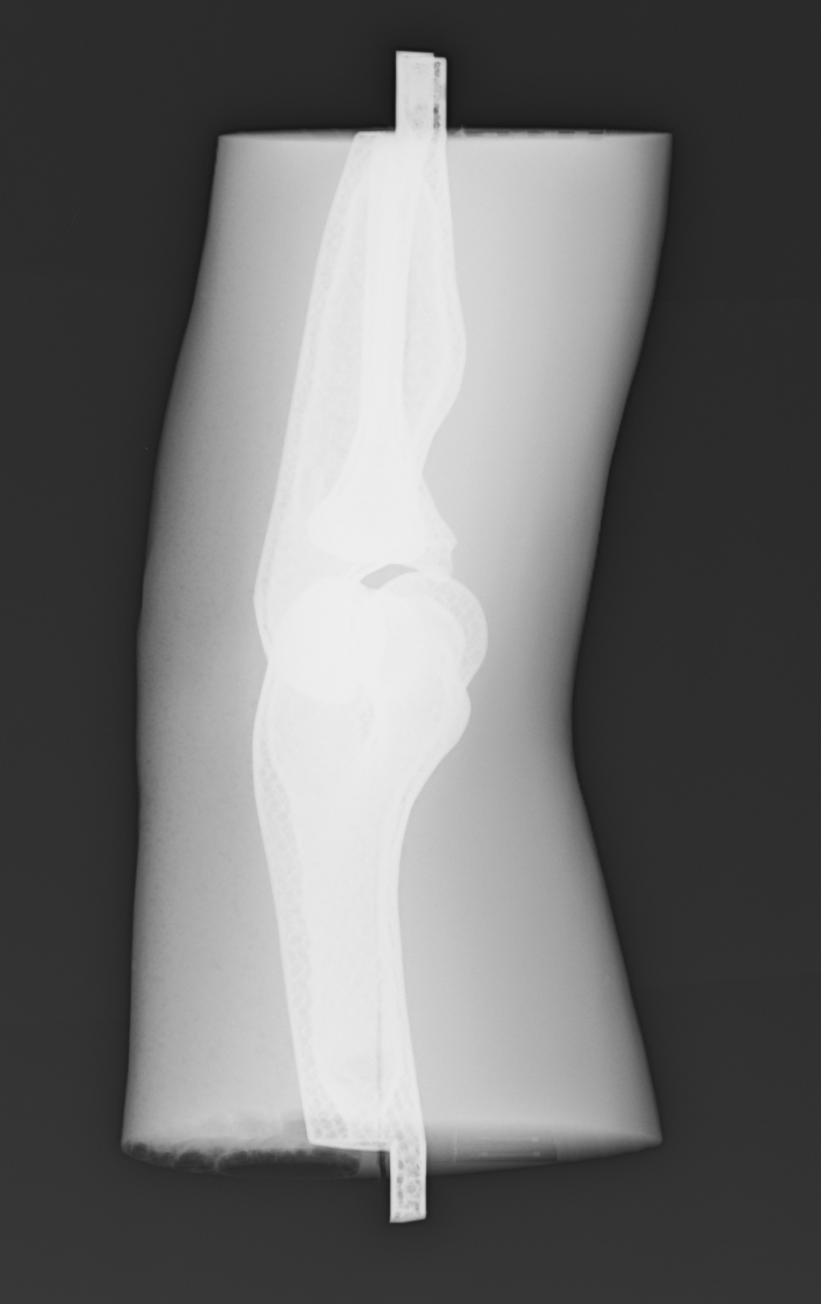
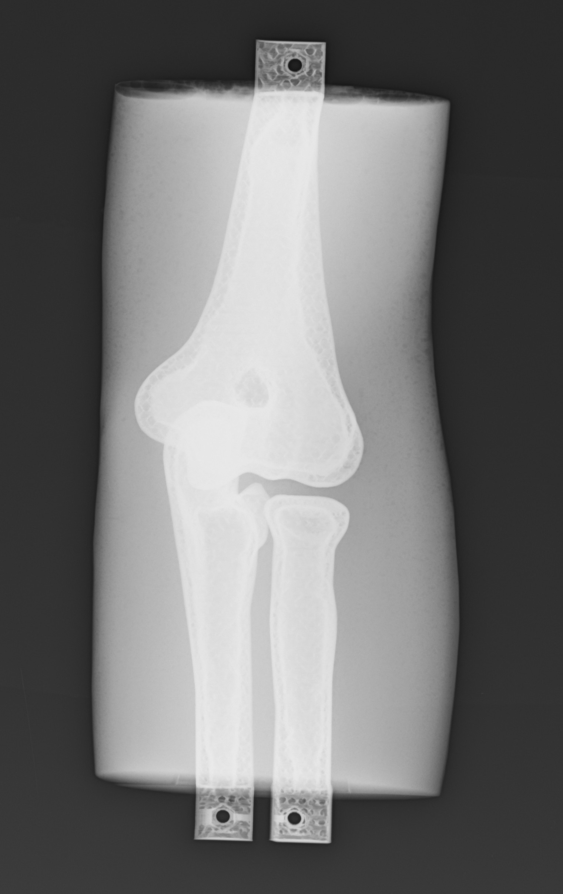
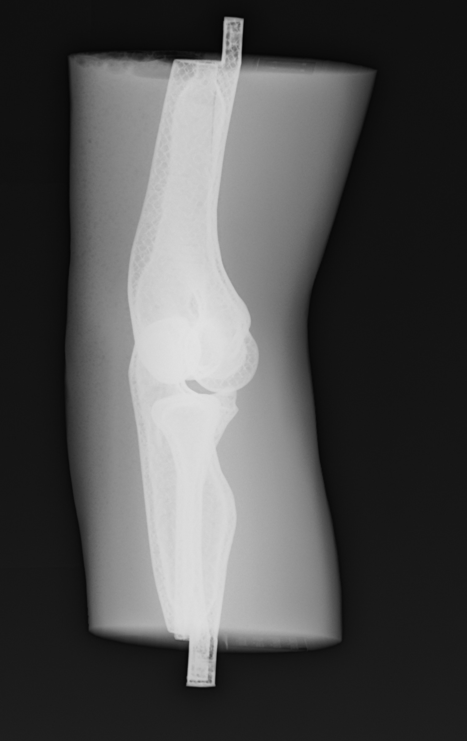
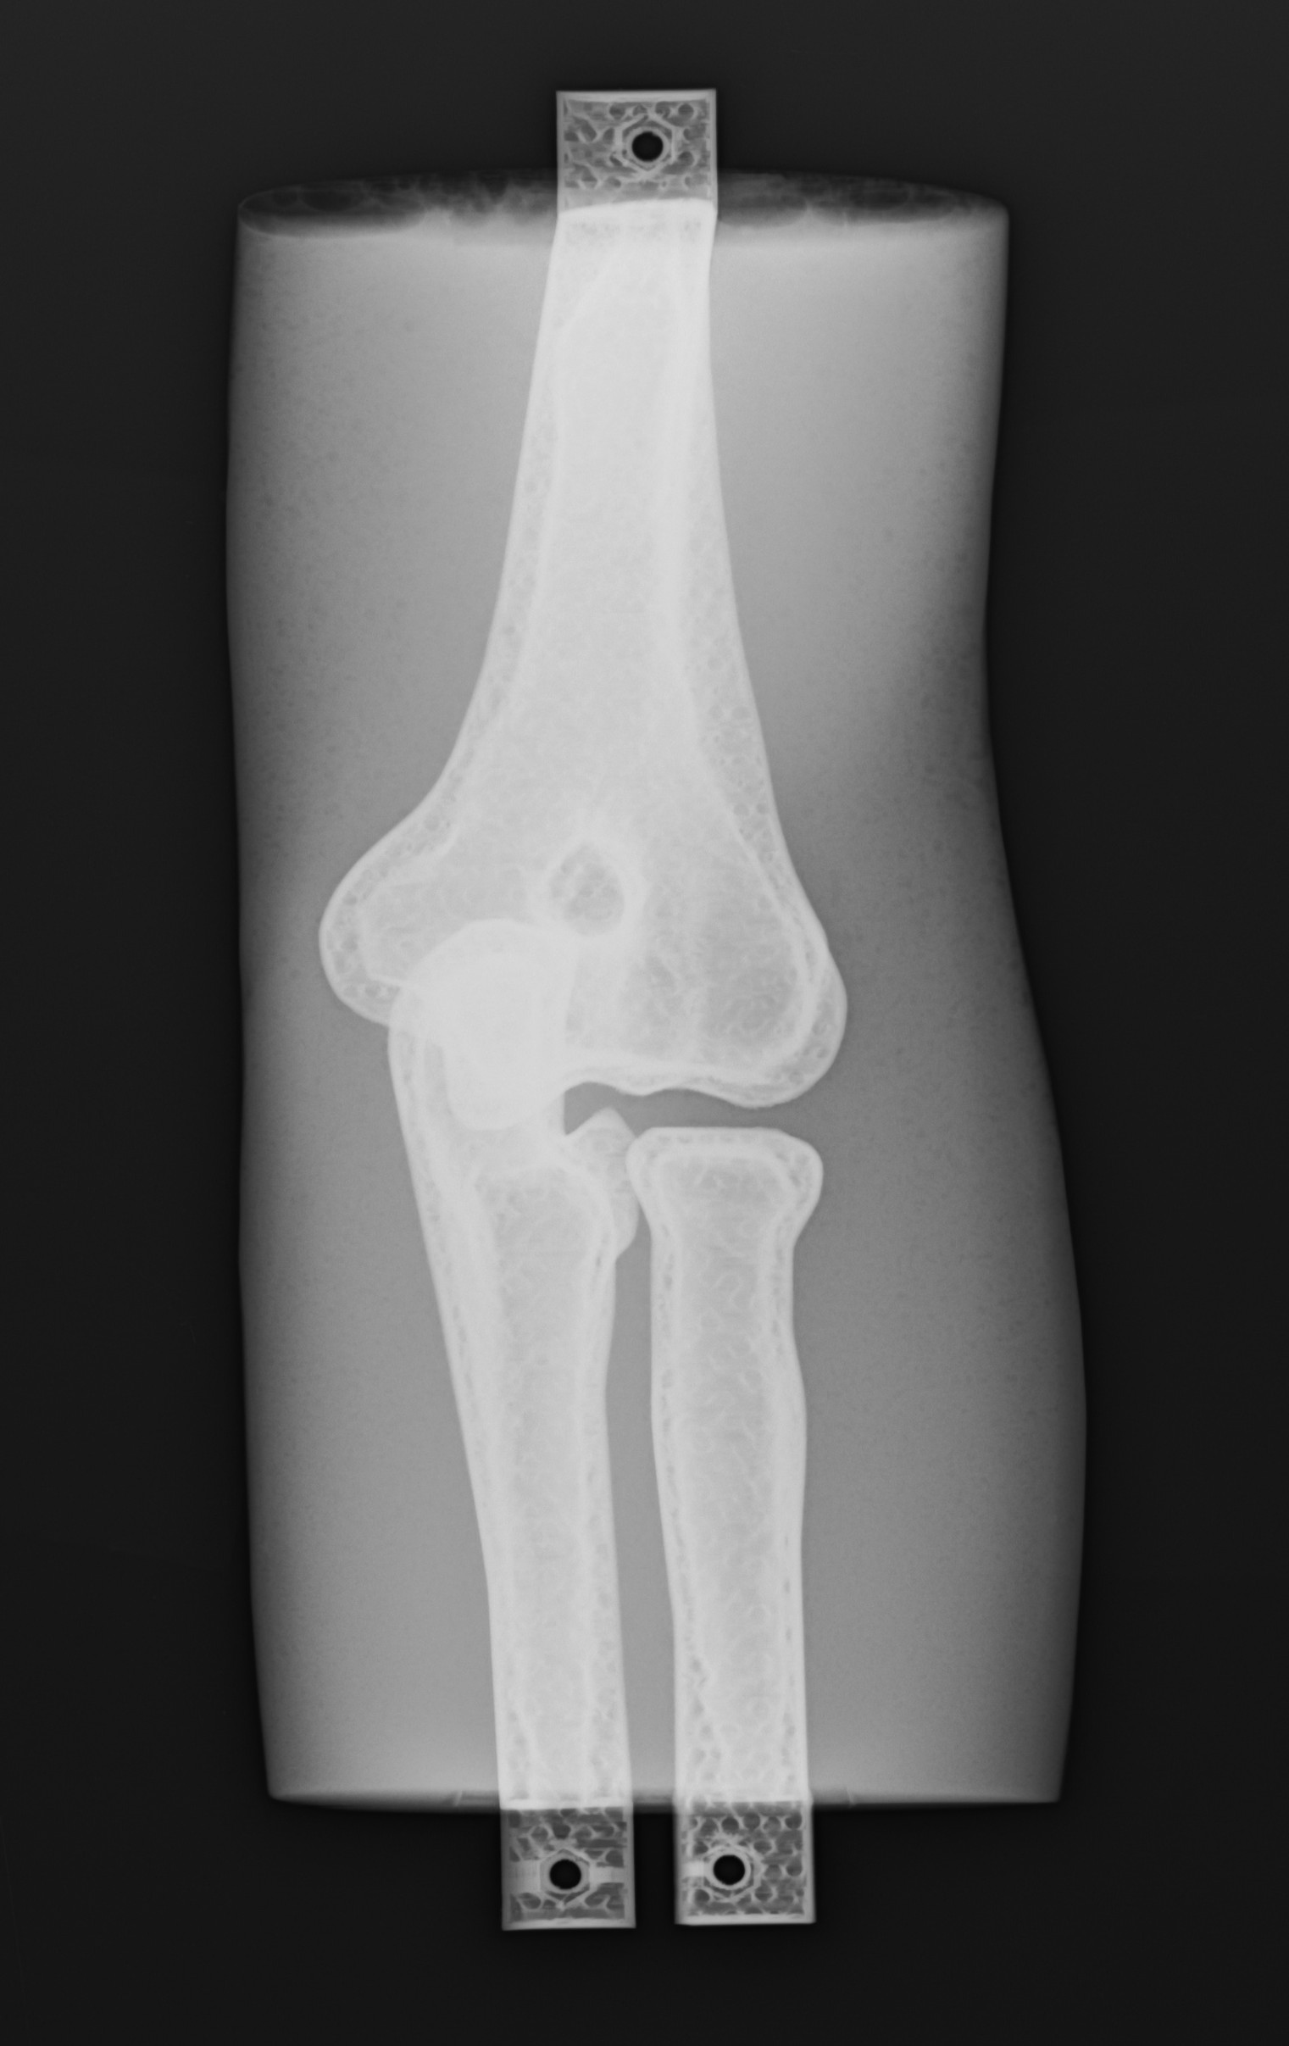
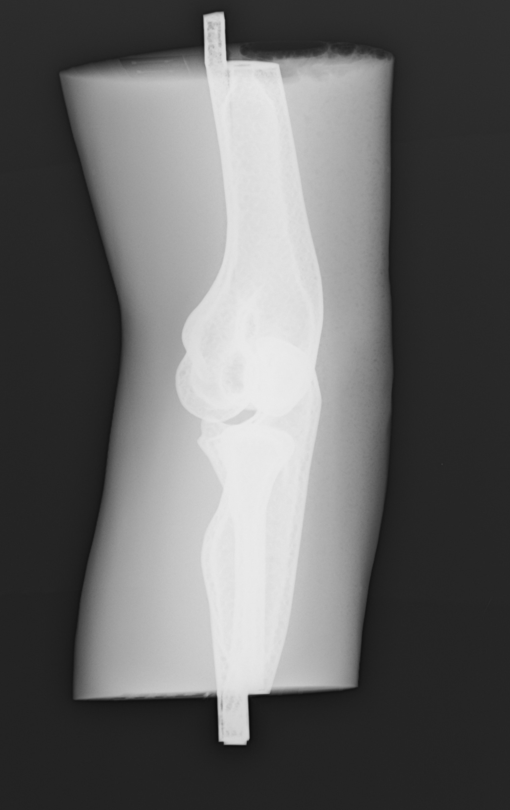
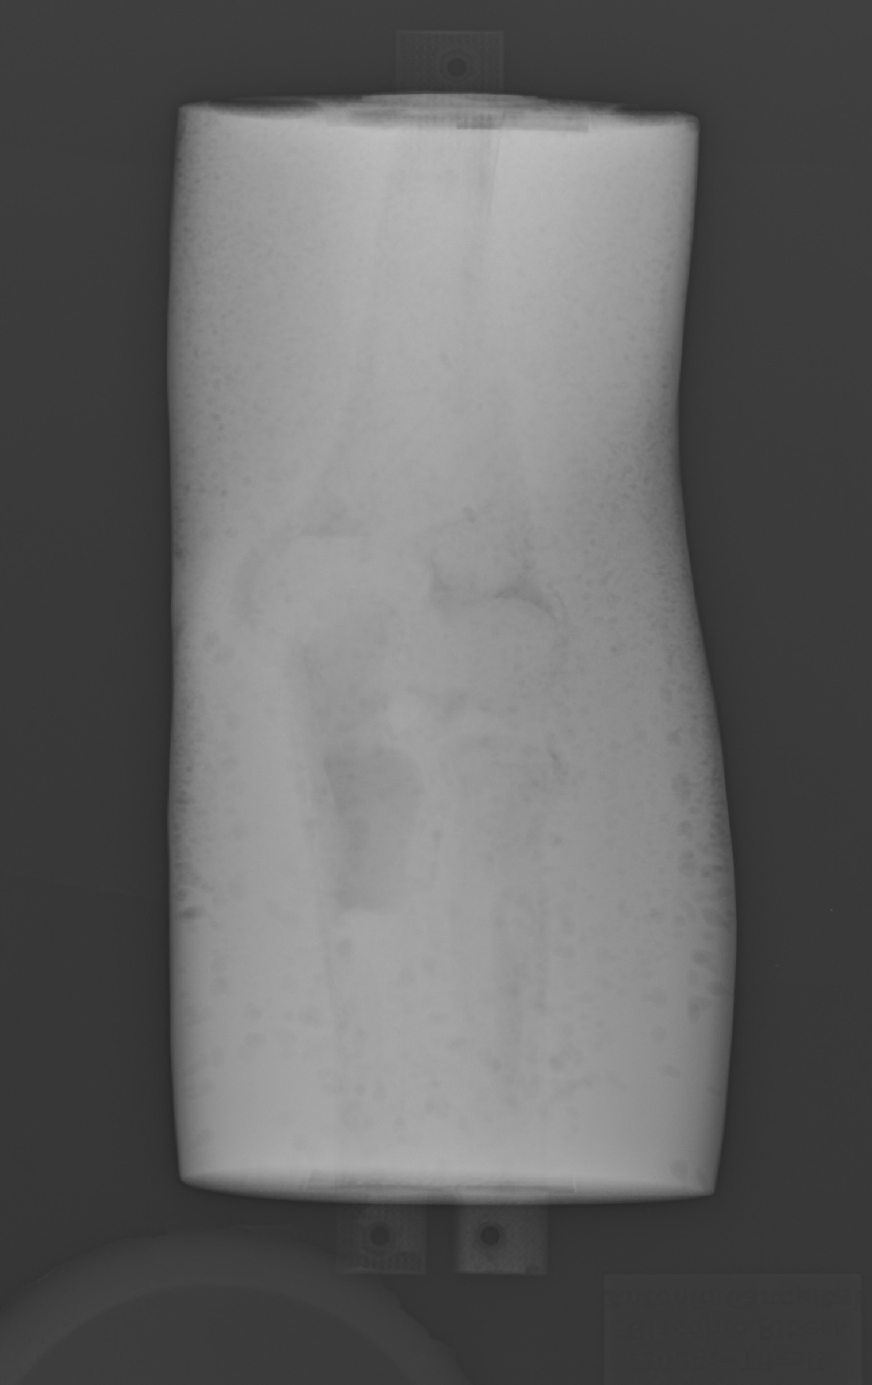
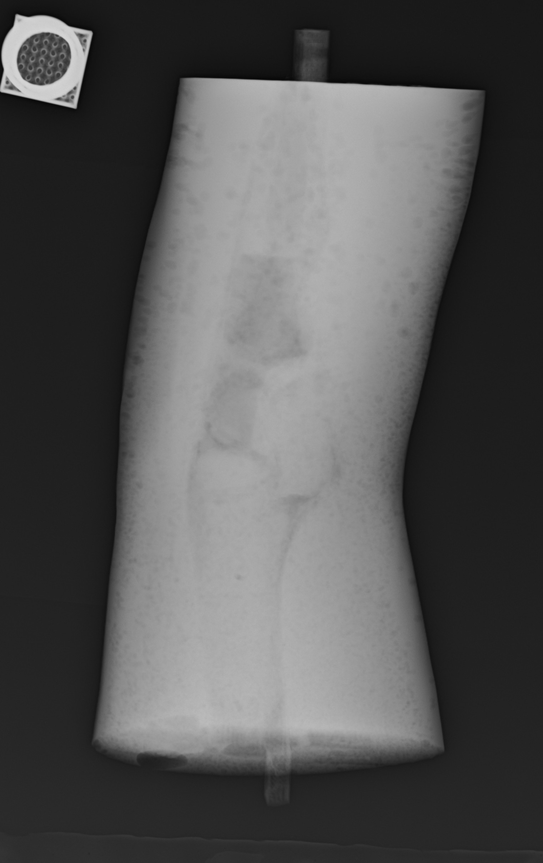
S143
p
PLA (AP)

Figure S6: Full set of AP and LAT radiographs for phantom bone configurations (p A–p D) and PLA-only control. Rows 1–2: p A (no medullary fill), p B (chalk–silicone 2:3), p C (chalk–silicone 1:3), and p D (steel wool) as described in Section S1.3. Row 3: PLA-only bone set; the humerus was painted internally and externally with PLA-based paint doped with ferrous oxide powder, and the ulna was partially (approxi-mately half) filled with a wax–powdered chalk mixture. These images complement Fig. 3 by illustrating how medullary filling strategies and PLA+Cu composition affect cortical/trabecular contrast and overall attenuation.

S145

S2.2 Extended Ultrasound Imaging Results

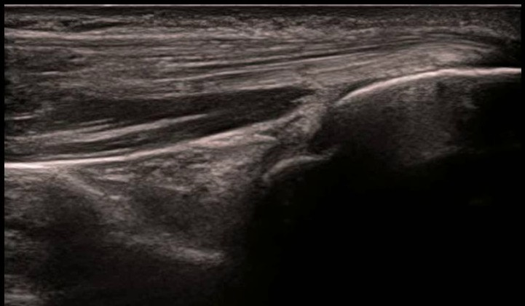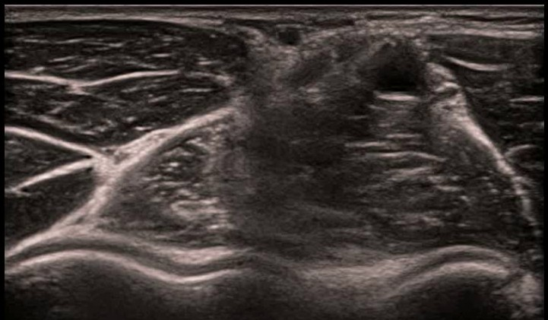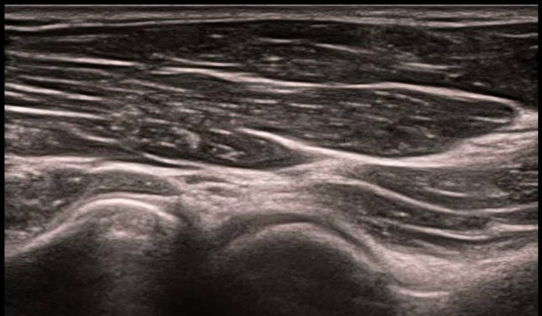
A
B
C
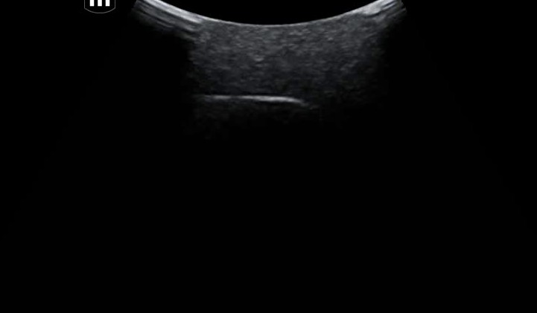


D
E
F
Figure S7: Representative ultrasound images. Images A–C were acquired in vivo from a human elbow:
(A) posterior view displaying triceps tendon and olecranon fossa, (B) anterior window displaying anterior joint, and (C) antero-lateral aspect showing radial fossa. Images D–F were acquired from the silicone phantom at equivalent probe positions; no anatomical structures are visible, and the silicone appears strongly attenuating. This demonstrates that the RTV silicone formulation used is unsuitable for ultrasound imaging applications.

S146

S147 S148 S149 S150 S151 S152

S2.3 Extended Drilling Resistance Results
The following figures present individual drilling resistance summary profiles for all tested specimens. Each summary panel displays the depth-resolved resistance curve alongside the eight similarity metrics defined in Section 4.3.4. Specimens are organized by category: biological bone samples (prefix ’b ’), the commercial Sawbones@ control (prefix ’s ’), and 3D-printed cylindrical surrogates (prefix ’c ’). These individual profiles complement the aggregate combined view (Figs. S12–S14) by enabling detailed examination of each specimen’s drilling characteristics.

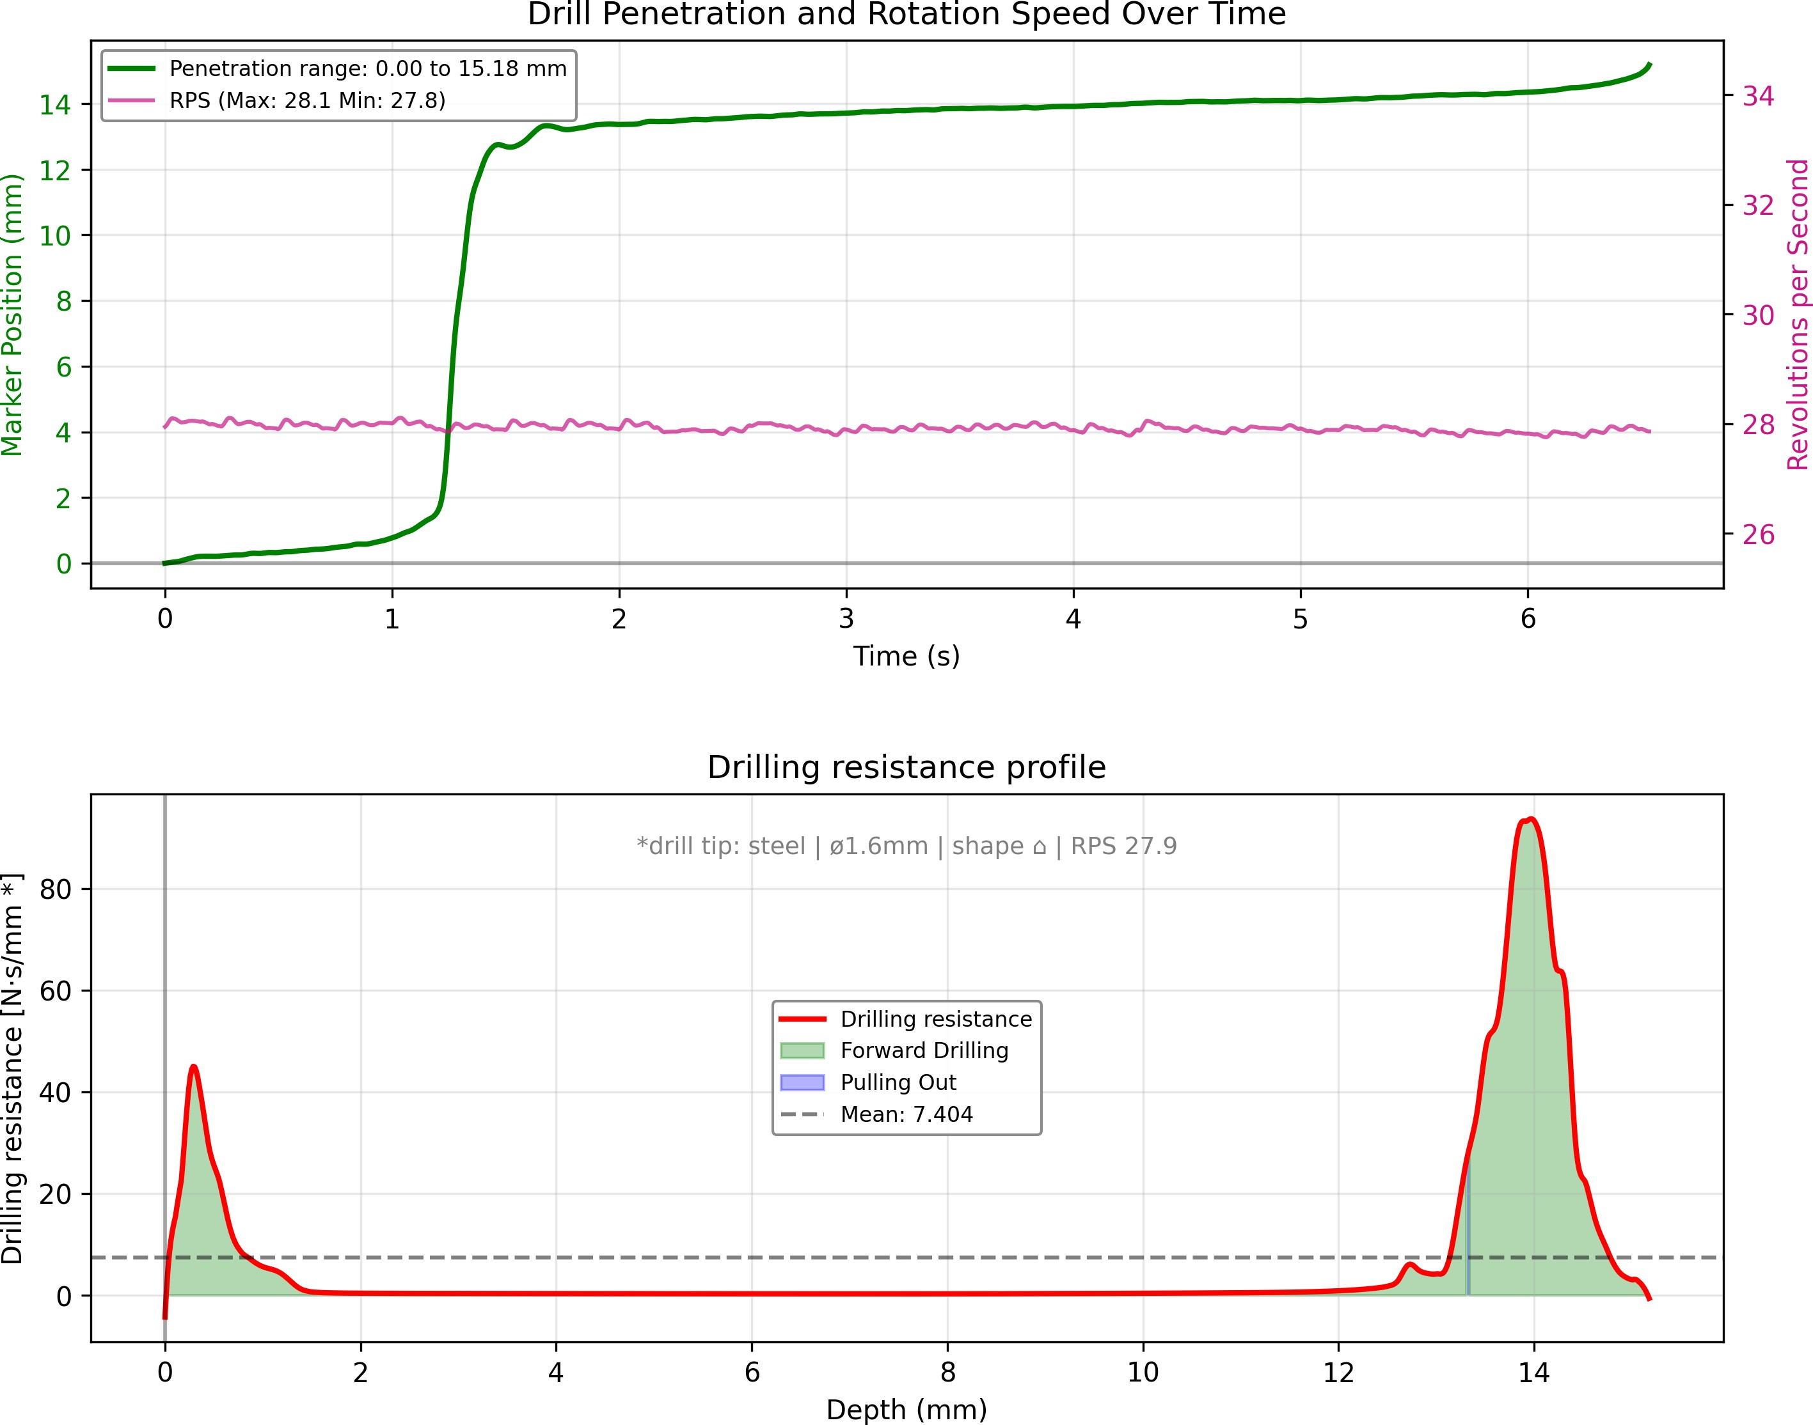
B
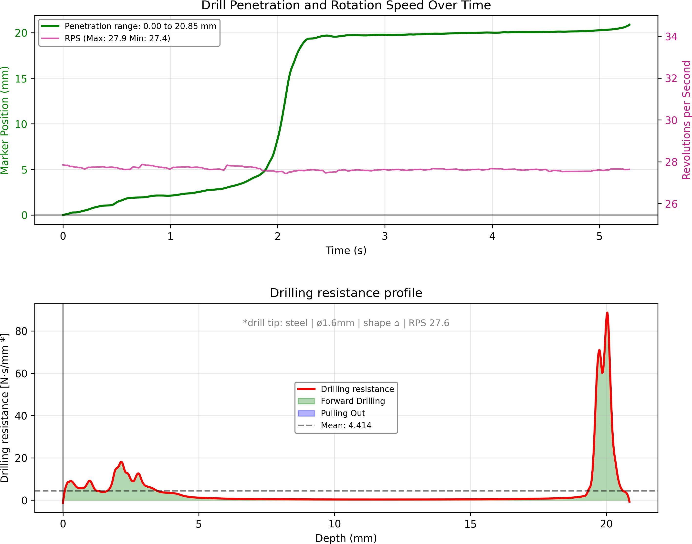
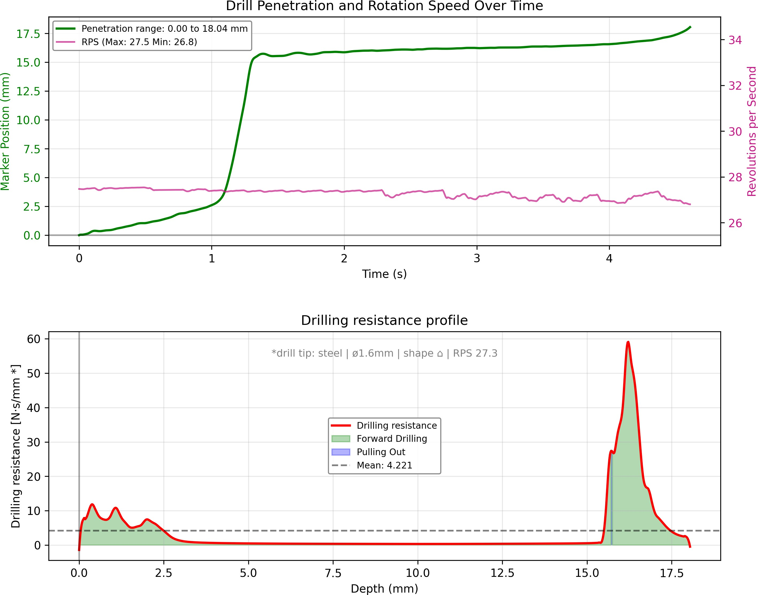
C
D

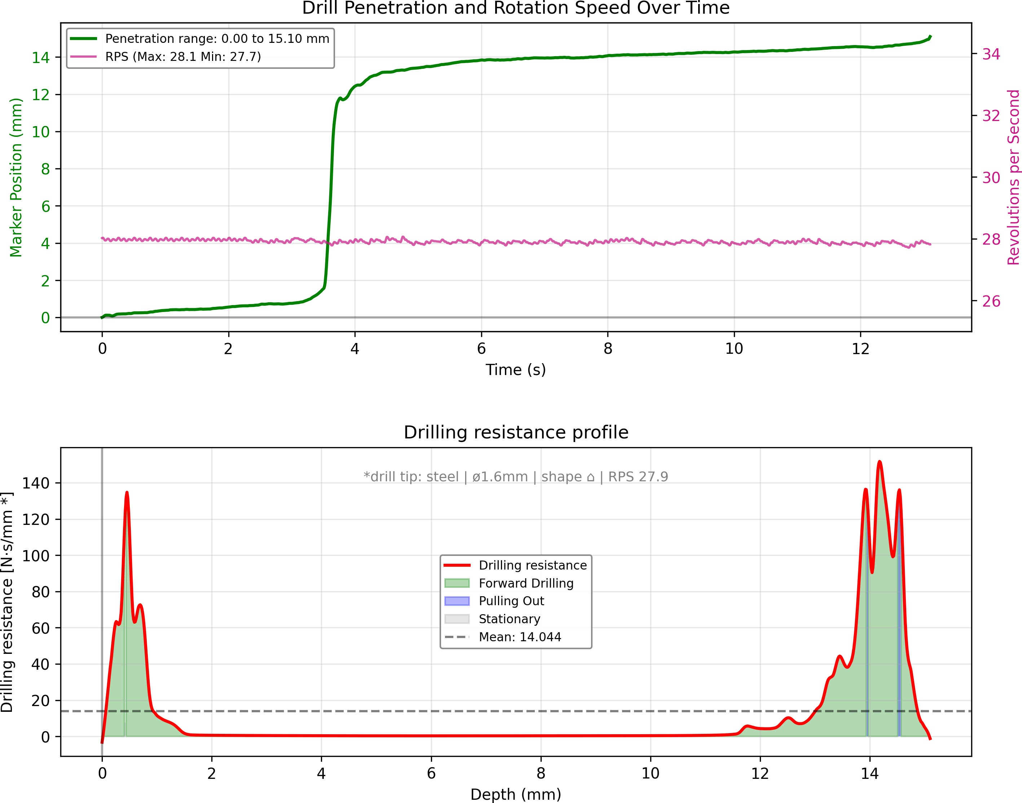
Figure S8: Drilling resistance summary profiles for bovine rib specimens. (A) Bovine rib 1 (b cowrib1).
A
(B) Bovine rib 2 (b cowrib2). (C) Bovine rib 3 (b cowrib3). (D) Bovine rib 4 (b cowrib4). These biological specimens demonstrate characteristic gradual transitions from cortical to cancellous bone regions. Sample codes are listed in Table S1.

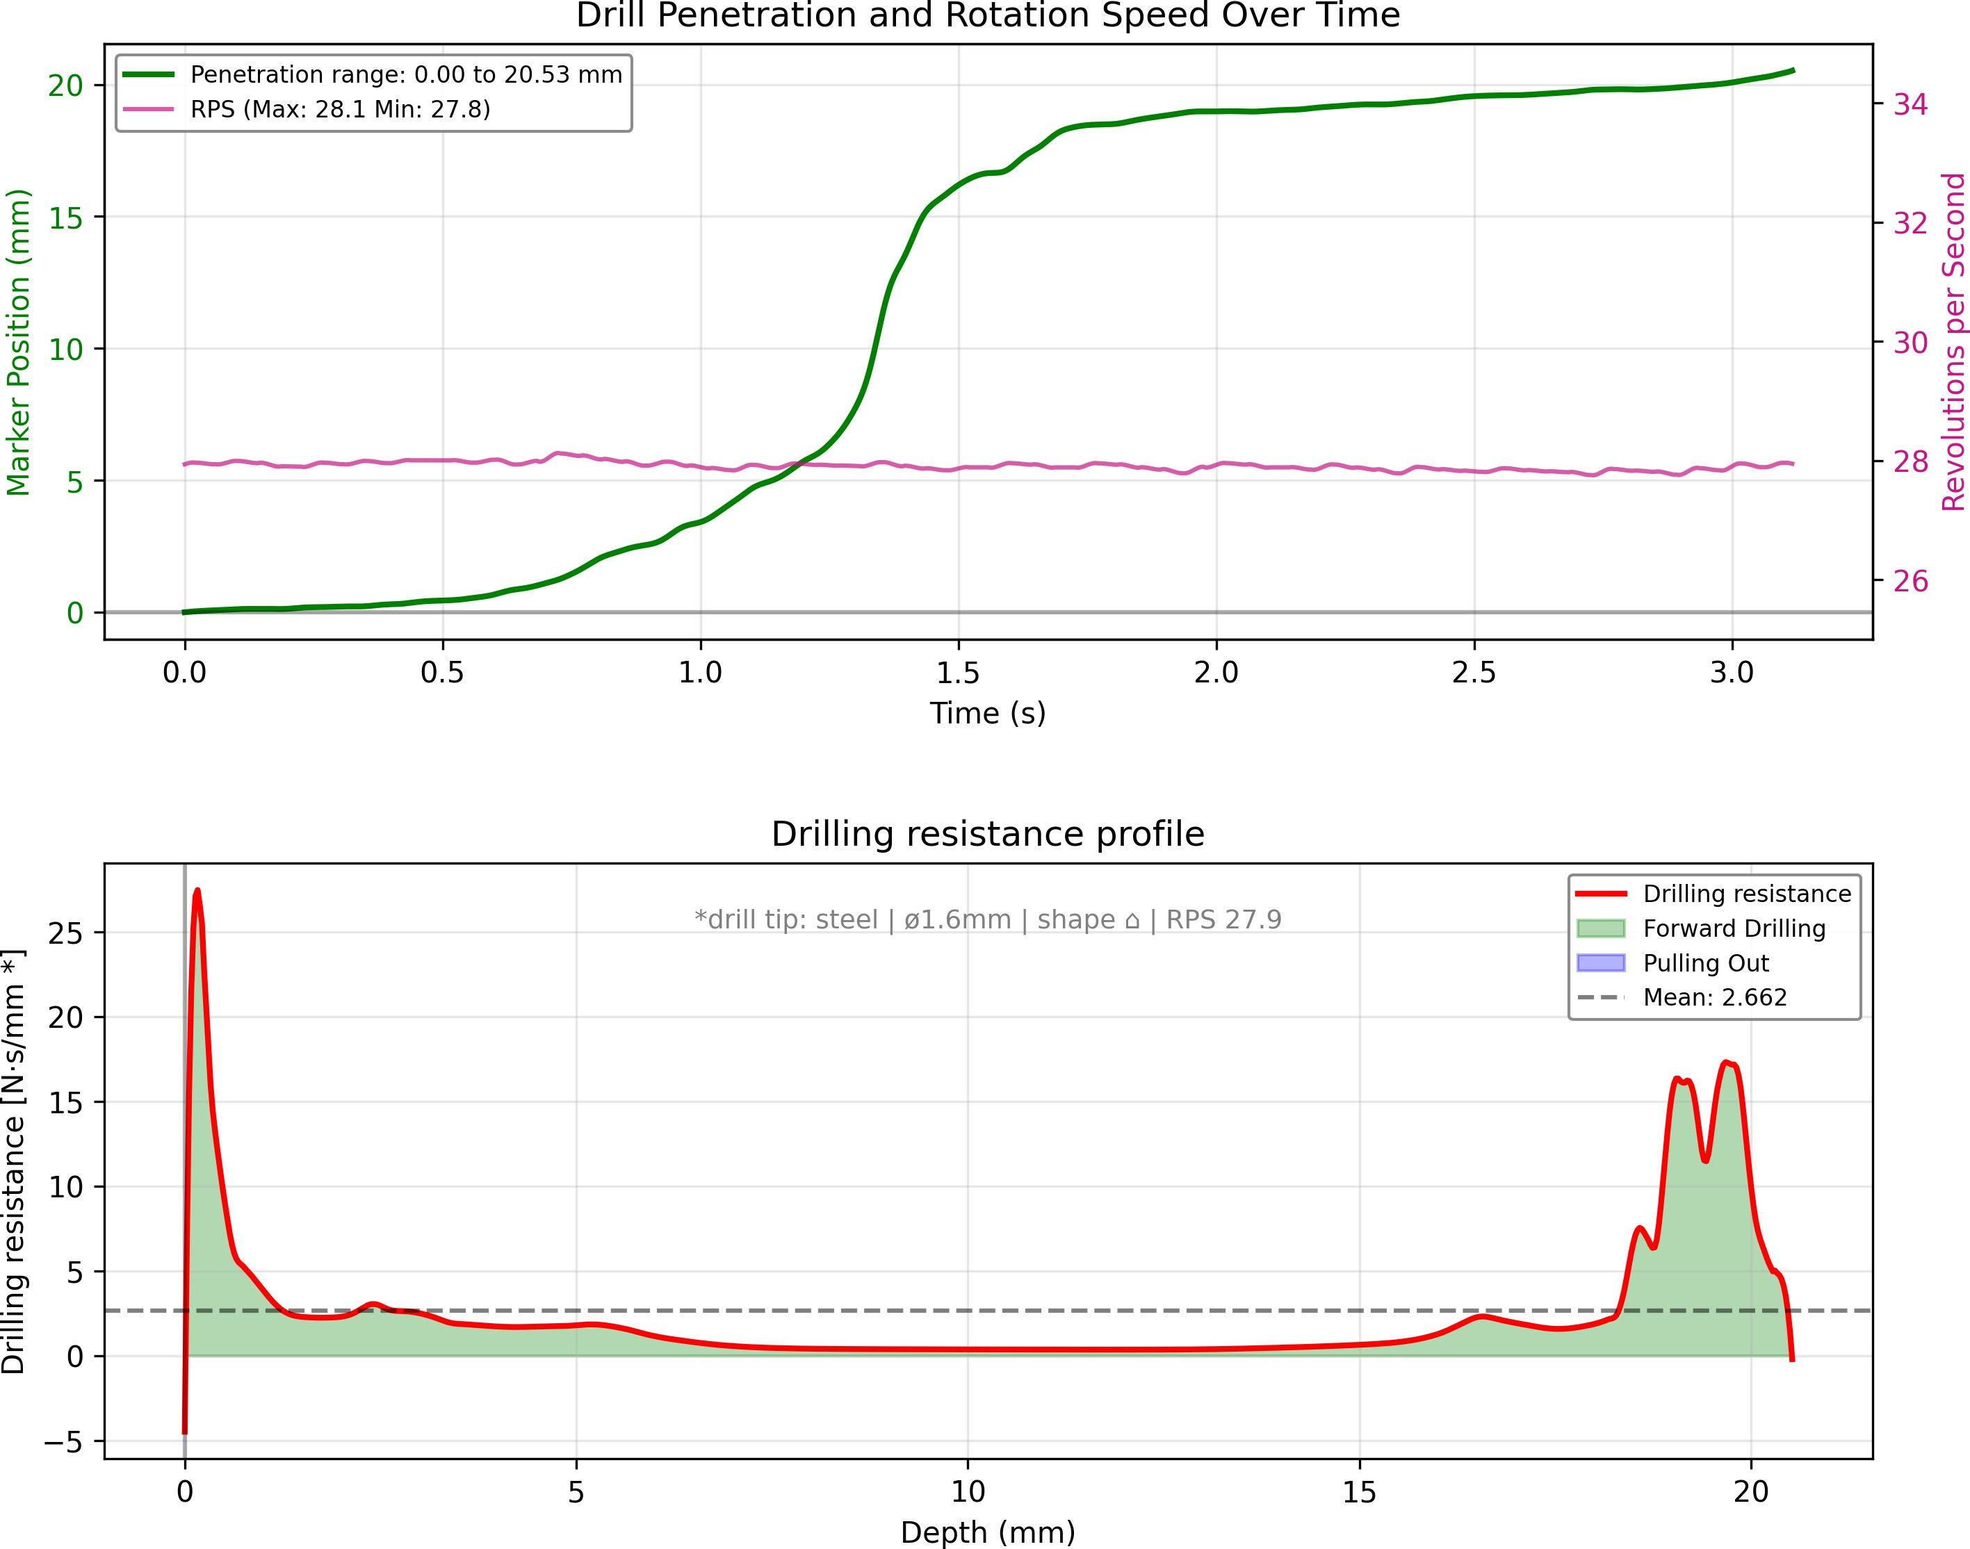
B
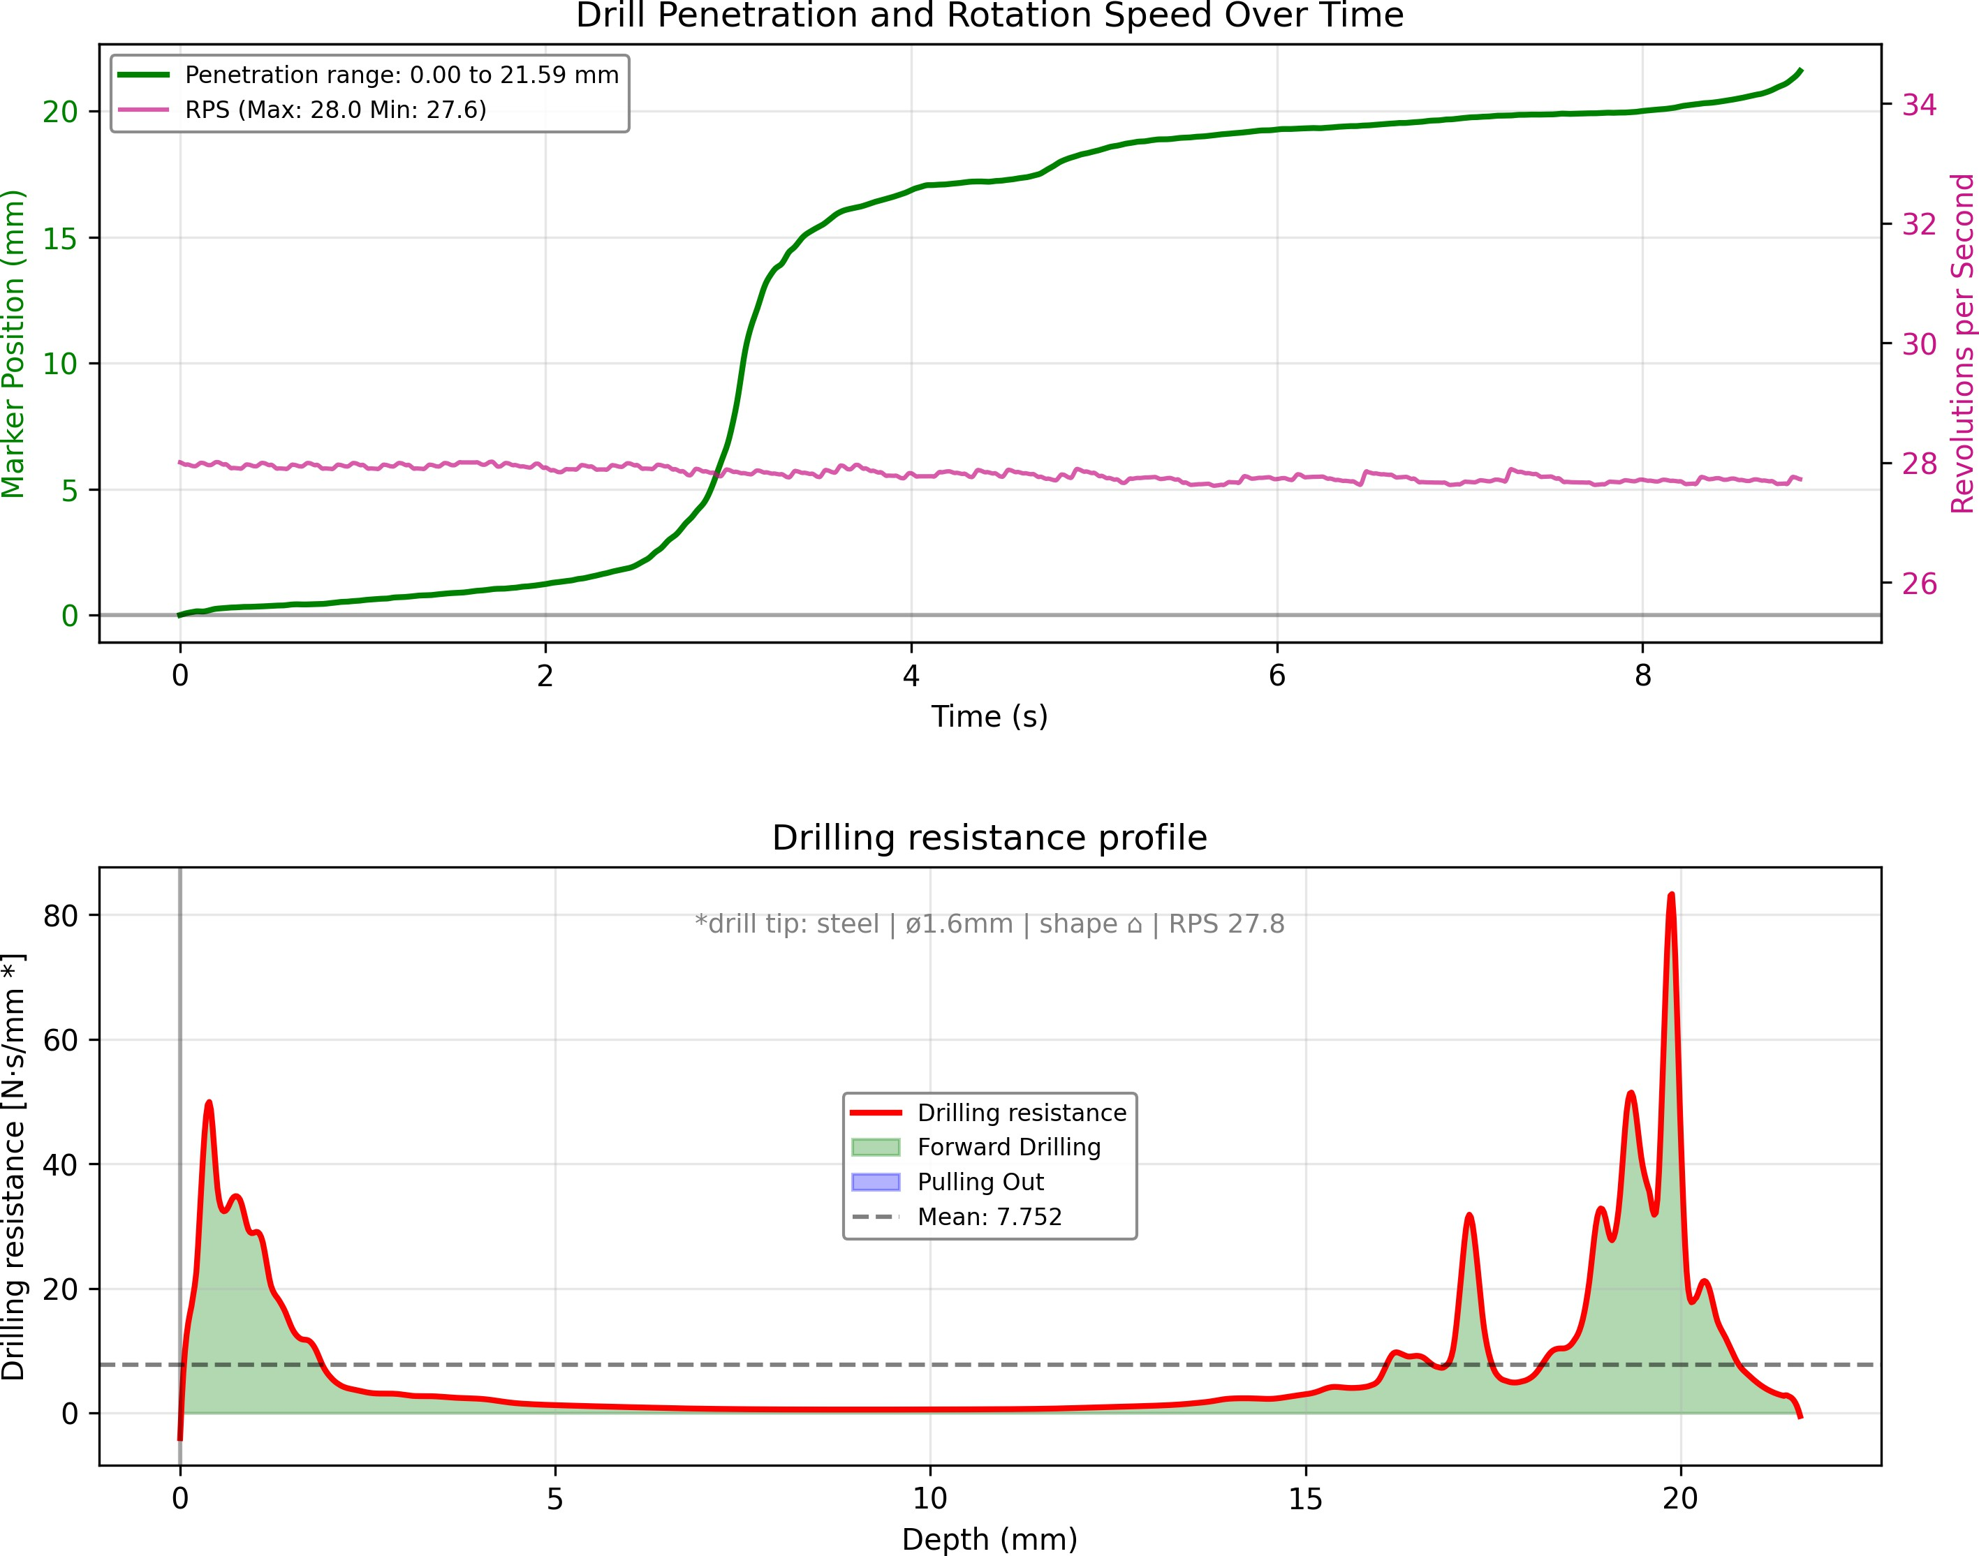
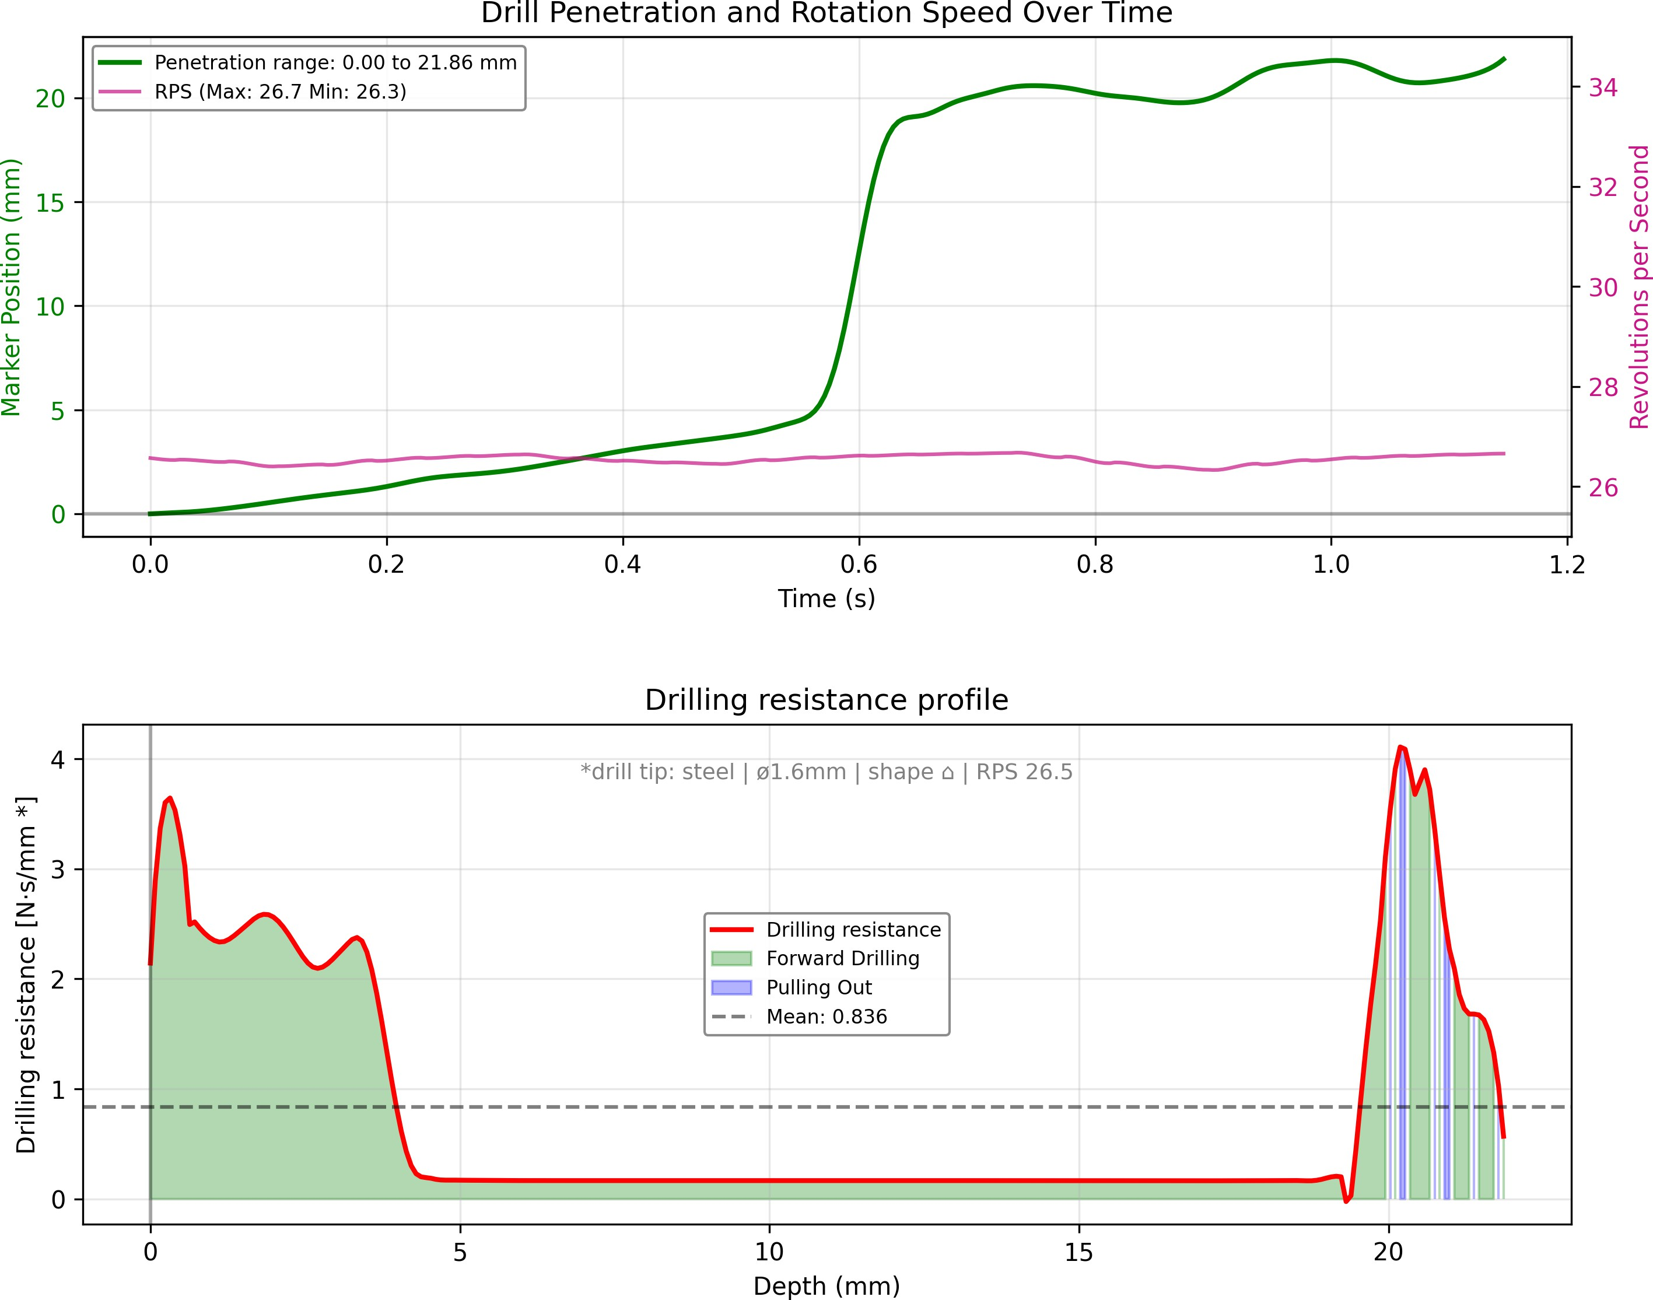
C
D

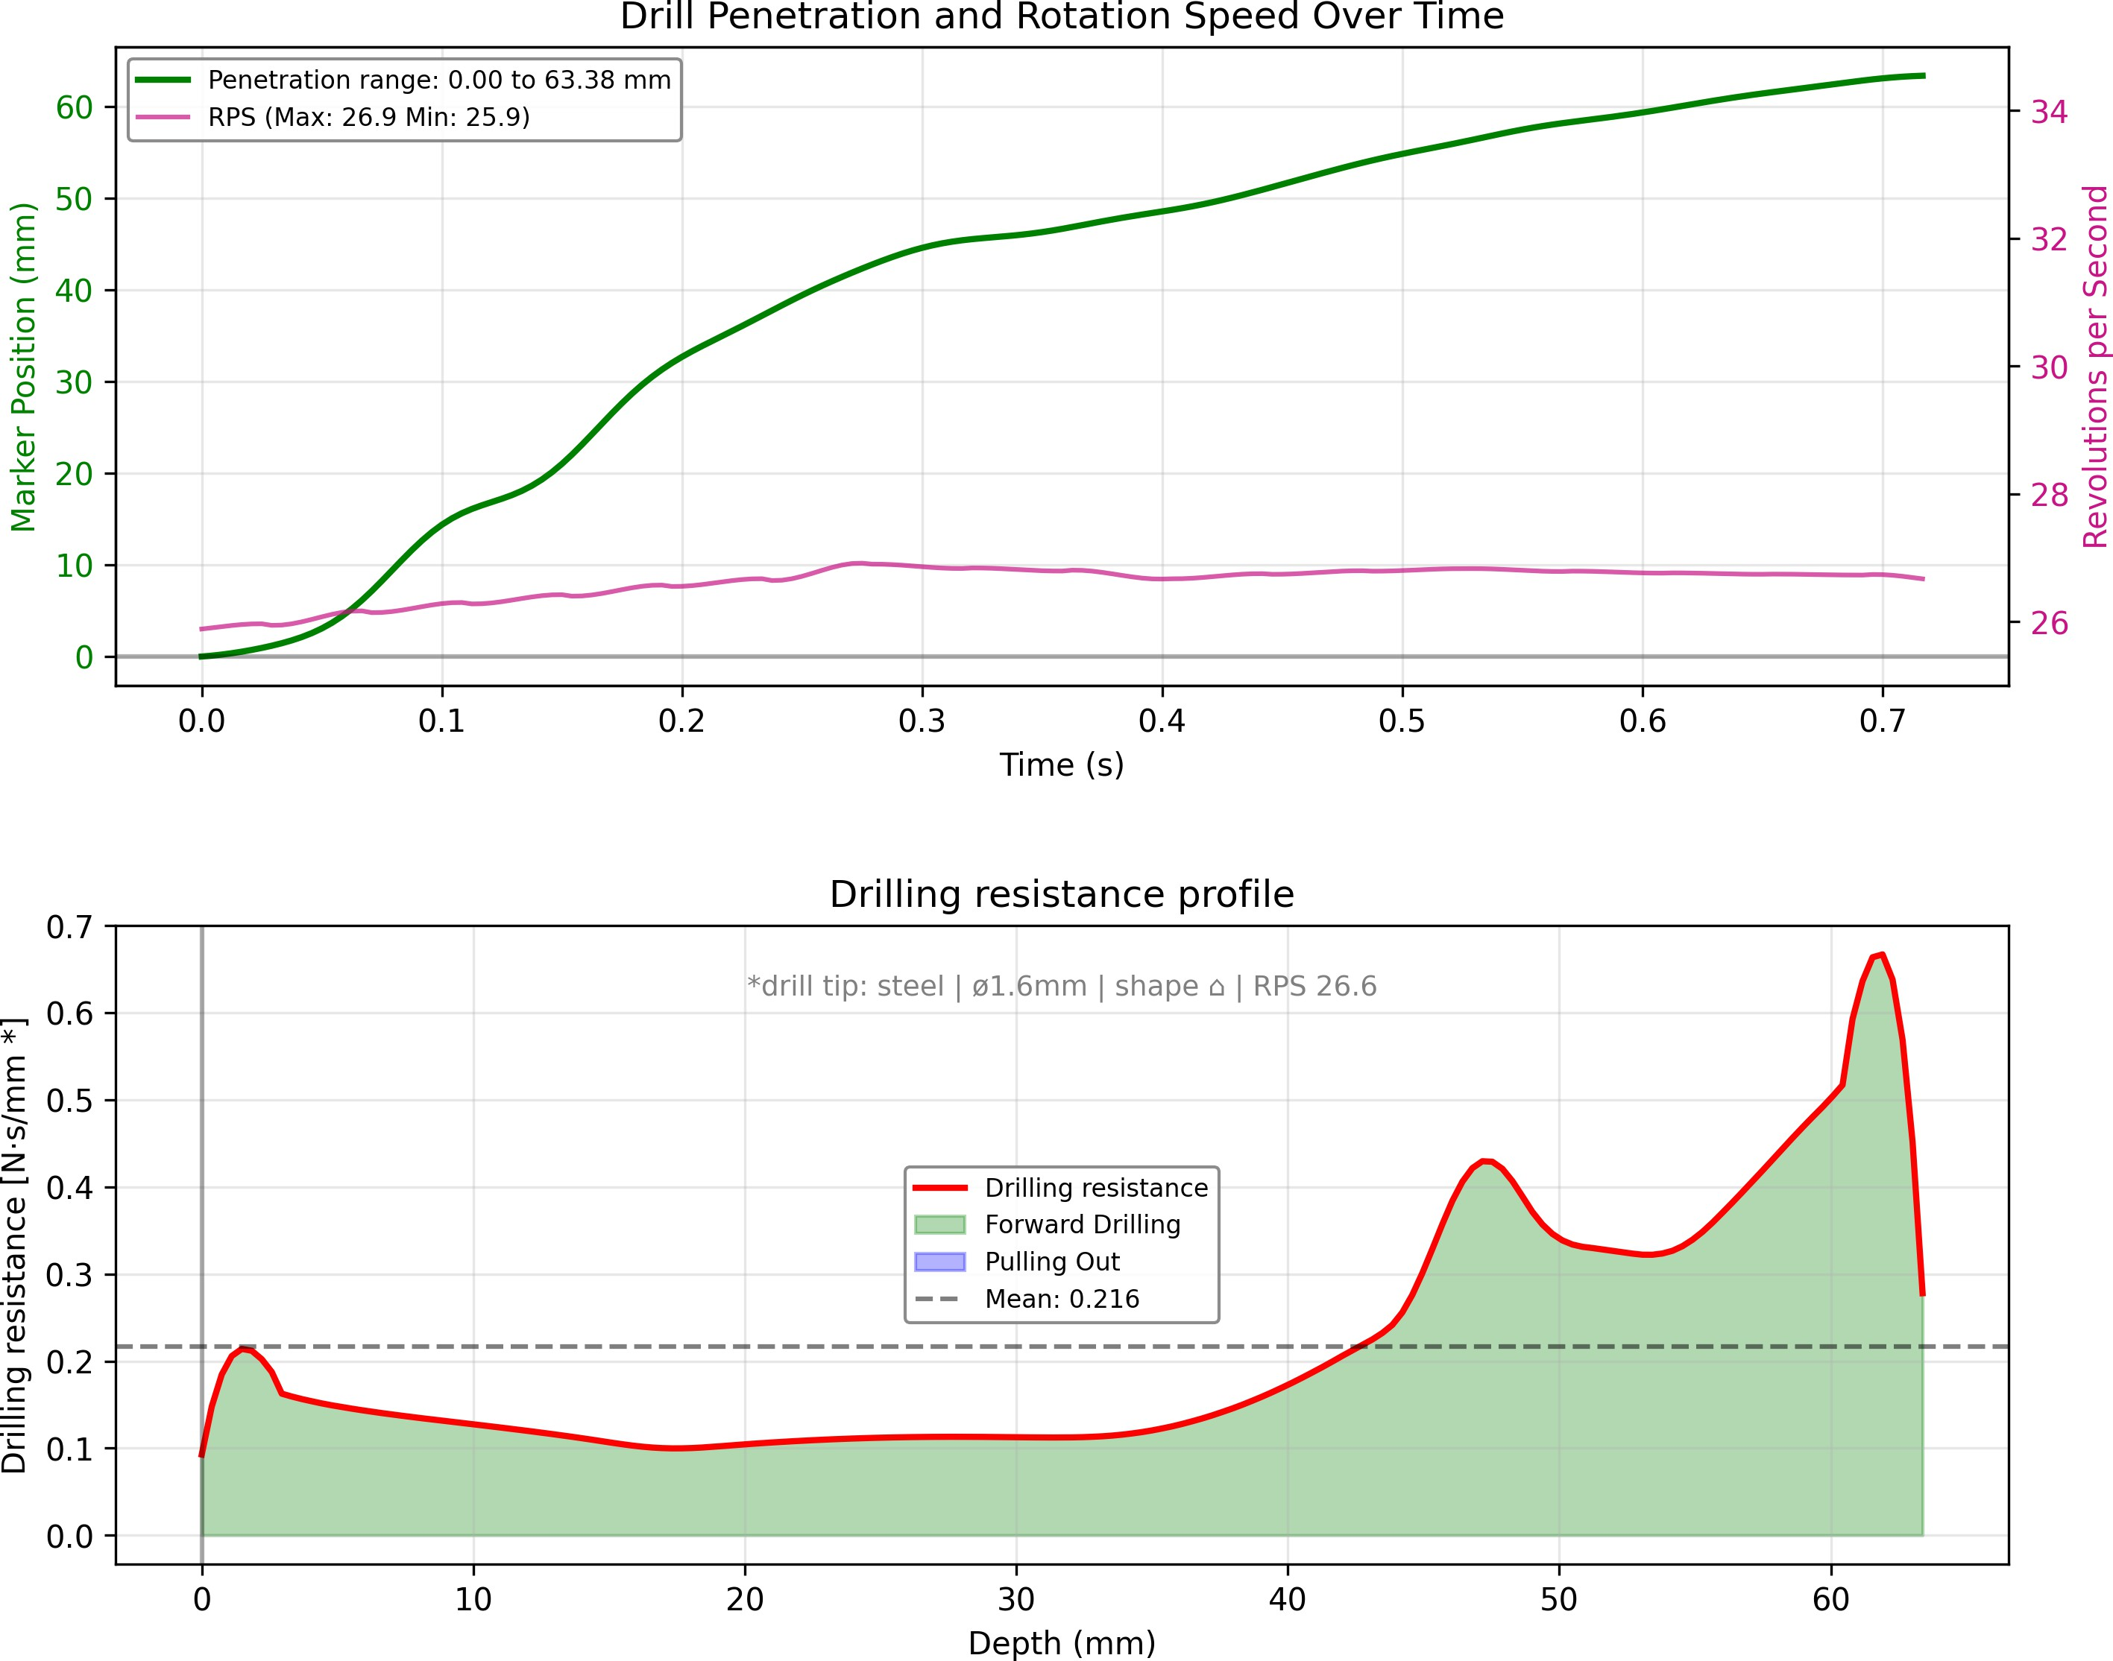
Figure S9: Drilling resistance summary profiles for additional biological specimens and the Sawbones@ control. (A) Bovine rib 1 drilled through medullary cavity (b cowrib1 medullary). (B) Bovine vertebra (b cow vertebra). (C) Ovine vertebra (b sheep vertebra). (D) Commercial synthetic tibia (s sawbone tibia). Sample codes are listed in Table S1.
A

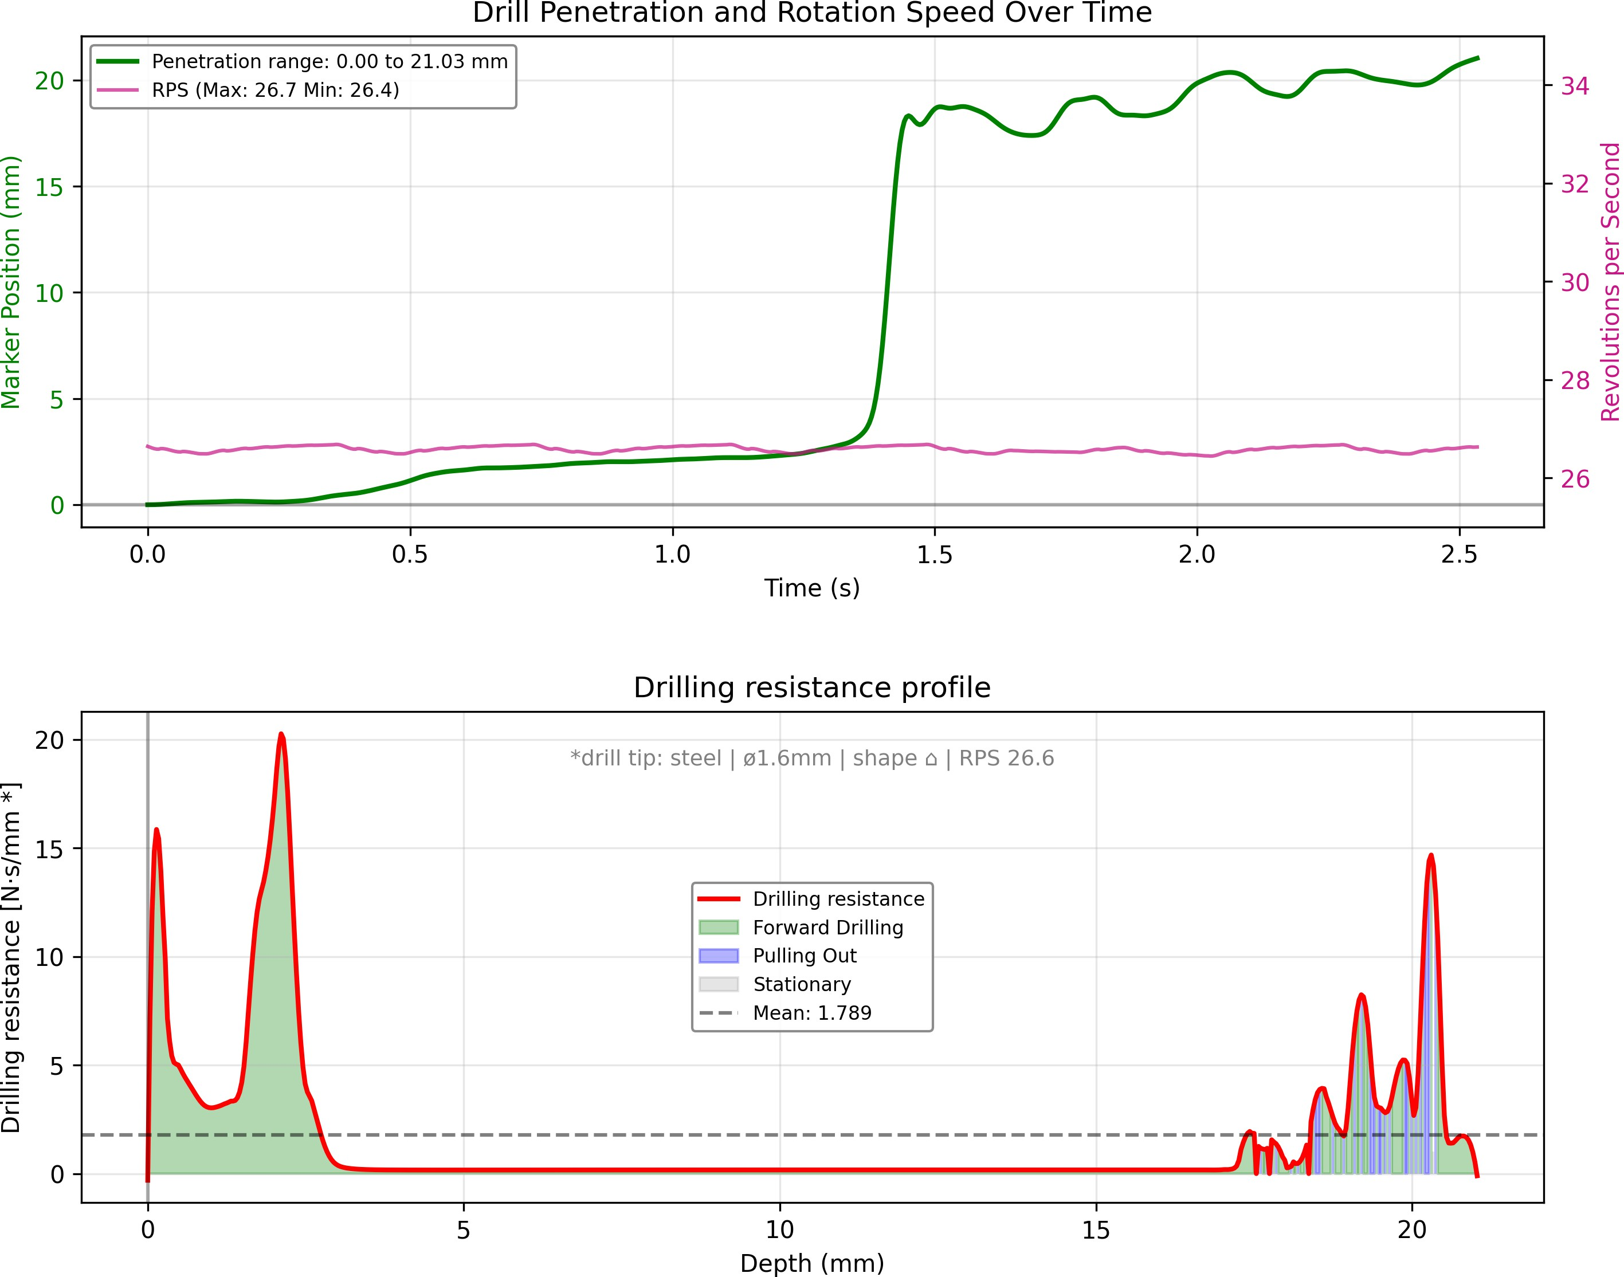
B
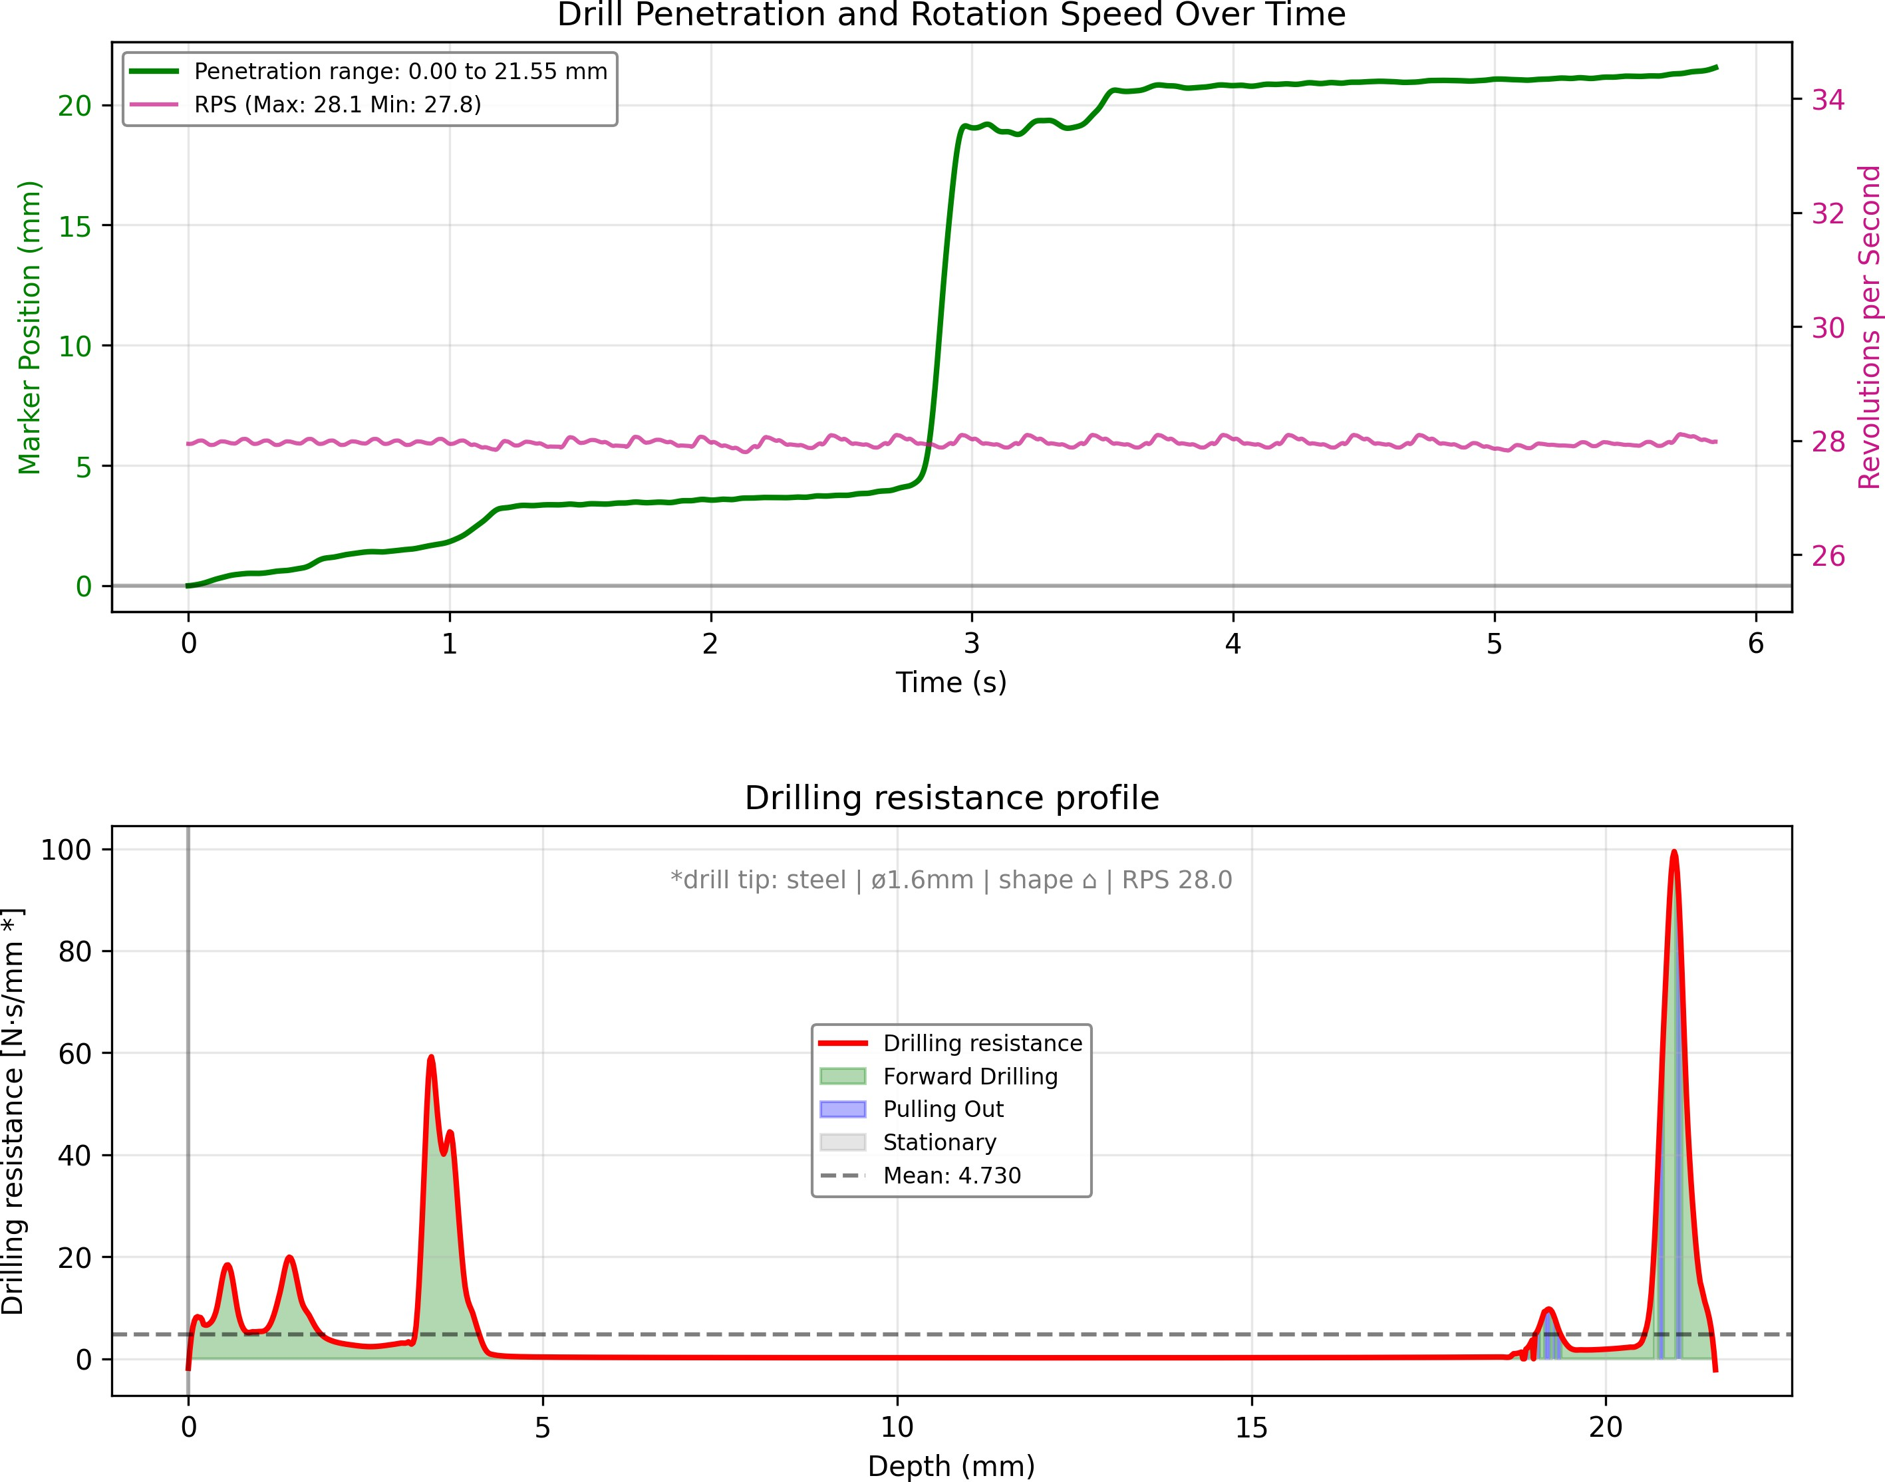
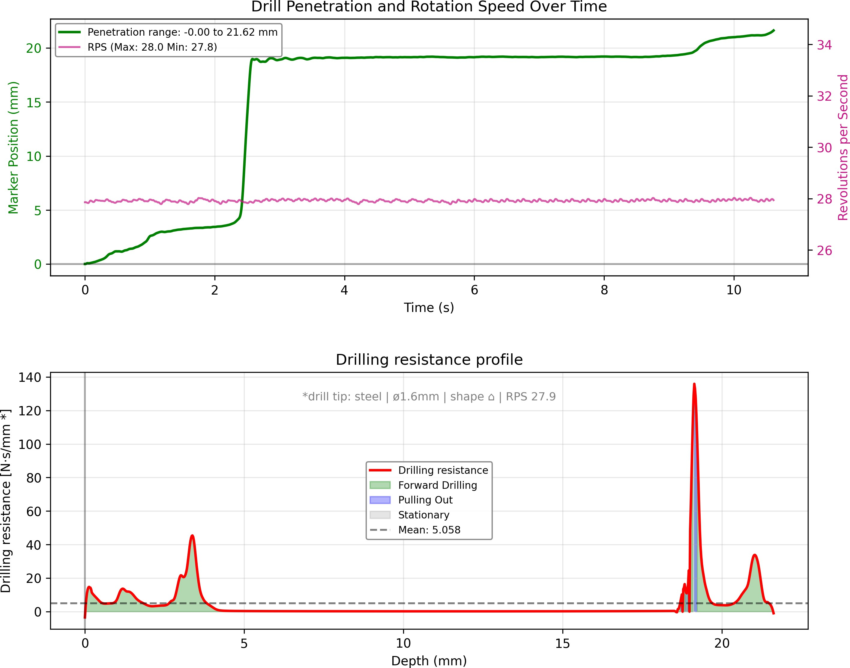
C
D

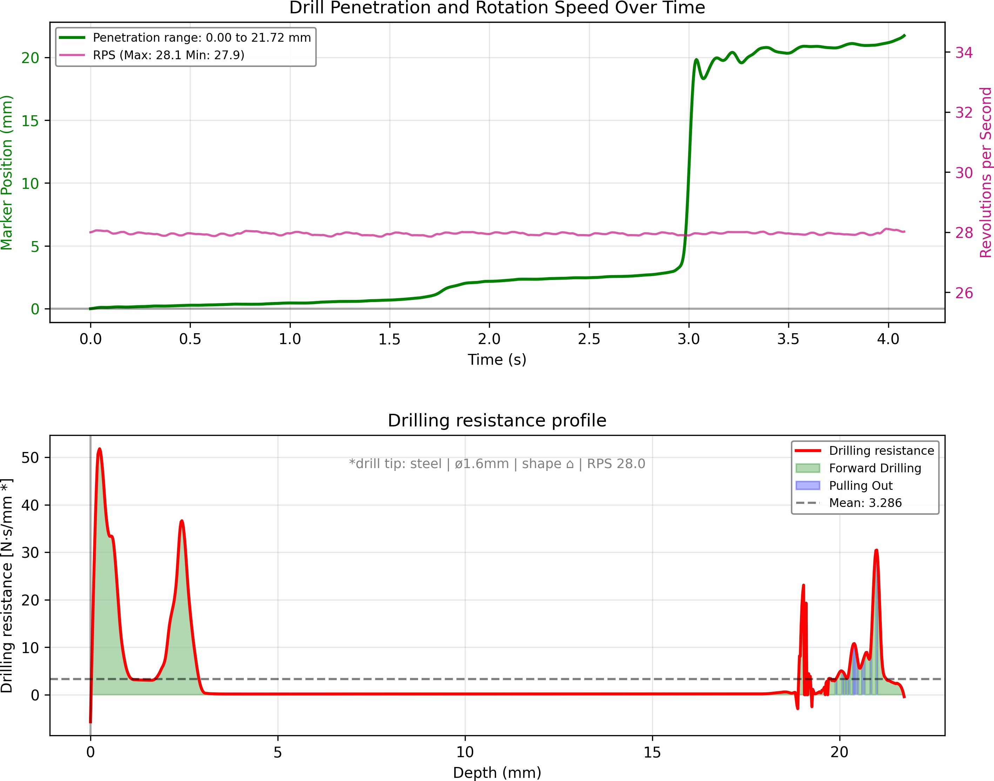
Figure S10: Drilling resistance summary profiles for 3D-printed cylindrical bone surrogates (unfilled and chalk–silicone filled). (A) Unfilled hollow cylinder in PLA (c A1). (B) Unfilled hollow cylinder in PLA+Copper (c A2). (C) Chalk–silicone filled (2:3 w/w) in PLA (c B1). (D) Chalk–silicone filled (2:3 w/w) in PLA+Copper (c B2). Sample codes are listed in Table S3.
A

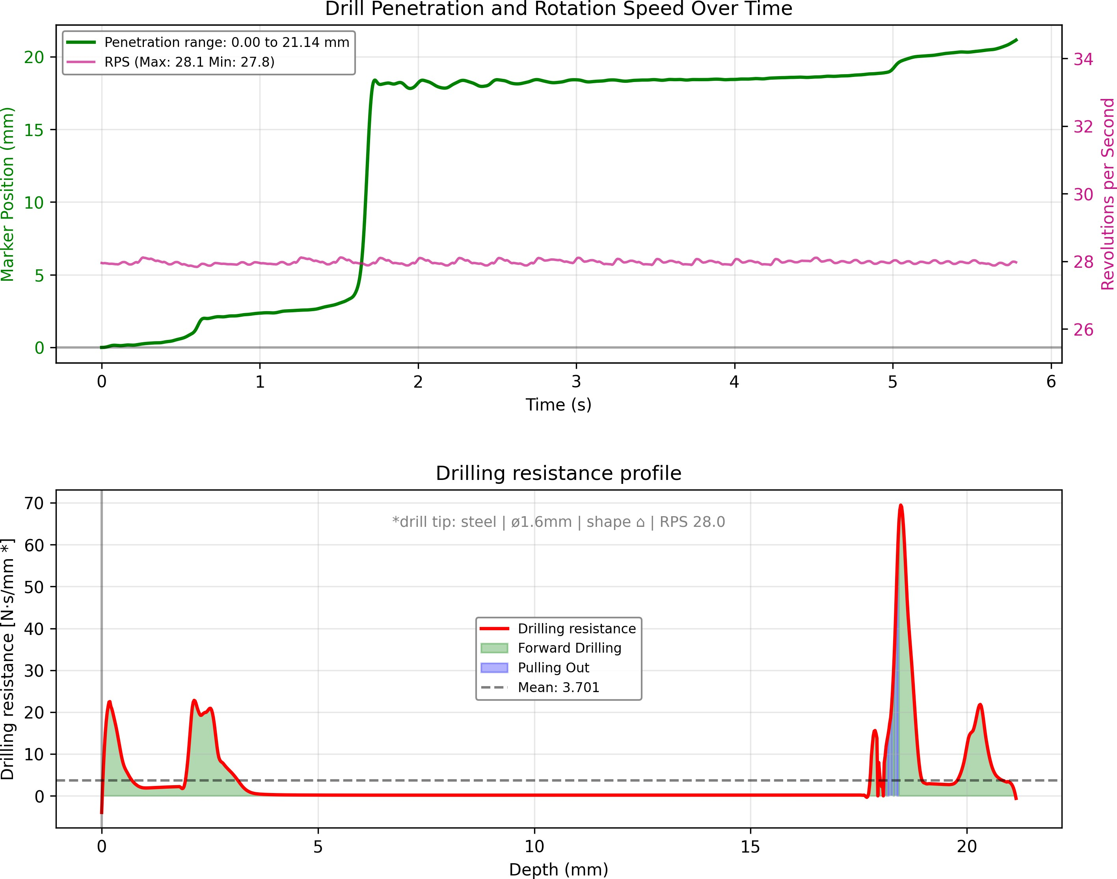
B
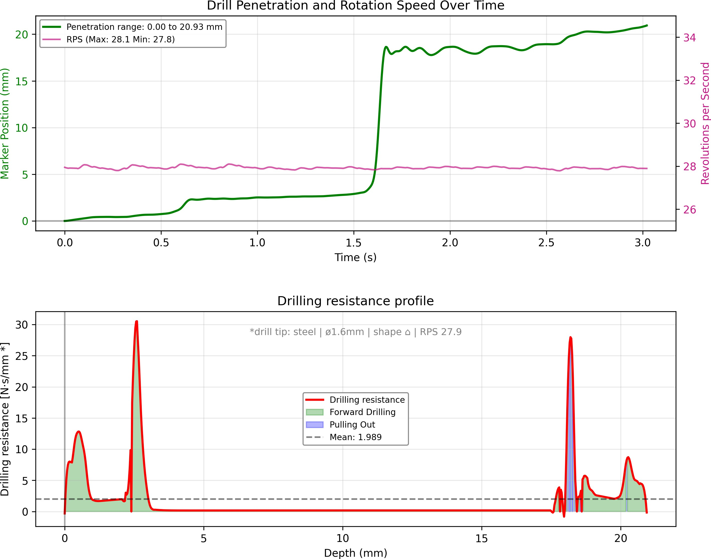
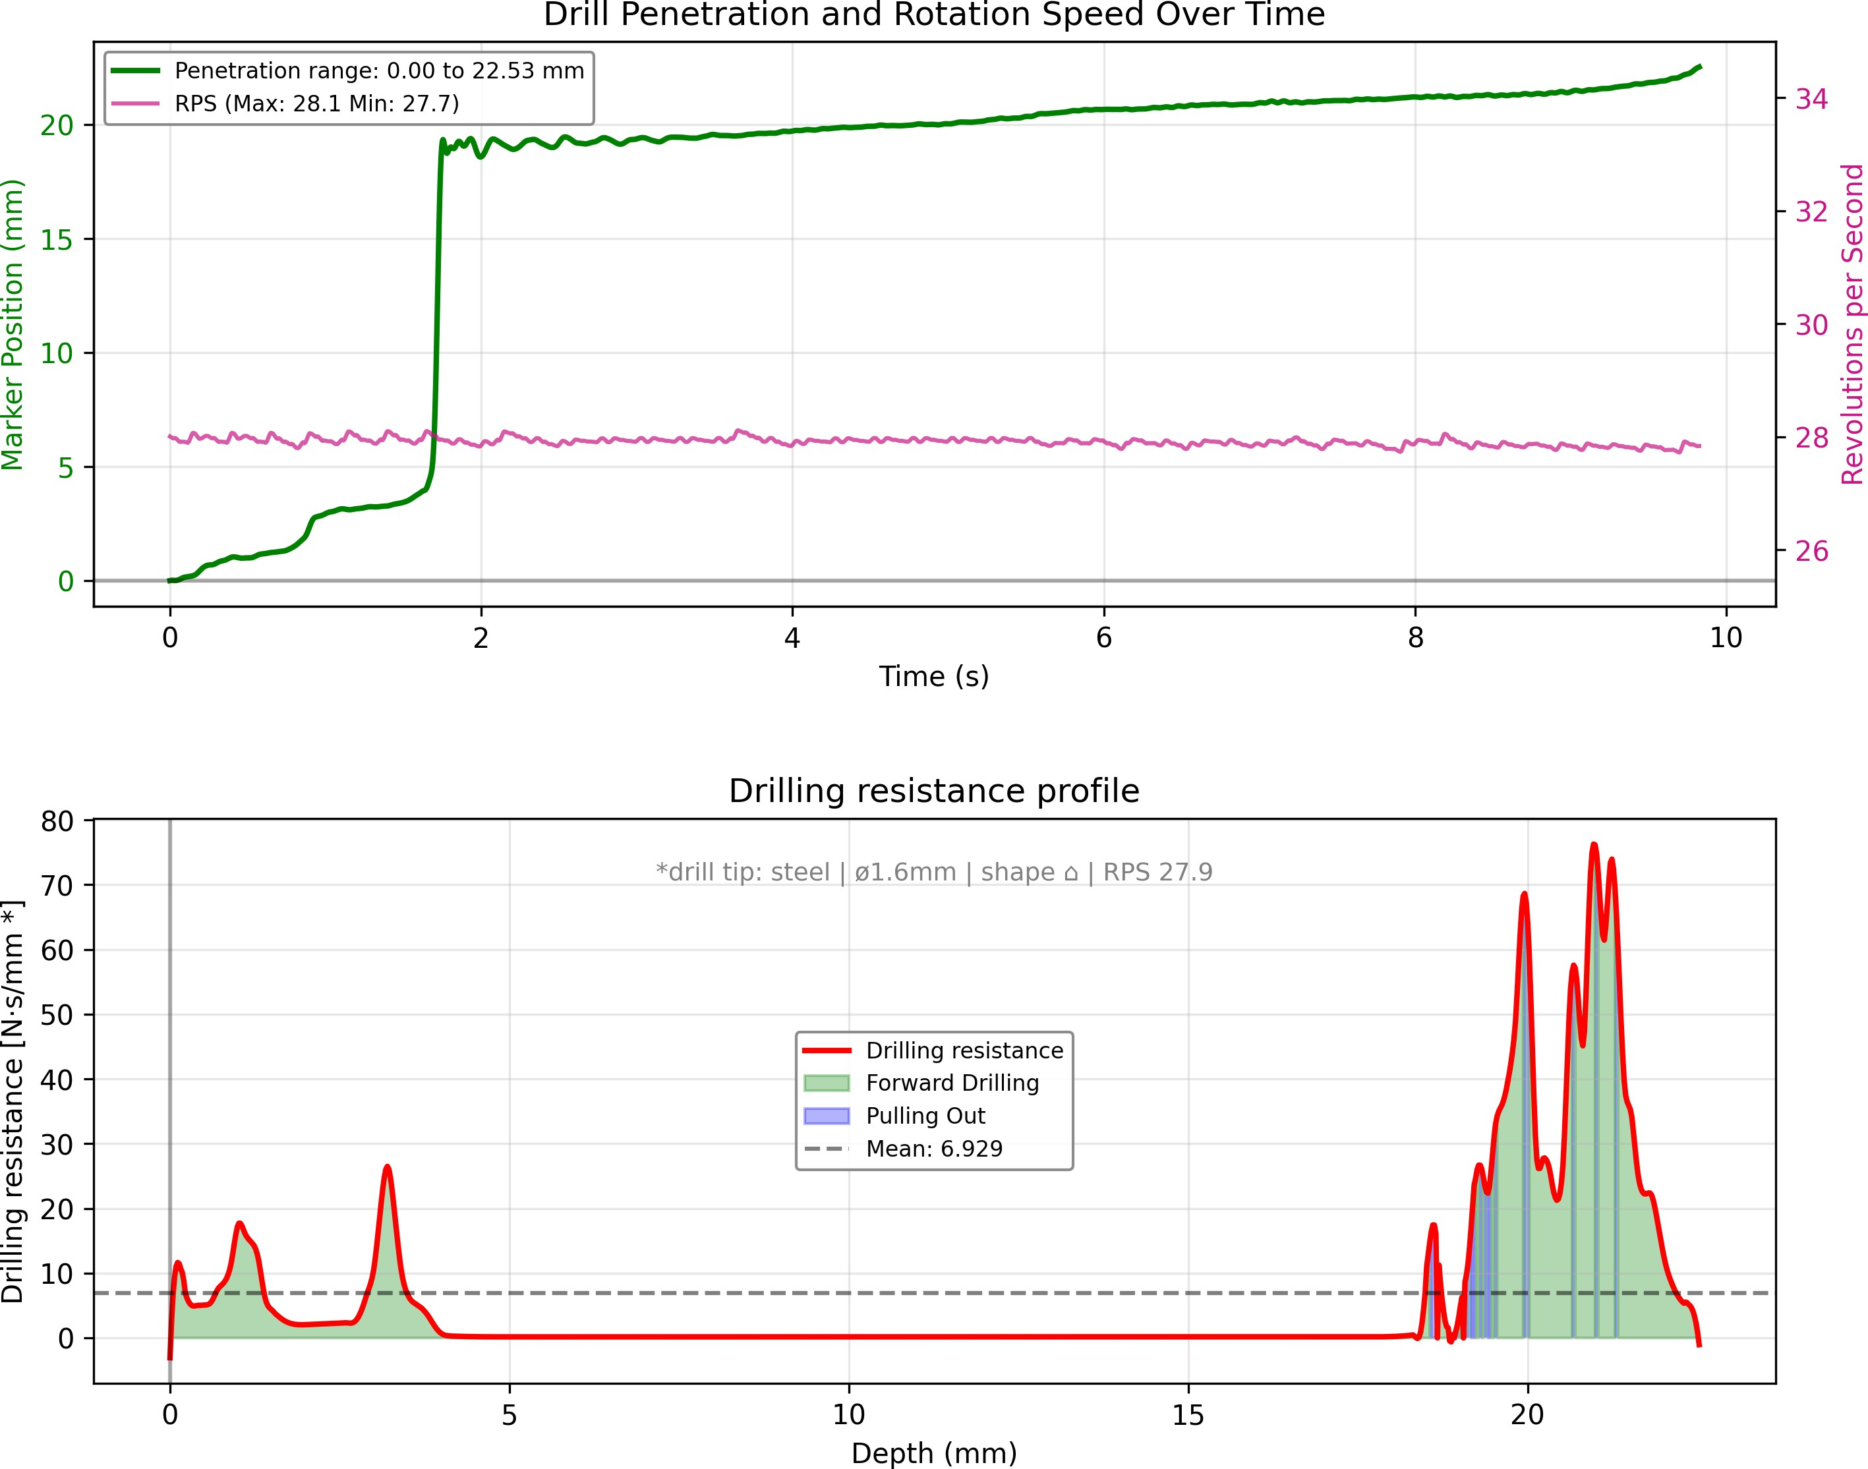
C
D

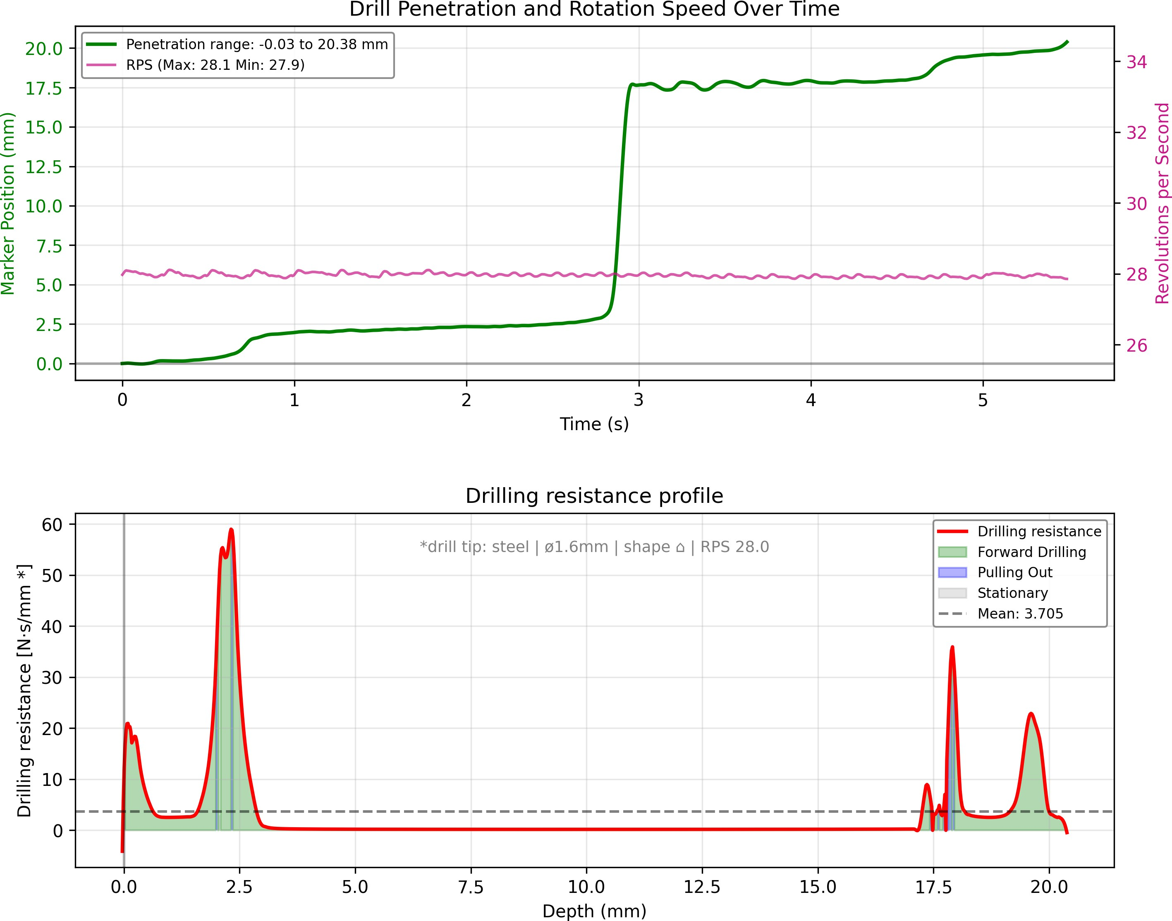
Figure S11: Drilling resistance summary profiles for 3D-printed cylindrical bone surrogates (chalk–silicone 1:3 and steel wool filled). (A) Chalk–silicone filled (1:3 w/w) in PLA (c C1). (B) Chalk–silicone filled (1:3 w/w) in PLA+Copper (c C2). (C) Steel wool filled in PLA (c D1). (D) Steel wool filled in PLA+Copper (c D2). The PLA+Copper specimens consistently demonstrate higher resistance magnitudes than their PLA counterparts, with the steel wool filled configuration (c D2) achieving highest overall similarity to biological bone (see Fig. 5). Sample codes are listed in Table S3.
A

S153 S154 S155 S156 S157 S158 S159
The following three-part figure aggregates drilling resistance profiles and similarity metrics for all tested specimens, with depth-resolved resistance curves shown alongside the eight similarity measures defined in Section 4.3.4. This visualization enables systematic comparison between biological bone (prefix ’b ’), the Sawbones@ control (prefix ’s ’), and 3D-printed surrogates (prefix ’c ’). The extended view confirms that gyroid-infill PLA/PLA+Copper cylinders achieve both high shape similarity and comparable magnitude of drilling resistance relative to real bone, supporting their use as mechanically faithful components within the elbow surgical phantom.

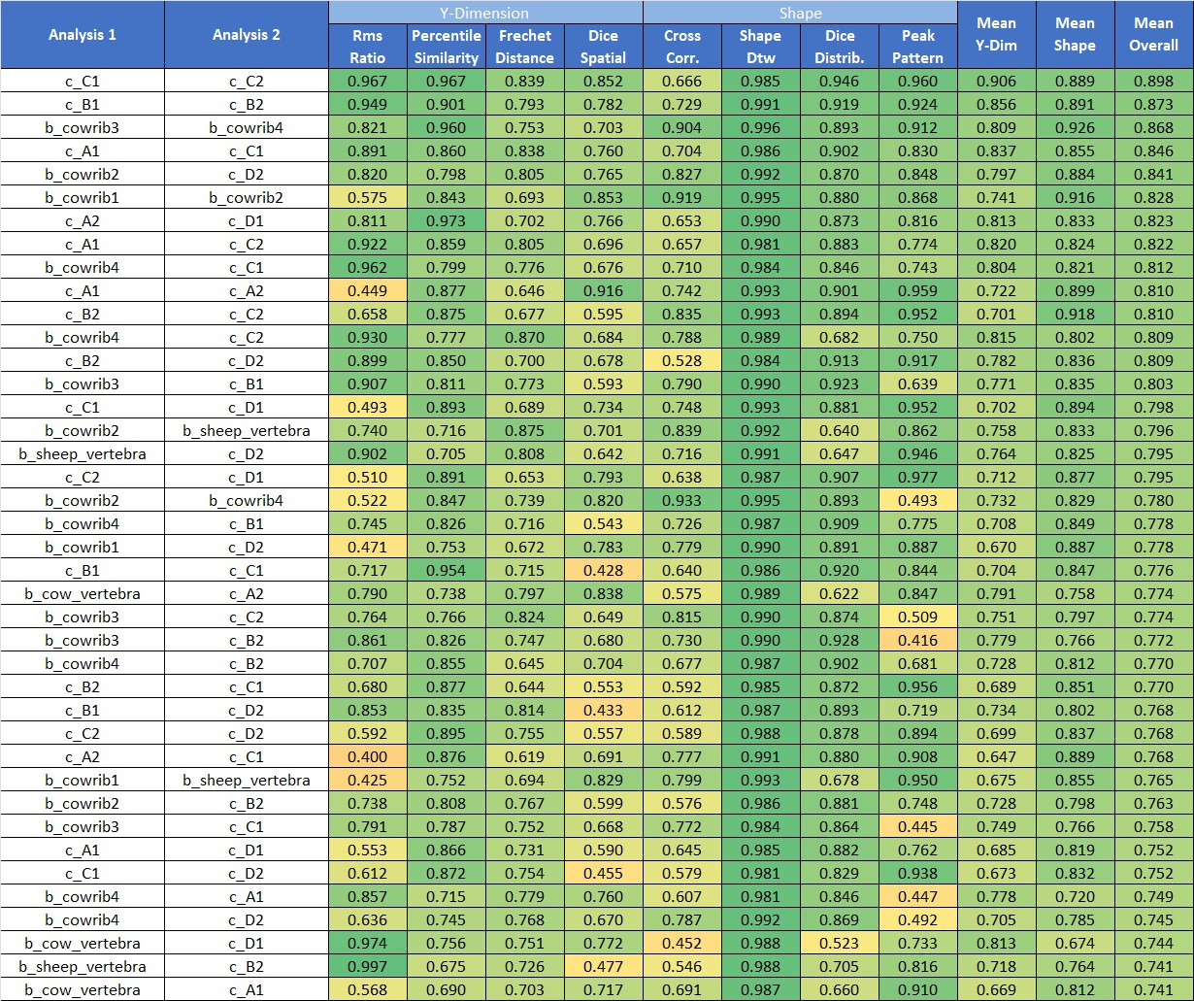
Figure S12: Combined visualization of drilling resistance profiles and similarity metrics (Part 1). Each panel displays depth-resolved resistance curves and the eight similarity measures for biological bone, com-mercial Sawbones@ control, and 3D-printed surrogate specimens.

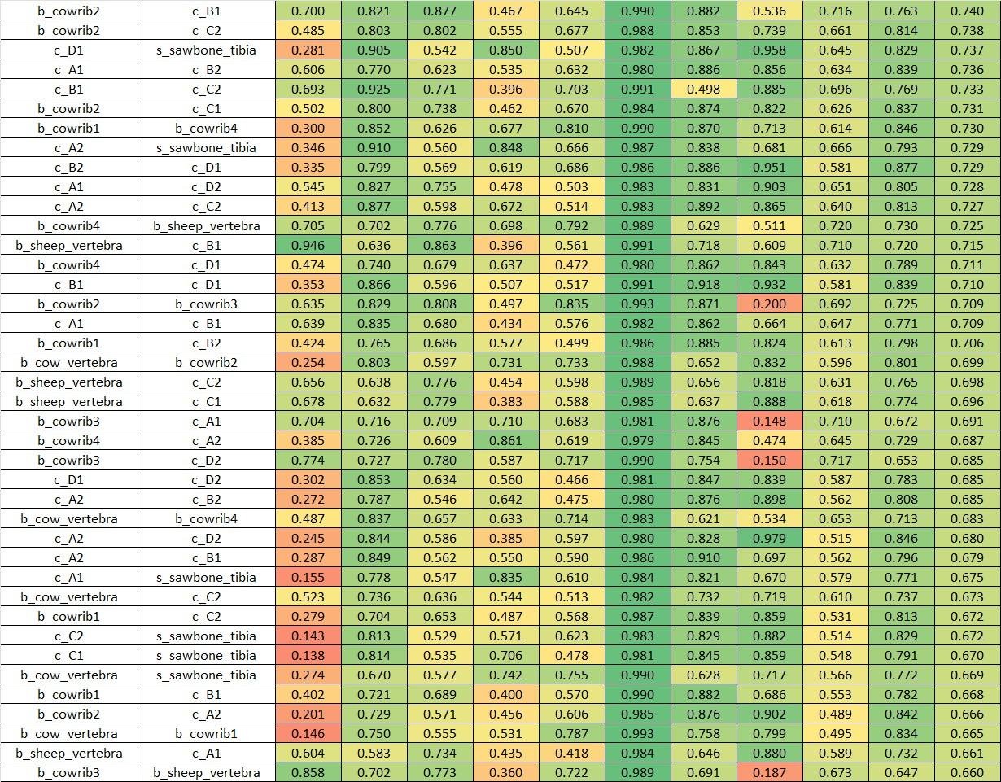
Figure S13: Combined visualization of drilling resistance profiles and similarity metrics (Part 2). Contin-uation of the systematic comparison across all specimen categories.

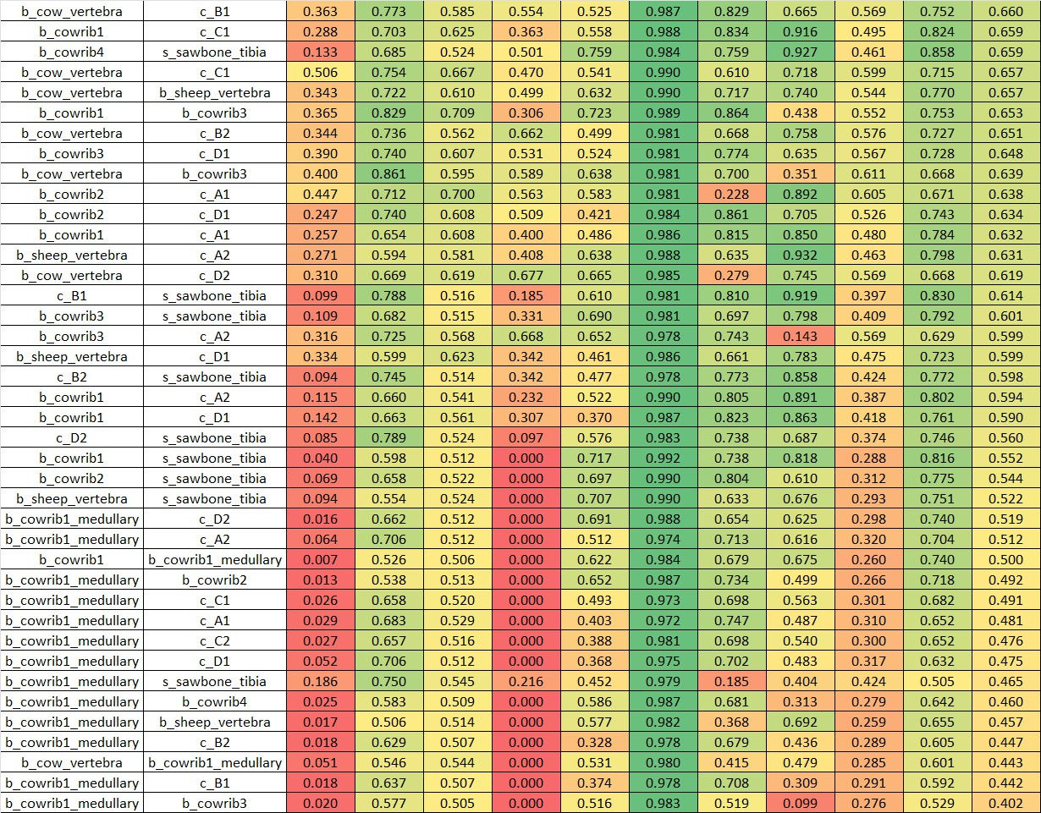
Figure S14: Combined visualization of drilling resistance profiles and similarity metrics (Part 3). Fi-nal portion of the aggregate comparison enabling systematic evaluation of phantom drilling characteristics against biological references.

S160

S161 S162

S2.4 Extended Similarity Metrics Description
This section provides detailed descriptions of the eight similarity metrics used for drilling resistance profile comparison.

S163

S164 S165 S166 S167 S168 S169 S170 S171 S172 S173 S174

S2.4.1 Y-Dimension Metrics
These four metrics preserve sensitivity to absolute drilling resistance values and are appropriate when comparing materials expected to exhibit different magnitude responses.
RMS Ratio: Compares global energy magnitude between profiles by calculating the ratio of root-mean-square values. A ratio of 1.0 indicates identical overall magnitude.
Percentile Profile Similarity: Examines the full distribution of resistance values by comparing percentile values (e.g., 10th, 25th, 50th, 75th, 90th percentiles) between profiles. This captures differences in value distribution independent of spatial position.
Fr´echet Distance: Measures curve similarity while preserving sequential order, conceptually rep-resenting the minimum leash length required for a person walking along one curve and a dog walking along the other to traverse both curves simultaneously. Lower values indicate greater similarity.
Spatial Dice Score: Quantifies overlap of high-resistance regions by binarizing profiles at a thresh-

S175 S176
old and computing the Dice coefficient of the resulting binary masks. This metric is sensitive to both magnitude and spatial position of resistance peaks.

S177

S178 S179 S180 S181 S182 S183 S184 S185 S186 S187 S188 S189 S190

S2.4.2 Shape Metrics
These four metrics apply Z-normalization prior to comparison, removing scale effects to focus purely on pattern and morphological similarity independent of absolute magnitude.
Normalized Cross-Correlation: Identifies optimal lag-based alignment between profiles and re-turns the maximum correlation coefficient. Values range from -1 to 1, with 1 indicating identical shape (possibly shifted).
Shape-DTW (DTW): Allows non-linear alignment to accommodate local temporal distortions, computing the optimal warping path that minimizes cumulative distance between profiles. This is particularly useful when comparing materials with similar features occurring at slightly different depths.
Distribution Dice Score: Compares histograms of resistance values regardless of position, quanti-fying similarity in the statistical distribution of values without considering their spatial arrangement. Peak Pattern Similarity: Compares locations of local extrema (peaks and troughs) between profiles, measuring how well characteristic features align spatially after normalization.

