Supplementary Materials (Document Title: S2)

Article Title:
Systematizing Data Preparation in Smart Manufacturing via Axiomatic Design: A Toolkit Integrating GUI and Agentic AI

Authors:
Angkush Kumar Ghosh, Saman Fattahi, Yu Kogawara, Bahman Azarhoushang, Takuya Okamoto, and Sharifu Ura

Description:
This document contains visual screenprints of the GUI- and Agentic AI-based toolkit, demonstrating the application scenario.

List of Contents:

Toolkit | Page
GUI-based toolkit | 2–14
Agentic AI-based toolkit | 15–24

- GUI-based toolkit

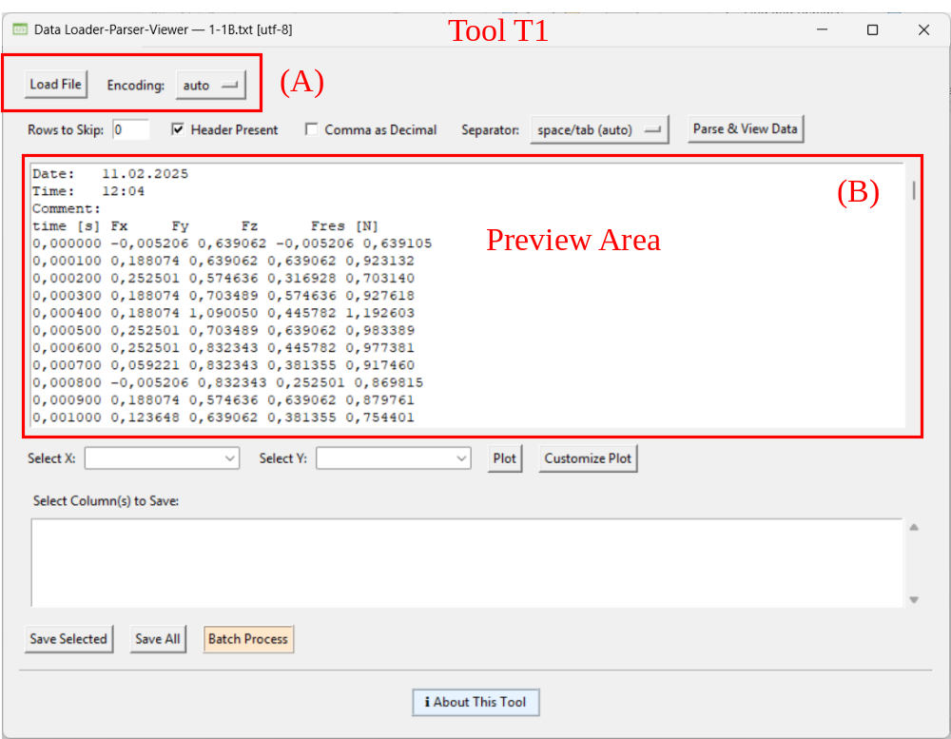
Figure S2-1. Loading and viewing file using tool T1.

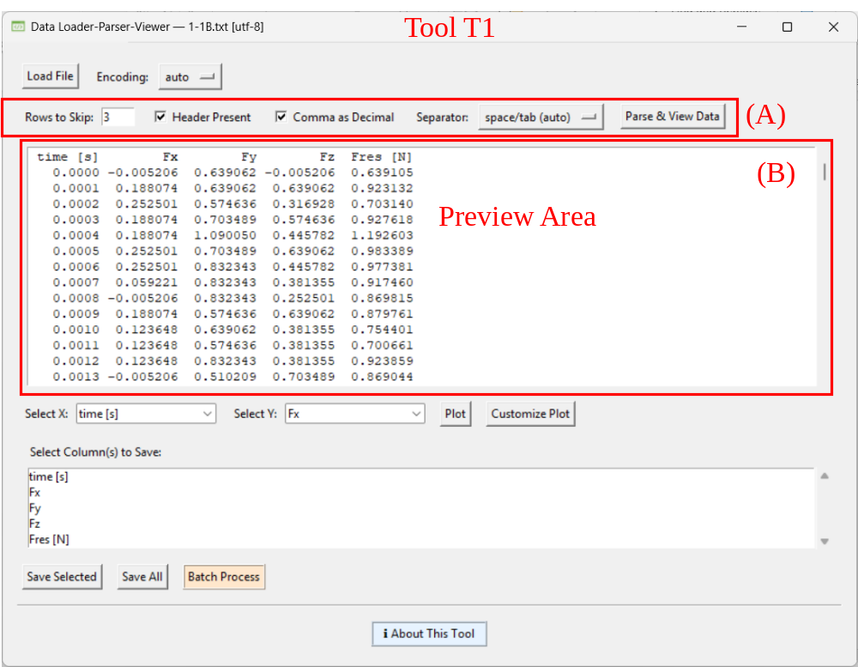
Figure S2-2. Parsing file using tool T1.

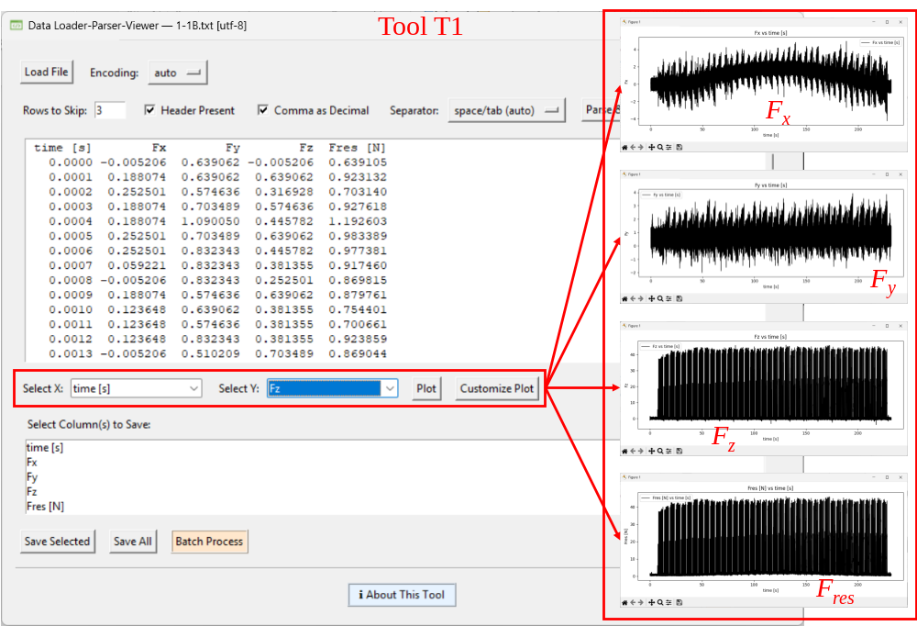
Figure S2-3. Visualizing data using tool T1.

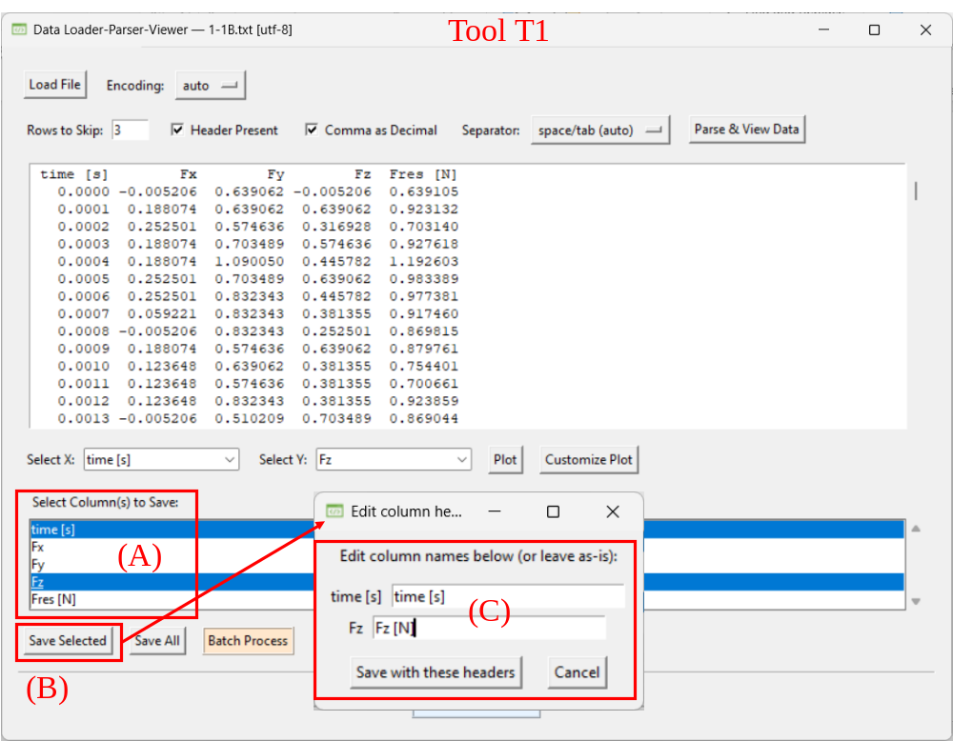
Figure S2-4. Saving relevant data using tool T1.

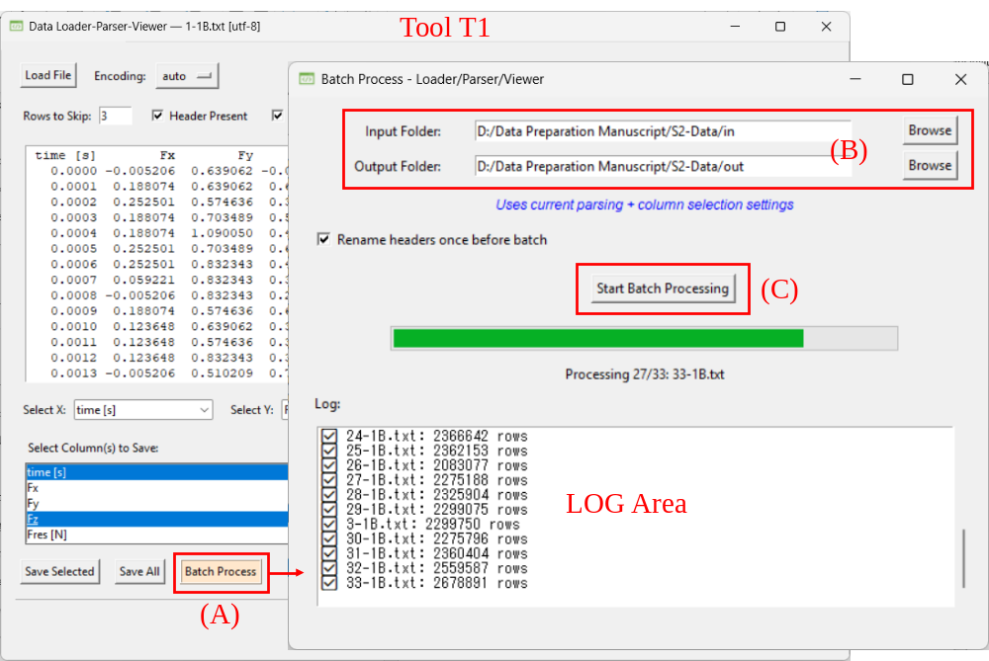
Figure S2-5. Batch-processing files using tool T1.

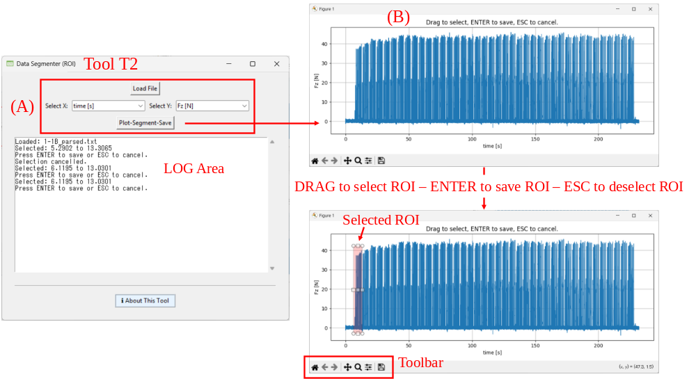
Figure S2-6. Segmenting data using tool T2.

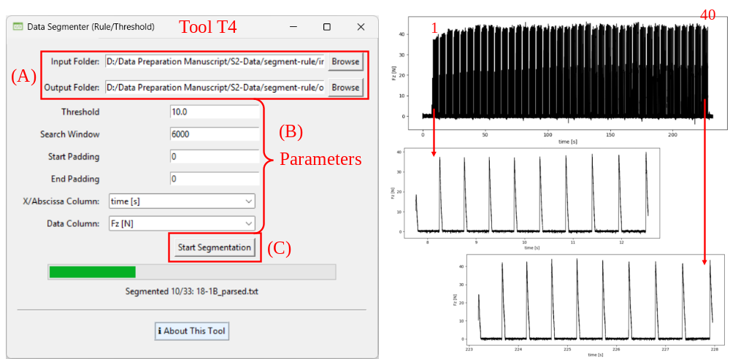
Figure S2-7. Segmenting data using tool T4.

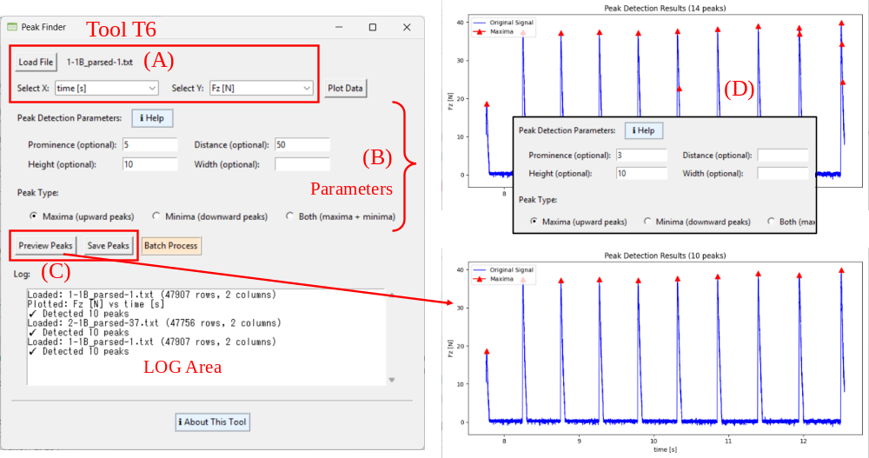
Figure S2-8. Feature-based resampling using tool T6.

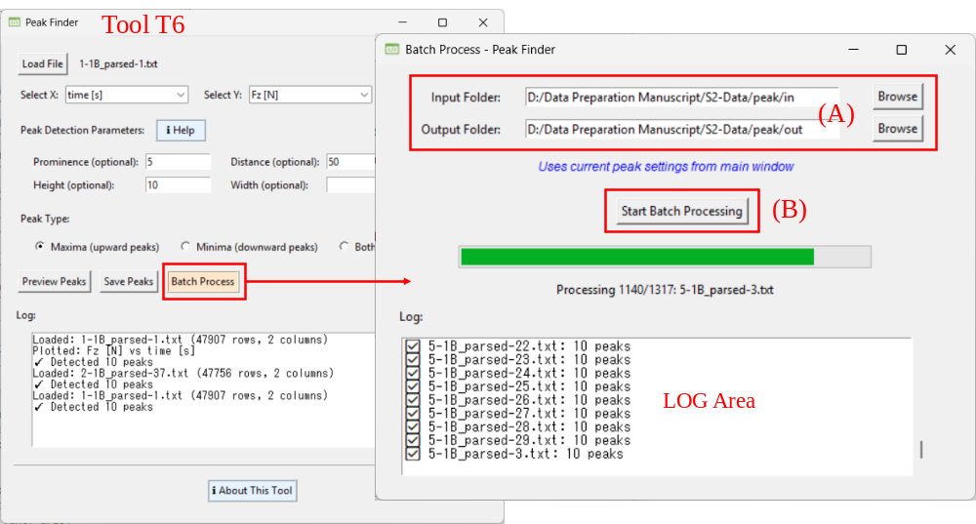
Figure S2-9. Batch-processing files using tool T6.

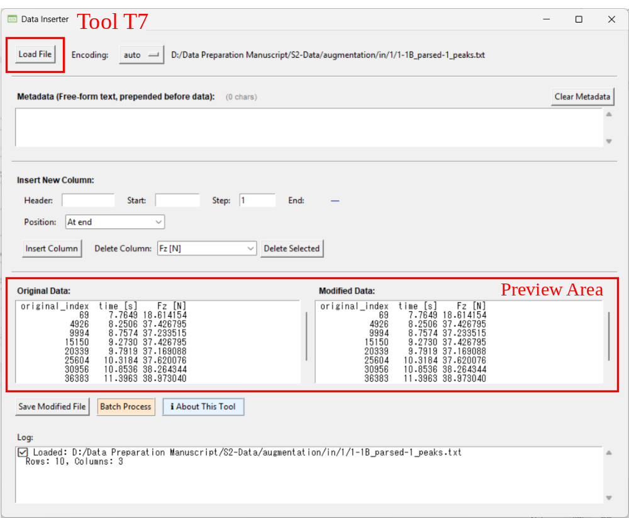
Figure S2-10. Loading and viewing file using tool T7.

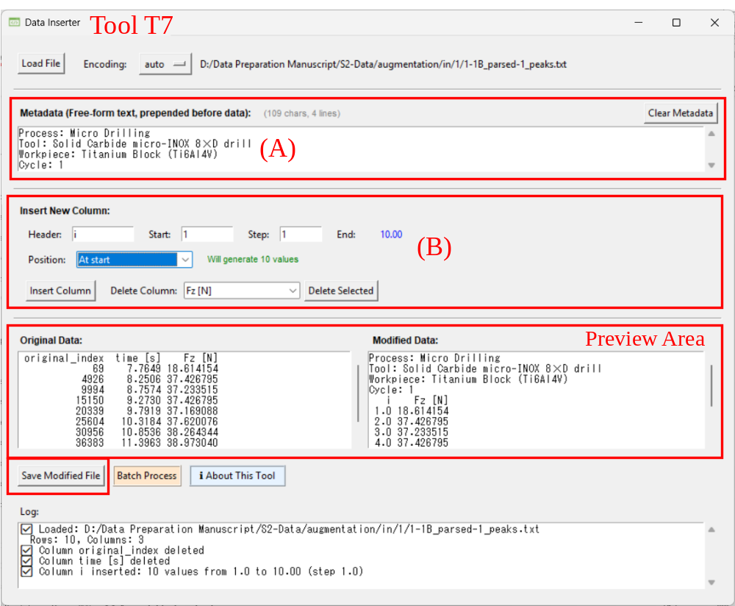
Figure S2-11. Data augmentation using tool T7.

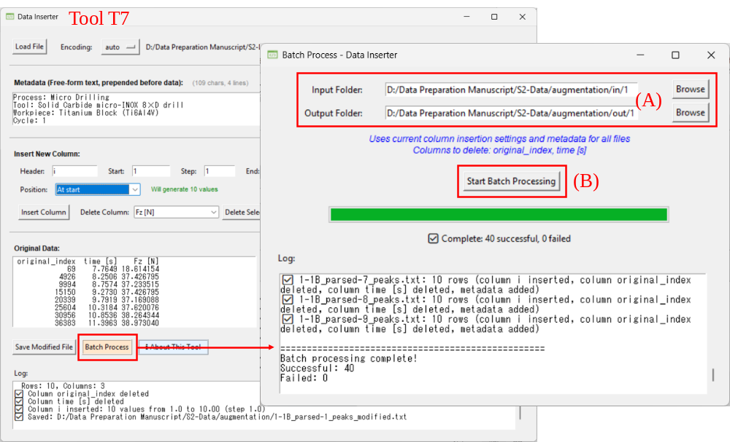
Figure S2-12. Batch-processing files using tool T7.

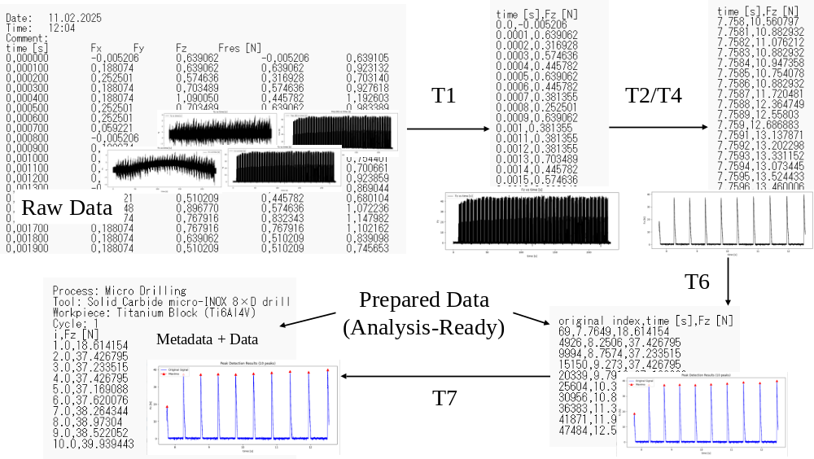
Figure S2-13. Summarizing the above workflow and tool interaction shown in Figures S2-1, …, S2-12.

- Agentic AI-based toolkit

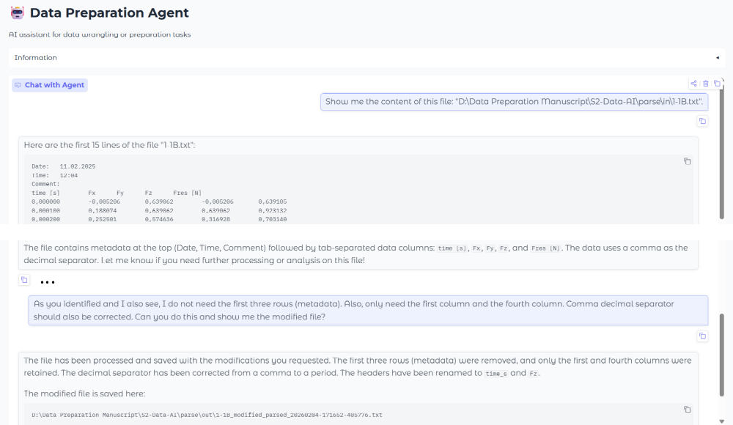
Figure S2-14. Data ingestion, exploration, and parsing using Agentic AI toolkit.

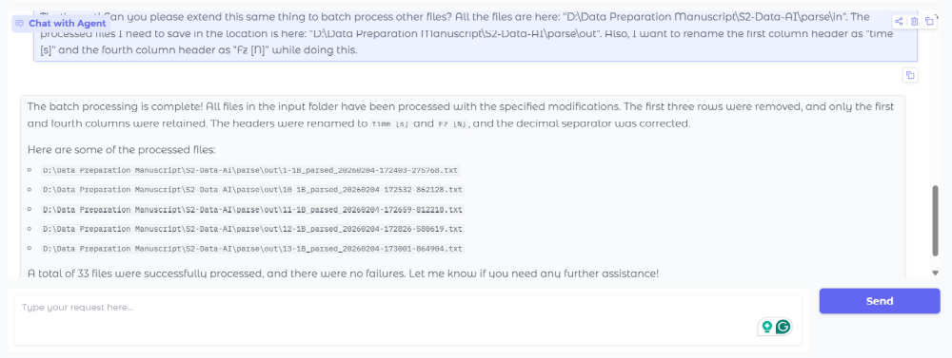
Figure S2-15. Batch-processing ingestion-exploration-parsing tasks using Agentic AI toolkit.

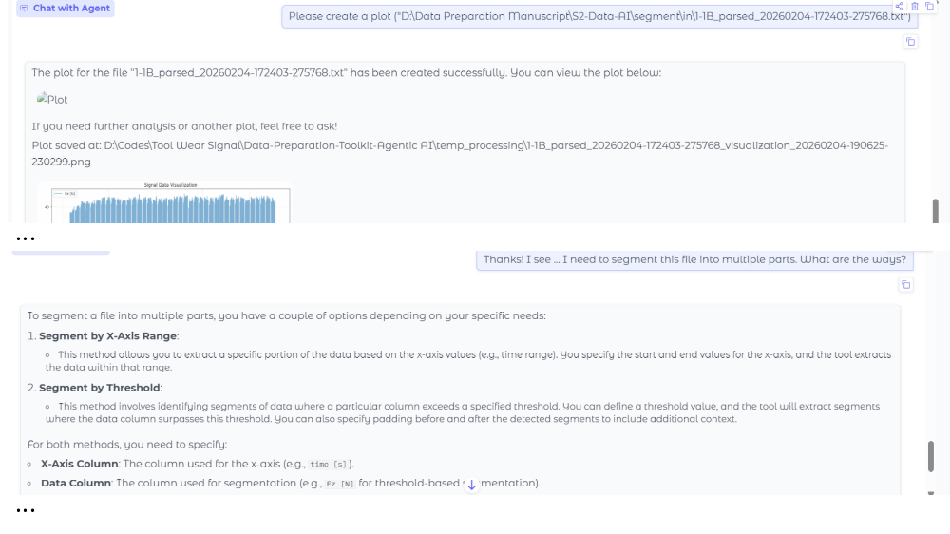
Figure S2-16. Exploring and initiating segmentation using Agentic AI toolkit.

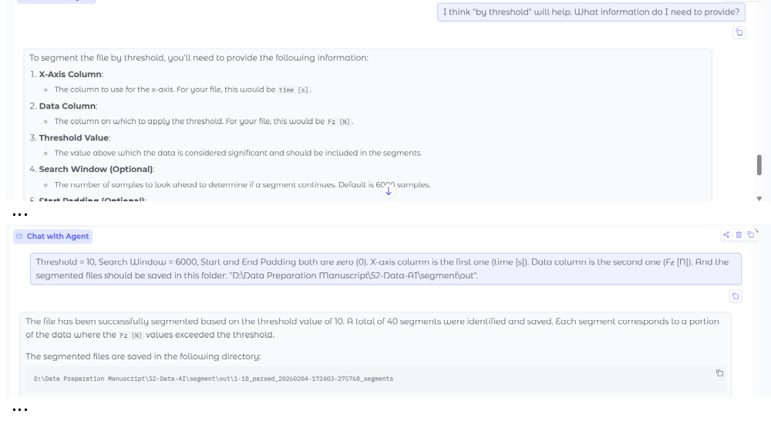
Figure S2-17. Segmenting a single file using Agentic AI toolkit.

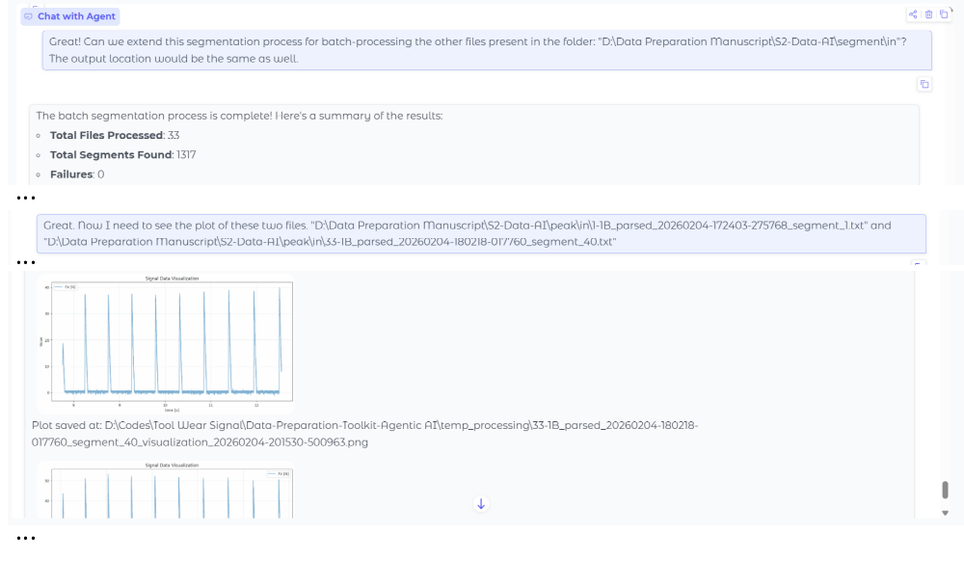
Figure S2-18. Batch-processing segmentation task and visualizing outcomes using Agentic AI toolkit.

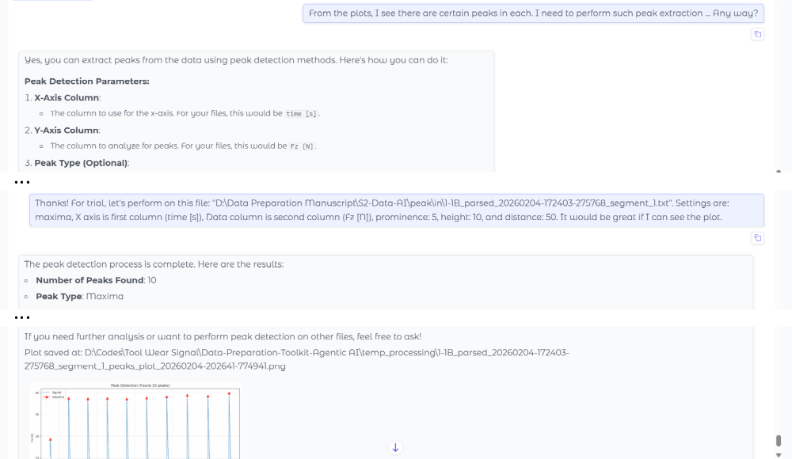
Figure S2-19. Exploring and initiating feature-based sampling (peak detection) task using Agentic AI toolkit.

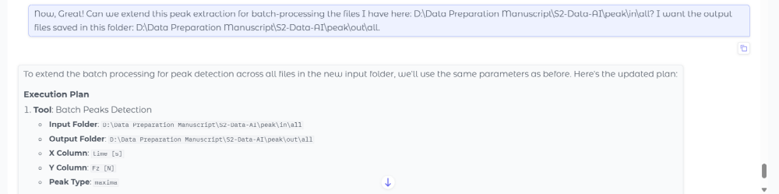
Figure S2-20. Batch-processing feature-based sampling (peak detection) task using Agentic AI toolkit.

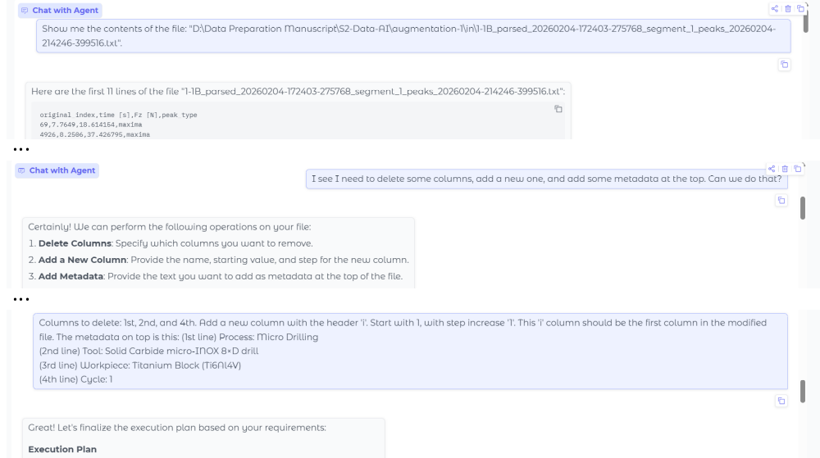
Figure S2-21. Exploring and initiating data augmentation tasks using Agentic AI toolkit.

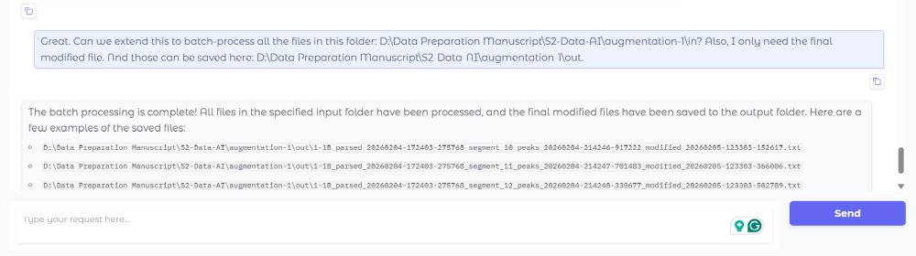
Figure S2-22. Batch-processing data augmentation tasks using Agentic AI toolkit.

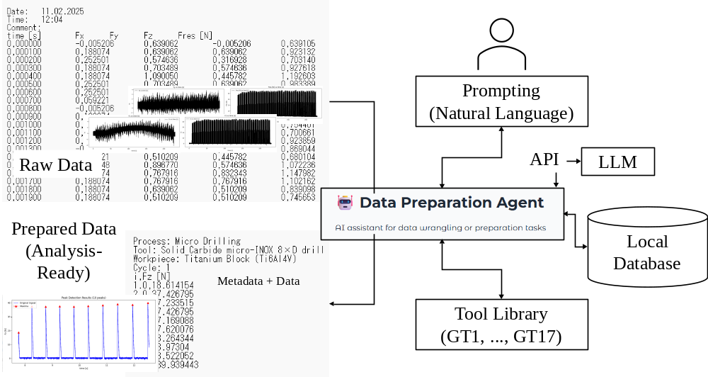
Figure S2-23. Summarizing the above workflow using Agentic AI toolkit shown in Figures S2-14, …, S2-22.

