Supplementary Materials (Document Title: S1)

Article Title:
Systematizing Data Preparation in Smart Manufacturing via Axiomatic Design: A Toolkit Integrating GUI and Agentic AI

Authors:
Angkush Kumar Ghosh, Saman Fattahi, Yu Kogawara, Bahman Azarhoushang, Takuya Okamoto and Sharifu Ura

Description:
This document contains visual screenprints and operational flowcharts for the launcher and tool underlying the developed GUI-based toolkit.

List of Contents:

Tool | Page
Launcher | 2
Loader–Parser–Viewer Tool (T1) | 3
Segmentation Tool (ROI-Based) (T2) | 4
Segmentation Tool (ROI Multi-Channel) (T3) | 5
Segmentation Tool (Rule/Threshold-based) (T4) | 6
Sampler Tool (T5) | 7
Peak Finder Tool (T6) | 8
Data Inserter Tool (T7) | 9

- Launcher

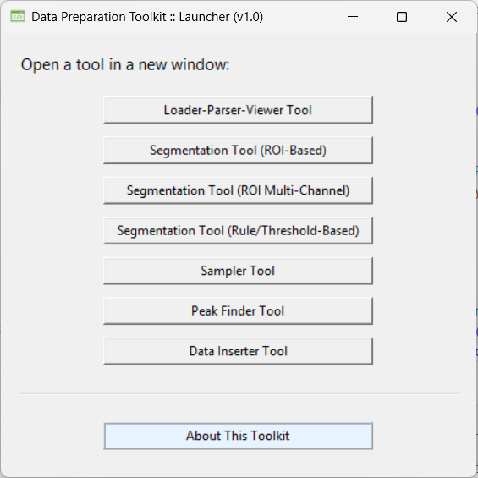
Figure S1-1. Screenprint of the launcher tool.
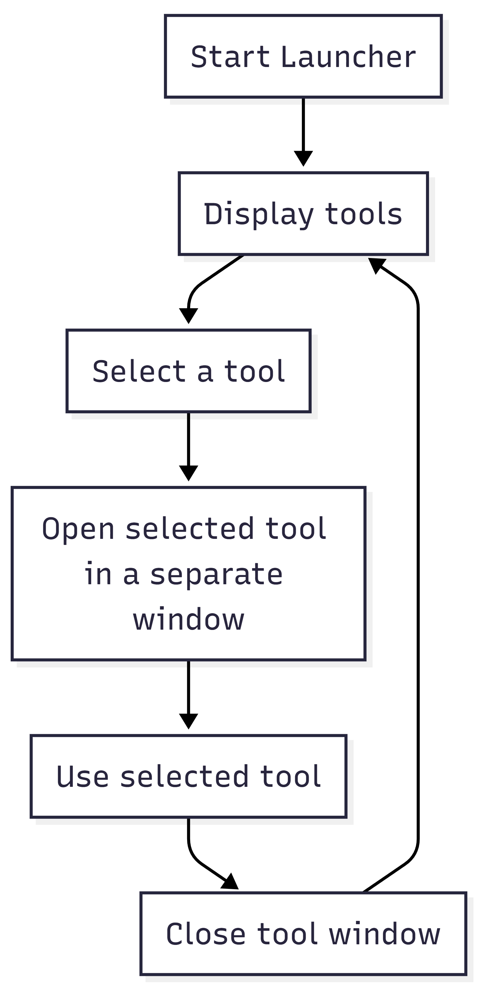
Figure S1-2. Operational flowchart for the launcher tool.

- Loader–Parser–Viewer Tool (T1)

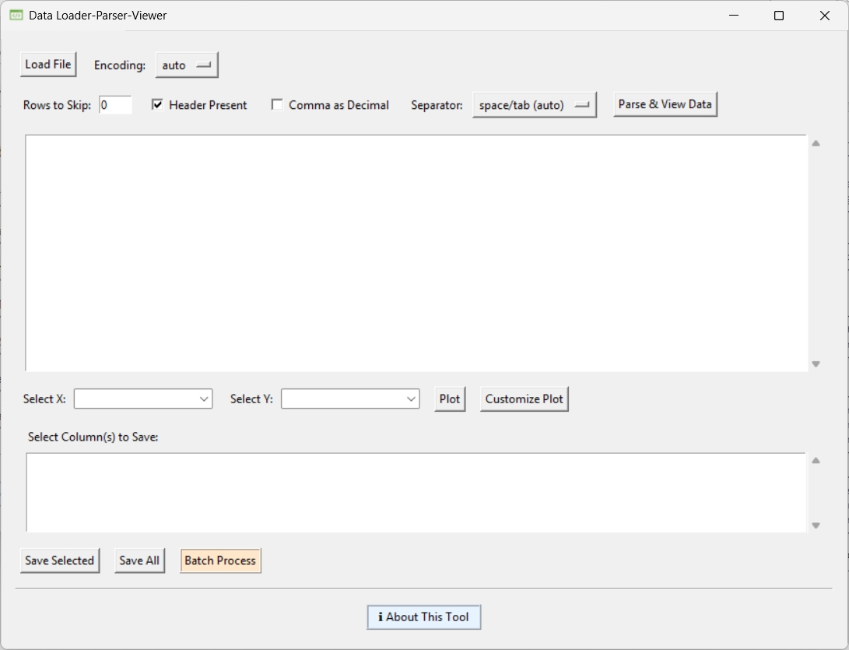
Figure S1-3. Screenprint of the T1 tool.
Figure S1-4. Operational flowchart for the T1 tool.

- Segmentation Tool (ROI-Based) (T2)

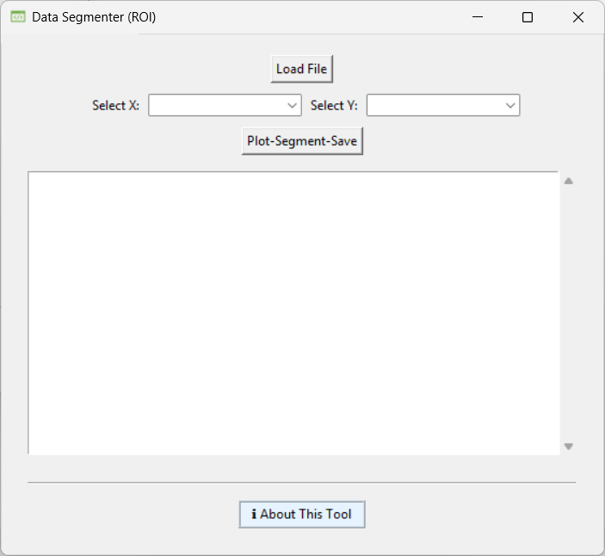
Figure S1-5. Screenprint of the T2 tool.
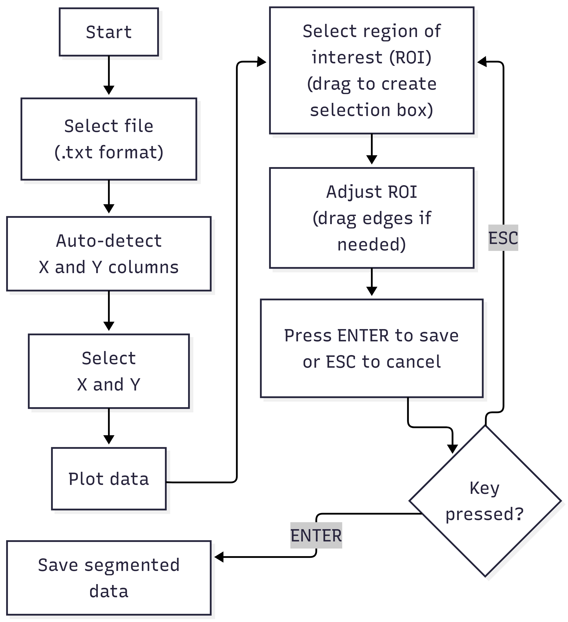
Figure S1-6. Operational flowchart for the T2 tool.

- Segmentation Tool (ROI Multi-Channel) (T3)

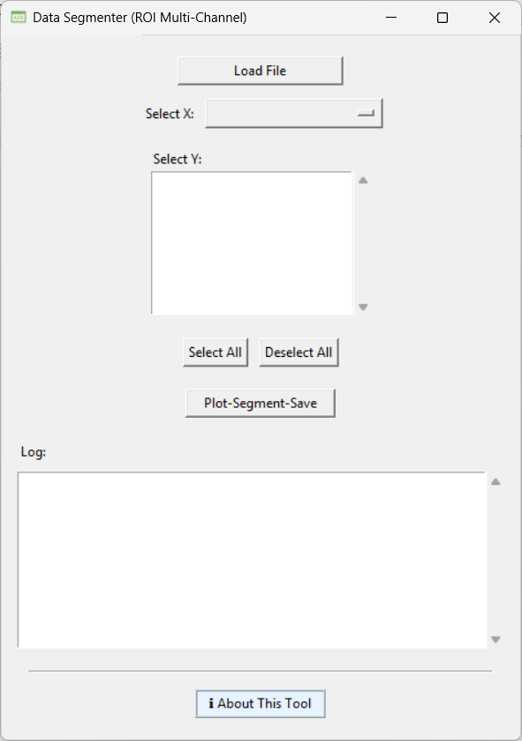
Figure S1-7. Screenprint of the T3 tool.
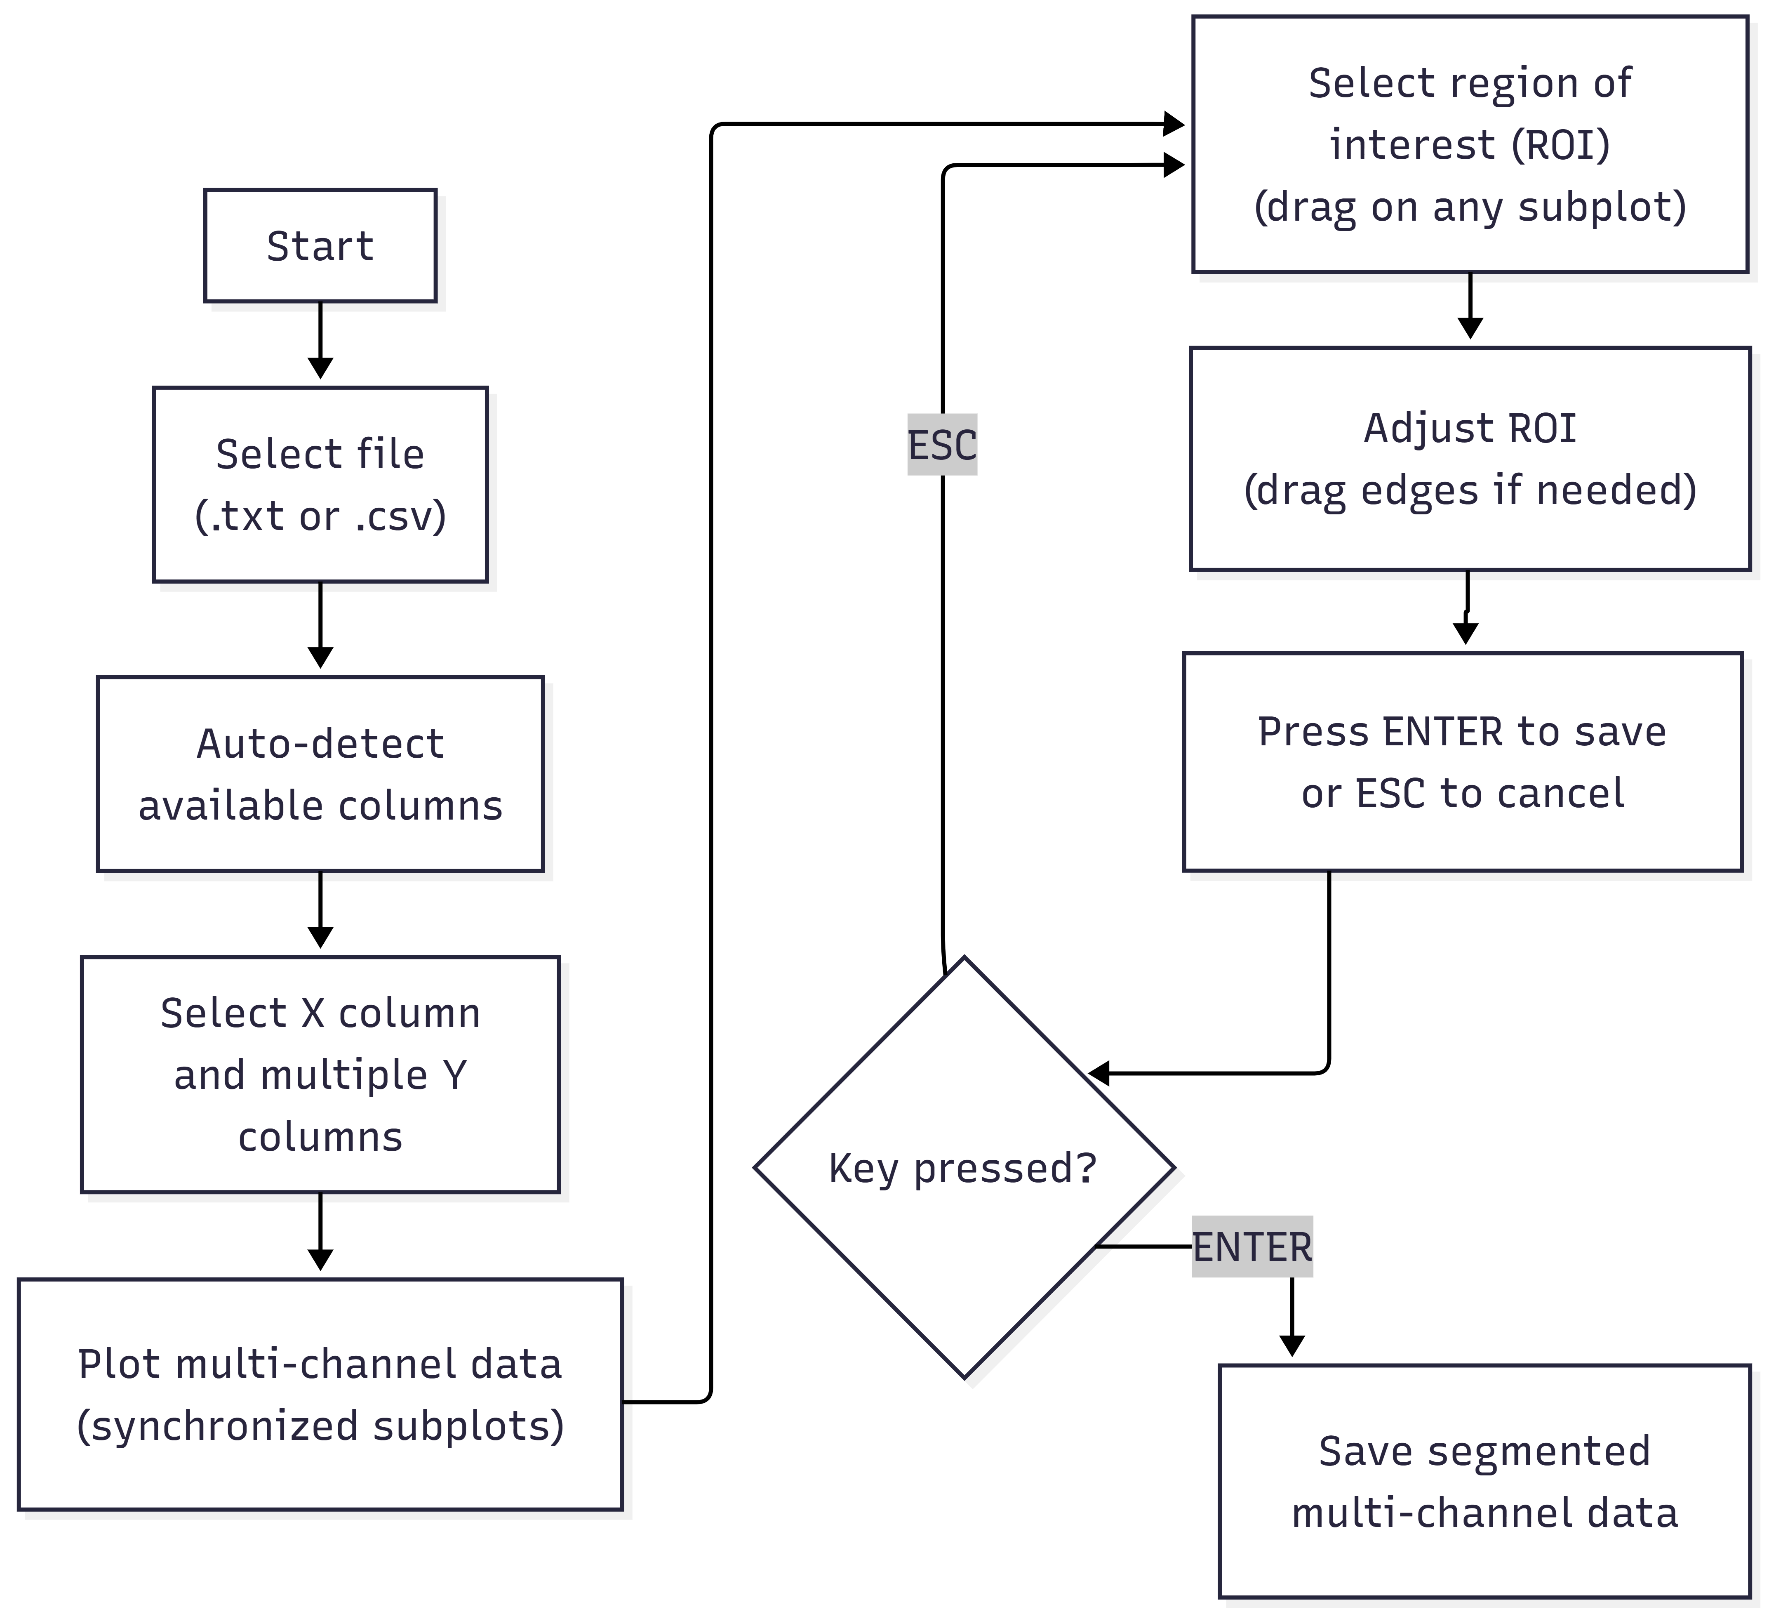
Figure S1-8. Operational flowchart for the T3 tool.

- Segmentation Tool (Rule/Threshold-based) (T4)

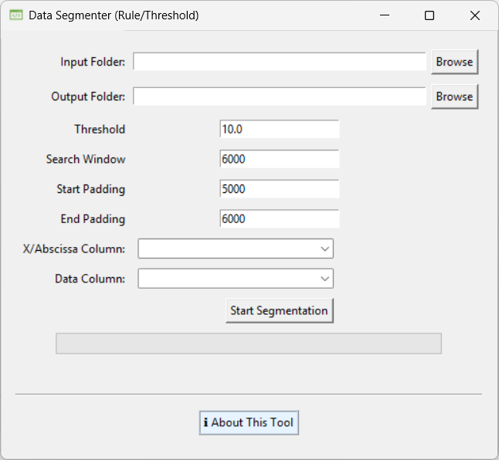
Figure S1-9. Screenprint of the T4 tool.
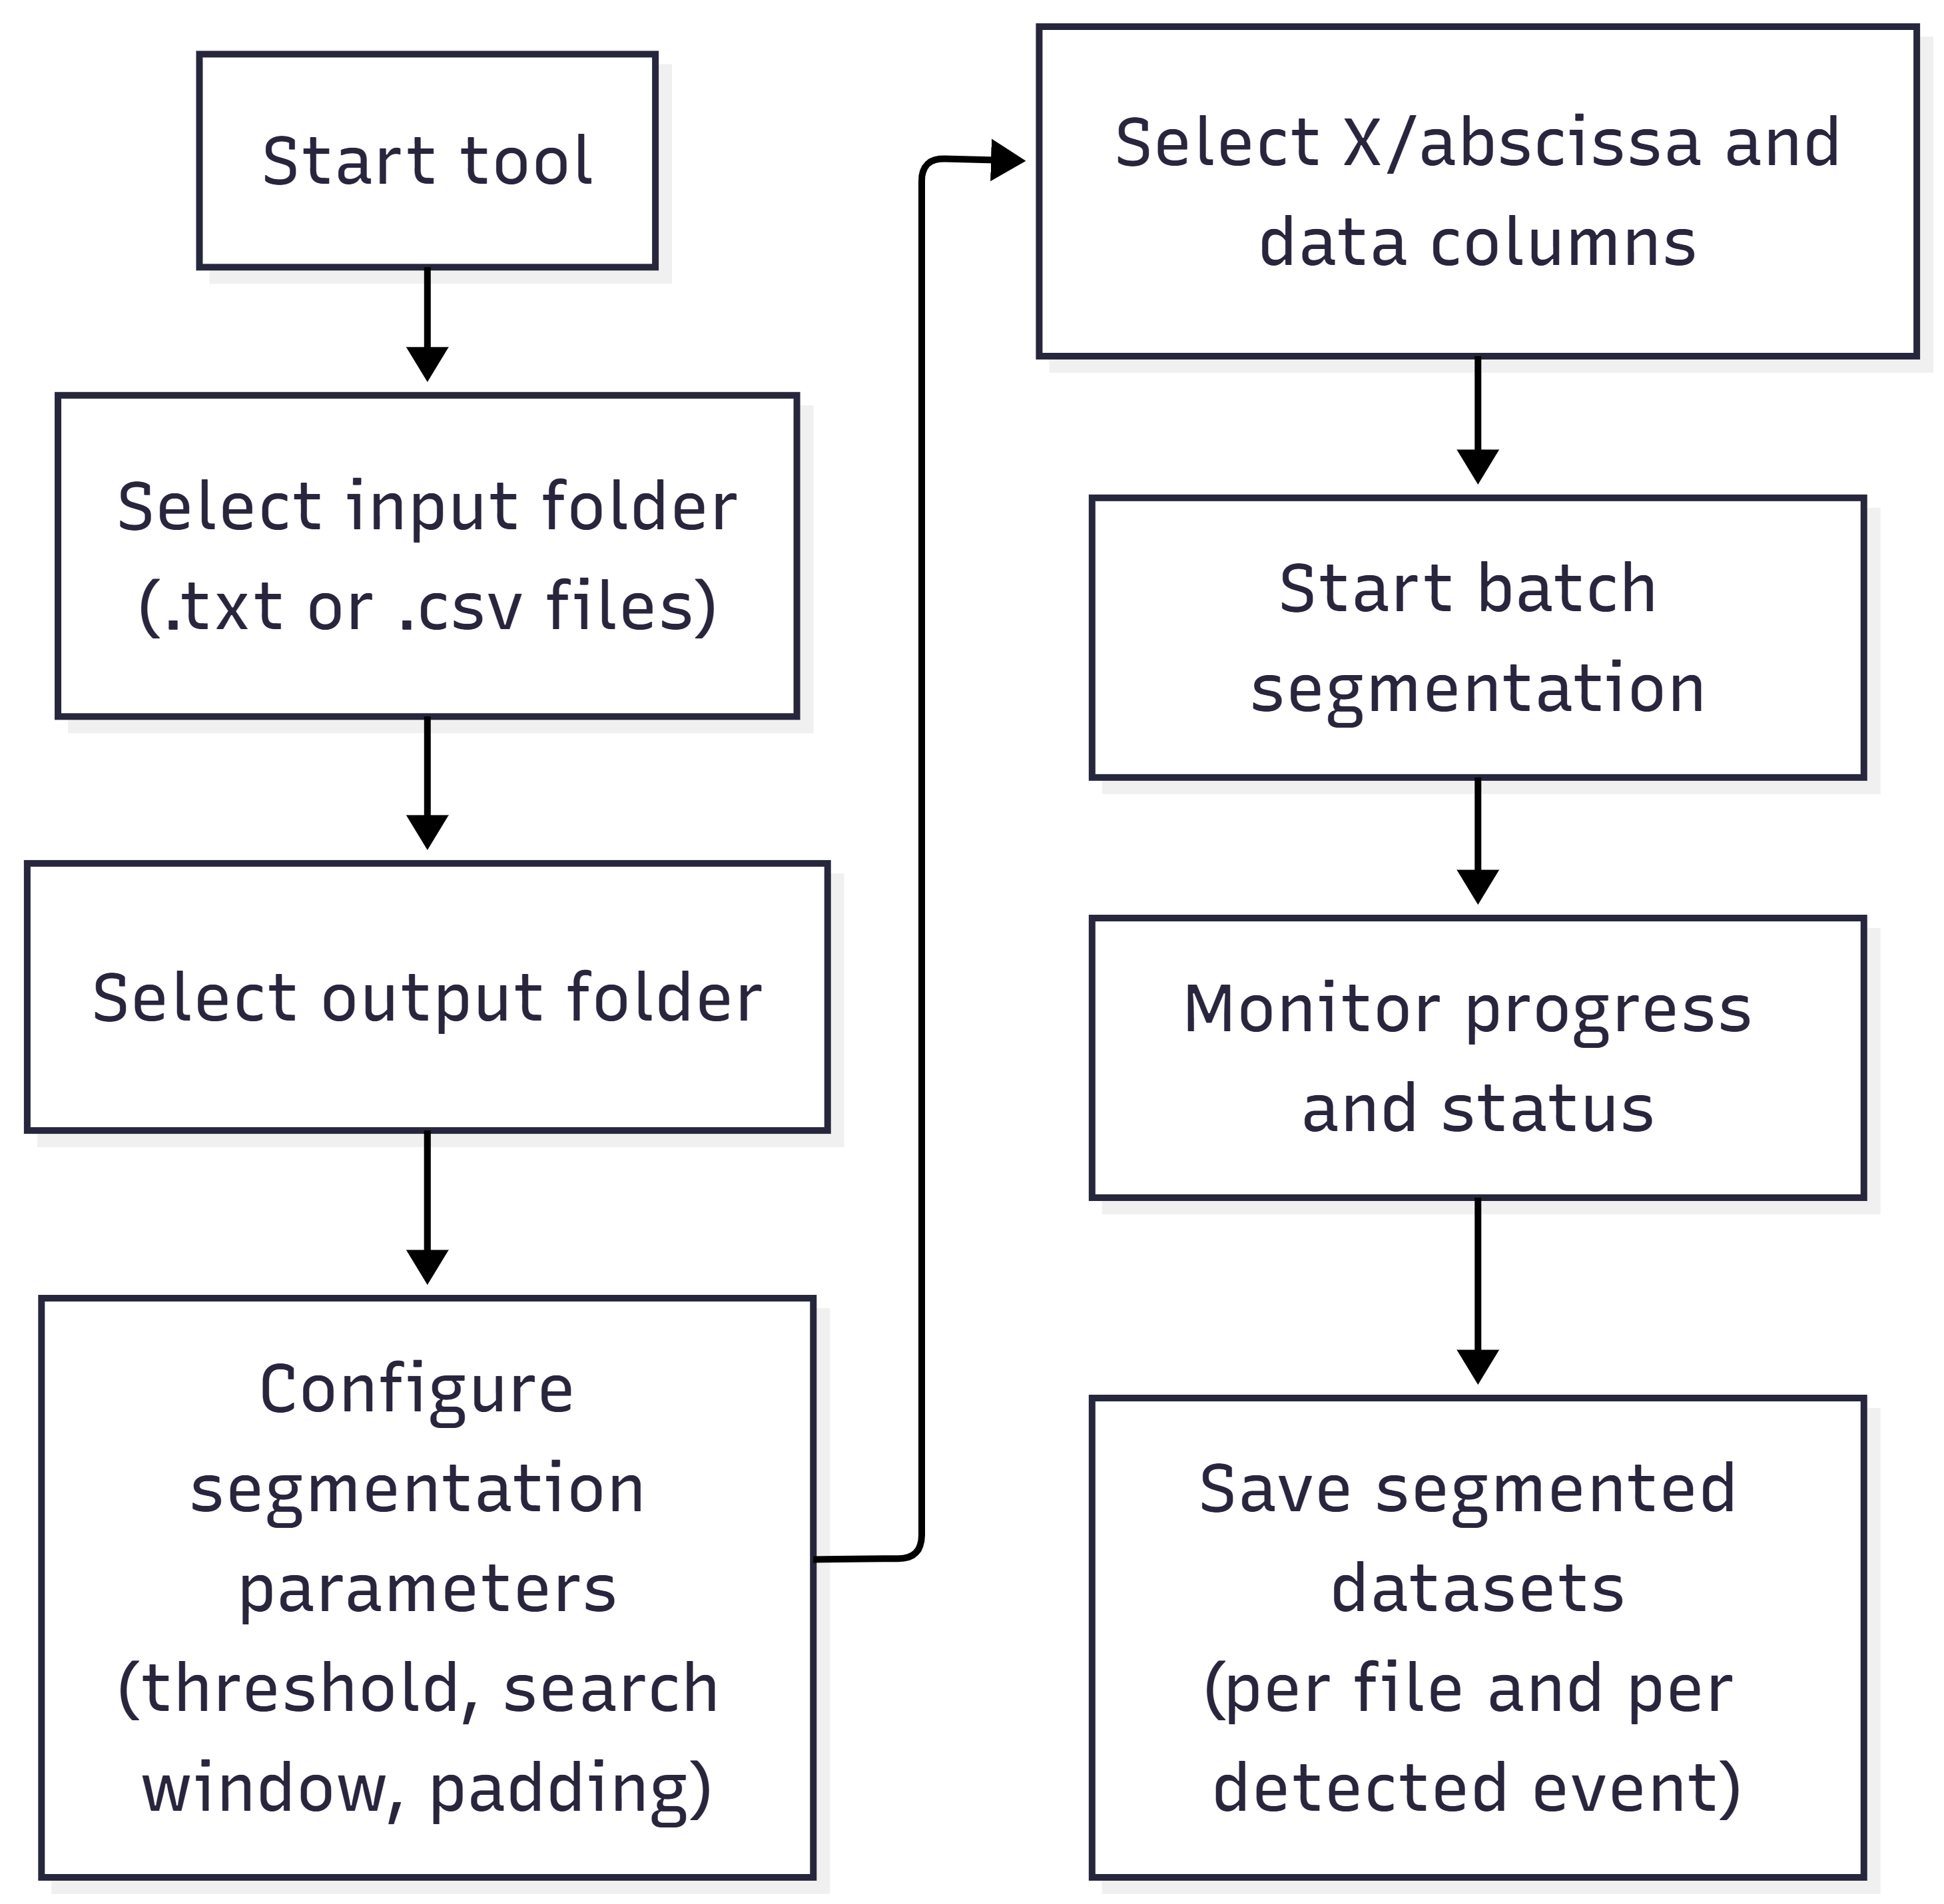
Figure S1-10. Operational flowchart for the T4 tool.

- Sampler Tool (T5)

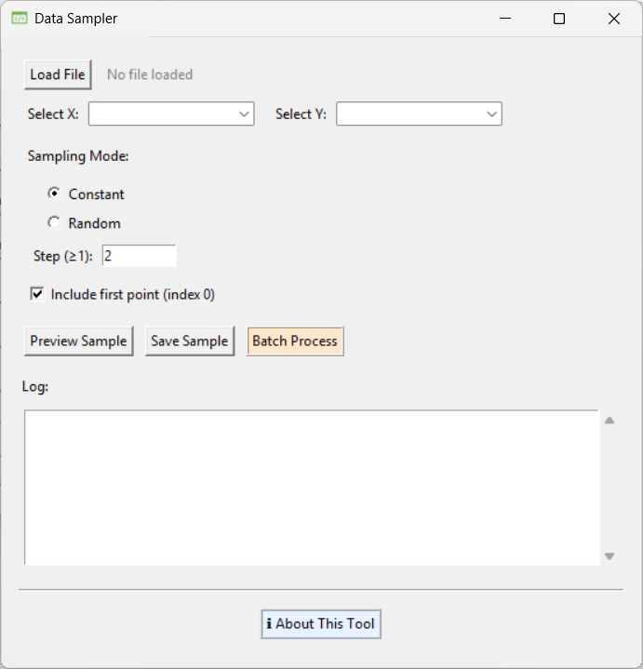
Figure S1-11. Screenprint of the T5 tool.
Figure S1-12. Operational flowchart for the T5 tool.

- Peak Finder Tool (T6)

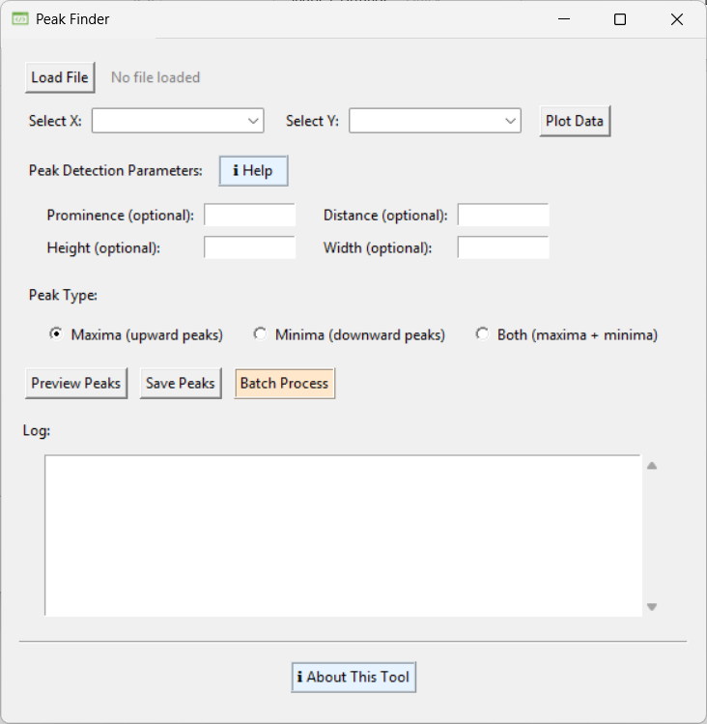
Figure S1-13. Screenprint of the T6 tool.
Figure S1-14. Operational flowchart for the T6 tool.

- Data Inserter Tool (T7)

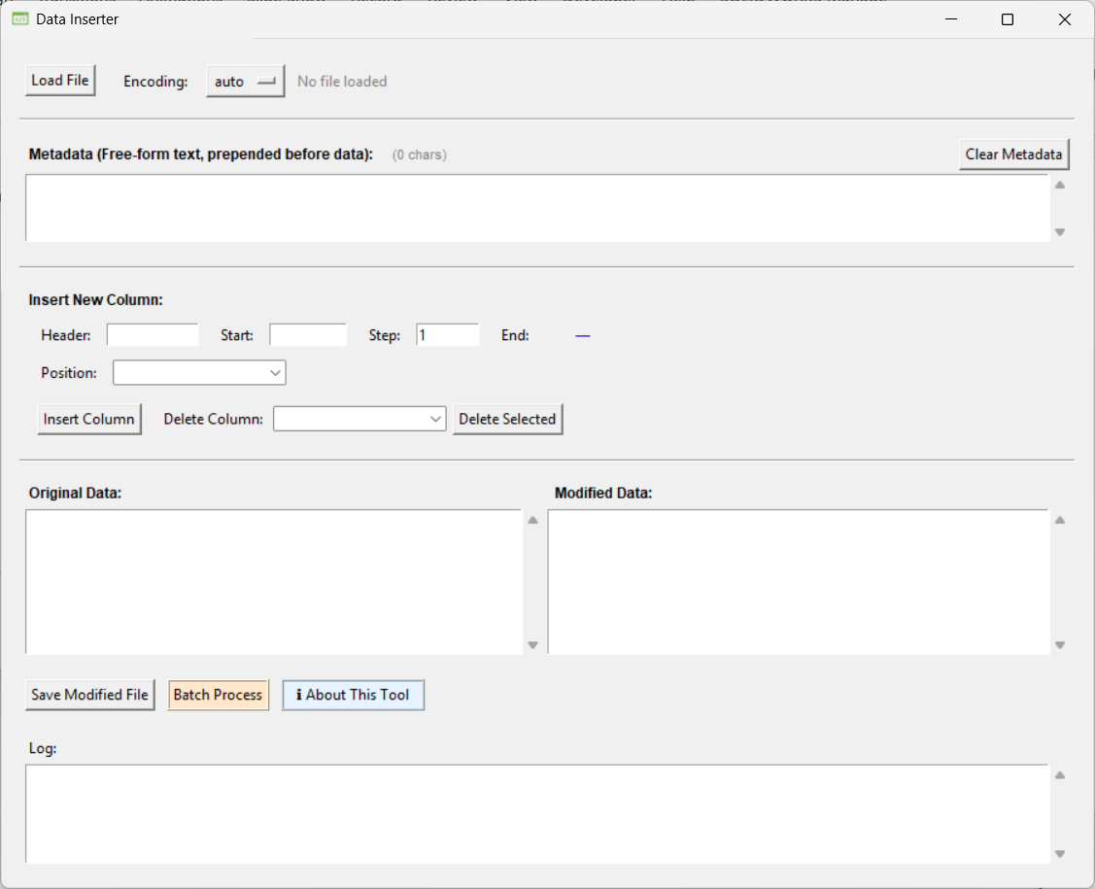
Figure S1-15. Screenprint of the T7 tool.
Figure S1-16. Operational flowchart for the T7 tool.

