Supplementary figures

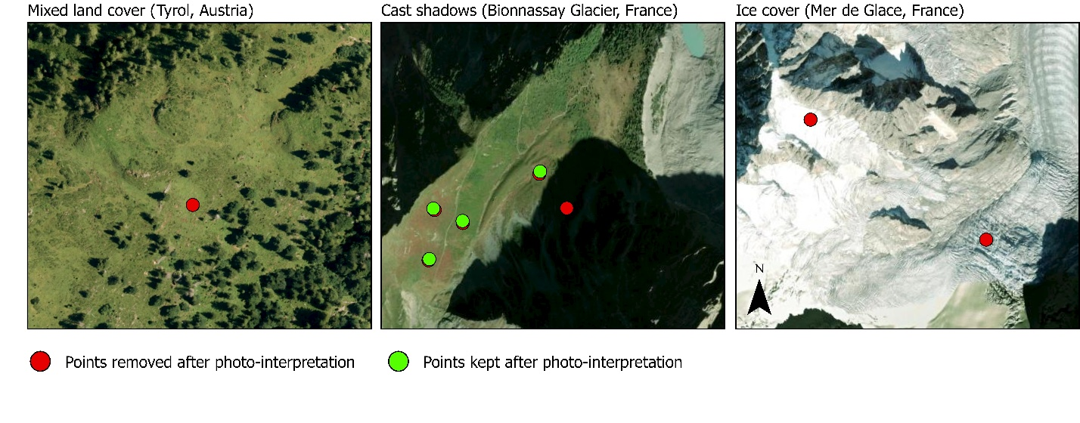
Figure S1 – Examples of training points removed or retained after expert photo-interpretation. High-resolution imagery was used to visually inspect candidate training points before random-forest classification. Red points indicate samples removed after photo-interpretation because they were affected by ambiguous or unreliable conditions, including mixed land cover at class boundaries, cast shadows, or residual ice/snow cover. Green points indicate samples retained because their land-cover class was visually interpretable and representative of the target class. Examples are shown for mixed land cover in Tyrol, Austria; cast shadows near Bionnassay Glacier, France; and ice-covered terrain at Mer de Glace, France.

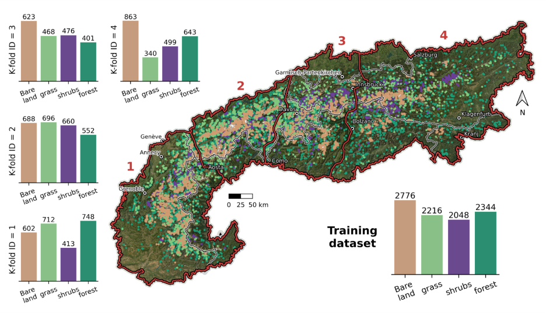
Figure S2 – Spatial distribution of the training dataset. The 4-fold spatial split zones are shown with red outlines and ID number. The total (bottom right) and respective folds (left) distribution of the training points are shown in histograms.

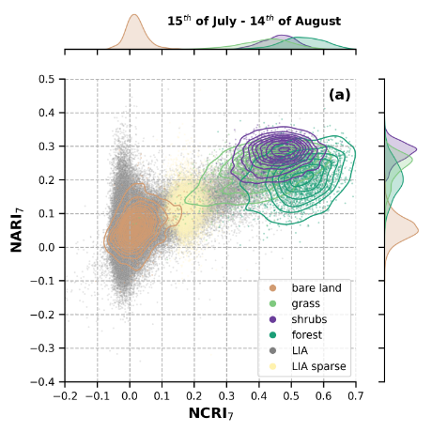
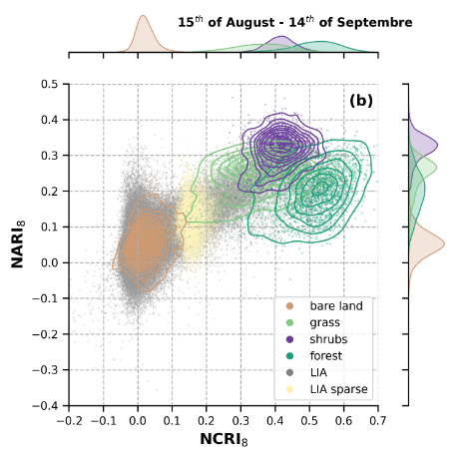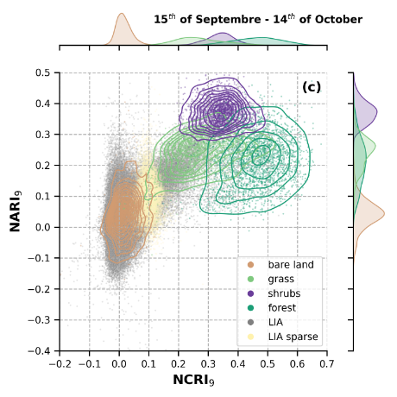
Figure S3 – NARI₇₋₈₋₉ and NCRI₇₋₈₋₉ predictive variables distribution of the training dataset (isoline contours) as well as for a sample of the mapped area (grey points) over the 2015 deglaciated parts of the end-of-LIA glacier extents. The panels (a)-(b)-(c) correspond to the different average periods. The yellow points show the predictive variable space distribution for pixels classified as sparse vegetation (see methods), highlighting the smooth connection they make between bare lands, sediments, and grassland space.

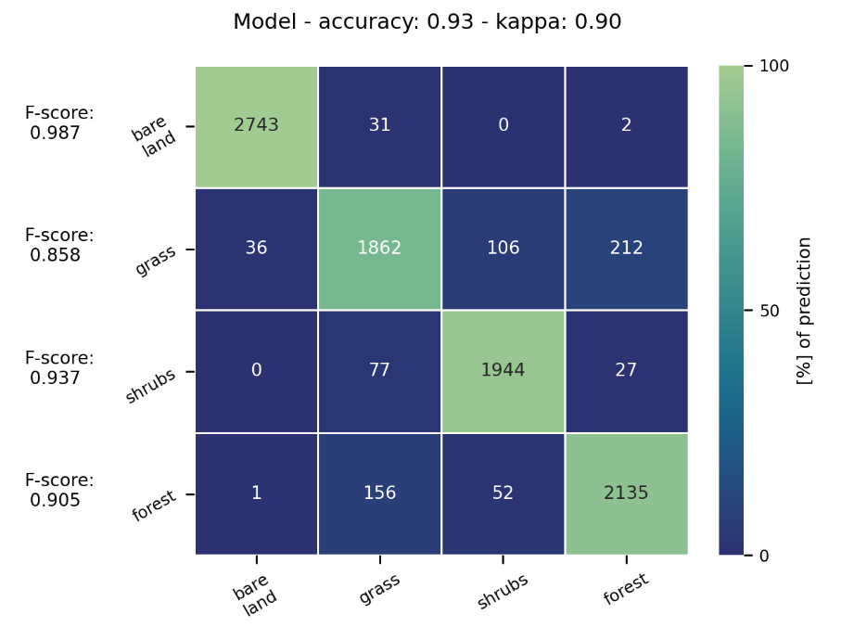
Figure S4 – Confusion matrix, F-scores, accuracy and kappa scores of the terrestrial random-forest model. Metrics are computed from spatially held-out test folds in a 4-fold spatial cross-validation. For each fold, the model was trained on three spatial blocks and evaluated on the remaining block; the confusion matrix aggregates the four out-of-fold predictions.

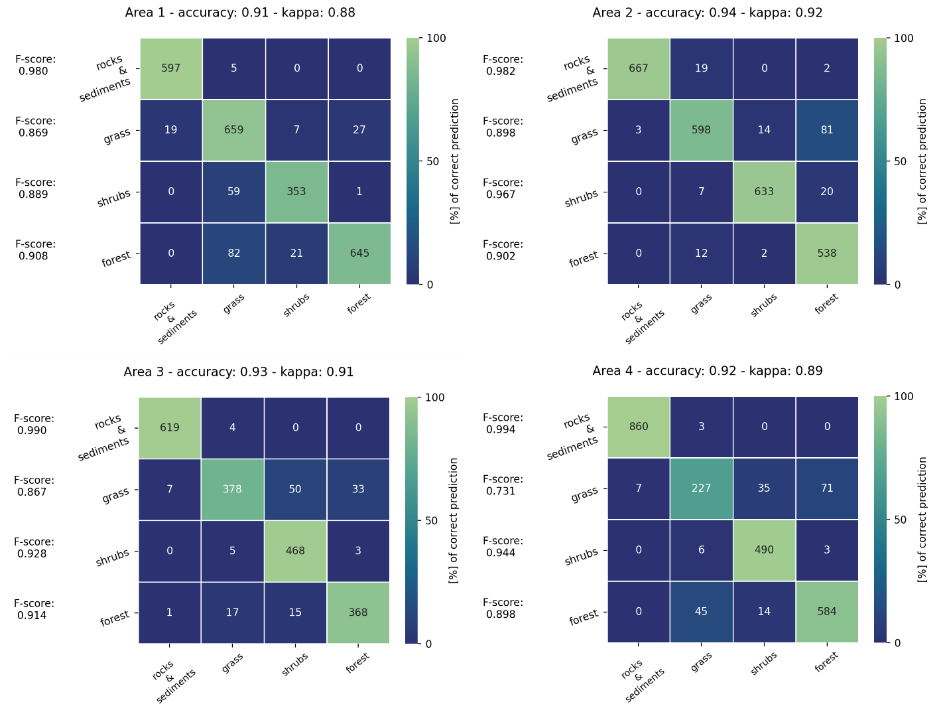

Figure S5 – Confusion matrix, F-scores, accuracy and kappa scores of the four terrestrial random-forest models. Metrics are computed from spatially held-out test folds in a 4-fold spatial cross-validation. For each fold, the model was trained on three spatial blocks and evaluated on the remaining block.

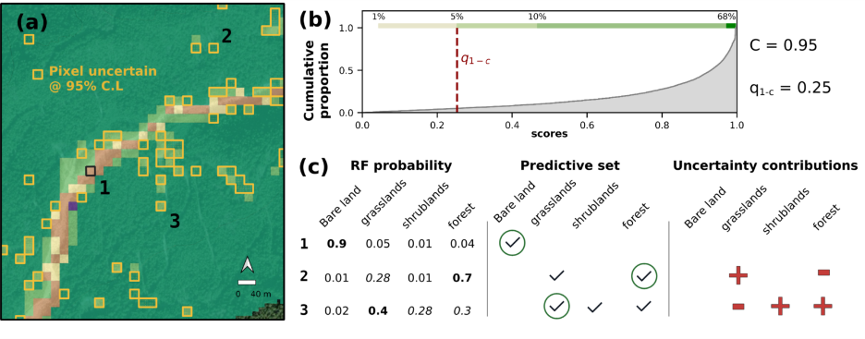
Figure S6 – Illustration of the uncertainty estimation of the land cover area. (a) Land cover map details on Mer-de-glace (Chamonix, France) postglacial area. Color codes are as in Fig. S1. The empty yellow squares indicate uncertain pixels at 95% confidence level following a conformal statistics approach. (b) Cumulative distribution of the conformal scores, i.e., the probability distribution associated with the true class of the training dataset points. The q_{1-C} quantile value is shown by the red dashed line, with C, the confidence level, here 95%. (c) Examples for three pixels, indicated on panel (a), of the random forest probabilities, predictive set content, and the contribution to the land cover area uncertainties. Bold text probabilities and green circles indicate the pixel land cover classification. The tick markers indicate land cover categories with probabilities higher than q_{1-C}, therefore included in the predictive set. When the predictive set contains more than one land cover category, the pixel is uncertain, and positive area uncertainties (red plus sign), or negative area uncertainties (red minus sign) are derived.

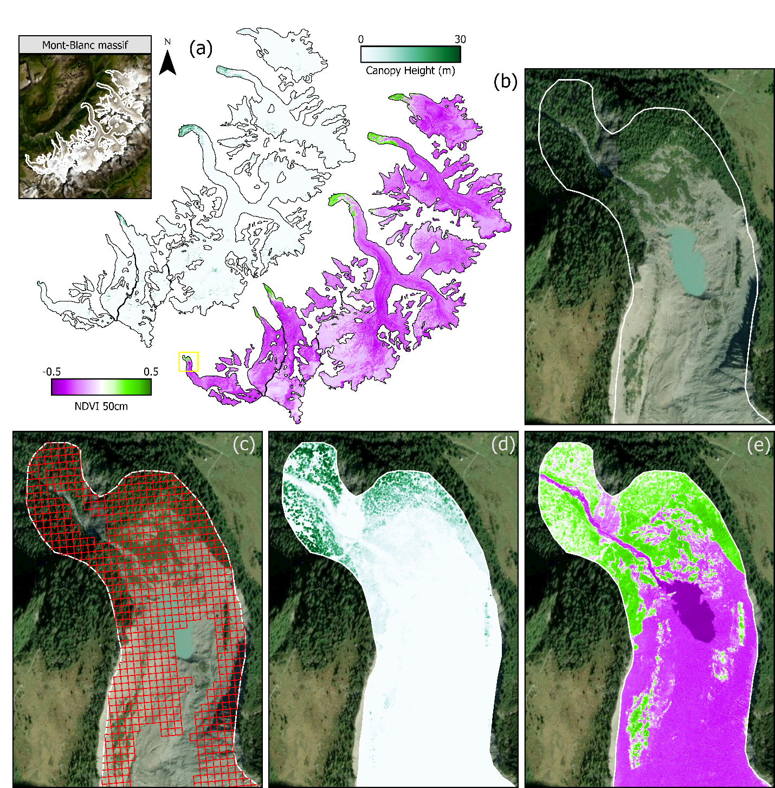
Figure S7 | High-resolution products used to characterize the sub-pixel composition of 20 m land-cover classes in the Mont-Blanc massif. (a) Spatial coverage of the 50 cm NDVI product derived from aerial orthophotography and the 50 cm canopy-height model derived from airborne LiDAR within the Mont-Blanc massif. The black outline indicates the post-LIA deglaciated terrain used for the land-cover analysis. The top left inset shows the location of the Mont-Blanc massif. (b) Example postglacial area used to illustrate the comparison between the 20 m Sentinel-2 land-cover classification and the high-resolution products for the Bionnassay glacier. The white outline indicates the post-LIA deglaciated terrain. (c) Overlay of the 20 m land-cover grid on high-resolution imagery. (d) Canopy-height model aggregated within the post-LIA outline, showing the fine-scale distribution of woody vegetation structure. (e) 50 cm NDVI product within the same area, showing sub-pixel variation in vegetation greenness. These high-resolution products were aggregated to each 20 m land-cover pixel to compute mean NDVI, NDVI variance, mean canopy height and canopy-height variance.
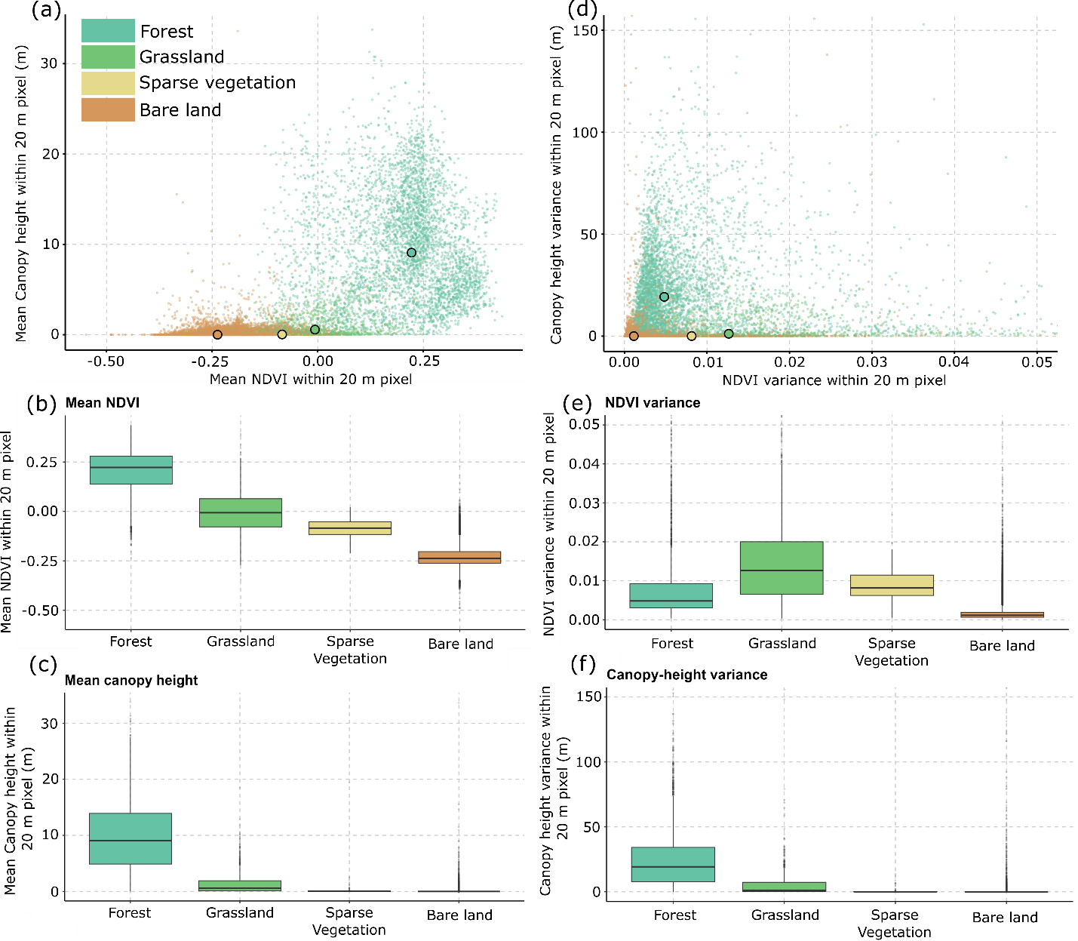
Figure S8 | High-resolution sub-pixel characterization of Sentinel-2 land-cover classes in the Mont-Blanc massif. Comparison between the 20 m land-cover classification and independent 50 cm NDVI and canopy-height products. For each 20 m pixel, 50 cm NDVI and canopy-height values were aggregated to calculate mean and variance. (a) Relationship between mean NDVI and mean canopy height, with points colored by 20 m land-cover class and black-outlined circles indicating class medians. (b–c) Class-wise distributions of mean NDVI and mean canopy height. (d) Relationship between NDVI variance and canopy-height variance, with black-outlined circles indicating class medians. (e–f) Class-wise distributions of NDVI variance and canopy-height variance. Sparse vegetation occupies an intermediate position between bare land and grassland in mean NDVI while remaining characterized by near-zero canopy height, supporting its interpretation as a low-stature bare-land–herbaceous vegetation transition at 20 m resolution. The low but non-zero NDVI signal within some bare-land pixels also confirms that the classification does not resolve all meter-scale pioneer vegetation, making the bare-land estimate conservative with respect to sub-pixel vegetation cover.

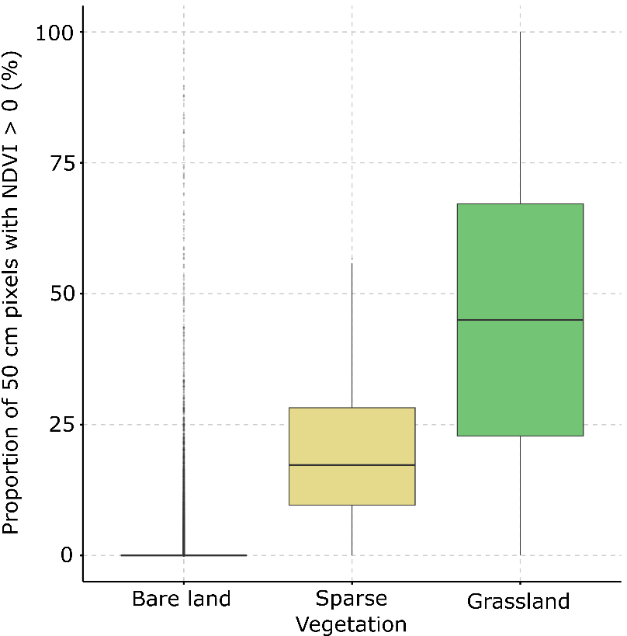
Figure S9 | Sub-pixel greenness within 20 m land-cover classes in the Mont-Blanc massif. Proportion of 50 cm pixels with NDVI > 0 within each 20 m Sentinel-2 land-cover pixel for the bare-land, sparse-vegetation and grassland classes. The 50 cm NDVI product was converted to a binary positive-greenness layer and aggregated to the 20 m land-cover grid. Bare-land pixels show predominantly low proportions of positive-NDVI sub-pixels, although 12.8% contain at least one positive-NDVI 50 cm cell. Sparse-vegetation pixels occupy an intermediate position, with a mean positive-NDVI fraction of 17.3% [9–28%], while grassland pixels show higher positive-NDVI fractions, with a mean of 45% [23–67%]. This pattern supports the interpretation of bare land, sparse vegetation and grassland as a landscape-scale continuum of increasing vegetation cover.

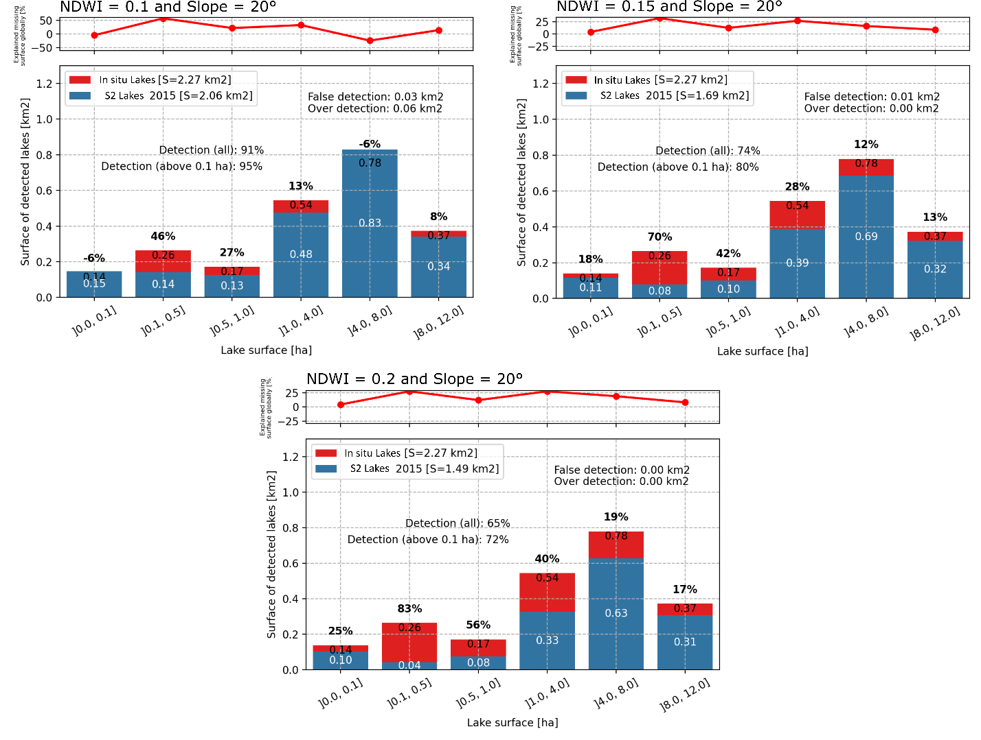
Figure S10 – Water mapping validation over French end-of-LIA glacier extent area based on varying NDWI thresholds. Bottom panels show the surface of detected lakes as a function of lake area. The top panel shows how much the missing surface per lake bin contributes to the total missing surface area.

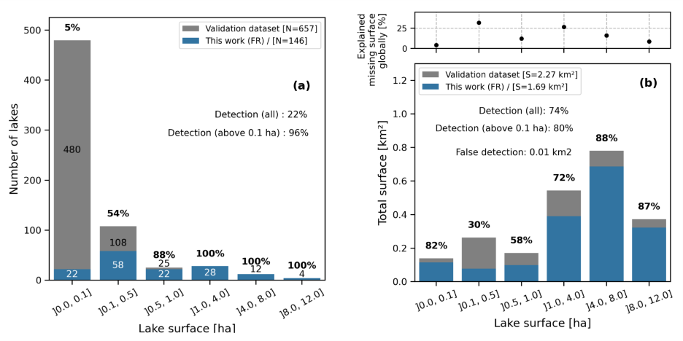
Figure S11 – Water mapping validation over French end-of-LIA glacier extent area.
(a) Number of detected lakes as a function of lakes area. (b) Surface of detected lakes as a function of lakes area. The top panel shows how much the missing surface per lake bin contributes to the total missing surface area.

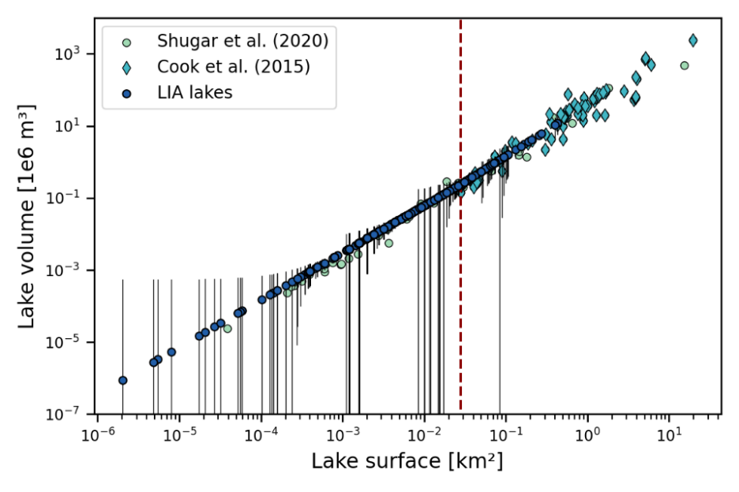
Figure S12 – Water volume derivation for natural lakes mapped within the 2015 deglaciated regions of the end-of-LIA glacier extents. Sample points used to derive area-volume scaling relations taken from two references are shown with light green points and blue diamonds. The lakes mapped in this study are shown with dark blue circles. Uncertainties derived from water mapping uncertainties and scaling relations residuals are shown with black vertical lines. The surface validity limit of Cook et al. (2015) is shown with the vertical red dashed line.

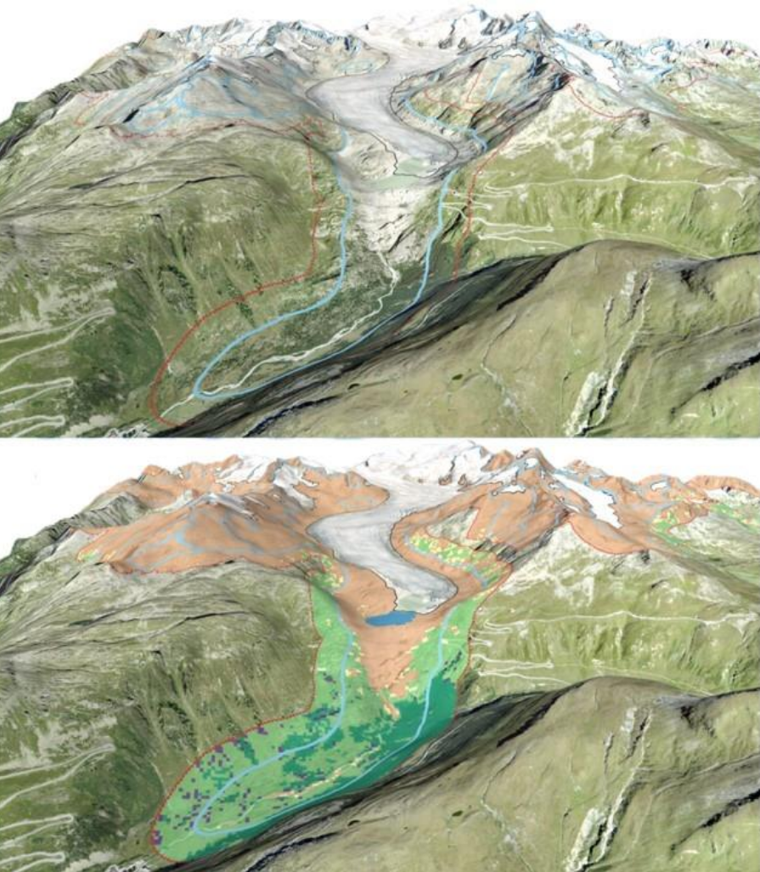
Figure S13 – Rhône glacier, Valais, Switzerland. (a) Illustration of the end-of-LIA glacier extents (light blue contours), the 200-m adjacent zone (dark red contours) and the 2015 glacier outlines (black contours) (b) Same illustration superimposed with the land cover map produced in this study at 20-m resolution. Color codes are as follows: (1)-Bare lands in light brown, (2)-sparse vegetation in yellow, (3)-grasslands in light green, (4)-shrublands in purple, (5)-forest in dark green, (6)-water in blue. Background images: ©ESRI World Imagery.

Supplementary tables

Table S1: Land cover surfaces and associated uncertainties within the end-of-LIA glacier extent of the European Alps. The glacierized and corresponding deglaciated area reflects the year 2015. Land cover type is mapped as observed in 2020. The percentages are given within the respective zones, e.g., the total end-of-LIA glacier extent, the 2015 deglaciated area, and the vegetated area. Uncertainties are given at the 95% confidence level. Zero values mean less than 0.5 (km² or %) but different from zero.

 |  | End-of-LIA  glacier extents area |  |  | Deglaciated areas in 2015 |  |  | Vegetation areas in 2020
Country | unit | Total | Glacierized | Deglaciated | Bare land | water | vegetation | sparse vegetation | grass | shrubs | forest
ALPS | [km²] | 4289 | 1783 | 2506 | 2336 ± 1 | 15 | 155 ± 7 | 44 | 100 ± 4 | 1 ± 0 | 11 ± 3
ALPS | [%] |  | 42 | 58 | 93 ± 0 | 1 | 6 ± 0 | 28 | 64 ± 2 | 1 ± 0 | 7 ± 2
AT | [km²] | 915 | 358 | 557 | 509 ± 0 | 3 | 44 ± 1 | 13 | 31 ± 0 | 0 ± 0 | 1 ± 0
AT | [%] |  | 39 | 61 | 91 ± 0 | 1 | 8 ± 0 | 28 | 70 ± 1 | 1 ± 0 | 1 ± 1
CH | [km²] | 1790 | 883 | 908 | 840 ± 0 | 7 | 61 ± 4 | 16 | 39 ± 2 | 0 ± 0 | 6 ± 2
CH | [%] |  | 49 | 51 | 92 ± 0 | 1 | 7 ± 0 | 27 | 63 ± 3 | 1 ± 0 | 9 ± 3
DE | [km²] | 4 | <1 | 4 | 4 ± 0
DE | [%] |  | 8 | 92 | 100 ± 0
FR | [km²] | 615 | 224 | 391 | 374 ± 0 | 2 | 15 ± 1 | 5 | 8 ± 0 | 0 ± 0 | 2 ± 0
FR | [%] |  | 36 | 64 | 96 ± 0 | 0 | 4 ± 0 | 30 | 54 ± 2 | 0 ± 0 | 16 ± 2
IT | [km²] | 964 | 318 | 647 | 609 ± 0 | 3 | 34 ± 1 | 10 | 22 ± 1 | 0 ± 0 | 2 ± 1
IT | [%] |  | 33 | 67 | 94 ± 0 | 1 | 5 ± 0 | 30 | 63 ± 2 | 1 ± 0 | 6 ± 2
SI | [km²] | 1 |  | 1 | 1 ± 0
SI | [%] |  |  | 100 | 100 ± 0

Table S2 - Land cover distribution of deglaciated areas within the end-of-LIA glacier extents (LIA), and within the 200-m adjacent areas likely ice-free during most of the Holocene (Adjacent). Values are given in percentage of the respective total deglaciated area. Uncertainties are given to the 95% confidence level. Zero values mean less than 0.5%, but different from zero.

Country | Deglaciated areas | Bare land | water | vegetation | sparse vegetation | grass | shrubs | forest
ALPS | LIA | 93 ± 0 % | 1 % | 6 ± 0 % | 2 % | 4 ± 0 % | 0 ± 0 % | 0 ± 0 %
ALPS | Adjacent | 83 ± 0 % | 0 % | 17 ± 1 % | 4 % | 11± 0 % | 0 ± 0 % | 1 ± 0 %
AT | LIA | 92 ± 0 % | 1 % | 8 ± 0 % | 2 % | 6 ± 0 % | 0 ± 0 % | 0 ± 0 %
AT | Adjacent | 78 ± 0 % | 0 % | 22 ± 1 % | 5 % | 16 ± 0 % | 0 ± 0 % | 0 ± 0 %
CH | LIA | 92 ± 0 % | 1 % | 7 ± 0 % | 2 % | 4 ± 0 % | 0 ± 0 % | 1 ± 0 %
CH | Adjacent | 84 ± 0 % | 0 % | 16 ± 1 % | 4 % | 11 ± 0 % | 0 ± 0 % | 1 ± 0 %
DE | LIA | 100 ± 0 %
DE | Adjacent | 93 ± 0 % |  | 7 ± 0 % | 2 % | 5 ± 0 % | 0 ± 0 % | 0 ± 0 %
FR | LIA | 96 ± 0 % | 0 % | 4 ± 0 % | 1 % | 2 ± 0 % | 0 ± 0 % | 1 ± 0 %
FR | Adjacent | 87 ± 0 % | 0 % | 13 ± 1 % | 3 % | 8 ± 0 % | 0 ± 0 % | 1 ± 0 %
IT | LIA | 94 ± 0 % | 0 % | 5 ± 0 % | 2 % | 3 ± 0 % | 0 ± 0 % | 0 ± 0 %
IT | Adjacent | 84 ± 0 % | 0 % | 16 ± 1 % | 4 % | 10 ± 0 % | 0 ± 0 % | 1 ± 0 %
SI | LIA | 100 ± 0 %
SI | Adjacent | 96 ± 0 % |  | 4 ± 0 % | 2 % | 2 ± 0 %

Table S3 – Abiotic parameters of the different land cover classes mapped in deglaciated regions, within the end-of-LIA glacier extent (LIA), and within the 200-m adjacent areas likely ice-free during most of the Holocene (Adjacent).

LAND COVER | Deglaciated region | Median elevation  [m a.s.l.] | Median MAAT  [°C] | Median slope  [degree]
Bare land | LIA | 2753 | -4.25 | 26
Bare land | Adjacent | 2862 | -4.45 | 36
vegetation | LIA | 2271 | -1.35 | 24
vegetation | Adjacent | 2428 | -2.15 | 32
sparse vegetation | LIA | 2407 | -2.15 | 25
sparse vegetation | Adjacent | 2557 | -2.85 | 33
grass | LIA | 2240 | -1.25 | 23
grass | Adjacent | 2409 | -2.05 | 31
shrubs | LIA | 2018 | 0.15 | 20
shrubs | Adjacent | 2153 | -0.55 | 32
forest | LIA | 1788 | 1.75 | 25
forest | Adjacent | 1911 | 1.15 | 32
water | LIA | 2440 | -2.55 | 2
water | Adjacent | 2290 | -1.75 | 1

Table S4 – Carbon stocks –in ktC- of the 2015 deglaciated areas within the end-of-LIA glacier extents. Stocks are given as first order, including biomass, litter, and soil stocks. Details are given for each land cover class and country for which we give the respective contribution to the Alpine end-of-LIA deglaciated areas.

Carbon stock  [ktC] | Bare land | Sparse vegetation | grassland | shrubs | forest | Total | Alpine End-of-LIA deglaciated areas contribution
ALPS | 1168 ± 1168 | 131 ± 44 | 599 ± 76 | 7 ± 2 | 131 ± 64 | 2036 ± 1353
AT | 255 ± 255 | 38 ± 12 | 186 ± 16 | 2 ± 1 | 8 ± 1 | 489 ± 285 | 24%
CH | 420 ± 420 | 49 ± 16 | 233 ± 32 | 3 ± 1 | 70 ± 40 | 774 ± 509 | 38%
DE | 2 ± 2 |  |  |  |  | 2 ± 2 | <1%
FR | 187 ± 187 | 14 ± 5 | 50 ± 4 | 1 | 30 ± 5 | 282 ± 201 | 14%
IT | 304 ± 304 | 31 ± 10 | 131 ± 17 | 2 | 24 ± 18 | 492 ± 350 | 24%
SI | <1 |  |  |  |  | <1 | <1%

Table S5 – Protection status of the end-of-LIA glaciers extent, detailed for glacierized, deglaciated, vegetation covered, and water surface areas. Each number indicates the percentage of the respective end-of-LIA glaciers extent area that is protected for a given country, zone and protected status (see 'methods'). The RAMSAR protected areas are counted in the 'Other protection' category, but here is detailed to highlight its spatial distribution.
Country | Zone | IUCN  (cat I-II) | IUCN  (cat III-IV) | UNESCO | RAMSAR | Other protection | No protection
ALPS | LIA | 21% | 17% | 10% | <1% | 65% | 30%
ALPS | GLACIERIZED | 18% | 14% | 16% | <1% | 69% | 28%
ALPS | DEGLACIATED | 24% | 20% | 7% | <1% | 63% | 32%
ALPS | VEGETATED | 21% | 30% | 8% | 1% | 66% | 27%
ALPS | WATER | 18% | 15% | 2% | 2% | 62% | 36%
AT | LIA | 37% | 41% | 0% | 0% | 80% | 16%
AT | GLACIERIZED | 39% | 43% | 0% | 0% | 84% | 13%
AT | DEGLACIATED | 37% | 39% | 0% | 0% | 77% | 18%
AT | VEGETATED | 44% | 33% | 0% | 0% | 79% | 17%
AT | WATER | 49% | 11% | 0% | 0% | 66% | 32%
CH | LIA | <1% | 10% | 24% | <1% | 56% | 39%
CH | GLACIERIZED | 0% | 3% | 31% | <1% | 65% | 33%
CH | DEGLACIATED | <1% | 17% | 17% | <1% | 48% | 44%
CH | VEGETATED | 0% | 39% | 21% | 4% | 57% | 29%
CH | WATER | 0% | 21% | 4% | 5% | 51% | 44%
DE | LIA | 17% | 0% | 0% | 0% | 100% | <1%
DE | GLACIERIZED | 0% | 0% | 0% | 0% | 100% | 0%
DE | DEGLACIATED | 19% | 0% | 0% | 0% | 100% | <1%
DE | VEGETATED | - | - | - | - | - | -
DE | WATER | - | - | - | - | - | -
FR | LIA | 47% | 11% | 0% | 0% | 62% | 32%
FR | GLACIERIZED | 40% | 14% | 0% | 0% | 50% | 40%
FR | DEGLACIATED | 51% | 9% | 0% | 0% | 69% | 28%
FR | VEGETATED | 38% | 9% | 0% | 0% | 60% | 38%
FR | WATER | 51% | 3% | 0% | 0% | 65% | 35%
IT | LIA | 29% | 14% | 3% | 0% | 70% | 28%
IT | GLACIERIZED | 29% | 8% | 1% | 0% | 75% | 22%
IT | DEGLACIATED | 29% | 16% | 3% | 0% | 68% | 30%
IT | VEGETATED | 22% | 16% | <1% | 0% | 68% | 31%
IT | WATER | 9% | 12% | <1% | 0% | 76% | 24%
SI | LIA | 100% | 81% | 0% | 0% | 100% | 0%
SI | GLACIERIZED | - | - | - | - | - | -
SI | DEGLACIATED | 100% | 81% | 0% | 0% | 100% | 0%
SI | VEGETATED | - | - | - | - | - | -
SI | WATER | - | - | - | - | - | -
Table S6 – Identical as Table SI 5, in surface (km²).
Country | zone | IUCN  (cat I-II) | IUCN  (cat III-IV) | UNESCO | RAMSAR | Other protection | No protection
ALPS | LIA | 911 | 750 | 447 | 5 | 2804 | 1306
ALPS | GLACIERIZED | 319 | 242 | 276 | <1 | 1227 | 499
ALPS | DEGLACIATED | 592 | 508 | 171 | 4 | 1576 | 807
ALPS | VEGETATED | 33 | 46 | 13 | 2 | 103 | 42
ALPS | WATER | 3 | 2 | <1 | <1 | 9 | 5
AT | LIA | 343 | 371 | 0 | 0 | 732 | 148
AT | GLACIERIZED | 139 | 155 | 0 | 0 | 300 | 45
AT | DEGLACIATED | 203 | 216 | 0 | 0 | 431 | 103
AT | VEGETATED | 19 | 15 | 0 | 0 | 35 | 7
AT | WATER | 2 | <1 | 0 | 0 | 2 | <1
CH | LIA | 3 | 180 | 423 | 5 | 1007 | 692
CH | GLACIERIZED | 0 | 28 | 272 | <1 | 575 | 293
CH | DEGLACIATED | 3 | 152 | 150 | 4 | 432 | 399
CH | VEGETATED | 0 | 24 | 13 | 2 | 35 | 18
CH | WATER | 0 | 1 | <1 | <1 | 3 | 3
DE | LIA | <1 | 0 | 0 | 0 | 4 | <1
DE | GLACIERIZED | 0 | 0 | 0 | 0 | <1 | 0
DE | DEGLACIATED | <1 | 0 | 0 | 0 | 4 | <1
DE | VEGETATED | <1 | 0 | 0 | 0 | <1 | <1
DE | WATER | - | - | - | - | - | -
FR | LIA | 287 | 66 | 0 | 0 | 384 | 199
FR | GLACIERIZED | 89 | 32 | 0 | 0 | 113 | 91
FR | DEGLACIATED | 198 | 34 | 0 | 0 | 271 | 108
FR | VEGETATED | 6 | 1 | 0 | 0 | 9 | 6
FR | WATER | <1 | <1 | 0 | 0 | 1 | <1
IT | LIA | 277 | 132 | 24 | 0 | 677 | 267
IT | GLACIERIZED | 91 | 27 | 4 | 0 | 240 | 70
IT | DEGLACIATED | 186 | 105 | 20 | 0 | 437 | 197
IT | VEGETATED | 8 | 6 | <1 | 0 | 23 | 11
IT | WATER | <1 | <1 | <1 | 0 | 3 | <1
SI | LIA | <1 | <1 | 0 | 0 | <1 | 0
SI | GLACIERIZED | - | - | - | - | - | -
SI | DEGLACIATED | <1 | <1 | 0 | 0 | <1 | 0
SI | VEGETATED | - | - | - | - | - | -
SI | WATER | - | - | - | - | - | -

Table S7 – Designation of the protected areas that cover the end-of-LIA glacier extents in the European Alps. The IUCN categories 'Not Reported', 'Not assigned' and 'Not applicable' were grouped in the category 'Other protection' along with IUCN categories V-VI, except for UNESCO World Heritage Sites and RAMSAR. Source: Protected Planet.

Country | IUCN category | Designation | Surface [km²]
AUT | Ib | Wilderness Area | 35.4
AUT | Ib | special conservation areas | 35.4
AUT | II | National Park | 307.3
AUT | IV | Nature Reserve | 21.7
AUT | IV | Protected Landscape Section | 0
AUT | IV | Rest Area | 349.3
AUT | V | Biosphere Park | 3
AUT | V | Landscape Protection Area | 41.1
AUT | V | National Park | 11.1
AUT | V | Nature Park | 329.9
AUT | VI | Biosphere Park | 0.1
AUT | Not Reported | Special Areas of Conservation (Habitats Directive) | 563.6
AUT | Not Reported | Special Protection Area (Birds Directive) | 558.3
CHE | Ia | Swiss National Park | 2.7
CHE | IV | Federal Hunting Reserves | 86.4
CHE | IV | Federal Inventory of Alluvial Zones of National Importance | 101.7
CHE | IV | Federal Inventory of Dry Grasslands and Pastures of National Importance | 0.2
CHE | IV | Federal Inventory of Fenlands of National Importance | 0
CHE | IV | Federal Inventory of Reserves for Waterbirds and Migratory Birds of International and National Imp. | 0.2
CHE | Not Reported | Emerald Network | 6
CHE | Not Reported | Ramsar Site, Wetland of International Importance | 5
CHE | Not Assigned | Emerald Sites | 6
CHE | Not Assigned | Forest Reserves | 6.5
CHE | Not Assigned | Private Nature Reserves | 30.9
CHE | Not Assigned | RAMSAR Sites | 4.9
CHE | Not Applicable | World Heritage Site (natural or mixed) | 422.8
DEU | II | National Park | 0.7
DEU | V | Landscape Protection Area | 3.2
DEU | Not Reported | Special Areas of Conservation (Habitats Directive) | 1.1
DEU | Not Reported | Special Protection Area (Birds Directive) | 0.7
DEU | Not Assigned | biosphere reserve | 0.7
DEU | Not Assigned | biosphere reserve - core area | 0.7
Table continues next page

FRA | Ia | National Park - Integrale Reserve | 0.5
FRA | II | National Park - Core Area | 286.7
FRA | IV | Biotope Protection Order | 3.4
FRA | IV | Forest Managed Biological Reserve | 0.6
FRA | IV | National Hunting and Wildlife Reserve | 1.8
FRA | IV | National Nature Reserve | 38.6
FRA | IV | Natural habitats protection Order | 21.7
FRA | V | National Park - Buffer zone/Area of adhesion | 39.2
FRA | V | Regional Nature Park | 3.1
FRA | Not Reported | Special Areas of Conservation (Habitats Directive) | 234.5
FRA | Not Reported | Special Protection Area (Birds Directive) | 294.3
ITA | Ia | State Nature Reserve | 0.2
ITA | II | National Park | 277.2
ITA | IV | Regional/Provincial Nature Park | 128.4
ITA | IV | State Nature Reserve | 3.4
ITA | V | Regional/Provincial Nature Park | 32.6
ITA | Not Reported | Special Areas of Conservation (Habitats Directive) | 634.7
ITA | Not Reported | Special Protection Area (Birds Directive) | 593
ITA | Not Applicable | World Heritage Site (natural or mixed) | 24.2
SVN | II | National Park | 0.8
SVN | III | Natural Monument | 0.7
SVN | Not Reported | Special Areas of Conservation (Habitats Directive) | 0.8
SVN | Not Reported | Special Protection Area (Birds Directive) | 0.8
SVN | Not Assigned | Specialy Protected Area | 1.6

Table S8 – Ski infrastructures within the end-of-LIA glacier extents. The length of the groomed ski runs and ski lifts –in km- are detailed for each country, both for glacierized and deglaciated areas, as in 2015. Source data: OpenSkiMap.org

Ski infrastructures | Country | unit | LIA | GLACIERIZED | DEGLACIATED
Groomed  ski runs | ALPS | [km] | 535 | 230 | 305
Groomed  ski runs | ALPS | [%] |  | 43% | 57%
Groomed  ski runs | AT | [km] | 206 | 115 | 91
Groomed  ski runs | AT | [%] |  | 56% | 44%
Groomed  ski runs | CH | [km] | 140 | 58 | 83
Groomed  ski runs | CH | [%] |  | 41% | 59%
Groomed  ski runs | DE | [km] | 9 | 1 | 7
Groomed  ski runs | DE | [%] |  | 17% | 83%
Groomed  ski runs | FR | [km] | 118 | 31 | 87
Groomed  ski runs | FR | [%] |  | 26% | 74%
Groomed  ski runs | IT | [km] | 62 | 25 | 37
Groomed  ski runs | IT | [%] |  | 41% | 59%
Groomed  ski runs | SI | [km] | - | - | -
Groomed  ski runs | SI | [%] |  | - | -
Ski lifts | ALPS | [km] | 212 | 91 | 122
Ski lifts | ALPS | [%] |  | 43% | 57%
Ski lifts | AT | [km] | 73 | 31 | 43
Ski lifts | AT | [%] |  | 42% | 58%
Ski lifts | CH | [km] | 59 | 27 | 32
Ski lifts | CH | [%] |  | 45% | 55%
Ski lifts | DE | [km] | 5 | 1 | 4
Ski lifts | DE | [%] |  | 15% | 85%
Ski lifts | FR | [km] | 47 | 21 | 25
Ski lifts | FR | [%] |  | 45% | 55%
Ski lifts | IT | [km] | 29 | 11 | 18
Ski lifts | IT | [%] |  | 39% | 61%
Ski lifts | SI | [km] | - | - | -
Ski lifts | SI | [%] |  | - | -

Table S9 – Protected areas and land cover types that are intersected by ski infrastructures within the end-of-LIA glacier extents for each country concerned. The intersection length is given in km.

 |  |  | Infrastructure length (km)
type | Country | Protection status | Glacierized | Bare land | Vegetation | water | Total length [km] | Part of LIA country's infras. [%]
Groomed ski runs | ALPS | IUCN (cat I-II) | 16 | 22 | 2 |  | 39 | 7%
Groomed ski runs | ALPS | IUCN (cat III-IV) | 21 | 6 | 8 |  | 34 | 6%
Groomed ski runs | ALPS | UNESCO | 5 | 1 | <1 |  | 6 | 1%
Groomed ski runs | ALPS | RAMSAR |  | <1 | <1 |  | <1 | <1%
Groomed ski runs | ALPS | Other | 56 | 78 | 13 |  | 147 | 25%
Groomed ski runs | ALPS | No protection | 163 | 189 | 17 | <1 | 368 | 62%
Groomed ski runs | AT | IUCN (cat III-IV) | 17 | <1 | <1 |  | 17 | 8%
Groomed ski runs | AT | Other | 17 | <1 | <1 |  | 17 | 8%
Groomed ski runs | AT | No protection | 98 | 82 | 8 | <1 | 189 | 85%
Groomed ski runs | CH | IUCN (cat III-IV) |  | 3 | 8 |  | 10 | 7%
Groomed ski runs | CH | UNESCO | <1 |  | <1 |  | <1 | <1%
Groomed ski runs | CH | RAMSAR |  | <1 | <1 |  | <1 | <1%
Groomed ski runs | CH | Other | 3 | 12 | 9 |  | 24 | 16%
Groomed ski runs | CH | No protection | 54 | 54 | 5 |  | 114 | 76%
Groomed ski runs | DE | Other | 1 | 7 | <1 |  | 9 | 100%
Groomed ski runs | DE | No protection |  | <1 | <1 |  | <1 | <1%
Groomed ski runs | FR | IUCN (cat I-II) | 4 | 8 | <1 |  | 12 | 10%
Groomed ski runs | FR | IUCN (cat III-IV) | 4 | 2 | <1 |  | 7 | 5%
Groomed ski runs | FR | Other | 24 | 46 | 2 |  | 72 | 56%
Groomed ski runs | FR | No protection | 2 | 34 | 3 | <1 | 39 | 30%
Groomed ski runs | IT | IUCN (cat I-II) | 12 | 14 | 1 |  | 27 | 32%
Groomed ski runs | IT | IUCN (cat III-IV) |  | <1 | <1 |  | <1 | <1%
Groomed ski runs | IT | UNESCO | 4 | 1 | <1 |  | 6 | 7%
Groomed ski runs | IT | Other | 10 | 13 | 2 |  | 25 | 29%
Groomed ski runs | IT | No protection | 8 | 18 | <1 |  | 26 | 32%
Table continues next page.

 |  |  |  |  | Infrastructure length (km)
type |  | Country | Protection status |  | Glacierized |  | Bare land |  | Vegetation |  | water |  | Total length [km] |  | Part of LIA country's infras. [%]
 | Ski lifts | ALPS |  | IUCN (cat I-II) |  | 7 |  | 7 |  | 2 |  |  |  | 15 |  | 7%
 | Ski lifts |  |  | IUCN (cat III-IV) |  | 1 |  | 4 |  | <1 |  |  |  | 6 |  | 2%
 | Ski lifts |  |  | UNESCO |  | 2 |  | <1 |  | <1 |  |  |  | 2 |  | 1%
 | Ski lifts |  |  | Other |  | 19 |  | 25 |  | 3 |  | <1 |  | 47 |  | 21%
 | Ski lifts |  |  | No protection |  | 68 |  | 83 |  | 4 |  | <1 |  | 155 |  | 69%
 | Ski lifts | AT |  | Other |  | <1 |  | <1 |  | <1 |  |  |  | <1 |  | <1%
 | Ski lifts |  |  | No protection |  | 31 |  | 40 |  | 2 |  | <1 |  | 73 |  | 100%
 | Ski lifts | CH |  | IUCN (cat III-IV) |  |  |  | <1 |  | <1 |  |  |  | <1 |  | 1%
 | Ski lifts |  |  | Other |  | 3 |  | 2 |  | 1 |  | <1 |  | 6 |  | 10%
 | Ski lifts |  |  | No protection |  | 24 |  | 26 |  | 2 |  | <1 |  | 52 |  | 88%
 | Ski lifts | DE |  | Other |  | <1 |  | 4 |  | <1 |  |  |  | 5 |  | 100%
 | Ski lifts | FR |  | IUCN (cat I-II) |  | 2 |  | 3 |  | <1 |  |  |  | 5 |  | 10%
 | Ski lifts |  |  | IUCN (cat III-IV) |  | 1 |  | 4 |  | <1 |  |  |  | 5 |  | 9%
 | Ski lifts |  |  | Other |  | 11 |  | 13 |  | <1 |  |  |  | 25 |  | 48%
 | Ski lifts |  |  | No protection |  | 9 |  | 7 |  | <1 |  | <1 |  | 17 |  | 33%
 | Ski lifts | IT |  | IUCN (cat I-II) |  | 5 |  | 3 |  | 1 |  |  |  | 10 |  | 27%
 | Ski lifts |  |  | UNESCO |  | 2 |  | <1 |  | <1 |  |  |  | 2 |  | 7%
 | Ski lifts |  |  | Other |  | 5 |  | 5 |  | 1 |  | <1 |  | 11 |  | 31%
 | Ski lifts |  |  | No protection |  | 4 |  | 9 |  | <1 |  | <1 |  | 12 |  | 35%

Table S10 – Natural and artificial water surface with imprints inside the end-of-LIA glacier extents. The artificial water surface has been classified using the Global Dam Watch database and visual inspection of ESRI images. Only the surface inside the end-of-LIA glacier extents is counted.

 | Total water  surface [km²] | Natural water surface [km²] | Artificial lakes with imprint inside end-of-LIA glacier extents
 | Total water  surface [km²] | Natural water surface [km²] | Number | Surface [km²] | Total water surface contribution
ALPS | 14.7 | 10.1 | 22 | 4.7 | 32%
AT | 3.1 | 2.5 | 4 | 0.6 | 21%
CH | 6.7 | 3.7 | 15 | 3.0 | 44%
DE | - | - | 0 | - | -
FR | 1.6 | 1.6 | 0 | - | -
IT | 3.4 | 2.3 | 3 | 1.1 | 32%
SI | - | - | 0 | - | -

