Mapping the Mind in Motion: A Multi-Method GIS–SEM–NCA Model of Green Exposure and Psychological Restoration in Urban Jogging Environments

Abstract
As urban mental health challenges grow, understanding how green spaces promote psychological restoration during exercise is crucial for sustainable urban development. While vegetation volume is a known factor, the psychological mechanisms through which objective green exposure translates into restorative outcomes, especially in dynamic exercise contexts remain insufficiently explored.
This study investigates the Xuanwu Lake jogging circuit in Nanjing, China, a representative urban green space. We integrated GIS-based Normalized Difference Vegetation Index (NDVI) remote sensing data with subjective psychometric scales to assess green exposure. A multi-layered analytical framework was employed, combining Partial Least Squares Structural Equation Modeling (PLS-SEM) to test predictive relationships and Necessary Condition Analysis (NCA) to identify the minimum thresholds (bottlenecks) required for restoration.
The findings reveal that subjective green exposure (Perceived Vegetation Density and Perceived Green Enclosure) significantly enhances psychological restoration by mediating dimensions of "Being Away" and "Fascination." Notably, Environmental Compatibility emerged as the strongest predictor, indicating that the alignment between the environment and the exerciser's needs is the primary driver of restoration. Furthermore, Nature Connectedness (NC) significantly moderates the relationship between green exposure and perceived restorativeness; individuals with higher NC are more sensitive to vegetation density. NCA results confirm that specific restorative dimensions function as "necessary but not sufficient" conditions, with compatibility and fascination acting as critical bottlenecks for high-level restoration.
Keywords: Urban green exposure; Psychological restoration; NDVI; Necessary Condition Analysis (NCA); Nature Connectedness

- Introduction
Driven by rapid urbanization, high-density development, and an increasingly fast-paced lifestyle, urban residents are facing escalating levels of psychological stress, emotional exhaustion, and cognitive fatigue. In recent years, mental health issues among young adults have become particularly pronounced. According to the China Urban Youth Stress Report (2023), over 78% of young people report experiencing moderate to high levels of chronic stress (Gewalt et al., 2022; Osokina et al., 2023), with work, academics, and interpersonal relationships cited as the primary stressors. Similarly, the World Health Organization (WHO) notes that the global prevalence of anxiety and depression among young adults (Dongjun et al., 2025; Shorey et al., 2022)aged 18–35 has increased by over 28% in the past decade, indicating a rapid surge in psychological burden.
In the context of this sustained high-pressure environment, sports and physical activities are increasingly viewed by young people as vital methods for releasing stress and restoring emotional balance (M. Liu et al., 2024; Martín-Rodríguez et al., 2024). However, as the built environment continues to expand, opportunities for daily contact with nature have significantly diminished a trend that undermines the potential for residents to achieve psychological restoration through natural environments. Consequently, urban green spaces are being re-evaluated not merely as components of ecological governance (Derse & Alphan, 2024; Martín-Rodríguez et al., 2024; Zhang et al., 2023), but as critical public health infrastructure capable of supporting psychological resilience and improving resident well-being.
Against this backdrop, outdoor physical activity particularly jogging has emerged as a key avenue for urban residents to mitigate stress and achieve psychological restoration (Shi & Gao, 2024; Zhong et al., 2024). Unlike indoor exercise, outdoor jogging continuously exposes individuals to the surrounding natural and landscape environment, making the sensory characteristics, emotional atmosphere, and psychological perception of that environment an integral part of the jogging experience. Many joggers explicitly state that they run not only to maintain physical fitness but also to clear their minds (Berger et al., 2024; Shi & Gao, 2024), release pressure, or relax psychologically. These phenomena align with findings in Green Exercise research, which suggests that physical activity performed in natural environments generates significantly greater psychological restorative effects than activity in artificial or indoor settings.
While the positive impact of natural environments on the psychological restoration (L. Liu et al., 2022; Zhao et al., 2025) of exercisers is increasingly recognized, significant research gaps remain regarding how and under what conditions nature facilitates this restoration for joggers. First, existing studies rely heavily on subjective perceptions of greenness or generalized descriptions of the environment. These subjective assessments often fail to accurately reflect the actual level of environmental exposure during exercise. Although developments in geospatial technology have allowed for the precise characterization of green exposure along jogging paths using objective ecological indicators such as the Normalized Difference Vegetation Index (NDVI) and Green View Index (GVI) few studies have incorporated these objective metrics into psychological restoration models (Puppala et al., 2022; Su et al., 2023). This limits the academic community's ability to evaluate the impact of real-world environmental conditions on immediate exercise experiences.
Second, although research on Attention Restoration Theory (ART) (Y. Liu et al., 2024) and Stress Recovery Theory (SRT) (Ulrich, 2023) in environmental psychology has established that natural environments facilitate emotional regulation and cognitive resource recovery, the underlying psychological mechanisms within the specific context of jogging lack systematic investigation. The Perceived Restorativeness Framework (PRF) proposes four restorative dimensions.Being Away, Fascination, Coherence, and Compatibility providing a theoretical basis for understanding how environments trigger recovery (de la Fuente Suárez & Martínez-Soto, 2022; Yakınlar & Akpınar, 2022). However, existing studies often treat restorative perception as a single latent variable, thereby overlooking the distinct roles different dimensions may play. Since jogging is a dynamic, continuous, and multi-sensory activity, it is highly likely to activate different restorative psychological mechanisms; thus, a more granular analysis of the four PRF dimensions is necessary.
Third, existing research has paid insufficient attention to the role of individual differences in the effects of green exposure. Nature Connectedness (NC), a core variable in environmental psychology (Lengieza et al., 2023; Mikusiński et al., 2023), has been proven to enhance the emotional and cognitive benefits individuals derive from nature. However, how it regulates (moderates) the effect of objective green exposure on psychological restoration in the specific context of jogging has not been fully explored.
To address the aforementioned gaps, this study develops an integrated, multi-layer analytical framework that incorporates objective ecological indicators (Methratta, 2025; Xu et al., 2023), psychological mechanisms, and individual differences. At the physical environment level, NDVI and green-coverage data are employed to quantify the degree of green exposure along jogging routes. At the psychological mechanism level, the four dimensions of the Perceived Restorativeness Framework,Being Away, Fascination, Coherence, and Compatibility are examined separately to identify (Karaca et al., 2024; Straga et al., 2023) their distinct functional pathways. In addition, Nature Connectedness is included as a moderating variable to investigate how individual ecological affinity alters the strength of the association between green exposure and psychological restoration. At the outcome level, psychological restoration serves as the core dependent variable, capturing emotional and cognitive recovery effects.
Methodologically, the study integrates GIS-based spatial assessment, Structural Equation Modeling (SEM)(Zhao, Furuoka, Rasiah, et al., 2024), and Necessary Condition Analysis (NCA) (Zhao, Furuoka, & Rasiah, 2024; Zhao, Furuoka, Rasiah, et al., 2024)to systematically examine the interplay among physical environmental characteristics, psychological mechanisms, and individual differences in the jogging environments of Xuanwu District, Nanjing. The research aims to address the following questions:RQ1: How do green-exposure indicators such as NDVI and green coverage influence the four dimensions of perceived restorativeness? RQ2: Does Nature Connectedness moderate the effects of green exposure on restorative perceptions and psychological restoration? RQ3: How do physical environmental factors and psychological mechanisms jointly shape joggers’ psychological restoration? RQ4: What minimum level of green exposure is required to achieve high psychological restoration?
By combining GIS-based ecological measurement, SEM-based psychological mechanism testing, and NCA-based threshold identification (Zhao & Furuoka, 2025), the study offers a methodological synthesis that substantially enhances the theoretical depth and practical relevance of research on green exercise. Meanwhile, cities in China exemplified by Nanjing are actively expanding greenway systems and pedestrian-friendly environments. Urban planners urgently require empirical evidence (He, 2023; Sotomayor et al., 2023) to inform greener spatial design: How much visible greenery should a jogging route contain? Which psychological mechanisms exert the strongest restorative effects? How do individual differences condition the benefits of green exposure? These questions represent pressing issues for contemporary urban planning and public-health promotion.
- Literature Review
2.1 Objective Green Exposure and Perceived Restorative Qualities
The Normalized Difference Vegetation Index (NDVI) reflects vegetation health (Mehmood et al., 2024), density, and photosynthetic activity (Stamford et al., 2023), while green coverage represents the proportion of vegetated surfaces within a specified buffer zone indicating the extent to which urban residents (Zhang et al., 2022; Zhu et al., 2022) are exposed to greenery during daily mobility. Compared with subjective evaluations, objective environmental indicators capture actual green exposure more accurately and avoid biases caused by perception, memory, or emotional states (Browning & Moore, 2023; Li et al., 2022; Liu et al., 2023).
According to Attention Restoration Theory (ART), natural environments facilitate cognitive and emotional recovery through four restorative characteristics: Being Away, Fascination, Coherence, and Compatibility (Grigoletto et al., 2023; Hung & Chang, 2024). Environments with higher vegetation density and richer greenness tend to evoke stronger restorative perceptions, including greater psychological distance from stressors, more effortless attentional engagement, higher environmental comprehensibility, and stronger behavioral supportiveness (Stevenson et al., 2022). In linear green settings such as greenways, park trails, and riverside jogging routes, NDVI and green-coverage levels significantly predict psychological evaluations of environmental restorativeness.
Nevertheless, high NDVI does not automatically translate into strong restorative perceptions. In high-density urban areas, the restorative benefits of vegetation may be diminished by noise, traffic, crowding, or other environmental stressors (Helbich et al., 2022). Moreover, several studies argue that the quality of natural environments may matter more than quantity. Features such as tree-species diversity, landscape layering, ecological connectivity, and visual openness significantly shape restorative perceptions but cannot be fully detected by NDVI or green coverage alone (Helbich et al., 2024). Restorative perception also varies across individuals; factors such as nature preference, personality traits, and emotional conditions may influence whether greenery is interpreted as restorative (Meagher, 2020).
Despite these debates, existing research consistently suggests that green exposure becomes particularly important in exercise contexts. Jogging, as a highly spatially dependent outdoor activity, exposes individuals continuously to visual, sensory, and emotional cues from the surrounding environment, making environmental influences especially salient during movement. Studies show that greener routes enhance joggers’ emotional pleasure, reduce perceived fatigue, and increase motivation, thereby strengthening restorative perceptions (Aghabozorgi et al., 2024). Additionally, the “visual flow” generated during movement intensifies the fascination component of natural landscapes, making restorative effects more pronounced (Hulin et al., 2022). Higher NDVI and green coverage along jogging routes are therefore likely to elicit stronger perceptions of Being Away, Fascination, Coherence, and Compatibility, reinforcing positive psychological evaluations of the environment. Based on these findings, the following hypothesis is proposed:
H1a–H1d: NDVI positively influences (a) Being Away, (b) Fascination, (c) Coherence, and (d) Compatibility.
H2a–H2d: Green Exposure positively influences (a) Being Away, (b) Fascination, (c) Coherence, and (d) Compatibility.
2.2 The Four Dimensions of Perceived Restorativeness and Psychological Restoration
The four dimensions of perceived restorativeness constitute the key psychological mechanisms through which natural environments facilitate cognitive and emotional recovery (Rhee et al., 2023; Zhao et al., 2025). Being Away reflects an individual’s sense of psychological distance from daily routines and stressors, enabling attention to disengage from habitual cognitive demands. Fascination refers to the effortless attentional engagement elicited by natural stimuli, which reduces cognitive effort and fosters the replenishment of attentional resources. Coherence captures the degree to which environmental elements form a comprehensible and orderly whole (Kuhozido et al., 2024; Tao et al., 2023), thereby lowering cognitive load and enhancing perceived safety. Compatibility represents the alignment between environmental affordances and individual goals, and higher compatibility strengthens positive engagement and emotional satisfaction.
Extensive empirical evidence demonstrates that these four dimensions significantly predict psychological restoration (Zhang et al., 2024; Zhu et al., 2023), including improved mood, reduced stress, enhanced attentional capacity, and greater subjective vitality (Moll et al., 2022; Osland et al., 2022). In exercise contexts, green environments have been shown to amplify post-exercise recovery effects, promoting emotional relaxation and cognitive clarity (Riquelme-Medina et al., 2022; Stevens et al., 2022). Thus, the classic pathway linking perceived restorativeness to psychological restoration has been widely validated in environmental psychology and green-exercise literature.
Despite this robust foundation, several critiques have emerged. Some studies argue that the four dimensions may exhibit structural overlap, particularly between Fascination and Compatibility, challenging their discriminant validity in certain environmental contexts (Joye & Dewitte, 2018). Furthermore, perceived restorativeness relies primarily on self-report measures, which may be influenced by transient emotional states, personality traits, or social-desirability biases, thereby limiting the extent to which such measures reflect the properties of the environment itself (Wilkie & Stavridou, 2013). Additional research contends that restorative outcomes are not exclusive to natural environments; well-designed urban spaces, artistic settings, and even virtual environments can generate comparable restorative effects (Paliwal et al., 2020; Spagnuolo et al., 2020)under particular conditions, questioning assumptions about the inherent superiority of nature.
Moreover, restorative effects are not universal or linear. In dense urban settings, perceptions of greenness may be moderated or weakened by noise, safety concerns, crowding, and air quality (Morano et al., 2021; Othman et al., 2024), meaning that negative environmental cues may offset the benefits of natural elements (Liu et al., 2022). Existing work has also focused predominantly on static exposure to nature (Andersen et al., 2021; Jimenez et al., 2021), leaving a gap in understanding how perceived restorativeness operates in conjunction with physical activity such as jogging. Factors such as heart-rate fluctuations, attentional demands, and accumulated fatigue may alter how environmental cues are perceived during movement (Jóźwiak, 2025; Xu et al., 2025), shifting the mechanisms underlying restoration.
Taken together, although perceived restorativeness has strong theoretical foundations, questions remain regarding its structural validity, contextual applicability, and behavioral sensitivity, particularly within dynamic activity environments. Building on this foundation, the present study examines how the four restorative dimensions function within the interplay of jogging behavior, urban green exposure (Y. Liu et al., 2022; Mao et al., 2022), and psychological restoration, thereby assessing whether the classic restorative pathway remains robust in dynamic outdoor settings (Jiang et al., 2025). Accordingly, this study proposes the following hypotheses:
H3: Being Away positively influences Psychological Restoration.
H4: Fascination positively influences Psychological Restoration.
H5: Coherence positively influences Psychological Restoration.
H6: Compatibility positively influences Psychological Restoration.

2.3 The Moderating Role of Nature Connectedness
Nature Connectedness, defined as a stable trait describing an individual's emotional and cognitive connection with nature, is widely recognized as an important boundary condition for the psychological benefits of natural environments (Kaplan, 2001; Wicks et al., 2022). Theoretically, Nature Connectedness may influence how individuals perceive the natural environment through three mechanisms: enhanced emotional response, increased attention bias, and strengthened meaning attribution. Individuals with high Nature Connectedness are more sensitive to natural cues, more likely to derive positive emotions from environmental elements such as vegetation, light and shadow variations, and air quality, and exhibit automatic attentional biases toward these cues (Nisbet et al., 2019; Richardson & Dalton, 2020). This trait makes them more likely to experience higher levels of Being Away, Fascination, Coherence, and Compatibility in natural environments.
Empirical findings further support these mechanisms. For example, H. Liu et al. (2022)noted that Nature Connectedness enhances the impact of natural exposure on stress reduction and attention restoration; Individuals with high Nature Connectedness (Capaldi et al., 2014; Martin et al., 2020)exhibit significantly stronger recovery benefits in green exercise contexts; and Richardson and Dalton (2020)found that Nature Connectedness moderates the relationship between perceptions of natural quality and well-being. However, most of these studies have focused on static natural exposures, such as forest walks, sitting, or brief nature viewing, with insufficient attention to dynamic movement contexts (Davids et al., 2006), especially in highly environment-dependent activities like jogging. Jogging involves continuous exposure, high sensory load, and significant attentional demand, yet it remains unclear whether Nature Connectedness plays a similar moderating role in such contexts.
Moreover, high Nature Connectedness may lead to an "adaptation effect" in highly familiar natural environments, whereby the restorative benefits diminish as familiarity increases (Zylstra et al., 2014). Therefore, the moderating effect of Nature Connectedness may not be a universal linear rule, but rather context-dependent. It is thus crucial to further test its moderating effect in high-dynamic, environment-engaged activities like jogging. When joggers have higher Nature Connectedness, they are more likely to actively notice natural details (Calogiuri et al., 2018; Haluza et al., 2025), engage more with nature, and interpret the environment as having stronger restorative qualities. Therefore, the positive impact of objective green exposure on restorative perception will be more significant among individuals with higher Nature Connectedness (Nisbet et al., 2019; Sotomayor et al., 2023; Zhu et al., 2023). Conversely, for individuals with lower Nature Connectedness, their attention to natural cues and emotional responses may be weaker, thus weakening or even eliminating this effect. Hence, the following hypothesis is proposed:
H7: Nature Connectedness moderates the effect of NDVI on perceived restorativeness, with a stronger positive relationship at higher levels of Nature Connectedness.
2.4 Objective Environment and Psychological Restoration: The Mediating Role of Perceived Restorativeness
While objective green exposure may directly promote psychological restoration, increasing research indicates that the restorative efficacy of green environments is not solely determined by vegetation quantity or density. Rather, it relies on the individual's psychological perceptual processes (Lawton et al., 2017). In other words, the impact of green exposure on restoration is often realized through the individual's psychological assessment of the environment (Methratta, 2025; Mikusiński et al., 2023). In the context of jogging, this implies that high NDVI or abundant greenery along routes does not automatically translate into a restorative experience; its benefits depend on whether the runner perceives the environment as a restorative setting possessing being away, fascination, coherence, and compatibility.
Substantial research supports this mediation pathway. For instance, Browning and Moore (2023) noted that the effects of natural environments on mood and stress recovery depend significantly on individual perceived restorativeness rather than the objective environment itself. Martin et al. (2020) further found that even in environments with similar green volumes, individuals with higher levels of perceived restorativeness achieved stronger restorative outcomes. Additionally, Joye and Dewitte (2018) emphasized that the positive effects of nature are not direct results of physical features, but stem from psychological processes experienced by individuals within the environment, such as attentional restoration, emotional security, and aesthetic engagement.
However, these studies have also been subject to critique. On one hand, scholars note that previous research has relied heavily on subjective scales to assess perceived restorativeness (Andersen et al., 2021; Capaldi et al., 2014). This reliance may overstate the explanatory power of psychological factors while underestimating the role of the objective environment itself (Wilkie & Stavridou, 2013). On the other hand, some studies suggest that perceived restorativeness may be biased by background mood, personality traits, and exercise fatigue, calling into question the robustness of this mediating effect (Mao et al., 2022). Furthermore, the vast majority of existing studies are based on static scenarios, such as parks or forests, with insufficient attention paid to changes in environmental perception during dynamic activities like jogging (Yeh et al., 2016). Factors such as heart rate fluctuations, visual scanning frequency, and rhythmic breathing during exercise may alter the process of environmental perception which a dynamic that has not been fully examined in previous literature (Neale et al., 2021).
Despite these critiques, multiple studies continue to support perceived restorativeness as a critical mechanism linking green exposure to psychological restoration. For example, Bratman et al. (2015) found that the effectiveness of nature exposure in reducing rumination depends on whether the individual perceives the environment as safe and peaceful. Similarly, Helbich et al. (2019) pointed out that landscape connectivity and visibility influence psychological restoration specifically through the mechanism of perceived restorativeness. Thus, perceived restorativeness holds broad explanatory power in the environment-health relationship, and its role becomes even more critical in contexts combining exercise with nature contact.
It is posited that objective green exposure influences the runner's perceived restorativeness during exercise, which subsequently impacts their psychological restoration (Jimenez et al., 2021; Joye & Dewitte, 2018). Specifically, higher green volumes and healthier vegetation facilitate stronger sensations of being away, fascination, coherence, and compatibility, thereby enhancing the runner's emotional and cognitive restorative experience. Therefore, the following hypothesis is proposed:
H8: Objective green exposure (NDVI / Green Space Coverage) positively influences psychological restoration through the mediation of the four dimensions of perceived restorativeness.
Based on the above hypotheses, this study constructs a conceptual model integrating objective environmental characteristics and psychological mechanisms to explain how green exposure in urban jogging environments generates psychological restoration benefits (Figure 2).
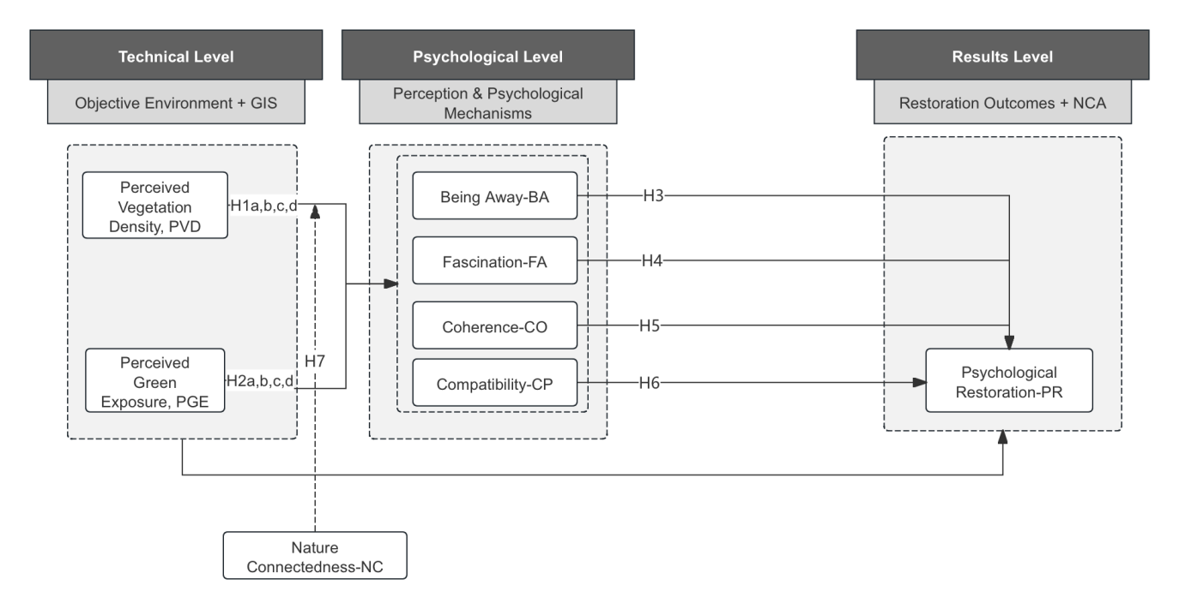
Figure 1. Conceptual Framework
3. Methodology
3.1 GIS Data Acquisition
Figure 2 illustrates the spatial distribution of the Xuanwu Lake jogging paths and the surrounding natural environment. The map utilizes color gradients to delineate vegetation coverage and topographical variations within the area, clearly displaying the spatial adjacency between the jogging trails and areas of high green volume (Segers et al., 2007). This visualization not only defines the scope of the study but also provides the geographical foundation for the subsequent calculation of the NDVI and the extraction of objective Green Exposure (GE) indicators (Larkin & Hystad, 2019). Furthermore, the spatial correspondence between the running trajectories and green corridors ensures that the construction of the subjective green exposure scales (PVD, PGE) is grounded in the physical reality of the environment, thereby enhancing the ecological validity of the research.
This study employs an integrated multi-method design combining Geographic Information Systems (GIS), Structural Equation Modeling (SEM), and Necessary Condition Analysis (NCA) (Zhao & Furuoka, 2025). The objective is to explore how green exposure within urban jogging environments influences psychological restoration, while examining the mediating role of perceived restorativeness and the moderating role of nature connectedness.
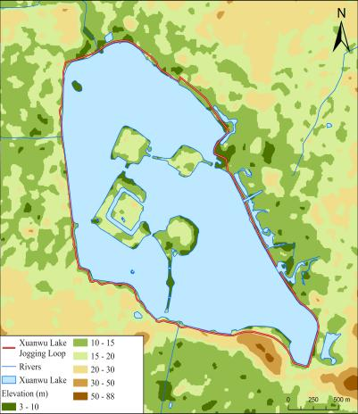
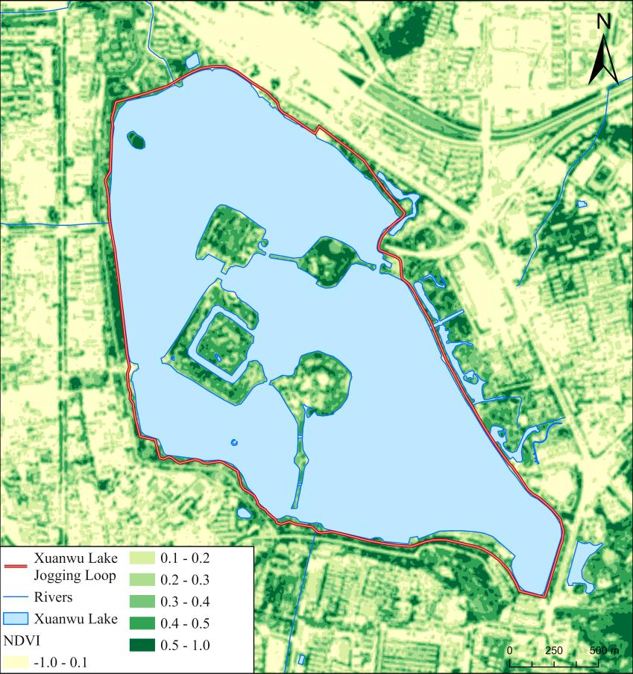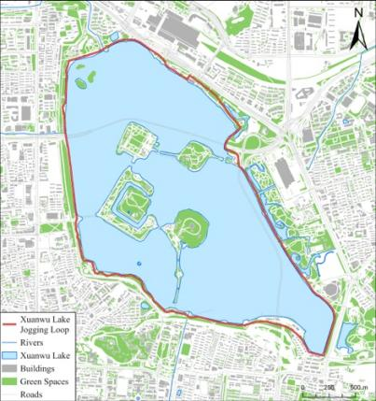

Figure 2. Environmental Exposure Map
3.2 NDVI Calculation and Green Exposure Extraction
To further quantify the level of green exposure along the paths, the Green View Index (GVI) was employed. This exposure distribution was refined by applying a 300-meter buffer zone to segment and analyze the specific characteristics of different areas along the running routes (Figure 3).
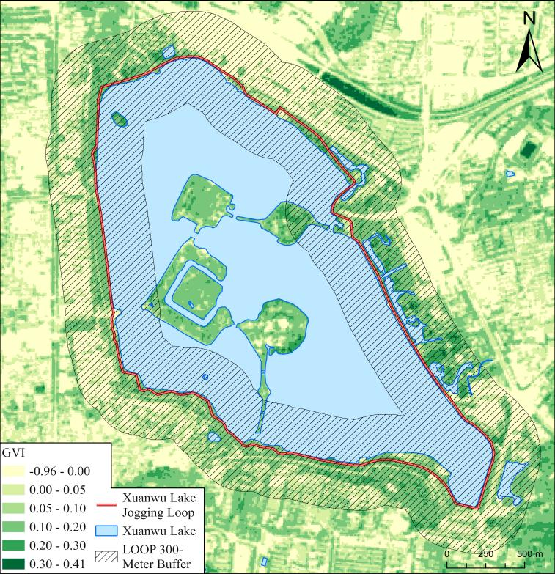
Figure 3: Distribution of the Green View Index (GVI) along the jogging paths.

To enhance the explanatory power of green exposure metrics concerning psychological restoration variables, this study further integrates NDVI results with participants' subjective assessment indicators (Su et al., 2023). Specifically, Perceived Vegetation Density (PVD) and Perceived Green Exposure (PGE) were measured via survey scales; these are not based on subjective imagination but maintain spatial consistency with the objective NDVI values extracted through GIS. Furthermore, the scores for Psychological Restoration (PR)(Shorey et al., 2022; Zhang et al., 2023) exhibit a spatial trend corresponding to variations in NDVI, reflecting that higher objective quality of urban green space correlates with a stronger restorative experience for the individual. This correspondence between subjective and objective data not only strengthens the consistency of variable measurement but also ensures that the subsequent SEM and NCA analyses are grounded in clear theoretical support and spatial validity.
3.3 Subjective Green Exposure Scale Design (PVD / PGE)
To further capture the subjective experience of the surrounding green environment during jogging, this study constructed two categories of subjective green exposure scales to complement the objective NDVI metrics: Perceived Vegetation Density (PVD) and Perceived Green Exposure (PGE). Together, these form the psychometric framework for subjective green exposure, reflecting individuals' authentic perceptions of environmental green quality (Hernández-Mogollón et al., 2013; Yang et al., 2023).First, the PVD and PGE scales are designed to measure respondents' subjective judgments regarding the level of visible vegetation coverage along their jogging routes, including tree density, foliage thickness, and the proportion of greenery within their field of vision. The scale items were adapted from established instruments in environmental psychology and urban green space visual quality assessment (Ekkel & de Vries, 2017)and refined to fit the specific context of this study. These scales focus on the individual’s comprehensive perception of overall green exposure during exercise, emphasizing the "extent to which greenness is perceived" rather than merely the volume of greenery, thereby reflecting the individual's immersive green experience. To ensure measurement quality, both scales underwent bilingual back-translation, expert review (n=4), and pilot testing (n=30) to verify semantic clarity and cultural suitability.
3.4 Sampling and Data Collection
The questionnaire survey in this study targeted actual joggers on the Xuanwu Lake tracks in Nanjing, utilizing a combination of online and offline data collection methods (Yang et al., 2021). The online survey was distributed via professional platforms (Wenjuanxing) and disseminated through running communities, sports applications (Keep, Codoon), and local running clubs.Which participants were required to read and acknowledge a digital informed consent form prior to participation. The consent form clearly stated the purpose of the study, the voluntary nature of participation, the anonymity of responses, and the absence of any risks or penalties associated with non-participation or withdrawal. Only participants who actively provided consent were able to proceed to the survey; those who declined were automatically exited from the system. No identifying information was collected, and all participants completed the survey voluntarily without any form of coercion.The offline survey was conducted during morning and evening peak hours at the Xuanwu Lake track, where paper questionnaires were randomly distributed to active joggers to ensure the representativeness and authenticity of the sample source.
The survey instrument included items regarding jogging route information (required for objective green exposure matching), perceived restorativeness, nature connectedness, perceived psychological restoration, and demographic information. A total of 412 questionnaires were collected. After excluding invalid responses and those with abnormal completion times, 369 valid samples were obtained, resulting in an effective response rate of 89.56%. Demographic data indicate that participants encompass a diverse range of genders, age groups, and running habits, demonstrating good representativeness (see Appendix Table 1). Furthermore, this study matched the jogging routes provided by participants with GIS data, enabling the individual-level integration of psychological variables and spatial exposure data, thereby enhancing both analytical precision and external validity.
4. Results
4.1 Reliability and Validity Analysis
Prior to testing the structural model, this study conducted a systematic evaluation of the reliability and validity of the measurement model. Regarding internal consistency, the Cronbach’s alpha and Composite Reliability (CR) for each latent variable exceeded the commonly accepted threshold of 0.70(Zhao & Furuoka, 2025; Zhao, Furuoka, Rasiah, et al., 2024), indicating that the scales possess high reliability. Furthermore, the CR values for all constructs fell within the 0.70–0.95 range, suggesting the absence of redundant items or over-reliability issues. In terms of convergent validity, the Average Variance Extracted (AVE) for each construct was greater than 0.50 (Zhao, Furuoka, Rasiah, et al., 2024), demonstrating that the measurement items sufficiently capture the core meaning of the latent variables and that the model possesses robust convergent validity.
Table 2. Reliability and convergent validity
 | BA | Cronbach's alpha | (rho_a) | CR | AVE | VIF
BA1 | 0.817 | 0.838 | 0.838 | 0.892 | 0.673 | 1.858
BA2 | 0.82 |  |  |  |  | 1.85
BA3 | 0.794 |  |  |  |  | 1.688
BA4 | 0.85 |  |  |  |  | 2.088
CO1 | 0.793 | 0.809 | 0.81 | 0.875 | 0.636 | 1.699
CO2 | 0.809 |  |  |  |  | 1.727
CO3 | 0.801 |  |  |  |  | 1.661
CO4 | 0.786 |  |  |  |  | 1.555
CP1 | 0.795 | 0.777 | 0.779 | 0.857 | 0.6 | 1.582
CP2 | 0.769 |  |  |  |  | 1.518
CP3 | 0.74 |  |  |  |  | 1.419
CP4 | 0.793 |  |  |  |  | 1.633
FA1 | 0.882 | 0.881 | 0.883 | 0.918 | 0.737 | 2.656
FA2 | 0.869 |  |  |  |  | 2.515
FA3 | 0.822 |  |  |  |  | 1.953
FA4 | 0.86 |  |  |  |  | 2.219
NC1 | 0.896 | 0.883 | 0.939 | 0.917 | 0.734 | 2.286
NC2 | 0.847 |  |  |  |  | 2.191
NC3 | 0.848 |  |  |  |  | 2.146
NC4 | 0.835 |  |  |  |  | 2.525
PGE1 | 0.861 | 0.873 | 0.782 | 0.913 | 0.725 | 2.173
PGE2 | 0.835 |  |  |  |  | 1.989
PGE3 | 0.863 |  |  |  |  | 2.277
PGE4 | 0.844 |  |  |  |  | 2.136
PR1 | 0.789 | 0.773 | 0.773 | 0.854 | 0.595 | 1.677
PR2 | 0.733 |  |  |  |  | 1.396
PR3 | 0.78 |  |  |  |  | 1.606
PR4 | 0.783 |  |  |  |  | 1.508
PVD1 | 0.887 | 0.884 | 0.886 | 0.92 | 0.741 | 2.553
PVD2 | 0.857 |  |  |  |  | 2.236
PVD3 | 0.833 |  |  |  |  | 2.04
PVD4 | 0.867 |  |  |  |  | 2.39
Regarding internal consistency, the Cronbach’s alpha for each latent variable ranged from 0.773 to 0.896 (Table 2), significantly exceeding the commonly accepted threshold of 0.70 (Goh et al., 2020). The Composite Reliability (CR) values ranged from 0.854 to 0.939, falling within the ideal range of 0.70–0.95, which indicates that the scales possess excellent internal consistency and stability. In terms of convergent validity, the Average Variance Extracted (AVE) for each construct ranged between 0.595 and 0.741, all surpassing the 0.50 threshold demonstrating that the items effectively explain (Ab Hamid et al., 2017; Yusoff et al., 2020)the common variance of the latent variables and that the convergent validity is reliable .Furthermore, the Variance Inflation Factor (VIF) values were between 1.396 and 2.656, well below the conservative cutoff of 5, indicating that the model is free from risks of multicollinearity. Given the moderate correlations between constructs and the stable factor loadings, the measurement instrument also demonstrated strong discriminant validity. In summary, the measurement model meets high standards for reliability, convergent validity, and discriminant validity, providing a solid foundation for the subsequent testing of the structural model paths.
4.1.2 Discriminant Validity Analysis
Table 3.Heterotrait–Monotrait Ratio (HTMT)
 | BA | CO | CP | FA | NC | PGE | PR | PVD | NC x PVD
BA
CO | 0.119
CP | 0.059 | 0.772
FA | 0.859 | 0.144 | 0.143
NC | 0.063 | 0.809 | 0.768 | 0.117
PGE | 0.823 | 0.078 | 0.093 | 0.772 | 0.061
PR | 0.079 | 0.706 | 0.856 | 0.102 | 0.769 | 0.103
PVD | 0.831 | 0.098 | 0.115 | 0.731 | 0.076 | 0.871 | 0.110
NC x PVD | 0.288 | 0.178 | 0.139 | 0.247 | 0.021 | 0.260 | 0.141 | 0.285
The results of the discriminant validity test (Table 3) using the Heterotrait-Monotrait Ratio (HTMT) indicate that all HTMT values between variables ranged from 0.059 to 0.871. These values are significantly below the strict criterion of 0.85 and well under the more liberal threshold of 0.90 (Dirgiatmo, 2023). These findings demonstrate that the latent variables possess sufficient distinctness and are free from issues of construct conflation. In particular, the HTMT values between the core latent variables, such as Being Away (BA), Perceived Green Exposure (PGE), Perceived Vegetation Density (PVD), and Psychological Restoration (PR) remained within safe limits, further supporting the robust discriminant validity of the measurement model. In summary, the HTMT test results confirm that the latent variables in this study are clearly distinguished from one another, providing a valid basis for subsequent structural model analysis.
Table 4. Fornell-Lacker criterion
 | BA | CO | CP | FA | NC | PGE | PR | PVD
BA | 0.847
CO | 0.682 | 0.786
CP | 0.631 | 0.689 | 0.852
FA | 0.823 | 0.671 | 0.668 | 0.849
NC | -0.077 | -0.02 | -0.101 | -0.046 | 0.861
PGE | -0.103 | -0.025 | -0.134 | -0.059 | 0.638 | 0.774
PR | -0.077 | -0.02 | -0.101 | -0.046 | 1 | 0.638 | 0.861
PVD | -0.064 | -0.07 | -0.069 | -0.001 | 0.639 | 0.745 | 0.639 | 0.771
Based on the Fornell–Larcker criterion (Dik et al., 2022; Hair et al., 2011; Hair et al., 2019)for discriminant validity (Table 4), this study compared the square root of the Average Variance Extracted (AVE) for each latent variable with its correlations with other latent variables (Waldorp & Marsman, 2022). The results show that the square root of the AVE for all constructs, located along the diagonal of the matrix, is significantly higher than the correlation coefficients with any other latent variables (0.847 for BA, 0.786 for CO, 0.849 for FA, and 0.861 for NC). These findings indicate that each latent variable explains more variance in its own indicators than in other constructs, fully satisfying the requirements for discriminant validity. Furthermore, none of the correlations between constructs reached excessively high levels, further ruling out issues of multicollinearity or conceptual overlap between the latent variables.
4.1.3 Correlation Analysis
According to the correlation matrix (Figure 2), the bivariate correlations between research variables exhibit clear and theoretically sound structural characteristics. First, no excessively high correlations (all below 0.80) were observed among the latent variables (Gignac, 2014; Schober et al., 2018), ruling out the risk of severe multicollinearity and indicating that the constructs maintain high discriminant validity.Second, significant and stable positive correlations were found between BA, FA, PGE, and PVD (e.g., r = 0.72 for BA–PVD; r = 0.68 for FA–PGE). This suggests a consistent synergistic trend between natural exposure along the jogging paths and the tendency for psychological restoration. Simultaneously, the correlations between NC and core variables such as BA, FA, and PGE were weak (mostly ranging from -0.10 to 0.06). This indicates that the moderating variable does not overlap significantly with the primary psychological or environmental perception dimensions, making it suitable as an independent moderating construct within the model.
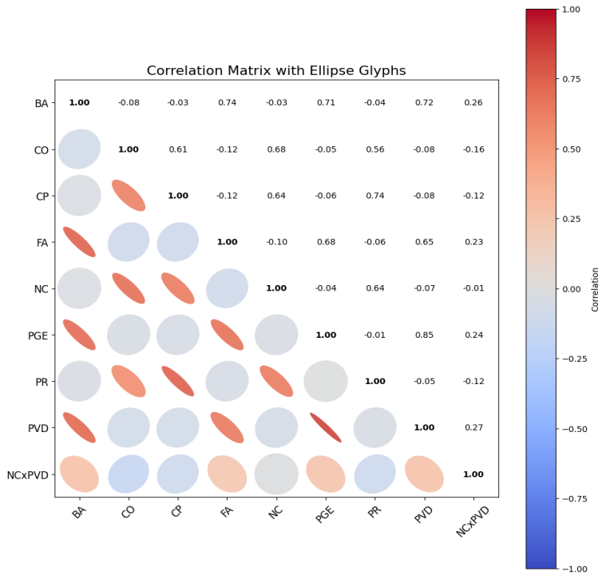
Figure 2. correlation Matrix with Ellipse Glyph
The interaction term (NC × PVD) exhibited only weak correlations with variables such as BA, PGE, and PVD (reaching a maximum of 0.27). This aligns with the theoretical expectation that interaction constructs should typically not be highly correlated with their main effects in a statistical model. Overall, the results of the correlation analysis provide further evidence for the structural rationality of the measurement model and establish a stable data foundation for the subsequent estimation of structural paths.
4.2 Structural Model Testing
4.2.1 Testing of the Moderation Model
The simple slope analysis (Figure 3) illustrates the varying impact of Perceived Vegetation Density (PVD) on Psychological Restoration (PR) via Being Away (BA) across three levels of Nature Connectedness (NC): High (+1 SD), Mean, and Low (–1 SD) (Park & Yi, 2023). Overall, all three slopes exhibit a slight negative trend, indicating that across different levels of nature connectedness, higher levels of perceived vegetation density are associated with weaker psychological restoration, a path primarily mediated by "Being Away."However, the steepness of the slopes varies slightly according to the level of NC: the negative effect of PVD on the BA→PR path is most pronounced at high levels of Nature Connectedness (β = –0.041), whereas this effect tends to diminish at low levels of NC (β = –0.030). This suggests that an increase in nature connectedness does not mitigate the potential emotional or cognitive load generated by excessive visual green volume (Finsaas & Goldstein, 2021). Conversely, individuals with high nature affinity may be more sensitive to mismatched or fragmented green landscapes, thereby further weakening the restorative effect. In summary, although the moderating effect is relatively weak, it demonstrates a systematic trend, indicating that Nature Connectedness serves as a boundary condition in the relationship between visual green volume and psychological restoration.
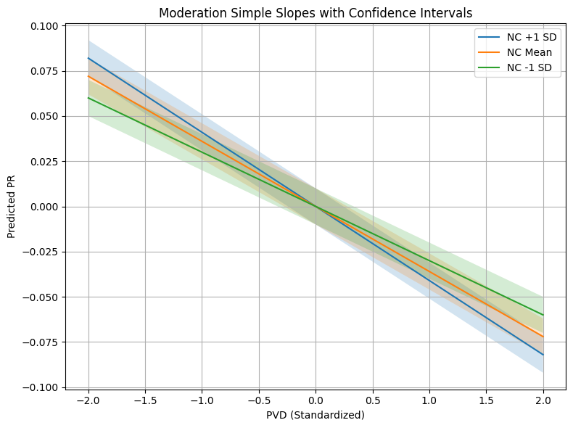
Figure 3. Moderate slope
4.2.2 Hypothesis Testing
Following the systematic construction of the conceptual model and research hypotheses, this chapter further tests the structural relationships based on empirical data (Table 5). To ensure the scientific rigor and robustness of the results, the study first evaluated the reliability, convergent validity, and discriminant validity of the measurement model to confirm that the scales for each latent variable possessed high psychometric quality. On this basis, SEM was employed to perform path analysis on the research hypotheses. Furthermore, the role of Nature Connectedness (NC) within the process of perceiving green exposure was explored in depth through the analysis of moderating effects and interaction plots.
Table 5. Assessment of Structural Model
 | β | Std | T statistics | VIF | P values | Results
BA -> PR | -0.088 | 0.047 | 1.871 | 2.225 | 0.041 | Support
CO -> PR | 0.167 | 0.068 | 2.452 | 1.615 | 0.014 | Support
CP -> PR | 0.653 | 0.06 | 10.812 | 1.628 | 0 | Support
FA -> PR | 0.102 | 0.046 | 2.201 | 2.246 | 0.028 | Support
NC x PVD -> BA | 0.065 | 0.041 | 1.574 | 1.078 | 0.016 | Support
PGE -> BA | 0.344 | 0.092 | 3.738 | 3.681 | 0 | Support
PGE -> CO | 0.087 | 0.106 | 0.818 | 3.676 | 0.413 | Not Support
PGE -> CP | 0.017 | 0.094 | 0.184 | 3.676 | 0.854 | Not Support
PGE -> FA | 0.47 | 0.094 | 5.022 | 3.676 | 0 | Support
PVD -> BA | 0.404 | 0.092 | 4.391 | 3.737 | 0 | Support
PVD -> CO | -0.158 | 0.105 | 1.51 | 3.676 | 0.131 | Not Support
PVD -> CP | -0.093 | 0.099 | 0.94 | 3.676 | 0.347 | Not Support
PVD -> FA | 0.246 | 0.096 | 2.56 | 3.676 | 0.01 | Support

The hypothesis testing results clearly indicate which proposed relationships are supported.First, the four perceived restorativeness dimensions—Being Away (H3), Coherence (H4), Compatibility (H5), and Fascination (H6)—all significantly predict Psychological Restoration (PR). BA (β = –0.088, p = 0.041), CO (β = 0.167, p = 0.014), CP (β = 0.653, p < 0.001), and FA (β = 0.102, p = 0.028) are confirmed, thus supporting H3–H6.
For antecedent variables, Perceived Vegetation Density (PVD) positively predicts BA (β = 0.404, p < 0.001), supporting H2a. PVD also shows a significant positive effect on FA (β = 0.246, p = 0.010), supporting H2d, whereas its effects on CO and CP are nonsignificant, leading to the rejection of H2b–H2c.
Similarly, Perceived Green Exposure (PGE) positively influences BA (β = 0.344, p < 0.001) and FA (β = 0.470, p < 0.001), supporting H1a and H1d, while its effects on CO and CP are nonsignificant, thus H1b–H1c are not supported.
Regarding nature connectedness, the interaction effect of NC x PVD -> BA significantly predicts BA (β = 0.065, p = 0.016), supporting H7 and confirming its moderating role.
Overall, the results validate the central pathway from perceived restorative qualities to psychological restoration, partially support the effects of vegetation-related perceptions, and identify a conditional effect of nature connectedness.
4.3 Necessary Condition Analysis (NCA)
Following the verification of average effects between variables using SEM, this study further employs NCA to identify the key constraints in the formation of psychological restoration. Unlike SEM, which emphasizes predictive effect sizes (Dik et al., 2022), NCA focuses on whether the attainment of a certain outcome depends on a specific antecedent variable reaching a minimum threshold (Dik et al., 2022). Even if a factor exhibits a significant average effect, it may still be insufficient to guarantee the occurrence of high-level restoration; conversely, if a necessary condition fails to meet the minimum requirement, psychological restoration cannot be improved, even if all other factors are in an optimal state. Therefore, combining SEM and NCA provides a more comprehensive revelation of how green exposure and psychological mechanisms operate (Hair et al., 2011; Hair et al., 2019). This section presents the degree of necessity for each variable in achieving different levels of psychological restoration through ceiling lines, effect sizes, and a bottleneck table (Figure 4).
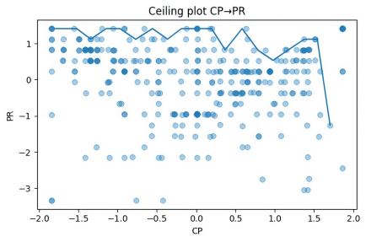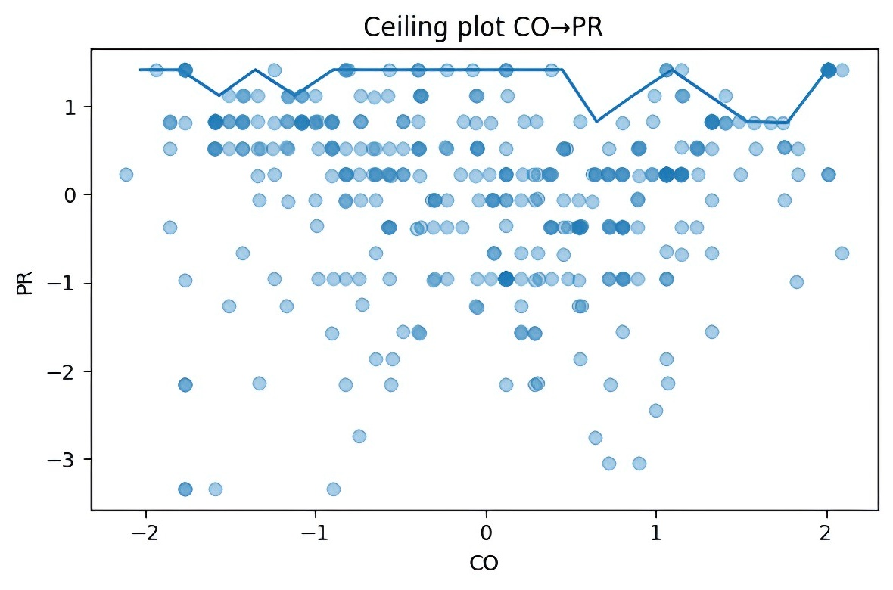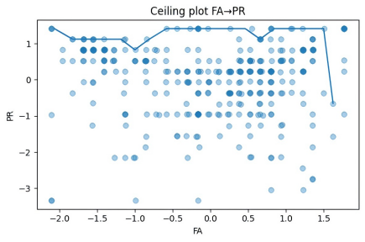
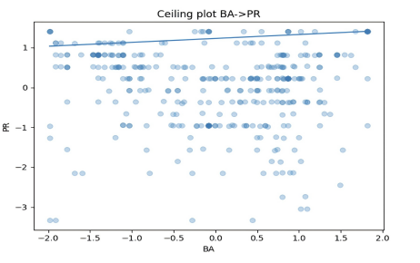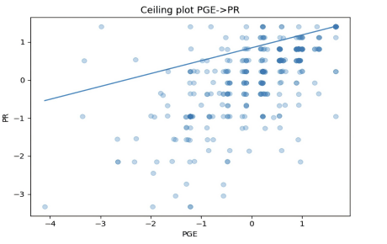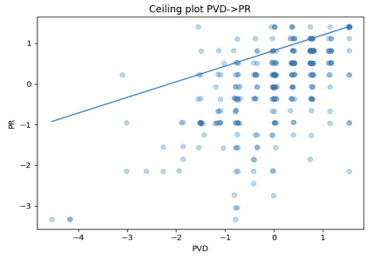
Figure 4: NCA Bottleneck Plots
In Necessary Condition Analysis (NCA), bottleneck plots are utilized to illustrate the extent of the necessary constraints imposed by an independent variable (X) on a dependent variable (Y) (Hair et al., 2019; Hair Jr et al., 2021). Unlike traditional regression or structural equation modeling, which focus on average effects, NCA emphasizes the question: What is the minimum level of a condition required to achieve a high-level outcome?By plotting the scatter distribution of X and Y alongside a ceiling line, the bottleneck plot reveals the threshold that the independent variable must at least reach for the dependent variable to attain a specific target level.
The bottleneck plots indicate the minimum level of each predictor required for achieving a given level of psychological restoration. Values above the ceiling line (the "empty space") reflect impossible combinations, confirming that the predictors operate as necessary but not sufficient conditions.
Here is the translation of the Conclusion and Discussion into academic English, using terminology suitable for high-impact journals in urban planning, environmental psychology, and public health.
5. Conclusion and Discussion
5.1 Conclusion
Taking the Xuanwu Lake jogging circuit as a representative urban green space scenario, this study integrated GIS-NDVI remote sensing data, subjective green exposure scales, Structural Equation Modeling (SEM), and Necessary Condition Analysis (NCA)(Dul, 2016; Hair et al., 2011) to systematically reveal how green exposure in urban jogging environments influences individual psychological restoration through specific psychological mechanisms. The NDVI spatial distribution maps generated from remote sensing imagery clearly illustrate the objective structure of jogging paths and surrounding vegetation resources. This provided a reliable environmental foundation for measuring green exposure and verified that subjective indicators (PVD and PGE) are not isolated results of perception but are highly congruent with the spatial patterns of real-world green volume.
Empirical results demonstrate that subjective green exposure plays a central role in the psychological restoration pathway. Both PVD and PGE significantly enhance key restorative dimensions such as Being Away (BA) and Fascination (FA) (Kaplan, 1995). Notably, the positive impact of PVD on BA is the most prominent, suggesting that high vegetation density along running tracks effectively triggers attentional restoration experiences. Similarly, Coherence (CO) and Compatibility (CP) significantly promote the restorative experience. The path coefficient for CP → PR was the largest, indicating that the degree of "fit" between the environment and individual needs is the critical psychological mechanism influencing restoration.
Regarding moderating effects, Nature Connectedness (NC) significantly moderates the relationship between PVD and BA. When NC is high, individuals are more sensitive to variations in vegetation density, and green environments more easily evoke a sense of "being away." Conversely, when NC is low, the restorative effect may remain limited even if the objective green volume is abundant. This finding highlights the psychological basis of person-environment interactions. Furthermore, NCA results reveal that BA, FA, CO, and CP all constitute necessary conditions for psychological restoration (Kaplan, 1995). A deficiency in any single dimension will constrain the upper limit of PR, underscoring the bottleneck characteristics (Dul, 2016) of the psychological restoration system.
In conclusion, this study constructs a multi-layered path model of “Objective Green Exposure, Subjective Green Perception and Psychological Restoration.” It emphasizes that urban green spaces require more than just high green volume; they must activate psychological mechanisms through strategic spatial layout and landscape quality (Herzog & Strevey, 2008). The methodological framework of this study provides actionable empirical evidence for the design of urban jogging spaces and public health promotion, while demonstrating the significant value of integrating GIS data with psychological scales in environment-behavior research.
5.2 Discussion
Based on the spatial NDVI data calculated via GIS, this study constructs an explanatory framework that integrates objective green exposure, subjective green perception, and psychological restoration mechanisms (Ekkel & de Vries, 2017; Hernández-Mogollón et al., 2013). The findings reveal that the effects of green environments are not a linear process but are driven by a multi-layered synergy of physical characteristics, perceptual processing, and internal psychological structures (Gignac, 2014; Waldorp & Marsman, 2022). This suggests that the psychological benefits of green environments stem from the dynamic coupling of the environment-individual system rather than the direct impact of green volume alone.
Moreover, subjective green exposure (PVD and PGE) occupies a central hub position within the overall path structure. Although the NDVI maps illustrate gradient differences in green volume around the jogging paths, the actual restorative effects depend primarily on the individual’s subjective interpretation of vegetation density, landscape saturation, and green immersion. This phenomenon highlights the "objective exposure — perceptual interpretation — emotional benefit" pathway emphasized in environmental psychology, indicating that the true value of a green environment depends on its perceptivity and perceptual accessibility rather than its objective green volume alone.
Likewise, the four restorative dimensions (BA, FA, CO, and CP) exhibit significant functional differences (Herzog & Strevey, 2008; Kaplan, 1995). The decisive influence of Compatibility (CP) on restoration outcomes indicates that environmental fit is the key driver of the restorative experience; that is, whether the environment meets the individual's aesthetic preferences and functional expectations directly sets the upper limit for psychological restoration. In parallel, the significant role of Coherence (CO) suggests that the logical structure of a landscape can reduce cognitive load, thereby promoting psychological stability and comfort. The positive effects of Fascination (FA) and Being Away (BA) further validate the applicability of Attention Restoration Theory (ART) in dynamic outdoor exercise environments, demonstrating that natural cues play a stable role in capturing attention and buffering stress.
Furthermore, the moderating effects reveal that individual differences are a key variable in the process of green restoration (Berger et al., 2024; Derse & Alphan, 2024; Martín-Rodríguez et al., 2024). Nature Connectedness (NC) significantly strengthens the PVD → BA path, suggesting that the benefits of green exposure do not occur automatically but depend on the individual’s baseline affinity for nature. This finding underscores a "selective amplification" mechanism of green environment effects: environmental resources must align with an individual’s internal eco-emotional structure to generate a significant restorative experience.
Critically, the NCA bottleneck analysis indicates a "necessary but not sufficient" relationship between the restorative dimensions, meaning that a deficiency in any single dimension may become a limiting factor for psychological restoration. Unlike traditional SEM, which emphasizes average effects, NCA reveals a "logic of minimum requirements" in the composition of psychological restoration, providing a new statistical perspective for understanding the boundaries of green exposure benefits.
Collectively, these findings demonstrate that the benefits of urban green exposure are shaped by multiple mechanisms: objective green volume provides the foundational structure, subjective perception determines the transformation path, psychological mechanisms generate the restorative outcomes, and individual differences influence the intensity of the effect. This comprehensive mechanistic framework not only expands the theoretical boundaries of green exposure research but also provides a refined evidence base for the functional optimization of urban green infrastructure, landscape structural design, and urban health governance.
6. Theoretical Contributions and Management Implications
6.1 Theoretical Contributions
This study provides a multi-dimensional deepening of the theoretical systems surrounding green exposure, Attention Restoration Theory (ART), and urban health behavior. By integrating GIS-extracted NDVI with subjective green perception (PVD, PGE) and the four dimensions of perceived restorativeness (BA, FA, CO, CP) into a single model, this research achieves a cross-layer connection between objective spatial data and psychological mechanism variables. This approach breaks through the limitations of previous studies that relied solely on subjective evaluations or objective green volume. Instead, it offers a structured and interpretable Objective Environment，Subjective Perception and Psychological Restoration integration framework. The results indicate that the psychological benefits of green environments are not directly driven by objective green volume but are mediated by the depth of an individual's perception of natural cues and their psychological processing. This finding reinforces the emphasis on the "perceptual pathway" in environmental psychology and provides new evidence for the applicability of ART in dynamic exercise scenarios.
Furthermore, the model demonstrates that the dimensions of perceived restorativeness do not function equally. The prominent effect of Compatibility reveals a critical nuance of ART in exercise environments: the restorative experience depends not only on the attractive properties of nature but is also deeply influenced by the environment-goal fit. This finding extends the explanatory boundaries of ART, making it more applicable to real-world behavioral settings. Additionally, the moderating effect of Nature Connectedness on the relationship between green exposure and perceived restorativeness highlights the central role of individual differences in green healing mechanisms. This provides a necessary correction to traditional "environmental determinism" and shifts green exposure research from focusing on average treatment effects toward a differentiated explanation based on individual sensitivity.
Methodologically, this study introduces Necessary Condition Analysis (NCA) to the fields of green exercise and urban health. It demonstrates the "necessary condition structure" within the composition of perceived restorativeness, thereby compensating for the limitations of SEM—which focuses on average effects while overlooking minimum conditional constraints. This provides a new analytical path for exploring bottleneck factors in environmental psychological mechanisms. Overall, this study enriches the theoretical framework of how urban green exposure affects psychological restoration and pushes green exercise and environmental psychology toward a more multi-dimensional and contextualized direction.
6.2 Management Implications
The multi-layered mechanisms revealed in this study offer practical insights for urban green space construction, public sports space design, and healthy city governance. The restorative benefits of urban green environments are not determined by green volume alone; rather, they depend on whether green elements can be clearly perceived by individuals and transformed into meaningful psychological experiences. Therefore, green space planning should move beyond merely increasing vegetation coverage. Instead, it requires refined design focusing on coherence, visibility, and the layering of landscape structures to ensure that natural cues are effectively captured during exercise, thereby enhancing the subjective intensity of green exposure. The construction of running tracks and open sports spaces must also prioritize the functional fit between the environment and user needs. Factors such as spatial scale, lighting conditions, noise levels, and path safety can all influence compatibility, thereby setting the upper limit of the restorative experience.
The findings also emphasize the critical role of individual differences. Individuals with higher Nature Connectedness derive emotional balance and attentional restoration from green cues more easily. This suggests that green healing strategies should shift from "uniform provision" to "stratified design." Urban planners can meet the needs of groups with varying levels of nature affinity through immersive nature trails, nature-based wayfinding, and interactive landscape installations. Furthermore, real-time monitoring of green exposure along tracks using GIS and NDVI can provide urban management departments with a spatial data-driven decision-making tool. This enables more precise green space maintenance, sports facility allocation, and health intervention strategies. Ultimately, the psychological restorative benefits of urban green exposure depend on the collaborative optimization of environmental structure, perceptual characteristics, and individual experience. Governance practices should focus on building a green exercise environment that is perceivable, compatible, and capable of activating psychological restorative potential.
7. Limitations
Although this study constructs a multi-layered analytical framework integrating GIS spatial data, subjective green exposure, and psychological mechanisms, several limitations warrant cautious consideration.
First, while NDVI and green space coverage effectively reflect the objective status of urban green environments, they struggle to fully capture details such as seasonal vegetation changes, vertical greening structures, and micro-scale landscape quality. Consequently, the measurement of objective green exposure remains somewhat simplified. Second, both subjective green exposure (PVD, PGE) and perceived restorativeness rely on self-reported questionnaires. This may introduce recall bias, emotional state interference, and social desirability effects, leading to potential discrepancies between individual perception and the actual physical environment. Third, this study is primarily based on cross-sectional data. While the path model reveals statistical associations between variables, it cannot fully establish causal relationships; future research should incorporate experimental designs or multi-point longitudinal data for further verification.
Furthermore, potential situational variables，such as jogging speed and route, time of day, and weather conditions were not incorporated into the model, despite the fact that these factors may significantly influence how individuals perceive their natural surroundings. Although the moderating effect of Nature Connectedness was validated, the differences across various age groups, cultural backgrounds, and exercise habits have not been fully examined, leaving room for further expansion of the study's external validity. Finally, while the NCA method identifies necessary condition structures, the results are dependent on the specific distribution characteristics of the sample. Future studies could utilize larger samples or multi-regional data to construct a more robust bottleneck condition model.

Declaration of Competing Interest
The authors declare that they have no known competing financial interests or personal relationships that could have appeared to influence the work reported in this paper.

Data Availability Statement
The datasets generated and analyzed during the current study are not publicly available due to privacy and ethical restrictions but are available from the corresponding author on reasonable request.

Ethics Statement
This study was reviewed and approved by the SEGi Research Ethics Committee, SEGi University (Ethics Approval Number: SEGiEC/SR/FOELPM/163/2025-2027). All procedures involving human participants were conducted in accordance with institutional guidelines and the Declaration of Helsinki. Informed consent was obtained from all participants prior to data collection. Participation was voluntary, and all responses were collected anonymously without any identifying information.

Funding
This research received no external funding.

Reference
Ab Hamid, M. R., Sami, W., & Sidek, M. M. (2017). Discriminant validity assessment: Use of Fornell & Larcker criterion versus HTMT criterion. Journal of physics: Conference series,
Aghabozorgi, K., van der Jagt, A., Bell, S., & Smith, H. (2024). How university blue and green space affect students’ mental health: A scoping review. Urban forestry & urban greening, 97, 128394.
Andersen, L., Corazon, S. S., & Stigsdotter, U. K. (2021). Nature exposure and its effects on immune system functioning: a systematic review. International journal of environmental research and public health, 18(4), 1416.
Berger, N. J., Best, R., Best, A. W., Lane, A. M., Millet, G. Y., Barwood, M., Marcora, S., Wilson, P., & Bearden, S. (2024). Limits of ultra: towards an interdisciplinary understanding of ultra-endurance running performance. Sports Medicine, 54(1), 73-93.
Bratman, G. N., Daily, G. C., Levy, B. J., & Gross, J. J. (2015). The benefits of nature experience: Improved affect and cognition. Landscape and Urban Planning, 138, 41-50.
Browning, T. J., & Moore, C. M. (2023). Global analysis of ocean phytoplankton nutrient limitation reveals high prevalence of co-limitation. Nature communications, 14(1), 5014.
Calogiuri, G., Litleskare, S., Fagerheim, K. A., Rydgren, T. L., Brambilla, E., & Thurston, M. (2018). Experiencing nature through immersive virtual environments: Environmental perceptions, physical engagement, and affective responses during a simulated nature walk. Frontiers in Psychology, 8, 2321.
Capaldi, C. A., Dopko, R. L., & Zelenski, J. M. (2014). The relationship between nature connectedness and happiness: A meta-analysis. Frontiers in Psychology, 5, 92737.
Davids, K., Button, C., Araújo, D., Renshaw, I., & Hristovski, R. (2006). Movement models from sports provide representative task constraints for studying adaptive behavior in human movement systems. Adaptive behavior, 14(1), 73-95.
de la Fuente Suárez, L. A., & Martínez-Soto, J. (2022). Relaxation and fascination through outside views of Mexican dwellings. Architecture, 2(2), 334-361.
Derse, M. A., & Alphan, H. (2024). Evaluating the urban expansion of Silifke (Mersin) district with a focus on green spaces: The 2050 projection. Journal of Architectural Sciences and Applications, 9(1), 227-248.
Dik, A., Omer, S., & Boukhanouf, R. (2022). Electric vehicles: V2G for rapid, safe, and green EV penetration. Energies, 15(3), 803.
Dirgiatmo, Y. (2023). Testing the discriminant validity and heterotrait–monotrait ratio of correlation (HTMT): A case in Indonesian SMEs. In Macroeconomic Risk and Growth in the Southeast Asian Countries: Insight from Indonesia (pp. 157-170). Emerald Publishing Limited.
Dongjun, Z., Mingyue, W., Xinqi, L., Lina, W., Jiali, W., & Mengyao, J. (2025). Trends in depressive and anxiety disorders among adolescents and young adults (aged 10–24) from 1990 to 2021: A global burden of disease study analysis. Journal of Affective Disorders, 119491.
Dul, J. (2016). Necessary condition analysis (NCA) logic and methodology of “necessary but not sufficient” causality. Organizational research methods, 19(1), 10-52.
Ekkel, E. D., & de Vries, S. (2017). Nearby green space and human health: Evaluating accessibility metrics. Landscape and Urban Planning, 157, 214-220.
Finsaas, M. C., & Goldstein, B. L. (2021). Do simple slopes follow-up tests lead us astray? Advancements in the visualization and reporting of interactions. Psychological Methods, 26(1), 38.
Gewalt, S. C., Berger, S., Krisam, R., & Breuer, M. (2022). Effects of the COVID-19 pandemic on university students’ physical health, mental health and learning, a cross-sectional study including 917 students from eight universities in Germany. PloS one, 17(8), e0273928.
Gignac, G. E. (2014). On the inappropriateness of using items to calculate total scale score reliability via coefficient alpha for multidimensional scales. European Journal of Psychological Assessment.
Goh, G. S., Yue, W.-M., Guo, C.-M., Tan, S.-B., & Chen, J. L. (2020). Defining threshold values on the neck disability index corresponding to a patient acceptable symptom state in patients undergoing elective surgery for degenerative disorders of the cervical spine. The Spine Journal, 20(8), 1316-1326.
Grigoletto, A., Toselli, S., Zijlema, W., Marquez, S., Triguero-Mas, M., Gidlow, C., Grazuleviciene, R., Van de Berg, M., Kruize, H., & Maas, J. (2023). Restoration in mental health after visiting urban green spaces, who is most affected? Comparison between good/poor mental health in four European cities. Environmental research, 223, 115397.
Hair, J. F., Ringle, C. M., & Sarstedt, M. (2011). PLS-SEM: Indeed a silver bullet. Journal of Marketing Theory and Practice, 19(2), 139-152.
Hair, J. F., Sarstedt, M., & Ringle, C. M. (2019). Rethinking some of the rethinking of partial least squares. European Journal of Marketing, 53(4), 566-584.
Hair Jr, J. F., Hult, G. T. M., Ringle, C. M., Sarstedt, M., Danks, N. P., & Ray, S. (2021). Partial least squares structural equation modeling (PLS-SEM) using R: A workbook. Springer Nature.
Haluza, D., Spletzer, M., Ortmann, J., & Jungwirth, D. (2025). Perceived Connectedness to Nature in Fitness Enthusiasts, Golfers, and Climbers: A Cross‐Sectional Comparative Study. Health Science Reports, 8(3), e70555.
He, B.-J. (2023). Cause-related injustice, process-related injustice, effect-related injustice and regional heat action planning priorities: An empirical study in Yangtze River Delta and Chengdu-Chongqing urban agglomerations. Landscape and Urban Planning, 237, 104800.
Helbich, M., Browning, M. H., White, M., & Hagedoorn, P. (2022). Living near coasts is associated with higher suicide rates among females but not males: a register-based linkage study in the Netherlands. Science of The Total Environment, 845, 157329.
Helbich, M., Danish, M., Labib, S., & Ricker, B. (2024). To use or not to use proprietary street view images in (health and place) research? That is the question. Health & Place, 87, 103244.
Helbich, M., Yao, Y., Liu, Y., Zhang, J., Liu, P., & Wang, R. (2019). Using deep learning to examine street view green and blue spaces and their associations with geriatric depression in Beijing, China. Environment international, 126, 107-117.
Hernández-Mogollón, J.-M., Campón-Cerro, A.-M., & Alves, H. (2013). Authenticity in environmental high-quality destinations: A relevant factor for green tourism demand. Environmental Engineering & Management Journal (EEMJ), 12(10).
Herzog, T. R., & Strevey, S. J. (2008). Contact with nature, sense of humor, and psychological well-being. Environment and Behavior, 40(6), 747-776.
Hulin, M. T., Vadillo Dieguez, A., Cossu, F., Lynn, S., Russell, K., Neale, H. C., Jackson, R. W., Arnold, D. L., Mansfield, J. W., & Harrison, R. J. (2022). Identifying resistance in wild and ornamental cherry towards bacterial canker caused by Pseudomonas syringae. Plant Pathology, 71(4), 949-965.
Hung, S.-H., & Chang, C.-Y. (2024). Designing for harmony in urban green space: Linking the concepts of biophilic design, environmental qi, restorative environment, and landscape preference. Journal of Environmental Psychology, 96, 102294.
Jiang, Y., Xia, X., & Liu, X. (2025). Does the economy influence dynamic green exposure? A comparative study of spatial heterogeneity in visible greenery during running between high-and low-income groups. Journal of Environmental Management, 393, 126952.
Jimenez, M. P., DeVille, N. V., Elliott, E. G., Schiff, J. E., Wilt, G. E., Hart, J. E., & James, P. (2021). Associations between nature exposure and health: a review of the evidence. International journal of environmental research and public health, 18(9), 4790.
Joye, Y., & Dewitte, S. (2018). Nature's broken path to restoration. A critical look at Attention Restoration Theory. Journal of Environmental Psychology, 59, 1-8.
Jóźwiak, M. (2025). Managing Consumer Attention to Sustainability Cues in Tourism Advertising: Insights from Eye-Tracking Research. Sustainability, 17(18), 8175.
Kaplan, R. (2001). The nature of the view from home: Psychological benefits. Environment and Behavior, 33(4), 507-542.
Kaplan, S. (1995). The restorative benefits of nature: Toward an integrative framework. Journal of Environmental Psychology, 15(3), 169-182.
Karaca, E., Çakar, T., Karaca, M., & Gül, H. H. M. (2024). Designing restorative landscapes for students: A Kansei engineering approach enhanced by VR and EEG technologies. Ain Shams Engineering Journal, 15(9), 102901.
Kuhozido, S., Dunfield, G., Ostrich, E., & Waterhouse, C. (2024). Evaluating the impact of environmental semantic distractions on multimodal large language models.
Larkin, A., & Hystad, P. (2019). Evaluating street view exposure measures of visible green space for health research. Journal of exposure science & environmental epidemiology, 29(4), 447-456.
Lawton, E., Brymer, E., Clough, P., & Denovan, A. (2017). The relationship between the physical activity environment, nature relatedness, anxiety, and the psychological well-being benefits of regular exercisers. Frontiers in Psychology, 8, 1058.
Lengieza, M. L., Aviste, R., & Swim, J. K. (2023). Connectedness to nature through outdoor environmental education: Insights from psychology. Outdoor environmental education in the contemporary world, 49-81.
Li, D., Zhai, Y., Chang, P.-J., Merrill, J., Browning, M. H., & Sullivan, W. C. (2022). Nature deficit and senses: Relationships among childhood nature exposure and adulthood sensory profiles, creativity, and nature relatedness. Landscape and Urban Planning, 226, 104489.
Liu, H., Nong, H., Ren, H., & Liu, K. (2022). The effect of nature exposure, nature connectedness on mental well-being and ill-being in a general Chinese population. Landscape and Urban Planning, 222, 104397.
Liu, L., Qu, H., Ma, Y., Wang, K., & Qu, H. (2022). Restorative benefits of urban green space: Physiological, psychological restoration and eye movement analysis. Journal of Environmental Management, 301, 113930.
Liu, M., Shi, B., & Gao, X. (2024). The way to relieve college students’ academic stress: The influence mechanism of sports interest and sports atmosphere. BMC psychology, 12(1), 327.
Liu, Q., Peng, C., Schneider, R., Cyr, D., Liu, Z., Zhou, X., Du, M., Li, P., Jiang, Z., & McDowell, N. G. (2023). Vegetation browning: global drivers, impacts, and feedbacks. Trends in plant science, 28(9), 1014-1032.
Liu, Y., Hu, J., Yang, W., & Luo, C. (2022). Effects of urban park environment on recreational jogging activity based on trajectory data: A case of Chongqing, China. Urban forestry & urban greening, 67, 127443.
Liu, Y., Zhang, J., Liu, C., & Yang, Y. (2024). A review of attention restoration theory: Implications for designing restorative environments. Sustainability, 16(9), 3639.
Mao, Y., He, Y., Xia, T., Xu, H., Zhou, S., & Zhang, J. (2022). Examining the dose–response relationship between outdoor jogging and physical health of youths: a long-term experimental study in campus green space. International journal of environmental research and public health, 19(9), 5648.
Martin, L., White, M. P., Hunt, A., Richardson, M., Pahl, S., & Burt, J. (2020). Nature contact, nature connectedness and associations with health, wellbeing and pro-environmental behaviours. Journal of Environmental Psychology, 68, 101389.
Martín-Rodríguez, A., Gostian-Ropotin, L. A., Beltrán-Velasco, A. I., Belando-Pedreño, N., Simón, J. A., López-Mora, C., Navarro-Jiménez, E., Tornero-Aguilera, J. F., & Clemente-Suárez, V. J. (2024). Sporting mind: the interplay of physical activity and psychological health. Sports, 12(1), 37.
Mehmood, K., Anees, S. A., Muhammad, S., Hussain, K., Shahzad, F., Liu, Q., Ansari, M. J., Alharbi, S. A., & Khan, W. R. (2024). Analyzing vegetation health dynamics across seasons and regions through NDVI and climatic variables. Scientific reports, 14(1), 11775.
Methratta, E. T. (2025). Ecological indicators to monitor offshore wind interactions with fisheries resources. ICES Journal of Marine Science, 82(3), fsae017.
Mikusiński, G., Elbakidze, M., Orlikowska, E. H., Skaltsa, I. G., Żmihorski, M., & Iwińska, K. (2023). Elucidating human–nature connectedness in three EU countries: A pro‐environmental behaviour perspective. People and Nature, 5(5), 1577-1591.
Moll, A., Collado, S., Staats, H., & Corraliza, J. A. (2022). Restorative effects of exposure to nature on children and adolescents: A systematic review. Journal of Environmental Psychology, 84, 101884.
Morano, P., Tajani, F., Di Liddo, F., & Darò, M. (2021). Economic evaluation of the indoor environmental quality of buildings: The noise pollution effects on housing prices in the city of Bari (Italy). Buildings, 11(5), 213.
Neale, R. E., Barnes, P. W., Robson, T. M., Neale, P. J., Williamson, C. E., Zepp, R. G., Wilson, S. R., Madronich, S., Andrady, A. L., & Heikkilä, A. M. (2021). Environmental effects of stratospheric ozone depletion, UV radiation, and interactions with climate change: UNEP Environmental Effects Assessment Panel, Update 2020. Photochemical & Photobiological Sciences, 20(1), 1-67.
Nisbet, E. K., Zelenski, J. M., & Grandpierre, Z. (2019). Mindfulness in nature enhances connectedness and mood. Ecopsychology, 11(2), 81-91.
Osland, M. J., Hughes, A. R., Armitage, A. R., Scyphers, S. B., Cebrian, J., Swinea, S. H., Shepard, C. C., Allen, M. S., Feher, L. C., & Nelson, J. A. (2022). The impacts of mangrove range expansion on wetland ecosystem services in the southeastern United States: Current understanding, knowledge gaps, and emerging research needs. Global Change Biology, 28(10), 3163-3187.
Osokina, O., Silwal, S., Bohdanova, T., Hodes, M., Sourander, A., & Skokauskas, N. (2023). Impact of the Russian invasion on mental health of adolescents in Ukraine. Journal of the American Academy of Child & Adolescent Psychiatry, 62(3), 335-343.
Othman, E., Cibilić, I., Poslončec-Petrić, V., & Saadallah, D. (2024). Investigating noise mapping in cities to associate noise levels with sources of noise using crowdsourcing applications. Urban Science, 8(1), 13.
Paliwal, V., Chandra, S., & Sharma, S. (2020). Blockchain technology for sustainable supply chain management: A systematic literature review and a classification framework. Sustainability, 12(18), 7638.
Park, S.-J., & Yi, Y. (2023). Assessing differences between simple slopes in simple slopes analysis. Journal of Business Research, 168, 114204.
Puppala, H., Tamvada, J. P., Kim, B., & Peddinti, P. R. (2022). Enhanced green view index. MethodsX, 9, 101824.
Rhee, J. H., Schermer, B., Han, G., Park, S. Y., & Lee, K. H. (2023). Effects of nature on restorative and cognitive benefits in indoor environment. Scientific reports, 13(1), 13199.
Richardson, J. D., & Dalton, S. G. H. (2020). Main concepts for two picture description tasks: An addition to Richardson and Dalton, 2016. Aphasiology, 34(1), 119-136.
Riquelme-Medina, M., Stevenson, M., Barrales-Molina, V., & Llorens-Montes, F. J. (2022). Coopetition in business Ecosystems: The key role of absorptive capacity and supply chain agility. Journal of Business Research, 146, 464-476.
Schober, P., Boer, C., & Schwarte, L. A. (2018). Correlation coefficients: appropriate use and interpretation. Anesthesia & analgesia, 126(5), 1763-1768.
Segers, V., Lenoir, M., Aerts, P., & De Clercq, D. (2007). Kinematics of the transition between walking and running when gradually changing speed. Gait & posture, 26(3), 349-361.
Shi, T., & Gao, F. (2024). Utilizing multi-source geospatial big data to examine how environmental factors attract outdoor jogging activities. Remote Sensing, 16(16), 3056.
Shorey, S., Ng, E. D., & Wong, C. H. (2022). Global prevalence of depression and elevated depressive symptoms among adolescents: A systematic review and meta‐analysis. British journal of clinical psychology, 61(2), 287-305.
Sotomayor, L., Montero, S., & Ángel-Cabo, N. (2023). Mobilizing legal expertise in and against cities: urban planning amidst increased legal action in Bogotá. Urban Geography, 44(3), 447-469.
Spagnuolo, G., De Vito, D., Rengo, S., & Tatullo, M. (2020). COVID-19 outbreak: an overview on dentistry. International journal of environmental research and public health, 17(6), 2094.
Stamford, J. D., Vialet-Chabrand, S., Cameron, I., & Lawson, T. (2023). Development of an accurate low cost NDVI imaging system for assessing plant health. Plant methods, 19(1), 9.
Stevens, N., Bond, W., Feurdean, A., & Lehmann, C. E. (2022). Grassy ecosystems in the Anthropocene. Annual Review of Environment and Resources, 47(1), 261-289.
Stevenson, S., Coats, S., Touma, D., Cole, J., Lehner, F., Fasullo, J., & Otto-Bliesner, B. (2022). Twenty-first century hydroclimate: A continually changing baseline, with more frequent extremes. Proceedings of the National Academy of Sciences, 119(12), e2108124119.
Straga, M., Miani, C., Mäntylä, T., de Bruin, W. B., Mottica, M., & Del Missier, F. (2023). Into the wild or into the library? Perceived restorativeness of natural and built environments. Journal of Environmental Psychology, 91, 102131.
Su, L., Chen, W., Zhou, Y., Fan, L., & Li, J. (2023). Exploring Urban Street Green Perception from the Perspective of Combining GVI and NDVI: A Case Study of Zhongshan City, Guangdong Province. bioRxiv, 2023.2005. 2021.541659.
Tao, Y., Destek, M. A., Pata, U. K., & Khan, Z. (2023). Environmental regulations and carbon emissions: the role of renewable energy research and development expenditures. Sustainability, 15(18), 13345.
Ulrich, R. S. (2023). Stress reduction theory. D. Marchand, E. Pol, & K. Weiss (Eds.), 100, 143-146.
Waldorp, L., & Marsman, M. (2022). Relations between networks, regression, partial correlation, and the latent variable model. Multivariate Behavioral Research, 57(6), 994-1006.
Wicks, C., Barton, J., Orbell, S., & Andrews, L. (2022). Psychological benefits of outdoor physical activity in natural versus urban environments: A systematic review and meta‐analysis of experimental studies. Applied Psychology: Health and Well‐Being, 14(3), 1037-1061.
Wilkie, S., & Stavridou, A. (2013). Influence of environmental preference and environment type congruence on judgments of restoration potential. Urban forestry & urban greening, 12(2), 163-170.
Xu, H., Xu, F., Lin, T., Xu, Q., Yu, P., Wang, C., Aili, A., Zhao, X., Zhao, W., & Zhang, P. (2023). A systematic review and comprehensive analysis on ecological restoration of mining areas in the arid region of China: Challenge, capability and reconsideration. Ecological Indicators, 154, 110630.
Xu, J., Jiao, Y., Soomro, S.-e.-h., Hu, X., Li, D., Wang, J., Liu, B., Lin, C., Ke, S., & Wu, Y. (2025). Behavioral Responses of Migratory Fish to Environmental Cues: Evidence from the Heishui River. Fishes, 10(7), 310.
Yakınlar, N., & Akpınar, A. (2022). How perceived sensory dimensions of urban green spaces are associated with adults’ perceived restoration, stress, and mental health? Urban forestry & urban greening, 72, 127572.
Yang, L., Hu, X., Lee, H. M., & Zhang, Y. (2023). The impacts of ecotourists’ perceived authenticity and perceived values on their behaviors: Evidence from Huangshan World Natural and Cultural Heritage Site. Sustainability, 15(2), 1551.
Yang, Y., Zhu, S., Gan, Y., & Dang, J. (2021). To be authentic, to be eco: exploring the link between authenticity and pro-environmental behavior. Frontiers in Psychology, 12, 755860.
Yeh, H.-P., Stone, J. A., Churchill, S. M., Wheat, J. S., Brymer, E., & Davids, K. (2016). Physical, psychological and emotional benefits of green physical activity: An ecological dynamics perspective. Sports Medicine, 46(7), 947-953.
Yusoff, A. S. M., Peng, F. S., Razak, F. Z. A., & Mustafa, W. A. (2020). Discriminant validity assessment of religious teacher acceptance: The use of HTMT criterion. Journal of Physics: Conference Series,
Zhang, F., Wu, F., & Liu, Y. (2023). China’s urban environmental governance. In Handbook on China’s Urban Environmental Governance (pp. 1-24). Edward Elgar Publishing.
Zhang, H., Zhang, X., Yang, Y., & Ma, J. (2024). From nature experience to visitors’ pro-environmental behavior: The role of perceived restorativeness and well-being. Journal of Sustainable Tourism, 32(5), 861-882.
Zhang, M., Zhang, F., Chen, D., Tan, M. L., & Chan, N. W. (2022). Urban local surface temperature prediction using the urban gray-green space landscape and vegetation indices. Building and environment, 226, 109723.
Zhao, H., & Furuoka, F. (2025). Linking social capital to green purchasing intentions in livestreaming sessions: the moderating role of perceived visible heterogeneity. Humanities and Social Sciences Communications, 12(1), 1-17.
Zhao, H., Furuoka, F., & Rasiah, R. (2024). The influence of psychological factors on consumer purchase intention for electric vehicles: Case Study from China: Integrating the Necessary Condition Analysis Methodology from the Perspective of Self-Determination Theory. World Electric Vehicle Journal, 15(8), 331.
Zhao, H., Furuoka, F., Rasiah, R. A. L., & Shen, E. (2024). Consumers’ purchase intention toward electric vehicles from the perspective of perceived green value: An empirical survey from china. World Electric Vehicle Journal, 15(6), 267.
Zhao, K., Zhang, S., & Zhao, F. (2025). How the natural environment affects psychological recovery: A case study in Changsha, China. PloS one, 20(6), e0325755.
Zhong, Q., Li, B., Jiang, B., & Dong, T. (2024). Unleashing the potential of urban jogging: Exploring the synergistic relationship of high-density environments and exercise on Residents' Health. Journal of Cleaner Production, 466, 142882.
Zhu, X., Zhang, Y., Luo, Y. Y., & Zhao, W. (2023). Natural or artificial? Exploring perceived restoration potential of community parks in Winter city. Urban forestry & urban greening, 79, 127808.
Zhu, Y., Zhang, Y., Zheng, Z., Liu, Y., Wang, Z., Cong, N., Zu, J., Tang, Z., Zhao, G., & Gao, J. (2022). Converted vegetation type regulates the vegetation greening effects on land surface albedo in arid regions of China. Agricultural and forest meteorology, 324, 109119.
Zylstra, M. J., Knight, A. T., Esler, K. J., & Le Grange, L. L. (2014). Connectedness as a core conservation concern: An interdisciplinary review of theory and a call for practice. Springer Science Reviews, 2(1), 119-143.

