Evolution of chronic diseases and multimorbidity clusters among the deceased in rural northeast South Africa (2012-2022): Insights from verbal autopsy data.
Cyril Tamuka Chironda^{2*}, Tobias Chirwa¹, Farai Mlambo³, Rumbidzai Mupfuti², Daniel Ohene-Kwofie², Belinda J Njiro², Jean Juste Harrisson Bashingwa², Stephen Tollman², Kathleen Kahn², F. Xavier Gomez-Olive², Chodziwadziwa. W. Kabudula²

¹Division of Epidemiology and Biostatistics, School of Public Health, Faculty of Health Sciences, University of the Witwatersrand, Johannesburg, South Africa.
²SAMRC/Wits Rural Public Health and Health Transitions Research Unit (Agincourt), School of Public Health, Faculty of Health Sciences, University of the Witwatersrand, Johannesburg, South Africa.
³Graduate School of Business Administration, Wits Business School, Faculty of Commerce, Law and Management, University of the Witwatersrand, Johannesburg, South Africa.
Contents of this Supplement:
List of Abbreviations
Author Initials and Full Names
Figure SUP 1: Disease Proportions Over Time by Age Group
Figure SUP 2: Disease Proportions Over Time by Age Group (Individual Disease Trends)
Figure SUP 3: Disease Proportions Over Time by Sex
Figure SUP 4: Disease Proportions Over Time by Sex (Individual Disease Trends)
Figure SUP 5: Multimorbidity Proportions Over Time by Age Group
Figure SUP 6: Multimorbidity Proportions Over Time by Sex
Figure SUP 7: Disease Combinations by Age for the periods 2012–2015 (a), 2016–2019 (b), and 2020–2022 (c)
Figure SUP 8: Disease Combination Upset Plots for Males and Females for the periods 2012–2015 (a), 2016–2019 (b), and 2020–2022 (c)
List of Abbreviations
Abbreviation | Full term
AIC | Akaike Information Criterion
ABIC | Adjusted Bayesian Information Criterion
BIC | Bayesian Information Criterion
CAIC | Consistent Akaike Information Criterion
CI | Confidence Interval
COPD | Chronic Obstructive Pulmonary Disease
CRVS | Civil Registration and Vital Statistics
HD | Heart Disease
HDSS | Health and Demographic Surveillance Site
HICs | High-Income Countries
HIV | Human Immunodeficiency Virus
HPT | Hypertension
KD | Kidney Disease
LCA | Latent Class Analysis
LMICs | Low- and Middle-Income Countries
NCDs | Non-Communicable Diseases
NOC | Number of Conditions
OR | Odds Ratio
PAM | Partitioning Around Medoids
SA | South Africa
TB | Tuberculosis
VA | Verbal Autopsy
WHO | World Health Organization

Author Initials
Initials | Full name
CC | Cyril Tamuka Chironda
TC | Tobias Chirwa
FM | Farai Mlambo
RM | Rumbidzai Mupfuti
BN | Belinda J. Njiro
FXGO | F. Xavier Gomez-Olivé
CWK | Chodziwadziwa W. Kabudula

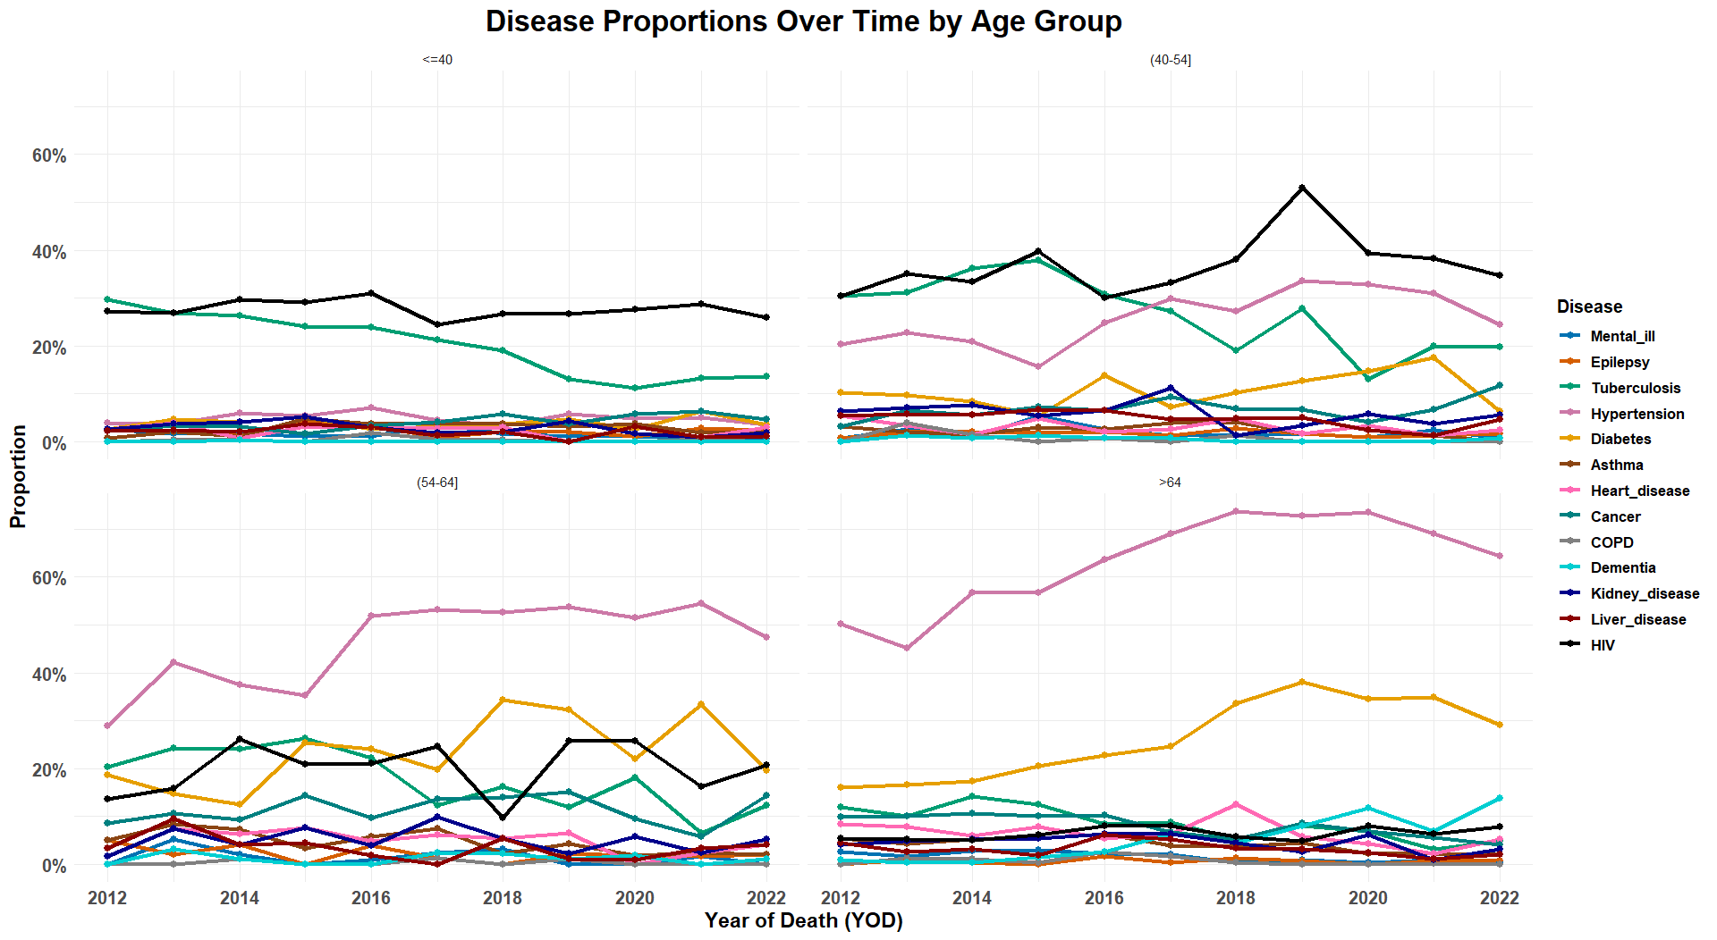
Figure SUP 1

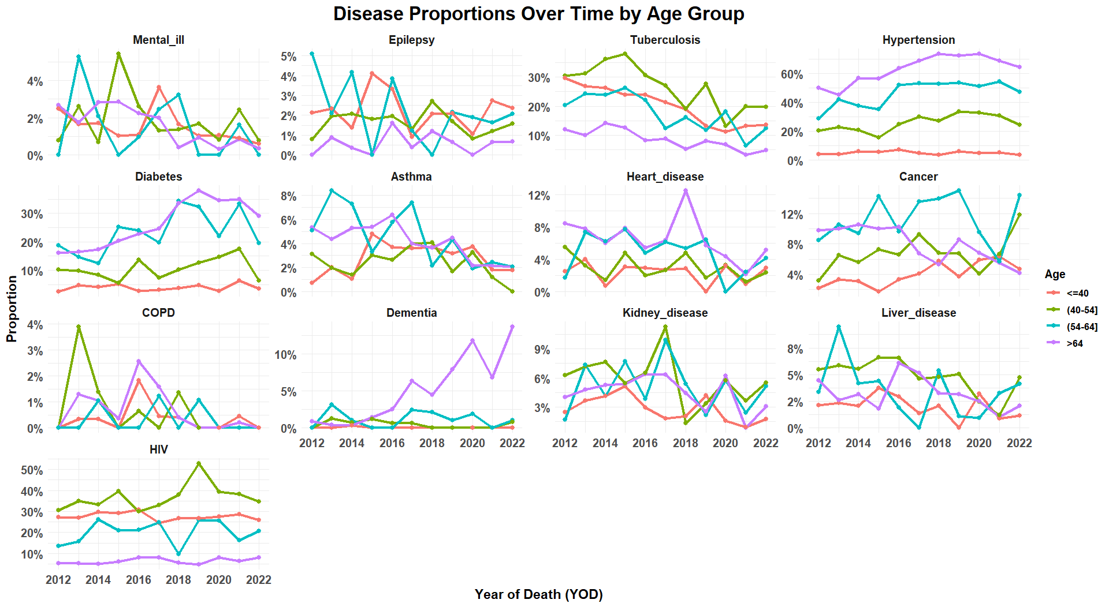
Figure SUP 2

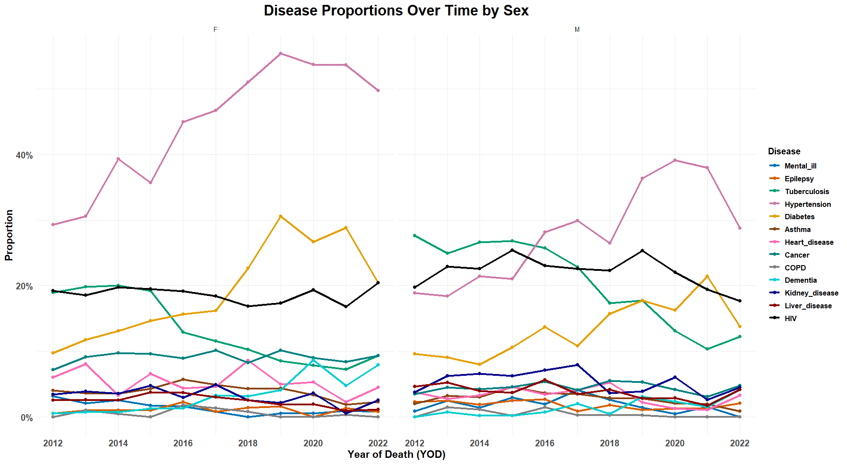
Figure SUP 3

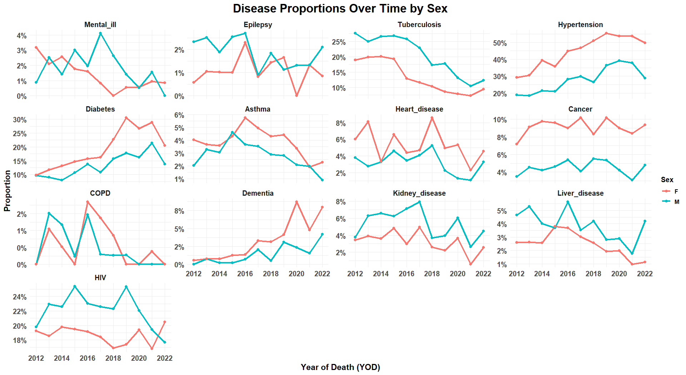
Figure SUP 4

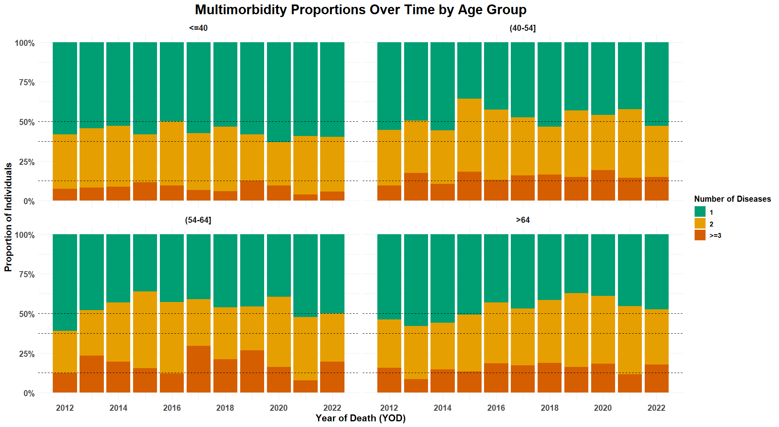
Figure SUP 5
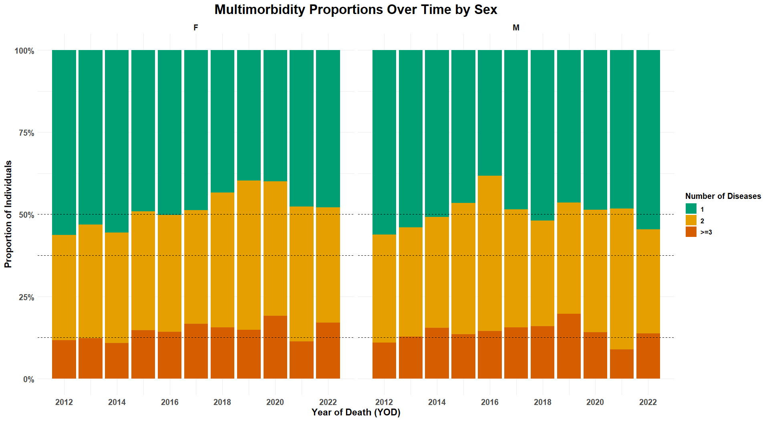
Figure SUP 6

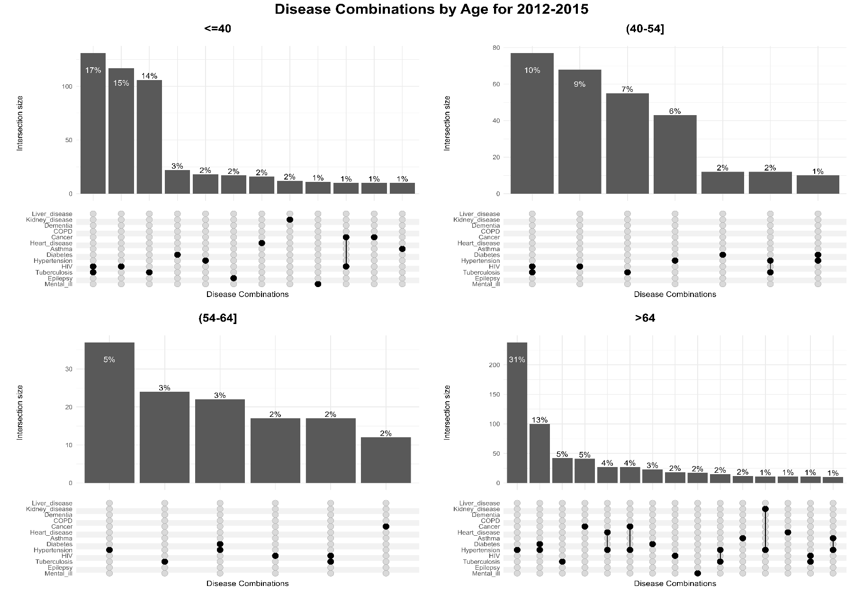
Figure SUP 7 a
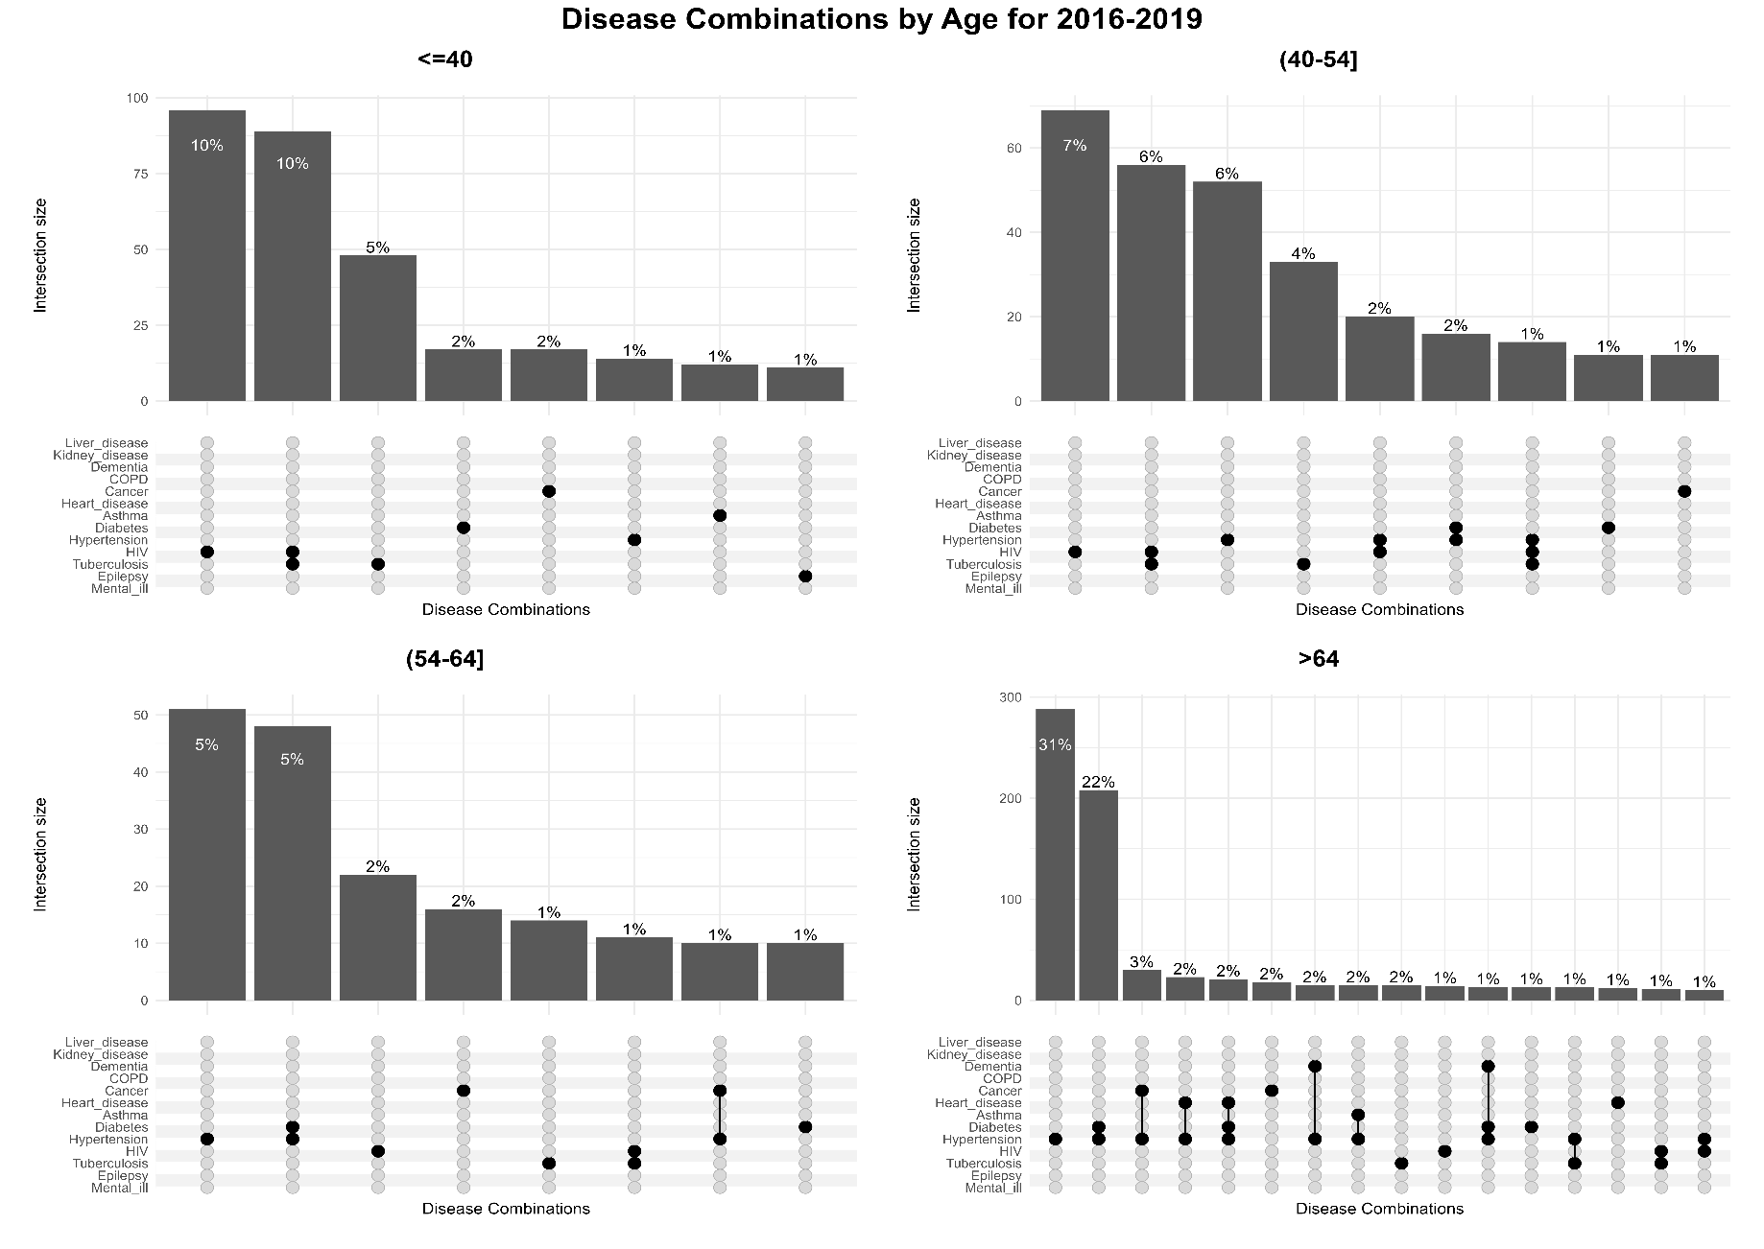
Figure SUP 7 b
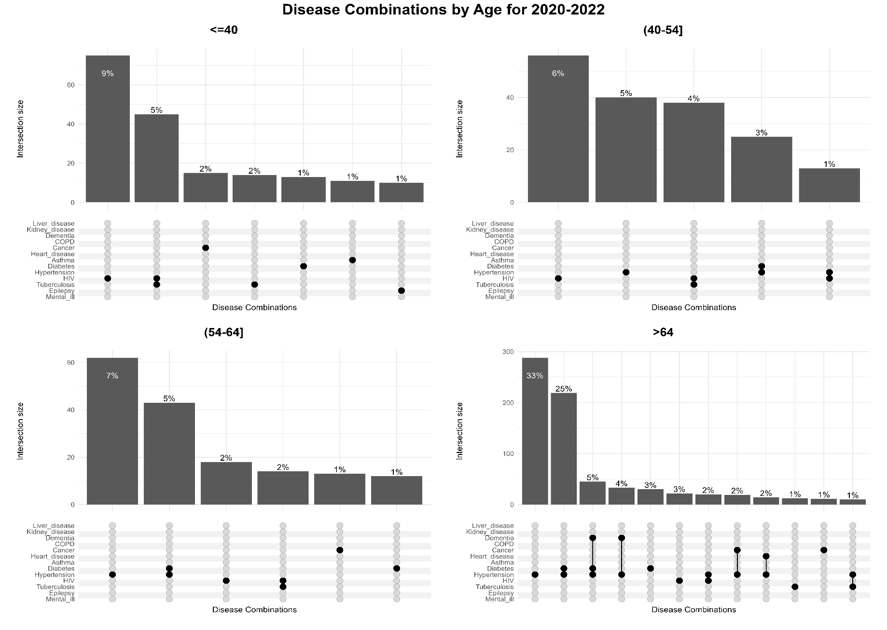
Figure SUP 7 c
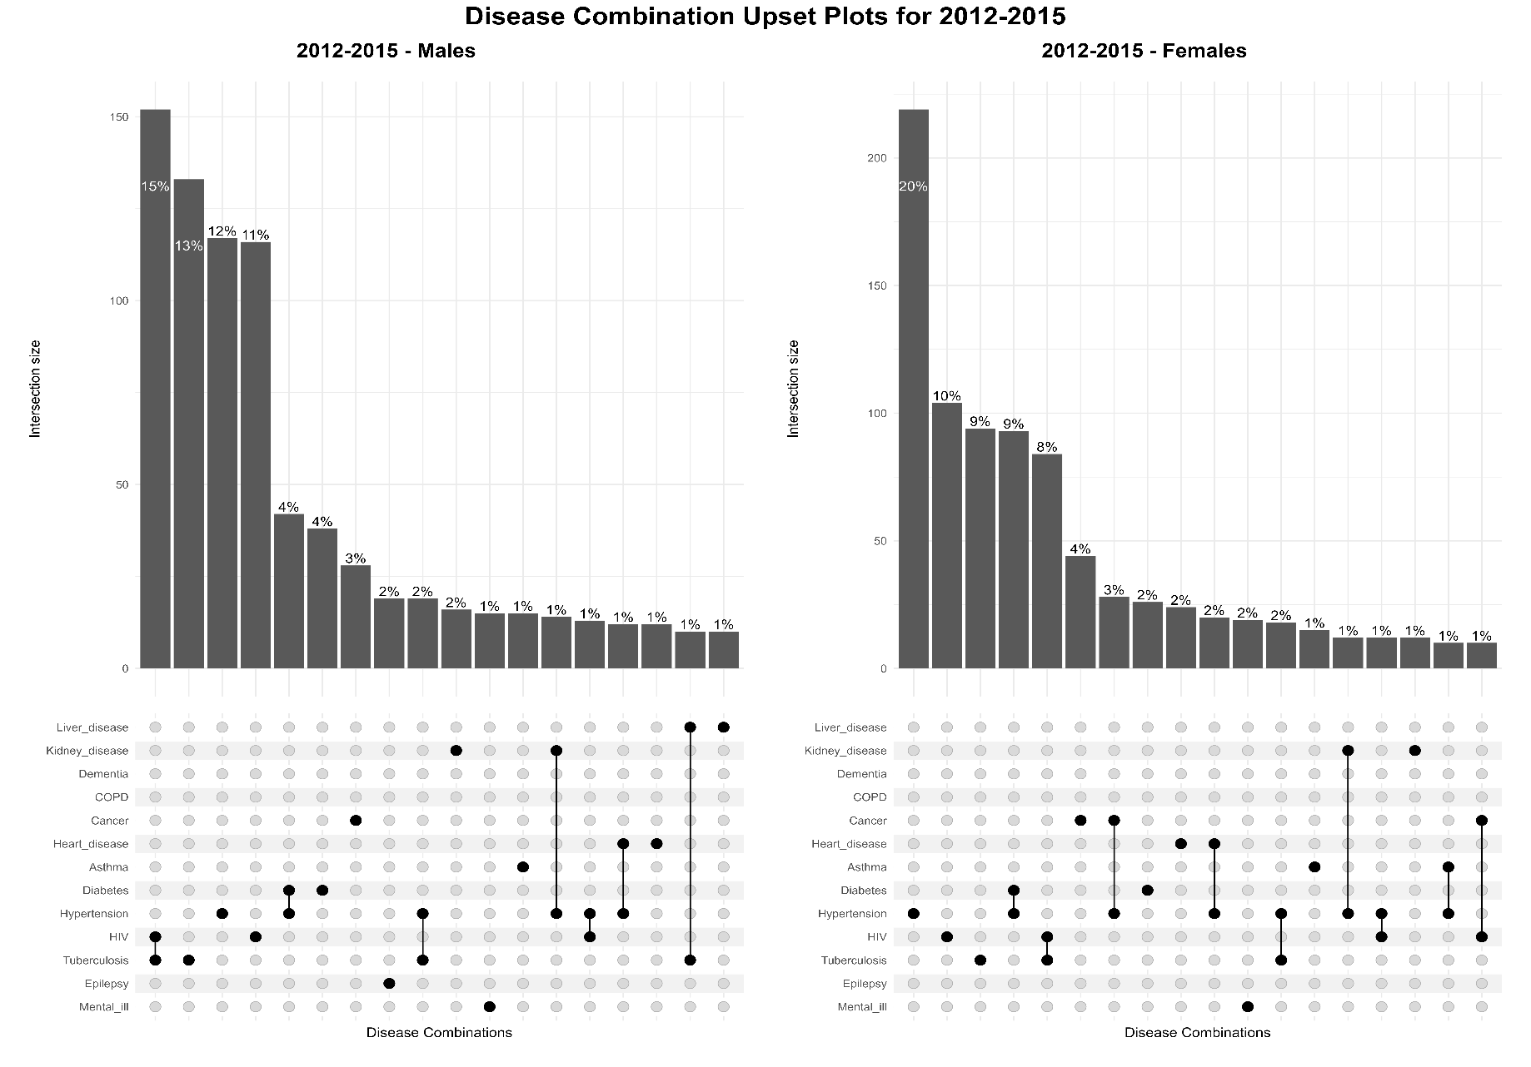
Figure SUP 8 a
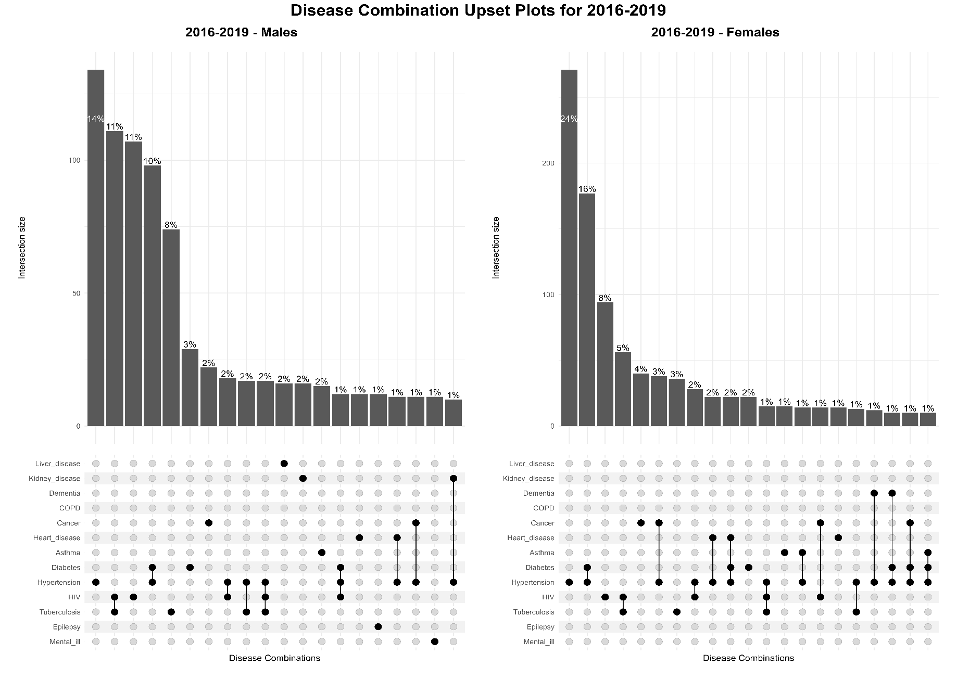
Figure SUP 8 b
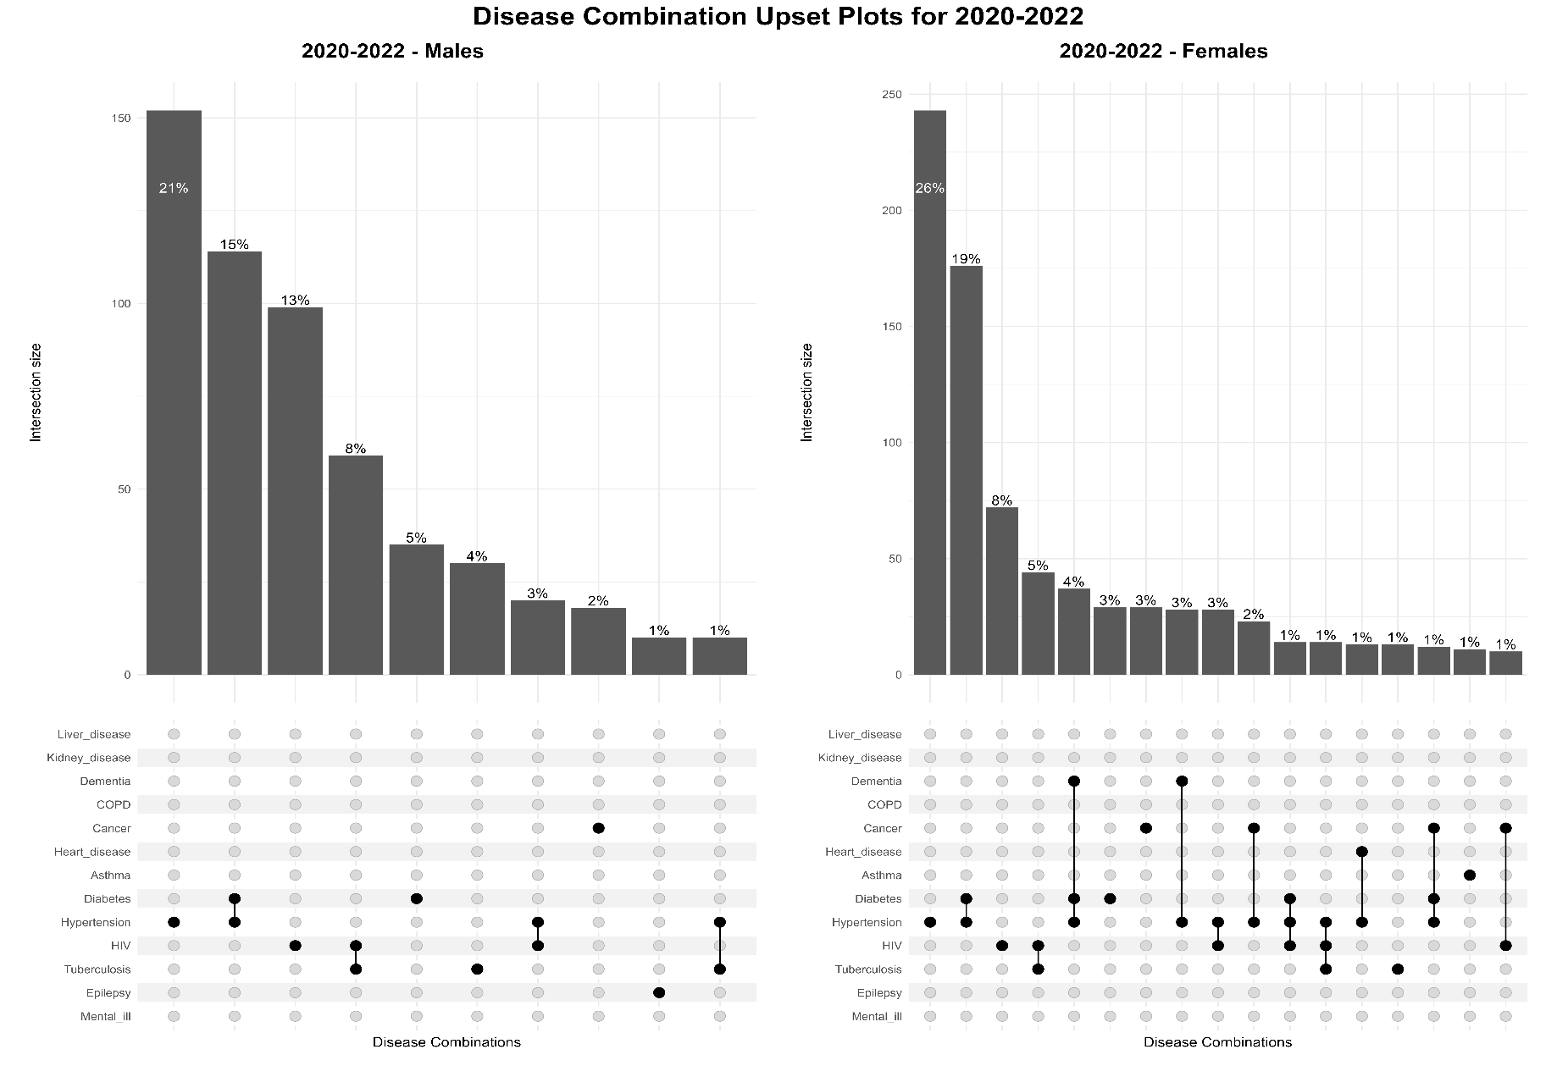
Figure SUP 8 c

