Supplementary Information for
“Octahedral Motif-Guided Design of Optoelectronic Semiconductors via Interpretable Machine Learning”

Xiaoyu Yang^{1#}, Wenyue Zhao^{2,3#}, Xin He¹, Weidong Fei⁴, Yuanhui Sun⁵*, Yu Zhao^{2,3,6}*, Lijun Zhang¹*
¹State Key Laboratory of Integrated Optoelectronics, Key Laboratory of Automobile Materials of MOE and College of Materials Science and Engineering, Jilin University, Changchun, China
²School of Physics, Harbin Institute of Technology, Harbin, China
³Laboratory for Space Environment and Physical Sciences, Harbin Institute of Technology, Harbin, China
⁴School of Materials Science and Engineering, Harbin Institute of Technology, Harbin, China
⁵Suzhou Laboratory, Suzhou, China
⁶Frontier Science Center for Interaction between Space Environment and Matter, Harbin Institute of Technology, Harbin, China
#These authors contributed equally.
*Corresponding author email address: sunyh@szlab.ac.cn; yuzhao@hit.edu.cn; lijun_zhang@jlu.edu.cn

Contents

1. Octahedral identification method 3
2. Components and connectivity of dataset 4
3. Element distribution of dataset 5
4. Formation energy distribution of dataset 6
5. Feature set for machine learning 7
6. Cross validation results of machine learning 9
7. Training loss of machine learning model 10
8. Heatmap of features 11
9. Feature distribution 12
10. Electronegativity and covalent radius of elements 13
11. Feature selection process 14
12. Discussion of the removed features after feature selection 15
13. Results of symbolic regression 16
14. Error analysis of machine learning 17
15. Calculation of convex hull energy 20
16. Thermodynamically stable materials 21
17. Photoelectronic materials 25
18. Partial charge density, projected band structures, and projected DOS 26
19. XRD of Ca₂GaCoO₅ synthesized by using various Co sources 32
20. Bright-field (BF) TEM image and EDS spectrum of Ca₂GaCoO₅ 33
21. Hyperparameter 34
22. Feature construction method 36
References 37

1. Octahedral identification method
We employed the local_env module¹ in pymatgen² software package to determine the existence of octahedral local structures. This module provides classes to perform analyses of the local environments of sites in crystals. The identification of octahedral crystals is accomplished through two steps: firstly, employing a bonding analysis method to identify the coordination number of crystal sites, followed by a local structure determination method to calculate the order parameter for the site with a coordination number of 6. This parameter comprehensively considers both the coordination number and bond angles to differentiate whether the coordination number of 6 corresponds to a hexagonal planar (the central atom is coplanar with six coordinating atoms), pentagonal pyramid (Constructed from five triangular planes and one pentagonal plane), or octahedron.¹ The bonding analysis identifies the central atom and coordinating atoms of the octahedron, represented respectively as $B_{Octa}$ and $X_{Octa}$.
From a total of 204,603 crystals, we successfully identified 17,290 unique octahedral crystals. To manage the computational workload while ensuring high-throughput calculations, we further refined the dataset by selecting 3362 crystals that met specific criteria for containing octahedral local structures.

Supplementary Figure 1: The screening process of machine learning dataset.

2. Components and connectivity of dataset
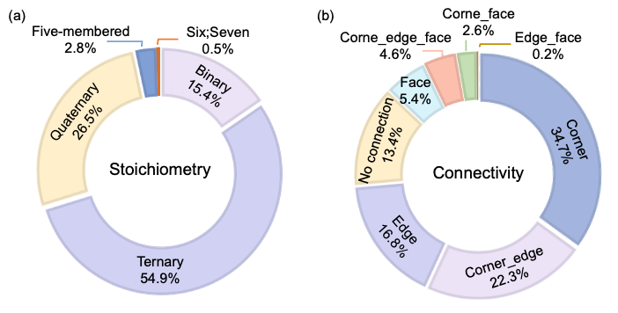

Supplementary Figure 2: The counts of components (a) and connectivity (b) of the crystals in the dataset.

3. Element distribution of dataset
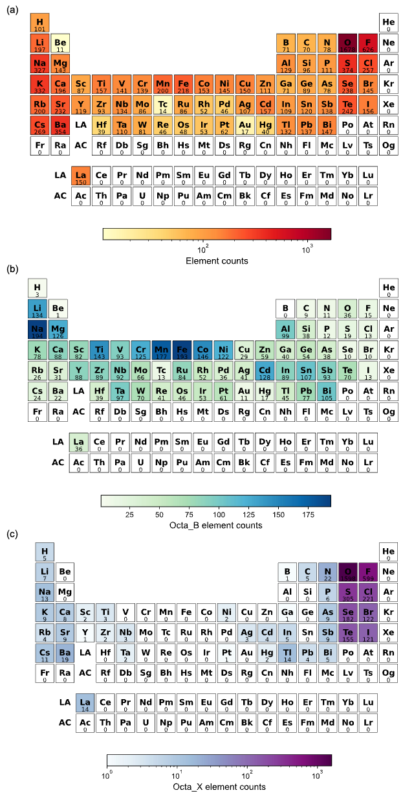
Supplementary Figure 3: The counts of total elements (a), octahedral central element (b), and octahedral coordinate element (c) within the dataset.

4. Formation energy distribution of dataset
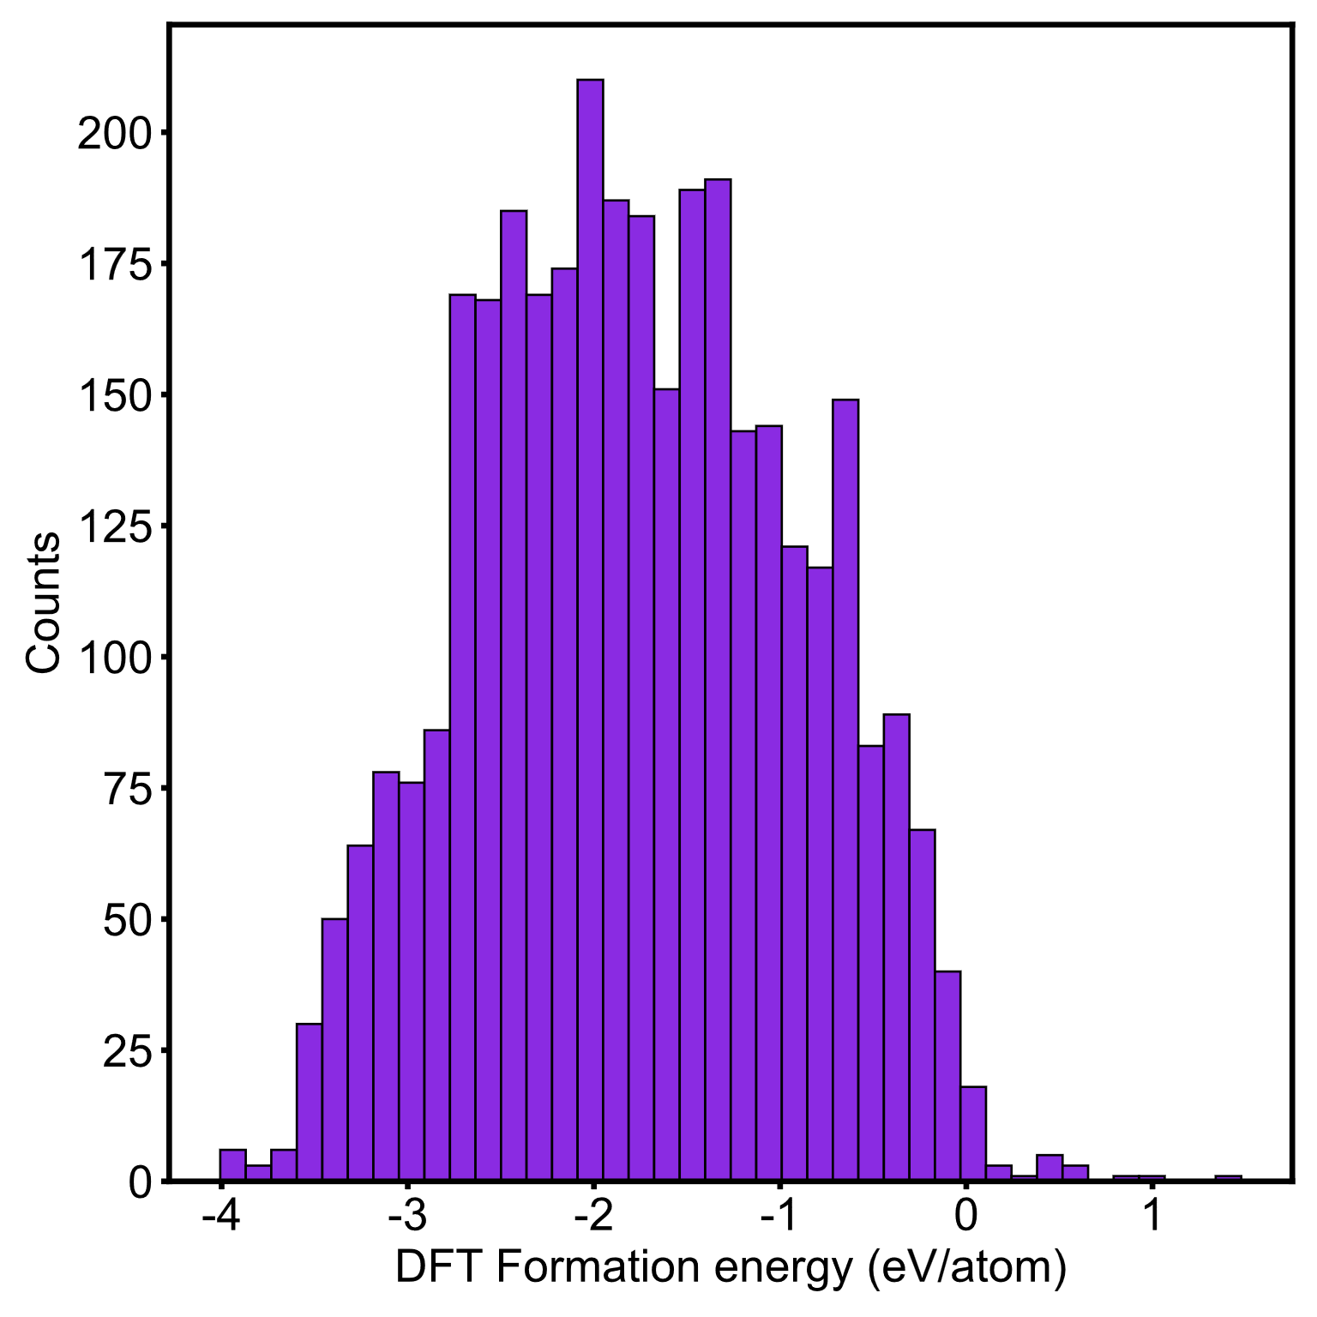
Supplementary Figure 4: The formation energies of crystals in dataset.

5. Feature set for machine learning
Supplementary Table 1: The features of machine learning model. B represents the central element in octahedra, and X represents the coordinate element in octahedra.
Index of importance | Symbol of features | Description
1 | $$χ_{B}/R_{B}^{C}-6×χ_{X}/R_{X}^{C}$$ | Electronegativity_B/CovalentRadius_B$-$  6×Electronegativity_X/CovalentRadius_X
2 | $${NdV}_{mean}$$ | Mean Number of d Valence electron
3 | $${LD}_{NdV}$$ | Local Difference in Number of d Valence electron
4 | $${LD}_{χ}$$ | Local Difference in Electronegativity
5 | $${gap}_{max}$$ | Maximum Ground State bandgap
6 | $$χ_{min}$$ | Minimum Electronegativity
7 | $$χ_{B}-6\text{×}χ_{X}$$ | Electronegativity_B$-$6×Electronegativity_X
8 | $$χ_{mode}$$ | Mode Electronegativity
9 | $${NdV}_{max}$$ | Maximum Number of d Valence electron
10 | $${NuV}_{range}$$ | Range Number of unfilled Valence electron
11 | $${NdV}_{range}$$ | Range Number of d Valence electron
12 | $$R_{range}^{C}$$ | Range Covalence Radius
13 | $${NuV}_{avg_dev }$$ | Average deviation Number of unfilled Valence electron
14 | $${NsuV}_{mean}$$ | Mean Number of unfilled s Valence electron
15 | $${NduV}_{max}⁡$$ | Maximum Number of unfilled d Valence electron
16 | $${LD}_{χ}^{Octa}$$ | Local Difference in Electronegativity of octahedra
17 | $${GSvolume}_{mode}^{B}$$ | Mode Ground State volume of $B_{Octa}$
18 | $${gap}_{avg_dev}$$ | Average deviation Ground State bandgap
19 | $$NDV$$ | Mean Neighbor Distance Variation
20 | $${NV}_{mean}$$ | Mean Number of Valence electron
21 | $${NpV}_{mean}$$ | Mean Number of p Valence electron
22 | $${LD}_{gap}$$ | Local Difference in Ground State bandgap
23 | $${LD}_{R}^{Octa}$$ | Local difference in CovalentRadius of octahedra
24 | $$χ_{B}/R_{B}^{i}-6×χ_{X}/R_{X}^{i}$$ | Electronegativity_B/ionicRadius_B$-$  6×Electronegativity_X/ionicRadius_X
25 | $$E_{std_dev }^{Ewald}$$ | Standard deviation Ewald Energy
26 | $$χ_{B}/R_{B}^{i}$$ | Electronegativity_B/ionicRadius_B
27 | $$density$$ | Density of crystal
28 | $$(χ_{B}-6×χ_{X})/{(R_{B}^{C}-6×R}_{X}^{C})$$ | (Electronegativity_B-6×Electronegativity_X)  /(CovalentRadius_B$-$6CovalentRadius_X)
29 | $$E^{ewald}$$ | Ewald Energy per atom
30 | $$χ_{mean}$$ | Mean Electronegativity
31 | $${LD}_{CR}$$ | Local Difference in CovalentRadius
32 | $$O_{f}⁡$$ | Octahedra factors (irB/irX)
33 | $${NuV}_{mean}⁡$$ | Mean Number of unfilled Valence electron
34 | $$χ_{B}/R_{B}^{C}$$ | Electronegativity_B/CovalentRadius_B

6. Cross validation results of machine learning
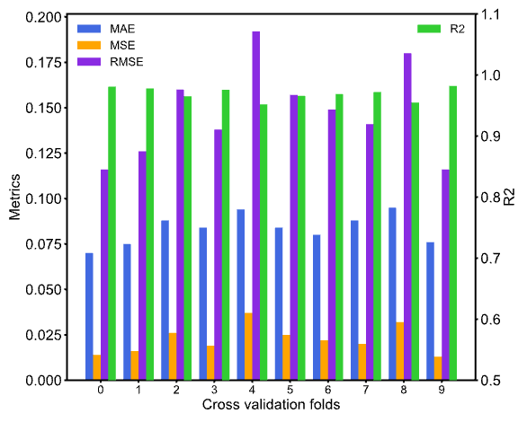

Supplementary Figure 5: 10-fold cross validation results of machine learning.

7. Training loss of machine learning model
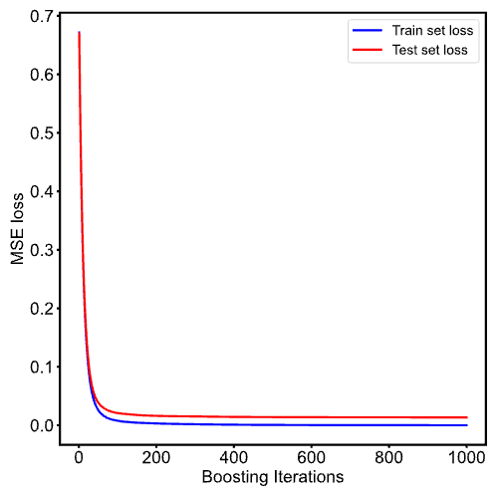

Supplementary Figure 6: MSE loss of machine learning.

8. Heatmap of features
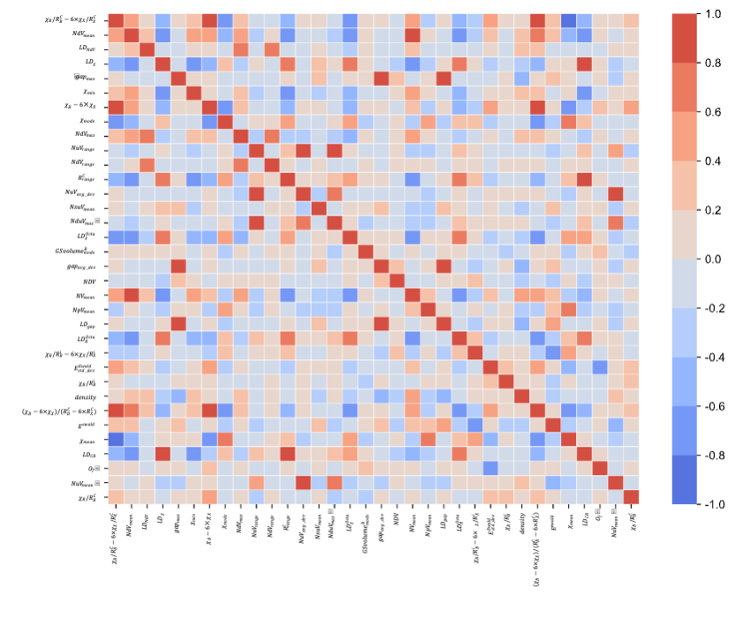
Supplementary Figure 7: The heatmap of feature correlations in machine learning.

9. Feature distribution
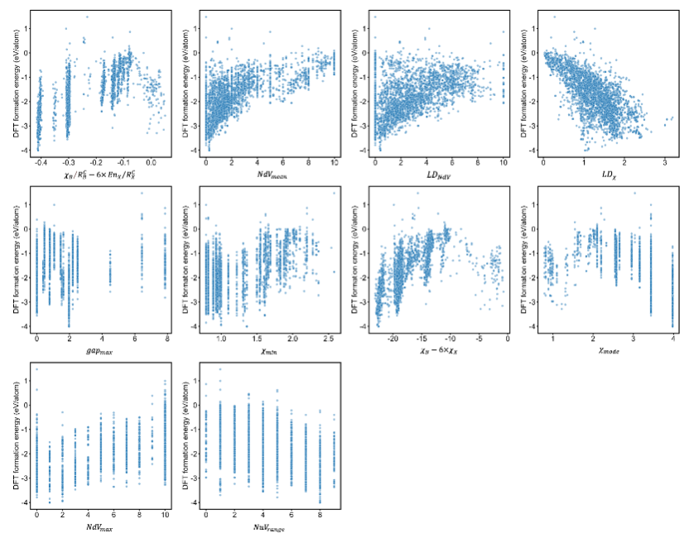

Supplementary Figure 8: Relationship between the top 10 important features and DFT formation energy.

10. Electronegativity and covalent radius of elements
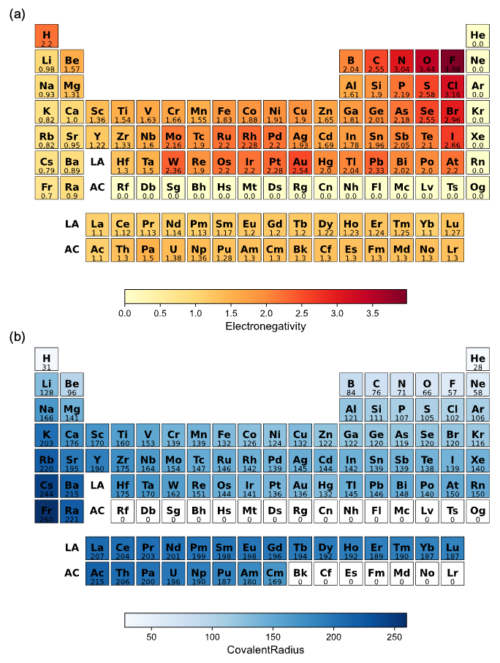
Supplementary Figure 9: The electronegativity (a) and covalent radius (b) of elements.

11. Feature selection process
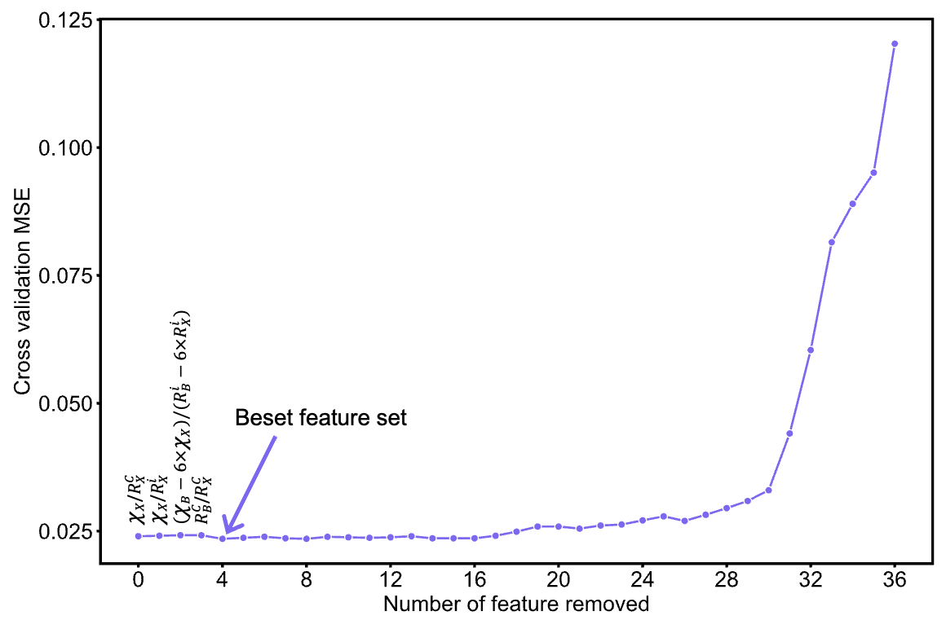

Supplementary Figure 10: The feature selection of machine learning. The minimum MSE is obtained after 4 features are removed. The removed 4 features are $χ_{X}$/$R_{X}^{C}$, $χ_{X}$/$R_{X}^{i}$, $(χ_{B}-6×χ_{X})/{(R_{B}^{i}-6×R}_{X}^{i})$, and $R_{B}^{C}$/$R_{X}^{C}$, respectively.

12. Discussion of the removed features after feature selection
There are some features commonly used to describe perovskites were excluded due to their lack of significant importance during the feature selection process, such as the bond angle, distortion factor, connectivity, space group number. Octahedra have a fixed coordination, making it ineffective in distinguishing between different octahedral structures as efficiently as bond length. The distortion factors were found to be ineffective due to the rich variety of octahedra in the dataset, where the degree of octahedral distortion appears less significant relative to factors such as element type and atomic distance. Furthermore, we noticed that the connectivity of octahedra was also excluded. It may be attributed to the complexity of octahedral connectivity in crystals, resulting in low information density in this feature. For example, two crystals with the same edge-shared octahedra may exhibit significantly different one-dimensional chain-like structures and two-dimensional layered structures.
Another reason for the exclusion is that some structural features, such as packing fraction, density, and volume per atom have already partly described the arrangement of octahedra in crystals, thus replacing the need for connectivity. We also contend that certain global features, which have been demonstrated to be crucial for perovskites, were discarded due to their low information density and were replaced by other structural features, such as the features employed by Jino Im et al.³, including space group number, crystal system, centrosymmetric, and dimensionality.

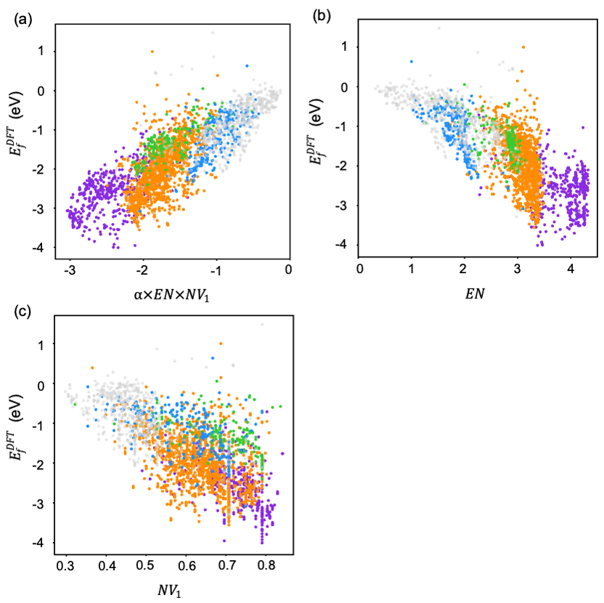
13. Results of symbolic regression

Supplementary Figure 11: Comparation of symbolic regression and DFT calculated formation energies. The color of scatters is same as the legend of Figure 3d.

14. Error analysis of machine learning
We considered the potential impact of cell volumes changes resulting from elemental substitutions between parent structures and generative structures. We performed lattice scaling on 691 candidates to bring their cell volumes closer to those obtained after structural relaxation. We employed the ratio of the sum of volumes of all atoms before and after element substitution as the scaling factor. Subsequently, the lattice was scaled using the scale_lattice function in Pymatgen. This approach effectively maintains the packing fraction of the crystal during the element substitution process. Supplementary Figure 12b demonstrates the effectiveness of the lattice scaling, indicating that the scaled crystal volume, when compared to the unscaled crystal, is closer to the volume after structural relaxation. Subsequently, predictions were made based on the scaled crystals. As shown in Supplementary Figure 13a, lattice scaling did not significantly enhance the accuracy of ML predictions (MAE=139 meV/atom). In other words, the ML prediction error does not stem from the change of crystal volume. This is because the ML model primarily relies on elemental features such as electronegativity, covalent radius, and the number of valence electron.
We also investigated the influence of structural relaxation on ML predictions. Supplementary Figure 13b shows that predictions based on relaxed structures are essentially the same as those based on unrelaxed structures (MAE=140 meV/atom).
The above tests demonstrate that the ML model is insensitive to changes in crystal structure, which makes it possible to predict without needing structure relaxation. To further confirm this conclusion, we randomly selected 50% of the 691 candidate materials and calculated their single-point energies without structure relaxation. The comparison between $E_{f}^{Single-poiont}$ and $E_{f}^{ML}$ is shown in Supplementary Figure 14. Clearly, there is a significant discrepancy between them (MAE=232 meV/atom in Supplementary Figure 13b compared to MAE=141 meV/atom in Figure 4c), with the $E_{f}^{Single-poiont}$ being significantly higher compared to $E_{f}^{ML}$. This is because the calculation of $E_{f}^{Single-poiont}$ is based on unrelaxed structures. This result further confirms our previous conclusion that ML can give prediction based on unrelaxed structures.

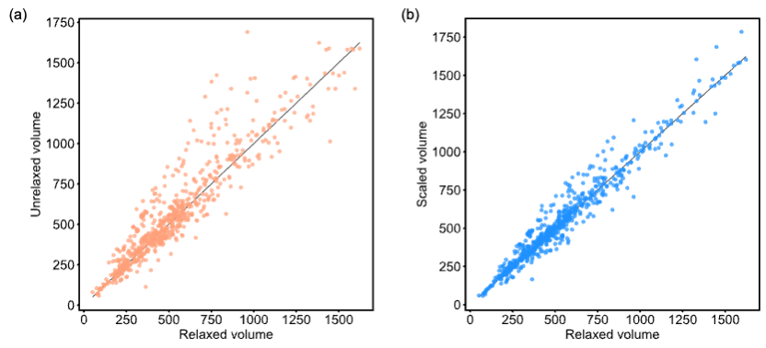
Supplementary Figure 12: (a) The comparison between relaxed volume and unrelaxed volume of crystals. (b) The comparison between relaxed volume and scaled volume of crystals.

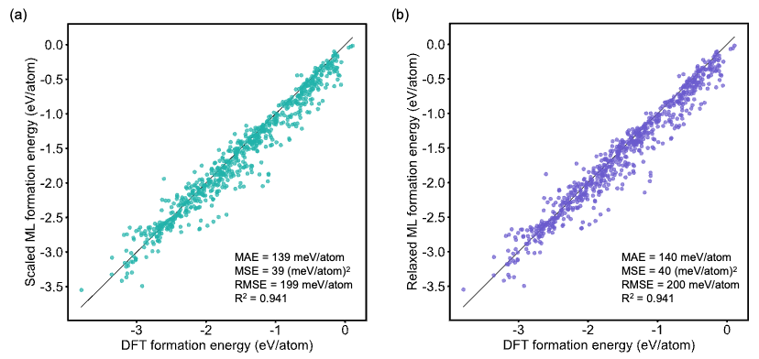
Supplementary Figure 13: (a) The comparison between DFT formation energy and ML predictive formation energy based on volume-scaled crystals. (b) The comparison between DFT formation energy and ML predictive formation energy based on structure-relaxed crystals.

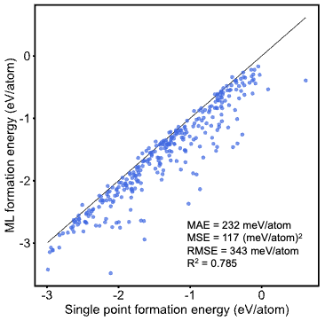
Supplementary Figure 14: The comparison between DFT single point formation energy and ML predictive formation energy.

15. Calculation of convex hull energy
${ΔE}_{hull}$ is defined as the difference between the $E_{f}$ of a material and $E_{f}$ of its corresponding competing phases on the convex hull diagram. The compounds located above these lines (${ΔE}_{hull}$>0) are unstable and can decompose into its competing phases. ${ΔE}_{hull}$ (i.e., the decomposition energy) can be calculated using the following equation (taking CsPbI₃ as an example):
$$ΔE_{hull\left(CsPbI_{3}\right)}=[{4×E}_{(CsPbI_{3})}-{3×E}_{\left(PbI_{2}\right)}-E_{\left({{Cs}_{4}PbI}_{6}\right)}]/20$$
Here, $E_{(CsPbI_{3})}$, $E_{\left(PbI_{2}\right)}$, $E_{\left({{Cs}_{4}PbI}_{6}\right)}$ represent the free energy or formation energies of CsPbI₃ and its two corresponding competing phases, respectively.
We calculated their convex hull energies using the PhaseAnalysis module from Jilin Artificial Intelligence-aided Material-design Integrated Package (JAMIP).⁵ This algorithm involves retrieving the phase space of each material and identifying all possible phases present in OQMD. Subsequently, convex hull diagrams were constructed for each candidate based on its $E_{f}$ and the $E_{f}$ of the competing phases. Then ${ΔE}_{hull}$ could be determined. Through this method, the 691 structures generated a total of 1142 competing phases, with their energies derived from high-throughput DFT calculations.

16. Thermodynamically stable materials
Supplementary Table 2: Information of the 129 thermodynamically stable (${ΔE}_{hull}^{DFT}$ $≤$ 0 eV/atom) SOMs. $B_{Octa}$ and $X_{Octa}$ refer to the central element and coordinate element in octahedra. $E_{g}$ refers to band gap. $m_{h}^{*}$ and $m_{e}^{*}$ refer to the effective transport mass of hole and electron.
Formula | Prototype ICSD-id | $$B_{Octa}$$ | $$X_{Octa}$$ | $E_{g}$ (eV) | Direct $E_{g}$ (eV) | $$m_{h}^{*}$$ | $$m_{e}^{*}$$ | Space group
Ag₂BiCl₉Rb₄ | ICSD-403158 | Bi | Cl | 3.99 | 4.08 | 2.462 | 0.902 | Pnnm
Ag₂Br₉Rb₄Sb | ICSD-403158 | Sb | Br | 3.23 | 3.23 | 2.339 | 0.692 | Pnnm
Ag₂CoKO₈V₂ | ICSD-194591 | Co | O | 1.874 | 1.904 | 2.989 | 18.654 | P-3
Ag₂CoO₈RbV₂ | ICSD-194588 | Co | O | 1.942 | 1.959 | 3.496 | 18.173 | P-3
Ag₃Fe₂O₆Sb | ICSD-174288 | Fe/Sb | O | 0.319 | 0.319 | 11.66 | 0.462 | P3_112
AlBaKS₃ | ICSD-234998 | K | S | 4.043 | 4.043 | 1.493 | 0.925 | Pnma
AlBaNaS₃ | ICSD-234999 | Na | S | 3.685 | 3.685 | 0.877 | 0.66 | Pnma
AlFeLa₃O₇ | ICSD-607565 | Fe | O | 2.271 | 2.3 | 5.099 | 3.521 | P6_3
AlHO₄Se | ICSD-422882 | Al | O | 5.479 | 5.479 | 1.533 | 2.159 | Pnma
AlKO₆Se₂ | ICSD-250870 | Al | O | 5.451 | 5.518 | 4.067 | 1.448 | Pnma
AlLa₃RuS₇ | ICSD-608317 | Ru | S | 1.485 | 1.61 | 6.115 | 1.218 | P6_3
AlNaO₆Se₂ | ICSD-250869 | Al | O | 5.122 | 5.123 | 1.999 | 2.472 | Pnma
Al₂O₉Te₃ | ICSD-261175 | Al | O | 5.097 | 5.123 | 6.409 | 1.29 | P6_3/m
AsCaLiO₄ | ICSD-262123 | Li/Ca | O | 5.535 | 5.535 | 4.082 | 0.574 | Pnma
AsCdFeHO₅ | ICSD-252665 | Fe | O | 0.807 | 0.813 | 17.737 | 0.397 | Pnma
AsCoHgO₅ | ICSD-131797 | Co | O | 1.436 | 1.442 | 9.03 | 1.12 | Pnma
AsK₃O₃ | ICSD-610764 | K | O | 4.683 | 4.687 | 21.859 | 1.684 | P2_13
AsNa₃O₃ | ICSD-1036 | Na | O | 4.771 | 4.963 | 10.597 | 1.253 | P2_13
As₃FO₉Pb₅ | ICSD-158900 | F | Pb | 3.609 | 3.616 | 3.728 | 1.058 | P6_3/m
BCoO₄Pb | ICSD-97665 | Co | O | 1.848 | 1.916 | 3.596 | 1.259 | Pnma
BInNi₂O₅ | ICSD-69616 | In | O | 1.176 | 1.212 | 1.546 | 2.323 | Pbam
B₂Ca₄O₂₅S₆ | ICSD-3029 | Ca | O | 7.736 | 7.736 | 82.147 | 0.618 | P-3
B₂Cd₄O₂₅S₆ | ICSD-3026 | Cd | O | 3.708 | 3.708 | 15.838 | 0.676 | P-3
B₂K₃O₆Sc | ICSD-245925 | Sc | O | 3.271 | 3.271 | 2.026 | 0.59 | Pnnm
B₃FeLaO₇ | ICSD-140990 | Fe | O | 2.719 | 2.719 | 11.234 | 1.616 | Cmme
B₆Ca₂K₅La₃O₁₈ | ICSD-112738 | Ca | O | 3.711 | 3.722 | 5.084 | 0.636 | P31m
BaCaLi₂O₈P₂ | ICSD-236294 | Ca | O | 7.312 | 7.312 | 4.463 | 0.517 | P-3
BaCaNa₂O₈P₂ | ICSD-262716 | Ca | O | 6.46 | 6.51 | 7.971 | 0.508 | P-3
BaGaNaS₃ | ICSD-235001 | Na | S | 3.439 | 3.439 | 0.812 | 0.619 | Pnma
Ba₃CaO₈Si₂ | ICSD-419862 | Ca | O | 6.159 | 6.163 | 8.373 | 0.451 | P-3
Ba₅FSb₃ | ICSD-199809 | F | Ba | 0.746 | 0.746 | 0.141 | 0.602 | P6_3/mcm
Ba₆Li₂Nb₂O₁₇P₂ | ICSD-249742 | Nb | O | 3.18 | 3.18 | 3.574 | 1.781 | P-3m1
Ba₆N₆Re₂S | ICSD-419636 | S | Ba | 0.059 | 0.09 | 0.397 | 2.593 | R-3
Be₃CdF₉K | ICSD-18022 | Cd | F | 5.745 | 5.745 | 8.883 | 0.871 | P-6c2
Be₃CdF₉Rb | ICSD-23133 | Cd | F | 5.769 | 5.769 | 11.043 | 0.856 | P-6c2
BiCl₈F₄H₃Rb₆ | ICSD-39524 | Bi/Rb | Cl | 5.215 | 5.22 | 16.972 | 4.025 | P6_3mc
BiCoSe | ICSD-616878 | Co | Se | 0.35 | 0.448 | 0.384 | 1.605 | P2_13
BiCsK₂Se₃ | ICSD-85412 | Cs | Se | 2.985 | 3 | 6.908 | 5.718 | P2_13
BiCuP₂S₆ | ICSD-195341 | Bi/Cu | S | 1.461 | 1.591 | 6.463 | 1.204 | P-31c
BiFeO₄Sb | ICSD-155236 | Fe | O | 1.282 | 1.287 | 4.151 | 1.643 | P-1
BiK₂RbS₃ | ICSD-85412 | Rb | S | 3.458 | 3.46 | 13.168 | 5.846 | P2_13
BiRb₃Te₃ | ICSD-300183 | Rb | Te | 2.196 | 2.212 | 4.538 | 3.38 | P2_13
Bi₂Br₆Cl₃Cs₃ | ICSD-130352 | Bi | Cl/Br | 3.518 | 3.526 | 1.491 | 0.526 | P-3m1
Bi₂Co₂Ga₂O₉ | ICSD-37087 | Co | O | 1.918 | 1.918 | 2.783 | 0.909 | Pbam
Bi₂Rb₂S₅Zn | ICSD-267980 | Bi | S | 2.33 | 2.47 | 1.952 | 0.528 | Pnma
Bi₃F₁₈In | ICSD-421923 | Bi/In | F | 4.024 | 4.024 | 56.231 | 1.055 | P-3c1
BrHg₂NaO₂ | ICSD-14125 | Br | Hg | 1.654 | 1.825 | 1.957 | 0.511 | C222
Br₈Pt₃ | ICSD-60761 | Pt | Br | 1.345 | 1.345 | 22.945 | 3.348 | P4_12_12
C₂Cl₆CoH₁₂KN₂ | ICSD-133476 | Co | Cl | 2.124 | 2.211 | 3.983 | 3.822 | P-3
CaClNa₂O₄V | ICSD-257851 | Cl | Na/Ca | 3.379 | 3.428 | 1.503 | 10.575 | Pnma
CaFK₂O₄V | ICSD-257851 | Ca | F/O | 3.969 | 3.972 | 5.69 | 10.432 | Pnma
CaLiO₁₂Re₃ | ICSD-101356 | Li | O | 4.038 | 4.039 | 12.282 | 25.843 | P6_3/m
CaO₉Sr₃Ta₂ | ICSD-194992 | Ta/Ca | O | 3.435 | 3.592 | 2.282 | 0.825 | P-3m1
Ca₂CoGaO₅ | ICSD-6320 | Co | O | 2.01 | 2.01 | 1.937 | 0.784 | Pnma
Ca₃F₂O₄Si | ICSD-252073 | Ca | F/O | 6.672 | 6.673 | 13.822 | 0.531 | Pnma
CdF₄Na₂ | ICSD-69344 | Cd | F | 3.919 | 3.999 | 10.598 | 0.575 | Pbam
CdHI₂NaO₇ | ICSD-17614 | Cd | O | 3.136 | 3.136 | 3.249 | 0.769 | Pnma
ClInRb₆Te₄ | ICSD-79543 | Cl | Rb | 2.692 | 2.692 | 6.832 | 0.329 | Cmc2_1
Cl₁₁CsV₄ | ICSD-26076 | V | Cl | 0.822 | 0.833 | 5.608 | 5.319 | Pmma
Cl₁₁RbV₄ | ICSD-412126 | V | Cl | 0.808 | 0.841 | 5.532 | 5.013 | Pmma
Cl₃KRu | ICSD-167455 | Ru | Cl | 1.978 | 2.011 | 3.016 | 6.533 | P6_3cm
Cl₄KSc | ICSD-402273 | K/Sc | Cl | 4.276 | 4.302 | 7.982 | 22.828 | Pbcn
Cl₈F₄H₃K₆Sb | ICSD-39524 | Sb/K | Cl | 4.44 | 4.452 | 11.459 | 2.683 | P6_3mc
Cl₉Cs₃Rh₂ | ICSD-201057 | Rh | Cl | 2.254 | 2.254 | 18.234 | 3.63 | P6_3/mmc
Cl₉Nb₂Rb₅S₄ | ICSD-410591 | Rb | Cl | 1.777 | 1.777 | 3.22 | 6.446 | Immm
CoFeLa₃O₇ | ICSD-603954 | Co | O | 0.865 | 0.972 | 5.212 | 6.363 | P6_3
CoKO₆Se₂ | ICSD-67916 | Co | O | 1.904 | 1.904 | 2.612 | 4.623 | Pnma
CoLa₃O₉W | ICSD-380405 | Co | O | 3.001 | 3.062 | 3.371 | 10.777 | P6_3/m
CoNaO₆Se₂ | ICSD-81559 | Co | O | 2.067 | 2.075 | 3.646 | 5.264 | Pnma
CoOSb | ICSD-624859 | Co | O | 0.909 | 0.928 | 1.267 | 1.122 | Pbca
Co₂H₃O₉P₃ | ICSD-66541 | Co | O | 2.488 | 2.584 | 4.069 | 13.555 | P6_3/m
Co₂KO₃ | ICSD-248051 | Co | O | 0.027 | 0.027 | 1.739 | 0.284 | P-3m1
Co₄Cu₃LaO₁₂ | ICSD-290761 | Co | O | 0.678 | 0.782 | 4.179 | 1.518 | Im-3
CsCuLa₂S₄ | ICSD-93680 | La | S | 0.512 | 0.512 | 3.654 | 0.717 | Cmcm
CsF₅Mo | ICSD-418675 | Mo | F | 0.807 | 0.807 | 9.038 | 41.555 | Pnma
CsK₂O₈P₂Y | ICSD-61787 | Y | O | 4.906 | 5.042 | 6.279 | 0.479 | P-3m1
CsS₅Y₃ | ICSD-433904 | Y | S | 1.933 | 1.933 | 1.612 | 0.628 | Pnma
Cs₂F₅H₂InO | ICSD-18929 | In | F/O | 7.129 | 7.136 | 50.719 | 0.603 | Pnma
Cs₂Ge₃O₉Zr | ICSD-19030 | Zr | O | 3.634 | 3.778 | 6.191 | 0.48 | P6_3/m
Cs₂Ge₄O₉ | ICSD-19031 | Ge | O | 4.262 | 4.424 | 3.901 | 0.382 | P6_3/m
Cs₃CuMn₄O₁₆ | ICSD-424701 | Cu | O | 0.634 | 0.707 | 3.946 | 8.334 | Pnnm
Cs₃F₉Ru₂ | ICSD-201057 | Ru | F | 1.528 | 1.528 | 495.445 | 1640.435 | P6_3/mmc
Cs₃F₉Ti₂ | ICSD-402407 | Ti | F | 0.752 | 0.763 | 110.133 | 162.919 | P6_3/mmc
Cs₃F₉Tl₂ | ICSD-27849 | Tl | F | 5.084 | 5.084 | 40.543 | 0.926 | R-3c
Cs₅GaP₄Se₁₂ | ICSD-50504 | Ga | Se | 1.96 | 1.963 | 2.509 | 0.817 | P4_2/m
Cs₅InP₄S₁₂ | ICSD-50504 | In | S | 3.065 | 3.065 | 4 | 1.381 | P4_2/m
Cs₅P₄S₁₂Sb | ICSD-260946 | Sb | S | 3.086 | 3.145 | 3.254 | 5.574 | P4_2/m
Cs₅P₄SbSe₁₂ | ICSD-260945 | Sb | Se | 2.326 | 2.392 | 2.621 | 0.875 | P4_2/m
Cs₅P₄Se₁₂Tl | ICSD-50504 | Tl | Se | 1.198 | 1.198 | 2.154 | 0.753 | P4_2/m
Cs₅P₅Se₁₂ | ICSD-260945 | P | Se | 2.229 | 2.243 | 4.173 | 0.497 | P4_2/m
CuHf₂NaS₅ | ICSD-98476 | Hf | S | 1.238 | 1.238 | 0.758 | 0.749 | Cmcm
FInK₆Te₄ | ICSD-79543 | F | K | 2.753 | 2.753 | 0.962 | 0.353 | Cmc2_1
FK₃MoO₄ | ICSD-194783 | F | K | 4.71 | 4.78 | 6.456 | 14.944 | Pnma
FNa₂O₄SrV | ICSD-257851 | F | Sr/Na | 3.992 | 4.046 | 6.273 | 6.471 | Pnma
F₁₂S₂Si | ICSD-60079 | Si | F | 7.156 | 7.156 | 32.851 | 5.601 | Pnnm
F₁₄Ga₃K₅ | ICSD-248085 | Ga | F | 7.623 | 7.661 | 31.604 | 0.629 | P4/mnc
F₁₄N₂Pd | ICSD-26397 | Pd | F | 2.195 | 2.197 | 99.165 | 8.589 | I4/m
F₁₄N₂Rh | ICSD-26397 | Rh | F | 1.33 | 1.33 | 25.365 | 112.053 | I4/m
F₂O₃SeZn₂ | ICSD-18869 | Zn | F/O | 4.091 | 4.111 | 5.127 | 2.167 | Pnma
F₃GaO₄Rb₂S | ICSD-143627 | Ga | F/O | 6.522 | 6.534 | 132.481 | 0.634 | Pbcn
F₃H₂Li | ICSD-433032 | Li | F | 10.234 | 10.242 | 6.572 | 0.682 | Pnma
F₄K₂O₂W | ICSD-201173 | K | F/O | 4.258 | 4.309 | 40.392 | 28.524 | Pbcn
F₆FeK₃Na | ICSD-23182 | Fe | F | 3.104 | 3.11 | 213.805 | 0.633 | R-3m
F₆H₈N₂Zr | ICSD-24834 | Zr | F | 6.953 | 6.958 | 16.243 | 0.656 | C2/m
F₇GaK₂Ni | ICSD-408111 | Ni/K/Ga | F | 1.645 | 1.645 | 2.658 | 3.924 | Imma
F₇InK₂Ni | ICSD-72110 | In/K | F | 2.287 | 2.287 | 6.187 | 3.038 | Pnma
F₇InLi₂Ni | ICSD-72110 | In/Li | F | 2.521 | 2.521 | 7.84 | 4.792 | Pnma
F₈NbOP | ICSD-24086 | Nb | F/O | 5.481 | 5.481 | 902.229 | 1652.884 | Pnma
FeGaLa₃O₇ | ICSD-426674 | Fe | O | 2.298 | 2.298 | 6.192 | 0.773 | P6_3
FeInLa₃O₇ | ICSD-426492 | Fe | O | 1.946 | 1.952 | 9.363 | 0.528 | P6_3
FeLa₄OS₆ | ICSD-391306 | Fe | S | 2.193 | 2.195 | 1.872 | 6.606 | P6_3mc
GaO₈RbW₂ | ICSD-24859 | Ga | O | 4.572 | 4.572 | 3.418 | 4.685 | P-3m1
Ga₂O₇Zn₄ | ICSD-247275 | Ga | O | 0.875 | 0.875 | 2.446 | 0.17 | P6_3/mmc
GeK₂O₉Si₃ | ICSD-19027 | Ge | O | 5.944 | 6.234 | 3.152 | 0.496 | P6_3/m
GeLa₃NaS₇ | ICSD-112861 | Na | S | 2.055 | 2.239 | 0.576 | 0.895 | P6_3
GeO₉Rb₂Si₃ | ICSD-19028 | Ge | O | 5.936 | 6.248 | 3.164 | 0.484 | P6_3/m
Ge₃O₉Tl₂Zr | ICSD-19029 | Zr | O | 3.124 | 3.138 | 1.685 | 1.078 | P6_3/m
I₄Na₂Zn | ICSD-69034 | Na | I | 4.30 | 4.30 | 3.065 | 0.393 | Pnma
InNa₃O₂ | ICSD-202028 | O | Na/In | 2.16 | 2.431 | 2.807 | 0.788 | Pnma
KNi₂O₃ | ICSD-248051 | Ni | O | 1.252 | 1.349 | 8.889 | 2.026 | R-3m
K₂O₅Rb₂Te | ICSD-202076 | Rb | O | 3.387 | 3.406 | 118.87 | 0.526 | P4_2/mnm
K₃O₂Tl | ICSD-202028 | O | Tl/K | 2.646 | 2.648 | 3.348 | 1.418 | Pnma
Li₂S₅ | ICSD-38349 | Li | S | 2.525 | 2.528 | 1.639 | 1.171 | Pnma
NaPt₂S₃ | ICSD-78788 | Pt | S | 1.464 | 1.494 | 4.179 | 0.65 | P6_3mc
Na₃O₄Rb₂Tl | ICSD-61402 | Rb | O | 2.608 | 2.608 | 6.861 | 0.391 | Pnnm
O₆PbSiTe | ICSD-254193 | Si/Pb/Te | O | 3.321 | 3.556 | 0.748 | 0.495 | P312
O₆RbScTe₂ | ICSD-291296 | Sc | O | 3.021 | 3.021 | 1.788 | 2.124 | Pnma
O₉Rb₂Si₃Zr | ICSD-19026 | Zr | O | 4.761 | 4.973 | 5.7 | 0.475 | P6_3/m
Rb₃SbTe₃ | ICSD-300182 | Rb | Te | 2.425 | 2.435 | 7.476 | 7.284 | P2_13

17. Photoelectronic materials

Supplementary Table 3. The DFT calculation results of 19 selected new octahedral crystals.
Octahedral  crystals | Dimension | $$B_{Octa}$$ | $$X_{Octa}$$ | DFT+U/HSE  $E_{g}$ (eV) | Direct  $E_{g}$ (eV) | Reduced  effective mass $μ$ | Optical  absorption $I$
KCo₂O₃ | 3D | Co | O | 0.03 | 0.03 | 0.24 | 1509.17
N₆Re₂SBa₆ | 3D | S | Ba | 0.06 | 0.09 | 0.34 | 2300.65
Zn₄Ga₂O₇ | 3D | Ga | O | 0.87 | 0.87 | 0.16 | 1193.91
CoOSb | 3D | O | Co, Sb | 0.91 | 0.91 | 0.59 | 1162.85
Ca₂GaCoO₅ | 3D | Co | O | 2.01 | 2.01 | 0.56 | 1422.81
Pt₂NaS₃ | 2D | Pt | S, Na | 1.46 | 1.49 | 0.56 | 2124.06
O₂InNa₃ | 3D | O | Na, In | 2.16 | 2.43 | 0.62 | 2868.41
Cs₅P₅Se₁₂ | 0D | P | Se | 2.23 | 2.24 | 0.44 | 1155.66
ZnRb₂Bi₂S₅ | 2D | Bi | S | 2.33 | 2.47 | 0.42 | 1299.26
Cs₅P₄SbSe₁₂ | 0D | Sb | Se | 2.33 | 2.39 | 0.66 | 1038.47
TlNa₃Rb₂O₄ | 3D | Rb | O | 2.61 | 2.61 | 0.37 | 1157.53
O₂TlK₃ | 3D | O | Tl, K | 2.65 | 2.65 | 0.99 | 1767.37
InFK₆Te₄ | 3D | K | Te | 2.75 | 2.75 | 0.26 | 1164.75
RbTe₂ScO₆ | 3D | Sc | O | 3.02 | 3.02 | 0.97 | 1086.86
Ge₃Tl₂ZrO₉ | 3D | Zr | O | 3.12 | 3.14 | 0.66 | 1080.85
Ag₂Rb₄SbBr₉ | 2D | Sb | Br | 3.23 | 3.23 | 0.53 | 1345.74
Ag₂Rb₄BiCl₉ | 2D | Bi | Cl | 3.99 | 4.08 | 0.66 | 1272.25
ZnNa₂I₄ | 3D | Na | I | 4.30 | 4.30 | 0.35 | 1124.24
HSeAlO₄ | 2D | Al | O | 5.48 | 5.48 | 0.90 | 1241.95

18. Partial charge density, projected band structures, and projected DOS
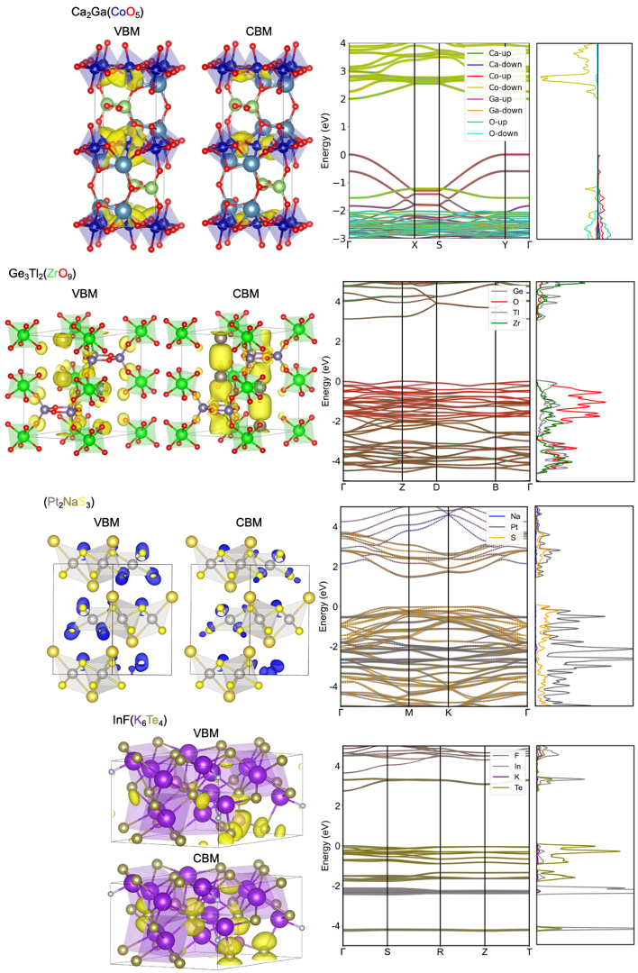
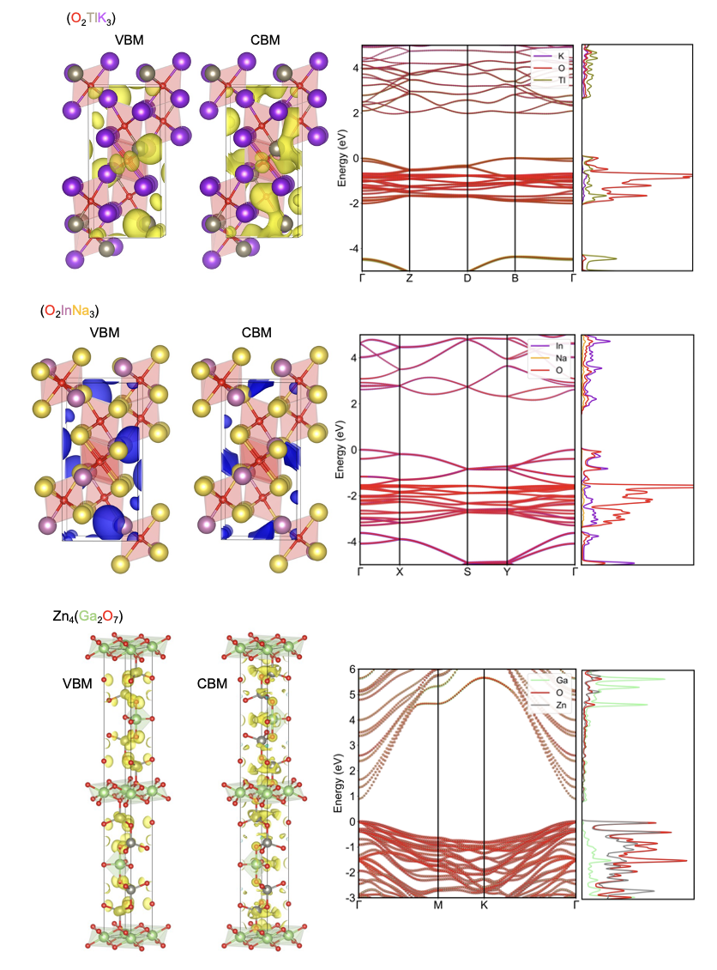

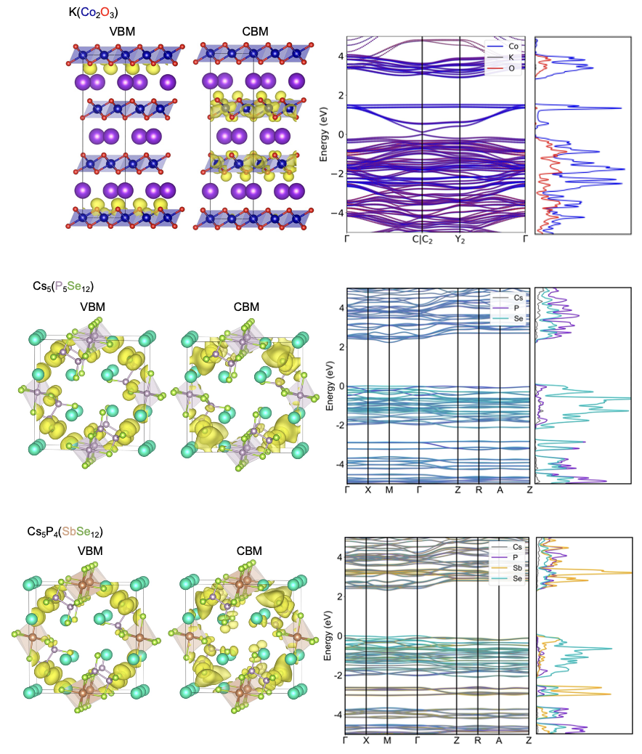

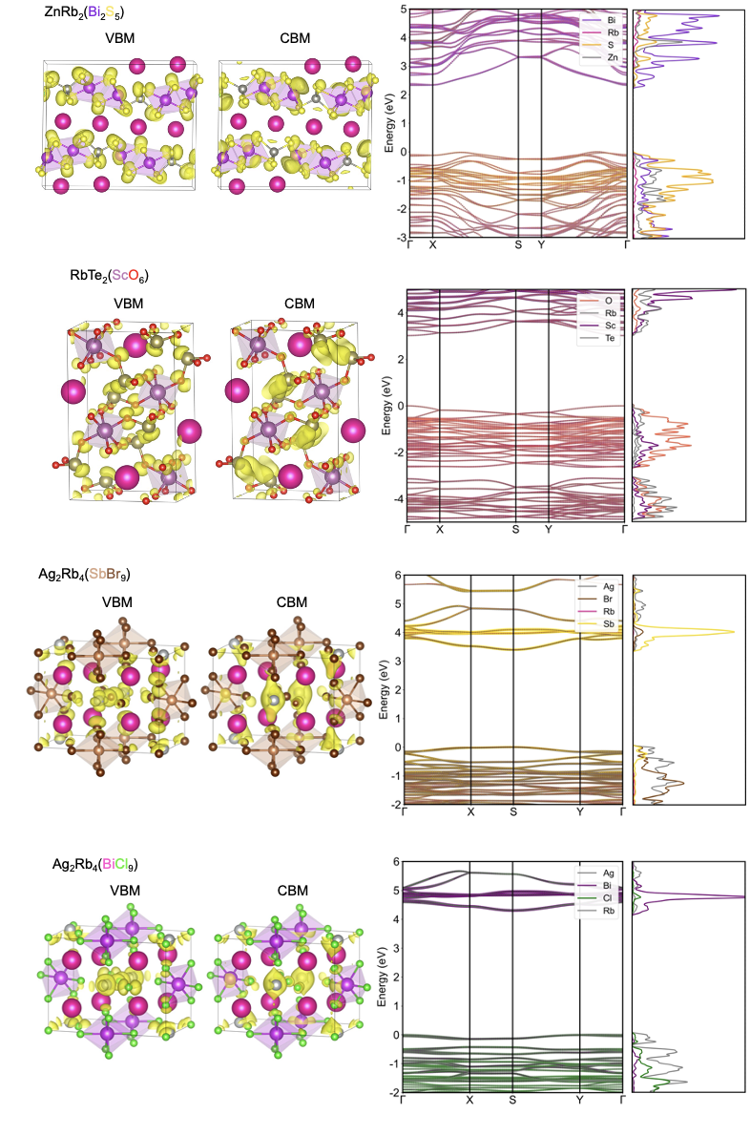
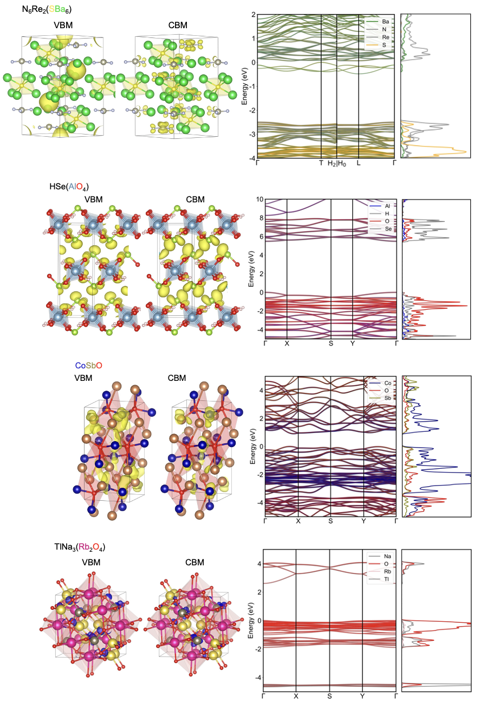
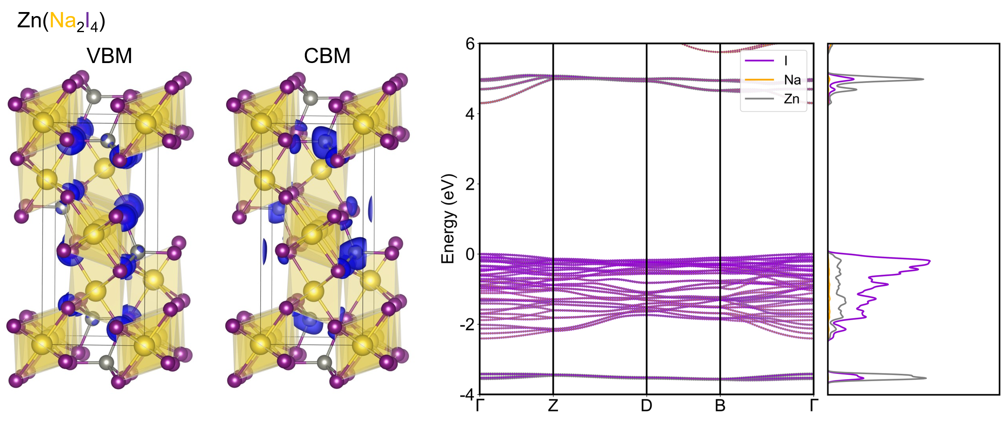

Supplementary Figure 15: Partial charge density, projected band structures, and projected density of states (pDOS) of the 19 new optoelectronic materials. Charge is displayed in orange or blue. Isosurface level is set to be 2e⁻⁷. The pDOS is divided by the number of atoms of each element for better visualization of each element's contribution. Octahedral compositions are given in parentheses.

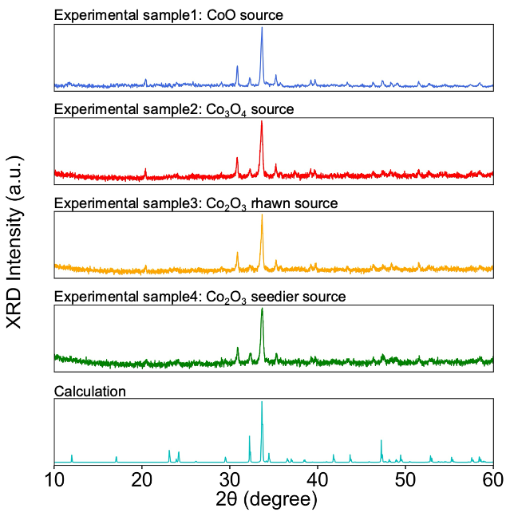
19. XRD of Ca₂GaCoO₅ synthesized by using various Co sources
Supplementary Figure 16. XRD of Ca₂GaCoO₅ synthesized by using various Co sources. Experimental sample1 was synthesized by using CoO source. Experimental sample2 was synthesized by using Co₃O₄ source. Experimental sample3 was synthesized by using Co₂O₃ produced by Rhawn Company. Experimental sample4 was synthesized by using Co₂O₃ produced by Seedior Company.

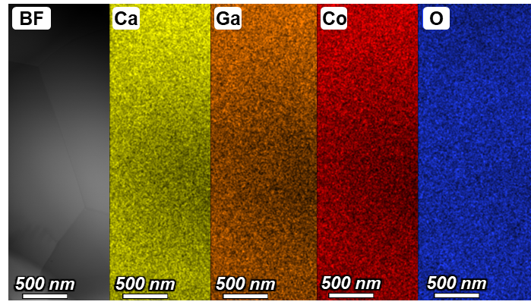
20. Bright-field (BF) TEM image and EDS spectrum of Ca₂GaCoO₅
Supplementary Figure 17. Bright-field (BF) TEM image and EDS spectrum of Ca₂GaCoO₅

21. Hyperparameter
The most critical hyperparameters in GBRT are maximum depth and learning rate. The max_depth parameter defines the maximum depth of the decision tree, that is, the length of the longest path that the decision tree can generate. It limits the maximum path length from the root node to the farthest leaf node. While The learning_rate determines how much a weak learner added to the model contributes to the final prediction at each iteration. We employed the grid search by method GridSearchCV in Scikit-learn⁶ to identify the optimal combination of the two hyperparameters.

Supplementary Table 4: The combination of hyperparameter and results of hyperparameter search.
Hyperparameters | Results
max depth = 3, learning_rate = 0.01 | MSE = 0.0538
max depth = 4, learning_rate = 0.01 | MSE = 0.0432
max depth = 5, learning_rate = 0.01 | MSE = 0.0387
max depth = 6, learning_rate = 0.01 | MSE = 0.0361
max depth = 7, learning_rate = 0.01 | MSE = 0.0383
max depth = 8, learning_rate = 0.01 | MSE = 0.0411
max depth = 3, learning_rate = 0.05 | MSE = 0.0336
max depth = 4, learning_rate = 0.05 | MSE = 0.0315
max depth = 5, learning_rate = 0.05 | MSE = 0.0315
max depth = 6, learning_rate = 0.05 | MSE = 0.0223
max depth = 7, learning_rate = 0.05 | MSE = 0.0357
max depth = 8, learning_rate = 0.05 | MSE = 0.0401
max depth = 3, learning_rate = 0.1 | MSE = 0.0280
max depth = 4, learning_rate = 0.1 | MSE = 0.0322
max depth = 5, learning_rate = 0.1 | MSE = 0.0319
max depth = 6, learning_rate = 0.1 | MSE = 0.0335
max depth = 7, learning_rate = 0.1 | MSE = 0.0366
max depth = 8, learning_rate = 0.1 | MSE = 0.0412

Supplementary Table 5: Hyperparameters of machine learning model.
Hyperparameter | Value
n_estimators | 1000
max_depth | 6
learning_rate | 0.05
loss | squared_error
min_samples_split | 2
min_samples_leaf | 1

Supplementary Table 6: Hyperparameters of symbolic regression (SISSO).
Hyperparameter | Value
desc_dim | 2
nsf | 34
fcomplexity | 5
fmax_min | 1e⁻⁵
fmax_max | 1e5
nf_sis | 100
method_so | 'L0'
fit_intercept | .true.
metric | RMSE

22. Feature construction method
The features used in machine learning were extracted using the Matminer,⁷ pymatgen,² and Mendeleev software packages.⁸
We also used the SiteAnalyzer module in Robocrystallographer package⁹ to describe the connectivity of octahedra, which was regarded as the semi-local environment of crystals. When there exist one, two, or multiple shared $X_{Octa}$ atoms between two adjacent $B_{Octa}$ atoms, the connection between these two octahedra is categorized as corner, edge, or face shared. When both corner and edge connections coexist in a crystal, we classify the connectivity as corner+edge. Thus, we categorize the connection modes into eight types, they are corner, edge, face, corner+edge, corner+face, edge+face, corner+edge_face and no connection. We adopted three types of categorical encoding methods for connectivity: label encoding, binary encoding, and one-hot encoding.
Due to lack consistent structure in our dataset, coupled with variations in the types of elements across different crystals, it is indispensable to employ numerical statistical methods to uniform the feature lengths for each sample before model training. The commonly adopted approach for perovskite materials is calculating the average value.^{10–13} Relying solely on the average may obscure material characteristics and limit the comprehensive capture of material information for various octahedra in our dataset, thereby hindering the training of ML models. To ensure a comprehensive representation of crystal information, we incorporated multiple numerical statistical methods for feature unification, including maximum ($max$), minimum ($min$), mean, range, mode, average deviation ($avg_dev$), and standard deviation ($std_dev$). By leveraging these diverse statistical measures, we aim to capture a more complete and nuanced understanding of the materials' properties and facilitate effective training of the ML models.

References
1. Zimmermann, N. E. R. & Jain, A. Local structure order parameters and site fingerprints for quantification of coordination environment and crystal structure similarity. RSC Adv. 10, 6063–6081 (2020).
2. Ong, S. P. et al. Python Materials Genomics (pymatgen): A robust, open-source python library for materials analysis. Comput. Mater. Sci 68, 314–319 (2013).
3. Im, J. et al. Identifying Pb-free perovskites for solar cells by machine learning. npj. Comput. Mater. 5, 37 (2019).
4. Ward, L. et al. Including crystal structure attributes in machine learning models of formation energies via Voronoi tessellations. Phys. Rev. B 96, 024104 (2017).
5. Zhao, X.-G. et al. JAMIP: an artificial-intelligence aided data-driven infrastructure for computational materials informatics. Sci. Bull. 66, 1973–1985 (2021).
6. Pedregosa, F. Scikit-learn: Machine learning in python. J. Mach. Learn. Res. 12, 2825–2830 (2011).
7. Ward, L. et al. Matminer: An open source toolkit for materials data mining. Comput. Mater. Sci 152, 60–69 (2018).
8. Mentel, L. M. mendeleev - A Python package with properties of chemical elements, ions, isotopes and methods to manipulate and visualize periodic table. (2021).
9. Ganose, A. M. & Jain, A. Robocrystallographer: automated crystal structure text descriptions and analysis. MRS Commun. 9, 874–881 (2019).
10. Chen, J., Xu, W. & Zhang, R. Δ-Machine learning-driven discovery of double hybrid organic–inorganic perovskites. J. Mater. Chem. A 10, 1402–1413 (2022).
11. Hu, W., Zhang, L. & Pan, Z. Designing two-dimensional halide perovskites based on high-throughput calculations and machine learning. ACS Appl. Mater. Interfaces 14, 21596–21604 (2022).
12. Ma, X.-Y., Lewis, J. P., Yan, Q.-B. & Su, G. Accelerated discovery of two-dimensional optoelectronic octahedral oxyhalides via high-throughput Ab Initio calculations and machine learning. J. Phys. Chem. Lett. 10, 6734–6740 (2019).
13. Kim, J. & Min, K. Data‐driven investigation of the synthesizability and bandgap of double perovskite halides. Adv. Theor. Simul. 5, 2200068 (2022).

