Supplementary information for

Dynamic Stress Enhances Electrocatalytic Hydrogen Evolution Reaction on Metals
Xiang Yu¹, Ettore Bianco¹, Hui Wang¹, Sander Deelen², Youri van den Brink³, Florian Meirer¹, Claire Bourquard³, Matteo Monai¹*
¹Inorganic Chemistry and Catalysis group, Institute for Sustainable and Circular Chemistry, Utrecht University, Universiteitsweg 99, 3584 CG, Utrecht (the Netherlands)
² Scientific Instrumentation, Utrecht University, Utrecht (the Netherlands)
³Department of Mechanical Engineering, Eindhoven University of Technology, 5600 MB, Eindhoven, The Netherlands
Corresponding author: *m.monai@uu.nl

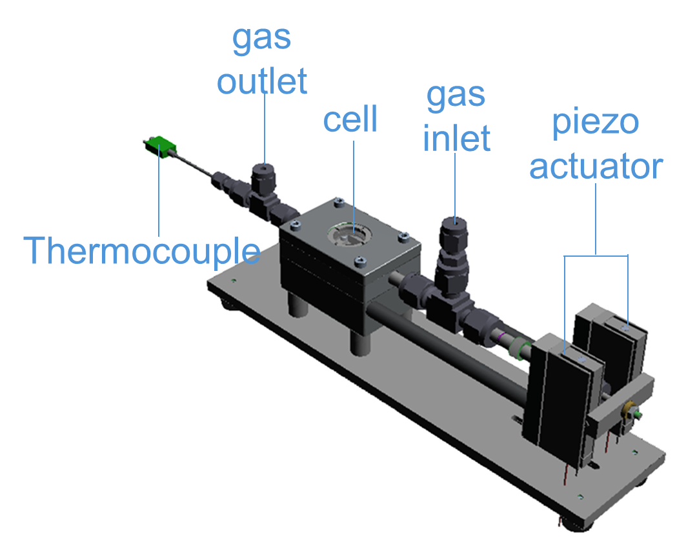

Supplementary Fig. 1: Illustration of multi-functional dynamic stress cell. The apparatus was designed as a versatile reaction cell for both thermal catalysis and electrocatalysis, incorporating gas inlet and outlet ports as well as a thermocouple. Additionally, windows were integrated into the lid to accommodate potential in situ or operando spectroscopic studies.

Supplementary Note 1: For electrochemical HER and operando LDV measurements, the lid, thermocouple, heater, and gas inlet/outlet were not used. The sample holder clips were replaced with the resin-based ones to ensure electrical insulation.

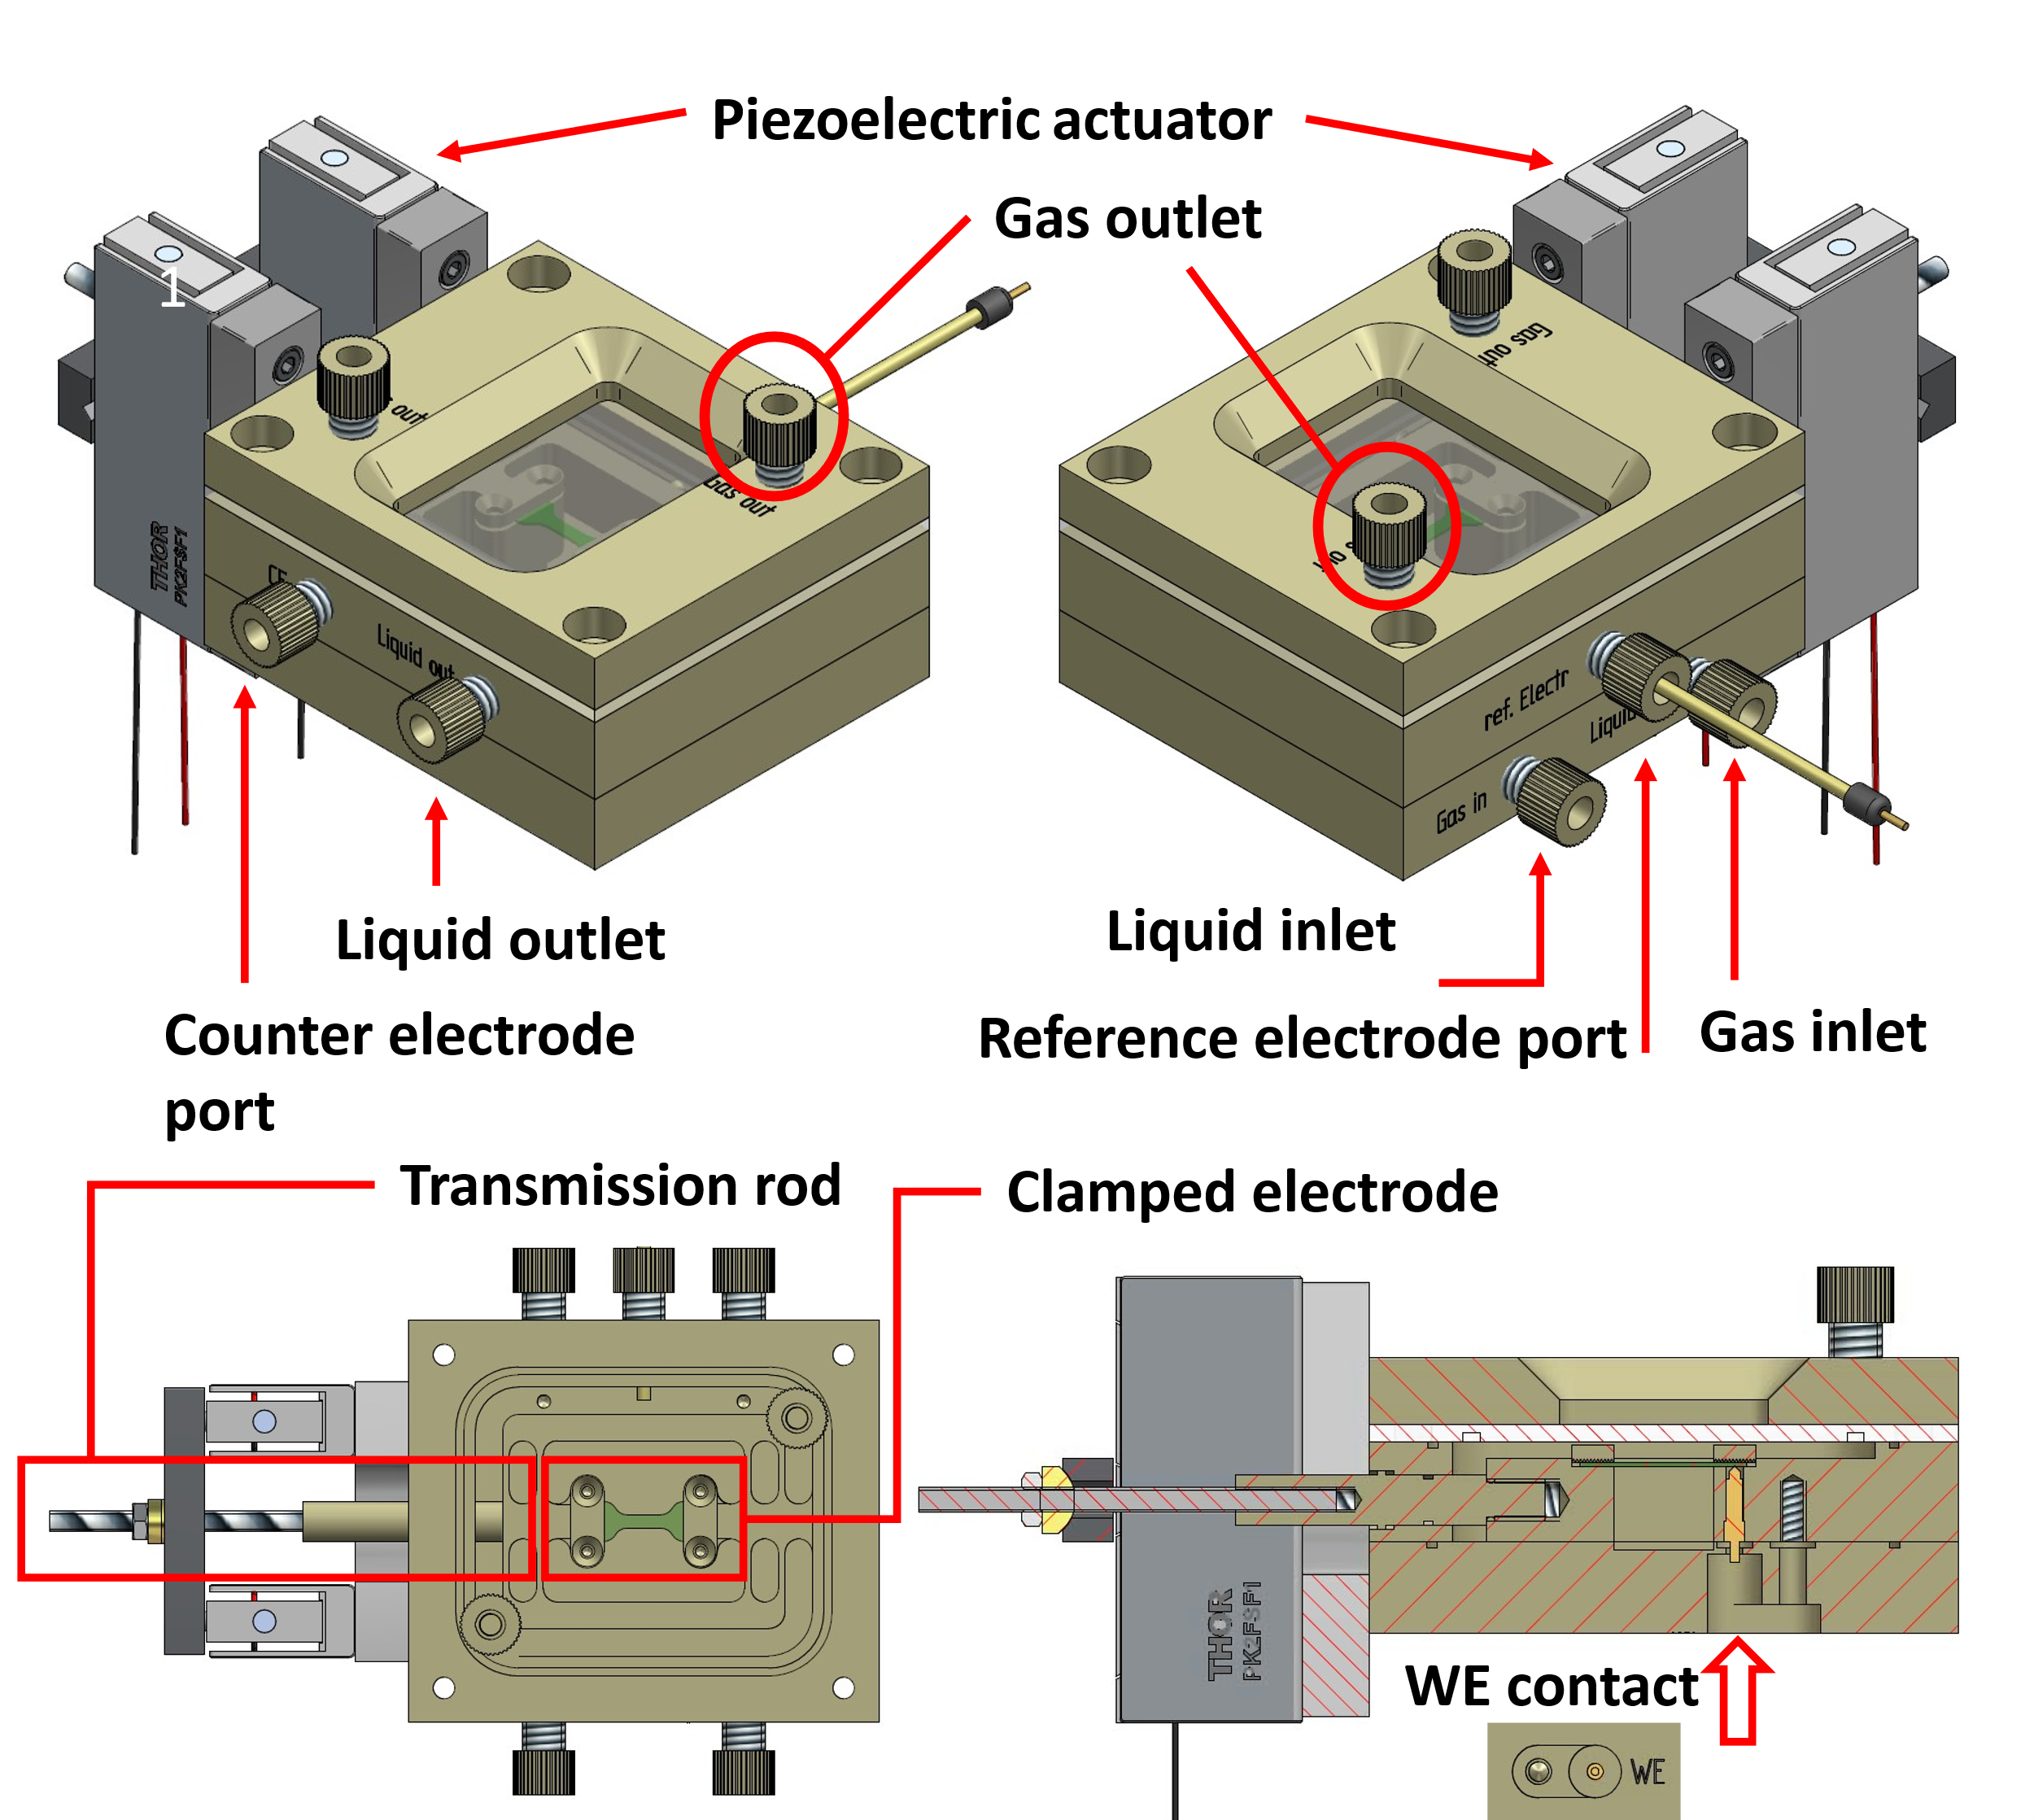

Supplementary Fig. 2: Illustration of the polyether ether ketone (PEEK) dynamic stress cell designed for GC H₂ determination during electrocatalysis and incorporating gas and liquid inlet and outlet ports.
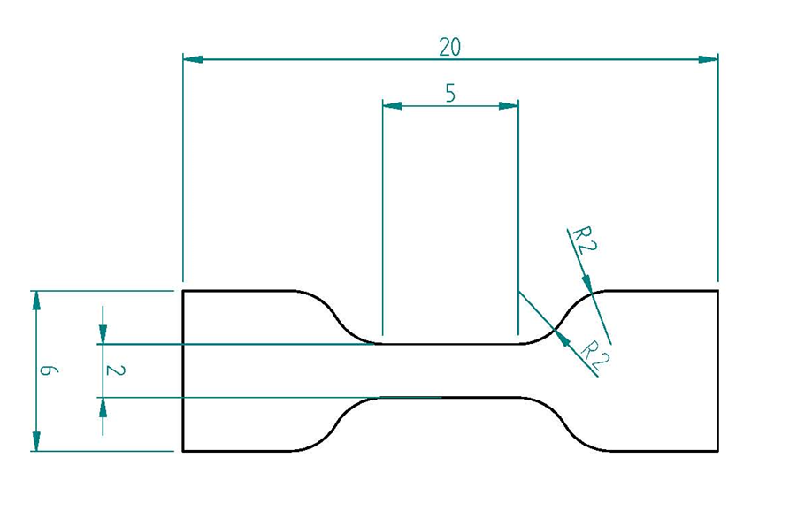

Supplementary Fig. 3: Dimensions of the catalyst foil (unit: mm). The wider parts at both ends of the dog-bone shaped foil were clamped to the cell and thus isolated from the electrolyte.

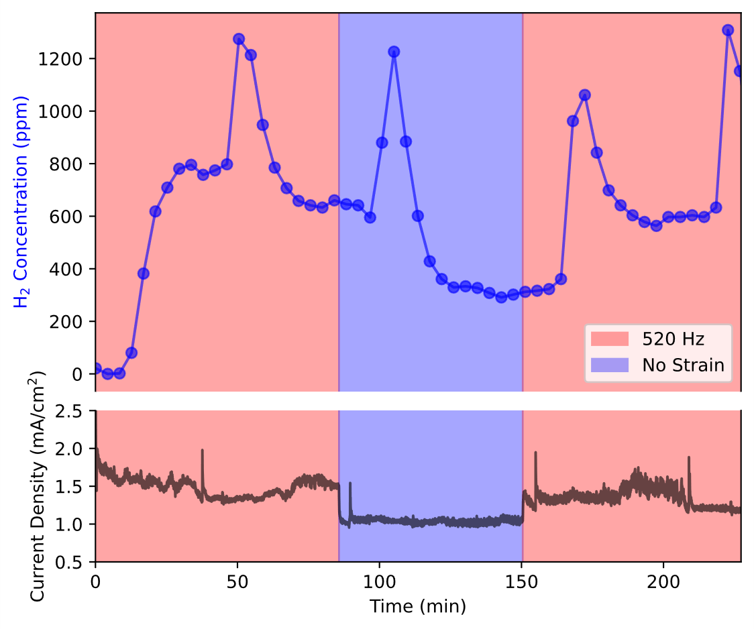
Supplementary Fig. 4: GC-monitored electrocatalytic H₂ evolution and measured current density on Cu electrode alternating different dynamic strain conditions at – 0.872 V vs RHE (-1.2 V vs Ag/AgCl RE). During dynamic strain, a sin function of 520 Hz frequency and 0~15 V Piezo Input Voltage (PIV) was applied to steer the piezoelectric actuators. The concentration of H₂ measured by online GC was almost double when dynamic strain was applied (red shaded area) with respect to the unstrained electrode (blue shaded area).4 peaks in H₂ concentration were observed at 50, 100, 160 and 220 min. These were anticipated by a sharp drop in the measured current, corresponding to the detachment of big bubbles trapped beneath the electrode. In the calibration curve, the intercept is forced to the baseline level so that it corresponds to 0 ppm.

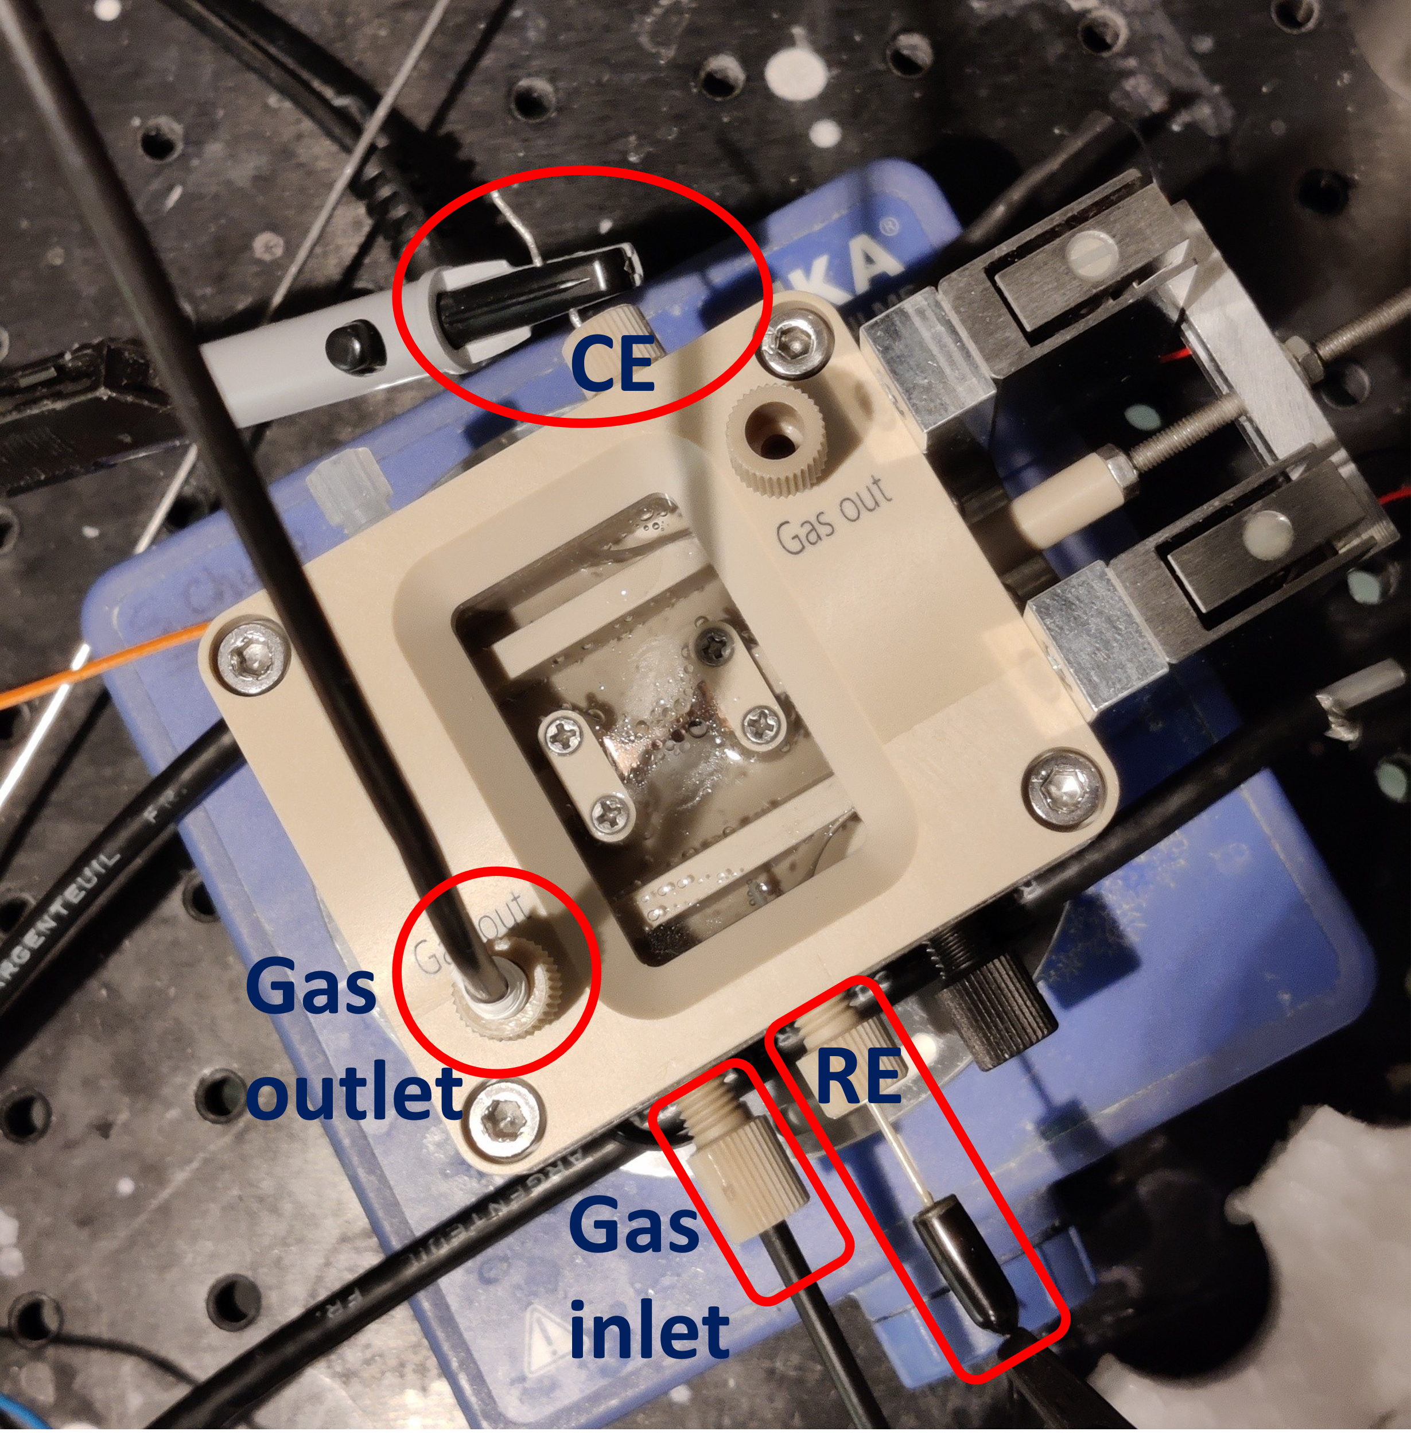

Supplementary Fig. 5: Setup adopted for the H₂ production measurement via GC, with the polyether ether ketone (PEEK) dynamic stress cell. Gas inlet and gas outlet were connected to a mass flow controller and GC respectively.
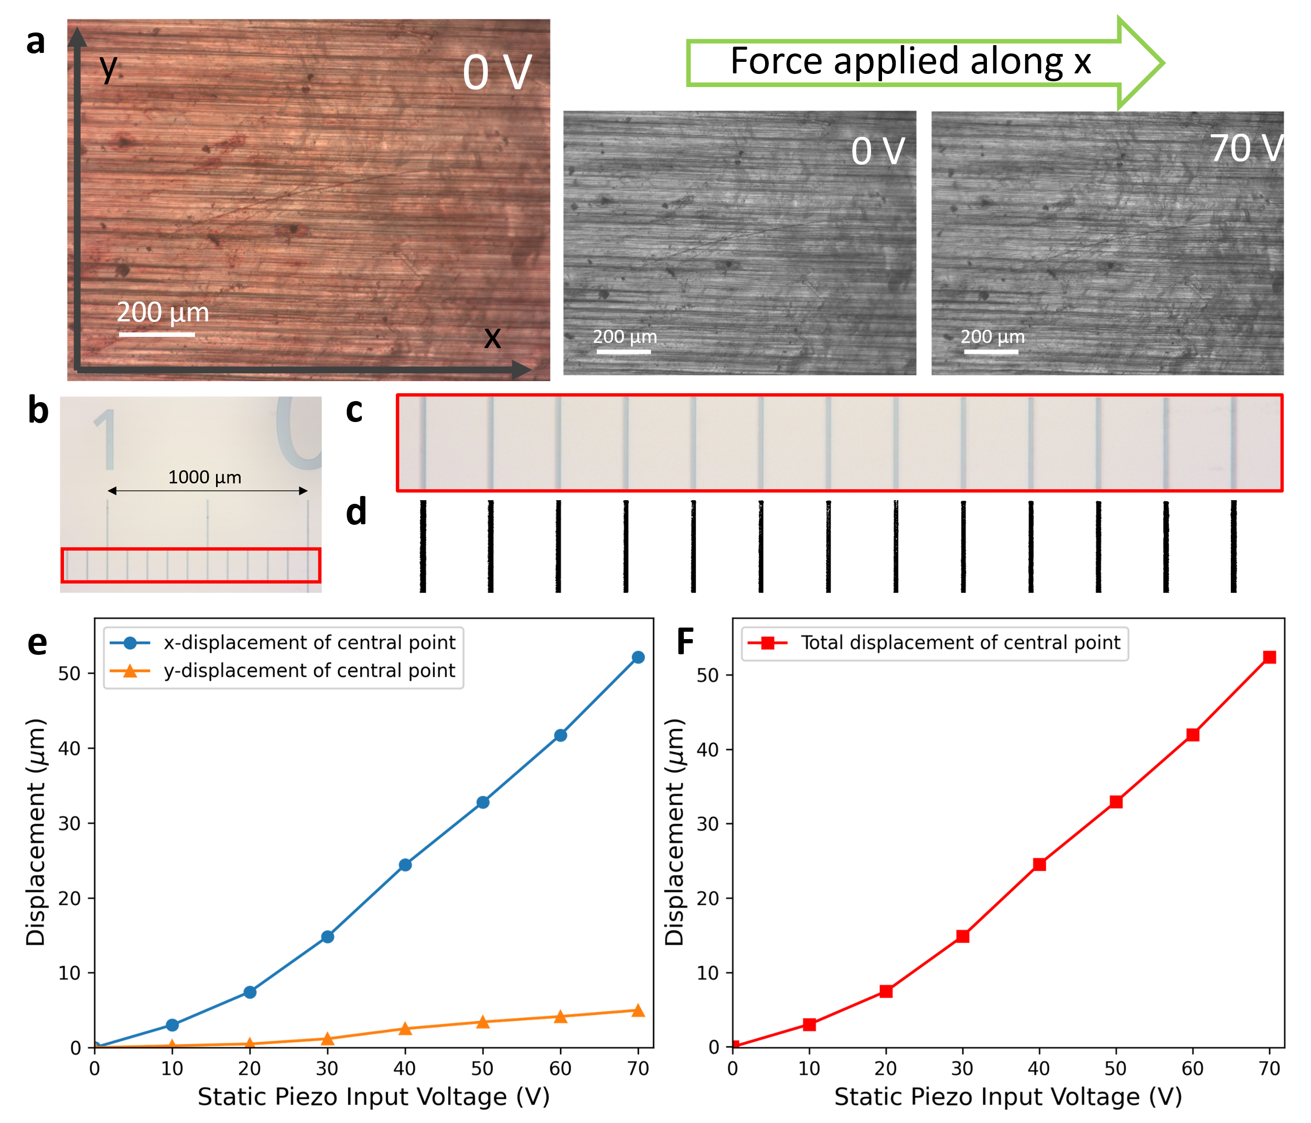

Supplementary Fig. 6: Optical microscopy digital image correlation (DIC) workflow. a, A sequence of pictures of a Cu electrode loaded in the stretch cell was taken at different piezo input voltage (PIV), transformed to greyscale, and rescaled according to a scale factor to reduce computation time (0.2). b, to calculate the displacement in µm from the pixel values, a calibration was performed as follows: a picture of a standard scale was taken with the same magnification as for the Cu electrodes, c, manually cropped to include only the scale ticks and d, transformed to black and white. The average distance between the black ticks was employed to calculate a pixel-to-µm conversion factor. e, Absolute displacement measured along x and y as a function of the static PIV, and f, the total displacement calculated as d= √(x²+y²).
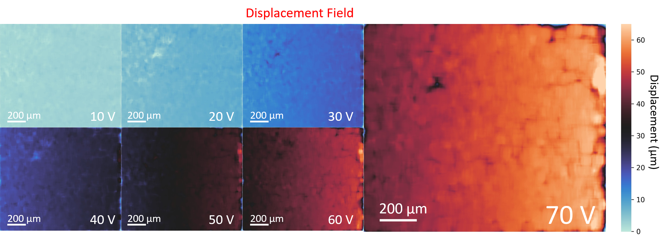

Supplementary Fig. 7: Displacement field map calculated at different piezo input voltage (PIV) for a Cu electrode loaded in the stretch cell, with static stress sequentially applied from 0 V up to 70 V PIV.
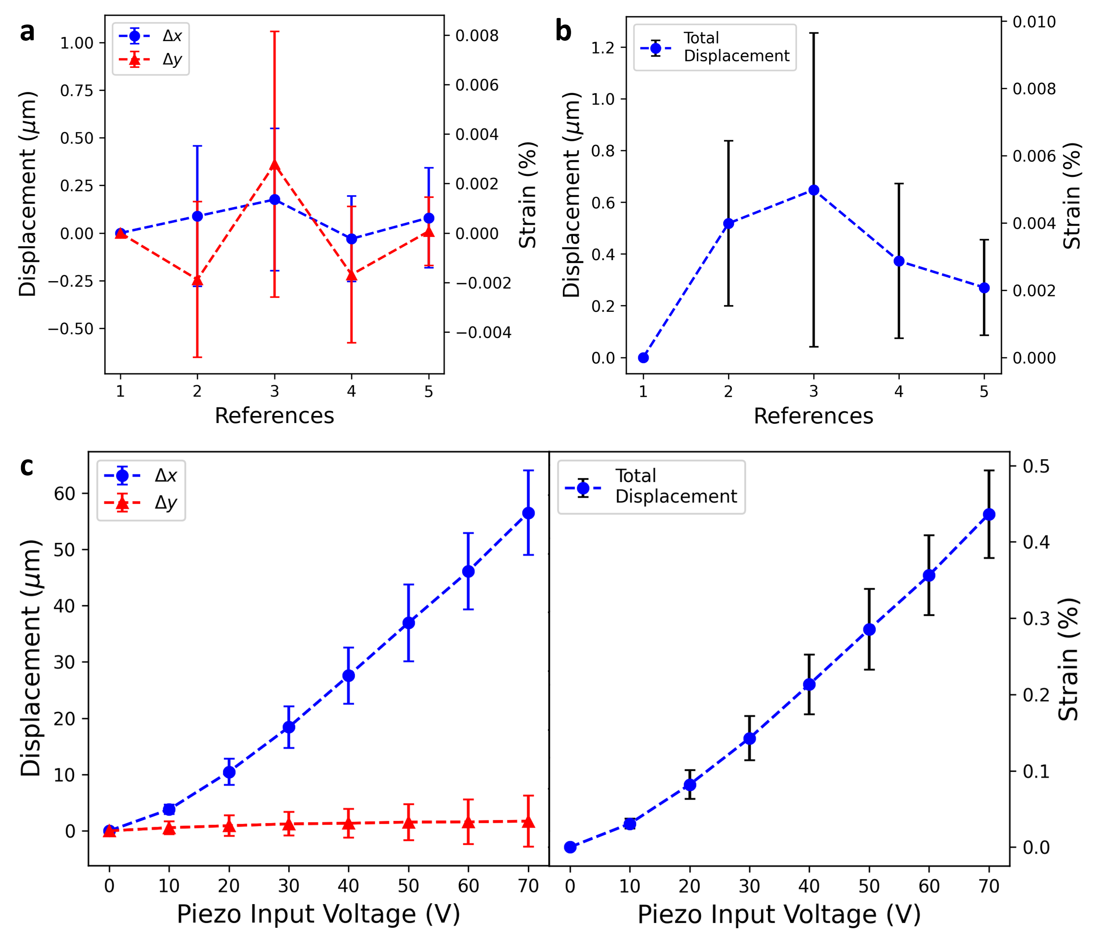

Supplementary Fig. 8: Optical microscopy digital image correlation (DIC) results, showing the absolute displacement measured along x and y as a function of the static PIV and the total displacement calculated as d= √(x²+y²) for: a and b, a sequence of five static reference pictures analyzed against the first image, to quantify the error on the measurement and analysis (<0.01 % strain); and c, d, six repeated DIC measurement on different Cu foils, showing the standard deviation on the strain values (±0.05 % strain).
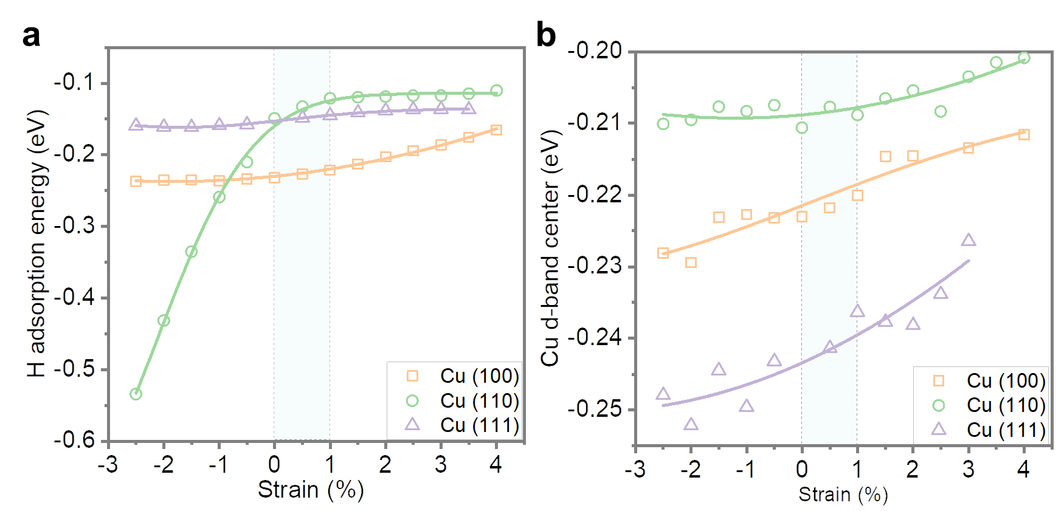

Supplementary Fig. 9: Hydrogen adsorption energy on various Cu surfaces and the d-band center position of Cu slabs as a function of the applied strain, obtained from Density Functional Theory (DFT) calculations. The light blue bar indicates the strain region experimentally probed in this study. On both the pristine and tensile-strained Cu (110) surfaces, hydrogen adsorbs in a two-fold coordinated configuration, bridging between two Cu atoms. Upon lattice compression, the adsorption mode transitions to a three-fold configuration, accompanied by local surface reconstruction and a substantial decrease in adsorption energy.

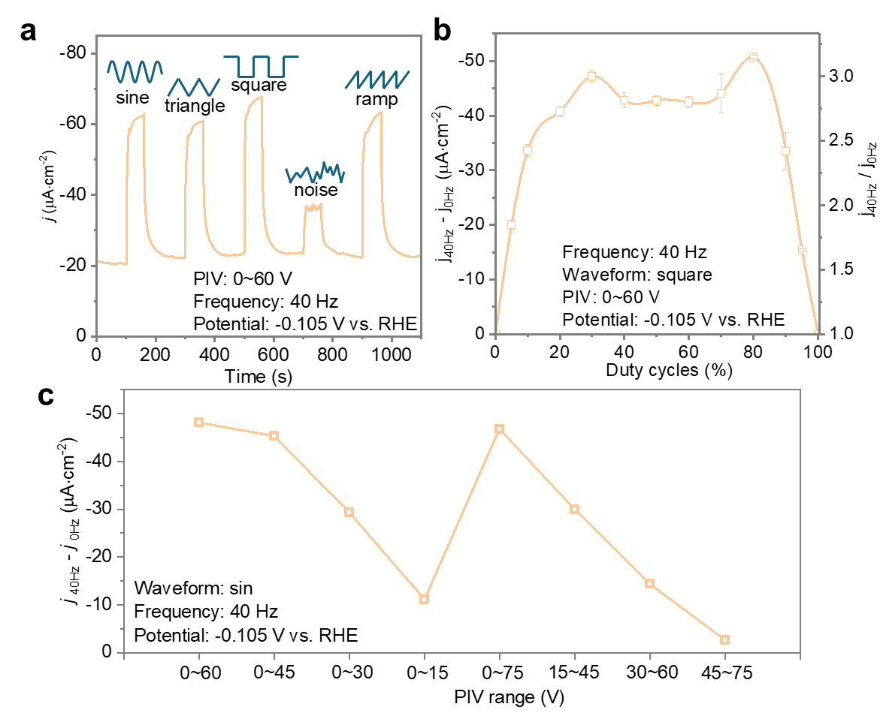

Supplementary Fig. 10: The effect of a, waveform b, duty cycle and c, piezo voltage input range on the current density of HER in a constant potential electrochemical test. The difference and ratio in current density between 40 Hz (j_{40Hz}) and 0 Hz (j_{0Hz}) is shown in B and C. In all cases, only a pulling force is applied. All foils are pre-stressed with a torque force of 5 cN x m, which corresponds to 18 N. When using 15~45 V, 30~60 V and 45~75 V, static stress is applied from the piezo, on top of the dynamic one. Applied frequency: 40 Hz, HER potential: - 0.105 V vs. RHE.

Supplementary Note 10: Under identical frequency and amplitude conditions, changes in waveform exhibit negligible impact on the dynamic stress effect. When the noise waveform was applied to the system, the resulting current response was lower than that observed under other waveforms.
The duty cycle refers to the proportion of time within one cycle of square-wave oscillation of the Cu foil during which the piezo actuator is active (PIV = 60 V). The increase in steady-state HER current density at 40 Hz relative to the static condition—expressed as the absolute increase (j_{40Hz} – j_{0Hz}) and the enhancement factor (j_{40Hz} / j_{0Hz})—was used as a descriptor to evaluate the influence of dynamic stress on the HER activity. The correlation between these descriptors and the duty cycle is illustrated in Supplementary Fig. 10b. Since the two descriptors exhibit nearly identical trends with respect to changes in the duty cycle, they are represented by a single curve. It can be observed that the enhancement of the HER activity with varying duty cycles is symmetric; that is, the HER performance at x% and (100–x)% duty cycles is comparable. In other words, the individual states of stretching and non-stretching exert similar influences on the HER, whereas the transition between these two states plays a critical role in determining the dynamic strain effect. Additionally, it can be observed that within the 20–80% duty cycle range, the enhancement in HER activity remains relatively constant. In contrast, in the 0–20% and 80–100% regions, the contribution of dynamic strain to HER activity gradually increases and decreases, respectively.
This behavior may be interpreted in two ways. A box function can be represented as a Fourier series, i.e. a sum of sine and cosine functions. For a dynamic stimulation with duty cycle close to 0 and 100 %, the relative contribution of the fundamental frequency with respect to higher harmonics decreases compared to the 50 % duty cycle case. If the sample is reacting mostly to the fundamental frequency component of the stimulation, this would explain the observed behavior.
To probe the influence of vibration amplitude on the dynamic stress effect, we systematically varied the input PIV range (Supplementary Fig. 10c). This input can be directly correlated with the range of strain variation, given that the 40 Hz oscillation lies outside the resonance band of the Cu foil (inferred from MES measurements). The contribution of dynamic stress to HER activity, quantified by the current enhancement (j_{40Hz} − j_{0Hz}), exhibits a positive correlation with the strain variation—or, equivalently, the vibration amplitude—regardless of the specific stress range from which the amplitude arises.

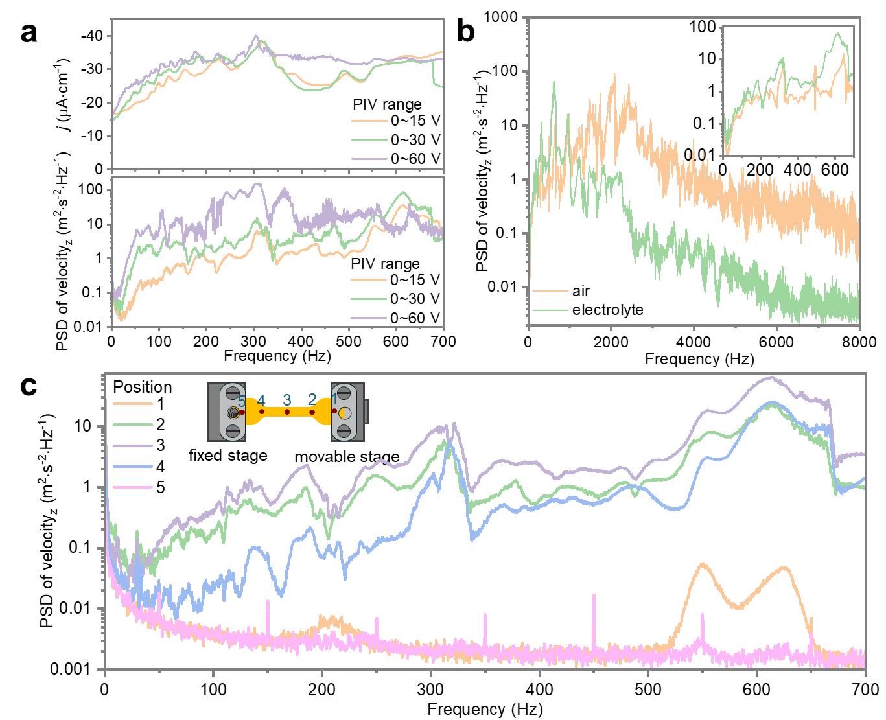

Supplementary Fig. 11: Operando laser Doppler vibrometry (LDV) results. a, Operando LDV results as power spectral density (PSD) of the velocity along z at the center of the Cu electrode (bottom), and the corresponding HER current densities (top) acquired under different ranges of piezo input voltages (PIV) for a Cu electrode loaded in the stretch cell. b, Vibrometry results for the Cu electrode collected in air and in the HER electrolyte, showing different PSD, with higher response frequencies for the Cu electrode in air. This showcases the need to perform the experiments in the electrochemical environment. The inset shows the spectral region between 0–700 Hz. c, to examine whether the forced oscillations are uniform across the foil, we collected vibrometry signals at multiple positions on the Cu foil and used the fixed and movable clamps at the two ends as references. Comparable PSD values were observed for points on the Cu electrode^{2–4}, while negligible velocity along z for the fixed and movable stage clamps^{1,5}.

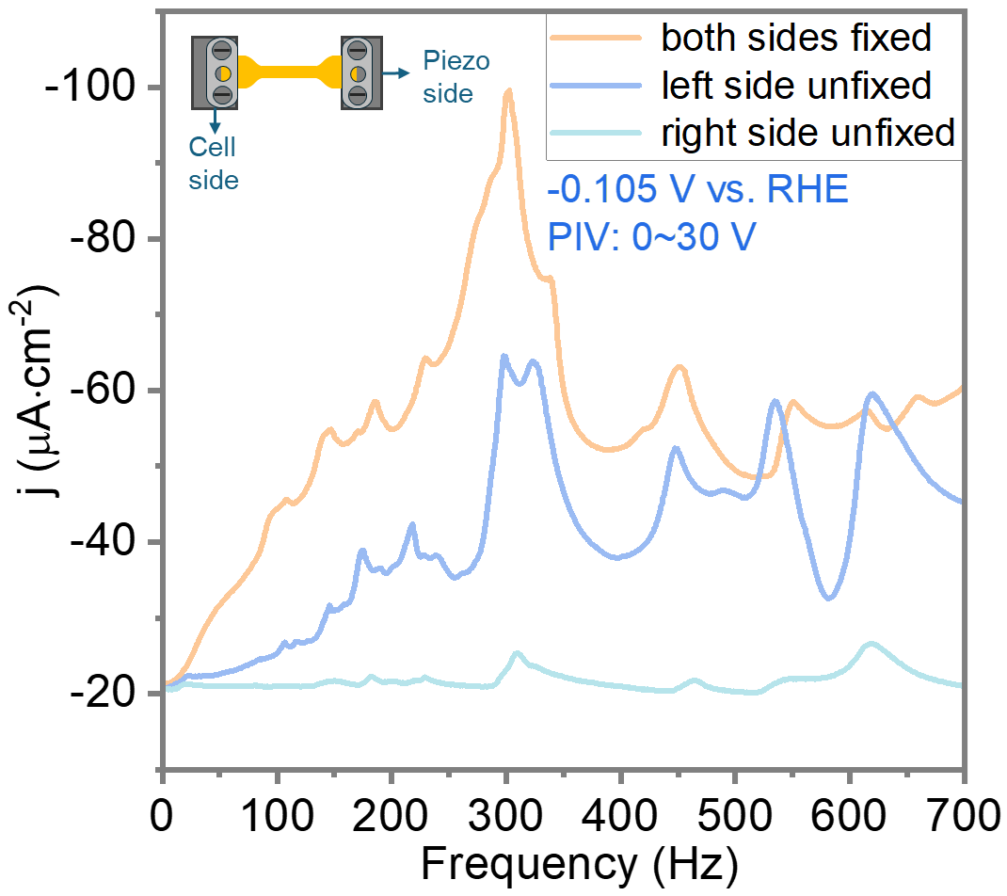

Supplementary Fig. 12: Mechano-Electrochemical Spectroscopy (MES) data obtained with both sides or one side of the polycrystalline Cu foil fixed. Potential: -0.105 V vs. RHE; Piezo input voltage: 0~30V. When the side connected to the piezo actuators was unfixed, the response in HER current density to vibrations was almost completely lost, except for some residual peaks in j_{HER} at frequencies corresponding to the frequencies of highest HER current enhancement when both sides of the Cu foil are fixed. When the side connected to the piezo actuator was fixed, but the side connected to the cell was let loose, the overall j_{HER} enhancement was lower than observed for the double-pinned Cu foil, but rather pronounced bands were still observed around 300, 450, 525 and 625 Hz. This indicates that the oscillatory movement of the electrode can itself cause an enhancement in j_{HER}, which is unexpected and still not understood. A possible explanation is that the electrode is deforming also in this case, due to friction with water (flow-induced flutter)^{1,2}. Further investigation into this phenomenon is needed.

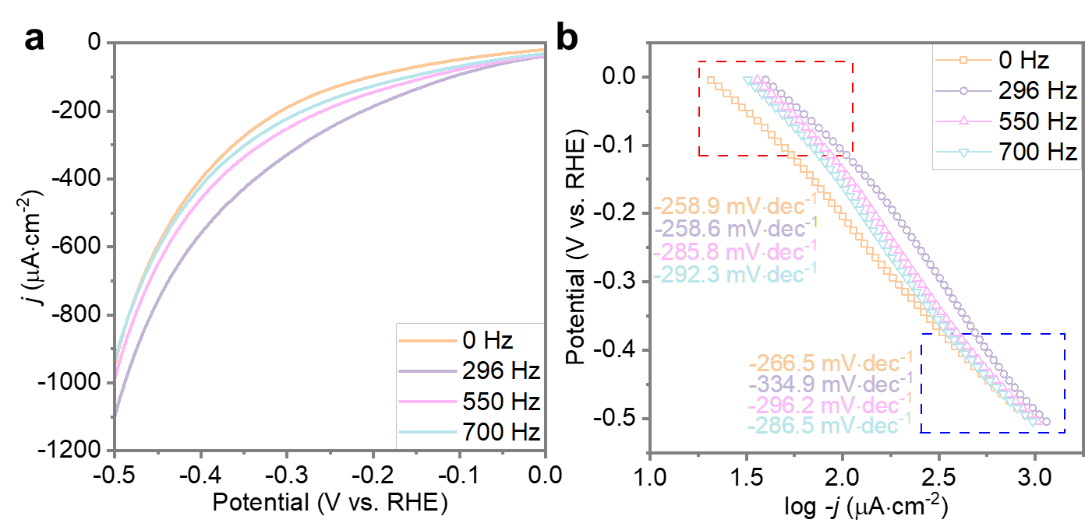

Supplementary Fig. 13: a, Linear Sweep Voltammetry (LSV) curves of polycrystalline Cu foil measured at different vibration frequencies (0 Hz, 296 Hz, 550 Hz, and 700 Hz) and b, the corresponding Tafel curves. Piezo input voltage: 0~30V.

Supplementary Note 13: Steady-state LSV curves were collected under static conditions and at vibration frequencies of 296 Hz, 550 Hz, and 700 Hz (Supplementary Fig. 13a), with the corresponding Tafel plots shown in Supplementary Fig. 13b. Tafel slopes were extracted in both the low (red dashed box) and high (blue dashed box) current density regions, reflecting the HER kinetics under surface-reaction-controlled and diffusion-influenced regimes, respectively. Across all frequencies and potentials, relatively high Tafel slopes were observed, indicating that the Volmer step significantly limits the overall reaction rate³. Notably, the application of vibration did not lead to substantial changes in Tafel slopes, but primarily affected the intercepts, indicating that in this case dynamic stress modulates the HER rate by influencing the exchange current density (j₀) rather than altering the energy barrier of the rate-determining step. In other words, the intrinsic activity of the electrode toward electrocatalytic HER is significantly enhanced by the application of dynamic stress⁴. We note that, in principle, Tafel analysis should be conducted under steady-state conditions to get accurate values of the slopes, due to capacitive effects^{5,6}. However, since the capacitive current density during our LSV measurements (5 mV/s) was below 0.229 μA cm⁻², we expect such effects to be negligible in our case.

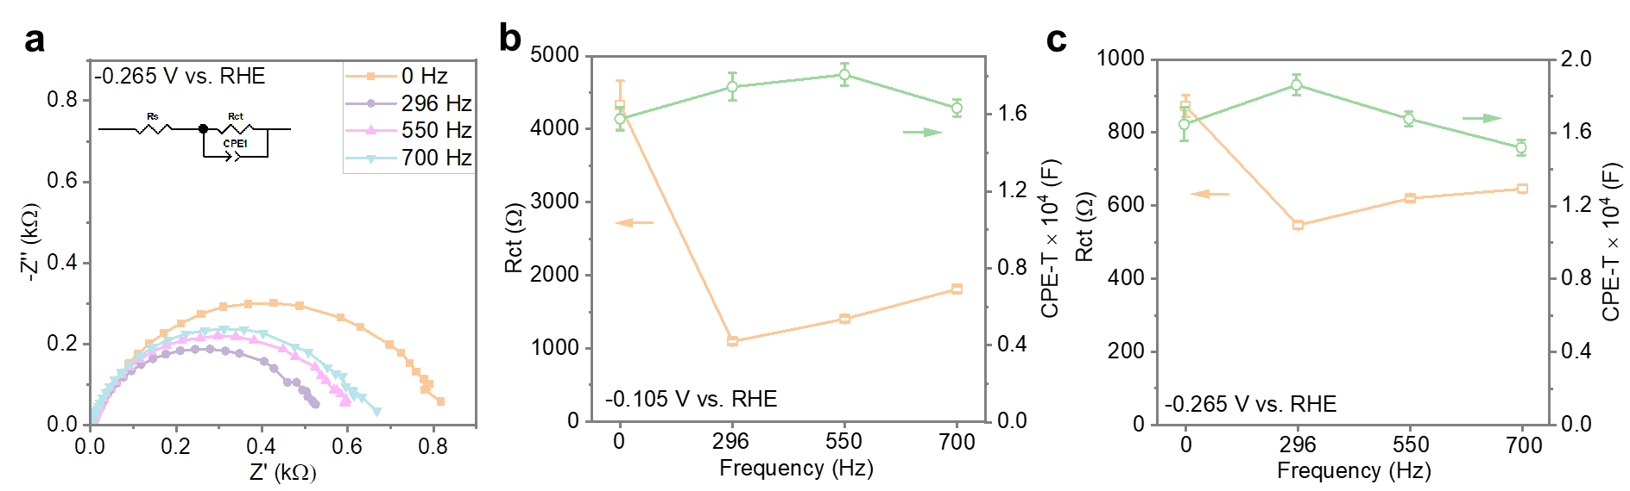

Supplementary Fig. 14: a, Electrochemical impedance spectra (EIS) of polycrystalline Cu foil obtained at different applied vibration frequencies. Potential: -0.265 V vs. RHE. Piezo input voltage: 0~30V. Plots of Charge Transfer Resistance (Rct) and Constant Phase Element – T parameter (CPE-T) as a function of frequency, obtained from fitting the EIS results measured at –0.105 V (b) and –0.265 V vs. RHE (c), respectively. PIV = 0~30 V. Waveform: sine.

Supplementary Note 14: Electrochemical impedance spectroscopy (EIS) measurements were also conducted at a potential of -0.265 V vs. RHE under static conditions and at vibration frequencies of 296 Hz, 550 Hz, and 700 Hz, as shown in Supplementary Fig. 14a. Consistent with Fig. 1e in the main text, the Nyquist plots indicate that the reaction rate at this potential is governed by charge-transfer kinetics. Accordingly, the equivalent circuit model shown in the inset of Supplementary Fig. 14a was employed to fit the EIS data⁷. The extracted charge-transfer resistance (R_{ct}) and the Constant Phase Element – T parameter (CPE-T) are presented in Supplementary Fig. 14b and Supplementary Fig. 14c, respectively. The series resistance (R_{s}), which reflects the intrinsic resistance of the polycrystalline Cu electrode, is not shown, as it has minimal influence on HER kinetics and remains nearly unchanged across the different vibration frequencies⁸.
MechanoElectrochemical Spectra (MES) results revealed that HER activity follows the order: 296 Hz > 550 Hz > 700 Hz > 0 Hz. This trend is inversely correlated with the R_{ct} values extracted from EIS fitting at both applied potentials. These findings indicate that the enhancement in HER rate under dynamic stress arises from the promotion of the charge-transfer step, which is rate-determining under the studied conditions⁸. Notably, higher input energy (e.g., at 700 Hz) does not necessarily yield greater HER enhancement.
The R_{ct} values at −0.265 V vs. RHE are lower than those at −0.105 V vs. RHE, consistent with the greater driving force for charge transfer at more negative potentials. When comparing R_{ct} across different vibration frequencies, the variation is more pronounced at the lower potential, suggesting that dynamic stress exerts a stronger influence under these conditions. At higher overpotentials, when the driving force for electron transfer is stronger, the effect of dynamic stress is less substantial³. As a result, the catalytic enhancement from dynamic stress diminishes at higher potentials, as shown in Fig. 2f of the main text.
The CPE-T values, which serve as a proxy for the double-layer capacitance, remain relatively constant across all vibration frequencies at both tested potentials. These values show no clear correlation with either the frequency of dynamic stress or the corresponding HER activity. This suggests that dynamic stress has a negligible effect on the structure or properties of the electrical double layer.
In term of the question whether the current enhancement induced by Cu vibration is a result of perturbation and recharging of the electrical double layer: ECSA measurements show that varying the vibration frequency has a negligible effect on the double-layer capacitance, which remains consistently low. This suggests that the structure of the electrical double layer is largely unaffected by the subtle vibrations of the Cu foil.

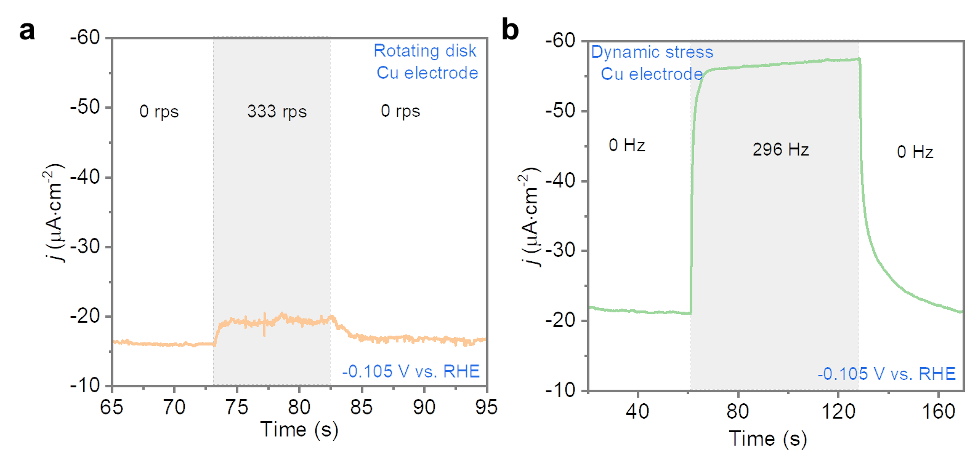

Supplementary Fig. 15: The time-dependent electrocatalytic HER current density at a constant potential of -0.105 V vs. RHE, during the on/off cycling of a 330 rps of a rotating Cu electrode (a) and a 296 Hz dynamic stress on Cu foil electrode (b). Although the rotating disk electrode setup also enhances HER activity, its effect remains significantly lower than that induced by dynamic stress under comparable operating conditions. This indicates that mass transfer is not the rate determining step under the conditions used in this study.

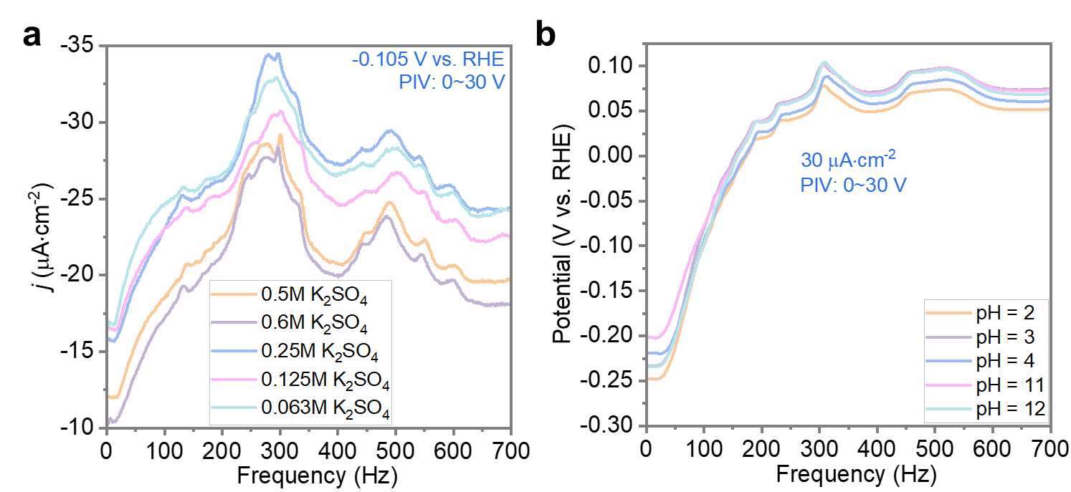

Supplementary Fig. 16: Mechano-Electrochemical Spectroscopy (MES) data as a function of a, K₂SO₄ concentration and b, pH, obtained under CA and CP conditions, respectively.

Supplementary Note 16: To explore the influence of the electric double layer (EDL) structure on MES data, the concentration of K₂SO₄ in the electrolyte was varied from 0.063 M to 0.6 M. It is important to note that even at the lowest concentration (0.063 M), the electrolyte resistance remained insufficient to limit HER activity (Supplementary Fig. 16a). Increasing the K₂SO₄ concentration compresses the EDL structure, thereby increasing the diffusion resistance for proton reduction. Accordingly, under static conditions (0 Hz), the HER current densities measured in 0.5 M and 0.6 M K₂SO₄ were lower than those in more dilute solutions. However, in the corresponding MES data, both the position and intensity of the bands remained nearly unchanged across all electrolyte concentrations. These results indicate that the enhancement of electrocatalytic performance by dynamic stress is independent of EDL structure and proton diffusion resistance.
To probe the influence of electrolyte pH on the dynamic stress effect, MES measurements were carried out at a current density of 30 μA•cm⁻² (Supplementary Fig. 16b). Variation in electrolyte pH alters the elementary steps of the HER. At low current densities or turnover frequencies, the Volmer step—proton or water reduction in acidic or alkaline media, respectively—is generally regarded as the rate-determining³. Notably, MES spectra obtained under different pH conditions showed a high degree of overlap, indicating that the dynamic stress effect is largely insensitive to the specific nature of the surface elementary step. Alternatively, it suggests that even under acidic conditions (pH = 2), water reduction may still play a significant role in the kinetics on Cu surfaces under these conditions.

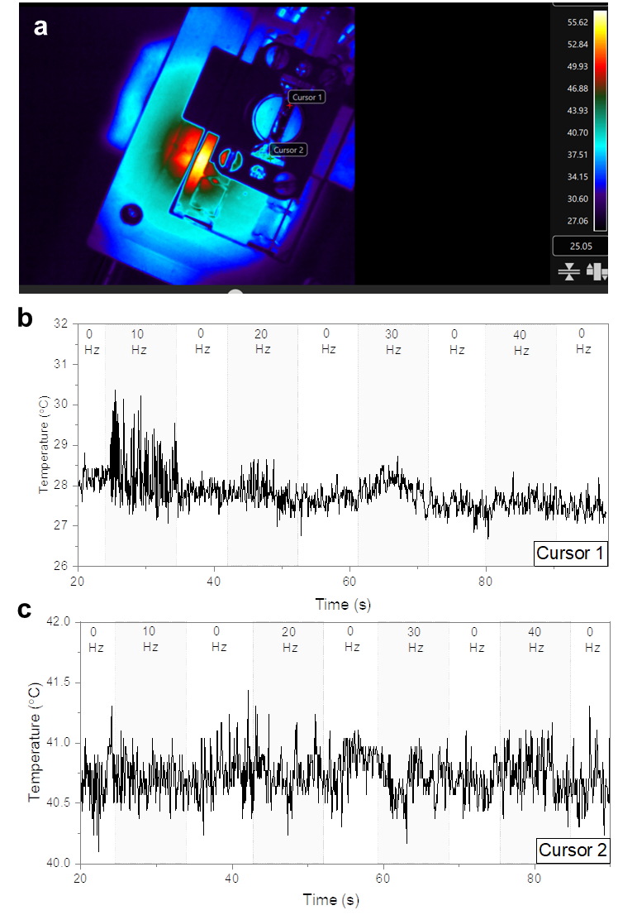

Supplementary Fig. 17: a, Infrared thermal image of the static dynamic-stress cell. Apparent temperature evolution at cursor 1 (b) and cursor 2 (c) as a function of time under varying vibration frequencies. Waveform: sine; PIV: 0~60 V. The apparent temperature differences in (a) arise from reflection of infrared signals by the cell surface, rather than actual temperature variations.

Supplementary Note 17: On a polished copper surface, it is usually hard to tell differences in temperature due to the very low emissivity (0.003)⁹. Nonetheless, due to the high thermal sensitivity of the infrared imaging system employed (with a resolution of up to 30 mK), temperature mapping of the Cu foil achieves a resolution of approximately 0.5–1 °C. Minor temperature changes below this threshold are considered negligible in terms of their impact on HER activity¹⁰.
Due to the use of an active infrared thermal imaging system, the close proximity of the lens to the sample, and the ambient room-temperature conditions, halo-like reflections from the cell surface were detected. However, these reflections do not correspond to actual temperature differences across the cell components. Two points on the Cu foil were selected for temperature monitoring over time—one at the center of the dog-bone-shaped foil and the other near the clamped edge. The difference in the measured infrared intensities can in principle arise from variations in reflectivity and from differences in surface temperature. Upon activation of vibrations at different frequencies (PIV: 0~60 V, sine waveform), both locations maintained constant apparent temperatures, independent of both frequency and duration. Some oscillations were observed at cursor 1, but in view of their fast dynamics, we attribute these to angle-dependent reflection changes of the vibrating Cu foil rather than thermal fluctuations. Under these same conditions, significant enhancements in HER activity were observed, indicating that the dynamic stress effect is not thermally driven. In actual electrochemical operating environments, heat dissipation through the electrolyte would further stabilize the Cu foil temperature. Direct temperature measurements of the electrolyte using a thermocouple confirmed that the solution temperature remained constant during experiments. These findings, together with the stable current densities observed under steady-state vibration, demonstrate that the dynamic stress effect is not driven by temperature.

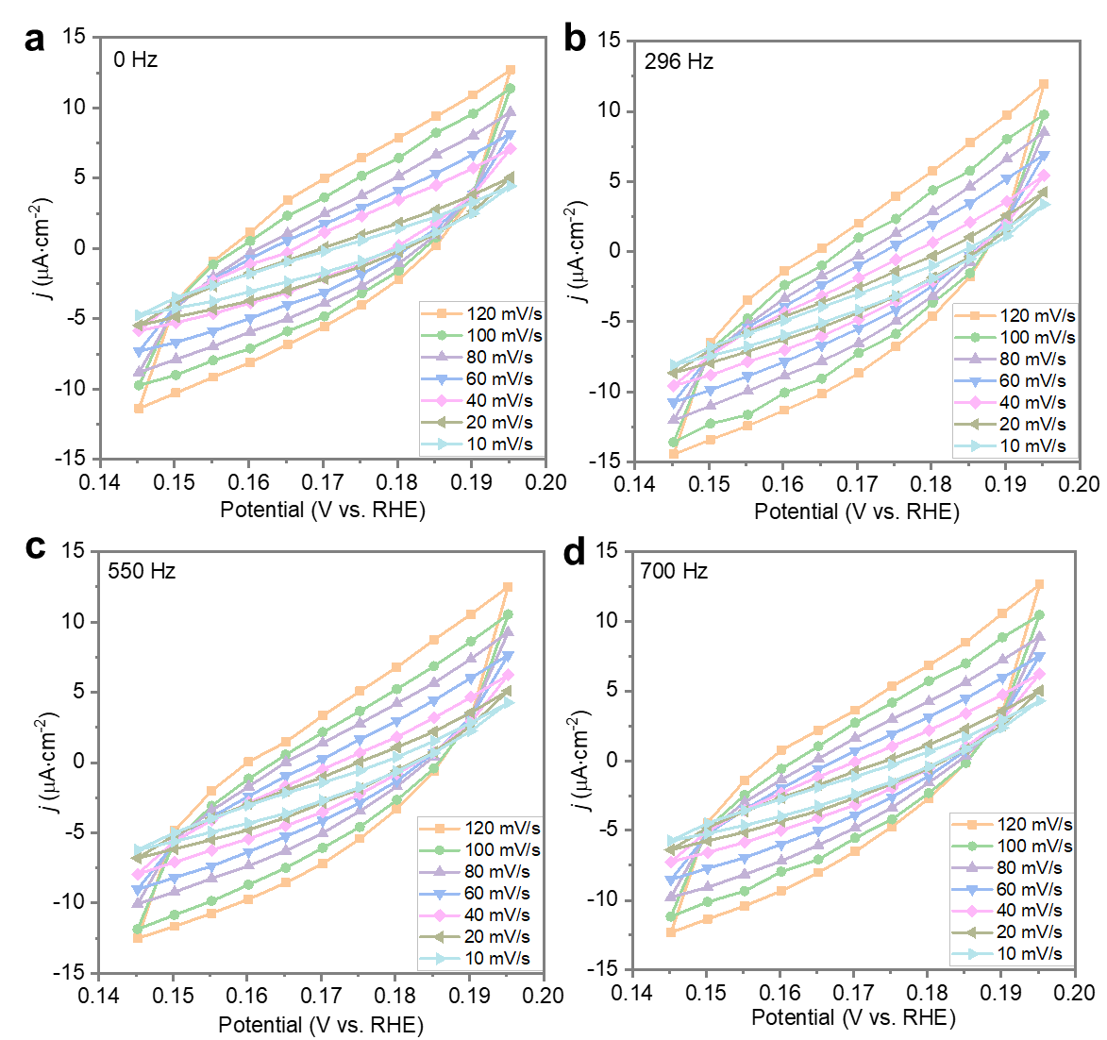

Supplementary Fig. 18: Electrochemical active surface area (ECSA) tests on a polycrystalline Cu foil under (a) static conditions and (b-d) vibrating at a frequency of b, 296, c, 550, and d, 700 Hz. PIV range: 0~30 V. Within the selected potential window, the measured current originates from the charging and discharging of the electrical double layer. In the cyclic voltammetry scans, the non-faradaic current density would exhibit a linear relationship with the scan rate, and the slope corresponds to the double-layer capacitance (C_{dl}). The fitting is shown in Supplementary Fig. 19.

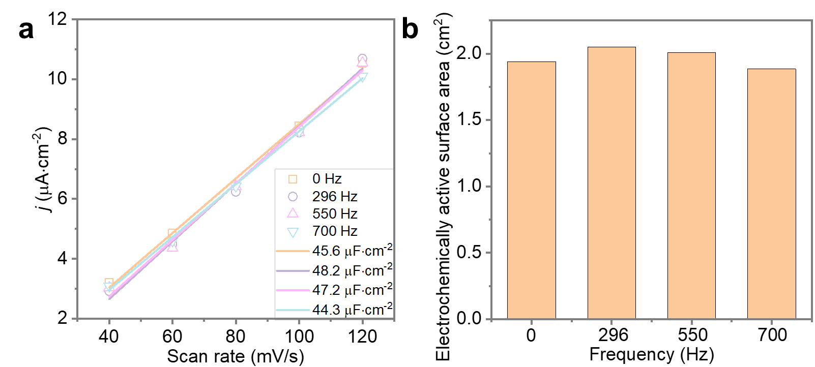

Supplementary Fig. 19: a, Charging current density differences at different scan rates, measured at different Cu vibration frequencies (0 Hz, 296 Hz, 550 Hz, and 700 Hz). (b)

Supplementary Note 19: Charging current density differences obtained from ECSA measurements were fitted to extract the double-layer capacitance (C_{dl}) under various vibration frequencies (0 Hz, 296 Hz, 550 Hz, and 700 Hz). The data points showed strong overlap across all conditions, and the extracted C_{dl} values remained nearly constant, regardless of vibration frequency. The ECSA was obtained by the following equation (1):
$ECSA= \frac{S\left({cm}^{2}\right)×C_{dl}(μF∙{cm}^{-2})}{C_{s, Cu}(μF∙{cm}^{-2})}$ (1)
Where S represents the geometric surface area of Cu foil, which is 1.234 cm⁻² in our cases. C_{s,Cu} is the specific capacitance for the smooth polycrystalline and a value of 29 μF/cm⁻² was used in our case according to previous studies. Across different frequencies, both the C_{dl} and the ECSA showed minimal variation, supporting the conclusion that dynamic stress does not alter electrochemical activity by modifying the properties of the electrical double layer.

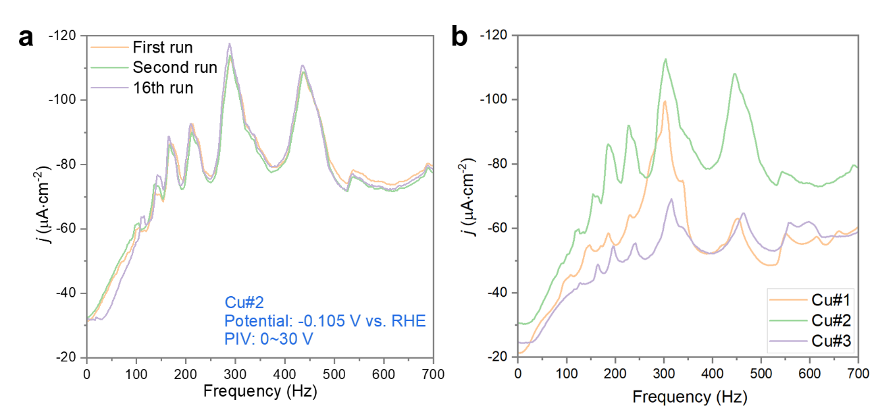

Supplementary Fig. 20: Mechano-Electrochemical Spectroscopy (MES) data collected from a, one Cu foil over multiple measurement cycles and b, three Cu electrodes of identical dog-bone shape, cut from the same Cu foil.

Supplementary Note 20: The reproducibility and repeatability of MES on Cu foils was systematically investigated. When testing the same Cu foil for multiple times, the MES results showed negligible changes (Supplementary Fig. 20a). These results showcase the high reproducibility of MES measurement for a given electrode once cut and mounted in the cell. To check the repeatability of the experiments, we tested three dog-bone shaped Cu electrodes with identical dimensions and cut from the same Cu foil (Supplementary Fig. 20b). The positions of the MES peaks remained nearly unchanged, although changes in relative intensities and peak shapes were observed. The reason for these differences is unclear, but it indicates a strong sensitivity of MES bands to sample geometry and/or crystallinity. Some hypotheses for the observed differences are: (i) electrode edge structure effects: during laser cutting, oxide layers formed at the foil edges, which were electro-reduced to metallic Cu prior to reaction. This may introduce changes in the geometry of the Cu foil edge, which in turn could be affected differently by dynamic stress; (ii) difference in Cu foil microstructure and crystallinity: the Cu foils were obtained by Sigma Aldrich, and are highly anisotropic in crystal structure. The crystal grains are preferentially oriented along the Cu(100) dimension, and irregular in size (240±263 μm long, 5–50 μm wide)¹¹. Depending on the cut, the crystalline domain may vary in dimension and orientation with respect to the applied uniaxial force. We hypothesize that such subtle differences may lead to variations in the MES across different Cu foils.

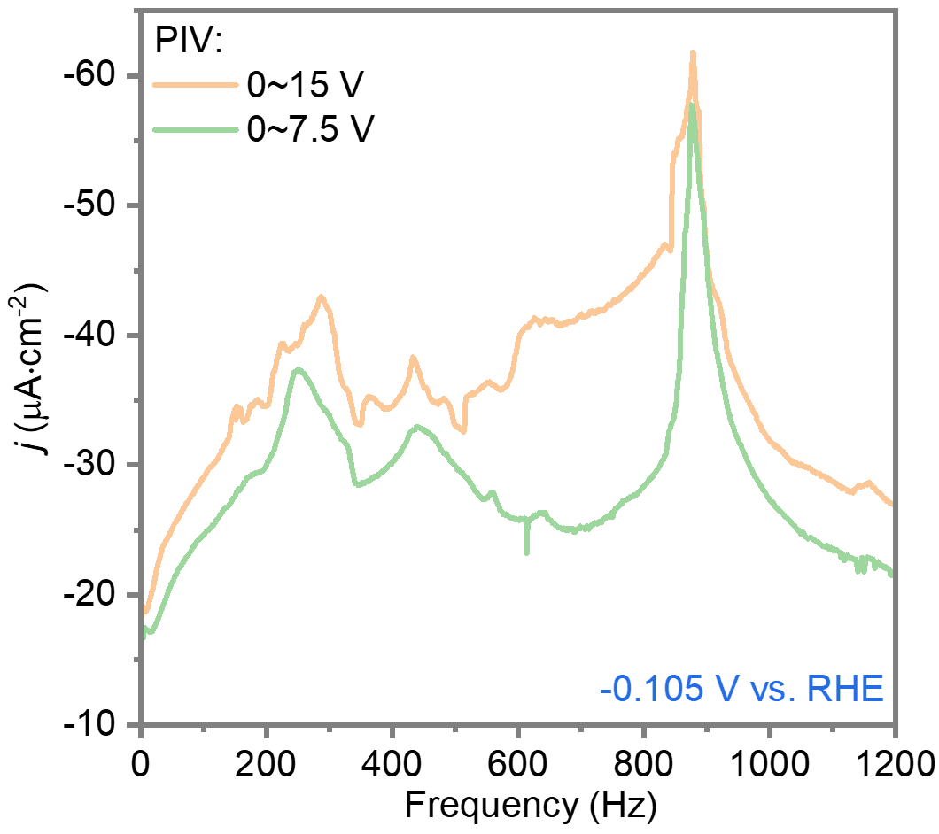

Supplementary Fig. 21: HER current density as a function of the applied vibration frequency from 1 Hz to 1200 Hz, at a sweep rate of 12 Hz/s, obtained with different piezo input voltages, which we dub Mechano-Electrochemical Spectroscopy (MES). The peak in HER current density observed around 900 Hz corresponds to the resonance frequency of the piezoelectric actuator at the relatively low loads used in this study. Since working at resonance can cause failure of the piezo, the frequency range was restricted to 0–700 Hz in our experiments.

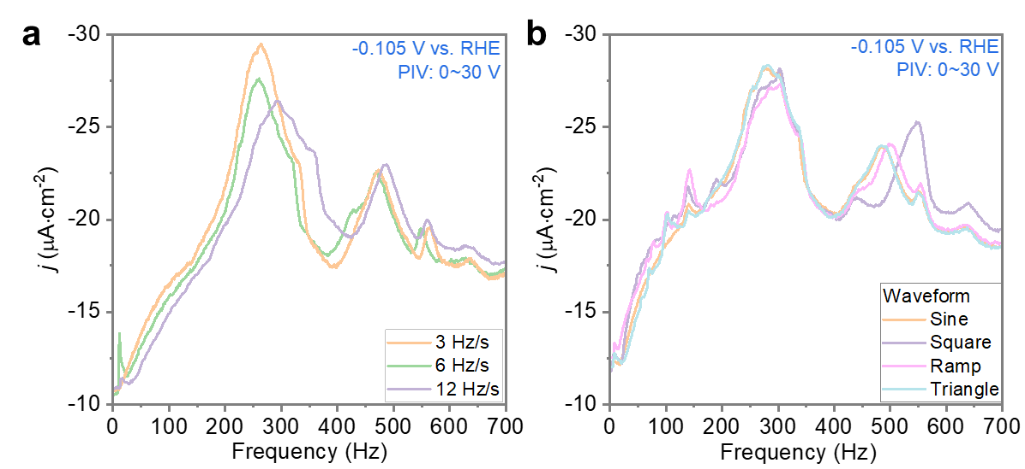

Supplementary Fig. 22: Mechano-Electrochemical Spectroscopy (MES) data obtained with a, different frequency sweep rates, and b, different waveforms.

Supplementary Note 22. The effects of frequency sweep rate and waveform on the MES data were investigated. Increasing the sweep rate was found to reduce the intensity of individual MES bands and, in some cases, to shift the band positions toward higher frequencies. While MES captures the frequency-dependent contribution of dynamic stress to HER activity, as shown in Figure. 2d in the main text, the dynamic enhancement effect exhibits a temporal delay to reach the peak response. A sweep rate of 12 Hz•s⁻¹ was adopted for all MES measurements reported in this study. However, more detailed studied on the effect of sweep rate could yield insights into the mechanism of enhancement of HER current by dynamic stress.
The waveform of the applied dynamic stress also influences the MES data. For sine and triangular waveforms, which feature relatively smooth variations in amplitude, the resulting MES data are nearly identical. In contrast, the ramp waveform—characterized by a sharp stress drop within each cycle—leads to enhanced band intensities in the low-frequency region (below 200 Hz). The square waveform, which induces abrupt stress changes over very short durations, not only reproduces the low-frequency features seen with the ramp waveform but also introduces distinct spectral alterations at higher frequencies (450–600 Hz). Specifically, the disappearance of the band at 470 Hz and the enhancement at 570 Hz resemble the spectral features observed under high-amplitude conditions shown in Fig. 2a of the main text. These findings suggest that in the high-frequency regime, the abruptness of stress transitions plays a significant role in modulating the intensity and position of MES bands.

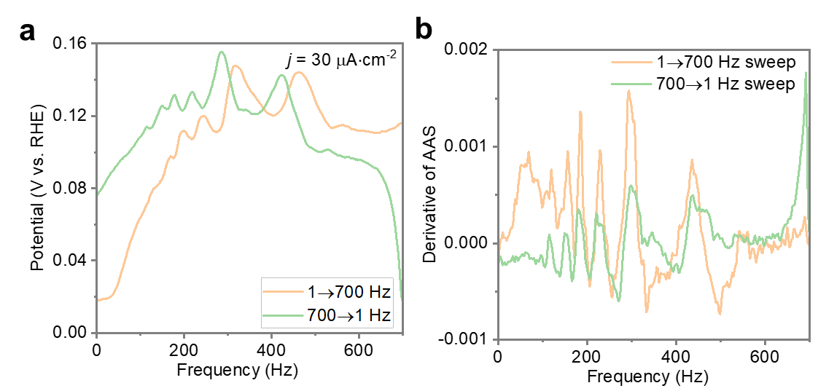

Supplementary Fig. 23: a, Mechano-Electrochemical Spectroscopy (MES) data obtained from forward and reverse frequency sweeps, along with b, their first-order derivatives with respect to frequency. Piezo input voltage: 0~30 V. Waveform: sine.

Supplementary Note 23: MES measurements were conducted on a Cu foil at a constant current density of 30 µA•cm⁻², using both ascending (1 → 700 Hz) and descending (700 → 1 Hz) frequency sweep directions. Under these testing conditions, a positive overpotential was observed upon application of dynamic stress to the Cu foil, but the magnitude of this overpotential remained below the open-circuit potential of the Cu electrode (about 0.20 V vs. RHE). Band shifts in the MES spectra were observed between the ascending and descending frequency sweep directions, although the overall band intensities remained comparable. To better resolve subtle frequency-dependent features, the MES data were differentiated, as shown in Supplementary Fig. 23b. Notably, the peaks and valleys in the derivative spectra appeared at nearly identical frequencies for both sweep directions, indicating that the underlying frequency response of the system is largely independent of the sweep direction. The emergence of a band is characterized by the most rapid increase in HER activity; however, the observed bands in MES typically appears with a temporal delay. These, therefore, reflect the system’s delayed response rather than the actual onset of resonance. In contrast, the first derivative of the spectra captures the true frequency at which resonance occurs. As a result, a slight offset is observed between ascending and descending frequency sweeps in the raw MES data, while the band positions in the derivative spectra remain consistent. Notably, during the descending sweep (700 → 1 Hz), a marked increase in HER activity is observed at the onset of vibration, highlighting the immediate stimulatory effect of dynamic stress on the reaction.

Supplementary Fig. 24: Mechano-Electrochemical Spectroscopy (MES) data obtained for the electrocatalytic hydrogen evolution reaction (HER, -0.105 V vs. RHE, orange line) and oxygen evolution reaction (OER, 0.365 V vs. RHE, green line).

Supplementary Note 24: To further investigate the role of surface reaction type on the MES response, we varied the applied potential to compare the frequency-dependent dynamic stress effects during HER at −0.105 V vs. RHE and OER at 0.365 V vs. RHE. As shown in Supplementary Fig. 24, the positions of the MES bands remained unchanged, demonstrating once again that the band positions are characteristic of the bulk electrode material and are independent of the specific surface reaction.

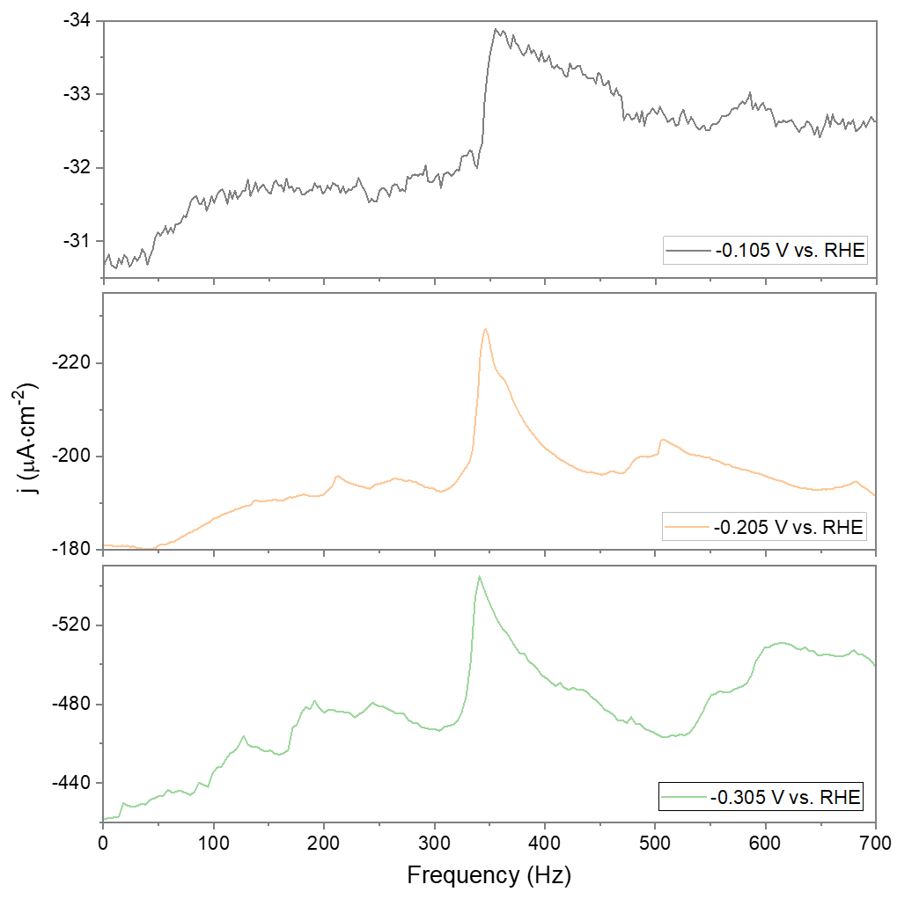

Supplementary Fig. 25: Mechano-Electrochemical Spectroscopy (MES) data of Ni foil recorded at different potentials. At –0.105 V vs. RHE, Ni foil exhibits higher HER activity than Cu foil under static conditions, but responds much less sensitively to dynamic stress, resulting in a MES with limited resolution. To obtain higher-resolution MES for Ni, additional measurements were performed at more negative potentials, namely –0.205 V and –0.305 V vs. RHE. The MES acquired at –0.305 V vs. RHE, which shows improved resolution, is used in the main text for comparison with those of Cu foil, Pt foil and Ir/Nafion.

Supplementary Fig. 26: The time-dependent current density at various constant potentials during the on/off cycling of 296 Hz vibration. Applied piezo input volage range: 0~30 V. Under testing conditions similar to those used for Cu, a smooth polycrystalline Pt foil exhibited more than a tenfold enhancement in HER activity when subjected to 296 Hz dynamic stress—far exceeding the response observed for Cu. This highlights the significant potential of Pt materials for dynamic electrocatalysis.

Supplementary Fig. 27: MES of Ir/Nafion recorded at different potentials. At +1.135 V and –0.305 V vs. RHE, the reactions occurring on Ir/Nafion surface are assigned to OER and HER, respectively. Notably, the current densities associated with both reactions showed no measurable response to dynamic stress (note the narrow y axis scale).

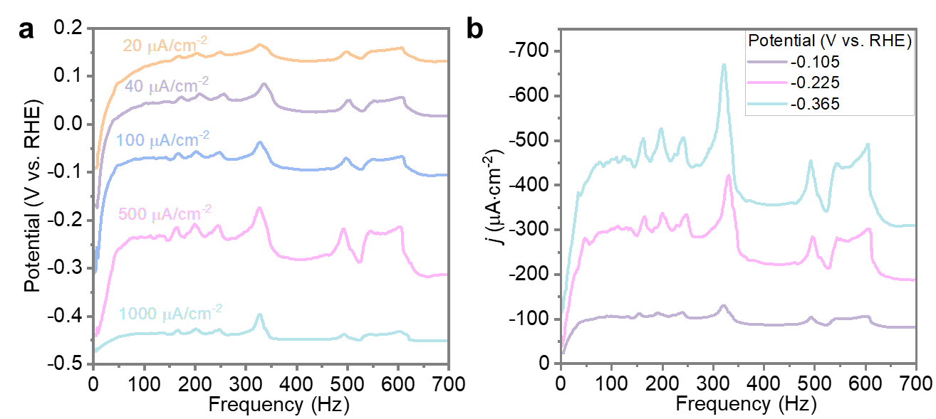

Supplementary Fig. 28: Mechano-Electrochemical Spectroscopy (MES) data of two overlapped Cu foils obtained during a, chronoamperometry (CA) and b, chronopotentiometry (CP) measurements. Piezo input voltage: 0~30V. Waveform: sine.

Supplementary Note 28: The MES measurements conducted on two overlapped Cu foils revealed consistent trends across different current densities and applied potentials, in agreement with the results presented in the main text. Significant enhancement in HER activity was observed at relatively low frequencies. This effect is tentatively attributed to mechanical interactions between the two foils.
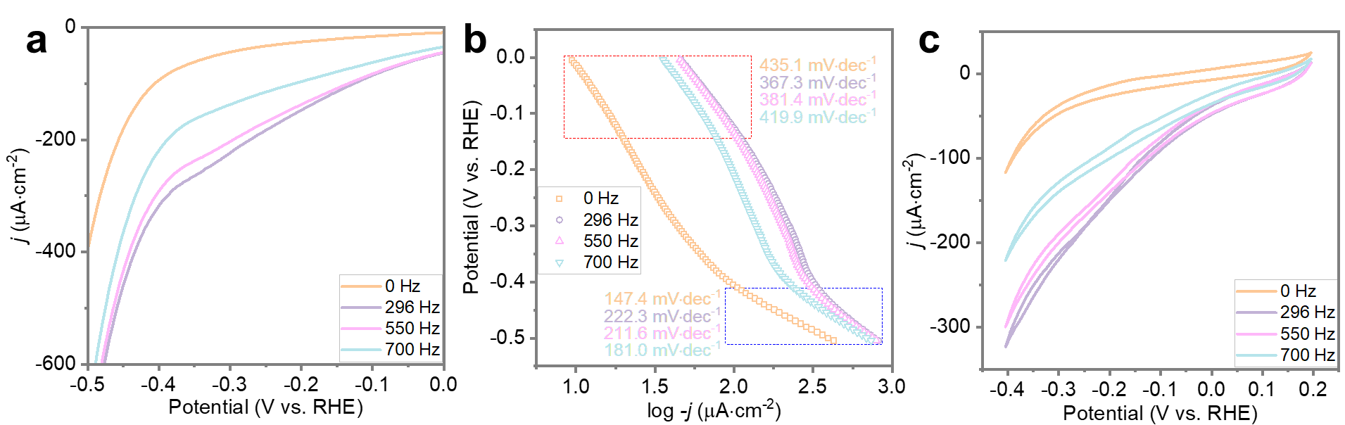

Supplementary Fig. 29: a, Linear Sweep Voltammetry (LSV) curves of two overlapped Cu foils measured at different vibration frequencies (0 Hz, 296 Hz, 550 Hz, and 700 Hz) and b, the corresponding Tafel curves. c, CV curves of two overlapped Cu foils measured at different vibration frequencies (0 Hz, 296 Hz, 550 Hz, and 700 Hz). Piezo input voltage: 0~30V.

Supplementary Note 29: Compared to a single Cu foil, dynamic stress exerted a more pronounced enhancement on the HER activity of overlapped Cu foils. This amplified effect appears to arise primarily from a further increase in the Tafel plot intercept, rather than a significant change in the slope, suggesting an elevated exchange current density without altering the fundamental apparent activation energy.

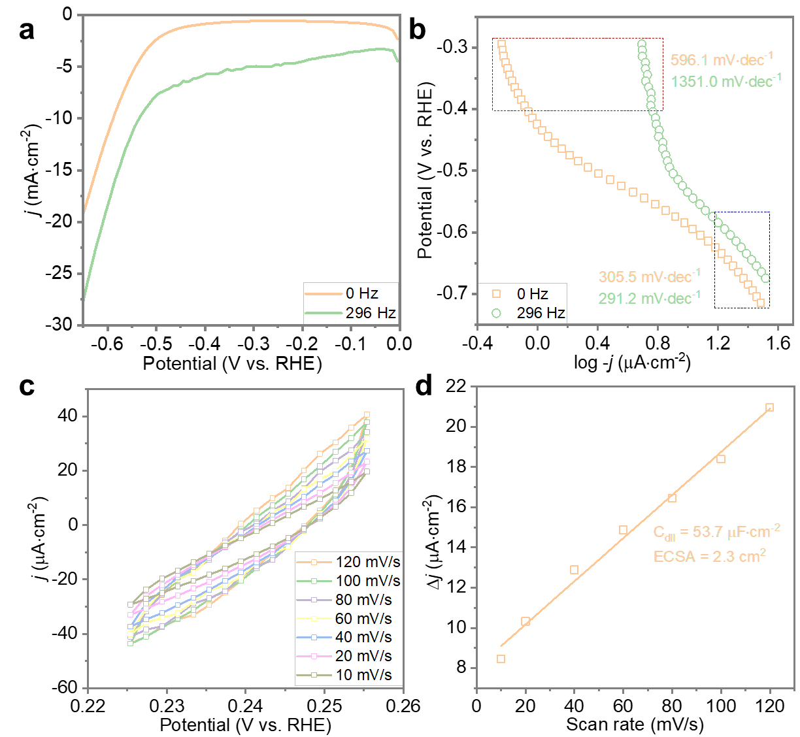

Supplementary Fig. 30: a, Linear Scanning Voltammetry (LSV) curves of an anodized Cu foil measured under static state and at the vibration frequency of 296 Hz, and b, the corresponding Tafel curves. c, Electrochemically active surface area (ECSA) tests and corresponding d, charging current density differences at different scan rates, obtained under the static conditions. As expected, the electrochemical surface area increased by 21% after anodization treatment. However, the increase in ECSA alone is insufficient to account for the markedly enhanced dynamic stress response observed after anodization. The anodization treatment was performed by applying one cycle of alternating potentials at 1.0 V vs RHE and -1.0 V vs RHE, holding each potential for 32 seconds.

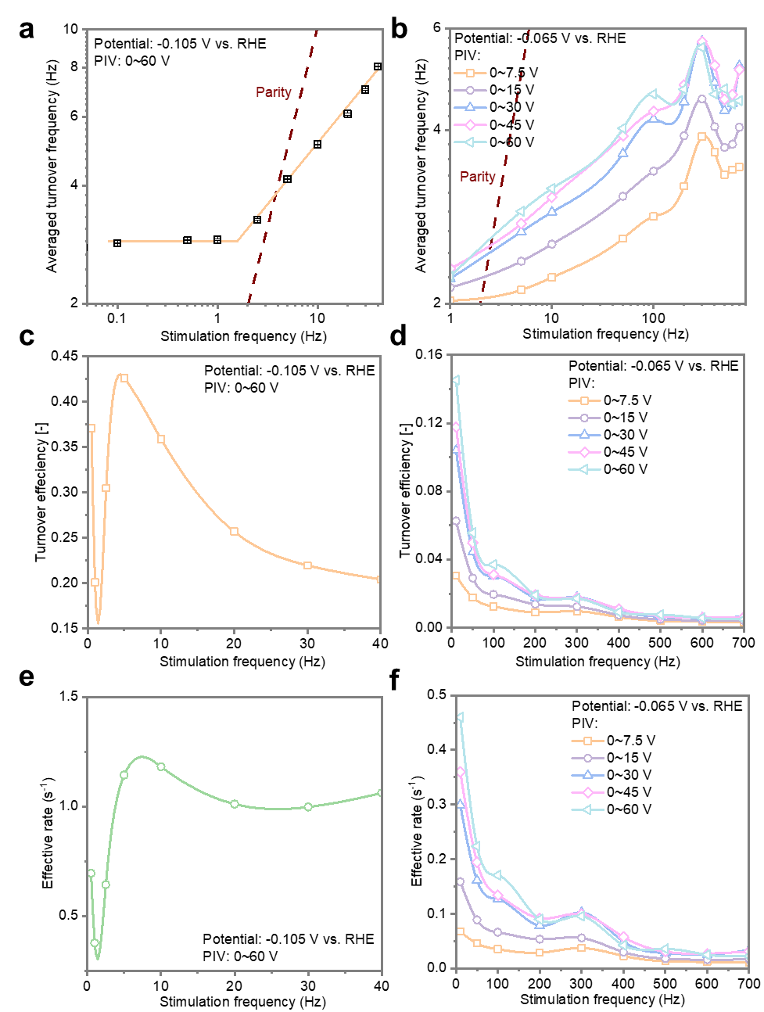

Supplementary Fig. 31: Turnover efficiency and effective rates of Cu foil catalysts in a fixed stimulation frequency. Average catalytic HER turnover frequency (TOF) as a function of dynamic strain frequency in the low-frequency a, and high-frequency b, regimes. The average turnover frequency falls below the parity line of the resonance frequency, indicating that the ideal resonance efficiency has not been achieved. The turnover efficiency for different stimulation frequencies, obtained at the low-frequency (c) and high-frequency (d) regimes. Effective rates at various stimulation frequencies in the low-frequency (e) and high-frequency (f) regimes.

Supplementary Note 31: The turnover frequency (TOF) was calculated by following equation (2):
$TOF \left(s^{-1}\right)=\left\{i\left(A\right)/S \left({cm}^{2}\right)×\frac{1H_{2}}{2e^{-}}×\frac{1e^{-}}{q_{e}}\right\}/N_{surf}$ (2)
Where i is the averaged current during HER in either static state or steady state under the applied dynamic stress at a specific frequency and amplitude. S represent the geometric surface area of the Cu foil (1.234 cm⁻² in our case), and q_{e} is the electron charge of 1.602 x 10⁻¹⁹ C. N_{surf} represent the number of surface Cu atom on the both side of the Cu foil. We estimated the value of N_{surf} according to the surface model of an unstressed Cu (100) facet, and the ESCA values measured under static condition. N_{surf} was calculated with the following equation (3):
$N_{surf}= \frac{ECSA ({cm}^{2})}{S_{Cu, atom} ({cm}^{2})}$ (3)
Where the ECSA value was determined from the static Cu foil (1.89 cm²). S_{Cu,atom}, the surface area occupied by a single Cu atom, was calculated based on the optimized Cu (100) surface and is 6.04 x 10⁻¹⁶ cm². In reality, the polycrystalline Cu surface consists of a mixture of various crystallographic facets, rather than being exclusively composed of the Cu (100) facet. Among these, the Cu (100) facet exhibits a relatively low surface atomic density, which leads to an overestimation of the calculated TOF. Conversely, if the surface were entirely composed of the densely packed Cu (111) facet, the TOF would be approximately 13.5% lower. Therefore, the actual TOF is expected to be 0–13.5% lower than the current estimate.
Supplementary Fig. 31a shows that, at low frequencies (<1 Hz), the applied dynamic strain has negligible influence on electrocatalytic activity, as the stimulation frequency remains below the intrinsic TOF of the reaction. Once the stimulation frequency exceeds 1 Hz, the HER TOF increases with frequency, exhibiting a roughly linear relationship until about 100 Hz (Supplementary Fig. 31b). Such linear increase in TOF after a frequency threshold is consistent with previous theoretical models proposed by Jesse et al¹². However, beyond 100 Hz, the TOF tends to fluctuate resulting in rather broad bands, which are not predicted by the existing models of resonance catalysis theory.
To assess the extent to which the applied stimulation frequency influences the HER TOF, we further calculated the turnover efficiency (η_{TOE}) and effective rate (r_{eff}) according to equations (4) and (5), respectively:
$η_{TOE}=\frac{{TOF}_{dynamic}-{TOF}_{ss}}{f_{stimu}}$ (4)
$r_{eff}=η_{TOE}{TOF}_{dynamic}$ (5)
Here, TOF_{dynamic} and TOF_{ss} represent the averaged TOF of HER under dynamic stress and static state, respectively. The f_{stimu} refers to the frequency of the dynamic mechanical stimulation applied to the Cu foil.
At low stimulation frequencies (<5 Hz), fluctuations in catalytic activity led to pronounced variations in turnover efficiency, resulting in significant scatter (Supplementary Fig. 31c). The highest turnover efficiency, 0.425, is observed at 5 Hz. As the frequency increases beyond this point, the efficiency declines steadily, a trend that persists across both the low-frequency regime (Supplementary Fig. 31c) and the high-frequency regime (Supplementary Fig. 31d). Another metric for assessing energy efficiency, the effective rate, quantifies the net enhancement in catalytic activity induced by external vibration. It exhibits a primary peak at 10 Hz (Supplementary Fig. 31e). Although it gradually decreases at higher frequencies, a secondary peak emerges at 300 Hz, likely due to amplitude amplification caused by resonance modes of the Cu foil.
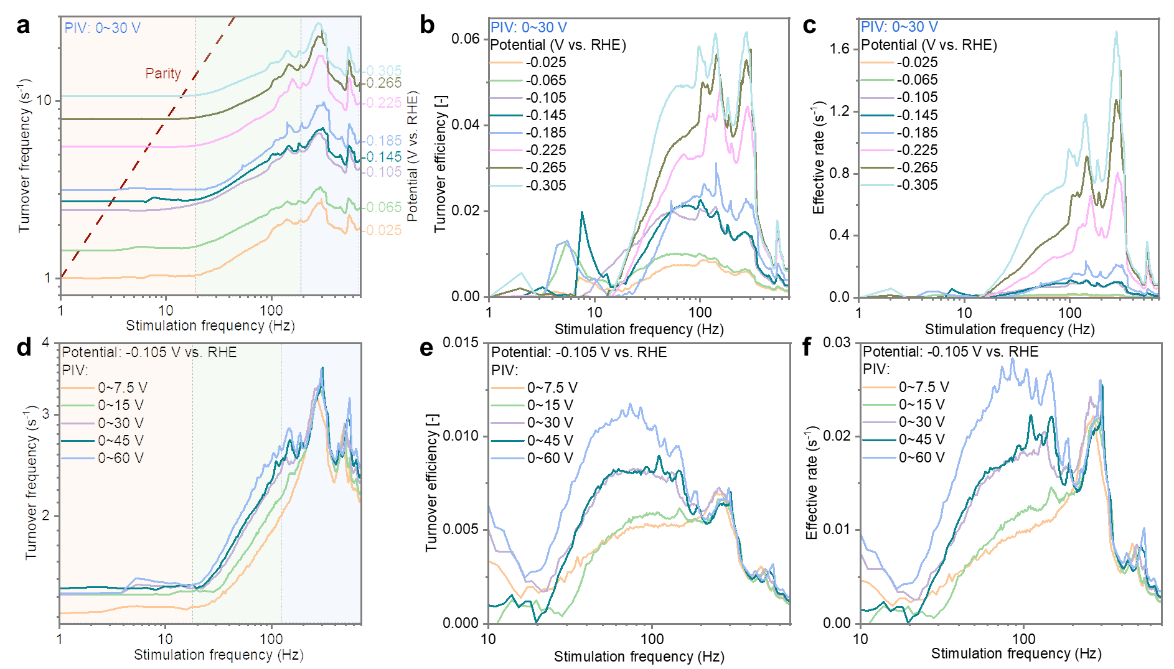

Supplementary Fig. 32: Turnover efficiency and effective rates under a MES measurement. a, TOF, b, turnover efficiency, and c, effective rate as a function of dynamic stress under different overpotentials; d, TOF, e, turnover efficiency, and f, effective rate as a function of dynamic stress under varying PIV oscillation amplitudes.

Supplementary Note 32: Using a similar data treatment approach, MES data were analyzed to extract the TOF, turnover efficiency, and effective rate as functions of frequency, providing insight into the efficiency of dynamic stress under various conditions. Supplementary Figs. 32a and 32c demonstrate a frequency dependence of dynamic stress on the HER turnover frequency. In the 0–20 Hz range (orange zone), the effect is relatively limited. Within the 20–130 Hz range (green zone), the TOF increases linearly with stimulation frequency. Beyond 130 Hz (blue zone), a further increase in frequency no longer lead to a significant enhancement in TOF, except at certain frequencies, where pronounced amplification was observed. At all tested overpotentials and PIV ranges, the relationship between TOF and stimulation frequency significantly deviated from the parity line, indicating suboptimal efficiency. This can also be seen in the turnover efficiency values: although increasing the overpotential or the PIV oscillation amplitude improved the efficiency, the peak values remained approximately two orders of magnitude lower than the ideal value of 1 (Supplementary Figs. 32b and 32d).
Increasing the overpotential exponentially enhanced both the surface reaction rate (Supplementary Fig. 32a) and the energetics of the surface reaction. As a result, the applied oscillatory stimulation boosted the overall response efficiency by up to sixfold, and lead to a more pronounced efficiency enhancement specifically within the high-frequency range 200–300 Hz (Supplementary Fig. 32b). In contrast, increasing the amplitude of the external stimulation (PIV range) while keeping the overpotential constant primarily enhanced the efficiency within the lower-frequency region 20–100 Hz (Supplementary Fig. 32b). Both observations suggest that improving the efficiency of external stimulation may require a proper matching between the surface reaction TOF and the frequency of the applied stimulus.
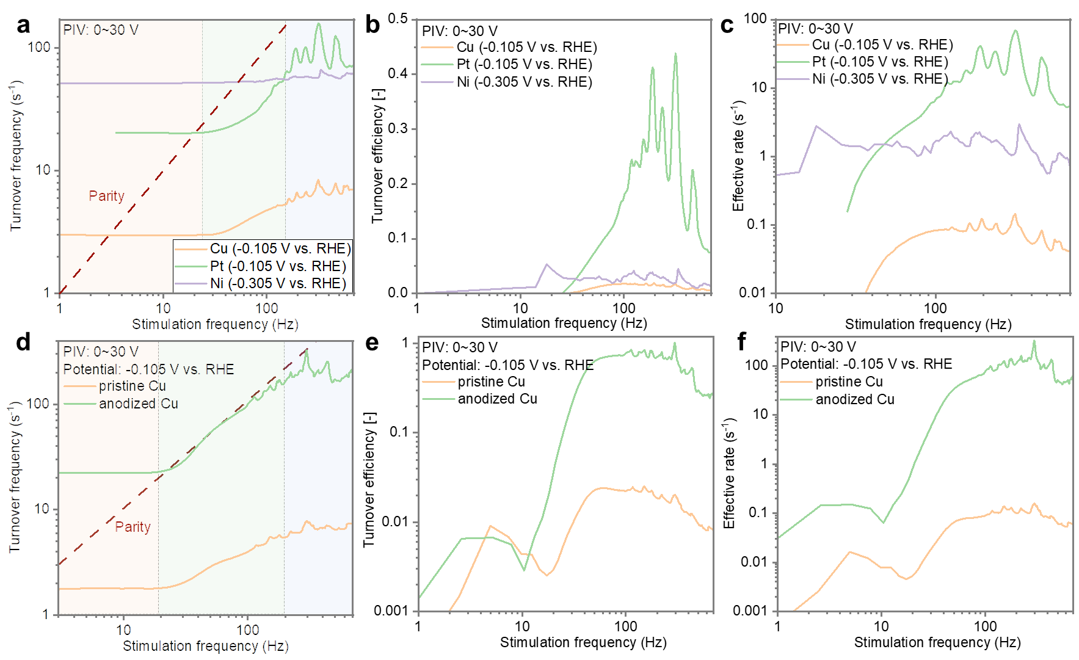
Supplementary Fig. 33. Turnover efficiency and effective rates of a dynamic stress catalysts obtained from MES data. a, TOF, b, turnover efficiency, and c, effective rate as a function of dynamic stress for different catalyst foils; (d-f) Corresponding metrics for Cu foils before and after anodic treatment.

Supplementary Note 33. Under dynamic stress (Supplementary Fig. 33a), the HER activity across different metal foils (Ni, Pt, and Cu) exhibited a similar frequency-dependent trend: the TOF remained relatively constant at both low (0–20 Hz) and high (200–700 Hz) frequencies, while it increased progressively with frequency in the intermediate range (20–200 Hz). Such intermediate frequency window was comparable across different materials (Supplementary Figs. 33b and 33c). In contrast, the efficiency of dynamic stress differed significantly across materials: Pt exhibited markedly higher performance than Cu or Ni, with a turnover efficiency of up to 0.43 s⁻¹ and an effective rate reaching 70.7 s⁻¹ at 296 Hz under dynamic stress stimulation.
Anodized Cu foils also exhibited significant activity enhancement under dynamic stress, as discussed in the main text. Consequently, their efficiency under dynamic stress was further investigated, as shown in Supplementary Figs. 33d-f. The HER turnover frequency of Cu foils before and after anodization exhibited similar frequency-dependent responses under dynamic stimulation. However, the onset of catalytic enhancement shifted from ~20 Hz to ~10 Hz after anodization. Notably, the turnover efficiency of anodized Cu foils approached the theoretical maximum value of 1 under dynamic stimulation in the range of approximately 30–300 Hz. This suggests that, on such modified catalytic surfaces, the surface reaction energetics constitute an “efficient catalytic ratchet”—i.e., an ideal resonance is achieved between the surface reaction rate and the stimulation frequency. This suggests that, through targeted surface modifications, a variety of solid catalytic surfaces may be tuned to form efficient catalytic ratchets.

Supplementary Note 34. While achieving high overall efficiency is beyond the scope of this work, we can estimate it to know where we stand. To this end, we compared the power used to dynamically stretch the Cu catalyst body to achieve a 30-fold enhancement of HER current to the electromotive force that would be required to achieve such enhancement just by applying a higher voltage in the HER cell.
A simple back-of-the-envelope calculation gives that the power from the piezo actuator is: (F x d) / t = 80 N x 10⁻⁴ m x 296 s⁻¹ = 2.4 W, where F is the force, d is the displacement and t the time, while the power difference needed to achieve same HER current at 0 Hz (based on LSV) is: Δj x A x V=-2.8 mA cm⁻² x 1.234 cm² x -0.510 V = 1.8 x 10⁻³ W. Therefore, the relative efficiency of the stimulation vs. a change in HER voltage is about ~0.1 %. While the copper foil is deformed less than the piezo, this does not change the order of magnitude. This simple exercise shows that the force should be dramatically reduced, or the effect on HER boosted by order of magnitudes, to make the stimulation approach viable for activity enhancement at the current stage.

Reference
1 Kumar, D., Poddar, K. & Kumar, S. The effect of aspect ratio and mass ratio on the flow-induced flutter of a thin flexible sheet. Physics of Fluids 36 (2024).
2 Kumar, D., Arekar, A. N. & Poddar, K. The dynamics of flow-induced flutter of a thin flexible sheet. Physics of Fluids 33, 034131 (2021).
3 Fang, Y.-H. & Liu, Z.-P. Tafel kinetics of electrocatalytic reactions: from experiment to first-principles. ACS Catalysis 4, 4364-4376 (2014).
4 Neyerlin, K., Gu, W., Jorne, J. & Gasteiger, H. A. Study of the exchange current density for the hydrogen oxidation and evolution reactions. Journal of The Electrochemical Society 154, B631 (2007).
5 Anantharaj, S. & Noda, S. How properly are we interpreting the Tafel lines in energy conversion electrocatalysis? Materials Today Energy 29, 101123 (2022).
6 van der Heijden, O., Park, S., Vos, R. E., Eggebeen, J. J. & Koper, M. T. Tafel slope plot as a tool to analyze electrocatalytic reactions. ACS Energy Letters 9, 1871-1879 (2024).
7 Jüttner, K. Electrochemical impedance spectroscopy (EIS) of corrosion processes on inhomogeneous surfaces. Electrochimica Acta 35, 1501-1508 (1990).
8 Anantharaj, S. & Noda, S. Appropriate use of electrochemical impedance spectroscopy in water splitting electrocatalysis. ChemElectroChem 7, 2297-2308 (2020).
9 Vollmer, M. & Möllmann, K.-P. Infrared thermal imaging: fundamentals, research and applications. (John Wiley & Sons, 2018).
10 Schmidt, T., Ross Jr, P. & Markovic, N. Temperature dependent surface electrochemistry on Pt single crystals in alkaline electrolytes: Part 2. The hydrogen evolution/oxidation reaction. Journal of Electroanalytical Chemistry 524, 252-260 (2002).
11 Asperti, S., Hendrikx, R., Gonzalez‐Garcia, Y. & Kortlever, R. Benchmarking the electrochemical CO2 reduction on polycrystalline copper foils: the importance of microstructure versus applied potential. ChemCatChem 14, e202200540 (2022).
12 Canavan, J. R., Hopkins, J. A., Foley, B. L., Abdelrahman, O. A. & Dauenhauer, P. J. Catalytic Resonance Theory: Turnover Efficiency and the Resonance Frequency. ACS Catalysis 15, 653-663 (2024).

