Lateral Epitaxy Suppresses Self-Trapped Excitons in 2D Perovskites
Chong Peng^{1†}, Zisheng Tang^{1†}, Jieheng Lv^{1†}, Shujing Ren^{1†}, Dafu Zhao¹, Xiaoqian Wang¹, Kefeiyang Hu¹, Manrui Liu¹, Damin Liu¹, Lindong Wang¹, Sicheng Luo¹, Zhe Pang¹, Xingbo Huang¹, Yingfei Liu¹, Zhicheng Shen¹, Jiaqian Que¹ and Yong Liu^{1*}
¹ State Key Laboratory of Advanced Technology for Materials Synthesis and Processing, International School of Materials Science and Engineering (ISMSE), Wuhan University of Technology, Wuhan 430070, China.
* Correspondence: liuyong3873@whut.edu.cn;
† These authors contributed equally to this work.

Methods
Chemicals and reagents.
Organic solvents, including dimethyl sulfoxide (DMSO 99.90%), chlorobenzene (CB 99.50%), N, N-Dimethylformamide (DMF 99.50%) and acetonitrile (ACN 99.50%) were purchased from Sinopharm Chemical Reagent Co., Ltd. And solid chemicals, including 2-phenylethylamine hydrochloride (PEACl 99.00%), lead chloride (PbCl₂ 99.99%) were purchased from Macklin Chemical Reagent Co., Ltd., phenethylammonium bromide (PEABr 98.00%), lead bromide (PbBr₂ 99.99%), tin (II) bromide (SnBr₂ 99.00%) were purchased from Aladdin Chemical Reagent Co., Ltd. All organic solvents and solid chemicals were used as received without further purification.
Synthesis of PEA₂PbCl₄ single-crystal sheets.
A stock solution of PEA₂PbCl₄ was prepared by dissolving 100 μmol of PEACl and 50 μmol of PbCl₂ in a mixed solvent of 2 ml DMSO, 4 ml DMF, and 4 mL CB. Then, 100 μl of the stock solution was added dropwise to 12 ml of a CB/ ACN co-solvent with a volume ratio between 1.5:1.0 and 2.0:1.0 to obtain a diluted solution for single-crystal growth. Subsequently, 8 μl of the diluted solution was dropped onto a SiO₂ (300 nm)/Si substrate placed at the bottom of a sealed glass vial, which was positioned on a hot plate set to 65 °C. After complete evaporation of diluted solution over 16 minutes, PEA₂PbCl₄ single-crystal sheets were obtained on the substrate.
Synthesis of PEA₂PbCl₄-PEA₂Pb_{1-x}Sn_{x}Br₄ heterostructures.
A stock solution for PEA₂Pb_{1-x}Sn_{x}Br₄ was prepared by dissolving 100 μmol of PEABr and 50 μmol of MBr₂ (M=Pb, Sn) in a DMF/CB co‑solvent (5 ml each). Then, 100 μl of each stock solution was added dropwise to 12 ml of a CB/ ACN co‑solvent with the following CB:ACN volume ratios=2.5:1.0 for PEA₂PbBr₄, 4.0:1.0 for PEA₂Pb_{0.5}Sn_{0.5}Br₄, and 4.5:1.0 for PEA₂SnBr₄ to obtain a diluted solution for heterostructures growth. Subsequently, 7 μl of the diluted solution was dropped onto a SiO₂/Si (300nm) substrate pre-grown with PEA₂PbCl₄ single-crystal sheets and placed at the bottom of a sealed glass vial, which was positioned on a hot plate set to 50 °C. After complete evaporation of diluted solution over 45 minutes, PEA₂PbCl₄-PEA₂Pb_{1-x}Sn_{x}Br₄ heterostructures were obtained on the substrate.
Characterizations
All samples were characterized by X-ray diffraction (XRD) using the Bruker D8 X-ray diffractometer under Cu Kα radiation (λ=1.54056 Å, 40kV, and 40mA). The bright-field optical images were collected by a custom microscope (RX50M). PL images were captured using an Olympus BX53 as the excitation source. All PL spectra were measured using Coherent OBIS 325 nm and 405nm laser as the excitation source. The scanning electron microscope images were collected in a S4800 with an accelerating voltage of 5.0 kV. Atomic Force Microscope images were recorded in tapping mode using an atomic force microscope (Bruker Dimension ICON-IR). The X-ray photoelectron spectroscopy of the samples was carried out using a Thermo Scientific Kα XPS spectrometer equipped with a monochromatic Al-Kα x-ray source.
TEM Characterization
TEM images and SAED patterns of PEA₂PbCl₄ single-crystal sheets were acquired using FEI Titan-X 60-300 microscope operated at 200kV. TEM images and SAED patterns of PEA₂PbCl₄-PEA₂Pb_{1-x}Sn_{x}Br₄ heterostructures were acquired using JEM-F200 Multi-purpose Electron Microscope operated at 200kV.
DFT Calculation
The Vienna Ab Initio Package (VASP) was employed to perform all the density functional theory (DFT) calculations within the generalized gradient approximation (GGA) using the Perdew, Burke, and Enzerhof (PBE) formulation¹⁻³. The projected augmented wave (PAW) potentials were applied to describe the ionic cores and take valence electrons into account using a plane wave basis set with a kinetic energy cutoff of 450 eV^{4,5}. Partial occupancies of the Kohn-Sham orbitals were allowed using the Gaussian smearing method and a width of 0.1 eV. The electronic energy was considered self-consistent when the energy change was smaller than 10⁻⁵ eV. A geometry optimization was considered convergent when the force change was smaller than 0.05 eV/Å. Grimme’s DFT-D3 methodology was used to describe the dispersion interactions⁶. The Brillouin zone integral utilized the structures of 2×2×1 monkhorst pack K-point sampling. The energy Edis. was calculated
Edis.=(Etotal-Egroud) (1)
Where Etotal is the total energy of distorted structure. Egroud is ground state energy the energy.

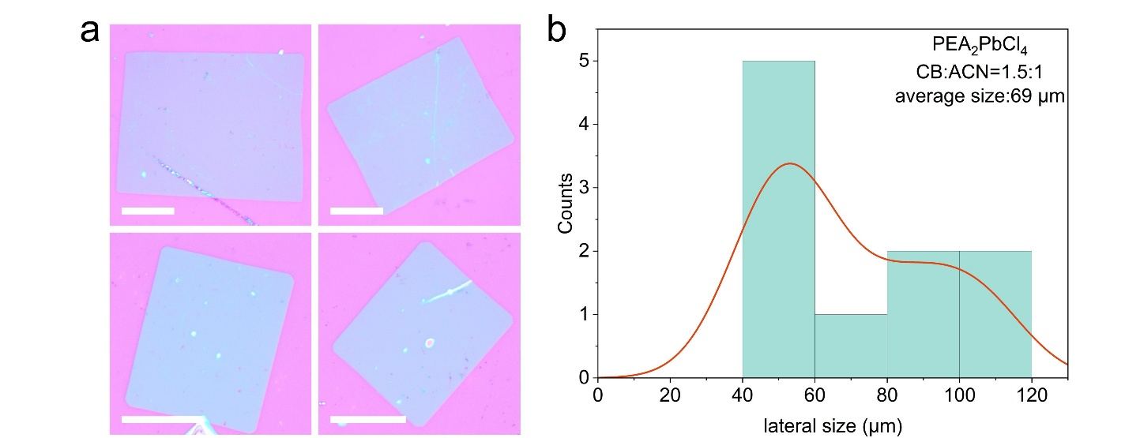
Fig. S1. Optical images of PEA₂PbCl₄ single-crystal sheets grown under the conditions CB: ACN volume ratios=1.5:1. (a) Optical images of PEA₂PbCl₄ single-crystal sheets. Scale bar: 30 μm. (b) Size distribution plot of PEA₂PbCl₄ single-crystal sheets.

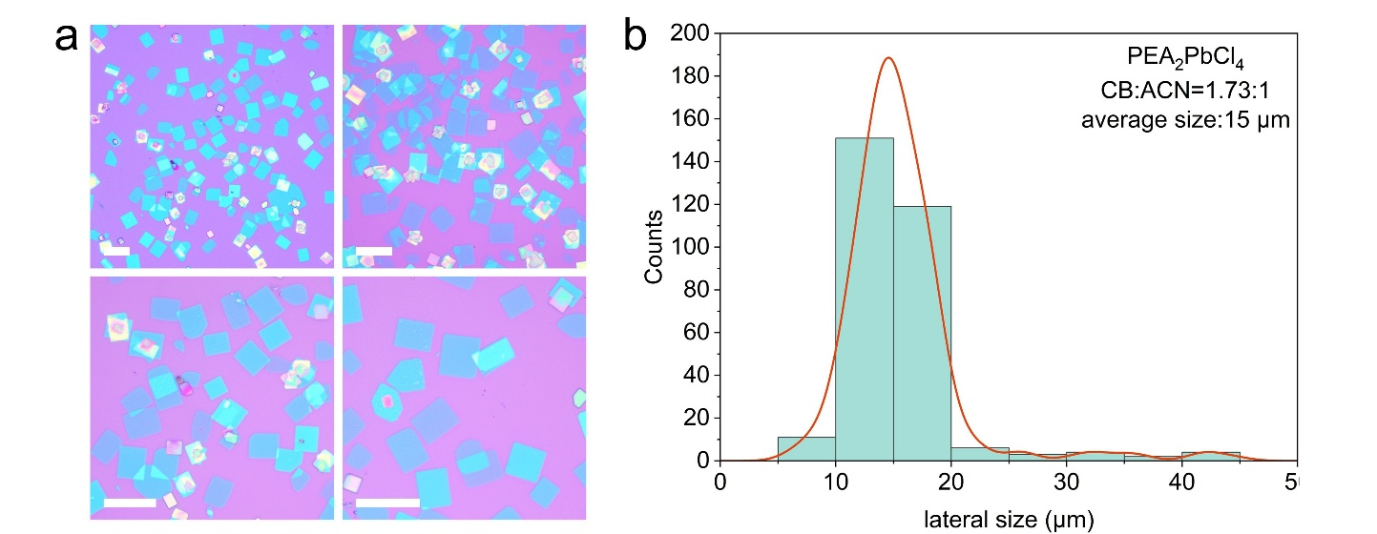
Fig. S2. Optical images of PEA₂PbCl₄ single-crystal sheets grown under the conditions CB: ACN volume ratios=1.73:1. (a) Optical images of PEA₂PbCl₄ single-crystal sheets. Scale bar: 30 μm. (b) Size distribution plot of PEA₂PbCl₄ single-crystal sheets.

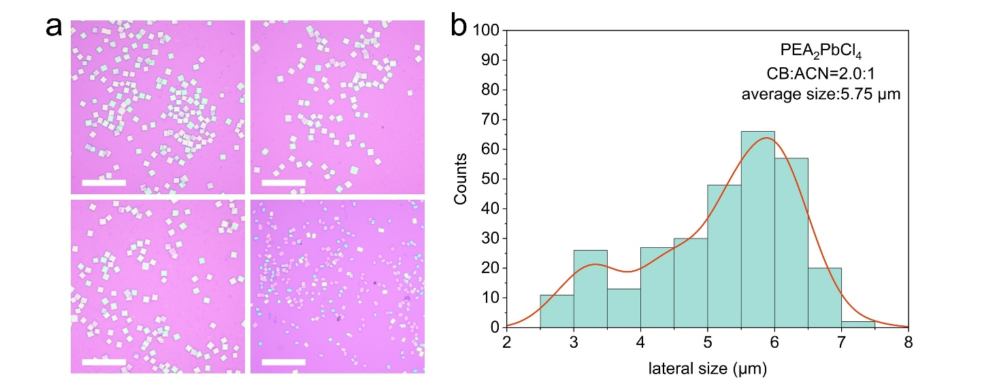
Fig. S3. Optical images of PEA₂PbCl₄ single-crystal sheets grown under the conditions CB: ACN volume ratios=2.0:1. (a) Optical images of PEA₂PbCl₄ single-crystal sheets. Scale bar: 30 μm. (b) Size distribution plot of PEA₂PbCl₄ single-crystal sheets.

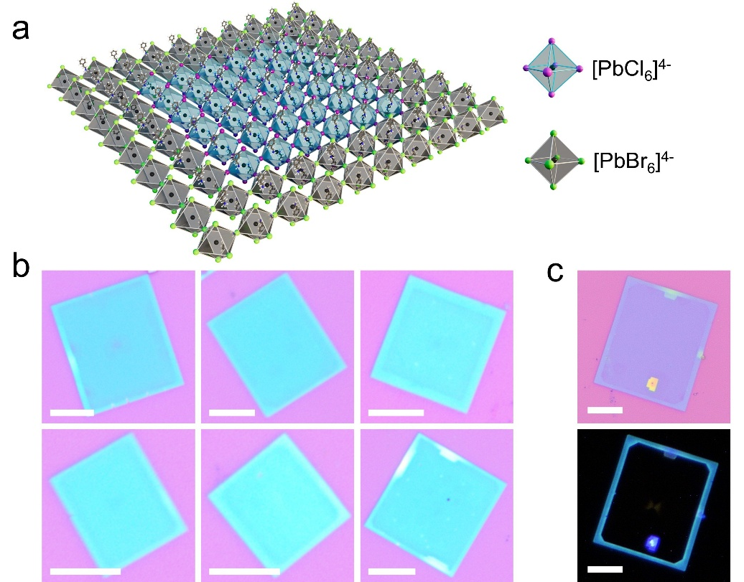
Fig. S4. The schematic diagram of the heterostructure, the optical images, and the fluorescence images of PEA₂PbCl₄-PEA₂PbBr₄. (a) Schematic diagram of the heterostructure of PEA₂PbCl₄-PEA₂PbBr₄. (b) Optical images of PEA₂PbCl₄-PEA₂PbBr₄. Scale bar: 10 μm. (c) The optical images and the corresponding images of PEA₂PbCl₄-PEA₂PbBr₄. Scale bar: 10 μm.

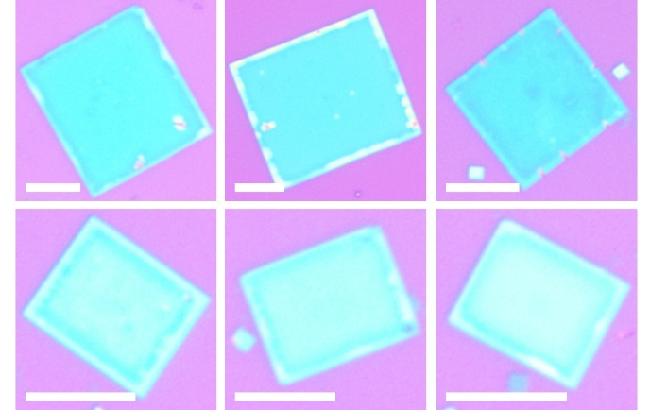
Fig. S5. The optical images of PEA₂PbCl₄-PEA₂Pb_{0.5}Sn_{0.5}B
‘’r₄ heterostructure. Scale bar: 10 μm.

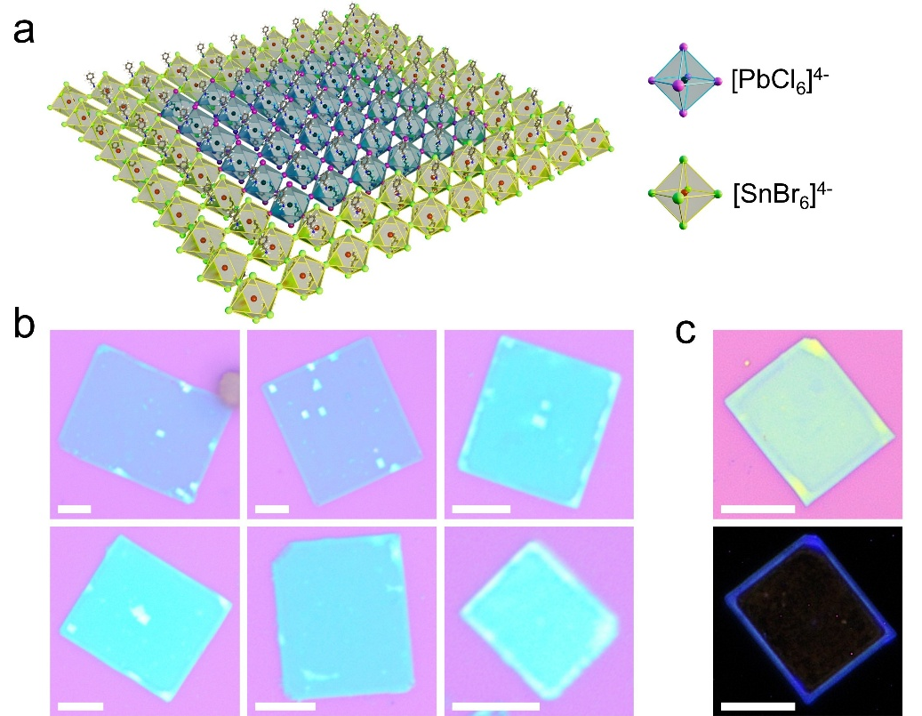
Fig. S6. The schematic diagram of the heterostructure, the optical images, and the fluorescence images of PEA₂PbCl₄-PEA₂SnBr₄. (a) Schematic diagram of the heterostructure of PEA₂PbCl₄-PEA₂SnBr₄. (b) Optical images of PEA₂PbCl₄-PEA₂SnBr₄. Scale bar: 10 μm. (c) The optical images and the corresponding fluorescence images of PEA₂PbCl₄-PEA₂SnBr₄. Scale bar: 10 μm.

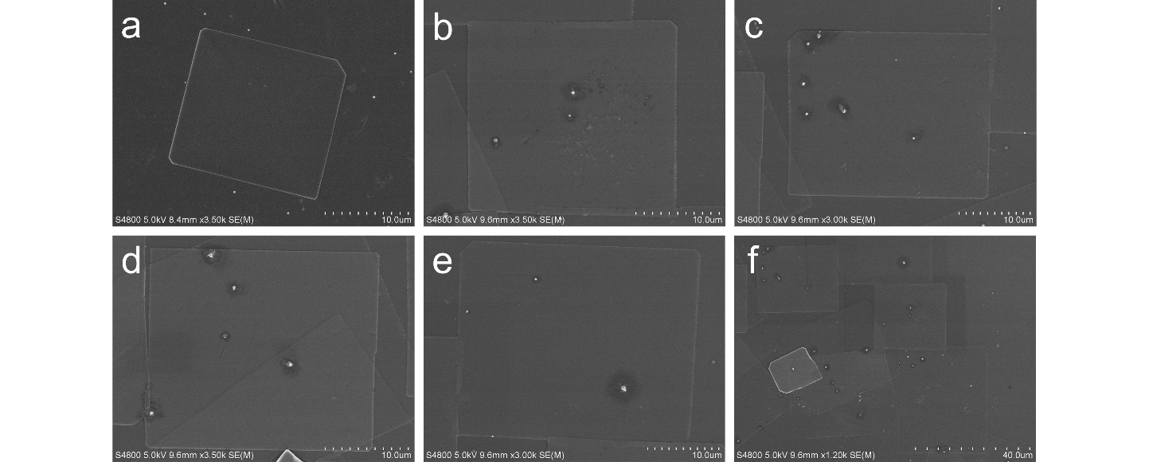
Fig. S7. The scanning electron microscopy images of PEA₂PbCl₄.

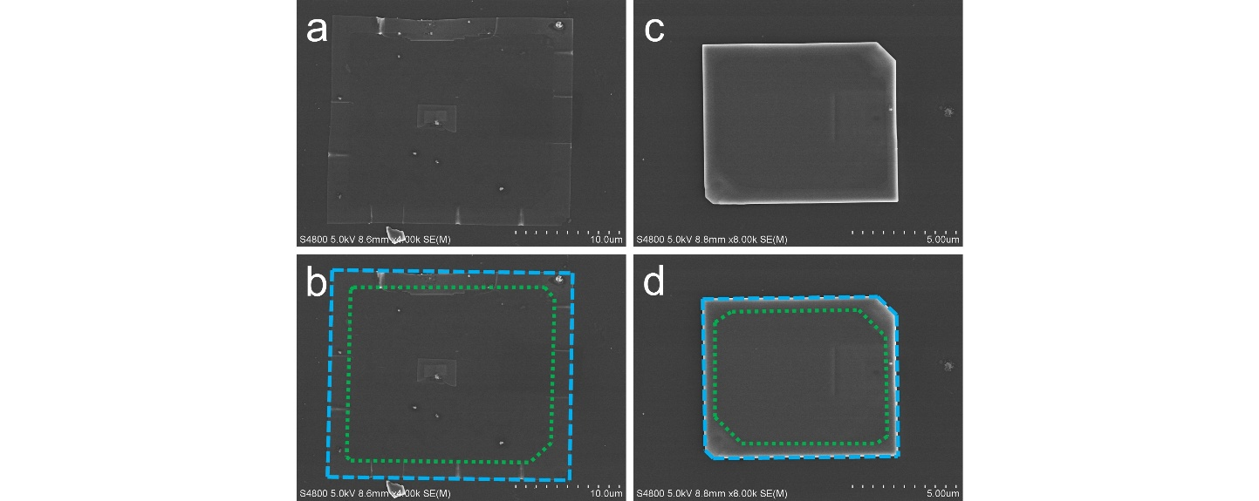
Fig. S8. The scanning electron microscopy images of PEA₂PbCl₄-PEA₂PbBr₄ heterostructure and PEA₂PbCl₄-PEA₂SnBr₄ heterostructures. The green dashed line highlights the heterostructure interface. (a, b) The SEM images of PEA₂PbCl₄-PEA₂PbBr₄ heterostructure. (c, d) The SEM images of PEA₂PbCl₄-PEA₂SnBr₄ heterostructure.

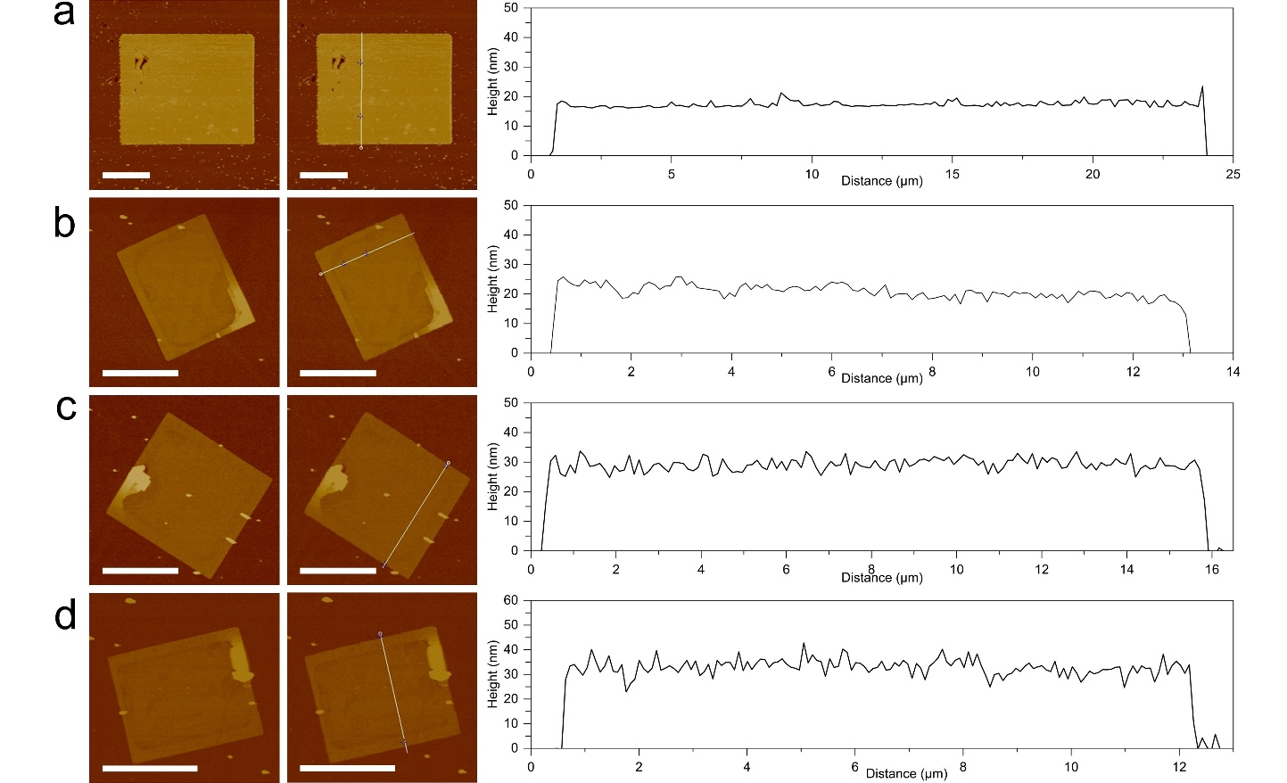
Fig. S9. The atomic force microscopy images of sheets and the corresponding surface roughness curve. (a–d) single-crystal sheets and surface roughness curve. (a) PEA₂PbCl₄ single crystal sheets. (b) PEA₂PbCl₄-PEA₂PbBr₄ heterostructure. (c) PEA₂PbCl₄-PEA₂Pb_{0.5}Sn_{0.5}Br₄ heterostructure. (d) PEA₂PbCl₄-PEA₂SnBr₄ heterostructure. Scale bar: 10 μm.

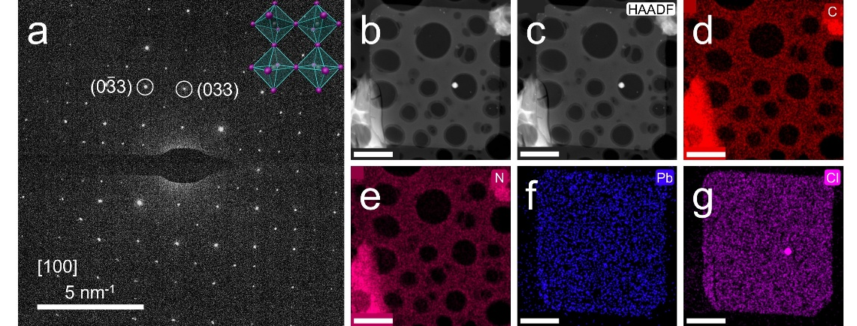
Fig. S10. Structural characterization of PEA₂PbCl₄ single-crystal sheets. (a) SAED pattern of PEA₂PbCl₄ single-crystal sheets, the upper right corner shows the schematic diagram of the heterostructure of the selected area. (b–c) Low-magnification TEM images of PE₂PbCl₄ single-crystal sheets. (d–g) EDS elemental mappings of PEA₂PbCl₄ single-crystal sheets. Scale bar: 2 μm.

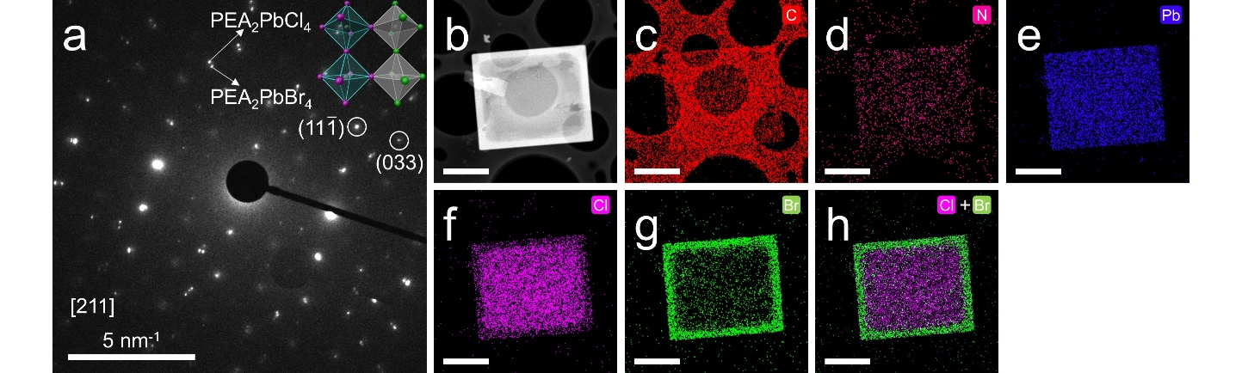
Fig. S11. Structural characterization of PEA₂PbCl₄-PEA₂PbBr₄ heterostructure. (a) SAED pattern of PEA₂PbCl₄-PEA₂PbBr₄ heterostructure, the upper right corner shows the schematic diagram of the heterostructure of the selected area. (b) Low-magnification TEM image of PEA₂PbCl₄-PEA₂PbBr₄ heterostructure. (c-h) EDS elemental mappings of PEA₂PbCl₄-PEA₂Pb_{0.5}Sn_{0.5}Br₄ heterostructure. Scale bar: 2.5 μm.

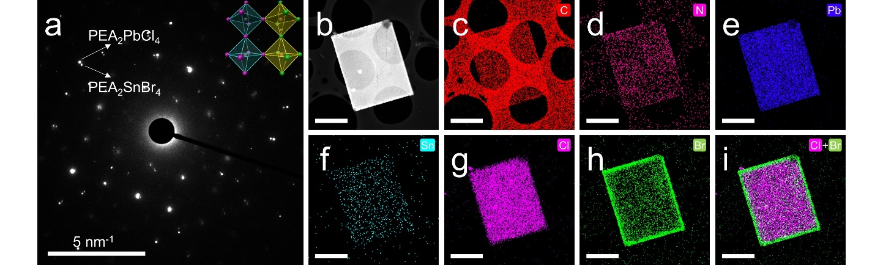
Fig. S12. Structural characterization of PEA₂PbCl₄-PEA₂PbSnBr₄ heterostructure. (a) SAED pattern of PEA₂PbCl₄-PEA₂SnBr₄ heterostructure, the upper right corner shows the schematic diagram of the heterostructure of the selected area. (b) Low-magnification TEM image of PEA₂PbCl₄-PEA₂SnBr₄ heterostructure. (c-i) EDS elemental mappings of PEA₂PbCl₄-PEA₂SnBr₄ heterostructure. Scale bar: 2.5 μm.

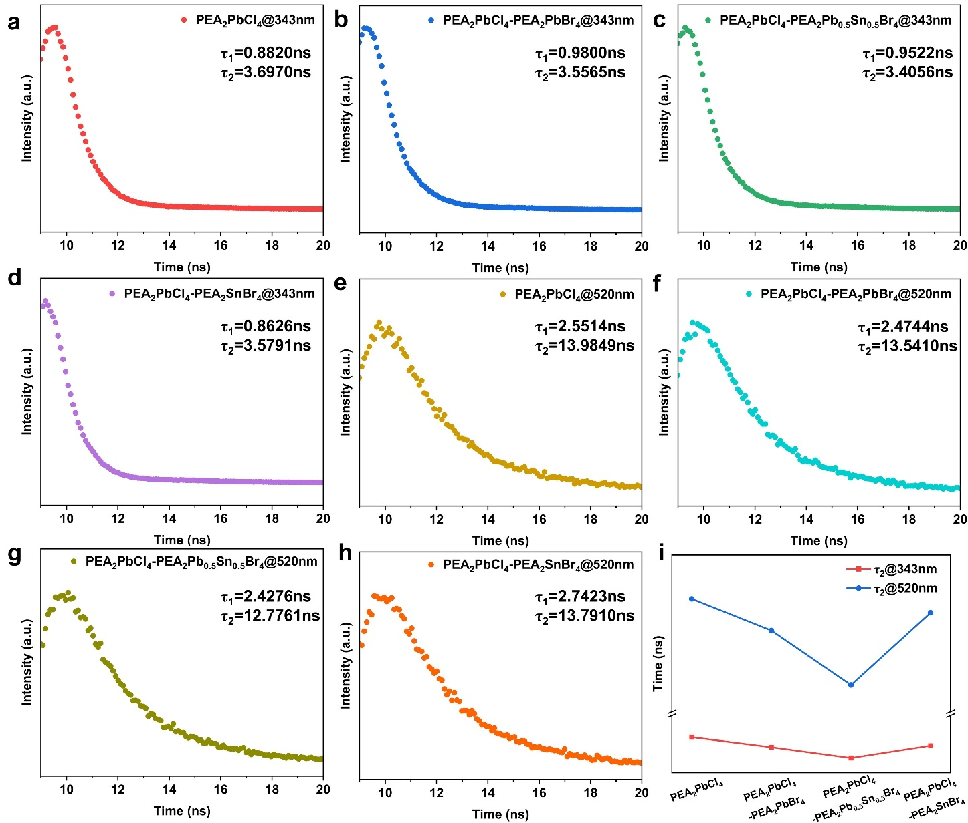
Fig. S13. Time-resolved RL decay of PEA₂PbCl₄ and PEA₂PbCl₄-PEA₂Pb_{1-x}Sn_{x}Br₄ lateral epitaxial heterostructures.

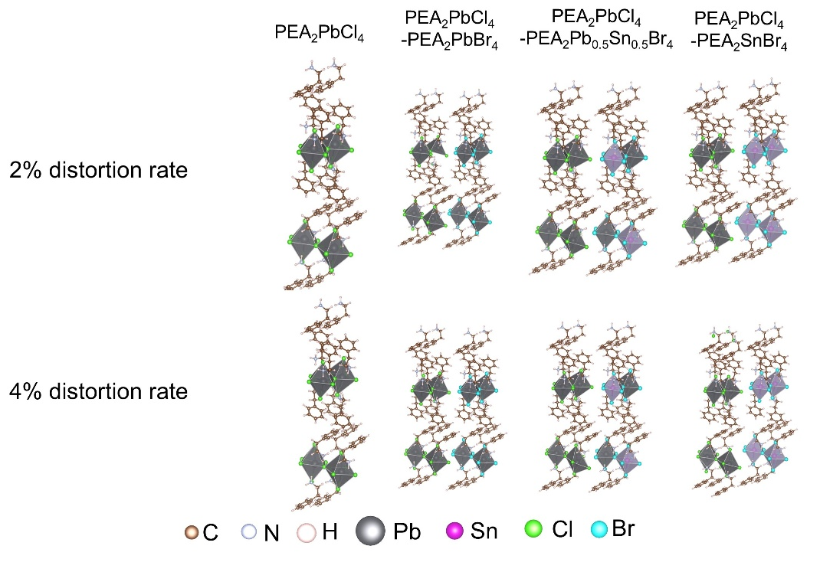
Fig. S14. The structural models of PEA₂PbCl₄ and PEA₂PbCl₄-PEA₂Pb_{1-x}Sn_{x}Br₄.

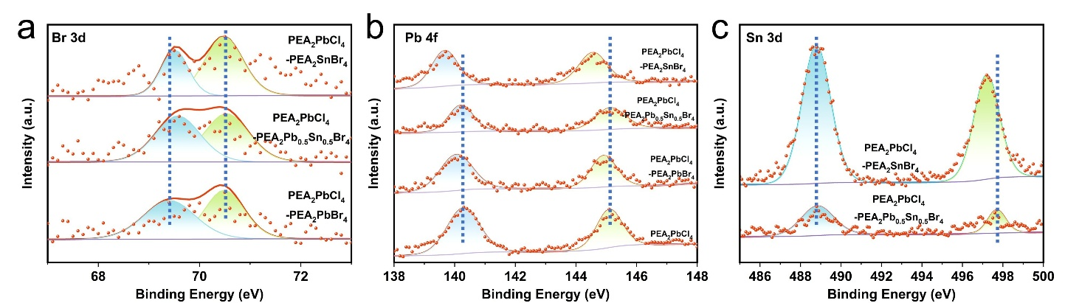
Fig. S15. The XPS spectra of PEA₂PbCl₄ single-crystal sheets and PEA₂PbCl₄-PEA₂Pb_{1-x}Sn_{x}Br₄ heterostructure. (a) The XPS spectra of Br 3d for PEA₂PbCl₄ single-crystal sheets, PEA₂PbCl₄-PEA₂PbBr₄, PEA₂PbCl₄-PEA₂Pb_{0.5}Sn_{0.5}Br₄ and PEA₂PbCl₄-PEA₂SnBr₄ heterostructure. (b) The XPS spectra of Pb 4f for PEA₂PbCl₄ single-crystal sheets, PEA₂PbCl₄-PEA₂Pb_{0.5}Sn_{0.5}Br₄ and PEA₂PbCl₄-PEA₂SnBr₄ heterostructure. (c) The XPS spectra of Sn 3d for PEA₂PbCl₄-PEA₂Pb_{0.5}Sn_{0.5}Br₄ and PEA₂PbCl₄-PEA₂SnBr₄ heterostructure.

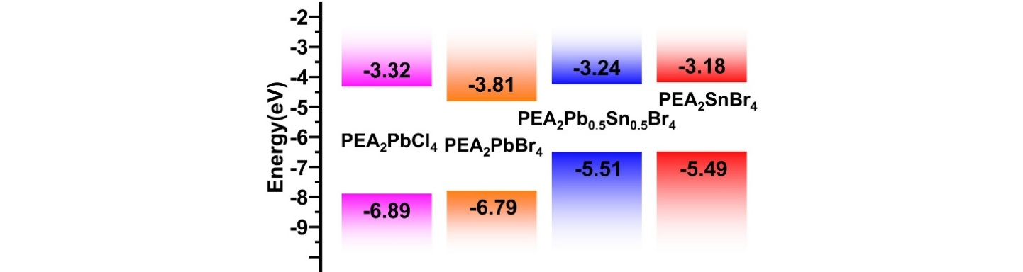
Fig. S16. The band structures of PEA₂PbCl₄ and PEA₂Pb_{1-x}Sn_{x}Br₄ obtained from theoretical calculations.

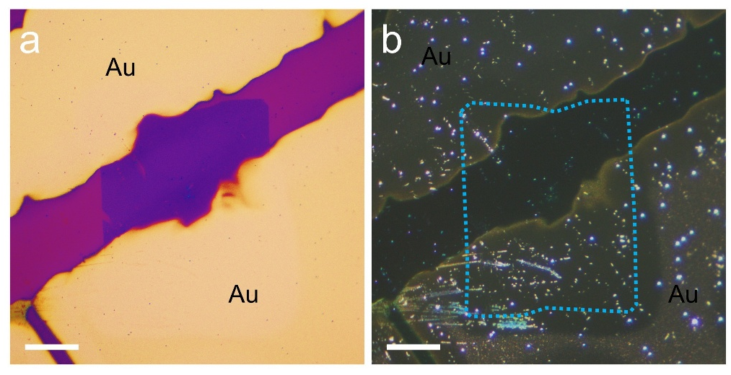
Fig. S17. Schematic diagram of the electrical device. (a) Optical Bright-field images. Scale bar: 30 μm. (b) Corresponding dark-field images. Scale bar: 30 μm.

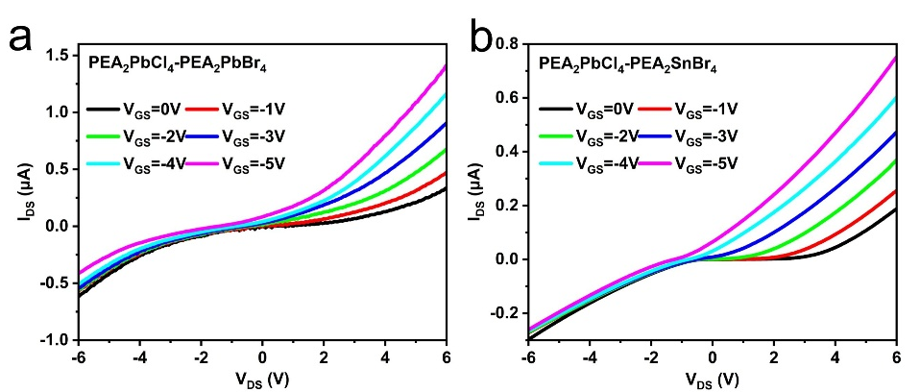
Fig. S18. Output characteristic curves of (a) PEA₂PbCl₄-PEA₂PbBr₄ and (b) PEA₂PbCl₄-PEA₂SnBr₄.

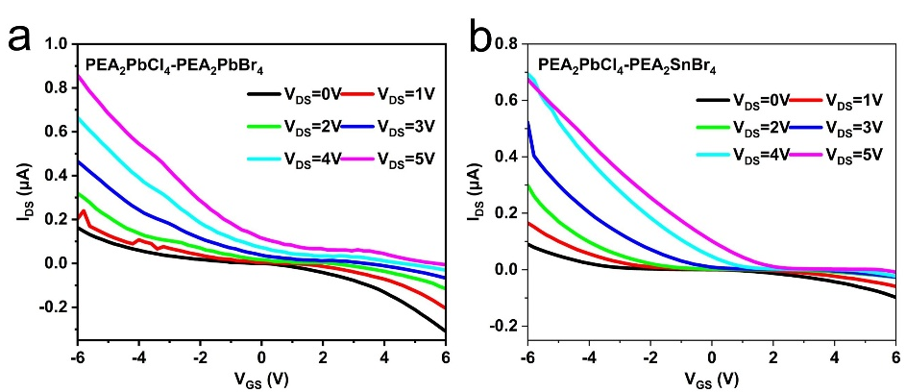
Fig. S19. Transfer characteristic curves of (a) PEA₂PbCl₄-PEA₂PbBr₄ and (b) PEA₂PbCl₄-PEA₂SnBr₄.

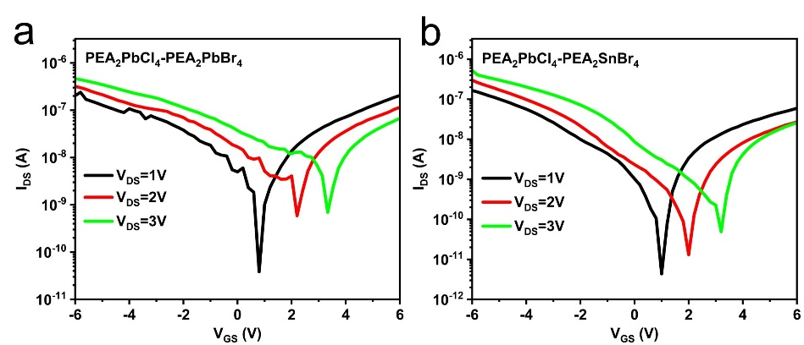
Fig. S20. Transfer characteristic curves of (a) PEA₂PbCl₄-PEA₂PbBr₄ and (b) PEA₂PbCl₄-PEA₂SnBr₄.

 | V_{DS}=1V | V_{DS}=2V | V_{DS}=3V
PEA₂PbCl₄ | 2.29 | 1.33 | 1.01
PEA₂PbCl₄-PEA₂PbBr₄ | 2.98 | 1.95 | 1.62
PEA₂PbCl₄-PEA₂Pb_{0.5}Sn_{0.5}Br₄ | 7.86 | 4.96 | 5.10
PEA₂PbCl₄-PEA₂SnBr₄ | 2.36 | 1.87 | 1.89
Table. S1. Carrier mobility of PEA₂PbCl₄ single-crystal sheets, PEA₂PbCl₄-PEA₂PbBr₄ heterostructure, PEA₂PbCl₄-PEA₂Pb_{0.5}Sn_{0.5}Br₄ heterostructure and PEA₂PbCl₄-PEA₂SnBr₄ heterostructure at V_{DS}=1V, 2V and 3V respectively.

References
1. Kresse. G et al., Efficient Iterative Schemes for Ab Initio Total-Energy Calculations Using a Plane-Wave Basis Set. Phys. Rev. B, 54, 11169–11186 (1996).
2. Perdew et al., Generalized Gradient Approximation Made Simple. Phys. Rev. Lett. 77, 3865–3868 (1996).
3. Kresse et al., From Ultrasoft Pseudopotentials to the Projector Augmented-Wave Method. Phys. Rev. B, 59, 1758–1775 (1999).
4. Blöchl et al., Projector Augmented-Wave Method. Phys. Rev. B, 50, 17953–17979 (1994).
5. Grimme et al., A consistent and accurate ab initio parametrization of density functional dispersion correction (DFT-D) for the 94 elements H-Pu. H. J. Chem. Phys, 132, 154104 (2010).
6. Henkelman et al., A climbing image nudged elastic band method for finding saddle points and minimum energy paths. H. J. Chem. Phys, 113, 9901 (2000).

