Supplementary materials
S1:ardized Workflow and Computation of Death/Mutation Curves
To promote the widespread adoption of the CPMI platform and ensure the traceability and reproducibility of experimental results(i.e.,experimental auditability), we established a standardized standard operating procedure(SOP) ,the detailed workflow of which is illustrated in Figure 1d.
- Inoculum preparation. The parental strain was streaked onto an appropriate agar medium and incubated under strain-specific conditions(e.g., temperature, humidity, and incubation duration). Two to three single single colonies, morphologically uniform colonies with smooth edges, were selected to ensure culture purity for subsequent experimental steps.
- Cell suspension and loading. A uniform cell suspension was prepared from the selected colonies using sterile growth medium or phosphate-buffered saline (PBS). The suspension concentration was adjusted to approximately 1 × 10⁶ CFU·mL⁻¹, as determined by an OD₆₀₀–CFU calibration curve or plate counting. An 10 μL aliquot of the suspension was loaded onto a sterile carrier and allowed to settle for 1–3 min to prevent edge drying and liquid pooling.
- CPMI exposure. The loaded carrier was placed beneath the CPMI plasma discharge zone at a fixed standoff distance of 2–6 cm with normal incidence. Samples were treated at 2–8 W for an exposure duration of 30–150 s. An unexposed control was included in each experimental run to account for background variability.
- Recovery and serial dilution. Immediately after exposure, the carrier was transferred to a tube containing PBS and vortexed to elute cells. Ten-fold serial dilutions were prepared and plated for colony enumeration, enabling derivation of survival (death) curves and apparent mutation curves.
- Primary selection. Colonies exhibiting clear phenotypic deviations relative to the parental background were selected (e.g., deeper pigmentation, larger or smaller colony diameter, altered edge morphology, or loss of secretion).
(6) Microplate-scale screening. Shortlisted isolates were cultivated in multiwell plates. Growth curves were recorded (e.g., growth rate and integrated OD₆₀₀) to eliminate false positives arising from slow growth.
(7) Confirmation of positives. Target product readouts (e.g., pigment titer) were quantified according to strain-specific assays. Isolates were passaged for ≥10 generations, with repeated measurements to verify stability. Only mutants demonstrating stable performance were retained.
We highlight four key control points (KCPs)to ensure reproducibility and reliability of CPMI-mediated mutagenesis: (i) Uniform spreading on the carrier.Ensure the cell/spore suspension spreads evenly to avoid puddling (which causes uneven plasma exposure) and edge dry-out (which reduces cell viability); (ii) stable standoff and normal incidence during exposure; (iii) rapid recovery immediately post-exposure to minimize post-treatment drift; and (iv) consistent dilution and plating to ensure comparability of survival estimates. For curve computation,the following metrics are derived from CFU enumeration and phenotypic screening:
Survival rate: Calculated as the ratio of treated to control CFUs:Survival=CFU treated / CFU control; the death curve:Generated by subtracting survival from 1. The apparent mutation curve:obtained by normalizing the number(or fraction) of pre-specified phenotype-positive colonies to total CFU at that exposure, reported versus power or time.
These two metrics provide complementary views—damage versus viability—that align with the power–time heatmap (Fig. 1c). In practice, we recommend users adopt a stepwise optimization workflow:begin with short exposures at 2–4 W, then increment power/time in small steps while monitoring both curves; identify the operating window where SOS-linked DNA damage (indicated by mutation activity) is induced without excessive cytotoxicity.

Table S1 Comparison of genotoxicity of Salmonella typhimurium TA1535/pSK1002 against different power CPMI treatments
Power  (w) | Time  (s) | G  (The growth factor) | IR  (The relative SOS induction rate) | ΔE_{max}  （Maximum β-galactosidase activity per unit cell density）
2 | 20 | 0.95 | 3.20 | 3.34
2 | 40 | 0.84 | 6.00 | 6.26
2 | 60 | 0.74 | 4.55 | 4.74
2 | 80 | 0.66 | 0.29 | 0.30
2 | 100 | 0.51 | 0.15 | 0.16
2 | 120 | 0.48 | 0.12 | 0.12
4 | 20 | 0.74 | 3.47 | 3.61
4 | 40 | 0.52 | 8.64 | 9.01
4 | 60 | 0.37 | 13.35 | 13.92
4 | 80 | 0.31 | 15.33 | 15.99
4 | 100 | 0.22 | 16.65 | 17.36
4 | 120 | 0.15 | 14.56 | 15.18
6 | 20 | 0.63 | 5.11 | 5.32
6 | 40 | 0.37 | 13.19 | 13.75
6 | 60 | 0.23 | 17.02 | 17.75
6 | 80 | 0.11 | 14.41 | 15.03
6 | 100 | 0.09 | 2.59 | 2.7
6 | 120 | 0.09 | 0.65 | 0.68
8 | 20 | 0.65 | 4.71 | 4.92
8 | 40 | 0.40 | 12.74 | 13.29
8 | 60 | 0.20 | 16.93 | 17.66
8 | 80 | 0.08 | 2.53 | 2.64
8 | 100 | 0.09 | 0.92 | 0.96
8 | 120 | 0.10 | 0.54 | 0.56
Table S2. Effects of CPMI plasma treatment on the chemical structures of different oligodeoxyribonucleotides (dA₈, dT₈, dG₈, dC₈)
Oligonucleotide | Molecular mass (Da) | Loss of chemical structure | Grafted chemical structure | Chemical structure illustration
dA₈ | 2933.5 | C₅H₇N₅（Adenine） | C₂₀H₂₆N₁₀O₁₁P₂（dA₂） | 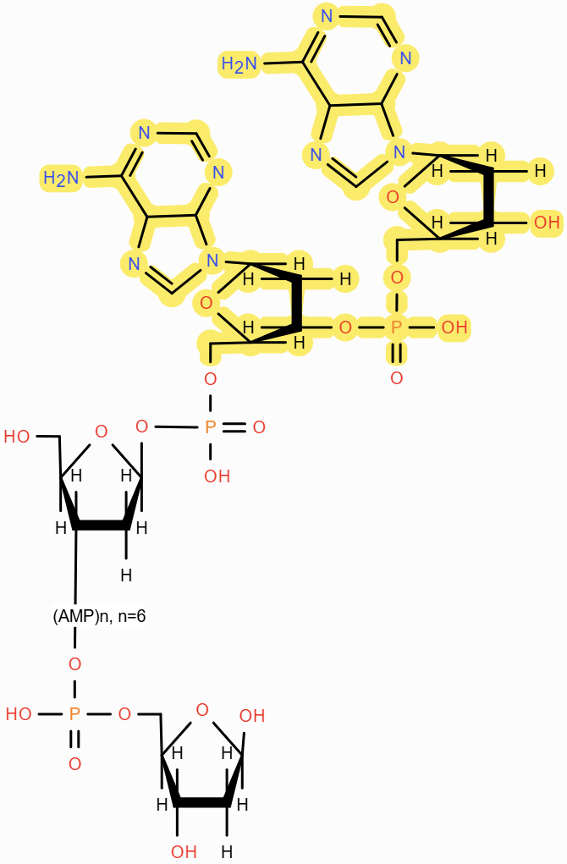
dA₈ | 2933.5 | NH₃ | C₂₀H₂₆N₁₀O₁₁P₂（dA₂）
dA₈ | 2095.1 | C₁₀H₁₄N₅O₆P（dA） | -- | 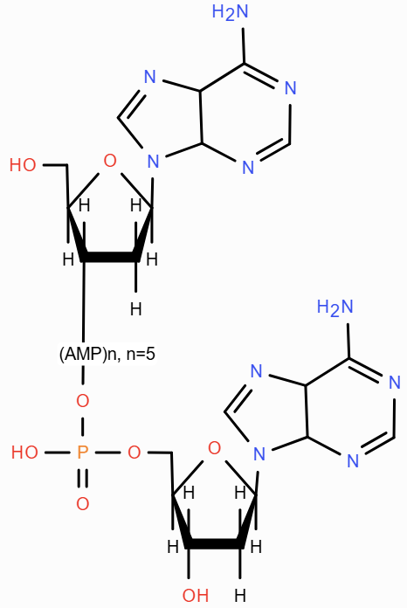
dA₈ | 1833.5 | C₂₀H₂₆N₁₀O₁₁P₂（dA₂） | -- | 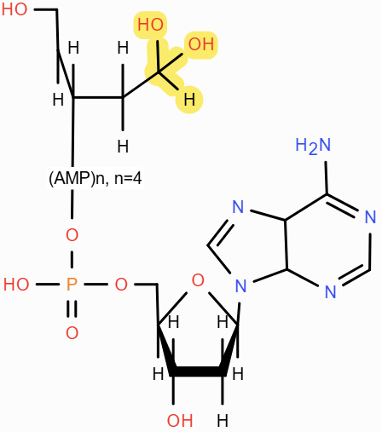
dA₈ | 862.8 | C₅₀H₆₂N₂₅O₂₇P₅（dA₅） | -- | 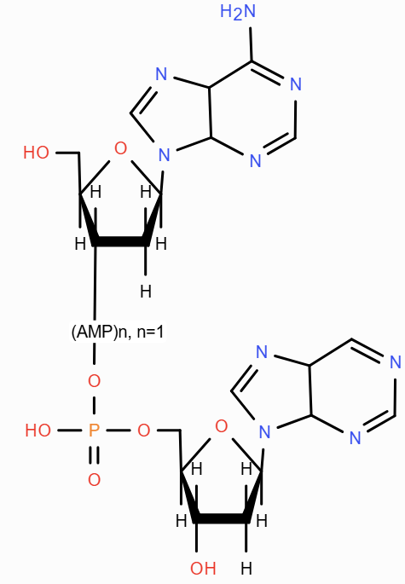
dA₈ | 862.8 | NH₃ | --
dA₈ | 772.1 | C₅₀H₆₀N₂₅O₂₆P₅（dA₅） | NH₃ | 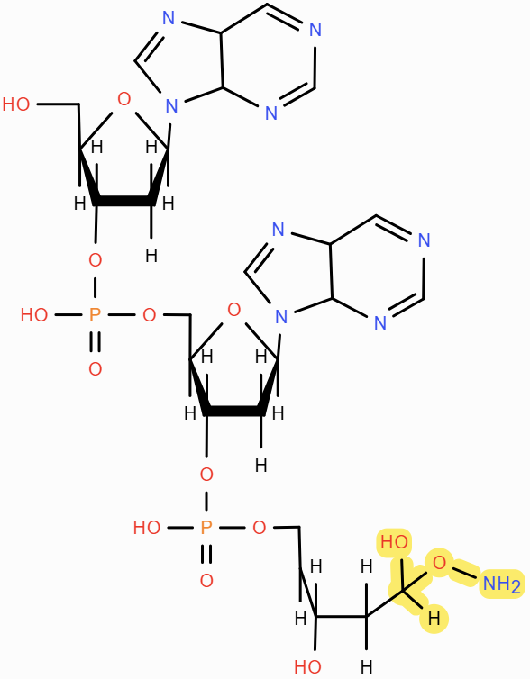
dA₈ | 772.1 | C₅H₇N₅（Adenine） | NH₃
dA₈ | 657.2 | C₆₀H₇₃N₃₀O₂₉P₅（dA₆） | NH₃ | 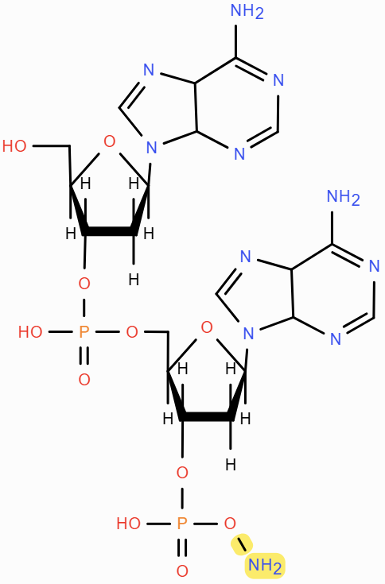
dA₈ | 657.2 | C₅H₆N₅（Adenine minus  its amino group） | NH₃
dT₈ | 2406.5 | -- | unknown | unknown
dT₈ | 2289.6 | C₄H₄ON（Thymine rupture structural） | -- | 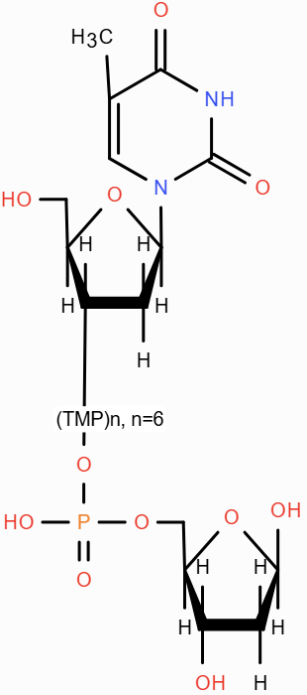
dT₈ | 2148.2 | C₁₂H₁₄N₅O₇（dA Group） | -- | 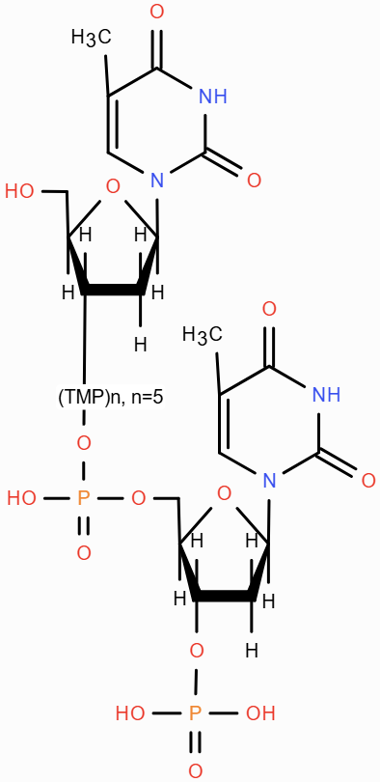
dT₈ | 2067.0 | C₁₀H₁₅N₂O₈P（dT） | -- | 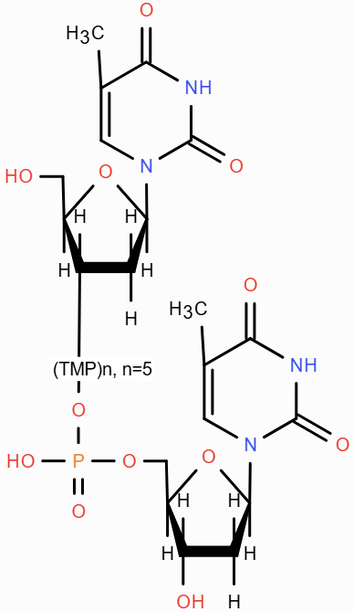
dT₈ | 1843.2 | C₁₀H₁₄N₂O₅（5'-dT） | -- | 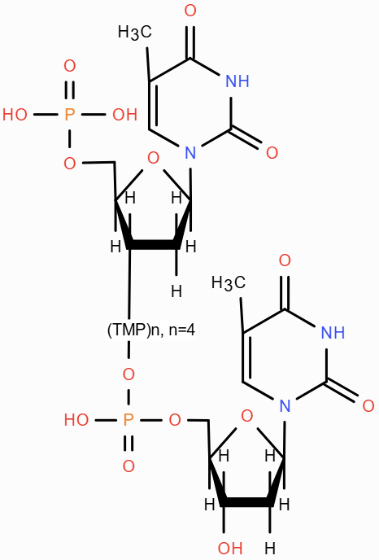
dT₈ | 1843.2 | C₁₀H₁₅N₂O₈P（dT） | --
dT₈ | 1581.6 | dT₃ | 2（NH₃） | 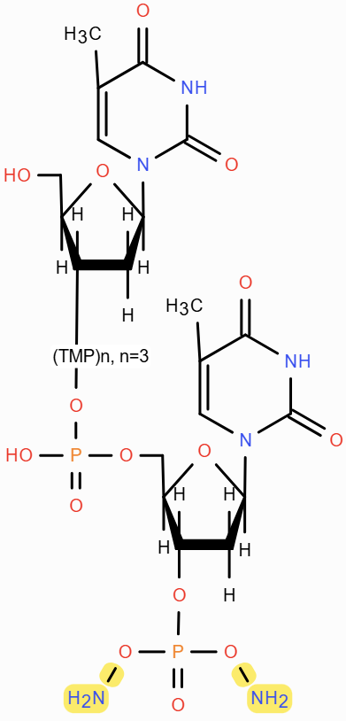
dT₈ | 1211.1 | dT₄ | -- | 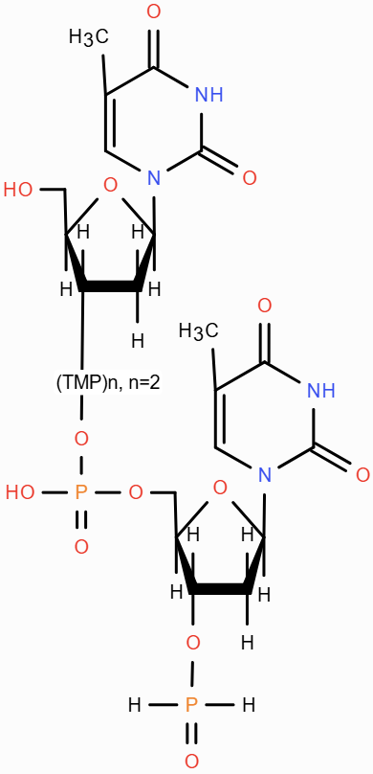
dG₈ | 2438.3 | C₅H₆N₅O（uanine minus its amino group） | -- | 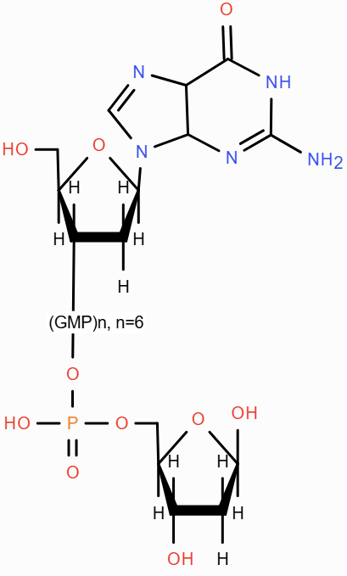
dG₈ | 2242.9 | C₁₀H₁₄N₅O₇P（dG） | -- | 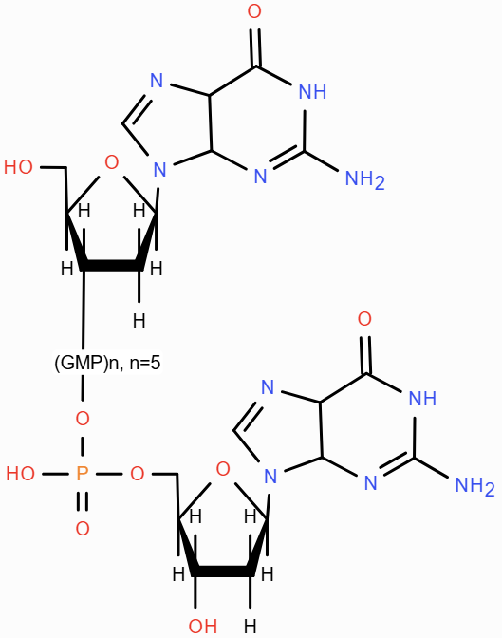
dG₈ | 1993.7 | C₂₀H₂₄N₁₀O₁₀P（5'-dG₂） | -- | 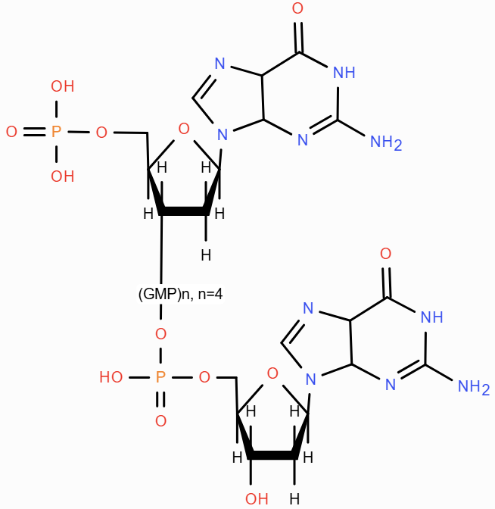
dG₈ | 1913.3 | C₂₀H₂₇N₁₀O₁₃P₂（dG₂） | -- | 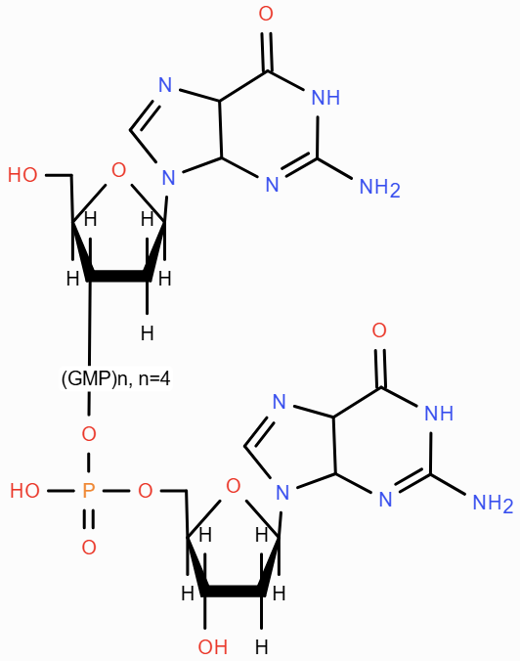
dC₈ | 2301.3 | -- | unknown | unknown
dC₈ | 2043.2 | C₉H₁₃N₃O₅（5'-dC） | -- | 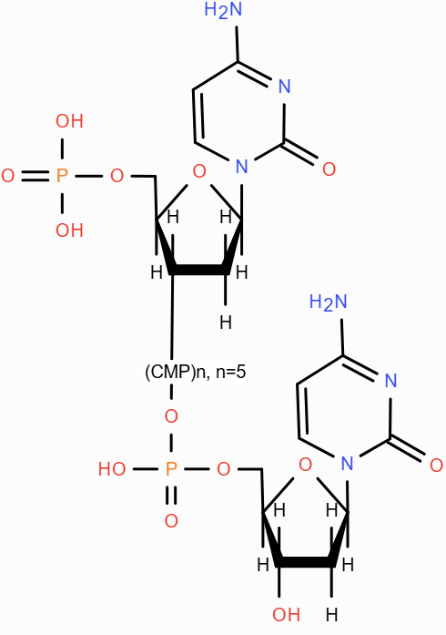
dC₈ | 1963.1 | C₁₈H₂₇N₆O₁₅P₂（dC₂） | -- | 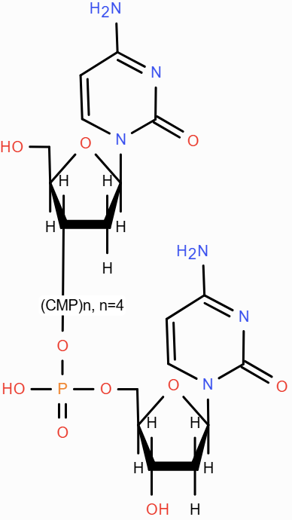
dC₈ | 1501.3 | C₉H₁₃N₃O₅（5'-dC） | -- | 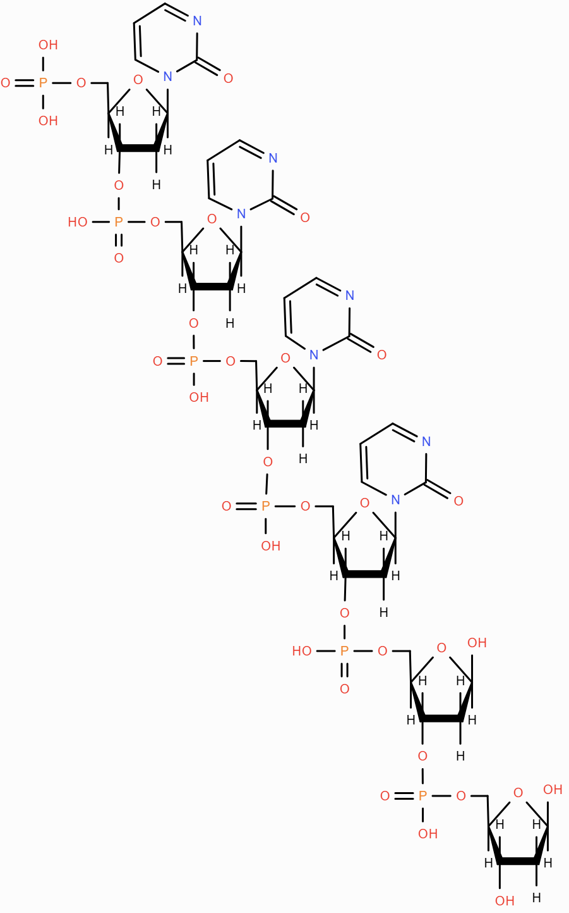
dC₈ | 1501.3 | dC | --
dC₈ | 1501.3 | 4（NH₃） | --
dC₈ | 1271.3 | C₂₇H₄₀N₉O₂₂P₃（dC₃） | -- | 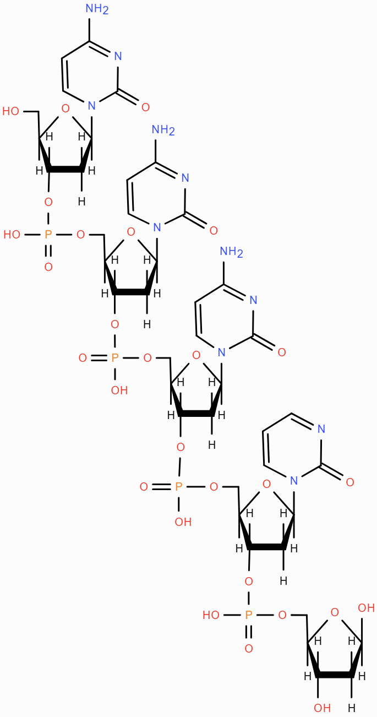
dC₈ | 1271.3 | C₄H₅N₃O（Cytosine） | --
Table S2 CPMI / ARTP / UV / Chmeical（EMS/NTG） / γ
Minimal comparison of mutagenesis modalities (six key dimensions).
Modality | Medium | Power / Distance | Cooling | Toxicity | Key Takeaway
CPMI (this work) | Air (no specialty gas) | 2–8 W; 2–6 cm | Not required | Non-toxic (no chemical residues)  *Basic ventilation for O3/NOx recommended* | Low-power yet effective; requires high-throughput screening to capture beneficial variants.
ARTP (plasma) | Ar / N2 (typical) | ≈180 W; mm-level gap | Typically required (head / gas-flow) | Low (no residues; gas/HV safety) | High excitation density but needs gas logistics and cooling.
UV (254 nm) | — | Dose = intensity × time | Not required | Low–Moderate (operator protection) | Simple and cheap; mutation spectrum biased; shading/dose control issues.
Gamma / ion beam | Facility-based | Facility dose settings | Facility-level | Moderate–High (radiation safety) | Large structural changes; dedicated facility and scheduling.
Chemical (EMS/NTG) | Hazardous chemicals | Concentration × time | Not required | High (toxic/carcinogenic; waste) | High efficiency; broad SNV spectrum; decontamination and waste burden.
Biological (ALE / editing) | Media / enzymes / kits | Design-/cycle-dependent | Not required | Low (method-dependent) | Precision (editing) or adaptive outcomes (ALE); time- and labor-intensive; editing may be regulated.
Notes:
1) CPMI uses ambient air as the discharge medium and generates minimal heat at low power (2–8 W), running stably at room temperature without active cooling.
2) ARTP commonly uses argon or nitrogen as the working gas and typically requires head/gas-flow cooling to stabilize discharge.

Figure S1. Mass spectrometry profiles of dA8, dG8, dC8, and dT8 oligonucleotides following 2 minutes of CPMI treatment, showing m/z values from 421 to 1650 and from 0 to 3000. CPMI generates base modifications consistent with oxidative DNA damage.
