Table S1. Characteristics by sarcopenia categories.
Variable | Non-sarcopenia (n = 48) | Possible sarcopenia (n = 83) | Sarcopenia (n = 63) | P-valueª
Age, mean (SD), years | 78.8 ± 5.6 | 81.7 ± 7.0 | 82.6 ± 6.9 | 0.009^{c}
Sex, n (%) (female) | 37 (77.1) | 64 (77.1) | 46 (73.0) | 0.824
Height, mean (SD), cm | 159.5 ± 6.6 | 154.9 ± 8.2 | 154.3 ± 9.5 | <0.01^{b,c}
Weight, mean (SD), kg | 61.4 ± 7.9 | 54.6 ± 9.2 | 48.9 ± 8.3 | <0.001^{b,c,d}
BMI, mean (SD), kg/m² | 24.2 ± 3.3 | 22.7 ± 3.2 | 20.6 ± 3.5 | <0.05^{b,c,d}
ASMI, mean (SD), kg/m² (n = 119)
Male | 7.2 ± 1.0 | 7.5 ± 0.4 | 5.4 ± 0.7 | <0.001^{c,d}
Female | 6.4 ± 0.8 | 6.1 ± 0.2 | 4.8 ± 0.7 | <0.001^{c,d}
Handgrip strength, mean (SD), kg (n = 194)
Male | 31.6 ± 4.0 | 18.4 ± 6.0 | 19.0 ± 4.2 | <0.001^{b,c}
Female | 21.7 ± 3.6 | 12.4 ± 3.4 | 11.7 ± 3.2 | <0.001^{b.c}
Rehabilitation group, n (%) (FIRM) | 26 (54.2) | 39 (47.0) | 39 (61.9) | 0.302
Fracture type, n (%) |  |  |  | 0.273
Femoral neck | 21 (43.8) | 27 (32.5) | 31 (49.2)
Intertrochanteric | 24 (50.0) | 52 (62.7) | 28 (44.4)
Subtrochanteric | 3 (6.2) | 4 (4.8) | 4 (6.3)
Operation type, n (%) |  |  |  | 0.034
Hemiarthroplasty | 18 (37.5) | 48 (57.8) | 24 (38.1)
Total hip arthroplasty | 3 (6.2) | 2 (2.4) | 7 (11.1)
Internal fixation | 27 (56.2) | 33 (39.8) | 32 (50.8)
Pre-fracture Koval, mean (SD), score | 1.3 (0.7) | 1.7 (1.0) | 2.0 (1.6) | 0.008^{c}
Pre-fracture FAC, mean (SD), score | 4.8 (0.6) | 4.7 (0.6) | 4.5 (0.9) | 0.44^{c}
Pre-fracture gait impairment, n (%) | 2 (4.2) | 5 (6.0) | 11 (17.5) | 0.023
Previous history of hip fracture, n (%) | 1 (2.1) | 1 (1.2) | 9 (14.3) | 0.002
Cognitive impairment, n (%) | 10 (20.8) | 35 (42.2) | 35 (55.6) | 0.001
Osteoporosis, n (%) | 26 (54.2) | 63 (75.9) | 49 (77.8) | 0.011
Charlson Comorbidity Index, n (%) |  |  |  | 0.001
None | 14 (29.2) | 39 (47.0) | 15 (23.8)
Mild (1–2 conditions) | 22 (45.8) | 37 (44.6) | 29 (46.0)
Moderate (3–4 conditions) | 3 (6.3) | 5 (6.0) | 10 (15.9)
Severe (≥ 5 conditions) | 9 (18.8) | 2 (2.4) | 9 (14.3)
Postoperative complications, n (%) | 3 (6.2) | 1 (1.2) | 7 (11.1) | 0.037
Length of hospital stay, mean (SD), days | 22.3 ± 5.8 | 23.6 ± 7.0 | 25.1 ± 5.9 | 0.067^{c}
Days to surgery, mean (SD) | 2.4 ± 2.5 | 3.1 ± 3.1 | 3.4 ± 3.3 | 0.274^{c}
Days to rehabilitation, mean (SD) | 7.5 ± 3.1 | 7.5 ± 2.8 | 8.6 ± 4.2 | 0.134^{d}
Discharge destination, n (%) |  |  |  | 0.003
Home | 35 (72.9) | 36 (43.4) | 30 (47.6)
Institution | 13 (27.1) | 47 (56.6) | 33 (52.4)
Independent ambulation at 12 months, n (%) (n = 116) | 31 (86.1) | 20 (64.5) | 28 (57.1) | 0.016
Participants without muscle mass measurements were not classified as having confirmed sarcopenia, even if they had low handgrip strength. Sarcopenia status could not be determined in 9 participants due to missing baseline handgrip strength and muscle mass measurements.
FIRM, fragility integrated rehabilitation management; BMI, body mass index; ASMI, appendicular skeletal muscle mass index; HGS, handgrip strength; FAC, functional ambulation category.
ª P-values were calculated using one-way analysis of variance or the χ² test, as appropriate.
^{b} Non-sarcopenia vs. possible sarcopenia.
^{c} Non-sarcopenia vs. sarcopenia.
^{d} Possible-sarcopenia vs. sarcopenia.

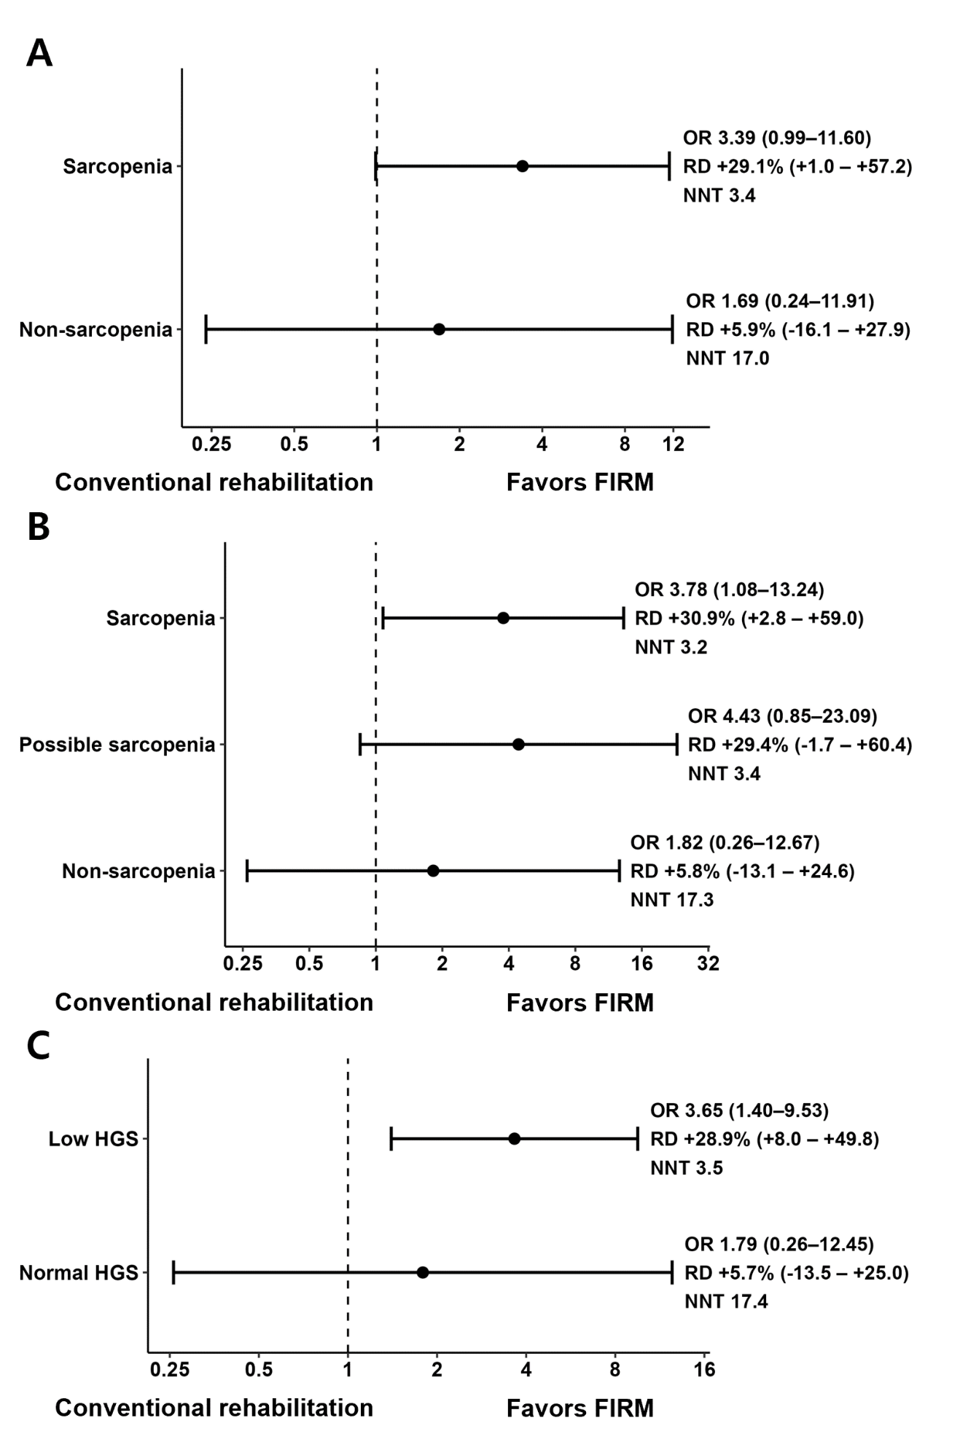
Figure S2. Age- and sex- adjusted effect of FIRM on 12-month independent ambulation. Panel A presents Model 1 (sarcopenia vs non-sarcopenia), Panel B presents Model 2 (three-level AWGS 2025 sarcopenia classification), and Panel C presents Model 3 (low vs normal handgrip strength). Treatment effects of FIRM compared with conventional rehabilitation are shown as stratum-specific odds ratios (ORs), risk differences (RDs), and numbers needed to treat (NNTs).

