Synthesis, photophysical, electrochemical, and DFT examinations of two new organic dye molecules based on phenothiazine and dibenzofuran
K. Periyasamy^{1*}, P. Sakthivel², G.Venkatesh³, P.M. Anbarasan⁴, P.Vennila⁵, Y.Sheena Mary⁶, S.Kaya⁷, Sultan Erkan⁸
¹Department of Physics, Vaigai Arts and Science Women’s College, Salem – 636 111, India
² Department of Physics, Selvamm Arts and Science College, Namakkal – 637 003, India
³Department of Chemistry, MMCAS, Rasipuram, Tamil Nadu-637408, India
⁴Department of Physics, Periyar University, Salem-636 011, India
⁵Department of Chemistry, Thiruvalluvar Government Arts College, Rasipuram – 637408, India
⁶Researcher, Thushara, Neethinagar-64, Kollam, Kerala, India
⁷Department of Chemistry, Cumhuriyet University, Sivas-58140, Turkey
⁸Department of Chemistry, Cumhuriyet University, Faculty of Science, Sivas-58140, Turkey

1.0 Synthetic procedure for PFCH and BFCH
(Z)-N-((5-(10H-phenothiazin-2-yl)furan-2-yl)methylene)-2-cyanoacetohydrazide (PFCH) and (Z)-2-cyano-N'-((5-(dibenzo[b,d]furan-4-yl)furan-2-yl)methylene)acetohydrazide (BFCH) were synthesized using (Pd(Ph₃)₄ as a catalyst in Suzuki coupling and Knoevenagel condensation reactions with (5-formylfuran-2-yl)boronic acid, as seen in Fig.1. 2-Chlorophenothiazine (0.47 g, 2 mmol), (5-formylfuran-2-yl)boronic acid (82.1 mg, 0.53 mmol), (Pd(Ph₃)₄ (0.05 g, 0.04 mmol), sodium carbonate (20 ml (2 M)), THF 10 ml, and purified water 5 ml are added to round-bottom flasks and boiled for one hour at 45°C. After cooling and quenching with 50 ml of distilled water, the mixture was isolated with CH₂Cl₂ (30 ml). The organic process is washed (50 ml) with purified water, dried with anhydrous sodium sulphate, and filtered. The compound was purified using column chromatography by silica gel with a mixture of CH₂Cl₂ and Hexane (1:6), then recrystallized with methanol/CH₂Cl₂, yielding a brown solid of 5-(10H-phenothiazin-2-yl)furan-2-carbaldehyde. A brown solid of 5-(10H-phenothiazin-2-yl)furan-2-carbaldehyde (0.34g, 1.09 mmol), 2-cyanoacetohydrazide (0.17 g, 1.72 mmol), piperidine (3 ml), and acetic acid (10 ml) was thoroughly mixed in a round-bottom flask. The round-bottom flask is connected to the reflux condenser, and the mixture has been heated at a constant temperature of 120°C for 12 hours. The mixture was allowed to cool to room temperature before being quenched with 5 ml of distilled water and the precipitate was purified and cleaned with distilled water. The residue was purified by column chromatography on silica (CH₂Cl₂/Ethanol 10:1) to yield 0.22 g of brown solid.
4-Bromodibenzofuran (0.5 g, 2.02 mmol), (5-formylfuran-2-yl)boronic acid (82.1 mg, 0.53 mmol), (Pd(Ph₃)₄ (0.05 g, 0.04 mmol, Sodium carbonate (20 ml 2 M), THF 15 ml, and purified water 10 ml are placed in round-bottom flasks and heated for two hours at 60°C. The mixture was subjected and quenched with purified water (30 ml) before being removed with CH₂Cl₂ (15ml). The mixture was cooled, and quenched with distilled water (30 ml), extracted with CH₂Cl₂ (30 ml). The residual is cleaned, dried, purified, and recrystallized using the same process. The mixture of 5-(dibenzo[b,d]furan-4-yl)furan-2-carbaldehyde (0.34 g, 1.078 mmol), 2-cyanoacetohydrazide (0.17 g, 1.72 mmol), piperidine (3ml), and acetic acid (10 ml) was stirred continuously for 12 hours at a steady temperature of 100 C. Following closure, the reaction was cooling and purified using the same procedure. Column chromatography on silica (CH₂Cl₂/Ethanol 10:1) was used to effectively purify the BFCH dye compound, yielding 0.18 g of brown solid.
2.0 Fabrication of the dye-sensitized solar cells
A fluorine-doped tin oxide conducting glass is washed in an ultrasonic bath with distilled water, alcohol and followed acetone to remove unnecessary objects. According to the previously study, titanium oxide nanoparticles (20 nm) have been prepared through a hydrothermal treatment with a precursor solution containing Ti(OBu)₄ (10 mL), ethanol (20 mL), acetic acid (18 mL), and distilled water (50 mL). The TiO₂ powder (1.0 g) had been ground for 40 minutes in a solution of ethanol (8.0 mL), acetic acid (0.2 mL), terpineol (3.0 g), and ethyl cellulose (0.5 g). The homogenized slurry was then sonicated in an ultrasonic bath for 15 minutes to create a viscous white titanium oxide paste. The paste was then screen-printed onto FTO glass and titanium oxide photoanodes (approximately 16 μm thickness) have been prepared. To extract the organic material, the primed films were annealed in a muffle furnace. Titanium oxide films have been soaking in TiCl₄ (0.04 M) aqueous phase for 30 minutes at 70°C to increase photocurrent and photovoltaic efficiency. The treated films are again cleaned with distilled water and ethanol before being sintered again at 520°C for 30 minutes. Since cooling to 80°C, the films are soaked in a 5.0 Χ 10⁻⁴ M solution of both dyes for 10 hours. Films is removed from solution and rinsed with CH₂Cl₂ to remove physical adsorbed organic dye. To evaluate the photovoltaic efficiency of dye-sensitized TiO₂/FTO glass films, they were sandwiched with a Pt/FTO counter electrode. The counter electrode is generated by thermally depositing a hexachloroplatinic acid hexahydrate (5 mM in isopropanol) solution onto FTO glass and then heating for 15 minutes in air at 400°C. The electrolyte (0.6 M 1-methyl-3-propylimidazolium iodide (PMII), 0.10 M guanidinium thiocyanate, 0.05 M LiI, 0.03 MI2 and 0.5 M tert-butylpyridine) in acetonitrile/valeronitrile (85:15) was inserted into the inter space between the photo anode and counter electrode through a hole created on the reference electrode. The dye coated TiO₂ film's active region was 0.16 cm², and the aspect ratio of the black mask used was approximately 0.25 cm².

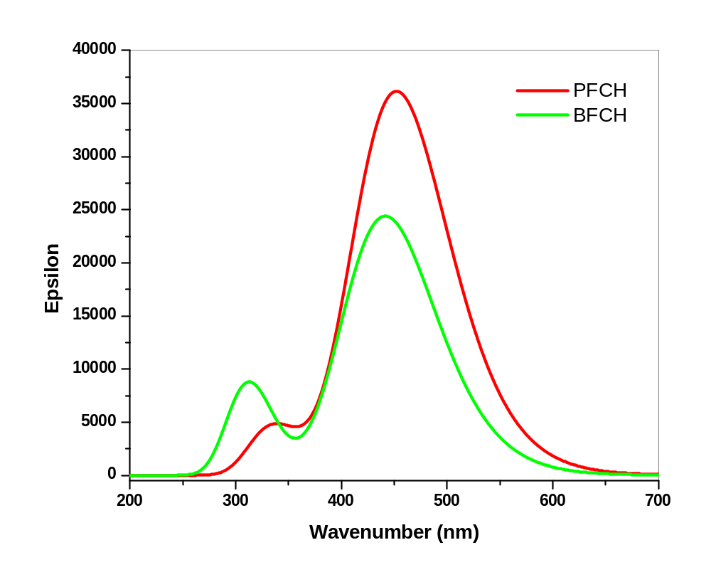
Figure S1: Calculated UV spectra of title compounds using 6-311G/CAM-B3LYP
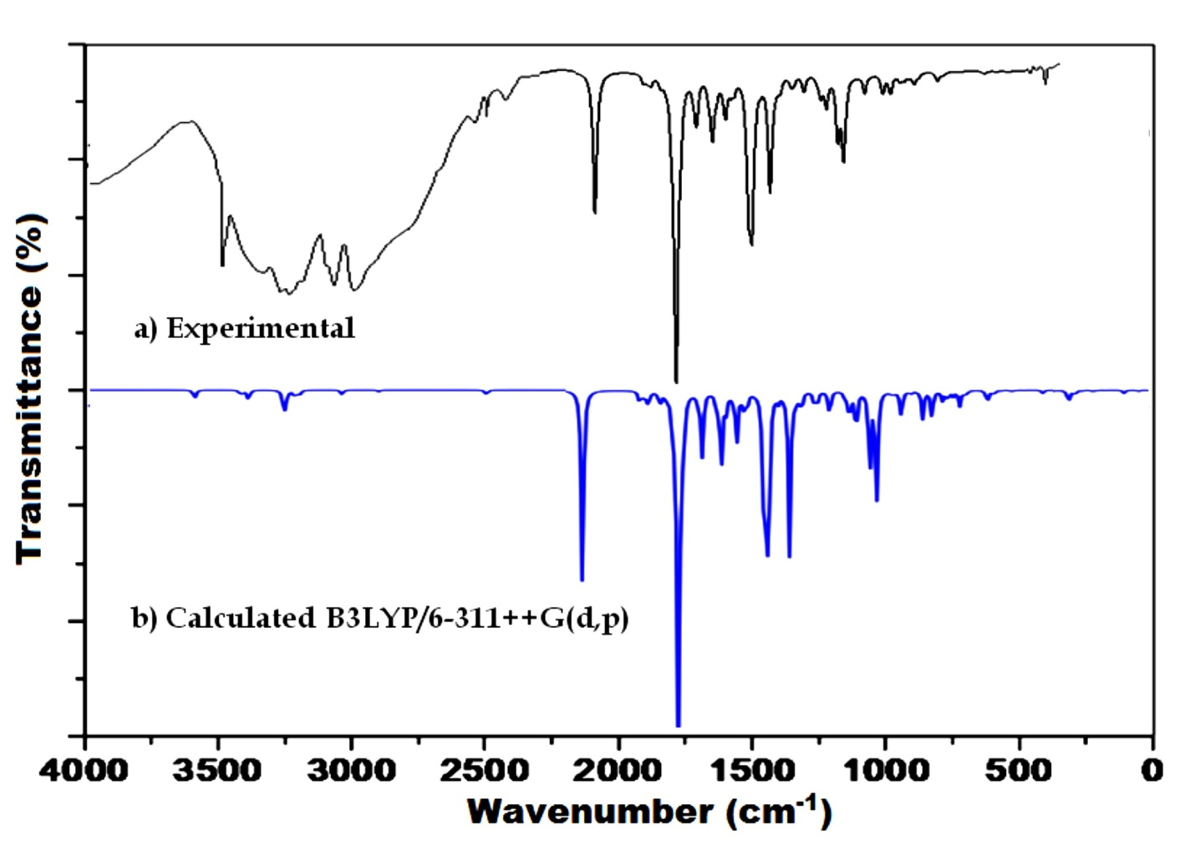
Figure S2: Vibrational spectra of PFCH
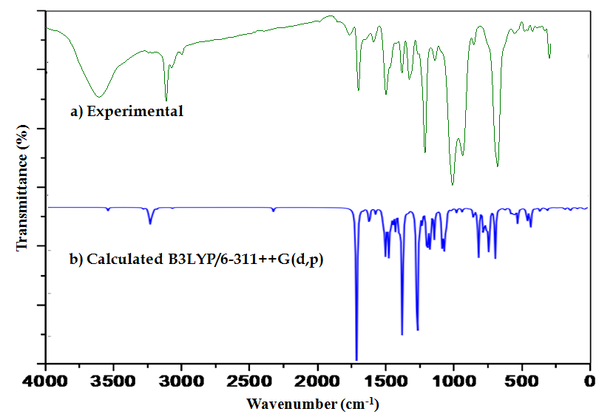
Figure S3: Vibrational spectra of BFCH
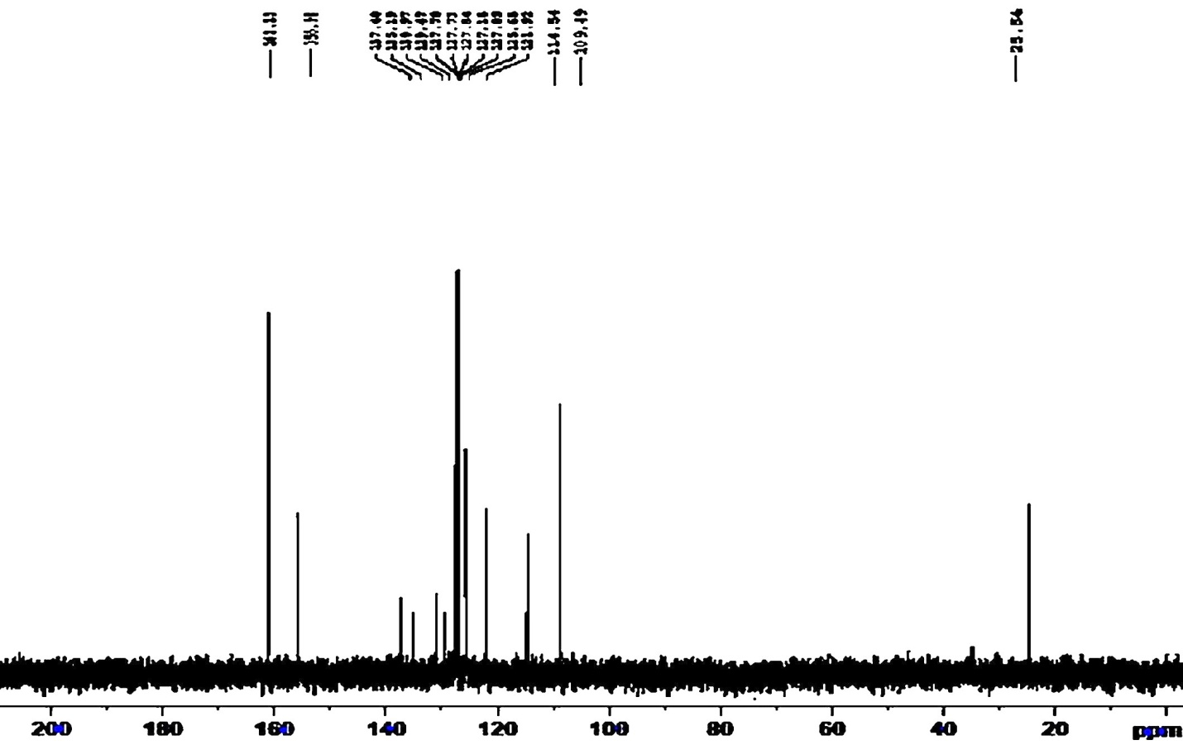
Figure S4: ¹³C NMR of PFCH
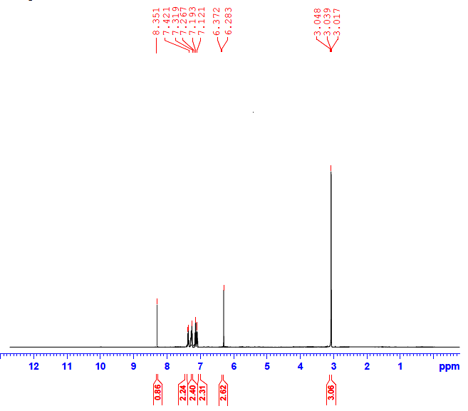
Figure S5: ¹H NMR of PFCH
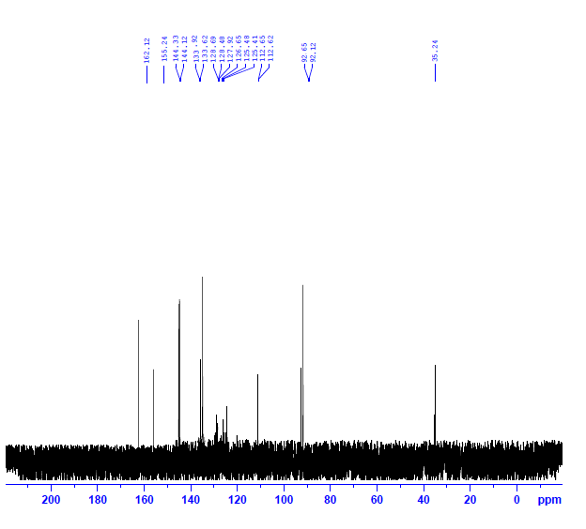
Figure S6: ¹³C NMR of BFCH
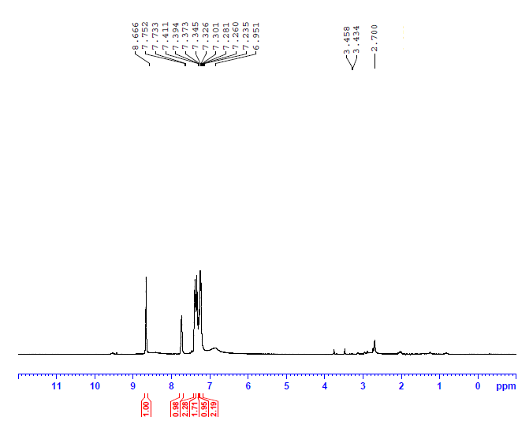
Figure S7: ¹H NMR of BFCH

Table S1: Natural bond orbital analysis of PFCH
Donor NBO(i) | Acceptor NBO(j) | E(2) kcal/mol | E(j)-E(i) au | F(i,j) au
C9-C10 | N5-C8 | 19.43 | 0.28 | 0.066
C9-C10 | C11-C12 | 14.44 | 0.30 | 0.060
C11-C12 | C9-C10 | 18.16 | 0.29 | 0.066
C11-C12 | C14-C15 | 12.99 | 0.31 | 0.059
C13-C26 | C14-C15 | 20.23 | 0.29 | 0.070
C13-C26 | C16-C17 | 16.67 | 0.28 | 0.062
C14-C15 | C11-C12 | 19.90 | 0.27 | 0.066
C14-C15 | C13-C26 | 18.57 | 0.27 | 0.064
C14-C15 | C16-C17 | 22.63 | 0.27 | 0.070
C16-C17 | C13-C26 | 20.80 | 0.28 | 0.070
C16-C17 | C14-C15 | 17.14 | 0.29 | 0.065
C19-C20 | C17-S18 | 16.35 | 0.29 | 0.063
C19-C20 | C23-C24 | 20.97 | 0.28 | 0.071
C21-C22 | C19-C20 | 22.72 | 0.27 | 0.071
C21-C22 | C23-C24 | 18.91 | 0.27 | 0.065
C23-C24 | C19-C20 | 17.62 | 0.28 | 0.063
C23-C24 | C21-C22 | 21.37 | 0.29 | 0.070
O3 | C1-C2 | 21.39 | 0.61 | 0.103
O3 | C1-N4 | 24.38 | 0.68 | 0.117
N4 | C1-O3 | 54.25 | 0.28 | 0.113
N4 | N5-C8 | 28.56 | 0.28 | 0.082
N5 | C8-C9 | 11.13 | 0.89 | 0.090
N7 | C2-C6 | 11.78 | 0.96 | 0.095
S18 | C16-C17 | 11.71 | 0.26 | 0.053
S18 | C19-C20 | 10.84 | 0.27 | 0.051
N25 | C13-C26 | 34.04 | 0.28 | 0.090
N25 | C23-C24 | 31.88 | 0.29 | 0.088
O41 | C9-C10 | 23.54 | 0.34 | 0.082
O41 | C11-C12 | 25.62 | 0.35 | 0.087

Table S2: Natural bond orbital analysis of BFCH
Donor NBO(i) | Acceptor NBO(j) | E(2) kcal/mol | E(j)-E(i) au | F(i,j) au
N5-C6 | C7-C8 | 10.28 | 0.35 | 0.057
C7-C8 | N5-C6 | 22.19 | 0.28 | 0.071
C7-C8 | C9-C10 | 15.05 | 0.30 | 0.061
C9-C10 | C7-C8 | 17.76 | 0.29 | 0.066
C9-C10 | C18-C19 | 13.83 | 0.30 | 0.060
C12-C13 | C14-C15 | 14.73 | 0.28 | 0.059
C12-C13 | C16-C17 | 19.32 | 0.29 | 0.068
C12-C13 | C18-C19 | 18.91 | 0.28 | 0.066
C14-C15 | C12-C13 | 15.05 | 0.28 | 0.058
C14-C15 | C20-C21 | 18.93 | 0.28 | 0.066
C14-C15 | C22-C23 | 19.43 | 0.28 | 0.068
C16-C17 | C12-C13 | 19.51 | 0.27 | 0.067
C16-C17 | C18-C19 | 21.44 | 0.27 | 0.070
C18-C19 | C9-C10 | 20.09 | 0.27 | 0.067
C18-C19 | C12-C13 | 22.28 | 0.28 | 0.071
C18-C19 | C16-C17 | 18.12 | 0.28 | 0.065
C20-C21 | C14-C15 | 22.36 | 0.28 | 0.072
C20-C21 | C22-C23 | 18.31 | 0.28 | 0.064
C22-C23 | C14-C15 | 19.14 | 0.27 | 0.067
C22-C23 | C20-C21 | 20.68 | 0.28 | 0.068
O3 | C1-C2 | 21.44 | 0.60 | 0.103
O3 | C1-N4 | 23.82 | 0.69 | 0.116
N4 | C1-O3 | 57.43 | 0.27 | 0.115
N4 | N5-C6 | 31.77 | 0.27 | 0.084
N5 | C6-C7 | 11.51 | 0.89 | 0.091
O11 | C12-C13 | 22.87 | 0.35 | 0.084
O11 | C14-C15 | 21.48 | 0.35 | 0.082
N25 | C2-C24 | 11.74 | 0.96 | 0.095
O39 | C7-C8 | 22.10 | 0.36 | 0.081
O39 | C9-C10 | 23.63 | 0.36 | 0.084

Table S3: Vibrational assignments of PFCH
S.No. | Experimental | Calculated | IR  Intensity | TED (%)
1 | 3503 | 3512 | 2.39 | νNH(100)
2 | 3356 | 3354 | 0.96 | νNH(94)
3 | 3152 | 3145 | 0.52 | νCH(100)
4 | 3122 | 3124 | 2.65 | νCH(98)
5 | - | 3097 | 2.38 | νCH(83)
6 | 3088 | 3089 | 3.72 | νCH(95)
7 | - | 3087 | 0.90 | νCH(92)
8 | - | 3078 | 0.25 | νCH(94)
9 | 3048 | 3055 | 1.69 | νCH(86)
10 | - | 3043 | 0.41 | νCH(99)
11 | 3028 | 3036 | 1.00 | νCH(86)
12 | 2988 | 2981 | 1.13 | νCH(94)
13 | 2872 | 2864 | 0.01 | νCH(99)
14 | 2851 | 2845 | 0.38 | νCH(100)
15 | 2341 | 2342 | 1.28 | νNC(89)
16 | 1801 | 1796 | 50.92 | νOC(15)
17 | 1592 | 1594 | 2.64 | νCC(42)
18 | 1588 | 1591 | 0.47 | νCC(23)
19 | 1581 | 1584 | 0.17 | νCC(12), νNC(14)
20 | - | 1575 | 1.67 | νCC(24)
21 | 1552 | 1563 | 2.48 | νCC(26)
22 | - | 1558 | 1.04 | νCC(18)
23 | 1514 | 1520 | 3.40 | νCC(24)
24 | 1488 | 1497 | 1.06 | νCC(31)
25 | - | 1475 | 9.13 | νOC(54)
26 | 1466 | 1462 | 10.09 | νCC(41), γHCN(11)
27 | - | 1455 | 100.00 | νCC (22)
28 | 1429 | 1438 | 5.25 | νCC (12)
29 | - | 1438 | 7.42 | νCC (22)
30 | - | 1390 | 0.73 | νCC (18)
31 | 1381 | 1383 | 3.04 | νCC(21), γHCN(14)
32 | - | 1371 | 16.08 | νCC (11)
33 | - | 1321 | 4.44 | νCC (18)
34 | 1301 | 1305 | 20.88 | γHCC(54)
35 | 1294 | 1298 | 0.64 | γHCC(42)
36 | 1292 | 1288 | 4.70 | γHCC(12)
37 | - | 1266 | 1.39 | γHCC(24)
38 | - | 1251 | 13.92 | γHCC(19)
39 | 1224 | 1227 | 0.01 | αCCC(18) γHCC(8)
40 | 1218 | 1222 | 4.26 | νSC(24)
41 | - | 1215 | 4.45 | γHCC(28)
42 | - | 1189 | 0.16 | γHCC(28)
43 | 1179 | 1181 | 0.06 | νNC(14)
44 | 1166 | 1158 | 11.74 | νNC(26)
45 | - | 1152 | 29.56 | νNN(11)
46 | - | 1145 | 5.36 | γHCC(22)
47 | 1133 | 1139 | 43.87 | νSC(14)
48 | - | 1104 | 2.16 | νNN(31)
49 | 1097 | 1084 | 0.83 | νOC(36), βHCN(24)
50 | - | 1065 | 41.15 | τCCCC(16)
51 | 1042 | 1046 | 2.70 | βHCC(12)
52 | - | 1032 | 1.23 | γCSC(18)
53 | - | 1023 | 4.35 | βCCO(22)
54 | 977 | 978 | 3.66 | βHCC(14)
55 | - | 976 | 0.01 | βCCN(11)
56 | 972 | 970 | 0.04 | αCOC(17)
57 | - | 968 | 0.18 | αCOC(11)
58 | - | 967 | 2.32 | τHCCC(8)
59 | - | 932 | 0.35 | τHCCN(11)
60 | 918 | 926 | 2.27 | αCCO(12)
61 | - | 923 | 4.05 | νCS(33)
62 | 878 | 870 | 2.07 | αCCC(13), βHCC(14)
63 | - | 855 | 6.68 | τCCCC(12)
64 | - | 851 | 0.54 | βHCC(24)
65 | 844 | 847 | 0.16 | βNCC(18), βHCC(18)
66 | - | 834 | 1.41 | αCCC(10)
67 | 828 | 831 | 9.50 | νCS(12)
68 | - | 826 | 0.18 | αCOC(14)
69 | - | 784 | 21.45 | τCCCC(22)
70 | 758 | 761 | 11.32 | βHCC(18)
71 | - | 758 | 18.63 | τSCCC(22)
72 | 715 | 717 | 0.18 | βHCC(24), τCCNC(12)
73 | 716 | 714 | 0.13 | αCNC(14)
74 | - | 706 | 0.49 | τCCCN(12)
75 | 696 | 699 | 0.50 | αCOC(18)
76 | - | 684 | 0.39 | τCCNC(22), αCNC(10)
77 | - | 676 | 0.67 | αOCN(19)
78 | - | 672 | 6.26 | αCSC(15), αCNC(11)
79 | 644 | 646 | 0.24 | αOCN(11)
80 | - | 638 | 0.64 | αCCC(18)
81 | 518 | 617 | 0.14 | αNNC(22)
82 | - | 598 | 7.21 | αCNC(21)
83 | - | 566 | 4.26 | αCNC(14)
84 | 562 | 564 | 2.78 | αCOC(11)
85 | - | 559 | 0.20 | γCCC(14)
86 | 522 | 528 | 2.04 | γNCC(16)
87 | - | 527 | 0.66 | τNCCC(10)
88 | - | 510 | 2.49 | τCSCC(9)
89 | 488 | 490 | 1.44 | αCSCC(11)
90 | - | 468 | 4.09 | τOCCC(12)
91 | 446 | 448 | 0.91 | αCNN(14)
92 | - | 447 | 0.37 | τCCNC(12)
93 | 438 | 437 | 0.16 | τCNNH(26)
94 | - | 371 | 1.90 | τCNNH (18)
95 | - | 370 | 1.39 | τCNCC(11)
96 | - | 349 | 1.00 | τCNCC(14)
97 | - | 347 | 0.15 | τCCCC(15)
98 | - | 325 | 0.15 | τCCNN(11)
99 | - | 286 | 0.32 | τNCCC(14)
100 | - | 268 | 0.07 | τNCCC(15)
101 | - | 244 | 0.04 | αCNN(10)
102 | - | 237 | 0.03 | αNCC(34)
103 | - | 212 | 0.04 | τCNCC(25)
104 | - | 177 | 0.80 | αNCC(34)
105 | - | 150 | 0.03 | αCNC(11)
106 | - | 136 | 0.01 | αNCC(14)
107 | - | 126 | 0.13 | αCCS(12)
108 | - | 123 | 0.15 | τCNNC(11)
109 | - | 102 | 0.05 | τNCCC(15)
110 | - | 98 | 0.42 | τCCNN(28)
111 | - | 84 | 0.01 | τSCCC(11)
113 | - | 66 | 0.01 | αCNC(12)
114 | - | 59 | 0.02 | τOCNC(10)
115 | - | 48 | 0.07 | τCCOC(12)
116 | - | 41 | 0.60 | τCCCC(33)
117 | - | 33 | 0.81 | τCCCC(12)

Table S4: Vibrational assignments of BFCH
S.No. | Experimental | Calculated | IR  Intensity | TED (%)
1 | 3446 | 3452 | 1.95 | νNH(100)
2 | 3202 | 3208 | 0.94 | νCH(97)
3 | - | 3081 | 2.08 | νCH(94)
4 | 3096 | 3089 | 1.68 | νCH(74)
5 | - | 3072 | 4.35 | νCH(66)
6 | 3069 | 3066 | 6.92 | νCH(84)
7 | - | 3061 | 0.64 | νCH(57)
8 | 3052 | 3053 | 2.07 | νCH(64)
9 | - | 3048 | 1.04 | νCH(50)
10 | 3046 | 3042 | 0.25 | νCH(52)
11 | - | 3025 | 0.96 | νCH(59)
12 | 2954 | 2948 | 0.01 | νCH(78)
13 | 2918 | 2916 | 0.63 | νCH(99)
14 | 2229 | 2223 | 2.47 | νNC(88)
15 | 1658 | 1652 | 97.55 | νCC(75)
16 | - | 1607 | 0.90 | νCC(58)
17 | 1575 | 1578 | 0.11 | νOC(14)
18 | 1562 | 1571 | 3.72 | νCC(62)
19 | - | 1566 | 2.59 | νCC(33)
20 | - | 1563 | 4.95 | νCC(16)
21 | 1518 | 1522 | 3.30 | νCC(47)
22 | - | 1472 | 7.60 | νCC(69)
23 | - | 1458 | 13.83 | νCC(49)
24 | 1448 | 1453 | 19.30 | νCC(38), γHCN(24)
25 | - | 1433 | 26.26 | νCC(19)
26 | 1422 | 1420 | 10.86 | νCC(28)
27 | - | 1403 | 7.65 | νCC(10)
28 | 1388 | 1386 | 11.12 | νNC(30)
29 | - | 1361 | 10.75 | νCC (18), γHCN(10)
30 | - | 1356 | 3.96 | νCC (11)
31 | 1333 | 1339 | 78.67 | γHCC(41), νNC(14)
32 | - | 1329 | 0.31 | γHCC(17)
33 | 1301 | 1305 | 1.05 | γHCC(18), γHCN(11)
34 | - | 1297 | 1.21 | γHCH(8), νCC(13)
35 | - | 1248 | 1.31 | νCC (25)
36 | 1236 | 1237 | 100.00 | γHCC(18), νNC(11)
37 | - | 1220 | 7.38 | γHCC(26)
38 | - | 1203 | 6.65 | γHCC(21), γHCN(8)
39 | - | 1190 | 0.01 | νNC(15), αCCC(10)
40 | - | 1174 | 16.09 | τCCCC(16)
41 | - | 1164 | 16.24 | αHCCN(11)
42 | 1158 | 1159 | 2.00 | γHCC(28)
43 | 1149 | 1147 | 26.82 | γHCC(18)
44 | - | 1119 | 16.34 | νNC(8)
45 | 1098 | 1100 | 0.91 | βCCN(18), γHCC(14)
46 | - | 1067 | 19.43 | νOC(12)
47 | - | 1053 | 25.48 | γHCC(17)
48 | 1042 | 1040 | 14.48 | νNN(44), γOC(12)
49 | - | 1004 | 0.57 | αCCC(18)
50 | - | 1001 | 0.88 | νNN(18)
51 | - | 969 | 0.00 | τCCCC(16)
52 | - | 967 | 2.48 | τHCCC(22), γCNC(11)
53 | 964 | 966 | 0.19 | βHCC(22)
54 | - | 929 | 1.87 | βHCC(10)
55 | - | 927 | 0.45 | βHCC(22)
56 | 918 | 921 | 0.17 | τHCCC(52)
57 | - | 905 | 0.10 | τCCCC(14)
58 | 891 | 884 | 0.38 | βCCN(11)
59 | - | 851 | 3.96 | τHCCN(14)
60 | - | 850 | 2.16 | αCCO(20)
61 | 826 | 825 | 1.57 | γCCC(19), βHCC(11)
62 | - | 816 | 29.15 | τHCCC(15)
63 | - | 813 | 0.21 | τCCCC(12)
64 | - | 788 | 0.12 | βHCC(16)
65 | - | 781 | 16.54 | τHCCC(16)
66 | - | 764 | 11.76 | αCCC(19)
67 | 746 | 748 | 23.58 | βHCC(26), τCCCN(11)
68 | - | 740 | 8.75 | αCCC(10)
69 | - | 717 | 0.01 | αCCC(14)
70 | - | 701 | 26.86 | τCOCC(11)
71 | 702 | 700 | 1.72 | τCOCC(18)
72 | - | 669 | 0.29 | τCCNC(17)
73 | 632 | 635 | 1.46 | αCNC(23)
74 | - | 609 | 0.04 | αCCC(14)
75 | - | 592 | 3.55 | τCCCC(20)
76 | - | 581 | 2.65 | τCCCC(61)
77 | - | 569 | 2.67 | τCCCC(35)
78 | - | 565 | 1.61 | τCOCC(34)
79 | 555 | 557 | 0.06 | τHNNC(43)
80 | - | 547 | 9.13 | τCCCC(34)
81 | - | 545 | 0.09 | τCCOC(21)
82 | 522 | 523 | 0.48 | αCCC(24)
83 | - | 497 | 0.24 | αCCC(27)
84 | - | 482 | 8.57 | τCCCC(36)
85 | - | 464 | 3.62 | τCCCC(31)
86 | - | 457 | 9.61 | βCNN(12)
87 | - | 423 | 0.68 | βOCC(24)
88 | - | 393 | 2.59 | τNNCC(12)
89 | - | 358 | 0.51 | τOCCC(30)
90 | - | 344 | 1.76 | τCCOC(16)
91 | - | 343 | 0.00 | αOCN(23)
92 | - | 325 | 0.28 | αCCC(25)
93 | - | 287 | 0.01 | αCCO(36)
94 | - | 279 | 0.19 | τCCOC(17)
95 | - | 267 | 0.08 | τOCCC(19)
96 | - | 228 | 0.31 | αNCC(20)
97 | - | 222 | 1.05 | αCCC(18)
98 | - | 187 | 1.70 | αCCC(29)
99 | - | 182 | 0.80 | τNCCC(14)
100 | - | 164 | 0.00 | αCCC(11)
101 | - | 138 | 0.79 | τCCCC(77)
102 | - | 109 | 0.05 | αCCC(22)
103 | - | 98 | 0.55 | τCCCC(13)
104 | - | 90 | 0.53 | αOCC(14)
105 | - | 84 | 0.60 | αNCCC(28)
106 | - | 76 | 0.00 | αNCCC(18)
107 | - | 58 | 2.31 | αNNCC(20)
108 | - | 44 | 0.58 | τCNNC(10)
109 | - | 36 | 0.24 | τNCCC(18)
110 | - | 28 | 0.25 | τCCNN(10)
111 | - | 22 | 5.66 | τCCCN(25)

