Supplementary Figures
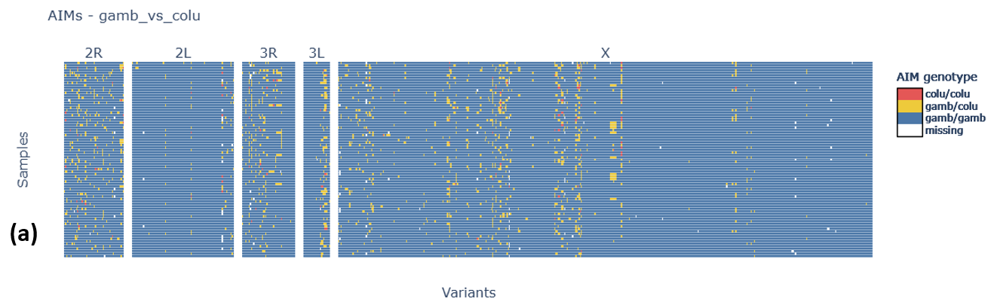
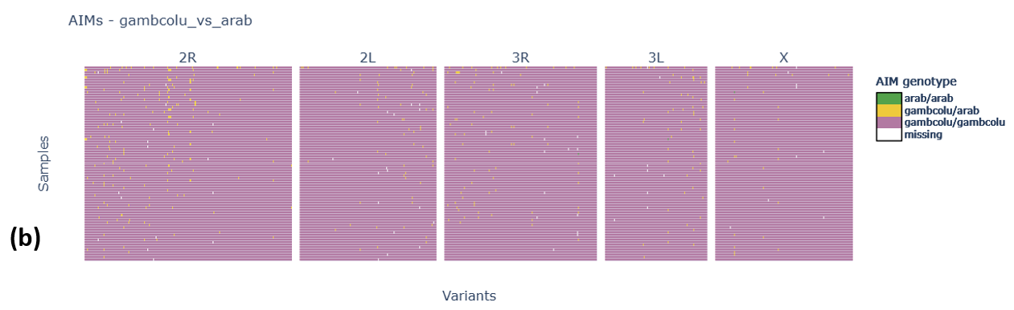
Figure S1. The taxonomic structure of the Anopheles gambiae by ancestral informative markers (AIM), Anopheles gambiae versus Anopheles coluzzii (top), and Anopheles gambiae/coluzzii versus arabiensis (bottom).

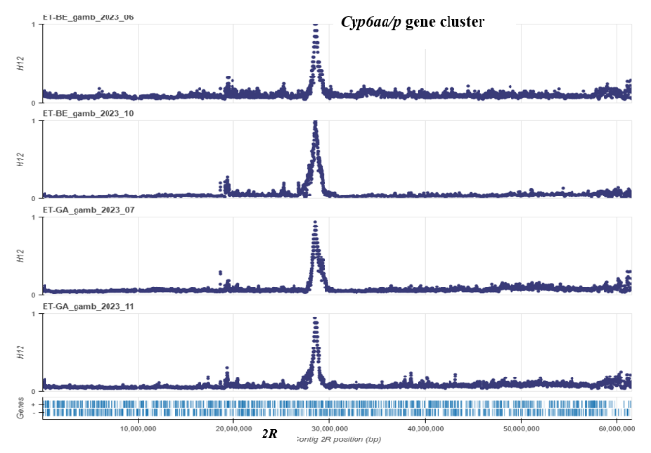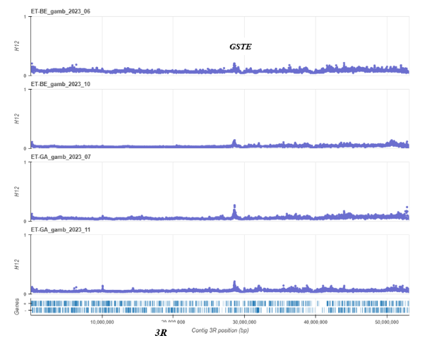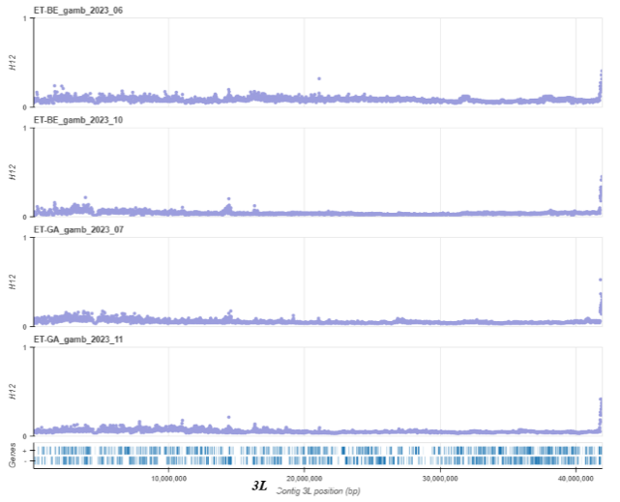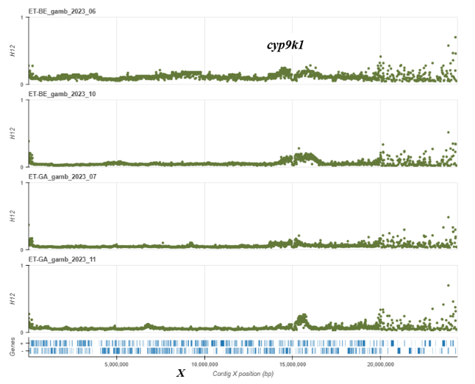
Figure S2. Genome-wide selection scan indicating strong recent positive selection sweep onto the 2R (Cyp6aa/p, Cyp6ad1, and Coeae6o), 3R (gste), and X (Cyp9k1) chromosome arms using the H12 statistics.

Supplementary Tables
Table S1. Putative genes showing increased H12 values (peaks) in both Gambella and Benishangul-Gumuz Anopheles gambiae cohorts.
Gene ID | Contig | Start | End | Name | Description
AGAP006517 | 2L | 33,767,545 | 33,773,835 | Gryzun | protein-coding gene
AGAP006518 | 2L | 33,776,282 | 33,777,612 | charged multivesicular body protein 1 | protein-coding gene
AGAP006532 | 2L | 33,939,186 | 33,946,087 | UDP-glucose 6-dehydrogenase | protein-coding gene
AGAP006535 | 2L | 33,963,337 | 33,969,843 | Oseg1 | outer segment 1
AGAP006533 | 2L | 33,948,755 | 33,950,031 | surfeit locus 1 family protein | protein-coding gene
AGAP006569 | 2L | 34,158,499 | 34,168,017 | acetyl-CoA synthetase | protein-coding gene
AGAP006570 | 2L | 34,168,871 | 34,170,407 | myo-inositol-1(or 4)-monophosphatase | protein-coding gene
AGAP006571 | 2L | 34,170,872 | 34,203,002 | nuclear receptor subfamily 1 group D member 3 | protein-coding gene
AGAP006590 | 2L | 34,288,135 | 34,391,778 | T-lymphoma invasion and metastasis-inducing protein 1 | protein-coding gene

Table S2. sample sets and accession numbers for Anopheles gambiae sequence data.
Sample sets | Accession numbers
1324-VO-ET-GOLASSA-VMF00257 | ERR12314211-ERR12314243
1324-VO-ET-GOLASSA-VMF00257 | ERR12326237-ERR12326277
1324-VO-ET-GOLASSA-VMF00275 | ERR12983154-ERR12983193
1324-VO-ET-GOLASSA-VMF00275 | ERR13101381-ERR13101432

