Supplementary Information
Projecting May Tornado Outbreak Patterns in a Warming Climate
Paulina Ćwik¹, Renee A. McPherson¹, Funing Li², Jason C. Furtado³, Harold E. Brooks^{3,4}, Hugo K. Lee⁵
¹South Central Climate Adaptation Science Center, 201 Stephenson Parkway, Suite 2100, Norman, Oklahoma.
² Department of Earth, Atmospheric, and Planetary Sciences, Massachusetts Institute of Technology, 77 Massachusetts Avenue, Cambridge, Massachusetts.
³School of Meteorology, The University of Oklahoma, 120 David L. Boren Blvd, Suite 5900, Norman, Oklahoma.
⁴NOAA National Severe Storms Laboratory, 120 David L. Boren Blvd., Norman, Oklahoma
⁵Jet Propulsion Laboratory, California Institute of Technology, 4800 Oak Grove Dr, Pasadena, California
Corresponding author: Paulina Ćwik (paulinacwik.new@gmail.com, paulinacwik@ou.edu)

Supplementary Methods

Supplementary Climatological Context
To provide context for the anomaly-based Maximum Covariance Analysis (MCA) patterns presented in the main manuscript, we computed May climatological means of WMAXSHEAR and 500-hPa geopotential height for the historical (1980–2014) and future (2065–2099) periods in the MPI-ESM1.2-HR simulations. Climatologies were calculated separately for each period and scenario to ensure consistency with the anomaly definitions used in the MCA methodology.
May climatologies were computed as gridpoint means across May timesteps for each period and scenario. Cosine-latitude area weighting was applied only when calculating domain-integrated summary statistics. Differences between historical and future mean states were evaluated to distinguish shifts in the baseline environment from changes in the anomaly structure identified by MCA. These fields are shown in Supplementary Figs. S1–S2.
Supplementary Pattern Magnitude Metrics

To further quantify changes in outbreak-supportive environments beyond spatial pattern comparison, we computed domain-integrated magnitude metrics from the MCA1 regression patterns for both WMAXSHEAR and 500-hPa geopotential height anomalies.

For each historical and future scenario, we calculated the domain-mean absolute regressuin magnitude, the mean magnitude of the positive WMAXSHEAR lobe, and the spatial maximum anomaly. These metrics allow direct comparison of the overall amplitude of outbreak-supportive patterns across emissions scenarios. Results are summarized in Supplementary Table S1.

Supplementary Spatial Exceedance Metrics

To characterize changes in the spatial footprint of the most intense outbreak-supportive environments, we calculated spatial exceedance statistics for WMAXSHEAR anomalies. Specifically, we quantified the number and fraction of grid points exceeding selected high-magnitude thresholds within each regression pattern.

These exceedance metrics complement the domain-mean statistics by highlighting changes in the areal extent of the strongest anomaly regions. These metrics are reported in Supplementary Table S2.

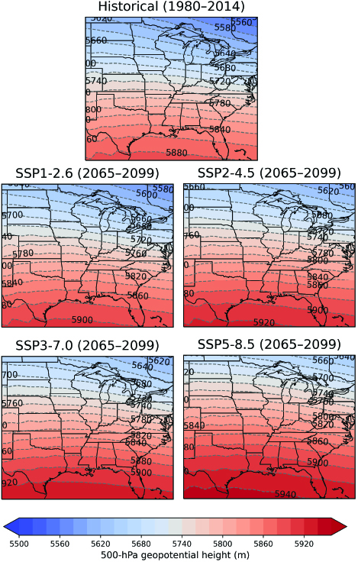

Supplementary Fig. S1. May climatological 500-hPa geopotential height (m) for the historical period (1980–2014) and future scenarios SSP1-2.6, SSP2-4.5, SSP3-7.0, and SSP5-8.5 (2065–2099) from the MPI-ESM1-2-HR model.

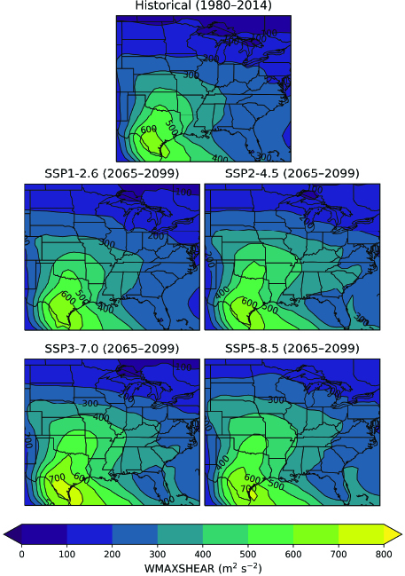

Supplementary Fig. S2. May climatological WMAXSHEAR (m² s⁻²) for the historical period (1980–2014) and future scenarios SSP1-2.6, SSP2-4.5, SSP3-7.0, and SSP5-8.5 (2065–2099) from the MPI-ESM1-2-HR model. Values represent monthly mean conditions, with contours denoting absolute magnitudes.
Supplementary Table 1. Summary metrics of the WMAXSHEAR regression pattern for the historical simulation and future scenarios. Pattern magnitude is quantified using the domain-mean absolute regression magnitude (MeanAbs), the mean of the positive lobe (MeanPos), and the spatial maximum (Max). Percent changes are relative to the historical simulation.

Simulation | MeanAbs (m² s⁻²) | Δ% vs hist | MeanPos (m² s⁻²) | Δ% vs hist | Max (m² s⁻²) |  | Δ% vs hist
Historical | 104.7 | – | 145.1 | – | 544.1 | –
SSP1-2.6 | 117.0 | +11.8 | 150.6 | +3.8 | 488.0 | –10.3
SSP2-4.5 | 114.6 | +9.5 | 151.7 | +4.6 | 530.2 | –2.5
SSP3-7.0 | 117.9 | +12.6 | 156.6 | +8.0 | 498.6 | –8.3
SSP5-8.5 | 132.1 | +26.1 | 182.3 | +25.7 | 591.2 | +8.7

Supplementary Table 2. Change in the spatial extent (per grid point) of strong positive WMAXSHEAR anomalies within the MCA-derived outbreak-supportive pattern relative to historical MPI. Percent changes are relative to the historical simulation.
Simulation | Threshold (m² s⁻²) | Number of grid cells | % of domain | Δ% vs historical
Historical | ≥ 350 | 70 | 5.9
SSP1-2.6 |  | 59 | 5.0 | –15.7
SSP2-4.5 |  | 87 | 7.3 | +24.3
SSP3-7.0 |  | 96 | 8.1 | +37.1
SSP5-8.5 |  | 131 | 11.0 | +87.1
Historical | ≥ 400 | 39 | 3.3
SSP1-2.6 |  | 23 | 1.9 | –41.0
SSP2-4.5 |  | 60 | 5.0 | +53.8
SSP3-7.0 |  | 60 | 5.0 | +53.8
SSP5-8.5 |  | 96 | 8.1 | +146.2
Historical | ≥ 450 | 17 | 1.4
SSP1-2.6 |  | 9 | 0.8 | –47.1
SSP2-4.5 |  | 32 | 2.7 | +88.2
SSP3-7.0 |  | 27 | 2.3 | +58.8
SSP5-8.5 |  | 68 | 5.7 | +300.0

