Supplemental Materials for Learning heritable multimodal brain representation via contrastive learning
Tian Xia, Xingzhong Zhao, Saiful Sheikh Muhammad Islam, Kamil Khan Mohammed, Ziqian Xie & Degui Zhi

- Supplementary Notes
- Supplementary Figures

Supplementary Notes

Notes 1: Model Training
The parameter of model training is as follows. Learing_rate 0.0001, img_size 182, patch_size 14, num_frames 224, tubelet_size 16, embed_dim 384, transformer_depth 12, transformder_num_heads 6, projector_dim 256, K (dictionary_size) 65536, m (momentum) 0.999, T(temperature) 0.07, symmetric=True, meaning both T1 and T2 get the chance to be queries and result loss is an average of two. We used AdamW optimizer with CosineAnnealingWarmRestarts scheduler of T_0=10, T_mult=2, eta_min=1e-6.

We performed training of MoCoV2 multimodal contrasting learning for 100 epoches until we see no further improvement. The hidden dimension is set with 384 because 128 dimension show substantial lower performance with loss 0.256 at epoch 100, compared with loss 0.089 (see Supplementary Figure 1).

Here we only report the training loss as validation loss has little or no direct meaning in contrastive learning. The loss value is strongly influenced by the composition of positive and negative samples, the number of negatives, and augmentation statistics, rather than reflecting an absolute notion of generalization. As a result, decreases in validation loss do not necessarily correspond to improved representation quality or downstream performance, and are therefore unreliable for model selection or early stopping.

Notes 2: Dimension reduction method ablation study
We conducted an ablation study to evaluate the impact of different patch-level dimensionality reduction methods, including PCA and average pooling. Attached is a comparison of their genetic discovery performance.

Model | SM-UDIP  (average pooling) | SM-UDIP (PCA) | MM-UDIP (PCA)
T1 T2 loci overlap | 36.9% | 17.4% | 52.3%
Heritability | - | T1: 0.11, T2:0.09 | T1:0.33, T2:0.33
Explained variance  (128 PCs) | - | 0.65 | 0.73

Notes 3: Model-level ablation study: Design of two intermediate models between MM (MoCoV2) and SM (ViT)
We designed two intermediate models bridging the multimodal (MM; MoCoV2) and single-modality (SM; ViT) frameworks: a MoCoV2 self-augmented model and a ViT autoencoder with cross-attention. Architectures similar to the ViT autoencoder have been reported previously, but were trained in a supervised manner using disease labels [1, 2]. The corresponding results are shown in Supp Fig 14 and 15. The designs of the two models are detailed below.
The MoCoV2 self-augmented model follows the original MoCoV2 framework. Each input image is transformed into two views: random spatial flips along each axis, random intensity scaling and shifting per sample, and mild Gaussian noise. These two views form a positive pair, while views from different samples are treated as negative pairs. The final loss is computed as the average of the T1 and T2 branches.
The ViT autoencoder with cross-attention builds upon the ViT autoencoder architecture [3]. . In the encoder, a cross-attention block is inserted after all the self-attention layers to enable information exchange between T1 and T2 modalities, while the decoder remains unchanged. This design represents a recent approach to late fusion in unsupervised multimodal deep learning for brain MRI representation learning.
Both models are trained for 100 epochs, or until convergence, and follow the same procedure to extract 128-dimensional embeddings from either MM or SM settings.

Supplementary Figures

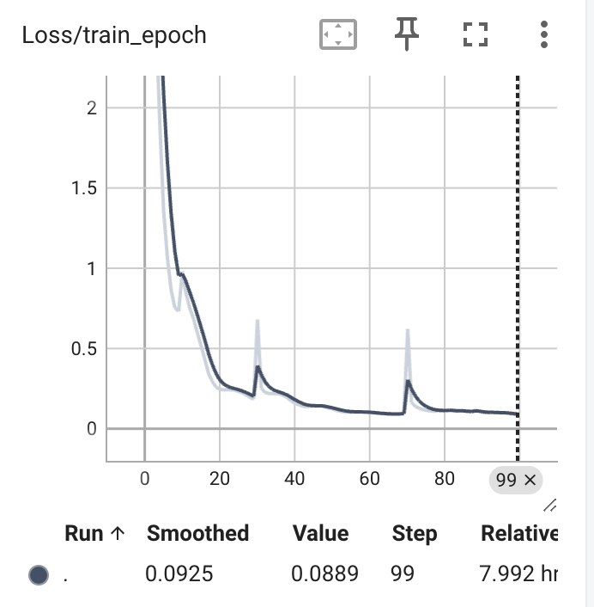
Supplementary Figure 1 | Training loss of MoCoV2 multimodal contrasting learning. Validation loss has little or no direct meaning in the contrast learning as contrastive objectives are relative and batch dependent.

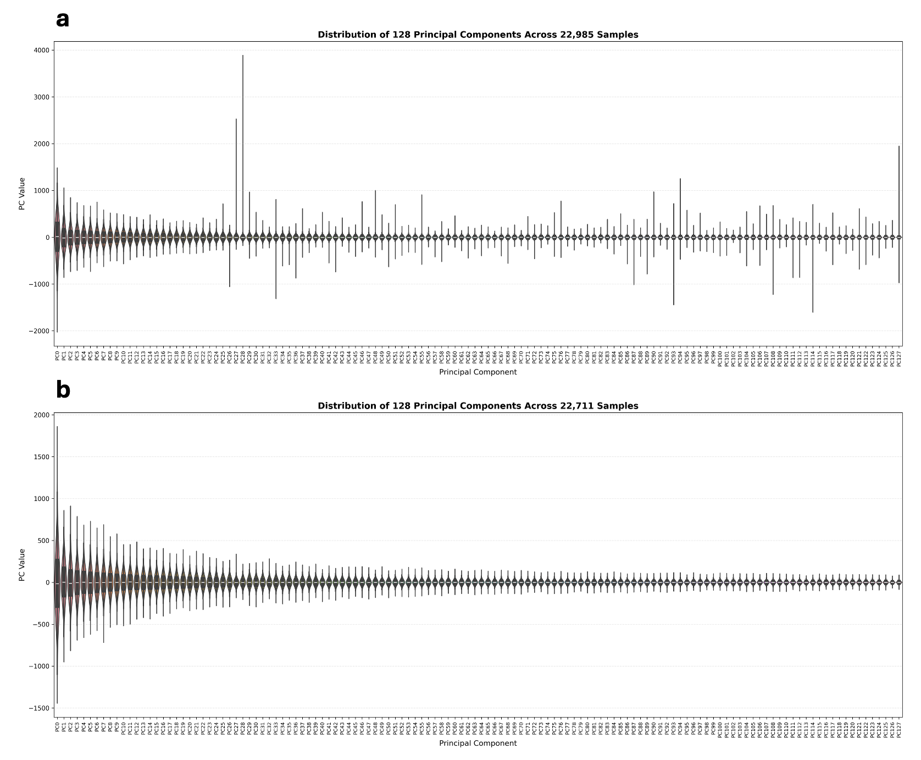
Supplementary Figure 2 | Distribution of UDIP value across discovery cohort (22,985 samples) for 128 UDIPs, before and after 5 std filtering. We removed samples that exceed 5 std for each UDIP as they are introducing noisy GWAS signal (shown below).

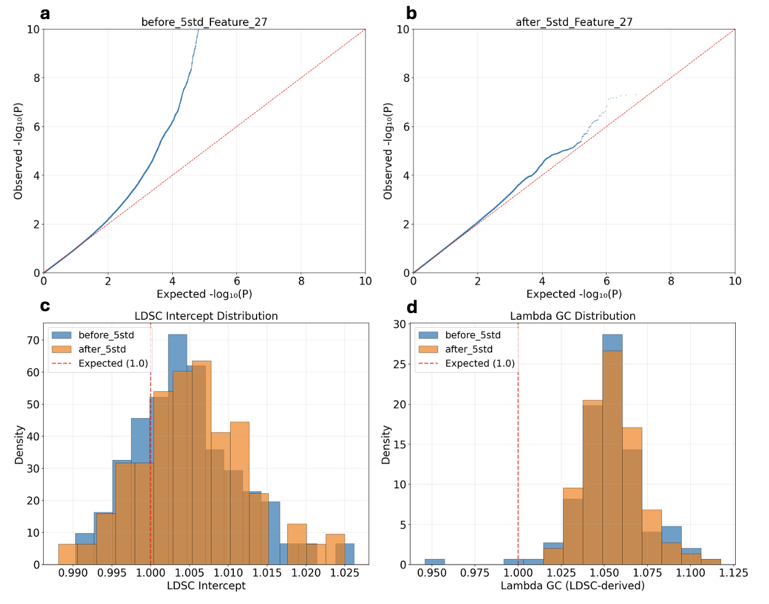
Supplementary Figure 3 | Comparison of GWAS quality-control metrics for MM-UDIPs before and after removal of outlier samples (>5 SD per UDIP). a) Representative QQ plot for feature 27 prior to 5-SD filtering, showing pronounced deviation from the null consistent with the presence of extreme outlier samples. b) QQ plot for feature 27 after 5-SD filtering, demonstrating reduced inflation and improved calibration. c) Distribution of LDSC intercepts across all 128 features before and after 5-SD filtering. d) Distribution of genomic inflation factors (λGC) across all 128 features before and after 5-SD filtering.

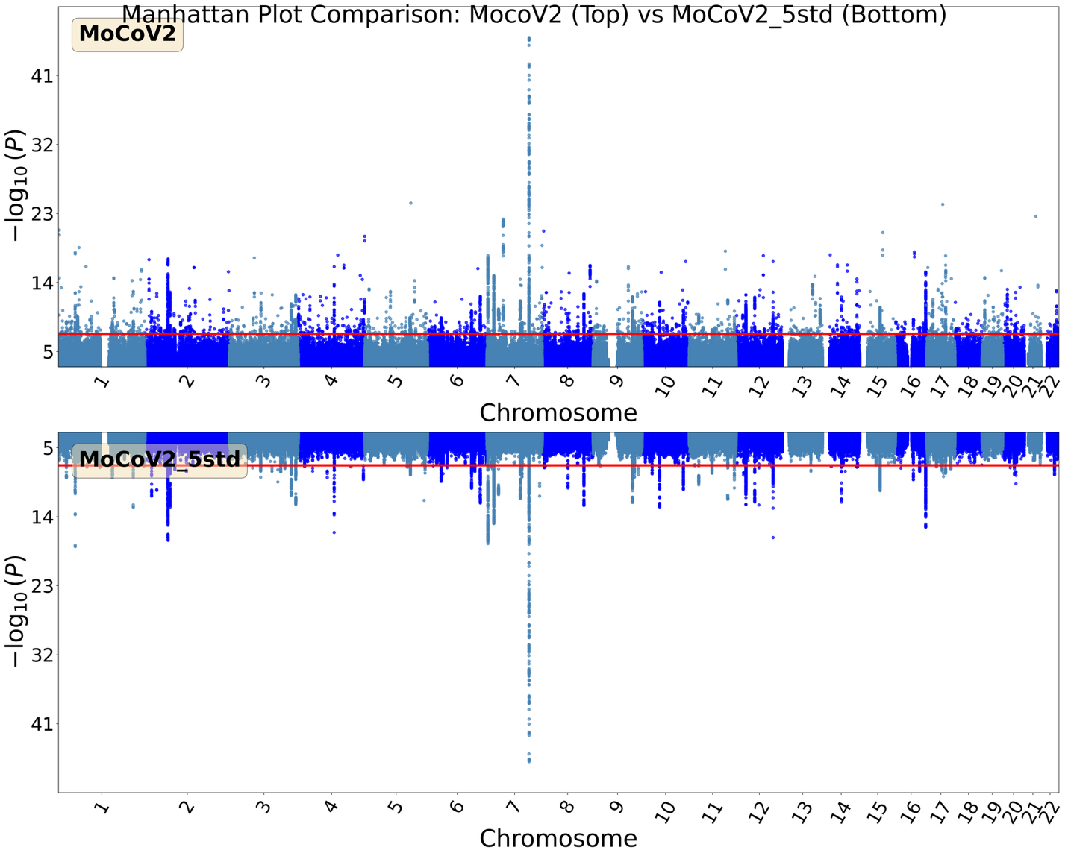
Supplementary Figure 4 | Comparision of GWAS summary statistics of MM-UDIPs, before and after removing samples over 5 std for each UDIP. The bottom manhattan plot shows much clearer peaks.

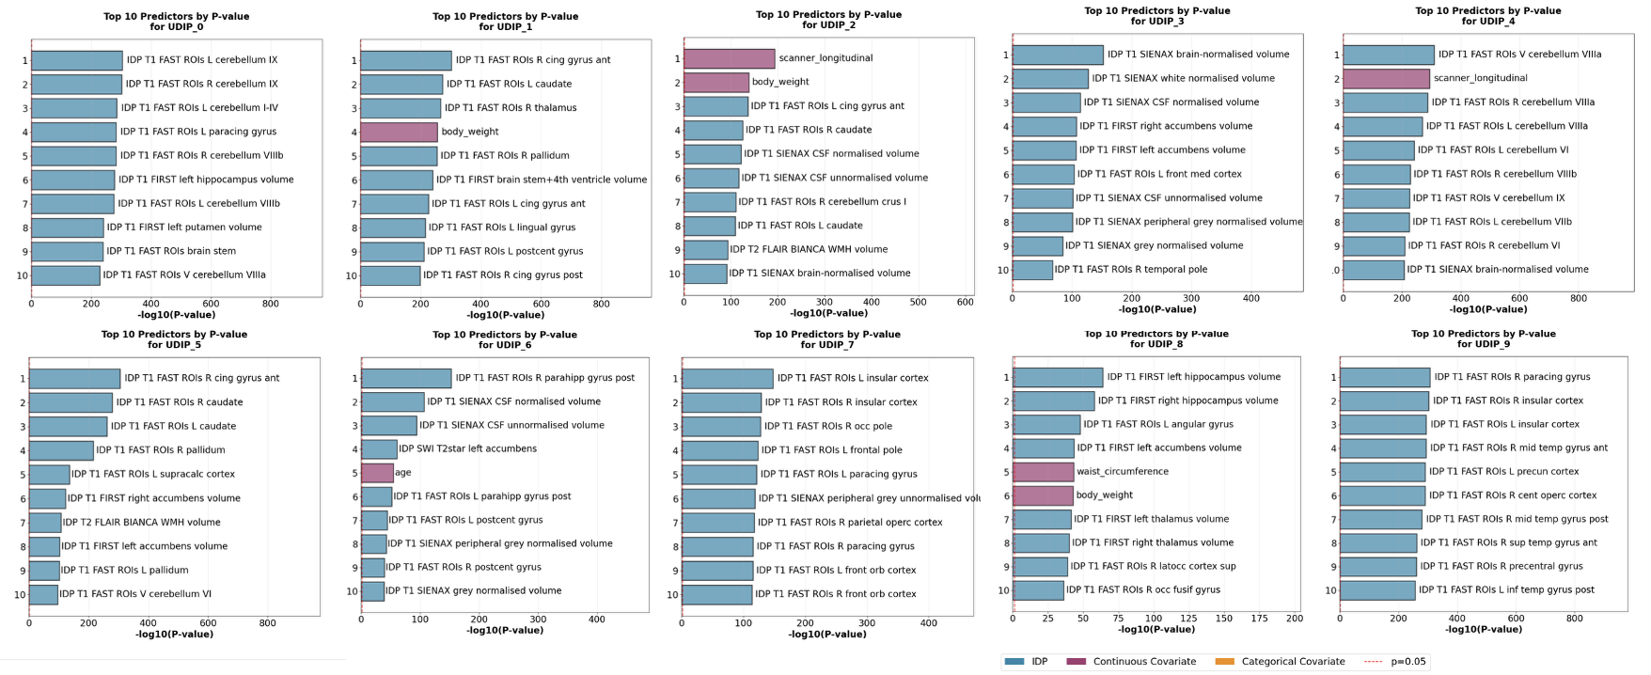
Supplementary Figure 5 | Top 10 T1 MM-UDIPs associations with covariates and IDPs, ranked by the -log10(p-value). MM-UDIPs are more associated with IDPs than covariates.

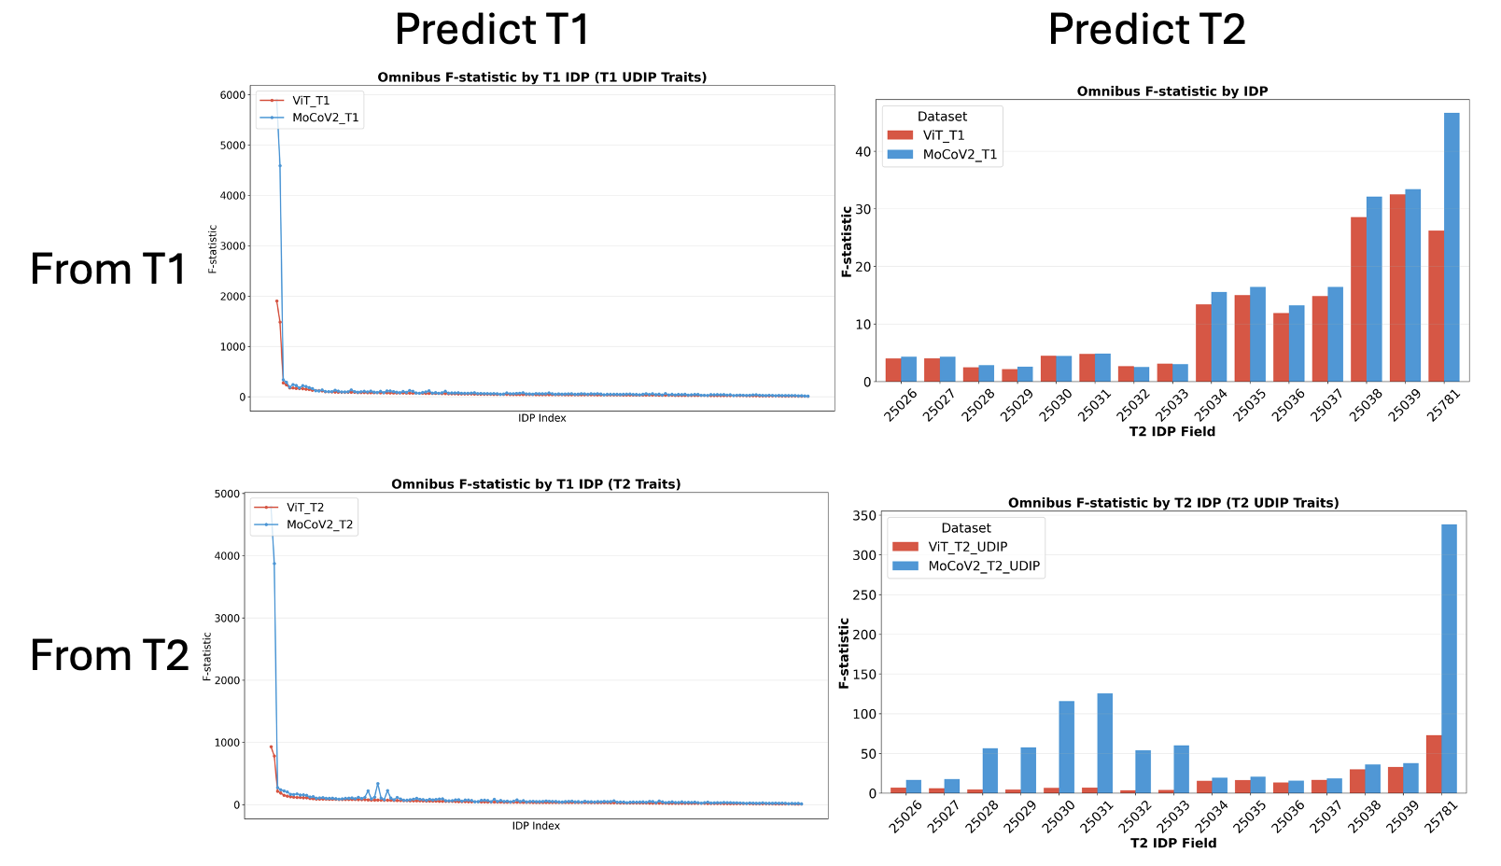
Supplementary Figure 6 | Comparison of MM-UDIP and SM-UDIP performance in predicting self/cross-modality IDPs, tested with Omnibus F statistic. MM-UDIPs show superior performance.

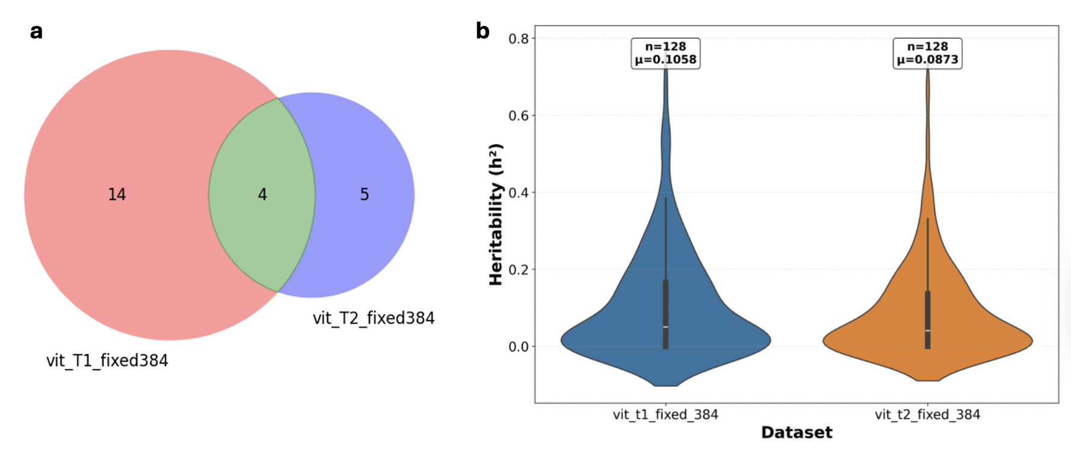Supplementary Figure 7 | Performance of ViT-based SM-UDIPs using the same PCA procedure as MM-UDIPs to obtain 128-dimensional representations. Compared with SM-UDIPs that use average pooling to derive 128-dimensional representations, this approach shows reduced T1–T2 loci overlap and lower heritability.

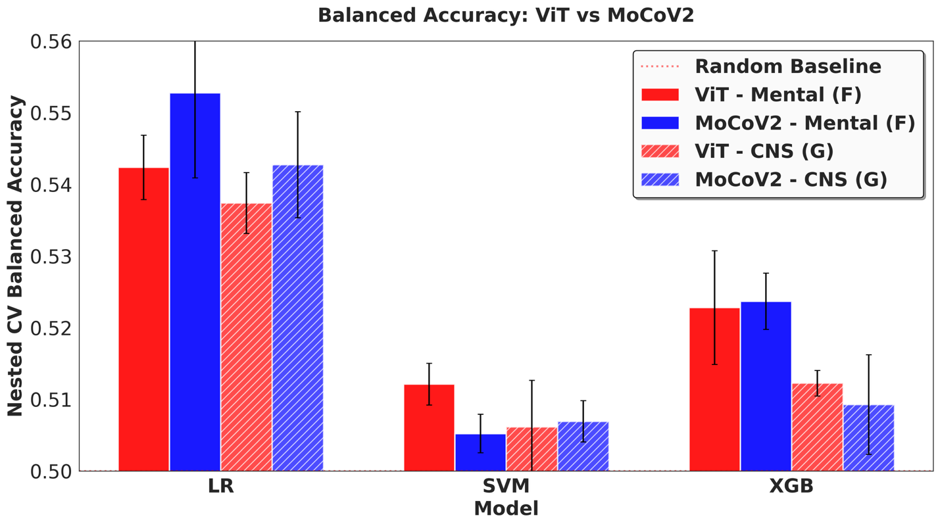
Supplementary Figure 8 | Comparison of MM-UDIP and SM-UDIP performance in predicting ICD-10 disease status, across different models. LR = Logistic Regression with regularization, SVM = Support Vector Machine, XGB = XG Boost. Logistic regression shows the best performance.

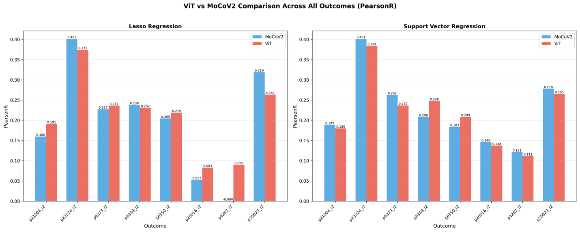
Supplementary Figure 9 | Comparison of MM-UDIP and SM-UDIP performance in predicting cognitive scores, across different models. Support Vector regression shows better performance in general.

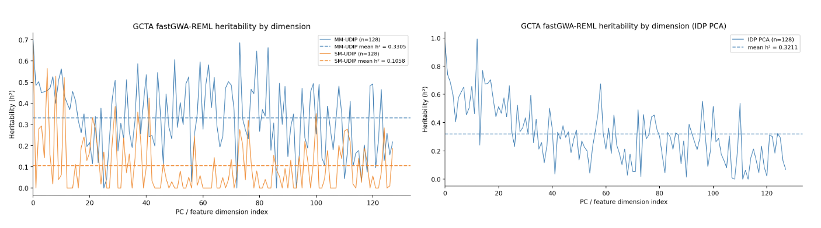
Supplementary Figure 10 | Comparison of heritability derived from GCTA fastGWA-REML across MM-UDIP, SM-UDIP, and IDP-PCs

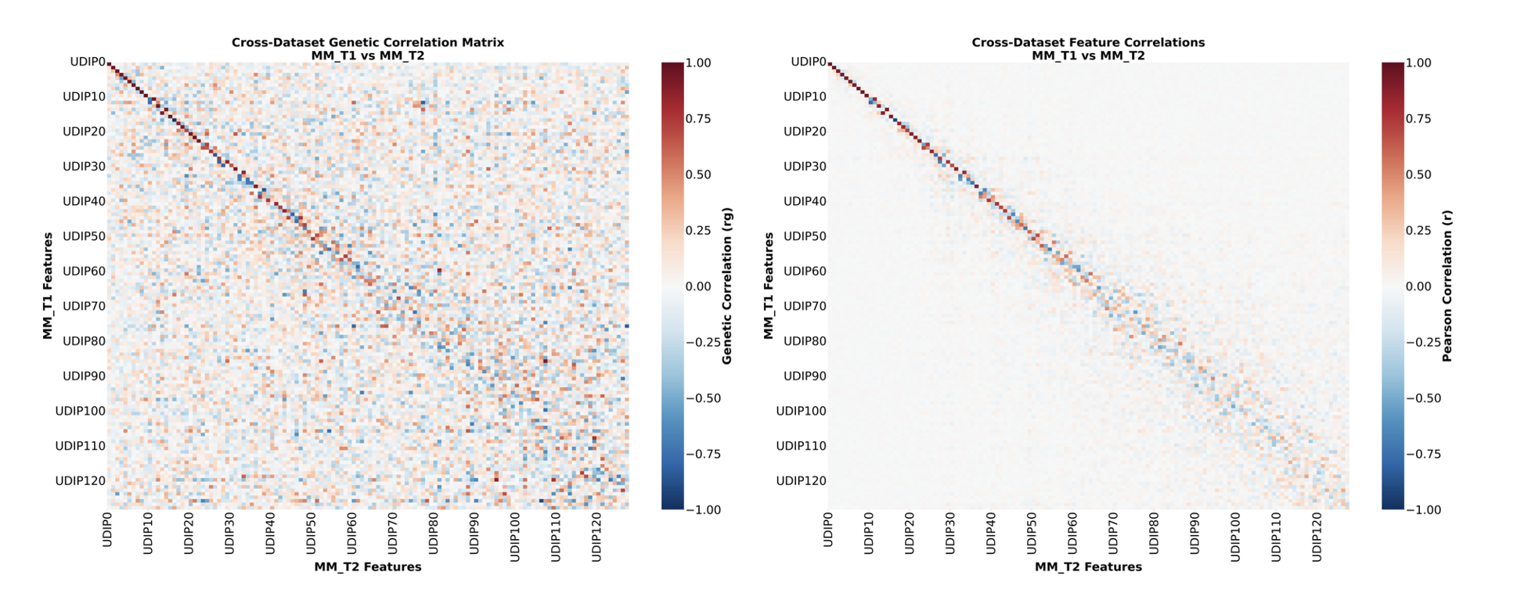 Supplementary Figure 11 | Comparison of genetic correlation and feature correlation of MM-UDIPs

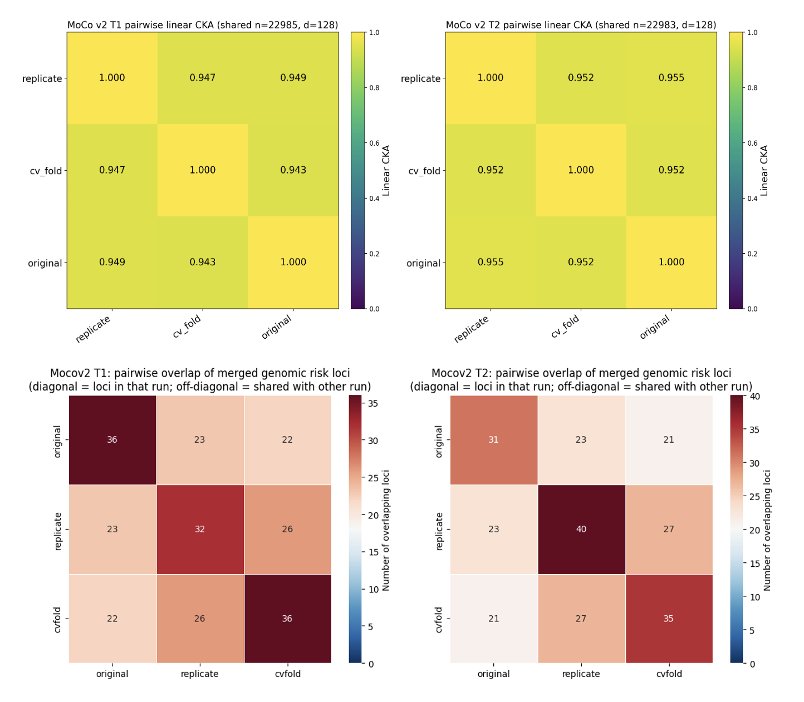
Supplementary Figure 12 | Evidence of reproducibility of MM-UDIPs across training seeds and training data split (cv_fold), evaluated by CKA and loci overlap

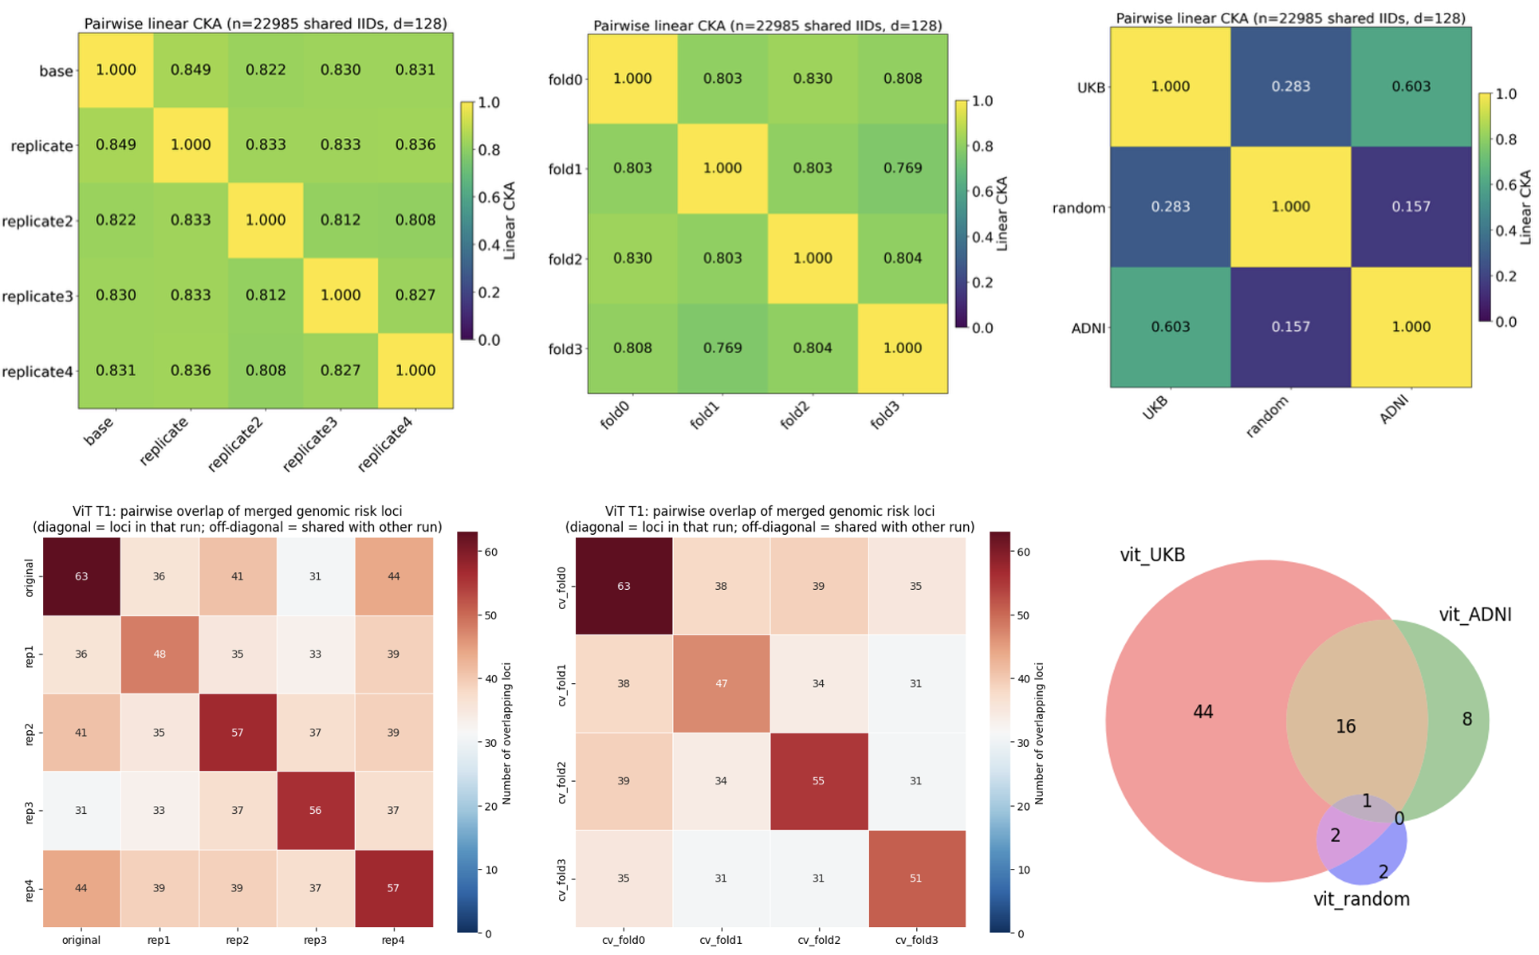
Supplementary Figure 13 | Evidence of reproducibility of SM-UDIPs (T1) across training seeds, training data split (cv_fold), and independent training dataset (ADNI), evaluated by CKA and loci overlap

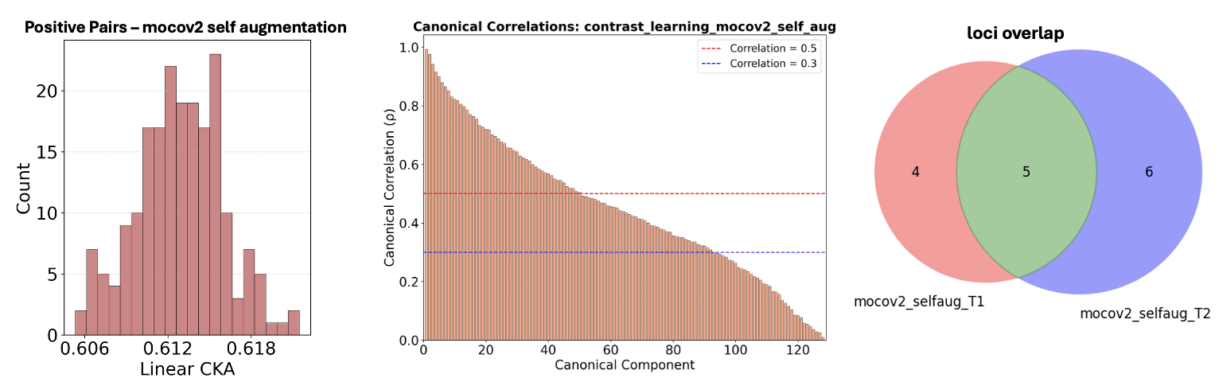
Supplementary Figure 14 | Performance of a self-augmented MoCov2 intermediate model between MM-UDIPs and SM-UDIPs

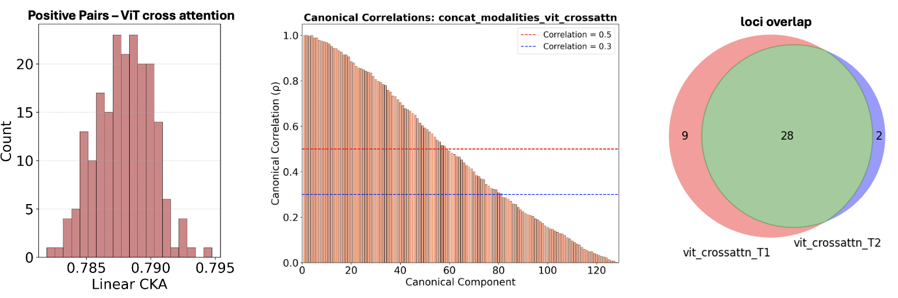
Supplementary Figure 15 | Performance of a ViT cross-attention intermediate model between MM-UDIPs and SM-UDIPs

1. Zhou, Z., et al., An interpretable cross-attentive multi-modal mri fusion framework for schizophrenia diagnosis. arXiv preprint arXiv:2404.00144, 2024.
2. Bi, Y., et al., A multimodal vision transformer for interpretable fusion of functional and structural neuroimaging data. Hum Brain Mapp, 2024. 45(17): p. e26783.
3. Islam, S., et al. Vision Transformer Autoencoders for Unsupervised Representation Learning: Revealing Novel Genetic Associations through Learned Sparse Attention Patterns. in NeurIPS 2025 Workshop for Imageomics: Discovering Biological Knowledge from Images Using AI. 2025.

