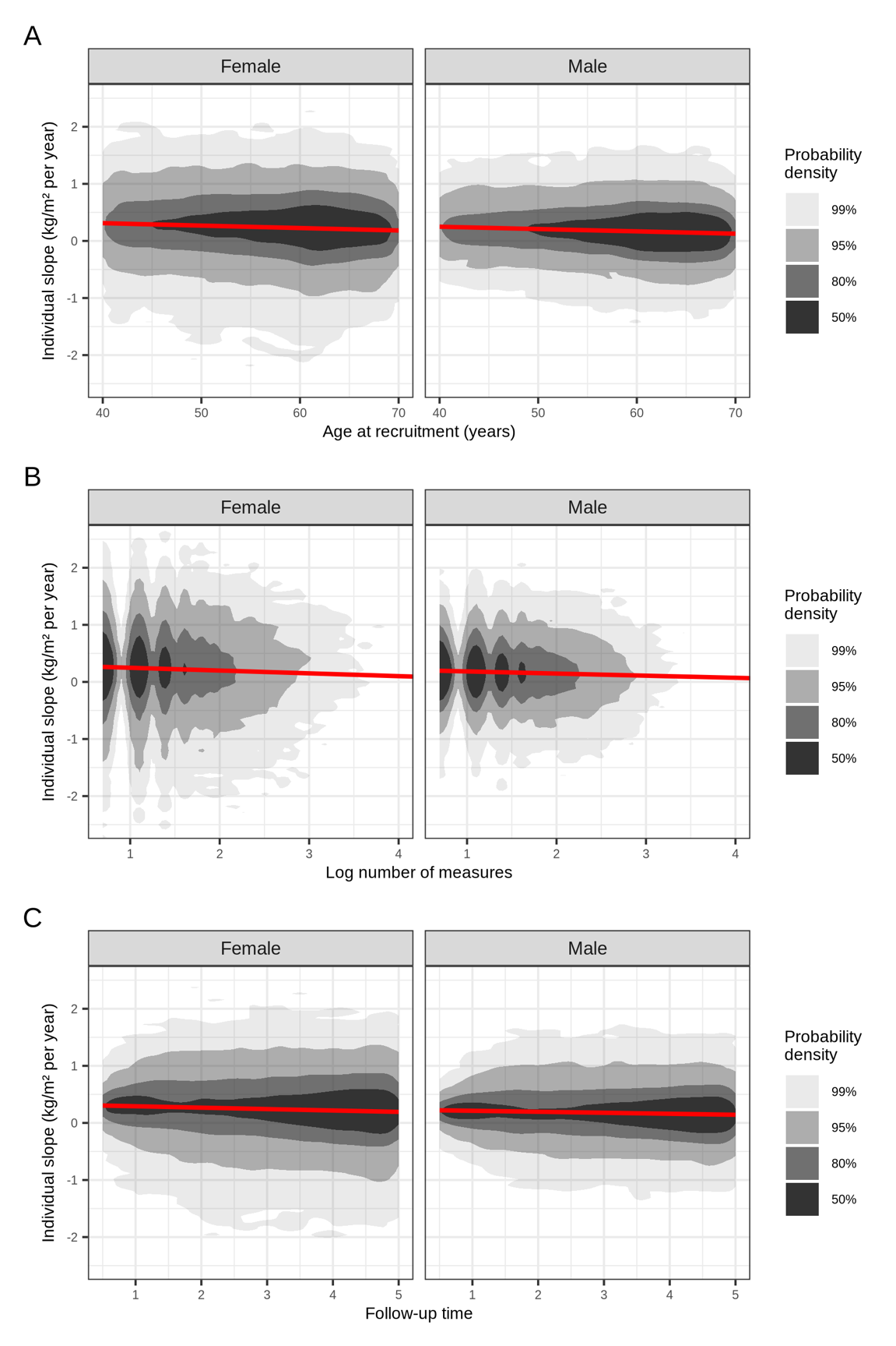
Supplementary Figure 1. Bivariate distributions of individual BMI trajectory slopes in relation to age at recruitment (A), number of BMI measurements (B), and follow-up time (C). Shaded contours indicate bivariate probability densities derived from kernel density estimation. The red line shows the correlation.

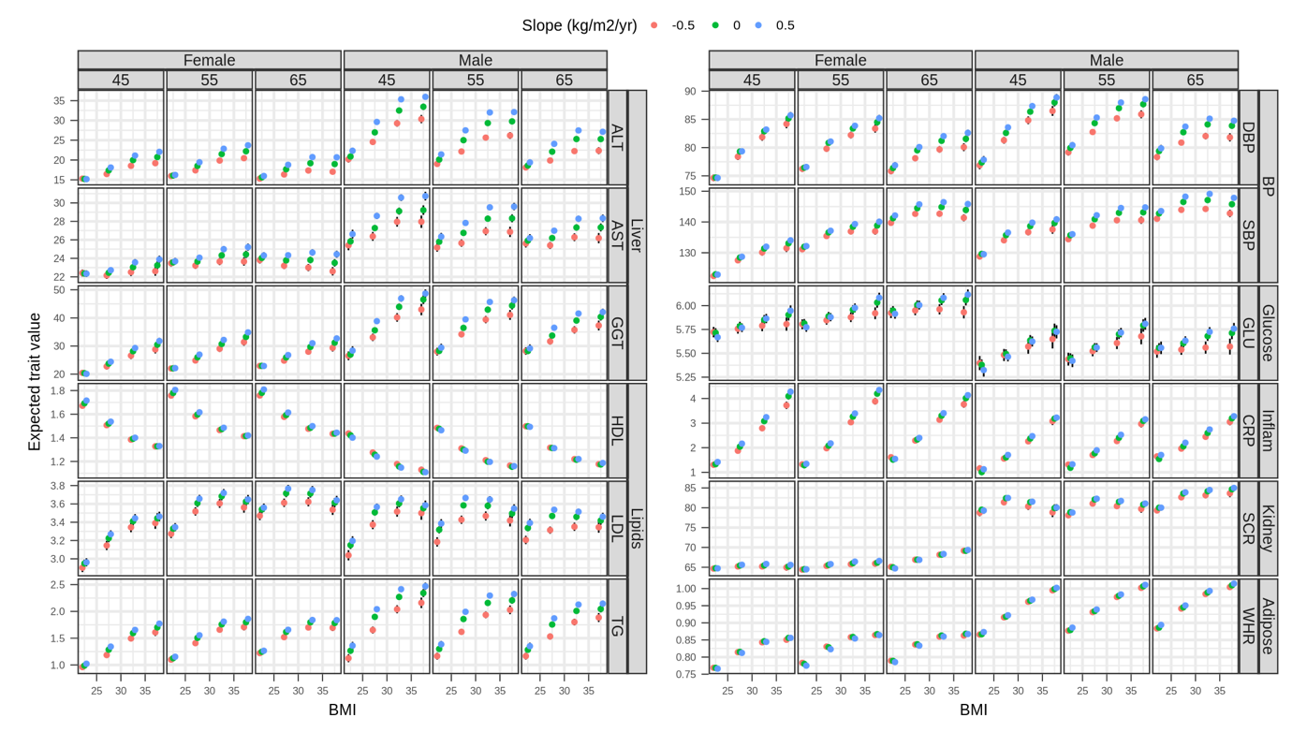
Supplementary Figure 2. Estimated values of biomarkers at varying age, recruitment BMI and BMI slope levels for males and females. Error bars represent 95% confidence intervals.

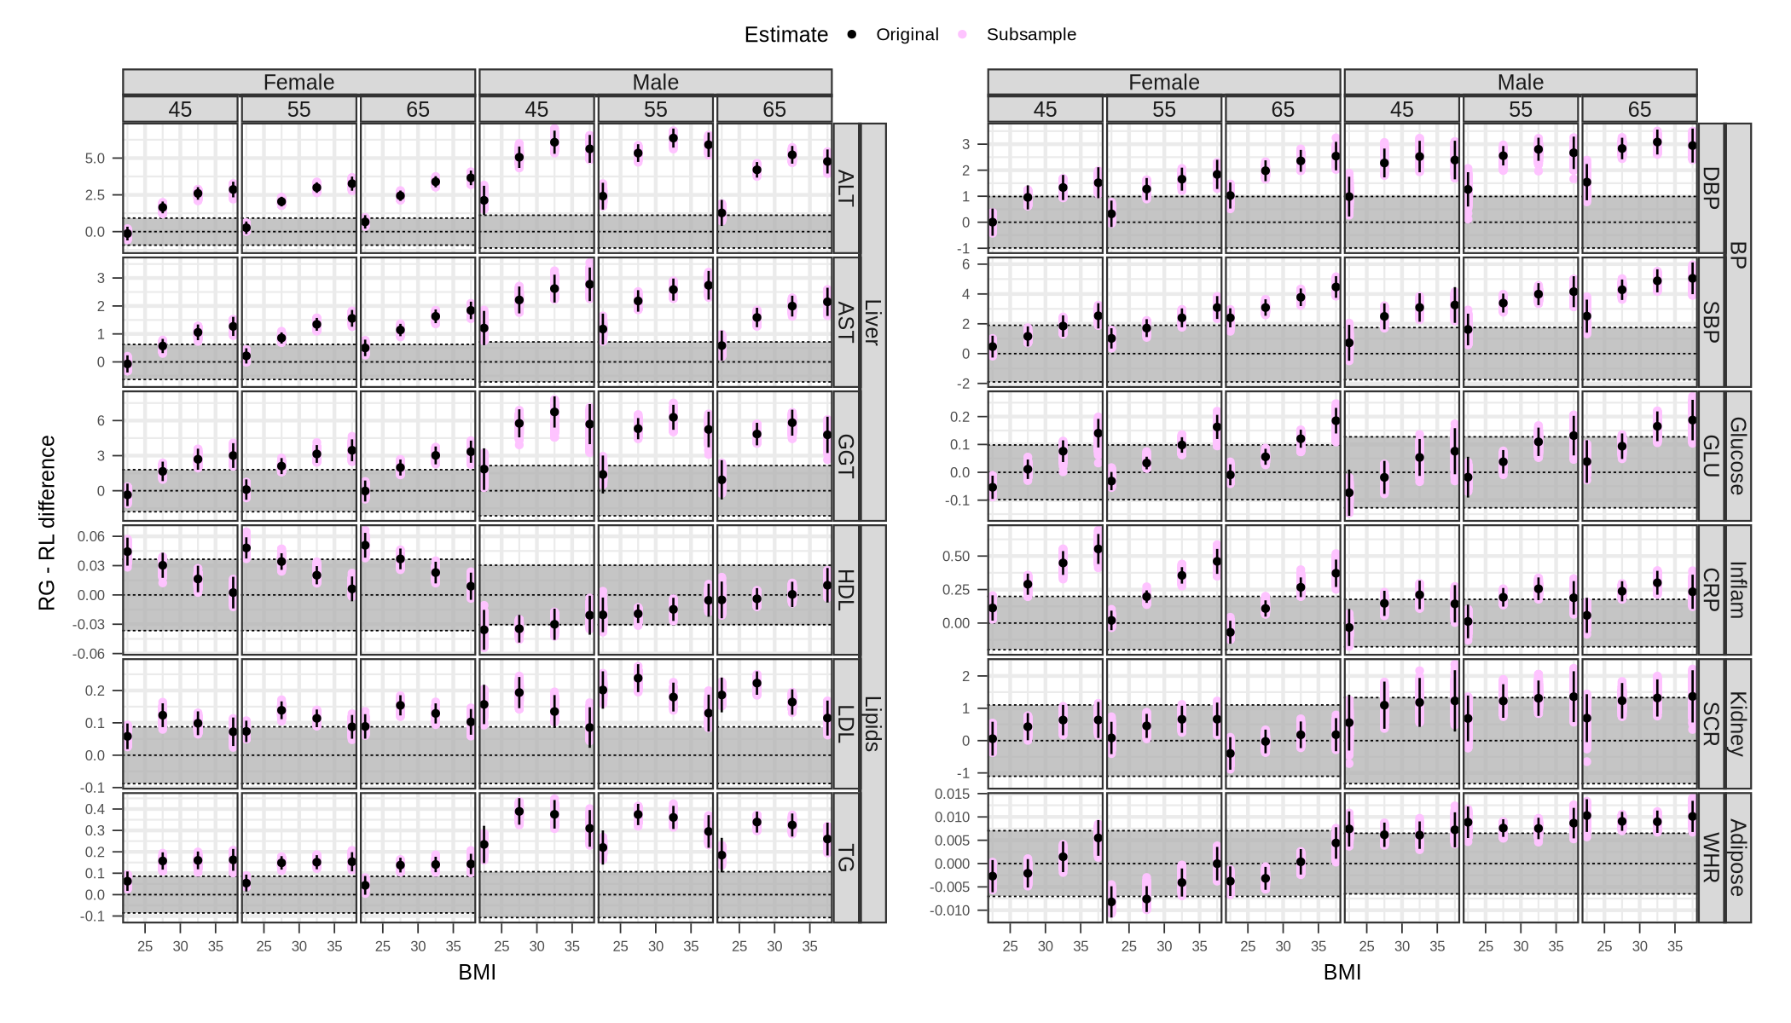
Supplementary Figure 3. Estimated differences in biomarker levels between rapid gain (RG, +0.5 kg/m²/year) and rapid loss (RL, –0.5 kg/m²/year) trajectories across BMI categories and ages, stratified by sex. Purple estimates were calculated from 1,000 subsamples of 80% of the available data for each biomarker without replacement. Black points and error bars are the original overall estimates and their corresponding 95% confidence intervals. Shaded regions indicate ±0.1 standard deviation (SD) of each biomarker (sex-specific).

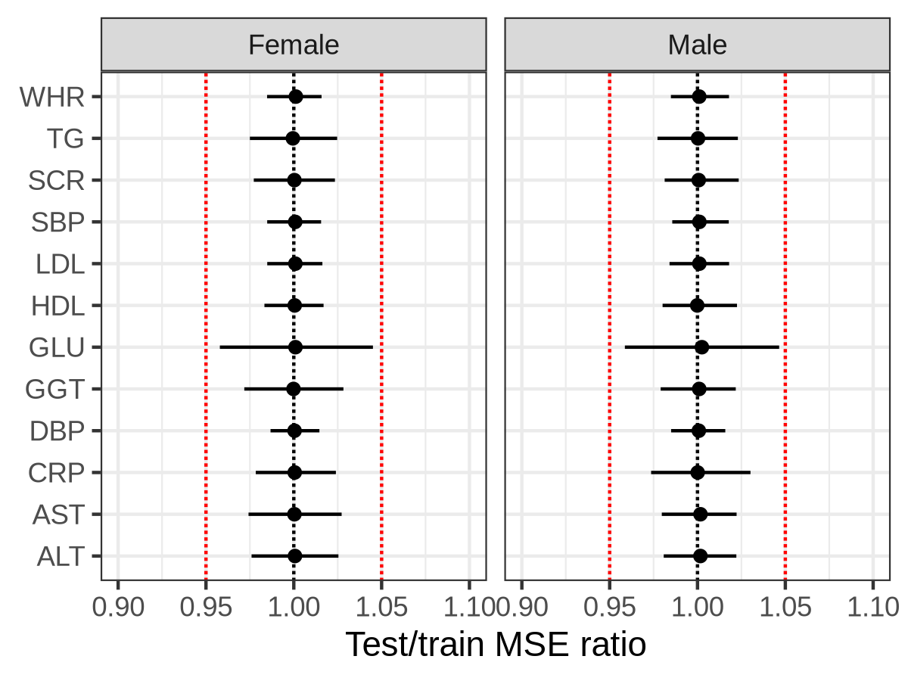
Supplementary Figure 4. Test versus train mean squared error (MSE) ratio obtained from subsampling 80% of the data for each biomarker without replacement for model training and testing in the remaining 20%. Point estimates represent the median over 1,000 runs and error bars represent 95% quantile-based confidence intervals. Red dotted lines are located 0.95 and 1.05 representing ±5% tolerance.

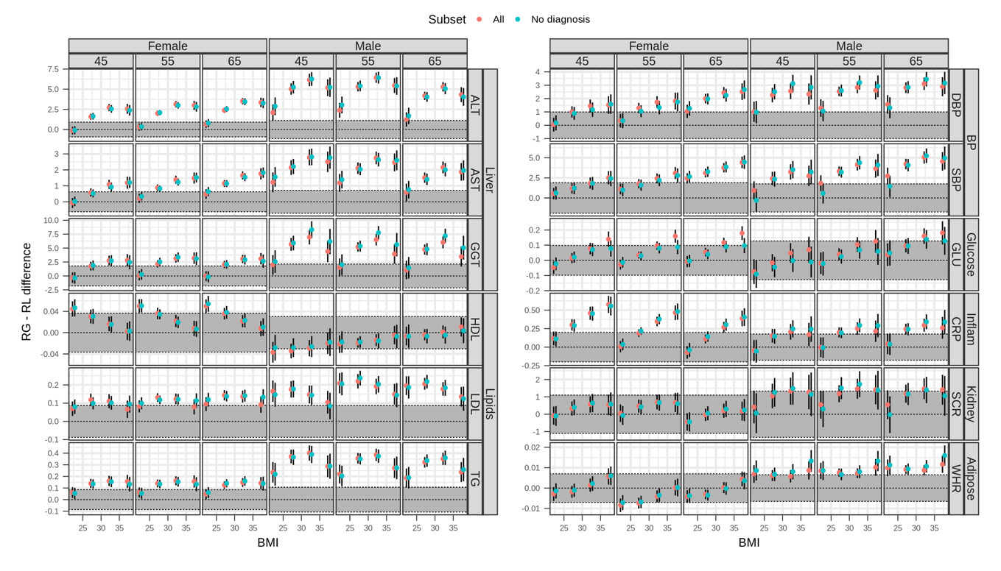
Supplementary Figure 5. Estimated differences in biomarker levels between rapid gain (RG, +0.5 kg/m²/year) and rapid loss (RL, –0.5 kg/m²/year) trajectories across BMI categories and ages, stratified by sex, in all vs individuals without selected diagnosis at recruitment (cancer, cardiovascular disease, asthma and COPD). Error bars represent 95% confidence intervals. Shaded regions indicate ±0.1 standard deviation (SD) of each biomarker (sex-specific).

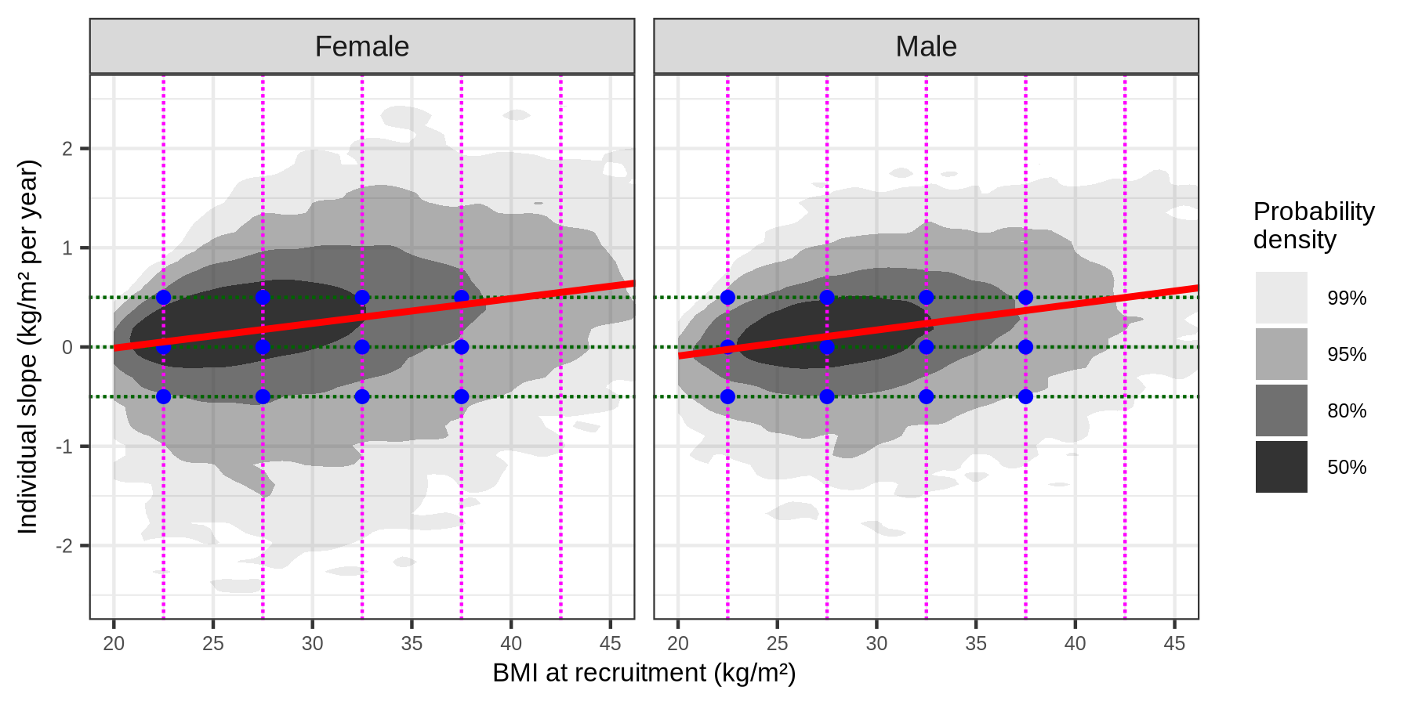
Supplementary Figure 6. Bivariate distribution of BMI at recruitment and the estimates of 5-year slopes in individuals with stricter follow-up criteria (≥3 BMI measurements, including at least one between 6 months and 2.5 years before recruitment and another more than 2.5 years earlier). Shaded contours indicate bivariate probability densities derived from kernel density estimation. The red line shows the correlation. Points represent the cut-offs selected to define rapid gain, stable and rapid loss trajectories across BMI categories, checking their locations were within the probability density area.

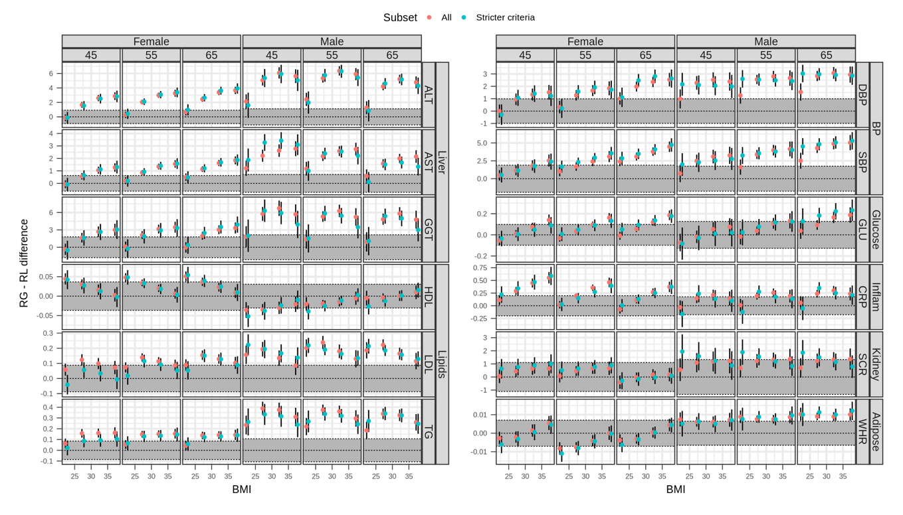
Supplementary Figure 7. Estimated differences in biomarker levels between rapid gain (RG, +0.5 kg/m²/year) and rapid loss (RL, –0.5 kg/m²/year) trajectories across BMI categories and ages, stratified by sex, in all vs individuals with stricter follow-up criteria (≥3 BMI measurements, including at least one between 6 months and 2.5 years before recruitment and another more than 2.5 years earlier). Error bars represent 95% confidence intervals. Shaded regions indicate ±0.1 standard deviation (SD) of each biomarker (sex-specific).

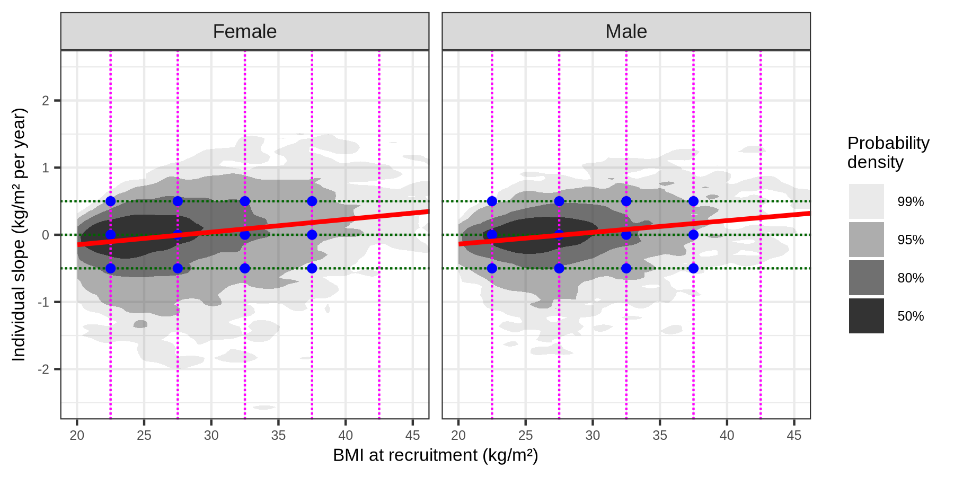
Supplementary Figure 8. Bivariate distribution of BMI at recruitment and the estimates of 5-year slopes prior to the second visit in UK Biobank. Shaded contours indicate bivariate probability densities derived from kernel density estimation. The red line shows the correlation. Points represent the cut-offs selected to define rapid gain, stable and rapid loss trajectories across BMI categories, checking their locations were within the probability density area.

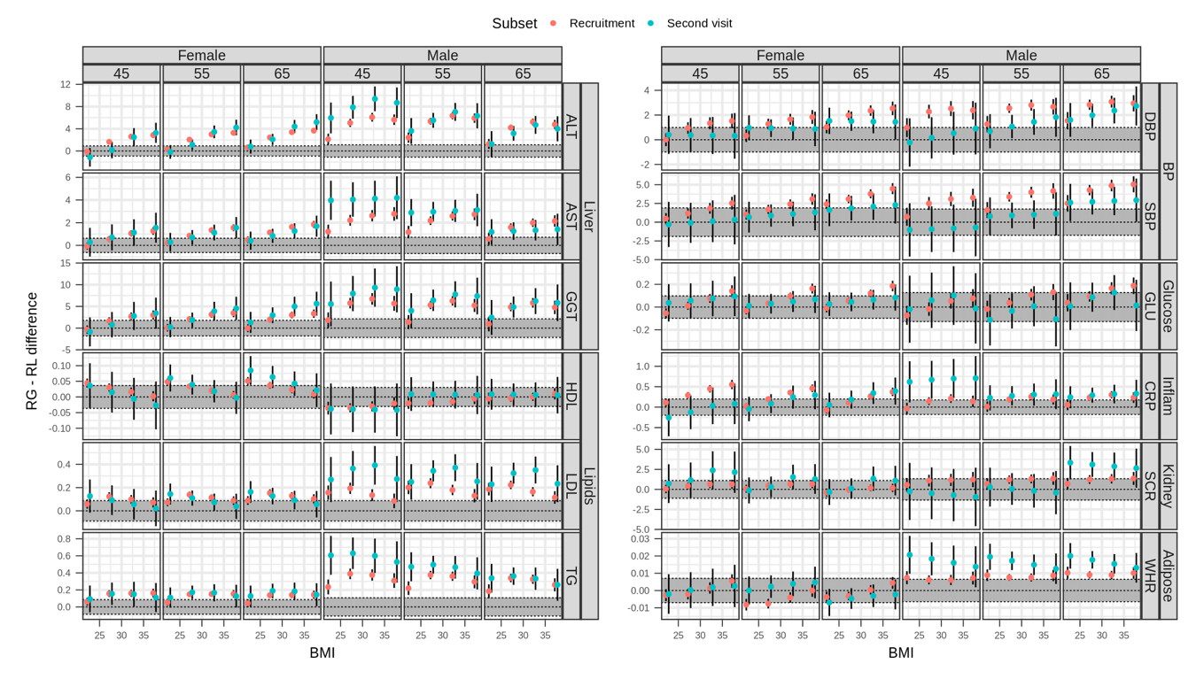
Supplementary Figure 9. Estimated differences in biomarker levels between rapid gain (RG, +0.5 kg/m²/year) and rapid loss (RL, –0.5 kg/m²/year) trajectories across BMI categories and ages, stratified by sex, in individuals at recruitment vs individuals at the second visit. Error bars represent 95% confidence intervals. Shaded regions indicate ±0.1 standard deviation (SD) of each biomarker (sex-specific).

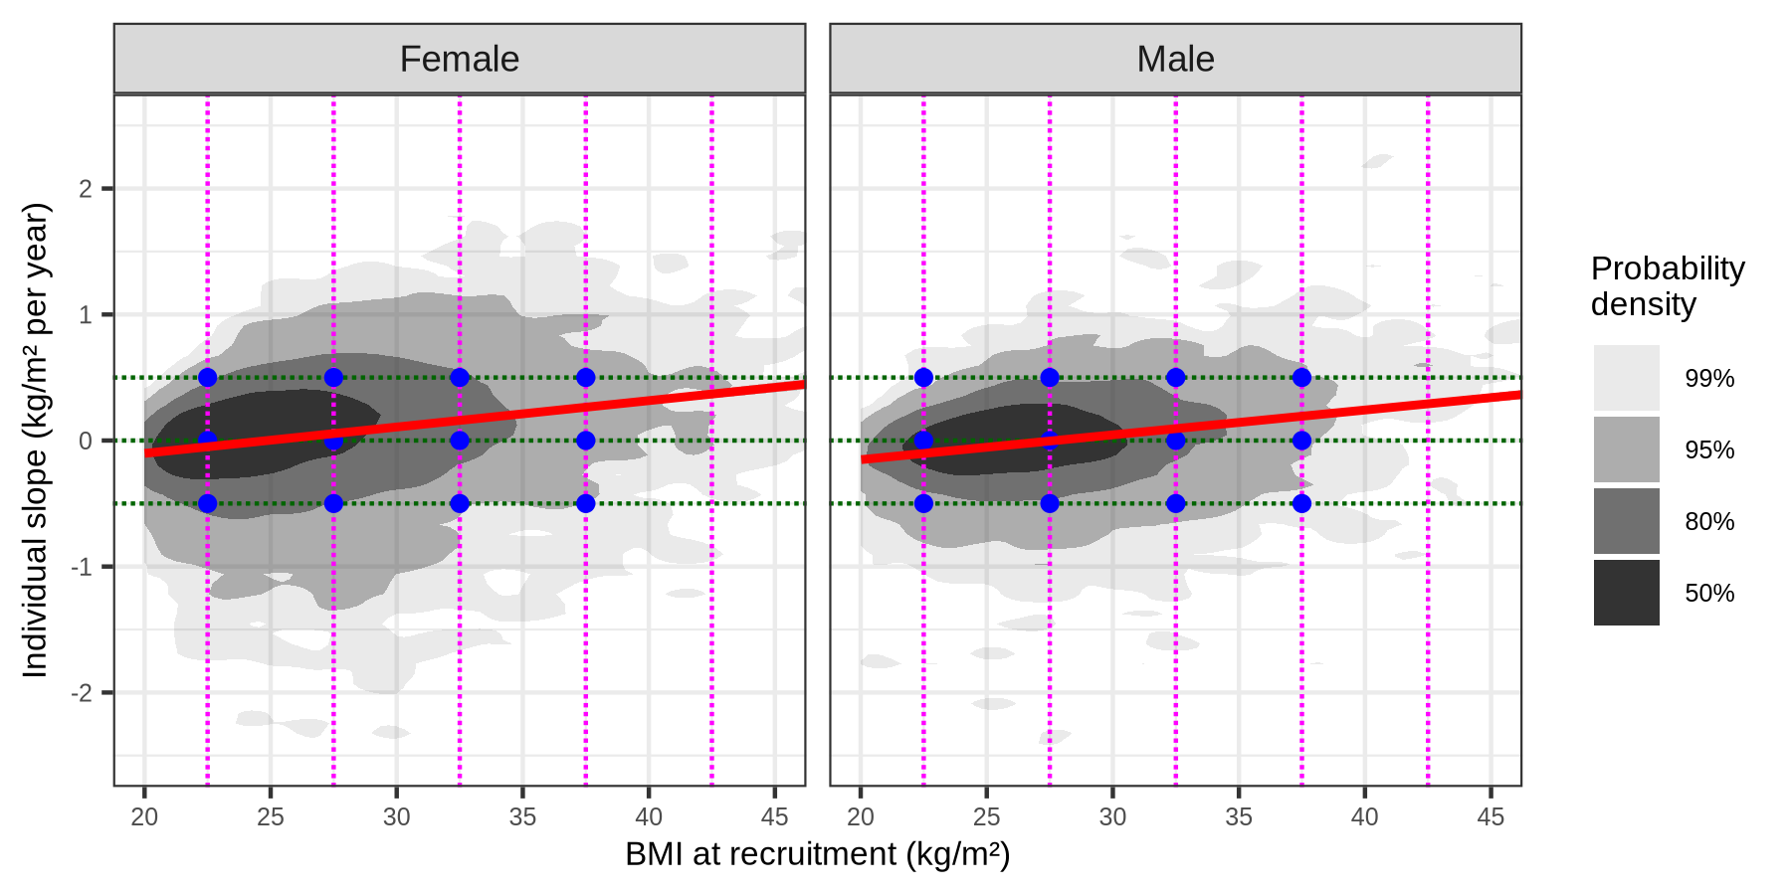
Supplementary Figure 10. Bivariate distribution of BMI at recruitment and the estimates of 5-year slopes prior to the third visit in UK Biobank. Shaded contours indicate bivariate probability densities derived from kernel density estimation. The red line shows the correlation. Points represent the cut-offs selected to define rapid gain, stable and rapid loss trajectories across BMI categories, checking their locations were within the probability density area.

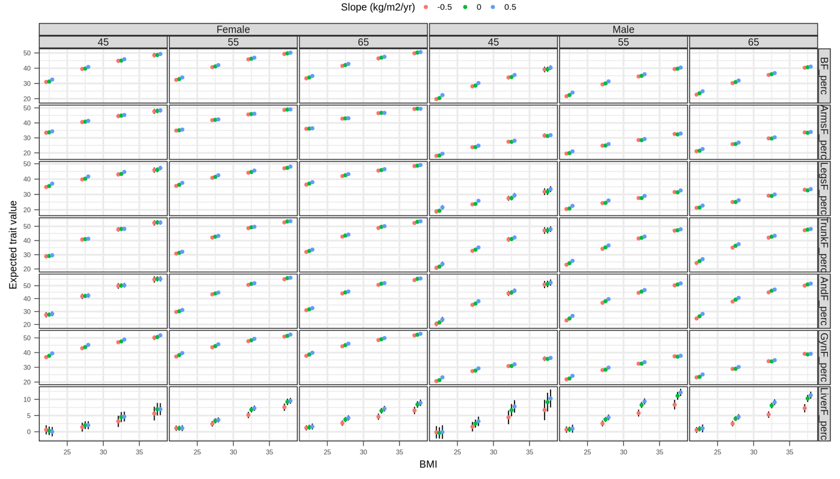
Supplementary Figure 11. Estimated values of imaging biomarkers at varying age, recruitment BMI and BMI slope levels for males and females. Error bars represent 95% confidence intervals.

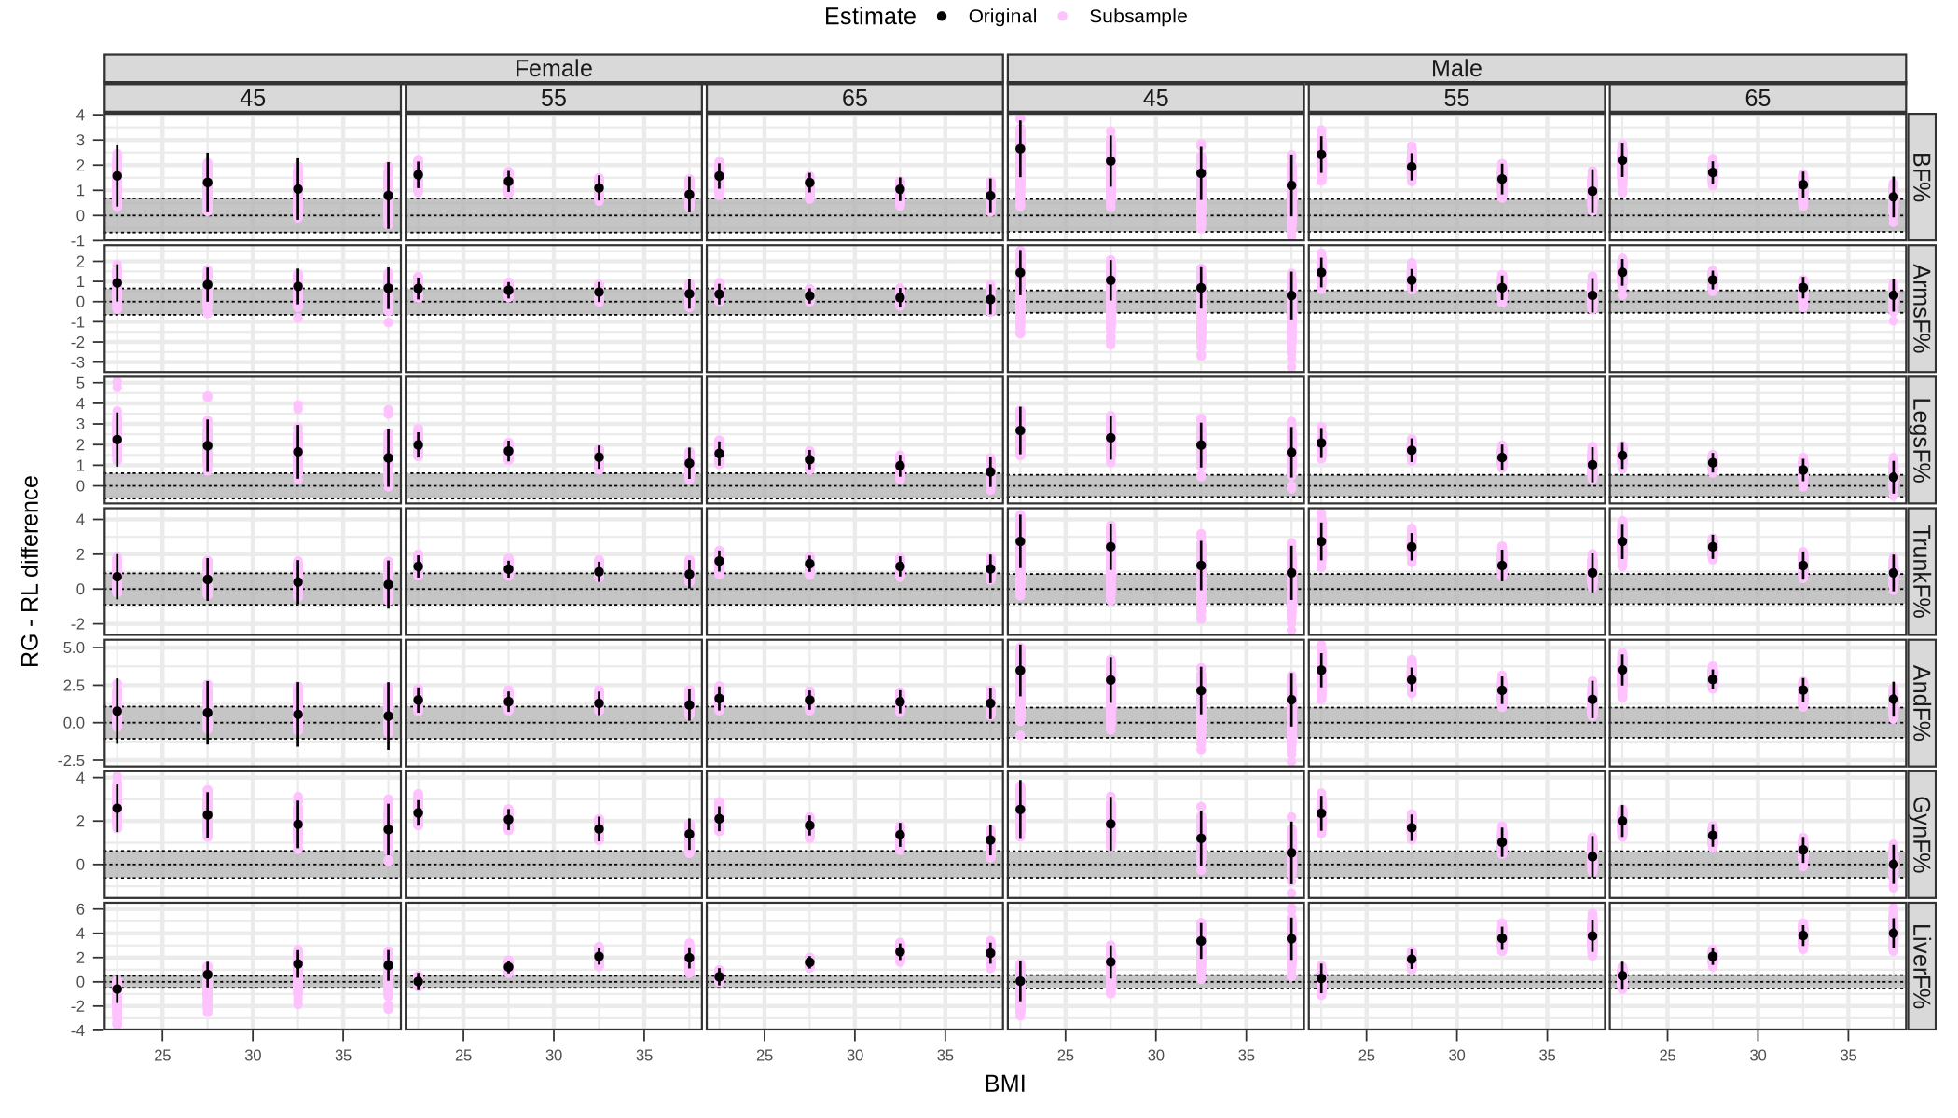
Supplementary Figure 12. Estimated differences in imaging biomarker levels between rapid gain (RG, +0.5 kg/m²/year) and rapid loss (RL, –0.5 kg/m²/year) trajectories across BMI categories and ages, stratified by sex. Purple estimates were calculated from 1,000 subsamples of 80% of the available data for each imaging biomarker without replacement. Black points and error bars are the original overall estimates and their corresponding 95% confidence intervals. Shaded regions indicate ±0.1 standard deviation (SD) of each imaging biomarker (sex-specific).

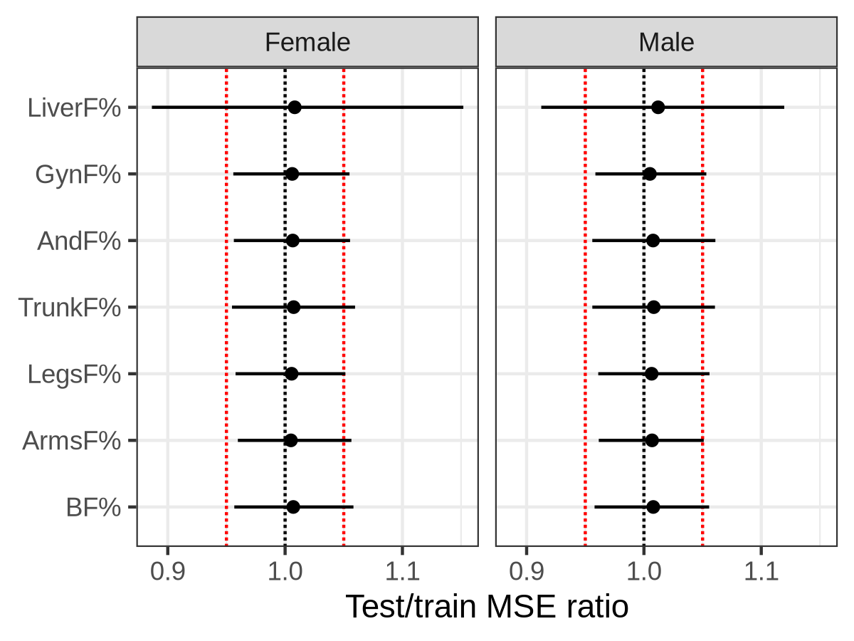
Supplementary Figure 13. Test versus train mean squared error (MSE) ratio obtained from subsampling 80% of the data for each imaging biomarker without replacement for model training and testing in the remaining 20%. Point estimates represent the median over 1,000 runs and error bars represent 95% quantile-based confidence intervals. Red dotted lines are located 0.95 and 1.05 representing ±5% tolerance.

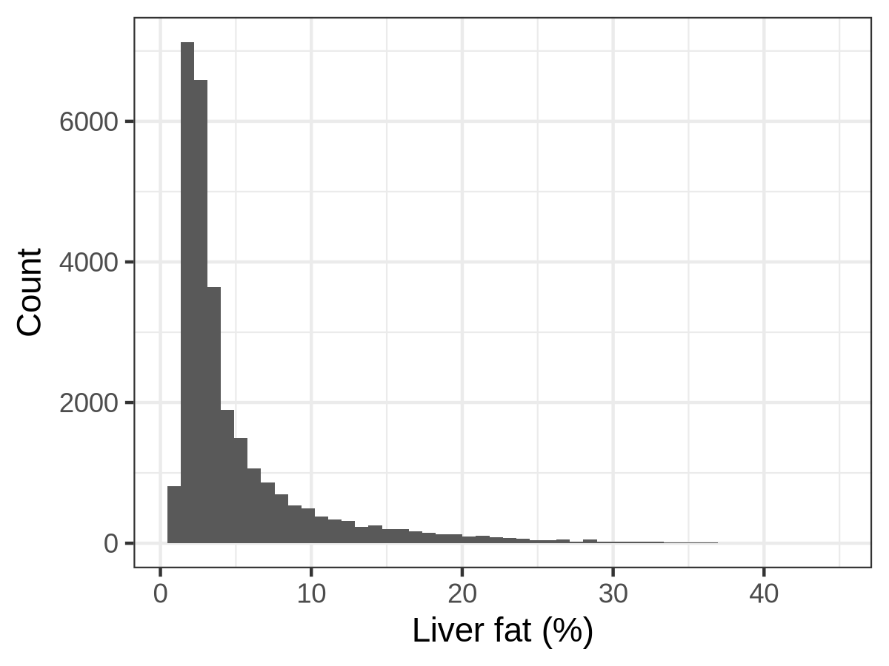
Supplementary Figure 14. Distribution of liver fat percentage in UK Biobank.

A  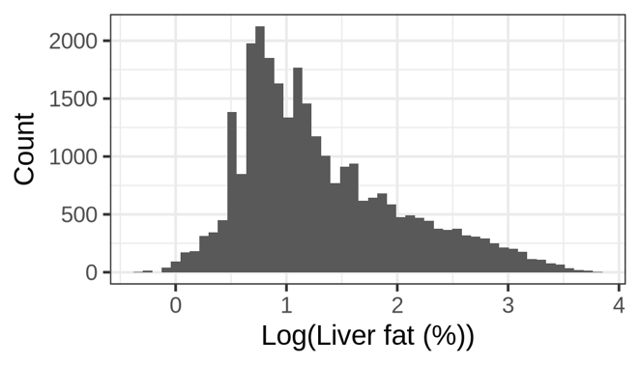 | B  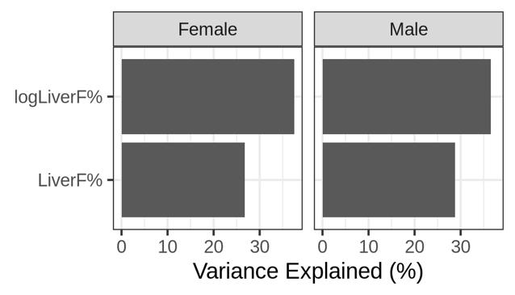
C  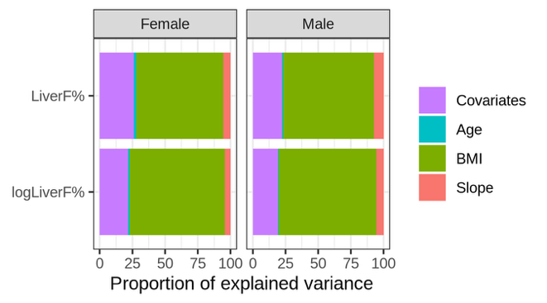 | D  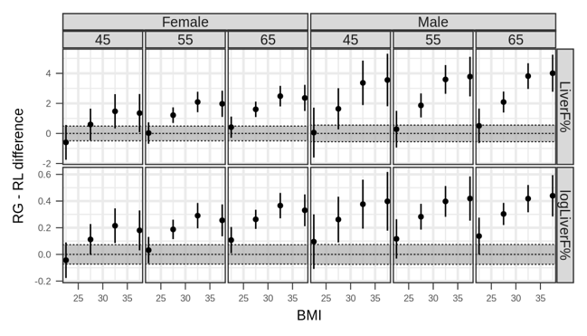
E  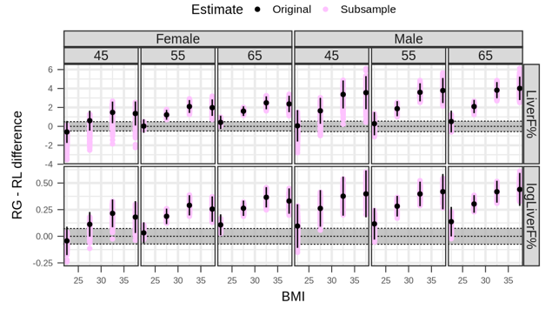 | F  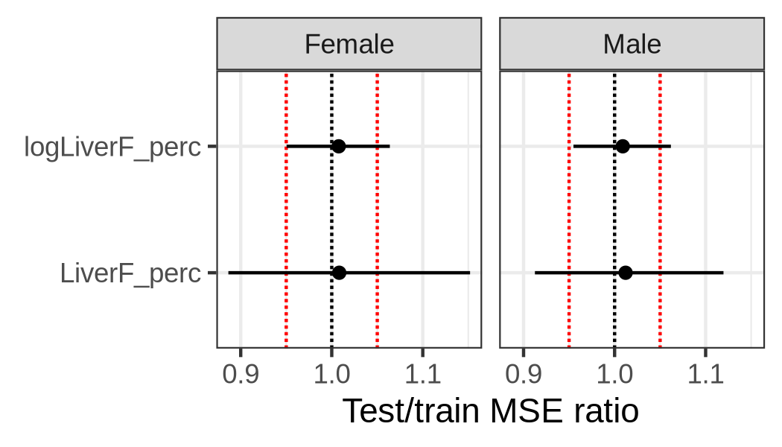
Supplementary Figure 15. A: Distribution of log-Liver fat percentage. B: Variance explained in liver fat percentage and its log transformation by the models. C: Proportion of variance explained by each predictor in the model. D: Estimated differences in liver fat percentage between rapid gain (RG, +0.5 kg/m²/year) and rapid loss (RL, –0.5 kg/m²/year) trajectories across BMI categories and ages, stratified by sex. Error bars are the corresponding 95% confidence intervals. Shaded regions indicate ±0.1 standard deviation (SD) of each imaging biomarker (sex-specific). E: Same as D, adding estimates calculated from 1,000 subsamples of 80% of the available liver fat data without replacement. F: Test versus train mean squared error (MSE) ratio obtained from the subsampling iterations. Point estimates represent the median over 1,000 runs and error bars represent 95% quantile-based confidence intervals. Red dotted lines are located 0.95 and 1.05 representing ±5% tolerance.

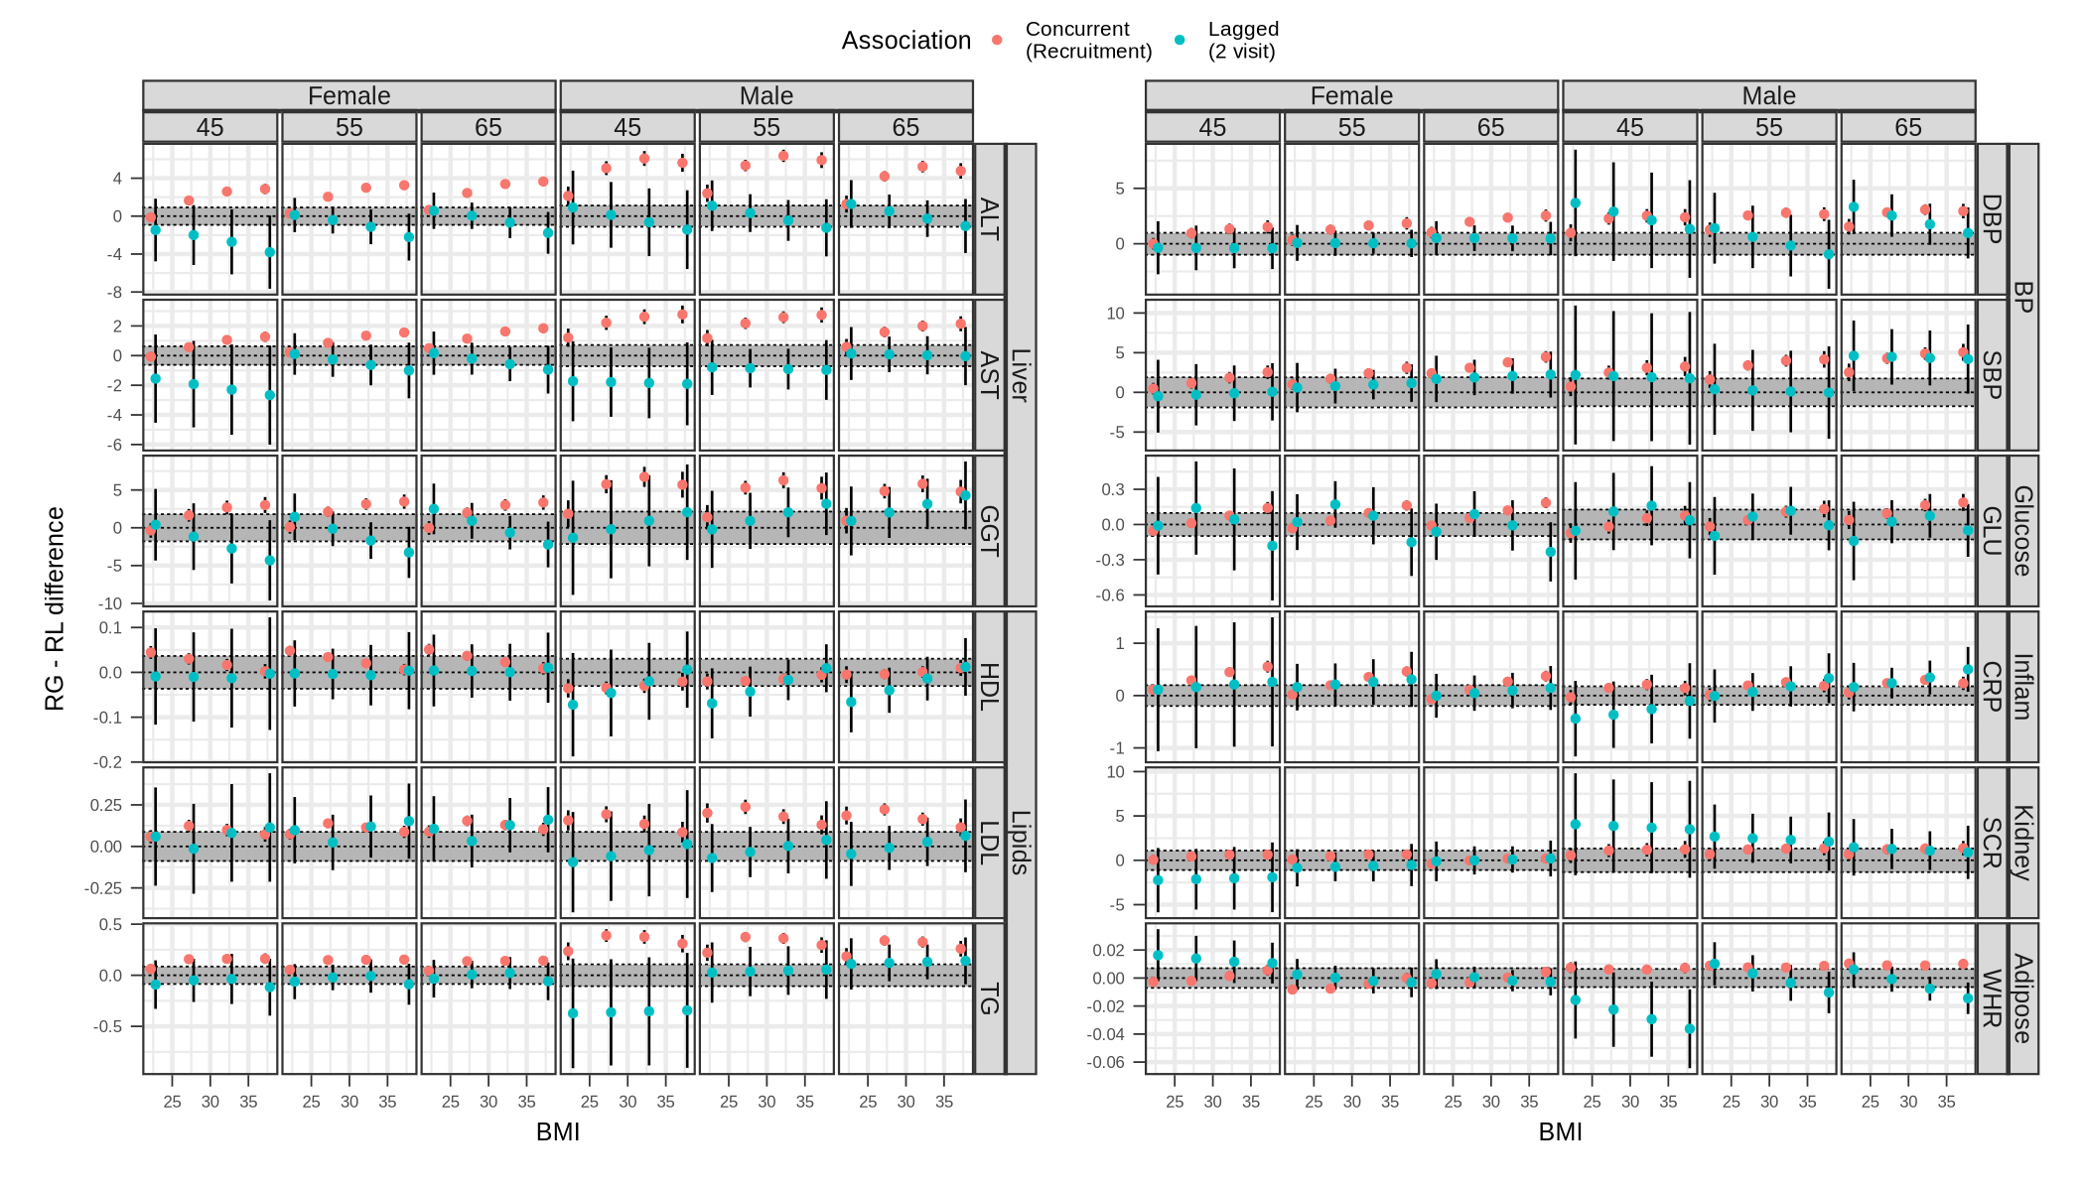
Supplementary Figure 16. Estimated differences in biomarker levels between rapid gain (RG, +0.5 kg/m²/year) and rapid loss (RL, –0.5 kg/m²/year) trajectories across BMI categories and ages, stratified by sex, in individuals at recruitment vs individuals at the second visit. Error bars represent 95% confidence intervals. Shaded regions indicate ±0.1 standard deviation (SD) of each biomarker (sex-specific).

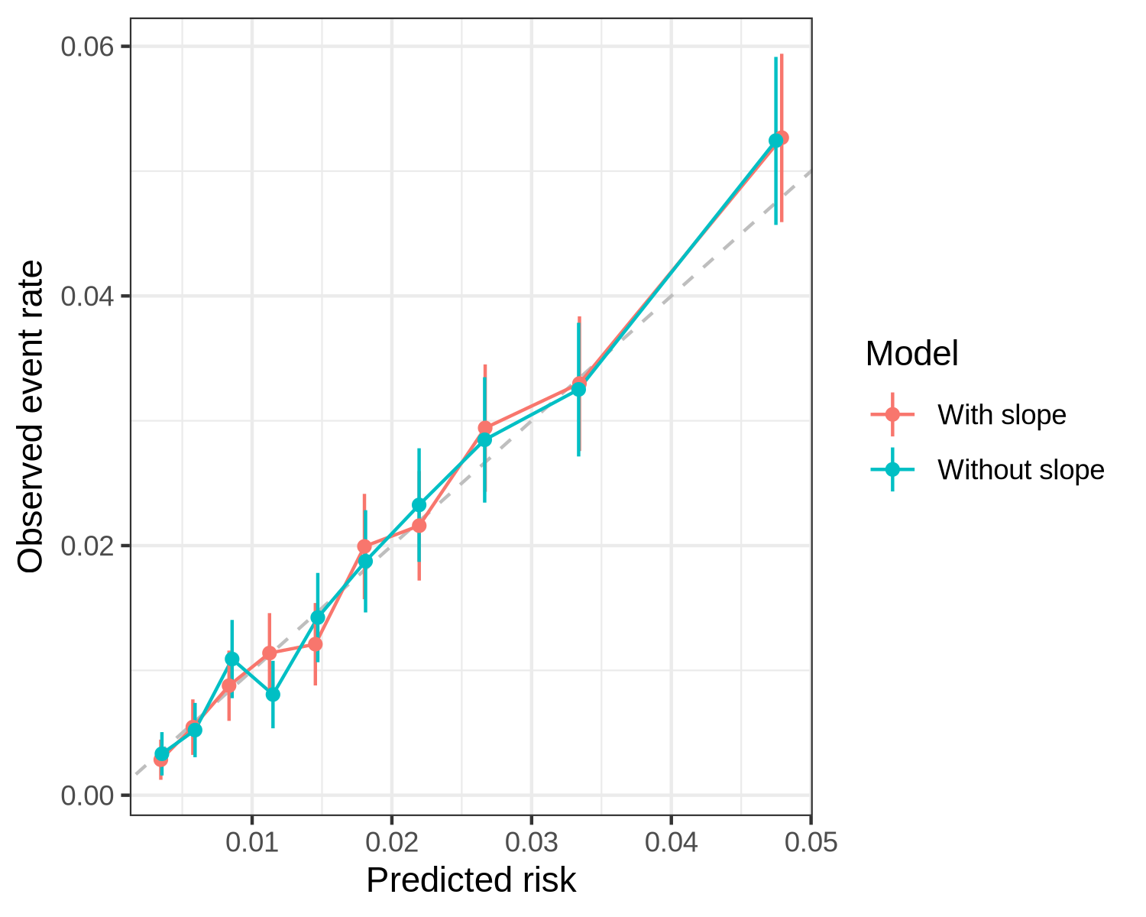
Supplementary Figure 17. Calibration plot of deciles of predicted risk by models with and without slope information versus observed event rates of stroke using Kaplan-Meier estimates. Error bars represent 95% confidence intervals.

A  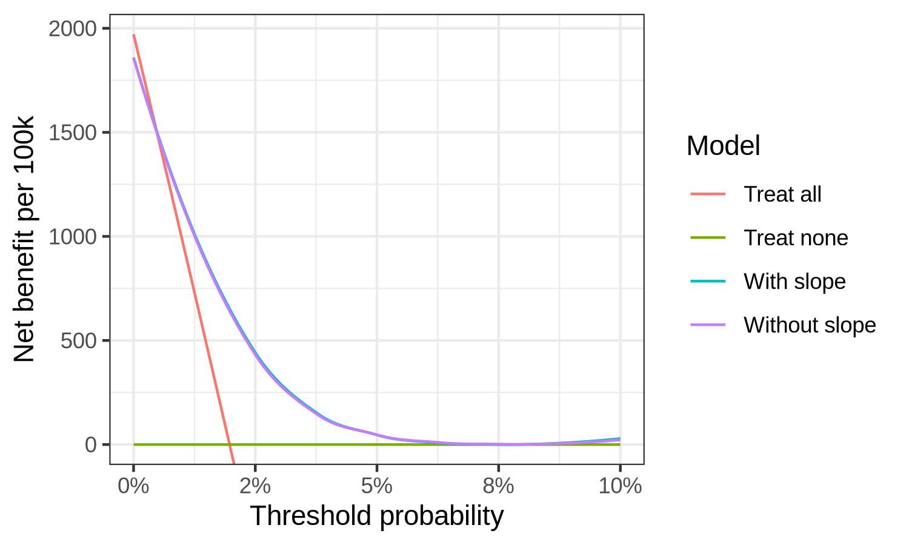 | B  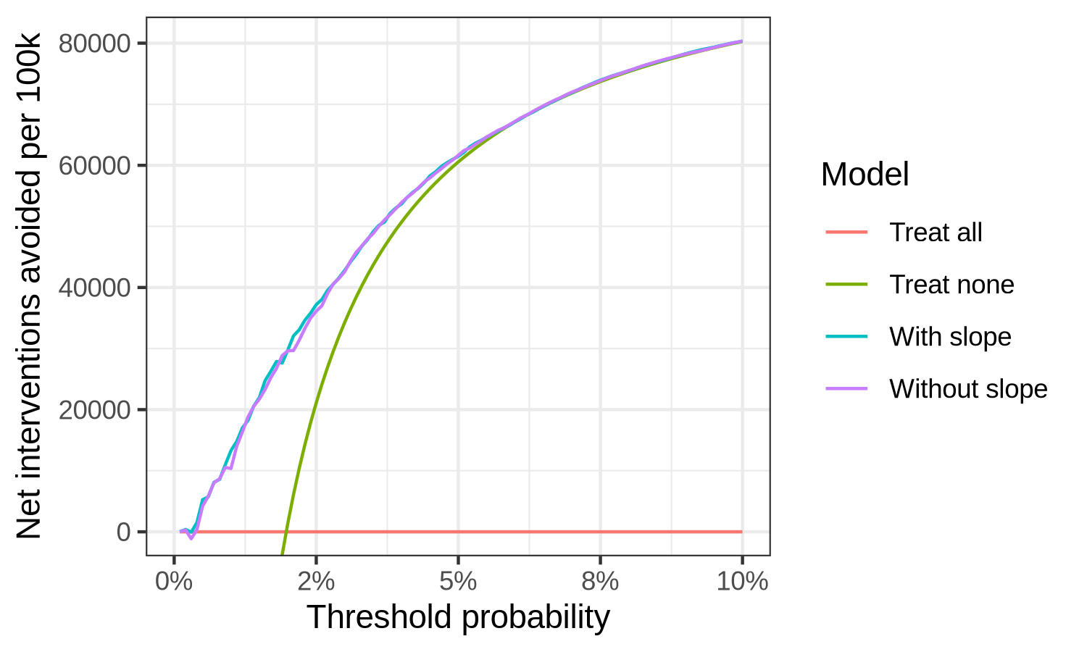
Supplementary Figure 18. Decision curve analyses of incident stroke models with and without slope information. A: Net benefit (A) and net interventions avoided (B) per 100,000 individuals measured at treatment thresholds from 0 to 10%. Treat all and treat none strategies are also plotted for reference.

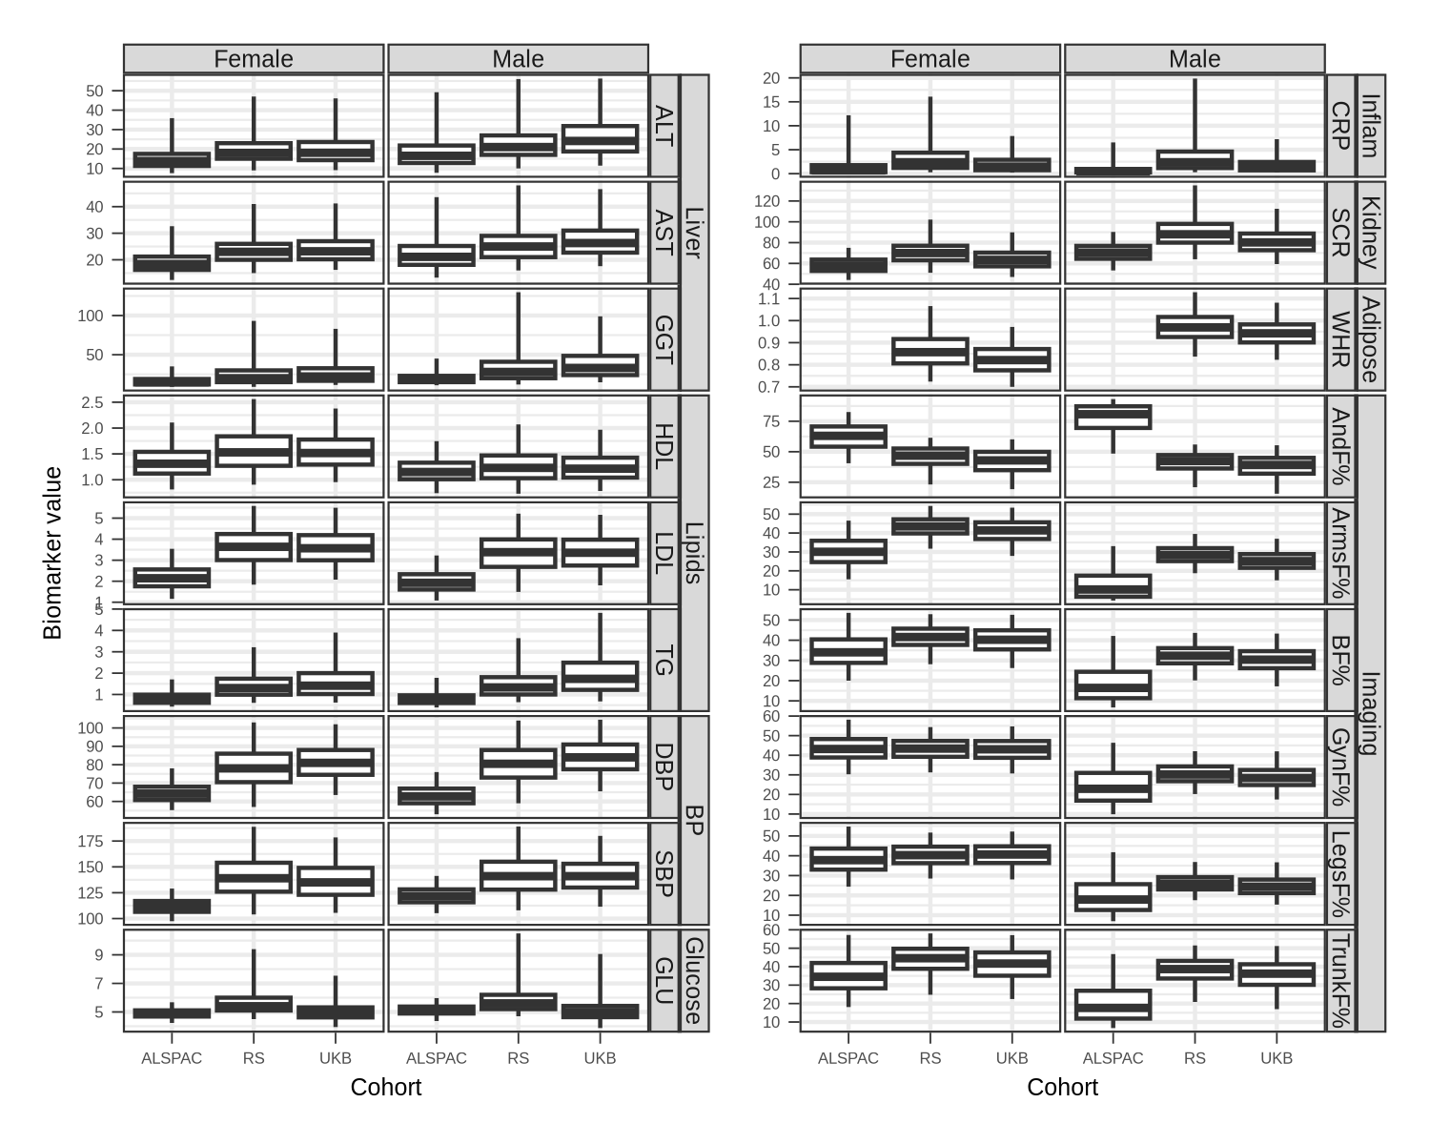
Supplementary Figure 19. Distribution of biomarkers analysed across cohorts.

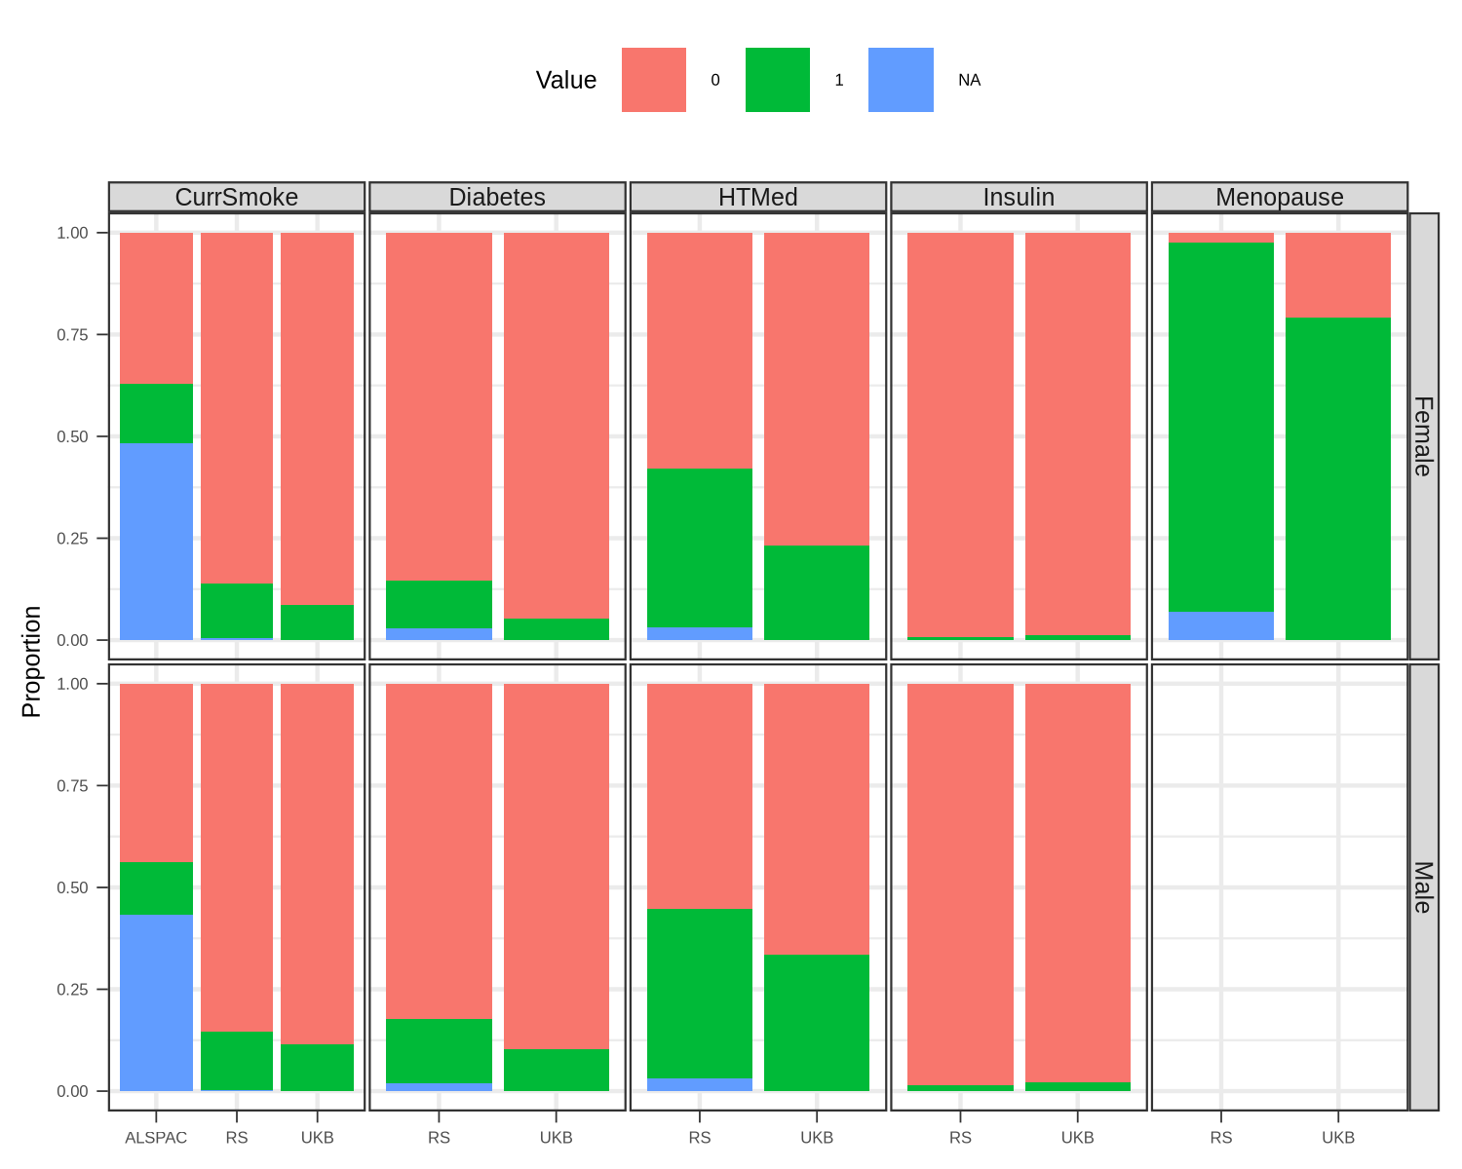
Supplementary Figure 20. Proportions with comorbidities across cohorts.

