Appendix:
Health status of oysters in the Paranaguá Estuarine Complex through interactions with pathogenic bacteria, protozoa and annelids
Ana Beatriz Vilas Boas Alves^{b}
Estela Pires^{a,b}
Ricardo Castro Alvarez^{b}
Luciene Correa Limaª
Maikon Di Domenico^{a,b}
a- Center for Marine Studies, Federal University of Paraná, Sea Studies Center, Av Beira-Mar, s/n Pontal do Sul, Pontal do Paraná, 83255976, PR, Brazil

b- Postgraduate Program in Coastal and Oceanic Systems (PGSISCO), Federal University of Paraná, Sea Studies Center, Av Beira-Mar, s/n Pontal do Sul, Pontal do Paraná, 83255976, PR, Brazil

Table 1. Table 1. Model selection results for Perkinsus sp. infection in the rectum and gills of Crassostrea sp. oysters. Best-fitting generalized linear models (GLMs) describing Perkinsus sp. infection intensity in the rectum and gills as a function of Bay, shell Length, Culture type, and shell Width. For each candidate model, the table presents the degrees of freedom (df), corrected Akaike Information Criterion (AICc), difference to the best model (ΔAICc), and Akaike weight (AICw). A “+” symbol indicates that the variable was included in the model; parameter signs correspond to the direction of coefficients in the averaged model (positive or negative effect). The Relative Importance (RI) values summarize the probability of each predictor being retained across the full model set, highlighting the strongest contributors to variation in Perkinsus infection.
 |  | Bay | Length | Culture | Width | df | AICc | Delta | AICw
Perkinsus rectum | 13 |  |  | + | -0,506 | 4 | 1515,4 | 0,00 | 0,583
 | 15 |  | 0,059 | + | -0,499 | 5 | 1516,1 | 0,67 | 0,416
RI |  | <0,01 | 0,42 | 1,00 | 1,00

 |  | Bay | Length | Culture | Width | df | AICc | Delta | AICw
Perkinsus gills | 8 | + | -0,129 | + |  | 5 | 761,8 | 0,00 | 0,748
 | 16 | + | -0,129 | + | -0,013 | 6 | 764,0 | 2,17 | 0,252
RI |  | 1,00 | 1,00 | 1,00 | 0,25

Table 2. Taxonomic list of annelid species associated with Crassostrea sp. oysters. Classification of annelid taxa recorded in the study, organized by the two major clades—Errantia and Sedentaria. The table lists each species identification alongside its respective family. Errantia includes predominantly mobile polychaetes (e.g., Nereididae, Phyllodocidae, Syllidae), whereas Sedentaria comprises tube-building and burrowing forms (e.g., Spionidae, Sabellidae, Serpulidae) commonly observed as oyster epibionts or shell borers.
Errantia | Família
Alitta sp. | Nereididae
Perinereis vancaurica (Ehlers,1868) | Nereididae
Nereis oligohalina(Rioja,1946 ) | Nereididae
Eumida sp. | Phyllodocidae
Syllidae sp. | Syllidae
Sedentaria | Família
Polydora sp. | Spionidae
Nicolea sp. | Terebelidae
Parasabella sp. | Sabellidae
Nainereis sp. | Orbinidae
Hydroides dianthus | Serpulidae
Branchioma sp. | Sabellidae

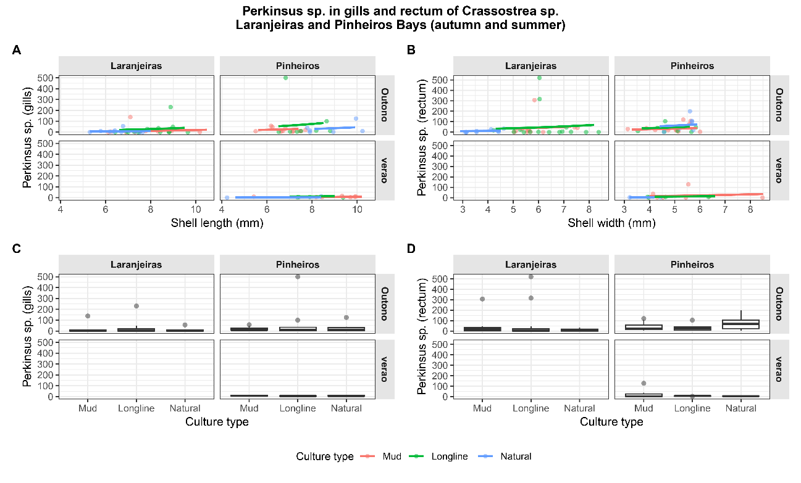
Figure 1. Perkinsus sp. infection in gills and rectum of Crassostrea sp. from Laranjeiras and Pinheiros Bays (autumn and summer). (A) Generalized linear model (negative binomial) showing the relationship between Perkinsus sp. counts in the gills and oyster shell length (mm), separated by bay and season. (B) Equivalent regression for Perkinsus sp. counts in the rectum as a function of shell width (mm). (C) Boxplots of Perkinsus sp. in the gills across culture types (Mud, Longline, Natural), showing differences between bays and seasons. (D) Boxplots of Perkinsus sp. in the rectum across culture types. Colors indicate culture method (red = Mud, green = Longline, blue = Natural). Panels illustrate seasonal patterns (autumn vs. summer) and spatial variation (Laranjeiras vs. Pinheiros), highlighting the influence of morphology and culture practice on Perkinsus infection intensity.
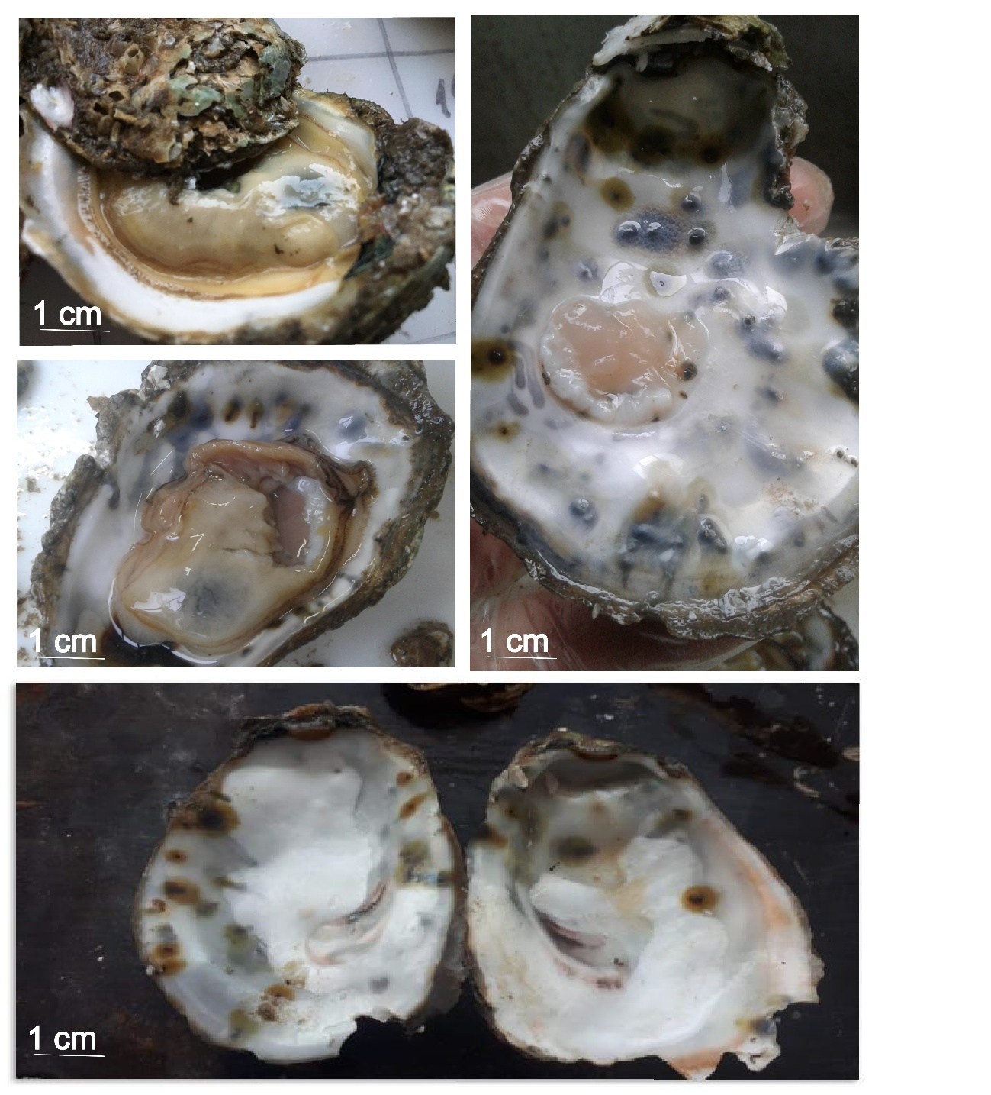
Figure 2. Signs of boring shells and mud blisters formed by the action of polydorid worms

