Supplementary Information

Molecular Engineering towards Efficient White-Light-Emitting Perovskite
Mingming Zhang^{1,†}, Lili Zhao^{2,†}, Qian Zhang¹, Najma Yaqoob³, Zhengmao Yin⁴, Payam Kaghazchi³, Weigao Xu^{2,}*, Lei Wang¹ & Jun Xing^{1,}*
¹Key Laboratory of Eco-Chemical Engineering, Ministry of Education, College of Chemistry and Molecular Engineering, Qingdao University of Science & Technology, Qingdao 266042, China.
²Key Laboratory of Mesoscopic Chemistry, Ministry of Education, School of Chemistry and Chemical Engineering, Nanjing University, Nanjing 210023, China.
³Forschungszentrum Jülich GmbH, Institute of Energy and Climate Research, Materials Synthesis and Processing (IEK-1), Wilhelm-Johnen-Straße, 52425 Jülich, Germany.
⁴School of Materials Science and Technology, Qingdao University of Science & Technology, Qingdao 266042, China.
*correspondence: xuwg@nju.edu.cn and xingjun@qust.edu.cn
† These authors contributed equally to this work.

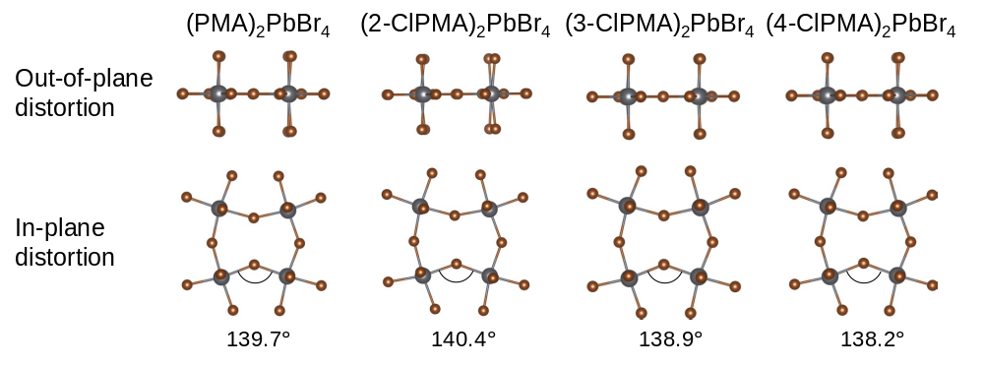

Figure S1. Atomic structure of perovskites (PMA)₂PBr₄, (2-ClPMA)₂PBr₄, (3-ClPMA)₂PBr₄ and (4-ClPMA)₂PBr₄.

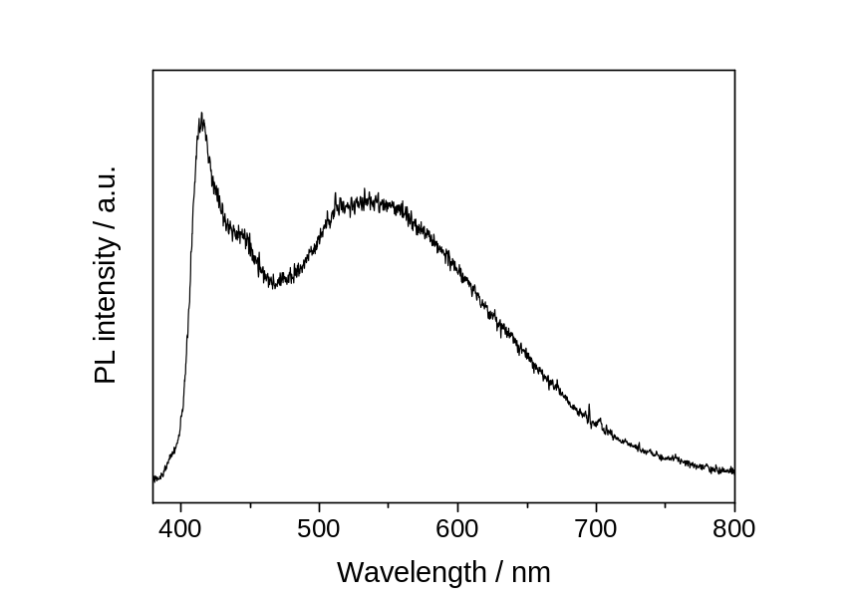

Figure S2. PL spectrum of (2-ClPMA)₂PbBr₄ synthesized by fast reprecipitation method.

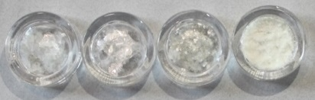
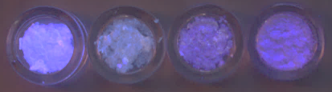
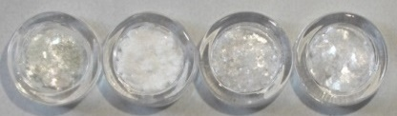
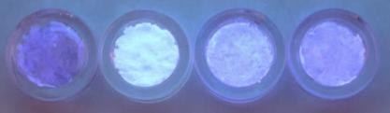
a
b

Figure S3. Digital images of (a) (PMA)₂PbBr₄, (2-FPMA)₂PbBr₄, (3-FPMA)₂PbBr₄, (4-FPMA)₂PbBr₄ and (b) (PMA)₂PbBr₄, (2-BrPMA)₂PbBr₄, (3-BrPMA)₂PbBr₄, (4-BrPMA)₂PbBr₄ crystals under ambient light (upper) and UV light (lower).

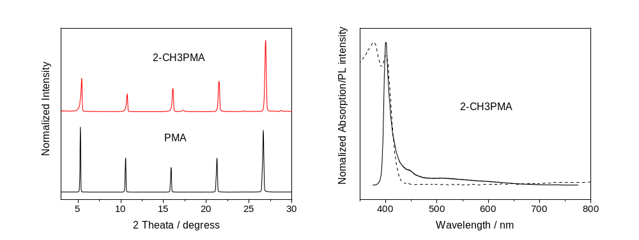
a
b

Figure S4. (a) Powder XRD patterns of perovskites (PMA)₂PbBr₄ and (2-CH₃PMA)₂PbBr₄. (b) Absorption (dashed line) and PL spectrum (solid line) of (2-CH₃PMA)₂PbBr₄.

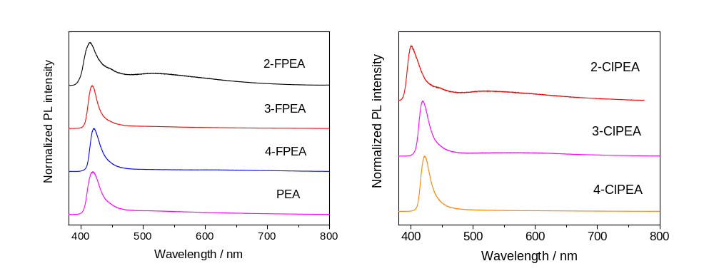
a
b

Figure S5. PL spectra of perovskites (a) (PEA)₂PbBr₄, (2-FPEA)₂PBr₄, (3-FPEA)₂PBr₄, (4-FPEA)₂PBr₄ and (b) (2-ClPEA)₂PBr₄, (3-ClPEA)₂PBr₄, (4-ClPEA)₂PBr₄.

Table S1. Crystal lattice constants of perovskites (PMA)₂PbBr₄, (2-ClPMA)₂PbBr₄, (3-ClPMA)₂PbBr₄ and (4-ClPMA)₂PbBr₄.
 | a (Å) | b (Å) | c (Å)
(PMA)₂PbBr₄ | 33.11 | 8.08 | 7.97
(2-ClPMA)₂PbBr₄ | 32.01 | 8.40 | 8.03
(3-ClPMA)₂PbBr₄ | 35.99 | 8.04 | 8.02
(4-ClPMA)₂PbBr₄ | 36.18 | 8.06 | 7.94

Table S2. The performance of reported low-dimensional hybrid perovskites with BWL emission.
Compositions | PLQY (%) | CRI | CIE | Ref
(N-MEDA)PbBr₄ | 0.5 | 82 | (0.36, 0.41) | J. Am. Chem. Soc.  2014, 136, 1718
(EDBE)PbBr₄ | 9 | 84 | (0.39, 0.42) | J. Am. Chem. Soc.  2014, 136, 13154
(EDBE)PbCl₄ | 2 | 81 | (0.33, 0.39) | J. Am. Chem. Soc.  2014, 136, 13154
(PEA)₂PbCl₄ | < 1 | 84 | (0.37, 0.42) | Chem. Mater.  2017, 29, 3947
(EA)₄Pb₃Cl₁₀ | / | 66 | (0.27, 0.39) | J. Am. Chem. Soc.  2017, 139, 11956
(EA)₄Pb₃Cl_{9.5}Br_{0.5} | / | 83 | (0.30, 0.35) | J. Am. Chem. Soc.  2017, 139, 11956
(CyBMA)PbBr₄ | 1.5 | / | (0.23, 0.29) | ChemSusChem  2017, 10, 3765
C₄N₂H₁₄PbBr₄ | 20 | 63 | (0.21, 0.28) | Nat. Commun.  2017, 8, 14051
(NAI)₂PbCl₄ | < 1 | 90 | (0.36, 0.37) | J. Mater. Chem. C  2018, 6, 1171
(2meptH2)PbBr₄ | 3.37 | 91 | (0.24, 0.23) | Chem. Commun.  2018, 54, 4053
C₅H₁₄N₂PbCl₄·H₂O | 1 | 94 | (0.39, 0.37) | J. Mater. Chem. C  2018, 6, 6033
(BAPP)Pb₂Br₈ | 1.5 | 87 | (0.37, 0.40) | Adv. Mater.  2019, 31, 1807383
(TDMP)PbBr₄ | 46 | 75 | (0.29, 0.37) | Adv. Mater.  2019, 31, 1807383
(TDMP)PbCl₄ | 7.5 | 74 | / | J. Am. Chem. Soc.  2019, 141, 12619
(C₄H₉NH₃)₂PbCl₄ | 1 | 86 | (0.37, 0.40) | Adv. Funct. Mater.  2019, 29, 1805038
(AMP)PbCl₄ | < 1 | 90 | (0.28, 0.34) | Adv. Funct. Mater.  2019, 29, 1805038
(1HIEA)PbBr₄ | / | 73 | (0.32, 0.41) | J. Mater. Chem. C  2020, 8, 889
(2-ClPMA)₂PbBr₄ | 32 | 86 | (0.30, 0.33) | This work

Table S3. The PL decay parameters of (2-ClPMA)₂PbBr₄ and (3-ClPMA)₂PbBr₄.
 | τ_{1,STEs} (ns) | τ_{2,STEs} (ns) | τ_{1,FEs} (ns) | τ_{2,FEs} (ns)
(2-ClPMA)₂PbBr₄ | 3.23 | 0.90 | 1.39 | 0.36
(3-ClPMA)₂PbBr₄ | 3.17 | 0.82 | 1.04 | 0.33
According to previous report (Chem. Sci. 2017, 8, 4497), the emission ratio I_{STEs}/I_{FEs} at a given temperature is related to △G_{self-trap} (self-trapping depth = E_{STEs} − E_{FEs}) and the radiative emission rates from the STE and FEs states (k_{r,STEs} and k_{r,FEs}).
$$ln\left(\frac{I_{STEs}}{I_{FEs}}\right) ∝ln \left(\frac{k_{r,STEs}}{k_{r,FEs}}\right)- \frac{{△G}_{self-trap}}{K_{b}T}$$
Equals to $$ln\left(\frac{I_{STEs}}{I_{FEs}}\right) ∝ln \left(\frac{τ_{r,FEs}}{τ_{r,STEs}}\right)- \frac{{△G}_{self-trap}}{25.7 meV} (T=298 K)$$
In this case, the STEs emission energy is several hundreds of meV lower than that of FEs, implying the STEs state should be much lower than that of FEs state. So,
$$\frac{{△G}_{self-trap}}{25.7 meV} ≫ ln \left(\frac{1.39}{3.23}\right)({(2\text{-}ClPMA)}_{2}{PbBr}_{4}) or ln \left(\frac{1.04}{3.17}\right) ({(3\text{-}ClPMA)}_{2}{PbBr}_{4})$$
Thus, I_{STEs}/I_{FEs} is dominated by the △G_{self-trap}.

Table S4. Summaries of atoms distances and Coulomb forces of perovskites (PMA)₂PbBr₄, (2-ClPMA)₂PbBr₄, (3-ClPMA)₂PbBr₄ and (4-ClPMA)₂PbBr₄.

Sample | Distance of N-Pb1 (nm) | Distance of N-Pb2 (nm) | Distance of N-Pb3 (nm) | Distance of N-Pb4 (nm) | Average Coulomb force (nN)
(PMA)₂PbBr₄ | 0.4305 | 0.4439 | 0.5361 | 0.5494 | 0.7270
(2-ClPMA)₂PbBr₄ | 0.4313 | 0.4340 | 0.5318 | 0.5333 | 0.8250
(3-ClPMA)₂PbBr₄ | 0.4314 | 0.4318 | 0.5343 | 0.5380 | 0.7669
(4-ClPMA)₂PbBr₄ | 0.4309 | 0.4357 | 0.5331 | 0.5341 | 0.7783

According to the crystal structure, we summarized the coordinates of atoms N and Pb in a unit cell and assume that the centers of the positive charges of -NH₃⁺ cations and the negative charges of PbBr₃⁻ anions are located on the N atoms and Pb atoms, respectively. According to Coulomb law $F=k\frac{q_{1}×q_{2}}{d^{2}}$, the average Coulomb force between -NH₃⁺ and four adjacent PbBr₃⁻ was calculated.

