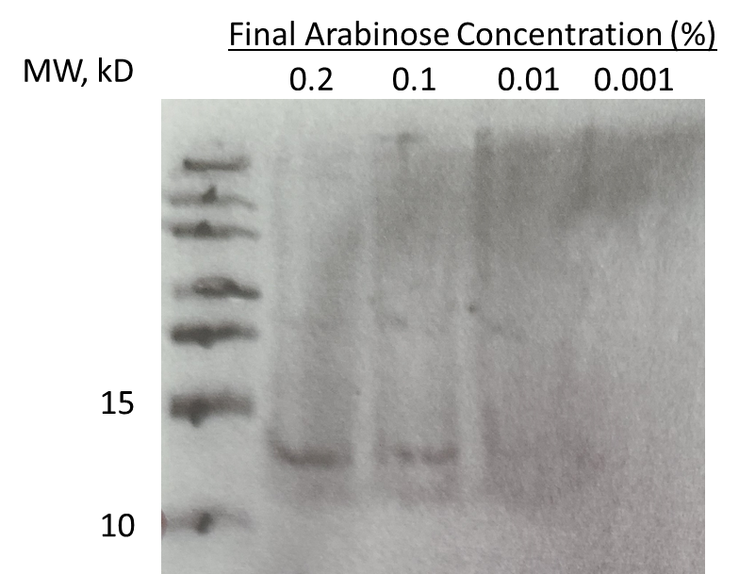

Supplemental Figure 1. Western blot of to confirm production of ChaB. K. pneumoniae chaB::ChaB colonies were cultured in TSB with 0.2, 0.1, 0.01 or 0.001%, Arabinose and whole cell extract was separated using SDS-PAGE prior to blotting on a PVDF membrane. Membrane was probed using Monoclonal ANTI-FLAG® M2 antibody (Sigma-Aldrich) followed by horseradish peroxidase-conjugated Goat anti-mouse IgG Fc secondary antibody. Expected size of ChaB-FLAG fusion protein is 10.8 kD.

