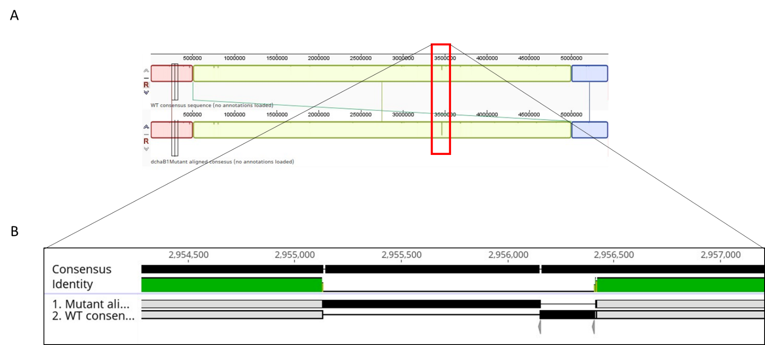

Supplemental Figure 2. Whole genome alignment of K. pneumoniae WT and chaB strain. The Geneious platform was utilized to align reads and visualizing alignments following Illumina sequencing A) Whole genome alignment using Mauve viewer to visualize alignment of assembled WT and chaB genomes. B) Zoom-in of loci where chaB gene is localized. WT and chaB are not properly aligned reflecting the insertion of chloramphenicol in place of chaB in the mutant strain.

