Supplementary material

- ITS models for SREL caseloads
Here is the hypothesised unadjusted segmented regression model for SREL caseloads:
[Model 1]
$${log⁡(Y}_{i})= β_{0}+β_{1}time_before_T_{1}+β_{2}time_after_T_{1}+β_{3}time_after_T_{2}+{β_{4}time_after_T_{3}+β_{5}time_after_T_{4}+ℇ}_{i}$$

Where i represents the time (in months), $β_{1}$ is the before covid pandemic slope, $β_{2}$ is the slope during the pandemic period, $β_{3}$is the before-change/after any covid-related measure slope, $β_{4}$ is the post-change/implementation slope, $β_{5}$ is the post-implementation slope. We included a robust variance estimator to adjust for overdispersion. We also included Fourier terms to adjust for seasonality and autocorrelation.

Stata code:
- Segment specification
Time_i = max(0,min(_n-start_period_i, end_period_i - start_period_i)
- Fourier terms:
gen degrees = (time/12)*360
fourier degrees, n(1)
- Model specification
glm apps time1 time2 time3 time4 time5 cos sin, family(poisson) link(log) vce(robust) eform

Table1 shows the β estimates for the adjusted model (all caseloads).

Table 1. Interrupted time series estimates for the effect of the regulatory change on SREL caseloads (on a monthly basis)
 | Global |  | Sex |  |  |  | Cancer |  |  |  | Pension age
 |  |  | Male |  | Female |  | Non cancer |  | Cancer |  | State pension age |  | Below pension age
 | β | 95%CI | β | 95%CI | β | 95%CI | β | 95%CI | β | 95%CI | β | 95%CI | β | 95%CI
Before covid ($β_{1})$ | 1.003 | [1.003; 1.004] | 1.004 | [1.003, 1.005] | 1.003 | [1.001, 1.005] | 1.009 | [1.008, 1.011] | 1.003 | [1.000, 1.005] | 0.998 | [0.996, 1.000] | 1.004 | [1.000, 1.008]
During covid ($β_{2})$ | 0.995 | [0.995; 0.996] | 0.996 | [0.995, 0.997] | 0.995 | [0.993, 0.997] | 0.996 | [0.995, 0.997] | 0.995 | [0.993, 0.998] | 1.009 | [1.007, 1.012] | 0.993 | [0.989, 0.998]
Post covid ($β_{3})$ | 1.003 | [1.003; 1.004] | 1.003 | [1.003, 1.004] | 1.003 | [1.002, 1.005] | 1.004 | [1.003, 1.005] | 1.003 | [1.001, 1.006] | 1.014 | [1.012, 1.016] | 1.002 | [0.998, 1.005]
Implementation ($β_{4})$ | 1.002 | [1.002; 1.003] | 1.003 | [1.003, 1.004] | 1.001 | [1.000, 1.003] | 1.002 | [1.001, 1.004] | 1.002 | [1.000, 1.005] | 1.011 | [1.010, 1.013] | 1.000 | [0.997, 1.003]
Post implementation ($β_{5})$ | 1.007 | [1.007; 1.008] | 1.008 | [1.008, 1.008] | 1.007 | [1.006, 1.008] | 1.014 | [1.014, 1.015] | 1.006 | [1.005, 1.008] | 1.014 | [1.013, 1.014] | 1.006 | [1.005, 1.007]
Cosinus term | 1.002 | [1.000; 1.004] | 1.002 | [1.000, 1.004] | 1.002 | [1.000, 1.004] | 1.002 | [1.000, 1.005] | 1.002 | [1.000, 1.005] | 1.000 | [1.000, 1.005] | 1.002 | [1.000, 1.005]
Sinus term | 0.994 | [0.992; 0.996] | 0.994 | [0.992, 0.996] | 0.994 | [0.992, 0.996] | 0.994 | [0.991, 0.996] | 0.994 | [0.991, 0.996] | 0.994 | [0.991, 0.996] | 0.994 | [0.991, 0.996]

In the article, the annual rate (Table 2) is calculated as ($β$ ¹²-1)*100. For example, for the variable “before covid”, which represents the slope before any lockdown, the AR = ($β_{1}$ ¹² -1)*100= (1.003¹² -1)=4.27%.

- ITS model for Attendance Allowance
Here is the hypothesised unadjusted segmented regression model for attendance allowance caseloads:
[Model 2]
$${log⁡(Y}_{i})= β_{0}+β_{1}time_before_T_{1}+β_{2}time_after_T_{1}+β_{3}time_after_T_{2}+{β_{4}time_after_T_{3}+β_{5}time_after_T_{4}+ℇ}_{i}$$

Where i represents the time (in quarters), $β_{1}$ is the before covid pandemic slope, $β_{2}$ is the slope during the pandemic period, $β_{3}$is the before-change/after any covid-related measure slope, $β_{4}$ is the post-change/implementation slope, $β_{5}$ is the post-implementation slope. Since the outcome did not follow a Poisson distribution, we included a robust variance estimator to account for overdispersion. We also included Fourier terms to adjust for seasonality and autocorrelation.

Table2 shows the β estimates for the adjusted model (all caseloads). Figure A is a graphical representation of the adjusted model.

Table 2. Interrupted time series estimates for the effect of the regulatory change on Attendance allowance caseloads (on a quarterly basis)
Variable | β | 95% CI
Before covid ($β_{1})$ | 1.013 | [1.006; 1.019]
During covid ($β_{2})$ | 0.965 | [0.950; 0.981]
Post covid ($β_{3})$ | 1.016 | [1.002; 1.031]
Implementation ($β_{4})$ | 1.055 | [1.043; 1.067]
Post implementation ($β_{5})$ | 1.009 | [1.004; 1.014]
Cosinus term | 1.006 | [0.992; 1.010]
Sinus term | 1.041 | [1.035; 1.047]
Intercept ($β_{0})$ | 35979.510 | [35584.340; 36379.060]

The annual rate is calculated here as ($β$ ⁴-1)*100. For example, for the variable “before covid” in [Model 1], which represents the slope before any lockdown, the AC = ($β_{1}$ ⁴ -1)*100= (1.013⁴ -1)=5.20%.

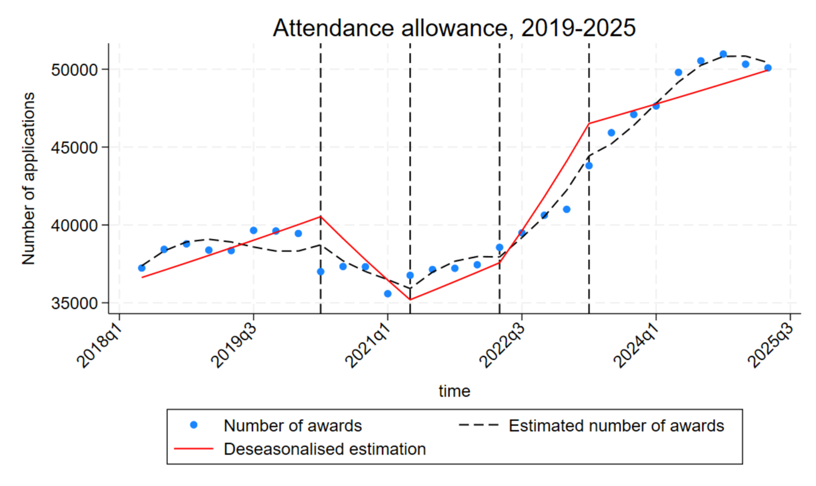

- Limitations

[Model 2] was fitted using data available only at quarterly intervals, which restricted the number of time points modelled to 29 and reduced statistical power. As a result, estimates from [Model 2] should be interpreted with caution, and any changes identified should be considered on a quarterly basis. In contrast, [Model 1] is more robust, having been fitted using monthly data. With 79 data points, [Model 1] allows for a more precise approximation and control of seasonal patterns. Consequently, direct comparisons between [Model 1] and [Model 2] are not appropriate.

