Supplementary

Résults:
OU admission was higher for the three risk groups in Turkey Hungary, Germany, France and Croatia. Interestigly Norway and Ireland had wery few OU admissions. Ward admission was higher in Norway and in Ireland, Hungary, Greece and Germany. ICU admission was found more frequently in Turkey and Germany (Figure S1).
ED LOS was higher in Italy, Ireland, Hungary ad France. OU LOS was higher in Italy. For both ED LOS and OU LOS, the MR group had a shorter stay across all countries. The Mean hospital LOS was shorter in Ireland and in Norway (Figure S2).
Death probability through 9 European countries was summurised in Mortality was higher in Turkey, Hungary and Greece. Hospital mortality was particularly low in Norway (Figure S3).
4 supplementary material: 3 figures et one Table
Element | Title
Figure S1 | Admission probability in 9 European countries according the brief geriatric assessment risk group
Figure S2 | Estimation of mean LOS in 9 European countries according the brief geriatric assessment risk group
Figure S3 | Hospital death probability in 9 European countries according the brief geriatric assessment risk group
Table S1 | 6-item Brief geriatric assessment score

(a)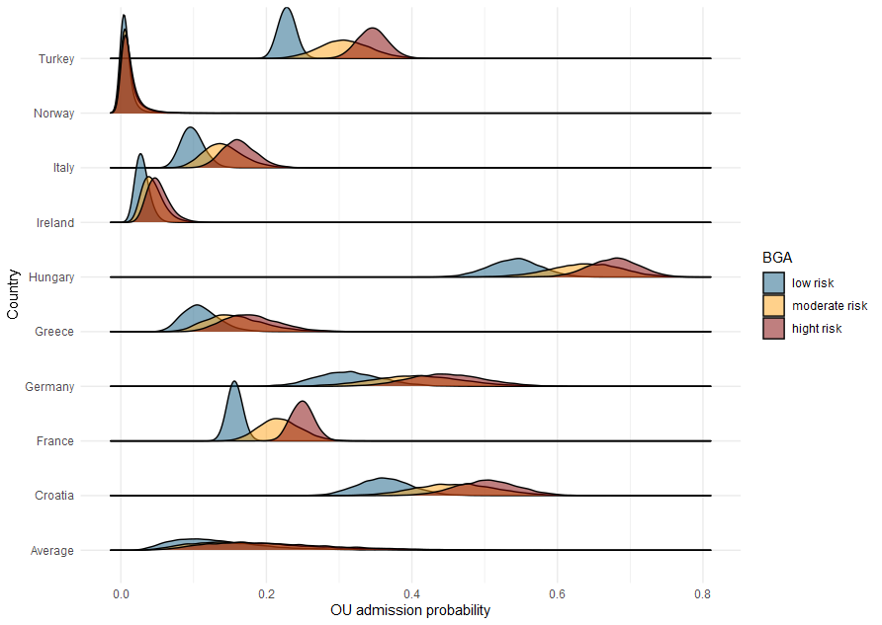(b) 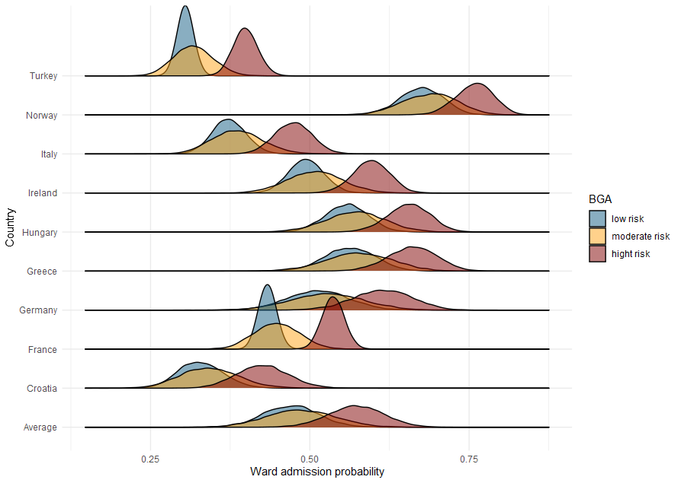
(c) 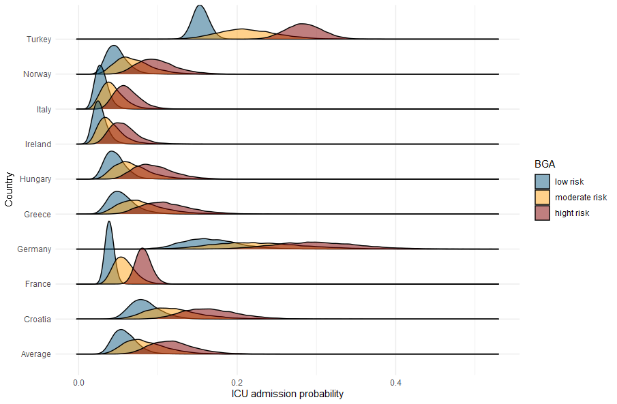
Figure S1: Admission probability in 9 European countries according the brief geriatric assessment risk group
(a): Observation unit probability of admission
(b): Ward probability of admission
(c): intensive care unit probability of admission

(a)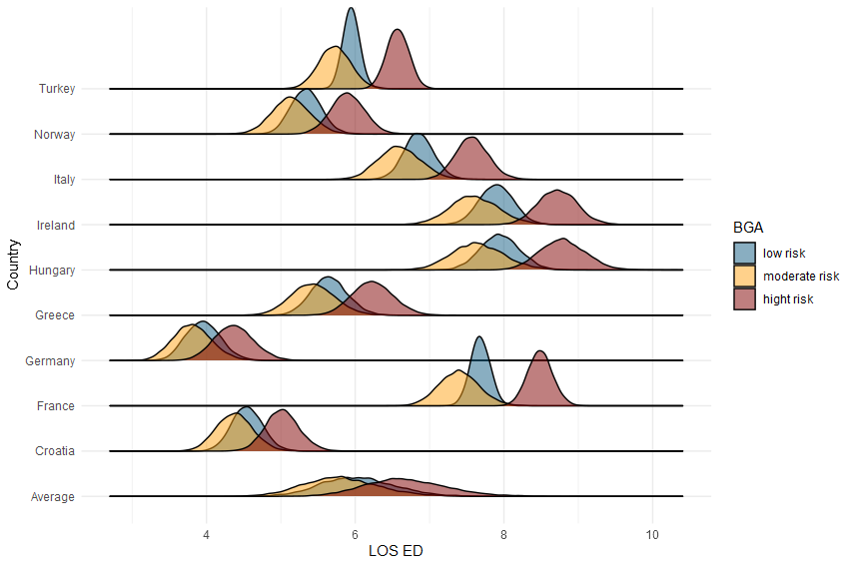(b)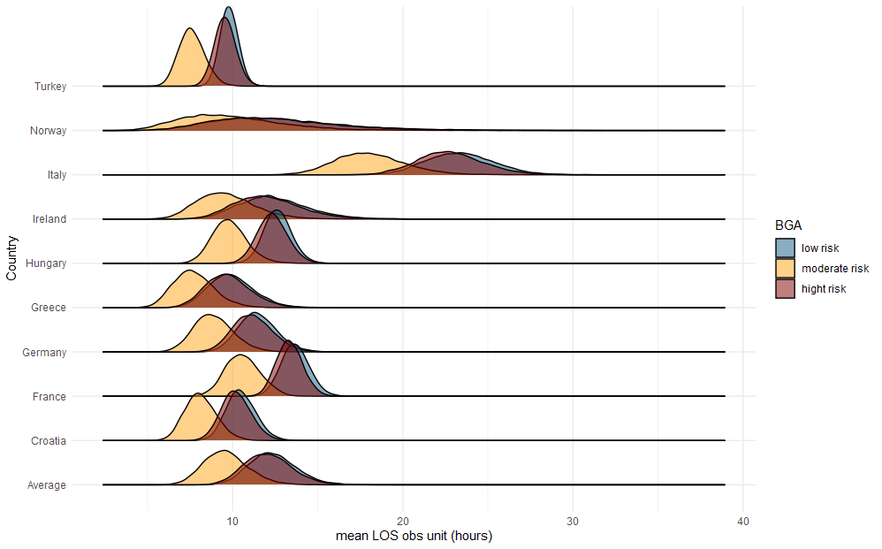

(c)
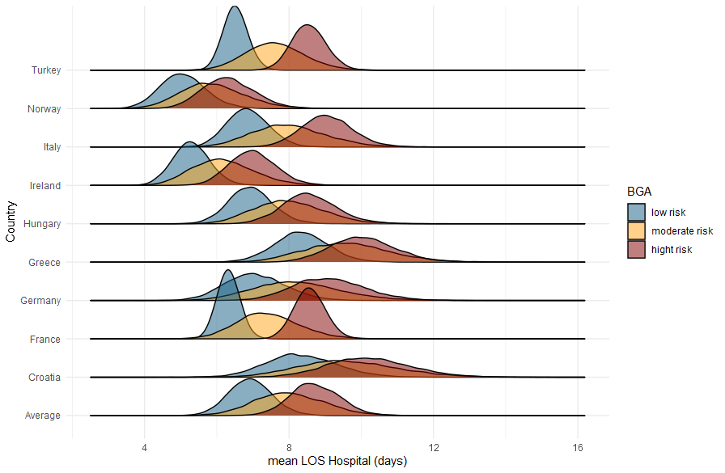

Figure S2: Estimation of mean LOS in 9 European countries according the brief geriatric assessment risk group
(a): Emergency department mean length of stay (in hours)
(b): Observation unit mean length of stay (in hours)
(c): Hospital mean length of stay (in days)

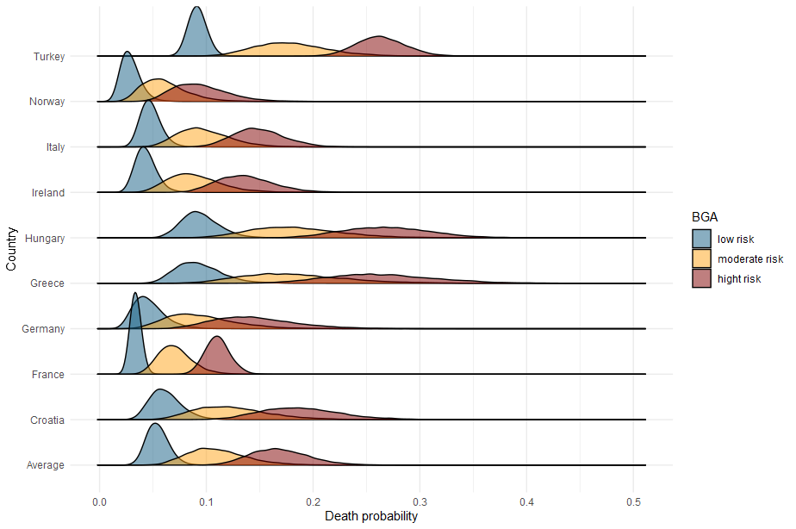
Figure S3: Hospital death probability in 9 European countries according the brief geriatric assessment risk group

 | Value
 | NO | YES
Age ≥ 85 y  Male  Home support (family, friend, health or social professional)  Taking daily ≥ 5 different medications  Use walking aid (OR HISTORY OF FALL)  Inability to name current year and/or month | 0  0  0  0  0  0 | 1  1  1  1  5  5
Interpretation: 1-3 = low risk; 4-5 = moderate risk; >5 = high risk. Total score = 14.

Table S1 6-item Brief geriatric assessment score

