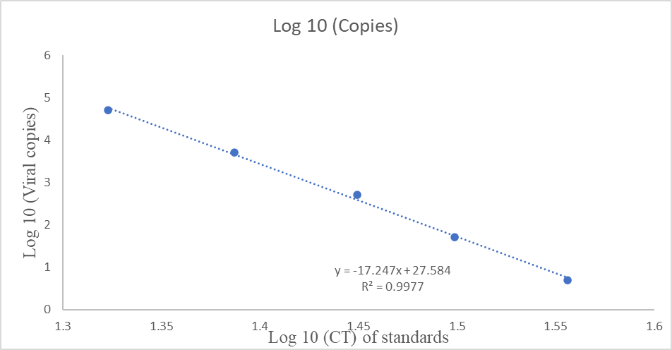
Figure 3: Linear graph of HDV standards and equation for the calculation of the viral copies of the 2 positive HDV samples.
Note: Log 10, Logarithm of 10; CT- cycle threshold; y, viral copies in log 10 for HDV standards; x- CT values of HDV standards; R, linear correlation coefficient

