Supporting information

Leveraging the Redox Shuttle Effect of TEMPO for the reactivation of Dead Zinc in Aqueous Zinc-Ion Batteries

Qianhong Da ª，Zhengze Dang ª, Dan Liu ª, Ziyi Kang ª, Yunbo Zhang ^{* a}，and Peizhi Yang^{* a}

ª School of Energy and Environment Sciences, Yunnan Normal University, Kunming, Yunnan, 650500, P. R. China.
*Corresponding authors: E-mail: zhangyunbo@ynnu.edu.cn (Yunbo Zhang), pzhyang@hotmail.com (Peizhi Yang).

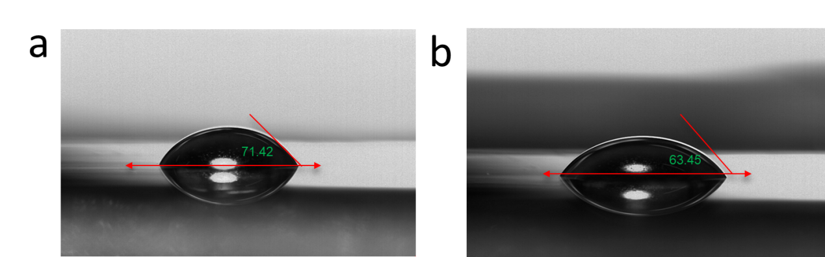
Figure S1 a) Contact angle of the electrolyte without TEMPO. b) Contact angle of the electrolyte containing 10 Mm TEMPO.

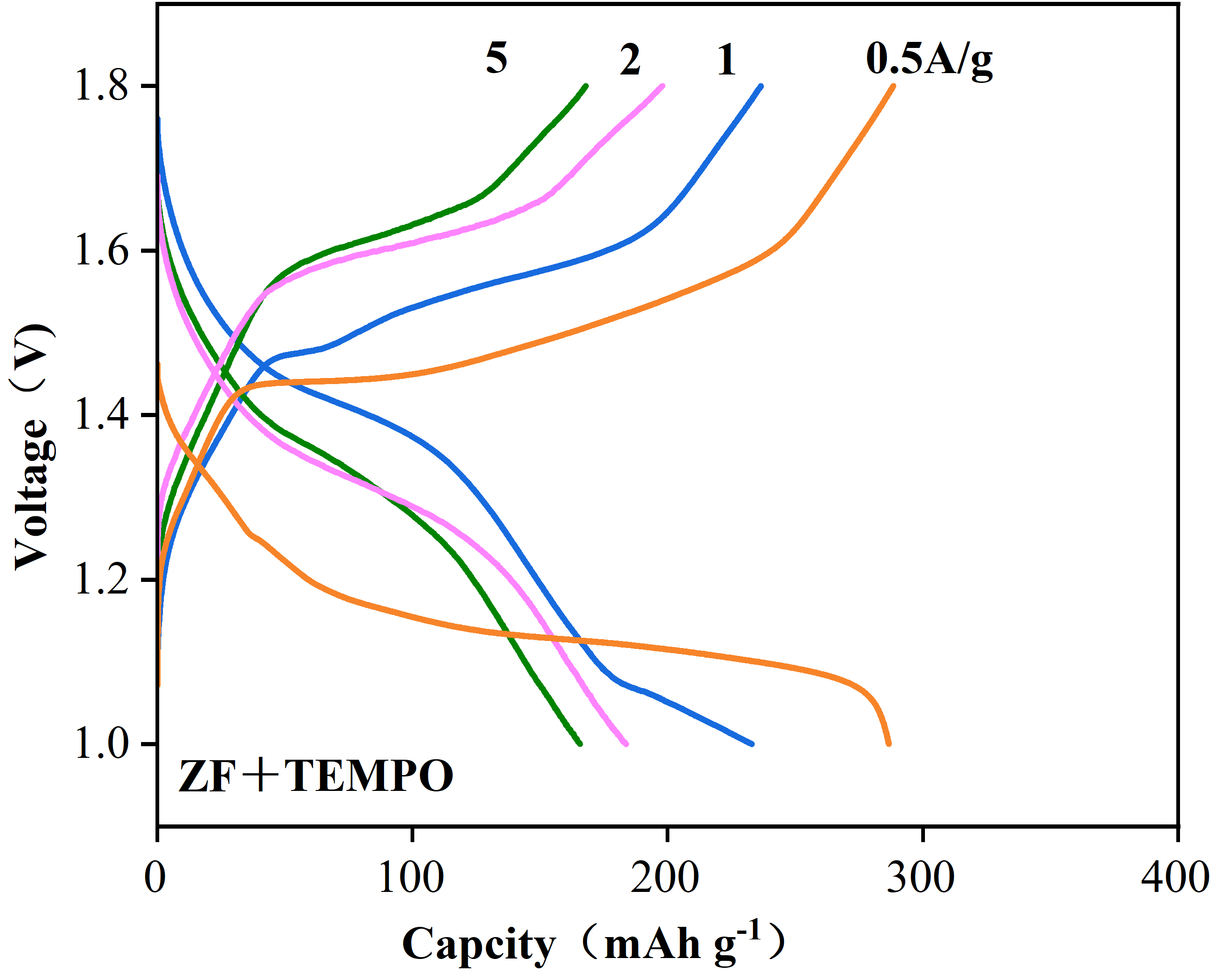
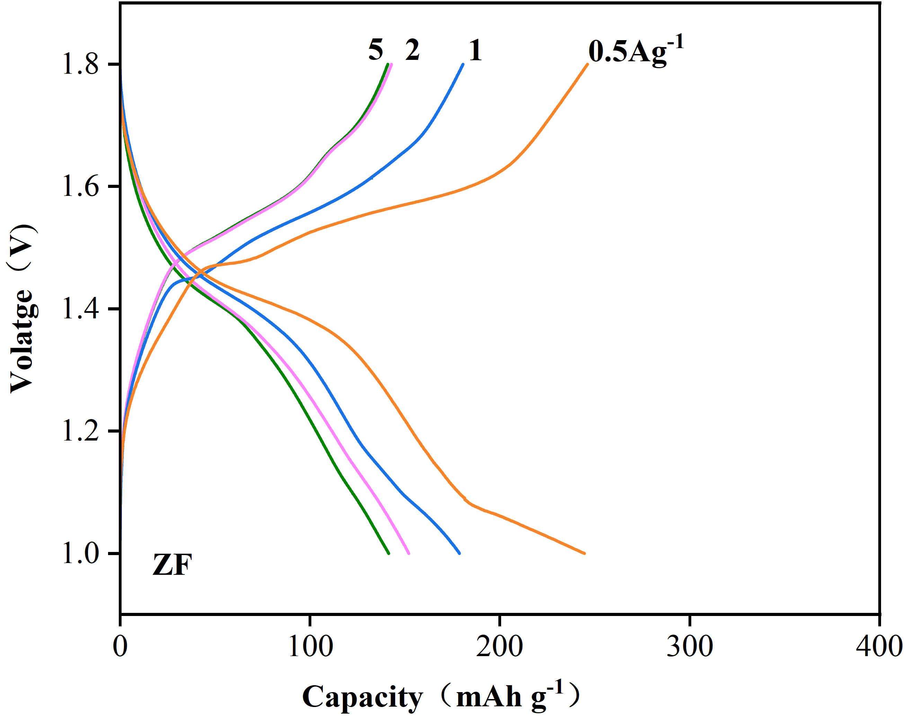
b
a

Figure S2 Voltage-capacity curves of a) Zn(OTF)₂ and b) TEMPO-modified electrolyte at different current densities.

