Figure S1–S3. Monte Carlo distributions for discrimination, MAIC, and calibration metrics across 1,300 trials.
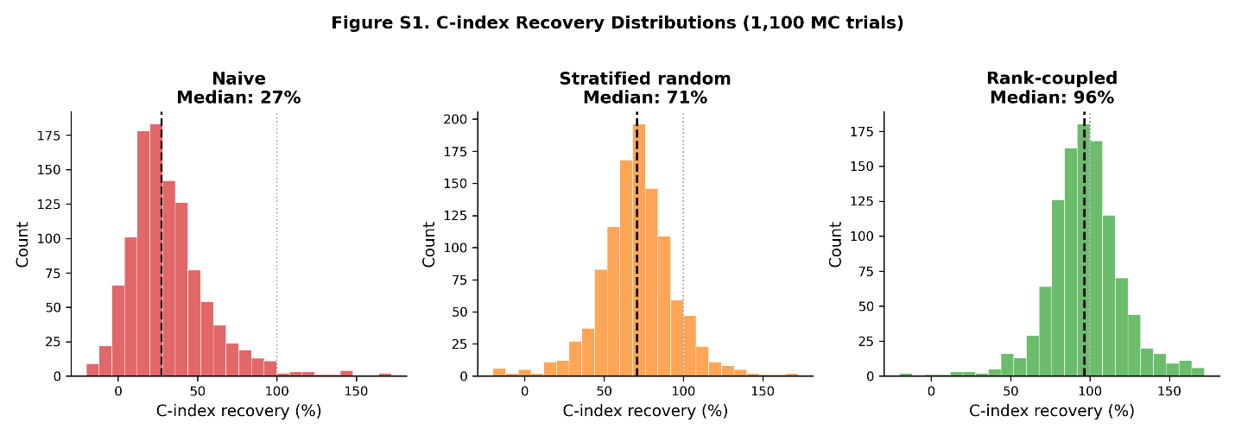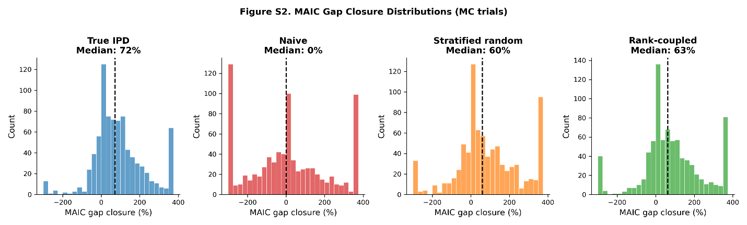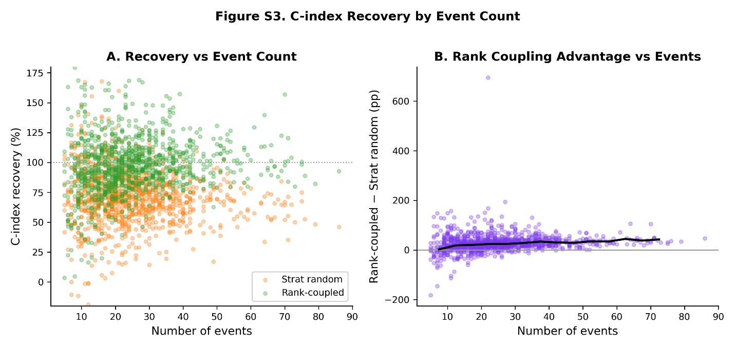

Figure 4.
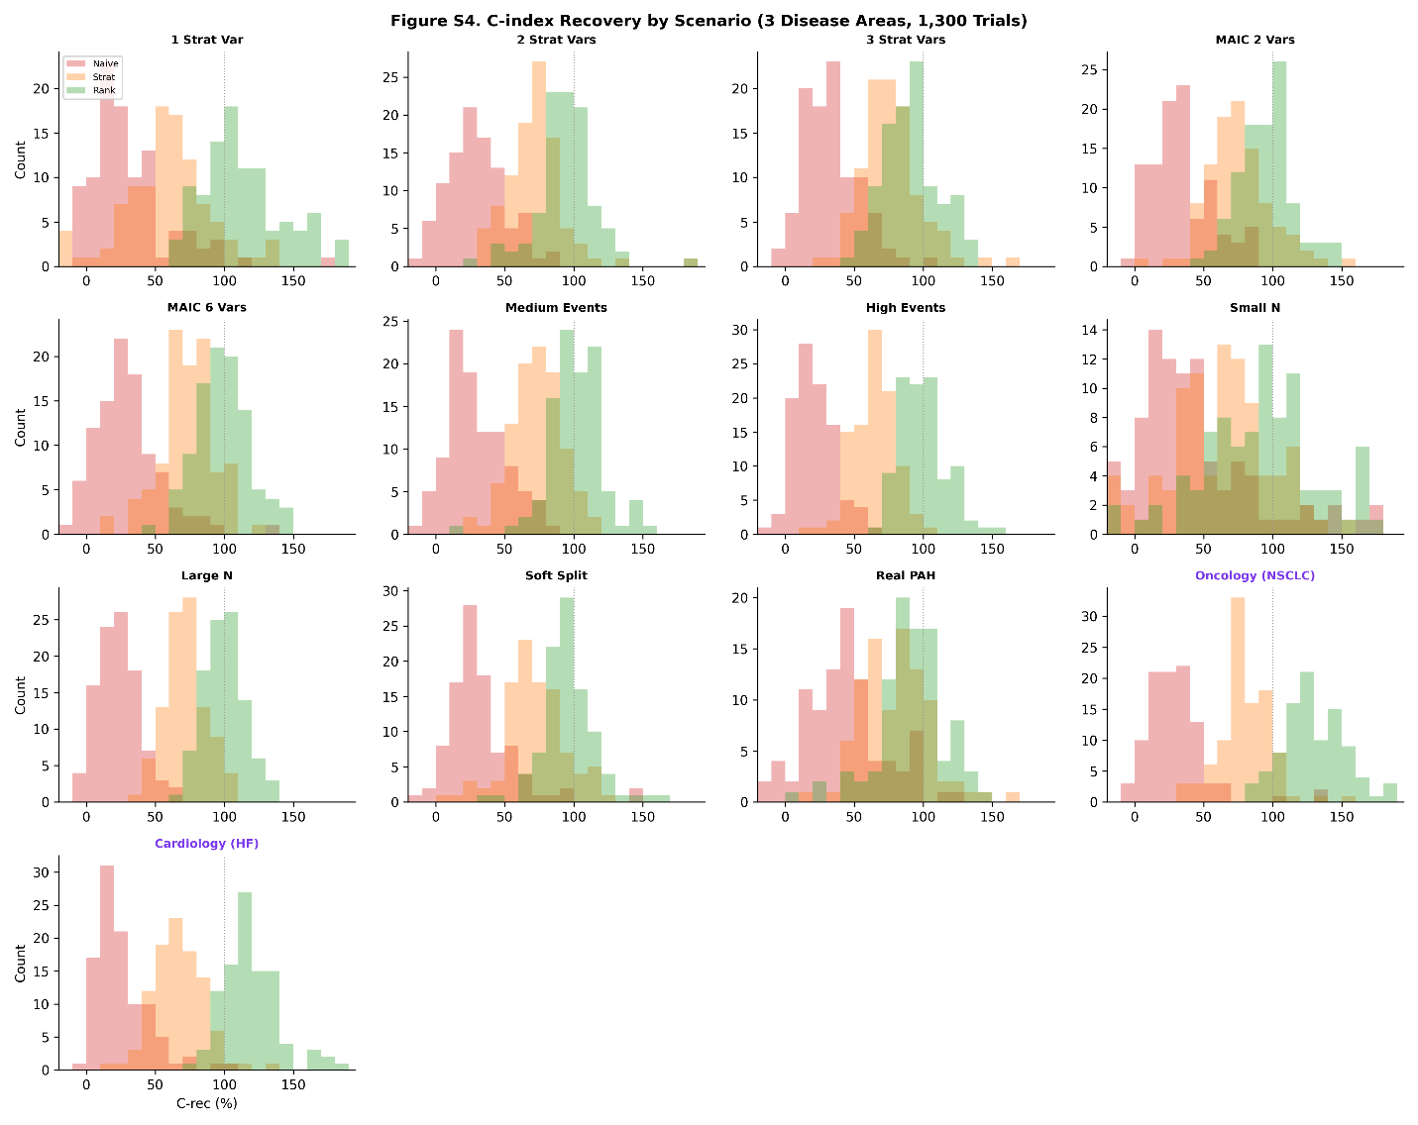
Figure S5. Scenario comparison boxplots (C-index recovery, MAIC RMSE, three methods).
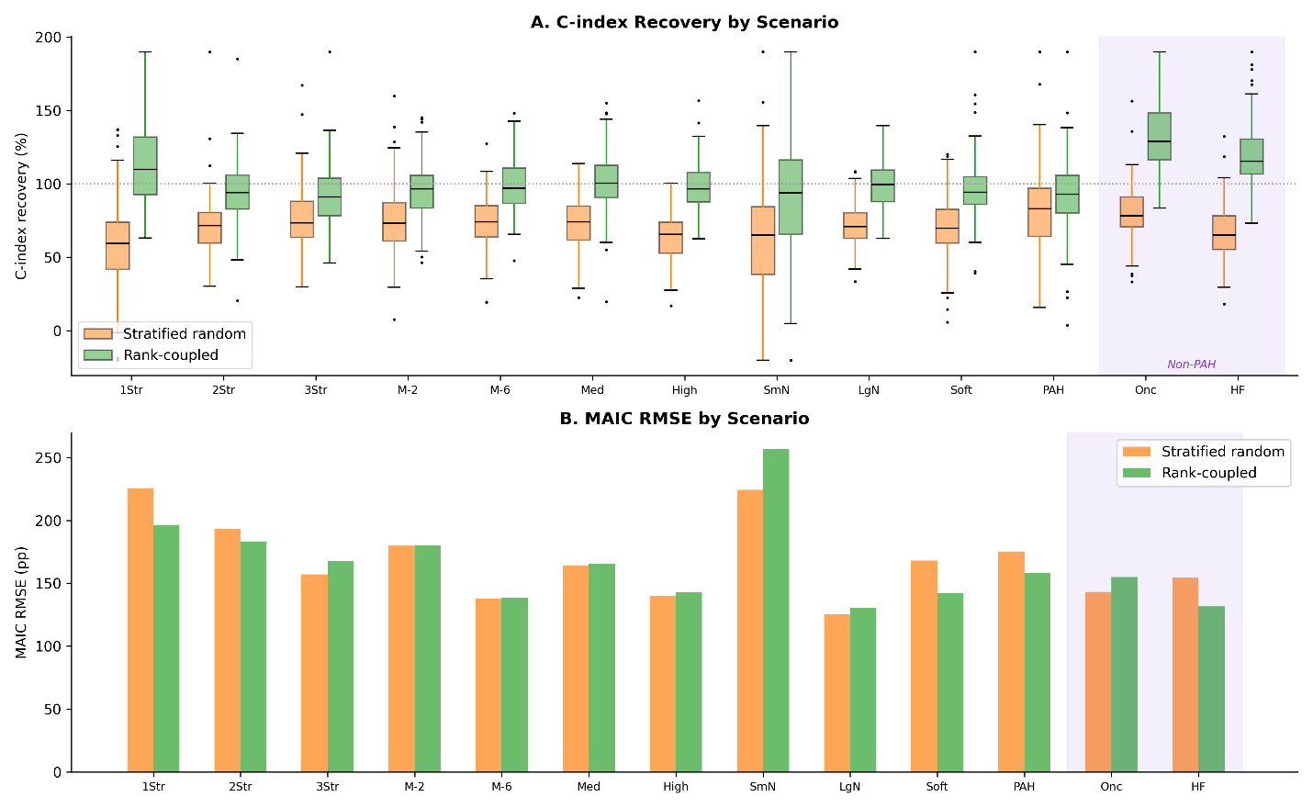

Figure S6. Coupling strength sensitivity: C-index recovery distributions at cs = 0.20, 0.30, 0.40.
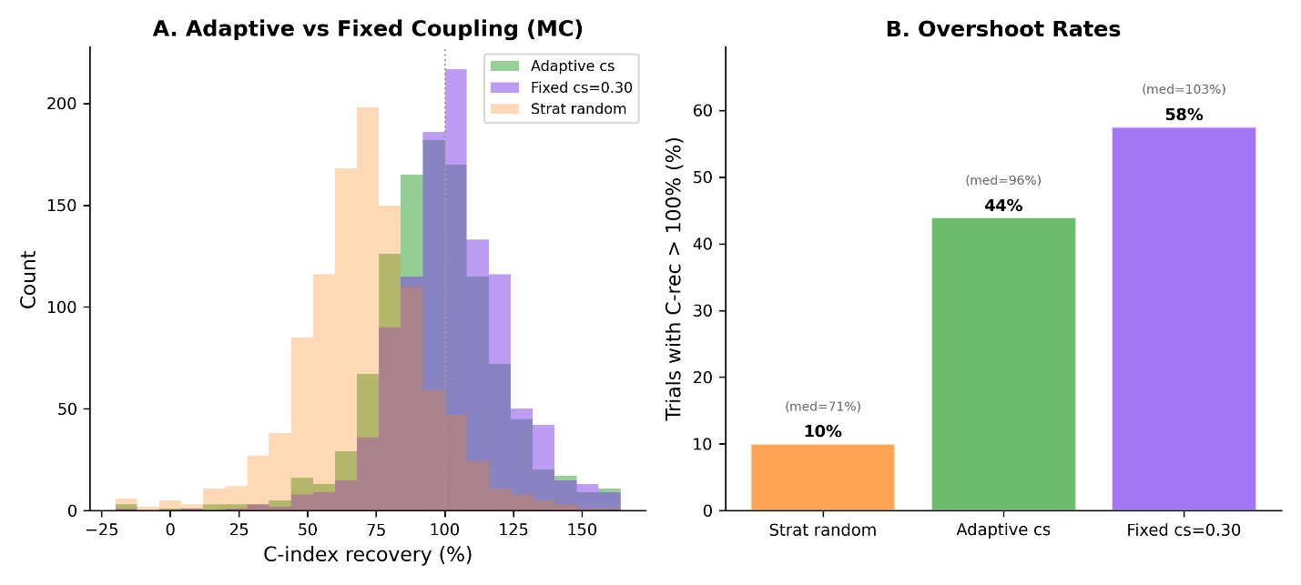

Figure S7. Cross-disease generalizability. Panel A: Median C-index recovery by disease area and reconstruction method. Panel B: Rank-coupled vs stratified random win rate by disease area (PAH, oncology, cardiology).
