Supporting information for Advanced Composites and Hybrid Materials
Article type: Full Paper

Surface Charge-Modulated Biomimetic Core-Shell Hybrid Nanovesicles for Redox-Triggered Synergistic Cancer Therapy

Hyeon-Ji Oh, Dong-Yong Hong, Jun Seob Lee, Jieun Han, Chun Gwon Park, Hyojin Lee, and Wooram Park*

H.-J. Oh, D.-Y. Hong, J. S. Lee, J. Han, and Prof. W. Park
Department of Integrative Biotechnology, College of Biotechnology and Bioengineering, Sungkyunkwan University (SKKU), Seobu-ro 2066, Jangan-gu, Suwon, Gyeonggi, 16419, Republic of Korea
E-mail: parkwr@skku.edu

Prof. W. Park
Department of MetaBioHealth, Institute for Cross-disciplinary Studies (ICS), SKKU, Seobu-ro 2066, Suwon, Gyeonggi 16419, Republic of Korea.

Prof. C. G. Park
Department of Biomedical Engineering, ICS, SKKU, Seobu-ro 2066, Suwon, Gyeonggi 16419, Republic of Korea.

Prof. C. G. Park, Dr. H. Lee, and Prof. W. Park
Biomaterials Research Center, Korea Institute of Science and Technology, 5, Hwarang-ro 14-gil, Seongbuk-gu, Seoul 02792, Republic of Korea.

1. Materials and Methods
1.1 Materials
Aromatic thiol precursors, including benzene-1,4-dithiol (BDT), benzene-1,2-dithiol, 1,4-benzenedimethanethiol, 4,4′-bis(mercaptomethyl)biphenyl, 4,4′-thiobisbenzenethiol, and 2,5-diamino-benzene-1,4-dithiol dichloride, were purchased from Sigma-Aldrich (St. Louis, MO, USA). 1,2-dioleoyl-3-trimethylammonium-propane (DOTAP) was obtained from Avanti Polar Lipids (Alabaster, AL, USA), and the photosensitizer pheophorbide A (PS) was purchased from Frontier Scientific (Logan, UT, USA).
For biochemical assays and imaging, monochlorobimane (MCB), 2′,7′-dichlorofluorescin diacetate (DCFH-DA), sodium dodecyl sulfate (SDS), and 3-(4,5-dimethylthiazol-2-yl)-2,5-diphenyltetrazolium bromide (MTT) were obtained from Sigma-Aldrich. Singlet Oxygen Sensor Green (SOSG) was purchased from Thermo Fisher Scientific (Waltham, MA, USA), while BODIPY 581/591 C11 and the Live/Dead viability assay kit (calcein-AM/propidium iodide) were obtained from Invitrogen (Carlsbad, CA, USA). The ferroptosis inhibitor ferrostatin-1 (Fer-1) was purchased from MedChemExpress (Monmouth Junction, NJ, USA).
Cell culture reagents, including Dulbecco’s Modified Eagle Medium (DMEM), antibiotic–antimycotic solution, fetal bovine serum (FBS), and phosphate-buffered saline (PBS), were purchased from Gibco (Grand Island, NY, USA) or HyClone (Logan, UT, USA). Murine colon carcinoma CT26 (Cat. No. 80009) and murine fibroblast NIH3T3 cells (Cat. No. 21658) were obtained from the Korean Cell Line Bank (Seoul, Korea). Tris(hydroxymethyl)aminomethane (Tris) was obtained from TCI Chemicals (Tokyo, Japan). All reagents were of analytical grade and used as received without further purification.

1.2 Preparation of pBDT Nanoparticles
Poly(benzene-1,4-dithiol) (pBDT) nanoparticles were synthesized via self-assembly using disulfide-containing aromatic thiols as structural precursors. Briefly, 200 µL of sodium dodecyl sulfate (SDS, 0.5% w/v) was added to 12 mL of Tris buffer (10 mM, pH 8.5) under magnetic stirring at 400 rpm, followed by dropwise addition of 1.0 mL of a DMSO solution containing aromatic thiols (3 mg/mL). The reaction mixture was stirred for 12 h at room temperature to induce spontaneous disulfide polymerization and nanoparticle formation. The resulting nanoparticles were collected by centrifugation at 13,000 rpm for 15 min, washed twice with deionized water, and re-dispersed in deionized water for storage at 4 °C. The morphology of the pBDT nanoparticles was characterized using a field-emission scanning electron microscope (FE-SEM; S-4800, Hitachi High-Technologies, Tokyo, Japan). Prior to imaging, samples were air-dried on glass coverslips and sputter-coated with a thin conductive layer. SEM images were acquired at an accelerating voltage ranging from 3 to 15 kV.

1.3 Preparation of PS/pBDT
PS-loaded poly(benzene-1,4-dithiol) (pBDT) nanoparticles were synthesized via self-assembly using benzene-1,4-dithiol (BDT) as the structural precursor and pheophorbide A (PS) as the photosensitizer. BDT (6 mg/mL in DMSO) and PS were mixed at molar ratios of 1:100, 1:200, or 1:400 (PS:BDT, v/v = 1:1; total 1 mL) and added dropwise to 12 mL of Tris buffer (10 mM, pH 8.5) containing 200 µL of 0.5% (w/v) SDS under stirring (400 rpm). After 12 h at room temperature, the suspension was centrifuged (13,000 rpm, 15 min), washed twice with deionized water, and re-dispersed for storage at 4 °C.
The hydrodynamic diameter and zeta potential were measured using dynamic light scattering (DLS) (Malvern Instruments, Malvern, UK). Encapsulation efficiency was quantified fluorometrically (Ex = 400 nm, Em = 680 nm) using a microplate reader (BioTek, USA) based on a standard calibration curve. Optical properties were analyzed using a UV–Vis spectrophotometer (UV-1280, Shimadzu, Japan), and chemical structures were analyzed using an FT-IR spectrometer (IRTracer-100, Shimadzu, Japan).
To evaluate ROS generation, Singlet Oxygen Sensor Green (SOSG, 10 µM) was employed at a PS-equivalent concentration of 10 µg/mL under 671 nm laser irradiation (100 mW, total dose of 10 J). Intrinsic redox reactivity was assessed via Ellman’s assay: samples were incubated with 2 mM GSH at 37 °C for 4 h, and the residual sulfhydryl groups were quantified by measuring the absorbance at 412 nm. The 1:200 (PS:BDT) formulation was selected as the optimal condition for subsequent biomimetic coating and charge-modulation studies.

1.4 Preparation of Biomimetic PS/pBDT@CNVs
CNVs were obtained from CT26 (murine colorectal carcinoma) and NIH3T3 (murine fibroblast) cells, representing tumor-derived and normal-cell membranes, respectively. Cells were harvested at 80–90% confluence, washed with PBS, and disrupted by probe sonication (3 s on/off, five cycles) on ice. The lysate was centrifuged (300 × g, 3 min) to remove debris, and the supernatant was sequentially extruded through 1.0 µm and 0.4 µm polycarbonate membranes (13 passes each) to form CNVs using a mini-extruder (Avanti Polar Lipids, Alabaster, AL, USA). The vesicles were stored at 4 °C for subsequent use.
To evaluate membrane stability, CNVs were treated with 5–50% (v/v) ethanol for 30 min, isolated by centrifugation (13,000 rpm, 15 min), and analyzed by Western blotting for TSG101, CD9, and LC3B. Morphology and size were characterized by high-resolution transmission electron microscopy (HR-TEM; JEM-3010, JEOL, Tokyo, Japan) and DLS.
For coating, PS/pBDT nanoparticles (10 µg/mL, PS equivalent) were mixed with CNVs at various concentrations (0.5 × 10¹¹, 1.0 × 10¹¹, and 2.0 × 10¹¹ particles/mL; v/v = 1:1) and incubated at 37 °C for 30 min with gentle agitation. The mixture was then extruded through a 0.4 µm membrane (13 passes) to yield CNV-coated nanoparticles (PS/pBDT@CNVs). Coating efficiency was confirmed by TEM, DLS, and western blotting for the specific vesicle marker TSG101. Protein bands were visualized using an iBright 750 Imaging System (Invitrogen, Carlsbad, CA, USA). Homotypic targeting ability was assessed by fluorescent labeling (Nile Red) and uptake analysis in CT26 and NIH3T3 cells using confocal microscopy and flow cytometry.

1.5 Surface Charge Modulation of CNV-Coated Nanoparticles
cCNVs were prepared by incorporating the cationic lipid DOTAP into preformed CNVs. Ethanol concentrations up to 50% (v/v) were first evaluated for protein stability, and western blot analysis of TSG101 and CD9 confirmed minimal disruption up to 10%. DOTAP was dissolved in ethanol at 5–25 mM and mixed with CNVs (1 × 10¹¹ particles/mL in PBS) at 10% (v/v). The mixtures were gently vortexed and incubated for 30 min at room temperature to enable electrostatic adsorption and partial lipid insertion.
After incubation, samples were centrifuged (13,000 rpm, 15 min) to remove unbound DOTAP and ethanol, and the resulting cCNVs were resuspended in PBS. Untreated CNVs served as controls. Hydrodynamic diameter and surface charge were measured by DLS at 25 °C to assess charge variation across DOTAP concentrations. The optimal condition (15 mM DOTAP) provided maximal positive surface charge without size increase or aggregation.
PS/pBDT@cCNVs were then produced by coating PS/pBDT nanoparticles (10 µg/mL, PS equivalent) with cCNVs (1 × 10¹¹ particles/mL) at a 1:1 (v/v) ratio, followed by extrusion through a 0.4 µm polycarbonate membrane (13 passes). The resulting PS/pBDT@cCNVs were uniform and exhibited stable, positively charged surfaces suitable for subsequent cellular uptake and photodynamic therapy evaluations.

1.6 Cell Culture
Mouse colorectal carcinoma (CT26) and murine fibroblast (NIH3T3) cell lines were used for all cellular experiments. Cells were maintained in DMEM supplemented with 10% FBS and 1% Antibiotic-Antimycotic solution. Cells were incubated at 37 °C in a humidified atmosphere containing 5% CO₂ and subcultured every 2–3 days using 0.25% Trypsin–EDTA when they reached approximately 80–90% confluence.

1.7 Cellular Internalization Study
Cellular uptake of nanoparticles was evaluated in CT26 (cancer) and NIH3T3 (normal) cells. Cells were seeded on cover glass–containing 24-well plates and treated with free PS, PS/pBDT, PS/pBDT@CNV, or PS/pBDT@cCNV at a PS-equivalent concentration of 0.25 µg/mL for 4 h under standard culture conditions. After incubation, cells were washed with PBS, fixed with 4% paraformaldehyde, and imaged by confocal laser scanning microscopy using the intrinsic fluorescence of PS to visualize intracellular localization.
For quantitative analysis, cells were collected and analyzed by flow cytometry to measure mean fluorescence intensity, representing nanoparticle uptake efficiency.
To assess intratumoral penetration, 3D CT26 spheroids were generated using the hanging-drop method and cultured until compact spheroids formed. Spheroids were treated with PS/pBDT@cCNVs (0.25 µg/mL PS equivalent) for 2 h and 6 h, fixed with 4% paraformaldehyde, and imaged in Z-stack mode by confocal microscopy to visualize fluorescence distribution through the spheroid depth.

1.8 In Vitro Photodynamic Cytotoxicity Assay
CT26 cells were treated with each formulation (0.25 µg/mL PS-equivalent) for 4 h, washed with PBS, and exposed to 671 nm laser irradiation (100 mW, 10 J total dose). Non-irradiated samples served as dark controls. Cell viability was measured by the MTT assay: after irradiation, MTT solution (2 mg/mL) was added for 4 h, followed by dissolution of formazan crystals in DMSO and absorbance measurement at 570 nm. Viability was expressed relative to untreated controls.
For qualitative assessment, cells were stained with calcein-AM (2 µM) and propidium iodide (4 µM) after laser treatment, incubated for 20 min, washed with PBS, and imaged by fluorescence microscopy. The ratio of live to dead cells was analyzed using ImageJ. All experiments were performed in triplicate.

1.9 Intracellular GSH Measurement
Intracellular GSH levels were evaluated using the monochlorobimane (MCB) assay. CT26 cells were treated with PBS, PS, PS/pBDT, PS/pBDT@CNV, or PS/pBDT@cCNVs (0.5 µg/mL PS-equivalent) for 4 h, washed with PBS, and incubated with 50 µM MCB in PBS for 30 min at 37 °C. The fluorescence intensity of the GSH–MCB adduct was observed by fluorescence microscopy to quantify intracellular GSH content.

1.10 Intracellular ROS Quantification
Intracellular reactive oxygen species (ROS) generation was quantified using the 2’,7’-dichlorodihydrofluorescein diacetate (DCFH-DA) assay. CT26 cells were treated with each formulation (0.25 µg/mL PS-equivalent) for 4 h, washed with PBS, and incubated with 2 µM DCFH-DA in serum-free medium for 30 min in the dark. After washing, cells were exposed to laser irradiation (671 nm, 100 mW, 10 J total dose). Fluorescence of oxidized DCF was observed by fluorescence microscopy to evaluate ROS generation efficiency.

1.11 Lipid Peroxidation Assay
Lipid peroxidation was assessed using the fluorescent probe BODIPY™ 581/591 C11. CT26 cells were treated with PBS, PS/pBDT, PS/pBDT@CNV, or PS/pBDT@cCNVs (0.25 µg/mL PS-equivalent) for 4 h, followed by laser irradiation (671 nm, 100 mW, 10 J). After treatment, cells were incubated with 2 µM BODIPY™ 581/591 C11 for 30 min at 37 °C in the dark, washed with PBS, and fixed with 4% paraformaldehyde. Confocal microscopy was used to detect fluorescence changes, where increased green emission indicated higher lipid peroxidation induced by ROS.

1.12 Mitochondrial Membrane Potential Analysis
Mitochondrial integrity was assessed using MitoTracker Deep Red FM. CT26 cells were treated with PBS, PS, PS/pBDT, PS/pBDT@CNV, or PS/pBDT@cCNVs for 4 h, followed by laser irradiation (671 nm, 100 mW, 10 J). After irradiation, cells were stained with 200 nM MitoTracker solution for 30 min at 37 °C, washed, fixed with 4% paraformaldehyde, and imaged by confocal microscopy. Reduced fluorescence intensity and altered mitochondrial morphology were used as indicators of mitochondrial depolarization and oxidative damage.

1.13 Western Blot Analysis of Oxidative Stress and Apoptotic Markers
Protein expression levels of STAT3, Bcl-2, Bax, Caspase-9, Caspase-3, GPX4, and GAPDH were analyzed by western blotting. CT26 cells were treated with PBS, PS, PS/pBDT, PS/pBDT@CNV, or PS/pBDT@cCNVs (0.25 µg/mL PS-equivalent), irradiated with laser (671 nm, 100 mW, 10 J), and incubated for 12 h. Cells were lysed in RIPA buffer containing protease inhibitors, and equal protein amounts (30 µg) were separated by SDS–PAGE, transferred to nitrocellulose membranes, and blocked with 4% BSA in TBS-T. Membranes were incubated with primary antibodies (1:1000) overnight at 4 °C and HRP-conjugated secondary antibodies (1:2000) for 1 h at room temperature. Bands were visualized using enhanced chemiluminescence and quantified by ImageJ.

1.14 Animal Model Establishment
All animal studies were approved by the Institutional Animal Care and Use Committee of Sungkyunkwan University (Republic of Korea). Female BALB/c mice (6-8 weeks old) were used for in vivo experiments. Subcutaneous tumors were established by injecting CT26 murine colorectal carcinoma cells (1 × 10⁶ cells in 100 µL PBS) into the right flank. Tumor growth was monitored by caliper measurement, and tumor volume (V) was calculated as 0.5 × (length) × (width)². Treatments were initiated when the average tumor volume reached 100–150 mm³.

1.15 In Vivo Biodistribution
Tumor-bearing mice were randomly divided into four groups and intravenously injected with free PS, PS/pBDT, PS/pBDT@CNV, or PS/pBDT@cCNVs at an equivalent PS dose of [e.g., 5 mg/kg]. Whole-body and ex vivo fluorescence imaging were performed at 24 h post-injection using an IVIS Lumina XR imaging system (PerkinElmer, USA) at the Biomedical Imaging and Optical Research Platform (BIORP) of the Korea Basic Science Institute (KBSI). Fluorescence signals corresponding to PS were analyzed to compare biodistribution profiles and tumor accumulation. Quantification of fluorescence intensity in major organs and tumors was conducted to evaluate targeting efficiency.

1.16 Tumor Cryosection Analysis
Excised tumors were embedded in optimal cutting temperature (OCT) compound, cryosectioned into 10 µm slices, and fixed with cold acetone. Sections were counterstained with DAPI to visualize nuclei, and PS fluorescence distribution within tumor tissues was analyzed by confocal microscopy under identical acquisition settings.

1.17 In Vivo PDT evaluation
CT26 tumor-bearing mice were divided into five groups (PBS, free PS, PS/pBDT, PS/pBDT@CNV, PS/pBDT@cCNV; n = 4 per group). Each mouse received intravenous injection at a PS-equivalent dose of 5 mg/kg. At 24 h post-injection, tumors were irradiated with a 671 nm laser (200 mW, 100 J total dose). Tumor volume was measured every 2 days for 14 days and normalized to the initial volume (day 0) to compare therapeutic efficacy.

1.18 Histological and Safety Analysis
At the end of treatment, tumors and major organs (heart, liver, spleen, lungs, kidneys) were collected, fixed in 4% paraformaldehyde, paraffin-embedded, and sectioned at 10 µm. Hematoxylin and eosin (H&E) staining was performed to assess tissue morphology. Body weight was recorded throughout the treatment period, and histopathological evaluation was used to confirm systemic safety.

1.19 Statistical Analysis
All quantitative data are presented as mean ± standard error of the mean (SEM) from at least three independent experiments. Statistical analyses were performed using GraphPad Prism. Two-tailed Student’s t-tests were used for pairwise comparisons, and one-way ANOVA followed by Tukey’s post hoc test for multiple groups. Statistical significance was set at p < 0.05. Significance levels are indicated as *p < 0.05, **p < 0.01, ***p < 0.001, and ****p < 0.0001.

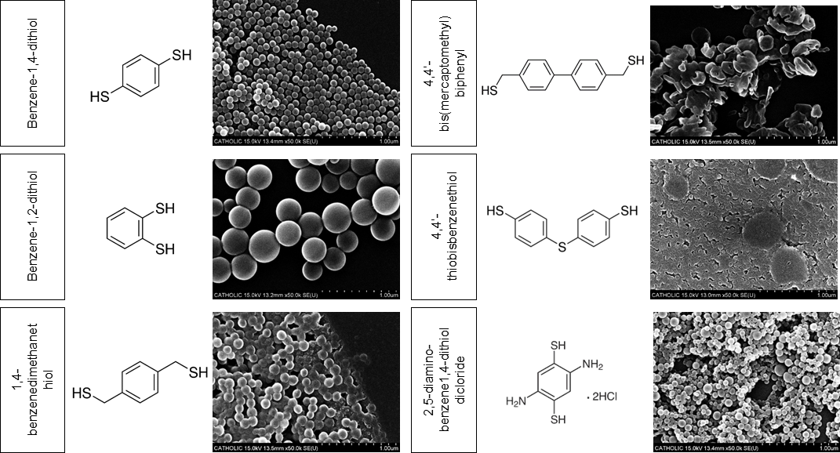
Fig. S1 Structural screening of thiol precursors. The nanoparticles, formed from Benzene-1,4-dithiol, Benzene-1,2-dithiol, 1,4-benzenedimethanethiol, 4,4’-bis(mercaptomethyl)biphenyl, 4,4’-thiobisbenzenethiol, and 2,5-diamino-benzene1,4-dithiol dichloride, are shown alongside the molecular structures of the corresponding thiol compounds. The scale bar represents 1 µm.

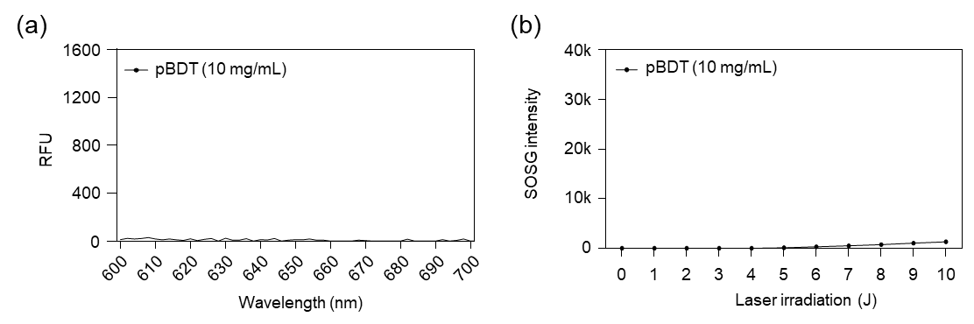
Fig. S2 Photodynamic inertness of the pBDT polymer matrix. (a) Fluorescence intensity of pBDT nanoparticles alone under light irradiation, showing no detectable photoresponsive signal. (b) Singlet Oxygen Sensor Green (SOSG) assay evaluating reactive oxygen species (ROS) generation from blank pBDT nanoparticles under identical irradiation conditions. Negligible SOSG fluorescence was observed, indicating that photodynamic activity originates from the encapsulated photosensitizer rather than the polymer matrix itself.

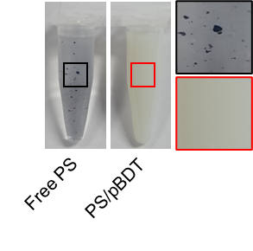
Fig. S3 Colloidal stability of PS/pBDT nanoparticles. Digital photographs showing the stable dispersion of PS/pBDT nanoparticles in aqueous media without visible aggregation.

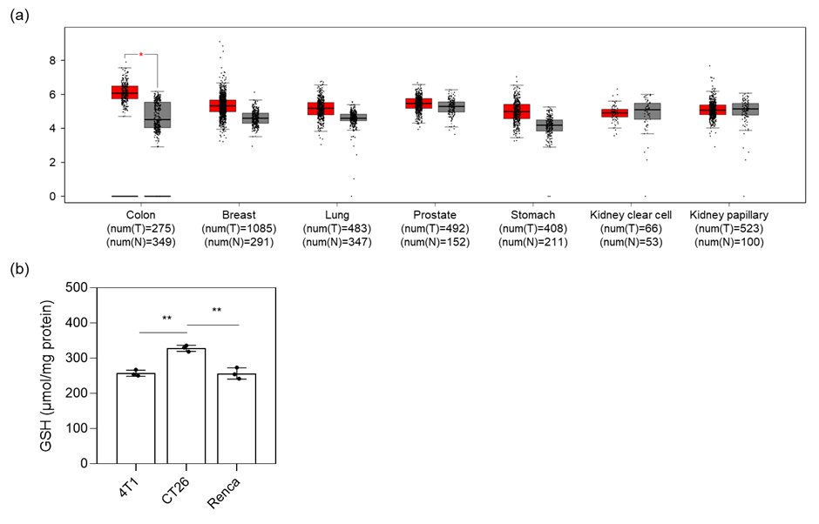
Fig. S4 Comparison of glutathione synthetase (GSS) expression across cancer types and intracellular glutathione levels in representative tumor cell lines. (a) GSS, a key enzyme catalyzing the final step of glutathione biosynthesis, was analyzed across multiple cancer types using the GEPIA platform, which integrates tumor transcriptomic data from The Cancer Genome Atlas (TCGA) and normal tissue data from the Genotype-Tissue Expression (GTEx) project. GSS expression in tumor tissues (T, red) was compared with corresponding normal tissues (N, black) for colon, breast, lung, prostate, stomach, and kidney cancers. A statistically significant increase in GSS expression relative to normal tissue was observed only in colon adenocarcinoma, whereas other cancer types showed no significant differences. (b) Intracellular glutathione (GSH) levels were experimentally quantified in CT26, 4T1, and Renca tumor cell lines by Ellman’s assay. Among the tested cell lines, CT26 cells exhibited the highest basal GSH level. Collectively, these results indicate that colorectal cancer displays a distinct elevation in glutathione synthesis–associated pathways at both the transcriptomic level and in a representative cellular model, supporting the selection of CT26 cells for subsequent redox-related therapeutic studies.

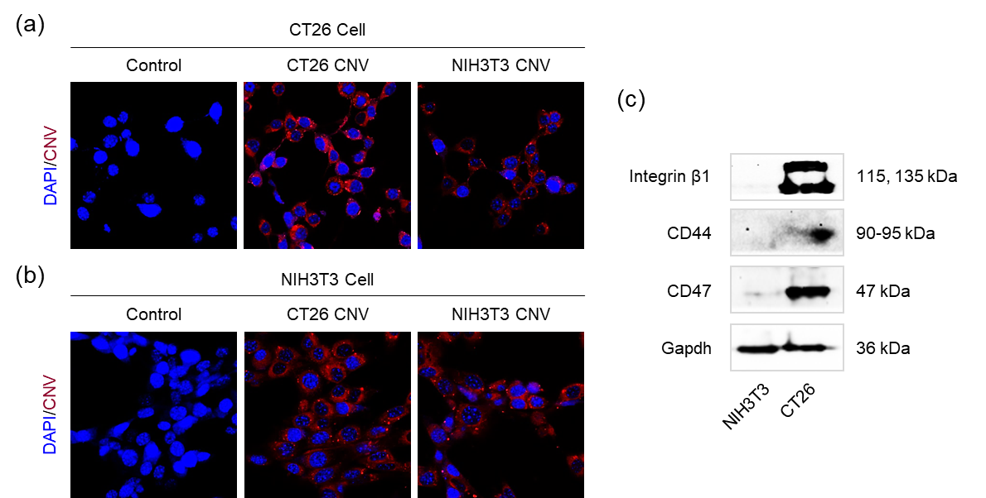

Fig. S5 Validation of homotypic targeting specificity of cell-derived nanovesicles. (a, b) Confocal fluorescence images showing cellular uptake of Nile Red–labeled CNVs. CNVs derived from CT26 cells exhibited preferential internalization into CT26 cells, whereas NIH3T3-derived CNVs displayed non-selective uptake in both CT26 and NIH3T3 cells. (c) Western blot analysis of adhesion-associated membrane proteins, including integrin β1, CD44, and CD47, in CT26- and NIH3T3-derived CNVs. GAPDH was used as a loading control. CT26-derived CNVs showed higher expression levels of these proteins compared with NIH3T3-derived CNVs, which may contribute to the observed homotypic uptake behavior.
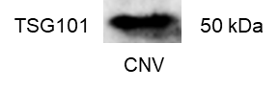
Fig. S6 Western blot characterization of CNVs. TSG101, a representative endosomal sorting complex required for transport–associated protein, was detected in CNVs, supporting their vesicular origin.

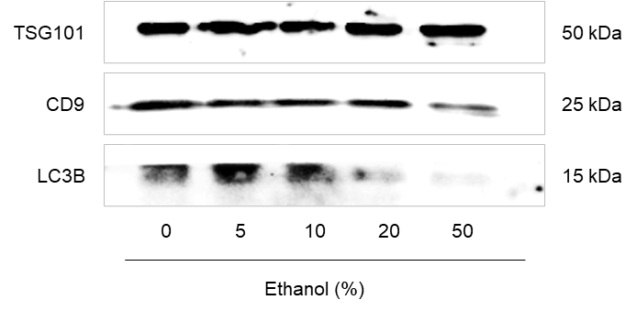
Fig. S7 Western blot analysis of membrane-associated proteins (TSG101 and CD9) and the luminal protein LC3B following exposure of CNVs to increasing ethanol concentrations. Membrane-associated proteins remained stable across the tested conditions, whereas the luminal marker LC3B showed a pronounced reduction at ethanol concentrations exceeding 10%, indicating increased membrane permeability. Based on these observations, 10% ethanol was selected as the upper limit for lipid incorporation to minimize structural disruption of CNVs.

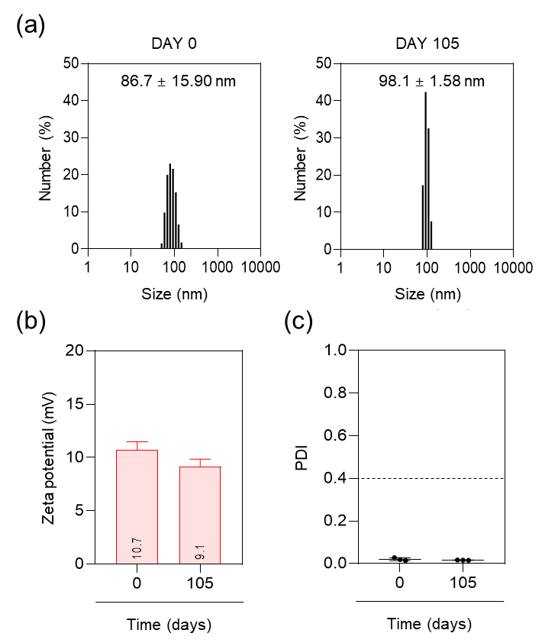
Fig. S8 Long-term colloidal stability of PS/pBDT@cCNVs during storage. (a) Hydrodynamic diameter of PS/pBDT@cCNVs measured by dynamic light scattering (DLS) on Day 0 and Day 105 during storage at 4 °C. A modest increase in the mean particle size was observed, while the overall size distribution remained narrow. (b) Zeta potential values measured on Day 0 and Day 105 showed a slight decrease from +10.7 mV to +9.1 mV, indicating the retention of a mildly cationic surface charge over the storage period. (c) Polydispersity index (PDI) values remained unchanged at 0.02 at both time points, confirming the maintenance of a uniform particle population during long-term storage.

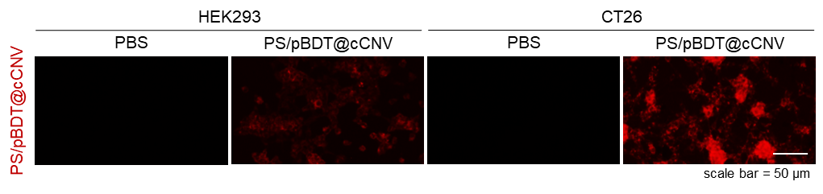
Fig. S9 Evaluation of tumor-associated cellular accumulation of PS/pBDT@cCNVs. PS/pBDT@cCNVs were labeled with Nile Red (0.5 µg/mL) and incubated with HEK293 and CT26 cells for 1 h, followed by fluorescence microscopy analysis. Stronger intracellular fluorescence signals were observed in CT26 cells compared with HEK293 cells, indicating preferential accumulation of PS/pBDT@cCNVs in tumor cells.

Fig. S10 Evaluation of cytotoxicity induced by laser irradiation alone. Cells were exposed to a 671 nm laser at an output power of 100 mW with irradiation doses of 1, 3, 5, and 10 J to assess laser-induced cytotoxicity. No detectable cytotoxic effects were observed under any irradiation condition, indicating that laser exposure alone did not induce measurable cellular toxicity under the applied conditions.

Fig. S11 Biocompatibility assessment in the absence of light irradiation. Cell viability of CT26 cells treated with each formulation without light irradiation. No significant cytotoxicity was observed under dark conditions, indicating that the hybrid nanovesicles exhibit minimal intrinsic toxicity prior to photoactivation.
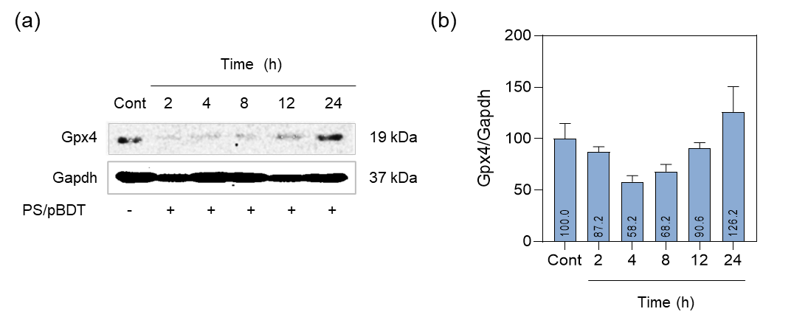
Fig. S12 Determination of laser irradiation timing following PS/pBDT@cCNV treatment based on GPX4 downregulation. (a) Representative western blot images showing GPX4 expression in CT26 cells at different time points after PS/pBDT treatment. GAPDH was used as a loading control. (b) Quantitative analysis of GPX4 expression normalized to GAPDH and expressed relative to the untreated control, which was set to 100%. GPX4/GAPDH levels reached a minimum at 4 h after treatment. Based on these results, this time point was selected for subsequent laser irradiation in photodynamic experiments.

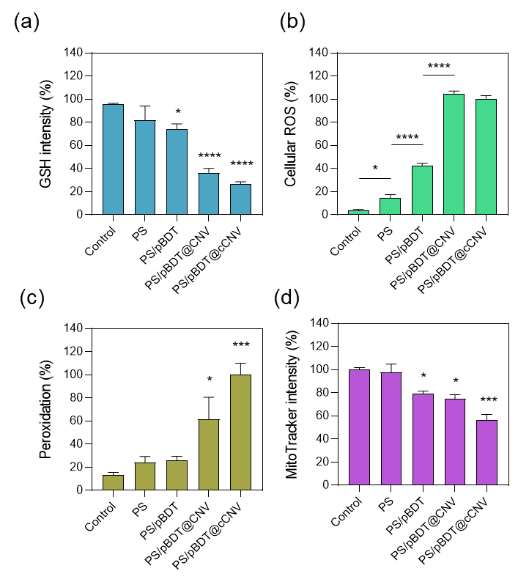

Fig. S13 Quantification of confocal fluorescence signals in Fig. 5. Fluorescence intensities were quantified using ImageJ. (a) Intracellular glutathione levels assessed by monochlorobimane (MCB). (b) Intracellular reactive oxygen species levels measured by DCFH-DA. (c) Lipid peroxidation evaluated using BODIPY 581/591 C11. (d) Mitochondrial dysfunction assessed by MitoTracker.

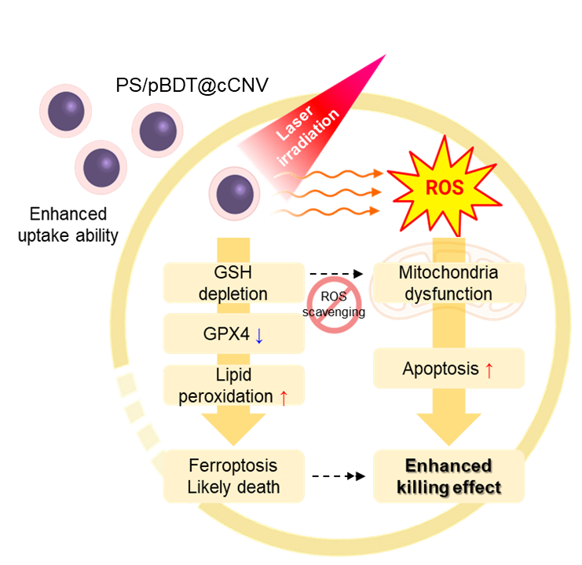

Fig. S14 Schematic illustration of the proposed intracellular mechanism of PS/pBDT@cCNVs–mediated photodynamic therapy. Following cellular internalization, laser irradiation induces ROS generation, while the pBDT core depletes intracellular GSH, leading to GPX4 downregulation and lipid peroxidation. Concurrent mitochondrial dysfunction promotes apoptotic signaling, together resulting in enhanced tumor cell killing through combined oxidative stress–associated pathways.

Fig. S15 Enlarged comparison of tumor growth kinetics between PS/pBDT@CNVs and PS/pBDT@cCNVs. To more clearly visualize differences in tumor growth trends that are less apparent in the full-scale plot shown in Fig. 8, tumor volume data for the PS/pBDT@CNVs and PS/pBDT@cCNVs groups are presented on an expanded scale.
Fig. S16 Systemic safety monitoring during treatment. Body weight profiles of mice recorded throughout the treatment period. No significant body weight loss was observed among the treatment groups.

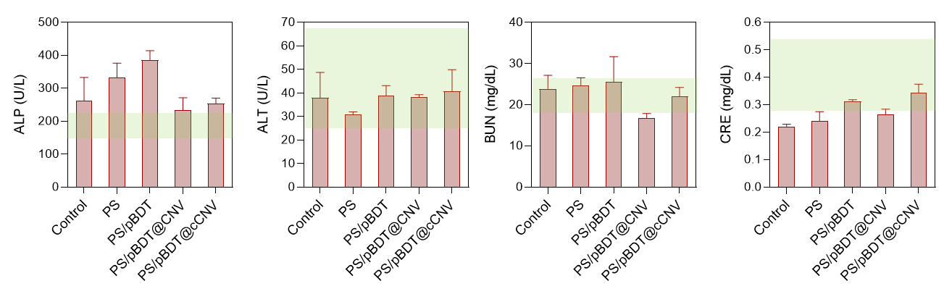Fig. S17 Serum biochemical analysis for systemic safety evaluation. Serum levels of alkaline phosphatase (ALP), alanine aminotransferase (ALT), blood urea nitrogen (BUN), and creatinine (CRE) were measured after treatment to evaluate hepatic and renal function.

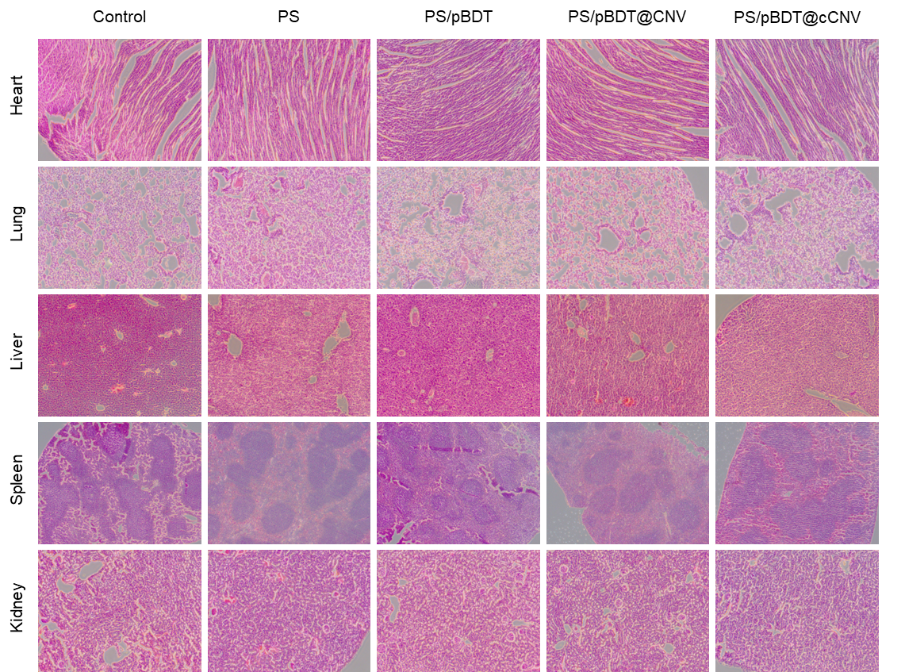

Fig. S18 Histological evaluation of systemic safety. Representative hematoxylin and eosin (H&E)-stained sections of major organs (heart, lung, liver, spleen, and kidney) collected at the study endpoint. No overt histopathological abnormalities were observed among the treatment groups.

