Supplementary File 01: Exploratory Factor Analysis
Factor | Eigenvalue
Factor 1 | 2.87544
Factor 2 | 1.04158
Factor 3 | 0.60883
Factor 4 | 0.25328
Factor 5 | 0.18135
Factor 6 | 0.11718
Factor 7 | 0.06019
Factor 8 | 0.03508
Factor 9 | -0.3127
Factor 10 | -0.05164
Factor 11 | -0.11400
Factor 12 | -0.12431
Factor 13 | -0.15587
Factor 14 | -0.18139
Factor 15 | -0.18623
Factor 16 | -0.22857
Factor 17 | -0.27428

Supplementary File 02: Scree Plot
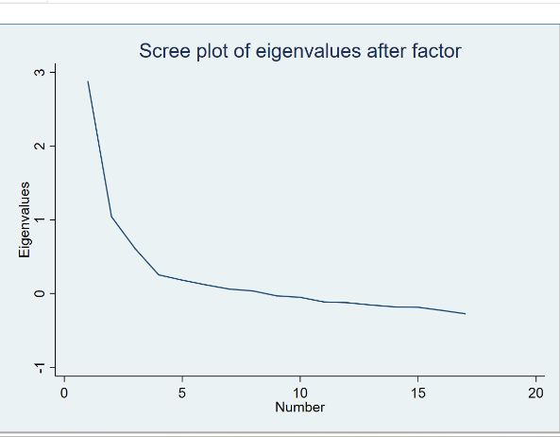

The above scree plot confirms that before the inversion, there are three points. As the this is one of the rules when assessing scree plots, that number of components before the point of inversion is the number of components that must be kept (Statistics Globe, 2023). However, in the context of our psychometric paper, the rule of interpretation of scree plot is the kaiser rule, which states that only components with an eigenvalue of greater than 1 must be retained. In the case of the above scree plot there are only two points at which the eigen value exceeds 1.
This therefore means that only 2 components would be retained, this also confirms what was in the paper that only two factors have been retained.

